**“Le principe d’Abravanel”:** **Bible Criticism’s Forgotten Debt to Isaac Abravanel**

In his exegetical work, Abravanel followed in the footsteps of the Italian humanists, who had dealt mostly with the literature and history of the Romans… it is no accident that this Jewish author, [Abravanel], was the first to implement the methods of the humanists [to study] the book of Israel’s antiquities, the Bible; later, Christian theologians and political philosophers learned [their methods] from him. (Yiṣḥaq Baer, *Tarbiz* 8 [1937]: 248).[1]

These words of celebrated historian of Iberian Jewry, Yishaq Baer – written just sixty years after the first publication of Wellhausen’s *Prolegomena* (1878) – sought to remedy a historiographical injustice committed by the new biblical criticism. In the opening pages of the *Prolegomena,* Wellhausen declared “the Law […] the entire Pentateuch, is no literary unity and no simple historical quantity.” This is immediately followed by the remark: “since the days of Peyrerius and Spinoza, criticism has acknowledged the complex character of that remarkable literary production.”[2] In his celebration of Spinoza’s contribution to a critical reading of Scripture, Wellhausen glossed over insights voiced almost two centuries earlier by another critical reader of Scripture – Don Isaac Abravanel.

Wellhausen’s focus on Spinoza approach was not mere chance. The Spinozan position fit well with Wellhausen’s personal – as well as intellectual – rejection of the Pentateuch and its theocratic theology as the foundational text of biblical history. “In my early student days,” writes Wellhausen, “I was attracted by the stories of Saul and David, Ahab and Elijah; the discourses of Amos and Isaiah laid strong hold on me.” But “my enjoyment of the latter was marred by the Law.”[3] A few pages later, Wellhausen offers a programmatic explanation of how the Priestly code succeeded “in concealing the true date of its composition.”[4] Later in the work Wellhausen mentions Spinoza, noting that it was he who noticed those signs in the Pentateuch that indicated a “distance between the present and past spoken of.” It was this discovery which famously prompted Spinoza to post-date the composition of the Pentateuch – a view that is defended throughout Wellhausen’s *Prolegomena*.

Baer was not the only one to draw attention to the dearth of Jewish figures in the historiography of Bible criticism. Baer’s former colleague at the Berlin *Akademie für die Wissenschaft des Judentums,* Leo Strauss, noted “Abravanel’s criticism of certain traditional opinions concerning the authorship of some biblical books […] paved the way for the much more thoroughgoing biblical criticism of Spinoza.”[5] Likewise, Baer’s colleague at the nascent Hebrew University in Jerusalem, Bible professor, Moshe Hirsch Segal, similarly emphasized Abravanel’s contribution: “Although still rooted in Middle Ages,” he writes, “one can already discern in Abravanel the first signs of new conceptions and views, which eventually would lead to the scientific and critical hermeneutics, developed by later scholars who did not belong to Israel. […] These echoes [of new humanistic views] in Abravanel’s works found receptive ears among Christians humanists who studied avidly Abravanel’s biblical commentaries in Hebrew or in Latin translation.”[6]

While Strauss and Segal were more cautious than Baer, and more reluctant to celebrate Abravanel as the Jewish “father” of biblical criticism, all three of these scholars, each one in his own way, drew attention to the puzzling erasure of Abravanel from the historical memory of Biblical criticism, and to his replacement by a figure from a later generation, Spinoza. The following chapter proposes to further this line of inquiry – by shedding light on this forgotten chapter of early modern biblical criticism, focusing on the odyssey of Abravanel’s seminal text – its first appearance in print in 16th century Italy, the historical and intellectual circumstances of its composition in late 15th century Iberia, and finally the text’s influence on the biblical criticism of the 17th century in northern Europe.

1. ***The Historical Background of the Editio Princeps of Abravanel’s* Commentary on the Former Prophets**

In the last two decades of the 15th century, on the eve of the Italian wars (1494-1559), Jewish printer Gershom Soncino launched his printing career in the northern Italian cities, Soncino and Brescia.[7] During this period, Soncino managed to print about a dozen Hebrew editions, until he was finally forced to suspend his activities in 1497.[8] Around the year 1500, Soncino moved to Venice. As Marx and other scholars have speculated “his chief purpose was to gain the permission for the [Hebrew] printing in that city.[9]” There, Soncino collaborated with the famous Christian printer and humanist Aldo Pio Manuzio, publishing with him a small tract, an introduction to Hebrew letters, in 1501.[10] The text in question was an addendum to Constatinus Lascaris’ Greek grammar *De octo partibus orationis –* the already bilingual publication, containing text in both Latin and Greek, was thus supplemented with a few folios with Hebrew characters and words. The tract was given the title “Introductio utilissima hebraice discere cupientibus,” but the name of its author, Gershom or Hieronymus Soncino, did not appear. In the introduction to the piece, Aldo Manuzio not only failed to mention the name of its Jewish author and printer, but also promised his readers to print further Hebrew texts – “institutiones grammaticas, dictionarium et sacras libros” in the near future.[11] The publication of such Hebrew books had been Gershom Soncino’s dream and it was probably the reason why he had agreed to collaborate with Manuzio in the first place. His ambitions to pioneer Hebrew printing in Venice dashed, Soncino left the city.

In the first decades of the 16th century, under the specter of the ongoing war between Venice and the League of Cambrai, Gershom Soncino managed to resume his printing activities, this time in the Adriatic cities of Fano, Pesaro, Ortona and Rimini during the period between 1503-1527, moving from one town to another in step with shifting political circumstances and military fortunes.

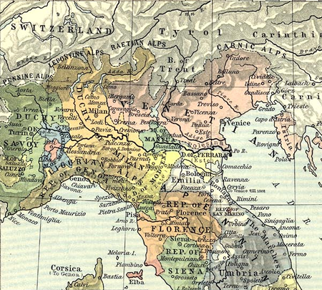

Map of Northern Italy in 1494

Over the course of almost two decades, he printed an impressive list of books in Latin, Italian, and Hebrew.[12] One of his first projects, was an edition of Petrarca’s *Opere volgari* (Fano 1503). The edition was meant to compete with the Venice edition recently published by Soncino’s former mentor, Aldo Manuzio, and edited by the great humanist Pietro Bembo in 1501.[13] In this case, Soncino was forced yet again to concede defeat – the quality of Aldo Manuzio edition far surpassed that of his own. Yet it was not long before he finally achieved the success he so greatly desired. Until Daniel Bomberg established himself as a printer of Hebrew books in Venice in 1515,[14] Gershom Soncino enjoyed the distinction of being the only printer of Hebrew books throughout the Italian Peninsula for about fifteen years. Furthermore, during the turbulent years of 1508-1512, during which the State of Venice lost most of its lands and possessions and faced the threat of invasion, printing activities in the citywere almost entirely discontinued.[15] This gap in the market allowed Soncino to successfully develop his own printing business.

Among the books Soncino published in these years was the first edition of Isaac Abravanel’s *Commentary on the Former Prophets* (Pesaro 1511/1512). The final redaction of the work in manuscript had been completed in Naples in 1493; an earlier version had been completed in Castile in 1483/1484.[16] Although this was not the first printed edition of Abravanel’s works (a volume containing three works was printed in Istanbul in 1505 during the author’s lifetime),[17] the Soncino volume represents the first posthumous edition.

In some sense, the edition was an attempt to memorialize the life and works of the great Abravanel, who had passed away just a few years earlier. Rabbi and biographer Barukh Forti describes Abravanel’s death in Venice in 1508 as follows: “Our luster has departed, our majesty has departed, and Isaac expired, and died, and he was gathered unto his people in the year 268 [5269, 1508]. His sun set in this world, but his contribution is in the World to Come. And the officers of the city [Venice] and the leaders of the Jews paid him great respect upon his death, and they brought him to Padua to be buried in the ancient graves.”[18]

The final page of this posthumous edition contains two poems composed by the corrector, Solomon “Crescente” (Rabbi Solomon Ben Peretz Bonfoy Zarfati).[19] As suggested by Isaiah Sonne, Rabbi Solomon may have met Isaac Abravanel when the latter arrived in Naples after the Expulsion. [20] The final stanzas of the second poem form an acrostic spelling *Crescente* (literally “increase”), a rough Italian equivalent of the Hebrew name of the author’s father – *Peretz*. Rabbi Solomon draws attention to the posthumous character of the project, stating that “even after death, [Abravanel] left behind many books.”

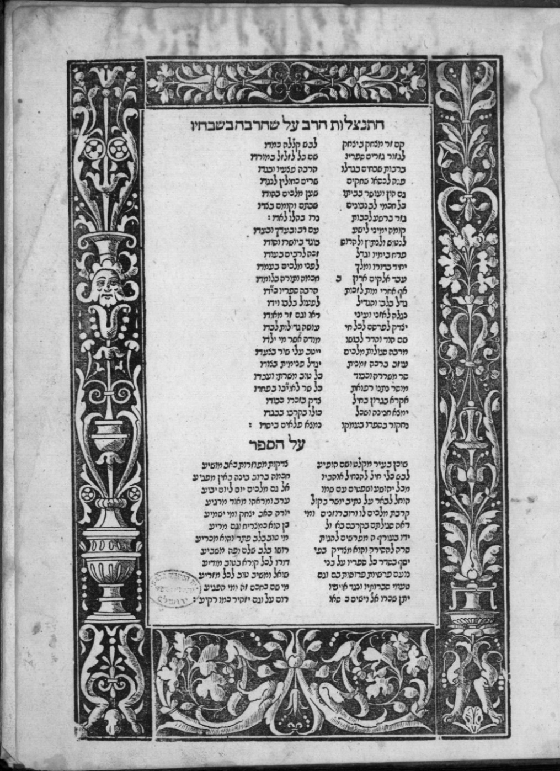

Crescente goes on to sing Abravanel’s praises:

He conceived great designs and with his heart and hands accomplished great things

To my eyes and ears they were revealed, and others did see them as well

It is fitting to publicize to all living creatures, the works of he who acted alone […]

From my throat I shall raise a valiant cry, it is just to [preserve] his memory and [give him] honor

May he find pardon, [for] his whole intellect is [now in this work] stored

We shall ponder the depths of his book, and find wonders at its foundation.[21]

In the second editorial poem, Rabbi Salomon describes how “each day [Abravanel] poured forth [his commentary] on the entire books of Joshua, Judges, Samuel and Kings, setting himself to comment upon them with rightness, using an agreeable speech and presenting a peaceful face.” Is Rabbi Solomon suggesting that he attended oral lessons delivered by Abravanel in Naples, during which the latter explicated the books of Kings? While we cannot say for sure, the two poems clearly indicate that Rabbi Solomon had direct access to Abravanel’s person and works, and was soon convinced that they ought to be printed – notwithstanding accusations that Abravanel suffered from delusions of grandeur and was predisposed to plagiarism.[22] The page concludes with a statement juxtaposing the deeds of God to those of the publisher for the afterlife of the deceased: “God will pay him his wage and elevate him to a seat upon high; he too will shine like the brightness of the heavens.”

The circumstances of the commentary’s composition can only be gleaned from some stray remarks made by its author. In his general introduction , written in Castile in 1483, Abravanel seems to suggest that the book originated in oral lessons: “Here the Lord your God sent me wise men full of knowledge, companions that hearken to my voice… Unto me, men lent their ears, waiting for my opinion in the interpretation of different parts of the books of the Former Prophets.”[23] As mentioned, Rabbi Solomon’s poem alludes to his own participation in the oral origins of the written commentary,[24] and he provides some general remarks about his acquaintance with the author and his work with the manuscript. Further information can be gleaned from other volumes edited by Soncino in those years.

A few months before publishing Abravanel’s *Commentary on the Former Prophets*, Soncino reprinted David Kimhi’s *Commentary on the Former Prophets* (previously published by his uncle, Joshua Soncino, some twenty years prior).[25] The printing of these two commentaries was facilitated by Soncino’s contemporaneous work on an edition of the Hebrew Bible, published in two volumes in 1511 and 1517 respectively.[26] Soncino reused the types and the formatting of the biblical text and simply added the commentaries of Kimhi and Abravanel in each edition. The edition of Kimhi’s commentary was completed on the same day (April 12, 1511) as the first volume of the Hebrew Bible,[27] clear evidence that Soncino worked on the two projects concurrently, likely planning the Abravanel volume as well. In 1517, the second and last volume of Soncino’s Bible was published, preceded a few months earlier by a volume containing *Kimhi’s Commentary on the Latter Prophets* and followed by a an edition of Abravanel’s *Commentary on the Latter Prophets* (1519/1520).

During these years, circumstances in Venice had begun to improve. The republic successfully forged alliances with the Pope Julius II and Europe’s leading monarchs and was regaining its territorial and political influence. As a result, printing activities were allowed to resume. In 1517, Daniel Bomberg published his first edition of the Hebrew Rabbinic Bible, *Miqraot Gedolot,* becoming in its second edition the standard Hebrew Bible throughout the Early Modern Period.[28] After more than a decade of enjoying a monopoly on Hebrew printing in Italy, Gershom Soncino was bested once again by competitors in Venice.

***Abravanel’s Introduction in its First Editorial Configuration***

A comparison of the paratextual elements of the edition of Abravanel’s *Commentary* with that of Kimhi’s *Commentary* yields some striking differences.[29] Kimhi’s short introduction is printed on the second page of the volume. Notably, Soncino seems to have made no attempt to emphasize or highlight the author of the work. A border is used to embellish the first word of the book of Joshua which appears on the third page. Similarly, the Abravanel volume opens with an introduction or preface.[30] However, unlike the Kimhi volume, the first lines of this text are adorned with a richly decorated border; the names of Isaac Abravanel and his prestigious ancestors feature at the top of the page in large print.

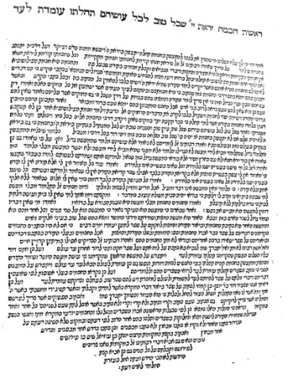

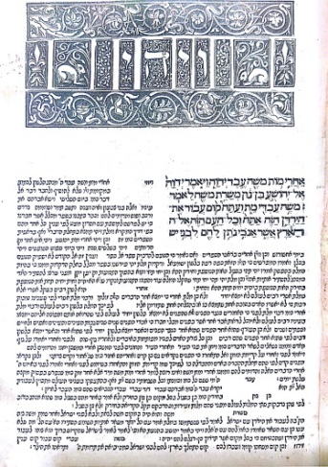

Page 2 (Introduction) and 3 (biblical text and commentary), *Nevi*ʾ*im Rišonim* ʿ*im Peruš Rabenu Kimḥi*, Pesaro 1511. Translation of the first lines of the Introduction: “The fear of the Lord is the beginning of wisdom; all who follow His precepts have good understanding. To him belongs eternal praise. [Ps 111:10] So said King David, may peace be on him: whoever prepares his mind [heart] to deal with wisdom, should first reach [the level] of the fear of God and make it his principle.”

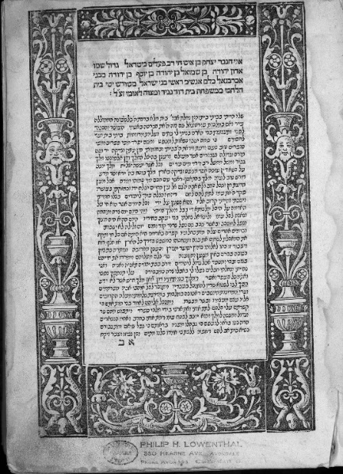

I am the man Isaac son of a valiant man who has done mighty deeds, his name is great in Israel, Sir Judah son of Samuel son of Josef son of Judah of the Abravanel family, all of them men who were heads of the children of Israel, from the seed of Jesse the Bethlehemite, from the house of David prince and commander to the peoples. May the memory of my father be blessed.

Page 2, Abravanel, *Peruš Nevi*ʾ*im Rišonim*, Pesaro 1511-1512 (translation of the first four lines).

In sharp contrast to the richly decorated second page of this volume, the format of the title page is markedly sober and brief. On it only these words appear: “The book of Joshua with the commentary of the Abravanel.”[31] The title is misleading in its brevity, omitting mention of whole swathes of the book’s contents – a complete commentary on the entire Former Prophets. In clear opposition to this rather modest title page, the first page of the introduction goes to great pains to highlight Isaac Abravanel’s role as an author– a message conveyed not only visually but also textually: the introduction opens with an autobiographical text penned by the author himself.

The editorial decision to celebrate Abravanel’s authorship in the layout of the second pages of the volume was certainly not a consistent policy on Soncino’s part, as can be seen in the way Kimhi’sintroduction is formatted. As I shall explain, the printer’s decision was motivated by the text of the introduction itself, and by the prestige of the recently deceased Isaac Abravanel (1437–1508) whose fame preceded him among Sephardic and Italian Jews – the potential market and reading audience of the book. This, and Soncino’s personal acquaintance with the Abravanel family, may explain why he employed the exquisite border he had previously used in his 1507 edition of Marco Vigerio’s *Decachordum Christianum*.[32]

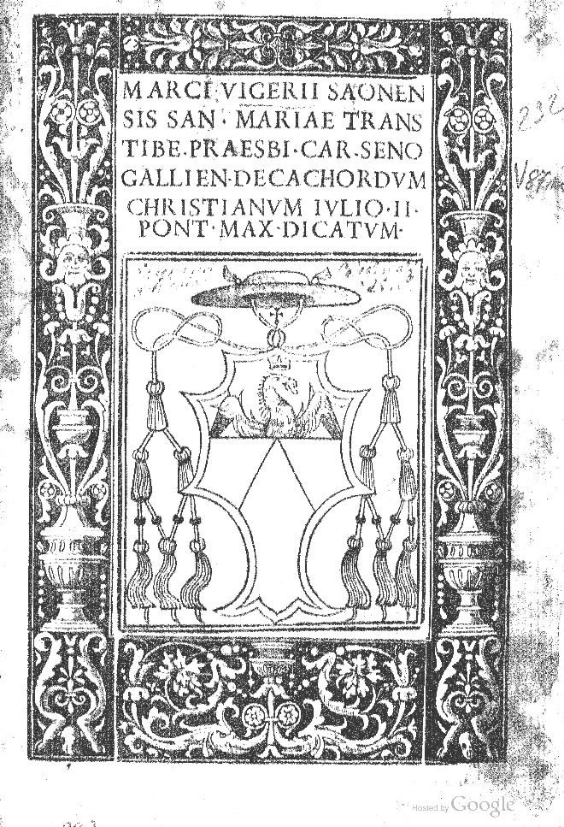 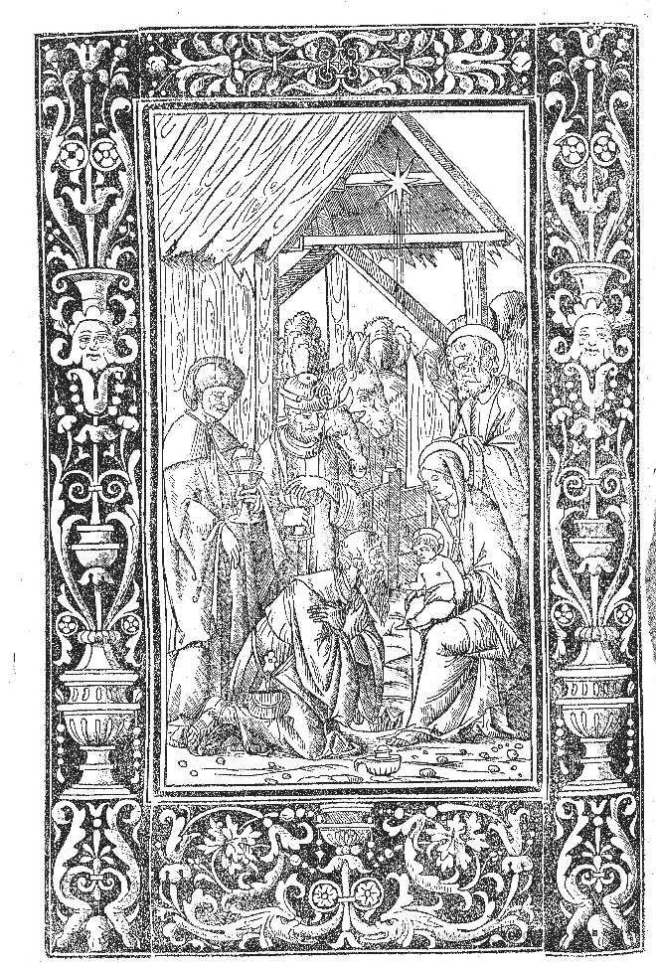

Title page (fig. 1) and second illustrative table (fig. 2), Marcus Vigerius, *Decachordum Christianum*, Pesaro 1507.

Here too the function of decorating the title page with a border (see fig. 1 and 2 above), is to highlight the figure of the author, Marcus Vigerius, and his relationship to his work. The square in the middle of the page, featuring symbols of his status as the Bishop of Sinigaglia and his family coat of arms, constitutes an authorial portrait of sorts reduced to major social attributes: family, priesthood, and work. The volume also contains ten illustrative tables in which the border is filled with different images of the life, death, and resurrection of Christ (see fig. 2 above). The engravings were made by Benedetto Mantagna.[33] In another famous work published by Soncino, Pietro Galatino’s *De arcanis catholicae veritatis*, the very same border is used to decorate not only the title page, but also the *praefatio* in which the name and titles of the author appear in large bold fonts at top the page. The Abravanel edition of 1511-1512 uses the same visual method.

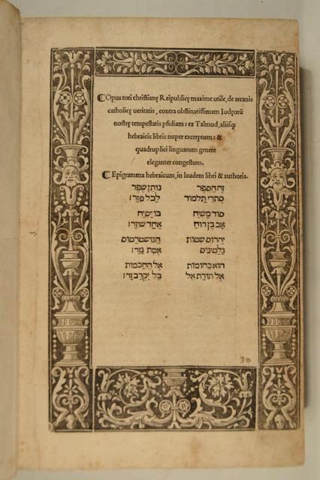 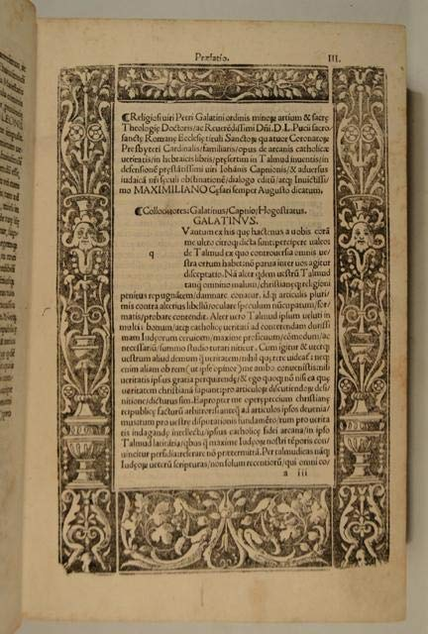

Title page and Praefatio of Pietro Galatino, *De arcanis catholicae veritatis*, Ortona 1518.

A year after publishing Galatino’s *De arcanis catholicae veritatis*, Soncino published Abravanel’s *Commentary on the Latter Prophets*. Once again, the border taken from the *Decachordum Christianum* is used – this time to decorate the title page. In the preface, Abravanel’s name (Isaac) is celebrated with large rubricated letters.

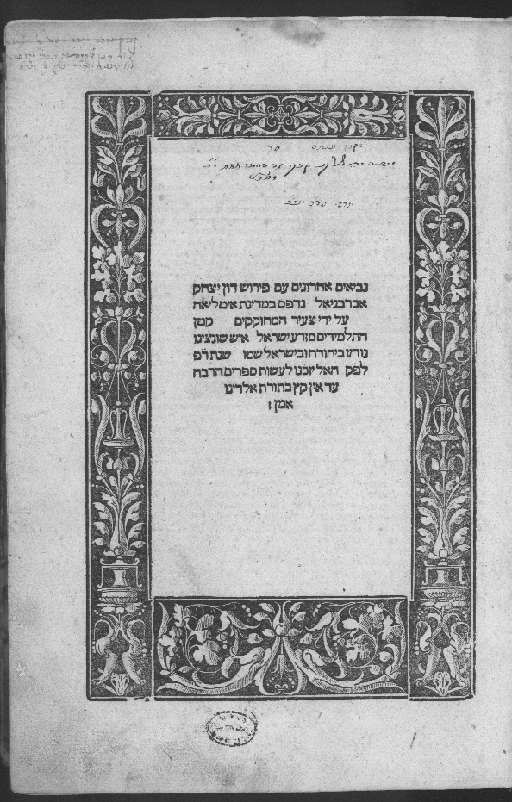 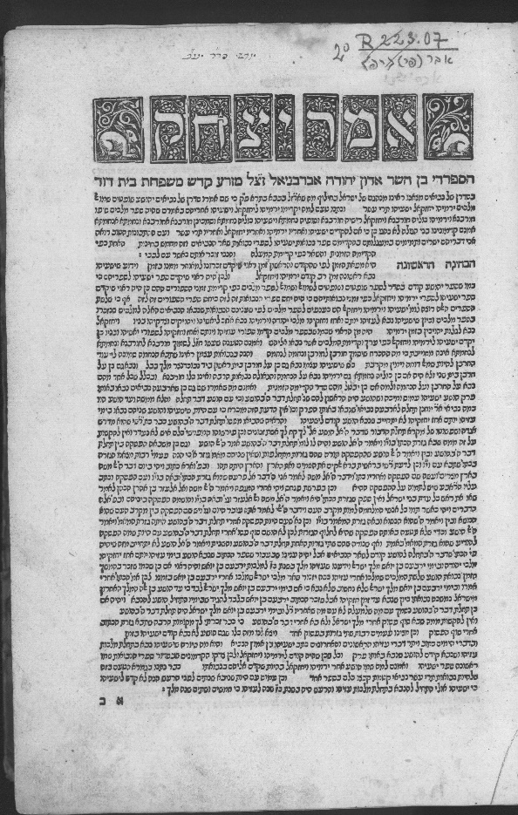

Abravanel, *Commentary on Later Prophets*, Pesaro-Ortona (?) 1519-1520

A comparison of these editions reveals Soncino’s goal: to celebrate and dignify the authorship of Abravanel by utilizing the same bibliographic codes used to celebrate Christian authors.[34] The adoption and adaptation of Christian notions of authorship was a new to the Jewish print-culture of the time. This stands in stark contrast to the more modest formatting used to present Kimhi’s *Commentary on the Former Prophets*. There the first page presents the names of the works, of the authors, the printer and the political authority authorizing the printing of the Hebrew; there is no decoration whatsoever.[35] The names of the biblical books precede the name of David Kimhi’s commentary. The biblical text appears already on the third page after the commentator’s one-page introduction. In the edition of Kimhi’s *Commentary on the Latter Prophets*, Soncino used the border of the *Decachordum Christianum* to format the title page, but not to decorate Kimhi’s preface. On the second page, Soncino highlights the name of the author by detaching it from the body of the text and by printing it above the preface in large bold letters.

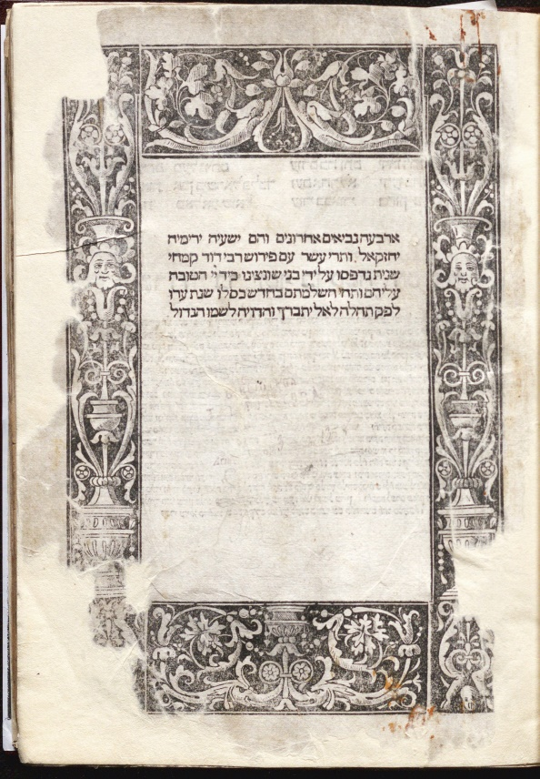 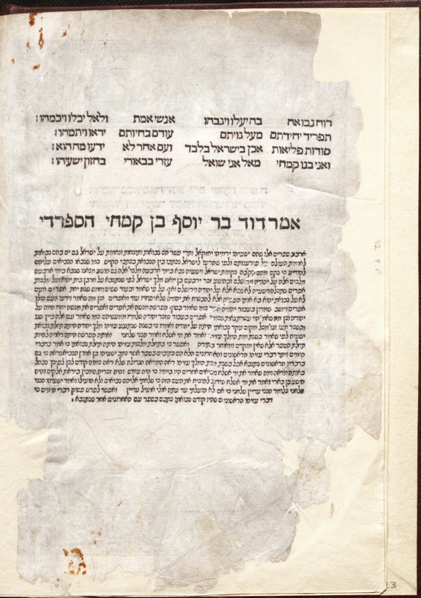

Kimhi, *Commentary on Later Prophets*, 1515-1516. (Title page and Preface)

The originality and novelty of Abravanel’s introduction can be easily sensed in the 1511-1512 edition. The title page does not even bother to provide a full list of the biblical books discussed in the commentary. Their names appear only on the third page. The biblical text itself appears only at the eleventh page, “postponed,” as it were, by the introductionand emphasis placed on Abravanel’s authorial role. In this lengthy preface, Abravanel begins by developing his self-image as an author and as a historical agent, presenting an autobiographical narrative about the political circumstances that impelled him to write his commentary.[36] He then devotes more than seven pages to two “investigations”(*ḥaqirot*) regarding the nature of the biblical books of the *Former Prophets*, dealing at length with the composition and authorship of the biblical books.[37] Finally, the introductionends with a presentation of Abravanel’s exegetical method[38] and with a list of the textual units or pericopes (*parašot*) that comprise the book of Joshua.[39]

This preliminary description of Abravanel’s introductionin its first editorial configuration reveals an interesting tension between the clear emphasis on Abravanel’s authorial role in the new age of print and the complex question of the authorship of the biblical books. In what follows, I intend to show how Abravanel’s distinctive understanding of the meaning of authorship is reflected in a new understanding of the authorship of the books of the Former Prophets.

***The Abravanels and Jewish printers***

The grandiose mise en page used to present Abravanel’s introduction was not purely the invention of a skilled printer. In many senses, it represents the visual and editorial manifestation of the author’s own rhetoric – a rhetoric developed with a consciousness of print. A year before Abravanel arrived in Castile and before he completed the first redaction of his *Commentary on the Former Prophets* (1482)*,* a printed editions of Kimhi’s *Commentary on the Latter Prophet*s was prepared in the Castilian city of Guadalajara.[40] From the year 1485, Abravanel served as a tax farmer on behalf of Cardinal Mendoza in the very same city.[41] In Montalbán, Toledo, Guadelajara, Híjar, Samora, and Lisbon, Hebrew printing shops were established in the 1470s-1490s for relatively short periods of time. Several editions of the Former and Latter Prophets were produced, as well as editions which included Kimhi’s commentary.[42] Abravanel spent time in these cities as well and also made the acquaintance of Híjar printer Eliezer Alantansi, as attested in a letter sent by Saul Hacohen to Don Isaac in 1506:[43]

Ten years ago, my lord [Abravanel] was standing near us in Corfu… in the company of they who are left of the leaders of the people [Iberian Jewry]. Among them was Eleazar Al Tansi, my friend, who I later encountered… in the land of the Ottomans. There I found him to be a prominent doctor, at the court of the king and the ministers. He also praises your virtues… and considers you the greatest of all our wise men.[44]

In 1487, Eliezer Alantansi published a manual on behalf of the Saragossa diocese, *Manuale Caesaraugustanum*,which included a beautiful decorated border on its title page.

*Manuele Caesaugustanum*, Híjar 1486.

The border was later used for the printing of Jewish books in Hebrew, first in Híjar and later in books produced by Lisbon printer Eliezer Toledano.[45] The same border was also employed by the Istanbul based printing shop owned by the Nahmias brothers: it appears in their 1505 edition of Abravanel’s writings – appearing on the first page, it frames a poem composed by Abravanel’s son, Judah, a panegyric of the author, his father.

**Poem by the scholar Rabbi Judah Abarbanel, son of the Prince, author of the Book *Principle of Faith****.*

The fundamentals of the Law were given to the community of God, conserved for long at His side;

The glory of this generation and a great master studied them, Lord Isaac Abravanel raised them;

How do you dare compare his work to any other? How could you compare the Amanah with the Jordan?

Look there for Mount Sinai, the Mount of God! In comparison, what are Snir, Hermon and Amnah!

This [book] is a garden, with the tree of life within; truth is its fruit and its leaf is faithfulness.

Enclosed in it are the roots and principles of [Jewish] belief; for this reason, my father named it *Principle of Faith*.

First page, Nahmias 1505 Constantinople edition of Abravanel’s *Rosh Amanah.*

The journey of this decorated border from an Aragonese liturgical Catholic manual to a celebration of Abravanel’s authorship alludes to the fact that Don Isaac Abravanel, his family, and his associates were involved in the nascent business of Hebrew printing, before and after the Expulsion. But its journey did not end in Constantinople. The only extant copy of the 1486–1487 Alantansi printed edition of the Latter Prophets*,* which most probably has pages decorated by the same border, is now housed in the Biblioteca Oliveriana in Pesaro.[46] Is it simply a coincidence that Pesaro was precisely where Soncino printed, or at least prepared, the two editions of Abravanel’s Commentary on the Former and Latter Prophets, in 1511-12 and 1519-20? Regardless, Soncino employed the same editorial techniques used by Alantansi and would continue to reuse the intricate border of the 1507 edition *Decachordum Christianum* for his Jewish Hebrew books, perpetuating the editorial practices of the 1505 Nahmias edition, in which an entire page is devoted to celebrating Abravanel’s authorship and literary skills.

The clearest evidence of the Abravanel family’s direct involvement in the two Soncino editions of Abravanel’s commentaries on the Prophets, is to be found in Judah Abravanel’s introductory poem to the 1518 [1519] *Commentary on the Latter Prophets*. There he refers to his father’s broader project to interpret all the book of the Prophets and refers to Soncino’s plans to print the commentary in two volumes.

His commentaries on the five books of the Law seemed to descend from the heights of heavens…

He commented on the eight books of the prophecies which are writings full of mysteries.

Both, the former and the latter, are printed in two halves.

They were engraved on paper by a printer, the greatest master in the art of print,

With the assistance of his eldest son and student, Judah, who sings among the pages.

May the soul of this genius author enter into the garden of God, may the prophets be his company.

...

You who seek insight, rise, cross and learn the precious books of the father and the songs of the sons.

Silver without alloy, purified, understanding forged in the furnace of the intellect, and rendered limpid.

The father prepared the wisdoms and the son builds stanzas for the poems according to the numeric value of son [52].

Judah Abravanel, introductory poem, Abravanel, *Commentary on the Latter Prophets,* Pesaro 1520.

The nature of Judah Abravanel’s assistance is unclear. As Judah refers to the “eight books of the prophets,” it is probable that it was he who provided his father’s manuscript to the printer. In the aforementioned letter sent to Saul Hacohen, Don Isaac relates: “for two years, my [firstborn] son was not in this land [Venice], since he was in Naples with the Gran Capitan and the King of Spain… and now that both have left Naples, my son has come home to me.”[47] It is thus likely, that Don Isaac, who considered Judah “the best philosopher in Italy today,” entrusted him with custody of his manuscripts – along with the responsibility for overseeing their printing. That Judah was entrusted with this task can be further deduced from the poems he wrote for the Istanbul edition and the 1520 Soncino edition. There he references Abravanel’s commentary on the Pentateuch, which “seemed to descend from the heights of heavens,” and which was then only extant in manuscript, yet seemed to be well-known to his son Judah.

The Abravanels had the opportunity to meet Gershom Soncino’s uncle, Joshua, in Naples in the years after the Expulsion. Gershom Soncino left Venice two years before the arrival of Isaac Abravanel and his son Joseph in 1503. Yet, Fano and Pesaro, were surely not out of reach for the Abravanels. Our knowledge about the precise relations between the Abravanels and Gershom Soncino is unfortunately fragmentary. Nevertheless, Judah’s praise of Gershom Soncino as “the greatest master in the art of print” may attest to their collaboration in printing the two volumes of the Abravanel commentaries on the Former and Latter Prophets. If the historical backdrop of Judah’s words eludes us, their rhetorical effect is clear: they present the two Soncino editions of Abravanel’s commentaries as the collaboration of a deceased *gaon* (great leader)*,* his talented firstborn and *talmid* (disciple), and an *aman* (craftsman), the greatest Jewish printer of the age.

1. ***From the court of the king to court of God: The road to historicizing the Bible***

Cooperation between the Abravanels and Gershom Soncino resulted in the first two posthumous editions of Abravanel’s biblical commentaries and in a new celebration of Abravanel’s authorship in the Italian editorial market. As mentioned, this celebration, was not entirely an innovation of the printed edition; in many senses, Soncino merely perpetuated a central aspect of the author’s composition, emphasizing through a visual medium the tenor of a commentary crafted with careful rhetoric and underscoring, in particular, Abravanel’s innovative introduction to the *Commentary on the Former Prophets.* It is this introduction – and its innovative vision of the Bible and the historical processes that produced it – that I will explore in the present section.

Abravanel used the medium of the author’s introduction, traditionally a short preface, to first expand upon the political context of his own commentary, and then to explain the historical and literary background of the biblical books of the Former Prophets. This structure suggestsa link between the autobiographical narrative, describing the circumstances behind the commentary’s composition,and the scholastic discussion about the biblical books of Joshua, Judges, Samuel and Kings. These two components of the introduction are linked through the political space of the royal court – a setting portrayed by Abravanel in order to reveal his motivations for writing his commentary and then, to explain the complex writing process which produced the books of the Former Prophets.

***A Portrait of a Jewish Courtier***

From the first decorated page of the *Commentary on the Early Prophets* and all along the second, Abravanel discusses the historical background of his work, weaving together a rhetorical narrative written in a rhymed prose and composed mostly of fragments of biblical verses, a use of the Hebrew medieval genre of *meliṣah*.Abravanel’s introductory narrative is constructed as a twofold drama which takes place in two interconnected political spaces – the royal court and the circles of the Jewish elite. The first lines of the introduction depict with great pathos the prominent position Isaac Abravanel once enjoyed among both the elites of Portuguese Jewry as well as the court of Afonso V, king of Portugal.[48]

I lived peacefully in my home […] a house full of God’s blessings in the famous Lisbon, a city and a mother in the Kingdom of Portugal. The Lord commanded there the blessing in my barns and all earthly bliss. [...] I built myself houses and wide porches. My home was a meeting place for the wise, there were thrones of judgment, going out from there, through books and authors, good discernment and knowledge and fear of God. In my house and inside my walls there were enduring riches and righteousness, a memorial and a name, science and greatness, as between noble men of ancient stock. I was happy in the court of the king Dom Afonso, a mighty king whose domain spread out and reached from sea to sea, prospering in whatsoever he did. [He was] a king who trusted in the Lord… seeking out the good for his people when the heads of the people were gathered, incomparable learned man and teacher… Under his shadow I delighted to sit, and when I was next to him, he leaned on my hand and so long as he lived, I walked freely in the palace of the King.[49]

Using the biblical parallelism contained in the verse Daniel 4:1 (“…I lived peacefully in my house, and flourished in my palace“), Abravanel depicts his life in Portugal as divided between two “houses”: his own private home and the palace of the king. By juxtaposing these two spaces, Abravanel’s casts his own house as the “court” of the Jewish elite, where sages convene, engage in learned discussions, and reach important communal decisions. The host of these meetings, the lord of the house, represents the virtues associated with a prince: nobility, justice, knowledge, wealth and grandeur. In the palace and court of Afonso V, described as the perfect ruler, Don Isaac was treated as a cherished courtier.[50] This opening scene in which Abravanel moves seamlessly from the Christian court to the Jewish “court” gathered in his house, is the setting from which the commentary on the Former Prophetswill emerge. As I will show below, the political space of the court is further used by Abravanel as a point of reference for understanding the composition of the Bible itself.

In books printed in the 16th century, the frontispiece was sometimes used to display a portrait of the author, as in the 1532 Ferrara edition of Ariosto’s *Orlando Furiososo*.[51]

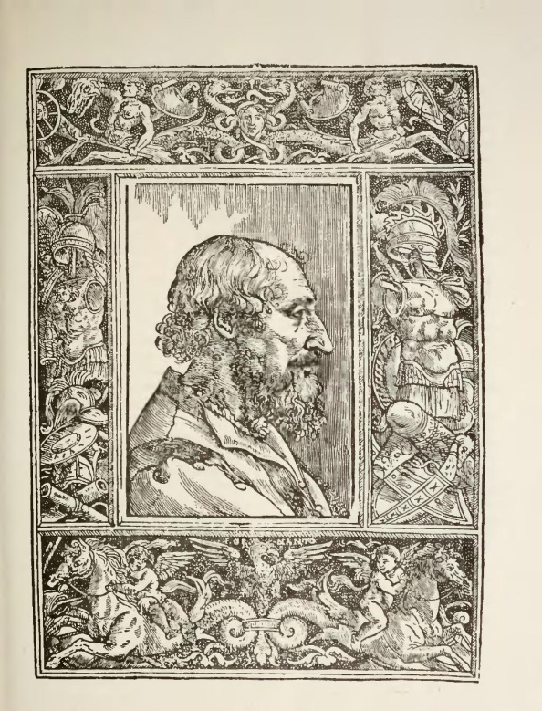

Frontispiece, Ludovico Ariosto, *Opere,* Ferrara, 1532.

In the Soncino edition of Abravanel’s writings, no visual portrait appears. But similar goals are accomplished by the literary self-portrait that occupy the first two pages: a dignification of the author and his work by identifying them with Jewish courtier Don Isaac Abravanel, and by displaying through his idealized image, one composed of words, his direct association with royal power – with the late medieval Christian Iberian court, and its social values.[52]

***The political crisis of the years 1481-1483: service of king or service God?***

The second moment in Abravanel’s introductory narrative is no less political than the first. It recounts the political crisis that took place in the years 1481-1483 within the court of the new Portuguese monarch, João II – a crisis in which Isaac Abravanel was intimately involved and which ultimately precipitated his flight to Castile.[53] Abravanel’s text is a contemporaneous, politically engaged narration of the event from the perspective of the courtiers who lost this struggle.

The years 1476–1481 were the twilight King Afonso V’s reign. Following his defeat in a war against Queen Isabel of Castile and failing to unite Castile and Portugal through a political marriage, Afonso V gradually retreated from political life, transferring most of his responsibilities to his son, João. During these years, the plague ravaged Portugal, and King Afonso succumbed to the disease. After the death of his father in 1481, King João II inaugurated a new strategy to reaffirm his royal power vis-à-vis the high nobility. His new policy was directed specifically against Abravanel’s powerful patron, the duke of Bragança. João II’s policies led to a direct and violent confrontation with some of Portugal’s most influential noble families. They were eventually accused of conspiring with the Castilian Queen against the Portuguese king. Many prominent figures of the Portuguese nobility were condemned to death, among them, the duke of Bragança who was executed on the June 20, 1483. This was a mere three months before Abravanel began his work on his *Commentary on the Former Prophets* in October.

After depicting a miraculous escape from the king’s agents, Abravanel goes on to describe his dramatic arrival in Castile and the process which led him to write his *Commentary on the Former Prophets*. The rhetorical account depicts his psychological development during this period, framed as a monologue which Abravanel delivers to himself:

Wherefore do you cry unto Him? . . . The Lord is righteous for you have rebelled against his word. Did you not put a hedge around Him? And then you forgot the God who gave you birth. For all your large property, you have ignored the Law of your God. You did not seek out the book of the Lord to hear what is taught. You impaired your conversation before God, so that you did not know how to sustain the weary with words. You chose the tongue of the crafty from a people of strange language, and you heeded lying words with kings and counselors of the earth, when their judgement comes, they will perish. Where are they now? They will perish, but you shall remain. You have put your hope in gold and in all the delights of this world, and you went after vanity, greatness, power and glory. If you have forgotten the name of your God, you will also forget these [former goods] and all your [past] abundance will fall in oblivion. But if you would seek God and meditate in His Law day and night, and if you would seek it as silver and make your supplication to the Almighty, God will again rejoice over thee for good, as he rejoiced over thy fathers…

In the opening lines of the introduction, when Abravanel’s still enjoyed good political fortunes, Jewish learning and success at court, *Torah ve-gedulah*, are presented as complementary virtues. By contrast, after the execution of Abravanel’s patron, Dom Fernando the Duke of Bragança, and after Don Isaac’s escape to Castile, fidelity to God and His Law, and service of the king and his court are cast as conflicting loyalties. Abravanel conveys this shift in perspective to his readers by inverting the literal sense of a fragment of the verse Job 1:10 in which the accuser decries God’s protection of the prosperous Job: “Have you not put a hedge around him and his household and everything he has? You have blessed the work of his hands, so that his flocks and herds are spread throughout the land.” Instead of depicting God’s protection, the verse is used here to stress Abravanel’s own neglect in serving God; he devoted his efforts to serving a gentile king and increasing his own wealth. To further this tension, Abravanel contrasts a “conversation before God” (prayer) which is said in the divine Hebrew language, to the “the tongue of the crafty” (Portuguese or other Christian languages), the language of court politics. This linguistic and religious opposition between the Hebrew language of Scripture and the liturgy and the vernacular language of the Christian king is further highlighted by contrasting the eternal reign of the Deity to the transient rule of an earthly monarch. As becomes clear from Abravanel’s unfolding rhetoric, the transient beneficence that a Christian king bestows upon his courtiers, is to be replaced by the true and eternal virtues and benefits gained from service of God – accomplished, in this case, by writing a commentary on Scripture. This act of divine service is depicted by Abravanel as an equivalent and an alternative to service of an earthly king.

At the end of the autobiographical narrative, Abravanel’s finally reveals the purpose of drawing such a stark contrast between the court of the king and the court of God:

Here the Lord your God sent me wise men and full of knowledge, companions that hearken for my voice. The law of God is perfect and restoring the soul… Unto me men gave ear, and waited for my opinion in the interpretation of different parts of the books of the Former Prophets . . . they asked me to lay hands and write the commentary of the books of Joshua, Judges, Samuel and Kings, and make it plain upon tables and you words shall be written since the words of the former commentators are very few and without strength and now I will rise up and do the business of the king, the Lord of Hosts is His name, and write the commentary of these four books.

Warmly received by the Jewish elites of Segura de la Orden in Castile, Don Isaac is able to reconstitute his role as a leader and to reassemble his Jewish court, this time not on the basis of his economic success or political affinities to a Christian monarch, but by dint of his oral (and latter written) exegesis on the Former Prophets. One of the major rhetorical goals achieved by Abravanel’s autobiographical narrative is to divorce service of the Christian king from Jewish service of God. After the crisis of 1483, a new reality emerges, in which the royal and divine courts are polar entities. The Jewish leader must pick one or the other. Thus, Abravanel’s life in the Portuguese court, a life which he was forced to leave behind, is metaphorically replaced by communal activity – the study and exegesis of Scripture.

***The rabbinic division of the biblical books and the medieval* accesus ad auctores**

Having completed his autobiographical narrative, Abravanel launches into a long scholarly discussion about the division of Scripture into distinct sections, specifically exploring the section designated the “Former Prophets” and attempting to characterize its distinctive features. This part of the introduction is labelled by Abravanel *haqdamah kolelet* (a general introduction) and it is divided into two *investigations* (*meḥqarim*) but in many ways, the passage is reminiscent of the medieval genre of *accessus ad auctores*.[54] It was the custom of medieval Christian commentators, from the 12th century onward, to preface their works with an introductory text which addressed questions related to the work being explicated: the author’s biography (*vita auctoris*), the titles of his works (*tituli operis*), the writer’s intention (*intentio scribentis*), the subject matter of the work (*materia operis*), the order of work (*ordo*), its utility (*utilitas*), and the branch of philosophy to which it belonged (*cui partis philosophiae supponatur*).[55]

An excellent example of the Jewish reception of the *accessus ad auctores* genre is Rabbi Joseph Hayun’s Commentary on Psalms, written only a few years before Abravanel’s own commentary.[56] Rabbi Joseph Hayun was not only one of the leading rabbinical authorities among Lisbon Jewry in the 1460s and early 1470s, but also exerted a formative influence upon Abravanel’s own intellectual path. Hayun’s introductionto his *Commentary on the Psalms* is divided into ten sections which discuss the standard categories associated with the *accessus ad auctores* genre, such as the author, the religious status of the book (prophecy or holy spirit), its division, its relation to the other biblical books, its intention, and its utility.[57]

But these affinities aside, Abravanel’s own introduction differs from the model employed by Rabbi Joseph Hayun, opening with a general question concerning the traditional, tripartite classification of the biblical books into *Torah, Neviim,* and *Ketuvim*. “It is necessary,” Abravanel explains, “to know why [the biblical books] were called by these names and what is the substantial difference between the [different] biblical books to which these names refer?”[58] Abravanel first tries to superimpose the categories of the *accessus ad auctores* upon the rabbinic taxonomy of Scripture (Pentateuch, Prophets, Writings). In doing so, he hopes to demonstrate the rationality of the rabbinic division of the biblical corpus – i.e. a coherent principle of organization and differentiation. The result is that each category in the tripartite rabbinic classification corresponds to a different category in the *accessus*. “Torah” refers to the “matter” or “substance” of the book; “Prophets” to the agent or the author; and “Writings” to “the way in which they were given”, “orally or written in a book”. Ultimately, however, Abravanel concludes that the rabbinic classification lacks coherence. It seems to obey no organizing principle and is missing a criterion for determining the “substantial difference” which characterizes each grouping of biblical books and differentiates it from the others:

I would say more generally that it is possible to include under the name “Prophets,” the Pentateuch together with the books of other prophets […] and it would be no less reasonable to call all the biblical books “Writings,” since they were all written. Therefore, one could ask why a special name was attributed to the first part of the Bible, differentiating it from the others; why the name of the second section [Prophets] distinguishes it from the third section [Writing]; while covering also the first section [Pentateuch]; and why the third part was given a name [Writings] which [seems to] designate a common feature shared by all three sections and of Holy Scripture [in general]?[59]

***Profiat Duran, Maimonides and the Christian Biblia Sacra***

Having exposed problems with the rabbinic classification of the Bible from the scholastic perspective of the *accessus*, Abravanel offers three alternative ways to understand the rationale behind the rabbinic division of the biblical books, all of them deriving from medieval approaches. The first justification for the traditional, tripartite division of the Bible is excerpted and paraphrased from Profiat Duran’s introduction to his Hebrew grammatical work *Ma‘ase Efod* (1403).[60].

Abravanel begins by quoting a fragment of Duran’s discussion of the third sect – the kabbalists.[61] There, Duran explains the unique attention kabbalists pay to the biblical text due to their search for divine names and the mystical properties they conceal. Duran then moves on to present his own thoughts regarding the crucial role played by the study of the Bible in securing the individual and collective continuity of the Jewish people. Abravanel takes from this passage a threefold comparison between the Bible, the Temple and the universe: “The compilation of the sacred books is similar in its properties to the Temple and to the universe as a whole,” paraphrases Abravanel.[62] Each section of the Bible corresponds to the tripartite structure of the Temple (Holy of Holies, the sanctuary, and the vestibule) which itself corresponds to the tripartite structure of the cosmos (separate intellects, celestial spheres, and sublunary world).[63] Because the structure of the Bible mirrors that of the Temple, careful and meticulous study of Scripture can serve as a substitute for the destroyed Temple during exile. “Just as the great sacrifices which used to be offered in the Temple were reason for God to forgive the sins of the nation […],” writes Duran, “so the study of Holy Scripture, with the proper intention and the desire to preserve it in [Jewish] hearts, is the reason that God forgives the sins of the people [today].”[64] Furthermore, the isomorphic structure of the Bible and the cosmos is explained to be “the reason for divine providence over the nation.” The repeated “reading” and “study” of the Bible by Jews are a vital factor in securing Israel’s “existence, continuity and perfection throughout history.”[65] This passage, quoted by Abravanel, justifies the rabbinic division of the Bible by supplying an external referent – the Temple or the cosmological order of beings. Abravanel, however, is not compelled. He concludes the excerpt from Duran with a succinct expression of criticism: “Words from the mouth of the wise are gracious, yet he did not solve the problems I have raised.”[66]

After this first cosmological justification of the rabbinic tripartite division, Abravanel offers a second explanation based on the epistemological hierarchy developed in Maimonides’ *The Guide of the Perplexed –* each part of the Bible corresponding to a different grade of divine knowledge. The first section was labelled ‘Torah’ “to distinguish [it]… from the other sacred books for its superiority in comparison to them in the quality of the divine influx [received in these books].” Other characteristics like “the recounting of past events” or “the foretelling the events of the future” are common to the other sections of the Bible and therefore are irrelevant so far as “the specific and substantial difference of the Torah” is concerned.[67] Moreover, the epistemological superiority of Torah is manifest in its literary and religious specificity; it is the only section of the Bible that contains divine commandments.

The second section, the Prophets, is defined both by its epistemological inferiority to the Pentateuch as well as by its superiority to books written under the inspiration of the Holy Spirit. The term prophets designates “the status of the authors, i.e. the authors [of these books] were prophets.”[68] The name of the third section, the Writings, also alludes to “the status of its [authors], to the nature of the divine influx that they received, i.e. to the fact they who spoke inspired by the holy spirit did not reach the level of receiving prophetic visions or of hearing the words of the living God.”[69] Abravanel here is alluding to the Maimonidean differentiation between Moses, the prophets, and the holy spirit – a discussion appearing in *The Guide of the Perplexed* (Part II, chap. 35 and 45). At this stage in Abravanel’s argument, the epistemological status of the biblical authors seems to be a better taxonomical solution than the fruitless search for a common feature that unites all the books in a single section. It can also explain, for example, why the section called “Prophets” is not called “Prophecies” – it is because “the larger part of these books are stories of events which happened at that time.”[70] In other words, while the books do not always record prophetic teachings, they were, nevertheless, written by prophets.

The innovation Abravanel introduces into his review of earlier explanations for the rabbinic classification of Scripture is the Maimonidean differentiation between levels and forms of knowledge (intelligible, imaginative-intelligible and inspired). This epistemological hierarchy within the biblical corpus partially corresponds to the cosmological hierarchy of beings reflected in the three rabbinic sections of the Bible, mentioned earlier with the reference to Profiat Duran. The Pentateuch corresponds to the highest beings (intellects) and to the perfect epistemological intellection that Moses achieved in his prophecy; the Prophets corresponds to the intermediary position of celestial spheres and to the intermediary knowledge of the prophets which is mediated by the imaginative faculty; and finally, the Writings corresponds to lower beings who are moved by the intellects and spheres as well as to the lowest grade of knowledge in which the author is indeed inspired by the divine, but without knowing or understanding it. Abravanel further insists on the elusive and transient nature of this lowest grade of knowledge: “the holy spirit dwelt upon [the authors] only while they were writing in that sacred language and wisdom, and not in other respects.”[71]

Having justified the rabbinic division of the Bible from the cosmological and epistemological point of view of Duran and Maimonides, Abravanel tries to further justify it, surprisingly contrasting it to the Christian division of the Old Testament:

Indeed, the Christian sages divided Holy Scripture into four sections: the legal [*torii*], these are the five books of Moses, the historical [*sipurii*], Joshua, Judges, Ruth, Samuel, Kings, Chronicles, Daniel, Ezra, and Esther; the prophetic [*nevui’i*], Isaiah, Jeremiah, Lamentations, Ezekiel, the Twelve Minor Prophets, the later parts of Daniel. And they included the book of Psalms within the *Prophets* section for they considered King David, peace be upon him, a full prophet enjoying the higher degree of Prophecy. And [finally] a sapiential [*mad‘aii*] section: Job, Proverbs, Ecclesiastes Song of Songs. And they designate these sections *legales*, *estoriales*, *propheticos*, and *sapientes*.[72]

While Abravanel here does not reveal his sources, throughout the *Commentary on the Former Prophets* one can find numerous allusions to *Biblia sacra* (Basel 1498), an edition of the Vulgatewith Nicholas de Lyra’s *Postilla*, Pablo de Burgo’s *Additiones*,[73] and an introduction, *De libris biblie canonicis et non canonicis*, written by Walafrid Strabo (9th century).[74] Strabo’s introduction contrasts the rabbinic tripartite division of the Bible with the four sections used by the Catholic Church (as well as enumerating those books omitted from the Jewish canon, which were introduced later by the Church fathers). Like Abravanel, Strabo’s text mentions that the “Hebrews” place Psalms not in the Prophets but in the Writings (*apud hebreos non ponantur in prophetas sed agiographia*). By contrast, “almost all the Catholics [*latini*] designate David not only a prophet, but even the highest or penultimate prophet [*non solum prophetam sed summum prophetam vel secundum*].” Strabo proceeds to define the quadripartite division used by the Christians (possibly the source for Abravanel’s descriptions):“the Catholics have divided the Old and New Testament differently – into legal, historical, sapiential and prophetical books.”

Abravanel’s references and uses the Christian scheme selectively. Among other things, he omits mention of the fact that according to Strabo*,* each section of the quadripartite division corresponds to a division of the New Testament. As Strabo explains:

The [Catholics] call the legal books the five books of Moses. And they make these books of the Old Testament correspond to the four gospels of the New Testament (quibus in nuovo faciunt respondere: quattuor evangelia). [Likewise,] the historical books, Joshua, Judges, Kings, Chronicles, Ezra, Esther and Job correspond to the Acts of the Apostles in the New Testament; the sapiential books […] correspond to the Pauline Epistles in the New Testament; and the prophetic books […] correspond in the New Testament to the Book of Revelations.[75]

Abravanel however presents the Christian division of the Hebrew Bible not as one rooted in correspondence to the New Testament, but rather as an alternative classification scheme which can be studied and criticized independently of the Christian canon. But ultimately, he concludes that the categories used by the Christian do not adequately describe the literary material contained in each section:

The books which they call ‘historical’ are also included under the name ‘prophets,’ and the books which they call “sapiential” were made under the inspiration of the Holy Spirit and are dissimilar to the [scientific] books of Aristotle. Scripture does mention that the word of God was given to David as it does for the other prophets.[76]

Abravanel concludes his brief study of the Christian division-scheme by reaffirming the superiority of the rabbinic approach which indicates the “degree of divine influx under which the various sacred books were composed.” He is, however, not satisfied with the result: the categories used by the Jewish and Christian scholars do not properly describe the diverse contents of books belonging to the same sections. For this reason, scholars seem to have preferred to use analogies to external models: the Temple, the New Testament, the cosmic hierarchy of being, or the hierarchic order of forms of knowledge.

***A Division based on historical criteria***

Abravanel does not, however, end here. Instead he proceeds to offer his own division scheme – one determined not by content but rather by chronology.[77]

I have devised a different division of Holy Scripture in accordance with the time in which they were written and compiled [*hubru*]. I would divide them into three different sections. The first section is [comprised] of that which was written and composed prior to Israel’s entry into the Land. And this is the Torah which Moses set before the children of Israel when they were in the wilderness before they entered the land of Israel. The second section contains all those books that were written while [Israel] was in the land up to the exile and the destruction of the Temple. These are the books of Joshua, Judges, Ruth, Samuel, Kings, Isaiah, Jeremiah, the scroll of Lamentations, Hosea, Joel, Amos, Obadiah, Jonah, Micah, Nahum, Habakkuk, Zephaniah… to this section belongs also the book of Psalms, Proverbs, Song of Songs, and Ecclesiastes… All these books were written and composed before the destruction of the Temple when the Children of Israel were in their land… The third section of the sacred books contains all those books written and composed after the Temple’s destruction, after the Children of Israel were exile from their land. These are the book of Ezekiel, the scroll of Esther, and also the book of Ezra and Chronicles which [Ezra] wrote as well. And the prophecies of Haggai, Zachariah and Malachi although written in the land of Israel, took place after the destruction of the Temple and the exile, during the return to the Land of Israel, the feeble awakening under the reign of Cyrus…[78]

The markers ‘before’ and ‘after’ applied to the central period in which Israel were living “in their land” are the temporal criteria by which Abravanel proposes to supplement – or even supplant – the rabbinic and Christian taxonomies. Whereas traditional rabbinic and Christian schemes of classification focused on the degree or content of divine knowledge conveyed in the various books of the Bible, Abravanel advances a different taxonomical principle which manages to bypass the difficulties entailed by these approaches. It is noteworthy that the use of “historical” as a distinct category is, according to Abravanel, a Christian innovation; but while Abravanel adopts it, he does so with a major qualification: “historical” is not a quality associated with a specific group of biblical books, pigeonholing them as neither legal, prophetical, nor sapiential. Rather it designates a new organizational principle to be applied to the Bible as a whole, a classification scheme based on the chronology of the narrative offered in each biblical book.

Abravanel’s classification of the biblical books according to linear-historical criteria not only avoids the issues associated with traditional classifications, but also shifts the center of gravity from the Pentateuch to those biblical books produced during the central period when the nation dwelt in the Land of Israel. In this perspective, the books of the Former Prophets occupy a privileged position since “they begin their narratives with the entry of Israel under Joshua in the Promised Land which the Lord gave to them and conclude with their departure from the land of Israel during the exile of King Zedekiah.” The centrality of the geographical, national and political period in which “Israel was in his land” is further reinforced by the fact that “the majority of the [biblical] books”[79] were composed during this era.

The division of Scripture according to specific chronological periods also allows Abravanel to formulate a new question:

Why were all the prophecies and words of Holy Spirit found in the Prophets and Writings, not written in the tales of the kings under whom they lived, as the prophecies of Samuel, Gad, Nathan, Eliyahu, Elisha and the other prophets are related in the book of Samuel and the books of Kings, each one in its place, in the time of the king under whose [reign] he made his prophecies? Why were special books devoted only to the prophecies of these prophets [Isaiah, Jeremiah and others]? Furthermore, why were Obadiah and Jonah and other prophets, who left only a few prophecies, nonetheless granted special books, whereas the prophecies of Samuel, Gad, Nathan, and Elisha were granted special books, but were dispersed as stories [within other books of the ProphetsandWritings]?[80]

According to the historical criterion adopted by Abravanel, the biblical texts should be arranged along sequential lines; they should be presented as a chronicle in which all the events of a single period are narrated in order. Thus, by introducing the possibility of an alternative classification of the biblical texts, the historical approach reveals itself as an important tool for understanding the literary criteria which shaped the composition of the biblical texts. The fact is that biblical sources dealing with contemporaneous events were not integrated into a single book which would narrate all the political and religious events of a single period. From this Abravanel adduces, as he goes on to explain, that the biblical books are not merely collections of contemporaneous sources; they are books in the full sense of a word – with literary form and unity:

The prophecies, poems, and words of wisdom appearing in the books of David’s Psalms, and the books of Solomon’s wisdom, were not incorporated into the books and narratives of the kings who reigned during their times, for two reasons: the first reason is so as not to place a heavy burden upon the readers who would be unable to conceive the truth of the stories if they were interspersed with lengthy prophecies, numerous poems, and the vast scientific texts [*hama’amarim hamada‘iim*]. Therefore, they decided to write the histories independently, as a contiguous and continuous account without interruption. [81]

In this passage Abravanel reveals a new rationale for the organization of the biblical books – one not grounded on an external model, such as the hierarchy of beings or a typology of variants grades of divine knowledge. Each biblical book is shaped by a specific rationale which can be discovered by exploring its negative limits. Scripture is not a broad anthology of sources lacking structure; it is not chronological narration of events without any sense of unity and purpose. Such a text would be unreadable and would not be able to function as a book. With his formulations “conceive the truth of the stories” and “a contiguous and continuous account without interruption,” Abravanel suggests that biblical books are compilations of preexisting sources which were shaped according to rhetorical criteria: communicationality, readability, and above all literary unity. In the case of the Former Prophets, this unity allows the reader to trace Israel’s historical development from their entry into the promised land until the exile to Babylon, affording a coherent picture and facilitating access to the truth.

Abravanel uses this rhetorical rationale to provide a broad characterization of the four books that comprise the Former Prophets:

These four books…. were devoted in their substance and in their first intention to the stories of the Judges and Kings and to befell them. Therefore, they included only those prophecies which are directly related to the affairs of the judges and kings and to their stories. Since these prophecies are a necessary [component] for understanding the story, it was necessary that they be included… and appear in the [books of the Former Prophets]. [Likewise] the stories of the prophets which do not entail prophecies and the stories of the miracles they performed in the time of the kings, (also without entailing prophecies) appear in the stories of the [books of the Former Prophets] since they are all related to the [stories of the] kings.

The books of the Former Prophets were produced when sources were compiled and selected – the primary rhetorical goal being to present a continuous and coherent narrative of the political and religious leaders of Israel while they were living in “their” land. Abravanel’s awareness of the literary criteria that constitute the books of the Former Prophets is thus made possible by his historical classification scheme in which biblical narratives and books which belong to the same period are grouped together. This highlights the possibility of incorporating all chronologically related sources into a single, monumental chronicle of Israel in their land. By revealing which sources which were chosen for the books of the Former Prophets and which were chosen for other books, Abravanel’s historical classification has contributed to the clarification of the “substantial difference” that characterizes the Former Prophets and separates it from other sections. The books of the Former Prophets were compiled from a wide range of sources (historical narratives, prophecies, poems, words of wisdom) that pertain to the medial period of Israelite history – extending from the conquest of the Holy Land to the exile and the destruction of the first Temple. The resulting works are united by a clear rhetoric purpose – to present its reader a comprehensive history of Israel in their land under the leadership of their judges and later their kings. This historical goal clearly distinguishes the books of the Former Prophets from the other books “of the period”; the latter are devoted either to the prophecies of a single prophet, to the psalms of David, or to Solomon’s proverbs and wisdom texts.

***The Former Prophets and the late medieval genre of chronicles***

Having defined the books of the Former Prophets as coherent rhetorical and literary entity within the Bible, Abravanel turns to the second inquiry of his introduction: a study of the biblical books of the Former Prophets through the lens of the four Aristotelian causes. “As [Aristotle] reminds us, something is perfectly known, when its causes are known” he explains.[82] Instead of offering a broad definition of the corpus of the Former Prophets, this new discussion offers a more precise characterization. One again adopting the genre of *accessus ad auctores*, Abravanel searches for a comprehensive and precise understanding of the causes informing the biblical books of the Former Prophets.

Abravanel begins by addressing the final cause, i.e., “*. . .*the primary purpose, which is common to these four books, is to teach us practical advantages [*to‘alot*] and useful teachings for acquiring true conceptions and for learning virtues and moral qualities based on that which is taught by the stories recounted in these books. The other final cause is to teach the days of old and the years of many generations.”[83] Thus by elaborating on his previous definition of the Former Prophets as a compendium of the “stories of the judges and kings and what befell to them,” Abravanel concludes that the books serve their readers in two ways: they provide moral and political edification and they build historical and chronological consciousness.

Abravanel’s evocation of the rhetorical function of historical works draws on classical Roman sources such as the first book of Livy’s *History of Rome*. Pero Lopez de Ayala’s Castilian translation of the work (a translation not directly from the Latin but from Bersuire’s French ) was a well-known text in 15th century Iberia.[84] This work may have been among “the histories of the nations, the Trojans, the Greeks and the Romans,” which Abravanel declares to have read.[85]

Ayala’s prologue to his translation opens by explaining the political moral which can be drawn from Livy’s *History*: “In his book on the ethical sciences, *The Politics*, [Aristotle] wrotethat this [knowledge] is required of the master, so that he know how to command, whereas for his servant or subject, it is but necessary to know how to implement [that which he is commanded].”[86] Merging the knowledge of the Aristotelian master with political knowledge, the great chronicler defines king’s political knowledge as “the order and discipline of chivalry […] which kings and princes of the [ancient] world knew to maintain during their battles and thus reaped noble victories.”[87] Ayala continues: “it pleased your Royal Majesty [Enrique III], that this book of Titus Livy, which narrates the tactics used by princes and knights [to fight] their battles […] be translated and made public so that the princes and knights who hear it, take it as a good example and learn from it.”[88] King Enrique III’s request to have Livy’s *History* translated, was preceded a few decades earlier by King Jean Le Bon of France who requested a French translation of the work from the scholar Pierre Bersuire (as Ayala recounts in his prologue).[89] Readings of Livy’s *History* and above all, the desire of monarchs to make the book accessible via translation, contributed important rhetorical and political insights to the historical writing of the period.

A comparison of Abravanel’s understanding of the rhetorical purpose of the Former Prophets with another text composed by Pedro Lopez de Ayala – his preface to his earlier work *Cronicas de los Reyes de Castilla* – sheds further light on their shared, cultural preoccupations. De Ayala writes as follows:

Man’s memory is very weak; it cannot remember all that has transpired in the past. This is the reason why the sages of antiquity invented the art of letters and writing so that sciences and great deeds which transpire in this world could be committed to writing and conserved by men of learning, producing good examples, teaching [men] to do good and refrain from evil… And since then, it has been the habit of princes and kings to order the production of books called chronicles and histories, in which chivalrous acts and other deeds accomplished by the princes of old would be recorded, so that men in later ages could read them and take greater care to do good and refrain from evil.[90]

A comparison of Abravanel’s introduction to Ayala’s preface indicates that the former viewed the books of Joshua, Judges, Samuel and Kings as chronicles, which serves the same function of their classical or medieval counterparts. “Each kingdom in its own script,” explains Abravanel, “every state in its writings and every nation in its language seeks to comprehend and know the years of [their] first ancestors and the span of their years, from one generation to the next, so as to know the periods and numbers of their years. [All the more so] the Children of Israel – in whom is embedded the belief in the creation of the world *ex nihilo* by an act of divine volition [*hidush ha‘olam hakelali haretsoni*] – it was proper that they know and understand the developments of generations from the beginning of creation until the exile from Jerusalem and until [the Messiah] shall come and the nations shall be obedient to him.”[91] Although in terms of genre, Abravanel equates the Former Prophets with the historical works of antiquity or the chronicles of the Middle Ages, he nevertheless emphasizes the difference between the Bible and gentile histories, insisting on the cosmological and messianic values of the former – Scripture narrates not only the history of a particular people during a particular period, but rather encompasses the history of the entire world from creation to final redemption. Abravanel suggests that for a people like Israel, whose national history is also an account of God’s actions in the world, it is even more crucial to develop a historiographical corpus.

***Generation and corruption***

Having broadly defined the purpose of the Former Prophets as a whole, Abravanel proceeds to characterize the goal of each individual book. The purpose of the book Joshua, he argues, is to demonstrate how God fulfilled His promise to bring the Children of Israel to the Land of Canaan, to conquer it and take possession of it.[92] The three other books – Judges, Samuel and Kings – were composed for another purpose: the period which began with the judges and ended with the exile to Babylon was an era in which Israel was confronted, for the first time, with the political consequences of its religious mission. For Abravanel, the book of Samuel occupies a privileged position in the corpus of the Former Prophets, since it revolves around the figure of Samuel, (who marks the end of the period of the judges), and the figure of David (who marks the beginning of the monarchy). “The book of Samuel is devoted to the merit of Samuel and to that of King David. That is why it situated between the book of Judges and the book of Kings. It is a medial book devoted to the stories of the most accomplished of all the judges, Samuel the prophet, and to the most accomplished of all the kings, David the servant of the Lord *. . .*”[93] Abravanel transforms the relationship between the children of Israel and their theological-political circumstances in the years after the conquest into a narrative with apexes and nadirs; it is the story of judges succeeding on another – reaching its peak with Samuel, and a dynasty of kings which begins with the ideal figure of David, and then undergoes a process of corruption and ultimately degenerates into exile. Thus, Abravanel not only associates the Former Prophets with the literary genre of chronicles, but also defines their subject matter as a historical and natural process of generation and corruption:

This is, in my opinion, the meaning of all these four books, which began with the growth of Israel’s inheritance and their honor as they conquered the Land of Israel, as narrated in the book of Joshua, and which continued until the extinction of their strength, the destruction of the Temple and the exile from the Land of Israel, as narrated at the end of the book of Kings.[94]

***Distributing Authorship among Several Agents***

Abravanel’s next discussion addresses the efficient cause of the books of the Former Prophets, a different type of historicization. In other words, his focus shifts from the surface-level of the narrative (the literary genre of the books or the nature of a process involving a specific nation) to the historical conditions of the text’s production and transmission. Adducing as proof certain anachronistic statements that pervade the text of the Former Prophets, Abravanel rejects the rabbinical opinion expressed in BT Baba Batra 14b-15a that “Joshua wrote his own book,” “Samuel wrote his book and the book of the Judges…” and “Jeremiah wrote his book and the book of Kings.” Quoting the talmudic passage at length, Abravanel simplifies the convoluted and contentious nature of its approach, criticizing it for attributing the authorship of each book of the Former Prophets to a contemporary author-prophet who is present – at least partly – during the events narrated.[95] “Do not be amazed,” Abravanel explains, “that I have deviated from the opinion of the Sages in this matter, since even in the Talmud, they did not agree on these matters.” Against the view of the Sages (as he understands it), Abravanel demonstrates that each biblical book is composite, encompassing sources which belong to clearly distinct periods and were written by distinct literary figures:[96]

When I probed the verses, though, I saw that the opinion Joshua wrote his book was highly unlikely, not on account of what is said at its end [that] Joshua died—this alone being the difficulty they [the rabbinic sages] raised in the Gemara—but rather because [other] verses which attest to the fact that Joshua did not write them. It says regarding the setting up of the stones in the midst of the Jordan *And they are there unto this day* (Josh 4:9)…. Now, if Joshua wrote this, how could he have said *unto this day* regarding them? For the writing [of them] would have followed immediately after the occurrence of these events, whereas the force of the expression *unto this day* indicates necessarily that it was written a long time after the events penned. In addition, you will find with respect to the inheritance children of Dan that it says, *And the coast of the children of Dan* *was* [too little] *for them*; therefore, the children of Dan went up against Leshem (Josh. 19:47). And it is known that this was in the days of the image of Micha at the end of the [period of the] Judges. This is decisive evidence that this statement was not written until many years after Joshua’s death, proving that Joshua did not write his own book.[97]

By drawing a distinction between the occurrence of an event and the act of committing it to writing, Abravanel historicizes the biblical text, he projects a historical background, the delay between the events and the book, speculating as to the circumstances of its composition and describing a series of historical actors who are responsible for creating the biblical narration. The distribution of authorship among several figures, an amalgam of contemporaneous actors-writers and later redactors and editors, transforms of the composition process into several acts of witnessing, recording, and editing, spread out over a relatively long period of time. All the acts in this series relate to the inherent problems of transmission and fidelity, as will become clear later. Abravanel’s historical approach is thus manifest not only in his willingness to ascribe the rhetorical orientation of a chronicle to the Former Prophets; history also informs his discussion of the efficient cause of the Former Prophets – the circumstances of their production; Abravanel changes a single, discrete moment in which events are committed to writing at God’s behest into a complex chain of transmission entailing several agents who span different periods:

Now who wrote the book of Samuel? […] What I think correct concerning this matter is that Samuel recorded the events that occurred in his time and similarly [that] Nathan prophet recorded on his own [what happened in his time] and similarly Gad the seer on his own, each one what occurred in his time. And writings (*ketuvim*) were [eventually] gathered and compiled (*kibbetsam ve-hibberam yahad*) by Jeremiah the prophet, who (*sidder*) the book as a whole on their basis. For if this is not so, who gathered these discourses (*ma'amarim*), which were the work of diverse agents? For Scripture does not say that they wrote their words one after the other, but rather that each wrote a book on his own. It seems, though, that Jeremiah, when he wished to write the book of Kings, prepared the book of Samuel that precedes it, and it was he who gathered the discourses of the aforementioned prophets into a book. There is no doubt that he [then] added things to clarify the discourses as he saw fit—hence its saying, *unto this day*, and it was he who wrote, *Beforetime in Israel ... he that is now called a prophet was beforetime called a seer*, and the rest of the verses which I mentioned that indicate a later date. All of these were the work of the editor (*metakken*) and assembler (*mekabbets*).[98]

The distinction drawn by Abravanel between primary sources written by contemporary witnesses of Israel’s history, and the compilation and editing of these sources by a later “editor and assembler,” continues earlier parallels he has drawn between the books of the Former Prophets and royal medieval chronicles. The latter are also are comprised of earlier royal, administrative documents which have been arranged into an historical narrative by a later compiler and editor – the chronicler. To introduce and justify this view, Abravanel quotes a verse from the Chronicles: “As for the events of King David’s reign, from beginning to end, they are written in the records of Samuel the seer, the records of Nathan the prophet and the records of Gad the seer, etc.’ [1 Chronicles 29:29].” It should be noted that this notion of a biblical editor is not Abravanel’s invention; it can be traced back to the earlier Karaite notion of “al-mudawwin,” the biblical scribe, editor and narrator, a notion most prominently articulated by Yefet ben Eli (second half of the 10th century), who indirectly influenced biblical commentators such as Abraham Ibn Ezra and David Kimhi.[99] Yet in contrast to the Karaite notion of “al-mudawwin,” Abravanel here not only insists on the literary editing accomplished by the scribe-editor-narrator of the biblical books from a narratological perspective, but also differentiates between earlier historical figures (Samuel, Nathan, Gad, etc.) responsible for the literary sources of the Former Prophets, and a later historical compiler (Jeremiah) who selected and edited the received documents into a coherent literary narrative.

***Abravanel versus Rabbi Yosef Hayun***

Abravanel’s distinction between earlier and later literary layers and agents points to a more developed notion of collective authorship and editorial practice which sharply differs from traditional, rabbinic understandings. Emblematic of these understandings is the approach taken by Joseph Hayun in his tract *Magid Mishneh* – written one or two decades before Abravanel wrote his introduction. At the beginning of the tract, Hayun responds to a question raised by Don Isaac himself,[100] clearly demonstrating the contrast between Abravanel’s strong sense of authorial role and Hayun’s defense of a more harmonistic approach that better accords with the rabbinic tradition.[101] Hayun presents Abravanel’s question as follows: “Don Isaac Abravanel asked me [...] a single question: My petition and my request is whether Deuteronomy was from the Lord in heaven… or perhaps Deuteronomy was composed by Moses himself, as someone explaining what he understood from the divine intention regarding the explication of the commandments.”[102] Hayun responds by opposing this stark distinction between “the Lord” and “Moses himself,” developing a more nuanced conception in which Deuteronomy is comprised of three elements: Moses’ final admonition to the Children of Israel, the exposition of new divine commandments which do not appear in the other books of the Pentateuch, and finally, Moses’ explication of the divine commandments transmitted in the previous four books. Hayun concludes that:

there is no reason for all the doubts which drove the questioner [Abravanel] to [present] the two parts of the contradiction… [His] doubts are founded on the assumption that the two parts of the question are contradictory and that there is no escape from the conclusion, that either Moses wrote [Deuteronomy] from the mouth of the Lord or from his own [understanding]… But in truth, and as I have explained, these two extremes are not contradictory at all. Rather an intermediary position lies between them: part of the book was written by Moses [dictated by] the Lord, and part by himself…[103]

For Hayun, there is no contradiction between the distinct roles Moses was required to unite in order to author Deuteronomy. On the contrary, Hayun perceives a single divine intention, manifest most directly in the case of the commandments, but sometimes expressed through a prophetic intermediary (Moses) to “whom was commanded and given the authority to organize some words [of the Torah] by himself according to the perfection of his intellect,”[104] and even “to elucidate to the Children of Israel entering into the Land those commandments already written in the former books [of the Pentateuch].”[105] Indeed, the role of editor or elucidator of God’s words was part of Moses’ prophetic “status as God’s emissary, given all the authority of He who dispatched him .”[106] Even if certain editorial comments and explanations were the words of Moses himself “only their utterance was from Moses himself, not their writing… [for] the entire Torah was written from the mouth of God; Moses did not write even one letter himself, for God accepted and approved the words which Moses had spoken to the people [in Deuteronomy].”[107] In Hayun’s rendition of the rabbinic position, Moses can take on a diversity of roles – prophet, scribe, editor and commentator – without ever deviating whatsoever from a single, uniform divine message and mission. In contrast, Abravanel voices a much stricter notion of authorship: the roles of prophet, scribe, and editor entail different agents acting at different moments in time. This in turn, raises the issue of transmission and the fidelity.

***Are the books of the Former Prophets prophetic?***

In his next discussion of the introduction, Abravanel addresses the formal cause of the Former Prophets, i.e. their prophetic status in contrast to other Biblical books written under the influence of the Holy Spirit. Here Abravanel mentions a treatise he wrote, *Mahaze Shadai*,“in which I investigated at length the subject matter of prophecy and holy spirit.”[108] This treatise was lost in the turbulent and peripatetic circumstances of the author’s life, but in his commentary Abravanel alludes to one of its discussions: a discussion of Maimonides’ and Nachmanides’ divergent opinions regarding the theological categories of prophecy and Holy Spirit. Alluding to these two opposing views, Abravanel wonders “whether the difference [between the two] is a function of the agent who grants and conveys influx to them or of the [status] of the receiver?” The first approach reflects Maimonides’ insistence on the epistemological gradation of figures endowed with the Holy Spirit and those reaching different levels of prophecy. The second reflects Nachmanides’ approach in his Commentary on Leviticus 11:17 in which he expands upon God’s unique attitude towards Moses and the elders who “receiving from the emanation of Moses’ holy spirit (*me-atzilut ruah moshe*), became acquainted with prophecy.”[109] For Maimonides, the epistemological achievements of the receiver is the determinant, for Nachmanides it is a different mode of divine emanation.

Having raised this discussion, Abravanel proceeds to offer a different answer to the question of the prophetic status of the Former Prophets. Once again invoking the parallels between the Former Prophetsand medieval chronicles, Abravanel develops three senses in which the books of Joshua, Judges, Samuel and Kings can be called “prophetic.” The *first* sense is that the books were “compiled and written by prophets” – i.e., “Samuel, Jeremiah and the other [authors] were [all] prophets.”[110] The *second* sense is that God expressly commanded the prophets to redact the books in the way that they did: “And after these books were written at the behest of God and his command, their status became prophetic.”[111] Finally,

The third sense pertains to the way in which God, may He be blessed, informed the prophets, through His prophetic influx, of many things which were unknown in Israel so that they could record them in their books. For example: the thoughts and declarations of the [foreign] nations and their kings, the sins of the Children of Israel and their repentance, and the consolation that God shall bring [to this people] for the evil he has promised them, and other things of the sort; the contours of and details [of these events] would have been unknown and unappreciated by the prophets, had they not been revealed to them from the mouth of God.[112]

Without this divine assistance, which afforded the prophet-authors a comprehensive knowledge of history, their works would have suffered the same deficiencies that plague the works of chroniclers who write with insufficient knowledge of their own people, the circumstances of other nations, and the general course of history.

***The royal chronicler: a model for the prophetic chronicler***

Abravanel contrasts the circumstances of royal chroniclers to the authors of the Former Prophets:

How did the prophets know of the ancient events which they wrote in [their] books? These prophets undoubtedly found contemporary writings, the work of judges, kings, and other righteous people of those generations or chroniclers. Since, however, these [sources] were scattered and disparate, and since they reflected [the] intention [of their authors] rather than the truth – for such is the way of chroniclers and narrators: they praise or blame unduly in accordance with what they venerate or despise – the result was that [these prebiblical records] were a mixture of truth and falsehood, extraneous and essential. For this reason, God’s spirit rested upon these prophets and He commanded them to compose a book [which would include] all these narratives [but] completely and truthfully. And the [prophets] would gather all these documents and God would inform them through prophecy what was missing from them, [and instruct them] of what is true and correct, and how to distinguish the true from the false and the essential from the extraneous.[113]

Here the prophetic nature of the books of the Former Prophets is shaped around a figure from Abravanel’s own time – the chronicler and the epistemological and political problems that plague his attempts to recount history. The prophetic authors of Former Prophets did not only rely on historical knowledge conveyed to them directly from God. Rather they relied also on earlier historical sources produced by the leading religious and political figures of the past (judges, kings, or pious men) or by chroniclers who worked on their behalf. The regimes of ancient Israel – first those headed by the judges and later that of the monarchy – are conceived by Abravanel as administrations which produce historical documents, preserving the memory of important deeds and events. Abravanel seems to envision an official royal archive – one that resembles those maintained by the monarchs of medieval Iberia. The historical documents, upon which the prophetic authors rely, are tainted by serious epistemological problems: the writings of royal chroniclers serve kings and flatter them at the expense of the truth. Only divine knowledge can free the prophetic chronicler from the bias which pervades his sources; only it can rectify the political interests imposed upon chroniclers by their patrons. The portrait of the prophetic chronicler adumbrated here is thus the mirror image of his medieval counterpart. The former succeeds in producing a perfect, complete and truthful historical narrative out of historical sources and divine supplementary knowledge; the latter can never produce anything more than an imperfect and servile narrative.

***Fernão Lopes (c. 1387-1459): The epistemological dilemma of a royal chronicler***

The nature of Abravanel’s “prophetic chronicler” is best understood in light of the epistemological and political problems associated with the royal chronicler as described in the contemporary historiography of the period. Abravanel describes himself as one “who has [read] many of these books… the histories of the nations.”[114] It is therefore not unreasonable to posit that he was familiar with one of the finest examples of the nascent Portuguese royal historiography of the period, Fernão Lopes’ *Cronica de D. João I*. For our purposes, it is important to note that Fernão Lopes wrote his work in his capacity as the head of the Portuguese royal archives, the *Torre de Tombo*, and even became the first royal officer to hold the title *cronista-mor* (c. 1434). The prologueof Lopes’ *Cronica de D. João I* clearly explains the complex situation in which the chronicler finds himself. As we shall see, it sheds important light on the backdrop of Abravanel’s conception of the biblical chronicler and the challenges that he was forced to overcome in his attempts to write a faithful history of Israel. Lopes writes as follows:

Those who compiled stories took great license [in their writing], due to their affection for the Lords under whose mercies they lived, and in whose lands they – and their ancient ancestors – dwelt. These chroniclers tended to be very biased towards [their patrons] when narrating their deeds. Such inclinations are the result of earthly affection which is nothing but the adaptation [*comformidade*] of human understanding to a certain thing. For when men have been born in a country [and lived] there for a long period of time, becoming accustomed to it, their human understanding [begins] to adapt to the country. And thus, forced to evaluate things related to [their country], men never tell it as it truly was, be it in their praise or in their criticism. For their praises always exaggerate what actually transpired, and conversely, fail to recount failures in all their ignominy.[115]

Lopes opens his *Chronicle* by disclosing the epistemological and political dilemmas that face the chronicler. The coherent narrative which the chronicler is expected to create out of the stories or documents relating the deeds of a king will most likely distort the truth, since they do not emerge from a dispassionate reproduction of historical sequence of events and the proper evaluation of their respective moral and political values, but rather are produced by the “conformity” of men’s understanding to their country. An author’s bias, so it was believed, could be attributed to the land or country which physically sustained his body; just as one’s blood imbibes the influence of the land, so too does one’s understanding. Quoting Cicero *De Officis* I, 22, Lopes states: “we are not born to ourselves alone, but our country claims a share of our being and our parents a share.”[116] Thus, when Abravanel writes “[the chroniclers] praise or blame unduly in accordance with what they venerate or despise,” he seems to be echoing Lopes’ epistemological dilemma. The possibility of composing an accurate historical narrative is naturally compromised and challenged by the fact that the chronicler’s understanding is inextricably bound up in the land which has produced him and the social context in which he lives. But while they may agree on the initial problem, Lopes and Abravanel propose very different solutions.

For Fernão Lopes, this shortcoming of human understanding is particularly manifest in the account of the Portuguese-Castilian crisis of 1383-1385 composed by Castilian chronicler (likely Pedro Lopez de Ayala). These narratives “deviated from the straight road… because of the flaws of the country from which they came.”[117] Lopes’ chronicle of King Don João I’s reign seeks to correct the bias which impelled the Castilian chronicler to paint his king, Don Juan I, in an overly sympathetic light (despite his attempts to seize Portuguese Kingdom by matrimony and by force). Lopes, however, has no intention of correcting Castilian bias by simply adopting its foil – a tendentious Portuguese perspective. On the contrary, he promises his readers a new type of historiography, one in which he will “write the truth without any other admixture (*sem outra mistura*).”

And if Lord God grants us that which He did not deny certain writers, one will learn from these works the truth with clear certainty, without any doubt that we have lied about that which we know, but also that even if we are mistaken, we nevertheless did not [intentionally] speak any falsehood…. Being deceived by the ignorance which pervades ancient writings or by mistaken authors, we may write that which is misleading, since a man who writes about that of which he is uncertain, will relate less than that which happened or will tell more than he should…[118]

Fernão Lopes ideal of truthful historiography not only critiques blatant lies, but also evinces a novel awareness of the inherent uncertainty that pervades documentary evidence, an uncertainty that sometimes produces unintentionally erroneous narratives. The doubtful character of historical sources is the epistemological challenge of historiography. It calls for a new sense of the “naked truth” and a marked rejection of lies, and above all an aversion to the taste of “magnificent and innovative words.” Truth can be achieved, or at the very least approached, through “the certitude of the stories” (*certidom das estorias*) “the confirmation of many” and “by written documents worthy of faith.”[119] As a consequence, the praises of King João I’s reign contained in Lopes’s chronicle are not the obsequious exaggerations of a servant, as was Lopez de Ayala’s chronicle written for the Castilian king, Don Juan I, but rather a truthful historical lesson. The more certain and truer the chronicle is, the stronger its political and apologetic effect.

The biblical redactor and editor described by Abravanel faces the same situation described by Fernão Lopes. He is forced to use earlier sources in order to produce a truthful and contiguous historical narrative. But while the Portuguese Chronicler seeks to overcome the limitations of his sources by relying on his critical sense and his moral probity, Abravanel’s biblical editor, overcomes the same challenge through the assistance of prophecy which allows him to discern truth from falsehood; the prophetic chronicler relies on the ultimate source of certainty, God’s omniscience.

***Particular stories and stories of general interest***

In order to deal with the last of the four causes, the material cause – i.e., the subject matter – of the Former Prophets, Abravanel raises several questions: “How is it that the books of Judges, Samuel and Kings belong to [the section of] the Prophets, whereas the books of the Chronicles, which often includes the same stories, belongs to [the section of] the Writings?” Abravanel further wonders why the stories of Boaz and Ruth are not included in the book of the Judges and why near-identical Davidic psalms can be incorporated into both the book of Samuel and the book of Psalms and thus be considered both part of the Prophets and the Writings? Answering the first doubt, Abravanel reminds us that Chronicles was neither written by a prophet nor at the behest of a divine commandment. For this reason, Ezra and Nehemiah “did not receive the matters written in [their] book from prophecy […], but rather composed the books according to what was accepted knowledge in their times about those matters and according to what they found [on the subject] in the books included the Prophets and the Writings. They intended also to add and change the words and matters which appeared in the books of the Prophets in order to clarify them and make them more comprehensible…”[120]

The mundane motives behind the composition and editing of the historical narratives contained in Chronicles reappear even more explicitly in Abravanel’s discussion of the book of Ruth.

When Samuel anointed David as the king of Israel, he made inquiries into the circumstances of his family and his ancestors, and he wrote the book of Ruth to praise [David], and to recount the root of Jesse who stands as a banner for the peoples […] When [Samuel] set out to write the scroll of Ruth, he had just completed the book of Judges. Therefore, he composed the book of Ruth an independent scroll. Moreover, since [Ruth] was a particular story, it was not worthy of being integrated in the book of the Judges which is devoted to stories of general interest. And because Samuel composed the book of Ruth with the intention of praising David and recounting the nobility of his extraction, without being commanded by God to do so, he did not narrate what he wrote in the book of Ruth using prophecy received from God… [121]

The difference between the matters narrated in the books of the Former Prophets and those told in the books of the Chronicles or the scroll Ruth is the difference between narratives of general interest – which delineate the broad contours of the divine history of Israel in their land and were prophetically composed and corrected for errors – and particular narratives which rely only on partial historical sources and on imperfect human intentions.

Concluding his investigation of the four causes that produced the books of the Former Prophets, Abravanel defines their material cause as “the narration of the events which transpired in those times.” “This primary specific substance is the general genre of these books, which is then divided into nine types of stories which appear in them.”[122] The nine species of narrative appearing in the books of the Former Prophets are: prophecies, miracle narratives, accounts of sin, accounts of divine punishment, moral admonitions, stories of repentance and deliverance, poems, and necessary information for building a contiguous narrative. By the end of this long inquiry, the books of the Former Prophets have become a compendium of very different literary texts whose unity is secured by the same general historiographical purpose which guided the initial selection of its components. This complex ensemble of sources from different authors is given coherence by the figure of the prophetic editor (a figure who is presented as the foil to that of the royal chronicler). Its truth is a special type of prophecy – a supplementary divine knowledge which enables the editor to contend with disparate sources assembled by the former prophets, and which confirms the selection. Prophecy thus receives a new definition. While the cosmological model of prophecy appears several times in Abravanel’s discussions of Maimonides and Duran, Abravanel slowly moves away from these conceptions. Ultimately, Abravanel views prophecy not so much as the cognition of the vertical cosmological order (reflected in the secret, inner meaning of the biblical books), but rather as a solution for the “horizontal” diversity of historical sources and agents while still achieving a perfect historical narrative, successfully securing the self-consciousness of the people and its faith in God.

Abravanel’s introduction opened with an autobiographical narrative which dramatized the tension between the service of the king and the service of God. By the end of the two scholastic inquiries into the nature of the books of the Former Prophets, it appears that the historical approach developed by Abravanel has succeeded in transposing a figure of the court, the chronicler and his historiographic service of the king, onto a divine court populated by ancients prophets, in which historiography also plays a major – even prophetic – role. The transposition of the Courtesan position of the Chronicler into the situation of the ancient biblical prophets and Judges is made possible by Abravanel’s own experience and identification with court life. This allowed him to imagine a biblical court populated by prophets and judges; it allowed him to infuse his description with his own familiarity with the court of the Portuguese monarchy – a knowledge rendered temporarily useless when he fled that country. A momentary crisis at the Portuguese court afforded Abravanel a moment of personal introspection, but also afforded him new insights into the historical and political background of the books of the Former Prophets – insights which would enjoy an important *Nachleben* in the biblical criticism of the 16th and 17th centuries.

1. **The reception of Abravanel’s introduction in the new religious context of the 16th and 17th centuries**

*Abravanel in the Biblia Rabbinica*

As mentioned, Soncino’s work on the first printing of Abravanel’s *Commentary on the Former Prophets* took place concurrently with his edition of the Bible and the printing of Kimhi’s commentaries on the Former and Latter Prophets.[123] In 1520, Soncino went on to publish Abravanel’s *Commentary on the Latter Prophets*, an assortment of texts written later in Abravanel’s life which contained new historical and philological discussions of the biblical books and their authorship.[124] In the same year that the second and last volume of Soncino’s Bible appeared, Daniel Bomberg together with Jewish convert and scholar, Felix Pratensis, published a new edition of the Bible, *Mikraot Gedolot*. Unlike Soncino’s edition, which was based on a single manuscript (with slight emendations), *Mikraot Gedolot* entailed the systematic comparison of a large collection of manuscripts previously purchased by the printer, Daniel Bomberg (c. 1483- c.1549).[125] As stated in Jordan Penkower’s studies of the *Mikraot Gedolot*, the 1517 edition was in fact “the first critical edition of the biblical text.”[126] It strove to restore the biblical text to its “verus et nativus candor,” paradoxically by studying and comparing multiple copies of the biblical text (*plurimis collatis exemplaribus hosce libros, studio nostro fide et diligentia castigatos imprimendos curavit*).[127] This early critical edition of the biblical text was supplemented – for the first time – with an extensive apparatus which included the Targum, medieval commentaries, Masoretic treatises, and the listing of chapters and verses. Eight years later, Bomberg published a second edition of *Mikraot Gedolot*, this time under the supervision of the Jewish scholar Jacob ben Hayyim ibn Adoniyah who expanded and refined Felix Fratensis’ critical and editorial work.[128] Most importantly, Ibn Adoniyah incorporated the notes of the Masora Magna and the Masora Parva, and produced what would become the authoritative edition of the Hebrew Bible throughout the Early Modern Period.[129] In his autobiographical and scholarly introduction to the first volume of *Mikraot Gedolot*, Ibn Adoniyah extensively quotes Abravanel’s introduction to his *Commentary on Jeremiah*, along with Profiat Duran’s *Maase Efod* and Kimhi’s introduction to his *Commentary on Former Prophets.* He presents Abravanel’s view – that Jeremiah abounds with instances of *ketiv* and *qeri* because of the prophet’s lack of eloquence and poor linguistic skills – [130] alongside the views of Profiat Duran and Kimhi who claimed that the *qeri and ketiv* resulted from a later degeneration of linguistic competence in Hebrew as well as the partial loss of the original text of the Bible.[131]

1524-1525 edition *Mikraot Gedolot*, “Introduction of Ibn Adoniyah” with the mention of the names of Efodi, Kimhi and *Hasar* Don Isaac Abravanel.

Abravanel’s name features on the first page of Ibn Adoniyah’s introduction, (the third page of the volume) below the names of Duran (*Efodi*) and Kimhi. He is introduced with the title *sar*, alluding to his positions of power in the courts of Christian monarchs.

***Ibn Adoniyah’s opposition to Abravanel***

Ibn Adoniyah’s vehemently rejected Abravanel’s claim that the *qeri* and *ketiv* reflect the grammatical errors of the prophets themselves. This constitutes the first explicit literary reaction to the two Soncino editions of Abravanel’s commentaries on Former and Latter Prophets – a reaction which, ironically, helped disseminate Abravanel’s views among Jewish and Christian scholars for generations to come:

I am not going to reply to the words of Abravanel in his second hypothesis, viz. “that the anomalous expressions are owning to the deficiency of the writer in his knowledge of Hebrew or orthography,” for I am amazed that such a thing should have proceeded from a man like him, of blessed memory. How can anyone entertain such an idea in his mind, that the prophets were deficient in such matters? If it really were so, then Abravanel, of blessed memory, had a greater knowledge of Hebrew than they; and for the life of me, I cannot believe this. And if they really did inadvertently commit an error, as he, of blessed memory, insinuates, how is it that the prophet or the inspired speaker did not correct it himself? Is it possible that eighty-one errors should occur in the Book of Jeremiah, and one hundred and thirty-three in the Book of Samuel, which he, of blessed memory, himself has counted, and has shewn was written by Jeremiah? Can we entertain the idea that a prophet, of whom it is said, “Before I formed thee in the belly I knew thee, and I ordained thee a prophet unto the nations” [Jer 1:5], should have fallen into such errors?[132]

Against Abravanel’s view that Jeremiah’s text suffered from grammatical shortcomings, or the claims of Kimhi and Duran that parts of the original biblical text had been lost, Ibn Adoniyah asserts that “the whole of it [i.e., the system of *qeri* and *ketiv*] is a Law of Moses from Mount Sinai, and that Ezra the Scribe did not put the *qeri* in the margin to explain ungrammatical phrases; nothing appeared anomalous to Ezra, nor did he meet with any uncertainties and confusions.”[133] It was because Ibn Adoniyah believed that the transmission of the prophetic message was uncorrupted and unbroken, that he thought it possible to reproduce and print an original, pristine text – by comparing and contrasting information arising from Masoretic, Talmudic and Biblical manuscripts. Ironically, there was a strong tension between this decidedly anti-historical view, and the extensive critical, philological, and capital investment in gathering all the information necessary to reproduce the original divine text from a wide range of sources. The tension between a plurality of versions and new technological methods of arriving at an Urtext, is emblematic of this moment of early Hebrew print and of Early Modern scholarship on the Bible.

***Three types of mimesis***

In his introduction to *Mikraot Gedolot*, Ibn Adoniyah develops a harsh critique Abravanel’s introduction to his *Commentary on Jeremiah.* In his introduction to the Book of Jeremiah, the text that so offended Ibn Adoniyah’s traditional sensitivities, Abravanel distinguishes between three mimesis or imitations (*hiqquyim*) which human thought must undergo in order to be transformed into text. “The first mimesis takes place in the soul [of man]; the forms of the existing beings, according to their truth, are imprinted and imitated in the knowledge and wisdom [of the soul].”[134] According to Abravanel, the quality of this first mode of imitation determines the degree of perfection attained by the philosopher or prophet. In this respect, Abravanel sees a close affinity between the prophecy of Jeremiah and the “lord of all prophets,” Moses.[135] “The second mimesis is the imitation of that which is depicted in the soul in language. Indeed, as the soul depicts what exists, so language reproduces what is in the soul.”[136] In terms of this second mimesis, Jeremiah “was less perfect in the organization of matters and in the beautification of his discourse vis-à-vis Isaiah.”[137] Whereas Isaiah was “a scion of the royal dynasty, raised at court,” Jeremiah, “attained prophecy while still a child, untrained in speech and its [components], and was thus forced to express what God ordered him in the language to which he was accustomed [at his age].”[138] In other words, due to his age and education, there was a gap between the perfection of the prophetic message Jeremiah received in his intellect and his rhetorical capacity to coherently and elegantly convey it. “The third mimesis [pertains to the] process of writing, when a philosopher or a prophet writes in a book what he said or what he wanted to say. Just as the representation of the soul (the first mimesis) is imprinted onto the speech of the tongue (the second mimesis) so too the stories and affirmations uttered are impressed in writing, by the third [mimesis].” Each of the three mimetic processes defines a distinct perfection: the first, the perfection of knowledge or prophecy, the second, rhetorical perfection, and the third, grammatical perfection. As a consequence, Jeremiah could be perfect in his intellectual ability to receive divine prophecy, yet be lacking in his rhetorical skills as well as “the correctness of his writing and grammar.”

For Ibn Adoniyah, Abravanel’s distinction between Jeremiah’s intellectual reception of the divine message and his flawed rendering of it in speech and writing was as disgraceful as Kimhi’s and Duran’s opinion about the defective transmission of the biblical text or the reading ability of the Jews in Exile. Both conceptions endangered the very project of *Mikraot gedolot* – to establish a stable and perfect text of the Bible – since both approaches assumed an insurmountable loss – either of the perfect prophetic message in the linguistic production of the book or of the Urtext due to later, defective transmission.

However, it should be noted that the association of Abravanel’s position with those of Kimhi and Profiat Duran only makes sense from Ibn Adoniyah’s perspective. Abravanel, for his part, rejected Kimhi’s and Duran’s notion that “loss and confusion” had corrupted the text of the Torah during the first Exile, since “this is our consolation that the Torah of God [has always been] with us during this long Exile.”[139] It was for this reason that Abravanel came up with a more complex approach which distinguishes between perfect prophetic content and the rhetorical, linguistic and grammatical representation of it, a representation subject to errors and inaccuracies. In the view of Ibn Adoniyah this sophisticated approach was even more blasphemous – to consider the link between the biblical text (especially of the Prophets) and the Masoretic notes as “an explanation based on Ezra’s reasoning, in those cases in which the nature of language and the simple sense of the story demanded a reading [different from that written].”[140] For Ibn Adoniyah, the relationship between the biblical text and the Masoretic readings was neither linguistic nor hermeneutic, but esoteric; it conveyed secrets and mysteries of the divine text – not corrections of “ungrammatical phrases.”[141]

***The new fortunes of Jewish-Hebrew scholarship during the Reformation***

Abravanel’s prominent but complex appearance in Ibn Adoniyah’s introduction contributed to his fame among 16th and 17th century Biblical scholars, Jewish and Christian alike. The new editorial methods employed by Felix Pratensis and Ibn Adoniyah for achieving a perfectly edited biblical text were soon to become part of the intense and violent theological-political debates of the Reformation which revolved around the principle of *sola scriptura*. Indeed, the publication of the first two editions of *Mikraot gedolot* coincide with the beginning of the Reformation. In 1520, Martin Luther claimed in his *Assertio* “that Scripture is, in and of itself, so certain, so accessible, and so clear that Scripture interprets itself and tests, judges and illuminates everything else.” (ut sit ipsa certissima, facillima, apertissima, sui ipsius interpres, omnium probans, iudicans, et illuminans) [142] The notion of a lucid and self-evident Scripture defended by Luther sparked a vibrant interest in Biblical, Jewish, and Hebrew studies among Protestant scholars. It soon shed new light on the editorial project of Bomberg, Pratensis and Ibn Adoniyah, which began to be considered the necessary textual foundation for a new autonomous interpretation of the Bible, freed from the authority of Catholicism and its exegetical tradition. Thus, after the second and third reprintings of *Mikraot gedolot* in 1548 and 1568, famous Protestant Hebraist Johannes Buxtorf the Elder produced a revised and expanded edition of the Ibn Adoniyah’s *Mikraot gedolot* (*Biblia sacra hebraica et chaldaica*, 1618-1620)disseminating Ibn Adoniyah’s introduction to further audiences.[143]

In parallel to the printing and diffusion of *Mikrʾaot gedolot*, and to the development of Christian and Jewish biblical scholarship, Abravanel’s Hebrew works appeared in many printed editions throughout the 16th and 17th centuries – either in their entirety or in the form of excerpts; they also continued to circulate in manuscript.[144] Moreover, during the 17th century, entire works of Abravanel (or sections of them) were translated into Latin by leading Protestant Hebraists like Constantijn L’Empereur (1591-1648), Johannes Buxtorf the Younger (1599-1664), and Guglielmus Vorstius (c. 1610–1652).[145] The accessibility and visibility of Abravanel’s works in manuscript, printed editions, and scholarly discussions – in both Latin and Hebrew – transformed Abravanel’s ideas into an important source for Jewish and Christian scholarship in the 17th century. Abravanel’s ideas exerted a particularly strong influence on learned Christian discussions of Jewish Law, the *Respublica Hebraeorum*, messianism, prophecy, miracles, and the history of Hebrew language and the biblical books.[146]

***R. Isaaci Abarbanelis elegantes & eruditae Dissertationes***

Exemplary of Abravanel’s imposing presence in 17th century Hebraist discourse is the Latin translation of eight passages excerpted from Abravanel’s works. These were appended to the end of the 1662 *Dissertationes Philologico-Theologicae*, written by Johannes Buxtorf the Younger,which deals mainly with the unique nature and history of the Hebrew language.

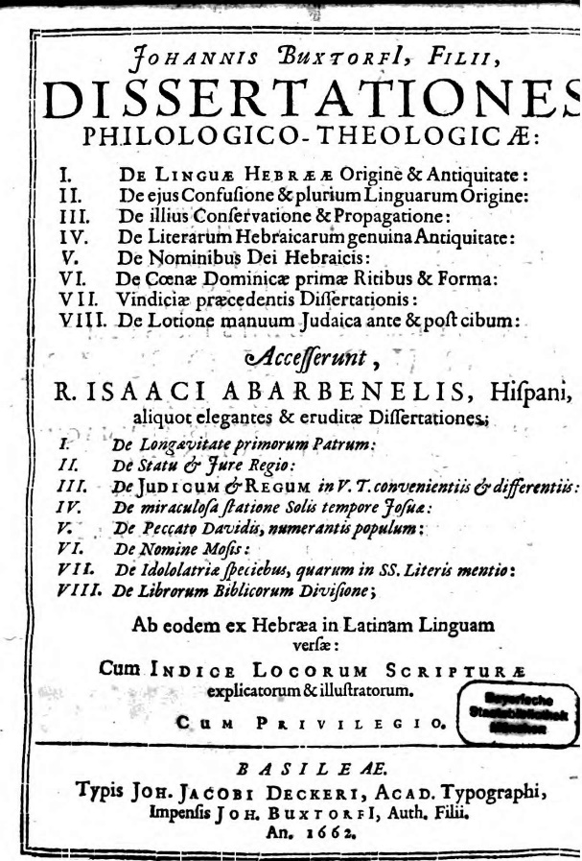

Johannes Buxtorf the Younger, *Dissertationes Philologico-Theologicae*, Basel, 1662.

These eight translated passages are labelled by the famous Christian Hebraist “*aliquot elegantes & eruditae Dissertationes*,” even though they were never written by Abravanel as independent texts. The last of these eight Latin translations is a translation is taken from the beginning of Abravanel’s introduction to his commentary on the Former Prophets, to which Buxtorf the Younger gave the title *De Librorum Biblicorum Divisione in Legem, Prophetas & Hagiographas*. By translating only half of the first investigation, Buxtorf reframed Abravanel’s introduction from an investigation into the special status and nature of the four books of the Former Prophets vis-à-vis the other biblical books into an exposition of the Jewish understanding of the tripartite division of Bible into the three sections: *Torah, Neviim and Ktuvim*. An exposition by a prominent Jewish scholar of the views of the talmudic sages, Maimonides, and Profiat Duran and an explanation of the tripartite division of Bible were of course very useful for and attractive to Christian Hebraists, even if Abravanel never wrote the passage for this purpose.[147]

Buxtorf’s omissions – specifically of Abravanel’s conception of the unique historiographical nature of the books of the Former Prophets, and the complex authorial processes which brought them into being – may also be explained by the Hebraist’s own ideological concerns. Indeed, one of Buxtorf’s major arguments in the *Dissertationes Philologico-Theologicae* is dedicated to drawing a clear distinction between the sacred nature of the Hebrew language vis-à-vis other languages – the latter subject to historical transformations and the whims of human conventions. In his first *Dissertatio De Linguae Hebrae Origine et Antiquitate*, Buxtorf enliststhe support of an impressive list of late medieval and early modern Jewish scholars. Among them, Abravanel features as a prominent source. Buxtorf quotes at length, first in Hebrew and then in Latin translation, Abravanel’s commentary on Gen 2:19. He seems particularly interested in Abravanel’s presentation of the primordial status of Hebrew:

God created man in his image, and just as he impressed upon him true divine notions, without any leaning or investigation, so too he impressed upon his soul the roots of this [divine Hebrew] language, which is adequate in nature to true divine cognitions and to the beings themselves.[148] (sic infudit ac impressit anima ejus radices vel fundamenta linguae illius, consentientis in natura cum illis notis veris divinis ac entibus in substentia ipsorum)[149]

Buxtorf thus uses Abravanel not only to justify his own conception of a primeval Hebrew language, but also to develop a theory of how the confusion of early Hebrew words with new invented terms was the historical process partly responsible for producing the plurality of languages that now prevails:

It seems thus reasonable to mention that the multiplication of languages resulted not only from the creation of new languages, but from the mixture and confusion of different names – either [entirely] new ones or corrupted Hebrew terms (or rather names coined for one reason or another, as well as new species of languages [that emerged]) – [which were incorporated into] the [dialects of the] Hebrew language [used] among many of the Gentiles. The Hebrew language thus remained pure within one family alone among whom no confusion took place. [150] (hebrea pura in una duntaxat permansit familia, cujus respectu, & apud quam nulla erat confusion)

Buxtorf’s views on the Hebrew language and Israel’s mission as its chosen conservers and transmitters echoes views voiced hundreds of years earlier in Judah Halevi’s *Kuzari,* translated into Latin by Buxtorf the Younger himself and published in 1660.[151] Interested in defending a divine and stable text of the Bible, Buxtorf adopted Halevi’s formula (*Kuzari* 3, 15) translating it as follows: *conservatata fuit in corde Sacerdotum ac Judicum,* (the Hebrew language was conserved in the hearts of the priests and judges)[152] even during the first Exile. It was precisely the continuity of Hebrew expertise among Jewish religious elites which allowed Ezra to “to expurgate God’s Law from its corruptions and to restore to its pristine form.” (*Legem Dei a variis corruptelis repurgavit, pristinaeque suae puritati restituit*).[153] Buxtorf’s representation of Ezra’s editorial project is strikingly reminiscent of Felix Prantesis’ declaration in the introduction to the first edition of *Mikraot Gedolot* that: “nothing is more missing in the [old] copies [consulted by us], than the true and native candor [of the Bible], restored now by us [in this edition], as all readers will recognize.”[154] For both the elder and younger Buxtorfs, the Jewish scholarship that produced Bomberg’s new edition had succeeded, at least partially, in restoring the original Hebrew text. This confirmed both the “philological-theological” role played by Jewish history (the preservation of Hebrew language and biblical competence) and its new trajectory: the new Protestant scholarship based on the principle of *sola scriptura.*[155]Buxtorf the Younger thus appropriated Abravanel’s views on the composition of Bible selectively. He adopted the distinction between the ontological status of Hebrew and the conventionality of later languages, but excluded from his translations and excerpts Abravanel’s important conclusion that the Bible was the handiwork of different authors – that it was a text comprised of multiple literary layers bound together by a later editor.

***“L’entêtement des deux Buxtorfes”***

“Buxtorf the Son, who has defended, as much as in him lay the integrity of the present Hebrew text”[156] is often presented in derogatory terms in Richard Simon’s 1678-1685 *Histoire critique du Vieux testament.* For Simon, Buxtorf the Younger represents the theological “entêtement” of Protestant Hebraists who wasted their impressive scholarly efforts on justifying theprinciple of *sola scriptura*, using “les sentiments des Rabbins.”[157] An example of Simon’s negative appraisal of Buxtorf’s scholarship is the former’s discussion of whether the original script of the Hebrews was Assyrian (used by the Jews) or Paleo-Hebrew (used by the Samaritans). This issue occupies the fourth of Buxtorf’s *Dissertationes philogico-theoligicae* (*De Literarum Hebraicarum genuine Antiquitate*) with Buxtorf concluding that Assyrian script used by the Jews today is the original – and ancient – Hebrew script.[158] Simon, however, defends not only the idea of a historical evolution and transformation of the Hebrew language (notably through the first Exile), but also of its script:

It would be unnecessary here to mention the Samaritan Characters, which by Antiquity have been thought to be the first Hebrew Letters, were there not some new Doctors, who, being much affected (entêtetés) with the Hebrew Copy of the *Mazoret Jews*, oblige us to speak of them. Saint Jerome assures us that *Esdras* made use of new Characters at the return from Captivity, and that the ancient ones are those which the *Samaritans* have.[159]

Later in chapter 13, Simon identifies the “doctors” in question as Buxtorf the Younger and his followers. As exemplified by this debate over the novelty of Assyrian script, but also by many other positions defended in the *Histoire critique du Vieux Testament*, Simon argues for a historical and critical approach to the Bible in its different versions. This is in stark contradistinction to the various Protestant strategies for bypassing the authority of ecclesiastical tradition in favor of a more direct access to the Hebrew Scriptures, which presupposes the stability and integrity of the Hebrew text.

In the opening of his preface, Simon defines his historical approach in the following terms:

First, it is impossible to understand thoroughly the Holy Scriptures unless we first know the different states of the Text of these Books according to the different times and places, and be instructed of all the several changes that have happened to it. This we may understand by the first Book of this Critical History, where I have taken notice of the several revolutions of the Hebrew Text of the Bible from Moses to our time…[160]

***Histoire critique or Tractus Theologico-politicus***

Simon’s affirmation of the historical transformation and the geographical and linguistic dissemination of the biblical texts was not only directed against Protestant Hebraists like the Buxtorfs; it also opposed the views espoused in 1670 by Spinoza in his *Tractus Theologico-politicus,* especially the historical and critical method featured in chapters 7 and 8. As Simon explains:

We may by this same principle easily answer all the false and pernicious consequences drawn by Spinoza from these alterations or additions for the running down of the Authority of the Holy Scripture, as if these corrections had been purely of humane Authority, whereas he ought to have considered that the authors of these alterations having had the Power of correcting them.[161]

Spinoza’s implementation of the historical method leads, in Simon’s view, to the destruction of the historical authority and reliability of the Bible, as expressed in the first paragraph of chapter 8:

For this is how it has come about that the history of the Bible has remained not only incomplete but also rather unreliable, that is, the existing basis of our knowledge of the Scriptures is not just too sparse for us to construct an adequate history, it also teems with errors.[162]

Ibn Ezra’s commentary on Deut 1:2 – which alludes to “the mystery” of 12 verses of the Pentateuch which could not have been written by Moses – is touted by Spinoza as medieval Jewish support for his “plan to remove our prevailing theological prejudices” (communia theologiae praejudicia tollere… meum institutum).[163] Against the obstinacy and censorship of the “Pharisees,” Spinoza wished to expose (and further develop) Ibn Ezra’s “mystery”, critically usurping the claims of the rabbinic tradition regarding the Mosaic authorship of the Pentateuch. But for Simon, Spinoza’s argument “proved only that something has been added in series of time, which destroys not the authority of the ancient Acts which were written in Moses’s time.”[164] In Spinoza’s view, the logical contradictions within the Bible itself (and certainly the contradictions in post-biblical religious traditions) cast serious doubt on the epistemological value of the Bible historically transmitted. Spinoza thus calls for a rational, theological-political approach. For Simon, however, the divergent and sometimes contradictory biblical traditions (including all historical documents containing biblical information) contain valuable information which can be retrieved - when submitted to a careful *histoire critique*.

Simon found an alternative – and a foil – to the Spinozian extrapolation of Ibn Ezra’s esoteric allusions, in those parts of Abravanel’s introduction to the Former Prophets which were not translated by Buxtorf. Abravanel’s introduction features in the *Histoire Critique* as a central text, its authority being used by Simon to justify his new yet balanced approach to “the revolutions of the Hebrew Text of the Bible.” Simon summarizes this attitude as follows:

we ought… to take heed of multiplying these additions or corrections, as Spinoza and some others have very injudiciously done: but on the contrary we ought not absolutely to deny them, or too subtilly or nonsensically explain them, for these additions are of the same Authority as the rest of the Scriptures.[165]

Rejecting the Spinozian identification of historical change with corruption, the Protestant theological principle “*sola scriptura*,” and the allegorical justification of later changes (by rabbis or Catholic scholars), Simon defends a critical conception of history which relies on rabbinic and ecclesiastical traditions, while applying to them a new critical approach:

The great alterations which have happened … to the copies of the Bible since the first Originals have been lost, utterly destroy the Protestants and Socinians Principle, who consult only the same Copies of the Bible as we at present have them. If the truth of Religion remained not in the Church, it would be unsafe to search for it at present in Books which have been subject to so many alterations, and have in many things depended upon the pleasure of transcribers…[166]

Simon’s conception of historical and textual change acknowledges on the one hand, the loss of the original text but on the other hand, preserves a notion of continuity of a proper understanding of the Bible refracted in a wide range of Jewish and Christian traditions, even if these traditions often mix truth with errors and are predisposed to allegoric fancies. Confronted with this combination of partial loss and diffracted continuity of the biblical source, Simon forged an ambitious comparative program that would compare “the Jewish commentaries as well as those of the Catholic Doctors,” to “the latter Protestant and Socinian Authors,” as well as examining the “Hebrew texts and all the translations” in Greek, Latin or “any other language.”

***The Burning of the Histoire Critique***

While Simon took special precautions in his preface to distinguish his work from Spinoza’s “pernicious” *Tractus Theolgico-politicus*, these ultimately proved ineffective. Receiving the table of contents of *Histoire critique du Vieux testament* on the eve of its publication in 1678, leading theologian and bishop at the court of Louis XIV, Jacques-Bénigne Bossuet used his influence to produce a Royal edict that order the book destroyed. Cited were the “pernicious consequences” which could be expected from the work’s publication.[167] The parallels between Simon’s biblical criticism and the methods of Spinoza played a major role in the violent response to the book’s publication in France. This can be seen from a letter addressed by Simon’s friend, Henri Justel, to Gottfried Wilhelm Leibniz (living at that time in Paris) which expressed an acute interest in both Simon’s and Spinoza’s approaches to the Bible:

We will soon receive a historical critique of the biblical books, in which bold claims are made. The author [Richard Simon] affirms that the canon of the Scripture was composed only after the captivity [Leibniz adds in the margin of the passage: “this is also the opinion of Spinoza”] and that the Sanhedrin could add to and omit from the Scripture whatever they deemed fit. He believes that Scripture has been as poorly conserved as other books. There are several other opinions in this vein which seem awful to me. It is easier to advance bold claims than to establish them. Nevertheless, this book [when published] will be good and will have its use. It will lay down rules to be followed for publishing a proper version of the Bible. It proposes a critique of all versions. Since he knows very well the Hebrew language, since he is a philosopher theologian and since he is a reasonable man and a man of good judgment, I believe that he will deliver us something stronger that anything we have seen before. [Unlike]the metaphysics of Spinoza which are the opinions of Manicheans.[168]

Whatever differences may exist between Spinoza’s *Tractus* and Simon’s *Histoire critique*, contemporary readers were challenged by their shared willingness to accept that the Scripture was subject to corruption and emendation, to historical processes and to textual evolution. The attack levelled by German-Swiss scholar Ezechiel Spanheim against the *Histoire critique* clearly attests to the conflation of Simon with Spinoza:

By following in the path of Spinoza, claiming that there is no certainty regarding the authors of the Old Testament, with the strong help of critical scholarship...… by exposing these sacred books to the same destiny as works generally called profane, and by refusing to recognize any effect of divine Providence in their conservation, he has, by the same means, fully compromised the certainty that underlies the divine word.[169]

In a later defense of his *Histoire critique*, Simon partly acknowledged his methodological similarity to Spinoza: “You can judge, Sir, by the former responses to the objections of Spinoza concerning the book of Moses, that [Spinoza] agrees often in principle with our most learned theologians and that he is only blamable due to the false consequences that he draws from these principles.”[170] This perceived and partly acknowledged methodological proximity to Spinoza is what Simon tried unsuccessfully to conceal by writing a more conservative and Catholic preface after finishing his work and becoming aware of the *Tractatus* and its arguments*.* Yet from the perspective of King Louis XIV and Bossuet, the differences between Simon and Spinoza were too negligible to merit attention*.* It was felt that a historically contingent Bible could easily lead to imputing change and discontinuity to the Church and the French monarchy.[171] Thus, Abravanel’s introduction which had emerged from a political crisis, played a major part two hundred years later in an important theological and political debate.

***Le principe d’Abravanel***

In the first chapters of the *Histoire Critique*, Simon develops the notion of “public scribes” who were entrusted with the composition, editing and conservation of the biblical texts. More than once, he characterizes this notion as one that is “supported strongly” by Abravanel’s introduction. He even refers to the idea as “le principe d’Abravanel.”[172] Simon seems to have expanded Abravanel’s ideas about the composition of the Former Prophets into a full-fledged critical system for the study of the Old Testament as a whole. Like Buxtorf, but relying on different passages, Simon reframed Abravanel’s introduction and expanded its scope far beyond a modest discussion of the status and nature of the books of Joshua, Judges, Samuel and Kings. Yet, in doing so, Simon reveals the powerful, critical potential that was latent in Abravanel’s historical model.

In a short biographical note about Isaac Abravanel appearing at the end of his book, Simon attests that he “used the first edition” of his Abravanel’s commentaries “on the historical books to whom the Jews gave the name of Prophets,” “printed in more beautiful fonts.”[173] He is referring to the 1511-1512 Soncino edition of Abravanel’s Commentary on the Former Prophets, to which he had access together with “the great many books which were brought out of the *Levant*, and are at present in the Library of the *Fathers of the Oratory* of Paris.” [174] There, around the year 1670, he was learning “les jours de Samedi après dîner” (Saturday afternoon) with Jona Salvadore, his Jewish “teacher” and bookseller at that time.[175] In a letter, Simon describes the “conversations which I had with the Jew of Pignerol, a scholar in his own Law.” He notes that “when I spoke to him of Abravanel as an accurate commentator of the literal meaning, he confessed to me that [Abravanel] was but a verbose anthologizer. His favorite author is Rashi.”[176]

***The Public Scribes***

Basing himself on the Abravanel’s preface, but also on the first book of Josephus’ *Against Apion* (as well as the way Josephus is used by Eusebius in his *Preparatio evangelica*), Simon incorporates some of Abravanel’s major arguments into his own critical history of the Bible. Simon explains the necessity of such a project at the very beginning of the first chapter:

None can doubt but that the truths contained in the Holy Scripture are infallible and of Divine Authority; since they proceed immediately from God, who in this has only made use of the ministry of Men to be his Interpreters. So there is no person, either Jew or Christian, who does not acknowledge that the Scripture being the pure word of God, is at the same time the first principle and foundation of Religion. But as Men have been the Depositories of these sacred Books, as well as of all others, and their first Originals have been lost, it was in some sort impossible, that there must needs happen some changes, as well as by reason of the length of time, as the carelessness of transcribers.[177]

While a critical history of the biblical text, as opposed to medieval allegorizing, is a prerequisite for regaining access to the pure word of God, it also attests to its deficient conservation in the Jewish and Christian religious and literary traditions. Raising from the very beginning the problem of how God’s word is conserved in religious documents, Simon redefines, much along the lines of Abravanel and Josephus, the roles played by the prophets, casting them not only as visionaries but as public writers and archivers, who had the right to compose and edit the acts of the Hebrew Republic.

During the Hebrew Commonwealth, there were from time to time among them these sorts of persons inspired by God, were it to write divine and prophetic Books, as the same *Josephus* has remarked, or, as *Eusebius* says, to distinguish between those which were truly prophetic and others that were not. Wherefore we ought not to search with too much curiosity who have been the particular Authors of every Book of the Bible […] I have called these Prophets, Scribes as they are termed in the Bible or public Writers, to distinguish them from private Writers, who applied themselves ordinarily to the writing of the History of their times, only out of the motives of interest, whereas the Prophets we speak of, did faithfully collect the transactions that passed in the whole state and kept them in Registries ordained for that purpose.[178]

Simon’s distinction between public and private writers echoes Abravanel’s distinction between the stories of general interest contained in the books of the Former Prophets and the stories of only particular interest contained in the book of Ruth which thereby relegates it to the Writings. Beyond this textual affinity to Abravanel (which will be explained later), Simon clearly explains how he is redefining the prophetic role. While he mentions the divine inspiration of the prophet, a prerequisite for writing authentic prophetic books, he focuses more attention on the function of the prophet as both a faithful chronicler and archivist working on behalf of the Hebrew Republic. The prophetic nature of their work is most evident in their critical capacity to “distinguish” “truly prophetic documents” or accounts of general interest from false prophetic or historical books. They served the Hebrew Republic by protecting their archives and official records from lies and biases. By turning the prophet into a public scribe, into a member of the Hebrew Republic’s administration, Simon was clearly adopting a “theologico-political” understanding of the prophetic function. At the same time, however, he was distancing himself from Spinoza, casting the prophet as an agent within a harmonious political system, as opposed to a figure competing with the other holders of power – the political ruler and the High Priest.[179]

This divine function is also the very reason for the historical transformation of the biblical documents:

One may further, from this principle of public writers give solid reasons of many additions and changes which we find *in* the Holy Scriptures. And it will be very difficult to explain them by any other means than this. One may take notice then that these Prophets or public writers, were not only charged with the collection of the Acts, which fell out in their time, and the reducing them to registries, but they gave sometimes a new form to the acts themselves which had been collected by their predecessors, by adding or diminishing according as they thought fit. Their Collections for all this had nevertheless authority, as Theodoret has judiciously observed, on the 10th [chapter] of *Joshua,* where heassures us that the History that we have under the name of *Joshua* is not his; but that it was extracted from ancient Records, which the Author cites that we might give credit to his collections.[180]

This reimagining of the prophets as the archivists, compilers and chroniclers of the Hebrew Republic is not without tension. On the one hand, it seems to represent a useful philological and historical tool inherited from an ancient hermeneutical tradition,[181] which can be expanded into a general principle explaining “additions and changes” in the Bible, and more broadly the dynamic historical process by which Holy Scripture was composed, edited, and transmitted. On the other hand, the very advantages that such a redefinition gains, also transform the prophets into a historical group of office-holders who enjoyed the theological and political authority to shape and reshape the “acts” of the “Republic.” The political model of the official chronicler, defended by Simon to explain how the Bible was written, thus yields a paradoxical situation: the chronicler is both the depository of the true divine message as well as a literary actor responsible for its historical transformation, and ultimately responsible for the deterioration or corruption of God’s authentic word. Simon clearly alludes to this tension on the very next page: “It is moreover certain that the books of the Bible that are come to our hands, are but abridgments of the ancient Records, which were more full and copious, before the last abridgment was made for the public use of the people.”[182] The distribution of the authorship between different historical agents reaches here its logical conclusion: the biblical texts not only reflects the words of God and the true deeds of Israel, but also echoes the historical process of their transformation and re-elaboration by the official scribes of the Hebrew Republic.

***Simon’s esoteric reading of Abravanel***

The second chapter of *Histoire Critique* contains several direct and indirect references to Abravanel’s introduction. Abravanel’s text serves as an important backdrop and authority to Simon’s notion of the prophets as public writers.

The Republic of the Hebrews differs in this from all other States in the world, in that she never acknowledged any other Head than God himself, who continued in this quality to govern her in those very times when she was subject to Kings. ’Tis this which has acquired It the title of *The Holy and Divine* Republic and those people have likewise assumed to themselves the title of *Holy,* that they might by this glorious name be distinguished from other Nations. ’Twas for this reason also that God himself gave Laws, by the ministry of *Moses* and of other Prophets who succeeded him, to a People he had chosen to be entirely at his service. That we may better understand in what nature these Prophets were whom God made use of to be his Interpreters among the Hebrews we shall take notice that in well governed States, chiefly in the East, there were always certain persons who took care to put into writing the most important affairs of the Republic, and to preserve the Acts in the Registries set apart for that purpose.[183]

This description of the theocratic regime of the Hebrews echoes chapter 17 in Spinoza’s *Tractus Theologico-politicus*, as well as other contemporary treatises that discussed the Hebrew Republic.[184] Yet, whereas Simon integrates the Hebrew prophet into the history of state administration, which began with the institution of oriental scribes, Spinoza turns him into an agent in the theological political conundrum of the Hebrew theocracy – in which “the right to interpret the laws and communicate God’s responses was assigned to one man while the right and power of administering government according to the laws interpreted by the first and the responses he communicated was given to another.”[185] Simon’s depiction corresponds to Abravanel’s discussions in his *Commentary on Former Prophets,* in which the latter portrays the regime of the judges as the truest and purest form of Jewish theocracy, contrasting it with the monarchy (especially in his famous interpretation of 1 Samuel 8). These theological-political texts were well-known to 17th century Christian Hebraists and were translated into Latin by Buxtorf the Younger in his *Dissertationes Philologico-Theologicae.*[186] By drawing attention to the theological-political regime in which the prophets acted, Simon discloses, intentionally or not, the connection between Abravanel’s introductionto the Former Prophets andAbravanel’s many discussions of theocracy scattered throughout his commentary. The prophet is described as an essential part of the administration of the theocratic Republic of the Hebrews. He serves both God and the state by recording divine laws and historical events, conserving them, editing them and publishing them as needed by the divine state. This political background accounts for the complex makeup of the Biblical books. In Abravanel’s *Commentary,* Don Isaac’s fall from grace at the Portuguese Court led to his projection of the prophets into the political setting of the theocratic regime and political administration. It allowed him to partially transform his own political experiences in Iberia into a historical reconstruction of the Former Prophets. Simon collected the political and philological threads running throughout Abravanel’s commentary and turned them into a coherent critical principle for articulating the history of the biblical text and the history of the biblical regime.

Relying on Josephus’ *Against Apion*, Simon ascribes the complexity of the biblical text to the political and divine functions played by the prophets in their capacity as the overseers of the state archives:

It *is* probable that *Moses,* who had been bred up as we said in the Court of Egypt, and in Whom were all the qualities of a perfect Lawgiver, established from the very infancy of the Republic *this* sort of Scribes, whom we may call public or divine Writers, to distinguish them from particular Writers, who seldom meddle with the writing the History of their own times but through motives of interest. ’Tis this which made *Joseph* say, that amongst the Jews everyone was *not* permitted to write Annals, but that was reserved to the Prophets only, who knew things future and far from them by divine inspiration, and who writ likewise what happened in their own time.[187]

Historicizing the prophet, turning him into a state functionary with the exclusive right to record history, results in a complete redefinition of his role and nature. “The Hebrew word *Nabi,*”Simon writes, “which the Septuagint has translated *Prophet,* signifies nothing in its original but *Orator,* or a person that speaks in public.”[188] What defines the prophetic vocation is not only his direct epistemic relationship with God, but his essential relationship with the state and his essential role in the public enunciation of the will of the ultimate monarch, God. Simon’s conflation of the Hebrew *navi* with the Roman *orator*, as well as his insistence on Moses’ debt to the norms and practices of the Egyptian administration, evinces the same tendency. The historicization of the prophet relies on his politization, on the projection of his figure into a state-administration, which is both distant and close in time, allowing a successful transfer of knowledge from the court of Early Modern kings to the ancient court of the Hebrew Republic.

.

Whence it is that Isaac Abravanel, a learned Spanish Jew, strongly maintains the Principle which we have mentioned touching these Prophets or public Writers, who took care to collect the Acts of what past in the State; and he pretends moreover that they did not only write the history of their times, but that they took the liberty of adding or diminishing what they thought fit from the Records of the other Prophets which went before them.[189]

Abravanel’s preface to the *Commentary of the Former Prophets* is cited in the margin of this passage. As Ibn Ezra served Spinoza, so Abravanel serves Simon – as a Jewish authority, hailing from a late medieval context, who confirms and yet conceals his new critical principle of the historical evolution of the biblical text at the hands of successive public scribes. It should be noted that Simon’s use of authorities to support his view was by no means limited to Jewish authors like Abravanel. Immediately after summing up Abravanel’s position, Simon adds: “This is likewise of the sentiment of *Procopius*, *Theodoret* and some other Fathers.” The addition of a “learned Spanish Jew” (Abravanel) to some “Fathers” was meant to produce an effect of objectivity and antiquity, proving that Simon’s view was not his personal opinion, but an approach accepted by Jews and Christians, ancient and medieval alike. Thus, Abravanel played an important role in the esoteric justification strategy of Simon’s critical enterprise

***Radicalization***

Simon understood the potential contribution of Abravanel’s introduction to his own critical views on the history of the Biblical text. His understanding of Abravanel’s earlier historicization of the Former Prophets draws attention on the one hand to the novelty of Abravanel’s approach, while, on the other hand, radicalizing it and going far beyond Abravanel’s explicit orientation which was strictly limited to the Former Prophets and did not pertain the Pentateuch:

I know ’tis expressly forbidden in *Deuteronomy* either to add or diminish any thing from the word of God, but we may answer with the Author of the Book intitule Corzi [Kuzari], that this prohibition relates only to private persons, and not to those whom God had expressly commanded to interpret his will. God has promised to the Prophets and to the Judges of the Sanhedrin who succeeded Moses, the same grace and the same of prophecy as those who lived in his time, and therefore they have held the same power, not only of interpreting the Law, but also of making new ordinances, which were afterwards writ and placed in the Registries of the Republic…

Merging Judah Halevi’s defense of the rabbinic interpretation of biblical commandments and a Roman Republican notion of political and impersonal *auctoritas*, Simon extends the political function of the prophets (the right to edit and interpret the word of God) to the text of the Pentateuch. It bears noting that Simon’s political reduction of the prophetic function seems much more inclined toward Halevi’s genealogical conception of prophecy than to Maimonides’ epistemological model. Indeed, what is at stake in prophecy is not its capacity to convey truth esoterically, but to perpetuate the continuity of a theological-political regime through the medium of written history. In this vein Simon writes, “the principle of Abravanel, which is confirmed by some Fathers, resolves all these difficulties. These Books, being reviewed by the Sanhedrin, or by other persons inspired by God, had all the necessary authority that could be desired in an affair of this importance.”[190] The principle of Abravanel, or rather of Richard Simon justified by Abravanel, resolves “all” the difficulties in the biblical books – positing the continuous historical evolution of the biblical text. But this critical principle is also theological and political, the prophecy in the Hebrew Republic representing the continuous legal and divine office of receiving, emending, and publishing the word of the king, God. The historical evolution of the divine text is no longer a contradiction in terms, but the genuine expression of the dynamic theocracy of the Hebrew people. Yet, the esoteric strategy of attributing this critical and theological-political principle to Abravanel, the Church Fathers, Josephus or Richard Simon, betrays the lack of authority that this radical historicization of the Bible so dearly needed. The greatest danger was that such a position would be associated with Spinoza’s scandalous thesis:

These alterations, in this case and in others, were I think introduced by Ezra in the course of explaining the Law of God to his contemporaries, as I have said, and hence this is the ‘Book of the Law of God’ as explained and elaborated by him. This is also, I think, the earliest of the books that I claimed he wrote. This I infer from the fact that it contains the laws of the country which is what the people most needs, and also because the book is not connected by any link with what comes before in the way that the others are but begins with the unconnected phrase, ‘These are the words of Moses’, etc. After he had completed this book and taught the laws to the people, I believe he then turned his attention to writing a complete history of the Hebrew nation, from the foundation of the world to the final destruction of the city, into which he inserted this book of Deuteronomy in its place.[191]

Against the danger of a complete historical and political reconstruction of the biblical text, Simon chose the “principle of Abravanel” which sought to harmonize processes of transmission and continuous change by positing the existence of a discrete group of prophet-scribes, divinely inspired (as Abravanel would have it), or at least invested with the authority of the state; they are, in turn, succeeded by the rabbinic tradition of Judaism and then the ecclesiastical tradition of Christianity.

***Josephus and the theological apology of biblical historiography***

While Simon marshals Abravanel as an authority to justify and efface the radical character of his historical and critical principle, he also highlights an essential affinity between Abravanel’s introduction and Josephus’ *Against Apion*. In the beginning of the first chapter and later in the second chapter, Simon explains how the first book of *Against Apion* further justifies his principle. He cites the following passage:

Of the care bestowed by the Egyptians and Babylonians on their chronicles from the remotest ages, and how the charge and exposition of these was entrusted, in the former country to the priests, in the latter to the Chaldaeans; and how, among the nations in touch with the Greeks, it was the Phoenicians who made the largest use of writing, both for the ordinary affairs of life and for the commemoration of public events; of all this I think I need say nothing, as the facts are universally admitted. But that our forefathers took no less, not to say even greater, care than the nations I have mentioned in the keeping of their records – a task which they assigned to their chief priests and prophets – and that down to our own times these records have been, and if I may venture to say so, will continue to be, preserved with scrupulous accuracy, I will now endeavor to demonstrate.[192]

Abravanel was acquainted with Josephus’ writings and refers to them numerous times in his works, (certainly in his later messianic works, but also in his commentary on the Former Prophets). This passage from *Against Apion* shows that the notion of prophets as state archivists and chroniclers originates in apologetics – an attempt to repulse the accusation that Jews never wrote history nor had any reliable historical records to speak of. Turning the Bible into a compendium of historical texts was the way Josephus and later Abravanel sought to prove to the Gentiles that Jews not only wrote history, but also wrote the best history. For Simon, these two apologies which cast the Hebrew Bible as the perfect historical chronicle constitute the basis for a critical principle for understanding the historical transformation and formation of the biblical text in the context of a coherent theological-political regime.

Simon’s appropriation of Josephus’ and Abravanel’s apologetic defense of biblical historiography highlights the similar contexts in which these two Jewish politicians and writers developed their related conceptions. After narrating the circumstances of his rise at the Portuguese court and his later fall and flight, Abravanel concludes his introductory autobiography with the following words: “Now I will rise up and do the business of the king, the Lord of Hosts is his name, and write the commentary of these four books.” Abravanel’s movement from the court of Portugal to the theocratic court of the Former Prophets is not only informed by a search for solace and consolation in Scripture, but is also moved by a deeper anxiety linked to his position and role at court. Familiar with the Portuguese monarchy and the way it was represented in contemporary Portuguese chronicles, Abravanel, not unlike Josephus, felt obliged to defend the historiography of the Bible. To this end, he conceived the Bible as a superior form of historiography which reflects the institutions of the biblical theocratic regime; unlike the 15th century chronicles which flatter kings, it is a perfect historical mode rooted in prophetic insight. Yet this attempt to contrast the biblical historiography and biblical monarchy to the Portuguese royal historiography and the Portuguese king, conceived in a time of flight and insecurity, was also a projection of Iberian monarchy and historiography into the historical and political background of the biblical books of Joshua, Judges, Samuel and Kings. This projection was an expression of Abravanel’s anxiety and admiration vis-à-vis Iberia’s monarchies and historical writing, as well as an opportunity to point at the flaws of the Iberian chronicles and to develop an ideal Jewish historiography freed from biases and vested interest through the medium of prophecy. Ultimately, however, Abravanel’s elaboration of biblical historiography did not achieve its goal, but rather laid the path for a more radical historicization of the biblical books as we have seen in the writing of Richard Simon.

***Epilogue: Autographon, apographon***

In chapter 8 of his *Tractatus theologico-politicus*, Spinoza concludes that all books of Scripture are apographa – derivative works. One page earlier, he writes the following about the book of Joshua: “Josuae librum similibus etiam rationibus ostenditur non esse autographon…” (For similar reasons, the Book of Joshua can also be not to have been written by Joshua…). This historical gap between the autographon and the apographon, between the original and the later, transformed copy, can be said to be opened and partially conceptualized by Abravanel in his 1483 prefaceto his *Commentary on the Former Prophets*, in that dramatic moment when he is forced to build anew his position in the Castilian Court and to defend biblical historiography against Christian Iberian chronicles.

My reading of Abravanel’s preface, its context and reception, has shown, that this “historicization” of the biblical text began as a taxonomical issue, the result of the applying the *accesus ad auctores* to the biblical books. Abravanel further developed this idea by integrating the biblical books into the context and politics of the court in which he was active. The politization of the biblical text which resulted (at least partially from a projection of his own experiences) is the basis for his comparison of the books of the Former Prophets with Iberian chronicles. In this approach, the biblical narrative becomes the official narrative of a historical and political entity – the Israelite regimes in the Land of Israel. Yet this historicizing approach is not limited to the account narrated in the books of the Former Prophets. The very text of the Bible is historicized by Abravanel and split into earlier and later sources, earlier and later writers and editors. The biblical text, thus understood as a compilation of earlier sources, becomes a problematic document, a political record that serves a political entity, one whose memory had mostly been forgotten, but which has now been rediscovered via comparison to the monarchies of the late Middle Ages and Early Modern Era. The prophetic role, as understood by Abravanel, seems on the one hand almost identical to the service a chronicler renders his king but on the other hand, strongly opposes to it. The prophet is an inspired servant of the Lord who produces a perfect and true historical narrative – a feat no chronicler could ever aspire to accomplish. Abravanel thought he could save the books of the Former Prophets from becoming mere political chronicles by positing a notion of divinely inspired authors, redactors, and editors. For Richard Simon, he opened the path to a *Histoire Critique du Vieux Testament*; he laid the foundation for a dynamic history in which the *autographon* is transformed into a myriad of *apographa* along the diverging paths of Judaism and Christianity. Two centuries later, Wellhausen did not even know the name of his predecessor.

1. Yiṣḥaq Baer, “Don Yiṣḥaq Abarbanʾel ve-yeḥaso el beʿayot ha-historiyah ve-hamedinah,” *Tarbiz* 8 (1937): 248 (Hebrew).
2. Julius Wellhausen, *Prolegomena to the History of Israel: With a Reprint of the Article ‘Israel' from the Encyclopaedia Britannica*, translated by J. Sutherland Black and A. Menzies, Cambridge, 2013, p. 6.. For the original, see: Julius Wellhausen, *Prolegomena zur Geschichte Israels,* Berlin, 1883, p. 6.
3. Ibid,, p. 3. German original: *Ibid*, p. 4.
4. *Ibid*, p. 9. German original: *Ibid.*, p. 10.
5. Leo Strauss, “On Abravanel’s Philosophical Tendency and Political Teaching,” J. B. Trend and H. Loewe (eds.), *Isaac Abravanel: Six Lectures*, Cambridge, 1937, p. 128.
6. Moshe Hisrsh Segal, “Rabbi Yiṣḥaq Abarbanʾel betor parshan hamiqra,” *Tarbiz* 8 (1937): 261.
7. A nearby castle, Barco, is also mentioned as a place in which Gershom Soncino conducted his printing activities.
8. For a list of the Hebrew printed books, see A. M. Habermann, *Study in the History of Hebrew Printers and Books*, Jerusalem: Rubin Mass, 1978, pp. 49-55 (Hebrew).
9. Alexander Marx, “Gerschom (Hieronymus) Soncino’s Wanderyears in Italy, 1498-1527 Exemplar Judaicae Vitae,” *Hebrew Union College Annual* XI (1936): 444 [427-501]. See also Giulio Busi, “Gershom Soncino a Venezia Cronaca di una Disillusione,” in Giuliano Tamani (ed.), *L’attività editoriale di Gershom Soncino 1502-1527*, Soncino (Cremona): Edizioni dei Soncino, 1997, pp. 13-29.
10. See Giacomo Manzoni, *Annali Tipografici dei Soncino, Parte seconda nella quale si descrivaneo e illustrano le editzione eseguite Da Gherscom o Girolamo Soncino nel secolo XVI a Fano, a Pesaro a Ortona a Mare e a Rimini,* Bologna: Presso Gaetano Romagnoli, 1883, pp. 256-265.
11. Marx, “Gerschom (Hieronymus) Soncino’s Wanderyears”, 454-455; Moritz Steinschneider, “Aldus Manutius und Gerson Soncino,” *Hebraeische Bibliographie* I (1858): 5-8.
12. For the list of Soncino’s Latin and Italian editions, see Angela Nuovo, “La parte del volgare del catalogo di Gershom Soncino,” in Tamani (ed.), *L’attività editoriale*, pp. 59-93; Ennio Sandal, “Indice cronologico delle edizioni latine e volgari di Girolamo Soncino (1502-1527),”*.*pp. 135-151. For the list of the Hebrew books, see Habermann, *Study*, pp. 55-75. Altogether, 67 Hebrew books.
13. For a comparison of Manuzio’s and Soncino’s edition of Petrarca’s *Opere volgari*, see Andrea Comboni, “Il ‘Petrarca’ di Gershom Soncino,” in Tamani (ed.), *L’attività editoriale*, pp. 111-125.
14. Paul Kahle, “Felix Pratensis – à Prato, Felix. Der Herausgeber der Ersten Rabbinerbibel, Venedig 1516/7”, *Die Welt des Orients* 1 (1947): 32-26. See also A. Habermann, *The Printer Daniel Bomberg and the List of Books Published by His Press*, Safed: Museum of Printing Art, 1978.
15. Marx, “Gerschom (Hieronymus) Soncino’s Wanderyears,” 464.
16. Abravanel, *Peruš Neviim Rišonim*, Pesaro 1511-1512. On Abravanel’s life and works, see: Benzion Netanyahu, *Don Isaac Abravanel Statesman and Philosopher*, Ithaca and London 1993; Eric Lawee, *Isaac Abarbanel's Stance Toward Tradition*, Albany 2001.
17. For a discussion of this edition, see Cedric Cohen Skalli, “On a Rhetorical Trend in Isaac Abravanel's First Edition in Constantinople 1505", *Hispania Judaica Bulletin* 5 (2007): 153-175.
18. Don Isaac was buried in Padua – at the time Jews were forbidden from burying their dead in the city of Venice. Forti further adds that, a year later [1509], “the war was pitched around the walls of Padua, and this was the reason that these graves were destroyed, so much so that no one knows where his own relatives are buried unto this very day” (“Publisher’s Introduction” in Isaac Abravanel, *Ma‘ayanei hayesh‘uah*, 4) Venice was much weakened from the war and was fighting desperately to regain its former territories.
19. Yeshayahu Sonne, “Shlomo Crescente,” *Kiryat Sefer* 9 (1932-1933): 505-506 (Hebrew). On the Jewish editor (Hebrew: Magihah) in the 16th century see Z. Gries, *Hasefer Haivri Peraqim le-Toldotav*, Jerusalem: Mosad Bialik, 2015, pp. 95-109 (Hebrew). For more information on the printing activities of Rabbi Solomon, see Hayim D. Friedberg, *Toledot hadefus haivri*, Tel Aviv 1956, pp. 31, 34, 41, 44, 46-47. On the role of correctors more generally, see Anthony Grafton, “Correctores corruptores? Notes on the Social History of Editing,” in Glenn W. Most, ed., *Editing Texts—Texte edieren*, Göttingen: Vandenhoeck & Ruprecht, 1998, 54–76.
20. At that time, Rabbi Solomon was working for the Hebrew printer Joseph ben Jacob Guenzenhauser. In the introduction to his Commentary on the Books of Kings, Abravanel describes the traumatic circumstances in which he wrote his commentary: “And they [exiles of Castile and Aragon] went without strength (Lam 1.6), three hundred thousand men and women of Israel . . . and I also chose out their way (Jb 29.25), the way of a ship in the midst of the sea (Prov 30.19). I was among the exiles (Ez 1.1), I went with all my family . . . to the renowned city (Ez 26.17) of Naples . . . It was the year ‘‘you were strangers’’ [5253/1492–93] (Ex 22.20). I spoke to my heart (Gn 24.44), that which I have vowed I will pay (Jon 2.10), I shall write the commentary of the book of Kings which I did not write until now. Also it is time to do some work for God (Ps 119.126), for the memory of the destruction of our holy and beautiful house (Is 64.10), and for the one of the exiles and expulsions that our nation endured, as it is written in the book [of the Kings], and as I shall explain it later.” (Abravanel, *Peruš Neviim Rišonim*, p. 377 [no page number]).
21. Abravanel, *Peruš Neviim Rišonim*, last page [no page number].
22. Joseph R. Hacker, “Rabbi Meir Arama's Letter of Censure against Isaac Abravanel – A Riddle Solved,” *Tarbiz* 76 (2007): 501-518.
23. Abravanel, *Peruš Neviim Rišonim*, p. 2 [no page number].
24. Several other documents testify to Abravanel’s oral lessons in Iberian Peninsula, but also after the Expulsion in Italy. See Menachem Ben Zerah, *Sefer Zedah la-derekh*, Ferrara 1554, p. 5 (Hebrew); David Ben-Zazon, *Nevokhim Hem*, Jerusalem: Yad Ben Zvi, 2005 (Hebrew);  *Avraham David,* “Spiritual Life in the Kingdom of Naples at the Turn of the Sixteenth Century according to Hebrew Texts,” in Elisheva Baumgarten, Amnon Raz-Krakotzkin and Roni Weinstein (eds.), *Tov Elem: Memory, Community and Gender in Medieval and Early Modern Jewish Societies Essays in honor of Robert Bonfil*, Jerusalem: Bialik Institute and the Mandel Institute of Jewish Studies, 2011, pp. 282-305 (Hebrew).
25. David Kimhi, *Nevi*ʾ*im Rišonim* ʿ*im Peruš Rabenu Kimḥi*, Soncino 1486; Pesaro 1511. According to the colophon, the edition was completed on Passover eve.
26. Marvin J. Heller, *The Sixteenth Century Hebrew Book, An Abridged Thesaurus,* vol. 1, Leiden and Boston, 2004, pp. 40-41.
27. Giacomo Manzoni, *Annali Tipografici dei Soncino,* Bologna 1886, pp. 274-281.
28. David Stern,“The Rabbinic Bible in Its Sixteenth-Century Context,”inJoseph R. Hacker and Adam Shear (eds.), *The Hebrew Book in Early Modern Italy*, Philadelphia, 2011, pp. 76-108.
29. For a general introduction to paratexts, see Gérard Genette, *Paratexts:* *Threshold of Interpretation,* translated byJ. E. Lewin, New York: Cambridge University Press, 2001. On interaction of Christians and Jews in shaping paratexts in Hebrew printed books, see Adam Shear, “Intercultural Contacts Projected in The Paratexts: Hebrew Books and Christians Readers,” [*Archivio Italiano per la Storia della Pietà* XXV (2012](https://www.torrossa.com/it/resources/an/2905838)), 87-112. On the perpetuation of the manuscript tradition of glossa in print, See Z. Gries, *The Hebrew Book: An Outline of its History*, Jerusalem 2015, pp. 39-46, especially pp. 43-44.
30. For the Hebrew term of *haqdamah* which can be translated introduction, preface, preliminary remark, premise, or principe according to thecontext, see Jacob Klatzkin, *Thesaurus Philosophicus Linguae Hebraicae et veteris et recentioris*, Leipzig, 1928, pp. 131-132.
31. Manzoni, *Annali Tipografici*, p. 311.
32. For a description of the volume, see *ibid*., pp. 114-123.
33. Samel Ludovici, *Arte del libro*, p. 163.
34. On “bibliographic codes,” see Jerome J. McGann, *The Textual condition*, New Jersey: Princeton University Press, 1991.
35. The text reads as follows: “Former Prophets with the Commentary of our Rabbi David Kimhi, may his memory be blessed. Printed with great care by the humblest of printers and the least of the scholars among the sons of Soncino, who dwells (Gerschom – גר שם) in Pesaro, in the city of Sir Giovanni Sforza, may God prolong his days. Praise to God and thanks to the Lord*.*”
36. *Peirush Abravanel ‘al nevi’im*, Vol. 1, *Yehoshu‘a-Shoftim*, Jerusalem, 2009, pp. 1-7. Abravanel, *Peruš Neviim Rišonim*, pp. 1-2.
37. *Peirush Abravanel ‘al nevi’im*, Vol. 1, *Yehoshu‘a-Shoftim*, 7-23. Abravanel, *Peruš Neviim Rišonim*, pp. 2-9.
38. *Peirush Abravanel ‘al nevi’im*, Vol. 1, *Yehoshu‘a-Shoftim*,.23-27. Abravanel, *Peruš Neviim Rišonim*, pp. 9-10.
39. *Peirush Abravanel ‘al nevi’im*, Vol. 1, *Yehoshu‘a-Shoftim*, 31-32. Abravanel, *Peruš Neviim Rišonim*, pp. 10-11.
40. David ben Joseph Kimḥi. *Commentary on the Latter Prophets*. Guadalajara: Solomon ben Moses Ha-Levi Alkabez, 1482. 2o. 319 (?) ff. For a complete description of the edition, see Shimon Iakerson, *Catalogue of Hebrew Incunabula from the Collection of the Library of the Jewish Theological Seminary of America,* New York and Jerusalem 2005, vol. 2, pp. 427-431. See also Adri Offenberg, “What Do We Know about Hebrew Printing in Guadalajara, Híjar, and Zamora?,” in Malachi Beit-Arié and Javier del Barco (eds.) *The Late Medieval Hebrew Book in the Western Mediterranean : Hebrew Manuscripts and Incunabula in Context*, Leiden: Brill, 2015, pp. 313-337.
41. Francisco Cantera Burgos. “Don ‘Ishaq Braunel’ (alguns precisions biograficas sobre su estancia en castilla),” in S. Lieberman (ed.), *Salo Wittmayer Baron Jubilee Volume*, Vol. 1, Jerusalem, 1974, 237–250.
42. See Iakerson, *Catalogue of Hebrew Incunabula*, vol. 2.
43. For the text of the documents, see Haim Beinart, *The Expulsion of the Jews from Spain* (Oxford, 2002), pp. 522–540.
44. Abravanel, *She’elot uteshuvot lerabi Sha’ul hakohen*, Jerusalem 1927, 3-4.
45. Allan Nigel, “A Typographical Odyssey: The 1505 Constantinople Pentateuch.” *Journal of the Royal Asiatic Society* 3 (1991): 343–51.
46. Offenberg, “What Do We Know about Hebrew Printing,” 319. At the time of this writing, I have yet to inspect the edition myself, but Offenberg posits that it has pages decorated by the same border.
47. Abravanel, *She’elot uteshuvot*, 20.
48. On the long reign of King Afonso V in the years 1448-1481, see Saul António Gomes, *D. Afonso V O Africano*, Lisbon 2006. On the Portuguese phases of Abravanel’s life, see Benzion Netanyahu, *Don Isaac Abravanel Statesman and Philosopher*, Ithaca and London, 1998, p. 3-32; Cedric Cohen Skalli, “Don Isaac Abravanel in Portugal (1437-1483): A Socio-cultural Profile,” *Alei Sefer* 282018: 49-118(Hebrew).
49. The translation of the Hebrew text is taken with a few changes from Elias Lipiner, *Two Portuguese Exiles in Castile: Dom David Negro and Dom Isaac Abravanel*, Jerusalem 1997, pp. 55-56.
50. On the figure of the Iberian Court Jew, see Haim Beinart, *Pirqei sefarad*. Jerusalem, 1998, pp. 51-62. (Hebrew).
51. Sergio Samek Ludovici, *Arte del Libro Tre secoli di storia del libro illustrato, dal Quattrocento al Seicento*, Milano 1974, pp. 145-148.
52. For a study of Abravanel’s literary self-portraits, see Cedric Cohen Skalli, “Abravanel’s Commentary on the Former Prophets: Portraits, Self-Portraits, and Models of Leadership,” *Jewish History* 23 (2009): 255-280. Ram Ben-Shalom, “The Courtier as the Scepter of Judah: The Letters and Panegyrics to Courtiers of Yomtov ben Hana, Scribe of the Jewish Community of Montalbán,” in Eli Yassif, et al., eds., *Ot Letova: Essays in Honor of Prof. Tova Rosen*, Beer Sheva: BGU, 2012, 196-224 (Hebrew)
53. Lipiner, *Two Portuguese Exiles*, pp. 45-76. A. B. Freire, 'As conspirações no reinado de D. João II', *Arquivo Historico Portuguez* I (1903), pp. 393-397; da Serra, *Collecção de livros ineditos da historia portuguesa*, vol. II, pp. 42-52; Resende, *Crónica de D. João II*, pp. 58-70. da Fonseca,  *D. João* *II,* pp. 66-80.
54. See Eric Lawee, “Introducing Scripture: The *Accessus ad Auctores* in Hebrew Exegetical Literature from the Thirteenth through the Fifteenth Centuries,” in J.D. McAuliffe, B.D. Walfish, and J.W. Goering(eds.) *With Reverence for the Word: Medieval Scriptural Exegesis in Judaism, Christianity, and Islam*, edited by, Oxford, 2003, 157–79. On the genre of biblical investigations and Abravanel’s dependence on Isaac Natan of Arles earlier “investigations,” see Ram Ben-Shalom, “Sidrat haiyunim bamiqra shel Ytshaq Natan meArles vetofaat hahasarah lamiqra” *Teuda* 28 (2017): 65-144.
55. For a general introduction, see: Edwin A. Quain, “The Medieval Accessus ad Auctores”, *Traditio* 3 (1945): 216-264.
56. Avraham Gross, *Rabbi Yosef ben Avraham Ḥayun,* *manhig qehilat Lisbon ve-yeṣirato,* Ramat-Gan 1993, p. 33.
57. Gross, *Rabbi Yosef ben Avraham Ḥayun*, pp. 172-178. Of particular interest for the present discussion is Hayun’s distinction between the redactor of the book and the different biblical figures who “said” and “invented” the different Psalms. (p. 173)
58. My translation; for the Hebrew text, see: *Peirush Abravanel ‘al nevi’im*, Vol. 1, *Yehoshu‘a-Shoftim*, Jerusalem, 2009, 7.
59. *Peirush Abravanel ‘al nevi’im*, Vol. 1, 8.
60. This introduction is an important text in its own right, because it contains a lengthy discussion of three “sects” (the talmudists, the philosophers, and the kabbalists) which, Profiat Duran claims, comprise the Jewish intellectual elite of his time. On Profiat Duran’s *Sefer ma‘aseh efod* and its context, see Yoel Marciano, *Hakhmei Sefarad be-Ayin Ha-Searah,* Jerusalem 2019, pp. 32-46;Eleazar Gutwirth, “Duran on Ahitophel: The Practice of Jewish History in Late Medieval Spain,” *Jewish History* 4 (1989), p. 59-74; Irene E. Zwiep, *Mother of Reason and Revelation A Short History of Medieval Jewish Linguistic Thought,* Amsterdam 1997, 46-106.
61. Duran, *Sefer ma‘aseh efod*, pp. 9-12.
62. *Peirush Abravanel ‘al nevi’im*, Vol. 1, 8.
63. Duran’s passage refers to Maimonides’ *Guide* in a very general manner, most probably to the chapters (Guide II, 36-45).
64. Duran, *Sefer ma‘aseh efod*, p. 11.
65. Ibid.
66. *Peirush Abravanel ‘al nevi’im*, Vol. 1, 8.
67. Ibid.
68. *Peirush Abravanel ‘al nevi’im*, Vol. 1, 9.
69. Ibid.
70. *Peirush Abravanel ‘al nevi’im*, Vol. 1, 9.
71. Ibid.
72. *Peirush Abravanel ‘al nevi’im*, Vol. 1, pp. 9-10.
73. *Biblia Latina cum glosa ordinaria Walfridi Strabonis aliorumque.* et interlineari Anselmi Laudunensis. et cum postillis ac moralitatibus Nicolai de Lyra. et expositionibus Guillelmi Britonis in omnes prologos S. Hieronymi et additionibus Pauli Burgensis replicisque Matthiae Doering, Basel, 1498, vol. 1-6.
74. *Biblia Latina cum glosa ordinaria Walfridi Strabonis aliorumque*, Basel, 1498, vol. 1, pp. 2-3.
75. Ibid*.*, p. 3.
76. *Peirush Abravanel ‘al nevi’im*, Vol. 1, p. 10. Abravanel renders “sapiential” with a Hebrew word, *mad‘aii,* which also means “scientific.” This allows him to associate this category with Aristotelian texts.
77. See Eric Lawee, *Isaac Abarbanel’s Stance Toward Tradition, Defense, Dissent, and Dialogue,* Albany 2001, pp. 169-202; Uriel Simon, *Ozen milin tivhan. Mehqarim bedarko haparshanit shel R. Abraham Ibn Ezra*, Ramat Gan 2013, pp. 337-348.
78. *Peirush Abravanel ‘al nevi’im*, Vol. 1, p. 10.
79. *Peirush Abravanel ‘al nevi’im*, Vol. 1, pp. 10-11.
80. *Peirush Abravanel ‘al nevi’im*, Vol. 1, p. 11.
81. Ibid.
82. *Peirush Abravanel ‘al nevi’im*, Vol. 1, p. 12. Abravanel’s invocation of the Aristotelian four causes is clearly meant to stress the scientific character of his literary inquiry. The books of the Former Prophets must be studied like physical beings according to their four causes in order to reach perfect knowledge of them according to the scientific model developed by Aristotle in Phys. 194b: “We have next to consider in how many senses ‘because’ may answer the question ‘why’. For we aim at understanding, and since we never reckon that we understand a thing till we can give an account of its ‘how and why’, it is clear that we must look into the ‘how and why’ of things coming to existence and passing out of it, or more generally into the essential constituents of physical change, in order to trace back any object of our study to the principles so ascertained.”
83. *Peirush Abravanel ‘al nevi’im*, Vol. 1, p. 12. Simon, *Ozen milin tivhan*,318-319
84. Lopez de Ayala, *Las Decadadas de Tito Livio,* ed.Curt J. Wittlin(Barcelona, 1982), 2 vols.
85. *Peirush Abravanel ‘al nevi’im*, Vol. 3, *Melakhim* (Jerusalem, 2011), 274.
86. Ayala, *Las Decadadas de Tito Livio,* 215.
87. Ibid.*,* 216.
88. Ibid., 217.
89. Ibid., 221-224.
90. Pero López de Ayala, *Crónicas,* ed. by J-L. Martín, Barcelona 1991, p. 3.
91. Ibid.
92. Ibid.
93. *Peirush Abravanel ‘al nevi’im*, Vol. 1, p. 13.
94. *Peirush Abravanel ‘al nevi’im*, Vol. 1, p. 14.
95. On the attitude of Abravanel vis-a-vis rabbinical literature, see Lawee, *Isaac Abarbanel's Stance Toward Tradition*, especially pp. 169-202.
96. For earlier example of this argument, see Simon, *Ozen milin,* 307-349.
97. I am using the translation published by Eric Lawee with slight changes. See Eric Lawee, “Don Isaac Abarbanel: Who Wrote the Books of the Bible?,” *Tradition* 30 (1996), 67-68. See also *Peirush Abravanel ‘al nevi’im*, Vol. 1, p. 14-15.
98. Lawee, “Don Isaac Abarbanel,” 70. See also *Peirush Abravanel ‘al nevi’im*, Vol. 1, p. 16.
99. Meira Polliack, “‘Scribe’, ‘Redactor’ and ‘Author’ - The Mulifaceted Concept of the Biblical Narrator (Mudawwin) in Medieval Karaite Exegesis,” *TE'UDA XXIX, Yad Moshe, Studies in the History of the Jews in Muslim Lands in Memory of Moshe Gil*, Tel Aviv, 2018, pp. 145-176.
100. See Abraham Gross, *Rabbi Joseph ben Abraham Hayyun, Leader of the Lisbon Jewish Community and his Literary Work,* Ramat Gan, 1993, pp. 36, 231, 246. (Hebrew) See also Eran Viezel, “Isaac Abravanel’s Question and Joseph Hayyun’s Answer: A New Stage in the Issue of Moses’ Role in the Composition of the Torah” *Religious Studies and Theology Journal* 53 (2016), pp. 53-72.
101. Gross, *Rabbi Joseph ben Abraham Hayyun,* pp. 231-240. See also Viezel, “Isaac Abravanel’s Question and Joseph Hayyun’s Answer.”
102. Ibid., p. 231. My translation.
103. Ibid., p. 235. My translation.
104. Ibid., p. 237. My translation.
105. Ibid., p. 234. My translation.
106. Ibid., p. 237. My translation.
107. Ibid., p. 238. My translation.
108. *Peirush Abravanel ‘al nevi’im*, Vol. 1, p. 16.
109. Commentary on Leviticus 11:17.
110. *Peirush Abravanel ‘al nevi’im*, Vol. 1, p. 16.
111. Ibid.
112. *Peirush Abravanel ‘al nevi’im*, Vol. 1, p. 17.
113. Ibid.
114. *Peirush Abravanel ‘al nevi’im*, Vol. 3, *Melakhim*, 274.
115. Fernão Lopes*,* *Crónica de D. João I*, vol. I, Porto, 1994, p. 1. My translation.
116. Ibid., p. 2. In the Latin original, the term is “amici,” but in the Portuguese translation used by Lopes it is “parentes.”
117. Ibid.
118. Ibid.
119. Ibid, p. 3.
120. *Peirush Abravanel ‘al nevi’im*, Vol. 1, p. 18.
121. Ibid, pp. 18-19.
122. Ibid., p. 20.
123. David Kimhi, *Nevi*ʾ*im Rišonim* ʿ*im Peruš Rabenu Kimḥi*, Pesaro, 1511; David Kimhi, *ʾArbaʿah* *Nevi*ʾ*im Aḥaronim* ʿ*im Peruš Rabenu Kimḥi*, Pesaro, 1515.
124. Abravanel, *Nevi*ʾ*im Aḥaronim* ʿ*im Peruš Don Y*ṣ*ḥaq Abarbaniʾel*, Pesaro [?], 1520.
125. *Ḥamišah Ḥumešei Torah, Nevi*ʾ*im, Ktuvim*, Venice, 1517; Stern,“The Rabbinic Bible in Its Sixteenth-Century Context.”
126. Jordan Penkower, *Yṣḥaq Ben Ḥayim ve-ṣmiḥat mahadurot miqraot gedolot*, Jerusalem, 1982, vol. 1, p. 4.
127. Penkower, *Yṣḥaq Ben Ḥayim*, vol. 2, p. 282, n. 20, 21; Paul Kahle, “Felix Pratensis — à Prato, Felix. Der Herausgeber der Ersten Rabbinerbibel, Venedig 1516/7,” Die Welt des Orients 1 (1947), pp. 32-36; Moshe Goshen-Gottstein (ed.), *Biblia Rabbinica, A reprint of the 1525 Venice Edition edited by Jacob Ben Hayim Adonya*, Jerusalem, 1972, pp. 5-16.
128. *Ḥamišah Ḥumešei Torah, Nevi*ʾ*im, Ktuvim* [*Miqrʾaot gedelot*, *Biblia Rabbinica*], Venice, 1524-25, p. 2.
129. ### David Stern, *“The Rabbinic Bible in Its Sixteenth-Century Context.”*

    
130. Abravanel, *Nevi*ʾ*im Aḥaronim*, fol. 129 [r-v]-130[r].
131. Kimhi, *Nevi*ʾ*im Rišonim*, p. 2. Profiat Duran, *Maʿasseh ʾefod*, Vienna, 1865, pp. 39-40.
132. Christian D. Ginsburg, *Jacob ben Chajim Ibn Adonijah’s Introduction to the Rabbinic Bible: Hebrew and English, with Explanatory Notes*, London, 1867, pp. 51-52. The passage is to be found in *Miqrʾaot gedelot*, Venice, 1524-1525, vol. 1, p. 4.
133. *Ibid.*, p. 50. For the original Hebrew text, see *Miqrʾaot gedelot*, Venice, 1524-1525, vol. 1, p. 4.
134. Abravanel*, Peirush Ha-neviim, Yirmiyahu,* Vol. 8*,* p. 1.
135. Ibid., pp. 2-3.
136. Ibid., p. 1.
137. Ibid., p. 3.
138. Ibid., p. 4.
139. Ibid., p. 4.
140. Ibid., p. 7.
141. Ginsburg, *Jacob ben Chajim Ibn Adonijah’s Introduction*, p. 50.
142. Luther, “Assertio omnium articulorum” [1520], Luther, *Werke kritische Gesamtausgage,* vol. 7, p. 97. For an overview of the principle “sola scriptura”, see Ian Provan, *The Reformation and the Right Reading of Scripture,* Waco, 2017, pp. 283-312; William H. Lazareth, “Das sola scriptura-Prinzip Martin Luthers Evangeliumstraditionen zur Bestimmung des christlichen Gerechtigskeitsbegriff,” in Joseph Ratzinger (ed.), *Schriftauslegung im Widerstreit*, Freiburg, 1989, pp. 98-123. See also Bernhard Rothen, *Die Klarheit der Schrift Teil 1: Die wiederendeckten Grundlagen*, Göttigen, 1990, pp. 8-10, 34-78.
143. For a study of this edition and his larger background, see Stephen G. Burnett, *From Christian Hebraism To Jewish Studies Johannes Buxtorf (1564-1629) and Hebrew Learning in the Seventeenth Century*, Leiden, New York and Köln, 1996, pp. 169-202.
144. During the 16th century, no less than 17 printed editions of Abravanel’s works were printed, 15 of them in Italy. In the 17th century, about 15 editions were printed or reprinted. Proliferation in manuscript is more difficult to estimate, but today about 40-50 manuscripts of Abravanel’s works, dating from the late 15th century until the end of 17th, are extant.
145. Aron L. Katchen, *Christian Hebraist and Dutch Rabbis*, Cambridge Mass and London, 1984, pp. 65-75, 84-87, 105, 195, 231-246; Abravanel, *De capite fidei*, translated by G. Vossius, Amsterdam, 1638; Constantijn L’Empereur, *D. Isaaci Abravanielis & R. Mosis Alschechi Comment. In Esaiae Prophetiam 30*, Lugdunum Batavorum, 1631; Johannes Buxtorf filius, *Dissertatio De Sponsalibus et Divortiis cui accessit Isaaci Abravanelis Diatriba de excidii poena, cujus frequens in lege & in hac materia fit mentio*, Basel, 1652, pp, 169-195; Johannes Buxtorf filius, *Liber Cosri,* Basel, 1660. See especially the translations of Abravanel’s text in the section entitled “Mantissa aliquot Dissertassionem ad quorundam locorum ulteriorem illustrationem”, ibid*.*, pp. 389-415, 431-455.
146. For a broad overview of these topics, see Theodor Dunkelgrün, “The Christian Study of Judaism in Early Modern Europe,” Jonathan Karp and Adam Sutcliffe (eds.), *The Cambridge History of Judaism: Volume 7, The Early Modern World, 1500–1815*, Cambridge, 2017, pp. 316-348.
147. In Menasseh ben Israel’s Introduction to his 1632 *Conciliador*, translated into Latin by another famous Hebraist colleague of Buxtorf, Dionysius Vossius, one can find the same passage almost ad verbatim. Menansseh ben Israel, *Conciliador*, Frankfurt and Amsterdam, 1632, pp. 3-4.
148. Abravanel, *Peirush hatorah lerabenu Yitshak Abravanel.* Vol. 1, *Sefer Bereishit*, Jerusalem, 1997, p. 167.
149. Buxtorfi, Fili, *Dissertationes*, 15. See also ibid., pp. 57-58, 62-63
150. Buxtorfi, Fili, *Dissertationes*, p. 66. My translation. “Videtur ergo indigitari, multiplicationem hanc linguarum factam esse non simpliciter per novarum linguarum creationem, sed per admistionem & confusionem aliorum, seu novorum, seu ex Hebrea corruptorum, aut potius ratione aliqua deductorum vocabulorum, tamquam aliarum & novarum quasi specierum linguarum, cum Hebrea, apud plerasque scil. Gentes: quia Hebrea pura in una duntaxat permansit familia, cujus respectu, & apud quam nulla erat confusion.”
151. Buxtorfi, Fili, *Liber Corsi,* Basil, 1660.
152. Buxtorfi, Fili, *Dissertationes*, p. 166.
153. “Hinc cum Deux populi sui misertus esset, illosque iterum in terram suam deduxisset, excitatus fuit Esdras, qui coacto consilio ex primariis Sacerdotibus et principibus populi, Legem Dei a variis corruptelis repurgavit, pristinaeque suae puritati restituit, in usum etiam cum lingua revocando pristinos et sanctos characters hebraicos.” Buxtorfi, Fili, *Dissertationes*, p. 156. See the whole passage, ibid*.* pp. 152-160.
154. See Kahle, *Frantensis*, p. 34. My translation. “Multi quidem antea manuscripti circumferebantur, sed adeo nitore suo privati, ut par fere mendarum numerus dictiones ipsas consequeretur, nihilque magis ab his desideraretur, quam verus et nativus candor, quem nunc a nobis illis esse restitutum qui legerint cognoscent omnes.”
155. For a succinct presentation of the historical and theological background to these trends, see Stephen G. Burnett, *From Christian Hebraism to Jewish Studies: Johannes Buxtorf (1564-1629) and Hebrew Learning in the Seventeenth Century,* Leiden, New York and Köln, 1996, pp. 169-239.
156. Richard Simon, *A Critical History of the Old Testament*, London, 1692, p. 132. For the original French, see Richard Simon, *Histoire critique du Vieux Testament*, Paris, 1678, p. 138 (1685 edition, p. 113).
157. Simon, *A Critical History of the Old Testament*, Preface, p. 13 (no page number). Simon, *Histoire critique du Vieux Testament*, Préface, p. 16 (no page number). For a history of the three versions of the Simon’s *Histoire critique du Vieux Testament* (1678, 1680, 1685), see Paul Auvray, *Richard Simon (1638-1712) Etudes bio-bibliographique avec des textes inédits*, Paris, 1974, pp. 39-100; Jacques Le Brun, “Richard Simon” in Jacques Briend et Edouard Cothenet (eds.), *Supplément au Dictionnaire de la Bible*,vol. 12, Paris, 1996, pp. 1354-1383. 
158. Buxtorfi, Fili, *Dissertationes*, pp. 167-246
159. Simon, *A Critical History*, p. 89; Simon, *Histoire critique*, p. 93.
160. Simon, *A Critical History*, Preface, p. 1 (no page number); Simon, *Histoire critique*, Préface p. 1 (no page number).
161. Simon, *A Critical History*, Preface, p. 3 (no page number); Simon, *Histoire critique*, Préface p. 3 (no page number).
162. Spinoza, *Theological-Political Treatise*, edited and translated by J. Israel and M. Silverthorne, Cambridge UK, 2007, p. 118. “Quo factum est, ut Scripturae histora non tantum imperfecta, sed etiam mendosior manserit, hoc est, ut fundamenta congnitionis Scripturarum non tantum pauciora, ut iis intera superstrui possit possit, sed etiam vitiosa” (C. Gebhardt [ed.], *Spinoza Opera III*, Heidelberg, 1925, p. 118).
163. See Gebhardt (ed.), *Spinoza Opera III*, p. 118.
164. Simon, *A Critical History*, Preface, p. 3 (no page number); Simon, *Histoire critique*, preface p. 4 (no page number).
165. Simon, *A Critical History*, Preface, p. 4 (no page number); Simon, *Histoire critique*, preface p. 4 (no page number).
166. Simon, *A Critical History*, preface, p. 8 (no page number); Simon, *Histoire critique*, preface, p. 10 (no page number).
167. “Vu par le Roi étant en son Conseil l’avis des docteurs en théologie de la faculté de Paris qui ont été préposés par ses ordres pour l’examen du livre intitulé Histoire critique du vieux Testament, et sa Majesté considérant combien il serait de pernicieuse conséquence que ce livre fut donné au public : Sa Majesté... a ordonné et ordonne que tous les exemplaires du livre intitulé Histoire critique du vieux Testaments seront supprimé...” (Paul Auvray, *Richard Simon [1638-1712]*, Paris, 1974, p. 46).
168. “Nous aurons bien tost une Critique historique sur les liures de la bible ou il y aura des choses hardies : L’auteur soutien que le Canon de l’écriture n’a été faict qu’après la captivité [Leibniz adds : c’est aussi le sentiment de Spinoza], que le Sanedrin pouuoit adiouter et oster ce qui’il luy plaisoit de l’écriture, qu’il croit avoir été maltraité comme les autres liures. Il y a plusieurs autres choses de cette force la qui me paroissent terribles. Il est aisé d’auancer des propositions ardies: mais il est difficile de les prouver, cependant cet ouurage sera bon et vtile, et marquera ce qu’il faut obseruer pour faire une bonne version de la bible et on fera une Critique de toutes les versions en general. Il n’y a pas d’apparence que Mr. Huet vienne a bout de son dessein. Cudzort a achevé son traitté sur le même suject. Comme il sait fort bien l’Hebreu, qu’il est philosophe Theologien et qu’il est homme de bon sens et de grand discernement, ie croy qu’il nous donnera quelque chose de plus fort que ce nous auons veu iusques a ceste heure. La Metaphysique de Spinoza est l’opinion des Manichéens” (Gottfried Wilhelm Leibniz, *Sämtliche Schriften und Briefe,* Erste Reihe Zweiter Band, p. 285). For historical and cultural context, see Auvray, Richard Simon, p. 41; Paul Vernière, *Spinoza et la pensée française avant la Révolution*, vol. 1, Paris, 1954, pp. 91-120; John D. Woodbridge, “Richard Simon’s Reaction to Spinoza’s Tractatus Teologico-Politicus,” Karlfried Gründer and Wilhelm Schmidt-Biggemann (ed.), *Spinoza in der Frühzeit seiner religiösen Wirkung*, Heidelberg, 1984, pp. 201-226.
169. “Le mal est que l’on a peut-être eu plus d’égard à ses preuves, qu’à ses intentions : qu’on aura craint sans doute, qu’en appuyant comme il l’aura fait après le même Spinoza, et encore de toute la force de la critique l’incertitude des auteurs de plusieurs livres du Vieux Testament, et même des révérés et des plus exacts, comme est, selon lui, le Pentateuque ; qu’en soutenant par des raisons, à son avis, incontestables ; qu’il n’ont pu être écrits pour la plus-part par des Ecrivains contemporains, ou dont ils portent les noms, il ne lui seroit pas aussi aisé après cela, de faire recevoir pour seurs et pour infaillibes, les fondemens de l’autorité ou de l’inspiration divine, qu’il prétend pourtant leur laisser : qu’en exposant de plus ces Livres Sacrés à toute la même destinée des Ouvrages appelées communément profanes ; en ne reconnaissant aucun effet de Providence divine dans leur conservation, et même en ayant pour but et pour principe d’en détruire la créance, c’était par même moyen mettre en compromis toute la certitude de cette parole divine, ou qui en tout cas, ne dépende pas des règles de la Critique ; encore plus que les Livres d’un Homere ou d’un Aristote ; et ainsi la réduire à ne pouvoir à l’avenir faire preue solide et non contestée en matière de Religion : qu’en postant pour principe et l’obscurité de cette Ecriture, et les changements survenus dans les Exemplaires, soit du Texte Hébreu, soit des anciennes versions, depuis les Originaux perdus, et ce non seulement (comme fait Cappelle à l’égard du premier) en des passage de peu d’importance pour la foi et les mœurs ; c’étoit ruiner en-effet le fondement des Protestans, ainsi que le P. Simon le prétend et dans cette Préface, et aileurs dans le Livre. Mais en même tems et d’une même main, c’étoit aussi, direz-vous, détruire le fondement de l’Eglise ancienne et Grecque et Latine, qui en ont fait un autre jugement ; le fondement des premiers Conciles ; celui enfin de la Religion Juive et de la Chrétienne, qui ont considéré ou considèrent encore cette Ecriture, soit dans l’Original soit dans les anciennes Versions, pour la base de leur créance et pour la preuve ou le Texte authentique de leurs décisions” (Richard Simon, *Histoire Critique du Vieux Testament,* Rotterdam, 1685, pp. 569-570). See also Vernière, *Spinoza*, vol. 1, pp. 139-142.
170. “Vous pouvez juger, Monsieur, par ces réponses aux objections de Spinosa contre les livres de Moïse, qu’il convient souvent de principe avec nos plus savans Theologiens, et qu’il est seulement blamable dans les fausses conséquences qu’il en tire” (Richard Simon, *De l’inspiration des livres sacrés,* Rotterdam, 1687, p. 48-49). For the context of this passage, see Vernière, Spinoza, p. 137-147 and Woodbridge, “Richard Simon’s Reaction.”
171. See Vernière, *Spinoza*, pp. 112-120.
172. Simon, *A Critical History*, p. 20, 22; Simon, *Histoire critique*, p. 21, 23.
173. Simon, *Histoire Critique*, p. 667.
174. He also mentions the new Amsterdam edition of Abravanel’s Commentary on the Later Prophets: Abravanel, *Perush al neviim aharonim*, Amsterdam, 1640-1641.
175. Bruzen La Maritniere (ed.), *Lettres Choisies de M. Simon*, Amsterdam 1730, vol. 3, p. 12. See Myriam Yardeni, “La vision des Juifs et du Judaïsme dans l’œuvre de Richard Simon,” *REJ* 129 (1971): 179-203 ; Bertram Eugene Schwarzbach, “Le témoignage de Jona Salvador sur les Juifs de Paris au XVII siècle,” *REJ* 155 (1996): 469-478.
176. Ibid*.*, p.11.
177. Simon, *A Critical History*, p. 1. “On ne peut pas douter que les Veritez contenues dans l’Ecriture Sainte ne soient infaillibles et d’une Autorité divine, puis qu’elles viennent immédiatement de Dieu, qui ne s’est servi en cela du ministère des Hommes, que pour être ses Interpretes. Aussi n’y a-t-il personne, soit Juif ou Chrétien, qui ne reconnoisse que cette Ecriture étant la pure parole de Dieu, est en même temps le premier principe et le fondement de la Religion. Mais comme les Hommes ont été les dépositaires des Livres sacrez, aussi bien que de tous les autres Livres, et que les premiers Originaux ont été perdus, il étoit en quelque façon impossible qu’il n’y arrivât plusieurs changemens, tant à cause de la longueur du temps, que par la négligence des copistes ” (Simon, *Histoire critique*, pp. 1-2).
178. Simon, *A Critical History*, p. 3; “Pendant que la Republique des Hebreux a subsisté, il y a eu de temps en temps parmi eux de ces sortes de personnes inspirées de Dieu, soit pour écrire de Livres Divins et Prophétiques, comme l’a remarqué le même Joseph, ou, comme dit Eusebe, pour distinguer ceux qui êtoient véritablement Prophétiques d’avec d’autres qui l’étoient point. C’est pourquoi on ne doit pas rechercher avec trop de curiosité, qui on été les Auteurs particuliers de chaque Livre de la Bible ; Il suffit, selon la maxime de Saint Grégoire, que ces Livres ayent été êcrits par des Prophetes. Qui haec scripserit, valde supervacue quaeritur ; cum tamen Autor Libri Spiritus Sanctus fideliter credatur. J’ai aussi nommé ces Prophètes Scribes, ainsi qu’ils sont appelez dans la Bible, ou Ecrivains publics, pour les distinguer des Ecrivains particuliers, qui ne s’appliquent ordinairement à êcrire l’Histoire de leur temps, que par des motifs d’interest, au lieu que les Prophetes dont nous parlons recueilloient fidèlement les Actes de ce qui se passoit dans l’Etat et les conservoient dans les Archives destinées à cet usage” (Simon, *Histoire critique*, p. 3).
179. This struggle is vividly portrayed in chapter 17 of the *Tractatus*: “From these instructions issued by Moses to his successors, we readily deduce that he chose people to be administrators of the state rather than absolute rulers. He gave no one the right to consult God alone whenever he wished, and consequently gave no one the authority he had himself possessed of making and repealing laws, deciding war and peace, of choosing both temple and state officials. All of these functions belong to one who holds sovereign power. The supreme priest, for example, had the right of interpreting the Law and transmitting God’s responses, not, like Moses, whenever he wished, but only when requested by the general or the supreme council or such like. The supreme commander of the army and the councils, on the other hand, could consult God whenever they wished, but could receive God’s responses only from the high priest” (Spinoza, *Theological-Political Treatise,* p. 217).

     “There was also, thirdly, the fear of a new prophet. If a man who lived a blameless life showed by certain accepted signs that he was a prophet, he had by this fact alone the supreme right of command like that of Moses which he exercised in the name of God who was revealed to him alone and not merely like the chiefs, who consulted God through the high priest. There is no doubt that such men could easily draw the oppressed people to themselves, and persuade them of whatever they wanted even by trivial signs” (ibid*.*, 221).
180. Simon, *A Critical History*, p. 4. “On peut de plus par ce principe touchant les Ecrivains publics, donner des raisons solides de plusieurs additions et changements qui se trouvent dans les Livres Sacrés, et il seroit malaisé de les expliquer par d’autres voyes que celle-là. On remarquera donc, que ces Prophètes ou Ecrivains Publics n’étoient pas seulement chargés de recueillir les Actes de ce qui arrivoit de leur tems, et de les mettre dans les Archives ; mais il donnoient quelquefois une nouvelle forme aux Actes qui avoient été recueillis par leurs Prédécesseurs, en y ajoutant ou diminuant, selon qu’ils le jugeoient à propos. Leurs Recueils n’en avoient pas pour cela moins d’autorité, comme Théodoret a remarqué judicieusement sur le chapitre dixième de Josué, où il assure que l’Histoire que nous avons sous le nom de Josué, n’est point de lui, mais qu’elle a été extraite d’autres Actes plus anciens, que l’Auteur cite, afin qu’on ajoûte foi à son Recueil” (Simon, *Histoire critique*, p. 4).
181. Simon refers to the paragraph 14 of Theodoret of Cyrus’ *Questions on the Octateuch*: “What is the meaning of the verse ‘Is this not written in the book that was found’? After he had set out the mighty deed of the prophet, who with no more than a word prevented the great heavenly lights from advancing until he had won a complete victory, the author, suspecting that some people might not trust his account, declared that he had found this in an ancient text. From this we conclude that the author of the book of Joshua lived in a subsequent age and drew his source material from that other book. This event also prefigured the miracles of our Savior. Just as the sun stood still while the prophet was fighting his battle, so while our Savior was destroying Death with his own death, the sun withheld its rays and filled the whole world with darkness at noon.” (John F. Petruccione [ed.], *The Questions on the Octateuch,* trans. R. Hill, Washington, 2007, pp. 298-291).
182. Simon, *A Critical History*, p. 5. “Il est de plus certain aue les Livres de la Bible qui nous restent, ne sont que des abrégés des anciens Mémoires, qui étoient beaucoup plus étendus, avant qu’on en eust fait le dernier recueil pour le mettre entre les mains du peuple” (Simon, *Histoire critique*, p. 5).
183. Simon, *A Critical History*, pp. 17-18. “La Republique des Hebreux differe en cela de tous les autres Etats du Monde, qu’elle n’a jamais reconnu pour Chef que Dieu seul, qui a continué à de la gouverner en cette qualité dans les tems même qu’elle a été soumise à des Rois. C’est ce qui lui a acquis le titre de République sainte et divine, et ses Peuples ont aussi pris la qualité de saints, afin de se distinguer du reste des Nations par ce nom glorieux. Ce fut aussi pour cette raison que Dieu donna lui-même des Loix par le ministère de Moïse et des autres Prophetes qui lui succederent, à un Peuple qu’il avoit choisi pour être entièrement à lui. Pour entendre mieux de quelle nature étoient ces Prophetes dont Dieu se servoit pour être ses Interpretes parmi les Hebreux, on remaraquera que dans les Etats bien reglés, principalement dans l’Orient, il a toujours eu de certaines personnes qui ont pris le soin de mettre par écrit les affaires les importantes de le République, et d’en conserver les Actes dans des Archives destinés à cet usage” (Simon, *Histoire critique*, p. 18).
184. See Eric Nelson, *Hebrew Republic Jewish Sources and the Transformation of European Political Thought*, Cambridge MA, 2010.
185. Spinoza, *Theological-Political Treatise,* p. 215.
186. Buxtorf, Fili, *Dissertationes*, pp. 423-456.
187. Simon, *A Critical History*, p. 18. “Il y a de l’apparence que Moïse qui avoir été élevé, comme nous avons dit, à la Cour d’Egypte, et en qui se rencontroient toutes les qualités d’un parfait Legislateur, établit dès les premiers commencements de la République cette sorte de Scribes, que nous pouvons appeler Ecrivains publics ou divins, pour les distinguer des écrivains particuliers, qui ne s’engagent d’ordinaire à écrire l’Histoire de leur tems, que par des motifs d’interest. C’est ce qui a fait dire à Joseph, *Que parmi les Juifs il n’étoit pas permis à chacun d’écrire des Annales ; mais que cela était réservé aux seuls Prophetes, qui connoissent les choses futures et éloignées d’eux par une inspiration divine, et qui écrivoient aussi ce qui arrivoit de leur tems*” (Simon, *Histoire critique*, p. 19).
188. Simon, *A Critical History*, p. 19; Simon, *Histoire critique*, p. 20.
189. Simon, *A Critical History*, p. 20. “Don Isaac Abravanel sçavant Juif Espagnol, appuye fortement le principe dons nous avons fait mention, touchant ces Prophetes ou Ecrivains publics, qui penoient le soin de recueillir les Actes de ce qui se passoit dans l’Etat ; et il pretend de plus qu’ils n’écrivoient pas seulement les Histoires de leurs tems, mais qu’ils prenoient liberté d’ajoûter ou de diminuer ce qu’ils jugeoient à propos aux Mémoires des autres Prophetes qui les avoient précédés” (Simon, *Histoire critique*, p. 21).
190. Simon, *A Critical History*, p. 22. “Le principe d’Abravanel, qui est confirmé par quelques Peres, résout toutes ces difficultés. Ces Livres étant reveus par le Sanhedrin, ou par d’autres personnes inspirées de Dieu, avoient toute l’autorité nécessaire qu’on pouvoit désirer dans une affaire de cette importance” (Simon, *Histoire critique*, p. 23).
191. Spinoza, *Theological-Political Treatise,* p. 129.
192. Josephus, *The Life*, *Against Apion,* translated by H. ST. J. Thackeray, New York and London, 1936, p. 175.