Features of modelling processes of group with visual and analytic mathematical thinking styles
Juhaina Awawdeh Shahbari¹ and Rania Salameh²
¹Al-Qasemi Academy & Sakhnin College, Israel; juhaina@qsm.ac.il
²Al-Qasemi Academy, Israel; salamerania84@gmail.com

Key words: Modelling, modelling process, modelling cycle, visual thinking style, analytic thinking style.
Mathematical thinking styles denote how individuals prefer to present mathematical tasks, and to understand and process mathematical facts (Borromeo Ferri, 2010). Thus, teachers’ awareness of different mathematical thinking styles is particularly important when students are exposed to mathematical modelling activities that offer them the opportunity to meet everyday challenges and demands, and that provide them with the capabilities to deal with real-word situations (Lesh & Harel, 2003). Mathematical modelling is the process of translating between the real world and mathematics (Blum & Borromeo Ferri, 2009). Knowledge about students’ modelling processes can ameliorate their teachers’ interventions (Blum & Leiß, 2005). Due to this potential, modelling processes have been studied widely (e.g., Blum & Borromeo Ferri, 2009). However, almost no studies have focused on modelling processes with respect to thinking styles characterizing groups, in which all modellers have the same mathematical thinking style. This study aims to shed light on the influence of group mathematical thinking style on members’ modelling processes while engaged in modelling activities.

Research question
Do groups of students with different mathematical thinking styles (visual or analytic) differ in their modelling processes while working on a sequence of modelling activities, and if so, how?

Method
For the first stage of the study, a questionnaire comprised of eight tasks for identifying participants’ thinking style was administered to 35 students in an eighth-grade class. For analysing students’ problem-solving processes for each task, we adopted the categories described by Borromeo Ferri and Kaiser (2003). In these tasks, the visual thinking style was characterized by sketches and drawings, while the analytical thinking style was expressed in a formula-oriented task. Based on the thinking styles reflected in solving the tasks in the questionnaire, students were then classified into three groups: analytic (14 students), visual (11 students), and integrated analytic and visual (10 students) thinking styles. In the second stage, we selected five students in the analytic style group and five students in the visual style group. We made the selection with the assistance of their mathematics teacher, in order to maximize matching their variables. Each group worked on three modelling activities adapted from the literature (e.g., Blum & Borromeo Ferri, 2009). Their work was documented by video recordings and transcribed. We used the constant comparative method to analyse the students’ modelling processes, taking into account the cognitive aspect of modelling cycles (Blum & Leiß, 2005).

Findings
The findings indicate that the analytic and visual groups demonstrated similar features in working on the three modelling activities, but differed in their modelling processes. The analysis of the modelling processes of the two groups (analytic and visual styles) in doing the three activities revealed that the major differences between them were in the realistic model and their ways of simplifying, mathematizing, and creating a mathematical model. The students in the analytic group tried to simplify the three activities by mathematizing them. In contrast, the visual group tried to simplify the activities by drawing and illustrating. In addition, the findings revealed differences in the mathematizing process and in the illustration of the mathematical model. The findings also indicate that the analytic group went through more modelling cycles than did the visual
group to obtain the final model in each activity. In addition, the analysis indicates that the analytic group engaged in more skipping during the modelling phases than did the visual group. The modelling cycles of the analytic and visual groups for the same activity are presented in Figure 1 and 2 respectively.

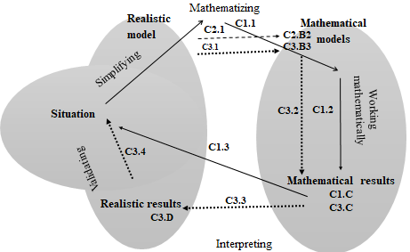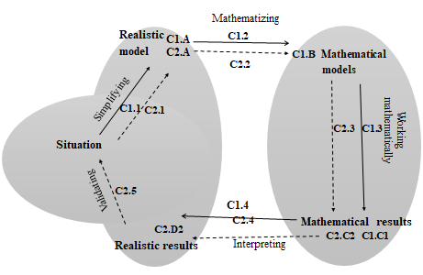
Figure1: Modelling cycle of analytic group | Figure2: Modelling cycle of visual group

Summary
The findings revealed differences in the two groups’ modelling processes and in features of modelling cycles. The major difference between the groups was in their ways of simplifying, mathematizing, and creating a mathematical model of the real-world situation. In the light of these findings, it is important to improve teachers’ awareness of students’ mathematical thinking styles, because this awareness can play a vital role in designing effective interventions for their students who are engaged in modelling activities.

References
Blum, W., & Borromeo Ferri, R. (2009). Mathematical modelling: Can it be taught and learnt?. Journal of mathematical modelling and application, 1(1), 45-58.
Blum, W., & Leiß, D. (2005). "Filling Up"-the problem of independence-preserving teacher interventions in lessons with demanding modelling tasks. In M. Bosch (Ed.), Proceedings of the Fourth Congress of the European Society for Research in Mathematics Education (CERME 4) (pp. 1623-1633). Sant Feliu de Guíxols, Spain: Fundemi Iqs, Universitat Ramon Llull.
Borromeo Ferri, R., & Kaiser, G. (2003). First Results of a Study of Different Mathematical Thinking Styles of Schoolchildren. In Leone Burton (Ed.) Which Way in Social Justice in Mathematics Education? (pp. 209-239). London: Greenwood.
Borromeo Ferri, R. (2010). On the influence of mathematical thinking styles on learners’ modelling behaviour. Journal für Mathematikdidaktik, 31 (1), 99-118.
Lesh, R., & Harel, G. (2003). Problem solving, modeling and local conceptual development. Mathematical Thinking and Learning, 5(2–3), 157–189.

