CHAPTER 4 - RESULTS

This chapter presents the analyses and results of the survey of Israeli veterinary students’ attitudes toward the welfare of farm animals, their stress and psychological well-being, and their ethical dilemmas over the course of their veterinary training. The results obtained from the cross-sectional and longitudinal surveys are presented in five parts as follows:
Part I presents findings related to the attitudes and concerns regarding the welfare of agricultural farm animals, as measured at the beginning of the study alone.
Part II presents the findings of a longitudinal and cross-sectional study, related to the development of veterinary students’ perception of animals feeling of pain and boredom, throughout the course of their studies.
Part III presents the findings of a longitudinal and cross-sectional study related to the development of veterinary students’ attitudes toward the welfare of agricultural farm animals, throughout the course of their studies.
Part IV presents the findings of a longitudinal and cross-sectional study related to the development of veterinary students’ stress and psychological well-being throughout the course of their studies.
Part V presents some of the ethical dilemmas the veterinary students encounter during their fourth year (the clinical year).
Each part will be followed by a summary of the main findings.

Part I: Students’ Attitudes at Baseline, toward the Welfare of Agricultural Animals, Current Production Methods, and Husbandry Practices
The participating students were asked whether they felt the predominant methods that are currently used to produce animal products provide an appropriate level of animal welfare for each of the following species: beef cattle, dairy cattle, layer chickens, meat birds, sheep, and swine. The results are presented in Table 1. These results indicate that the respondents were most comfortable with the methods used in the beef and dairy cattle industries, in which the percentage of the “Agree” (i.e., agree with the methods) responses ranged between 23% and 42% (beef cattle) and between 30% and 55% (dairy cattle).
With regards to the other animals surveyed (birds, chickens, and swine), most of the students were not comfortable with the methods used in the respective industries, as the percentage of the “Agree” responses for these animals was very low (≤10%). Table 1 also presents the results of association between the students’ year of studies (i.e., Year A, B, C, or D) and level of agreement within each species. No significant associations were found (p > 0.05), apart from swine, for which Year D students reported greater disagreement with the methods used in the industry, compared with students in Years A–C (p < 0.001).

Table 1. Distribution of responses to the question whether the students felt that the predominant methods currently used to produce animal products provide an appropriate level of animal welfare

Type of farm animals | Response | Year A | Year B | Year C | Year D | χ²_{(df)} or Fisher’s exact,  p-value
Beef cattle | disagree | 13 (30%) | 14 (29%) | 20 (48%) | 18 (60%) | χ²₍₆₎ = 11.0, p = 0.09
 | neutral | 15 (34%) | 14 (29%) | 11 (26%) | 5  (17%)
 | agree | 16 (36%) | 20 (42%) | 11 (26%) | 7  (23%)
Dairy cattle | disagree | 13 (30%) | 20 (42%) | 23 (55%) | 14 (47%) | χ²₍₆₎ = 7.5, p = 0.28
 | neutral | 13 (30%) | 9  (19%) | 9  (21%) | 8  (27%)
 | agree | 18 (41%) | 19 (40%) | 10 (24%) | 8  (27%)
Layer chickens | disagree | 33 (75%) | 41 (85%) | 40 (95%) | 27 (90%) | Fisher’s exact = 10.1,  p = 0.07
 | neutral | 10 (23%) | 4  (8%) | 2  (5%) | 2  (7%)
 | agree | 1  (2%) | 3  (6%) | 0  (0%) | 1  (3%)
Meat bird | disagree | 30 (68%) | 36 (75%) | 37 (88%) | 25 (83%) | Fisher’s exact = 10.0, p = 0.11
 | neutral | 10 (23%) | 10 (21%) | 2  (5%) | 2  (7%)
 | agree | 4  (9%) | 2  (4%) | 3  (7%) | 3  (10%)
Sheep | disagree | 7  (16%) | 10 (21%) | 14 (35%) | 13 (45%) | χ2₍₆₎ = 11.5, p = 0.07
 | neutral | 25 (57%) | 26 (54%) | 14 (35%) | 9  (31%)
 | agree | 12 (27%) | 12 (25%) | 12 (30%) | 7  (24%)
Swine | disagree | 8  (18%) | 11 (23%) | 19 (48%) | 19 (63%) | Fisher’s exact = 22.2,  p < 0.001
 | neutral | 34 (77%) | 35 (73%) | 19 (48%) | 11 (37%)
 | agree | 2  (5%) | 2  (4%) | 2  (5%) | 0  (0%)
df, degrees of freedom.
Attitudes toward the Five Freedoms
The students were asked to express their agreement or disagreement with the importance of the Five Freedoms (Farm Animal Welfare Council, 2004) and related core values that impact farm animal welfare. The results are presented in Table 2, and indicate that more than 90% of the respondents agreed with the importance of freedom from: 1) hunger; 2) thirst; 3) unnecessary pain or discomfort; 4) injury or disease; and 5) unnecessary fear or distress. No significant difference was found between the students’ year of studies or their level of agreement with these value statements (p > 0.05 for all freedoms).

Table 2. Number and percentage of respondents who agreed with the Five Freedoms and related core values of animal welfare

Type of freedom | Response | Year A | Year B | Year C | Year D | Fisher’s exact, p-value
Freedom from hunger | disagree | 1  (2%) | 0  (0%) | 1  (2%) | 0  (0%) | Fisher’s = 5.5, p = 0.31
 | neutral | 0  (0%) | 0  (0%) | 2  (5%) | 1  (3%)
 | agree | 43 (98%) | 48 (100%) | 39 (93%) | 29 (97%)
Freedom from thirst | disagree | 0  (0%) | 0  (0%) | 1  (2%) | 0  (0%) | Fisher’s = 6.3, p = 0.13
 | neutral | 0  (0%) | 0  (0%) | 0  (0%) | 1  (3%)
 | agree | 44 (100%) | 48 (100%) | 41 (98%) | 29 (97%)
Freedom from unnecessary pain or discomfort | disagree | 0  (0%) | 0  (0%) | 1  (2%) | 0  (0%) | Fisher’s = 2.8, p = 0.44
 | agree | 44 (100%) | 48 (100%) | 41 (98%) | 30 (100%)
Freedom from injury or disease | disagree | 1  (2%) | 0  (0%) | 1  (2%) | 0  (0%) | Fisher’s = 2.0, p = 0.69
 | agree | 43 (98%) | 48 (100%) | 41 (98%) | 30 (100%)
Freedom from unnecessary fear or distress | disagree | 1  (2%) | 0  (0%) | 1  (2%) | 0  (0%) | Fisher’s = 2.0, p = 0.69
 | agree | 43 (98%) | 48 (100%) | 41 (98%) | 30 (100%)

Attitudes toward four belief statements related to the welfare of agricultural animals
The students were asked to express their agreement or disagreement with four belief statements related to various aspects of animal welfare. The results are presented in Table 3. These findings show that regarding the first and second statements, the students agreed that agricultural animals have individual temperaments (agreement rates ranging from 82% to 94% across each year of studies), and it is important to meet the majority of their behavioral needs (agreement rates ranging from 80% to 100% across each year of studies). The students’ responses to the third statement, which inquired about the association between production and animal welfare, were intermediate, with disagreement rates ranging between 64% and 71% across each year of studies (in this statement, disagreement represented greater concern for animal welfare).
Regarding the fourth statement about the capacity of agricultural animals to experience boredom, the students’ responses were intermediate as well, with agreement rates ranging between 43% and 80% across each year of studies. For the latter statement, a significant association was also observed between year of studies and level of agreement, indicating a greater level of agreement among students in advanced years, compared with their counterparts in earlier years (p = 0.02). No significant association was found between year of studies and level of agreement for the remaining statements (p > 0.05).

Table 3. Students’ responses to four belief statements regarding the welfare of agricultural animals at baseline, across each school year

Belief statement | Response | Year A | Year B | Year C | Year D | Fisher’s exact, p-value
- Agricultural animals have individual temperaments | disagree | 1  (2%) | 0  (0%) | 1  (2%) | 2  (7%) | Fisher’s = 6.8,  p = 0.26
 | neutral | 7  (16%) | 3  (6%) | 5  (12%) | 1  (3%)
 | agree | 36 (82%) | 44 (94%) | 36 (86%) | 27 (90%)
- It is important to meet the majority of the behavioral needs of agricultural animals | disagree | 1  (2%) | 0  (0%) | 0  (0%) | 0  (0%) | Fisher’s = 10.0,  p = 0.06
 | neutral | 8  (18%) | 5  (11%) | 3  (7%) | 0  (0%)
 | agree | 35 (80%) | 42 (89%) | 39 (93%) | 30 (100%)
- If animals are producing (i.e., gaining weight, producing eggs, etc.), that means they have good welfare | disagree | 28 (64%) | 32 (67%) | 30 (71%) | 20 (67%) | Fisher’s = 1.2,  p = 0.99
 | neutral | 6  (14%) | 5  (10%) | 5  (12%) | 4  (13%)
 | agree | 10 (23%) | 11 (23%) | 7  (17%) | 6  (20%)
- Agricultural animals can experience something akin to boredom | disagree | 3  (7%) | 3  (6%) | 2  (5%) | 2  (7%) | Fisher’s = 13.9,  p = 0.02
 | neutral | 22 (50%) | 13 (27%) | 10 (24%) | 4  (13%)
 | agree | 19 (43%) | 32 (67%) | 30 (71%) | 24 (80%)

Husbandry practices and outcomes
Figure 1 presents the students’ responses, when asked to express their level of concern with various husbandry practices and outcomes, as previously identified in another relevant survey (Heleski et al., 2003). Responses ranged from 99% agreement that poor/indifferent stockmanship is a concern, to a minimum of 29% and 31% agreement that gestation crates and early weaning of piglets, respectively, are concerns. Interestingly, the concerns of students in higher classes were related to chronic states of low welfare conditions for animals, followed by one-time procedures that inflict acute pain. At the lower end of concern, were practices related to piglets and sows, for which the majority of students chose “neutral” or “do not know enough to form an opinion” (66% and 71%, respectively).

Figure 1. Percentages of veterinary students across all years who agreed, disagreed, or did not know enough to form an opinion, regarding whether or not the various animal practices and outcomes warrant concern

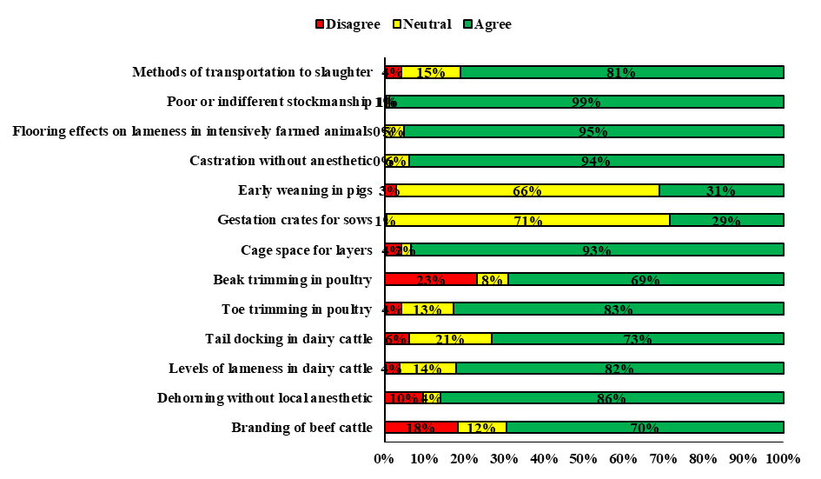

Table 4 presents agreement rates for the various practices across each year of studies. A significant association was found between the year of studies and the students’ level of concern. These findings indicated greater concern among students in advanced years, compared with their counterparts in earlier years, with regards to tail docking in dairy cattle (p = 0.009); toe trimming in poultry (p = 0.01); gestation crates for sows (p = 0.01); early weaning in piglets (p = 0.02); and methods of transportation to slaughter (p = 0.002).

Table 4. Students’ responses to husbandry practices/outcomes at baseline, across year of studies

Practice | Response | Year A | Year B | Year C | Year D | Fisher’s exact, p-value
Branding of beef cattle | disagree | 10 (23%) | 9  (19%) | 6  (14%) | 5  (17%) | Fisher’s = 8.1,  p = 0.23
 | neutral | 7  (16%) | 6  (13%) | 7  (17%) | 0  (0%)
 | agree | 27 (61%) | 33 (69%) | 29 (69%) | 25 (83%)
Dehorning without local anaesthetic | disagree | 4  (9%) | 10 (21%) | 2  (5%) | 0  (0%) | Fisher’s = 8.1,  p = 0.23
 | neutral | 4  (9%) | 2  (4%) | 1  (2%) | 0  (0%)
 | agree | 36 (82%) | 36 (75%) | 39 (93%) | 30 (100%)
Levels of lameness in dairy cattle | disagree | 2  (5%) | 2  (4%) | 1  (2%) | 1  (3%) | Fisher’s = 1.5,  p = 0.98
 | neutral | 5  (12%) | 8  (17%) | 5  (12%) | 5  (17%)
 | agree | 36 (84%) | 38 (79%) | 35 (85%) | 24 (80%)
Tail docking in dairy cattle | disagree | 4  (9%) | 1  (2%) | 3  (7%) | 2  (7%) | Fisher’s = 15.6,  p = 0.009
 | neutral | 17 (39%) | 9  (19%) | 6  (15%) | 2  (7%)
 | agree | 23 (52%) | 38 (79%) | 32 (78%) | 26 (87%)
Toe trimming in poultry | disagree | 4  (9%) | 1  (2%) | 1  (2%) | 1  (3%) | Fisher’s = 14.5,  p = 0.01
 | neutral | 12 (28%) | 5  (10%) | 2  (5%) | 2  (7%)
 | agree | 27 (63%) | 42 (88%) | 38 (93%) | 27 (90%)
Beak trimming in poultry | disagree | 11 (25%) | 8 (  17%) | 12 (29%) | 7  (23%) | Fisher’s = 11.2,  p = 0.07
 | neutral | 8  (18%) | 2  (4%) | 3  (7%) | 0  (0%)
 | agree | 25 (57%) | 38 (79%) | 27 (64%) | 23 (77%)
Cage space for layers | disagree | 2  (5%) | 2  (4%) | 1  (2%) | 2  (7%) | Fisher’s = 2.5,  p = 0.93
 | neutral | 2  (5%) | 1  (2%) | 1  (2%) | 0  (0%)
 | agree | 40 (91%) | 46 (94%) | 40 (95%) | 28 (93%)
Gestation crates for sows | disagree | 1  (2%) | 0  (0%) | 0  (0%) | 0  (0%) | Fisher’s = 12.7,  p = 0.01
 | neutral | 33 (75%) | 38 (78%) | 32 (76%) | 14 (47%)
 | agree | 10 (23%) | 11 (22%) | 10 (24%) | 16 (53%)
Early weaning in pigs | disagree | 3  (7%) | 1  (2%) | 1  (2%) | 0  (0%) | Fisher’s = 12.9,  p = 0.02
 | neutral | 34 (79%) | 33 (67%) | 26 (62%) | 15 (50%)
 | agree | 6  (14%) | 15 (31%) | 15 (36%) | 15 (50%)
Castration without anaesthetics | disagree |  |  |  |  | Fisher’s = 0.6,  p = 0.94
 | neutral | 3  (7%) | 3  (6%) | 3  (7%) | 1  (3%)
 | agree | 40 (93%) | 45 (94%) | 39 (93%) | 29 (97%)
Flooring effects on lameness in intensively farmed animals | disagree |  |  |  |  | Fisher’s = 2.1,  p = 0.58
 | neutral | 4  (9%) | 2  (4%) | 1  (2%) | 1  (3%)
 | agree | 40 (91%) | 47 (96%) | 41 (98%) | 29 (97%)
Poor or indifferent stockmanship | disagree | 1  (2%) | 0  (0%) | 0  (0%) | 0  (0%) | Fisher’s = 6.3,  p = 0.22
 | neutral | 0  (0%) | 0  (0%) | 0  (0%) | 1  (3%)
 | agree | 42 (98%) | 49 (100%) | 42 (100%) | 29 (97%)
Methods of transportation to slaughter | disagree | 5  (11%) | 0  (0%) | 1  (2%) | 1  (3%) | Fisher’s = 18.1, p = 0.002
 | neutral | 10 (23%) | 10 (21%) | 4  (10%) | 0  (0%)
 | agree | 29 (66%) | 37 (79%) | 37 (88%) | 29 (97%)

Self-assessment of attitudes toward animal use
The students were presented with a seven-point scale and were asked to choose between three anchor definitions: Anchor 1 represented a strong animal rights position; Anchor 4 (the midpoint) represented the use of animals for the greater human good, providing that the majority of their physiological and behavioral needs are met; Anchor 7 represented no concern about animal welfare issues. Figure 2 presents the distribution of responses within these anchors. Forty-two percent of the students chose Anchors 1 and 2 (a strong animal rights position); 56% chose 3 and 4 (using animals, but with an obligation to provide them with appropriate welfare); and only 2% chose 5 (a weaker obligation to provide proper conditions of animal welfare). None of the students chose 6 or 7, which represented no concern for animal welfare. Interestingly, the majority of students’ attitudes in the preclinical years (Years 1 to 3) of veterinary school were distributed between responses 2 and 4, whereas the attitudes of those in the Year 4 were distributed almost evenly among the four anchors.

Figure 2. Students’ responses to the item reflecting self-assessment of attitudes toward animal use. Low scores reflect a strong animal rights position

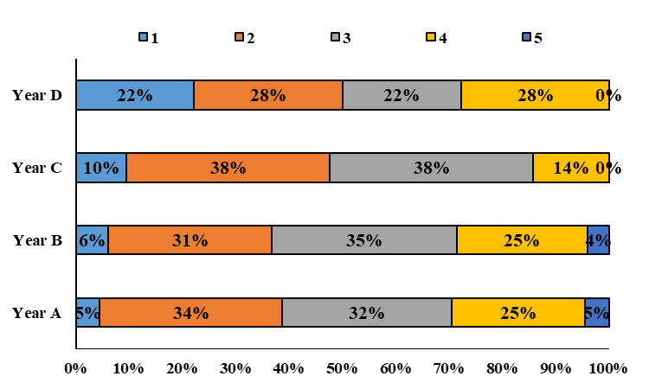
חסר כאן השאלון של Empathy toward animal at baseline (Paul, 2000)(. מופיע באקסל בלשונית ואני מתייחסת אליו בחלק 3

Summary of Part I
At baseline, the students across all years expressed high concern for the welfare of agricultural animals. The species that raised the greatest concerns were birds and swine. The importance of the Five Freedoms was widely agreed upon/accepted, as well as the statements regarding the individual temperaments of agricultural animals and the importance of providing them with the majority of their behavioral needs. Apart from the practices regarding pigs (gestation crates for sows and early weaning in piglets) for which the majority of students either did not know enough to form an opinion or were neutral, common husbandry practices raised a concern for the majority of the students. (Beak trimming in poultry was the practice for which the lowest percentage (69%) of students agreed was a concern).
Two statements granted less unequivocal agreement. The first asked about presumed association between productivity and good welfare in agricultural animals, and exhibited agreement rates of 36% and 29% respectively, across the various years of studies. Responses to the second statement, about the capability of agricultural animals to experience boredom, showed a significant association between year of studies and level of agreement, indicating a greater level of agreement among students in advanced years, compared to their peers in earlier years (p = 0.02).
The self-rated scores of the students’ attitudes toward animal use revealed that the responses of those in the preclinical years (1 to 3) were distributed among Anchor definitions 1 to 4; i.e., a strong animal rights position, but mostly between 2 to 4; whereas the responses of those in the clinical year were distributed almost evenly among Anchors 1 to 4, indicating an inclination of fourth year students toward a stronger animal rights position.

Part II: Perception of pain and boredom in animal species
This part explored the perceptions of veterinary students regarding feelings of pain and boredom among animal species. In order to achieve this aim, the participants responded to questions about the degree to which certain animal species can feel pain or boredom in a similar way to humans. The responses where rated on a four-point scale, where “1” represented a pro-animal position (“Yes, in a way very similar to humans”) and “4” represented the opposite (“Not at all”). Overall, there were 16 questions - eight about the of perception pain and eight about the perception of boredom, with differing questions according to the species of animals (e.g., “Do you think that mice/sheep etc. can feel pain?”).
The responses were grouped into four categories - rodents, farm animals, pets, and monkeys. As these questions were asked in all years of studies and in a repeated measures fashion, a mixed linear model for repeated measures was applied to evaluate the effects of time of measurement and year of studies, together with other covariates of interest. Figure 3a presents the responses for the pain perception questions, as it relates to various animal species; Figure 3b presents the responses for the boredom perception questions, as it relates to various animal species. The analysis for pain perception yielded non-significant effects for the time of measurement (F(3, 106) = 1.93, p = 0.13); year of studies (F(3, 157) = 0.70, p = 0.55); and time (of measurement) by year (of studies) interaction (F(4, 141) = 0.56, p = 0.70), as illustrated in Figure 3a.
The responses were mostly unanimous, as most of the students responded “1,” i.e., a response that expressed the belief that animals can feel pain just like humans (see detailed results in Appendix 1 [online material]). With regards to boredom perception, however, the results differed. Analysis of those results revealed a significant effect for time of measurement (F(3, 53) = 4.06, p = 0.01), indicating that over time, the students were more likely to perceive animals as feeling boredom in a similar way to humans. A significant effect for year of studies was also found (F(3, 150) = 3.27, p = 0.02). This indicated that compared with students in earlier years, students in advanced years perceived animals as feeling boredom in a similar way to humans. The time by year interaction was also significant (F(3, 150) = 3.27, p = 0.02), indicating that the development of a pro-animal position over time was more salient among Year A students, compared to those in more advanced years (see detailed results in Appendix 2 [online material]). The effects of age and gender were non-significant for both models (pain model: age (F(1, 202) = 0.04, p = 0.83); gender (F(1, 174) = 0.83, p = 0.36); and boredom model: age (F(3, 171) = 0.73, p = 0.40); gender (F(1, 144) = 0.00, p = 0.93)) (see detailed results for gender analysis in Appendices 3 and 4 [online material]).

Figure 3. Associations among time of measurement, year of studies, and perception of animals’ pain (a) and boredom (b)

a. Pain perception | b. Boredom perception
Values are presented as estimated marginal means; error bars are not shown because of the visual load of the figures. See Appendix 1 for full details. Abbreviations: BL, baseline; sem, semester; yr, year.

Figure 4 (a-d) and Figure 5 (a–d) present the results of the perception of pain and boredom, respectively, within each animal category - rodents (Figs. 4a, 5a); farm animals (Figs. 4b, 5b); pets (Figs. 4c, 5c); and monkeys (Figs. 4d, 5d). The pattern of results for pain perception within each animal category was very similar to the pattern presented in Figure 4a; i.e., most of the responses reflected an attitude that animals, regardless of their species, can feel pain just like humans and these responses showed little variation across time of measurement or year of studies. Thus, their effects were nonsignificant, with one exception – rodents – for which a significant effect for time of measurement was observed (F(3, 80) = 3.15, p = 0.03). These findings indicated that over time, the students perceived rodents as feeling pain in a similar way to humans (see detailed results for each animal category in Appendices 5 (rodents); 6 (farm animals); 7 (pets); and 8 (monkeys) [online material]).

Figure 4 (a–d). Associations among time of measurement, year of studies, and perception of animals’ pain within each species category

a. Rodents | b. Agricultural animals
 | 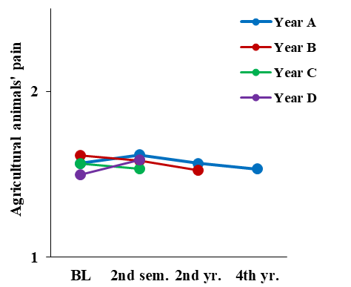
Figure 4c: Pets | Figure 4d: Monkeys
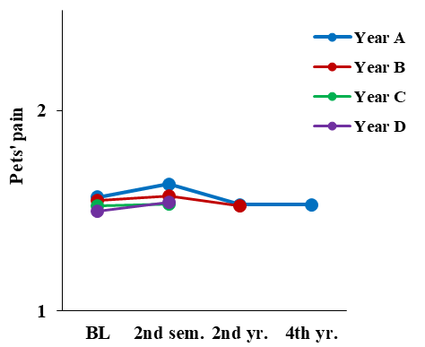 | 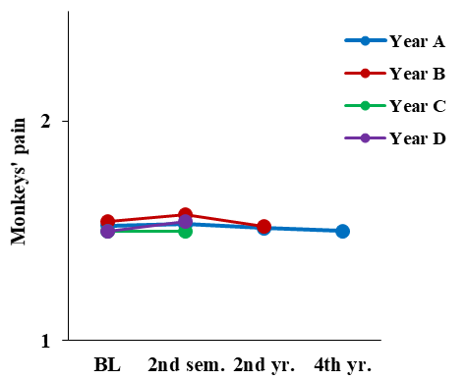
Values are presented as estimated marginal means; error bars are not shown because of the figures’ visual load. See Appendix 1 for full details. Abbreviations: BL, baseline; sem, semester; yr, year.

With regards to the perception of animal boredom, analysis of the results for rodents revealed significant effects for the time of measurement (F(3, 55) = 3.26, p = 0.03); year of studies (F(3, 151) = 3.60, p = 0.02); age (F(1, 188) = 3.95, p = 0.05); and time by year interaction (F(4, 154) = 2.46, p = 0.05). These results indicate that students in advanced years perceive rodents as feeling boredom more similar to humans, compared to students in earlier years and this perception changes across measurements, specifically among Year A students. However, the trend for the time of measurement was mixed.
Similar patterns were found for farm animals - significant effects for the time of measurement (F(3, 57) = 7.76, p < 0.001); year of studies (F(3, 154) = 2.95, p = 0.03); and time by year interaction (F(4, 149) = 2.98, p = 0.02). These findings indicated that compared with students in earlier years, students in advanced years perceive that farm animals feel boredom in a manner more similar to humans, and this perception showed change across measurements, specifically among Year A students. The results for pets and monkeys were not significant, as the responses were very similar across time of measurement and year of study (Figs. 5c, 5d) (see detailed results for each animal category in Appendices 9 (rodents); 10 (agricultural animals); 11 (pets); and 12 (monkeys) [online material]).

Figure 5 (a–d). Associations among time of measurement, year of studies, and perception of boredom within each animal category

a. Rodents | b. Agricultural animals
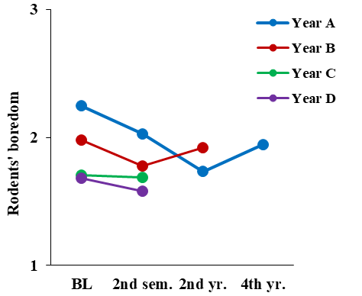
c. Pets | d. Monkeys
 | 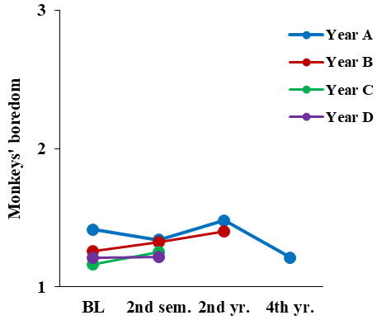

Summary of Part II
Our purpose in this part of the research was to explore the patterns of perceptions among veterinary students, over the course of their studies, regarding pain and boredom among different categories of animal species. Using a mixed model for repeated measures (MMRM) analysis allowed us to follow the same students at different times of measurement (i.e., over time). The MMRM analysis allowed us to identify changes in the students’ perception of various animal species categories.
Regarding the perception of pain, the effects were not significant for time of measurement, year of studies, or time of measurement by year of studies interaction. This is because the responses were mostly unanimous, expressing a belief that animals can feel pain just like humans. Regarding the perception of pain within each animal category (rodents, farm animals, pets, and monkeys) the results were consistent, with the exception of rodents. In that category, a significant effect was observed for time of measurement, indicating that over time, the students perceived rodents as feeling pain in a more similar way to humans.
Regarding the perception of boredom, analysis of the results revealed a significant effect for time of measurement, year of studies, and time by year interaction. These findings indicated that over time, and among those in advanced years, students perceived animals as feeling boredom in a more similar way to humans. Furthermore, Year A students demonstrated a more salient change in perception of the animals’ capability to experience boredom toward a more human-like manner.
Regarding the perception of boredom in each animal category, significant changes were observed for farm animals, demonstrating a significant effect for time of measurement, year of studies, and time by year interaction. This pattern indicated that students in advanced years perceive farm animals as feeling boredom more similar to humans, compared with students in earlier years. In addition, this perception showed change across measurements, specifically among Year A students. The results for pets and monkeys showed no significant changes, as the responses were very similar across time of measurement and year of study.

Part III: Total Attitude Score model and its relationships with background variables of interest
This part presents the changes in the Total Attitude Score scale (TAS) over time, as well as some of its associations with background and other demographic variables of interest. The TAS scale was developed and used by Heleski (2004), to measure the general concern among different target audiences for the welfare of agricultural animals (See chapter 3 Table X for further elaboration about the scale). The basic model included the TAS as the outcome variable, as well as the time of measurement and year of studies in veterinary school, as explanatory variables, and students’ age as a control variable.
In subsequent analyses, the following covariates were added to the model: gender; religiosity; political affiliation; childhood residence; reasons for choosing a veterinary career; future animal practice plans; and dietary preferences [need to explain, in short, why I chose these covariates]. Since the question composing the TAS scale were given to the students in all years, in a repeated measures fashion, a mixed linear model for repeated measures was applied, to evaluate the effects of interest.

Basic model: changes in TAS over time and across year of studies
The results of this analysis, as shown in Figure 6, revealed a significant effect for the time of measurement (F(3, 63) = 5.85, p = 0.001) and year of studies (F(3,158) = 5.54, p = 0.001). These findings indicate that the students’ concern for animal welfare grew over time. Furthermore, compared with their counterparts in earlier years, the students in advanced years of veterinary training were more concerned about the welfare of agricultural animals. No significant effect was observed for time by year interaction (F(4, 137) = 0.54, p = 0.71), nor for students’ age (F(1, 184) = 1.60, p = 0.21) (see detailed results in Appendix 13 [online material]).

Figure 6. Associations among time of measurement, year of studies, and TAS

Values are presented as estimated marginal means; error bars are not shown because of the figures’ visual load. See Appendix 2 for full details. Abbreviations: TAS, Total Attitude Score; BL, baseline; sem, semester; yr, year.

Relationship between changes in TAS over time and across year of studies and covariates of interest
Gender
The results of this analysis, as presented in Figure 7 (a–b), revealed significant effects for time of measurement (F(3, 59) = 7.60, p < 0.001) and year of studies (F(3, 165) = 5.18, p = 0.002), which were in the same pattern found in the basic model (see Fig. 6 above). In addition, a significant effect was observed for gender (F(1, 149) = 8.88, p = 0.003). This indicated that, overall, women scored higher than men on the TAS scale, i.e., they were more concerned about the welfare of agricultural animals. No significant effects were found for the time by year by gender triple interaction (F(14, 125) = 1.68, p = 0.07), nor for age of the students (F(1, 189) = 0.43, p = 0.51) (see detailed results in Appendix 14 [online material]).

Figure 7 (a–b). Associations among time of measurement, year of studies, gender, and TAS

a. Men | b. Women
Values are presented as estimated marginal means; error bars are not shown because of the figures’ visual load. See Appendix 2 for full details. Abbreviations: TAS, Total Attitude Score; BL, baseline; sem, semester; yr, year.

Religiosity
In this analysis, the relationships among time of measurement, year of studies, age, sense of religiosity (atheist, secular, traditional, or religious), and the TAS of the students were examined (Figure 8 (a–d)). Significant effects were observed for time of measurement (F(3, 74) = 4.30, p = 0.008) and year of studies (F(3, 160) = 4.98, p = 0.002) that showed a similar pattern to that found in the basic model (see Fig. 6 above). Furthermore, a significant effect was found for religiosity (F(3, 147) = 7.03, p < 0.001), for which the main difference stemmed from the results of the atheist students, who reflected greater concern for welfare of agricultural animals, compared with the traditional and religious students. No significant effects were found for the time by year by religiosity triple interaction (F(28, 131) = 1.08, p = 0.37), nor age of students (F(1, 172) = 2.68, p = 0.10) (see detailed results in Appendix 15 [online material]).

Figure 8 (a–d). Associations among time of measurement, year of studies, religiosity, and TAS

a. Atheist | b. Secular
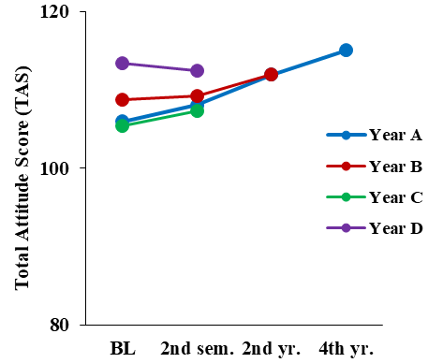 | 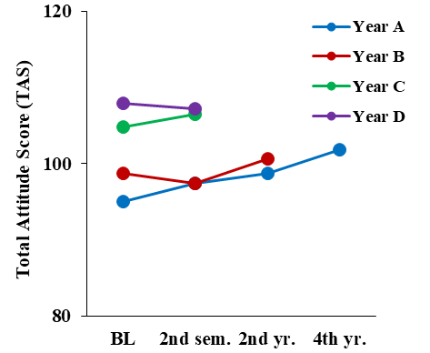
c. Traditional | d. Religious
 | 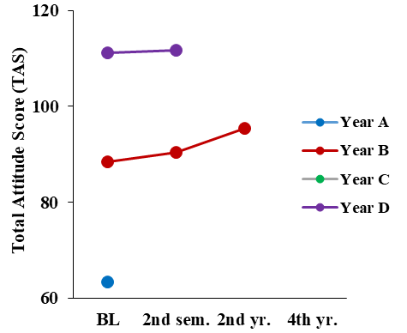
Values are presented as estimated marginal means; error bars are not shown because of the figures’ visual load. See Appendix 2 for full details. Abbreviations: TAS, Total Attitude Score; BL, baseline; sem, semester; yr, year.

Dietary Preferences (Diet)
In this analysis, the relationships between time of measurement, year of studies, age, diet (omnivores, vegetarians/vegans) and the students’ TAS were examined (Figure 9 (a–b)). A significant effect was found for year of studies (F(3, 137) = 3.36, p = 0.02) that showed a similar pattern as that found in the basic model (see Fig. 6 above). In addition, a significant effect was found for diet (F(1, 119) = 27.00, p < 0.001), indicating greater concern for the welfare agricultural animals among vegetarian or vegan students, compared with omnivorous students. No significant effects were observed for time of measurement (F(3, 60) = 1.71, p = 0.17); time by year by diet triple interaction (F(14, 111) = 0.85 p = 0.62); or age (F(1, 168) = 0.51, p = 0.48) (see detailed results in Appendix 16 [online material]).

Figure 9 (a–b). Associations among time of measurement, year of studies, diet and TAS

a. Omnivores | b. Vegetarians or vegans
Values are presented as estimated marginal means; error bars are not shown because of the figures’ visual load. See Appendix 2 for full details. Abbreviations: TAS, Total Attitude Score; BL, baseline; sem, semester; yr, year.

Future Animal Practice Plans
This analysis evaluated the associations among time of measurement, year of studies, age, practice plans following graduation (small animals only; or mixed practice, i.e., small animals and farm animals), and the students’ TAS (Figure 10 (a–b)). Significant effects were observed for time of measurement (F(3, 53) = 3.87, p = 0.01) and year of studies (F(3, 124) = 2.75, p = 0.05), which showed a similar pattern as that observed in the basic model (see Fig. 6 above). A significant effect was also observed for the students’ practice plans following graduation (F(1, 117) = 11.09, p = 0.001). This indicated a greater concern for the welfare of agricultural animals among students who planned to work with small animals following graduation, compared with those who planned to work in mixed practice. No significant effects were observed for the time by year by practice triple interaction (F(14, 102) = 0.93, p = 0.53); nor for age (F(1, 146) = 1.73, p = 0.19) (see detailed results in Appendix 17 [online material]).

Figure 10 (a–b). Associations among time of measurement, year of studies, planned future practice, and TAS

a. Small animals only | b. Mixed practice
Values are presented as estimated marginal means; error bars are not shown because of the figures’ visual load. See Appendix 2 for full details. Abbreviations: TAS, Total Attitude Score; BL, baseline; sem, semester; yr, year.

Other covariates that were analyzed in a similar fashion, but did not yield significant effects included students’ residence (urban areas versus rural areas), which were defined in the survey as kibbutz or moshav (cooperative Israeli settlements) (F(1, 146) = 3.54, p = 0.06); political affiliation (left wing, center, right wing, and uncertain) (F(3, 137) = 1.60, p = 0.19); and reasons for choosing a veterinary career (a calling to help animals versus other reasons) (F(1, 125) = 2.92, p = 0.09).

TAS and self-measure scales
In an effort to validate the TAS with the respondents’ self-assessment of their attitudes toward animals, as well as their self-rated empathy toward animals, we used two self-measure scales, each of which was analyzed for correlation with the TAS score. One was the Animal Empathy Scale (Paul, 2000), and the second was the self-assessment of attitudes toward animal use (Heleski, 2004).

TAS and the Animal Empathy Scale
Figure 11 presents the results of the correlation between the Animal Empathy Scale (Paul, 2000) and the students’ TAS. The analysis was conducted within each time of measurement separately, collapsed over years of study. The analysis revealed positive correlations between the two scales, i.e., students who scored higher on the Animal Empathy Scale also tended to score higher on the TAS. The correlations were significant, with a medium effect size at baseline (r = 0.44) and at the second time of measurement (second semester of the first year) (r = 0.41), p < 0.001, for both correlations. The correlation for the third time of measurement (second semester of the second year) was also significant, with a large effect size (r = 0.64, p < 0.001). However, the correlation for the last time of measurement (fourth year) was small and not significant (r = 0.11, p = 0.62). This result might have stemmed from the small number of students who completed both scales at this time of measurement (n = 24).

Figure 11. Correlations between the Animal Empathy Scale score and TAS within each time of measurement according to year of study

Abbreviations: TAS, Total Attitude Score; BL, baseline; sem, semester; yr, year.

TAS and self-assessment of attitudes toward animal use
In order to analyze the relationship between the students’ self-assessed attitudes toward animal use and care and their TAS, a one-way ANOVA was conducted, in which the means of the TAS scores, within each time of measurement, were compared across the various categories of self-assessed attitudes toward animal use. The analysis revealed a significant effect for the self-assessed categories at all times of measurement, except the fourth time point (baseline, F(4, 160) = 16.87, p < 0.001; second semester, F(4, 128) = 15.40, p < 0.001; second year: F(4, 90) = 5.41, p = 0.001; fourth year: F(2, 29) = 0.60, p = 0.56).
Generally, a significant linear trend was observed for the significant results, indicating that the less concern the students showed toward animals, the lower their TAS scores (p < 0.001 for all times of measurement). The post-hoc analysis revealed that at baseline, the differences stemmed mainly from the difference between statements 1 and 2 (which reflected strong animal rights position) and the other statements; and between statement 5 (which reflected a belief in the use of animals for human good if the majority of their physiological and behavioral needs are met) and the other statements (p ≤ 0.001 for all comparisons). A similar pattern was also apparent and significant in the second semester and in the second year, but not during the fourth year. Figure xxx (a–d) presents these findings and illustrates that the TAS scores are higher among students who identify themselves as having greater concern toward animal use and care.
Figures X (a–d). TAS scores (y-axes) within each category of the Self-assessment of attitudes toward animal use scale (x-axes) at each time of measurement

a. Baseline | b. First year-second semester
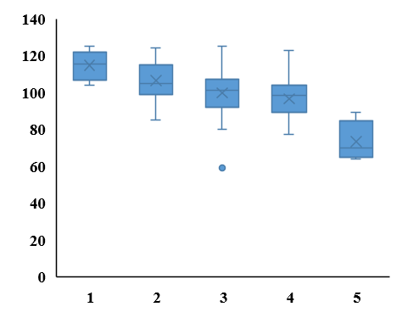 | 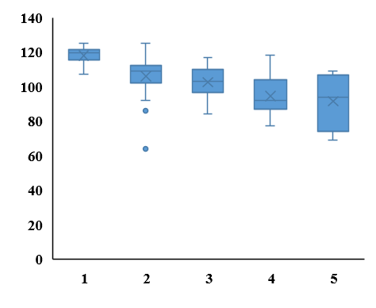
c. Second year | d. Fourth year
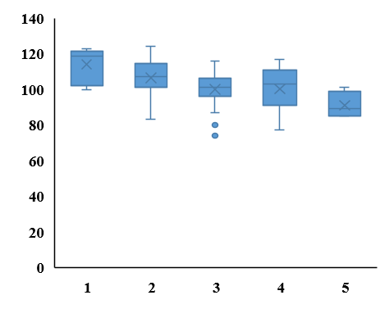 | 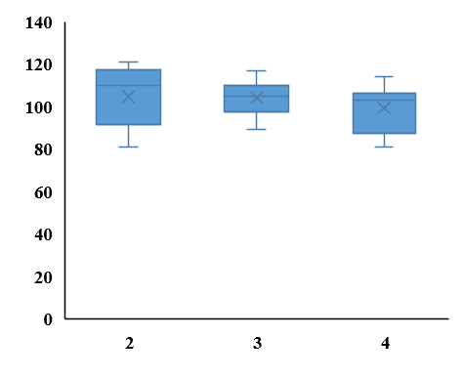
Category 1 represents a strong animal rights position; category 2 represents the midpoint, but closer to category 1; category 3 represents the midpoint, but closer to category 4; category 4 represents a belief in the use of animals for human good, if the majority of their physiological and behavioral needs are met; category 5 represents the midpoint, but closer to category 4; the line within each box represents the median, the X represents the mean, the whiskers represent the 25th and 75th percentiles. Abbreviation: TAS, Total Attitude Score.

Summary of Part III
The TAS scale, developed by Heleski (2004), served as the main model for assessing changes in the attitudes of students throughout veterinary school. The basic model included the TAS as the outcome variable; the time of measurement and year of studies in veterinary school, as explanatory variables; and age as a control variable. The results of the MMRM analyses revealed a significant effect for time of measurement and year of studies. This indicated that the students’ concern for animal welfare grew over time, and those in advanced years of veterinary training were more concerned about the welfare of agricultural animals, compared with their peers in earlier years. No significant effects were observed for the time by year interaction, nor for students’ age.
Subsequent analyses included other relevant covariates, such as gender, religiosity, political affiliation, childhood residence, reasons for choosing a veterinary career, future animal practice plans, and dietary preferences. Almost all analyses of the covariates demonstrated a similar pattern of significant effects for time (of measurement) and year of studies. In addition, the following covariates exhibited significant main effects: gender, indicating that overall, women scored higher than men on the TAS, and showed greater concern for the welfare of agricultural animals; religiosity, indicating that atheist students showed greater concern for the welfare of agricultural animals, compared with all other students; diet, indicating that vegetarian or vegan students, compared with omnivorous students, were more concerned about the welfare of agricultural animals; practice plans after graduation (small animals versus mixed practice), indicating a greater concern for the welfare of agricultural animals among students who planned to work with small animals, compared with those who planned to work in mixed practice.
Furthermore, positive correlations were observed between the students’ TAS and two self-assessment scales as follows: students who scored higher on the Animal Empathy Scale also scored higher on the TAS, and students who identified themselves as having greater concern toward animal use and care (a strong animal rights position) also scored higher on the TAS .

Part IV: Stress and psychological well-being of students throughout veterinary studies
This part of the study explored the well-being of Israeli veterinary students during their years at veterinary school, as reflected by measures of general stress, veterinary-related stress, life satisfaction, and self-esteem. The analyses sought to explore the levels of these factors among veterinary students in different years of studies and their pattern of change over time. Stress levels were measured by two instruments: The Perceived Stress Scale-10 (PSS-10; Cohen et al., 1983) and the Veterinary Studies Related Stress scale (VSRS) (Paul and Podberscek, 2000). Life satisfaction was measured using the Satisfaction with Life Scale (SWLS) (Diener et al., 1985) and self-esteem was measured using The Rosenberg Self-Esteem Survey (RSE) (Rosenberg, 1965).
The methodology utilized in this part was similar to that used to measure the students’ attitudes toward the welfare of agricultural animals. It was based on quantitative description and analysis of the data collected in the cross-sectional and longitudinal surveys (See Methods chapter). The findings are divided into two sections: 1. Analysis of stress, life satisfaction, and self-esteem over time of measurement and across years of study; and 2. The relationships among stress, life satisfaction, self-esteem, and gender. A mixed linear model for repeated measures was used for the analyses of both parts.

Stress, life satisfaction, and self-esteem among veterinary school students
The analysis used to evaluate the changes in stress, life satisfaction, and self-esteem over time and across year of study was similar to that of the basic model, which was used for TAS analysis. Thus, the PSS (perceived stress scale), VSRS (stress scale specific to veterinary school studies), SWLS (life satisfaction scale) and RSE (self-esteem scale) scores served as outcome variables; the time of measurement and year of studies in veterinary school served as explanatory variables; and age served as the control variable. Figure 12 (a–d) presents the results of these analyses (see detailed results for each scale in Appendices 18 (PSS), 19 (VSRS), 20 (SWLS), and 21 (RSE) [online material]).
Analysis of the PSS scores (general stress, Fig. 12a) showed no significant effects as follows: time of measurement (F(3, 49) = 1.22, p = 0.31); year of studies (F(3, 166) = 1.22, p = 0.30); age (F(1, 188) = 0.11, p = 0.74); and time by year interaction (F(4, 143) = 1.99, p = 0.10). As can also be seen in Figure 12a, stress levels, as measured by the PSS, were very similar over time of measurement and across years of study.
Analysis of the VSRS scores (stress specific to veterinary students, Fig. 12b) showed significant effects for year of studies (F(3, 156) = 2.71, p = 0.05), age (F(1, 179) = 6.83, p = 0.01) and time by year interaction (F(4, 134) = 4.10, p = 0.004). These findings indicated greater stress levels, notably among Year D students, compared with students in earlier years. The significant effect of age indicated that overall, older students reported less stress, compared with younger students. No significant effect was observed for time of measurement (F(4, 47) = 1.06, p = 0.37).
Analysis of the SWLS scores (life satisfaction, Fig. 12c) showed significant effects for the time of measurement (F(3, 47) = 3.11, p = 0.04) and year of studies (F(3, 164) = 3.80, p = 0.01). This indicated lower levels of life satisfaction over time and across year of studies; i.e., students in advanced years reported lower life satisfaction, compared with students in earlier years. No significant effects were observed for age (F(1, 173) = 1.43, p = 0.23), or the time by year interaction (F(4, 136) = 0.71, p = 0.59).
Analysis of the RSE scores (self-esteem, Fig. 12d) showed significant effects for the time of measurement (F(3, 51) = 4.72, p = 0.006) and year of studies (F(3, 174) = 3.60, p = 0.02), indicating lower levels of self-esteem over time and across year of studies. These findings indicated that students in advanced years had decreased levels of self-esteem, compared with those in earlier years. No significant effects were observed for age (F(1, 190) = 0.23, p = 0.63) or the time by year interaction (F(4, 144) = 0.85, p = 0.50).

Figure 12 (a–d). Associations among time of measurement, year of study, and PSS (perceived stress levels), VSRS (veterinary studies related stress), SWL (satisfaction with life) and SE (self-esteem)

a. PSS (Perceived stress levels) | b. VSRS (Veterinary studies-related stress)
Figure 12c: SWL (satisfaction with life) | Figure 12d: SE (self-esteem)
Values are presented as estimated marginal means; error bars are not shown because of the figures’ visual load. See Appendix 1 for full details. Abbreviations: BL, baseline; sem, semester; yr, year.

Stress and students’ gender
An extensive body of literature suggests that veterinary students in the USA, UK, Australia, and New-Zealand experience high levels of stress (ref). The literature also shows that female students display higher levels of stress, compared with male students, during their training in veterinary school (ref). Following these findings, the models described below included gender, as an explanatory variable, as well as a time by year by gender triple interaction (see detailed results for each scale in Appendices 22 (PSS), 23 (VSRS), 24 (SWLS), and 25 (RSE) [online material]).
Analysis of the PSS scores (general stress, Fig. 13 (a–b)) showed a significant effect for gender (F(1, 149) = 13.01, p < 0.001), and the time by year by gender triple interaction (F(14, 122) = 1.98, p = 0.02). This indicated that overall, women are more stressed than men. However, the change over time and across year of studies varied within gender, e.g., women in Year A were reportedly more stressed, compared with men, but their levels of stress remained more or less constant over time. Among the male students, a steep increase in stress levels were observed at the last time of measurement. No significant effects were observed for time of measurement (F(3, 47) = 1.81, p = 0.16); year of studies (F(3, 173) = 2.63, p = 0.052); or age of student (F(1, 191) = 0.03, p = 0.85).

Figure 13 (a–b). Associations among time of measurement, year of studies, gender, and PSS

a. Men | b. Women
Values are presented as estimated marginal means; error bars are not shown because of the figures’ visual load. See Appendix 3 for full details. Abbreviations: PSS, Perceived Stress Scale; BL, baseline; sem, semester; yr, year.

Analysis of the VSRS (stress specific to veterinary school, Fig. 14(a–b)) also showed a significant effect for gender (F(1, 147) = 15.52, p < 0.001), and the time by year by gender triple interaction (F(14, 120) = 2.97, p = 0.001). This again indicated that overall, women are more stressed than men, with regards to stress specific to veterinary school. However, the change over time and across year of studies varied within gender, e.g., women in Year A were reportedly more stressed overall, compared with their male counterparts, but their stress levels showed a decline at the last time of measurement, as opposed to their male peers. Significant effects were also observed for year of studies (F(3, 164) = 4.33, p = 0.006), and age (F(1, 182) = 4.63, p = 0.03), in a similar pattern described for the VSRS in the first section above. No significant effect was observed for time of measurement (F(3, 46) = 0.38, p = 0.77).

Figure 14 (a–b). Associations among time of measurement, year of studies, gender, and VSRS

a. Men | b. Women
Values are presented as estimated marginal means; error bars are not shown because of the figures’ visual load. See Appendix 3 for full details. Abbreviations: VSRS, Veterinary Studies Related Stress scale; BL, baseline; sem, semester; yr, year.

The analysis for SWLS (life satisfaction) showed no significant effects for gender (F(3, 154) = 0.37, p = 0.54), or the time by year by gender triple interaction (F(14, 119) = 1.52, p = 0.11). Significant effects were observed for time of measurement (F(3, 48) = 5.25, p = 0.003), and year of studies (F(3, 170) = 4.46, p = 0.005). These effects showed a similar pattern as that described for SWLS in the first section above. No significant effect was observed for age (F(1, 174) = 1.36, p = 0.25).
Analysis of the RSE (self-esteem, Fig. 15 (a–b)) showed a significant main effect for gender (F(1, 169) = 7.47, p = 0.007), indicating that overall, women reported less self-esteem than men. Significant effects were also observed for time of measurement (F(3, 50) = 6.11, p = 0.001) and year of studies (F(3, 181) = 3.02, p = 0.03), which showed a similar pattern as that described for RSE in the first section above. No significant effect was observed for age (F(1, 191) = 0.00, p = 0.98), nor the time by year by gender triple interaction (F(14, 135) = 1.13, p = 0.34).

Figure 15 (a–b). Associations among time of measurement, year of studies, gender and RSE

a. Men | b. Women
Values are presented as estimated marginal means; error bars are not shown because of the figures’ visual load. See Appendix 3 for full details. Abbreviations: RSE, Rosenberg Self-Esteem Survey; BL, baseline; sem, semester; yr, year.

Summary of Part IV
The methodology utilized in this part was similar to that used to measure the students’ attitudes toward the welfare of agricultural animals. It was based on quantitative description and analysis of the data collected in the cross-sectional and longitudinal surveys. The research questions were: how stressed are Israeli veterinary students across their years of study in veterinary school; and how does this stress vary over the years of study.
The analysis used to evaluate the changes in stress over time and across year of studies was similar to that of the basic model, which was used for TAS analyses. The dependent variables (score of each scale) were
the PSS-10 (Cohen et al., 1983); VSRS (Paul and Podberscek, 2000); SWLS (Diener et al., 1985); and RSE (Rosenberg, 1965).
The explanatory variables were the time of measurement and year of studies in veterinary school; and age served as the control variable.

Overall, as they progressed in their veterinary studies, students in the clinical year (fourth year) were more stressed by veterinary studies-related factors, compared with their peers in the preclinical years of veterinary school (years 1 to 3). In addition, the age of the students was significant, such that older students were less stressed than younger students. The students’ perceived stress score (general reported stress) showed no change nor increase.

Regarding life satisfaction (SWLS), the students experienced a decline in life satisfaction, which was more salient among those in advanced years, compared with students in earlier years. Furthermore, students experienced a decline in self-esteem, which was greater among those in advanced years, compared with students in earlier years of veterinary school.

Adding gender as an explanatory variable to the analyses, yielded significant main effects as follows:
PSS - women were more stressed at baseline and sustained these higher levels of stress across time and year of study. Men, however, reported a steep increase in stress levels only in the fourth year.
VSRS - overall, female students were more stressed than male students from the beginning of their studies. However, the change over time and across years of study varied with gender, e.g., female students showed a decline in stress levels at the last time of measurement, as opposed to their male peers.
RSE - female students scored lower than male students on the self-esteem scale, and this pattern was consistent across time of measurement and year of study.

Part V: Ethical dilemmas in the fourth year (clinical year)
In this part of the study, ethical dilemmas encountered by the students during their fourth year of veterinary studies (the clinical year) were explored. The research question asked whether the students encounter moral dilemmas throughout their fourth year; and if they do, are they associated with moral stress. Thus, we explored in a quantitative manner, the possible associations between stress and ethical dilemmas unique to veterinary studies during the clinical year.
This part is divided into two sections: 1. Descriptive analysis of the dilemmas; and 2. Prediction of the dilemmas from variables of interest, related to the students’ background, feelings of stress, and attitudes toward the welfare of agricultural animals.

Descriptive Analysis of the Dilemmas
The data about these dilemmas were collected from two samples of students - those who were in their fourth year when the data was initially collected (2011, i.e., Year D students, n = 44); and those who were in their fourth year, three years later (year 2014, i.e., Year A students, n = 60). Both samples of students were asked during their fourth year to check whether they had come across any of the following 13 ethical dilemmas:
- Taking action or intervening opposite to students’ expected role.
- Witnessing inappropriate treatment of sick animals.
- Witnessing a fault in clinical work: negligence or maltreatment of sick animals.
- Issues in treating animals with a terminal condition.
- Euthanasia of healthy animals without owners.
- Welfare of food-producing animals (slaughter, holding conditions, maximizing production over welfare, etc.)
- Experimenting on animals.
- Sharing information with the owners of animals.
- Issues of trust between the student and the animals’ owner.
- Issues regarding refusal of the owners to treat sick animals.
- Inappropriate staff attitudes toward students: humiliation, sexual harassment.
- Students’ family obligations versus academic obligations.
- Problematic class peers: cheating, not suitable for the profession.
These 13 dilemmas were grouped into four categories as follows:
Category I: Animal treatment dilemmas - included dilemmas 1 through 7.
Category II: Dilemmas related to animal owners - included dilemmas 8 through 10.
Category III: Veterinary staff attitudes toward students - included dilemmas 11.
Category IV: Conflict between different responsibilities - included dilemmas 12 and 13.
This categorization created four count variables that could have received values ranging between 0 (i.e., the student did not encounter any dilemmas in the category) and the number of dilemmas comprising the category (7 for Category I; 3 for Category II; 1 for Category III; and 2 for Category IV). Thus, a student who scored 7 in Category I would have reportedly encountered all seven dilemmas during their fourth year at veterinary school.
Figure 16 (a–b) presents the percentage of students who encountered ethical dilemmas in each category. The occurrences were dichotomously grouped into “never encountered any dilemma in the category” or “encountered at least one dilemma in the category.” In both years, the dilemmas that were most frequently encountered were those related to the treatment of animals (Category I), and in both years, there were hardly any encounters with dilemmas related to staff attitudes toward the students (Category III).
Figure 16 (a–b). Categories of the dilemmas and percentage of students who encountered one or more dilemmas versus no dilemmas at all in their clinical year

a. Year 2011
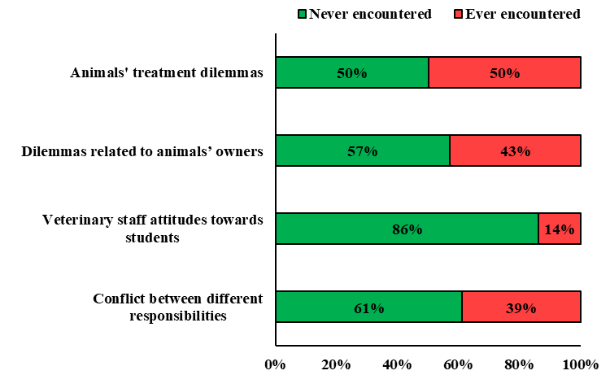
b. Year 2014
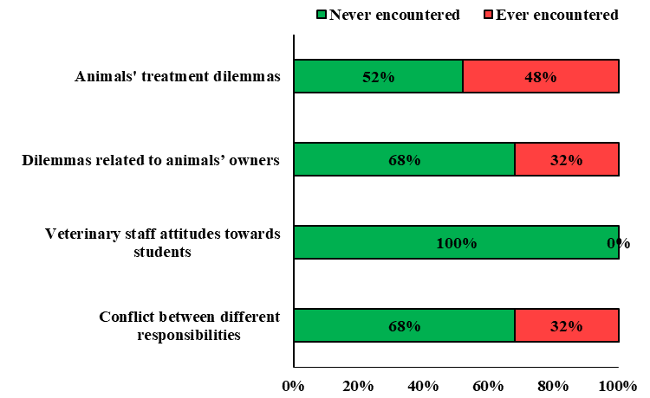

Associations between ethical dilemmas and background variables
The association between the background variables of gender, year of study (2011 or 2014), and dietary preferences (omnivores, vegetarians/vegans) with respect to the dilemmas encountered was examined. As hardly any variance was observed in Category III (veterinary staff attitudes toward students), it was omitted from subsequent analyses.
The analyses showed a significant association between dietary preferences and occurrences of dilemmas in Category II (Dilemmas related to animal owners; z = -2.62, p = 0.02). Thus, vegetarians and vegans reported more occurrences of such dilemmas, compared with omnivores. No significant associations were observed between gender and year of study with respect to the occurrences of dilemmas related to Categories I, II, or IV. Furthermore, no significant associations were observed between dietary preferences and dilemmas related to Categories I and IV (see detailed results in Appendix 26 [online material]).

Associations among ethical dilemmas, stress, and attitudes toward animals
The associations among stress variables (PSS and VSRS), and attitudes toward animals variables (TAS and Empathy with Animals scale score), with occurrences of the dilemmas were examined. Furthermore, a more refined analysis was conducted, which examined the association between the occurrence of each dilemma composing Category I (Animal treatment dilemmas) and the VSRS score. The latter scale was chosen for this analysis because, unlike the PSS, which measures general stress, the VSRS is geared toward events that are specific to veterinary studies (e.g., “dealing with the death of patients,” “dealing with other students,” etc.). Thus, significant correlations between the VSRS and the occurrence of ethical dilemmas could support our hypothesis that ethical dilemmas and moral distress are experienced by fourth year students.
Analyses were conducted using the Mann–Whitney test and Spearman correlations.

Regarding stress and attitudes toward the welfare of agricultural animals, significant associations were found between the VSRS (Veterinary studies related stress) and occurrence of dilemmas in Category II (dilemmas related to animal owners, r_{s} = 0.34, p = 0.01) and category IV (Conflict between different responsibilities, r_{s} = 0.43, p < 0.001). This indicated that students who reported higher levels of stress specific to veterinary school (VSRS) also tended to report more occurrences of the relevant dilemmas. No significant associations were observed between PSS, TAS, or FTA scores and the occurrences of dilemmas related to Categories I, II, or IV. Likewise, no significant associations were observed between the VSRS and dilemmas related to Category I (see detailed results in Appendix 27 [online material]).
Furthermore, the association between the response for each dilemma comprising Category I (see list in the first section above) with the VSRS score was examined. The response for each dilemma could have been “Yes” (i.e., the student reportedly encountered the specific dilemma) or “No” (i.e., the student reportedly did not encounter the specific dilemma). The VSRS scores were compared between these two responses. The analysis showed no significant association between the type of response to each of the seven dilemmas and the VSRS score (see detailed results in Appendix 28 [online material]).

Summary of part V
This part of the work explored three aspects of ethical dilemmas encountered during fourth year studies in veterinary school as follows: 1) Description of the four categories of ethical dilemmas encountered by the students. 2) Analyses of possible associations between reported encounters with the dilemmas and demographic variables of the students. 3) Possible associations among reported encounters with the dilemmas, stress levels, and attitudes toward agricultural animals.
The dilemmas most frequently encountered by the students were those related to the treatment of animals (Category I). Notably, there were hardly any encounters with dilemmas concerning staff attitudes toward the students (Category III).
Significant associations were observed between the dietary preferences of students and dilemmas related to animals’ owners (Category II). In addition, vegetarians and vegans reported a greater number of encounters with such dilemmas compared with omnivores.
The analyses of possible associations between stress and ethical dilemmas unique to veterinary studies, revealed associations between VSRS and the dilemmas of categories II and IV (conflict between different responsibilities). Students who reported more encounters with these dilemmas also reported higher levels of VSRS.

Appendix_1_Animal_pain.xls
Appendix_2_Animal_boredom.xls
Appendix_3_Animal_pain_by_gender.xls ³ Appendix_4_Animal_boredom_by_gender.xls
Appendix_5_Rodents_pain.xls
Appendix_6_Farm_animals_pain.xls
Appendix_7_Pets_pain.xls ⁷ Appendix_8_Monkeys_pain.xls
Appendix_9_Rodents_boredom.xls
Appendix_10_Farm_animals_boredom.xls
Appendix_11_Pets_boredom.xls
Appendix_12_Monkeys_boredom.xls
Appendix_13_TAS.xls
Appendix_14_TAS_with_gender.xls
Appendix_15_TAS_with_religiosity.xls
Appendix_16_TAS_with_diet.xls
Appendix_17_TAS_with_practice_plans.xls
Appendix_18_PSS.xls
Appendix_19_VSRS.xls
Appendix_20_SWLS.xls
Appendix_21_RSE.xls
Appendix_22_PSS_with_gender.xls
Appendix_23_VSRS_with_gender.xls
Appendix_24_SWLS_with_gender.xls
Appendix_25_RSE_with_gender.xls
Appendix_26_Dilemmas_background_vars1.xls
Appendix_27_Dilemmas_background_vars2.xls
Appendix_28_Dilemmas_VSRS.xls

