**COMPARISON OF OCULAR MANIFESTATIONS BTWEEN TWO DIFFERENT GROUPS OF PATIENTS WITH CONGENITAL INSENSITIVITY TO PAIN**

**BAKER ELSANA, LIBE GRADSTEIN, AHED IMTIRAT, RONIT YAGEV, OREN INY, EREZ TSUMI**

*`*

Ophthalmology Department, Soroka University Medical Center and Clalit Health Services, Beer Sheva, Israel. Affiliated to theFaculty of Health Sciences, Ben-Gurion University of the Negev, Beer Sheva,

Israel.

Pediatric ambulatory services, Saban Pediatric Medical Center for Israel, Soroka University Medical Center.

Inquiries to:

Baker Elsana, Ophthalmology Department, Soroka University Medical Center

Ben-Gurion University of the Negev, Beer-Sheva 84101, Israel.

Email: [bakerelsana1@gmail.com](mailto:bakerelsana1@gmail.com)

**Abstract**

**Purpose:** To describe ocular manifestations among children with Congenital insensitivity to pain (CIP) and to analyze the natural history of their ocular disease.

**Design:** Retrospective observational case series.

**Methods**: Records of all patients who visited the outpatient clinic at Soroka medical center with confirmed diagnosis of CIP syndrome were reviewed. Diagnosis was established by clinical criteria and by genetic analysis. Collected data included demographic information, medical history, ocular surgeries, genetic analysis, and ophthalmic examination. Retrieved data included visual acuity, cycloplegic refraction, ocular surface findings, corneal sensitivity, tear film production and fundoscopy.

**Results**: A total of 6 patients, equally divided into two groups. 3 had mutations at the PRDM12 gene and 3 had mutations at the SCN9Agene. Mean follow-up time was 56 months and 130 months, respectively. Corneal opacities were found in 5/6 eyes and in 2/6 eyes of 2 different patients, respectively. Most patients in the first group had diffuse and dense superficial punctate keratopathies (SPK), while among patients in the second group dense SPK were found in 4/6 eyes and no SPK in both eyes of 1 patient. Schirmer was normal in the first group but reduced among all eyes of the second group. Corneal reflex was absent in all patients of the first group, versus positive in both eyes of 2/3 patients from group 2. Best corrected visual acuity (BCVA) was ≤ 20/40 in most patients from the first group, while among patients from group 2, it was 20/30, except one eye of two patients who had BCVA of 20/80 and 20/200.

**Conclusion:** In conclusion, patients with PRDM12 CIP have a poorer prognosis, with severe corneal involvement, and lower BCVA in comparison to patients with mutation at the SCN9A gene.

**Introduction**  
Congenital insensitivity to pain (CIP) is part of a group of extremely rare autosomal recessive neuropathies characterized by the inability to perceive noxious stimuli as pain and heat. It belongs to a group of hereditary sensory and autonomic neuropathies (HSAN).1The current classification is based on a genetic diagnosis. Yet, the exact prevalence of this group of disorders remains poorly known.2 CIP patients are predisposed to multiple self-inflicting injuries such as biting of lips and finger, self extraction of teeth and are more prone to bone fractures and burns. Other complications include charcot joints, poorly healing injuries and abscesses may cause permanent orthopedic devastating disabilities while intellectual ability and sweat function are preserved.2 Currently several mutations were found to be correlated with development of CIP. Among them a missense mutation in voltage-gated sodium channel type IX α subunit (SCN9A*)* that cause loss of function of voltage-gated sodium channels in sensory neurons, phenotypically characterized with insensitivity to pain and anosmia while Other sensorial modalities are Intact3 and mutations in the epigenetic regulator PR domain zinc finger protein 12 (*PRDM12* ) that interrupt the normal development of nociceptive sensory neurons.4

The ocular manifestations of CIP are thought to be related to impaired corneal innervation and include dry eye syndrome, superficial punctate keratopathies(SPKs), corneal opacities, neurotrophic keratopathy and corneal ulcers.5 PRDM12 mutation is correlated with reduced lacrimation, corneal abrasions and reduced or absent corneal reflex, causing keratitis and corneal scarring.4, 6 the current literature regarding ocular manifestations among patients with *SCN9A* are inconclusive and based on small scale studies.

The aim of this study is to describe ocular findings, and to compare the natural history of the disease, among these two most prevalent groups of CIP patients**.**

**Methods**

A retrospective case series of all patients with confirmed diagnosis of CIP who visited the outpatient clinic at Soroka University Medical Center (SUMC), a tertiary referral center located in Southern Israel, between 2007-2019. All patients were followed by an ophthalmologist and a pediatrician at the CIPA outpatient unit at SUMC. Demographic data, as well as medical history were obtained from computerized medical records. The collected ophthalmic data included visual acuity, cycloplegic refraction, presence of corneal opacities, SPKs, corneal sensitivity, tear breakup time (TBUT), Schirmer test, and posterior segment findings. Data of ancillary exams, such as corneal tomography and anterior segment photos were included if performed. Visual acuity (VA) was evaluated by Snellen chart. SPKs were measured according to the SPKs grading method.7 The area and density of the lesions were used as parameters to quantify SPKs, where A represents the area of the lesion ranging from A0 – no staining to A3- area occupies more than two thirds of the cornea, and D represents the density ranging from D0- no punctate staining to D3- high density and lesions overlap.

Corneal sensitivity was assessed by cotton thread.

Tears production was evaluated by Schirmer test. After instillation of Oxybuprocaine hydrochloride 0.4% for local anesthesia, Schirmer strip (TearFlo®) were inserted into the lower fornix, avoiding touching the cornea. The length of wetting strips in millimeters was recorded after 5 minutes.

Corneal opacity was assessed by three parameters: location (central, eccentric or peripheral), diameter (less than 2mm, between 2 and 4 mm or more than 4mm), and depth (subepithelial, stromal- superficial or deep). Active corneal ulcer was defined as a corneal infiltrate with epithelial defect and was described by location, diameter and depth. All patients were genetically diagnosed at the Institute of Human Genetics at SUMC by real time -PCR technique. The research was approved by SUMC Institutional Review Board and Ethics Committee and adhered to the tents of the Declaration of Helsinki.

**Results**

All demographic data and results are summarized in table 1. A total of 6 patients genetically diagnosed with CIP, divided into two groups (A and B) of 3 patients, Group A with mutation at the PRDM12 gene, and Group B with mutation at the SCN9A gene. Group A consist of two first degree siblings (sister and brother), an offspring from a consanguineous marriage and a third unrelated patient (11, 3 and 6 years old). Group B consist of 3 sisters (24,16, and 13 years old), born to a same father, but from two different mothers. Mean follow up time was 56 months (23-94 months), and 130 months (121-143 months) for group A and B respectively.

All patients in group A versus 2 patients in group B (66%), 24 and 13 years old, were presented to the outpatient clinic or to the ophthalmic emergency room with corneal ulcer by the first year of life, they were hospitalized, and treated aggressively with topical and sub conjunctival fortified antibiotics, and by lateral tarsorrhaphy (LT).

In group A, the brother (3 years old) had repeated amniotic membrane (AM) transplant. In total he underwent repeated LT and AM transplant on both eyes (6-5, and 7-8, respectively) due to non healing corneal ulcers, he also required two corneal covering graft transplantations due to descemetocele on his left eye.

All patients in both groups had signs of dry eye syndrome with variable severity, measurements of tear break-up time and Schirmer test were conducted among these group of patients.

In group B, short tear break-up time and abnormal result of Schirmer test were measured in two patients (66%), 16 and 13 years old. Signs of moderate dry eye syndrome with localized and dense SPK were observed among two patients (66%), 24 and 13 years old, while no signs of dry eye syndrome were observed among the 3rd 16 year old patient. All patients in both groups required constant treatment with eye lubrication, and 100% of patients in groups A, and 66% of patients in group B, 24 and 13 years old, underwent therapeutic lateral tarsorrhaphy due to severe dry eye syndrome. In addition, In group A the brother and sister (66% of patients), 3 and 11 year old, underwent therapeutic punctal occlusion.

Corneal reflex was absent (4 of 6 eyes, 66%), or could not be defined (2 of 6 eyes, 33%) among patients in group A versus a conserved corneal reflex among two sisters, 24 and 13 years old (4 of 6 eyes, 66%), and absent (2 of 6 eyes, 33%) in the 16 year old sister in group B.

Corneal opacities were observed in 5 of 6 eyes in group A (83%) versus 2 of 6 eyes in group B (33%).

In group A, visual acuity on last follow up visit was 20/30 on both eyes for the 11 year old sister, the 3 years old brother had light perception (LP) in his right eye and VA could not be determined in the other eye. For the unrelated third patient 20/200 in his right eye and 20/40 in his left eye. While, in group B, two of the sisters, 24 and 13 year old, has developed amblyopia, visual acuity on last follow up visit was 20/200 and 20/80 in the amblyopic eye respectively, versus 20/30 on the non amblyopic eye. Both had corneal opacities and astigmatism at the amblyopic eye. The 3rd patient, the 16 year old sister, had visual acquity of 20/30 in both eyes on last follow up visit, with bilateral clear corneas and no signs of dry eye syndrome.

**Discussion**

Congenital insensitivity to pain is a rare disorder, little is known about the disease course regarding ocular manifestation of patients with CIP, and a comparison between patients with different genetic mutations have not been made yet. In this study we conducted a comparison of ocular manifestations among patients with CIP disease who has mutation at the PRDM12 gene versus patients who has mutation at the SCN9Agene.

In our study, patients with mutation at the PRDM12 gene tended to have a poorer prognosis in comparison to patients with mutation at the SCN9Agene. All had absent corneal reflex, versus all but one patient in group B.

Higher SPK grade among all patients in group A versus milder SPK grade among 2 patients in group B (66%), and no SPK among the 3rd patient. Tear production was decreased among all patients in group B, versus a normal tear production among the only patient that had it measured in group A.

Corneal opacities and SPK grade were more pronounced among all patients in group A versus only 33% among patients in group B (2 of 6 eyes in two patients).

Patients from both groups had refractory non healing corneal ulcers that required surgical procedures in order to achieve resolution. Though they were more frequent and tended to be more severe and difficult to treat among patients with mutation at the PRDM12 gene in comparison to patients with mutation at the SCN9A gene.

Similar results has been demonstrated in previous studies among patients with mutation at the PRDM12 gene, including absent corneal reflex, corneal scaring and impaired tear production.4,6 While, ocular findings among patients with *SCN9A* mutation are variable, in one case series on 3 patients (31,34 and 44 years old) corneal reflex was intact.8 But, in a previous study from Israel, on 4 patients, of which, 3 were included in this study, all had decreased (75%), or absent (25%) corneal reflex. While, lacrimal production was normal.3 One case report described a patient with mutation at the SCN9A gene who had absent corneal reflex and has developed bilateral sterile corneal ulcer that was attributed to neurotrophic keratopathy.9

It is known that mutation in SCN9A gene cause non function of nociceptive sensory neurons in dorsal root ganglia (DRG) and trigeminal ganglia (TG) throw a defect in the voltage gated sodium channels. PRDM12 mutation causes CIP by undeveloped nociceptive neurons namely Aδ and C nerve fibers. Corneal nerves also play a role in the homeostasis and the normal regeneration of corneal epithelium by secreting various neuropeptides, among them NGF and substance P (SP). Moreover, corneal nerve impairment is responsible for epithelial defects, ulcerations, corneal perforations, and reduced function of corneolimbal stem cells as part of neurotrophic keratopathy.10

All cases of corneal ulcer occurred until the age of 2 years old, except one repetitive case at age of 10 years old. One explanation could be that parents were not aware to possible complications of the disease before the first episode.

In conclusion we noticed that patient with *PRDM12* have a more serious ocular involvement in comparison to patients with *SCN9A*. But both can develop corneal ulcer at an early age. Final outcome tended to be better among patients with SCN9A mutation. This is probably because some degree of preserved corneal sensitivity in SCN9A patients in comparison to patients with PRDM12 mutation. Therefore, ocular manifestations in both groups may represent variable degrees of neurotrophic keratopathy and the different manifestations are due to a variable degree of corneal hypoesthesia or anesthesia. Our case series is highly limited due to a small number of patients, lack of control, and by its retrospective nature. More studies are required in order to determine the genotype phenotype correlation in these disorders.

**References**

1. Dyck PJ, Mellinger JF, Reagan TJ, et al. Not “indifference to pain” but varieties of hereditary sensory and autonomic neuropathy. *Brain*. 1983;106(2):373-390. doi:10.1093/brain/106.2.373

2. Katherine Schon, MB ChB, MRCP, MA, Alasdair Parker, MBBS, MRCP, MD, MA, and Christopher Geoffrey Woods, MB ChB, FRCP Fm. Congenital Insensitivity to Pain Overview. *GeneReviews® [Internet]*. 2018.

3. Cox JJ, Sheynin J, Shorer Z, et al. Congenital insensitivity to pain: Novel SCN9A missense and in-frame deletion mutations. *Hum Mutat*. 2010;31(9):1670-1686. doi:10.1002/humu.21325

4. Chen YC, Auer-Grumbach M, Matsukawa S, et al. Transcriptional regulator PRDM12 is essential for human pain perception. *Nat Genet*. 2015;47(7):803-808. doi:10.1038/ng.3308

5. Mimura T, Amano S. In Vivo Confocal Microscopy of Hereditary Sensory and Autonomic Neuropathy. 2008:940-945. doi:10.1080/02713680802450992

6. Zhang S, Sharif SM, Chen Y, et al. Clinical features for diagnosis and management of patients with PRDM12 congenital insensitivity to pain. 2016:533-535. doi:10.1136/jmedgenet-2015-103646

7. Miyata K, Amano S, Sawa M, Nishida T. A Novel Grading Method for Superficial Punctate Keratopathy Magnitude and Its Correlation With Corneal Epithelial Permeability. *Arch Ophthalmol*. 2003;121(11):1537-1539. doi:10.1001/archopht.121.11.1537

8. McDermott LA, Weir GA, Themistocleous AC, et al. Defining the Functional Role of Na V 1.7 in Human Nociception. *Neuron*. 2019;101(5):905-919.e8. doi:10.1016/j.neuron.2019.01.047

9. Jarade EF, El-Sheikh HF, Tabbara KF. Indolent corneal ulcers in a patient with congenital insensitivity to pain with anhidrosis: A case report and literature review. *Eur J Ophthalmol*. 2002;12(1):60-65. doi:10.1177/112067210201200112

10. Shaheen BS, Bakir M, Jain S. Corneal nerves in health and disease. *Surv Ophthalmol*. 2014;59(3):263-285. doi:10.1016/j.survophthal.2013.09.002

**Fig. 1.** Pedigree of Family with CIP (right. Filled symbols indicate affected individuals. Small round filled symbols indicate abortions. Squires indicate males, circles – females. Diagonal lin across the symbol – deceased individual.

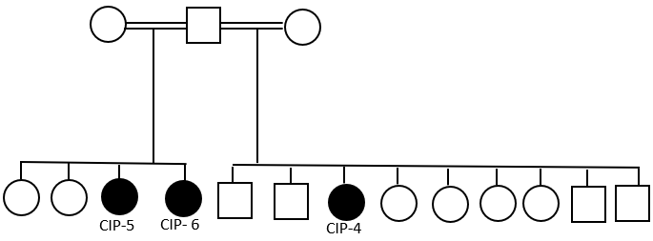

Table 1- Demographic data and ocular findings of patients with CIP.

FU= follow up; CO= corneal opacity; CS= corneal sensitivity; CT= cotton thread; SPK= superficial punctate keratopathy; TBUT (seconds)= tear break up time; M= male; F= female; mm= millimeters; yo= years old; LT= lateral tarsorrhaphy; CXL= cross linking; AM= amniotic membrane; CCG= corneal covering graft; PO= punctal occlusion; ET= esotropia; NA= not applicable; NF= not found; CSM= Central, Steady, Maintained; LP= light perception. Visual acuity: referred as best corrected visual acuity at first visit and last visit. SPK grade- represented by area (A) ranging from A0- no staining to A3- diffuse staining. and density (D) ranging from D0- no staining to D3- lesions are dense and coalescent. Visual acuity is referred as first available VA and VA at the last visit.

|  |  |  |  |  |  |  |  |  |  |  |  |  |  |  |  |  |  |  |
| --- | --- | --- | --- | --- | --- | --- | --- | --- | --- | --- | --- | --- | --- | --- | --- | --- | --- | --- |
|  |  | **Age** | **Gender** | **Consanguinity** | **mutation** | **FU** | **EYE** | **visual acuity** | | **CO** | **CS** | **Refraction** | **SPK Grade**  **A D** | | **TBUT** | **Schirmer** | **Corneal abscess** | **other** |
| **family 1** | **1** | **11** | **F** | **+** | **PRDM12** | **94** | **RIGHT** | **6/7.5** | **6/9** | **-** | **-** | **+2.25-3.50X175** | **3** | **3** | **NA** | **25** |  | **LT, PO** |
|  |  |  |  |  |  | **LEFT** | **6/21** | **6/9** | **+** | **-** | **+3.50-3.25X40** | **3** | **3** | **NA** | **30** | **2,10 YO** | **LT, PO** |
| **2** | **3** | **M** | **+** | **PRDM12** | **23** | **RIGHT** | **NF** | **LP** | **+** | **-** | **NA** | **3** | **3** | **NA** | **NA** | **1 YO** | **6AM+7LT, , PO** |
|  |  |  |  |  |  | **LEFT** | **NF** | **NA** | **+** | **-** | **NA** | **3** | **3** | **NA** | **NA** | **1 YO** | **5AM+8LT, 2CCG, PO.**  **ET, TRICHIASIS** |
|  | **3** | **6.06** | **M** | **NA** | **PRDM12** | **53** | **RIGHT** | **CSM** | **6/60** | **+** | **NA** | **NA** | **NA** | **NA** | **NA** | **NA** | **1 YO** | **LT** |
|  |  |  |  |  |  |  | **LEFT** | **CSM** | **6/12** | **+** | **NA** | **+3.25-2.00X15** | **NA** | **NA** | **NA** | **NA** | **2 YO** | **LT** |
| **family 2** | **4** | **24.05** | **F** | **+** | **SCN9A** | **143** | **RIGHT** | **NF** | **6/60** | **+** | **+** | **-0.75-4.50X145** | **2** | **3** | **7** | **3** | **1 YO,3LT** | **Amblyopia** |
|  |  |  |  |  |  | **LEFT** | **NF** | **6/9** | **-** | **+** | **+1.00-0.50X14** | **1** | **3** | **7** | **7** |  |  |
| **5** | **16.01** | **F** | **+** | **SCN9A** | **128** | **RIGHT** | **6/9** | **6/9** | **-** | **-** | **PLANO** | **0** | **0** | **3** | **<1** |  |  |
|  |  |  |  |  |  | **LEFT** | **6/9** | **6/9** | **-** | **-** | **PLANO** | **0** | **0** | **7** | **<1** |  |  |
| **6** | **13.06** | **F** | **+** | **SCN9A** | **121** | **RIGHT** | **6/18** | **6/24** | **+** | **+** | **+5.25-5.00 X40** | **1** | **3** | **2** | **<1** | **1 YO, LT,** |  |
|  |  |  |  |  |  | **LEFT** | **6/12** | **6/9** | **-** | **+** | **+4.25-1.00X179** | **1** | **3** | **2** | **<1** |  |  |

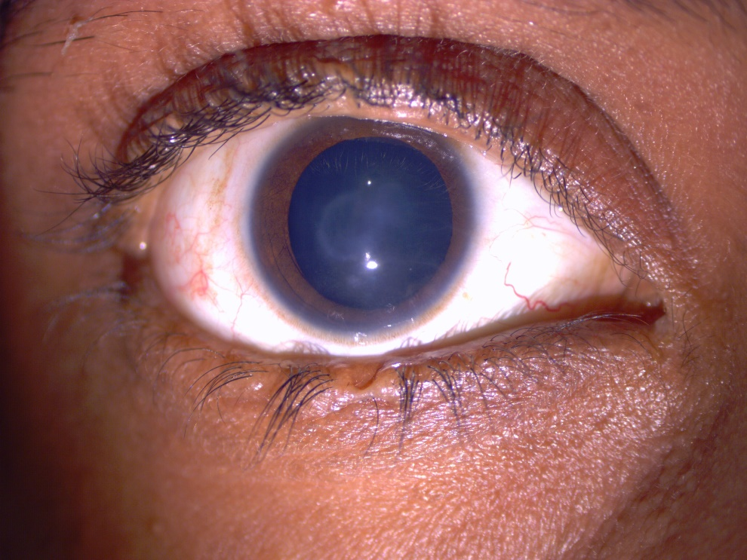

Figure 1: right eye of patient CIP 5. Central corneal opacity. note the notch in upper and lower eyelids where tarsorrhaphy was mad.

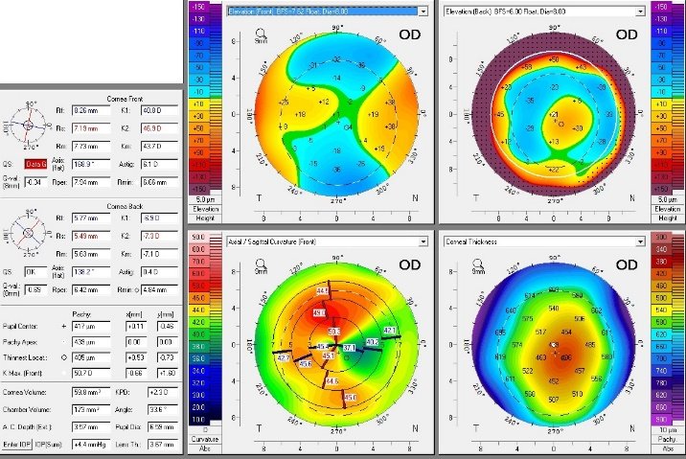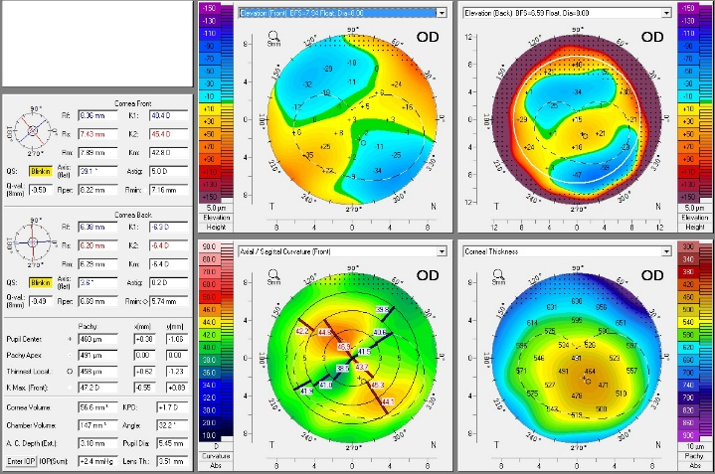

Figure 6: PENTACAM® tomography, right eye of patients CIP4 and CIP5 respectively showing high with the role astigmatism.