**Histologic and Immunohistochemical Features of Vulvovaginal Tissues following Pixel CO2 Laser Treatment of Vulvar Atrophy and Lichen Sclerosus**

Rachel RIBAK1, Diana PRUS2, Eli PIKARSKI2, Ahinoam LEV-SAGIE3

1 Department of Obstetrics and Gynecology, Meir Medical Center, Kfar Saba, Israel, Affiliated to Tel-Aviv University

2 Department of Pathology, Hadassah-Hebrew University Medical Center, Jerusalem, Israel

3 Department of Obstetrics and Gynecology, Hadassah-Hebrew University Medical Center, Jerusalem, Israel

Disclosure statement:  “The author(s) report(s) no conflict of interest.”

Sources of financial support:

Clinical trial identification number and URL of the registration site.

Corresponding Author:

Ahinoam Lev-Sagie, MD

Department of Obstetrics and Gynecology, Hadassah-Hebrew University Medical Center, Jerusalem, Israel

Email: levsagie@netvision.net.il

Telephone: +972-52-5223933

Fax: +972-74-7405516

WORD COUNT:

***Condensation, Implications and Contributions, and short version of title***

On the next page of the manuscript, supply:

• 1) Condensation: a 1-sentence condensation of the paper, consisting of no more than 25 words, stating its essential point(s); this sentence, which is subject to copy editing in conformance with Journal style, will appear in the Table of Contents.

• 2) Short Title: a short version of the article title, for the identification line inserted at the bottom of each published table and figure.

• 3) AJOG at a Glance: Applies to Original Research and Systematic Review submissions. This section is limited to no more than 130 words, 1-3 short sentences or phrases in bullet form, briefly describing your study, its significance, and its contribution to the literature. Responses should be listed in bullet form with A., B., and C., headings (not in paragraph form). All responses are subject to minor editorial alterations and/or shortened without the authors' approval, and published both in print and on the Journal website.

• A. Why was this study conducted?

• B. What are the key findings?

• C. What does this study add to what is already known?

# Abstract

Keywords: as many alphabetized key words or short phrases as needed for indexing

# Introduction

Fractionated CO2 laser technology has been introduced in recent years as a treatment for various gynecological conditions, including Genitourinary Syndrome of Menopause (GSM),1–10 urinary incontinence, 7,11,12 vulvodynia 13 and lichen sclerosus.14–16 The treatment is based of delivery of CO2 laser energy via a designated vaginal probe, causing minimal and superficial tissue ablation and deeper thermal deposition of the energy.17 Based on studies conducted in dermal tissues, it is suggested that this microablative action results with proliferation of fibroblasts 18), collagen and elastic fibers remodeling,18 angiogenesis,19–21 stimulation of heat shock proteins, 19 and production of extracellular matrix components, 17,19 resulting with overall tissue remodulation.

Genitourinary syndrome of menopause (GSM), previously referred to as vulvovaginal atrophy (VVA), is a collection of urogenital symptoms associated with hypoestrogenic state, including dryness, burning, irritation, lack of lubrication, itching, pain, dyspareunia, impaired sexual function as well as urinary symptoms of urgency, dysuria and recurrent urinary tract infections. 22 With estrogen withdrawal during menopause, significant physiological changes occur in the urogenital tissues whereas the vaginal epithelium becomes pale, thin and less elastic. The vagina can narrow and shorten and the introitus may constrict.23 Histologic changes include reduced collagen content and hyalinization, decreased elastin, altered appearance and function of smooth muscle cells, increased density of connective tissue, and fewer blood vessels.22 Topical hormonal treatment is considered the gold standard therapy for postmenopausal vaginal symptoms, promoting restoration of epithelial integrity and improving symptoms.24 However, in the last decade multiple studies suggested that fractional CO2 laser may be as efficient as hormonal therapy to treat GSM 17,25) According to these studies, a substantial improvement in patients with GSM was achieved after three treatments,1,4,6–8,10,26,27 comparable to topical estrogen treatment.28

Lichen sclerosus (LS) is a chronic, benign, inflammatory skin disease of unknown etiology which can occur at any site, but has a predilection for the ano-genital area. In the majority of patients the disease is progressive, causing vulvar scarring, loss of portions or all of the labia minora (“resorption”), clitoral adhesion and narrowing of the introitus. 29See comment in PubMed Commons below Symptoms of LS include pruritus, soreness, irritation and pain. It most frequently affects the labia minora and labia majora, clitoris and clitoral hood, and it may also involve the peri-anal skin. LS usually require permanent management with topical corticosteroids to maintain remission.30 Previous reports of CO2 laser treatment in women with vulvar LS have shown promising results, in which patients who were refractory to ultrapotent topical steroids improved following laser treatment. 11,14,15

Due to its ease of use, the possible advantage as a clinic-based procedure and the opportunity to avoid hormonal and other chronic topical treatments, this treatment modality gained popularity as a possible option for various vulvovaginal disorders in recent years. Multiple observational studies were published, with favorable results, however, these studies lack sham-control, and often based their conclusions on subjective measures. In addition, the histological data is scarce, 18,31 and the actual mechanism of action in genital tissues is not understood.

The purpose of this study was to evaluate tissue histologic and immunohistochemical changes following laser treatment in vulvovaginal atrophy and LS, in order to understand its possible mechanism of action.

# Material and Methods

This was a prospective cohort-study of sixteen women. Patients were recruited from the Clinic for Vulvovaginal disorders at the Hadassah University Medical Center from January 2017 to December 2017. Eight had biopsy-conﬁrmed LS and eight were diagnosed with vaginal atrophy (see below).

The study was approved by the local Institutional Review Board, Clinicaltrial.gov NCT03063684.

## Vaginal atrophy

Inclusion criteria were: menopause≥1 year; at least one of the following GSM symptoms: vaginal dryness, itching, burning, irritation, dysuria, dyspareunia or lack of lubrication; vaginal atrophy upon gynecological examination, defined as Vaginal Health Index (VHI) <15; pH≥5.1; Vaginal Maturation Index (VMI), calculated according to the percentage of parabasal, intermediate, and mature-squamous epithelial cells 32) showing a value of 0 to 49, indicating atrophy; normal cervical cytologic screening within 12 months. Exclusion criteria included other possible causes for patients' symptoms, such as candida vaginitis, bacterial vaginosis, desquamative inflammatory vaginitis, sexually transmitted infections, vulvar dermatosis or dermatitis, pelvic organ prolapse, previous vaginal operation, history of uro-genital dysplasia or malignancy, undiagnosed genital bleeding, usage of antidepressants, anti-coagulants or chronic use of analgesics. Patients were requested to avoid usage of systemic or topical hormonal medications three months before enrollment.

Included patients signed the informed consent form and completed a questionnaire detailing demographics, general health history, obstetrics and gynecological history (Annex 1), genital symptoms and previous treatments.

Patients underwent a gynecological examination using a speculum, in which the vaginal health index (VHI) was assessed , and a vaginal swab was taken from the middle third of the vagina using a cotton swab, smeared on a glass slide and sprayed with a fixative for cytological evaluation, the VMI.33 In addition, vaginal pH measurement was obtained using a pH-indicator strip (pH range 4 – 8, Merck, Germany). Following examination, a 5 mm punch biopsy was taken from the middle third of the vagina, under local anesthesia.

Patients were requested to start laser-therapy at least 4 weeks from the initial assessment, allowing healing of the biopsy-wound. All participants received 3 laser treatments, using the Femilift fractional micro ablative CO2 laser system (Alma Lasers, Israel), according to the recommended protocol (Laser mode: Pulse, Energy: 40-80 mj/pulse). Treatments were conducted in a 4-5 weekly intervals (Figure 1). The treatment was conducted using a designated vaginal probe (Figure 2a) which allows treatment of vaginal and vestibular tissues.

Before treatment, 5ml of topical anesthetic ointment (compounded 10% lidocaine in Vaseline base) was spread in the vagina and on the vestibule for 30-60 minutes to prevent pain during the treatment. Following each treatment, patients were requested to abstain from vaginal intercourse for one week.

In every visit during the study, patients underwent a speculum examination to assess VHI, pH and VMI, and completed a questionnaire evaluating GSM symptoms, using a visual analogue scale (VAS) for each symptom (vaginal dryness, dyspareunia, burning, itch, discomfort and dysuria) as well as treatment induced pain, side effects and overall satisfaction from the treatment's results.

Within a month following the third treatment, another biopsy was taken in a similar way to the first biopsy. After the second biopsy, patients were given the option to end treatments or continue up to 3 more laser-sessions, in case their symptoms persisted. During each follow-up visits 4-6, patients were requested to report symptoms and were examined as detailed above. In case they reported resolution of symptoms, requested to withdraw from additional treatments or signs of atrophy resolved (pH<5 and VMI>65), they were withdrawn from receiving further treatments. Otherwise, every patient received 6 treatments.

During the study period, patients were requested to avoid vaginal lubricants and moisturizers, as well as usage of systemic or local hormonal preparations. A third biopsy was planned a year after the final treatment.

Histology and immunohistochemical staining were done for Hematoxylin and Eosin (H&E), Masson’s trichrome in order to distinguish collagen fibers from the connective tissue in the dermis, and immunohistochemical stains for Estrogen and Progesterone receptors, P63, as an indicator for proliferation in the basal cell membrane, P16, KI-67, as a marker of proliferative activity, in basal and parabasal cells in normal squamous epithelium and CD 34, as a marker for vascularization.

CD34 and ????.

## Lichen sclerosus

Inclusion criteria were symptomatic LS (pruritus, burning, pain, dyspareunia and dysuria attributable to LS), confirmed by biopsy. Exclusion criteria were those detailed above, in addition to a current or planned pregnancy in the upcoming year and a previous vulvar dysplasia. All LS patients had been previously treated with topical corticosteroids ointments (betamethasone valerate 0.1% or clobetasol propionate 0.05%) with either limited efﬁcacy, side effects or dissatisfaction with non-compliance. Patients were requested to stop topical corticosteroid treatment two months prior to the beginning of the study and avoid it during the study period. Pre-treatment assessments included a gynecologic examination and documentation of vulvar findings and symptoms. Photos of the vulva were taken on initial assessment and in each follow-up visit for comparison. A vulvar biopsy was taken using a punch biopsy one month before initiation of laser treatment.

Participants received 3 laser treatments, using Pulse laser mode, with energy settings varying according to patient's toleration to pain (15-60 mj/pulse), after application of 10% lidocaine ointment. Treatments were conducted in a 4-5 weekly intervals. The treatment was conducted using a designated probe (Figure 2b).

In every visit during the study, patients underwent vulvar examination to assess vulvar findings and completed a questionnaire evaluating symptoms, using a VAS for each symptom (itching, burning, discomfort, dryness, dyspareunia and dysuria) as well as treatment induced pain, side effects and overall satisfaction from the treatment's results. Within a month following the third treatment, a second biopsy was taken in a similar way to the first biopsy. Following the third laser treatment, and in every consecutive visit, patients were requested to report whether resolution of symptoms occurred, in such case they were withdrawn from receiving further treatments. Otherwise, every patient received up to 6 treatments.

A third biopsy was planned a year after the final treatment.

Histology and immunohistochemical staining were done as detailed above.

## Statistics

# Results

A total of 16 patients were included in the study, 8 were treated in the lichen sclerosus group and 8 in the vaginal atrophy group (Table 1).

## Vaginal atrophy

All 8 patients completed three vaginal treatments: 5 patients were not satisfied with their condition after 3 treatments and sought to undergo additional treatments, complete the series of 6 treatments; one patient was diagnosed with breast cancer after completing 3 treatments and requested to terminate her participation of the study before the second biopsy was performed; and 2 patients were not interested in continuing treatment after the third treatment even though they did not report complete improvement.

After 3 vaginal treatments, an increase (improvement) in the VHI value (graph 3a) of 4.3 +/- 3.1 was observed, from a mean of 11.5 (range: 9-16) to a mean of 16 (range 13-22). For the five patients who underwent additional treatment, the degree of additional improvement was uneven: some exhibited only slight improvement and some not at all (for the range of 13-23). The average improvement was 0.05.

pH values showed a decrease (improvement) of 1.8 ± 2.4 units (Graph 3b) from 6.7 to 5.5. In the 5 patients who received additional treatments, there was no further improvement in pH value.

VMI values (Graph 3c) showed that all patients demonstrated atrophy (range 0-40, mean 2) before beginning treatments. After 3 treatments, an improvement was observed, with an increase of VMI values to the range of 15-95 (mean 40, average 47) − in total, an improvement of 21% in VMI values (P = 0.018). After the third treatment, two patients had normal VMI values (above 65), one patient has a VMI value that indicated light atrophy (VMI - 60) and 5 patients had VMI values of 22-39, meaning that despite a relative improvement in values, atrophy could still be detected based on cytological indicators. For patients who continued treatments beyond the third treatment, only one showed additional improvement, while the VMI values of the other patients did not change subsequent to the third treatment.

Also, in the subjective report regarding GSM symptoms according VAS values, the patients reported a decrease in vaginal dryness, burning, discomfort, dyspareunia and burning during urination (Graph 4).

No serious adverse events were reported. Three patients experienced episodes of urinary tract infection following treatments. All were treated with antibiotic therapy and resumed laser therapy as scheduled. All eight participants reported vaginal discomfort during the laser procedure, albeit topical anesthetics. Pain was reported especially with vestibular treatment, necessitating remarkable reduction of laser energy in the vestibule. Most of the women reported vaginal irritation, discomfort, and discharge, sometimes with a scant amount of blood, in the days following laser treatment.

In examining sections stained with Hematoxylin and Eosin, in 5 of the 7 patients no significant change was observed in the appearance of the epithelium before and after treatment. A histological change was observed in 2 patients (Fig. 5). After three sessions of laser treatment, epidermal thickening was observed and the cells were observed to become the SUPERFICIAL type, with an increase in glycogen (the hollow areas of the epidermis layer).

Since most women did not show a change in the appearance of the tissue and the staining of the imonistochemious after 3 treatments, it was decided to refrain from performing a further biopsy a year later, based on the assumption that if no changes were observed after the treatment, there would be no changes a year later, and because the patients stated that despite a partial improvement in their condition, they could not promise that they would not use topical estrogen.

The results of the immunohistochemical staining in the epidermis and dermis tissue are shown in Table 2.

Because receptor estrogen levels were elevated from the beginning in both the epidermis and the dermis, an increase in their levels was not observed. The levels of progesterone receptors did not show a consistent image in the dermis or epidermis and no staining was exhibited for P16, which was not detected in the epidermis layer, while the dermis layer did not exhibit a consistent trend.

The staining which has consistently observed in all the women with a vaginal atrophy after the laser treatment was the colorization of P63 in the epidermal layer. This consistent increase can be seen in graph No. 5.

## Lichen sclerosis

One patient requested to terminate participation after the first 3 cycles of treatment, five patients finished 6 cycles of treatment, one patient completed 5 treatments, and one other patient completed 4 treatments.

Most patients could not tolerate the pain associated with vulvar laser treatment, and therefore were treated with energy levels of 15-30 mj/pulse.

Examination of the genitalia and also the comparison of images during treatments either demonstrate no improvement whatsoever, or alternating improvement and deterioration.

Even though the clinical findings did not demonstrate any change, after 3 cycles of treatment, a reduction of 1.4 ± 1.2 (VAS from 6.4 to 5) was observed regarding complaints about vulvar itching (Fig. ?) and 7 patients reported feeling less irritation by an average of 2.4 ± 2.3 (from 6.8 to 4.1). A non-uniform change was observed in relation to the burning and dyspareunia, where some reported on improvement and some worsening.

Side effects that were reported included itching and tingling a few days after treatment.

When comparing samples taken before and after treatment, no histological changes (Fig. ??) were observed. After treatment, areas of hyperkeratosis, epidermal atrophy, and hydrophous??? changes to the basal layer were noted. In addition, areas of edema in the dermal layer with characteristic inflammation cells that are typical for lichen sclerosus.

The immunohistochemical staining is shown in Table 3. No consistent changes were observed in the immunohistochemical staining of the biopsies performed before and after treatment.

# Comment

In this study, we wanted to examine whether laser treatment lead to histological changes and changes in the protein expression that indicate tissue aging, in order to understand the mechanisms that apply to the tissue following laser treatment. Similar to previous studies in vaginal atrophy, it was also found in this current study that laser beam treatment – Fractional/Pixel CO2 Laser − led to clinical improvement in women with vaginal atrophy, and this improvement was also demonstrated by objective indices of pH' and VMI. Nevertheless, histological changes were not observed in all patients and immunohistochemical changes were observed only by staining with P63. Despite the therapeutic advantage observed in women with a vaginal etiology, treatment of lichen sclerosus did not show any consistent improvement, neither subjectively or objectively, nor histologically.

In most of the reports published so far, the effectiveness of 3 treatments were tested. This recommendation was not experimentally confirmed, and with the exception of two studies, the number of treatments needed to reach optimal improvement was not determined. In this study, although all the patients reported improvement after three treatments, most of them sought to continue treatments since the improvement was not maximal. The partial improvement is also evident in the VHI index, which showed improvement, although complete improvement to optimal values was not observed, even following the additional treatments for patients who requested to continue treatment. The improvement in the symptoms and the morphological appearance of the vagina was also reflected by cytological and pH indices, which attest to an improvement in vaginal epithelial ripening. However, the VMI values remained in the realm of atrophy for 4 out of 8 patients, and the pH levels also remained above 5, a value that points to atrophy.

The above-mentioned changes were also supported on the hysterological level in two of the samples, which showed an increase in cell stratification in the epidermis layer, an increase in cells differentiation, and an increase in the level of glycogen in the tissue, although the changes were not observed in all patients. In terms of the immunohistochemical changes, observations showed an increase in 63P levels in the epidermis tissue. 63P is a protein that has a role in epithelial development in various organs, and it manifests in the female genital system in the basal and para-basal cells of the cervix's scaly epithelial cells, the vagina, the vulva, and in the "reserve" cells in the area of the epithelial transition zone of the cervix, as well as in immature metaplastic cervical cells and atrophied cells in the cervix. The increase in its level supports the proliferation of para-basal cells under laser treatment.

In the treatment of women with lichen sclerosus, a consistent subjective improvement could be observed only with respect to the indices of itching and discomfort. Changes in burning and dyspareunia were inconsistent and therefore cannot be discussed. In addition, no consistent change in the appearance of the genitalia following the treatment was observed, and some of the women exhibited a worsening in the skin condition following treatment. It is possible that these changes may not represent changes as a result of laser treatment but spontaneous changes in the appearance of the skin due to lichen sclerosus, which is manifested in alternate improvement and worsening, as is also seen in women who have not undergone treatment. Furthermore, histological observations did not show improvement in the genital skin before and after treatment, and we also found no changes in the immunohistochemical staining.

Contrary to what has been reported in other studies, the patients in this study reported experiencing pain during treatment, despite the use of a potent local anesthetic ointment. The sense of pain limited the strength of the laser energy used, specifically in the vestibular tissue and the vaginal skin, which are more sensitive to pain than vaginal tissue. In women with LS, we had to significantly reduce the therapeutic energy due to the experienced pain, and it is possible that the use of relatively low energy levels in the treatment of the vaginal skin was the reason of the lack of improvement in these women.

Given the favorable reports on one hand, its high cost and possible complications on the other hand, it is of question whether laser treatment can replace or add to current treatment, and as such may be an alternative treatment for patients with contraindications, allergies, side effects or low compliance (eden, biglia)

The FDA recently issued [] a statement indicating that there are no energy-based devices currently marketed in the United States that have been cleared for vaginal procedures, including indications for managing GSM, urinary incontinence or other menopause-related conditions. The FDA statement cite numerous adverse events from use of lasers and for these indications, including both surgically related complications and thermal injuries causing burns, scarring, and pain.

In contrast to the FDA’s report, no significant side effects were observed, something that indicates that a careful selection of patients alongside limiting energy levels will not lead to complications. However, this study did not indicate a significant advantage in laser treatment, and other controlled sham??? studies are required to ascertain whether laser treatment is effective and how long the results are retained.

# Highlights (optional)

# Acknowledgement(s)

# References

# NOTE: If you have the doi for the references, you just need to list that and not the http. etc. Simply give the Author.Title. Journal.Year;Vol.:pp. doi (###).

# If you do not have the DOI (because it is unavailable!), Author.Title. Journal.Year;vol:pp. Retrieved from URL. I am not sure if you need [Internet] or the order, since I cannot access a sample article and while the instructions say to follow APA (which doesn’t need [Internet]), they do make changes.

# According to APA, it is unnecessary to include retrieval dates, unless the source changes often over time (like in a Wikipedia article). See no. 3 and 4 for my interpretation of how to do the reference. But please check the refs in any article of this particular journal (I don’t have access) to see how they format an internet-retrieve article.

Note that titles of articles should NOT be in title case. I have fixed this (e.g. 13, 15, 16, etc.) On the other hand, when giving the (non-abbreviated) titles of journals, all the major words ARE capitalized – e.g. it should be Current Opinion in Obstetrics & Gynecology, and not Current opinion in obstetrics & gynecology. However, I have not fixed this as they need to be abbreviated anyway.

1. Salvatore S, Nappi RE, Zerbinati N, et al. A 12-week treatment with fractional CO2 laser for vulvovaginal atrophy: A pilot study. Climacteric. 2014;VOL:pp.

2. Pitsouni E, Grigoriadis T, Falagas M, Tsiveleka A, Salvatore S, Athanasiou S. Microablative fractional CO2 laser for the genitourinary syndrome of menopause: power of 30 or 40 W? Laser Med Sci. 2017;VOL:pp.

3. Athanasiou S, Pitsouni E, Falagas ME, Salvatore S, Grigoriadis T. CO2-laser for the genitourinary syndrome of menopause. How many laser sessions? Maturitas. 2017;104:24–8. doi: 10.1016/j.maturitas.2017.07.007

4. Behnia-Willison F, Sarraf S, et al. Safety and long-term efficacy of fractional CO2 laser treatment in women suffering from genitourinary syndrome of menopause. Eur J Obstet Gynecol Reprod Biol. 2017;213:39–44. doi:10.1016/j.ejogrb.2017.03.036

5. Salvatore S, Athanasiou S, Candiani M. The use of pulsed CO2 lasers for the treatment of vulvovaginal atrophy. Current opinion in obstetrics & gynecology [Internet]. 2015 Nov [cited 2019 Sep 30];27(6):504–8. Available from: http://content.wkhealth.com/linkback/openurl?sid=WKPTLP:landingpage&an=00001703-900000000-99497

6. Salvatore S, Nappi RE, Parma M, et al. Sexual function after fractional microablative CO₂ laser in women with vulvovaginal atrophy. Climacteric : the journal of the International Menopause Society [Internet]. 2015 Apr 4 [cited 2019 Sep 30];18(2):219–25. Available from: http://www.tandfonline.com/doi/full/10.3109/13697137.2014.975197

7. Perino A, Cucinella G, Gugliotta G, et al. Is vaginal fractional CO2 laser treatment effective in improving overactive bladder symptoms in post-menopausal patients? Preliminary results. European review for medical and pharmacological sciences [Internet]. 2016 [cited 2019 Sep 30];20(12):2491–7. Available from: http://www.ncbi.nlm.nih.gov/pubmed/27383297

8. Sokol ER, Karram MM. An assessment of the safety and efficacy of a fractional CO2 laser system for the treatment of vulvovaginal atrophy. Menopause (New York, NY) [Internet]. 2016 Oct [cited 2019 Sep 30];23(10):1102–7. Available from: http://content.wkhealth.com/linkback/openurl?sid=WKPTLP:landingpage&an=00042192-201610000-00009

9. Pieralli A, Bianchi C, Longinotti M, et al. Long-term reliability of fractioned CO2 laser as a treatment for vulvovaginal atrophy (VVA) symptoms. Archives of gynecology and obstetrics [Internet]. 2017 Nov 2 [cited 2019 Sep 30];296(5):973–8. Available from: http://link.springer.com/10.1007/s00404-017-4504-8

10. Pieralli A, Fallani MG, Becorpi A, et al. Fractional CO2 laser for vulvovaginal atrophy (VVA) dyspareunia relief in breast cancer survivors. Archives of gynecology and obstetrics [Internet]. 2016 Oct 12 [cited 2019 Sep 30];294(4):841–6. Available from: http://link.springer.com/10.1007/s00404-016-4118-6

11. González Isaza P, Jaguszewska K, Cardona JL, Lukaszuk M. Long-term effect of thermoablative fractional CO2 laser treatment as a novel approach to urinary incontinence management in women with genitourinary syndrome of menopause. International urogynecology journal [Internet]. 2018 Feb 18 [cited 2019 Sep 30];29(2):211–5. Available from: http://link.springer.com/10.1007/s00192-017-3352-1

12. Behnia-Willison F, Nguyen TTT, Mohamadi B, et al. Fractional CO2 laser for treatment of stress urinary incontinence. European journal of obstetrics & gynecology and reproductive biology: X [Internet]. 2019 Jan [cited 2019 Sep 30];1:100004. Available from: https://linkinghub.elsevier.com/retrieve/pii/S2590161319300031

13. Murina F, Karram M, Salvatore S, Felice R. Fractional CO2 laser treatment of the vestibule for patients with vestibulodynia and genitourinary syndrome of menopause: a pilot study. The journal of sexual medicine [Internet]. 2016 Dec [cited 2019 Sep 30];13(12):1915–7. Available from: https://linkinghub.elsevier.com/retrieve/pii/S1743609516304660

14. Origoni M. Fractional carbon dioxide laser in recalcitrant vulvar lichen sclerosus. The Australasian journal of dermatology [Internet]. 2017 Aug [cited 2019 Sep 30];58(3):e157–8. Available from: http://doi.wiley.com/10.1111/ajd.12538

15. Lee A, Lim A, Fischer G. Fractional carbon dioxide laser in recalcitrant vulval lichen sclerosus. The Australasian journal of dermatology [Internet]. 2016 Feb [cited 2019 Sep 30];57(1):39–43. Available from: http://doi.wiley.com/10.1111/ajd.12305

16. Baggish MS. Fractional CO 2 laser treatment for vaginal atrophy and vulvar lichen sclerosus. Journal of Gynecologic Surgery [Internet]. 2016 Dec 1 [cited 2019 Sep 30];32(6):309–17. Available from: http://www.liebertpub.com/doi/10.1089/gyn.2016.0099

17. Tadir Y, Gaspar A, Lev-Sagie A, Alexiades M, Alinsod R, Bader A, et al. Light and energy based therapeutics for genitourinary syndrome of menopause: Consensus and controversies. Lasers in Surgery and Medicine. 2017;49(2):pp..

18. Salvatore S, Leone Roberti Maggiore U, Athanasiou S, Origoni M, Candiani M, Calligaro A, et al. Histological study on the effects of microablative fractional CO2 laser on atrophic vaginal tissue: An ex vivo study. Menopause (New York, NY) [Internet]. 2015 Aug [cited 2019 Sep 30];22(8):845–9. Available from: http://content.wkhealth.com/linkback/openurl?sid=WKPTLP:landingpage&an=00042192-201508000-00009

19. Capon A, Mordon S. Can thermal lasers promote skin wound healing? American Journal of Clinical Dermatology [Internet]. 2003 [cited 2019 Sep 30];4(1):1–12. Available from: http://www.ncbi.nlm.nih.gov/pubmed/12477368

20. Dafforn TR, Della M, Miller AD. The molecular interactions of heat shock protein 47 (Hsp47) and their implications for collagen biosynthesis. Journal of Biological Chemistry [Internet]. 2001 Dec 28 [cited 2019 Sep 30];276(52):49310–9. Available from: http://www.ncbi.nlm.nih.gov/pubmed/11592970

21. Prignano F, Campolmi P, Bonan P, Ricceri F, Cannarozzo G, Troiano M, et al. Fractional CO 2 laser: A novel therapeutic device upon photobiomodulation of tissue remodeling and cytokine pathway of tissue repair. Dermatologic Therapy [Internet]. 2009 Nov [cited 2019 Sep 30];22:S8–15. Available from: http://www.ncbi.nlm.nih.gov/pubmed/19891690

22. Portman DJ, Gass MLS. Genitourinary syndrome of menopause: New terminology for vulvovaginal atrophy from the International Society for the Study of Women’s Sexual Health and The North American Menopause Society. Menopause (New York, NY) [Internet]. 2014 Oct [cited 2014 Nov 1];21(10):1063–8. Available from: http://www.ncbi.nlm.nih.gov/pubmed/25160739

23. Lev-Sagie A. Vulvar and vaginal atrophy: Physiology, clinical presentation, and treatment considerations. Clinical obstetrics and gynecology [Internet]. 2015 Sep [cited 2017 Jun 17];58(3):476–91. Available from: http://content.wkhealth.com/linkback/openurl?sid=WKPTLP:landingpage&an=00003081-201509000-00006

24. AUTHOR. Management of symptomatic vulvovaginal atrophy: 2013 position statement of The North American Menopause Society. Menopause (New York, NY) [Internet]. 2013 Sep [cited 2014 Aug 30];20(9):888–902; quiz 903–4. Available from: http://www.ncbi.nlm.nih.gov/pubmed/23985562

25. Gambacciani M, Palacios S. Laser therapy for the restoration of vaginal function. Maturitas. 2017;VOL:pp..

26. Pitsouni E, Grigoriadis T, Tsiveleka A, Zacharakis D, Salvatore S, Athanasiou S. Microablative fractional CO2-laser therapy and the genitourinary syndrome of menopause: An observational study. Maturitas [Internet]. 2016 Dec [cited 2019 Sep 30];94:131–6. Available from: https://linkinghub.elsevier.com/retrieve/pii/S0378512216302328

27. Siliquini GP, Tuninetti V, Bounous VE, Bert F, Biglia N. Fractional CO2 laser therapy: A new challenge for vulvovaginal atrophy in postmenopausal women. Climacteric [Internet]. 2017 Aug 4 [cited 2019 Sep 30];20(4):379–84. Available from: https://www.tandfonline.com/doi/full/10.1080/13697137.2017.1319815

28. Cruz VL, Steiner ML, Pompei LM, Strufaldi R, Fonseca FLA, Santiago LHS, et al. Randomized, double-blind, placebo-controlled clinical trial for evaluating the efficacy of fractional CO2 laser compared with topical estriol in the treatment of vaginal atrophy in postmenopausal women. Menopause. 2017; VOL:pp.

29. Smith YR, Haefner HK. Vulvar lichen sclerosus : Pathophysiology and treatment. American journal of clinical dermatology [Internet]. 2004 [cited 2019 Sep 30];5(2):105–25. Available from: http://link.springer.com/10.2165/00128071-200405020-00005

30. Kirtschig G, Becker K, Günthert A, Jasaitiene D, Cooper S, Chi C-C, et al. Evidence-based (S3) guideline on (anogenital) lichen sclerosus. Journal of the European Academy of Dermatology and Venereology [Internet]. 2015 Oct [cited 2019 Sep 30];29(10):e1–43. Available from: http://www.ncbi.nlm.nih.gov/pubmed/26202852

31. Zerbinati N, Serati M, Origoni M, Candiani M, Iannitti T, Salvatore S, et al. Microscopic and ultrastructural modifications of postmenopausal atrophic vaginal mucosa after fractional carbon dioxide laser treatment. Lasers in medical science [Internet]. 2015 Jan 20 [cited 2019 Sep 30];30(1):429–36. Available from: http://link.springer.com/10.1007/s10103-014-1677-2

32. Davila GW, Singh A, Karapanagiotou I, Woodhouse S, Huber K, Zimberg S, et al. Are women with urogenital atrophy symptomatic? American journal of obstetrics and gynecology [Internet]. 2003 Feb [cited 2014 Nov 15];188(2):382–8. Available from: http://www.ncbi.nlm.nih.gov/pubmed/12592244

33. Davila G. Are women with urogenital atrophy symptomatic? American Journal of Obstetrics and Gynecology [Internet]. 2003 Feb [cited 2013 Jul 27];188(2):382–8. Available from: http://linkinghub.elsevier.com/retrieve/pii/S0002937802713537

Tables followed by figures (figures are in separate files).

Table 1: TITLE

|  |  |  |
| --- | --- | --- |
| HEADING | Vaginal Atrophy  (n = 8) | Lichen Sclerosus  (n = 8) |
| Age (Range, mean) | 60 (49-71) | 53 (35-71) |
| Menopausal years (Range, mean) |  |  |
| Past use of topical preparations | 6 patients | 6 patients |
| Causes for non-use of topical preparations | Breast Cancer-1  Side Effects-  RVVC-1 PATIENT | LOW COMPLIANCE-2 |
| Length of topicals non-use |  |  |

**Table 2: Immunohistochemical features before and after laser CO2 treatments in the epidermis and dermis of vaginal atrophy**

|  |  |  |  |  |  |  |  |  |  |  |  |
| --- | --- | --- | --- | --- | --- | --- | --- | --- | --- | --- | --- |
| Patient | Number of laser treatments | P63 E1 | P63 D D | P16 E | P16D | ER E | ER D | PR E | PR D | KI-67 E | KI-67 D |
| 1 Before laser |  | 0 | 0 | 0 | 1 | 3 | 3 | 0 | ± | 0 | 0 |
| 1 After laser |  | 2.5 |  | 0 | 1 | 3 | 3 | 0 | 1 | 2 | 0 |
| 2 Before laser |  | 2 |  | 1 | 1 | 3 | 3 | ± | ± | 3 | 1 |
| 2 After laser |  | 3 |  | 0 | 1 | 3 | 3 | 0 | 2 | 1.5 | 1 |
| 3 Before laser |  | 1 | 0 | 0 | 2 | 3 | 3 | 3 | 3 | 3 | 0 |
| 3 After laser |  | 3 |  | 0 | 2.5 | 3 | 3 | 0 | 3 | 3 | 0 |
| 4 Before laser |  | 2 |  | 0 | 2 | 3 | 3 | 0 | 3 | 2 | 0 |
| 4 After laser |  | 3 |  | ± | 1 | 2.5 | 3 | 0 | 2.5 | 1.5 | 1 |
| 5 Before laser |  | 1 |  | 0 | 1 | 3 | 3 | 2 | 1 | 3 | 0 |
| 5 After laser |  | 3 |  | 0 | 2.5 | 3 | 3 | 0 | 2 | 3 | 2 |
| 6 Before laser |  | 3 |  | 0 | 1 | 3 | 3 | 1 | 3 | 3 | 0 |
| 6 After laser |  | 1 |  | 0 | 1 | 3 | 3 | 2 | 3 | 1 | 0 |
| 7 Before laser |  |  |  |  |  |  |  |  |  |  |  |
| 7 After laser |  | 3 |  | 0 | 2 | 3 | 3 | 0 | 1 | 1 | 0 |

1E-epidermis; D- dermis; PR- progesterone receptor; ER- estrogen receptor

**Table No. 2 – Changes in immunohistochemical staining in lichen sclerosis**

|  |  |  |  |  |  |  |  |  |  |  |
| --- | --- | --- | --- | --- | --- | --- | --- | --- | --- | --- |
| Sample no. | P63 E1 | P63 D | P16 E | P16 D | ER E | ER D | PR E | PR D | MIB E | MIB D |
| 2 | 1(BASAL LAYER) | 0 | 1(NON SPEC) | 2 | 0 | 0 | 0 | 0 | 3(BASAL LAYER) | ± |
| 17 | 3 |  | 1(NON SPEC) | 1 | 0 | 0 | 0 | 0 | 3 | 3 |
| 4 | 2(BASAL LAYER) | 0 | 1(NON SPEC) | 1 | 2(few) | 3(few) | 0 | 1(few) | focal2 | 1 |
| 13 | 3(BASAL LAYER) |  | 1(NON SPEC) | 2 | 0 | 2 | 0 | 2 |  | 2.5 |
| 5 | 2.5 |  | non specific | 1 | 2(few) | 0 | 0 | 0 | 3 | 1 |
| 28 | 3 |  | 0 | 1 | 0 | 0 | 0 | 0 | 2 | 1 |
| 7 | 2(Besal+ sup) |  | 0 | ± | 3() | 2 | 0 | 2 | 2 | 1 |
| 20 | 2.5 |  | 1 | 1 | 1 | 2 | 0 | 1.5 | 3 | 2 |
| 9 | 1 (besal) |  | 2(NON SPEC) | 1 | ± | 1 | 0 | 0 | 2 | 2 |
| 23 | 2 |  | 1.5 | 2 | 0 | 1.5 | 0 | 1 | 2 | 1 |
| 11 | 2 |  | 0 | 1 | 0 | 0 | 0 | 0 | 4 | 1 |
| 26 | 2.5 |  | 1 | 1 | 0 | 1 | 0 | 0 | 2.5 | 1 |
| 14 | 3(besal+sup) |  | 1(new spea) | 0 | 0 | 0 | 0 | 0 | 3 | 0 |
| 25 | 3 |  | 1 | 2 | 1.5 | 1 | 0 | 1.5 | 2.5 | 0 |
| 18 | 3 |  | 1(new spea) | 1 | 0 | 2 | 0 | 1.5 | 3 | 1(focel) |
| 30 | 3 |  | 1 | 1 | 0 | 3 | 0 | 3 | 1 | 0 |

1E-epidermis; D- dermis; PR- progesterone; ER- estrogene

**Figure Captions and Legends**

**Figure 1: Study's flow chart**

**Figure 2a: Vaginal probe**

**Figure 2b: Vulvar probe**

**Figure 3a: Change in Vaginal Health Index during the study**

**Figure 3b: Change in vaginal pH during the study**

**Figure 3c: Change in Vaginal Maturation Index during the study**

**Figure 4: Improvement in GSM symptoms by VAS scores during the study**

**Figure 5: Histologic findings before and after CO2 laser treatments in vaginal atrophy: H&E staining, magnification X200?**

**Figure 6: Improvement in lichen sclerosus symptoms by VAS score during the study**

**Figure 7: Histologic findings before and after CO2 laser treatments in lichen sclerosus: H&E staining, magnification X200?**

**Figure 11: 63P staining before and after treatment of vaginal atrophy**

On the final page of the manuscript supply the following for each figure:  
The figure number, figure title, and a 1- or 2-sentence description (legend, caption). Explain any arrowhead, letter, or other symbol used to identify parts of a photograph, drawing, or other illustration. Spell out any abbreviations used. In photomicrographs, explain the internal scale and identify the method of staining, if appropriate. If a figure was previously published by any of the bylined authors or others, insert a statement that permission has been granted and by whom, as well as a full citation of the original publication.

**Figures 1 and 2???**

**Figure 3a: Change in Vaginal Health Index during the study**

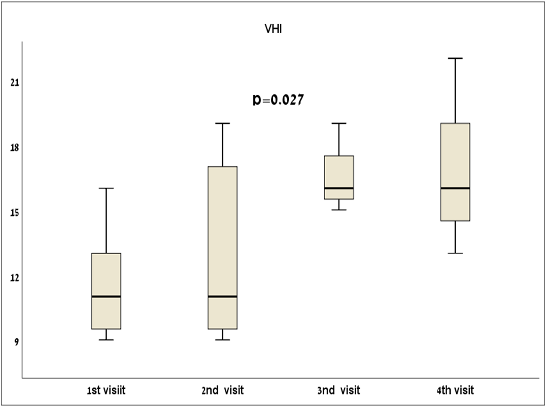

**Figure 3b: Change in vaginal pH during the study**

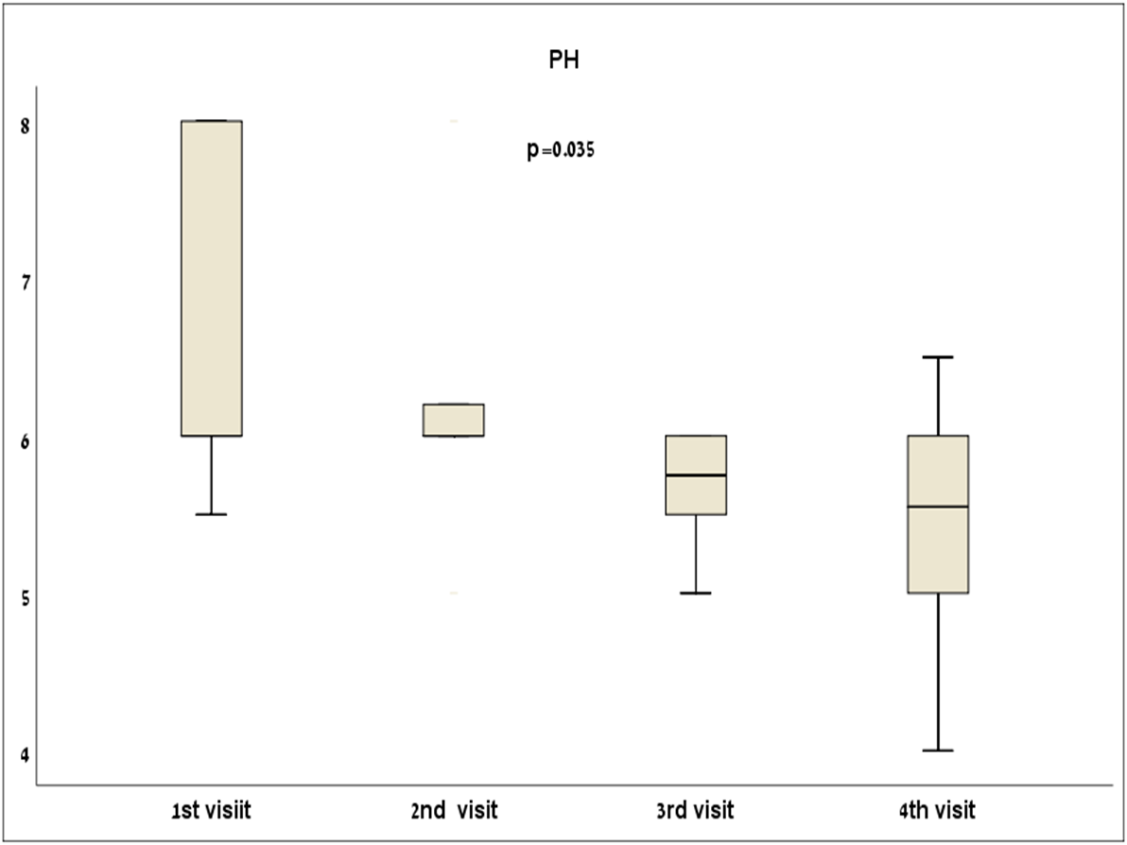

**P=0.035**

**PH**

**Figure 3c: Change in Vaginal Maturation Index during the study**

**P=0.018**

**VMI**

**Figure 4: Improvement in GSM symptoms by VAS scores during the study**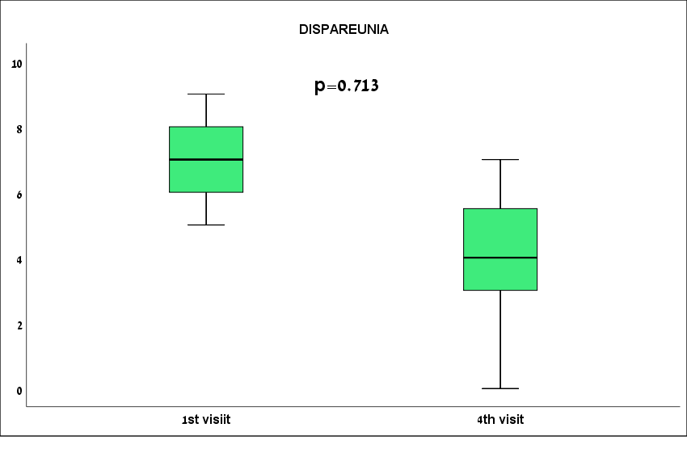

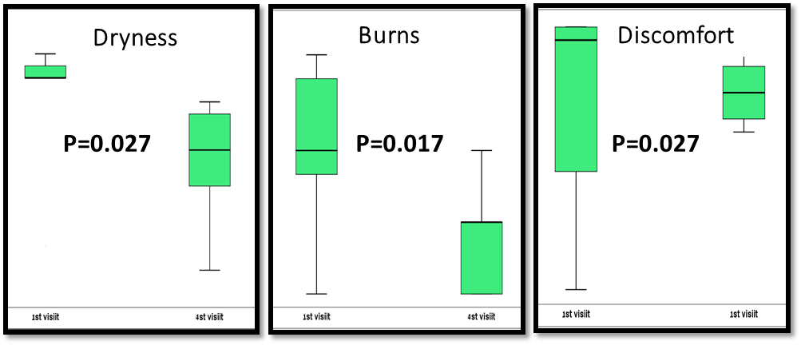

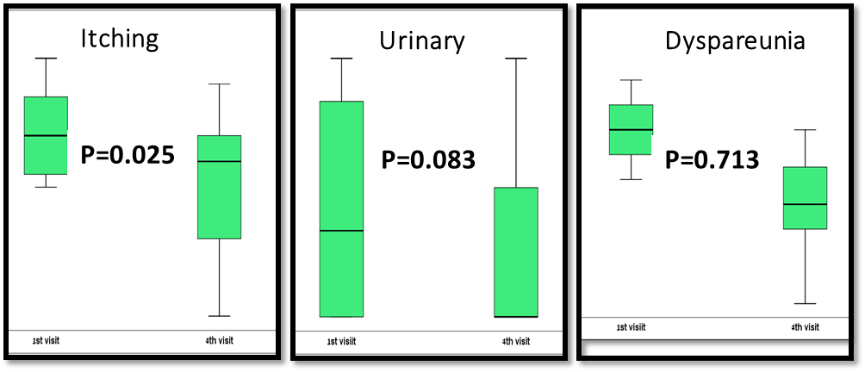

**Figure 5: Histologic findings before and after CO2 laser treatments in vaginal atrophy: H&E staining, magnification X200?**

Before treatment

After treatment

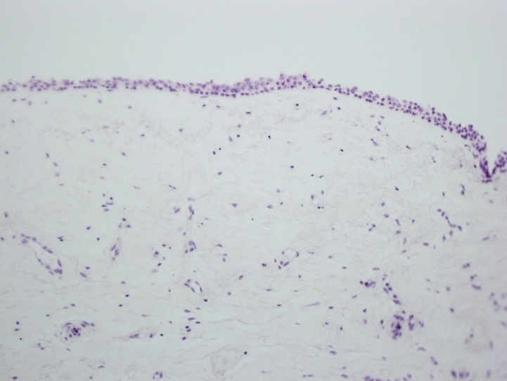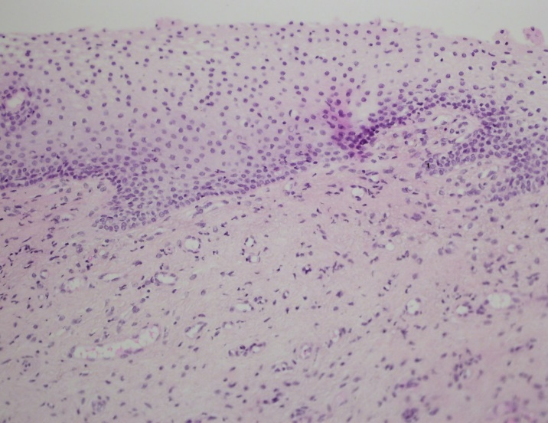

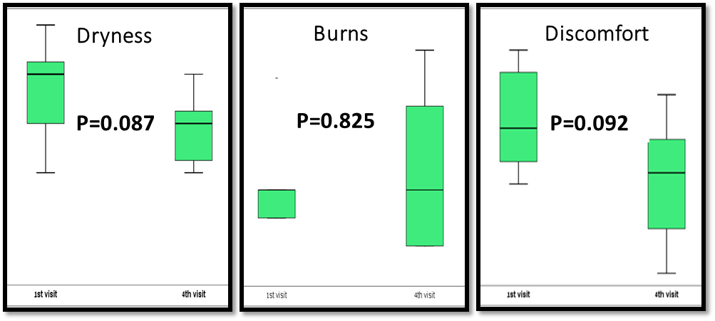**Figure 6: Improvement in lichen sclerosus symptoms by VAS score during the study**

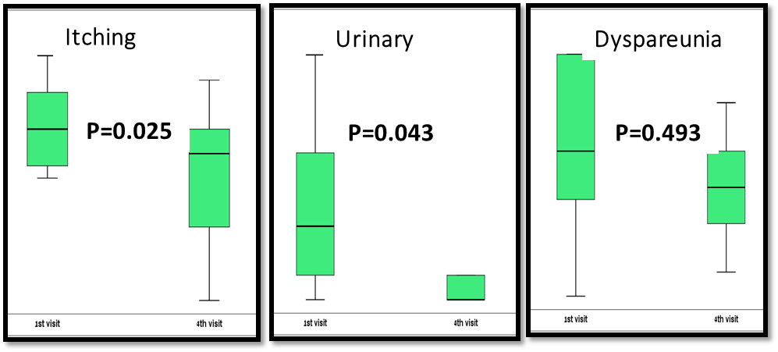

**Figure 7: Histologic findings before and after CO2 laser treatments in lichen sclerosus: H&E staining, magnification X200?**

After treatment

Before treatment

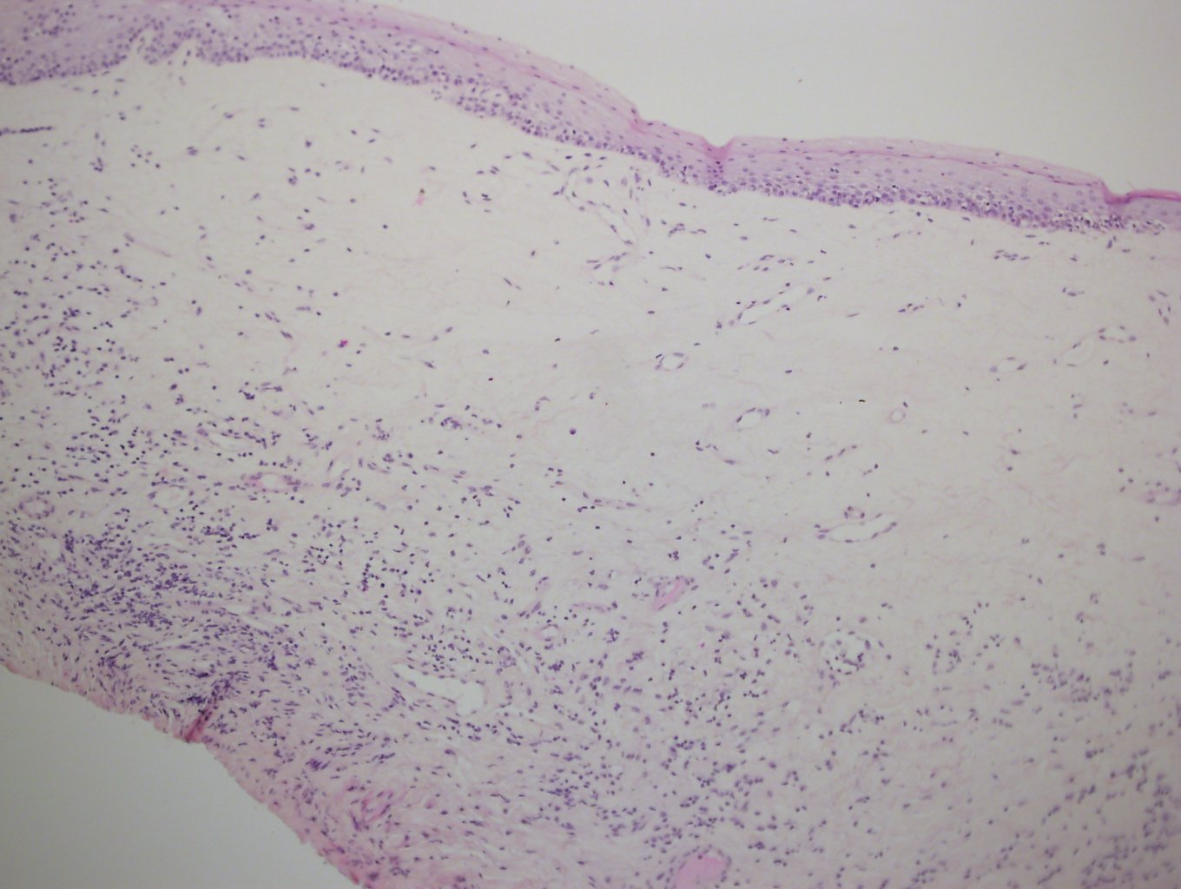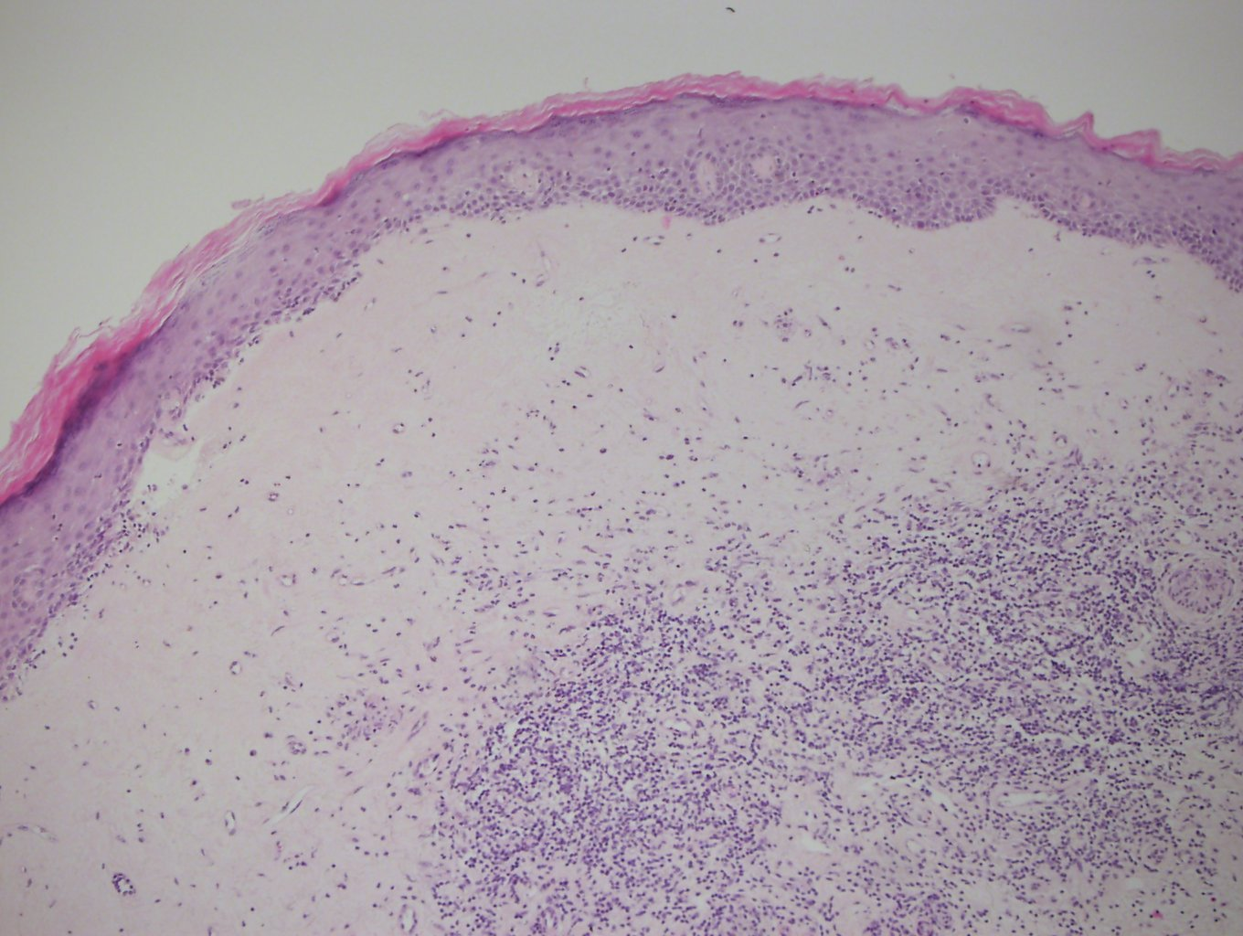

**Figure No. 11 – 63P staining before and after treatment of vaginal atrophy**

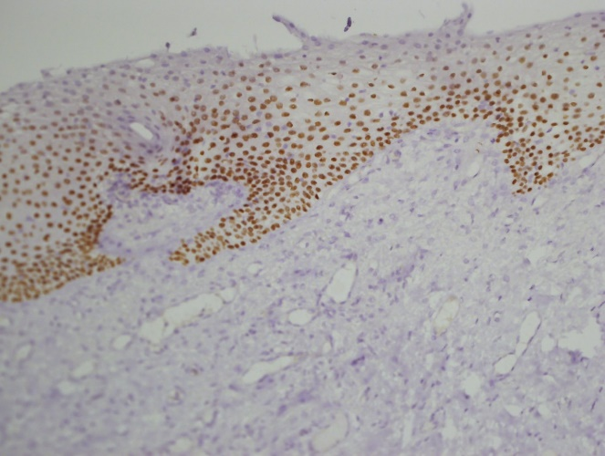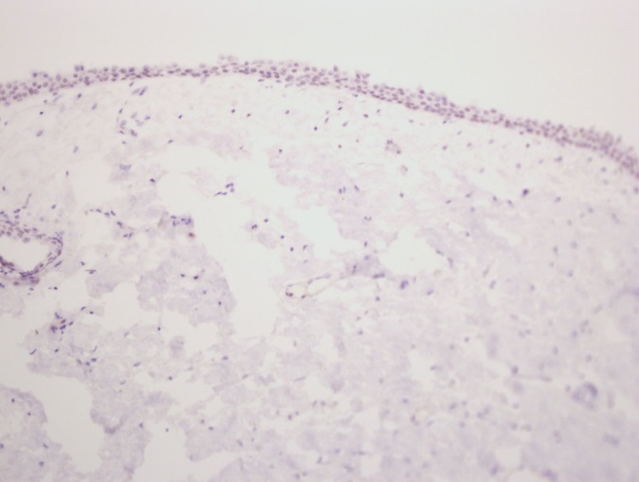

[**https://www.ajog.org/content/authorinfo#idp1724048**](https://www.ajog.org/content/authorinfo#idp1724048)

**FORMATTING instructions**

**Manuscripts must be submitted in American English, double spaced, with a font size no smaller than 12. Number pages consecutively in the upper right corner in the following order: title page, condensation and short version of title, abstract, main text, acknowledgments, references, tables, and figure legends.**

**IMPORTANT: Figures are to be uploaded individually and in separate files (one figure per file). DO NOT embed the figure into the manuscript text file, as this compromises the image quality, creating an unpublishable image (see artwork).**