### --

**Title Page**

The title page should contain**:**

1. A brief informative title containing the major key words. The title should not contain abbreviations (see[Wiley's best practice SEO tips](http://www.wileyauthors.com/seo)). The title needs to follow EQUATOR guidelines. I.e. the title should include the specification of the study design (e.g. randomized clinical trial, case-control study, cohort study, cross-sectional study, case-series, case-report) or a key word identifying the study as a diagnostic accuracy study (e.g., sensitivity, specificity, etc.)
2. A short running title of less than 40 characters;
3. The full names of the authors;
4. The authors' institutional affiliations where the work was conducted, with a footnote for the author’s present address if different from where the work was conducted;
5. The name, mailing address and e-mail address of the designated corresponding author;
6. A conflict of interest statement. Please note the any funding received to conduct a study needs to be reported. If authors have no conflict of interest relevant to the content of the submission, please state "The authors declare no conflict of interest";
7. An author contribution statement for each author. Examples of categories for authors' contributions: Concept/Design, Data analysis/interpretation, Drafting article, Critical revision of article, Approval of article, Statistics, Funding secured by, Data collection, Other. The author contributions should specify who was responsible for the data analyses.
8. Acknowledgments. Contributions from anyone who does not meet the criteria for authorship should be listed, with permission from the contributor. Financial and material support should also be mentioned.

**Summary Box**

Authors must include a summary box after the title page and before the abstract. This summary box should be no more than 100 words and should not be a repetition of the abstract. The purpose of the Summary Box is to provide a quick synopsis of the study. It should provide a clear and concise explanation of what was known before and of how the presented results advance knowledge of this field. The summary box should be structured as follows:

* A first header with what is known on the topic, followed by 1-3 bullet points.
* A second header with what the submitted study adds, followed by 1-2 bullet points.

### Comparison Between Three Scan Abutments and the Effect on Determining the

**Implant Axis Using an Intraoral Digital Scanner**

**--**

**Introduction**

At present, there is an increasing use of digital scanning technology for taking impressions before implant-supported prosthesis. This uptick is due to the many benefits associated with digital impressions, including: 1) reduced distortion from impression materials and plasters, 2) less chair time, 3) the acquisition of a three-dimensional picture of the preparation, 4) improved patient comfort, and 5) the ability to take completely passive impressions.1,2,3,4 There are two possible methods of taking a digital impression: extraorally, where the lab itself scans either the impression or the model, or using an intraoral scanner, chairside.5 Yet many dentists continue using traditional impression methods for implants.6,7,8,9

The marginal fits of digitally scanned impressions are equivalent to those from conventional impressions. Both methods yield similar marginal fits, both for single crowns as well as full mouth reconstruction. In the case of impressions for implants, digital impressions are more exact for single crowns, however, cross-arch scanning for multiple unit bridges remains questionable. Hence, for multiple units, even proponents of digital impressions believe conventional impression-taking techniques have advantages over digital methods.10

For software to recognize the scan files, it must accept or convert a digital STL-type (stereolithography) file, which allows access to all the programs. This type of file is an algorithm that transmits the three-dimensional scan with a high degree of accuracy, from which the final work can be designed.11

The transfer abutments (impression coping) are made from polyether ether ketone (PEEK) plastic or titanium type 5, and are screwed into the implant and scanned. The scans convert information about the implant’s position in the mouth into a computerized, virtual STL file. The geometry of the scanned abutment is important for accurately conveying the position of the implant, i.e., its position relative to adjacent teeth and the opposite jaw along all axes, M-D, B-L, and G-I. Many implants are now marketed with the appropriate impression abutment. The various scanners have a library of the numerous abutments from which they can make an appropriate selection, based on the implant and the scanned information. Each abutment has its own unique geometry, so it is important to indicate which abutment we used for the purpose of digital impression. Data from the digital model is transferred to a CAD/CAM machine that produces the prosthetic. The scan data allows the software to define the longitudinal axis of the implant, as well as the rotational axis and the implant’s vertical position relative to the occlusal plane, so that the future restoration can be appropriately fabricated.12,13

The connection between the implant and the abutment (and therefore, also between the implant and the scanning body) can be either an external or internal hexagonal design. According to a study by Sialdat et al.,14 abutments attached to implants by an internal hexagon show less rotational movement. This study also concluded that the marginal fit of the prosthetic is better than that of those with a external hexagonal design. In our study we used standard implants with internal hexagon connections, as well as the matching impression abutments. This led us to conclude that the deviations in scanned impressions are probably due to scanner error or improper processing of the geometry of the impression coping, and not from incorrect threading of impression coping to the implant.

PEEK, with the formula OC6H4-OC6H4-OC6H4-CO)n, is a polymer developed in 1978 by English scientists.15 It is a radiolucent, rigid, hypoallergenic material that does not accumulate plaque. Its modulus of elasticity is similar to enamel, dentin, and human bone, and it demonstrates high stability to heat, as well as stable physical and chemical properties. In this study, only impression copings made of PEEK or titanium were used.

To compare the types of scanners, we first define several terms relating to the accuracy of the digital files:

1. **Value**: A theoretical concept that sometimes cannot be accurately calculated. Value represents a quantitative characterization under certain conditions. For example, when shooting arrows at a target, the true value can be thought of as the center of the target.
2. **Trueness**: Proximity between the expectation of a particular test result/measurement and the true value, or in our example, the proximity of the results to the target goal.
3. **Precision**: Proximity between independent test results under defined conditions. This depends solely on the scattering of random errors regardless of the true value, that is, the greater the number of results that are close to each other (not necessarily in value, or true to the target goal) the greater the precision, and if they are close to the target goal, they will also be considered “true’.
4. **Accuracy**: If the results are precise and true they will be considered accurate, meaning the results will be close to each other and close to the target.

In this study, we will be examining the accuracy of various scans (see Supporting Information).16 In studies comparing conventional methods and digital scanners, it has been found that a laboratory digital scanner provides the highest degree of accuracy and will therefore serve as the gold standard in our evaluation of intraoral scanners.17 We used the CEREC Omnicam AC (Dentsply Sirona) scannerintraoral scanner, which works by the triangulation method, where light rays are projected onto the scanned area and reflected back to the sensor, thereby revealing locational details. The advantages of this method are its speed and accuracy. The disadvantage is the difficulty accessing the deep distal proximal areas, thus the doctor must continuously scan these areas until everything is thoroughly covered. This scanner uses a high resolution, heated oral 3-D camera with a removable reflective sleeve (the reflective sleeve is sterilizable with hot air).

It is best to have a passive fit of the prosthesis, as the final prosthesis’ alignment is dependent of the type of said prosthesis.18 With cemented prostheses, improper seating can worsen after cementation, possibly due to cement expansion. With screw-retained prostheses, improper seating of the prosthetic can present as an inability to properly screw the prosthetic to the implant. The best passive seat is found in single unit prosthetics, as the ability to seat a multiple-unit prosthesis decreases as the number of units increases. In recent years, there has been a marked improvement in the impression techniques as well as in prosthetic fabrication, such that the difference in passive seating between cemented and screw-retained crowns has become an insignificant factor.18 Digital software can produce either type of prosthetic. However, even in cemented prosthesis produced by CAD/CAM systems, the abutment is screwed into the implant and only the crown itself is cemented, therefore scanning errors will cause the entire prosthesis not to seat properly.

This research is the first of its kind, because no evidence has been found in the literature comparisons between the scan bodies of different manufacturers and their effect on the length of the implant created by the design software. To date, studies have compared the difference between digital impressions using scan bodies and conventional impressions using impression copings, and even these studies have not given unequivocal answers.19The purpose of this study is thus to evaluate the differences in the digitally derived longitudinal axis of the implant between the different groups.

**Methods and materials:**

For the purpose of this research, a VOCO V-Print model was printed by a VOCO 3-D printer, a SolFlex 650*350. In place of tooth #35, we used a MIS internal hex implant analog with a circumference of 3.75 mm and a length of 11.5 mm (standard with an internal hex). We used three different standard scanning bodies (Figure 1):

1. A MIS scan post, with an internal hex connection, SP, and a 10 mm titanium scanning body, for an internal hex implant with an asymmetrical geometry.
2. An Alpha Bio (AB) Dual scan body, with a PEEK scan body and titanium screw and hex, for an internal hex and cylindrical/asymmetric implant.
3. A Zirkonzahn (ZZ) M UA Non-Hex or Six Position scan body, completely fabricated from PEEK, including the hex that goes into the implant, and also for an internal hex and cylindrical/asymmetric implant.

For every scanning body, one extraoral scan was performed on a TRIOS (E2) laboratory desktop scanner to create compatible STL files. This scanner and the resulting scans are considered the gold standard in terms of accuracy.17 The intraoral scans were performed with a CEREC AC Omnicam (Dentsply Sirona) scanner and converted to STL files. Every scanning body was scanned 30 times, and for each scan a STL file was created. The comparison between all the scans was done by software designed by PolyWorks | Inspector™ Measurement and Verification Software.

The various scanning pins have different geometries, yet all three have an internal cylinder, a flat occlusal surface, and a flat side surface. Using these common characteristics, we have a basis for comparing these pins. (Figure 2):

1. The longitudinal axis of the scanning pin is defined by the center of the internal cylinder of the pin.
2. The point of intersection between the longitudinal axis and the top of the scanning pin is another point of comparison.
3. The intersection between the top (occlusal) surface and the flat side surface is a straight edge. Based on this straight edge, we can calculate the angle of rotation of the scanning pin (the angle of the scanning pin relative to its longitudinal axis).

For every type of scanning pin, we have defined a system of axes that originates in the center of the upper surface, according to the gold standard of digital scanning. The x-axis is defined as the mesial-distal length, where the preferred inclination is distal. The y-axis is defined by the buccal-lingual length where the preferred inclination is lingual. The z-axis is defined as the incisal-gingival length, where the preferred inclination is incisal. Figure 3 illustrates the axis system of a scan.

With the help of PolyWorks | Inspector™Software Verification and Measurement, we superimposed every intraoral scan image with the gold standard scan, based on the adjacent teeth of the model’s scanning pins. The superimposition process allowed us to measure the trueness of the scanning pin scan. Subsequently, we were able to extract the key features for each scanning pin scanned intraorally, and calculated the spatial characterization of each scanning pin relative to the gold standard as follows:

1. From the three-dimensional position of the center of the occlusal surface, defined as the shift of the scan pin head with respect to the gold standard from all the axes (x-axis = M-D, y-axis = B-L, z-axis = G-I), it is easy to calculate the distance between the centers of the upper surfaces of the pins. (x2 +y2+z2�� √)
2. The longitudinal axis angle is the three-dimensional angle between the longitudinal axis of the gold standard scan and the longitudinal axis of the intraoral scan (center-line angle).
3. The rotational axis (angle of rotation) is the angle representing the rotation around the longitudinal axis of the scanning pin, or the angle between the straight lines that comprise the intersection between the occlusal surface and the side surface of the pin (the green straight line in Figure 2) between the standardized scan and the intraoral scan.

Statistics

In order to characterize the placement of the scanning pin in an intraoral scan in relation to the standardized extraoral scan, five spatial properties were reviewed. These include the displacement of the scanning head relative to the standard along three axes (x-axis = M-D, y-axis = B-L, z-axis = G-I), and directly derived from that is the distance R between the longitudinal axes of the scanning pins (√𝑥2 + 𝑦2+ 𝑧2 =��). These properties also include the center-line angle or longitudinal axis angle, the three-dimensional angle between the longitudinal axis of the scanned gold standard and the longitudinal axis of the intraoral scan, as well as the rotational angle, the angle representing the rotation around the longitudinal axis of the scanning pin.

These characteristics were statistically analyzed to determine if the parameters examined were significantly different from the reference scan. We used a t-test, which tests for independent variables that are normally distributed, as well as a Wilcoxon signed-rank test, which tests for variables that are not normally distributed. The significance level was determined to be p <0.05. Additionally, box plot graphs were drawn for each of the parameters, showing the distribution of the samples of the parameters and allowing for visual comparison.

**Results**

We examined the location of the center point of the occlusal surface.

Displacement in the mesio-distal axis (x-axis)

1. MIS – A t-test was performed, yielding a p-value of 0.6565. This scan pin has no statistically significant displacement along the x-axis.

2. AB – A Wilcoxon signed-rank test was performed, with a p-value of <.001. A statistically significant displacement on the Z axis was demonstrated.

3. ZZ – A t-test was performed with a p-value of <.001. A statistically significant displacement on the Z axis was demonstrated.

Absolute distance from the axes origin (R)

1. MIS – A t-test was performed with a p-value of <.001. A statistically significant displacement was demonstrated.

2. AB - A Wilcoxon signed-rank test was performed with a p-value of <.001, hence a statistically significant displacement was demonstrated.

3. ZZ - A Wilcoxon signed-rank performed with a p-value of <.001, thus a statistically significant displacement was demonstrated.

Rotational angle

1 MIS – A t-test was performed with a p-value of <.001, so deviation in the rotational angle was demonstrated to be statistically significant.

2. AB – A t-test was performed with a p-value of <.001, demonstrating a statistically significant deviation in the angle of rotation.

3. ZZ- A Wilcoxon signed-rank test was performed with a p-value of <.001, demonstrating a statistically significant deviation in the rotation angle.

Longitudinal axis angle

1. MIS – A t-test was performed with a p-value of <.001, so deviation from the longitudinal axis was demonstrated in a statistically significant manner.

2. AB - A Wilcoxon signed-rank test was performed with a p-value of <.001, therefore statistically significant deviation from the longitudinal axis was demonstrated.

3. ZZ – A Wilcoxon signed-rank test was performed with a p-value of <.001, thus deviation from the longitudinal axis was demonstrated to be statistically significant.

**Discussion**

Digital impressions of implants have become more common, due to many advantages: the reduction of distortion due to impression material or casting plaster, the ability to obtain a three-dimensional image of the preparation, increased patient comfort, and the reduction of chair time.1,2,3,4 In our study, we proposed a method to characterize the spatial position of the scan pins based on key features from the scan, and deriving the spatial position of the implant, the longitudinal axis angle, and the rotational angle around the longitudinal axis.

Based on a study by Andriessen et al., it was found that scan pins were developed to allow intraoral scans of implants.20 Despite deformation in the impression materials and the expansion of dental gypsum, conventional impressions are still clinically successful. Inaccurate impressions are likely to cause ill-fitting prosthetic work that may lead to mechanical complications, fractures, and prevent a passive fit of the final work.

The biological tolerance of a bone that surrounds teeth is different from that of a bone that surrounds dental implants.21 Due to the elasticity of the periodontal ligament, the teeth have a movement of 25-100 microns in axial directions and 56-108 microns in lateral directions. Implants undergo osseointegration, and their displacement depends on the amount of bone compression, about 3-5 microns in the axial direction and 10-50 microns laterally.20 As such, non-passive placement on the implant will cause pressure upon the bone around it.

The study by Andriessen et. al determined that the maximum tolerance of the bone around one implant is 50 microns.20 Hence, in this study, we assumed that movement in any of the axes (B-L, M-L, or I-G) of more than 50 microns will cause distortion in the rehabilitative work, which will be expressed in bone pressure beyond the biological tolerance of the bone. The spatial location point of the center point of the occlusal surface was defined as the origination point of the axes in the extra-oral scan. Displacement in any of the axes (x, y, z) will result in incorrect distribution of pressure on the surrounding bone:

1. M-D displacement (on the x-axis) causes inaccurate seating due to inadequate contact with adjacent teeth.
2. B-L displacement (on the y-axis) causes distortion of the internal walls of the crown, and improper distribution of forces on the implant. Buccal or lingual insertion may cause cheek or tongue biting, respectively.
3. G-I displacement (on the z-axis) causes defective occlusal contacts. Hyperocclusion can wear down the opposite natural tooth and cause too much load on the implant and the tooth, while hypoocclusion can cause the opposing natural tooth to overerupt.

Figure 5 illustrates the distribution of results (with some close to the defined upper threshold) of displacement in the x-axis, for the MIS scan pin. The AB and ZZ scan both demonstrate a dense distribution of results that is not close to the upper threshold (50 microns), with the ZZ scan pin having the least displacement in the x-axis and a minimal spread of results. The y-axis of the MIS scan pin demonstrates the widest distribution of results (with some exceeding the set upper threshold). ZZ and AB scan pins are in the acceptable error range of up to 50 microns. In the z-axis, all the scanning pins are in a small deviation range, with the MIS scan pin showing a statistically significantly distribution around zero, so the trueness in the z-axis is high.

The MIS scanning pin demonstrated trueness in the spatial position parameters (Table 1 shows the statistical significance), but demonstrated a wide distribution in the spatial position (mainly in the XY plane and the longitudinal axis angle) relative to the other scanning pins, so its precision is low. The result is a high standard deviation (82 microns) from the maximum threshold of 50 microns presented in the articles mentioned.

The other two scan pins (AB and ZZ) showed better precision results with a smaller distribution (without statistical significance), below the 50-micron threshold in the XY plane which is critical for implant axis position. These two scan pins (AB and ZZ) are relatively similar in shape and roundedness, with a wide inner cylinder, in contrast to the geometric shape of the MIS pin, something that may affect the quality of the scan.

In the longitudinal axis angle, there does not appear to be a statistically significant difference between the three types of scan pins (see Figure 6), and there is a similar distribution to all three.

In constrast, this was not the case for the rotational angle, which is of the greatest clinical importance due to its effect on passive seating. A large deviation in the angle will completely prevent the prosthesis from being seated on the scanned implant. The AB pin showed a deviation of about 1.04 degrees (statistically significant, with a standard deviation is 0.12) while the other two pins showed deviations of about half a degree (Table 1 and Figure 7). However, no research has been found in previous literature to indicate the effect of the rotational angle and the maximum threshold at which it has an effect. Thus, it can only be concluded that the AB scan pin has the largest deviation. It is reasonable to assume that a scanning error of one-degree may not clinically affect a single implant-based crown, but will affect the scan on two or more implants.

Methodology Limitations

The method of deriving properties from scans has been characterized as uniform between the scan pins, but unfortunately it may favor some scan pin designs over others. Particularly those scan pins with an internal cylindrical design and a wide radius will scan more accurately with an intraoral scanner, and the data points from this design will be more accurate. It stands to reason that other spatial characteristic measurements may vary depending on the geometry of the scanning bodies. In order to overcome this limitation, it would be interesting to explore, in future studies, the fit of the spatial model from each scanning pin not based on point characteristics (as performed here) but based on all possible points of the scan, by superimposing the model of the scan body and thus extracting spatial properties.

**Conclusions**

This study was the first, to our knowledge, to examine the relationship between the geometry of different scanning pins and the quality of the scan obtained from an intraoral scanner, in relation to the gold standard extraoral scanner. The results showed that the geometric shape of the scan pin influences the quality of the scan obtained. The MIS pin’s geometry is that of a trapezoidal prism, and thus showed great variability in the x- and y-axis, which indicates low precision relative to the other two pins. The three pins had similarly high trueness.

The standard deviation from the MIS pin was higher than the maximum threshold set for clinical bone tolerance around the implant. As noted, the rotational angle has the most profound clinical impact on the entire scan. In the AB pin, which is cylindrical, there is the largest rotational angle of the scan pins (about one degree), with low trueness and high precision relative to the other two pins, which can cause problems in passive seating. Our conclusion is that, at the level of a single unit scan, there is probably no clinical impact on which scan pin we will use. Nevertheless, it is worthwhile to further research and examine whether a digital intraoral scan of two or more pins will create too much distortion in fabrication and clinically affect the final prosthetic result.

**Reference List**

1. Rosenstiel SF, Land MF. *Contemporary fixed prosthodontics*. St. Louis, Missouri: Elsevier Health Sciences; 2015.

2. Anadioti E, Lee C, Schweitzer A. Fit of CAD/CAM Tooth-supported Single Crowns and Fixed Dental Prostheses. *Curr Oral Health Rep*. 2017;4(2):142-150.

3. Allen KL, Schenkel AB, Estafan D. An overview of the CEREC 3D CAD/CAM system. *Gen Dent*. 2004;52(3):234-235.

4. Culp L, Wong NY, Misch CE. Digital Technology in Implant Dentistry. In: *Dental Implant Prosthetics*. 2nd ed. St. Louis, Missouri: Elsevier Mosby; 2015:700-723.

5. Malaguti G, Rossi R, Marziali B, et al. In vitro evaluation of prosthodontic impression on natural dentition: a comparison between traditional and digital techniques. *Oral Implantol*. 2016; 9(Suppl 1/2016 to N 4/2016):21-27.

6. Alikhasi M, Siadat H, Nasirpour A, Hasanzade M. Three-Dimensional Accuracy of Digital Impression versus Conventional Method: Effect of Implant Angulation and Connection Type. *Int J Dent*. 2018.

7. Lee H, So JS, Hochstedler JL, Ercoli C. The accuracy of implant impressions: a systematic review. *J Prosthet Dent*. 2008;100(4):285-291.

8. Amin S, Weber HP, Finkelman M, El Rafie K, Kudara Y, Papaspyridakos P. Digital vs. conventional full-arch implant impressions: a comparative study. *Clin Oral Implants Res*. 2017;28(11):1360-1367.

9. Basaki K, Alkumru H, De Souza G, Finer Y. Accuracy of Digital vs Conventional Implant Impression Approach: A Three-Dimensional Comparative In Vitro Analysis. *Int J Oral Maxillofac Implants*. 2017;32(4):792–799.

10. Chochlidakis KM, Papaspyridakos P, Geminiani A, Chen CJ, Feng IJ, Ercoli C. Digital versus conventional impressions for fixed prosthodontics: a systematic review and meta-analysis. *J Prosthet Dent*. 2016;116(2):184-190.

11. Magne P, Stanley K, Schlichting LH. Modeling of ultrathin occlusal veneers. *Dent Mater*. 2012;28(7):777-782.

12. Priest G. Virtual-designed and computer-milled implant abutments. *J Oral Maxillofac Surg*. 2005;63(9):22-32.

13. Fluegge T, Att W, Metzger M, Nelson K. A Novel Method to Evaluate Precision of Optical Implant Impressions with Commercial Scan Bodies—An Experimental Approach. *J Prosthodont*. 2017;26(1):34-41.

14. Siadat H, Beyabanaki E, Mousavi N, Alikhasi M. Comparison of fit accuracy and torque maintenance of zirconia and titanium abutments for internal tri- channel and external-hex implant connections. *J Adv Prosthodont*. 2017;9(4):271-277.

15. Skirbutis G, Dzingute A, Masiliunaite V, Sulcaite G, Zilinskas J. PEEK polymer's properties and its use in prosthodontics. A review. *Stomatologija*. 2018;20(2):54- 58.

16. Lebon N, Tapie L, Duret F, Attal JP. Understanding dental CAD/CAM for restorations–accuracy from a mechanical engineering viewpoint. *Int J Comput Dent*. 2015;18(4):343-367.

17. Mandelli F, Gherlone E, Gastaldi G, Ferrari M. Evaluation of the accuracy of extraoral laboratory scanners with a single-tooth abutment model: A 3D analysis. *J Prosthodont Res.* 2017;61(4):363-370.

18. Gomez-Polo M, Ortega R, Gomez-Polo C, Celemin A, Highsmith JDR. Factors Affecting the Decision to Use Cemented or Screw- Retained Fixed Implant-Supported Prostheses: A Critical Review. *Int J Prosthodont*. 2018;31(1).

19. Flugge T, van der Meer WJ, Gonzalez BG, Vach K, Wismeijer D, Wang P. The accuracy of different dental impression techniques for implant-supported dental prostheses: A systematic review and meta-analysis. *Clin Oral Implants Res*. 2018;9:374-392.

20. Andriessen FS, Rijkens DR, van der Meer WJ, Wismeijer DW. Applicability and accuracy of an intraoral scanner for scanning multiple implants in edentulous mandibles: a pilot study. *J Prosthet Dent*. 2014;111(3):186–194.

21. Kim Y, Oh TJ, Misch CE, Wang HL. Occlusal considerations in implant therapy: clinical guidelines with biomechanical rationale. *Clin Oral Implants Res*. 2005;16(1):26-35.

**Tables**

Table 1: Values (mean, standard deviation) of the spatial position characteristics of the intraoral scans relative to the standard gold scans in the extraoral scanner, and statistical tests for each (t-tests for normal distributions, Wilcoxon signed-rank otherwise), where p-value< 0.05 indicates statistical significance of the results being distributed around 0.

|  |  |  |  |  |  |
| --- | --- | --- | --- | --- | --- |
| **Pin** | **Parameter** | **Mean** | **STD** | **p-value** | **Test** |
| **MIS** | **x (mm)** | -0.007 | 0.083 | 0.656 | T-test |
|  | **y (mm)** | -0.082 | 0.072 | <.001 | T-test |
|  | **z (mm)** | -0.002 | 0.016 | 0.475 | T-test |
|  | **R (mm)** | 0.125 | 0.058 | <.001 | T-test |
|  | **rotational angle (deg)** | 0.506 | 0.233 | <.001 | T-test |
|  | **center-line angle (deg)** | 0.324 | 0.236 | <.001 | Wilcoxon signed-rank |
| **ZZ** | **x (mm)** | -0.013 | 0.015 | <.001 | Wilcoxon signed-rank |
|  | **y (mm)** | 0.03 | 0.024 | <.001 | Wilcoxon signed-rank |
|  | **z (mm)** | 0.026 | 0.005 | <.001 | T-test |
|  | **R (mm)** | 0.046 | 0.022 | <.001 | Wilcoxon signed-rank |
|  | **rotational angle (deg)** | 0.468 | 0.245 | <.001 | Wilcoxon signed-rank |
|  | **center-line angle (deg)** | 0.304 | 0.269 | <.001 | Wilcoxon signed-rank |
| **AB** | **x (mm)** | -0.033 | 0.02 | <.001 | T-test |
|  | **y (mm)** | -0.025 | 0.016 | <.001 | T-test |
|  | **z (mm)** | -0.007 | 0.089 | <.001 | Wilcoxon signed-rank |
|  | **R (mm)** | 0.069 | 0.075 | <.001 | Wilcoxon signed-rank |
|  | **rotational angle (deg)** | 1.045 | 0.121 | <.001 | T-test |
|  | **center-line angle (deg)** | 0.194 | 0.165 | <.001 | Wilcoxon signed-rank |

**Figures**

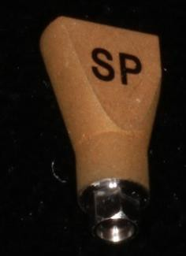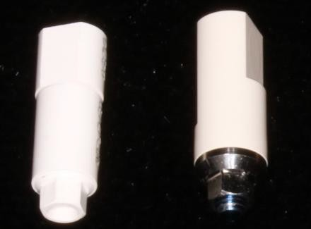

Figure 1: Scanning bodies, from left to right: Zirkonzahn ZZ, Alpha Bio (AB), and MIS.

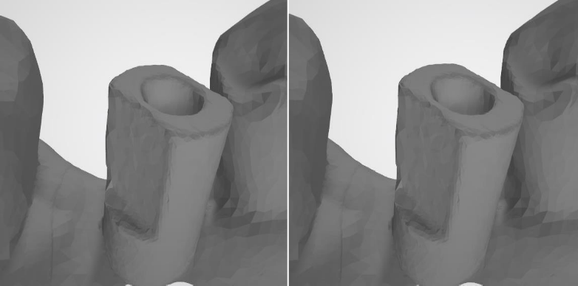

Figure 2: The left panel illustrates the key features of the scanning pin, where the orange represents the internal cylinder of the scanning pin and the red represents the longitudinal axis of the pin. The right panel illustrates the scanned image of the Alpha Bio pin. The purple field covers the center of the upper surface that is defined by the intersection of the longitudinal axis (red) with the flat occlusal surface (blue). The intersection of the top surface (blue) and the side surface (yellow) gives us the straight edge (green), used for calculating the angle of rotation.

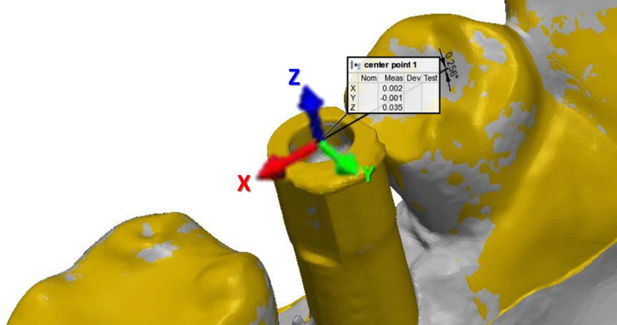

Figure 3: This illustrates the system of axes defined by the scanning pin. For each axis there is a preferred direction as indicated by the different colored arrows. The origination point is in the center of the top of the scanning pin and the direction of each axis is as follows: the x-axis is M-D, the y-axis is B-L, and the z-axis is G-I.

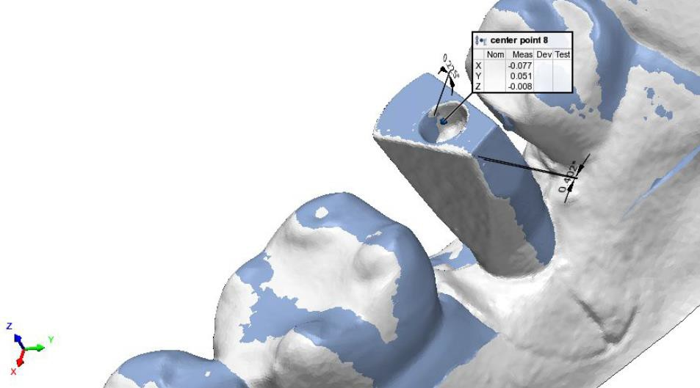

Figure 4: Superimposition and the parameters extracted from the scan pin. The system of axes and their directions are shown in the cut out on the left, as well as the two angles that are demonstrated. The white scan is defined as a reference scan and was done by a laboratory scanner, while the blue scan exemplifies an intraoral scan.

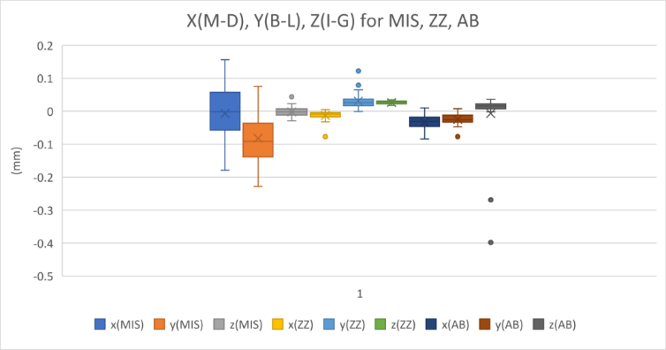

Figure 5: For the x-axis shift (the M-D axis), the y-axis shift (the B-L axis), and the z-axis shift, (the I-G axis). All values are relative to the standard for any type of scanning bodies.

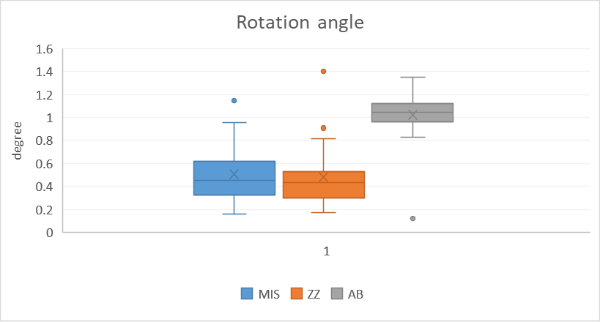

Figure 6: For the rotational angle of the scan pin around the longitudinal axis, with respect to gold standard for any type of scan pin.

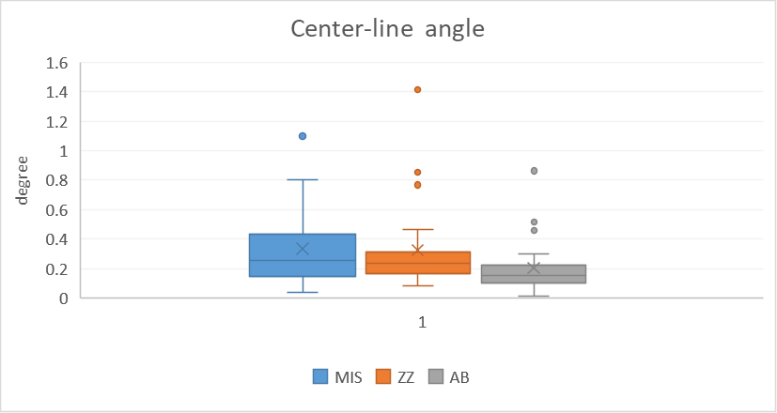

Figure 7: For the longitudinal axis angle of the scan pin, relative to the gold standard for each type of scan pin.

**Supporting Information**

1. MIS SP Scan Post, int. hex connection

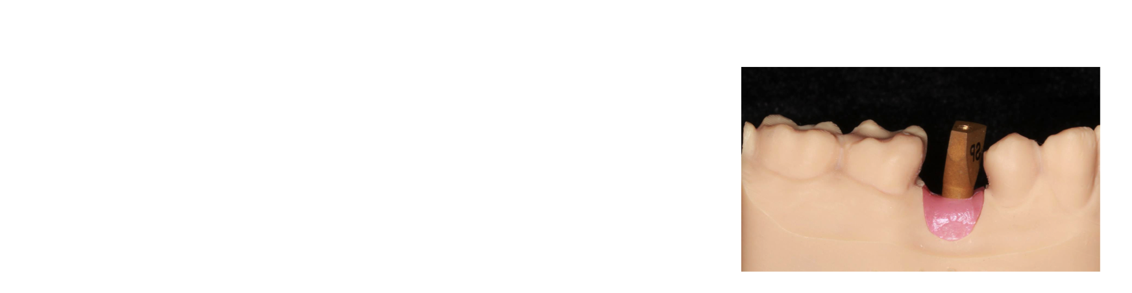

1. Working model

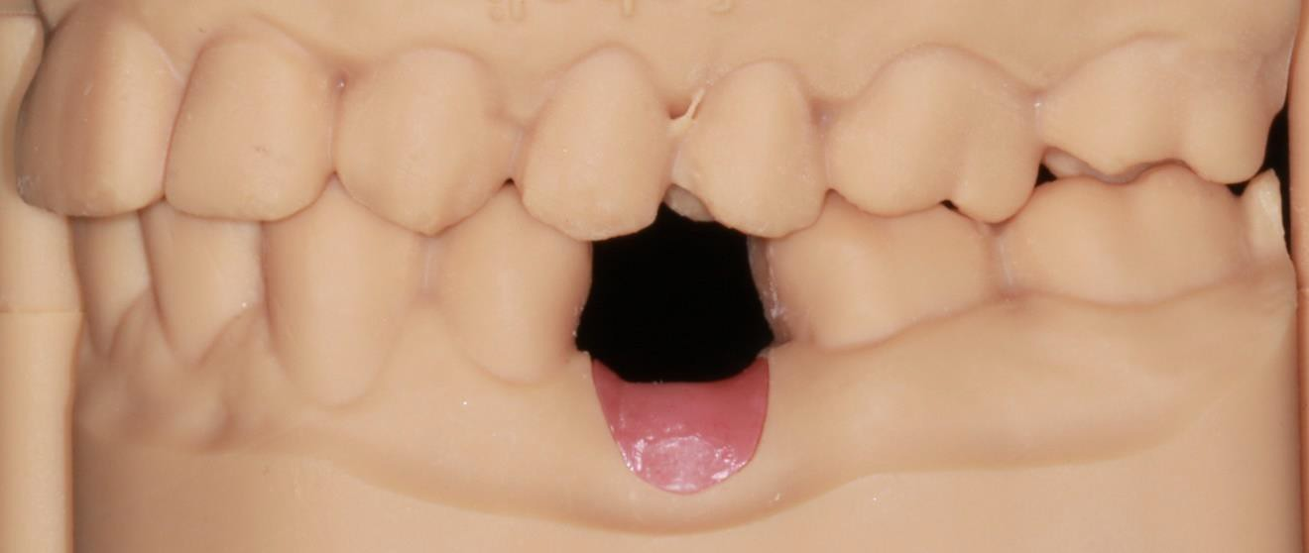

1. a) Results that are close to the goal, but far from each other are therefore true but not precise.

b) The results are close to each other and therefore are precise, and close to the center of the goal and as such true, showing accuracy.

c) Random scattering of results indicates error. The results are not close to each other nor are they close to the center, and therefore they are neither true nor precise

d) The results are very close to each other but far from the center the goal, therefore precise but not true.

