**Applying Behavioral Insights to Manage Public Demand**

**Effective policy is needed in response to an undesirable behavior**

Governments have mandates for managing certain patterns of behavior of individuals and use policies and regulation to encourage people to behave in the sought-after manner. Undoubtedly, if people naturally conducted themselves in ways their governments preferred, there would be no need for regulations. The challenge, of course, is that there are many opportunities in daily lives for individuals to engage in suboptimal behaviors. This is where governments need to intervene, whether to limit drug use, to make rules about parking, to force people to send their children to school, or to encourage healthy eating, among many examples.

Once the behavior we want to be limited or encouraged is clarified, the next step is to determine what regulatory mechanism or policy is most likely to induce people to act in desirable ways. The question of how to select such mechanisms or policies is the main subject of this article.

When governments select a policy approach to encourage behavioral change, they first need to recognize that behavior and behavioral changes are context specific. That is, the kind of mechanism that would motivate someone to stop smoking is very different from the mechanism that will impel someone to drive safely or to pay their taxes on time. Second, governments need to recognize how complex the behavior they are trying to change is. Third, it must be acknowledged how little governments, and people in general, know about the behavior they are trying to change, or what causes that behavior. Unfortunately, the combination of these basic elements – building blocks of changing behavior – underscore the fundamental limitations of humanity’s favorite decision-making tool: intuition. While we each may have very strong intuitions about what would generate or not generate a specific needed behavioral change, we are very often wrong. Perhaps it is preferable to disregard these intuitions and focus on data and experiments instead.

Applying the three building blocks mentioned aboveto the behavioral goal of encouraging mask-wearing during COVID-19, we see how complicated it can be to encourage desirable behavior. First wearing masks to protect people from COVID-19 is very different from mask wearing in other contexts. For example, we are accustomed to seeing surgeons wear masks; in the Japanese context, citizens commonly wear masks on public transportation during flu season. Second, the required behavior is complicated to maintain: not only do people have to remember to wear a mask and for how long, they have to remember the rules for many hours of the day, overcoming annoyance at having a piece of cloth or paper on the face that often feels hot. Other social aspects are involved in the behavior, such as how to tell others that we don’t feel comfortable if they are not wearing a mask. Third, we need to deeply understand the characteristics of this behavior in order to start thinking about how to change it. Requiring people to wear a mask daily, over a continuous period of time, is, in fact, asking people to form a new habit. What might succeed in convincing people to do that?

One regulatory option may be to threaten people with punishment, such as fines. The problem with this approach is that when fines are not imposed immediately and uniformly, the impact of the threat diminishes, because statistically, the punishment is not universal or inevitable. If I did not get caught, I can conclude that I am doing something right (or at least doing nothing inherently wrong). The result is that after not putting on the mask several times and not getting caught, it becomes harder to change one’s behavior to comply with the regulations or conform to expectations for different conduct. Habit formation is very different from onetime games and, therefore, different behavioral rules apply to it. Punishment isn’t the only option. In recurring events that require significant habit formation, working to make a certain behavior socially appropriate might be a better approach than punishment. Other questions arise regarding the required behavioral change: Will people become accustomed to the change at some point? If so, how long will it take? And what are the reasons behind the denial of COVID and the behaviors that come with it?

Understanding the underlying behavioral mechanisms is key to developing a good theory of behavioral change; that is, a good hypothesis about how behavioral change will occur in a specific context. Governments typically have a simplistic perspective about how behavioral change occurs. Consequently, their methods for inducing behavioral change are seldom rooted in behavioral insights (BI). This may be the result of faulty intuition, inadequate attention to details, and/or a lack of a clear methodology for evaluating alternative courses of action.

Behavioral economics is a field of study that seeks to understand both behaviors and the barriers to behavioral change, together with the alternative mechanisms that could help produce a desired behavioral change. In addition to the theoretical tools supplied by behavioral economics, data represents another important tool for better understanding the details of any specific behavior. This short paper will examine some examples of how Israel’s Ministry of Finance (MoF) has been using behavioral insights, data, behavioral economics, and experiments to encourage effective and efficient policies.

Before delving into a discussion of how precepts of behavioral economics have been implemented in Israel, it is worthwhile to consider more generally the cost-benefit of generating and using data to inform government decision-making. Imagine a scale with costs on one axis and the quantity of data on the other. At the bottom left of the scale, we have zero data with zero cost. On the upper right, we have enormous amounts of costly data – like that generated from the randomized controlled trials (RCT) conducted for new medications (where current estimates for a U.S. Food and Drug Administration (FDA) approval process are estimated to amount to about a billion dollars). In identifying the ideal balance between data generated and its costs for each policy program examined, it is useful to evaluate the extent to which we can learn from data already collected about how people might respond to changes in policy. For example, behaviors related to parking regulations have been widely tested in various contexts and with different solutions, so there may be little to be learned from investing heavily in experiments and obtaining additional data. On the other hand, we know little about how to handle fake news, for example, or how to protect consumers from crypto risks. In these areas, we need to invest more in learning about the desired behavioral change before formulating behavioral intervention policies.

For the purpose of this article, we will divide the methodologies of behavioral intervention into three main types: applying behavioral insights from existing literature, collecting data and analyzing what might work, and running experiments. We will discuss examples from Israel for all these.

**Incorporating behavioral insights in Israel’s MoF**

In describing Israel’s experience with implementing behavioral economics tools, we will first discuss the choice of agent within the government to introduce the tools and methodologies and implement them, in this case the Ministry of Finance (MoF). Second, we will discuss the chosen set up for introduction and implementation.

There is no one clear arm of governments where a central behavioral economics initiative should originate. That being said, ministries of finance – in this case, Israel’s Ministry of Finance – have several key advantages for leading and administering such an effort: the interest of budget officials in individuals’ economic decisions; the focus of budget officials on efficiency and effectiveness of outcomes versus specific outcomes; and their centralized and strategic point of view.

In principle, behavioral economics deals with how people make economic decisions. Therefore, behavioral tools can prove useful to finance ministries, focused as they are on improving macro-financial outcomes that are often affected by the aggregate economic choices of individuals. A renowned example in this context, already used by several governments, is utilizing behavioral interventions to boost tax compliance and to improve the attitudes of both the public and tax officials. There are, however, many more possible applications, including improving public health and the efficiency of public spending by promoting preventative healthcare, encouraging participation of underrepresented communities in public education and in the workforce, encouraging pension plan savings, reducing traffic congestion, and even urging better utilization of public lands (IDB, 2020).

Budget officers are mainly interested in the optimal allocation of resources and more likely to be indifferent to, or at least objective about, particular policy outcomes. This makes them well suited to perform neutral evaluations of programs that are based on highly measurable, transparent and non-context specific goals. Behavioral economics, which is more detached from political pressures and priority considerations that may enter into the budgeting process, offers neutral methodologies to evaluate the chances that policy programs will achieve the goals for which they were designed as a prerequisite to budgeting them and as an assistive tool for prioritizing them.

Moreover, since ministries of finance are more interested in efficiency and effectiveness than in context specific success, budget officials have inherently higher willingness to accept results that may indicate that a certain program is not working, making them better candidates for incorporating tools that focus on collecting data and running experiments.

Lastly, budget officers, whose viewpoints encompass government-wide strategic resource allocation priorities, can also develop cross-area tools to measure effectiveness and responsiveness to policies based on behavioral insights. Such tools can measure behavioral responses to changes in tax benefits or rates; they also have built-in mechanisms to evaluate alternative incentive plans, such as sensitivity to payment schedules or timing of payment. Behavioral tools can also prove effective in conducting spending reviews in which the objective is not only to increase the participation of line ministries in programs using incentives, but also to boost their motivation for improving internal processes that favor longer-term, long-lasting, continuous savings over one-time savings opportunities.

An example of a specific cross-sectional tool that was developed for the Israeli MoF is an index that reflects the pain of bureaucracy. The tool adopts citizens’ perspectives and measures the level of bureaucratic burden they experience when using governmental services. The citizen-centric approach represented by the index highlights four pillars in the public services experience: clarity of the procedure in order to reduce anxiety and disorientation (i.e., the importance of avoiding the “black boxes” of bureaucracy); feasibility of completing the bureaucratic process (i.e., minimizing frustrations that result from not knowing how much time and effort are required for successful completion); and level of autonomy (i.e., citizens’ ability to complete tasks on their own); and trust in public institutions, reflecting a deep understanding of the importance of building trust in interactions with citizens and designing systems accordingly. The index reflects the view that these are the foundation to the overall perception of citizens and are built over time.

The next section will describe the introduction of the behavioral economics initiative to the work of Israel’s MoF’s Budget Department, beginning in 2016. It describes each stage of the introduction of the process to government partners, as well as the specific circumstances of how the process developed in the way that it did.

**The Israeli government experience with behavioral insights**

Introducing any change to customary workflows can be challenging, particularly in the work of public officials, where existing procedures are often in place for many years and changes are also technically difficult to implement. From a budget perspective, such an effort needs to be justified economically. Equally important is that if the benefits are still vague, or if it is suspected that unfamiliar analyses, research, or experimentation are required to evaluate a program, thereby causing delays in initiating that program, the challenge of introducing change becomes even greater. Bringing public officials onboard and engaging them in building a new framework for evaluating programs/policies/regulations requires careful consideration.

We first identified that a concrete motivation for initiating a change was a necessary precondition for building a new framework that demanded effort and whose benefits were still vague. In the Israeli context, we identified an opportunity for change that was both a central governmental challenge and that carried apparent and significant behavioral elements – namely, that of rapidly growing traffic congestion. The prospect of using behavioral tools that are expected to be more efficient and at the same time require more less financing, versus heavy investment in infrastructure, ignited high interest and engagement from stakeholders.

While it is important to create engagement at the beginning of the process, it is no less critical to maintain it throughout the daily work process to ensure successful implementation of a policy change. Policymaking is work in progress, and it is not always easy to identify areas that can benefit from behavioral analysis. The goal of this study’s initial policy focus in the case of traffic congestion was to help public servants develop critical behavioral thinking skills and a citizens-focused approach when designing public policies. Therefore, the introductory phase included educational sessions using case studies from existing challenges faced by the budget officers, and theoretical discussions about possible paths to solutions based on behavioral analysis. This approach highlights the difference between closed-ended projects, and more fundamental changes in the process of forging policy programs and reforms. For the latter, a more gradual and educational integration is required.

Following the introduction of the policy change, it was important to create a work process that aligned with the cyclical nature of the budget office work. At the beginning of every budget cycle, a “wish list” of topics with potential for behavioral interventions was generated. The list was adopted as an integral part of the annual budget cycle and included a combination of “small” interventions (derived from applying BI based on existing literature and, therefore, quicker to implement), and “large” interventions (topics that were more complex and required deeper analysis and experimentation techniques, but were a focus of interest of the Budget Department, and therefore enjoyed higher motivation for application and implementation).

Integrating the wish list within existing budget procedures eliminated the need to justify the necessity for each item on the list and shifted the focus to deciding which were best fits for implementation. To support this decision, the list of topics included a cost-benefit analysis for every possible project. The final assessment was based on three simple parameters: implementability of the suggested intervention, scalability of possible solutions, and potential behavioral impact. This type of assessment was later also used as a tool to evaluate alternative policy plans in each research project.

Lastly, applying BI tools included a feature with which budget offices are very familiar: scarcity. Governments, and finance ministries in particular, operate in inherently resource-constrained environments. Here too, in order to reap the opportunity to implement behavioral insights for their area-specific challenges, line ministries, directed by the MoF, stood to compete over an annual allocation of projects presented in advance of every budget cycle.

Since the inception of the national behavioral economics initiative in 2016, the Israeli government has performed dozens of experiments based on behavioral tools in various areas of public policy, most of them coordinated by the Budget Department in the Ministry of Finance. The following section outlines examples of selected topics and describes the behavioral approaches drawn upon in the policy process, the tools used to find suitable solutions, and the specific, as well as more general impact of integrating BI into the process.

**Examples of applying BI public finance-driven policies (promoted by the Budget Department at the MoF):**

In this chapter, we present various examples of the application of behavioral tools in public policymaking in Israel. These examples demonstrate different methodologies for implementation, ranging from the application of behavioral insights, through collecting and analyzing data, all the way to complex experiments. At the end of this chapter, we present an analysis of the costs and benefits of each of these applications, in a manner similar to how they were carried out by the Ministry of Finance in real time.

Healthcare: No-shows

In medical literature, an appointment no-show is a situation where a patient fails to attend a scheduled appointment without cancelling in advance. According to the latest statistics supplied by all four health maintenance organizations (HMOs) in Israel, the no-show rate in the HMO community is approximately 25%. Missed appointments have a detrimental impact on care quality: the time cannot be transferred to other patients. On an economic level, no-shows therefore lead to unnecessary expenses and a waste of financial and human resources, as well as infrastructure, which consequently reduce the accessibility and availability of medical care for all patients.

The no-show phenomenon is common throughout the entire healthcare system – within the HMO community, ambulatory care, and elective surgery. The goal of the research was to propose and develop behavioral tools that will help minimize this phenomenon and its negative effects. The intervention examined how various versions of SMS reminders, based on emotional and mental approaches, affect the actual behavior of members of Clalit Health Services (CHS), the largest HMO in Israel.[1] Members who had scheduled outpatient clinic appointments in 14 CHS hospitals were randomly assigned to one of nine groups and received a SMS text reminder, based on theoretical principles from behavioral economics, five days before the appointment. The messages were intended to minimize the appointment no-show rates by raising patients’ involvement and motivating them to show up for their appointments, or at least cancel them in advance.

The reminder effect was examined in terms of the rate of cancellations and actual appointment attendance. Out of eight versions of messages tested on different groups, the results for five groups differed significantly from the control group (the standard message). Members who received a reminder designed to evoke emotional guilt (“... Not attending without prior notification delays treatment in patients who require medical attention”) had the lowest no-show rate of 14.2%, compared with 21.1% in the control group.

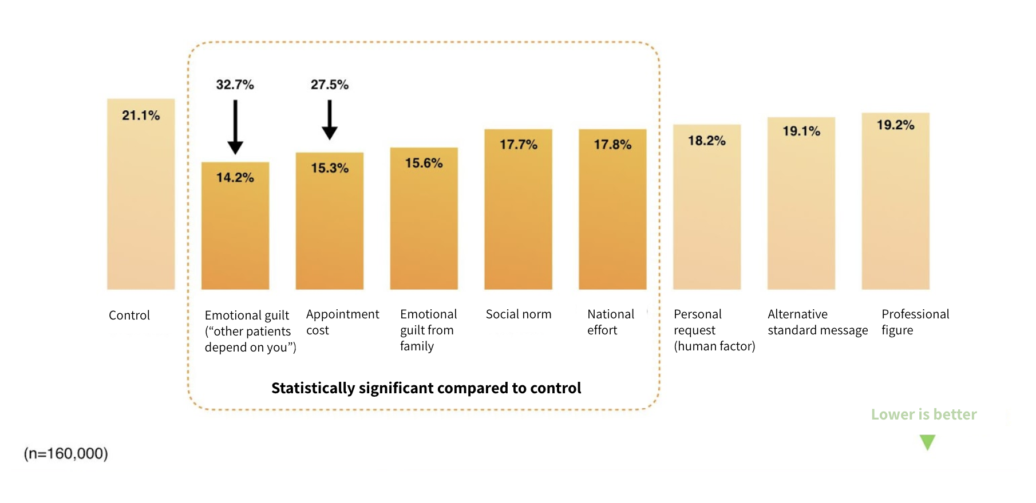

**Figure 1.** No-show rates by SMS group

As of 2018 (at the time of the trial), the annual proportion of unattended appointments across all outpatient clinics in all 14 CHS in Israel was approximately 18.7% of all outpatient clinic appointments. Results indicate that replacing the reminder message with a carefully designed message can potentially reduce unattended appointments by 31% at the 14 hospitals annually. This has the potential to free up doctors’ time and resources in the medical system, and improve the quality of care across the country. The intervention system was fully adopted by CHS from May 2019, and is used by over 4 million members, creating a substantial improvement in scheduling appointments and in saving thousands of doctor, surgeon, anesthesiologist, and nurse hours.

The outcomes of this trial show how relatively small steps can yield significant results. The simple, cost-effective, strategic use of traditional SMS reminders enables healthcare providers to systematically customize their interaction with members in order to increase the effectiveness of healthier behavior and reduce public expenditure. Broadly speaking, this simple intervention shows the untapped potential of smart messaging in health care.

The no-show intervention demonstrates how people often do not act according to what is “right” and efficient for society, not because they forget (since the baseline reminders did not create the desired effect), but because they lack the motivation or awareness to do so. More positively, the study also highlights how policymakers can use simple policy tools to nudge people towards the desired behavior.

The trial was later expanded to include more specific tailored messaging for sub-groups of society, which decreased no-show rates even further. Testing what type of motivational efforts work on different groups of people can have significant implications for other healthcare-related services, such as vaccinations and preventative care. Furthermore, such efforts can be effective in other types of policies which depend on people’s motivation to act – especially when non-action harms the common good of society – such as policies to encourage tax payment and policies aimed at fighting global warming.

Money laundering: Reducing the use of cash in the economy

Cash is still a basic, common and widely accepted means of payment among the general public. However, the prevalence of cash has many negative effects, such as facilitating criminal activity, money laundering, the financing of terrorism and the black economy. According to a report by the Israel Money Laundering and Terror Financing Prohibition Authority, the most popular method of money laundering in 2016 was through the use of cash. According to the World Bank report on Shadow Economies All Over the World, a correlation was found between the scope of black economy and the cash to GDP ratio.

The size of the black economy in Israel is among the highest in developed countries. It is estimated at about NIS 240 billion, which corresponds to approximately 22% of GDP. The loss of state tax revenues due to activity in the black economy is estimated at about 5% of GDP. An investigation of the movements of cash from the banking system to the black economy has found that about 95% of the black economy originates in cash withdrawn from banks every year by the public, which then continues circulating through economic activity to private entities, businesses, and the black economy.

Due to recent improvements in digital technology, the number of cash withdrawals is trending downwards. However, at the moment, despite the decrease in cash withdrawn from bank branches, there has been an increase in cash withdrawn from ATMs. The average withdrawal amount from ATMs increased by 82% between 2012–2020.[2]

In light of the situation described above, we examined which policy tools are likely to be effective in achieving the government’s objective to reduce the use of cash and increase the use of alternative payment methods. The premise of the study, as presented by the Budgets Department staff, is that the use of cash is a behavioral phenomenon and that action should be taken to reduce the cash circulating among the law-abiding population. Such reduction would in turn lead to a reduction in the flow of cash into criminal activities, thus reducing its negative effects on society and government finances.

The study examined whether it is possible to reduce the amount of cash in circulation by influencing the average amount of cash withdrawn by the public through the ATM interface, the medium by which cash is transferred from the banking system to the public. Specifically, the influence of “choice architecture” (a term coined by researchers Thaler and Sunstein referring to the design of different ways choices can be presented to consumers) on ATM users was evaluated using behavioral tools. These included lowering default withdrawal amounts, using anchoring by changing selection options to lower withdrawal amounts, increasing the difficulty of withdrawing higher amounts by applying a slower and longer process, providing information about the negative effects of cash, and reducing the sense of anonymity by identifying the withdrawn banknotes with the specific customer to encourage pro-social behavior.

As part of the experiment, about 1,300 Israelis were randomly assigned to one of 15 groups to evaluate the effects of the various behavioral tools described above, and the effect of combining several tools in a “golden interface” featuring multiple forms of intervention. The experiment showed that the “golden interface” reduced the average withdrawal amount by 50%. An analysis of the factors in the experiment showed, for example, that the interaction between low withdrawal amounts and automatic default settings had a significant effect on the withdrawal amount, and that the warning statement providing information about the negative effects of cash had no effect.

In the case of a shadow economy, personal habits do not necessarily reflect a strong personal motivation to engage in harmful social behavior, but, in the aggregate, such behavior can prove harmful to the economy. The intervention in the ATM cash withdrawal habit formation is consistent with and supportive of macro changes in the economy, in light of technological advancements and the transition to digital wallets that are reducing the need for ATM withdrawals.

Interventions aimed at changing everyday behaviors often attempt to alter people’s beliefs and intentions, but research shows they are unlikely prove effective regarding repetitive behaviors that have become habits and automatic behavior. Successful habit change interventions involve disrupting the environmental factors that automatically cue habit performance. Since the root of the behavior at ATMs is in people’s habits, and the environment of choice is easily identifiable, the approach was to nudge behavior by designing a environment of choice encouraging behaviorial change. Indeed, our findings support the premise that a simple choice architecture based on a default system can create effective behavioral change.

More generally, when considering the implementation of policies that deal with similar habitual unconscious behaviors, for example, energy consumption and healthy eating, policymakers can bridge the gap between people’s intentions and their behavior by removing the barrier to the “good” behavior – the need to actively undertake an action – and design the choice environment in a way that is likely to promote the desired behavior.

Efficient burial: How to use limited land more wisely

By the end of 2050, an area of about 6,458 square kilometers will be required for burial land, amounting to 29% of the total land area of Israel, or five times the area of ​​New York City. Israel’s burial problem is unique and provides an unprecedented case study as a result of the twofold complexity the state is faced with: an unprecedented combination of halakhic (Jewish law) restrictions and customs and extremely high population density (population to area ratio), especially in metropolitan centers. The country is forced to find alternative solutions at cemeteries, such as layered burial. Despite the obvious advantages of layered burial, which is space efficient and complies with institutional Jewish law and customs, the Israeli public is generally reluctant to choose it, opting mostly for field burial, which is perceived as the normative and preferred option.

This study was designed to review and analyze which behavioral tools are expected to be most effective in motivating Israelis to choose the layered method of burial, without restricting their decision-making process and freedom of choice. Two major situations in which the individual is required to make a decision regarding the burial method were identified: (1) a decision made by the living individual, which reflects his or her personal desire and is therefore characterized by rational thought; and (2) a decision made in the name of the deceased by a family member (by a significant other or by the deceased’s children), usually when under severe emotional stress.

An online questionnaire designed as a Randomized Control Trial was distributed to a representative sample of 2,500 Israelis. Results indicate that regarding the question of burial, people’s choice for themselves differs from their choice for their family members, and that the proportion of people who choose layered burial is higher when they decide for themselves (see Figure 2). Furthermore, the study showed higher satisfaction among respondents who chose layered burial for themselves, compared to those who chose field burial for themselves.

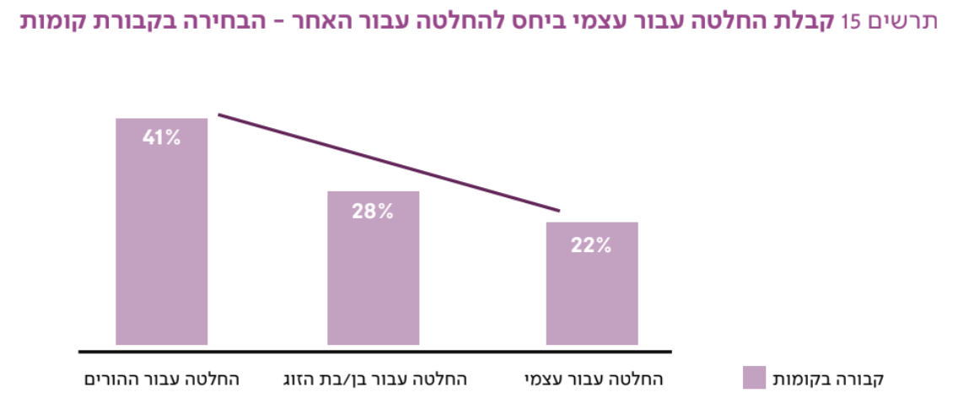

|  |  |  |
| --- | --- | --- |
| Decision for self | Decision made by the significant other of the deceased | Decision made by child of deceased |

**Figure 2.** Proportion of respondents who chose layered burial: decision for self/ decision made by a significant other or child

These findings suggest the likely effectiveness of a policy that encourages citizens to decide on their method of burial during their own lifetimes. Following this finding, the study further tested the effect of a new model for layered burial, which allows individuals to decide for themselves how they would like to be buried when the default is layered burial. Results show that the simplest, most cost-effective, and applicable solution to motivate the public to opt for this method is a default system of layered burial offered for free, with field burial offered as an alternative at a price, with payment to be made in multiple installments. This condition encouraged 69% of participants to prefer layered burial over field burial, compared to 43% in the control group. Furthermore, participants in this group were more satisfied with their decision relative to other groups.

The study suggests that the effectiveness of the model is largely explained by the possibility of obtaining a free plot, and that free burial is the most influential variable in the choice of layered burial. Moreover, the study also shows that presenting respondents with a choice between burial in a plot of land alone versus layered burial next to family members or spouses led to an increase in the choice of layered burial and increased satisfaction with the choice. Changing the basic narrative to one wherein the state offers its citizens layered burial as a solution to a problem – that is, a response to people’s preference to be buried next to family members and the difficulty in obtaining adjacent plots for family members – increases the satisfaction of individuals with their decision and is therefore likely to form the basis of a sustainable public policy.

This case highlights the importance of the context in which policy meets people’s decisions. The shortage of land for burial appears at first to be an economic question involving the price people are willing to pay for the land needed for field burial, but the question in fact deals with one of the most sensitive issues they face in life: decisions regarding death. Policymakers should take into account the fact that people do not always evaluate the optimal decision as one that maximizes their economic wealth. Policymakers should also understand both the harmful and beneficial emotional drivers contained within policies. This understanding makes it possible to predict how emotional drivers affect behavior, better equipping policymakers to choose economically efficient solutions for society as a whole.

Education: Underrepresentation of women in high tech

In the Israeli high-tech sector there is an imbalance between high demand for employees and inadequate supply. In addition, women make up only a quarter of those employed in the sector and are therefore one of the populations with the largest potential for increasing the supply of human capital. There is a myriad of women’s underrepresentation in this area. Few women study sciences in high school and engineering at institutions of higher learning. They also choose not to enter technological professions due to gender structuring and the perception of male predominance created around these fields. According to Israel’s Ministry of Finance, the scarcity of women in high-tech fields results in a loss of innovation and creativity that talented women could offer.

The research focused on increasing the presence of women in the high-tech sector, specifically at the first point of selection carried out by adolescents when deciding on a future career: choosing their major in high school. Surveys conducted with about 450 pupils from grades eight to twelve suggested that one of the main factors for female pupils in not choosing to major in computer science (CS) is a lack of exposure to the field. When reviewing the selection process itself, the research showed that choosing a major is subject to various biases. Information regarding the majors is delivered differently by each school and by family members, and not necessarily in a way that encourages pupils to choose subjects with which they are less familiar.

In two field experiments, we examined two alternative approaches to solve this familiarity problem. The first approach included an experiment which was conducted among 500 ninth graders before they chose a major, measuring the effect of adding a short course of CS studies in middle school. The experiment was intended to create familiarity with the subject via hands-on experience, and examine whether a short course consisting of four sessions of CS can influence the willingness of pupils to major in CS in high school. The results of the experiment showed that the course had no significant influence on the level of willingness.

The second approach was designed to measure the effect of exposure to first impression personal experience, delivered via informative videos on the decision to major in CS, presented on a “majors digital platform.” Six thousand ninth graders were exposed to the platform at the beginning of the school year: a website with video clips of various major graduates talking about their day-to-day life at work, and the contribution of their major to the career path they chose. The solution focused on enhancing familiarity with CS using various behavioral tools, such as choice architecture, personalization, enhancing perceived self-efficacy, and reducing present bias.

Results indicate that watching these clips increased students’ willingness to choose computer science by about 25% (see Figure 3). However, at the end of the school year, six months after the intervention, the actual choice of 1,122 students showed that 36% percent in the treatment group actually chose CS compared to 33% percent in the control group: not a statistically significant difference. A possible explanation for the decline of the effect is that the timing of intervention is crucial for creating a genuine behavioral change. If this is the case, then presenting information immediately prior to the actual choice of major would lead to a better chance that the positive effect on students’ intentions was translated into an actual behavioral change.

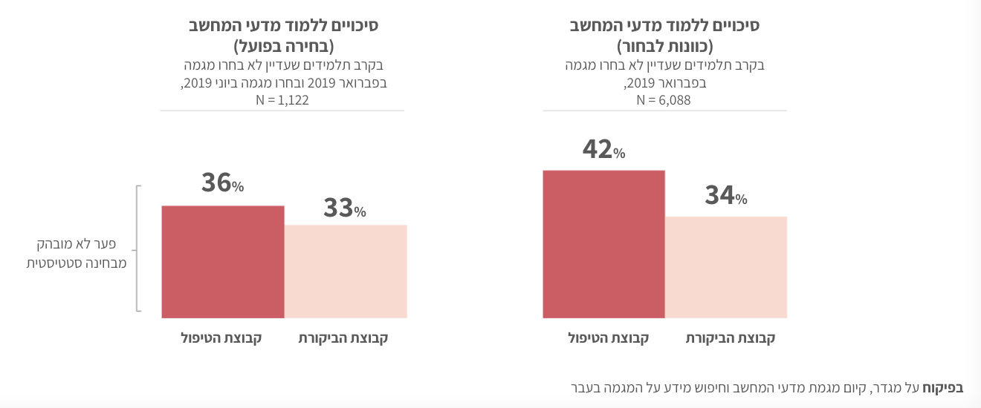

|  |  |
| --- | --- |
| Treatment group | Control group |

of majoring

As noted by Sheeran (2002),[3] human behavior is often characterized by an intention-behavior gap; i.e., the failure of individuals to translate their positive intentions into action. Beyond the timing of the intervention, combining additional behavioral tools which allow students to translate motivation into action, such as goal-setting techniques that promote the implementation of intentions, might have been an effective force for maintaining the intervention’s positive effect on intention to study CS (and would create a positive engagement in behavioral change as a result).

Increasing the number and diversity of young women choosing a STEM career (science, technology, engineering, and mathematics) is a “wicked problem,” namely a problem that has many causes which are interlinked and consequently does not have one single, simple solution. Policy design requires policymakers to break down the set of experiences and decisions that shape wicked problems. In order to do so, they need to examine the details of the problem, and identify and test a wide scope of possible interventions which may have the potential to produce the eventual desired outcome.

Bedouin women

Bedouins are an ethnic group with a tribal social structure living mainly in the Negev region of the south of Israel. This population is characterized by extremely low employment rates among women, about 26% (compared to 83% among Jewish women in the south of Israel).

Upon entering the employment market, Bedouin women are faced with a host of barriers, some of which are structural – for example, lack of appropriate education, lack of satisfactory public transportation, and lack of services and programs for children. In addition, there are factors related to the Bedouin social structure which specifically affect women who try to find jobs: Bedouin society is traditional, with a patriarchal structure according to which the men are the ones holding the power and making the decisions, while women are relegated to the domestic space and the family unit. These traditional perceptions of women’s role make it difficult for women in some areas to find work.

As part of the efforts to reduce poverty in this population by increasing the employment rates of women, the project was aimed to assist in delivering solutions to the challenges described above. Three experiments were conducted to examine how attractive a series of employment opportunities would be for the target audience, opportunities adapted to remove the barriers faced by the women and to meet the requirements of employers in the region. In addition, the experiments evaluated the influence of each of the solutions on the employment rates of women.

Findings from the three trials reveal a number of significant insights that contribute to a deeper understanding of barriers to employment, and point to potential directions for intervention. First, getting home from work at a reasonable hour is a major barrier to finding work, as most women are looking for a job that allows them to return home in the early afternoon so they can be there for their children. Second, a strong link was found between having a driver’s license and employment. Third, the study showed that unemployed women look for work mostly informally and often rely on information from friends and family rather than taking active steps, such as sending out their resume or going for a job interview. This behavior limits their ability to effectively find a suitable job.

Contrary to popular belief regarding Bedouin women, most of the women who participated in the trials did not express strong opposition to working outside their area of residence, although most were looking for work within their town or municipality. Also contrary to popular belief, no significant relationship was found between employment and the availability, hours of operation, and cost of childcare.

Based on the findings of the study, applicable behavioral solutions were formulated. The solutions were tailored to different target audiences, depending on the type of intervention offered, for example:

1. Encouraging Bedouin high school students to get a driver’s license. This solution consists of three parts: allocating an hour of study in the school schedule for all 12th graders to study driving theory; assistance in bureaucratic procedures, including providing transportation to the licensing office and assisting in filling out forms; subsidizing driving lessons and relevant fees for female students and subsidizing driver’s license fees contingent on proof of active job search.
2. Recruiting community placement coordinators. This solution involves locating working women, or those who have worked in the past, and recruiting them for the position of placement coordinators in the community. The placement coordinators would receive information about vacancies and an incentive to match the women in the community with these jobs. The jobs would be advertised in a way that is intended to encourage distribution by word of mouth.
3. Incentives for women to proactively search for employment and for men to support this search. These would include setting up job search stands (kiosks) in various hubs in recognized localities, and providing incentives to women to use these kiosks.

Culture can be recognized as a pervasive and ubiquitous cause as well as product of human behavior. Whereas basic processes of mentation in the human species (such as heuristics, association, recall, perception, inference, and comparison) are common, the origins of complex human behavior are rooted in cultural experience. Behavioral tools have proven to be effective in cases of regulatory design which influence basic processes of human behavior, for example, in cases that require identifying choices that are influenced by the simplicity of information and the range of available options; by using choice architecture and the design of convenient options (especially default options); and by emphasizing the salient points of options or attributes that affect how they are weighted in decisions. When it comes to complex culture-dependent behaviors, policy design is often an unprecedented task in the policy makers’ toolbox and should therefore be exercised with caution, together with learning processes that aim to understand the unique frictions and motivations that exist in addition to the basic, universal processes of human behavior.

Public digital interfaces: Evidence-based policy

The process of digitizing government services has a significant positive effect on the economy and society. For the public, the main advantages are an easy and simple interaction with government entities, better and far more accessible services, minimizing bureaucracy and frustration, and reducing the need to visit government offices in person, thereby saving valuable time. As far as the government is concerned, the process leads to a significant saving in resources, as well as increased efficiency and productivity.

Expenses can be saved as a consequence of reducing the need for front-office service providers, offices for receiving the public, office supplies, and more. Thus, for example, the British government estimates that since it added the option of receiving government services online, it has saved approximately 1.7 to 1.8 billion pounds per year.

The research highlighted the importance of a one-stop shop, which provides citizens with a single focal point from which to access all the necessary information, transactions and services. When done well, one-stop shops can reduce transaction costs and provide “win-win” outcomes for governments and clients by improving both services and compliance with regulations. Citizens and businesses can more easily locate forms, supply information once for multiple purposes, and do business more easily. Governments can receive better quality information in the first instance, and improved compliance rates that reduce the amount of resources needed for enforcement.

In the survey, 88% of respondents stated that they prefer interacting with the government through a one-stop shop-style platform. A significant gap was found between the desire to receive end-to-end digital services and the perceived digitalization in the field, which consists mostly of semi-digital government services. The gap described creates a sense of frustration and disappointment, which lowers the likelihood of using digital governmental services again in the future by 50%. Those who experienced satisfaction from digital government services are more likely to use them again.

In order to create an efficient interaction between the Israeli government and its citizens, the solution focused on digitizing government services, based on the idea of a one-stop shop. The nature of the platform was based on various behavioral aspects, such as personalization, gamification, compensation and incentives, nudging action through a sense of progress, positive feedback, minimizing friction, and other features. Principles from the platform’s elements were implemented in gov.il, Israel’s official government services and information website.

The idea of a one-stop shop is not unique to Israel, and many countries have advanced its implementation. This case therefore does not focus on the use of data for identifying and forming policy solutions, but rather highlights the power of data as a catalyst in the process of adapting to change. Further, it shows how the application of behavioral economic tools does not necessarily need to focus on specific moments of decision-making, and how it can be generally applied to human-centered design processes to make products and services more reliable, intuitive, effective, and easy to use.

Public transportation: A data problem

The transportation system in Israel is far from optimal. Traffic congestion costs the economy hundreds of thousands of working hours every day, causing an escalation in mental stress and a deterioration in welfare due to loss of leisure time. Despite the fact that the COVID-19 pandemic has had a significant impact on mobility due to “stay-at-home” orders during the outbreak, and while many commuters changed their working and travel habits in the post pandemic period; it is clear that road congestion during peak times is still a serious problem. It is thus essential to improve the efficiency of travel networks and options in urban areas, and optimize public transportation systems and private mobility.

In order to establish a knowledge infrastructure, we carried out an empirical analysis of traffic congestion patterns using aggregated data extracted from millions of mobile devices throughout the country. This unique data set made it possible to extract useful information about traffic trends and analyze behavior patterns on a weekly, daily, and hourly basis.

The analysis allowed the budget department to identify intervention points based on areas with a high potential to bring about behavioral change. For example, the analysis divided 500 commuters from the Ramat Hachayal neighborhood in Tel Aviv into three levels of potential for changing commuting habits: low, medium, and high. It showed that 16% of the commuters had a high potential to use public transport, bike or walk to work, and another 33% had medium potential with the right nudge – a total of 49% with the potential to change their commuting behavior. Furthermore, the analysis showed that 98% of the commuters had the potential to carpool to work, based on the routes they took from home to work every day, and 15% of them had a high potential based both on their daily commuting routes and the time they wake up in the morning.

The research emphasized the need to improve the tools used by policymakers to design transportation policies which meet citizens’ needs. Due to the lack of literature and relevant data, collecting dynamic data based on behavioral gap analysis was a necessary preliminary stage for planning concrete interventions to promote an effective behavioral change in commuting behavior patterns. Insights drawn from the data led to a series of field experiments. The ability to collect and analyze large amounts of data enables decision makers to cut through potential distortions to discover where intervention is most needed, or where the potential for an effective behavioral change is the greatest. The case of transportation highlights the importance of building a broad database before examining policy alternatives and constructing concrete solutions, as well as the importance of understanding differences between sub-populations and geographical areas.

Raising employment rates among people with disabilities

There are over 1.4 million people in Israel with disabilities, constituting a considerable 17% of the general population. People with disabilities are among the weak socioeconomic populations in the country, in part due to a low employment rate of 51% (compared to 79% among people without disabilities).

Workplace accessibility is one of the main barriers preventing people with disabilities from entering the employment market: measures such as reducing work hours or installing a wheelchair ramp have a crucial effect on minimizing gaps in productivity caused by the employee’s disability. Thus, the decision to hire people with disabilities becomes in many cases not only a social decision, but also a financial one. Adjusting the workplace can impose a great financial cost on the employer, and the process of filing a request for governmental grant (reimbursement for the cost of adjustment) is very protracted: receiving the reimbursement grant takes about a year and causes great friction for employers, who therefore fail to use it.

Following extensive research and a series of experiments, the research team developed an alternative process for filing a request for reimbursement based on principles from the field of behavioral economics. The new process focused on enabling faster reimbursement and reducing friction and bureaucratic burden which exists due to policy makers’ mistrust and fear of potential fraud.

The effectiveness of the alternative process was examined in an experiment with 480 employers and HR managers who deal with employee recruitment. Results indicate that compared to the control group, which relied on the existing process, the willingness to hire people with disabilities among the treatment group was 23% higher – a significant improvement. Also, the effect of the new process was significantly higher among employers that did not employ people with disabilities at the time (see Figure 4).

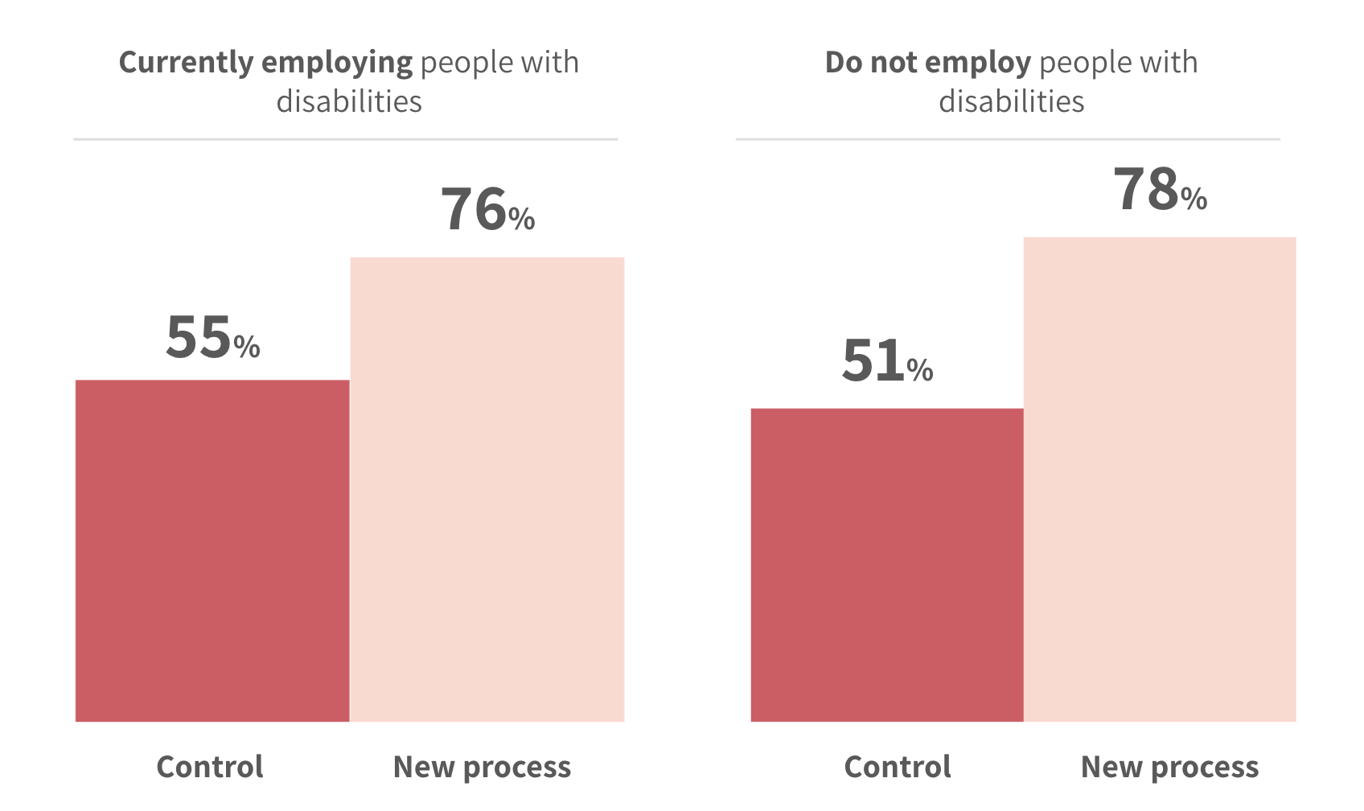

Figure 4. Willingness to hire and personal experience in hiring people with disabilities

To summarize, people prefer doing nothing over doing something. When policymakers design systems, they need to keep in mind that the “big prize” — incentives and motivations — may not be as effective as removing friction in a certain task that affects policy compliance. Behavioral frictions generally decrease the likelihood that we will complete a specific task or act in a certain manner, and increase our propensity to persist the status quo and avoid making choices. Fortunately, friction is something policymakers can study, analyze, and react to.

Reducing friction in the process of filing a request for reimbursement is an example of regulatory design that can be applied to various policies. An example that merits further examination is the bureaucratic burden of opening and running businesses, especially small and medium-sized ones. It is also clear that policymakers should examine their own intuitions, especially because they are prone to perceive some behaviors to be rooted in complex or covert considerations, and thus have little faith in efforts to change them, even when this is not necessarily the case. (An example of this is the assumption that employers do not apply for a reimbursement grant because they are not genuinely willing to employ those with disabilities.) Another important point to be aware of is the lack of motivation for institutional representatives themselves to encourage grant deployment; hence the tendency to over-emphasize risk consciousness and fraud prevention at the expense of the efficacy of policy programs.

Awareness of the method of communication of policies and their delivery can improve their overall effectiveness, especially when the reason for underutilization is the difficulty in deployment: long bureaucratic processes that require beneficiaries to provide multiple forms of evidence along the way. Simplifying these processes and highlighting trust may improve not only the rate of deployment, but also the overall satisfaction and appreciation resulting from the benefits and the interaction with the public authority itself.

**Table 1.**

|  |  |  |  |  |  |  |
| --- | --- | --- | --- | --- | --- | --- |
| **Targeted Behavioral Problem** | **Literature and prominent tools** | **Did we use existing Data?** | **Did we use surveys?** | **Did we use experiments?** | **Difficulty of study** | **Difficulty of applying chosen mechanism** |
| Healthcare: Reducing no- shows | Messaging; reminders |  | No | **Randomized controlled trial**  via SMS text reminders | **Medium,** due to dependency on the partnership with Clalit Health Service | Easy solution, based on existing SMS system |
| Money laundering: reducing the use of cash in the economy | Choice architecture, defaults, anchoring, pro-social behavior |  | Three surveys were conducted as part of exploratory research; led to the ATM experiment | **Randomized controlled trial**  via ATM interface simulator | **High,** due to dependency on advanced technological capabilities (development of the ATM interface) | The application itself is easy (a change of interface). The main barrier is banks’ opposition to the move. |
| Efficient burial: using limited land more wisely | Limited |  | Two surveys were conducted as part of exploratory research; led to the experiment | **Randomized controlled trial**  via online survey | **Medium,** due to the complexity and sensitivity of the subject | Political barriers, mainly due to opposition from specific interest groups. |
| Education: improving underrepre-sentation of women in high tech | Choice architecture, personalization, perceived self-efficacy, present bias |  | Two surveys were conducted as part of exploratory research; led to both RCT experiments | **Randomized controlled trial**  Field experiment (hands-on experience) & via online digital platform | **High,** due to dependency on the Ministry of Education (for distribution and design of the experiment), and also due to advanced technological capabilities needed for the design of the designated digital platform | A popular and desirable solution for all relevant actors. Requires expensive infrastructure and investment for implementation. |
| Bedouin women: Increasing employment | Limited |  | Two surveys were conducted as part of exploratory research; led to the drivers license RCT experiment | **Randomized controlled trial**  via online surveys, paper-pencil surveys | **High,** due to the great complexity of the research question including its cultural context and limited accessibility to the study population | Requires a policy decision, although does not require large resources relative to alternative solutions. |
| Improving public digital interfaces: evidence- based policy | Emphasis on behavioral UX/UI literature: Personalization, gamification, compensations and incentives, nudging action through a sense of progress, positive feedback, minimizing friction |  | Two surveys were conducted as part of exploratory research |  | **Low,** due to vast literature and number of case-studies. The complexity was mainly a question of the ability to harness relevant players and influence their willingness to adapt policy to reflect the results of the study. | Some issues require privacy-related legislation. Other aspects of implementation involve mainly simple interface issues. |
| Public transporta-tion: data problem;  reducing congestiona | Based on big-data analysis | Yes, aggre-gated mobile data |  |  | **Medium,** due to the complexity of the data analysis, difficulty gaining access to relevant data and deducing relevant and applicable policy applications. | The main difficulty is setting infrastructure of data. Leads to various solutions and interventions with different levels of difficulty. |
| Raising employment rates among people with disabilities | Reducing friction and bureaucratic burden, trust |  | Two surveys were conducted as part of exploratory research | RCT: via online survey | **Low,** althoughcomplexity and sensitivity of the research question required a long and patient research process | Requires changes in regulation. |

**Conclusions from Israel’s experience applying Behavioral Insights (BI) in policymaking**

A few conclusions to be drawn from Israel’s experience, discussed throughout the article, might prove helpful to other OECD governments contemplating implementing behavioral insight tools in their policy processes.

First is the importance of integrating behavioral methodologies as part of existing processes, such as the regular budget cycle. This alleviates the need for tools to be “pulled” intentionally in each case and lowers the barriers to their use. In addition, enabling the budget field managers rather than the behavior experts to control the processes proved key. This approach is particularly helpful for implementation: while behavioral experts know more about how to manage the learning process, they are not connected to the dynamics of the field and are thus limited in their ability to identify obstacles and promote successful implementation. We discovered, as well, that making sure that every budget cycle includes opportunities to work on topics of high priority to budget officials was also beneficial in centralizing the use of the BI tools and making them visible and readily available to many stakeholders relatively quickly.

In the implementation of behavioral insights, it is also important to remember that existing policies can be of great assistance. Every government has experience with what works and how well and performs varying degrees of cost-benefit analyses. It is important not to attempt to override good practices, and to opt instead for the integration of BI with existing policies when appropriate. Moreover, behaviorally informed interventions cannot achieve the desired outcomes when deployed alone; rather, these innovative tools are meant to complement more traditional policy tools (IDB 2020). In fact, understanding how to implement a behavioral approach is an iterative process for each government and should occur at a each government’s singular pace and on its unique terms.

A key conclusion regarding the implementation of BI is the importance of adopting a citizen-focused approach which is primarily based on data (rather than on intuition) to know what does and does not work well. In many cases, regulation does not fully integrate a citizen’s behavioral perspective, thus undermining efforts to achieve desired behavioral changes. Policymakers should carefully scrutinize the process from the perspective of the citizens in order to understand their views on what happens before a policy is implemented, what will change afterwards, and what is the measured impact of the change.

Using essentially neutral, evidence-based tools can also help promote cooperation and unqualified acceptance of the recommended course of action. It is easier to adopt solutions that are rooted in external factual analysis than those that are untested and, therefore, more prone to multiple interpretation and outside influence. This feature is particularly supportive of MoF officials being the leading agents in the government to advocate for the implementation of BI tools, given this ministry’s strong focus on the efficiency and effectiveness of public spending. Evidence-based methodologies can be further reiterated by mechanisms of data sharing across line ministries and government agencies, and eventually across different regions and governments, learning from each other about mechanisms of change and what methodologies may work best in different policy areas.

A primarily data-based approach warrants allowing sufficient room for flexibility and innovation, as people’s behavior changes in response to changes in their environment. Regulation should have built-in flexibility mechanisms (like sunset policies for the introduction of new and burdening regulations, e.g., in small and medium business regulation regulation), which include behavioral developments by design. Policies should include motivation for policymakers to incorporate changes when the change in environment justifies this, removing burdens proven not to be necessary. Technology’s impact on privacy is a great example of a rapidly changing environment to which policymakers should position themselves to respond. While privacy is very important and violations can be damaging, governments should nevertheless perform a cost-benefit analysis for privacy policies from a behavioral perspective. For example, to protect privacy, an unintegrated digital government services requires that citizens enter their details every time they request a service. However, instead of assuming basic public mistrust, governments should ask their citizens about their privacy preferences. They may discover that people primarily prefer convenience and efficiency over privacy with almost all the services they consume, whether private or public.

It is important to perform cost-benefit analyses to determine what approach to take in specific cases: behavioral economics is not a code for magic solutions, and it can be hard to tell what approach will work best. It is rather a set of tools from which we can choose and apply contextually, informed by a fair weighing of projected gains versus costs that aim to bring about better and more efficient policy. The analysis should also include reference to scalability of the program or solution considered, anticipated implementation difficulties, and the expected impact. In addition, it is important to take note of whether the course or policy considered is expected to be a one-time implementation effort or is the beginning of a longer process. In the case study of the public transportation data problem described above, the high investment in setting up the infrastructure for data collection and analysis was justified because it was a clear first step of many toward building a data framework. This framework was intended to significantly boost the understanding of behavioral biases in the use of national public transportation systems and was indeed used as a live database for several experiments. Importantly, it is expected to continue yielding benefits over a long period of time.

Finally, budget officials should also refer to past policies and analyze what worked and what did not, and under which circumstances. While it may not be possible to automatically apply conclusions from one successful application to a different policy question, past successes may still provide a good indicator for the direction of potential impact. For example, if a certain experiment showed that exposing citizens to information about how their tax money is being used increased tax compliance by 30%, it may serve as a valuable model for how to boost citizen engagement in other civil activities, even though we will not be able to rely on this information alone to infer the extent of impact.

**Conclusion**

The advantages of integrating behavioral insights in developing public finance policies are significant. These include freeing resources by referring to often low-budget behavioral interventions in place of more complex structural solutions; enhancing efficacy of public policies by testing what works before implementing extensive and expensive public programs; improving internal policymaking processes by moving to a primarily data-driven, citizen-focused approach (which has the added benefit of also improving motivation among government officials); and improving citizen appreciation and satisfaction with public services, with its collateral impact of increasing trust in public institutions and bolstering citizen motivation to more generally comply with regulations and pay taxes.

Our case studies demonstrate that there are ways to adopt and utilize behavioral tools in policymaking that are not burdensome. If that is so, why is this approach not practiced more widely? Integrating behavioral economics in public policy is being carried out cautiously, but not because it is controversial. In fact, the practical and self-explanatory nature of the tools and the ease with which they can be understood make them readily available to public institutions wishing to use them in varying contexts (John, 2016). The cautiousness, instead, seems to arise more from resistance to changing habitual ways of thinking. Applying behavior economics to public policy problems requires not only developing new critical thinking skills in order to thoroughly understand what works, but doing so even when what we learn seems counter to intuition. Not only is such intuition a strong force with which to contend, but it is also often easier and takes less time to explain our intuition than to dive in, interpret and explain the results of an experiment. People often also have a strong preference to avoid experiments and an even stronger preference against being wrong. Experiments can highlight what we do *not* know, and measurement increases the chances of discovering that you are wrong from time to time.

Curiously, behavioral insights focus a lot on friction, many times the friction that stands between citizens and doing the right thing for society as a whole. However, in addition to the effort involved in overcoming habitual patterns of thinking, the introduction of behavioral insights into the policy process, like the introduction of any innovation, can, on its own, create a lot of friction. We see such friction when attempting to apply a constructive research approach based on existing literature in areas that experienced teams feel they already know a lot about. Then there is the physical and psychological friction of collecting data, which has an asymmetrical chance of making people happy. If the data support what we believed *a priori*, then we consider it worth our time. But if the data is counter to our beliefs, the chances for adoption, or even further data collection to deepen our understanding, ironically drop.

The highest levels of friction are created when working teams ask to run complex experiments for testing uniquely tailored solutions in specific contexts. The perception that time and resources are wasted on such attempts is difficult to counter. However, as the case studies presented here demonstrate, the potential benefits of such efforts can be high.

With time, practice and success, the process of integrating behavioral economics in the policymaking process will get easier. Eventually, we recommend that governments should mandate data-driven policies in much the same way as the FDA mandates testing for new medications. We understand that we would not want to live in a world in which physicians can follow their intuition in determining what medications to prescribe. In time, we will come to expect data-driven public policies.

Finally, as economists increasingly help governments design new policies and regulations, they take on an added responsibility to engage with the details of policymaking (E. Duflo). When implementing behavioral insights and focusing on citizens’ perspective, details can make all the difference in determining what will eventually work. While the specific approach and goals of integrating BI in policymaking will differ across different public contexts and national governance structures, it is nevertheless increasingly important for every policy maker to engage in understanding data and the details of how mechanisms of behavioral change actually work.

Fortunately, avoiding friction is an important determinant of human behavior, which suggests that if we implement changes correctly, and ensure that the standard is to have data-driven policies, over time this will become the norm – a good habit from which it will be harder to deviate.

1. Berliner Senderey, A., Kornitzer, T., Lawrence, G., Zysman, H., Hallak, Y., Ariely, D., & Balicer, R. (2020). It’s how you say it: Systematic A/B testing of digital messaging cut hospital no-show rates. *PloS one*, *15*(6), e0234817.
2. add reference
3. Add reference