Long-Term Care Facilities as a Risk Factor for Death Due to COVID-19

© Matan Yonas, Neil Gandal, Michal Feldman, Mark Last, Ady Pauzner, Avraham Tabbach, and Liat Ayalon[1]

May 24, 2020

Abstract

A large percentage of the deaths from COVID-19 occur among residents of long-term care facilities. There are two possible reasons for this phenomenon. First, the structural features of such settings may lead to death. Alternatively, it is possible that individuals in these facilities are in poorer health than those living elsewhere, and that these individuals would have died even if they had not been in these facilities.

Our findings show that controlling for the number of COVID-19 cases per capita and the percentage of older adults in the population, there is a significant positive association between the number of long-term care beds per capita and COVID-19 mortality rates.

This finding provides support for the claim that long-term care living arrangements of the elderly are a significant risk factor for COVID-19 mortality.

1. Introduction

A large percentage of the deaths worldwide from COVID-19 have occurred among residents of long-term care institutions (Comas-Herrera et. al, 2020). According to data reported in *Euronews,* a very large percentage of deaths from COVID-19 occur in nursing and retirement homes. Indeed, it is possible that deaths due to COVID-19 among such long-term care residents could account for more than 50% of all COVID-19 deaths in Europe.[2] According to a report in *The Guardian*, data from the Kaiser Family Foundation indicates that COVID-19 deaths among long-term care residents account for more than 50% of all deaths attributed to COVID-19 in fourteen states in the United States. Additionally, the same article notes that in the state of New Hampshire, 72% of COVID-19 deaths occurred among those living in long-term care settings.[3] Overall, according to the *New York Times*,[4] more than one third of the deaths in the United States from COVID-19 have occurred among long-term care residents. The U.S. Center for Disease Control and Prevention (CDC) has formally stated that generally, people 65 years and older, and in particular “People who live in a nursing home or long-term care facility” are at high-risk for severe illness from COVID-19.[5]

There are two possible explanations for the higher COVID-19 mortality rates in long-term care facilities:

* The first possible explanation is that the structural features of such settings, such as a communal living area, multiple residents in a room, care provided by multiple caregivers to multiple care recipients, etc., can lead to a greater number of deaths.
* The second possible explanation is that individuals in these facilities are in poorer health than those outside of such facilities and they would have been likely to die in the near future even had they had not been in these facilities.

Each of these two explanations has major policy implications. Using country-level data from Europe,[6] this paper addresses the two competing explanations presented above by examining the association between long-term care beds per capita in a country and COVID-19 deaths per capita. We find that controlling for the number of cases per capita and the percentage of older adults in the population, there is a significant positive association between the number of long-term care beds per capita and COVID-19 mortality rates in different European countries. This finding supports the thesis that living in long-term care facilities presents a significant mortality risk factor for older people contracting COVID-19.

Our results also provide a preliminary explanation as to why the death rates from COVID-19 differ so widely among the European Countries. This issue needs to be explored in more depth once there is more detailed data available, including additional countries, regional level data, and more. Therefore, there is a need for future research on this question.

In the following section, Section 2, we look at the data on long-term care beds per capita by region for one European country, Italy. Section 3 analyzes the data from Europe, and the discussion in Section 4 offers some conclusions and suggestions for further research.

1. The Regions in Italy

This section focuses on country-level data. For research purposes, having data on long-term care beds per capita for regions within a country, and not just for the country as a whole, is ideal. The one country that did have such regional data available was Italy. This information enabled us to break down the data for Italy into the smaller sub-regions of countries. The correlation of deaths per capita and long-term care beds per capita (in levels) is 0.70 when all counties are included. Since the northern part of Italy had many more cases per capita, the correlation between COVID-19 deaths and living in long-term care facilities was calculated excluding the northern counties. The result of 0.74 was very close to that of the country as a whole. This suggests that even when excluding the northern regions of Italy from consideration, there is strong positive relationship between mortality rates per capita and long-term care beds per capita. See Figure 1, which shows the data for non-northern Italian counties.

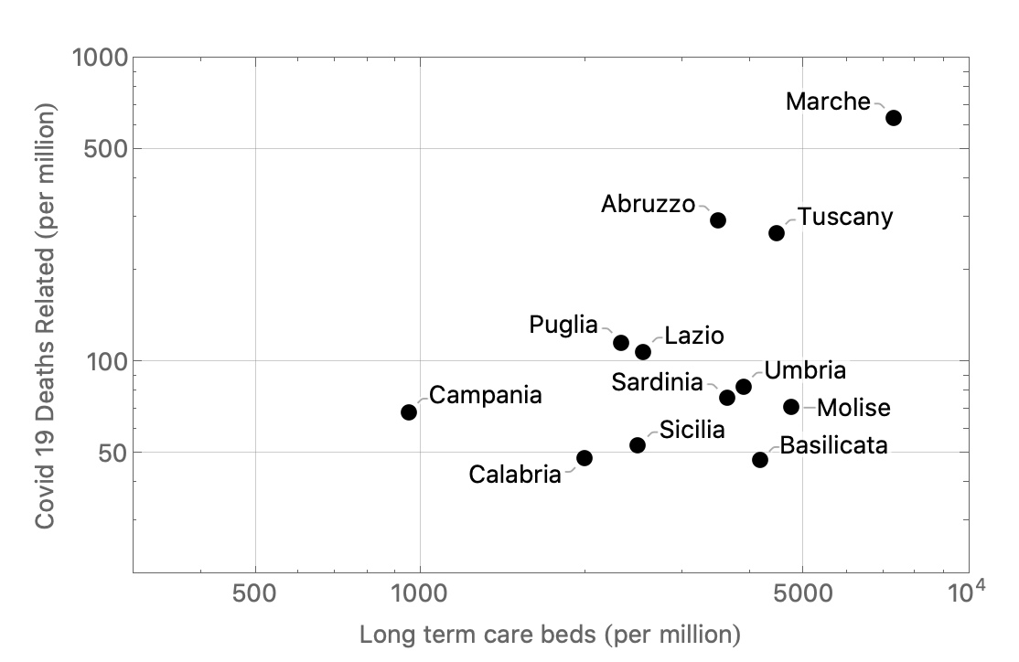

Figure 1: Deaths per capita in relation to long-term care beds per capita, non-northern Italian counties (logarithmic scale.)

3. Econometric Analysis

This research sought to examine the factors that affect deaths per capita, and, in particular, long-term care beds per capita.[7] Additional factors have been controlled for as well: (1) the number of official COVID-19 cases per capita and (2) the percentage of the population aged sixty-five and older.

This section will formally explore the relationship between these three factors of long-term care beds per capita, the number of official COVID-1o deaths per capital, and the percentage of the populated aged sixty-five and over. The percentage of the population aged sixty-five and older and the number of long-term care beds per capita are truly exogenous variables.

However, it should also be taken into account that the number of cases per capita is itself endogenous. Cases per capita are also likely a function of the percentage of the population aged sixty-five and older and long-term care beds per capita. Fortunately for the analysis, the factor of cases per capita is also a function of the number of tests per capita for COVID-19. It is reasonable to treat tests per capita as an exogenous variable, since it depends primarily on the technology available in the country, institutional features of the country, and government policy. In order to estimate this model, an instrumental variables regression to take account of the endogeneity of cases per capita was run.

We included all European countries for which we have data on long-term beds per capita. We have data on thirty-three of the thirty-seven European countries with more than 600,000 residents.[8] Figure 2 shows a graph of deaths per capita in relation to long-term care beds per capita for these countries.[9]

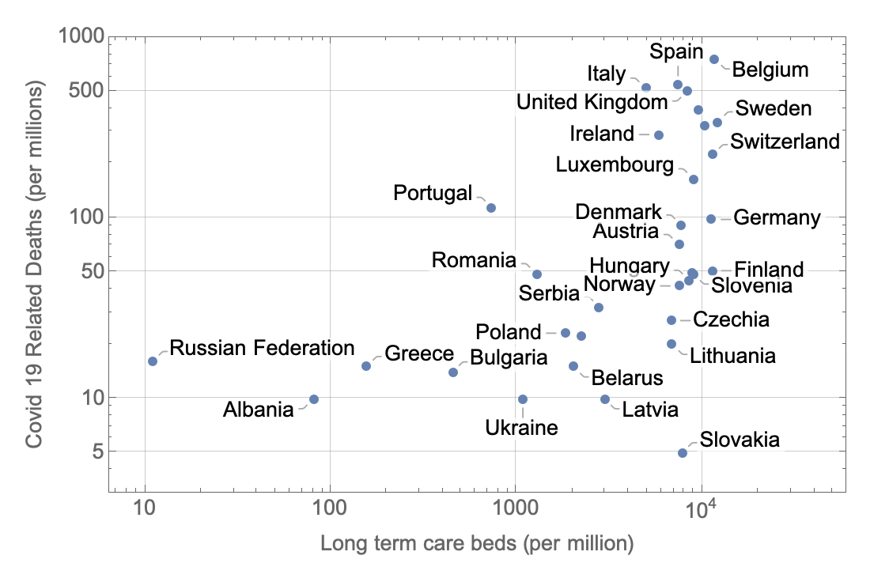

Figure 2: Deaths per capita in relation to long-term care beds per capita: 33 countries: logarithmic scale.

The European Health Information Gateway, which is part of the European Regional Office of the World Health Organization is the source for the data used in this study and for the definition of long-term care beds. Their definition for long-term care beds is “beds available for people requiring long-term care in institutions (other than hospitals).The predominant service component is long-term care and the services are provided for people with moderate to severe functional restrictions.”[10] Although the quality of the settings, and their structures also differ,[11] the nature of the facilities included is well-defined by the agency. Figure 2 shows that there is a large difference in the number of long-term care beds per capita.

The data available for the study are

* Deaths per capita = deaths from COVID-19 per million residents
* Beds per capita = number of long-term care beds per million residents
* Cases per capita = number of COVID-19 cases per million residents
* 65+ per capita = the percentage of the population aged 65 and older
* Tests per capita = the number of tests conducted for COVID-19 cases per million residents

Descriptive Statistics are shown in Table 1.

|  |  |  |  |  |
| --- | --- | --- | --- | --- |
| Variable | Maximum | Minimum | Std. Error | Mean |
| Deaths per capita | 760.0 | 5.0 | 197.6 | 149.8 |
| Beds per capita | 12,140.0 | 11.0 | 4,014.1 | 6,045.7 |
| Cases per capita | 6319.0 | 269.0 | 1689.6 | 2,050.0 |
| 65+ per capita | 0.23 | 0.14 | 0.024 | 0.19 |
| Tests per capita | 101,878.0 | 4150.0 | 24,701.0 | 37,685.3 |

In Table 2 below, we include correlations among the above variables for the thirty-three European countries which are shown in Figure 2. The Table shows that long-term beds per capita is positively correlated with COVID-19 deaths per capita (0.47.) Table 2 shows that, as anticipated, cases per capita and COVID-19 deaths per capita (0.74) are highly correlated. The table also shows that the percentage of the population aged 65 and over and deaths per capita are positively correlated, with a correlation coefficient of 0.14. Significant for the analysis is that there is not a very high correlation between cases per capita and beds per capita. Finally, the table also shows that the correlation between cases per capita and tests for capita is 0.57. This means that tests per capita is a useful instrument for determining cases per capita.

Table 2: Correlations Among the Variables for 33 European Countries

|  |  |  |  |  |  |
| --- | --- | --- | --- | --- | --- |
|  | Deaths/capita | Beds/capita | Cases/capita | 65+/capita | Tests/capita |
| Deaths/capita | 1.00 |  |  |  |  |
| Beds/capita | 0.47 | 1.00 |  |  |  |
| Cases/capita | 0.74 | 0.39 | 1.00 |  |  |
| 65+/capita | 0.14 | 0.13 | -0.17 | 1.00 |  |
| Tests/capita | 0.23 | 0.29 | 0.57 | -0.05 | 1.00 |

From Figure 2, it appears that the variance of the dependent variable increases with the number of long-term care beds, which is indicative of heteroscedasticity. When we estimate a linear model that takes into account the endogeneity of cases per capita, we indeed find, using the Hall-Pagan test, that constant variance of the noise factor can be rejected in favor of heteroscedasticity.

The typical solution is to use a functional form with all of the variables in natural logarithms, i.e., a log/log specification. Hence, we estimate a log/log model using instrumental variables, where cases per capita are instrumented by tests per capita. In this case, the hypothesis of constant variance of the noise term cannot be rejected. Consequently, this specification is the appropriate one to use.

Thus, using the log/log model and running instrumental variables, we have addressed the two key econometric issues: (1) endogeneity of cases per capita and (2) heteroscedasticity. The results of estimating this model appear in Table 3.

The regression uses the natural logarithm of deaths per million residents from COVID-19 as the dependent variable and the natural logarithm of beds per capita, natural logarithm of cases per capita, and the natural logarithm of the percent of the population 65 and older as explanatory variables.

NLDC()

|  |  |
| --- | --- |
|  | Logarithmic Regression |
| Beds/capita | 0.28** (0.11) |
| Cases/capita | 0.60** (0.27) |
| 65+/capita | 1.75 (1.14) |
| Constant | 0.41 (2.24) |
| R squared | 0.67 |
| N = observations | 33 |

(Standard Errors in parentheses: *** (**) [*] = significant at 99% (95%) and [90%] level.)

This regression yields the following results:

As expected, both cases per capita and the percentage of the population aged 65 and over show a positive association with deaths per capita. The coefficient on cases per capita is positive and statistically significant at the 95% level of confidence. The coefficient of the natural log of beds per capita is an elasticity. Thus, the 0.60 coefficient from the instrumental variables regression in Table 3 means that a one percent increase in the number of cases per capita is associated with a 0.60 percent increase in deaths per capita.[12] The coefficient on age is positive, but not statistically significant.

Controlling for the number of cases, and the proportion of adults aged 65 and older, long-term care beds per capita is positive and statistically significant at the 95% level of confidence in explaining the differences in the deaths per capita in Europe. This is an important result, because even after including cases per capita, which has a high correlation with deaths per capita, long-term care beds per capita emerges as a risk factor for death from COVID-19.

The coefficient of the natural log of beds per capita is an elasticity. Thus, the 0.28 coefficient from the instrumental variables regression in Table 3 means that a one percent increase in the number of long-term care beds per capita is associated with a 0.28 percent increase in deaths per capita.[13]

The regression explains a non-trivial amount of the difference in death rates per capita. A log/log regression that did not take into account the endogeneity of cases per capita has an adjusted “R squared” of 0.78. Although “R squared” has no natural interpretation in instrumental variable estimation, there is, as Wooldridge (2008) has written, no harm in referring to it, and hence we report it. The high value of “R squared” in our instrumental variables regression (0.67) shows that tests per capita is a strong instrument for determining cases per capita.

4. Discussion and Further Work

Controlling for the number of COVID-19 cases, and the proportion of adults “aged 65 and older,” the number of long-term care beds per capita is positive and statistically significant in explaining the differences in the deaths per capita for countries in Europe. This suggests that the structural features of such settings are associated with death from COVID-19. In European countries with fewer long-term care beds per capita, the death rate from COVID-19 is lower. These findings are, of course, very preliminary, but they nonetheless raise policy implications. In particular, efforts should be geared to protecting older adults living in long-term care settings. This can be done through targeted ongoing testing of this population and the allocation of adequate means for infection prevention and control in these settings.

It appears that additional and more detailed data concerning long-term care residents may be available in the next few months, and this analysis will be continued at such time as such data become available.

**References**

Armijo-Olivo, S., Craig, R., Corabian, P., Guo, B., Souri, S., & Tjosvold, L. (2020). Nursing staff time and care quality in long-term care facilities: a systematic review. *The Gerontologist*, 60,(3), e200–e217.

Caiumi, A. and Paccagnella, M. Mitigating the work-safety trade-off, *Covid Economics Issue*, 2, April 8, 2020. Available at <https://cepr.org/sites/default/files/news/CovidEconomics2.pdf>

Comas-Herrera, A, Zalakaín, J., Litwin, C, Hsu, A.T., Lane, N. and Fernández, J. L. (2020). Mortality associated with COVID-19 outbreaks in care homes: Early international evidence. *LTCcovid.org, International Long-Term Care Policy Network*, CPEC-LSE, May 3, 2020.

Onder, G., Rezza, G., & Brusaferro, S. (2020). Case-fatality rate and characteristics of patients dying in relation to COVID-19 in Italy. *JAMA*.

Wooldridge, J., Introductory Econometrics: A Modern Approach, *Cengage Learning*, 2008.

**Appendix:**

**Data Sources**

|  |  |  |
| --- | --- | --- |
| **Description** | **Source** | **Comment** |
| Long-term care beds by country | <https://gateway.euro.who.int/en/indicators/hfa_491-5101-number-of-nursing-and-elderly-home-beds/visualizations/#id=19556&tab=table> | DK 2011, BE and NL 2012, DE and ES 2013, IE, LU and UK 2014, the rest 2015 |
| Coronavirus death statistics by country | <https://www.worldometers.info/coronavirus/> | Data as of May 13, 2020 |
| Demography statistics by countries | <https://www.cia.gov/library/publications/the-world-factbook/docs/rankorderguide.html> | Population Est. 2020 |
| Mobility data | <https://www.google.com/covid19/mobility/> | Data as of May 9, 2020 |
| Age Groups | <https://data.worldbank.org/indicator/SP.POP.65UP.TO.ZS> | 2019 Revision |
| Italy Regional long-term care beds | <http://dati-anziani.istat.it/index.aspx?lang=en&SubSessionId=83aaf6dc-879c-457e-abe0-ce4781c6f43a> | Data as of 2016 |
| Portugal long-term care beds | Lopes, H., Mateus, C, Hernández-Quevedo, C. (2018): Table 2: Ten Years after the Creation of the Portuguese National Network for Long-Term Care in 2006: Achievements and Challenges. Health Policy. | Data as of 2016 |
| Italy regional Coronavirus statistics | <https://statistichecoronavirus.it/regioni-coronavirus-italia/toscana/> | Data as of May15, 2020 |

1. Matan Yonas, Tel Aviv University, School of Economics, ([matany@mail.tau.ac.il](mailto:matany@mail.tau.ac.il))

   Neil Gandal, Tel Aviv University, School of Economics, and CEPR ([gandal@tauex.tau.ac.il](mailto:gandal@tauex.tau.ac.il))

   Michael Feldman, Tel Aviv University, School of Computer Science, ([michal.feldman@cs.tau.ac.il](mailto:michal.feldman@cs.tau.ac.il))

   Mark Last, Ben-Gurion University of the Negev, Software and Information Systems Engineering ([mlast@bgu.ac.il](mailto:mlast@bgu.ac.il))

   Ady Pauzner, Tel Aviv University, School of Economics, ([pauzner@tauex.tau.ac.il](mailto:pauzner@tauex.tau.ac.il))

   Avraham Tabbach, Tel Aviv University, Law Faculty, ([adtabbac@tauex.tau.ac.il](mailto:adtabbac@tauex.tau.ac.il))

   Liat Ayalon ([liat.ayalon@biu.ac.il](mailto:liat.ayalon@biu.ac.il),) Bar-Ilan University, School of Social Work
2. [https://www.euronews.com/2020/04/17/coronavirus-care-homes-could-be-where-over-half-of-europe- s-covid-19COVID-19-deaths-occur-says-new](https://www.euronews.com/2020/04/17/coronavirus-care-homes-could-be-where-over-half-of-europe-  s-covid-19COVID-19-deaths-occur-says-new). See also the report by Comas-Herrera et. al., 2020.
3. <https://www.theguardian.com/us-news/2020/may/11/nursing-homes-us-data-coronavirus>
4. <https://www.nytimes.com/2020/05/12/business/nursing-homes-coronavirus.html>
5. <https://www.cdc.gov/coronavirus/2019-ncov/need-extra-precautions/groups-at-higher-risk.html>
6. All data sources can be found in the Appendix.
7. We currently do not have data on how many people aged sixty-five and older are living in long-term care settings. Therefore, we use the factor of long-term care beds per capita as a proxy for older persons living in long-term care facilities which we believe is an excellent proxy for the percentage of the population living in such setting. It should be noted that such data on the number of people aged 65 and older living in such facilities are available for most European countries.
8. Two small island countries, Iceland and Malta were excluded from the analysis.
9. While not all the country names not appear in Figure 2, all thirty-three observations are

   Included in the figure.
10. The quote is from the European Health Information Gateway, <https://gateway.euro.who.int/en/indicators/hfa_491-5101-number-of-nursing-and-elderly-home-beds/>, which served as the data source for all countries except Portugal for this study. Data from Portugal is from Lopez el. al, 2028. Most of the data on beds from our data source is from 2015, the most recent year available. See the Appendix for details. See the source for the detailed explanation.
11. See Armijo-Olivo et al., 2020
12. No variable in such an analysis is perfectly exogenous, but tests per capita come as close as possible. When not adjusting for the endogeneity of cases per capita, an elasticity on cases per capita that is greater than one is obtained. This is anomalous, since at the margin, the less severe cases are less likely to lead to death. Hence, the adjustment for endogeneity is working properly.
13. In an earlier version of the paper, cases per capita were excluded. With this factor excluded, a one percent increase in the number of long-term care beds per capita was found to be associated with a 0.5 percent increase in deaths per capita. The positive aspect of this regression is that the right-hand side variables are perfectly exogenous. However, the regression analysis was conducted as reported, as it is important to control for cases per capita.