*Curriculum Vitae*

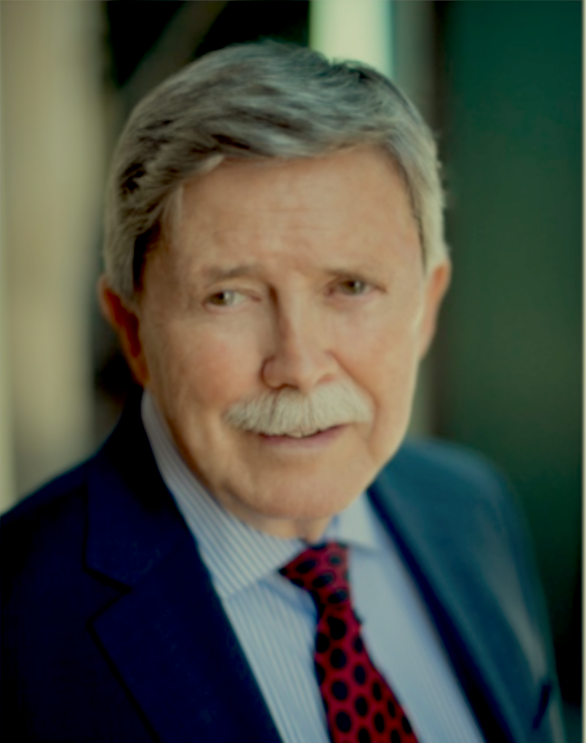

LARRY D. BRUCE

*Biblical Archaeologist*

June 2022

INDEPENDENT RESEARCHER

EDUCATION

* PhD, Southwestern Baptist Theological Seminary (1988)
  + Major: Biblical Backgrounds and Archaeology; Minor: Old Testament
  + Archaeological field training: Tel Batash, Israel
  + Dissertation: *The Israelite Exodus and the Conquest of Canaan in the Early Iron Age: A Synthesis of the Archaeological and Literary Evidence in the Light of Ethnographic Studies*
* MDiv, Southwestern Baptist Theological Seminary (1981)
* Woodrow Wilson Fellow, University of Kansas (graduate studies in philosophy)
* BA, *magna cum laude*, Western Carolina University (history, philosophy) (1965)

EXPERIENCE

* Independent researcher (2005–present) with a focus on the biblical and archaeological evidence of ancient Israel’s origins in Canaan
* Instructor in the encore program, Gulf Coast State College (2019–present), where I teach courses in biblical archaeology and hermeneutics
* Adjunct Professor of Archaeological and Biblical Studies (graduate and undergraduate courses), Baptist College of Florida (2013–2015)
* Teacher, Bible Studies and Archaeology Seminars, First Baptist Church, Panama City, Florida (20 years)

PUBLICATIONS

* *The Israelite Exodus and Conquest in the Early Iron Age: A Synthesis of the Archaeological and Literary Evidence in the Light of Ethnographic Studies* (PhD dissertation, Southwestern Baptist Theological Seminary, 1988). Ann Arbor, MI: UMI Publications, 1988.
* “The Merenptah Stele and the Biblical Origins of Israel.” *Journal of the Evangelical Theological Society* 62.3 (2019): 463–493.
* Appearing on ResearchGate.com (20,000 reads)
  + “The Biblical Origins of Israel” (2019)
  + “Abraham and the Amorites” (2019)
  + “The Vast Numbers of the Israelites” (2019)
  + “Israel in the Time of Merenptah” (2019)
  + “Bibliography: Ancient Israel Unearthed” (2019)
* Appearing on Academia.com: (1,350 reads)
  + “The Merenptah Stele and the Biblical Origins of Israel” (2020)
  + “Dissertation Abstract” (6/2022)
  + “The Period of the Israelite Judges (ca. 1130–1032 BC)” (6/2022)

AFFILIATIONS (past and present)

* American Schools of Oriental Research (ASOR)
* Evangelical Theological Society (ETS)
* Near East Archaeology Society (NEAS)
* Egyptian Exploration Society (EES)
* Biblical Archaeology Society (BAS)

NON-ACADEMIC EMPLOYMENT

* International Airline Captain: World Airways (1989–2011) (retired)
  + International airline captain, check captain, manager, test pilot
  + Global operations flying DC10s (cargo and passenger); rated in the MD11
  + Trained and evaluated flight crews inflight and in the simulator; managed a remote base of operations in Indonesia
  + Wrote aircraft flight manuals and training materials (used throughout the industry)
  + Test flew all new aircraft acquisitions, as well as post-overhaul flight evaluations, and all engine-out ferry operations
* International Flight Training Development: American Airlines (1988–2002) (retired)
  + Developed the international flight training program required of all international American Airline pilots
  + Trained the instructors; wrote manuals used throughout the airline industry
  + (Simultaneously worked for American Airlines and World Airways during this period; retired from both airlines.)
* Other civilian experience
  + Data engineer: Monitored and logged deep oil well drilling operations in the Gulf of Mexico
  + Executive search consultant (self-employed): Identified and recruited engineering and scientific personnel for the oil and gas industry

MILITARY EXPERIENCE: United States Air Force, Captain, (1967–1973)

* F-102 interceptor pilot (Germany) and test pilot
* F-100 fighter pilot (Vietnam): Awarded the *Silver Star*, three *Distinguished Flying Crosses* for heroism and extraordinary achievement, eight Air Medals, and the Air Force Commendation Medal (for ground action in Cambodia)—in addition to other medals and commendations
* T-38 advanced pilot training instructor

CONTACT INFORMATION

* 2100 W. Beach Drive, Y101  
  Panama City, FL 32401
* (850) 896-8208
* Email: Ldeanbruce@gmail.com