|  |  |
| --- | --- |
| **EXTRANET CODE** | **315601** |
| **COMMERCIAL NAME** | **CORMORAN 180 EC** |
| **ACTIVE INGREDIENT** | **ACETAMIPRID 80 g/L + NOVALURON 100 g/L** |
| **DESCRIPTION** | **Final report, Development, Rice, Insects** |
| **SUBJECT:** | **Field trial for development** |
| **2. PLANNED OR PLACED TRIAL:** | **Placed** |
| **3. TRIAL DATE:** | **June 20, 2017 for the final report** |
| **4. TARGET PEST:** | ***Hydrellia griseola, Hortensia similis*,and *Tagosodes oryzicolus*** |
| **5. WEEDS (INSECTICIDE)** | ***Hydrellia griseola and Hortensia similis*,and *Tagosodes oryzicolus*** |
| **6. PROTOCOL OR FINAL REPORT (ATTACHED):** | **FINAL SCREENING REPORT** |
| **7. EXPECTED PAYMENT DATE:** | **IMMEDIATE** |
| **9. RESEARCHER NAME:** | **Herney Moreno – Oscar Girón** |
| **10. RESEARCHER ADDRESS:** | **Espinal, Colombia.** |
| **11. NAMES OF FILES SENT** | **315601 Final Report Acetamiprid + Novaluron**  **Tagosodes** **Rice 20 Jun 17 OG** |
| **NOTES.** | **Reports from two locations** |



**EFFICACY OF CORMORAN 180 EC (ACETAMIPRID 80 g/L + NOVALURON 100 g/L) IN THE CONTROL OF LEAF MINERS (*Hydrellia griseola – Liriomisa* spp.) AND SUCKING INSECTS (*Tagosodes oryzicolus, Hortensia similis, etc.*) IN FOLIAR APPLICATION TO RICE CROP**

# DEVELOPMENT - SCREENING REPORT RESULTS AND RECOMMENDATIONS

**HERNEY MORENO: AGRICULTURAL IMPLEMENTATION ENGINEER**

# OSCAR GIRÓN: TECHNICAL COORDINATOR FOR WARM CLIMATES

# ADAMA COLOMBIA SAS

**ESPINAL – TOLIMA JUNE 2017**

**EFFICACY OF CORMORAN 180 EC (ACETAMIPRID 80 g/L + NOVALURON 100 g/L) IN THE CONTROL OF LEAF MINERS (*Hydrellia griseola – Liriomisa* spp.) AND SUCKING INSECTS (*Tagosodes oryzicolus, Hortensia similis, etc*) IN FOLIAR APPLICATION TO RICE CROP**

**Summary**

The present trial was conducted using Fed-2000 and Fed-67 rice crops in the municipalities of Saldaña and Espinal in two agroecological regions of the department of Tolima. The objective was to evaluate the ability of Cormoran 180 EC to control sucking insects (*Hortensia similis* and *Tagosodes oryzicolus*) and leaf miner (*Hydrellia griseola*) at doses of 250 and 300 mL/ha, with 80% set as the minimum level of control. The insecticide was applied to rice plants from 10 to 20 days after emergence, with average populations in the control of 22–26 sucking insects (*H. similis* and *T. oryzicolus*) for every five double insect net sweeps and a 17%–25% incidence of leaf miner (*H. griseola*). The critical evaluation time was determined to be 9 days for sucking insects and leaf miners.

Based on the average of the two locations, Cormoran 180 EC at 300 mL/ha was found to be the best treatment for controlling the sucking insects *H. similis* and *T. oryzicolus*, with 92% control at 9 days. This was 7% higher than Voliam Flexi at 180 mL/ha with 85%, 8% higher than the lower dose Cormoran at 250 mL/ha with 84%, 14% higher than Bingo SG at 150 g/ha with 78%, and 18% higher than Imidacloprid at 150 mL/ha with 74%, all at 9 days. On the other hand, the control of the leaf miner *H. griseola* was statistically similar in the two locations. The best treatment was Cormoran 180 EC at 300 mL/ha with 93% control at 9 days. This was 4% higher than Voliam Flexi at 180 mL/ha and Imidacloprid at 150 mL/ha with 89%, 5% higher than the lower dose of Cormoran at 250 mL/ha with 88%, and 7% higher than Bingo SG at 150 g/ha with 86%, all at 9 days.

Regarding toxicity, none of the applied treatments appeared to damage the leaf area of the rice crop in the two locations, resulting in scores equivalent to grade 1 of the EWRC toxicity table (1 = no symptoms).

In conclusion, use of the insecticide Cormoran 180 EC is recommended at 300 mL/ha for rice crops between 10 and 20 days after emergence to control sucking insects (*H. similis* and *T. oryzicolus*) and leaf miner (*H. griseola*), with applications beginning when the first populations of these insects and their damage are observed, given that this product at this dose achieves 92% control of sucking insects and 93% control of leaf miners at 9 days.

**Resumen**

El presente ensayo se realizó en dos zonas agroecológicas del departamento del Tolima, en los municipios de Saldaña y Espinal, en cultivos de arroz de la variedad Fed-2000 y Fed-67. El objetivo buscado fue evaluar el control de Cormoran 180EC, sobre insectos chupadores *(Hortensia similis* y *Tagosodes oryzicolus)* y minador (*Hydrellia griseola*), en dosis de 250 y 300 cc/ha, fijando como nivel mínimo de control un 80%. Las aplicaciones se realizaron en plantas de arroz de 10 a 20 días de emergidas, con poblaciones promedios de 22 a 26 insectos chupadores (*H. similis* y *T. oryzicolus)* por cada 5 pases dobles de jama y de 17 a 25% de incidencia de minadores (*H. griseola*) en el testigo. El momento de evaluación crítico se determinó a los 9 días para para chupadores y minadores.

Se encontró que Cormoran en dosis de 300 cc/ha fue el mejor tratamiento en promedio, en las dos localidades, sobre el control de insectos chupadores *H. similis* y *T. oryzicolus,* con un control del 92% luego de 9 días, generando un 7% más que el tratamiento comercial, Voliam Flexi a 180 cc/ha, 8% más que Cormoran a 250 cc/ha , 14% más que Bingo a 150 gr/ha y 18% más de control que Imidacloprid a 150 cc/ha, luego de 9 días.

Por otra parte, en el control sobre el minador *H. griseola,* se presentó una tendencia estadísticamente similar en las dos localidades, determinando que el mejor tratamiento fue Cormorán a 300cc/ha, con 93% de control a los 9 días, obteniendo un 4% más que Voliam Flexi a 180 cc/ha e Imidacloprid a 150 cc/ha, 5% más que la dosis mínima de Cormoran a 250 cc/ha y 7% más que Bingo a 150 gr/ha co luego de 9 días.

Con respecto a la toxicidad NINGÚN tratamiento aplicado presentó daños en el área foliar del cultivo de arroz en las dos localidades, equivalente al grado 1 de la tabla de toxicidad según EWRC (1= ausencia de síntomas).

Finalmente se recomienda el uso del insecticida Cormoran 180EC en dosis de 300 cc/ha en el cultivo de arroz, con edades entre los 10 a 20 días para el control de insectos chupadores (*Hortensia similis* y *Tagosodes oryzicolus)* y minador (*Hydrellia griseola)*, en aplicaciones iniciales cuando se observen las primeras poblaciones y daños de estos insectos, debido a que este producto en dicha dosis generó control de 92% sobre chupadores y 93% sobre minadores luego de 9 días.

**EFFICACY OF CORMORAN 180 EC (ACETAMIPRID 80 g/L + NOVALURON 100 g/L) IN THE CONTROL OF LEAF MINERS (*Hydrellia griseola – Liriomisa* spp.) AND SUCKING INSECTS (*Tagosodes oryzicolus, Hortensia similis, etc.*) IN FOLIAR APPLICATION TO RICE CROP**

# OBJECTIVES

* + Assess the efficacy of leaf miner and sucking insect control in rice cultivation.
  + Evaluate the phytotoxicity of the applied treatments on the rice crop.

# 1.2. DOCUMENTATION

Appendix 1. Relevant photographs Appendix 4. Statistical analysis

Appendix 2. Trial protocol Appendix 5. Calibration of the application equipment

Appendix 3. Field data

# MATERIALS AND METHODS

# 2.1 Table 1. Treatments applied

|  |  |  |  |  |  |
| --- | --- | --- | --- | --- | --- |
| **T** | **PRODUCT** | **AI** | **CONC. g/L** | **CP DOSE mL/ha** | **AI DOSE /ha** |
| **1** | Cormoran 180 EC | Acetamiprid + Novaluron | 80 + 100 | 250 mL | 20 + 25 |
| **2** | Cormoran 180 EC | Acetamiprid + Novaluron | 80 + 100 | 300 mL | 24 + 30 |
| **3** | Bingo SG | Acetamiprid + Emamectin | 240 + 50 | 150 g | 36 + 7.5 |
| **4** | Voliam Flexi | Thiamethoxam + Chlorantraniliprole | 200 + 100 | 180 mL | 36 + 18 |
| **5** | Imidacloprid | Imidacloprid | 350 | 150 mL | 52.5 |
| **6** | Untreated control | - | - | - | - |

All treatments were applied with the silicone adjuvant Silwet L-77 at 0.3 milliliters per liter of the mixture.

# Table 2. Location data.

|  |  |  |
| --- | --- | --- |
|  | **Location 1** | **Location 2** |
| **Farm** | Santa Mónica | La Virgen |
| **Municipality** | Saldaña | Espinal |
| **Region** | Normandía | Caimanera |
| **Crop type** | Rice | Rice |
| **Variety** | Fedearroz 2000 | Fedearroz 67 |
| **Sowing system** | In 17-cm rows | In 17-cm rows |
| **Sowing density** | 175 kg/ha | 180 kg/ha |
| **Application vol.** | 156 L/ha | 156 L/ha |
| **Type of application** | Foliar application, with total coverage of plants at between 5 and 20 dae, when they show the first insect populations | |
| **Sampling method** | Net sweeps for sucking insects and plant damage for leaf miners | |
| **Freq. of assessment** | 0, 3, 6, 9, and 12 days after application | |

Foliar spraying was performed with a 15-L Royal Condor Ceres sprayer at a pressure of 1 bar with a 2-m-wide boom with four TeeJet 80-015 flat spray nozzles. The average mixture volume obtained was 156 L/ha. Calibration data can be found in the appendix.

Field data were obtained as follows. As a control for calculating the incidence of leaf miners, all plants, both healthy ones and those with eggs or leaf miner mines in the upper leaves, were counted at three locations in each plot in a 25 × 25-cm square. The incidence data were then used to calculate control efficacy. As a control for sucking insects, three locations were selected in each plot and five double sweeps were made with an insect net; the numbers of adults found were noted for all captured insects. The species found were recorded under their scientific names but a general count of all insects was also obtained and the number of adults found in the control plot was compared with those found for each treatment at the evaluations times of 0, 3, 6, 9, and 12 daa. A statistical analysis was then performed using a completely randomized design and the least significant difference (LSD) test at 95% level of confidence. To evaluate phytotoxicity, the damage caused to the crop was described for each treatment with an assessment interval of 8 to 12 days after application using the European Weed Research Council (EWRC) scale.

# EWRC phytotoxicity scale:

1 = No effects (healthy plant).

2 = Very slight effects, such as some stunting or yellowing.

3 = Slight effects, such as some stunting and clearly visible yellowing.

4 = Substantial chlorosis and/or stunting, without effects on crop growth.

5 = Population reduction, strong chlorosis and/or stunting, effect on growth.

6 = Increasing severity of damage impeding crop growth.

7 = Increasing severity of damage causing partial crop loss.

8 = Increasing severity of damage approaching total crop loss.

9 = Total crop loss.

# RESULTS OF OBJECTIVES

**3.1. INCIDENCE OF INSECT POPULATIONS**

# Table 3. Average numbers of insects and damage found in the control before application

|  |  |  |
| --- | --- | --- |
| **Insects** | **Location 1: Saldaña** | **Location 2: Espinal** |
| Sucking insects in five double insect net sweeps | 22 | 26 |
| Incidence (%) of leaf miners | 25 | 17 |

**3.2. ANALYSIS OF THE EFFICACY OF TREATMENTS FOR THE CONTROL OF SUCKING INSECTS (*Hortensia similis* and *Tagosodes oryzicolus*)AND LEAF MINERS (*Hydrellia griseola*)IN RICE**

We must clarify that the efficacy analysis was performed with the Henderson and Tilton formula for sucking insects to assess the best control at 9 daa of sucking insects and leaf miners with a minimum threshold of 80% for mobile insects. The results can be seen in the following figure:

**Figure 1. LSD test at 5% probability for the average control efficacies for sucking insects (*Hortensia similis* and *Tagosodes oryzicolus*)in location 1.**

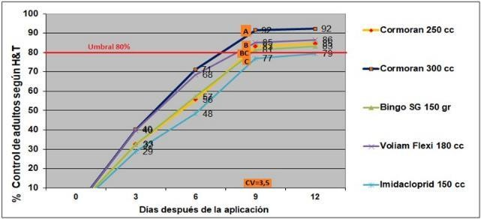

**Figure 2. LSD test at 5% probability for the average control efficacies for sucking insects (*Hortensia similis* and *Tagosodes oryzicolus*)in location 2.**

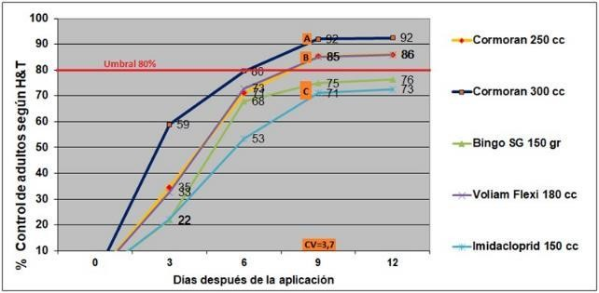

Calculated as an average of the two locations, the trend for this trial in the control of the sucking insects *H. similis* and *T. oryzicolus* showed that the best treatment was Cormoran 180 EC at a dose of 300 mL/ha with 92% control at 9 days, 7% higher than Voliam Flexi at 180 mL/ha with 85% and 8% higher than the lowest dose of Cormoran at 250 mL/ha with 84%; these doses achieved control exceeding the 80% threshold at the same evaluation time. On the other hand, the efficacy controls below the threshold included Bingo SG at 150 g/ha and Imidacloprid at 150 mL/ha with 78% and 74%, respectively, at 9 days.

# Figure 3. LSD test at 5% probability for the average control efficacies for miners (*Hydrellia griseola*) in location 1.

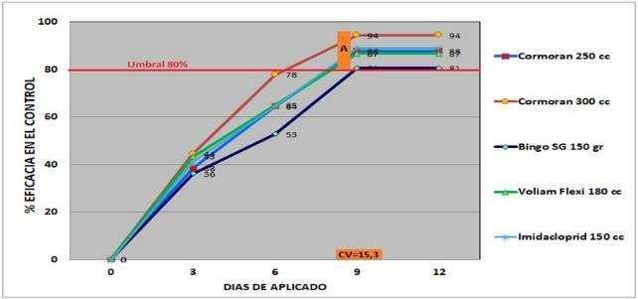

**Figure 4. LSD test at 5% probability for the average control efficacies for leaf miners (*Hydrellia griseola*)in location 2.**

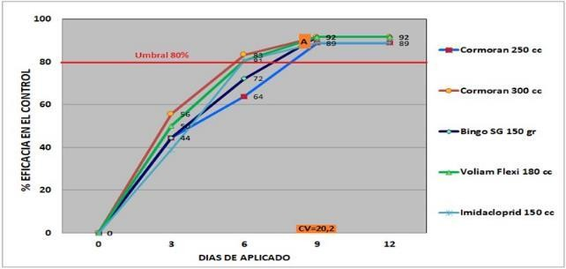

The control of the leaf miner *H. griseola* was statistically similar in the two locations analyzed. On average, the best treatment was Cormoran 180 EC at 300 mL/ha with 93% control at 9 days. This was 4% higher than Voliam Flexi at 180 mL/ha and Imidacloprid at 150 mL/ha with 89%, 5% higher than the lower dose of Cormoran at 250 mL/ha with 88% and 7% higher than Bingo SG at 150 g/ha with 86% at the same evaluation time; all treatments exceeded the minimum threshold of 80% control.

# PHYTOTOXICITY

Regarding toxicity, none of the treatments applied damaged the leaf area of the rice crop in either of the two locations. They were thus scored 1 on the toxicity table (1 = no effects).

# DISCUSSION AND CONCLUSIONS

The following conclusions can be reached:

* + Applications were made to rice plants 10 to 20 days after emergence, with the control showing average populations of 22–26 sucking insects (*Hortensia similis* and *Tagosodes oryzicolus*) for every five double insect net sweeps and a 15%–25% incidence of leaf miners (*Hydrellia griseola*). These conditions were ideal for testing the trial treatments. The critical evaluation time point was determined to be 9 days for sucking insects and leaf miners, with a minimum control threshold of 80%.
  + Cormoran at 300 mL/ha was the best treatment on average in both locations in terms of the control of the sucking insects *H. similis* and *T. oryzicolus*, with 92% control at 9 days, which was 7% higher than the commercial treatment Voliam Flexi at 180 mL/ha, 8% higher than Cormoran at 250 mL/ha, 14% higher than Bingo at 150 g/ha, and 18% higher than Imidacloprid at 150 mL/ha, all at 9 days.
  + In addition, regarding the control of the leaf miner *H. griseola,* a statistically similar trend was found in the two locations. The results indicated that the best treatment was Cormoran at 300 mL/ha, with 93% control at 9 days, which was 4% higher than Voliam Flexi at 180 mL/ha and Imidacloprid at 150 mL/ha, 5% higher than the lower dose of Cormoran at 250 mL/ha and 7% more than Bingo at 150 g/ha, all at 9 days.
  + Regarding toxicity, none of the treatments applied damaged the foliar area of the rice crop in the two locations, scoring 1 on the toxicity table of the EWRC (1 = no effects).

# RECOMMENDATIONS

In conclusion, after the analysis of the data from the two locations, use of the insecticide Cormoran 180 EC is recommended at 300 mL/ha for rice crops between 10 and 20 days after emergence to control sucking insects (*Hortensia similis* and *Tagosodes oryzicolus*) and leaf miners (*Hydrellia griseola*), with applications beginning when the first populations of these insects and their damage are observed, given that this product at this dose achieves 92% control of sucking insects and 93% control of leaf miners at 9 days.

# APPENDICES.

**APPENDIX 1. RELEVANT PHOTOGRAPHS 8 DAYS AFTER APPLICATION**

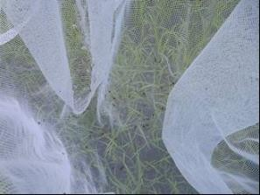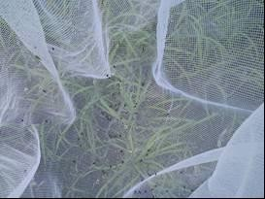

Photograph. Cormoran 180 EC at 250 mL Photograph. Cormoran 180 EC at 300 mL

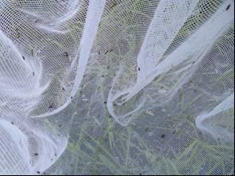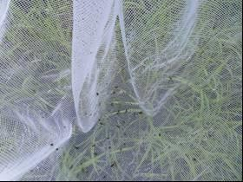

Photograph. Bingo SG at 150 g Photograph. Voliam Flexi at 180 mL

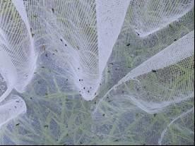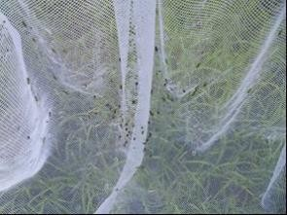

Photograph. Imidacloprid at 150 mL Photograph. Untreated control

|  |  |  |  |  |  |  |
| --- | --- | --- | --- | --- | --- | --- |
| **CODE** | | **315601 CORMORAN 180EC MINADORES ARROZ 7 MARZO-17** | | | | |
| **CATEG.** | | Development screen | | | | |
| **TITLE** | | Efficacy of Cormoran 180 EC (Acetamiprid 80 g/L + Novaluron 100 g/L) in the control of leaf miners (*Hydrellia griseola* – *Liriomisa* spp.) and sucking insects (*Tagosodes oryzicolus* – *Hortensia similis*) in foliar application to rice crop | | | | |
| **SPECIFIC OBJECTIVES** | | 1. Assess control efficacy for leaf miners 2. Assess control efficacy for sucking insects 3. Assess the phytotoxicity of the applied treatments on the rice crop. | | | | |
| **LOCATION** | | Two locations in Tolima | | | | |
| **CROP** | | Commercial varieties of rice whose name will be provided in the report | | | | |
| **APPLICATION TYPE** | | Foliar coverage, when the plants are between seedling and tillering and show the first signs of pests | | | | |
| **EST. DESIGN** | | Side by side. A cluster analysis will be performed with six treatments and three repetitions. ANOVA and LSD test at 5% probability | | | | |
| **PLOT** | | 6 × 10-m plots. | | | | |
|  | | | | | | |
| **TREATMENT TABLE** | | | | | | |
| **T** | **PRODUCT** | | **AI** | **CONC. g/L or kg** | **CP DOSE mL/ha** | **AI DOSE g/ha** |
| **1** | Cormoran 180 EC | | Acetamiprid + Novaluron | 80 + 100 | 250 mL | 20 + 25 |
| **2** | Cormoran 180 EC | | Acetamiprid + Novaluron | 80 + 100 | 300 mL | 24 + 30 |
| **3** | Bingo SG | | Acetamiprid + Emamectin | 240 + 50 | 150 g | 36 + 7.5 |
| **4** | Voliam Flexi | | Thiamethoxam + Chlorantraniliprole | 200 + 100 | 180 mL | 36 + 18 |
| **5** | Imidacloprid (commercial) | | Imidacloprid | 350 | 150 mL | 52.5 |
| **6** | Untreated control | | - | - | - | - |
|  | | | | | | |
| **MIXTURE** | | Water + Insecticide + Adjuvant. | | | | |
| **ADJUVANT** | | Apply Silwet L-77 at 0.3 mL/L water of the final mixture. | | | | |
| **APPLICATION DESCRIPTION** | | Foliar application will be performed at stage 1 to 2 (CIAT [International Centre for Tropical Agriculture]), from seedling to tillering and at the first signs of pests. | | | | |
| **MIXTURE VOL.** | | The volume will be calibrated to obtain 130–180 L/ha. | | | | |
| **APPLICATION EQUIPMENT** | | The name of the equipment, nozzles, working pressure, and final discharge volume will be recorded. | | | | |
| **ASSESSMENT VARIABLES** | | Objective 1. Control efficacy: at three locations in each plot on a 0.50 × 0.50-cm square, all plants are to be counted, both healthy plants and those with eggs or leaf miner mines in the upper leaves, to calculate the incidence. The incidence data will then be used to calculate efficacy.  Objective 2. In each plot and at three locations, five double insect net sweeps will be performed, counting sucking insects and each species captured and comparing the numbers with those obtained from the untreated control.  Objective 3: Phytotoxicity. In each plot, possible damage will be recorded according to the EWRC scale. | | | | |
| **EVALUATION** | | Efficacy: 0, 3, 6, 9, and 12 daa; Toxicity: 3, 6, and 12 daa. | | | | |

**FIELD DATA FOR SUCKING INSECTS (*H. similis* and *T. oryzicolus*)**

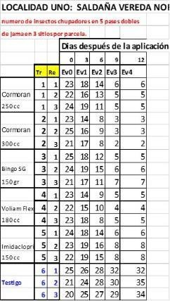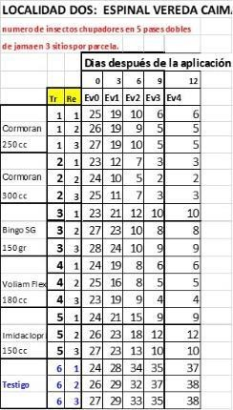

**FIELD DATA FOR LEAF MINERS (*H. griseola*)**

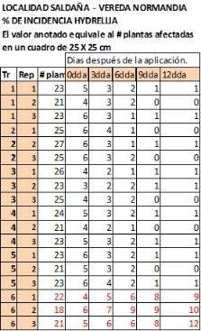 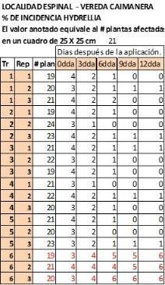

**APPENDIX 4. STATISTICAL ANALYSIS**

**STATISTICAL ANALYSIS OF CONTROL EFFICACY FOR SUCKING INSECTS (*H. similis* and *T. oryzicolus*). LOCATION 1**

**Completely Randomized AOV for Ev3=9dda Source DF** **SS** **MS** **F** **P**

Tr 5 17847.6 3569.52 578.84 0.0000

Error 12 74.0 6.17

Total 17 17921.6 Grand Mean 69.722 CV 3.56 **LSD All-Pairwise Comparisons Test of Ev3 by Tr Tr** **Mean Homogeneous Groups**

2 91.667 A

4 85.000 B

1 83.333 B

3 81.333 BC

5 77.000 C

6 0.0000 D

**STATISTICAL ANALYSIS OF CONTROL EFFICACY FOR SUCKING INSECTS (*H. similis* and *T. oryzicolus*). LOCATION 2**

|  |  |  |
| --- | --- | --- |
| **Completely Randomized AOV for Ev3=9dda Source DF** **SS** **MS** **F** **P**  Tr 5 17562.9 3512.59 554.62 0.0000  Error 12 76.0 6.33  Total 17 17638.9 Grand Mean 68.056 CV 3.70  **LSD All-Pairwise Comparisons Test of Ev3 by Tr**  **Tr** **Mean Homogeneous Groups** | | |
| 2 | 92.000 | A |
| 1 | 85.333 | B |
| 4 | 85.333 | B |
| 3 | 74.667 | C |
| 5 | 71.000 | C |
| 6 | 0.0000 | D |

**STATISTICAL ANALYSIS OF CONTROL EFFICACY FOR LEAF MINERS (*H. griseola*). LOCATION 1**

**Completely Randomized AOV for Ev3=9dda Source DF** **SS** **MS** **F** **P**

Tr 5 19455.6 3891.12 31.02 0.0000

Error 12 1505.3 125.44

Total 17 20960.9 Grand Mean 72.944 CV 15.35 **LSD All-Pairwise Comparisons Test of Ev3 by Tr Tr** **Mean Homogeneous Groups**

2 94.333 A

5 88.667 A

1 87.667 A

4 86.667 A

3 80.333 A

6 0.0000 B

**STATISTICAL ANALYSIS OF CONTROL EFFICACY FOR LEAF MINERS (*H. griseola*). LOCATION 2**

|  |  |  |
| --- | --- | --- |
| **Completely Randomized AOV for Ev3=9dda Source DF** **SS** **MS** **F** **P**  Tr 5 20492.9 4098.59 17.62 0.0000  Error 12 2791.3 232.61  Total 17 23284.3 Grand Mean 75.389 CV 20.23  **LSD All-Pairwise Comparisons Test of Ev3 by Tr Tr** **Mean Homogeneous Groups** | | |
| 2 | 91.667 | A |
| 3 | 91.667 | A |
| 4 | 91.667 | A |
| 1 | 88.667 | A |
| 5 | 88.667 | A |
| 6 | 0.0000 | B |

# APPENDIX 5. CALIBRATION OF THE APPLICATION EQUIPMENT

