***Daring to Dream: Supporting a Path to a Meaningful Adulthood[1]***

Diane Nelson Bryen, PhD

Professor Emerita, Temple University

Philadelphia, Pennsylvania, USA

With Contributions by

Jane Odom, M. Ed

Director of Implementation Resources, PRC-Saltillo

מנהלת היחידה ליישומי טכנולוגיה של תקשורת חלופית

Arizona, USA

Candice Steel, BS, SLP-L, ATP

Assistive Technology Specialist, Gompers

Arizona, USA

**Prologue**

Years ago I asked adults with cognitive and communication disabilities the following question:

*“How old were you when someone asked you what you want to do when you grow up?”*

Their answers shocked me. Every one of them indicated that,

*“Nobody ever asked me!”*

I soon discovered, that if nobody ever asked you what you wanted to do when you grow up, you might never dream about being a doctor or a dancer or a teacher, or cowgirl (what I wanted to do when I grew up) and certainly never work toward turning that dream into a future reality.

**Why Dream?**

People with disabilities and members of other marginalized and oppressed groups have been ‘”told” by society in words and through actions to “adjust” to the realities of their current condition, accept their limitations and develop “realistic” (and generally low) expectations for their futures. Rarely are they asked to envision a future where they can lead ‘everyday’ lives like those of us who are more privileged. Even more rarely are they asked to *dream*. For those with cognitive and communication disabilities, the problem is compounded by their difficulty in expressing themselves – let alone their hope and dreams for their future. In many countries they remain a silent and, often, invisible group. However, we all need to dream and to take our dreams seriously for they are our lifelines to our future. Listen to some words of wisdom about the importance of dreams.

*“I understood that no matter how poor a person is, they could still afford a* ***dream****.” – Ricky C. Hunley*

*“****Dream*** *big! Imagine what you would ideally like to be doing – not what you “realistically” think you might end up doing.” – Dale S. Brown*

*“Those who lose* ***dreams*** *are lost.” -- Australian Aboriginal proverb*

**Why Dare to Dream?**

*“Oppression can only survive through silence.” – Carmen de Monteflores (Writer and Psychotherapist)*

In contrast to being entitled to dream, oppression is often defined as the state of being kept down by unjust use of force or authority. Oppression is the negative outcome experienced by people targeted by the exercise of power in a society or by the exercise of power by one social group over another social group. Just as women’s oppression is the experience of sexism, oppression of people with disabilities is the experience of ableism[2] often the result of medical, rehabilitation or charity social constructs of disability. Sadly, oppression is not only a social act, it is also a personal act of internalization by those oppressed. One consequence of being oppressed is that those who are oppressed fail to dream.

*“Dare to be what you ought to be; dare to be what you* ***dream*** *to be; dare to be the finest you can be. The more you dare, the surer you will be of gaining just what you dare!” -* Norman Vincent Peale

Judith Snow, poet, philosopher, activist and self-advocate from Canada, once said that

*“The* ***dream*** *should guide all planning. One's personal dream is the driving force behind all actions and life circumstances. It illuminates, guides, and sometimes even changes as time goes by.”*

Carol Marfisi, teacher, activist, and self-advocate adds that

“*If we don't dream, take our dreams seriously, make them known to others, and work towards their fulfillment, then we will live according to someone else's decisions and visions for our lives”.*

Fiona Given from Australia, adds that it is

*“important for everybody to have dreams. Dreams provide us with challenges, pleasure and fulfilment. Dreams are key ingredients to a happy and healthy life.*

*People with significant disabilities often do not pursue their dreams because they face many barriers and are, therefore, discouraged from pursuing their dreams.”*

It is only through “daring to dream” that oppressed individuals can begin to throw off years of oppression due to poverty, unemployment, minority group membership and disability status.

*Daring to Dream* does just that. It begins to throw off, in some cases, years of oppression by providing the opportunity for individuals with cognitive and communication disabilities to envision his or her dream for their future. Each dream may focus on any or all of the following: Where they will live and with whom, what they will do during the day (e.g., go to school, paint, work at a desired job, or even watch soap operas), who will be significant people in their lives, what they will do for fun, etc.

In *Daring to Dream*, participants with cognitive and communication disabilities are encouraged to visualize their dreams. With guidance, the individual’s dream must be clear enough to them so that they are able to communicate it to others so that it can be graphically represented through pictures. They must not remain silent; but instead, with support, be bold enough to voice their dreams so that others can hear them, hopefully believe them, and support them in turning their dreams into future realities.

*Daring to Dream* is an interactive process for people with cognitive and communication disabilities and their supporters followed by a one-year support process for turning their dreams into future realities. It starts with a dream, which is developed via a guided process, drawn in detail by a support person and shared with the group. Dreams are nonnegotiable. A person’s dream can be as small as choosing what to eat or what to wear. Dreams can be as large as getting married or traveling. Dreams are somewhat universal. They are generally about relationships, a place of one’s own, and meaningful activities. Dreams are also influenced by one’s culture. Shown below is a sample of *Daring to Dream* participants from United States, Israel, South Africa, Australia, Singapore, and India.

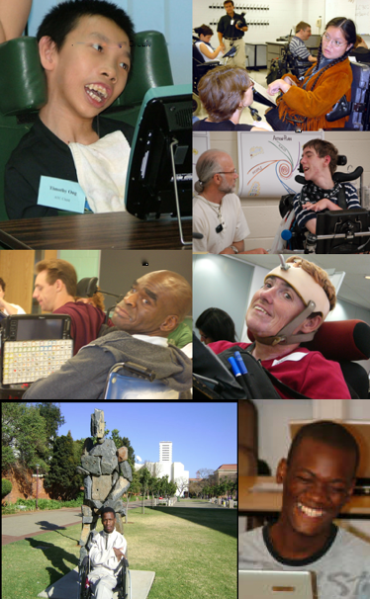

Below are a few dreams of adults with disabilities who participated in the *Daring to Dream*.

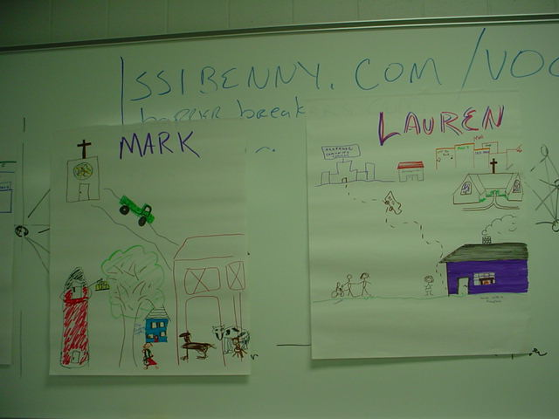

*Mark will live on a farm with cows and horses. He will have a van and live with a wife.*

*Lauren will live in a purple house near the community college, and near the Methodist Church. She will live with her sister and a friend and will have a full-time personal assistant.*

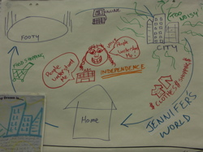

*Jennifer, from Australia, dreams of communicating effectively and independently at home, at the footy [soccer game], in the city, and when shopping.*

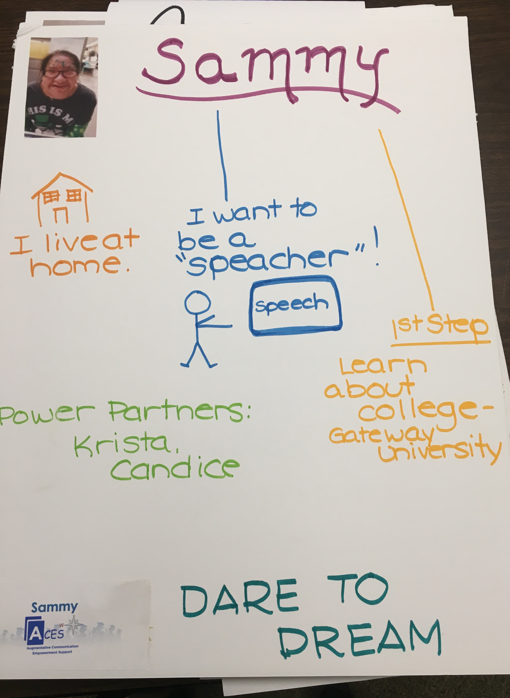

*Sammy, from Arizona, wants to help others who use Augmentative and Alternative Communication (AAC). She wants to explore college classes while living at home. Her dream job is to become a ‘speacher’.*

**Challenges Faced when Daring to Dream**

Since many people with disabilities have not had the chance to dream about their futures as young children due to commonly held stereotypes about what people with disabilities can and cannot do as adults, the process of daring to dream may be difficult. Dale Brown identifies several challenges. Each challenge is accompanied by possible and helpful responses.[3]

***Challenge 1:*** Because of your disability, you have never been considered a contributor. Instead you have been treated as a passive recipient of other people’s actions. As noted earlier in this chapter, most adults with cognitive or communication disabilities were rarely if ever asked as children “What do you want to be when you grow up.” So, when asked to dream, individuals with disabilities may have difficulty considering themselves as contributors or doers or creators of a future for themselves.

***Possible responses****:*

Connect the individual with a coach or peer-mentor who has successfully dreamed and who can encourage the individual to dream.

Support the individual in volunteering and contributing to another person, demonstrating that his or her actions can positively help another person.

***Challenge 2:*** Stereotypes about what people with disabilities can and cannot do with their lives is a challenge to daring to dream. For example, many people with cognitive or communication disabilities are told that they cannot work, have a home of their own, or get married and have children. Although today, this may often be the case, it does not have to define a person’s future and therefore their dreams.

***Possible responses:***

It is important to recognize these stereotypes and dispel them whenever possible through acknowledging them as stereotypes as opposed to realities and by presenting many, many other options. Meeting individuals with disabilities who are not leading stereotypical lives is another effective response.

***Challenge 3:*** Lack of experience often limits the individual’s inclination towards daring to dream. People with disabilities may have more limited social networks, education, first job experiences, and community participation. As such, the range of future possibilities limits the range of possible futures to dream about.

***Possible responses:***

Joining clubs, interest groups and voluntary organizations is one way to expand experience and to learn about what you enjoy and what you dislike.

Encourage the individual to volunteer or engage in paid or unpaid internships.

Finally, encourage the individual to broaden their social networks through synagogue, through alumni groups, or through websites that focus on expanding social networks. The more experiences the individual has, the more opportunities there are to see people with and without disabilities living a wide variety of possible lifestyles.

***Challenge 4:*** Individuals with disabilities may have limited knowledge about how their disability can be accommodated so that they can engage in activities previously thought as impossible. Without knowing about the full range of accommodations and supports, the individual may see only his or her disability rather than their abilities when provided with needed accommodations.

***Possible responses:***

Help the individual learn about the full range of accommodations available for learning, living, working, and parenting. Minimally, expose the individual to the full range of assistive technologies, personal assistance services, home modifications, and job accommodations.

**Setting the Context for Daring to Dream**

We will return to the process of *Daring to Dream,* but first describing the context will be helpful.First, itis best implemented in a quiet accessible space where privacy can be optimized and interruptions kept to a minimum. Sufficient space for both group sharing and individual communication is essential.

Each participant with a disability will need to be accompanied by a facilitator who will listen carefully, respect the dream of the participant, and who will attempt to pictographically represent the dream of their partner. This does not mean that the facilitator needs to be an artist. From our experience the facilitator can be a trusted family member, support person or professional; a friend or a person with a disability who has successfully completed the process and is living their dream. Importantly, the facilitator must be willing to listen and authentically question the individual to obtain enough detailed information so that their partner’s dream can be drawn with sufficient detail to capture the actual dream.

A group of 6 to 10 individuals with disabilities and their facilitators is optimal for providing the richness and time to complete the whole process in one day. If you have more individuals with disabilities, the process will likely take longer because each person will share their dream, get feedback from others and then move on to their action planning. Because the rate of communication may be slower if the individual has communication disabilities, ample time should be provided. From past experience, the process has been completed within 4 - 6 hours to as long as 4 days. If time is limited to 4 hours or less, be sure that all individuals have time to share their dreams with the group and that at least one or 2 individuals have time to share their dream-centered action plans. However, all should leave with a completed dream-centered action plan. Finally, having a person with disability who has successfully completed the *Daring to Dream* process is ideal since he or she can model every step of the process.

Words, and the concepts they represent, that are frequently used during the daring to dream process, may be initially unfamiliar to the individual and should be discussed before the process actually begins. Some of the terms that may be unfamiliar to the person are noted below and are illustrated by open-sourced icons to support these terms[4]. Please note, however, that they are open-source and may not be culturally appropriate in Israel. You may want to draw or find via Google images or illustrations that better represent these concepts and terms in Hebrew.

למחוק את כל האיקונים הלא ברורים

Dream

Future

Vision

Job or work

Apartment

Married

Boyfriend

Girlfriend

Family

Date

Children

 Volunteer

Resources

 Plan

Supports

 Objectives

 College or University

 Writer

 Painter

 Earn

 Teacher

 Money

 Designer

 Career

 Social worker

 Counselor

 Internship

 Personal assistant

 Movies

 Theatre

 Restaurant

 Full-time

 Part-time

 Scholarship

 Mentor/Coach

Accommodations

*Visualizing* and *sharing* one’s dream is an important beginning. However, it cannot end there. Participants in the daring to dream process must not remain silent; but instead be bold enough to voice their dreams so that others can hear them (Remember the earlier quote by de Monteflores that “Oppression can only survive through silence.”)

Individuals with and without disabilities must take their dreams seriously and, based on their dream, develop an action plan that will forge the path to a future reality. Listen again to a few quotes.

*“Vision without action is a dream.*

*Action without vision is simply passing the time.*

*Vision with action can change the world.”*

*Joel Barker*

*“Vision without action is a daydream.*

*Action without vision is a nightmare.”*

*Japanese Proverb*

Each dream-centered action plan should include goals that are segments or components of the larger dream (**be positive**) as well as **possible** (can be accomplished in one year). The dream-centered action plan also identifies *resources* needed (time, money, learning opportunities), *places* (real or virtual where people who have had similar dreams and have achieved their goals to a large extent work, create, and live), and *people* (persons who are needed and willing to help them achieve their one-year goal). Finally, first steps to be taken within one week as well as a coach or mentor to facilitate the process are clearly defined.

Each part of the dream process is portrayed in the illustration below. Space to illustrate the individual’s dream appears in the top half. In the bottom half of photo, a thematic illustration is provided for completing the dream-centered action plan. If possible, print out and enlarge the dream process photo and use it not only as a visual guide but also a visual reminder to both the person with a disability and the dream coach and others in the person’s life.



2012 Copyright Diane Nelson Bryen

Sharing the dream is important for two reasons. First, by sharing the dream with others, support from others is likely to emerge! Take, for example, what happened to CS, when he shared his dream with others.

*CS came from California with his grandmother to Temple University in Philadelphia. During the Daring to Dream process, CS noted that one of his dreams has always been to visit New York City. By sharing this dream, the facilitator noted that New York City was only 90 miles from Philadelphia and that there were accessible trains leaving hourly. By sharing his dream, a plan including voluntary supports spontaneously emerged. Two days later, CS, his grandmother, and two high school student volunteers who were doing a summer internship at Temple University made the trip to New York City with CS!*

If CS had not shared his dream during the Temple University program, he may not have had the opportunity to turn his *dream* into a reality.

Finally, having an illustration of the *dream* posted where the individual lives will also serve as a visual reminder to the person with a disability and his or her supporters that this dream can and should guide future goals and action planning.

Once participants have had the chance to share their *dreams* and clarify them, it is time to begin to turn those dreams into actions. This process is described next.

**Dream-centered Action Planning**

The second step in the process of *Daring to Dream* is to identify a *goal* that is part of the larger *dream* that is both *positive* and *possible*. This is the first part of the ***action plan***. If you use the template introduced earlier in this chapter, the bottom half should help you focus on goal setting. We have used a variety of formats for the action plan and the one that we have found most useful is listed below:

1. *Dream* Illustrated and shared
2. Action Plan
   * One-year goal
   * Resources/Supports Needed
   * First Step
   * Enlisting a Coach

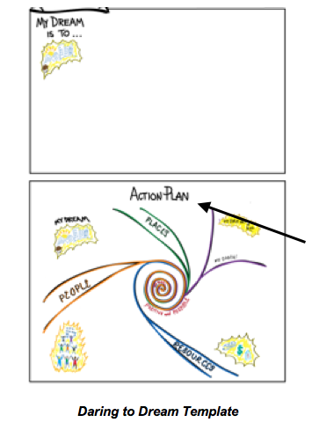

A *goal* is a piece of the *dream* that the participant can do (**action**) that is both:

*Positive*

and

*Possible*

These are abstract terms so it is important to explain. A *goal* has to be either a piece of the *dream* or something that leads directly to the *dream*. The individual’s *dream* must directly inform the goal and that is why we refer to these goals as dream-centered *goals*. A dream-centered goal has a direct relationship to the dream, itself. This is what we mean by **positive**. You may need to provide several examples to illustrate this concept to participants, such as:

*If* *the* *dream* is to *move into one’s own accessible apartment in the city near accessible transportation*, a positive goal might be the following:

***Locate*** *accessible apartments in the city and get on to a waiting list for accessible housing.*

or

***Learn*** *what it takes to live independently in one’s own apartment by spending several days* ***visitin****g with someone who is living independently in her own apartment.*

Both of these goals are *positive* because they lead directly to the larger *dream* of living in one’s own apartment. The *goal* must also have some action words such as *locate, learn, and visit*. Action words ground the person in what he or she must do to begin to move toward the person’s dream. The responsibility is placed directly on the individual. Once again, it is optimal to have as a co-facilitator someone who has disability and who has successfully gone through the full *Daring to Dream* process. S/he can share a real goal that is based on a personal dream.

Having a goal that is *positive* is one-half of what comprises a dream-centered *goal*. The goal must also be able to be accomplished in one year. In other words, it must also be *possible*. If the *goal* is too far in the future, it may become as elusive as the dream, itself, and therefore is not likely to be accomplished.

Once everyone understands what comprises a dream-centered *goal*, the participant and support person should return to the illustrated dream and begin to develop the *goal*. While each individual is working on his or her *goal*, co-facilitators should go around reminding each that the *goal must be both positive and possible*, and that it must contain *action words*. The goal does not have to be drawn. In fact, from this point on, words can be used to capture each part of the action plan starting with the *goal*.

When the person’s *goal* is presented to the larger group, the group will be asked to evaluate whether *the goal is positive,* and whether *the goal is possible*. If it is not positive or possible, the group is asked to help clarify it. Also, the group is asked to provide feedback about what actions the participant will be taking (remember those action words!).

Go through this process with at least 3 participants. If time permits have everyone present his or her goal to the larger group. Regardless of whether or not everyone’s *goal* is presented, make certain that everyone has his or her goal written on the *Daring to Dream* template. Once dream-centered goals are developed and shared with the larger group, it is time to move onto the next part of the process – identifying needed *resources*, *places* and *people*.

At this point, if the *Daring to Dream* template has been used the top half of the poster should have the individual’s *dream* illustrated in as much detail as possible. You may also have a written statement of the *dream*, such as, ***[****Person’s name’s] dream “is to open and own a toy shop****”*** written as part of the illustration. On the bottom half of the template and in the center, there can be a bull’s eye with the *individual’s positive and possible one-year goal* stated in action terms, such as “*I will develop a small business plan and volunteer in a toy store”.*Notice that this is a related or necessary step needed to accomplish the big dream of opening and owning a toyshop. As such, this dream-centered goal is *positive*. It is also *possible* to accomplish this in one year. Finally, it contains two **action words** – *develop* and *volunteer.* This is the beginning of the action plan.

Now that each participant has envisioned his or her *dream*, shared the dream, and developed a one-year *goal* that is both *positive* and *possible*, it is time to identify the resources, places, and people who will be needed to accomplish the one-year goal. It is important to stress that no one can accomplish a goal and ultimately a dream without resources and supports. So the next step in the action planning process is to identify the *resources*, *places*, and*people* needed to help each participant achieve the one-year goal and progress towards making the dream become a future reality.

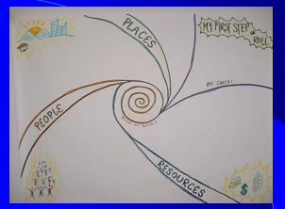

*Identify needed resources, people and places.*

Needed supports include Resources, Places, and People:

**1.** *Resources* (skills, training, money, transportation);

**2.** *Places* (where people lead the lives they want whether it is a particular job, a place to live, school to learn); and most importantly

**3.** *People* who will provide support and who believe in the participant’s big dream as well as their one-year goal.

Keep reinforcing the idea that no one accomplishes their dreams without support from others.

In order to *turn a dream into a future reality*, a person must have some control over resources, places and people. Experience has taught us that even when a person lives in an institution or nursing home, they have some control, even if limited, over *resources*, *places*, and*people*. When control of these three ingredients is limited, two things are likely to occur: (1) the dream will be “small” but can be accomplished, or (2) the dream will be unreachable unless circumstances change.

An example of the former is that of Betty.

*Betty lives in a nursing home where she has little control over resources and places. She does, however, have some control or influence over a few people who are nursing staff. Her dream, while appearing small to many, was huge for her – that of having macaroni and cheese once each and every week and getting the TV Soap Opera Guide so that she can watch the soaps that she loves. She recognized that if she saved some of her money (a resource), she could purchase a subscription to the weekly Soap Opera Guide. She also realized that if she asked her favorite nurses (people) to get her favorite foods (a very daring act in her nursing home), this too could be accomplished.*

After reviewing the three ingredients needed to accomplish a particular goal, have each participant return with their support person to identify what resources, places, and people are needed to accomplish their one-year goal. Remind all that they must be as detailed as possible because these are the ingredients needed for success in reaching their dream-centered goal. As with baking bread, if the ingredients are not carefully detailed, the bread is not likely to come out as planned.

With ***resources***, money may be the first thing identified but often the hardest to obtain. Don’t dismiss the need for money. However, focus on other resources such as time, learning new skills, or access to online information. Even when accessible transportation is difficult to secure, as was the case in India, a small amount of money might provide a cab to get the person to a needed place. Remember, be as specific as possible when identifying needed resources.

People often forget the ingredient, ***places***. Perhaps this is due to the lack of accessible transportation in many locations throughout the world. Perhaps folks are afraid to venture out into places they have never been. Additionally, they might not be able to get into a school or desired place of business because it is inaccessible. Despite all these real barriers, it is important for participants to get to places where people are living the lives that they are only now dreaming about. So if someone wants to be a writer, have they ever spent one day with an actual writer? If a participant wants to open a toyshop, has he ever been to a toyshop and learned what is takes to open and operate one?

Finally, while ***resources*** and ***places*** are important ingredients, the most important one is ***people***. None of us can accomplish our dreams – big or small – without the support from other people. This “social capital” is key to getting a job, finding a home of your own, participating in religious/spiritual activities, and meeting others. Make sure time is spent in listing people who can help the individual with disability accomplish a particular one-year goal. Once more, be specific. Who will you ask (name names) to help you do what? For example, if your want to learn about running a toy shops, who will you ask to let you do an internship at their toy store for one month? Who will help you write your small business plan? No one can just assume the person will agree, so that individuals identified will have to actually be asked or enlisted to help with a particular activity.

As with the ***dream*** and the ***one-year goal***, it is important to share this stage of the action plan with the group. Minimally, 2 or 3 participants with help from their support person should share ***resources***, ***places***, and ***people*** needed while the facilitator should probe for completeness and preciseness. This whole process can take some time depending on the size of the group, so plan time accordingly,

At this point, participants will think the ***action plan*** is complete. However, from our experience there is one more step to the ***Daring to Dream*** process and that is taking the ***first step or roll if the person uses a wheelchair*** and to enlist a ***coach***. This last part of the action plan is described next.

The final part of the action planning process of ***Daring to Dream: Turning Dreams into Realities*** is identifying both the ***first step*** to be taken as well as a ***coach*** who will support and cheer you on. Participants with cognitive and communication disabilities and their support persons will no doubt be excited and motivated about their ***dreams*** and ***action plans***. They have been surrounded by peers and support people who believe in the process and are energized by *Daring to Dream* and by hearing the ***dreams*** and ***action plans*** of others. However, soon we all return to our lives where many will not believe in the power of dreams. Everyday lives will get so busy that the best action plan guided by one’s dream and fueled by positive and possible one-year goals and the ingredients to accomplish that goal may get lost in the business of the “same old, same old!” The last part of the *Daring to Dream* process is to identify a ***first step*** to be taken within one week of returning home. In addition, each participant will identify a ***coach*** who will ensure that the first step or first roll, if a wheelchair user, is taken.

Before identifying the ***first small step*** or roll to be taken it is important to discuss what a ***coach*** is and why it is needed.

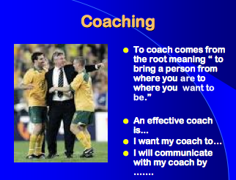

*In English, to* ***coach*** *comes from the root, meaning ”to bring a person from where you* ***are*** *to where you* ***want to be****.”*

Those who have been involved in sports will have experience with a *coach*. However, if an individual has never been involved in sports as either a dedicated participant or spectator, the concept of a coach may not be familiar. So it is important to discuss the characteristics of a good *coach*including:

* Trust
* Acceptance
* Empathy
* Congruence
* Availability

Ask participants about other characteristics of what they think is an effective coach. Ask them to think about what they want from their coach.

Now we return one last time to finishing this last part of the process with the participant’s support person – that of identifying a ***first small step*** or roll that will get them going on working on their one-year goal. This ***first step*** is to be taken within one week of returning home. In addition, have each participant identify a desired ***coach***. If this person is in the room, he or she must enlist that person to ensure agreement. Within 20 to 30 minutes, gather everyone back into the group to share their last steps.

Wrap up the session with something inspiring – a poem, a quote, or even a sticker that says ***“I dare to dream!”*** Congratulate their boldness, their daringness, and their graciousness in ***sharing their dreams*** with the group. Finally, remind them that the hard work now begins. Give each participant their *daring to dream* poster so they can visibly post it back home to remind them of the beauty of their dreams and to share their dreams with others.

**Follow-Up is Necessary**

Without follow-up, it is unlikely that the process of *Daring to Dream* will get very far. Support people may move away. Family members may question the value of the process or the ability of the person with cognitive and communication needs to accomplish the one-year goal.  *Dreams* may even change. To ensure that the process continues, a plan for follow-up must be in place.

Follow-up can take many forms. It can be provided face-to-face, via telephone, or through the Internet. If you have the luxury of being able to meet face-to-face, monthly meetings with the entire group are ideal. This was possible for the group in India, since many came to the Indian Institute on Cerebral Palsy on a regular basis. However, given great distances, this was not possible in South Africa, Australia, or the United States. In order to have the support of the entire group, an electronic listserv was used in the United States (ACOLUG) and in Australia. In South Africa, contact was provided through individual phone calls or visits and, for many, an annual retreat.

Regardless of the method, the important component is connecting with each person to help him or her:

* Recommit to their *dream* unless it has changed;
* Celebrate progress in achieving the *goals*;
* Discuss barriers as they relate to their *resources, places and people*; and
* Problem-solve **possible solutions** to these barriers.

In some cases, the person with disability will have accomplished his or her *goal* in less than a year. If that is the case, it is time to revisit the original *dream* and establish, if needed, a new ***action plan*** that gets that person even closer to the ***dream***.

On the one-year anniversary of beginning the *Daring to Dream* process, if at all possible, it is ideal to bring the original group together to celebrate accomplishments and to plan anew.

**Epilogue**

Successful implementation of *Daring to Dream* may require ***policy changes*** at the national, regional, or program level given that programs for adults with disabilities are often still based on a medical model. The medical model reflects the belief that a person with a disability has an impairment that needs fixing or remediation. As such, the focus is on identifying the specific impairment and what is 'wrong' with the person that needs fixing not what the person needs or wants. Put simply, intervention focuses on what the individual cannot do generally creating low expectations and leads to people losing independence, choice and control in their lives.

In contrast to the medical model, the social model of disability notes that people are disabled by barriers in society, not by their impairment or difference. Barriers can be physical, like buildings not having accessible entrees or toilets. They can also be caused by people's attitudes to difference, like assuming people with disabilities cannot do certain things. The social model helps us recognize barriers that make life harder for people with disabilities. Removing these barriers and increasing opportunities and support create equality and offer those with disabilities more independence, choice and control.

Successful implementation of *Daring to Dream* also generally requires ***changes in practice*** in the development and implementation of Individual Support Plans for students transitioning from school to work or for adults with disabilities already living in a variety of settings. Regardless of setting, the process must include all of the following:

1. Developing and sharing the individual’s nonnegotiable dream with key stakeholders,
2. Developing a positive and possible one-year goal which includes needed
   1. Resources (e.g., funds, time, skill development)
   2. Places where others are already living their dream, and
   3. People who believe in the power of dreams and will mentor or support the individual
3. First steps to be taken within one week of the workshop, including enlisting a coach.

***Daring to Dream: Turning Dreams Into Future Realities*** was developed by Diane Nelson Bryen more than 20 years ago while she was a professor and executive director of the Institute on Disabilities at Temple University. The process for *Daring to Dream: Turning Dreams into Future Realities* has been done throughout the United States, in India, Singapore, Australia, South Africa, and Israel and at several international conferences. A detailed guide to *Daring to Dream: Turning Dreams into Future Realities* has been published in English as an electronic book by Amazon’s Kindle.



**References**

Brown, D. S. (2005), *Daring to Dream: Finding your Purpose.* <http://www.icdri.org/DSB/daring_to_dream.htm>

Bryen, D. N. (2012). [www.amazon.com/Daring-Dream-Turning-Dreams-Realities-ebook/dp/B008O5BKHU/ref=sr_1_fkmr0_1?s=digital-text&ie=UTF8&qid=1529526336&sr=1-1fkmr0&keywords=Daring+to+Dream%3A+Turning+Todays+Dreams+into+Future+Realities#reader_B008O5BKHU](http://www.amazon.com/Daring-Dream-Turning-Dreams-Realities-ebook/dp/B008O5BKHU/ref=sr_1_fkmr0_1?s=digital-text&ie=UTF8&qid=1529526336&sr=1-1fkmr0&keywords=Daring+to+Dream%3A+Turning+Todays+Dreams+into+Future+Realities#reader_B008O5BKHU)

1. This chapter is copyrighted 2019 © Diane Nelson Bryen. It may not be used or translated without her permission.
2. Ableism is a set of beliefs or practices that devalue and discriminate against people with physical, intellectual, or psychiatric disabilities and often rests on the assumption that disabled people need to be ‘fixed’ in one form or the other.
3. Many thanks go to Dale S. Brown for her work “Daring to Dream: Finding your Purpose”, 2005, [www.icdri.org](http://www.icdri.org)
4. The icons used in this chapter are from Graphics Factory, an open source resource at <https://www.graphicsfactory.com>