**Full-Load Hours in Germany in 2020 (in h/a)**

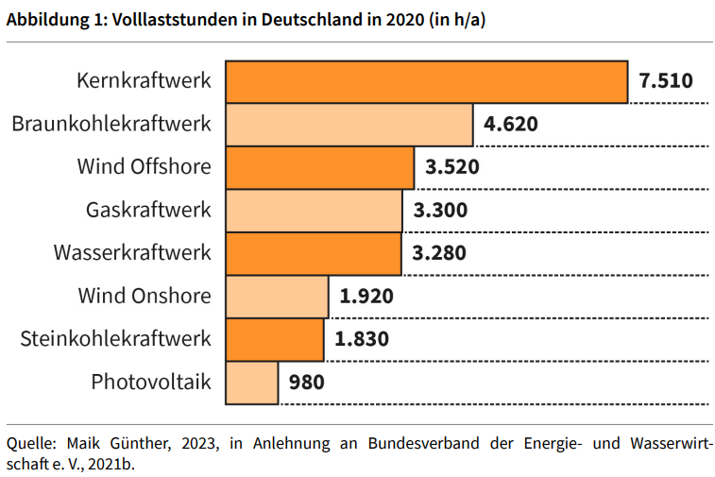

|  |
| --- |
| Nuclear power plant |
| Brown coal-fired power plant |
| Wind, offshore |
| Gas-fired power plant |
| Hydroelectric power plant |
| Wind, onshore |
| Hard coal-fired power plant |
| Photovoltaics |

**Illustration of the Types of Potential**

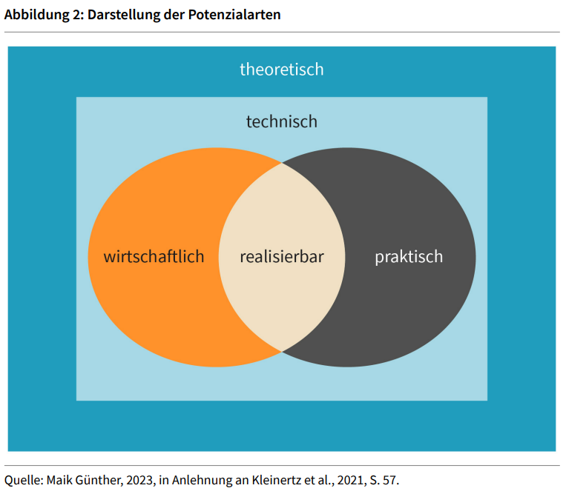

|  |  |
| --- | --- |
| Theoretical |  |
| Technical |  |
| Economical |  |
| Realizable |  |
| Practical |  |

**Selected Conversion Paths of Renewable Energy Sources**

|  |
| --- |
| Solar radiation |
| Tides |
| Wind |
| Water |
| Electromagnetic radiation |
| Geothermal energy |
| Turbine |
| Photovoltaics |
| Plants |
| Chemical energy |
| Mechanical energy |
| Prime mover |
| Combustion |
| Generator |
| Electrical energy |
| Thermal energy |

**Interaction Between Radiation and Matter**

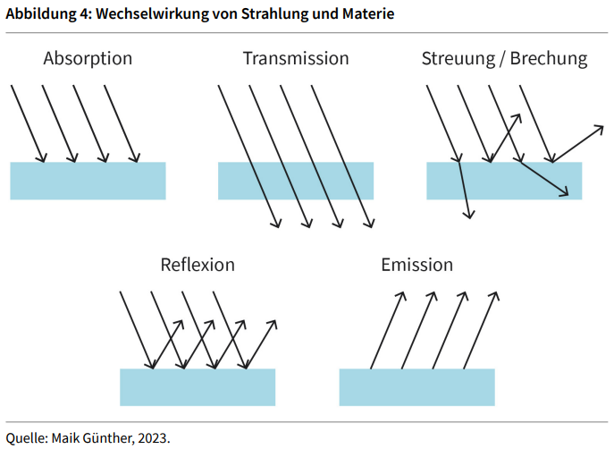

|  |  |
| --- | --- |
| Absorption |  |
| Transmission |  |
| Scattering/refraction |  |
| Reflection |  |
| Emission |  |

**Comparison of the Intensity of Solar Radiation**

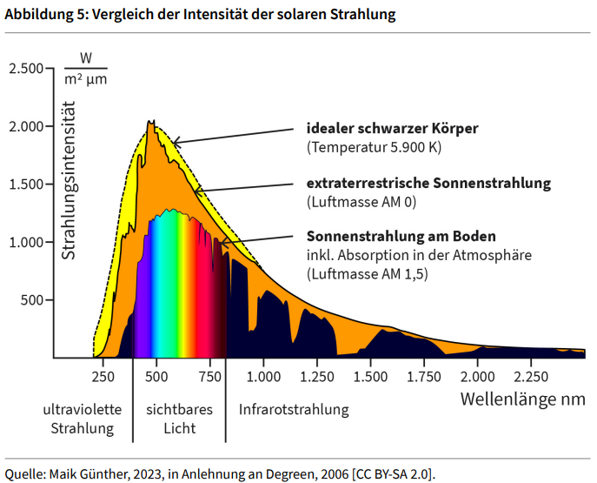

|  |  |
| --- | --- |
| Radiation intensity |  |
| Ideal black body |  |
| Temperature |  |
| Extraterrestrial solar radiation |  |
| Air mass |  |
| Solar radiation on the ground |  |
| Incl. absorption in the atmosphere |  |
| Ultraviolet radiation |  |
| Visible light |  |
| Infrared radiation |  |
| Wavelength |  |

**Functional Principle of Photovoltaics Using the Example of a Silicon Solar Cell**

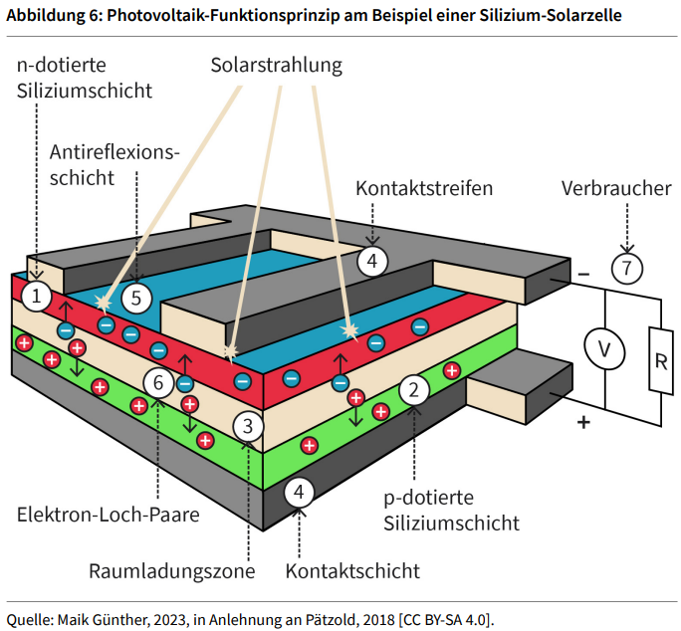

|  |  |
| --- | --- |
| n-doped silicon layer |  |
| Anti-reflection coating |  |
| Solar radiation |  |
| Contact strips |  |
| Consumer |  |
| Electron-hole pairs |  |
| Space charge region |  |
| Contact layer |  |
| p-doped silicon layer |  |

**Shift in MPP with Changing Irradiance as well as Current and Power Against Voltage**

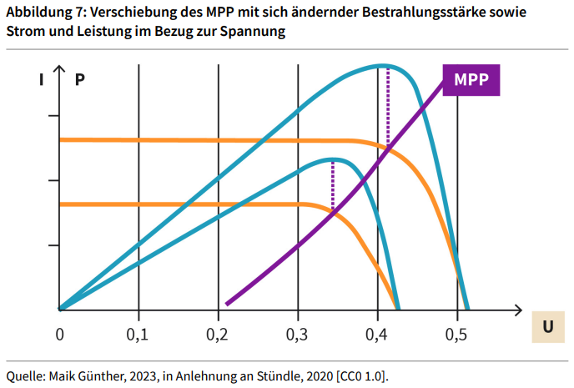

|  |  |
| --- | --- |
| MPP |  |

**Example of Hourly Electricity Prices on a Work Day in Summer for 2025 and 2050**

|  |  |
| --- | --- |
| Euro/MWh |  |
| Real value for base year |  |

**Soil Map of the Wind and Pressure Belts**

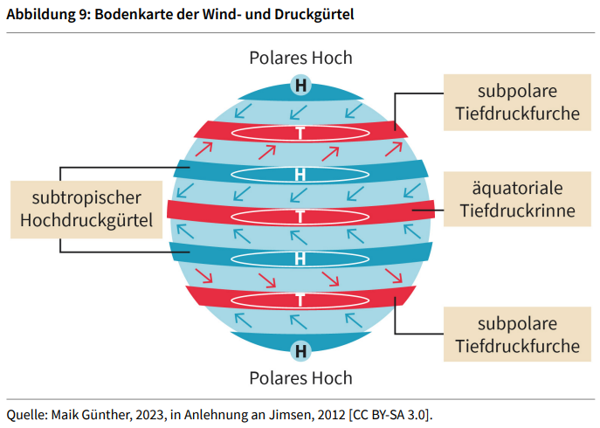

|  |  |
| --- | --- |
| Subtropical high-pressure belt |  |
| Polar high |  |
| Subpolar low-pressure trough |  |
| Equatorial low-pressure trough |  |
| Subpolar depression |  |

**Outlines of Enercon Wind Turbines by Year of Introduction to the Market**

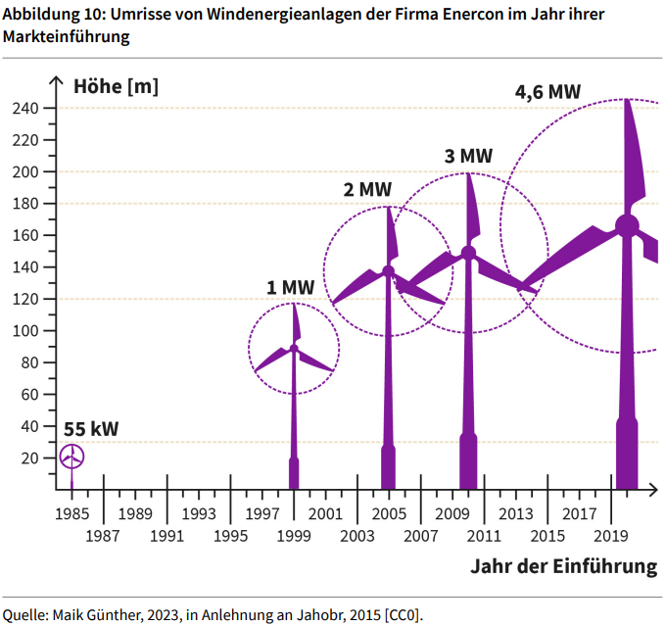

|  |  |
| --- | --- |
| Height m |  |
| kW |  |
| MW |  |
| Year of introduction |  |

**Characteristic Curve Ranges of a Wind Turbine**

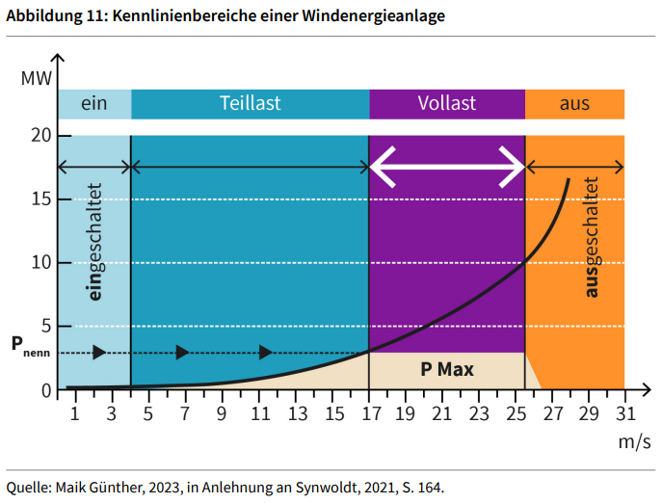

|  |  |
| --- | --- |
| MW |  |
| On |  |
| Partial load |  |
| Full load |  |
| Off |  |
| Switched on |  |
| Switched off |  |
| P rated |  |
| P max |  |

**Vertical Axis Wind Turbines**

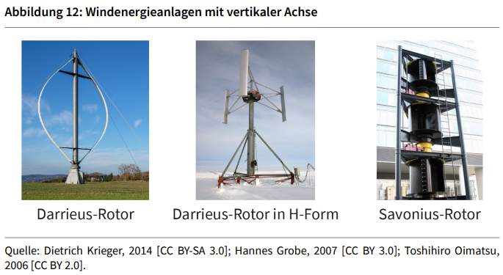

|  |  |
| --- | --- |
| Darrieus rotor |  |
| H-type |  |
| Savonius rotor |  |

**Schematic of a Wind Turbine with Horizontal Axis of Rotation**

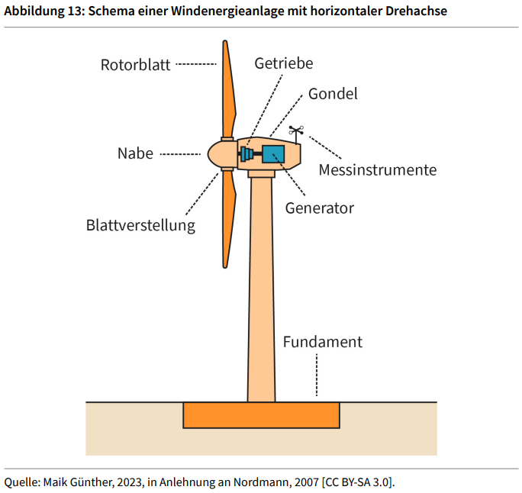

|  |  |
| --- | --- |
| Rotor blade |  |
| Hub |  |
| Blade adjustment |  |
| Gearbox |  |
| Gondola |  |
| Measuring instruments |  |
| Generator |  |
| Base |  |

**Characteristic Map Showing the Application Areas of Turbines**

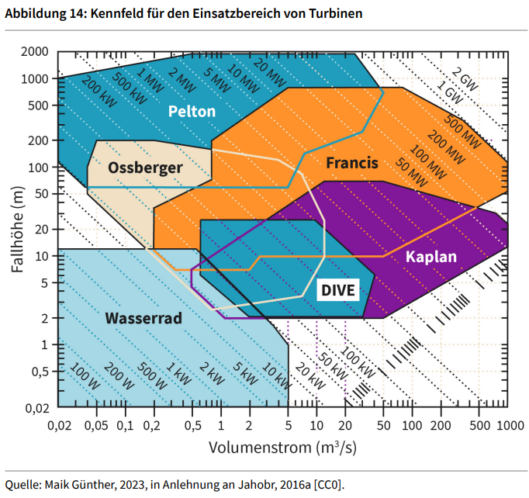

|  |  |
| --- | --- |
| Head m |  |
| Pelton |  |
| Ossberger |  |
| Francis |  |
| Waterwheel |  |
| DIVE |  |
| Kaplan |  |
| Volume flow m³/s |  |

**Schematic Representation of Various Turbines**

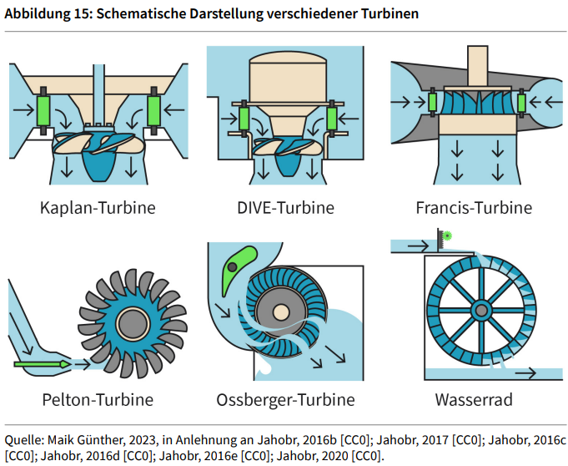

|  |  |
| --- | --- |
| Kaplan turbine |  |
| DIVE turbine |  |
| Francis turbine |  |
| Pelton turbine |  |
| Ossberger turbine |  |
| Waterwheel |  |

**Bioenergy conversion chain**

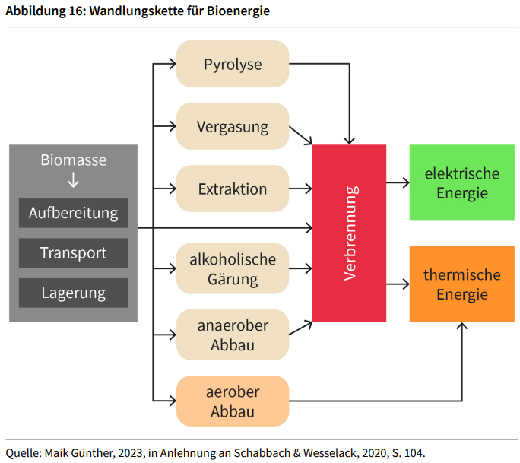

|  |  |
| --- | --- |
| Biomass |  |
| Treatment |  |
| Transport |  |
| Storage |  |
| Pyrolysis |  |
| Gasification |  |
| Extraction |  |
| Alcoholic fermentation |  |
| Anaerobic digestion |  |
| Aerobic digestion |  |
| Combustion |  |
| Electrical energy |  |
| Thermal energy |  |

**Structure of a Single-Stage Biogas Plant**

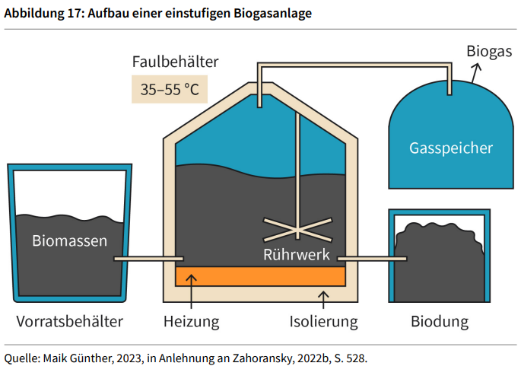

|  |  |
| --- | --- |
| Digestion tank |  |
| Biogas |  |
| Gas tank |  |
| Biomass |  |
| Agitator |  |
| Storage container |  |
| Heating |  |
| Insulation |  |
| Biodung |  |

**Diagram of a Waste Incinerator**

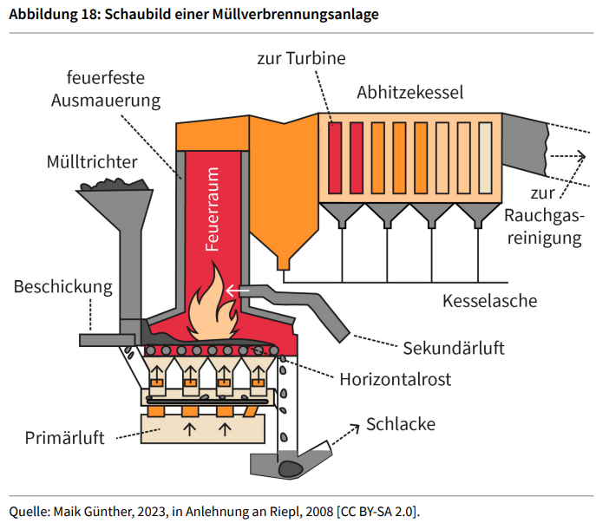

|  |  |
| --- | --- |
| Fireproof lining |  |
| To the turbine |  |
| Waste heat boiler |  |
| Waste hopper |  |
| Combustion chamber |  |
| To flue gas purification system |  |
| Feed |  |
| Boiler ash |  |
| Secondary air |  |
| Horizontal grate |  |
| Primary air |  |
| Slag |  |

**Circuit Diagram for Blocks One and Three of the North Combined Heat and Power Plant in Munich**

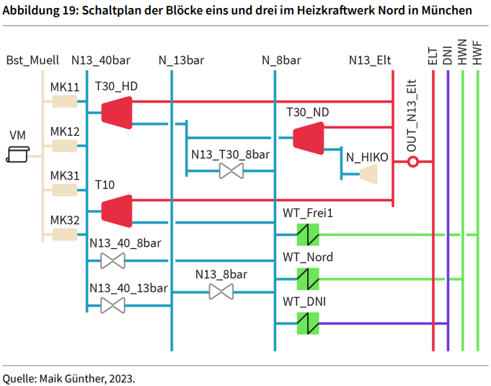

**Schematic View of a Flat Plate Collector**

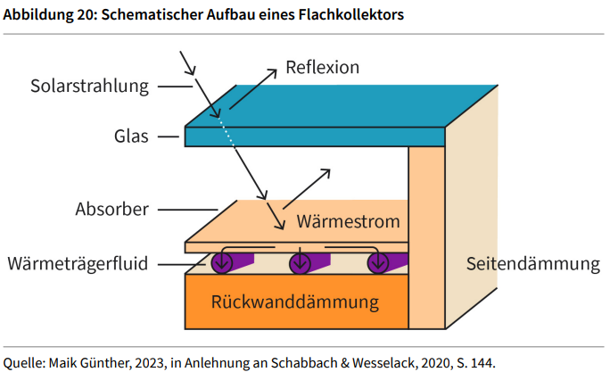

|  |  |
| --- | --- |
| Solar radiation |  |
| Glass |  |
| Absorber |  |
| Heat transfer fluid |  |
| Reflection |  |
| Heat flow |  |
| Back wall insulation |  |
| Side insulation |  |

**Examples of Solar Collectors**

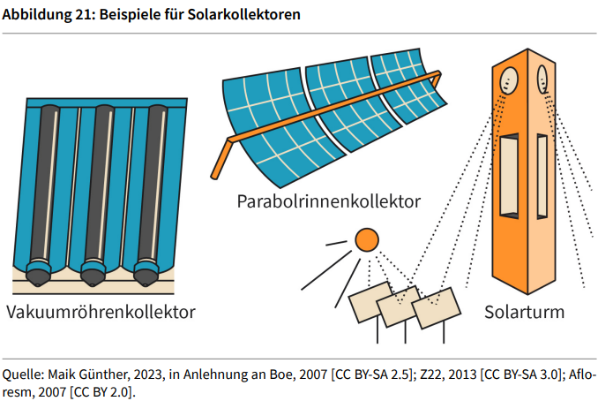

|  |  |
| --- | --- |
| Evacuated tube collector |  |
| Parabolic trough collector |  |
| Solar tower |  |

**Schematic View of the Earth**

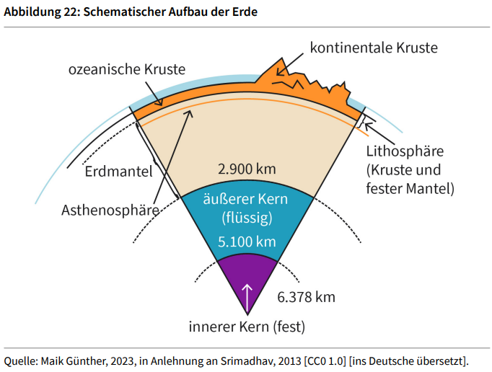

|  |  |
| --- | --- |
| Oceanic crust |  |
| Continental crust |  |
| Mantle |  |
| Asthenosphere |  |
| Liquid outer core |  |
| Solid inner core |  |
| Lithosphere crust and solid mantle |  |

**Diagram of a Compression Heat Pump**

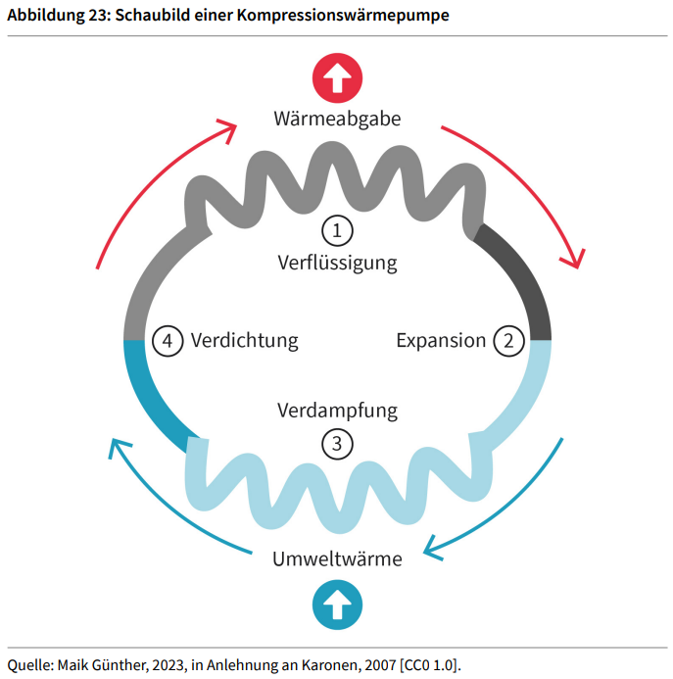

|  |  |
| --- | --- |
| Dissipation of heat |  |
| Liquification |  |
| Compression |  |
| Expansion |  |
| Evaporation |  |
| Ambient heat |  |

**System Configuration with Groundwater Heat Pumps in a New Building**

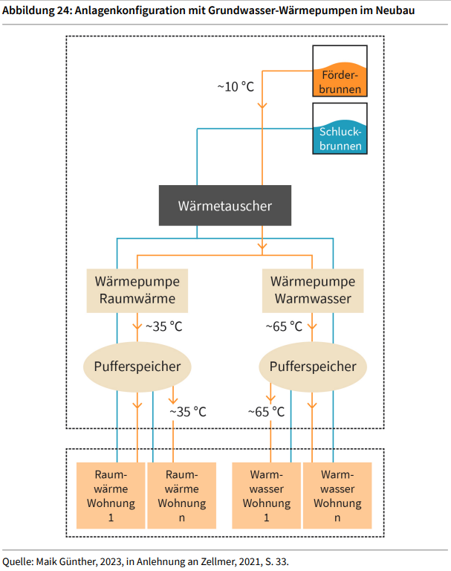

|  |  |
| --- | --- |
| Production well |  |
| Injection well |  |
| Heat exchanger |  |
| Heat pump Space heat |  |
| Hot water |  |
| Buffer storage |  |
| Space heat Apartment |  |
| Hot water Apartment |  |

**System Configuration with Groundwater Heat Pumps in an Existing Building**

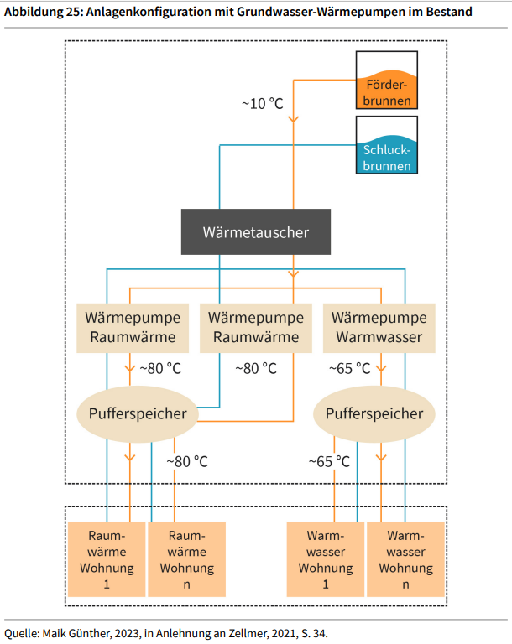

|  |  |
| --- | --- |
| Production well |  |
| Injection well |  |
| Heat exchanger |  |
| Heat pump Space heat |  |
| Hot water |  |
| Buffer storage |  |
| Space heat Apartment |  |
| Hot water Apartment |  |

**Five target categories for the energy system of the future**

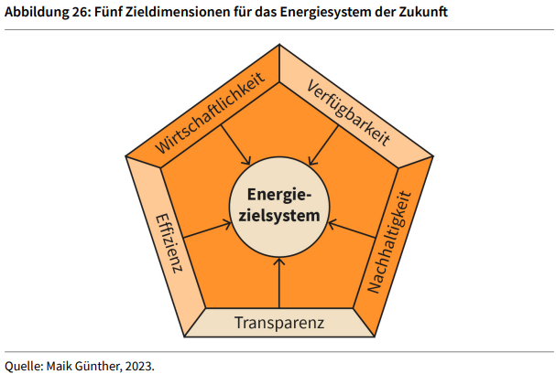

|  |  |
| --- | --- |
| Cost-effectiveness |  |
| Availability |  |
| Sustainability |  |
| Transparency |  |
| Efficiency |  |
| Energy target system |  |

**Comparison of Storage Technologies in Terms of Capacity and Discharge Time**

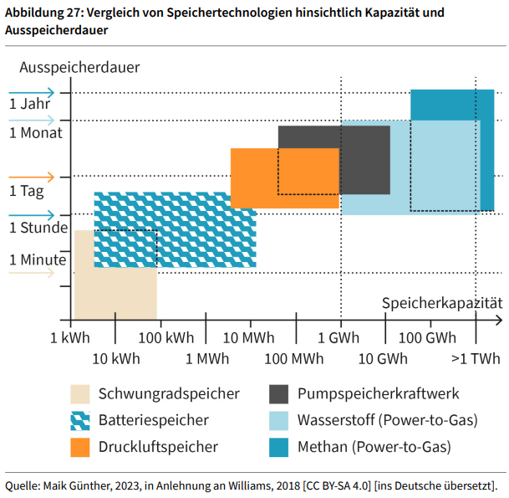

|  |  |
| --- | --- |
| Discharge time |  |
| Year |  |
| Month |  |
| Day |  |
| Hour |  |
| Minute |  |
| Storage capacity |  |
| kWh |  |
| Flywheel storage |  |
| Battery storage |  |
| Compressed air storage |  |
| Pumped storage power plant |  |
| Hydrogen (power-to-gas) |  |
| Methane |  |