**State of Israel  
Ministry of Environmental Protection**

Noise Prevention and Radiation Safety Department

**Limiting Exposure to Magnetic Fields as a Function of Exposure Duration (Updated September 2013)**

An electric field is generated around electrical installations. This type of magnetic field (radiation from electrical sources) has been defined by the World Health Organization as a "possible carcinogen." The higher the current passing through the facility, the larger the magnetic field generated surrounding the facility.

In Israel, as in many other countries, no legal mandatory threshold for chronic exposure to a magnetic field originating from an electrical facility has yet been established. Chronic exposure, or continuous, prolonged exposure, is defined as exposure of over four hours every day, for more than five days a week. Residences, offices, educational institutions, commercial and industrial buildings, etc., are considered places in which there is chronic exposure.

Determining a quantitative index for the chronic exposure threshold is essential for the purposes of engineering designs of electrical systems in a land-use environment for extended stays, issuing construction and operating permits for electrical facilities, interpreting measurements performed around electrical facilities, and more.

Taking into consideration existing information, practices in developed countries, and thresholds that electrical companies adhere to voluntarily in such countries, **the Health Ministry and the Environmental Protection Ministry in Israel have proposed a daily average threshold of 4 mG for typical maximum electricity consumption.**

This value is based on a lack of morbidity concerns from exposure to a magnetic field that on an annual average does not exceed 2 milligauss, and on statistics that show that the ratio between the average daily current with high consumption is twice the annual average current.

**With typical daily peak consumption, the electricity system oeprates at about 60% capacity** (there are facilities where the percentage is different). If the electrical current at the time of measuring is known or measured, the exposure measurement is to be normalized according to the ratio between the maximum current that can pass through the facility and the current that flowed through it at the time of the measurement. It is not always possible to measure or estimate the current flowing through the facility at the time of the measurement of exposure to a magnetic field. In the absence of this value, when the source of exposure is a facility within a building, activating all the main consumers in the building, such as the air conditioning system, at the time of measuring, is a sufficient representation of maximum load conditions.

There are places where the exposure is defined as exposure of 24 hours a day, such as exposure within a residential building. However, there are places where exposure is limited and exposure time is limited to certain hours, such as workplaces, public and private transportation, passage areas, etc. Although there is no clear evidence of the type of connection between the duration of exposure and exposure's effect on health, it is advisable to act on the side of caution and assume there is a direct linear relationship between the duration of exposure and its intensity. Based on this assumption, it is possible to use the index of 4 mG on average per day, in which there is maximum consumption, for the purpose of estimating the level of exposure as a function of exposure duration. The proposal below serves as a guideline, and requires use of discretion by anyone planning proximity between a populated area and an electric facility, each case considered individually. For example, it is recommended not to use this type of average regarding exposure in educational institutions used by children under 15.

If a person is located in the vicinity of an electrical facility for T hours every day, the exposure near the facility is Bw, and the exposure the remainder of the day is B0. Its total average exposure throughout the day is:

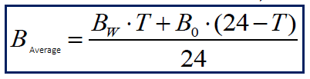

Although the exposure of a person who is not located in the vicinity of an electrical installation does not exceed 4 milliGauss for the most part, it must be taken into account that this exposure is 1mG on average. Therefore, B0 = 1mG. If there is a reliable measurement of the background radiation, and it is greater than 1mG, the measurement should be used. According to the joint recommendation of the Health Ministry and the Environmental Protection Ministry, the average exposure on a day with maximum typical power consumption must be lower than 4 milligauss:

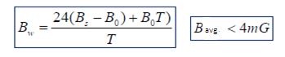

Therefore: if the duration of time near the electrical facility is known, the exposure should be limited, in milligauss, to:



If the level of the magnetic field Bw is known, as a result of a calculation or a measurement and normalization to maximum current, the proximity time should be limited to:

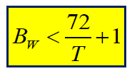

Under these considerations, only the worst case is taken into account, without taking into account the lower exposure on rest days and weekends, in order to err on the side of caution.

**Exposure to a magnetic field (milligauss) – time (hours)**

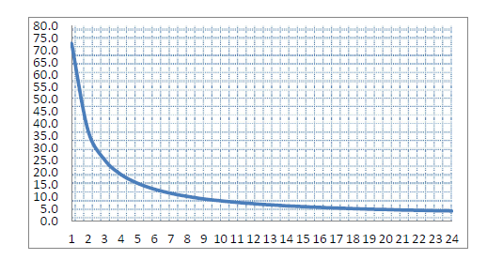

These values are the basis for determining the need to reduce exposure around existing facilities.

**Warning: Do not use these formulas for proximity time lower than one hour a day or for exposure of less than 1 milligauss.**