1 November 2020

593/מזמין/RADHAZ-ELF

**Mr. Gal Groner – Gronner DEL Engineers Ltd.**

[gal@grdel.co.il](mailto:gal@grdel.co.il), Tel 04-8559111, Fax 04-8559100, Mobile 050-5213945

**Subject: Professional Opinion: Effects of Electromagnetic Radiation on Scientific Equipment on the Bar-Ilan University Campus, above the route of Metro Line M2, southern alternative**

**References:**

1. Ministry of Industry, Trade, and Labor, Regulation 5 of the regulations of the work supervision organization (Environmental Monitoring and Biological Monitoring of Workers), 1990;
2. Situational map of the Bar-Ilan University campus and the southern alternative of the Metro M2 line;
3. Summary of damage to research laboratories and sensitivity thresholds of instrumentation at the university, document of the Office of the VP of Operations at the Faculty of Life Sciences and Exact Sciences, 2020-13319 of 16 September 2020;
4. Letter regarding the severe impact of the southern alternative of the Metro line on Bar-Ilan University, Bureau of the University President Prof. Arie Tzavan dated 23 September 2020;
5. Document from Moshe Netzer (the undersigned) – Prediction of the magnetic field flux on the M2 Metro line, 18 August 2019.
6. **Administrative Data and Executive Summary**
   1. Objective of the Document

The document addresses concerns expressed in References 3 and 4 regarding electromagnetic interference that will be caused by the electrical activity of the southern alternative of the Metro M2 line that will run near the university buildings as shown on the situational map (Reference 2). The response to BIU’s concerns, provided according to the results of a static and variable over time magnetic field flux prediction of the Metro M2 line that was carried out by the undersigned (Reference 5). The appendix to this professional opinion presents the theoretical estimates of the distribution of static magnetic field flux and alternating current in the normal driving current of the Metro and in the maximum fault current.

Professional opinion commissioned by Groner DEL Engineers, Ltd.

* 1. **Author of the response (this document)**

I am providing this professional opinion in lieu of testimony in court, and hereby declare that I am well aware of the provisions of the criminal law regarding false testimony; the law regarding this opinion as signed by myself, is identical to the law of testimony given under oath in court.

I declare that this professional opinion was prepared by me to the best of my knowledge, understanding, and professional experience, and I have no part or interest in properties subject to this opinion.

The following are the details of my education and professional experience:

1. Master’s degree in Electronics and Electrical Engineering, Technion, Haifa;
2. Rafael employee (Research A on research rating) as an electromagnetic compatibility engineer, 1976 – 2011;
3. Manager of non-ionizing radiation safety at Rafael for 33 years;
4. Independent non-ionizing radiation consultant since 2011.
   1. **Executive Summary**

This report details the results of the theoretical estimate of the static and time-varying field flux density at grade level above and on either side of the planned Metro M2 route. For each building for which the sensitivity of its instrumentation is detailed in Reference 3, specific information is summarized in the table below.

|  |  |  |  |  |  |  |
| --- | --- | --- | --- | --- | --- | --- |
| Building | Distance from the Metro | Sensitivity of the scientific equipment to electromagnetic fields | Static magnetic field flux from normal driving current | Static magnetic field flux from short current or maximum load | Magnetic field flux variable over time (ripples of alternating current 1200 Hz) | Comments |
| Meters | mG | mG | mG | mG |
| 100 | Unknown |  |  |  |  | Not on the map |
| 202 | 123 | 1-10mG AC  No DC data | 0.28 | 0.82 | 0.8µG | Interference not expected |
| 204 | 123 | Low sensitivity | - | - | - | No comparison made – not necessary |
| 205 | 111 | No data available | 0.075 | 0.35 | 1µG | Interference not expected |
| 206 | 49 | 10µG AC | 1.0 | 3.7 | 5µG | Interference not expected |
| 207 | 82 | Medium sensitivity | 0.14 | 0.46 | 1.85µG | No quantitative value  Interference not expected |
| 208 | 72 | Not given | 0.17 | 0.6 | 2.4µG |  |
| 209 | 43 | High sensitivity | 0.5 | 1.7 | 6.7µG | No quantitative value  Disturbance possible |
| 211 | 42 | 1-10mG AC  No DC data | 0.52 | 1.8 | 7µG | Disturbance possible |
| 212 | 5 | Low sensitivity |  |  |  | No comparison made – not necessary |

In summary, no electromagnetic interference is expected to sensitive scientific electronic equipment in any buildings with the exception of 209 and 211, which according to the data, operate equipment with magnetic field flux sensitivity of 1-10µG (testing required!).

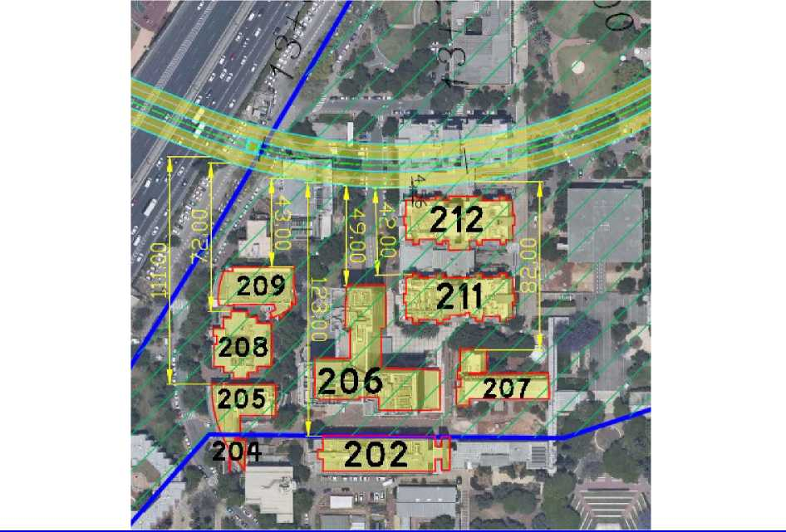

Figure 1 Situational Map of University Buildings and Distances from the Metro Line

1. **Scientific Electronic Equipment – Enduring Magnetic Field Flux**

Electronics, and scientific electronic systems in general are not vulnerable to static magnetic fields or ELF magnetic fields, that are the main product of the electricity used to drive the Metro. In the past, cathode ray tube computer screens were sensitive to a magnetic field flux higher than 5mG, which caused the screen to flicker. There are still scientific systems that are sensitive to magnetic field flux, such as the scanning electronic microscope (SEM) which can be sensitive to low magnetic field flux, such as 2mG (rms).

According to Reference 3, the scientific equipment at the university is sensitive to very low magnetic field flux, even down to 1µG. Achieving such a small value is unlikely in this case unless the equipment is protected in a Faraday cage that prevents regular external magnetic field flux the source of which is in the electricity facility and electrical wiring of the building from penetrating the instrument. On the other hand, if there is magnetic protection on the sensitive instrumentation, there is no reason to be concerned that the electrical activity of the Metro which distributes magnetic field flux that is variable over time that does not exceed 7µG will manage to disrupt the scientific equipment that certainly includes a suitable protection encasement.

1. **Summary and Conclusions**

This professional opinion presents the results of a theoretical prediction of magnetic field flux in a complex intending for the passing of the Metro M2 line near university buildings where the scientific equipment is operated.

Density of the static magnetic field flux cannot disrupt equipment, as its value in relation to the geomagnetic static field is lower than 1%, and, therefore, if the scientific equipment is not sensitive to the geomagnetic field, it is certainly not sensitive to the static field the source of which is from the Metro, which is fed direct current.

Magnetic field flux, which is variable over time, the source of which is from current ripples of less than 1% on the corrected current, is very low as a result of its distance from the source. For Buildings 209 and 211, which are 42-43 meters from the Metro path on the ground, receive a maximum field flux of an alternating current of about 7µG. The magnetic field flux in the background of any urban building is not lower than 200µG; i.e., if the equipment is sensitive to a magnetic field flux of 1-10µG, it is necessarily protected by magnetic protection, and therefore also protected from magnetic field flux distributed by the Metro.

Some of the equipment is sensitive to stray currents. This is not significant regarding the Metro data, as stray currents generated at a depth of 17 m underground do not flow to the ground level. In addition, there is an option to run the train with a fourth rail which returns all the driving current of the train via the fourth rail, which is insulated from the ground, therefore resulting in no problem of stray currents (See additional data in Appendix 4A).

Best regards,

Moshe Netzer – NCE

Electromagnetic Compatibility Engineer and Radiation Safety

Environment Protection Ministry Permit 20150-10-4