**Cervical traction suture procedure with loop electrosurgical excision procedure increases complete lesion excisions**

Jacob Bornstein, Dor Shahar

Department of Obstetrics & Gynecology, Galilee Medical Center and Bar-Ilan University Faculty of Medicine, Nahariya, Israel

Financial support:

Conflict of interest:

Word counts:

Précis:

Abstract: 229

Text: 2839

Number of figures:

Number of tables:

IRB status:

Correspondent:

Précis

**Abstract**

**Introduction:** The proximity of the cervix to adjacent tissues may lead to unintentional injuries to the vagina, bladder, and rectum during surgery. Therefore, we introduced the use of a cervical traction suture technique that keeps the cervix away from the surrounding tissue and allows for manipulating it during the excision. We found that the traction suture might increase the rate of complete excision of cervical intraepithelial neoplasia.

**Objectives:** Our aim was to evaluate the effectiveness of the suture technique in increasing the prevalence of complete lesion excisions and reducing the incidence of unintended injuries during the loop electrosurgical excision procedure of the transformation zone (LEEP). A retrospective comparative analysis was conducted of patients who have undergone LEEP. The study population included 66 patients: 33 with a traction suture and 33 without a traction suture.

**Results:** The prevalence of complete lesion excisions was 93.3% among patients undergoing LEEP with a traction suture and 72.7% in women without a traction suture. The incidence of unintentional injuries to adjacent organs was 12.1% in women with a traction suture and 18.2% in women without a traction suture.

**Conclusions:** Using a cervical traction suture along with LEEP can effectively increase the prevalence of complete lesion excisions and possibly reduce the prevalence of unintended injuries. The LEEP procedure is the method recommended and preferred by most physicians for the treatment of high-grade cervical intraepithelial neoplasia.

**Introduction**

During the loop electrosurgical excision procedure (LEEP), a thin loop of wire with a diameter of 1 to 1.5 cm is heated by transmission of an electric current to cut the tissue from the edge of the cervix where a precancerous process has developed. The surgeon removes, through the vagina, the entire transformation zone, because even if only part of the region is precancerous, the process may spread to the lower part of the cervix.

The anatomic proximity between the incision zone in the cervix and the adjacent tissues may make it difficult to perform the excision. The rigidity and inflexibility of the LEEP loop also reduces maneuverability and the active field. In addition, clear visualization of the cervix and its adjacent tissues is not possible. There is a fear of entering too far and causing accidental injury.1 Situations that cause further reduction of the gap between the cervix and the tissues adjacent to it, such as sudden movement of the patient or surgeon, cervical malformation, large lesions, abnormal position of the uterus, and pelvic organ prolapse (rectocele, enterocele, cystocele), further increase the risk of complications.2

Studies of excision of precancerous cervical lesions by LEEP have also shown a significant number of incomplete lesion excisions. Results of a 2017 study that compared 43 previous investigations of premalignant cervical lesion excisions by LEEP reported a mean of 25.9% incomplete excisions,3 and in a report published in 2008, where approximately 250 patients were retrospectively investigated, the mean rate of incomplete excisions was reported as 27.6%.4 Incomplete lesion excision implies an increased risk of remnants and future relapse of the cervical intraepithelial neoplasia (CIN), and it may lead to a repeat excision.

In light of the high incidence of incomplete excision of lesions performed by LEEP and the inadvertent injuries that have occurred, our group has developed a surgical technique to raise the rate of complete lesion excisions and reduce inadvertent complications. This technique is called cervical traction suture procedure and involves the use of a suture through which it is possible to retract the cervix from the adjacent tissues during the LEEP procedure. The present study aimed to gather, analyze, and compare data from using this technique for precancerous cervical lesion excisions with LEEP, mainly for obtaining complete excisions and also for reducing inadvertent injuries during the LEEP procedure.



**Materials and Methods**

The research was a retrospective observational study (survey) based on the collection of existing medical information from patient files in the Medical Center of the Galilee – Nahariya. The study population included all ages, and the cases chosen were taken from the files of patients who had precancerous cervical lesions excised by the LEEP procedure.

The study used data from the files of 66 patients and included information on the procedure technique, completeness of the excision, presence of complications, classification of the lesion, and demographic material.

During LEEP, a thin loop of wire with a diameter of 1 to 1.5 cm is heated by transmission of an electric current to cut the tissue from the edge of the cervix where a precancerous process has developed. The surgeon removes, through the vagina, the entire transformation zone, because even if only part of the region is precancerous, the process may spread to the lower part of the cervix.

The technique is performed under local or general anesthesia in the operating room and includes the passage of a silk suture (0–2) in a curved needle (22 mm) through the cervical lips. The sewing is performed by introducing the needle about 0.5 cm anterior to the entry opening of the cervix and pulling it out about 0.5 cm behind it, such that the depth of penetration of the needle is 1 cm (Figure 1).

After pulling out the needle through the posterior region of the cervix, the thread is not knotted, and 2 ends of the silk suture are passed through the loop of the electrode. Afterwards, pulling the ends of the suture permits moving the cervix and retracting it from the adjacent tissues (Figure 2).

Patients in the study were divided into 2 groups depending on the technique by which the LEEP procedure was performed. In half of the cases, the cervical traction suture techniquewas used during the LEEP procedure (Group A, 33 patients), and in half of the cases, the cervical traction suture technique was omitted (Group B, 33 patients).

The technique was determined by the specialists in the clinic. One of the surgeons always used the cervical traction technique, and the second never used the cervical traction technique in the LEEP procedure.

Variables

*Dependent variables*

1. Complete or incomplete excision of the lesion. Complete lesion excision was defined as an excision where the pathology laboratory reported negative margins without dysplastic cells, and incomplete lesion excision was defined when positive margins and the presence of dysplastic cells were reported by the pathology laboratory. Excisions of the legions were recorded in the study as complete excision / incomplete excision.

2. Occurrence of complications as a result of the LEEP procedure / no occurrence of complications as a result of LEEP. Complications were defined as the appearance of bleeding, infection, vaginal discharge, or penetration of an adjacent tissue and were recorded as complications / no complications.

*Independent variables*

1. LEEP procedure with the cervical traction suture technique

2. LEEP procedure without the cervical traction suture technique

Statistical methods

Quantitative data were defined as mean, standard deviation, coefficient of variation, median, and range and presented graphically by histograms. Qualitative data were reported as prevalence and percentage and presented graphically by bar charts.

To verify that the results of the study were not linked to differences in the age of the patients, we examined the age distribution of each group and compared the mean age between them. In addition, to verify that the severity of the lesions did not differ between the groups, we compared the number of lesions at each level of severity in the groups. To assess the variance of the dependent variables between the study groups and examine if there was a statistical relationship between the 2 variables that would indicate that the use of the technique has an effect on the number of complete excisions of the lesion and on the complications that occurred, a statistical analysis of the qualitative study data between the groups was performed by the use of the chi-square test and the Fisher’s exact test as needed (occurrence / non-occurrence of complications as a result of the LEEP technique used; number of complete / incomplete excisions of the lesion compared to the LEEP technique used).

Comparison of quantitative variables was performed by an independent-samples *t* test. Comparison between the study data and the rate of complete excisions and inadvertent complications caused by the LEEP procedure as reported in the literature was performed by the proportion test. The sample size of patients needed for the study was 26 in each group (total 52 patients) and was calculated according the G*POWER 3.1.9.4 program. Significant difference was defined as *P* < .5 at a power of 0.8, one-way. Data were analyzed by the SPSS statistics program version 24.0.

The research was approved by the Helsinki Committee of the Galilee Medical Center (local IRB).

**Results**

The study included data collected from the files of 66 patients who underwent excision of a precancerous cervical lesion by the LEEP procedure. Patients were divided into 2 groups based on the technique used in the LEEP procedure: Group A—LEEP including the cervical traction suture technique and Group B—LEEP without the cervical traction suture technique. Each group contained 33 patients. (Patient data according to group are summarized in Table 1.) The ages in each group followed a normal distribution, and the mean age in both groups was similar (Table 2, Graph 1). The mean age of all the patients in the study was 37 years; the youngest was 21 and the eldest was 58.

Twelve patients had lesions grade CIN1, 18 had grade CIN2, and 36 had grade CIN3. The number of lesions in each category was similar between groups (Table 3, Graph 2).

When we compared the LEEP techniques (Group A and Group B) and excision completeness, the number of complete excisions was higher in Group A. There were 31 complete lesion excisions in Group A and 24 in group B. The difference in the number of complete lesion excisions between each group was statistically significant (*P* = .044; Table 4, Graph 3).

In comparing the rate of complete lesion excisions in group B to the rate of complete lesion excisions reported in the literature, we found that the rates were similar (72.7% and 74.1%, respectively). Comparing the rate of complete lesion excisions in group A (93.9%) to the rate of complete lesion excisions in the literature (74.1%), we found that the rate in group A was higher and statistically significant (*P* < .05; Table 5, Graph 4).

In comparing the techniques of LEEP used (Group A and Group B) and complications that occurred in each group, we found that in Group A, the number of complications (4) was lower than in Group B (6). The complications that occurred in Group A included bleeding after the procedure (2), infection/inflammation (1), and vaginal discharge with a bad odor (1). The complications that occurred in Group B included bleeding after the procedure (4), infection (1), and vaginal discharge with a bad odor (1). These differences were not statistically significant (*P* = .733; Table 6, Graph 5).

Although the rate of complications that occurred in Group A (12.1%) and group B (18.8%) differed from the complications reported in the literature (16.5%), in the comparison we performed, we found that these rates were similar and were not statistically significant (*P* = .617 and *P* = 8.02, respectively; Table 7, Graph 6).

In both groups there is a normal distribution of patient ages, and the mean age of patients in the groups is similar (*P* = .322).

**Discussion and Conclusions**

Loop excision of the transformation zone is one of the common methods for the treatment of cervical precancerous lesions and is the treatment recommended and preferred by most physicians.5 Excision of CIN by LEEP permits the presentation of the dysplastic lesion and the transformation zone for histopathological evaluation in the laboratory, where microinvasion can be detected or ruled out.6 Consequently, complete removal of the lesion is considered a quality indicator of clinical practice and is a significant part of CIN treatment.3 Most cases of relapse occur during the first 2 years postexcision in 5% to 15% of patients.7

Studies of excision of precancerous cervical lesions by LEEP have shown a significant number of incomplete lesion excisions, which imply an increased risk of remnants and future relapse of the CIN that may lead to a repeat excision. A 2017 study that compared 43 previous investigations of premalignant cervical lesion excisions by LEEP reported a mean of 25.9% incomplete excisions,3 and in a report published in 2008, where approximately 250 patients were retrospectively investigated, the mean rate of incomplete excisions was reported as 27.6%.4 In a German study from 2000, the rate of incomplete cervical lesion excisions was 20%.8 Another study, published in 2009, reported a rate of 26.8% incomplete excisions.9

Although the LEEP procedure is considered safe, it is also not risk free. Studies performed to examine the safety of the LEEP procedure reported a 16.5% frequency of complications. The main complications include bleeding (11%); infections (1.5%)10; unintentional contact of the metal thread with tissues adjacent to the excision during the LEEP procedure, which may cause an unintentional thermal injury (iatrogenic) and as a result lead to bleeding and infection; damage to the vaginal wall; and even penetration into the adjacent organ.

In this study, we investigated whether the use of the cervical traction suture technique, which permits retraction of the cervix away from the surrounding tissues during the performance of the LEEP procedure, is related to a higher rate of complete lesion excisions and a lower rate of inadvertent complications compared to the LEEP procedure without this technique. Retracting the cervix increases the working space of the LEEP operator and improves the visualization of the cervix and the adjacent tissues. As a result, excision of the lesion is more convenient, the fear of deep entry is reduced, the accuracy of the cervical lesion excision is improved, and the resection is possible in one procedure.2

In comparing the technique used in the LEEP procedure to the rate of complete lesion excision between the study groups, we found that the use of the technique leads to a higher number of complete lesion excisions (31 versus 24) and that there was a link between the performance of the cervical traction suture technique to the higher rate of complete lesion excisions (*P* =.44). This increase is consistent with the assumption that retraction of the cervix during excision of the lesion improves the visualization of the cervix and the surrounding tissue and permits more accurate excision of the lesion.2

The rate of complete lesion excision of the study group where the technique was used (93.9%) was higher than the rate reported in the literature (74.9%; *P* = .009). This finding reinforces the link between the use of the cervical traction suture technique and a higher rate of complete excisions of the lesion. The rate of complete lesion excisions in the study group without the use of the cervical traction suture technique (72.7%) was similar to the rate of complete lesion excisions reported in the literature (*P* = .857) and therefore supports the fact that the population of patients in the study is representative.

Because incomplete lesion excisions sometimes involve repeat excisions due to the increased risk of CIN remnants and recurrence, this surgical traction suture technique can be put forward as a new treatment that could lead to a higher rate of complete lesion excisions, reduction of the risk of CIN recurrence, and reduction of the need for repeat excisions.3 In addition, if this finding is supported by further studies, it should be possible to further optimize the technique and to consider if a new kind of suture with built-in loop handles would be more comfortable and would lead to an additional improvement in the ability of the surgeon to control and more accurately perform the procedure.

The results of the present study also showed a lower incidence of complications in the group where the technique was used during the performance of the excision compared to the group in which the technique was not used (12.1% vs 18.2%). However, this difference did not reach statistical significance (*P* = .733). The rate of complications in the literature (16.5%) was similar to that seen in our patients (*P* = .617 and *P* = .802, respectively).10

Since the study was not powered to meet the stringent requirements to prove reduction of complications, it is not possible at this stage to confirm or reject the assumption that the use of the cervical traction suture technique in the performance of LEEP will lead to a reduction in complications. To arrive at a more definite conclusion, additional investigations including a larger population of patients are needed.

Although the average age of the study patients was similar to the literature with respect to the average age at which most of cases of CIN occur,11 and although the distribution by grade of the lesions was similar in the study groups, there are some limitations to our study; being retrospective makes it difficult to accurately collect all the data. Some of the files that were collected were missing data necessary for the study, which prevented including them.

Also, the excisions in the study were performed by a number of surgeons and not by a single surgeon, and it is possible that some of the surgeons were more skilled than others and thus influenced the study.

Therefore, a follow-up prospective study, during which a single surgeon will perform all the excisions in both groups, would be a more comprehensive investigation that would strengthen the findings of the study and would even permit examination of additional data such as the ease of using the technique, the length of time excision takes using the technique, follow-up of patients who had an excision, and examination of the rate of relapse after a period of 2 years, which has been reported as the period of time when most recurrences appear.7

In addition, there were no up-to-date reports in the literature about the rate of complete lesion excisions and the rate of complications of the LEEP procedure in Israel. Therefore, comparison of data that were collected in the study relied on information that was reported in the world literature.

In summary, the study shows that performance of the cervical traction suture technique for excision of a cervical precancerous lesion by the LEEP procedure is significantly efficient in increasing the rate of complete excision of the lesion and also showed a tendency to reduce the rate of complications.

**List of Abbreviations and Acronyms**

CIN = cervical intraepithelial neoplasia

LEEP = loop electrosurgical excision procedure of the transformation zone

**References**

1. Panoskaltsis T, Ind TE, Perryman K, Dina R, Abrahams Y, Soutter WP. Needle versus loop diathermy excision of the transformation zone for the treatment of cervical intraepithelial neoplasia: a randomised controlled trial. *BJOG* 2004;111(7):748–753.

2. Bornstein J, Harroch J, Morad E. Traction suture of the cervix: a novel procedure with loop electrosurgical excision. *Obstet Gynecol* 2003;102(5 Pt 1):1063–1065.

3. Arbyn ME, Charles A, w. E. R. Freija V. Incomplete excision of cervical precancer as a predictor of treatment failure: a systematic review and meta-analysis.

4. Boonlikit S, Junghuttakarnsatit P, Asavapiriyanont S. Treatment failure following large loop excision of the transformation zone for the treatment of cervical intraepithelial neoplasia at Rajavithi Hospital. *J Med Assoc Thai* 2008;91(1):31–36.

5. Prendiville W. Large loop excision of the transformation zone. *Clin Obstet Gynecol* 1995;38(3):622–639.

6. Rothmann S, Mikkelsen M, Bor P. Radical conization of intraepithelial neoplasia. *Ugeskr Laeg* 2014;176(8):

7. Nuovo J, Melnikow J, Willan AR, Chan BK. Treatment outcomes for squamous intraepithelial lesions. *Int J Gynaecol Obstet* 2000;68(1):25–33.

8. Hillemanns P, Kimmig R, Dannecker C, et al. LEEP versus cold knife conization for treatment of cervical intraepithelial neoplasias. *Zentralbl Gynakol* 2000;122(1):35–42.

9. Panna S, Luanratanakorn S. Positive margin prevalence and risk factors with cervical specimens obtained from loop electrosurgical excision procedures and cold knife conization. *Asian Pac J Cancer Prev* 2009;10(4):637–640.

10. Maleerat P, Chumworathayi B, Kietpeerakool C, Luanratanakorn S, Temtanakitpaisan A. Post-loop electrosurgical excision procedure complications in Srinagarind Hospital. *Cancer Prev* 2016;17(4):2211–2215.

11. Ting J, Kruzikas DT, Smith JS. A global review of age-specific and overall prevalence of cervical lesions. 2010:

**Table 1.** Division of Data Collected According to Study Groups

|  |  |  |  |  |
| --- | --- | --- | --- | --- |
| Variables | | Group A:  LEEP with cervical traction suture technique | Group B: LEEP without cervical traction suture technique | Study population |
| Patients | No. patients | 33 | 33 | 66 |
| Study population | 50% | 50% | 100% |
| Age (y) | Mean | 38.73 | 36.39 | 37.56 |
| Median | 39.00 | 38.17 | 38.44 |
| Std. Dev. | 9.606 | 9.401 | 9.503 |
| Marital status | Single | 6 | 8 | 14 |
| Married | 18 | 19 | 37 |
| Divorced | 7 | 6 | 13 |
| Widow | 2 | 0 | 2 |
| Use of birth control | Pills | 6 | 2 | 8 |
| Device | 2 | 5 | 7 |
| Condom | 6 | 3 | 9 |
| None | 19 | 23 | 42 |
| Completeness of the excision | Complete excision (*n*) | 31 | 24 | 55 |
| Complete excision (%) | 93.9% | 72.7% | 83.3% |
| Incomplete excision (*n*) | 2 | 9 | 11 |
| Incomplete excision (%) | 6.1% | 27.3% | 16.7% |
| Lesion Classification | CIN1 | 7 | 5 | 12 |
| CIN2 | 8 | 10 | 18 |
| CIN3 | 18 | 18 | 36 |
| Complications | Complication occurrence (*n*) | 4 | 6 | 10 |
|  | No complication occurrence (*n*) | 29 | 27 | 56 |

LEEP = large loop excision of the transformation zone; CIN = cervical intraepithelial neoplasia

**Table 2.** Age Distribution (Years) of the Study Patients

|  |  |  |  |  |  |  |  |
| --- | --- | --- | --- | --- | --- | --- | --- |
| Group | *N* | Mean | Median | Std. Dev. | Variance | Skewness | Kurtosis |
| Group A | 33 | 38.73 | 39.00 | 9.606 | 92.267 | .232 | –.686 |
| Group B | 33 | 36.39 | 38.00 | 9.401 | 88.371 | –.055 | –.589 |
| Group A,B (%) | 66 | 37.56 | 38.50 | 9.503 | 90.312 | .097 | –.587 |
| The Kolmogorov-Smirnov Test of Normality  Group A data is normally distributed: The value of the K-S test statistic (D) is .08532, *P* = .95277.  Group B data is normally distributed: The value of the K-S test statistic (D) is .14463, P = .45312. | | | | | | | |

|  |  |  |  |  |  |  |
| --- | --- | --- | --- | --- | --- | --- |
|  | | Levene’s test for equality of variances | | Independent samples *t* test for equality of means | | |
|  |  | F | Sig. | *t* | df | Sig. (2 tailed) |
| Age (y) | Equal variances assumed | .000 | .986 | .997 | 64 | .322 |

**Table 3**. Comparison of the CIN Grade of Lesions Between Groups

|  |  |  |  |  |  |
| --- | --- | --- | --- | --- | --- |
|  | | Grade of the lesion | | |  |
|  |  | CIN1 | CIN2 | CIN3 | total |
| Group A | Number (*n*) | 7 | 8 | 18 | 33 |
| % within group | 21.2% | 24.2% | 54.5% | 100.0% |
| Total % | 10.6% | 12.1% | 27.3% | 50.0% |
| Group B | Number (*n*) | 5 | 10 | 18 | 33 |
| % within group | 15.2% | 30.3% | 54.5% | 100.0% |
| Total % | 7.6% | 15.2% | 27.3% | 50.0% |

CIN = cervical epithelial neoplasia

|  |  |  |
| --- | --- | --- |
|  | Value | Sig. 2-sided |
| Chi-square | .556a | .757 |
| aZero cells (0.0%) have expected count less than 5. The minimum expected count is 6.00. | | |

Table 4: Comparison of complete excision between groups.

|  |  |  |  |  |
| --- | --- | --- | --- | --- |
|  | | Completeness of lesion excision | |  |
| Incomplete | Complete | Total |
| Group A | Number (*n*) | 2 | 31 | 33 |
| Group A (%) | 6.1% | 93.9% | 100.0% |
| Group B | Number *(n)* | 9 | 24 | 33 |
| Group B (%) | 27.3% | 72.7% | 100.0% |
| Groups A,B | Number *(n)* | 11 | 55 | 66 |
| Group A,B (%) | 16.7% | 83.3% | 100.0% |

|  |  |  |
| --- | --- | --- |
|  | Value | Sig. 2-sided |
| Chi-square | 5.345a | .021 |
| Continuity correctionb | 3.927 | .048 |
| Likelihood ratio | 5.712 | .017 |
| aZero cells (0.0%) have expected count less than 5. The minimum expected count is 5.50.  bComputed only for a 2x2 table. | | |
|  | Exact Sig. |  |
| 1-sided | 2-sided |
| Fisher’s exact test | .022 | .044 |

**Table 5.** Comparison of the Rate of Complete Lesion Excisions of the Patients in the Study with the Rate of Complete Lesion Excisions Reported in the Literature

|  |  |  |
| --- | --- | --- |
|  | Incomplete lesion excisions (%) | Complete lesion excisions (%) |
| Group A | 6.1 | 93.9 |
| Group B | 27.3 | 72.7 |
| Other studies | 25.9 | 74.1 |

|  |  |  |  |  |  |
| --- | --- | --- | --- | --- | --- |
|  | Category | *n* | Proportion observed | Test proportion | *P* value |
| Group A | Complete lesion excision | 31 | .939 | .741 | .00928 |
| Incomplete excision | 2 | .061 |  |  |
| Group B | Complete lesion excision | 24 | .727 | .741 | .85715 |
| Incomplete excision | 9 | .273 |  |  |

**Table 6.** Number of Complications Occurring in the Study Groups as a Result of the LEEP Procedure

|  |  |  |  |  |  |  |
| --- | --- | --- | --- | --- | --- | --- |
|  | | | Occurrence of Complications | | | Total |
| with | | without |
| Group A | Number (*n*) | | 4 | | 29 | 33 |
| Group A (%) | | 12.1% | | 87.8% | 100.0% |
| Group B | Number (*n*) | | 6 | | 27 | 33 |
| Group B (%) | | 18.18% | | 81.82% | 100.0% |
| Group A,B | Number (*n*) | | 10 | | 56 | 66 |
| Group A,B (%) | | 15.15% | | 84.85% | 100.0% |
|  | | Exact Sig. | |
| Fisher’s exact test | | .733 | |

**Table 7.** Comparison Between the Rates of Complications That Occurred Among Study Patients as a Result of the LEEP Procedure and the Complications of the LEEP Procedures Reported in the Literature

|  |  |  |  |  |  |
| --- | --- | --- | --- | --- | --- |
|  | Category | *n* | Observed Proportion | Test Proportion | *P* value |
| Group A | With complications | 4 | .121 | .165 | .617 |
| Without complications | 29 | .878 |  |  |
| Group B | With complications | 6 | .181 | .165 | .802 |
| Without complications | 27 | .818 |  |  |

|  |  |
| --- | --- |
| Figure 1. Insertion of the traction suture by passing a curved needle through the anterior and posterior lips of the cervix.  Urinary bladder    vagina  Silk suture  speculum  tissue  Round needle  cervix | Figure 2. The ends of the suture are passed through the loop. The ends of the suture are pulled outwards (dotted arrow) at the same time moving the loop inwards (arrow), permitting a retraction of the cervix from the adjacent tissues. |

Study population

33 patients

Group A

Use of cervical traction suture technique during the LEEP procedure

33 patients

Group B

Without use of cervical traction suture technique during the LEEP procedure

9 patients were removed from the study because of the following reasons:

1. There was no information in their medical files as to the completeness of the incision (2)

2. Results after the LEEP showed no CIN lesions (7)

3. During the LEEP procedure a labeling suture was used (2)

66 patients were included in the study and were organized into 2 groups depending on the technique of LEEP used

75 patients who underwent excision of a precancerous cervical lesion by the LEEP method were first examined according to the characterization of the collected files

Distribution of patients’ age Group B

Distribution of patients’ age Group A

Number of patients (N)

Number of patients (N)

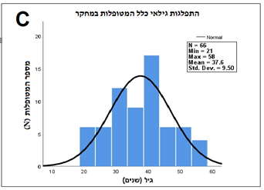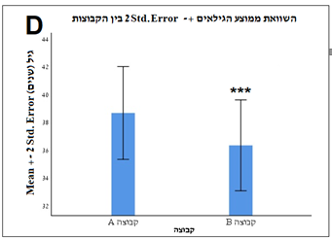

Comparison of mean age ± 2SD between groups

Distribution of patients’ age total patients

Number of patients (N)

mean ± 2StD.Error Age (years)

**Graph 1.** Age Distribution of the Study Patients

(A) Group A, (B) Group B, (C) entire patient population, (D) comparison of the ages between the Groups A and B; 2 SEM, *P* = .322, indicating that the age distribution between the 2 groups is similar.

**Graph 2.** Classification of the Lesions by Groups

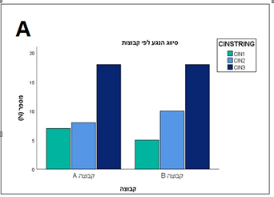

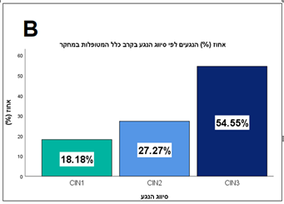

% of Lesions by Grade in All the Study Patients

Grade of Lesion by Group

Number (%)

Number (%)

Groups

Grade of lesion

(A) In both groups, an identical number of patients had excision of lesions classified as CIN3; also, prevalence of CIN2 and CIN1 is similar between the groups (*P* = .757). (B) Most (54.55%) of the study patients had lesions classified as high grade (CIN3).

**Graph 3.** Comparison Between Number of Complete and Incomplete Lesion Excisions in the Study Groups

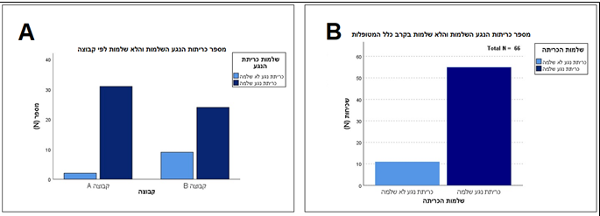

Number of total complete / incomplete lesion excisions

Number of complete / incomplete lesion excisions by group

Number (%)

Group A Group B

Groups

(A) The number of complete excision lesions is higher in group A as compared to Group B: 31 as opposed to 24, respectively. (B) Complete excisions were performed in 55 out of 66 patients in the study.

**Graph 4.** Comparison Between the Rate of Complete Lesion Excisions in the Study Patients and the Complete Lesion Excisions Reported in the Literature

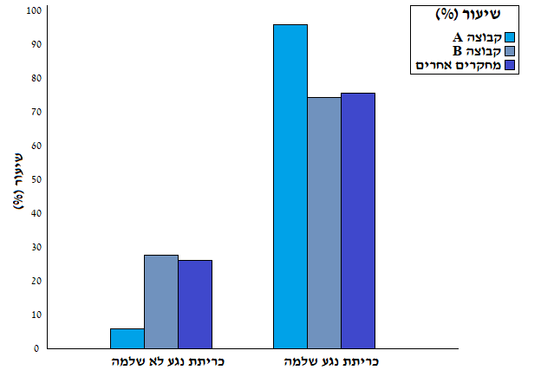

Number (%)

Incomplete lesion excision complete lesion excision

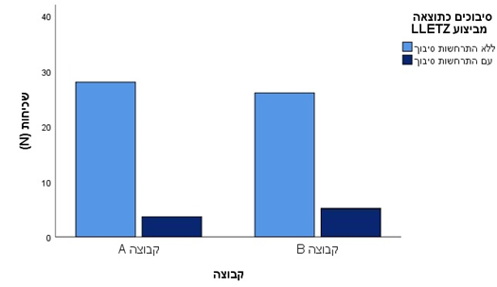**Graph 5.** Number of Complications That Occurred as a Result of the LEEP Procedure in Each Group of the Study

Number (%)

Group A

**Graph 6.** Comparison Between the Rate of Complications Among the Study Patients and the Rate of Complications Reported in the Literature

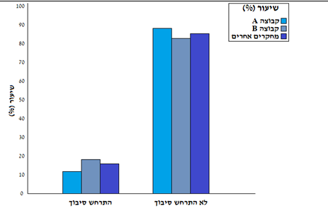

With complications No complications

Number (%)

Rate of complications in patients of Group A: 12.1%; rate of complications in patients of Group B: 18.1%; rate of complications reported in the literature: 16.5%.