**Behavior of financial markets during the COVID-19 crisis: a comparison of countries with high and low numbers of infections**

Sharon Teitler-Regeva\* and Tchai Tavora

*aDepartment of Economics and Management, The Max Stern Yezreel Valley College, Israel 19300*

\*Corresponding author: [sharont@yvc.ac.il](mailto:sharont@yvc.ac.il), Department of Economics and Management, The Max Stern Yezreel Valley College, Israel 19300.

**Behavior of financial markets during the COVID-19 crisis: a comparison of countries with high and low numbers of infections**

# Introduction

The year 2020 will be remembered as a year of public health crisis caused by the COVID-19 virus, which has led to some of the greatest economic disruption the world has known. The health emergency and the extreme measures that have been used to slow the spread of the virus have generated economic crises whose extent and outcome are yet to be determined. This event is unique, as the virus has spread quickly around the world to almost every country. Starting in December 2019, economic disruption first affected specific industries, including hospitality and culture, and later extended to the market as a whole. In many countries, employees have been made redundant or forced to take leave, schools have been closed and lessons transferred online, and many employees are working from home. There has also been a direct effect on the supply side, with many supply chains slowed or blocked, which has led to a decline in private consumption and investments. The effect of COVID-19 on the stock market in the United States more closely resembles the impact of the major economic crises of 2008, 1987, and 1929 than that of other infectious diseases (Baker et al. 2020).

Many academic studies have focused on how the stock market is affected by negative or positive events, including news announcements (Hussain and Ben Omrane 2020), major sporting events (Curatola et al. 2016), environmental phenomena (Guo, Kuai and Liu 2020), and political uncertainty (Hillier and Loncan 2019). Likewise, many scholars have examined how the media affect the stock market (Raimondo 2019), and some of this research has used text analysis of media content (Lu, Shen, and Wei 2013). Wu and Lin (2017) categorized news items as positive or negative, and found that the quality of news announcements affected the trading behavior of investors. In a market reaction test, these authors also found a significant positive correlation between positive and negative tone in media coverage and abnormal returns.

Focusing on news data from the *Wall Street Journal* at short time intervals, Tetlock (2007) found that the tone of media reports predicted movement on several indicators of stock market activity a few days in advance, and that severe optimism or severe pessimism in media sentiment predicted high trading volumes the next day. Strycharz, Strauss, and Trilling (2018) tested the relationship between online media coverage and the closing prices of three companies listed on the Amsterdam exchange index (ING, Philips, and Shell). Using automated methods of content analysis to investigate sentiment, they found a positive correlation between the amount of coverage and the emotions associated with stock prices. Similarly, Wu and Lin (2017) categorized news items as positive or negative according to the nature of the content. Their results indicate that investor trading behavior was affected by the quantity and quality of news announcements; in a market reaction test, positive and negative tones in media coverage were significantly and positively associated with abnormal returns. Likewise, Chan (2003) found that news regarding a specific company generated momentum in its stocks, and that bad news led to a longer negative drift.

The impact of natural disasters, health emergencies, and terrorist attacks on various economic activities increases significantly when the number of such events increases. For example, in a study of the effects of different types of events on the stock market, Tavor and Teitler-Regev (2019) concluded that natural disasters inflicted the greatest damage on the economy, with terrorism causing the least damage. In addition, natural disasters showed the highest level of severity and artificial disasters the lowest. In Taiwan, Chen (2011) demonstrated that extreme incidents such as earthquakes, the 9/11 terrorist attacks, and the SARS outbreak of 2003 had a strong effect on hotel sales and a smaller negative effect on the stock prices of hotel companies.

The effect of diseases and pandemics on the stock market has received attention from researchers. Donadelli, Kizys, and Riedel (2017) tested whether World Health Organization (WHO) alerts and media news about dangerous infectious diseases affect investor mood and pharmaceutical stock prices in the United States. Their results indicate that news related to diseases has a positive and significant sentiment effect among investors on Wall Street. Similarly, Bai et al. (2020) researched the effects of an infectious disease pandemic on the volatility of the stock markets in the US, China, the UK, and Japan between January 2005 and April 2020. They found significant positive impacts on the permanent volatility of the markets with a lag of up to 24 months, even after controlling for the influences of past-realized volatility, global economic policy uncertainty, and the volatility leverage effect. The different actions taken by each country produced different effects on the stock market.

Focusing on outbreaks of foot‐and‐mouth disease in Korea, Pendell and Cho (2013) found that the five outbreaks between 2000 and 2010 caused both expected and unexpected reactions in the stock market to individual companies in different industries. These market reactions were gradual rather than immediate, with the statistically significant cumulative abnormal returns (CAR) higher than single-day abnormal returns (AR). Chen, Jang, and Kim (2007) used an event-study approach to investigate the effect of the SARS outbreak on Taiwanese hotel stock prices. Their results showed that seven publicly traded hotel companies experienced a sharp decline in earnings and stock prices during the outbreak. Hotel stocks showed significantly negative cumulative mean abnormal returns on the day of and subsequent to the SARS outbreak. Likewise, Ali et al. (2010) found that the SARS outbreak had a dramatic effect on the Malaysian stock market. In contrast, Nippani and Washer (2004), in a study of the effects of SARS on the stock markets of Canada, China, Hong Kong, Indonesia, the Philippines, Singapore, Thailand, and Vietnam, found that only China and Vietnam were affected. Ichev and Marinč (2018) found that the effect of the Ebola outbreak on the US stock market was strongest for the stocks of companies whose operations were exposed to West African countries or to the US, and for events that took place in those countries.

The COVID-19 outbreak has generated a lot of research into its effects on the economy and the stock markets. For example, Albulescu (2020) analyzed the effect of official announcements regarding new cases of infection and death ratios on the financial markets volatility index (VIX) 40 days after the outbreak began. The results showed that while new cases reported in China and elsewhere had a mixed effect on financial volatility, the death ratio had a positive influence on VIX, with reported cases outside China triggering a significant impact. Moreover, the higher the number of affected countries, the higher the financial volatility.

Looking at global financial markets, Ali, Alam, and Rizvi (2020) examined the correlation between the spread of COVID-19 and the markets. According to their findings, global financial markets have gone into freefall, whereas the Chinese market has stabilized during the more recent phase of the crisis. Similarly, Zhang, Hu, and Ji (2020) observed significant impacts of the pandemic on global financial markets. Focusing on the effects of COVID-19 on the US stock market, Baker et al. (2020) found that from February 24 to March 24, 2020 (a period of 22 trading days) there were 18 market jumps – more than in any other period in history with the same number of trading days. They considered several explanations for this effect, including the severity of the disease; however, they concluded that this is not a good explanation, as the Spanish flu, which was at least as severe, had a less substantial effect on the stock market. Other explanations they offered are the availability of information regarding COVID-19, the nature of the modern economy (which is based on services, travel, and countless face-to-face interactions), and the severe economic damage caused by preventive measures (including social distancing and travel restrictions). They claimed that policy responses to the COVID-19 pandemic provide the most compelling explanation for its unprecedented impact on the stock market.

Likewise focusing on the US stock market, but using an event-study approach, Chowdhury and Abedin (2020) found that the stock market reacted negatively toward confirmed cases and numbers of deaths from COVID-19. Similar results on the Chinese stock market were reported by Al-Awadhi et al. (2020), who used panel data analysis to examine the impact of COVID-19. They found that the daily growth in both total confirmed cases and total cases of death caused by COVID-19 had a significant negative effect on stock returns across all companies.

Focusing on the effect of the media, Haroon and Rizvi (2020) analyzed the reactions of financial markets to news announcements during the pandemic, finding that the media made a large contribution to the climate of investment uncertainty. In particular, panic generated by the news was associated with increasing volatility in the equity markets. However, sentiment and quantum of media coverage had only a small to moderate association with price volatility. From a different perspective, Zaremba et al. (2020) focused on government interventions and found that these significantly and robustly increased volatility in international stock markets. The effect derived mainly from information campaigns and cancellations of public events.

The present study is unique in combining the factors examined by previous researchers to test the effects of many variables from different aspects. It includes the effects on the stock market of government restrictions, public obedience, news about vaccines or experimental treatments, and VIP infections, as well as numbers of infections and deaths. Moreover, it covers 16 countries and is not limited in its focus to a single country or group of countries. The data collected for this research cover a period of six months, including the first wave of the COVID-19 outbreak.

# Research method and design

This study includes daily data from January 2 until June 30, 2020 and covers the following 16 countries: the UK, the US, Spain, Italy, Germany, Austria, Sweden, Slovenia, France, Israel, Argentina, Brazil, China, Taiwan, Singapore, and New Zealand. Data were collected from several websites and included the numbers of people infected by COVID-19 (*Infected*), the numbers of deaths from COVID-19 (*Dead*), the numbers of tests for COVID-19 performed in the country (*Tests*), and the numbers of people who recovered from COVID-19(*Healed*).

Closures and travel bans are included in the variables that indicate the level of restrictions in the relevant country (*Restrictions*), including restrictions on citizens’ movements, limitations on tourists coming into the country, lockdowns, and isolation measures. The value of this variable is negative when there is a new restriction, 0 when there is no change, and positive when a restriction is removed. The education situation in the country (*Education*) is a variable with a value that is negative when there is a new restriction on the education system, 0 when there is no change, and positive when restrictions on the education system are removed. The VIP variable (*VIP*) represents the level of infection among key people in the country, including leaders, medical personnel, and security workers. This variable receives a negative value when there is a new infection of such a person and 0 otherwise.

Public behavior is a subjective variable that represents public responsiveness to government instructions (*Public\_behavior*); it has a negative value when the public does not comply with government instructions, is equal to 0 when there is no change in the level of compliance, and has a positive value when there is evidence of public compliance. The positive measures a country takes to deal with COVID-19 include advertising economic measures, developing vaccines, trialing experimental treatments, and increasing the number of tests available to citizens; these are included in a variable (*Dealing*) that receives a positive value when there is an announcement of a positive step and 0 when there are no new announcements. The variable for restrictions on work in the country (*Working*) has a negative value when there is a new restriction regarding workplaces, is equal to 0 when there is no change, and has a positive value when restrictions regarding workplaces are lifted.

The details of the data sources for these variables are given in Appendix A. Data regarding each country’s major financial indexes were collected from Investing.com, which serves as the main source of information regarding the major capital market indexes around the world. Those data were used to build a variable that represents the daily return for the main index of 16 countries (*Return*): FTSE 100 (the UK), S&P 500 (the US), Madrid 35 (Spain), Milano 40 (Italy), DAX (Germany), ATX (Austria), Stockholm 30 (Sweden), SBITOP (Slovenia), CAC 40 (France), TLV-35 (Israel), Argentina General (Argentina), Brazil INDEX 50 (Brazil), SSEC (China), TPEX 50 (Taiwan), FTSE Singapore (Singapore), and NZX 50 (New Zealand).

In addition, several ratios between the variables were calculated: deaths per infection (*DPI*), an index that represents the ratio between the number of people who have died of COVID-19 and the number of people who have been infected; recoveries per infection (*HPI*), an index that represents the ratio of the number of people who have recovered to the total number of people infected; tests per infection (*TPI*), an index that represents the ratio between the number of tests administered and the total number of people infected; and tests per death (*TPD*), an index that represents the ratio of the number of tests to the total number of people who have died of COVID-19.

The countries included in this study are divided into two groups: countries with high numbers of infections (the UK, Italy, Spain, Sweden, France, Germany, the US, and Brazil) and countries with low numbers of infections (New Zealand, Austria, Slovenia, Argentina, China, Taiwan, Singapore, and Israel). This study provides descriptive statistics for the variables in both groups and an OLS regression analysis on the effects on the return of the stock indexes of each variable for each group.

In order to test the effect of COVID-19 on the stock markets in countries in each group, two separate regressions were performed. The first regression was performed for the different variables that influence the stock indexes, and the regression models are as follows:

*AR\_FC = α + β1⸱infected + β2⸱Dead + β3·Healed + β4·Restrictions +β5·Public\_behavior + β6·VIP + β7·Dealing + β8·education + β9·Working + β10·Tests + ε.*  (1)

and

*AR\_MC = α + β1⸱infected + β2⸱Dead + β3·Healed + β4·Restrictions + β5·Public\_behavior + β6·VIP + β7·Dealing + β8·education + β9·Working + β10·Tests + ε.* (2)

where *AR\_FC* represents the average return in countries with low numbers of infections and *AR\_MC* represents the average return in countries with high numbers of infections.

The second regression tested the effects of the ratio variables on the return of the indexes, and the regression models are as follows:

*AR\_FC = α + β1·DPI + β2·HPI + β3·TPI + β4·TPD + ε* (3)

and

*AR\_MC = α+β1·DPI + β2·HPI + β3·TPI + β4·TPD + ε.* (4)

# Results

## Descriptive statistics

Table 1 shows the descriptive data for index return, numbers of infections, numbers of deaths, numbers of people who recovered, and numbers of tests performed in each country. For comparability, the data were normalized per million residents. The countries in the table were divided into two panels: Panel A, which includes the eight countries with relatively low numbers of infections (Few Infected), and Panel B, which includes the eight countries with relatively high numbers of infections (Many Infected). The average for each variable was calculated, and an independent t-test was performed to establish whether the differences between the groups are significant.

Table 1. Descriptive statistics for Panels A and B.

|  |  |  |  |  |  |  |  |  |  |
| --- | --- | --- | --- | --- | --- | --- | --- | --- | --- |
| **Panel A: Few Infected** | | | | | | | | | |
|  | Israel | Austria | Slovenia | Argentina | China | Taiwan | Singaporeb | New Zealand | ALL |
| *Return* | -20.75% | -30.43% | -8.72% | -8.36% | -3.26% | 2.45% | -12.50% | -5.64% | -9.42%\*\* |
| *Infected* | 2,823.74 | 1,961.49 | 762.41 | 1,377.45 | 58.90 | 18.77 | 7,462.98 | 244.29 | 1636.53\*\*\* |
| *Dead* | 36.86 | 78.06 | 53.39 | 28.32 | 3.22 | 0.29 | 4.44 | 4.56 | 23.27\*\*\* |
| *Healed* | 2003.46 | 1829.59 | 665.73 | 487.39 | 55.33 | 18.35 | 6580.81 | 240.74 | 1,329.64\*\*\* |
| *Tests* | 115,648.56 | 68,035.62 | 48,933.32 | 7,797.23 | 0a | 3,228.05 | 0a | 83,363.81 | 47,176.38\*\*\* |
| **Panel B: Many Infected** | | | | | | | | | |
|  | UK | Spain | Italy | Sweden | France | Germany | US | Brazil | ALL |
| *Return* | -18.69% | -25.38% | -18.67% | -7.98% | -18.30% | -8.03% | -4.84% | -19.80% | -15.21% |
| *Infected* | 4,595.42 | 5,331.46 | 3,976.66 | 6,700.19 | 2,516.49 | 2,318.57 | 7,826.38 | 6,436.77 | 4,962.74 |
| *Dead* | 641.89 | 606.46 | 574.64 | 525.78 | 456.74 | 107.10 | 381.09 | 274.34 | 446.00 |
| *Healed* | 0a | 3,216.3 | 3,146.6 | 0a | 1,098.67 | 2,125.7 | 2,177.12 | 3,708.69 | 2,578.84 |
| *Tests* | 87,243.06 | 74,219.79 | 89,148.98 | 0a | 14,375.51 | 0a | 97,578.04 | 6,956.51 | 61,586.98 |

Note. \*\*\* 99% significance level, \*\* 95% significance level, \* 90% significance level. a Missing data.

b Singapore was one of the countries least affected by COVID-19, and is therefore included in Panel A. However, since it is a relatively small country, the number of infections per million people was relatively high.

In Panel A, the index returns showing the least decline were those of Austria (‑30.43%) and Israel (-20.75%). In Panel B, the indexes of five countries declined sharply: the UK (-18.69%), Spain (-25.38%), Italy (-18.67), France (-18.30%), and Brazil (-19.8%). Of the seven indexes that declined, five are in European countries. Comparison of the panels shows that the average cumulative number of infections per million people was significantly lower in Panel A countries (1,636.53) than in Panel B countries (4,962.74). The countries with the lowest numbers of infections were Taiwan (18.77) and China (58.9); the countries with the highest numbers of infections were the US (7,926.38), Brazil (6,436.77), and Sweden (6,700.19).

The numbers of COVID-19 deaths per million in Panel A countries (23.27) were significantly lower than for countries in Panel B (446). The countries with the lowest numbers of deaths were Taiwan (0.29) and China (3.22), with the UK (641.89), Spain (606.46), and Italy (574.64) having the highest numbers of deaths. Conversely, the numbers of recoveries per million people in Panel A countries (1,329.64) were significantly lower than in Panel B countries (2,578.84). The highest numbers of recoveries were in Brazil (3,708.69), Spain (3,216.3), and Italy (3,146.6), and the lowest were in Taiwan (18.35) and China (55.53). The average numbers of tests per million people were significantly higher in Panel B countries (61,586.98) than in Panel A countries (47,176.38). The countries with the highest numbers of tests were Israel (115,648.56), and the US (97,578.04), while the countries with the lowest numbers of tests were Taiwan (3,228.0) and Brazil (6,956.51).

Figures 1.1 to 1.3 show the behavior of the indexes during the test period for both groups: Panel A countries (represented by a continuous line), with low numbers of infections, and Panel B countries (represented by a dotted line), with high numbers of infections. Figure 1.1 represents the ratio between the number of COVID-19 deaths and the number of infections (*DPI*); Figure 1.2 represents the ratio between the number of recoveries and the number of infections (*HPI*); and Figure 1.3 represents the ratio between the number of tests and the number of infections (*TPI*).

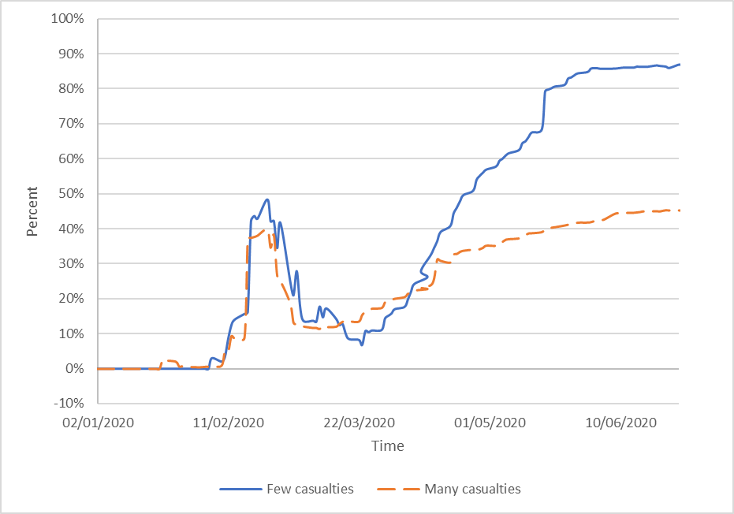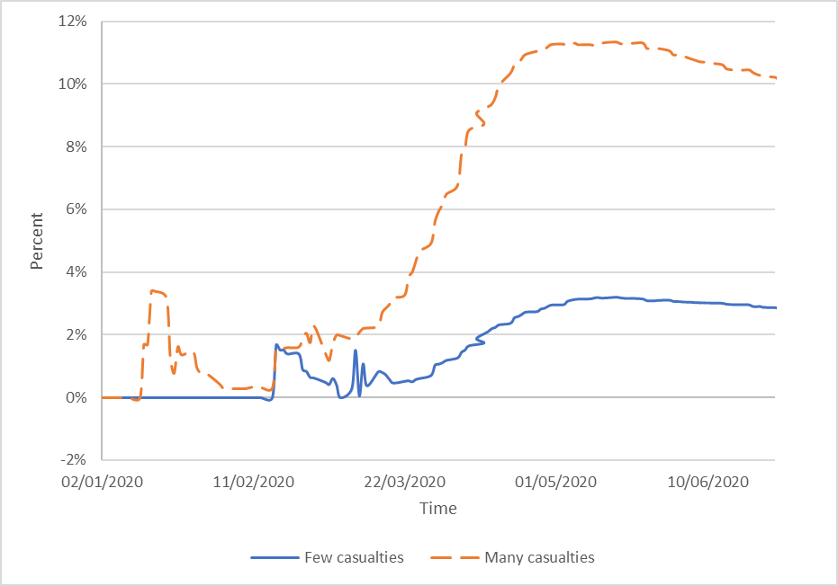

Figure 1.2. Performance of the *HPI* index.

Figure 1.1. Performance of the *DPI* index.

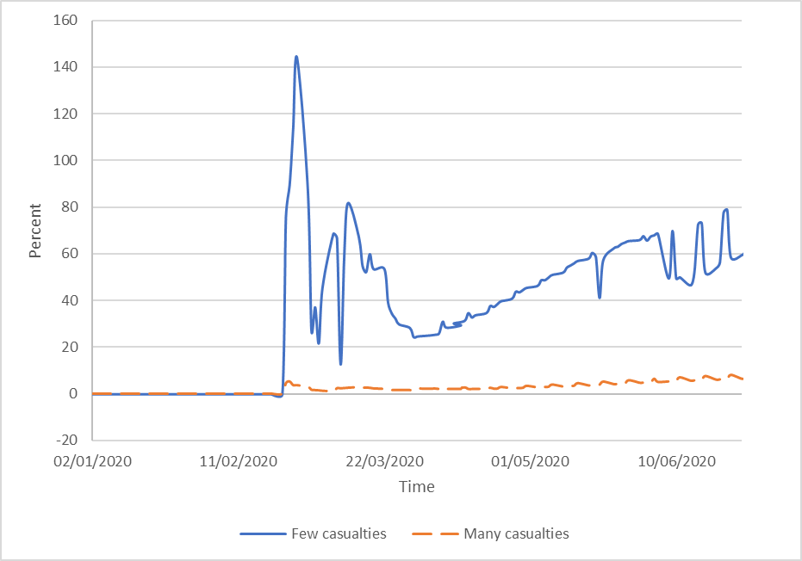

Figure 1.3. Performance of the *TPI* index.

Figure 1.1 shows that the test period can be divided into three phases: the initial phase lasting to the middle of March, the spreading phase from the middle of March to the end of April, and the containment phase from the beginning of May to the end of June. During the initial phase, *DPI* was low for both groups, although much higher for Panel B countries. This phase, in January, saw the first massive wave of deaths in the Asian countries, with high numbers of infections. This wave subsided, and *DPI* declined until the middle of March. During the spreading phase, a gap opened up between the groups in terms of *DPI*. Whereas the Panel B countries saw an exponential increase in *DPI*, the Panel A countries saw only a moderate increase. During the containment phase, *DPI* in both groups declined, probably because of the various restrictions that the countries imposed.

Figure 1.2 makes it clear that during the initial phase there was no difference between the groups in terms of *HPI*, which increased sharply until the middle of February and then declined (this affected only the Asian countries). In the two subsequent phases of spread and containment, there was a sharp increase in *HPI* in the Panel A countries and a moderate increase in the Panel B countries. A possible explanation is the sharp increase in the number of infections in the former compared to the slower increase in the latter.

Figure 1.3 compares the numbers of tests to the numbers of infections. Data for numbers of tests began to be published from February 24, and therefore the data in the figure start on that date. *TPI* increased in both groups, but was much higher in the Panel A countries than in the Panel B countries. A possible explanation can be found in Table 1. While the numbers of tests in countries with high numbers of infections increased slightly more than in the countries with lower numbers of infections, the number of infections was much higher, and so the *TPI* increased more.

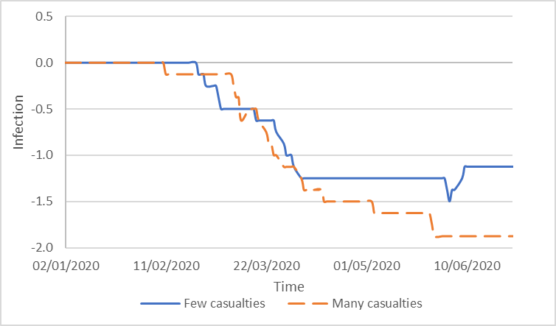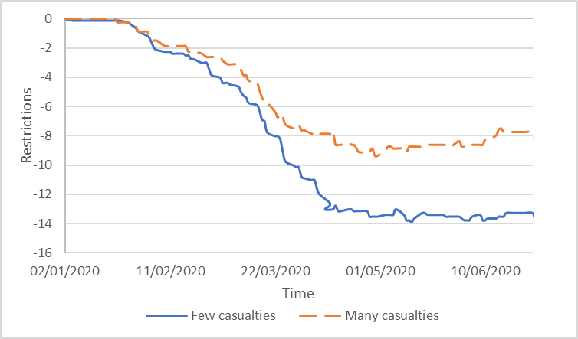

Figure 2.2. Changes in the *VIP* variable.

Figure 2.1. Changes in the *Restrictions* variable.

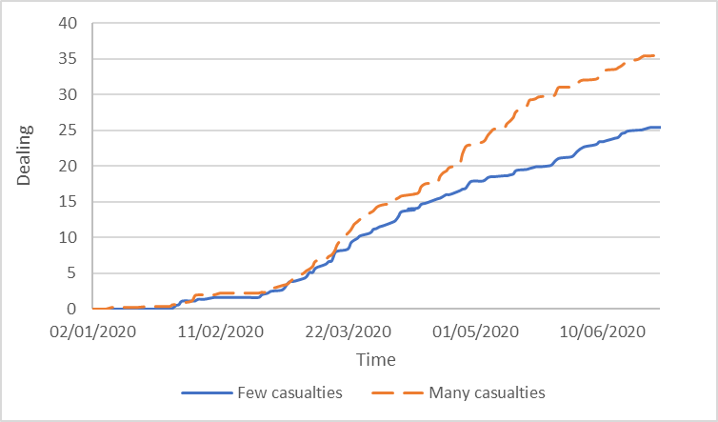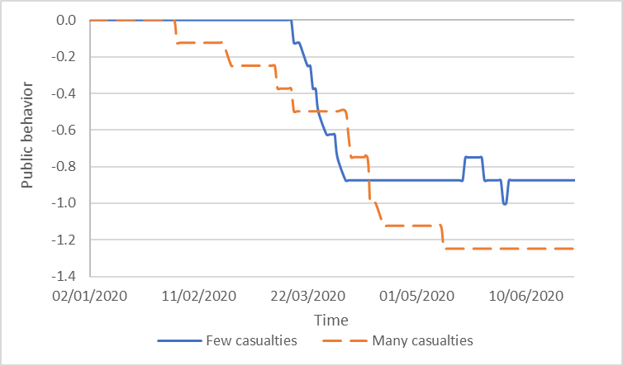

Figure 2.3. Changes in the *Public\_behavior* variable.

Figure 2.4. Changes in the *Dealing* variable.

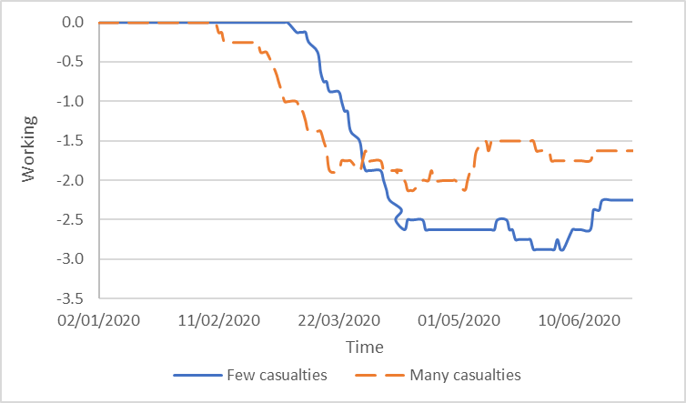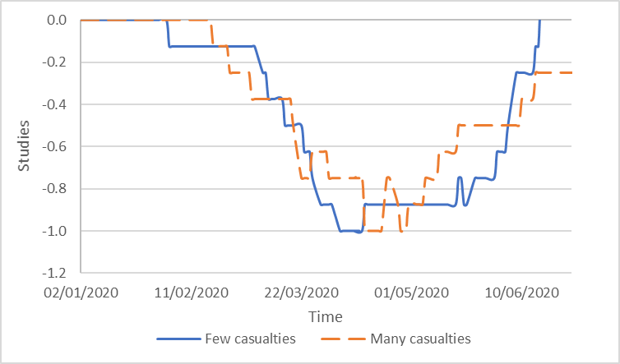

Figure 2.6. Changes in the *Working* variable.

Figure 2.5. Changes in the *Education* variable.

Figures 2.1 to 2.6 illustrate the changes in public and private behavior during the test period for both groups. Figure 2.1 shows the average value of the index for restrictions, which includes movement restrictions, limitations on incoming international tourists, and lockdown and quarantine measures applied to citizens. Until the beginning of February, there was no difference between the groups and hardly any restrictions. From that point on, governments started to impose restrictions. In countries with low numbers of infections, there were severe restrictions to prevent the spread of the virus; in countries with high numbers of infections, there were fewer restrictions, and this made it easier for the virus to spread. By mid-April, each group had reached an equilibrium, as is clear from the horizontal lines on the chart.

Figure 2.2 shows the average levels of infection of VIPs (leaders, health personnel, and security forces) in each group. Until mid-February, there were hardly any infections in either group, but from then until the beginning of April there were many infections in both groups. From the beginning of April onwards, there were hardly any reports of infections in the countries with low numbers of infections overall, whereas in the other countries the spread of the virus continued, albeit that the trend was moderated. A possible explanation is that restrictions imposed in countries with lower numbers of infections overall prevented the spread of the virus to VIPs.

Figure 2.3 shows changes in the public response to government instructions. Public behavior was characterized by a cycle of initial compliance with government instructions, followed by a period of weaker compliance, and then a return to stricter compliance. The longer the period of compliance, the lower the rate of infection. Compliance weakened much less in countries with low numbers of infections (mid-March until the beginning of April) compared to countries with high numbers of infections (beginning of February until mid-May). Together with the analysis in Figure 2.2, this suggests that in countries with high numbers of infections, responsibility for the spread of the virus must be attributed to both governments and the general public.

Figure 2.4 represents the positive actions that countries used in order to deal with COVID-19, including economic measures, vaccine development, experimental treatments, and advertising increases in testing available to citizens. The trend is similar in both groups. Until the end of February, there was hardly any government involvement in either group. Afterwards, because of the spread of the virus and its major impact on public health and the economy, governments started to implement measures to support the public. These measures were stronger in countries with higher numbers of infections than in those with lower numbers of infections. A possible explanation is that the former were seeing greater health and economic damage and were therefore more motivated to take substantial action.

Figure 2.5 describes the education situation. The level of restrictions on the education system was similar in both groups, and four phases can be identified. In the first phase, there were hardly any restrictions, as the horizontal line in the figure shows. In this phase, restrictions began about two weeks earlier in countries with lower numbers of infections than in countries with higher numbers of infections. In the following phase, presumably because of increasing fears of infection in places of education, further restrictions were gradually imposed. In the third phase, restrictions were at their maximum level in both groups. In the final phase, governments began to ease the restrictions. Although the trend is similar for the groups, the phase of maximum restrictions was much longer in countries with lower numbers of infections (mid-April to the end of May) compared to the others (mid-April to the end of April). This might account for the lower level of infections in the former countries.

Figure 2.6 describes the working situation, which was similar in the two groups and can be divided into three phases. In the first phase, there were hardly any restrictions in workplaces, as can be seen from the horizontal line in the figure. In the next phase, increasing fears of infection in the workplace prompted governments to implement gradual restrictions. In this phase, restrictions began three weeks earlier in the countries with high numbers of infections. During the third phase, all the countries reached the maximum extent of their workplace restrictions. It can be seen that the restrictions in the countries with lower numbers of infections were more intense than those in the countries with higher numbers of infections.

## Effect of the variables in the model

The effects of the variables on index returns were then tested for both groups of countries. The regression models are as follows:

*AR\_FC = α + β1⸱infected + β2⸱Dead + β3·Healed + β4·Restrictions + β5·Public\_behavior + β6·VIP + β7·Dealing + β8·education + β9·**Working + β10·**Tests + ε.* (1)

*AR\_MC = α + β1⸱infected + β2⸱Dead + β3·Healed + β4·Restrictions + β5·Public\_behavior + β6·VIP + β7·Dealing + β8·education + β9·Working + β10·Tests + ε.* (2)

*AR\_FC* represents the average return for countries with low numbers of infections, and *AR\_MC* represents the average return for countries with high numbers of infections.

Table 2. Regression estimate.

|  |  |  |  |  |  |  |
| --- | --- | --- | --- | --- | --- | --- |
| **Variable** | **Panel A: Few Infected** | | | **Panel B: Many Infected** | | |
|  | R2 = 0.929, F = 168.731 | | | R2 = 0.896, F = 102.085 | | |
|  | Coefficient | Std. error | t-statistic | Coefficient | Std. error | t-statistic |
| *C* | 0.018\*\*\* | 0.006 | 2.924 | 0.029\*\*\* | 0.008 | 3.609 |
| *Infected* | -1.04E-05\*\*\* | 0.000 | -2.484 | 0.000 | 0.000 | -0.136 |
| *Dead* | -2.06E-07\*\*\* | 0.000 | -3.438 | -1.02E-05\*\*\* | 0.000 | -3.125 |
| *Healed* | 5.91E-05\*\*\* | 0.000 | 7.148 | 0.000 | 0.000 | 0.216 |
| *Restrictions* | -0.023\*\*\* | 0.005 | -4.119 | -0.030\*\*\* | 0.012 | -2.582 |
| *Public\_behavior* | -0.434\*\*\* | 0.063 | -6.838 | -0.215\*\*\* | 0.076 | -2.816 |
| *VIP* | -0.081\*\*\* | 0.033 | -2.451 | -0.137\*\*\* | 0.048 | -2.878 |
| *Healing* | 0.048\*\*\* | 0.004 | 10.789 | 0.032\*\*\* | 0.006 | 5.759 |
| *Education* | 0.073\*\* | 0.038 | 1.927 | -0.075 | 0.055 | -1.371 |
| *Working* | 0.065\*\*\* | 0.025 | 2.649 | 0.144\*\*\* | 0.031 | 4.607 |
| *Tests* | 5.64E-07\*\*\* | 0.000 | 2.799 | 4.26E-08 | 0.000 | 1.067 |

Note. \*\*\* 99% significance level, \*\* 95% significance level, \* 90% significance level.

The results in Table 2 indicate that in general COVID-19 affected the index returns in both groups of countries, both those with low numbers of infections (F = 168.731, R2 = 0.929 (and those with high numbers of infections (F = 102.085, R2 = 0.896). In countries with low numbers of infections, all the variables affected returns. As the numbers of deaths or infections increased, so the decreases in the stock markets were greater. In addition, stock markets reacted positively to increases in the numbers of recoveries or tests.

Among the continuous variables, the number of recoveries had the strongest effect on the stock indexes, perhaps because it indicated good news in contrast to the bad news of the other variables. New government-imposed restrictions and public unresponsiveness led to a decline in the indexes, whereas positive steps led to increases in returns. When restrictions in workplaces and the education system were eased, index returns increased. The variable *VIP* was associated with a decrease in returns. The categorical variable with the strongest effect on stock indexes was public responsiveness, perhaps indicating an understanding that public compliance is a key factor in dealing with the epidemic.

For countries with high numbers of infections, it is clear that the effects of the variables were weaker. The numbers of deaths had a negative effect on the indexes, but the numbers of recoveries, infections, and tests had no effect. In the countries with low numbers of infections, government restrictions, public behavior, and VIP infections had a negative effect on the indexes, whereas positive steps and work had a positive effect. The education variable had no effect.

## Effect of the indexes in the model

The study then went on to analyze the effects of the indexes *DPI*, *HPI*, *TPI*, and *TPD*. The regression models are as follows:

*AR\_FC = α + β1·DPI + β2·HPI + β3·TPI + β4·TPD + ε* (1)

*AR\_MC = α + β1·DPI + β2·HPI + β3·TPI + β4·TPD + ε* (2)

where *AR\_FC* represents the average return in countries with low numbers of infections, and *AR\_MC* represents the average return in countries with high numbers of infections.

Table 3. Regression estimate.

|  |  |  |  |  |  |  |
| --- | --- | --- | --- | --- | --- | --- |
| **Variable** | **Panel A: Few Infected** | | | **Panel B: Many Infected** | | |
|  | R2 = 0.564, F = 47.693 | | | R2 = 0.553, F = 34.011 | | |
|  | Coefficient | Std. error | t-statistic | Coefficient | Std. error | t-statistic |
| *C* | -0.049\*\*\* | 0.013 | -3.769 | -0.051\*\*\* | 0.013 | -4.186 |
| *DPI* | -1.10E+01\*\*\* | 1.48E+00 | -7.432 | -1.652 | 1.307 | 1.264 |
| *HPI* | 0.635\*\*\* | 0.054 | 11.759 | 0.219\*\*\* | 0.098 | 2.237 |
| *TPI* | 2.08E-03\*\*\* | 0.000 | 8.501 | 0.005 | 0.006 | 0.768 |
| *TPD* | 1.39E-05\*\*\* | 0.000 | 3.371 | 0.002\*\*\* | 0.000 | 5.894 |

Note. \*\*\* 99% significance level, \*\* 95% significance level, \* 90% significance level.

Table 3 shows that even when using the indexes there was a significant effect of COVID-19 on stock returns for both countries with high numbers of infections (F =34.011, R2 = 0.553) and those with low numbers of infections (F = 47.693, R2 = 0.564). In countries with low numbers of infections, all the indexes affected the stock index returns; as the ratio of the number of deaths to the number of infections increased, so the stock index return decreased. On the other hand, as the ratios between recoveries and infections, between tests and infections, and between tests and deaths increased, so the returns increased. As in the results of the regression with actual numbers, the strongest effect on the stock indexes came from the ratio of recoveries to infections. For the countries with high numbers of infections, the effects were weaker, with only two indexes having a positive significant effect on stock returns. As the ratio of recoveries to infections and the ratio of tests to deaths increased, so did the returns.

To summarize, testing the effects of the variables and testing the effects of the indexes yielded similar results. In both cases, more variables had an effect in countries with low numbers of infections than in countries with high numbers of infections. This may be because governments in the former countries took action in the initial stages of the pandemic and each of the changes they made affected the stock indexes. In contrast, in countries with high numbers of infections, governments took action only at a later stage, by which time the market had already adjusted to the situation and was therefore less affected by changes in the variables considered here.

# Summary and conclusions

The health emergency caused by the COVID-19 virus has led to one of the biggest economic crises the world has known. The pandemic started in December 2019 in China and quickly spread around the world, affecting almost every country and impacting all areas of life. The focus of this study is the effect of COVID-19 on the stock market.

The effects of different variables on stock indexes were tested for 16 different countries grouped according to numbers of infections. The variables included government restrictions, public compliance, news about vaccines or treatments, and VIP infections, as well as numbers of infections, recoveries, tests, and deaths. The data covered a period of six months, including the first wave of the COVID-19 outbreak. Countries were divided into two groups according to their numbers of infections. The descriptive statistics revealed significant differences between the groups for all the variables. Analysis of the variables over the period identified further differences; that is, in countries with fewer infections, governments took preventive measures earlier, which probably had an impact on public health outcomes (in terms of numbers of infections).

The results show that the period under study can be divided into three phases: an initial phase until the middle of March, a spreading phase from the middle of March to the end of April, and a containment phase from the beginning of May to the end of June. The initial phase started in Asia, with a first massive wave of deaths, and then extended to the rest of the world. The next phase was characterized by the extended spread of the virus, and it is here that differences between the groups started to appear. Some countries experienced high rates of infection, while others contained the virus more successfully. In the third phase, most of the countries were able to contain the virus, and markets gradually reopened.

The regression analysis revealed that in countries with low numbers of infections, all the variables affected stock index returns; however, in countries with high numbers of infections, only a few of the variables did so. This is true both for the regression with the actual numbers and for the regression with the calculated indexes. Among the continuous variables, the strongest effect was shown by the number of recoveries, perhaps because it indicated good news compared to the other variables. This was also the case in the regression with the indexes. Among the categorical variables, the strongest effect was shown by public responsiveness, perhaps because people realized that public compliance with government restrictions was a key factor in dealing with the epidemic.

The results of this study regarding the effects of positive and negative news on the stock market are in line with those of previous research (Lin 2017; Tetlock 2007; Wu and Lin 2017), which found a significant positive correlation between abnormal returns and positive and negative tones in media coverage. The present results are also in line with the findings of Bai et al. (2020), who noted that different actions led to different effects on the stock market. The current study confirms that government restrictions, including those in workplaces and in the education system, affected stock indexes in countries with low numbers of infections and in countries with high numbers of infections.

The present results are also in line with the findings of Albulescu (2020) regarding the effects of new cases of infection and death ratios on VIX. Albulescu found that new cases reported in China and elsewhere had a mixed effect on financial volatility, while the death ratio influenced VIX positively. The present study found that the numbers of deaths affected the stock indexes in all the countries considered, whereas the numbers of infections affected the indexes only in the countries with low numbers of infections.

This study of the effects of the COVID-19 epidemic, which has had a major impact on daily life and on economies around the world, has focused on the effects on stock indexes. Many researchers have studied the general effects of COVID-19 and even its effect on stock indexes specifically, but this study is unique in a number of ways. First, it covers a longer period of time (six months) than other studies. Second, it includes 16 countries, while other studies have covered only one country or a small group of countries (five at the most). Third, it includes a wide range of variables relating to numbers of infections, deaths, and recoveries, as well as categorical variables regarding public behavior and government restrictions. Nevertheless, this study has some limitations which indicate paths for further research. Many countries affected by COVID-19 have not been included here. Furthermore, this study is based on the data reported by different countries. It should be noted that not every country reports complete data and that different measures are used, as this may influence any comparisons. Future research should address this issue and seek to extend the framework of this study to cover more countries and to include the second wave of COVID-19.

# References

Albulescu, C. 2020. “Coronavirus and Financial Volatility: 40 Days of Fasting and Fear.” Advance online publication. arXiv:2003.04005.

Al-Awadhi, A. M., K. Alsaifi, A. Al-Awadhi, and S. Alhammadi.2020. “Death and Contagious Infectious Diseases: Impact of the COVID-19 Virus on Stock Market Returns.” *Journal of Behavioral and Experimental Finance* 27: 100326. doi:[10.1016/j.jbef.2020.100326](https://doi.org/10.1016/j.jbef.2020.100326" \o "Persistent link using digital object identifier" \t "_blank).

Ali, M., N. Alam, and S. A. R. Rizvi. 2020. “Coronavirus (COVID-19): An Epidemic or Pandemic for Financial Markets.” *Journal of Behavioral and Experimental Finance* 2020: 100341. doi:[10.1016/j.jbef.2020.100341](https://doi.org/10.1016/j.jbef.2020.100341" \o "Persistent link using digital object identifier" \t "_blank).

Ali, N., A. M. Nassir, T. Hassan, and S. Z. Abidin. 2010. “Short Run Stock Overreaction: Evidence from Bursa Malaysia.” *International Journal of Economics and Management* 4(2): 319–333.‏

Bai, L., Y. Wei, G. Wei, X. Li, and S. Zhang, S. 2020. “Infectious Disease Pandemic and Permanent Volatility of International Stock Markets: A Long-Term Perspective.” *Finance Research Letters*: 101709.‏ doi:[10.1016/j.frl.2020.101709](https://doi.org/10.1016/j.frl.2020.101709" \o "Persistent link using digital object identifier" \t "_blank).

Baker, S., N. Bloom, S. J. Davis, K. Kost, M. Sammon, and T. Viratyosin. 2020. “The Unprecedented Stock Market Reaction to COVID-19.” *Review of Asset Pricing Studies* 1(3). [doi:10.1093/rapstu/raaa008](https://doi.org/10.1093/rapstu/raaa008).

Chan, W. S. 2003. “Stock Price Reaction to News and No-news: Drift and Reversal after Headlines.” *Journal of Financial Economics* 70(2): 223–260.‏

Chen, M. H. 2011. “The Response of Hotel Performance to International Tourism Development and Crisis Events.” *International Journal of Hospitality Management* 30(1): 200–212.

Chen, M. H., S. S. Jang, and W. G. Kim. 2007. “The Impact of the SARS Outbreak on Taiwanese Hotel Stock Performance: An Event-Study Approach.” *International Journal of Hospitality Management* 26(1): 200–212.‏

Chowdhury, E. K., and M. Z. Abedin. 2020. “COVID-19 Effects on the US Stock Index Returns: An Event Study Approach.” *SSRN*. doi:10.2139/ssrn.3611683.

Curatola, G., M. Donadelli, R. Kizys, and M. Riedel. 2016. “Investor Sentiment and Sectoral Stock Returns: Evidence from World Cup Games.” *Finance Research Letters* 17: 267–274.

Donadelli, M., R. Kizys, and M. Riedel. 2017. “Dangerous Infectious Diseases: Bad News for Main Street, Good News for Wall Street?” *Journal of Financial Markets* 35:84–103.‏

Guo, M., Y. Kuai, and X. Liu. 2020. “Stock Market Response to Environmental Policies: Evidence from Heavily Polluting Firms in China.” *Economic Modelling* 86: 306–316.

Haroon, O., and S. A. R. Rizvi. 2020. “COVID-19: Media Coverage and Financial Markets Behavior – A Sectoral Inquiry.” *Journal of Behavioral and Experimental Finance* 27: 100343. doi:[10.1016/j.jbef.2020.100343](https://doi.org/10.1016/j.jbef.2020.100343" \o "Persistent link using digital object identifier" \t "_blank).

Hillier, D., and T. Loncan. 2019. “Political Uncertainty and Stock Returns: Evidence from the Brazilian Political Crisis.” *Pacific Basin Finance Journal* 54: 1–12.

Hussain, S. M., and W. Ben Omrane. 2020. “The Effect of US Macroeconomic News Announcements on the Canadian Stock Market: Evidence Using High-Frequency Data.” *Finance Research Letters*. Advance online publication. [doi:10.1016/j.frl.2020.101450](https://doi.org/10.1016/j.frl.2020.101450" \o "Persistent link using digital object identifier" \t "_blank).

Ichev, R., and M. Marinč. 2018. “Stock Prices and Geographic Proximity of Information: Evidence from the Ebola Outbreak.” *International Review of Financial Analysis* 56: 153–166.

Lu, Y. C., C. H. Shen, and Y. C. Wei. 2013. “Revisiting Early Warning Signals of Corporate Credit Default Using Linguistic Analysis.” *Pacific-Basin Finance Journal* 24: 1–21.‏

Nippani, S., and K. M. Washer. 2004. “SARS: A Non-event for Affected Countries’ Stock Markets?” *Applied Financial Economics* 14(15): 1105–1110.‏

Pendell, D. L., and C. Cho. 2013. “Stock Market Reactions to Contagious Animal Disease Outbreaks: An Event Study in Korean Foot‐and‐Mouth Disease Outbreaks.” *Agribusiness* 29(4): 455–468.‏

Raimondo, C. 2019. “The Media and the Financial Markets: A Review.” *Asia-Pacific Journal of Financial Studies* 48(2): 155–184.

Strycharz, J., N. Strauss, and D. Trilling. 2018. “The Role of Media Coverage in Explaining Stock Market Fluctuations: Insights for Strategic Financial Communication.” *International Journal of Strategic Communication* 12(1): 67–85.‏

Tavor, T., and S. Teitler-Regev. 2019. “The Impact of Disasters and Terrorism on the Stock Market.” *Jàmbá: Journal of Disaster Risk Studies* 11(1): 1–8.‏

Tetlock, P. C. 2007. “Giving Content to Investor Sentiment: The Role of Media in the Stock Market.” *The Journal of Finance* 62(3): 1139–1168.‏

Wu, C. H., and C. J. Lin. 2017. “The Impact of Media Coverage on Investor Trading Behavior and Stock Returns.” *Pacific-Basin Finance Journal* 43: 151–172.‏

Zaremba, A., R. Kizys, D. Y. Aharon, and E. Demir. 2020. “Infected Markets: Novel Coronavirus, Government Interventions, and Stock Return Volatility around the Globe.” *Finance Research Letters* 35: 101597.‏ doi:[10.1016/j.frl.2020.101597](https://doi.org/10.1016/j.frl.2020.101597" \o "Persistent link using digital object identifier" \t "_blank).

Zhang, D., M. Hu, and Q. Ji. 2020. “Financial Markets under the Global Pandemic of COVID-19.” *Finance Research Letters* 36: 101528. doi:[10.1016/j.frl.2020.101528](https://doi.org/10.1016/j.frl.2020.101528" \o "Persistent link using digital object identifier" \t "_blank).

# Data sources

administracion.gob.es. 2020. Retrieved from Nueva normalidad. Crisis sanitaria COVID-19: https://administracion.gob.es/pag\_Home/atencionCiudadana/Nueva-normalidad-crisis-sanitaria.html#-bb7ad21ed1cf

Argentina.gob.ar. 2020. Retrieved from nuevo coronavirus COVID-19: https://www.argentina.gob.ar/salud/coronavirus-COVID-19

Bundeskanzleramt. 2020. Retrieved from Bundeskanzleramt - Bundesregierung: https://www.bundeskanzleramt.gv.at/bundeskanzleramt/die-bundesregierung.html

Bundesministerium für Gesundheit. 2020. Retrieved from Coronavirus: https://www.bundesgesundheitsministerium.de/coronavirus/chronik-coronavirus.htmlGouvernement.fr. 2020. Retrieved from Les actions du Gouvernement: https://www.gouvernement.fr/les-actions-du-gouvernement

Congress.gov. 2020. Retrieved from Current Legislative Activities: https://congress.gov/

Gov.il. 2020. Retrieved from חדשות: https://www.gov.il/he/departments/news?limit=10

gov.sg. 2020. Retrieved from Latest update: https://www.gov.sg/features/covid-19

GOV.UK. 2020. Retrieved from Coronavirus (COVID-19) - News and communications: https://www.gov.uk/search/news-and-communications?level\_one\_taxon=5b7b9532-a775-4bd2-a3aa-6ce380184b6c

Governo do Brasil. 2020. Retrieved from Legislação COVID-19: http://www.planalto.gov.br/CCIVIL\_03/Portaria/quadro\_portaria.htm

Governo Italiano. 2020. Retrieved from Coronavirus, le misure adottate dal Governo: http://www.governo.it/it/approfondimento/coronavirus/13968

HDX. 2020. Retrieved from Novel Coronavirus (COVID-19) Cases Data: https://data.humdata.org/dataset/novel-coronavirus-2019-ncov-cases

Investing.com. 2020. Retrieved from Investing.com: https://il.investing.com/indices/major-indices

Israel Ministry of Health. 2020. Retrieved from: https://govextra.gov.il/ministry-of-health/corona/corona-virus/?gclid=CjwKCAjw0\_T4BRBlEiwAwoEiAaeH0-sYUL95P5WMn0ThqucoCRlSMvw662XArQJRI6OkaaZGK5ZlsRoCNLYQAvD\_BwE

New Zealand Legislation. 2020. Retrieved from COVID-19 legislation: http://www.pco.govt.nz/covid-19-legislation/

Regeringen styr Sverige. 2020. Retrieved from Regeringsförklaringen: https://www.regeringen.se/tal/20192/09/regeringsforklaringen-den-10-september-2019/

Republike Slovenije. 2020. Retrieved from Vlada Republike Slovenije: https://www.gov.si/drzavni-organi/vlada/novice/

World Health Organization. 2020. Retrieved from WHO Coronavirus Disease (COVID-19) Dashboard: https://covid19.who.int/

中国政府. 2020. Retrieved from 中国政府: http://www.gov.cn/

台湾政府. 2020. Retrieved from 台湾政府: https://www.president.gov.tw/

|  |  |
| --- | --- |
| **Use** | **Source** |
| Spain | administracion.gob.es |
| Argentina | Argentina.gob.ar |
| Germany | Bundesministerium für Gesundheit |
| France | Gouvernement.fr |
| Israel | Gov.il |
| UK | GOV.UK |
| Italy | Governo Italiano |
| Brazil | Gov.br |
| numbers of people who recovered | HDX |
| stock index | Investing.com |
| Israel | Israel Ministry of Health |
| New Zealand | New Zealand Legislation |
| Singapore | New Zealand Legislation |
| Austria | Österreich |
| Sweden | Regeringen styr Sverige |
| US and VIX | U.S*.*gov |
| Slovenia | Vlada Republike Slovenije |
| COVID-19 data | World Health Organization |
| China | 中国政府 |
| Taiwan | 台湾政府 |

Appendix A. List of data sources.