***

XX February 2021



Stock Exchange

**TASE, NASDAQ**

Symbol

**MITC**

Sector

**Technology**

Sub-sector

**FoodTech**

Stock Price Target

**XXX NIS**

Closing Price

**XXX NIS**

Market Cap

**XXX million NIS**

# of Shares

**123 million**

Average Daily

Trading Volume

**XXX Stocks**

Stock Performance

(since January 2020 / Since IPO)

**XXX%**

**MeaTech – 3D Printing of Clean Meat**

INITIATION OF COVERAGE

**MeaTech (NASDAQ: MITC), founded in 2018, focuses on the global alternative protein food-tech industry. The company was the first publicly traded cell-based meat company and is listed on the Tel Aviv Stock Exchange (TASE). The company completed a NASDAQ dual listing during H1 2021.**

**Market** – MeaTech is developing a novel bio-printing process designed to create tissue from edible raw meat components. The company is the first to 3D-print edible bio-inks, resulting in living tissue composed of several different bovine cell types. Frost & Sullivan estimates the global **cultured meat** market value to reach $630 billion by 2040, recording a CAGR of 41% from 2025 to 2040.

**Strategy** – MeaTech’s strategy is to expand its business both organically (see future milestones described later in this report) and via acquisitions in the cultured meat sector. For example, the company recently acquired the cultured fat pioneer Peace of Meat. Thus, MeaTech can also be seen as a platform within the cultured meat sector.

**Valuation** – MeaTech closed (March 21) its Nasdaq listing, raising $28 million in capital. This significant figure will support the company’s strategy and plans. We initiate our coverage…TBD.

WIP



**MeaTech – 3D Printing of Clean Meat**

XX April 2021

MeaTech is developing a novel bio-printing process designed to create tissue from edible raw meat components.

To this end, technicians take a sample of stem cells from an animal, and reproduce and differentiate them into different meat components to produce clean meat with the same structure and texture as ordinary meat.

MeaTech had a very successful year and achieved several milestones, including:

* Differentiation of stem cells to fat cells
* Development of a lower-cost growth medium
* First printing of uniform meat tissue (Project “Carpaccio”)
* Differentiation of stem cells to muscle cells
* Bio-printing of cultured beef fat structure
* Agreement to acquire Peace of Meat, a Belgian producer of cultured poultry products for up to a valuation of €15.

In December 2020, MeaTech announced that it had signed an agreement to acquire 100% of the share capital of Peace of Meat PV. MeaTech 3D will pay up to €15 million in cash and MeaTech shares, depending on future milestones.

MeaTech 3D plans to leverage Peace of Meat's technologies, including its novel hybrid food products, to enter the market. Simultaneously, MeaTech has developed an industrial process for cultivating and producing real meat using 3D bio-printing technology—without harming animals.

This acquisition is consistent with MeaTech's growth strategy, whereby it aims to streamline development processes and expand its product range to penetrate the cultured meat technology market as quickly as possible.

**MeaTech is working to create synergy and added value for food manufacturers in the advanced production of cultured meat while sustaining animal welfare and meeting the growing global demand for meat.**

|  |  |  |  |
| --- | --- | --- | --- |
| **Milestone** | **Significance** | **Timeline** | **Status** |
| Successful differentiation of stem cells to fat cells | **High** | **Q2-2020** | **Achived** |
| Successful development of lower cost growth medium | **High** | **Q3-2020** | **Achived** |
| First printing of uniform meat tissue Project ‘Carpaccio’ | **Medium** | **Q3-2020** | **Achived** |
| Successful differentiation of stem cells to  muscle cells | **High** | **Q3-2020** | **Achived** |
| MeaTech agrees to acquire cultured fat pioneer  ‘Peace of Meat’ | **Medium** | **Q4-2020** | **Achived** |
| Bioprinting cultured beef fat structure | **High** | **Q4-2020** | **Achived** |
| Printing 100 gr of meat | **High** | TBC |  |
| Enlarging the production volume | **High** | TBC |  |

**Executive Summary**

Investment Thesis

Emerging technologies across the alternative protein landscape are poised to transform protein production in the coming years by offering higher efficiency, greater consistency, and less harm to public health, the environment, and animals compared to conventional meat production. The clean meat (cultivated meat) industry is a relatively young but rapidly growing field within this landscape. Clean meat technology builds upon deep insights into cell biology and biological manufacturing, acquired from the developments of much more mature industries, like biopharma and industrial biotechnology. These fields serve as informative models for scale-up and growth.

One of the leading companies in the field of cultured meat is MeaTech 3D. The company is developing an alternative to industrialized farming, avoiding the problems raised by conventional animal husbandry's ethical and environmental issues by developing an industrial cultured meat production process using integrated 3D printing technology. Compared to other companies in this field, the company has introduced a new vision to the market of scaling up its 3D printed meat production.

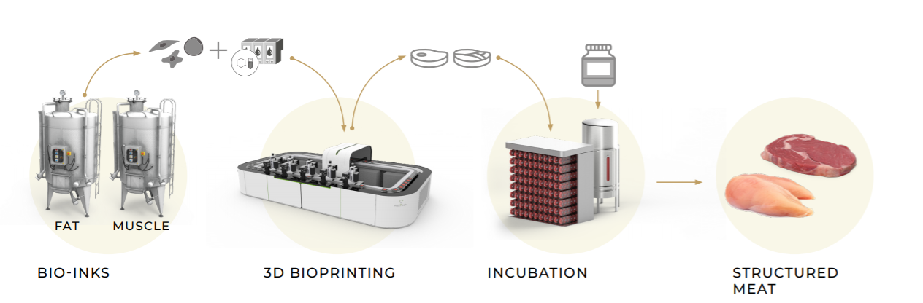

In November 2020, the company announced that it had succeeded, for the first time, in printing a cultured beef fat structure composed of bovine fat cells and bio-ink, which were grown and developed from stem cells in the company’s laboratories. The printing of beef fat and bio-ink created an edible structure that reached a height of 10 mm; this achievement represents a significant advancement toward developing high-throughput 3D tissue printing technology for clean meat tissue.

Ultimately, MeaTech believes that such 3D bio-printing will include additional components, such as muscle cells. The real meat tissue based on cell growth, cell differentiation, and bio-printing technologies that MeaTech is developing is designed to leverage cellular agriculture while avoiding the need to raise and slaughter, or otherwise harm animals.

In October 2020, the company invested €1 million in Peace of Meat (POM), a Belgian producer of cultured poultry products. Two months later, during December 2020, MeaTech signed an agreement to acquire 100% of the share capital of POM; MeaTech 3D will pay €15 million in cash and MeaTech ordinary shares.[1]

MeaTech expects to leverage POM’s technologies, including novel hybrid food products, to expedite market entry. Simultaneously, MeaTech has developed an industrial process for cultivating and producing real meat using 3D bio-printing technology.

The technology’s first expected application is in hybrid food products, wherein it will combine plant-based protein with cultured animal fat in order to provide meat analogs with qualities of “meatiness” (in terms of taste and texture) that are close to those of conventional meat products. MeaTech estimates that the first hybrid products based on POM’s technology could enter the market as early as 2022.

* **Clean meat can revolutionize meat production by providing a more sustainable and environmentally friendly alternative to conventional meat production.**
* **The industry has several challenges such as customer education, regulation perspective, reduces costs, texture, and complicated scalability.**
* **Furthermore, the clean meat industry requires an influx of experts from interdisciplinary fields to solve technical issues, leading to lower costs. The commercialization of clean meat will hugely depend on bridging the price barrier against conventional meat.**
* MeaTech’s **strategy is profound and different from other clean meat companies. They are working to create synergy and added value for food manufacturers in the advanced production of cultured meat while sustaining animal welfare and meeting the growing global demand for meat**

**Table of Contents**

**Executive Summary** Error! Bookmark not defined.

**Company Overview** Error! Bookmark not defined.

**Meat Tech Technology 8**

**Intellectual property 9**

**Market Overview 12**

**Market analysis 16**

**Cultured Meat – Regulations 18**

**Competitive Landscape 18**

**Cell based Clean Meat companies 22**

**Financial Valuation and Projections** Error! Bookmark not defined.

**Appendix 1** Error! Bookmark not defined.

**Contact Details & Management** Error! Bookmark not defined.

**Disclaimers, disclosures, and insights for more responsible investment decisions** Error! Bookmark not defined.

# Company Overview

MeaTech 3D Ltd. (NASDAQ:MEAT) is a FoodTech company developing technologies to produce cultured meat products. The company is developing technologies for the next generation of cultured meat food products by leveraging 3D digital printing technology[2].

According to the Food and Agriculture Organization (FAO), the global population, 7.3 billion today, is expected to surpass 9 billion by 2050. It is forecasted that in 2050 - 70% of additional food will be needed to fulfill the growing population's demand, which is a great challenge due to resource and arable land limitations.

Meat consumption is related to living standards, diet, livestock production, and consumer prices, as well as macroeconomic uncertainty and shocks to GDP. Compared to other commodities, meat is characterized by high production costs and high output prices.

Meat demand is associated with higher incomes and a shift - due to urbanization - to food consumption changes that favor increased proteins from animal sources in diets[3]. Today's farming technologies cannot meet future demand.

The way that we have traditionally produced meat by farming animals is environmentally unsustainable. It's putting pressure on our resources such as land and water, contributing to the loss of biodiversity and the greenhouse gas emissions driving climate change[4].

Consequently, more efficient ways of protein production are being developed to sustain the growing global population while complying with today's challenges, such as environmental and animal welfare issues. Among the solutions, clean meat is presented by its advocates as a sustainable alternative for consumers who want to be more responsible.

Clean meat (also called cultured meat, *in vitro* meat, lab-grown meat, or cellular agriculture) is grown in cell culture. Organizations such as the Good Food Institute (GFI) are strong advocates of clean meat and are aiming to create awareness and change consumer perception.

In the last few years, the area has gained significant interest from government and research institutes, big venture capitalists, and meat producers.

MeaTech - a clean meat sector leader is developing an alternative to conventional age-old farming methods. MeaTech has the technology, knowledge, and experience in applying tissue engineering practices for producing fat and muscle tissue for food consumption. The company can also print, using a 3D bio-printer, a combination of live animal cells, growth factors, and biological materials to produce living tissues that mimic the characteristics of natural tissue[5].

MeaTech's has a B2B business model while offering both tissue engineering and cells production for rapid commercialization. The company is targeting a broad range of cell types and cultured products through R&D and acquisitions. Acquisitions are consistent with MeaTech's growth strategy, aiming to streamline development processes and expand the Company's product range to penetrate cultured meat technology markets as quickly as possible.

* The company's next step is printing 100 gr of meat and improving cell lines while enlarging the production volumes.

# MeaTech Technology

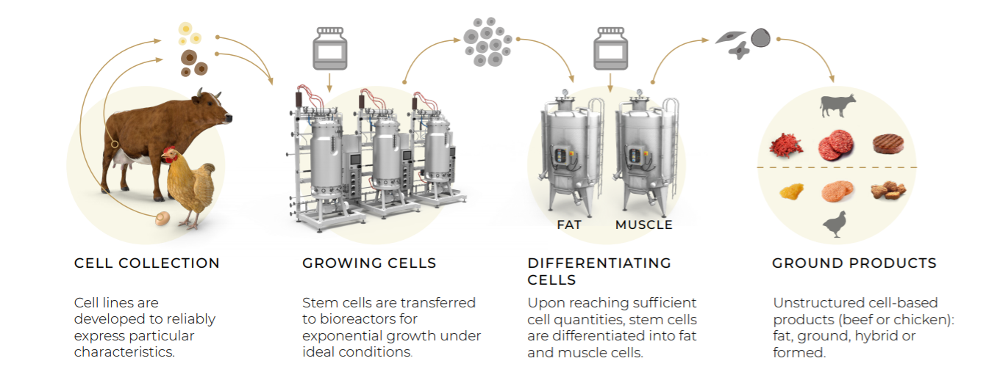

MeaTech production begins with obtaining cell lines for the desired animal species and isolating the stem cells population without harming the animal. The next step in production is *in vitro* cultivation of the cells for exponential growth using Bioreactors under ideal conditions.

During the process, companies are using cultured media, which usually contains buffers, salts, proteins, fat, and especially growth factors that direct the cells to differentiate and specialize to a particular cell type. Each company usually develops its own media due to cost issues and the fact the use of bovine serum is not a good option from ethical purposes.

After proliferating in bioreactors, the cells are differentiated into inks by cell types: fat, muscle, etc. The cell types are accurately 3D bio-printed to create the foundation for a true cut of meat.

The printed structure is then placed to grow in an incubator (the hypertrophy stage) to grow the final product.

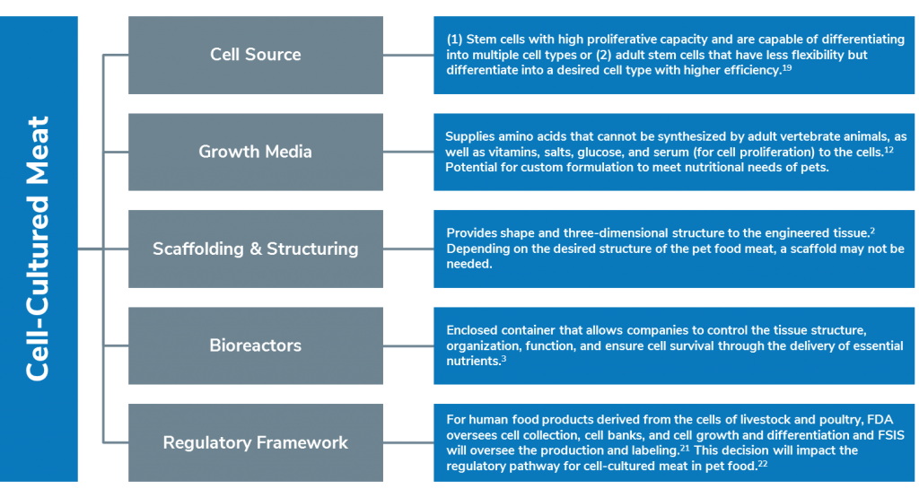

# Intellectual property

MeaTech has an extensive patents portfolio that includes the following:

1. Cultured Edible Meat Fabrication Using Bioprinting
2. Physical Manipulation of Cultured Tissue
3. Growth Support For Cell Culture
4. Harvesting Bovine Embryonic Inner Cell Mass
5. Bioprinter Print Head
6. Bovine Umbilical Cord Stem Cells As Feeder Layer

All patents are innovative solutions that support their technology and differentiate them from other developing companies.

# MeaTech Leadership and advisors

**Sharon Fima: CEO&Co-Founder**

Sharon is an entrepreneur with over 20 years of experience in the printing industry.

Sharon was a co-founder and the CTO of Nano Dimension (NNDM) and spearheaded the development of a complete desk-top 3D printing system for multilayer PCBs. Prior to NNDM, Sharon was the R&D Integration manager at XJet and an R&D team leader at H.P. Indigo.

**Omri Scanin: COO & Co-Founder**

Omri is a co-Founder of MeaTech, and its astute COO focused on supporting cross-functional teams to see R&D achieve commercialization.

Omri has a successful history of entrepreneurship in various high-tech sectors, with excellent leadership, organizational skills, and strategic planning.

**Steveh H.Lavin: Chairman**

Mr. Lavin serves as Vice Chairman of OSI Group, LLC, a privately held company and a global supplier of value-added food and meat products. Mr. Lavin is the President of Lavin & Gedville, a boutique law firm. Mr. Lavin is director, general counsel, and advisor to Germin8 Ventures, LLC, and co-founder and director of Silver Road Capital, Ltd., a financial and consulting firm

**Guy Hefer: CFO**

Guy has broad international business experience with a successful track record of transaction generation and execution. Prior to joining MeaTech, Guy was the CFO of a tech-focused holding company. Before that, Guy was an investment banker for Leumi bank in Israel, and Barclays investment Banking Division in Israel and the U.K. Guy holds a B.A. in Accounting & Economics from Tel Aviv University.

***Advisors:***

**Prof. Tal Dvir**

Prof. Dvir obtained his degrees in Biotechnology Engineering from the Ben-Gurion University of the Negev in Israel. Prof. Dvir continued his postdoctoral studies in the laboratory of Prof. Robert Langer in the Department of Chemical Engineering at MIT. Prof. Dvir was recruited by the Department of Biotechnology and the Center for Nanotechnology of Tel Aviv University to establish the Laboratory for Tissue Engineering and Regenerative Medicine.

**Prof. Shlomo Magdassi**

Prof. Shlomo Magdassi is a Professor of Chemistry at the Casali Center for Applied Chemistry, the Institute of Chemistry, and the Center for Nanoscience and Nanotechnology at the Hebrew University of Jerusalem, Israel. Prof. Magdassi holds the Enrique Berman Chair in Solar Energy. His research focuses on colloid science, particularly on the formation, formulation, and application of novel micro and nanoparticles

**AMB. Danny Ayalon**

Former Israeli Ambassador to the United States and Deputy Minister of Foreign Affairs, Member of Knesset, and advisor to three prime ministers. Co-founder and Chairman of Silver Road Capital Ltd.

# Market Overview

Bio-engineered foods

Bio-engineered food startups develop food alternatives using advanced technologies to simulate dairy and meat products using plant matter or cell cultures. We believe the coronavirus pandemic affects this industry in the following ways: First, the spike in grocery sales is potentially attracting new customers to try plant-based products if traditional meat and dairy are temporarily out of stock. Second, providers focused on restaurant sales channels (i.e., Impossible Foods and Rebellyous Foods) are likely struggling more than those focused on grocery sales channels. Lastly, supply chain disruptions are probably having a disproportionately negative impact on this industry, given it is relatively nascent. We segment the vertical into plant-based meat and dairy providers, cellular agriculture producers, novel ingredients, and meal replacement.

**Plant-based meat & dairy providers** develop vegetarian food products that simulate meat and dairy products in taste and texture. Growth in the sector is primarily driven by an increasing view that plant-based food products have more health and environmental benefits compared to the traditional meat industry. Over time, we expect that plant-based meats will take share from the approximately $350 billion annual meat industry. Investment in plant-based meat & dairy presents both a financial, social, and environmental impact opportunity. Impact investors view plant-based meats as helping to raise awareness of animal welfare, environmental issues, and human health at a time when industrial meat production has been linked to increased greenhouse gas emissions, water pollution, overconsumption and deforestation, among other issues. While many of these products sell at a premium today, we expect the gradual scaling of the industry could result in more affordable and authentic meat substitutes.

**Cellular agriculture,** also known as cultured meat, clean meat, or lab-grown meat, is a term used to describe animal products (for example, meat, dairy, and leather) produced by replicating animal cells in a lab through a combination of biotechnology, tissue engineering, molecular biology, and synthetic biology. Cellular agriculture companies compete not only with the traditional meat industry but with emerging plant-based meat companies (such as Beyond Meat), as well. At scale, cellular agriculture has the potential to produce high-quality (e.g., Kobe beef), safe (e.g., no hormones, antibiotics, or diseases) meat and dairy products at a fraction of the costs of current meat production.' Even at scale, traditional meat production is incredibly inefficient and requires enormous land, water, fertilizer, feed, oil, and other resources. Although consumer prices may be low ($3 to $4 per pound), the cost is offset by government subsidies, and the full environmental and ecological impacts are likely much more significant. In 2013, the first cultured meat cost an estimated $1.2 million per pound to produce. While today's cultured meat has reportedly come as low as $37 per pound, this is still well out of reach for most consumers. Regulation poses additional challenges, with the

### Clean Meat

**70% is the estimated increase in global demand for meat and milk by 2050[6]**

**~96% is the potential cut in agricultural greenhouse gas emissions by switching to cultured meat[7]**

**$50 is the predicted cost of the first clean meat burger, a dramatic fall from $330K in 2013[8] [9]**

The world consumption of proteins, especially from meat products, continues to rise. The accelerated demand for animal protein creates massive environmental, health, financial, and ethical problems.

Animal-based food products are considered inefficient, as animals consume large amounts of food throughout their lives, of which up to 97% of the calories are lost for processes regarding body maintenance and the production of non-edible tissues.

Compared to other industries, animal-based products have a larger environmental footprint than plant-based products in terms of soil and water demand and greenhouse gas emissions. The beef industry imparts the heaviest ecological impact.

According to the Food and Agriculture Organization of the United Nations report, the livestock sector is responsible for 14.5% greenhouse gas emissions. It taps 30% of Earth's terrain and 8% of the global freshwater[10].

Clean meat is a prominent alternative for traditional meat, derived from live animals. This approach gained increasing attention in public opinion, popular media, animal welfare organizations, the scientific community, and investors, particularly after producing the first clean meat prototype.

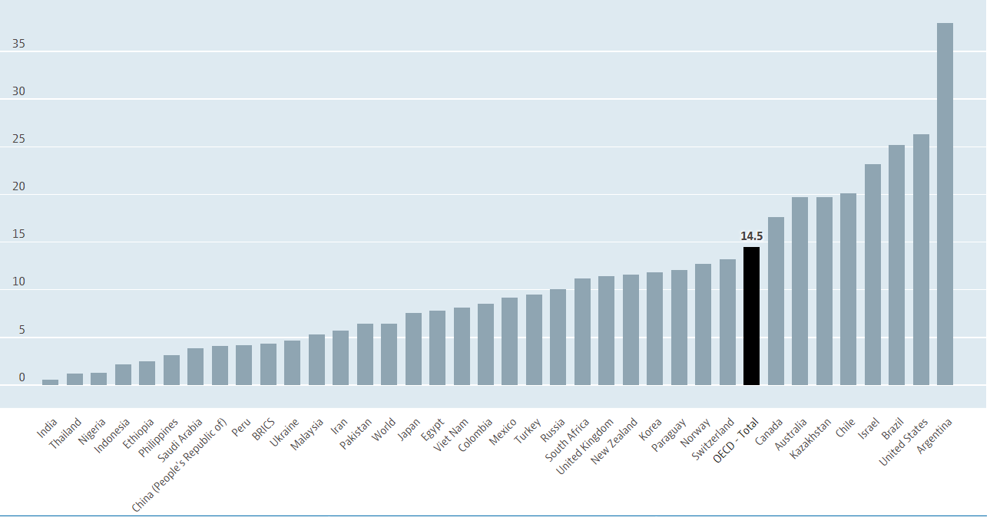

**How is it done?**

The cell lines used in cultivated meat production ultimately determine many of the downstream variables to consider. We begin the process with stem cells, meaning- cells that can self-renew and differentiate into the cell types that make up meat tissue (i.e., myofibers, adipocytes, fibroblasts, chondrocytes, endothelial cells, etc.)[11].

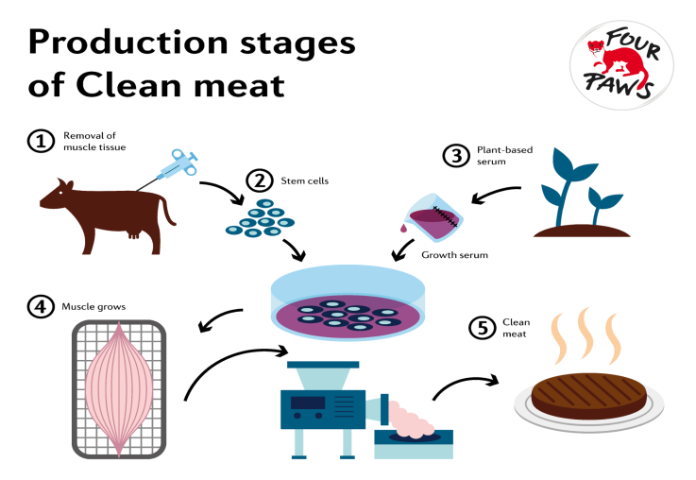The stem cells are cultivated in a bioreactor under the strict control of environmental factors. During the first step, the cells multiply until they reach the desired concentration. The second step starts with differentiating the cells into muscle cells. After differentiation, they begin to merge and form myotubes that continue to grow into skeletal muscle tissue if the right conditions are provided.

The structure of the meat product depends on the length and conditions of the production process. At the early stages of the differentiation phase, the cell culture consists of tiny and soft cell strands that require electric or mechanical stimulation to boost protein production, improve the structure and produce larger pieces of meat. In theory, it could even be possible to generate a steak‐like structure; it would require a vascular system to deliver nutrients to the tissue[12].

**Clean meat - Advantages**

**Health awareness**

**Technological**

**Environmental**

**Concern**

**Supports better health:**

* No antibiotics use
* Free of pathogens and parasites
* Allows usage of healthy additives, such as vitamins

**Ethically produced:**

* No need for animal slaughter

**Environmentally friendly:**

* Fewer greenhouse emissions
* Less land and water usage

**Clean meat – Challenges**

**Costs**: The culture media is the most significant cost driver

**Scalability**: It's one thing to create a few ounces of cultured cells in the laboratory. It's quite another to create kilograms of cultured meat.

**Texture**: The main problem with synthesized, extruded, and printed meat has been, and continues to be, one of mouthfeel. Real meat isn't homogeneous; it has fat, gristle, connective tissue, and other organic stuff bits in its structure. Researchers are working on it, and multi-material 3D printing could offer the solution.

**Customer acceptance**

# Market analysis

The global **cultured meat** market value is projected to reach $630 billion by 2040, recording a CAGR of 41% from 2025 to 2040[13]. The global meat sector was valued at 945.7 billion U.S. dollars in 2018 and was forecast to increase to 1142.9 billion U.S. dollars by 2023[14]. Hence, in our view, cultured meat holds huge growth potential in the next few years. We present below global meat consumptions trends forecast:

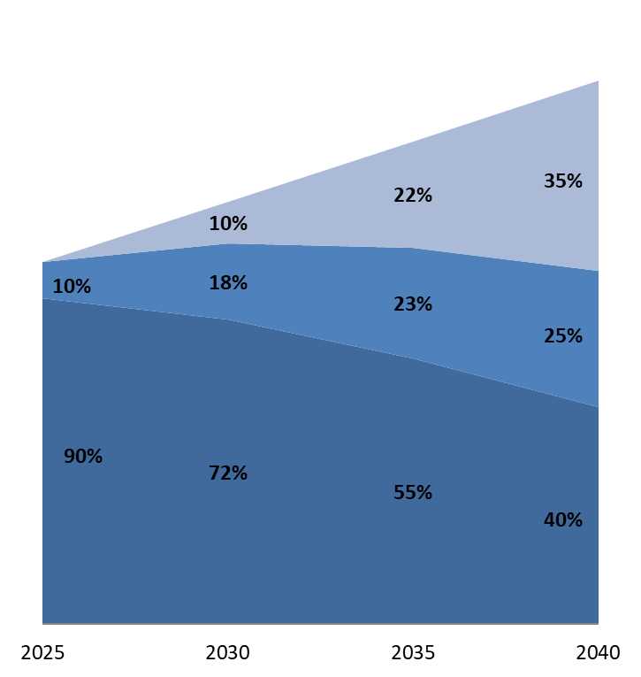

CAGR: 3%

$1.2 Bn

$1.4 Bn

$1.6 Bn

$1.8 Bn

Cultured meat

+41%

Plant-based meat

+9%

Conventional meat

-3%



Source: United Nations, World Bank, Expert Interviews, A. T. Kearney Analysis.

Many factors contribute to the market growth, such as innovation in cellular agriculture, the rising inclination towards animal welfare, environmental sustainability, and interest in the market that attracts investors to this field[15].

There are 32 companies worldwide that develop clean meat products; most of them are (40%) based in North America, 31% in Asia, 25% in Europe, and one in Australia. From 2015 to early 2020, the amount of publicly disclosed capital invested in clean meat companies reached approximately 320 million USD.

According to recent studies that examined clean meat prices, cell-based meat can achieve price parity with mainstream conventional meat once produced at an industrial scale. Before price parity is achieved, cell-based meat companies might use go-to-market strategies that aim to reduce costs.

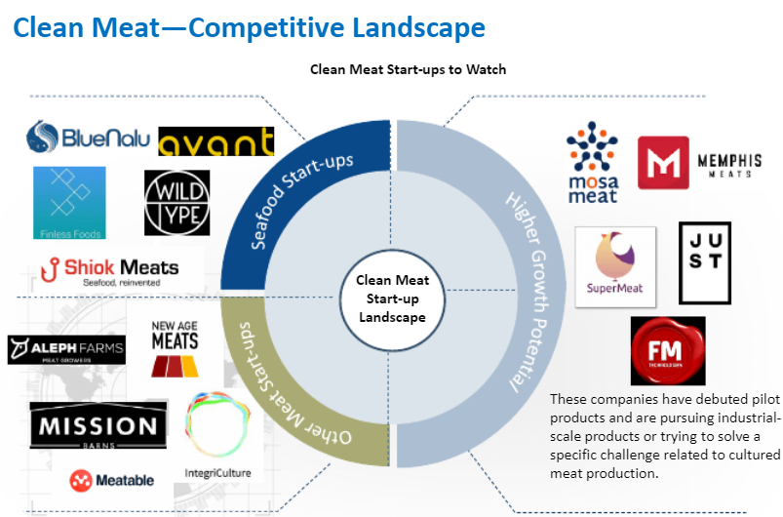

***Companies to watch according to Frost & Sullivan***

The science behind cultured meat production is relatively well-established; the main challenges are **cost reduction and scale-up**. Both require significant investment into equipment, such as high efficiency, large scale bioreactors, and process engineering, so companies will be keen to secure additional funding

Cultivated meat companies are classifiable by product focus. They also differentiate themselves in other ways: go-to-market strategy (launch country and plan), marquee partnerships (e.g., Memphis Meats with Tyson and Cargill, BlueNalu and Mosa Meat with Nutreco, and Mosa Meat with Merck), and ethics and sustainability claims.

**Market Drivers[16]**

* Sustainability, environmental friendliness, animal welfare, and food safety are the top considerations.
* A life cycle assessment study conducted by the University of Oxford showed that compared to European meat, lab-grown meat requires 7% to 45% less energy, is responsible for 78% to 96% less greenhouse gas emissions, and uses 99% less land and between 82% and 96% less water depending on the product.

**Market Challenges**

* Cost remains a major restraint. Affordable media culture and scaling of production are immediate concerns.
* There is a lack of regulatory standards for lab-grown meat, and consumer perception has been mixed.
* The use of fetal bovine serum (FBS) has been a concern.
* Meatable designed a method of culturing cells without using FBS.
* Mosa Meat developed a proprietary technology that is not dependent on animal serum.

***No company has reported industrial-scale production***.

Cultured Meat – Regulations

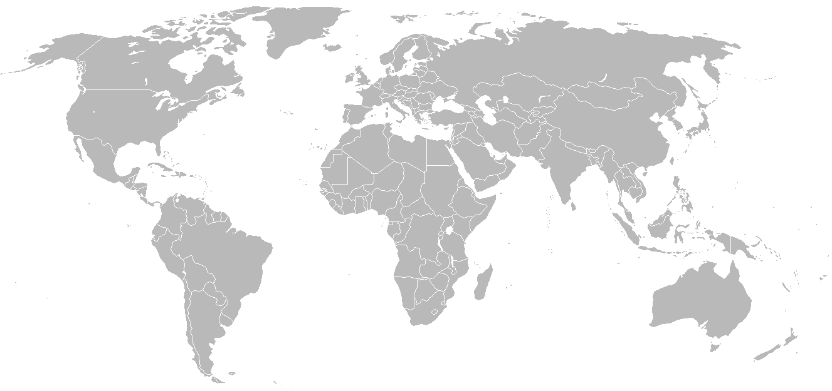

**Europe** is a supporter of alternative proteins and has adopted a number of strategies to boost innovation in alternative protein.

There is no specific regulation for plant-based or cultured meat, but the products can broadly fall under the preamble of the novel food regulation, and the food information to consumers’ regulation is applied.

Labeling remain a bottleneck for these types of products, with France and Germany passing amendments against using designations with animal products to market food products of which a significant part is vegetable based. The European Union has announced plans to review labeling rules for vegan and vegetarian food from 2019.

**China, Hong Kong, Australia, and Singapore** have shown significant penetration of plant-based meat products.

From a regulatory standpoint, products are battling labeling laws similar to Western countries.

In 2019, The **USDA** announced plans for regulatory framework for cell based meat. Labeling guidelines need to be put in place. Missouri, Mississippi and Arkansas have passed legislation against labeling plant or cell based products as “Meat” in 2018.

# Competitive Landscape

There is enormous interest surrounding clean meat technology, as it offers the potential to produce 'meat' products without the environmental and social risks embedded in the current meat production industry[17].

In 2013, food critics ate a lab-grown burger on live T.V. that had a price tag of around $300,000. Since then, the price has plummeted and is predicted to reach $50 within the next years; It is likely to further decline in the future. Thus, it may not be too long before clean meat products start to reach our menus[18].

Although product focus is one way to classify cell-based meat companies, it is not the primary way these companies differentiate themselves from each other. When pitching to investors, cell-based meat companies focus primarily on making a case for why their technical approach will enable them to scale up production and bring costs down faster than their competitors. A company's current product focus might indicate what its first product will be. Still, most companies' goal is to create an efficient production platform that can be applied to a variety of cell types and end products[19].

**The following companies are the direct competitors of MeaTech in terms of TECHNOLOGY:**

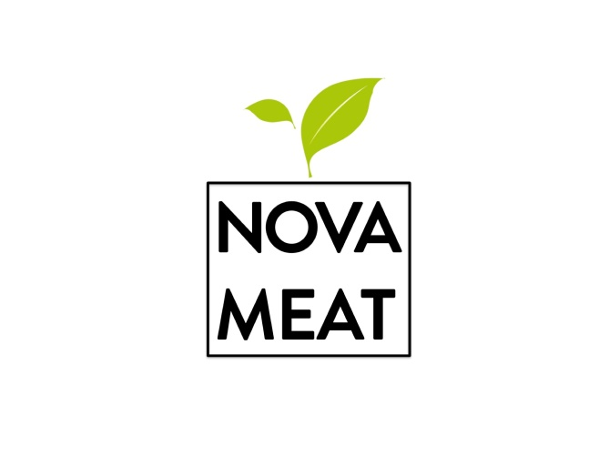**Novameat (Spain)**

NOVAMEAT develops cutting-edge technological solutions to feed the planet's growing population with the next generation of plant-based foods to overcome the challenges of today's unsustainable and inefficient animal agriculture industry and create a healthy, efficient, humane, and sustainable food supply system.

 A new version of NovaMeat's 3D printed steak was unveiled, showing impressive improvements in texture and appearance. Moreover, the startup revealed that costs are also dropping, costing around ***US$1.5 to produce 50 grams***. The plant-based protein is extracted from rice, peas, and algae fibers in terms of ingredients used. Additionally, it contains natural plant-based colorants like paella for appearance and some fats such as olive, canola, and coconut oil in their food paste formulation.

The next step will be to improve taste and nutritional value to offer an alternative that can compete with meat truly[20].

[Novameat](https://www.novameat.com/) has developed what it bills as the "world's biggest cell-based meat prototype" to date- hybrid meat analogs, as they mix mammalian adipose cells with a biocompatible plant-based scaffold – score at 22500mm​³ in volume.

The company decided to take a hybrid approach to alternative proteins to have the most disruption on the unsustainable meat supply chain. Using both plant-based and cell-based technology would allow them to overcome key obstacles that the cultivated space continues to face[21].

**Redefine meat (Israel)**

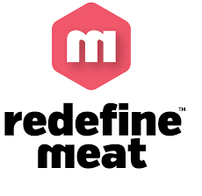Redefine Meat Ltd. technology produces animal-free meat with the same appearance, texture, and flavor of animal meat from natural and sustainable ingredients. Their technology combines proprietary 3D meat modeling, food formulations, and food printing technology to deliver a new category of complex matrix "meat" in a cost-effective and scalable way. Redefine Meat™ Products have a 95% smaller environmental impact, no cholesterol, and are more affordable than animal meat[22].

**Savor Eat (Israel)**

Savor Eat was founded in 2018 by CEO Racheli Vizman, CTO Prof. Oded Shoseyov, and Prof. Ido Braslevsky. They use a technology developed at the Faculty of Agriculture of the Hebrew University of Jerusalem by Shoseyov and Braslevsky, licensed exclusively from Yissum.

Last November, in the first-ever food-tech Initial Public Offering (IPO) on the Tel Aviv Stock Exchange, [SavorEat](https://savor-eat.com/" \t "new) (TASE: SVRT) has raised NIS 42.6 million (about $13 million) from leading Israeli institutional investors. (The company's valuation for the offering was NIS 170 million ($50 million) before money. )

Their product combines 3D-printing technology, plant-based ingredients in cartridges, and a unique, plant-based nano-cellulose fiber developed by the scientists. The cellulose binds the ingredients together, creating a meat-like texture.

Customers would use a combination of a revolutionary chef robot, proprietary 3D printing technology, and unique non-GMO plant-based ingredients. Consumers can now enjoy different textures that characterize meat, tailored to their specific taste, diet, and lifestyle

**Aleph Farms (Israel)**

Together with Prof. Shulamit Levenberg (the Faculty of Biomedical Engineering at the Tech - Israel Institute of Technology), the Israeli startup Aleph Farms has cultivated the world's first slaughter-free ribeye steak. Aleph Farms use 3D bio-printing technology and natural building blocks of meat - real cow cells, without genetic engineering.

Unlike 3D printing technology, Aleph Farms' 3D bioprinting technology is the printing of actual living cells that are then incubated to grow, differentiate, and interact to acquire a real steak's texture and qualities. A proprietary system, similar to the vascularization that occurs naturally in tissues, enables the fusion of nutrients across the thicker tissue and grants the steak a similar shape and structure of its native form as found in livestock before and during cooking.

* The company reported in May 2019, on a US$12M Series-A investment participated by strategic partners and venture capital.
* Israel's largest food company Tnuva Food Industries Ltd. Recently entered the meat substitute products market. The company will import the U.K. brand Meatless Farm products and compete with the U.S. giants Beyond Meat and Impossible Foods. Tnuva also likely intends to distribute Meatless Farm's products to the catering and institutional markets.

# Cell-based Clean Meat companies

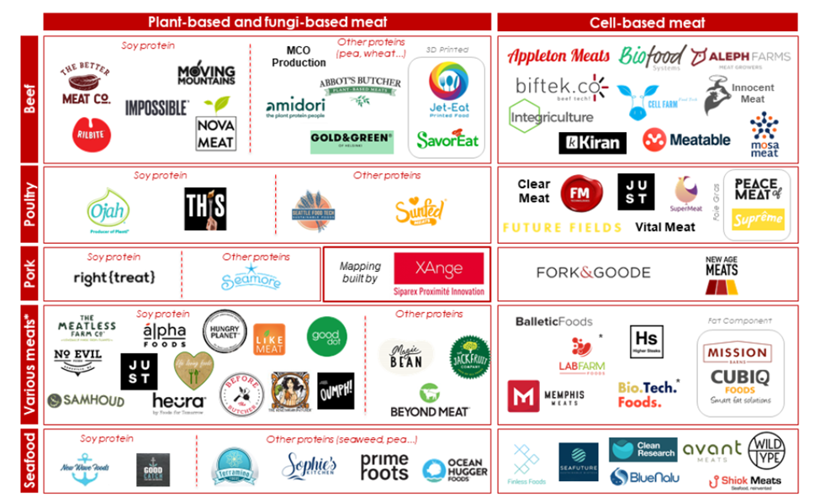

* USA based: BlueNalu, Finless foods, JUST, Mission barns, New Age Meat, Memphis Meats.
* Israel Based: Aleph farms, Future Meat, Super Meat.
* Netherlands: Meatable, Mosameat.



BlueNalu will produce real seafood products directly from fish cells that are as delicious and nutritious as products that have been grown conventionally, in a way that is healthy for people, humane for animals, and sustainable for our planet.

Their mission is to be the global leader in cell-based seafood, providing consumers with great tasting, healthy, safe and trusted seafood products that support our ocean's sustainability and diversity.

JUST [23]is a company that develops and markets plant-based alternatives to conventionally-produced egg products. It raised about $120 million in early venture capital and became a unicorn in 2016 by surpassing a $1 billion valuation.

 In December 2020, its lab-grown chicken became the first lab-grown meat to receive regulatory approval in Singapore. Shortly thereafter, Eat Just's cultured meat was sold to diners at the Singapore restaurant "1880", making it the "world's first commercial sale of cell-cultured meat.

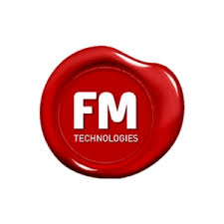

Future Meat Technologies is a groundbreaking biotechnology company advancing a distributive manufacturing platform for cultured meat's cost-efficient production. It is the only company worldwide holding a GMO-free, unlimited cell source capable of differentiating to muscle and fat, growing in a serum-free, antibiotic-free cultured medium. Future Meat Technologies patented bioreactor design permits the cost-efficient production of cultured meat and fat.

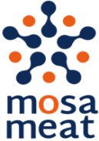Mosa Meat is a Dutch food technology company. In 2013, their CEO, Professor Mark Post, unveiled the world's first cultured meat hamburger to a packed press conference in London. The burger was harvested directly from cow cells, rather than raising and slaughtering a whole animal. It was the result of years of research at Maastricht University and cost €250,000 to make.

Following the first hamburger's success, they created Mosa Meat to commercialize cultured meat and bring it to plates everywhere. The company is focusing on scaling up the production process and getting our first products to market. Mosa Meat estimates that commercial availability of cultured meat could happen around 2021 in high-end restaurants at first, at around $11 per hamburger.

The market has additional players worldwide: SuperMeat (Israel), Integriculture (Japan), Aleph Farms Ltd (Israel), Avant Meats Company Limited (China), Balletic Foods (U.S.), Appleton Meats (Canada), Higher Steaks (U.K.), Biofood Systems LTD (Israel), Fork & Goode (U.S.), Mission Barns (U.S.), New Age Meats (U.S.), Shiok Meats (Singapore), Seafuture Sustainable Biotech (Canada), Wild Type (U.S.), Lab farm Foods (U.S.), Cubiq Foods (Spain), Kiran Meats (U.S.), and Cell Farm FOOD Tech/Granja Celular S.A (Argentina).

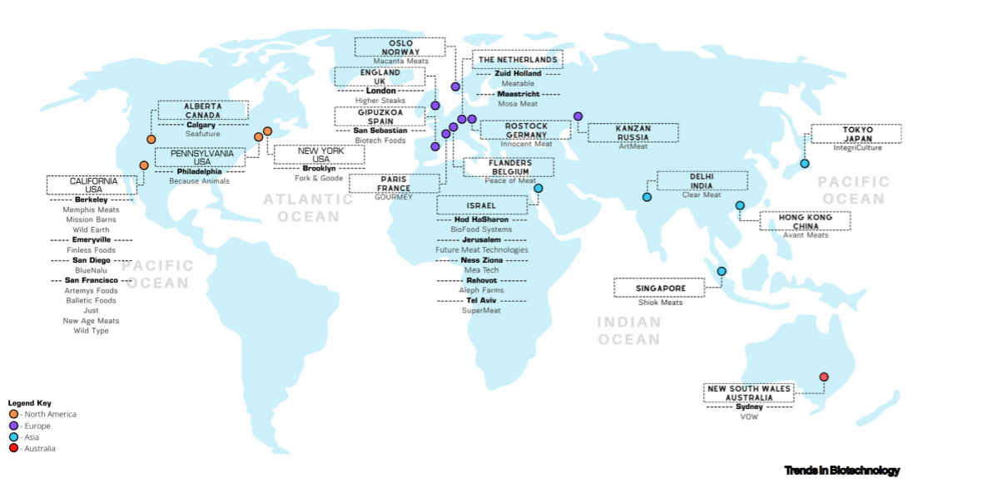

# MeaTech's financial analysis & valuation

Valuation method & approach

Valuation of a start-up company in its early stages can be challenging due to limited cash flow (if any) and uncertainty regarding the future. As part of a Discounted Cash Flow (DCF), the accepted method used in financial valuations, there are several modifications to a start-up company's valuation. In general, there are four primary methods within the DCF method:

1. Real options – this valuation method is designated for pre-clinical and early-stage clinical programs/companies where the assessment is binary during the initial phases and based upon scientific-regulatory assessment only (binomial model with certain adjustments).
2. Pipeline assessment – a valuation method used for early-stage companies before the market stage where time-to-market may be a few years for full operations. The company's value is the total discounted cash flow for its products/signed agreements plus unallocated costs and its technology platform assessment.
3. DCF valuation - this method applies to companies with products that have a positive cash flow from operations.
4. Market benchmark – this method is based on recent deals (M&A and/or fundraising) within the company's domain and on market multiples.

MeaTech is a publically held firm, thus a late-stage firm from a financial aspect, however early-mid stage in its time-to-market. Our valuation is based on market benchmark approach.

# FoodTech – Venture Capital (VC) activity

VC investment activity within the FoodTech sector declined in 2020 versus previous years as to COVID19, with $2.6 billion invested across 144 deals until Q3 2020. Both deal values and volume declined following the initial pandemic spread, which has made it harder to evaluate opportunities and redirected investment toward existing portfolio companies. However, based on previous years and the great potential we foresee, we assume activity will return to (new) normal.

Quarterly investment activity predominately focused on startups within two segments: bio-engineered foods and food suppliers, which together constituted 70% of the total deal value for the quarter. Categories including online grocery, plant-based meat & dairy, and cultivated agriculture have outperformed, with investors putting capital into technologies enabling consumers to buy and experience foods under pandemic conditions. For the first time, the bio-engineered foods sector attracted the most investment capital, suggesting the increasing importance of food products within the venture landscape.

The two largest deals in 2020 included an online grocer and a cultured dairy company. Miss Fresh raised a $495M later stage V.C. investment led by state-backed China International Capital Corporation. Perfect Day raised a $300M Series C investment following FDA approval of its B-lactoglobulin protein. The cultivated dairy producer recently initiated limited production of ice cream products made with cultivated dairy protein, which may pave the way for future investment activity.

Despite the decline, year-to-date investment activity of $12.3 billion is only slightly behind pace to match 2019's record-setting deal value of $17.5 billion. **A surge of investment activity in bio-engineered foods has been a significant contributor to this performance**, with $2.55 billion invested year-to-date, up 62% from 2019 year-end totals. **The cultivated meat category, which competes with traditional and plant-based meat production, has been the segment's shining star, with investment activity up 360% year-to-date** despite no clear path to regulatory approval for meat products. Robust investment activity in the sector has been driven by several factors, including rapid innovation and meat-supply-chain vulnerability concerns during the pandemic. We expect this momentum to continue, if not increase, in the near term.

**FoodTech VC's average deal size was $24.65M in 2020.**

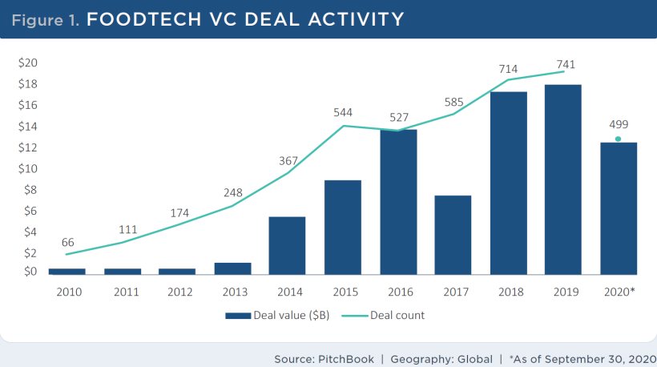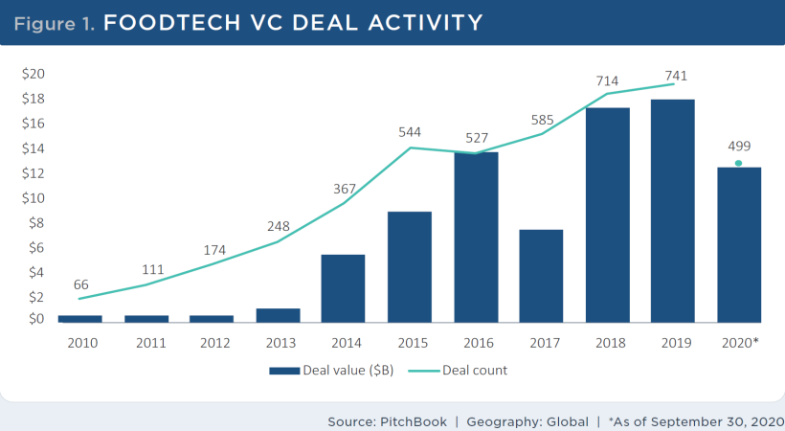

# We will now dive into food tech sub-segments relevant to MeaTech operations – Bio-engineered food.

Bio-engineered foods V.C. ecosystem and activity

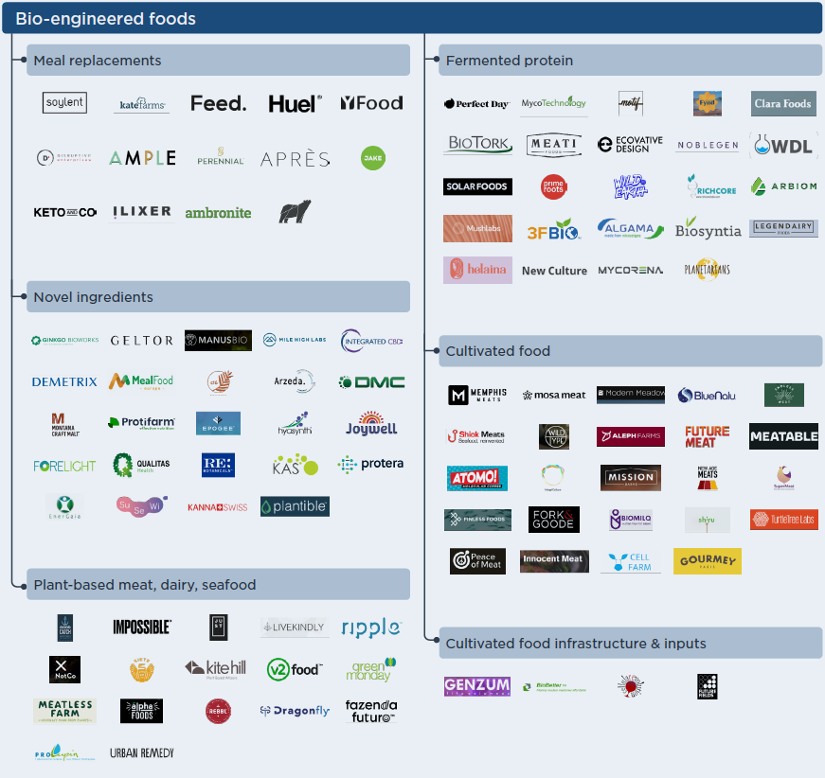

In Q3 2020, the bio-engineered foods segment saw the highest quarterly deal value in the past decade, with $1.0 billion invested across 35 deals. Annually that brings year-to-date totals to $2.6 billion across 101 deals. The pandemic is accelerating already strong tailwinds by highlighting vulnerabilities in the meat supply chain and the importance of healthy eating, increasing investor appetite for bio-engineered foods, and supporting technologies. **The largest deal in Q3 was a $300M series C investment in cultured dairy company Perfect Day.** The company commercialized the first cultivated protein ice cream; however, future business plans involve selling the cultivated dairy protein to other food companies**. Impossible Foods raised the other significant funding round this quarter, closing a $200M series G at a $5 billion pre-money valuation;** this is the company's second mega-deal in 2020; total funding now tops $1.5 billion. Impossible is making significant investments in the plant-based category with plans to double its R&D team in the next year, extend into new product categories such as plant-based milk, and expand its Asian market.

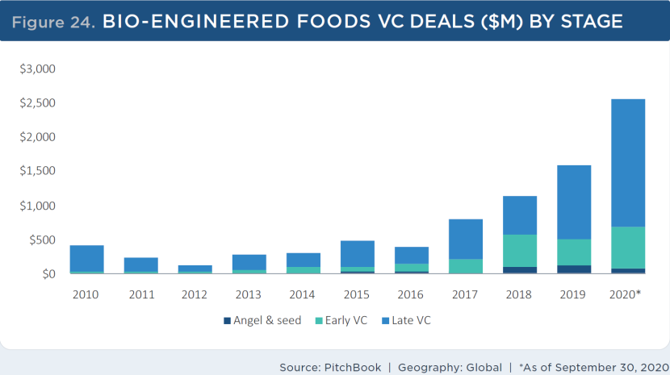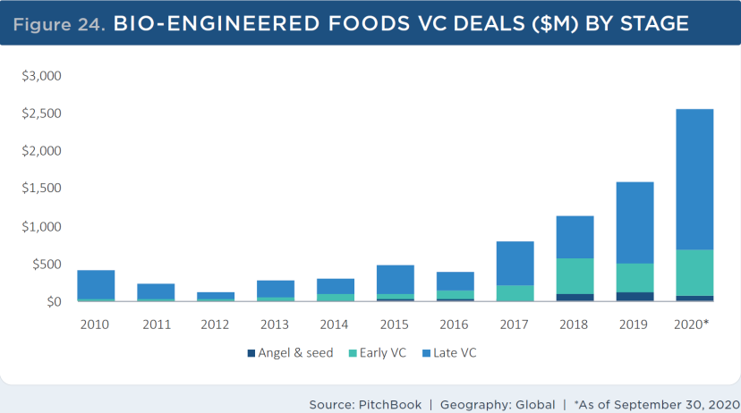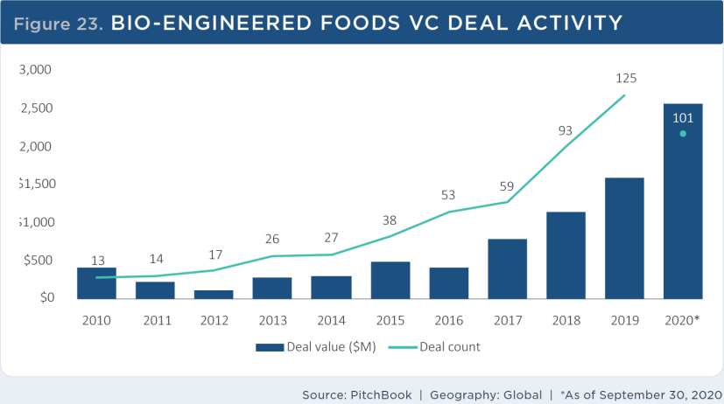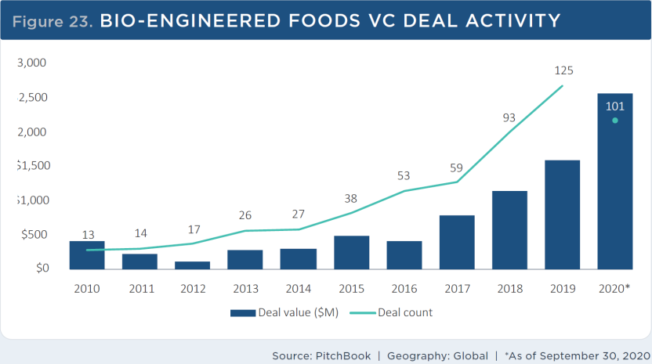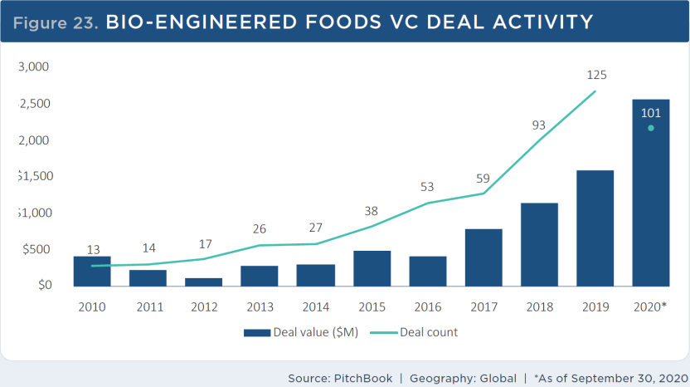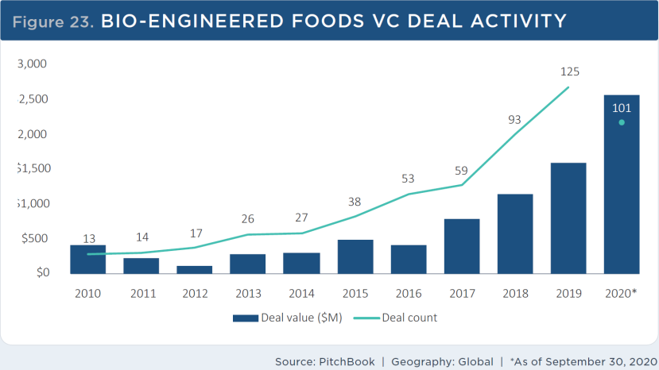

Despite rapid growth in the sector, exit activity remains limited. Year-to-date, $1.4 billion has been exited across three deals. However, the competitive landscape has exploded in recent years, especially among cultivated and plant-based protein companies. We expect more consolidation from larger incumbents as they seek to enter this market.

# 

**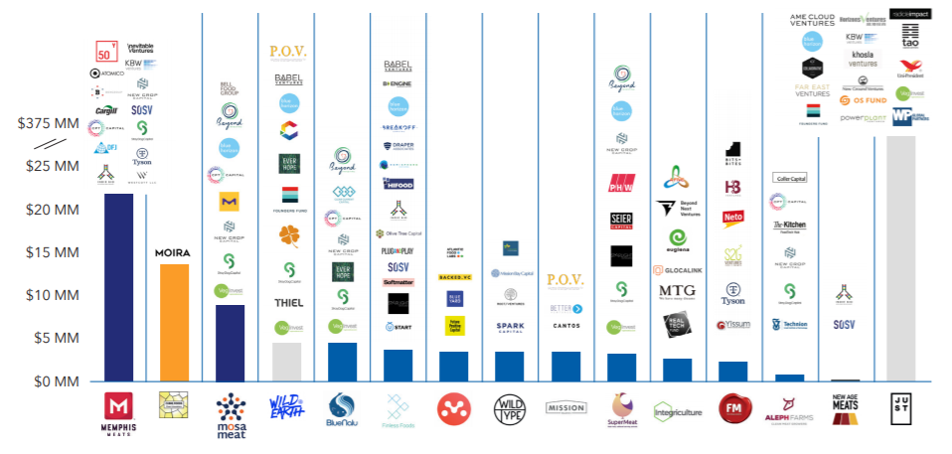*Capital Invested in Cell-based Meat Companies by Stage and Investor***

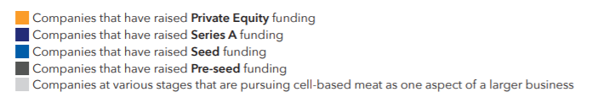

**See additional deals worldwide in Appendix 1.**

**There are 32 companies worldwide that develop clean meat products**, similar to MeaTech. Most of them are (40%) based in North America, 31% in Asia, 25% in Europe, and one in Australia. From 2015 to early 2020, the amount of publicly disclosed capital invested in clean meat companies reached approximately $320M.

# Valuation by Comparable Method

Similar deals

We present below a relevant benchmark to MeaTech's equity value by exploring specific deals we identified as highly relevant to MeaTech:

|  |  |  |  |  |
| --- | --- | --- | --- | --- |
| *(Millions USD)* | **Total funding amount** | **SEED** | **A** | **B** |
| **Avant Meats** | 3.2 | 3.2 |  |  |
| **Wild Type** | 16 | 3.5 | 12.5 |  |
| **Shiok Meats** | 20.4 | 4.75 | 12.6 |  |
| **BlueNalu\*** | 84.8 | 4.5 | 20 |  |
| **Finless Foods** | 3.5 | 3.5 |  |  |
| **Aleph Farms** | 26.4 | 2.4 | 24 |  |
| **New Age Meats** | 5 | 5 |  |  |
| **Mission Barns** | 3.5 | 3.5 |  |  |
| **Meatable** | 13.5 | 13.5 |  |  |
| **Integriculture** | 10.45 | 2.85 | 7.6 |  |
| **Mosa Meat** | 86 |  | 9.5 | 75 |
| **SuperMeat** | 4.2 | 4.2 |  |  |
| **Eat Just\*\*** | 220 |  | 4 | 23 |
| **Memphis Meats** | 181.1 | 3 | 17 | 161 |
| **Future Meat Technologies\*** | 43 | 2.2 | 14 |  |
| **Redefine** | 6 | 6 |  |  |
| **SavorEat** | 17.9 | 2 | 3 | 13 |
| **Average** | 43.82 | 4.27 | 12.42 | 68.00 |
| **Estimated pre-money valuation** | **219 - 292** | **21 – 28** | **62 - 83** | **340 - 453** |

*Deducting convertible notes funding

**Deducting advanced funding rounds

We assume a standard 15% to 20% equity share in each round, reflecting VC activity in numerous segments. Thus a range of $340M to $453M is implied for round B+ firms. However, we have a limited number of observations.

We then explored the average FoodTech deal size as elaborated above of $24.65M. We also found that the average deal size for a bio-engineered deal in 2020 was very similar, $24.75M. Therefore, applying the same method, **we assume pre-money valuation to be in the range of $123.5M to $165.0M, and on average $144.25M.**

**MeaTech – NASDAQ listing**

On March 16, 2021, MeaTech announced on the completion of an initial public offering of 2,427,185 American Depositary Shares ("ADSs"), each ADS representing 10 of its ordinary shares. The initial public offering price was $10.30 per ADS, for gross proceeds of approximately $25M. Also, MeaTech has granted the underwriter a 30-day option to purchase up to 364,077 ADSs at the initial public offering price, less underwriting discounts, and commissions. On March 23, 2021, MeaTech announced that the mentioned underwriter has partially exercised its option to purchase additional ADSs, and purchased 294,086 ADSs at the terms discussed above. MeaTech received additional gross proceeds of approx $3M, resulting in total gross proceeds from the offering of approx $28M.

Including proceeds from the exercise, MeaTech received net proceeds of approximately $24.7 million from the

offering, after deducting underwriting discounts and commissions and estimated offering expenses payable by

MeaTech.

MeaTech intends to use the net proceeds from this offering to advance its program to develop commercial technologies to manufacture alternative foods, including potential acquisitions of other companies whose technologies are complementary or synergistic to its own, and for general corporate purposes, including working capital requirements.

# Valuation summary

***We conducted MeaTech's valuation using market benchmarks from recent deals and analysis of VC’s activity; We value the company's stock price target to be in the range of USD TBC to USD TBC in view of all aforementioned findings and assessments.***

**Appendix #.1: About Frost & Sullivan**

Frost & Sullivan* is a leading global consulting, and market & technology research firm that employs staff of 1,800, which includes analysts, experts, and growth strategy consultants at approximately 50 branches across 6 continents, including in Herzliya Pituach, Israel. Frost & Sullivan’s equity research utilizes the experience and know-how accumulated over the course of 55 years in medical technologies, life sciences, technology, energy, and other industrial fields, including the publication of tens of thousands of market and technology research reports, economic analyses and valuations. For additional information on Frost & Sullivan's capabilities, visit: www.frost.com. For access to our reports and further information on our Independent Equity Research program visit: www.frost.com/equityresearch.

*Frost & Sullivan Research and Consulting Ltd., a wholly owned subsidiary of Frost & Sullivan, is registered and licensed in Israel to practice as an investment adviser.

**What is Independent Equity Research?**

Nearly all equity research is nowadays performed by stock brokers, investment banks, and other entities which have a financial interest in the stock being analyzed. On the other hand, Independent Equity Research is a boutique service offered by only a few firms worldwide. The aim of such research is to provide an unbiased opinion on the state of the company and potential forthcoming changes, including in their share price. The analysis does not constitute investment advice, and analysts are prohibited from trading any securities being analyzed. Furthermore, a company like Frost & Sullivan conducting Independent Equity Research services is reimbursed by a third party entity and not the company directly. Compensation is received up front to further secure the independence of the coverage.

**Analysis Program with the Tel Aviv Stock Exchange (TASE)**

Frost & Sullivan is delighted to have been selected to participate in the Analysis Program initiated by the Tel Aviv Stock Exchange Analysis (TASE). Within the framework of the program, Frost & Sullivan produces equity research reports on Technology and Biomed (Healthcare) companies that are listed on the TASE, and disseminates them on exchange message boards and through leading business media channels. Key goals of the program are to enhance global awareness of these companies and to enable more informed investment decisions by investors that are interested in "hot" Israeli Hi-Tech and Healthcare companies. The terms of the program are governed by the agreement that we signed with the TASE and the Israel Securities Authority (ISA) regulations.

**For further inquiries, please contact our lead analyst:**

Dr. Tiran Rothman **T:** +972 (0) 9 950 2888 **E:** equity.research@frost.com

**Appendix #.2: Team biographies**

**Dr. Tiran Rothman** is the head of Frost & Sullivan Research & Consulting Ltd., a subsidiary of Frost & Sullivan in Israel. He has over 10 years of experience in research and economic analysis of capital and private markets, obtained through positions at a boutique office for economic valuations, as chief economist at the AMPAL group, and as co-founder and analyst at Bioassociate Biotech Consulting. Dr. Rothman also serves as the Economics & Management School Head at Wizo Academic College (Haifa). Tiran holds a PhD (Economics), MBA (Finance), and was a visiting scholar at Stern Business School, NYU.

**Dr. Hadar Cohen-Halevy** is a Consultant at Frost & Sullivan Research & Consulting Ltd., a subsidiary of Frost & Sullivan in Israel. Hadar has over 3 years of experience in research and analysis in the fields of healthcare and life sciences for public and private companies. Hadar worked at Teva pharmaceutical’s R&D for several years and is an expert in regulations of drug developments and medical devices. She holds a Ph.D from Weizmann Institute of Science and a MSc in Biotechnology from Tel Aviv University.

**Almog Josef Sokolik** is an Analyst and Consultant at Frost & Sullivan Research & Consulting Ltd., a subsidiary of Frost & Sullivan in Israel. He has experience in valuation of public and private firms, research and market analysis obtained through positions at the Ministry of Finance - Department of the Chief Economist, and Ben-Gurion University - Laboratory for Judgment & Decision Making as research analyst. Almog holds a BA in Economics and Psychology.

**Disclaimers, disclosures, and insights for more responsible investment decisions**

Definitions: "Frost & Sullivan" – A company registered in California, USA with branches and subsidiaries in other regions, including in Israel, and including any other relevant Frost & Sullivan entities, such as Frost & Sullivan Research & Consulting Ltd. ("FSRC"), a wholly owned subsidiary of Frost & Sullivan that is registered in Israel – as applicable. "The Company" or "Participant" – The company that is analyzed in the report**;**"Report", "Research Note" or "Analysis"  – The content, or any part thereof where applicable, contained in a document such as a Research Note and/or any other previous or later document authored by "Frost & Sullivan", regardless if it has been authored in the frame of the "Analysis Program", if included in the database at www.frost.com and regardless of the Analysis format-online, a digital file or hard copy**;**"Invest", "Investment" or "Investment decision" – Any decision and/or a recommendation to Buy, Hold or Sell any security of The Company. The purpose of the Report is to enable a more informed investment decision. Yet, nothing in a Report shall constitute a recommendation or solicitation to make any Investment Decision, so Frost & Sullivan takes no responsibility and shall not be deemed responsible for any specific decision, including an Investment Decision, and will not be liable for any actual, consequential, or punitive damages directly or indirectly related to The Report. Without derogating from the generality of the above, you shall consider the following clarifications, disclosure recommendations, and disclaimers. The Report does not include any personal or personalized advice as it cannot consider the particular investment criteria, needs, preferences, priorities, limitations, financial situation, risk aversion, and any other particular circumstances and factors that shall impact an investment decision. Nevertheless, according to the Israeli law, this report can serve as a raison d'etre off which an individual/entity may make an investment decision.

Frost & Sullivan makes no warranty nor representation, expressed or implied, as to the completeness and accuracy of the Report at the time of any investment decision, and no liability shall attach thereto, considering the following among other reasons: The Report may not include the most updated and relevant information from all relevant sources, including later Reports, if any, at the time of the investment decision, so any investment decision shall consider these; The Analysis considers data, information and assessments provided by the company and from sources that were published by third parties (however, even reliable sources contain unknown errors from time to time); the methodology focused on major known products, activities and target markets of the Company that may have a significant impact on its performance as per our discretion, but it may ignore other elements; the Company was not allowed to share any insider information; any investment decision must be based on a clear understanding of the technologies, products, business environments, and any other drivers and restraints of the company's performance, regardless if such information is mentioned in the Report or not; an investment decision shall consider any relevant updated information, such as the company's website and reports on Magna;  information and assessments contained in the Report are obtained from sources believed by us to be reliable (however, any source may contain unknown errors. All expressions of opinions, forecasts or estimates reflect the judgment at the time of writing, based on the Company's latest financial report, and some additional information (they are subject to change without any notice). You shall consider the entire analysis contained in the Reports. No specific part of a Report, including any summary that is provided for convenience only, shall serve per se as a basis for any investment decision. In case you perceive a contradiction between any parts of the Report, you shall avoid any investment decision before such contradiction is resolved. Frost and Sullivan only produces research that falls under the non-monetary minor benefit group in MiFID II. As we do not seek payment from the asset management community and do not have any execution function, you are able to continue receiving our research under the new MiFiD II regime. This applies to all forms of transmission, including email, website and financial platforms such as Bloomberg and Thomson.

Risks, valuation, and projections: Any stock price or equity value referred to in The Report may fluctuate. Past performance is not indicative of future performance, future returns are not guaranteed, and a loss of original capital may occur. Nothing contained in the Report is or should be relied on as, a promise or representation as to the future. The projected financial information is prepared expressly for use herein and is based upon the stated assumptions and Frost & Sullivan's analysis of information available at the time that this Report was prepared. There is no representation, warranty, or other assurance that any of the projections will be realized. The Report contains forward-looking statements, such as "anticipate", "continue", "estimate", "expect", "may", "will", "project", "should", "believe" and similar expressions. Undue reliance should not be placed on the forward-looking statements because there is no assurance that they will prove to be correct. Since forward-looking statements address future events and conditions, they involve inherent risks and uncertainties. Forward-looking information or statements contain information that is based on assumptions, forecasts of future results, estimates of amounts not yet determinable, and therefore involve known and unknown risks, uncertainties and other factors which may cause the actual results to be materially different from current projections. Macro level factors that are not directly analyzed in the Report, such as interest rates and exchange rates, any events related to the ecosystem, clients, suppliers, competitors, regulators, and others may fluctuate at any time. An investment decision must consider the Risks described in the Report and any other relevant Reports, if any, including the latest financial reports of the company. R&D activities shall be considered as high risk, even if such risks are not specifically discussed in the Report. Any investment decision shall consider the impact of negative and even worst case scenarios. Any relevant forward-looking statements as defined in Section 27A of the Securities Act of 1933 and Section 21E the Securities Exchange Act of 1934 (as amended) are made pursuant to the safe harbor provisions of the Private Securities Litigation Reform Act of 1995.

The Report shall include a description of the Participant and its business activities, which shall inter alia relate to matters such as: shareholders; management; products; relevant intellectual property; the business environment in which the Participant operates; the Participant's standing in such an environment including current and forecasted trends; a description of past and current financial positions of the Participant; and a forecast regarding future developments and any other matter which in the professional view of Frost & Sullivan (as defined below) should be addressed in a research Report (of the nature published) and which may affect the decision of a reasonable investor contemplating an investment in the Participant's securities. An equity research abstract shall accompany each Equity Research Report, describing the main points addressed. A thorough analysis and discussion will be included in Reports where the investment case has materially changed. The named lead analyst and analysts responsible for this Report certify that the views expressed in the Report accurately reflect their personal views about the Company and its securities and that no part of their compensation was, is, or will be directly or indirectly related to the specific recommendation or view contained in the Report. Neither said analysts nor Frost & Sullivan trade or directly own any securities in the company. The lead analyst has a limited investment advisor license for analysis only.

This research paper is not intended for, and should not be used by, investors in Australia. Frost & Sullivan does not hold an Australian financial services licence and is not regulated by the Australian Securities and Investments Commission in connection with the preparation of this research paper or its publication. This research paper is for information purposes only and should not be treated as an opinion, proposal, recommendation or advice for the investment in, holding or disposal of the securities described in it. It has been prepared without taking into account any client's individual circumstances and investors should therefore consider whether an investment in the securities described in this research paper (Securities) is appropriate for them having regard to their own circumstances. Investors should seek their own independent professional advice from an appropriately licensed person before making any such decision. Any advice contained within this research paper is only intended for wholesale investors. Recipients of this research paper, including the issuer of the Securities, are strictly prohibited from permitting retail investors to view, obtain or download a copy of the research paper or placing it on a website or other forum where a retail investor may obtain access to it.

© 2021 All rights reserved to Frost & Sullivan and Frost & Sullivan Research & Consulting Ltd. Any content, including any documents, may not be published, lent, reproduced, quoted or resold without the written permission of the companies.

**Endnotes**

1. https://en.globes.co.il/en/article-meat-tech-3d-buys-belgian-culture-fat-co-1001352335
2. https://www.prnewswire.com/news-releases/meat-tech-announces-further-advancement-of-3d-printing-technology-for-food-products-by-bioprinting-cultured-beef-fat-structure-301181563.html?tc=eml_cleartime
3. https://data.oecd.org/agroutput/meat-consumption.htm
4. https://www.merckgroup.com/en/research/science-space/envisioning-tomorrow/scarcity-of-resources/cleanmeat.html
5. https://www.prnewswire.com/news-releases/meat-tech-agrees-to-acquire-cultured-fat-pioneer-peace-of-meat-301188400.html
6. <http://www.fao.org/3/a-ap106e.pdf>
7. <https://pubs.acs.org/doi/10.1021/es200130u>
8. <https://www.bbc.com/news/science-environment-23576143>
9. <https://qz.com/1598076/the-first-cell-cultured-meat-will-cost-about-50/>
10. https://www.frontiersin.org/articles/10.3389/fsufs.2019.00046/full
11. http://elliotswartz.com/cellbasedmeat/cleanmeat301
12. https://www.embopress.org/doi/full/10.15252/embr.201847395
13. Source: United Nations, World Bank, Expert Interviews, A. T. Kearney Analysis.
14. https://www.statista.com/statistics/502286/global-meat-and-seafood-market-value/
15. https://www.marketsandmarkets.com/Market-Reports/cultured-meat-market-204524444.html
16. Frost Radar in the Meat Alternatives Market, 2019
17. https://www.fairr.org/article/clean-meat/
18. https://www.merckgroup.com/en/research/science-space/envisioning-tomorrow/scarcity-of-resources/cleanmeat.html
19. https://www.gfi.org/non-cms-pages/splash-sites/soi-reports/files/SOI-Report-Cell-Based.pdf
20. https://www.3dnatives.com/en/novameat-version-2-0-3d-printed-steak-200120205/#!
21. https://www.greenqueen.com.hk/spanish-food-tech-novameat-3d-prints-the-world-biggest-cell-based-meat-prototype/?ct=t(OCT+8+2020+INDUSTRY+SCOOP_COPY_01)
22. https://www.redefinemeat.com/what-we-do
23. https://equityzen.com/company/just/