Three Baga Masters

In May 2019, Guinea’s former First Lady of twenty-four years (1984–2008) Henriette Conté, passed away.

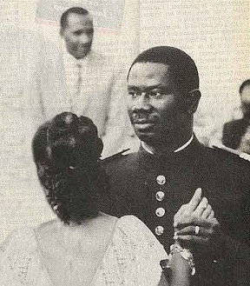Henriette had been Lancana Conté’s first love; the image of them waltzing together while Lancana was a young captain serving at the Guinean border still resonates today.

Although President Conté had three other wives, Henriette, who was known for her honesty, compassion, and integrity, remained at his side and continued to serve as Guinea’s First Lady throughout Lancana’s twenty-four years in office.

During this time, she was often called to mediate between her husband and her countrymen, employing her skills to ease tensions between Guinea’s unions and her husband’s military regime.

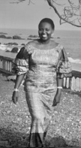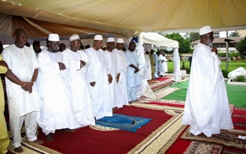Henriette Conté was Guinea’s moral beacon; as such, her death was grieved by all within the Guinean political sphere. Guinean President Alfa Condé attended the state funeral held in her honor, as did Cellou Diallo, head of the Guinean opposition. Lengthy obituaries were published in all the Guinean media.

Being a Baga from Boké, born to the Bangoura of Taigbe, Katako, she advocated for the Baga’s agenda in Conte’s centralist regime in Conakry.

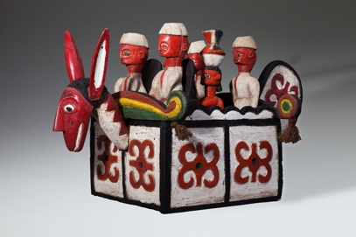Traces of the Guinean government’s close connections to the Baga community can be seen in the assortments of figures riding atop the Sibindel headrests from the 1960s and 1970s, which were used by dancers during receptions honoring government dignitaries visiting the Bagaland.

Henriette, like most of her female rural compatriots, was initiated into the the Baga women’s secret societies.

The various women’s associations of Guinea were the only traditional civil groups to survive Sekou Touré’s twenty-five years of Marxist dictatorship, a time in which the Baga village skyline , which had been dominated for centuries by the silhouettes of the sacred cotton trees, gradually gave way to one of mosques and minarets.

These were years in which the male Baga population converted en masse to Islam, the old forest spirits and their advocates became branded as colonial collaborators, and foreign agents and village elders who adhered to the “ancient regime” were arrested and their sacred groves uprooted.

Unlike their male counterparts, 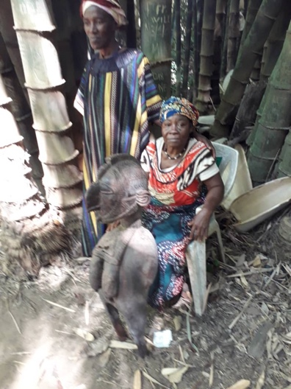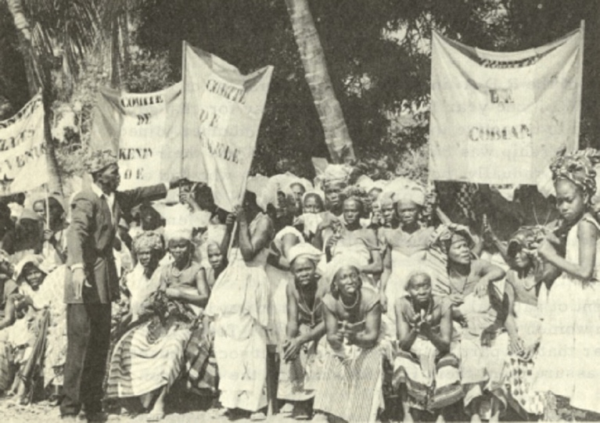the women’s secret associations challenged the revolutionary zeal of the central government. Advocating for their responsibilities in their community, they managed to retain their power, traditions, and morals. The women’s sacred groves and their domain thus remained virtually untouched.

Throughout her long career, Henriette was approached by delegations and representatives of the Baga women’s association who pressed their cases while bearing gifts., as customary at such meetings. Due to her position as a Baga elder, Henriette was entrusted with major artifacts from the Baga women’s sacred paraphernalia.

Upon her death, elaborate farewell celebrations were held due to her status. Traditionally, the cost of such week-long receptions was covered primarily by the sale of religious paraphernalia held by the deceased. The elder was merely the custodian of the objects entrusted by the community to his/her care, and thus upon his/her death the objects were regarded as communal property. As was customary, I was approached by the Baga elders to mediate the funeral costs and the receptions held in Henriette’s honor.

Slowly, a group of twelve pieces were uncovered, ten of which were masterpieces of the early twentieth century that had been hidden from sight since the iconoclasm of 1957. The final two were later versions of these from the eighties.

As some of the statues were in a progressive state of decay, a major painstaking restoration project led by master Nkai Sidime and Master Morri Curia, a renown Guinean restoration expert, was undertaken.

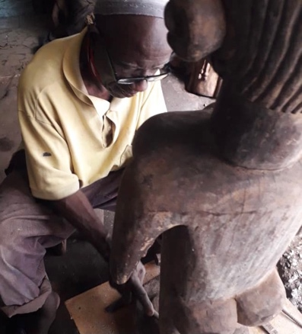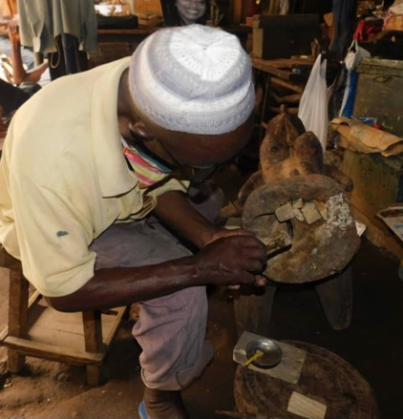

Henriette Conté’s collection, supplemented by the Katako hoard, currently on view at the Israel Museum in Jerusalem’s ***Nimba****: Baga Art & the Great Mother* exhibit, consists of most of the known oeuvre used by the Baga’s women’s association in the early twentieth century.

It is a cohesive group that represents Baga culture at its zenith.

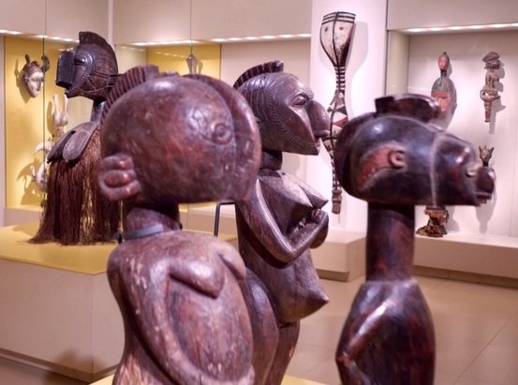

Close examination reveals three distinctive artists within the group, each with his own unmistakable approach, manner, and realm of interests. All operated within the liturgy and canon of Baga paraphernalia, but each employed his own unique and personal artistic vocabulary. The first embarked on a formalist journey toward the abstract. The second aimed at the metaphysical and the spiritual. Finally, the third indulged in his love of the figurative and delight in detail while moving towards realism and portraiture.

The still living Baga elders were approached with questions regarding the artists, their whereabouts, biographies, and other details. Contrary to former Western beliefs, all three artists were known figures, respected members of their communities. Some were descendants of a long line of masters, whose craftsmanship had been loved, known, and appreciated for years.

Further research facilitated by the Boké governor revealed their years of birth, and more.

The three masters are :

Femora Camara, born in 1885 in Faraba.

Mangue Bangoura, born in 1900 in Camala.

Anadi fote’ Camara, born in 1890 in Taigbe

A comparative study of collections in other Western museums enabled additional attributions to the oeuvre of these three masters. For example, Famori Camara’s distinctive abstract vocabulary enabled the attribution of the following works:

*Standing Male and Female Figures*, Yale University Art Gallery, acquired 1954.

*Nimba Headdress*, Rierberg Museum, Zurich.

*Head of Janus*, National Museum van Wereldculturen.

It is a great privilege to make this small gesture and replace the customary museum plaques attributing these African masterpieces to an anonymous artist with one that bears an actual name.

Each of these artists worked in his community, within the canonical guidelines of his cult, and was attuned to the spirit of his time; each possessed his own artistic manner and a fully developed, personal voice.

We are pleased to give these three masters the pedestal they so truly deserve.

Michael Weiss – Tel Aviv – 2021.