**Correlation Between the Role of the Quality Engineer and Corporate Culture**

Sharon Anker1

1Department of Management, Ben-Gurion University of the Negev, Beer-Sheva 8410501, Israel

*Corresponding author. Email: [sharon_anker@hotmail.co.il](mailto:sharon_anker@hotmail.co.il)

Sharon Anker holds an M.Sc. in Environmental Engineering from Ben-Gurion University of the Negev. He is currently Manager of Quality/Organizational Excellence at the Shimon Peres Negev Nuclear Research Center. He holds certifications from the Israel Society for Quality (ISQ) and the American Association of Quality (ASQ).

# ABSTRACT

This is the third article discussing the status of a quality engineer, taking into account the effect of quality events that have recently occurred in Israel and around the world. The first article examined tension between expertise on the one hand and authority on the other in the role of a quality engineer (Anker, 2019). The second article examined the impact of the COVID-19 crisis on quality management in organizations (Anker, 2020). This article examines the correlation between professionalism and the degree of job success, and the characteristics of the job (Anker, 2019; 2020). The previous articles emphasized that management support is necessary for job success, as it can be difficult to measure success of quality processes in the organization carried out by those in the safety professions, as the results are necessarily long term.

This article examines the assumption that the role of a quality engineer depends on corporate culture, focusing on Israel, and the assuming that company profitability is harmed by the existence of a culture of poor quality.

A survey of attitudes and the accompanying verbal comments reveal that participants presume that there is a correlation between professionalism and the degree of job success. Characteristics considered important to the role of the quality engineer include an ability to pay attention to details, teamwork skills, and analytical ability, while relevant knowledge in the quality field were deemed less important. Most participants identified the effects of the success and added value of a quality engineer as raising awareness of quality among all stakeholders, improving motivation among employees, and helping management understand the company’s quality status.

In summary, while success depends considerably on professionalism, it depends more on organizational culture, and the application of different communication styles across the organization.

**KEYWORDS**: quality; quality engineer; organizational culture

# BACKGROUND

In recent years, the position of quality engineer has received a great deal of attention due to the increasing difficulties quality practitioners face in performing their work. Some incidents resulting from poor quality products led those involved in the field in Israel to fear losing their jobs, and therefore, they refrained from talking to outside parties (for example, recent incidents in the food industry in Israel; see, *The Marker*, August 20, 2016). Such events have raised critical issues regarding the professional ethics of those involved in the quality field, and many working in the field find that their status varies from one organization to another and depends on the organizational culture.

Results published in 2019 and 2020 (Anker) suggested that professionals in the field believe the role of quality engineer depends on organizational culture regardless of the type of organization. However, to

date, the degree of success and the role of a quality engineer in organizations have yet to be examined This study was intended to confirm the hypothesis that professionalism and success as a quality engineer are interdependent. Previously, we found that success stems from changing and raising awareness of quality, savings, improving motivation among employees, and helping management reflect the image of quality. A change in corporate culture

Responding to customers’ demands for stricter quality standards, large enterprises in Israel began appointing quality engineers despite not being required to do so, and notwithstanding the lack of a national consensus regarding the minimum requirements for the position.

To date, no criteria have been set for the position of quality engineer. Professional articles suggest that one should choose the most suitable person, that is, an individual with abilities or attributes that will enable him or her to perform the role in an optimal manner (Anker 2019, 2020). The quality engineer is responsible for the input of the organization (building an organizational culture for quality, providing employees with tools to produce a quality product), while the management and employees are responsible for the output (working according to the established quality infrastructure).

In a survey conducted in 2012 by Liat Milo and Moshe Ekroni, examining how the respondents entered the field of quality, most of the respondents answered, “I entered the field by chance” and had not entered the field from a specialized occupation. Many respondents took on quality positions by chance or lack of choice and not necessarily because they viewed quality as a real vocation or part of their career development. Some previously had enjoyed long-standing careers in business or operational fields, and had reached high-level positions, with all the authority accompanying such ranks. When they entered the field of quality, they felt a regression in both the image and the authority they had (see Figure 1).

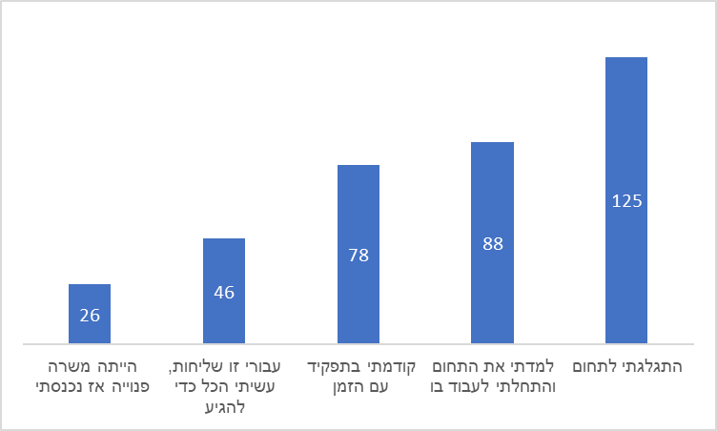

Figure 1: How you entered the field of quality management

# Aim

This study is intended to confirm the research hypotheses that there is a dependence between professionalism and success in the role of quality engineer.

Two hypotheses were examined in this study:

1. **H1:** There is a correlation between professionalism and success in the role of quality engineer.
2. **H2:** There is a correlation between the roles of quality engineers in Israel and abroad.

In short, what is success? What is failure? What is the added value of the perspective of quality engineers?

The research hypotheses were examined quantitatively based on a questionnaire sent to quality practitioners in 2021 through various media — the Israeli Quality Association website (iasq), email and sharing the questionnaire on collaborative media (Facebook, LinkedIn, WhatsApp).

# Methods

The present study examined whether there is a correlation between professionalism and success in the role of quality engineer. It also aimed to define the characteristics of the position of quality engineer, and what is success or failure in such a position.

The questionnaire was built using Google Forms and was sent to participants as a link via the Israeli Quality Association website, email, Facebook, LinkedIn or WhatsApp. Each questionnaire took an average of 10 minutes to complete. Data analysis was carried out using SPSS software and based on a Chi-squared split.

# Study Participants

Forty-nine (49) quality personnel [25 men (58%) and 18 women (42%)] from a variety of positions, including VP Quality/Global Quality Manager, Quality Engineer and Quality Manager responded to the survey.

**Quality Engineers**

## **Success in the Job**

Researchers around the world have been trying for many years to crack the riddle of what is success, and how can it be achieved. We will first define the contrasting terms “success” and “failure.”

* **Success** – Achieving a pre-defined goal within a predetermined timeframe.
* **Failure** – Failure to achieve a defined goal within the predetermined timeframe.

If we ask ten different people what success means to them, we will likely receive ten different answers: one might say that success is winning the lottery, another might say that success is becoming the CEO of the company where he or she is employed, and so on. Perception plays a role in defining success and varies from person to person; therefore, it is not possible to comprehensively define success (achievements and accomplishments) based on our personal results or those of others.

Success refers primarily to professional knowledge and experience gained over time. For example, expertise in chess, music or sports results from a combination of professionalism and success. Consequently, expertise in a field may be tested according to three criteria: whether the results of one’s work yields concrete results; (2) whether one’s performance consistently exceeds that of one’s peers; (3) whether expertise can be replicated and measured (Ericsson, 2007).

It is very difficult to measure success in the field of quality, in part because of the difficulties in quantifying preventive activity, which is the essence of the world of quality. As a resulting, evaluating short-term success can be problematic, and measuring long-term success quality professionals poses particular challenges. We need to measure ourselves, to see where we stand in the face of the goals we have set for ourselves and to see if we have been able to meet them.

As Amnon Margalit has reported: “More than once I experienced a ‘conflict’ between the implementation of quality solutions and compliance with the system delivery system. This conflict limits one's authority and impairs one's ability to perform one's role and be a partner in the organization's business success.”

Regarding the correlation between professionalism and success in the role of quality engineer, a lecture by Roni Khamtian, Afcon Group Quality Engineer is edifying. He found that “the quality engineer does not necessarily affect business results, given the difficulties arising from the organizational culture, the state of the relevant knowledge, the inadequacy of appropriate techniques for addressing problems that have developed, and the multidisciplinary nature of this work” (Khamtian, 2019).

Success in a quality-related position may be deduced from a survey conducted by Moshe Ekroni (2012). Most participants think that “a quality engineer can be measured on compliance, standard quality tasks, or organization performance – this measurement is done even though he is not directly responsible for achieving goals. And its activities contribute and influence ‘indirectly’ by focusing on helping to improve the organization's business processes” (see Figure 2.

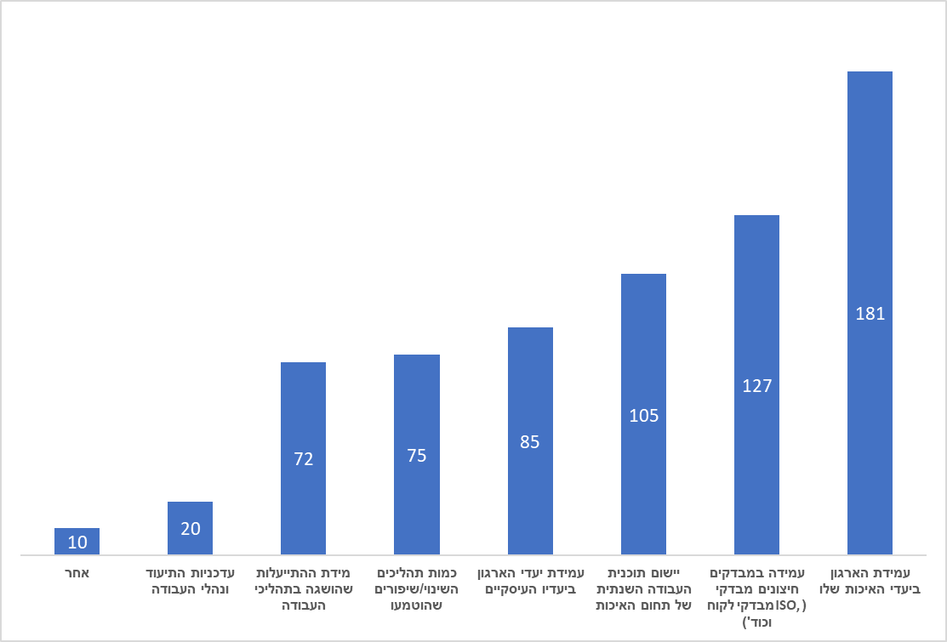

Figure 2: How is your success in a job measured?

# Findings

Analysis of the survey responses revealed that some of the respondents did not begin their careers in the field of quality, but “fell” into it from other fields, e.g., engineering, promotion by the CEO, recruitment by a friend, coincidence, personal recommendation, a managerial career, via project management, and more.

Although the respondents did not seek careers in the field of quality, they now view the position as a real vocation chosen as part of personal career development. When they entered the position, they did not feel a regression in either the image or the authority they had, a trend that emerged from a survey conducted by Moshe Ekroni and Liat Milo 2012.

# Results

**H1**: There is a correlation between professionalism and success in the role of quality engineer.

This hypothesis was tested by asking the following question (Appendix A):

* Do you think there is a correlation between your professionalism and the degree of your success in the job?

Analysis of the survey found that over 86% (see Figure 3) of the respondents believe that as their professionalism and success in the position improves, they are granted greater authority with stakeholders to prevent quality events, matching the authority of other professions. The characteristic of expertise is not innate, but is acquired over time through practice and the accumulation of knowledge, specifically professional experience. For example, there is a correlation between professionalism and success in chess, music or sports. These results are consistent with those obtained in a study by Anker (2019), in which over 62% of the respondents agreed that a role in the field of quality requires knowledge in that field.

A strong response was noted among respondents who answered regarding the correlation between professionalism and the degree of success, and the question of how they came into the position. Those who did not begin in the field of quality and “fell” into the job believe that professionalism is required to be successful in the job. There is also correlation between how a respondent came into the position and his or her added value in the organization.

In conclusion, the more the quality professional specializes in quality, the more successful that individual will be in the field (Anker, 2019).

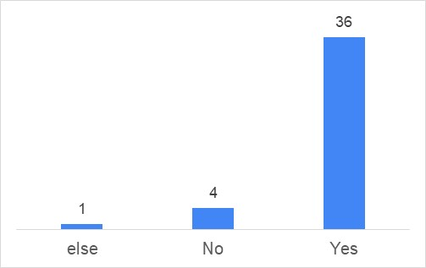

Figure 3: Correlation between professionalism and the degree of success as a quality engineer

**Second hypothesis**: There is a correlation between the roles of quality engineers in Israel and abroad.

To examine this, we asked the following question (Appendix A):

* Which characteristics reflect your role in the organization?

Analysis of the attitudes survey found that over 70% of practitioners believe that teamwork skills and critical thinking rate higher than relevant knowledge in the field of quality and authority to perform the job (59%). Softness is more important in performing the job than relevant knowledge in the field of quality and authority (see Figure 4).

These results are consistent with those from the tests of the previous hypothesis, where most respondents felt that specializing in quality increases their success in the job. Although the respondents believed that specialization in the field of quality is required, and that the quality engineer must be familiar with and apply different communication styles at work across the organization, success depended considerably on motivating people to implement necessary changes, and at “taking on” authority as a leader and supporter in matrix management (Anker, 2019).

believeandelementsinwhilespecific

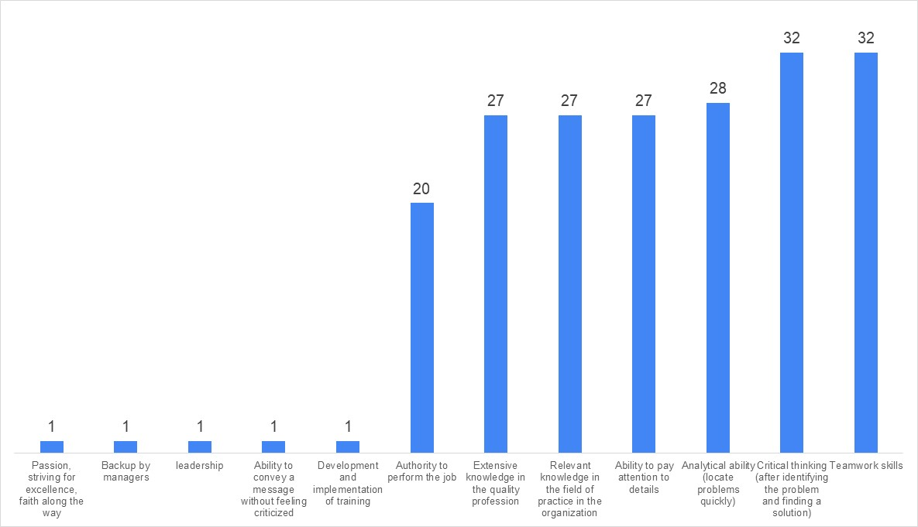

Figure 4: What characteristics reflect your role in the organization?[1]

What is success? What is failure? What is the added value of the perspective of quality engineers? We examine these issues through the following questions (Appendix A):

* How would you define success in the job?
* How would you define failure in a job?
* What is your added value in the organization?

Analysis of the attitude survey revealed that in the opinion of those engaged in quality, success refers to repeated themes: with change and improvement of quality through organizational culture, repeated most often (a result consistent with the earlier study by Anker); raising awareness of quality, recruiting management to the issue and employing a knowledge person for the organization, with all management and employees as partners who understand and care about quality (repeated 11 times); examination and improvement of processes from data collection and analysis: assimilation of work processes as a way of life, reduction of invalidities and customer complaints, failure to repeat a mistake (repeated 4 times); meeting customer requirements, for example, so that the customer and not the product returns; customer retention; reduction of customer complaints; zero malfunctions (repeated 6 times); achievement of the goals and objectives of the organization, for example, involvement and influence in achieving the goals of the organization (repeated 4 times); colleague discourse, such as field inquiries and open discourse; peer inquiries for advice and help; and, finally, achieving goals and objectives (repeated 3 times).

It was anticipated that analysis of the attitude survey on the issue of failure would reveal results contrary to those related to success. The opinions of respondents about failure in the quality field referred to themes that had already repeated several times, with organizational culture raised most frequently. The main issues mentioned in the survey included lack of recognition of quality; quality out of fear; authority due to position and not out of recognition that quality is important; the voice of quality not being heard in management and organizational decisions; performing the tasks required by law or regulation standard only, management’s not seeing any value in the position (repeated 10 times); many disqualifications, defective product reaches the customer due to a failure in quality processes that were not identified by the quality department within the framework of internal audits; a decrease in production yields; multiple customer complaints, (repeated 5 times); failure to meet organization or customer goals (repeated twice); quality perceived as something “interfering”; lack of influence; and failure to provide value to stakeholders.

Analysis of the survey revealed that, in the opinion of respondents, value-added quality refers to themes which also have been repeated several times. Here, improved processes and reduced repetitive costs appeared most often. The main points included: saving; improving motivation and satisfaction among employees (repeated 9 times); work across the organization; raising awareness of the issue and importance of quality; assisting management in promoting a quality approach in processes; and identifying and flooding gaps (repeated 6 times); contributing to the business goals of the organization (repeated 4 times); improving processes and reducing costs; savings; process flow; business achievements; improved employee experience, with high potential to bring the organization to new heights via creative, original thinking, requiring fewer resources from fewer departments.

In conclusion, the findings of the study show that in the opinion of the respondents, success in the field of quality requires knowledge and professionalism in the field. This success depends on "soft" traits and organizational culture.

# Conclusions

This is the third article written about the status of the quality engineer, in view of non-quality events that took place in Israel and around the world, affecting the trust of customers and consumers, and resulting in discussion of the weighty issues regarding the professional ethics of quality engineers. In this study, the basic assumptions of the previous two studies were re-examined, namely that the role of a quality engineer depends on organizational culture (Anker, 2019; 2020), meaning that success depends largely on management support in light of the long-term results of quality processes in the organization. In addition, it is difficult to examine the success of safety programs in the short term and therefore, unsubstantiated statements that a professional and authoritative quality engineer can reduce and/or prevent incidents of non-quality abound.

Analysis of the results of the survey of the attitudes and verbal comments of the participants revealed that most of the participants believe there is a correlation between professionalism and the degree of success in the job. They identified the characteristics that reflect the role of the quality engineer as: ability to pay attention to detail, teamwork skills and analytical ability. On the other hand, relevant knowledge in the field of quality received a low ranking. For most participants, success entailed changing and raising awareness of quality, working with partners, and understanding quality. Failure was defined by pursuing quality out of fear and authority and not out of the recognition that quality is important and added value includes savings, improving motivation and satisfaction among employees, introducing the issue and importance of quality, helping management reflect quality, and identifying and filling gaps.

The differences between the research hypotheses are due to the fact that although the respondents believe that knowledge and professionalism in the field of quality are necessary, they are also required to know and apply different communication styles at work across the organization, with success depending on motivating people to implement necessary changes. Thus, according to participants, it is very difficult to measure success in achieving quality, which is the very essence of the field.

# REFERENCES

Abbott, A. (1988). *The System of Professions: An Essay on the Division of Expert Labor*. Chicago, IL: University of Chicago Press.

Anker, S. (2019). Expertise and authority in the work of a quality engineer. Thesis submission work.

Anker, S. (2020). The impact of the COVID-19 crisis on quality management in organizations.

Ekroni, M. (2012). ‘Facing Forward to Quality’, *Quality and Excellence Journal of the Israeli Society for Quality*, 51: 26–9 [Hebrew].

Ekroni, M. (2012). “Challenges and Ways to Empower the Quality Manager,” *Quality and Excellence Journal of the Israeli Association for Quality*, 50: 12–14 [Hebrew].

Etzioni, A. (1969). *The Semi-Professions and their Organisation*: *Teachers, Nurses, Social Workers.* New York: Free Press

Gal, M & Nir, T. (2020).

[The future of automation is not? (Corona condition)](https://automation.co.il/%d7%a2%d7%aa%d7%99%d7%93-%d7%94%d7%90%d7%95%d7%98%d7%95%d7%9e%d7%a6%d7%99%d7%94-%d7%a2%d7%aa%d7%99%d7%93-%d7%94%d7%91%d7%93%d7%99%d7%a7%d7%95%d7%aa-%d7%9c%d7%90%d7%9f/)

In principle, and in full (2012). With the face forward. Quality: Journal of Quality and Excellence of the Israeli Quality Association, 51, 26–29.

In principle, and in full, (2012). Challenges and ways to empower the quality manager. Journal of Quality and Excellence of the Israeli Quality Association, 50, 12–14.

Halevi, A. (2017)*. Assimilation of Knowledge and Quality Methods in Industry*. 35th Annual Conference of the Israeli Tel Aviv Quality Association, November 2017

Parker, M. (2000). *Organizational Culture and Identity*. London: Sage.

Ronen, Z. (2013). “Does Your Company Need Quality Management?’ *Business Excellence*, May 5 <https://business-excellence.co.il/blog/126-do-you-need-a-quality-manager> accessed 7 September 2019.

State of Israel v. Bar-Ilan et al. (2000). <[shalhevetold.co.il/pub//psak%20din/psak_makabiya.doc](https://www.google.co.il/url?sa=t&rct=j&q=&esrc=s&source=web&cd=1&ved=2ahUKEwi3tfqf0vfdAhXRMewKHcuYBI0QFjAAegQIAhAC&url=http%3A%2F%2Fshalhevetold.co.il%2Fpub%2F%2Fpsak%2520din%2Fpsak_makabiya.doc&usg=AOvVaw0KpnL6wMbHbnK2eBEv3gY1)> accessed 7 September 2019.

Schein, E.H. (2004).*Organizational Culture and Leadership*, 3th edition. San Francisco: Jossey Bass.

Schein, E.H. (1990). “Organizational Culture,” *American Psychologist*.

Weber, M. (1968). *Economy and Society*. Berkeley, CA: University of California Press.

Zonnenschein, A. (2016). “We Must Uproot the Culture of the Loose Slapdash in the Food Industry,” *The Marker* <https://www.themarker.com/opinion/1.3103885> accessed 7 September 2019.

A survey to examine success in a job that deals with quality

<https://docs.google.com/forms/d/e/1FAIpQLSc5FY8uzMkLUDtZG0-oMhWfpWsans_a0Eh4yDlWUuRzpBkxHw/viewform?usp=sf_link>

1. [[Top 10 Characteristics of Quality Managers (accountlearning.com)](https://accountlearning.com/top-10-characteristics-quality-managers/)](https://www.infinityqs.com/blog/january-2019/11-skills-your-quality-team-needs-to-have) 