|  |  |  |  |  |  |  |  |  |  |  |
| --- | --- | --- | --- | --- | --- | --- | --- | --- | --- | --- |
| ***Table 1:*** *Participant demographic and background characteristics (N=58)* | | | | | | | | | | |
|  | |  | |  | |  | |  | ***Statistical comparison*** | |
| **Variant** | | **All sample**  **(n=58)** | | **TYP**  **(n=30)** | | **ASD**  **(n=28)** | |  | ***Statistic*** | ***p*** |
| **Gender, N (%)** | |  |  |  |  |  |  |  | 2 (1) = 0.10 | .746 |
| **Boys** | | 35 | (60.3%) | 17 | (56.7%) | 18 | (64.3%) |  |  |  |
| **Girls** | | 23 | (39.7%) | 13 | (43.3%) | 10 | (35.7%) |  |  |  |
| **Age** | | 9.92 | ).59( | 9.83 | ).65( | 10.02 | ).52( |  | *t* (56) = 1.19 | .238 |
| **Vocabulary** | | 56.10 | (38.55) | 58.30 | (7.97) | 43.07 | (9.41) |  | *t* (56) = 6.67 | <.001 |
| **RAVEN** | | 30.76 | (4.22) | 31.47 | (3.46) | 30.00 | (4.86) |  | *t* (56) = 1.33 | .189 |

|  |  |  |  |  |  |  |  |
| --- | --- | --- | --- | --- | --- | --- | --- |
|  | TYP  (n=30) | |  | ASD  (n=28) | |  | |
| **Dependent variable** | *M* | *SD* |  | *M* | *SD* | *F (1,55)* | $$η_{p}^{2}$$ |
| Idiom understanding | 17.33 | 2.96 |  | 10.57 | 3.90 | 6.78* | .110 |
| Irony understanding | 13.87 | 1.69 |  | 6.64 | 2.57 | ***64.58 | .540 |
| Social situation understanding | 8.30 | 1.76 |  | 4.54 | 1.57 | ***15.72 | 222. |
| ToM | 18.70 | 1.97 |  | 10.68 | 3.52 | ***39.99 | 421. |
| *Note*: TYP: the group with typical development. ASD: the group diagnosed on the autism spectrum.  * *p* < 0.05, *** *p* < 0.001. | | | | | | | |

***Table 2:*** *Means, standard deviations, and one-way MANCOVA analysis findings when examining differences in understanding of idioms, irony, and social understanding situations among groups (N=58)*

***Figure 1:*** *Adjusted means for idiom, irony, and social situation understanding and ToM (N=58)*

z

ToM

|  |  |  |  |  |  |  |
| --- | --- | --- | --- | --- | --- | --- |
| ***Table 3:*** *Pearson correlations and supervised correlations between the index of social situation understanding and the indices of figurative language understanding* | | | | | | |
|  |  | **TYP** | |  | **ASD** | |
|  |  | **Idiom understanding** | **Irony understanding** |  | **Idiom understanding** | **Irony understanding** |
| Social situation understanding | Pearson correlations | ***81. | ***69. |  | ***68. | ***72. |
|  | Supervised correlations | .43* | .35* |  | 20. | .74*** |
| *Note:* TYP: the group with typical development. ASD: the group diagnosed with Autism. Supervised correlations were calculated while controlling for measured vocabulary. | | | | | | |

|  |  |  |  |  |  |  |  |  |  |
| --- | --- | --- | --- | --- | --- | --- | --- | --- | --- |
|  | | | | | | | | | |
| ***Table 4:*** *Summary of regression models for predicting the understanding of idioms and irony* | | | | | | | | | |
|  | **Dependent variables** | | | | | | | | |
|  | Idioms understanding | | | |  | Irony understanding | | | |
| **Predictor variables** | *B* | *SE* | *Beta* | *p* |  | *B* | *SE* | *Beta* | *p* |
| **Step I** |  |  |  |  |  |  |  |  |  |
| Gender | .28 | 1.31 | .03 | .834 |  | .24 | 1.13 | .03 | .835 |
| Age | -1.11 | 1.09 | -.14 | .316 |  | -1.56 | .94 | -.22 | .104 |
| $$R^{2}$$ | .019 |  |  | .597 |  | .048 |  |  | .262 |
| **Step II** |  |  |  |  |  |  |  |  |  |
| Non-verbal intelligence | .12 | .08 | .11 | .111 |  | -.17 | .10 | -.17 | .085 |
| Vocabulary | .35 | .03 | .84 | **<.001** |  | .31 | .04 | .83 | **<.001** |
| $$ΔR^{2}$$ | .810 |  |  | **<.001** |  | .573 |  |  | **<.001** |
| $$R^{2}$$ | .829 |  |  | **<.001** |  | .620 |  |  | **<.001** |
| **Step III** |  |  |  |  |  |  |  |  |  |
| Research groups | .80 | .48 | .17 | .101 |  | .83 | .27 | .20 | .003 |
| Social situation understanding | .67 | .88 | .14 | .452 |  | .73 | .49 | .17 | .144 |
| ToM | .09 | .76 | .02 | .907 |  | 2.96 | .43 | .70 | **<.001** |
| $$ΔR^{2}$$ | .028 |  |  | **.028** |  | .321 |  |  | **<.001** |
| $$R^{2}$$ | .857 |  |  | **<.001** |  | .942 |  |  | **<.001** |
| **Step IV** |  |  |  |  |  |  |  |  |  |
| Social situation understanding | -.28 | .79 | -.04 | .724 |  | .32 | .43 | .05 | .464 |
| ToM | .36 | .94 | .04 | .700 |  | .04 | .52 | .01 | .938 |
| $$ΔR^{2}$$ | .000 |  |  | .924 |  | .002 |  |  | .456 |
| $$R^{2}$$ | .857 |  |  | **<.001** |  | .944 |  |  | **<.001** |

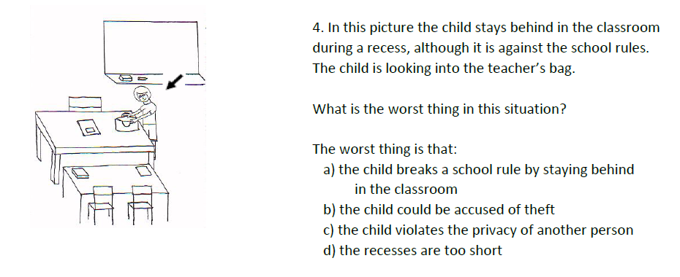

1. .‏
2. Vulchanova, M., Saldaña, D., Chahboun, S., & Vulchanov, V. (2015). Figurative language processing in atypical populations: The ASD perspective. *Frontiers in Human Neuroscience*, *9*, 24.‏