Names: \_\_\_\_\_\_\_\_\_\_\_\_\_\_\_\_\_\_\_\_\_\_\_\_\_\_\_\_\_\_\_\_\_\_\_\_\_\_\_\_\_\_\_\_\_\_\_\_\_\_\_\_\_\_\_\_\_

**Translate these words together with a partner:**

|  |  |
| --- | --- |
| advisor - | nectar - |
| disappointed - | powerful - |
| embarrass - | real flower - |
| fake flowers - | to solve riddles - |
| feast - | to sting - |
| guard(s) - | whispered - |

**Organize the words according to categories:**

|  |  |  |
| --- | --- | --- |
| Noun | Adjective | Verb |
|  |  |  |
|  |  |  |
|  |  |  |
|  |  |  |
|  |  |  |
|  |  |  |
|  |  |  |

|  |
| --- |
|  |
|  |
|  |
|  |
|  |

**Together, write what you think the story will be about based on the words you just defined.**

King Solomon and the Queen of Sheba

**Have you heard of King Solomon or the Queen of Sheba? Do you know who they were and where they lived? In the following table indicate yes/no/I don’t know.**

|  |  |  |  |
| --- | --- | --- | --- |
|  | Yes | No | I don’t know |
| 1. King Solomon was the king of Sheba. |  |  |  |
| 1. He was able to communicate with animals. |  |  |  |
| 1. The Queen of Sheba was very beautiful. |  |  |  |
| 1. The Queen sent a note to King Solomon. |  |  |  |
| 1. The Queen of Sheba lived in Ethiopia. |  |  |  |
| 1. The Queen of Sheba wanted to meet King Solomon. |  |  |  |
| 1. King Solomon decided to visit Ethiopia. |  |  |  |

**Now read this short passage and check your answers.**

**1. What new information did you learn about King Solomon and the Queen of Sheba?**

**2. Mark it in the text with a colored marker / highlighter.**

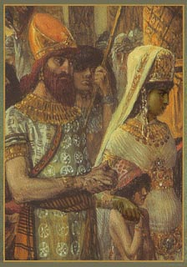The Bible states that King Solomon was the greatest king of Israel because of the great wisdom that God had given him. It is said that King Solomon knew the languages of all the animals and ruled over them. He sent birds to explore the world and tell him of what they saw. One day, a bird came and told him of an amazing sight: a great city far away in Ethiopia, ruled by a woman, the Queen of Sheba, who was not only beautiful but also wise. King Solomon wrote a message on a scroll, tied it to the leg of the bird, and sent it to the Queen.

One morning in Ethiopia, the Queen of Sheba was climbing up the stairs when suddenly a bird flew to her with a scroll tied to its foot. She opened it and read about this great and wise king. The Queen very much wanted to know more about King Solomon so she said to herself, "I must go and see this great king."

It took her seven years to get there, but when she finally met King Solomon he was far greater than she had expected. The Queen was impressed with the King's wisdom as he was with her beauty. The Queen therefore decided to learn about King Solomon’s wisdom.

**Word Bank**

|  |  |  |
| --- | --- | --- |
| wisdom חכמה | amazing מדהים | rule (v)שלט |
| expected ציפה | impressed הרשים | scroll קלף |
|  |  |  |
|  |  |  |

BD14710_

At the end of this passage we read that the Queen of Sheba wanted to learn about King Solomon’s wisdom. You are going to read the fable “The King and the Bee,” which tells us of King Solomon’s wisdom.

**The story we are going to read contains many new words. Do you know them?**

**Read the following sentences to learn the new words.**

**By matching the Hebrew words to the English words in the table below, you will learn the meaning of the new vocabulary.**

1. The King had an ***advisor*** to help him make decisions.
2. I was***disappointed*** because my friend didn’t visit me yesterday.
3. Speak kindly to your friends, otherwise you might ***embarrass*** them.
4. I don’t have to water these flowers, they aren’t ***real***. They are made of silk. They are ***fake flowers***.
5. There is a big ***feast*** at the palace. Everyone is invited to dinner.
6. The ***guards*** always stand at the gates of the palace. They don’t let strangers come in.
7. Real flowers have ***nectar***. The bees love to drink it.
8. He is a ***powerful*** person. He has great influence over many people’s lives.
9. A wise man can ***solve*** many ***riddles***.
10. Do not catch that bee. If you do, it may ***sting*** you.

|  |  |
| --- | --- |
| advisor | 1. שומר (שומרים) |
| disappointed | 1. לעקוץ |
| embarrass | 1. לחש |
| fake flowers | 1. חזק (רב עצמה) |
| feast | 1. מביך |
| guard(s) | 1. לפתור חידות, תעלומות |
| nectar | 1. משתה, סעודה |
| powerful | 1. פרחים לא אמתיים |
| real flower | 1. פרח אמיתי |
| solve riddles | 1. צוף |
| to sting | 1. מאוכזב/ת |
| whispered | 1. יועץ |

**Before reading the fable** (**(אגדה, look at the following questions. The answers to these questions will give you a summary of the text. Write your summary by using the graphic organizer below.**

Why did the Bee ask King Solomon to save him?

Who wanted to show everyone that King Solomon was not wise?

What happened on the day of the feast?

There were 99 of them. What were they?

There was only one. What was it?

How did King Solomon prove his wisdom to the Queen of Sheba?

**Graphic Organizer**

**Summarize the fable in your words by completing the diagram below:**

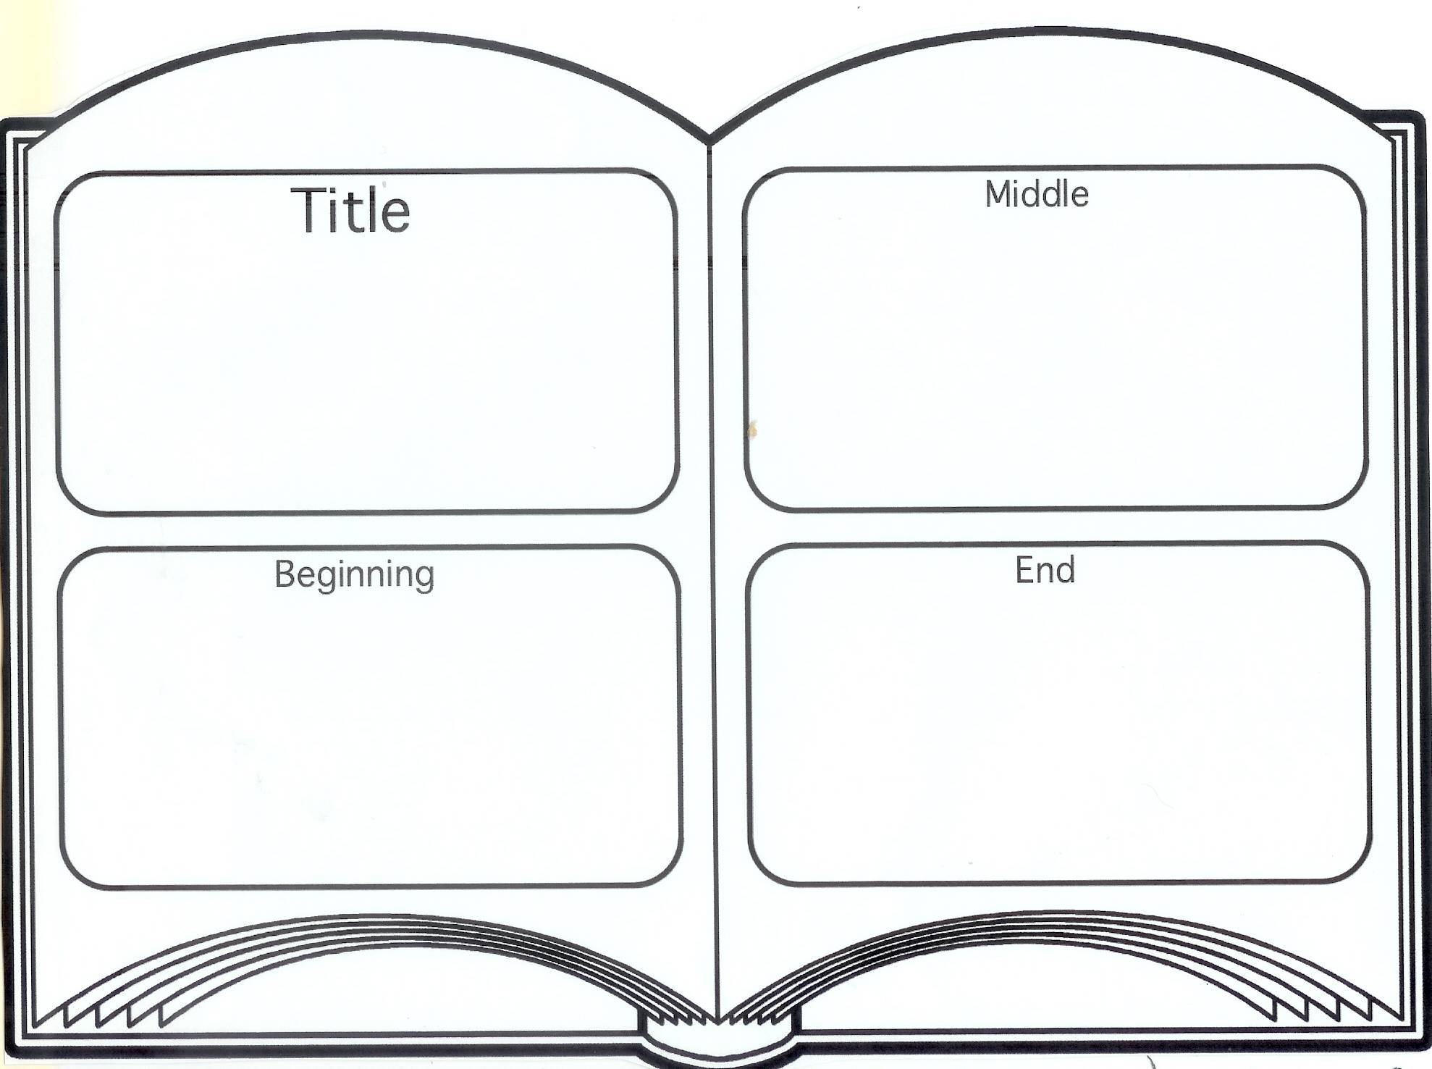

The King and the Bee

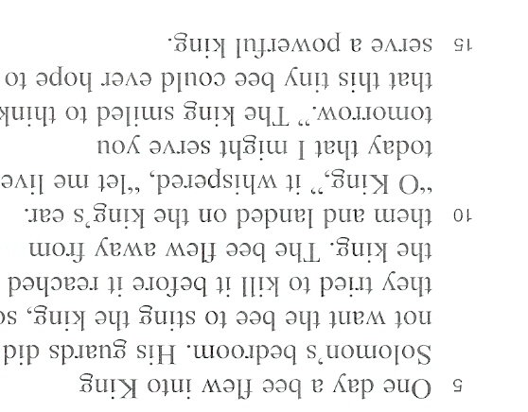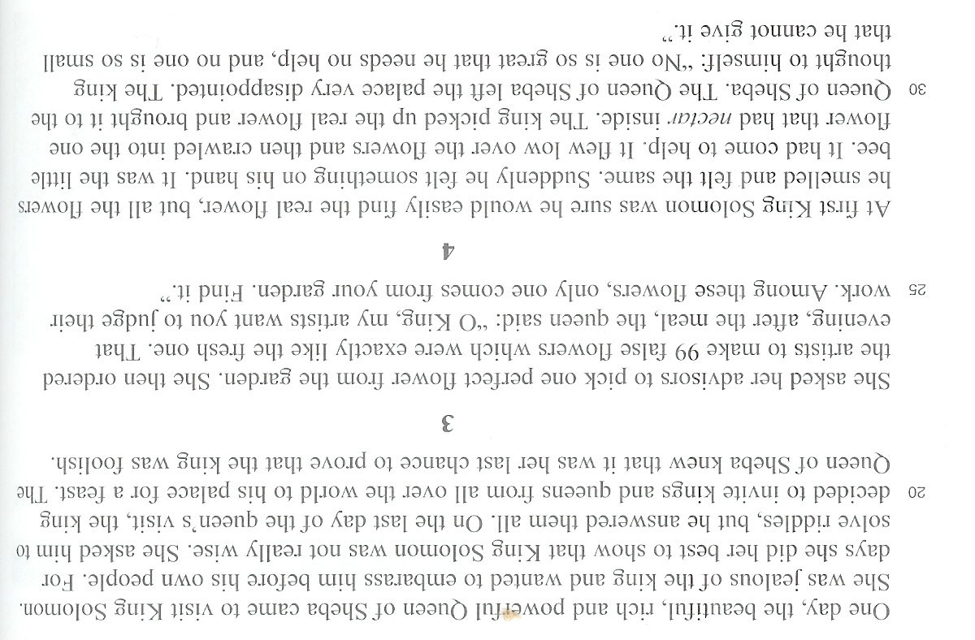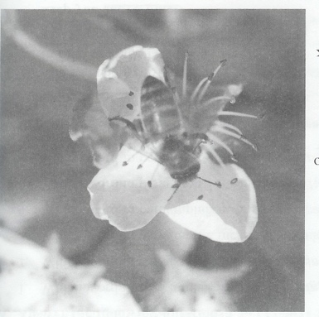

2

**Let us learn more about the fable by completing the following tasks:**

A fable is a story that usually has animal characters that behave like humans. The characters may be wise or foolish. A fable describes a problem that the characters try to solve, and the end of the fable shows the moral or lesson to be learned from the story.

What animal(s) or living creatures are mentioned in this story? \_\_\_\_\_\_\_\_\_\_\_\_\_\_\_\_\_\_\_\_\_\_\_\_\_\_\_\_\_  
\_\_\_\_\_\_\_\_\_\_\_\_\_\_\_\_\_\_\_\_\_\_\_\_\_\_\_\_\_\_\_\_\_\_\_\_\_\_\_\_\_\_\_\_\_\_\_\_\_\_\_\_\_\_\_\_\_\_\_\_\_\_\_\_\_\_\_\_\_\_\_\_\_\_\_\_\_\_\_.

What is the problem that the King has to solve? \_\_\_\_\_\_\_\_\_\_\_\_\_\_\_\_\_\_\_\_\_\_\_\_\_\_\_\_\_\_\_\_\_\_\_\_\_\_\_\_\_  
\_\_\_\_\_\_\_\_\_\_\_\_\_\_\_\_\_\_\_\_\_\_\_\_\_\_\_\_\_\_\_\_\_\_\_\_\_\_\_\_\_\_\_\_\_\_\_\_\_\_\_\_\_\_\_\_\_\_\_\_\_\_\_\_\_\_\_\_\_\_\_\_\_\_\_\_\_\_\_.

What is the lesson learned in this fable? (Quote from the fable or write in your own words.)

\_\_\_\_\_\_\_\_\_\_\_\_\_\_\_\_\_\_\_\_\_\_\_\_\_\_\_\_\_\_\_\_\_\_\_\_\_\_\_\_\_\_\_\_\_\_\_\_\_\_\_\_\_\_\_\_\_\_\_\_\_\_\_\_\_\_\_\_\_\_\_\_\_\_\_\_\_\_\_\_\_\_\_\_\_\_\_\_\_\_\_\_\_\_\_\_\_\_\_\_\_\_\_\_\_\_\_\_\_\_\_\_\_\_\_\_\_\_\_\_\_\_\_\_\_\_\_\_\_\_\_\_\_\_\_\_\_\_\_\_\_\_\_\_\_\_\_\_\_\_\_\_\_\_\_\_\_\_

Who is the “great one” and who is the “small one”?\_\_\_\_\_\_\_\_\_\_\_\_\_\_\_\_\_\_\_\_\_\_\_\_\_\_\_\_\_\_\_\_\_\_\_\_\_\_\_  
\_\_\_\_\_\_\_\_\_\_\_\_\_\_\_\_\_\_\_\_\_\_\_\_\_\_\_\_\_\_\_\_\_\_\_\_\_\_\_\_\_\_\_\_\_\_\_\_\_\_\_\_\_\_\_\_\_\_\_\_\_\_\_\_\_\_\_\_\_\_\_\_\_\_\_\_\_\_

Do you think King Solomon could have found the “real” flower without the help of the bee? \_\_\_\_\_\_\_  
\_\_\_\_\_\_\_\_\_\_\_\_\_\_\_\_\_\_\_\_\_\_\_\_\_\_\_\_\_\_\_\_\_\_\_\_\_\_\_\_\_\_\_\_\_\_\_\_\_\_\_\_\_\_\_\_\_\_\_\_\_\_\_\_\_\_\_\_\_\_\_\_\_\_\_\_\_\_

In your own words, explain what King Solomon learned from the bee: \_\_\_\_\_\_\_\_\_\_\_\_\_\_\_\_\_  
\_\_\_\_\_\_\_\_\_\_\_\_\_\_\_\_\_\_\_\_\_\_\_\_\_\_\_\_\_\_\_\_\_\_\_\_\_\_\_\_\_\_\_\_\_\_\_\_\_\_\_\_\_\_\_\_\_\_\_\_\_\_\_\_\_\_\_\_\_\_\_\_\_\_\_\_

Write the names of other fables you know. Write the lessons you learned from the fables you mention.

|  |
| --- |
|  |
|  |
|  |
|  |
|  |
|  |
|  |
|  |
|  |
|  |

**(The reading passage is taken from Eric Cohen’s book ‘More Unseens 3.’)**