Pre-reading activities:

1: Match the captions to the pictures:

- a woman from Gondar in a traditional white dress
- preparing ‘injera’ on an outdoor fire
- a decorated mud hut
- two Ethiopian children
- the big city of Addis Ababa
- a straw hut

2: *Look at some of the new vocabulary.
*Find the new vocabulary in the text. Can you translate the words? (Use the pictures as clues).
*If you can’t translate the words, use your dictionary.

photographs |  | sticks
special occasions |  | straw
traditional |  | statues
decorated |  | ovens
beads |  | jewelry
photographs |  | language
activities

3: Arrange the words in alphabetical order (optional activity):

4. Complete the KWL Chart:

What I know about Ethiopia: | What I want to know: | What I learned from the story:
4: You are ready to read ‘Our Family Album’.
While reading, answer the questions above each section.

A: Who are the two friends?
Where did they live five years ago?
They brought something special with them from Ethiopia. What was it?

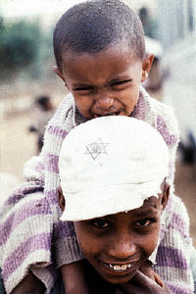
Orit, a young girl, and Rada, a young boy, are two friends who came to Israel about five years ago. When they came to Israel they brought along few belongings, but they did manage to bring their family album with many photographs. They invite people to look at their album in order to learn about the Jewish children of Ethiopia.

Before they came to Israel, both children lived in a Jewish village in the Gondar area in Ethiopia. Both children still speak Amharic, the language of Ethiopia. In Amharic, Rada’s name means “he shall help”, and Orit’s name means “the law of the Bible".

B: What is special about this picture?
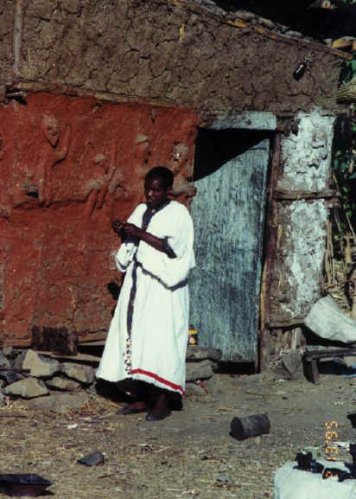
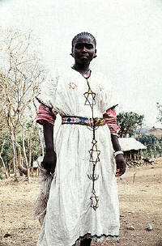
On special occasions, men and women in Ethiopian villages would wear traditional white Ethiopian dress as they still do now in Israel. The women in Ethiopia would also decorate their white dresses with beads and jewelry – often adorned with the symbol of the Magen David (Star of David).

C: Find words that describe life in an Ethiopian village.

Life in the village was not easy, but nevertheless everyone carried out their daily routine. The little huts they lived in were made of sticks, straw, sometimes mud, and they did not have bathrooms. Instead of soft beds, they slept on straw mats on the floor.

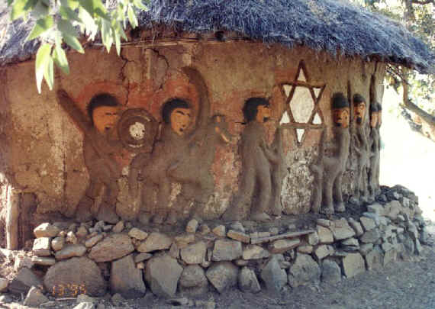
Some families had bigger homes made of mud. They decorated their homes by paintings and beautiful sculptures – often incorporating the Magen David.

D: The woman is making something. What is it?
Why isn’t she cooking in her kitchen?

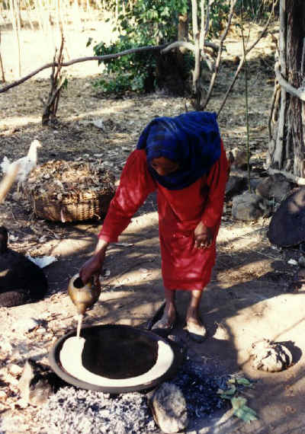
In the villages they did not have big kitchens with big ovens. Instead the women would cooked on an open fire outside their hut. In the picture a woman is preparing ‘injera’ – a slightly sour "gummy" pancake made from flour.

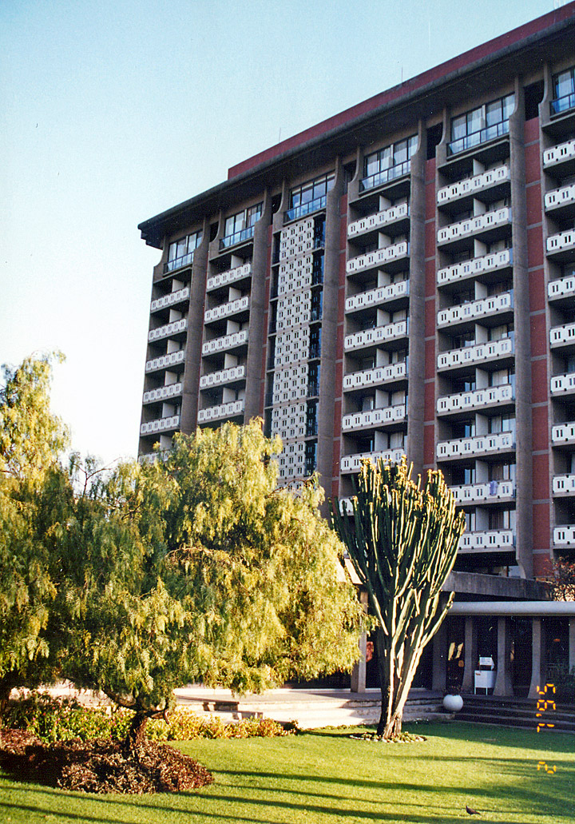
E: Where is this picture taken?
Why is it in Orit and Rada’s Family Album?

Before coming to Israel, the Jewish Agency brought our families and many other families to Addis Ababa. Because people don’t speak Amharic in Israel, we spent a few months at an ulpan learning Hebrew. The teachers at the ulpan prepared us for our new and different life in Israel.
After reading the text:

Compare Ethiopian life in Gondar to Ethiopian life in Israel

 | Gondar | Israel
traditional dress
houses
bedrooms
kitchens
bathrooms
spoken language

Matching – Match part A of the sentence to part B

- Orit and Rada brought | white and decorated with beads and a Magen David.
- They came from a small Jewish | were very simple and had no kitchens.
- Ethiopian traditional dress is | a family album with them from Ethiopia.
- The mud and straw homes | a sour pancake made from flour.
- Injera is | some time in Addis Ababa before coming to Israel.
- Orit and Rada’s families spent | village in Gondar

Find the past forms of the following verbs in the text.

Base / Present | Past Form | Base / Present | Past Form
arrive |  | have
come |  | sleep
wear |  | are
is |  | bring
make |  | spend

What colors are in the Ethiopian flag? (If you do not know, ask Google!)
_______________________________________________________
As long as you are there, ask Google what other countries have those colors in their flag. What do most of those countries have in common?
________________________________________________________________________________________________________________________

Now read this:

Did you know?
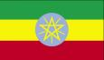
The Ethiopian flag is green, yellow and red. The round emblem (סימן) is a blue disk, known as the National Coat of Arms. In the blue disk is a pentagram (כוכב מחמש) and single yellow rays emanating (נובע) from the angles between the points.
It is intended to reflect the desire of the nations, nationalities, and peoples of Ethiopia, as well as of its religious communities, to live together in unity and equality.

Other African countries have adopted the colors of the Ethiopian flag which have become known as “The Pan-African Colors”.

http://www.ethioworld.com/CountryInformation/ethiopianflag.htm

What do you THINK the colors represent? Write your guesses in the left side of the table.
What I think….
Green
Yellow
Red

Now use Google again to see how close you were, and copy down the information you find:

