**The effect of cluster size on the intra-cluster ionic polymerization process**

Estefania Rossich Molina1 and Tamar Stein1

Fritz Haber Research Center for Molecular Dynamics, The Hebrew University of Jerusalem, Jerusalem, Israel, 9190401

*Corresponding author: tamar.stein@mail.huji.ac.il, tel: +972-2-658-6108

**Abstract**

Polyaromatic hydrocarbons (PAHs) are widespread in the interstellar medium (ISM). The abundance and relevance of PAHs call for a clear understanding of their formation mechanisms, which, to date, have not been completely deciphered. Of particular interest is the formation of benzene, the basic building block of PAHs. It has been shown that ionization of neutral clusters can lead to an intra-cluster ionic polymerization process that results in molecular growth. *Ab initio* molecular dynamics (AIMD) studies in clusters consisting of 3–6 units of acetylene modeling ionization events under ISM conditions have shown maximum aggregation of three acetylene molecules forming bonded C6H6+ species: the larger the number of acetylene molecules, the higher the production of C6H6+. These results lead to the question of whether clusters bigger than those studied thus far promote aggregation beyond three units of acetylene, and whether larger clusters can result in higher C6H6+ production. In this study, we report results from AIMD simulations modeling the ionization of 10 and 20 acetylene clusters. The simulations show aggregation of up to four acetylene units producing bonded C8H8+. Interestingly, C8H8+ bicyclic species were identified, setting precedent for their astrochemical identification. Comparable reactivity rates were shown with 10 and 20 acetylene clusters.

**Keywords:** acetylene – polycyclic aromatic hydrocarbons – interstellar medium – molecular growth – benzene – *Ab initio* molecular dynamics – van der Waals clusters – ion-molecule reactions – astrochemistry

**Introduction:**

Polyaromatic hydrocarbons (PAHs) are widespread in the interstellar medium (ISM).1-3 They are believed to be ubiquitous and abundant in space, with interstellar IR spectra providing evidence of their presence in different areas by identifying their characteristic features in the spectra.4-7 PAHs serve as a bridge between small organic molecules and large carbonaceous materials,8 and thus play an important role in the chemical evolution of the ISM.

Routes for the formation of PAHs and other organic molecules known to be present in the interstellar medium are not thoroughly understood. Various mechanisms for PAH formation and growth have been suggested, based on, for example, radical reactions.9-15 One such example is the well-known hydrogen abstraction C2H2 addition (HACA) mechanism, which is based on two steps: the first is the formation of the aryl radical, and the second is the addition of acetylene. Repetition of these two steps results in PAH formation. Other studies suggest the formation of naphthalene via reaction of the phenyl radical and vinylacetylene, or, alternatively, via the formation of naphthalene ion through ion-molecule reactions between benzene cation and ethynyl radical.16 The formation of benzene, the basic building block of PAHs, has drawn a great deal of attention. Different pathways for its formation have been proposed, depending on the physical and chemical conditions.17-20 Jones et al. suggested a barrierless route for benzene formation via reaction of the ethynyl radical and 1,3-butadiene, which is relevant to areas such as the Taurus Molecular Cloud (TMC-1).21 In several astrochemical models, routes for the formation of benzene are based on ion-molecule reactions15, 22-25. Recently, Zhao et al. showed that molecular growth processes can occur via the reaction between two stabilized propargyl radicals at high temperature and diluted environments. Such a reaction can lead to the formation of benzene molecules among other species.26

A number of experiments have demonstrated that the molecular growth can occur via the intra-cluster ionic polymerization process.27-40 Acetylene clusters have been the starting point of multiple experiments and, upon ionization of these clusters, covalently bonded structures, such as benzene and cyclobutadiene cations, have been observed. In addition, molecular growth has been observed experimentally for a cluster of ethynylbenzene, where ionization leads to the formation of larger covalently bonded structures.32

To understand the intra-cluster ionization process at the molecular level, several studies performed *ab initio* molecular dynamics (AIMD) simulations modeling different neutral cluster compositions. In agreement with experimental work, AIMD simulations demonstrated that the molecular growth process occurs and that covalently bonded structures are formed.38, 41-43 It has been shown that, upon ionization, part of the cluster forms covalently bonded core structures, while the remaining molecules serve as spectators of the process. The role of spectator molecules is important for the growth process, as these molecules change the potential energy surfaces and thus play a catalytic role for the formation of various core structures. Moreover, spectator molecules enable stabilization routes, as they can dissipate the excess energy via evaporation.38, 42 For example, upon ionization of acetylene clusters containing up to six acetylene units, the formation of bonded C4H4+ and C6H6+ including benzene cation was also observed.38 Ionization of small clusters (up to five units) containing acetylene and hydrogen cyanide also lead to molecular growth, in which three and four units bonded to form structures on the potential energy surfaces of C6H6+, C5H5N+, C7H7N+, and C8H8+. Likewise, when the clusters are built from acetylene and cyanoacetylene units, building blocks that can be found in TMC-1, the ionization process leads to bonding between three and four units.41 Many of the structures that are formed are aromatic structures and contain a nitrogen atom within the ring or as a side chain; thus the structures are important from an astrobiological point of view. Among the formed structures we observed was benzonitrile cation, which was recently identified in its neutral form in TMC-1.44

AIMD results from previous studies demonstrate the importance of the composition and size of the cluster in promoting aggregation to give chemically bonded structures. In reference to pure acetylene clusters, in particular, it has been demonstrated that the larger clusters (five and six acetylene units) enable higher rates of bonded C6H6+ formation in comparison to the smaller ones (three and four acetylene units).38 Here, we focus on the study of pure acetylene clusters to understand the influence of a large number (10 and 20, significantly larger than the six clusters studied to date) of acetylene molecules in the aggregation process that produces (C2H2)n+ species following ionization of the van der Waals clusters. Specifically, our aim is to investigate the effect of cluster size on the percentage of C6H6+ produced in the larger clusters versus the smaller ones. Additionally, we examine the extent of molecular growth in the larger clusters.

**Results:**

In order to answer the aforementioned questions, we studied large van der Waals clusters containing 10 and 20 units of acetylene. We built 40 structures: 20 decamers and 20 eicosamers (10 and 20 acetylene units, respectively), considering different relative orientations of the acetylene molecules that maximize the CH- $π$ interaction between hydrogen and the $π$ clouds of neighboring acetylenes, and then optimized them to obtain minima on the neutral potential energy surface (PES).40 Fig. 1 shows examples of a decamer structure (Fig. 1a) and an eicosamer structure (Fig. 1b). The complete set of coordinates corresponding to the optimized AIMD starting structures are available in the SI. In order to model the ionization process, the optimized neutral structures were utilized as starting structures in the molecular dynamic simulations on the cationic PES.

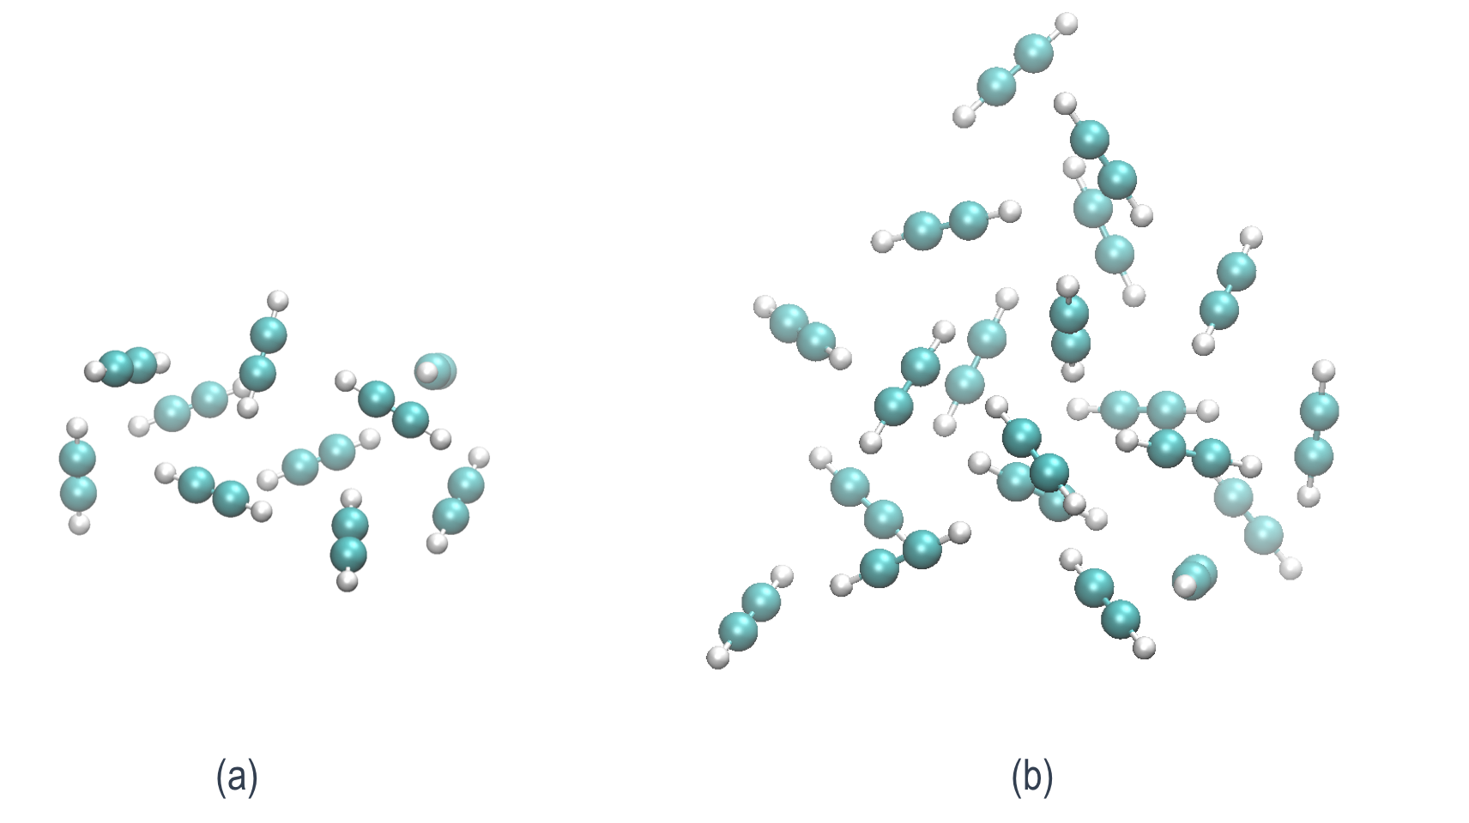

Fig. 1. Pure neutral acetylene clusters consisting of a) 10 units of acetylene (decamer) and b) 20 units of acetylene (eicosamer).

The neutral cluster geometries are nonoptimal after vertical ionization, and they relax on the cationic PES, yielding to bonded structures. Fig. 2 presents the structures after optimization on the cationic PES. In both cases (decamer and eicosamer), the clusters relax to core bonded structures in the C4H4+, C6H6+, and C8H8+ PES (Fig. 2a, b, and c for the decamer, and Fig. 2d, e, and f for the eicosamer) without any barrier. The core structures are solvated by additional nonbonded acetylene molecules. We note that the largest core structure that is formed upon optimization is a bonded C8H8+. The coordinates of all 40 optimized cationic isomers are reported in the SI.

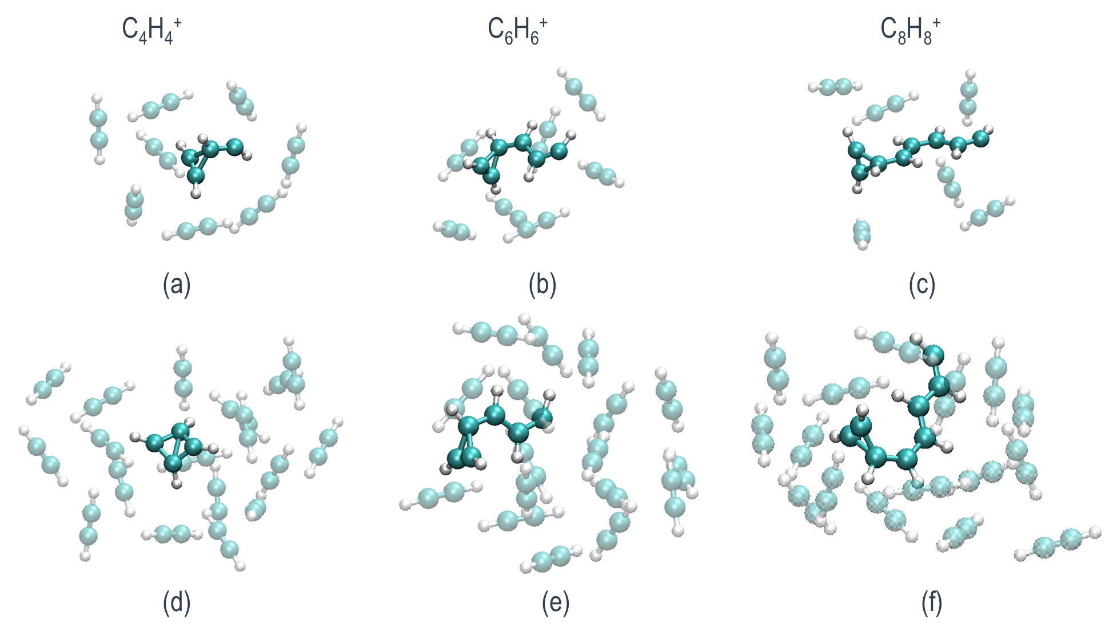

Fig. 2 (a), (b), and (c) are decamer clusters optimized on the cationic PES with C4H4+, C6H6+, and C8H8+ core bonded structures, respectively; (d), (e), and (f) correspond to the eicosamer clusters that also show C4H4+, C6H6+, and C8H8+ core bonded structures.

**AIMD Simulations**

Following ionization and formation of the core structures, the system contains a large amount of excess energy (~5 eV) that can be utilized to cross barriers on the PES. In order to study the evolution of the systems in time, and the potential formation of different products upon ionization, we use AIMD. The results of the AIMD simulations shed light on the structures that can be formed at the end of this process, and the relative probability of their formation. The structures of the most relevant mono- and bicyclic molecules obtained are presented, and a comparison is made between the decamers and eicosamers as well as smaller acetylene van der Waals clusters previously studied by means of AIMD under similar conditions.38 We analyze the extent of the molecular growth as a function of the number of acetylene molecules in a cluster, and conclude the relevance of the present results in understanding PAH formation routes and astrochemical identification of cyclic molecules.

**AIMD of the acetylene decamer clusters**

For each of the 20 starting structures, 30 trajectories were run, totaling 600 trajectories. All trajectories were performed for 2.4 ps. For trajectories ending in structures where further potential rearrangements or growth were suspected, simulation time was extended up to 4.8 ps. The resulting core structures are shown in Fig. 3. From the 600 trajectories for this cluster size, we found that 56.5% of the trajectories lead to molecules product of the reaction of 2 units of acetylene to give bonded C4H4+. The vast majority of the C4H4+ species produced correspond to cyclobutadiene (Fig. 3a), while a minor percentage is methylenecyclopropane (Fig. 3b). In other trajectories, which represent 40.8% of the trajectories, three units of acetylene react to give bonded C6H6+. Multiple C6H6+products were identified. Among them are benzene (Fig. 3h) and its conformational isomers fulvene (Fig. 3e), dewar-benzene (Fig. 3f), and benzvalene (Fig. 3g), all of which are known to easily interconvert into benzene. In a previous study, these products were also identified in the products from the ionization of clusters up to hexamer, although in smaller percentages.38 Interestingly, here we observe a higher percentage of the trajectories leading to bonded C6H6+, which reinforces the important role played by the cluster environment. In the remaining ~2.7% of the trajectories, we observe the aggregation of four acetylene molecules to give bonded C8H8+. While other cluster compositions (namely, mixed acetylene with HCN and cyanoacetylene) enable bonding between four units,41, 43 C8H8+ species were not obtained from the acetylene hexamers previously studied, clearly demonstrating that more than six acetylene units are required to observe aggregation beyond C6 structures from a pure acetylene cluster.38, 42 Again, this emphasizes the role of the cluster environment, not only for stabilization of the products, but also in their formation.

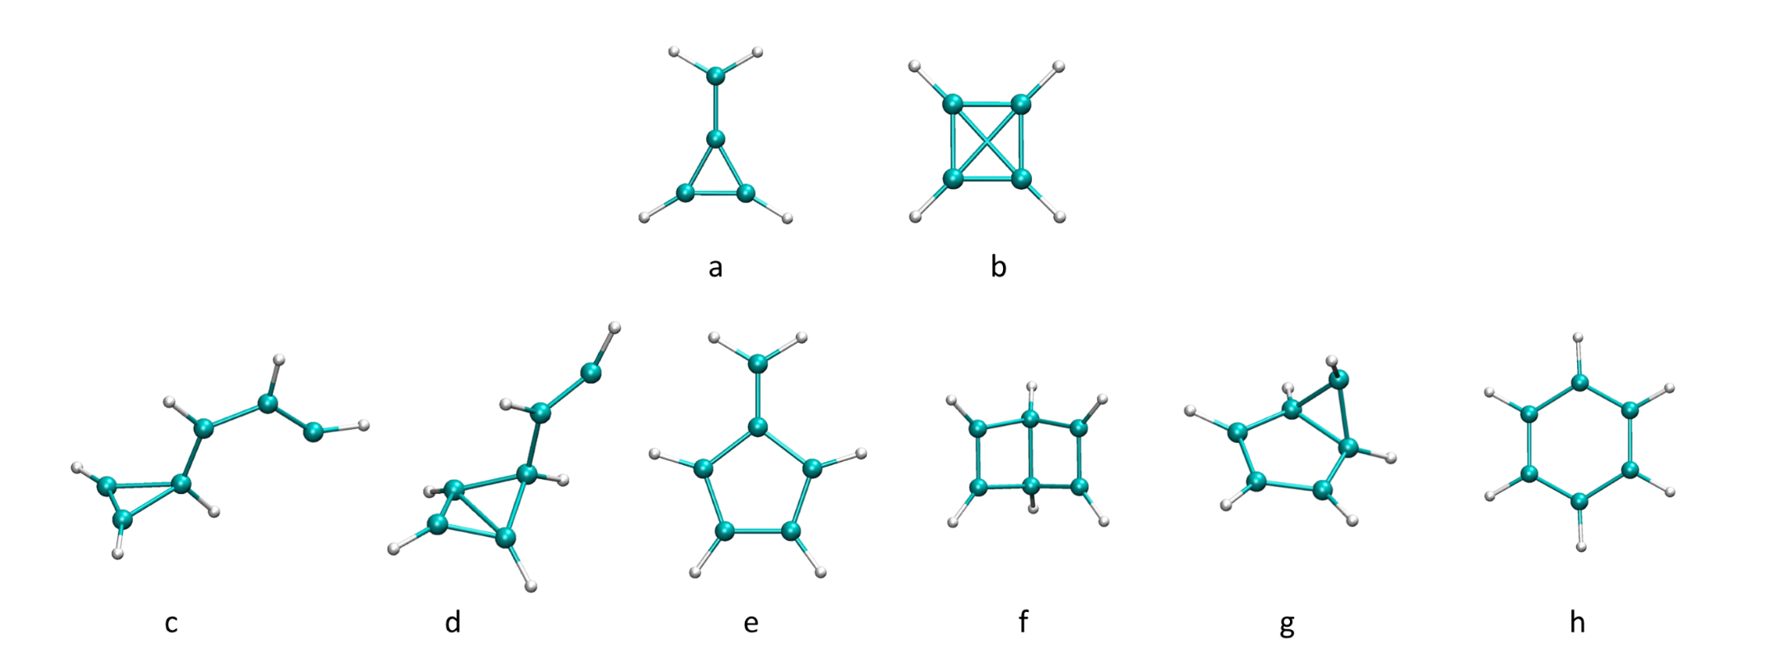

Fig. 3. Optimized bonded C4H4+ and C6H6+ core structures.

The biggest bonded structures obtained correspond to the aggregation of four acetylene units to give C8H8+ isomers, shown in Fig. 4. Among these products, we detected structures that contain a three-member (Fig. 4a) or four-member (Fig. 4b) ring, as observed in the C4H4+ and C6H6+ structures. Trajectories leading to C8H8+ were extended for an additional 2.4 ps. At these longer times, C8H8+ products further react, giving bicyclic products with five- and three- (Fig. 4c), five- and four- (Fig. 4d), five- and five- (Fig. 4e), and six-and four- (Fig. 4f) member ring structures. In the literature, C8H8+ is attributed to a benzene cation complexed to an acetylene molecule, which we also observed in our simulations.33 The PES for the formation of the structure in Fig. 4f is presented in Fig. 5, along with the corresponding time of occurrence of each structure during simulation time. At the first stages of the simulation, two acetylene molecules are bonded together, and a three-member ring structure (Fig. 5, 252 fs) is formed. This resembles the association product of acetylene and its cation, observed by Bera et al.45 Afterwards, an additional bond forms with a neighboring acetylene molecule, resulting in a bicyclic structure (Fig. 5, 584 fs), which later reorganizes to a three-member cyclic structure with a long chain (Fig. 5, 1067 fs). A similar structure is also seen when all four acetylene molecules are bonded (Fig. 5, 1592 fs). We observed a transition to a four-member ring (Fig. 5, 1729 fs), which reorganizes to give the final product.

A bicyclic C8H8+ molecule with five- and three-member rings (Fig. 4c) was observed in two of the trajectories. One of them dissociates in a later stage into C5H5 and c-C3H3+, which was experimentally detected,46 and its direct observation in the ISM is only feasible via ro-vibrational transitions due to the absence of pure rotational transitions.46

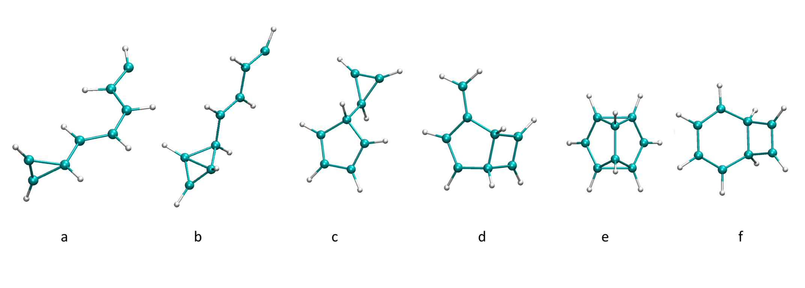

Fig. 4. Optimized bonded C8H8+ core structures.

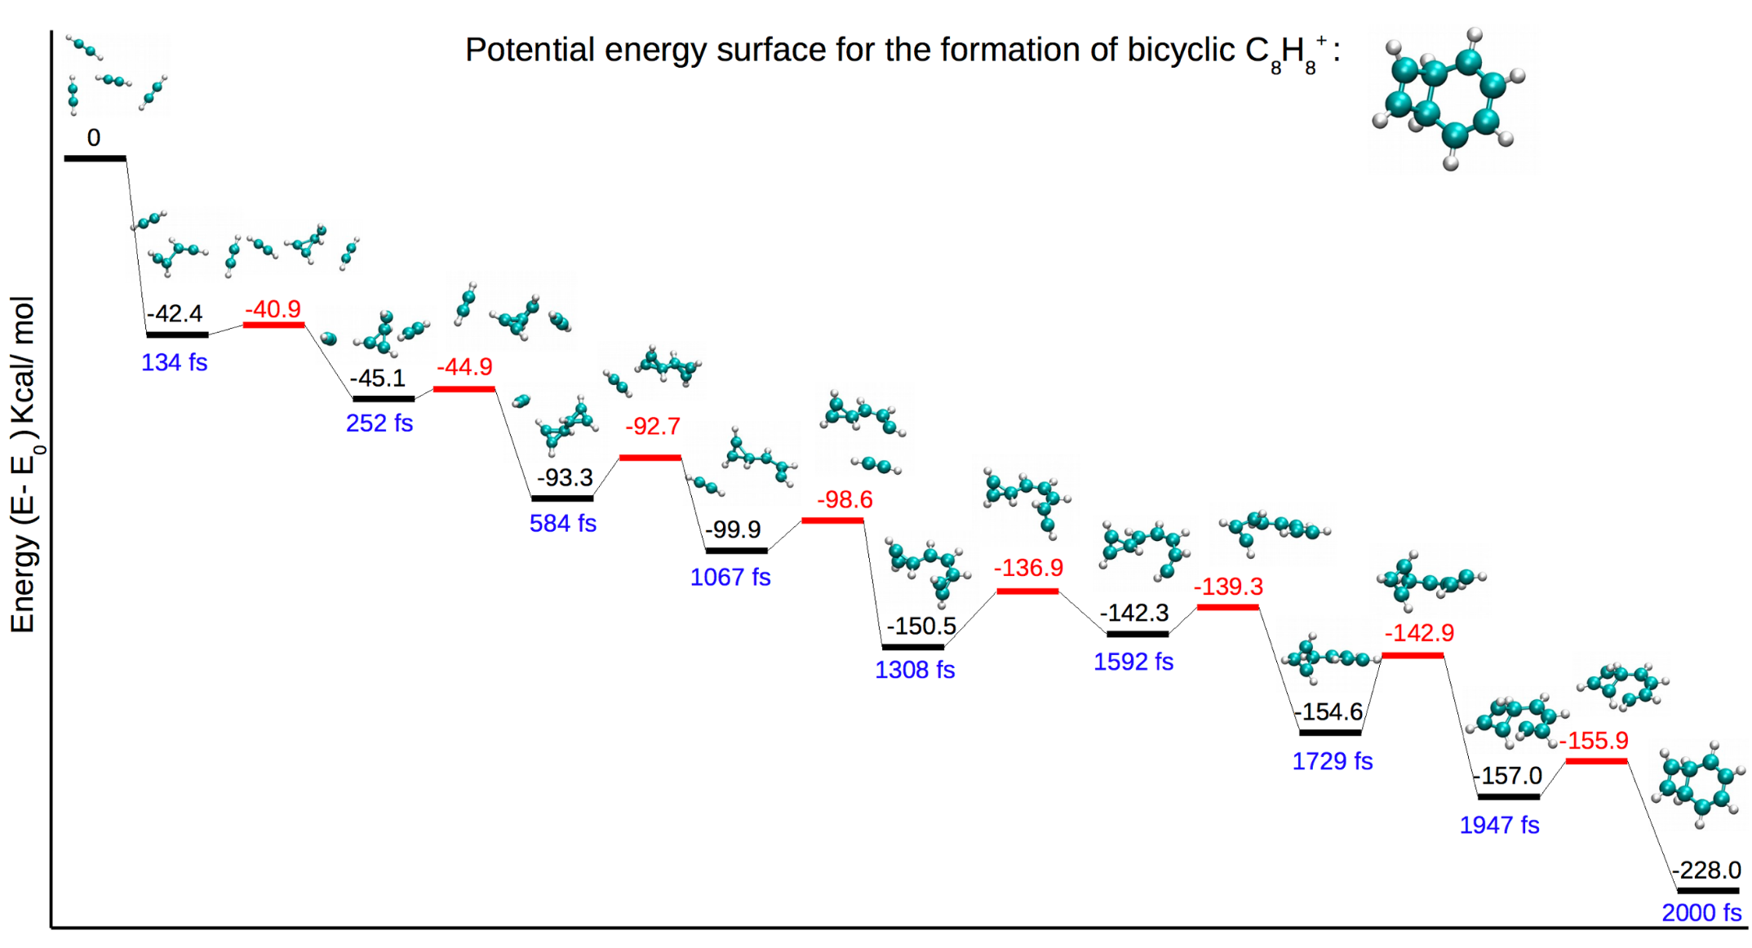

Fig. 5. Potential energy surface for the production of bicyclic C8H8+ structure containing a four- and six-member ring. The minima energies are reported in black, and the transition state energies in red. The corresponding time of each structure during molecular dynamics trajectory is noted in blue.

**Comparison of the growth process in different cluster sizes:**

Starting from 20 eicosamer optimized structures, we ran a total of 600 trajectories at 2.4 ps. The results for this cluster size are similar to those obtained for the decamer clusters; no additional structures were found when the AIMD started from the eicosamer clusters. Fig. 6 shows a comparison of the amount of core structures obtained at the end of the AIMD simulations of different cluster sizes consisting of six, 10, and 20 acetylene units. In the case of the hexamer clusters, it can be seen that the majority of trajectories formed C4H4+ core structures, while the rest of the trajectories formed C6H6+ core structures. No C8H8+ structure was observed. In the case of the decamer and eicosamer clusters, more C6H6+ was obtained with respect to the hexamer clusters. Additionally, these cluster sizes enable the formation of C8H8+ structures that were not observed in the smaller clusters. In fact, a previous photoionization mass spectrometry study demonstrates that C8H8+ can be obtained from acetylene, and is identified by a peak at *m/z* = 104.38 The percentages for the formation of different structures are similar for the decamers and eicosamers; no significant difference is observed between them.

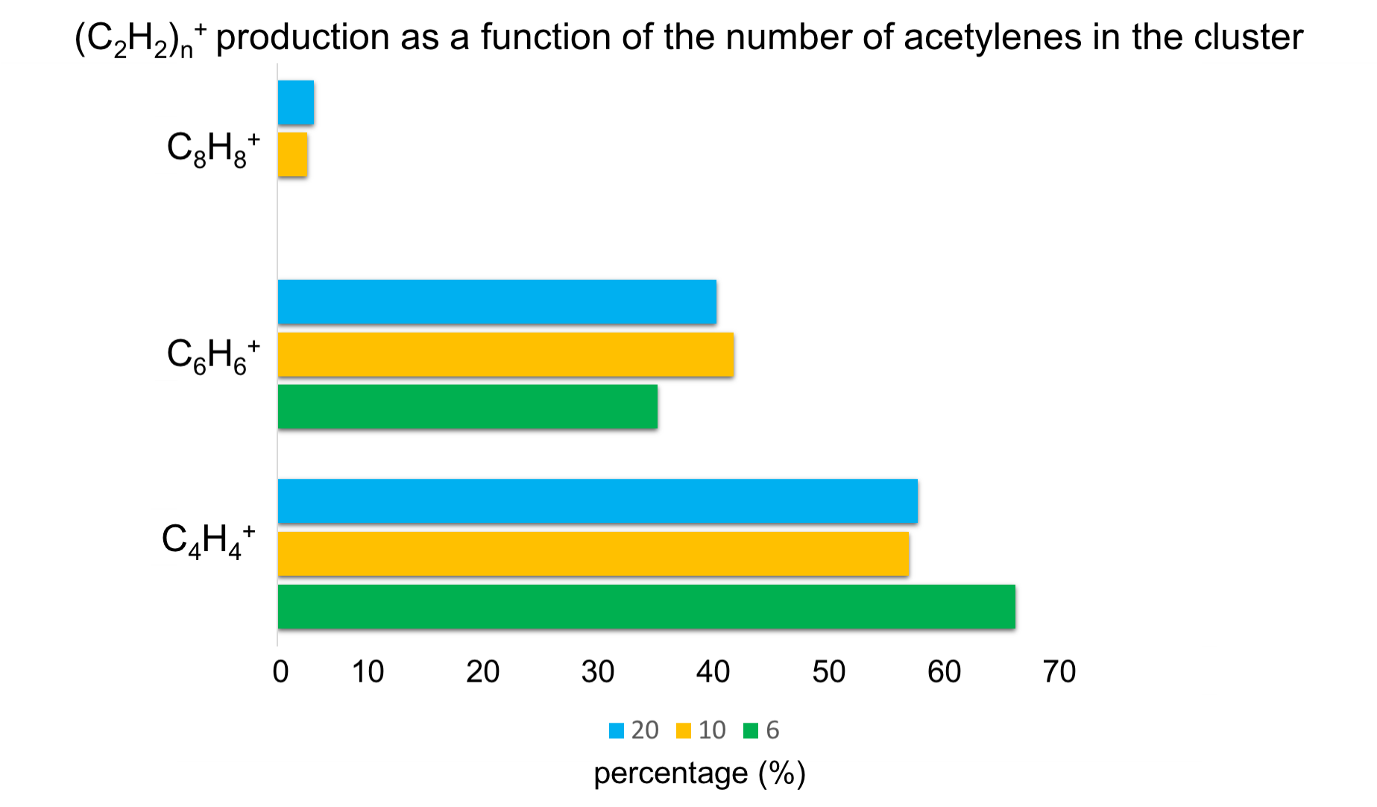

Fig. 6. Histogram of the percentage of (C2H2)n+ n = 2–4 bonded structures obtained upon ionization of the clusters as a function of the number of acetylene molecules in them. Percentages for six acetylene molecules were taken from the literature.38 The percentages for 10 and 20 acetylene molecules correspond to the results in the present work.

The C6H6+/C4H4+ ratio is a way to express the capacity of molecular growth in acetylene clusters. A previous study found that C6H6+/C4H4+ is ~0.3 for acetylene dimers and trimers, and C6H6+/C4H4+ is ~0.5 for tetramers and pentamers.38 Here, we find that C6H6+/C4H4+ = 0.7 for decamers and eicosamers. Fig. 7 summarizes the trend of the C6H6+/C4H4+ ratio for pure acetylene clusters as a function of the number of acetylenes, and is an adaptation of a figure from a previous work38 in order to add the results from the present study. Again, the results demonstrate that a growing number of acetylene spectator molecules in a cluster promote the molecular growth process by the process described above. As can be seen from the figure, decamers and eicosamers present comparable reactivity; eicosamers do not lead to further aggregation (e.g., C10H10+ and beyond) despite having double the number of acetylenes. This suggests that the addition of acetylene molecules to the large clusters’ environment (beyond the decamers studied here) does not affect the environment substantially, and does not prompt additional growth. We note, however, that it is also plausible that clusters containing species other than acetylene can be involved in catalyzing the formation of structures larger than C8H8+.

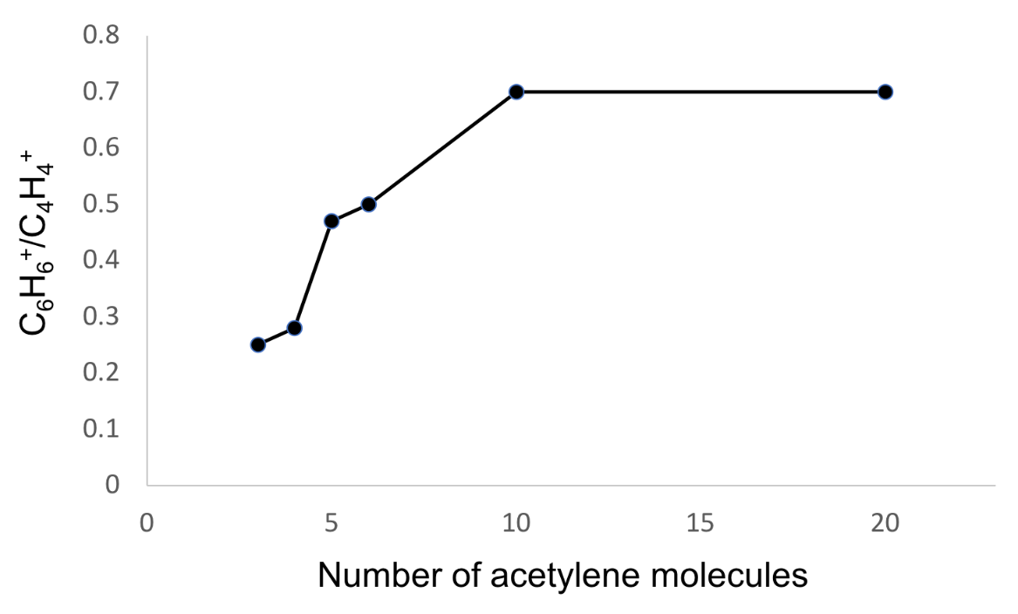

Fig. 7. C6H6+/C4H4+ ratio as a function of the number of acetylene units in the cluster.

**Conclusion**

We studied ionic polymerization processes on large clusters containing 10 and 20 acetylene molecules in conditions relevant to the ISM by means of AIMD. Our results reinforce the observations of previous studies on clusters consisting of 3–6 acetylene units, i.e., an increased number of spectator acetylenes promote molecular growth. We observed a larger C6H6+/C4H4+ ratio for decamers and eicosamers than what was previously found for acetylene clusters up to hexamer. Additionally, we observed C8H8+ structures that were not obtained from smaller clusters (consisting of 3–6 units of acetylene). Eicosamer clusters exhibit results similar to the decamer clusters, demonstrating that the additional 10 acetylene molecules do not significantly influence the environment to promote further growth. Moreover, we predict the formation of mono- and bicyclic structures with formulas (C2H2)n+ n = 2–4 produced by ionic polymerization processes that can serve as a guide for astronomers in search of new molecules in the ISM.

**Materials and Methods:**

Every calculation in this manuscript was performed using Q-Chem 5.1 software.47 Optimizations of neutral and cationic structures were done with the wB97X-V functional48 and cc-pVTZ basis set.49 Using the same level of theory, we performed vibrational frequency calculations to categorize the structures as minima or saddle points on the PES.

Starting from the optimized minima structures of isomers of clusters consisting of 10 or 20 units of acetylene, we ran AIMD simulations on the cationic PES utilizing the ωB97 functional50 and 6-31G* basis set.51 The initial velocities for the dynamics were the corresponding thermal ones to the randomly sampled temperatures in the range 30–80 K. Each of the 30 trajectories for each isomer was run for ~2.4 ps (time step = 1.21fs) unless otherwise stated. Twenty different starting structures were considered per system size (decamer and eicosamer), giving a total of 1200 trajectories.

**Conflicts of interest**

The authors declare no conflicts of interest.

**Acknowledgments**

This work was supported by the Israel Science Foundation, Grant number 1941/20.

**Graphical Abstract**

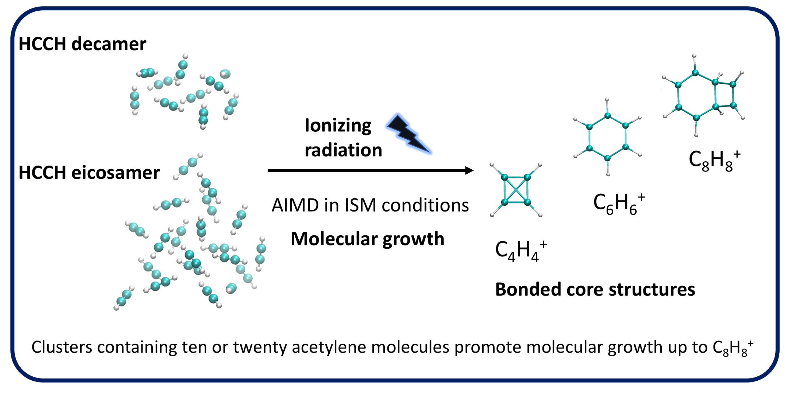

**References**

1. Ehrenfreund, P.; Sephton, M. A., Carbon molecules in space: from astrochemistry to astrobiology. *Faraday Discussions* **2006,** *133* (0), 277-288.

2. Rhee, Y. M., et al., Charged polycyclic aromatic hydrocarbon clusters and the galactic extended red emission. *Proceedings of the National Academy of Sciences of the United States of America* **2007,** *104* (13), 5274-5278.

3. Joblin, C.; Mulas, G., Interstellar polycylic aromatic hydrocarbons: from space to the laboratory. *Eas Publications* **2009,** *35*, 133-152.

4. Leger, A.; Puget, J. L., Identification of the 'unidentified' IR emission features of interstellar dust? *Astronomy and Astrophysics* **1984,** *137* (1), L5 - L8.

5. Allamandola, L. J., et al., Interstellar polycyclic aromatic hydrocarbons - The infrared emission bands, the excitation/emission mechanism, and the astrophysical implications. *Astrophysical Journal Supplement Series* **1989,** *71*, 733-775.

6. Tielens, A. G. G. M., Interstellar Polycyclic Aromatic Hydrocarbon Molecules. *Annual Review of Astronomy and Astrophysics* **2008,** *46* (1), 289-337.

7. Sellgrem, K., The near-infrared continuum emission of visual reflection nebulae. *Astrophysical Journal, Part 1* **1984,** *277*, 623-633.

8. Puget, J. L.; Léger, A., A new component of the interstellar matter: small grains and large aromatic molecules. *Annual Review of Astronomy and Astrophysics* **1989,** *27* (1), 161-198.

9. Frenklach, M.; Wang, H., Twenty-Third Symposium (International) on CombustionDetailed modeling of soot particle nucleation and growth. *Symposium (International) on Combustion* **1991,** *23* (1), 1559-1566.

10. Bittner, J. D.; Howard, J. B., Eighteenth Symposium (International) on Combustion Composition profiles and reaction mechanisms in a near-sooting premixed benzene/oxygen/argon flame. *Symposium (International) on Combustion* **1981,** *18* (1), 1105-1116.

11. Wang, H.; Frenklach, M., Calculations of rate coefficients for the chemically activated reactions of acetylene with vinylic and aromatic radicals. *The Journal of Physical Chemistry* **1994,** *98* (44), 11465-11489.

12. Marinov, N. M., et al., Aromatic and polycyclic aromatic hydrocarbon formation in a laminar premixed n-butane flame. *Combustion and Flame* **1998,** *114* (1–2), 192-213.

13. Parker, D. S. N., et al., Hydrogen abstraction/acetylene addition revealed. *Angewandte Chemie International Edition* **2014,** *53* (30), 7740-7744.

14. Hopf, H., From acetylenes to aromatics: novel routes – novel products. In *Modern Arene Chemistry*, Wiley-VCH Verlag GmbH & Co. KGaA: 2004; pp 169-195.

15. Peverati, R., et al., Nucleophilic Aromatic Addition in Ionizing Environments: Observation and Analysis of New C–N Valence Bonds in Complexes between Naphthalene Radical Cation and Pyridine. *Journal of the American Chemical Society* **2017,** *139* (34), 11923-11932.

16. Ghesquière, P.; Talbi, D., On the formation of naphthalene cation in space from small hydrocarbon molecules: A theoretical study. *Chemical Physics Letters* **2013,** *564*, 11-15.

17. Paul, M. W.; Karen, W., Benzene formation in the inner regions of protostellar disks. *The Astrophysical Journal Letters* **2007,** *655* (1), L49.

18. Woods, P. M., The formation of benzene in dense environments. *EAS Publications Series* **2011,** *46*, 235-240.

19. C. Brown, R. F., Some developments in the high temperature gas phase chemistry of alkynes, arynes and aryl radicals. *European Journal of Organic Chemistry* **1999,** *1999* (12), 3211-3222.

20. Hopf, H., et al., Formation of isobenzenes by thermal isomerization of 1,3-hexadiene-5-yne derivatives. *Angewandte Chemie International Edition in English* **1997,** *36* (11), 1187-1190.

21. Jones, B. M., et al., Formation of benzene in the interstellar medium. *Proceedings of the National Academy of Sciences* **2011,** *108* (2), 452-457.

22. Murray, J. M., et al., New H and H2 reactions with small hydrocarbon ions and their roles in benzene synthesis in dense interstellar clouds. *The Astrophysical Journal* **1999,** *513* (1), 287.

23. Paul, M. W., et al., The synthesis of benzene in the proto-planetary nebula CRL 618. *The Astrophysical Journal Letters* **2002,** *574* (2), L167.

24. Kaiser, R. I., et al., Reaction dynamics in astrochemistry: low-temperature pathways to polycyclic aromatic hydrocarbons in the interstellar medium. *Annual Review of Physical Chemistry* **2015,** *66* (1), 43-67.

25. Yang, Y., et al., Mechanism for the formation of benzene in the Titan’s atmosphere: A theoretical study on the mechanism of reaction. *Computational and Theoretical Chemistry* **2012,** *991*, 66-73.

26. Zhao, L., et al., Gas-phase synthesis of benzene via the propargyl radical self-reaction. *Science Advances* **2021,** *7* (21), eabf0360.

27. Tzeng, W. B., et al., A study of the unimolecular decomposition of the (C2H4)+3 complex. *The Journal of Chemical Physics* **1985,** *83* (6), 2813-2817.

28. Ono, Y.; Ng, C. Y., A study of the unimolecular decomposition of the (C2H2)3+ complex. *Journal of the American Chemical Society* **1982,** *104* (18), 4752-4758.

29. Shinohara, H., et al., Photoionization mass spectroscopic studies of ethylene and acetylene clusters: intracluster excess energy dissipation. *The Journal of Physical Chemistry* **1990,** *94* (17), 6718-6723.

30. Booze, J. A.; Baer, T., The photoionization and dissociation dynamics of energy‐selected acetylene dimers, trimers, and tetramers. *The Journal of Chemical Physics* **1993,** *98* (1), 186-200.

31. Coolbaugh, M. T., et al., Intracluster polymerization reactions within acetylene and methylacetylene clusters ions. *The Journal of Physical Chemistry* **1992,** *96* (23), 9139-9144.

32. Momoh, P. O., et al., Formation of covalently bonded polycyclic hydrocarbon ions by Intracluster polymerization of ionized ethynylbenzene clusters. *The Journal of Physical Chemistry A* **2014,** *118* (37), 8251-8263.

33. Momoh, P. O., et al., Structure of the C8H8•+ radical cation formed by electron impact ionization of acetylene clusters. Evidence for a (Benzene•+·Acetylene) complex. *The Journal of Physical Chemistry Letters* **2011,** *2* (19), 2412-2419.

34. Momoh, P. O., et al., Structure and hydration of the C4H4•+ ion formed by electron impact ionization of acetylene clusters. *The Journal of Chemical Physics* **2011,** *134* (20), 204315.

35. Momoh, P. O.; El-Shall, M. S., Stepwise hydration of ionized acetylene trimer. Further evidence for the formation of benzene radical cation. *Chemical Physics Letters* **2007,** *436* (1–3), 25-29.

36. Momoh, P. O., et al., Polymerization of ionized acetylene clusters into covalent bonded ions:  evidence for the formation of benzene radical cation. *Journal of the American Chemical Society* **2006,** *128* (38), 12408-12409.

37. Relph, R. A., et al., Structural characterization of (C2H2)1–6+ cluster ions by vibrational predissociation spectroscopy. *The Journal of Chemical Physics* **2009,** *131* (11), 114305.

38. Stein, T., et al., Ab initio dynamics and photoionization mass spectrometry reveal ion-molecule pathways from ionized acetylene clusters to benzene cation. *Proc Natl Acad Sci USA* **2017,** *114* (21), E4125-E4133.

39. Ahmed, M.; Kostko, O., From atoms to aerosols: probing clusters and nanoparticles with synchrotron based mass spectrometry and X-ray spectroscopy. *Physical Chemistry Chemical Physics* **2020,** *22* (5), 2713-2737.

40. Bandyopadhyay, B., et al., Probing Ionic Complexes of Ethylene and Acetylene with Vacuum-Ultraviolet Radiation. *The Journal of Physical Chemistry A* **2016,** *120* (27), 5053-5064.

41. Jose, J., et al., Molecular dynamics reveals formation path of benzonitrile and other molecules in conditions relevant to the interstellar medium. *Proceedings of the National Academy of Sciences* **2021,** *118* (19), e2101371118.

42. Stein, T.; Jose, J., Molecular Formation upon Ionization of van der Waals Clusters and Implication to Astrochemistry. *Israel Journal of Chemistry* **2020,** *60*, 1-9.

43. Stein, T., et al., Molecular growth upon ionization of van der Waals clusters containing HCCH and HCN is a pathway to prebiotic molecules. *Physical Chemistry Chemical Physics* **2020,** *22* (36), 20337-20348.

44. McGuire, B. A., et al., Detection of the aromatic molecule benzonitrile (c-C6H5CN) in the interstellar medium. *Science* **2018,** *359* (6372), 202.

45. Bera, P. P., et al., Association mechanisms of unsaturated C2 hydrocarbons with their cations: acetylene and ethylene. *Physical Chemistry Chemical Physics* **2013,** *15* (6), 2012-2023.

46. Zhao, D., et al., LABORATORY GAS-PHASE DETECTION OF THE CYCLOPROPENYL CATION (c-C 3 H 3 + ). *The Astrophysical Journal* **2014,** *791* (2), L28.

47. Shao, Y., et al., Advances in molecular quantum chemistry contained in the Q-Chem 4 program package. *Molecular Physics* **2015,** *113* (2), 184-215.

48. Mardirossian, N.; Head-Gordon, M., [small omega]B97X-V: A 10-parameter, range-separated hybrid, generalized gradient approximation density functional with nonlocal correlation, designed by a survival-of-the-fittest strategy. *Physical Chemistry Chemical Physics* **2014,** *16* (21), 9904-9924.

49. Dunning , T. H., Jr, Gaussian basis sets for use in correlated molecular calculations. I. The atoms boron through neon and hydrogen. *The Journal of Chemical Physics* **1989,** *90* (2), 1007-1023.

50. Chai, J.-D.; Head-Gordon, M., Systematic optimization of long-range corrected hybrid density functionals. *The Journal of Chemical Physics* **2008,** *128* (8), 084106.

51. Rassolov, V. A., et al., 6-31G* basis set for atoms K through Zn. *The Journal of Chemical Physics* **1998,** *109* (4), 1223-1229.