**4.4 Electromagnetic Fields**

**4.4.1 Electromagnetic fields from the railway route**

This chapter presents a theoretical characterization of electromagnetic field safety for humans, and the effects on land uses and designations resulting from the potential creation of interference in areas near the Metro Line M2 railway infrastructure. Data on the metro line currents was provided by SYSTRA for Metro Line M3. The assessments presented in this document are based on the assumption that Metro Line M2 and M3 have identical data regarding regular current and overcurrent passing through their electrification strips. The calculated flux data was compared to the exposure criteria for checking compliance with standards and regulation requirements.

**4.4.1.1 Criteria for human exposure to electromagnetic fields**

The electromagnetic safety and compliance ranges include determination of exposure levels and the distances required to prevent conflict with Environmental Protection Ministry (EPM) guidelines, and are in compliance with European standard CENELEC EN 50121-2 regarding electromagnetic emissions from the railway infrastructure and the train.

**Magnetic Field Flux Density with Direct Current (DC)**

The EPM does not restrict exposure to static magnetic field flux (DC). A partner to the World Health Organization (WHO), which is involved in setting restrictions for exposure to non-ionizing radiation, the International Commission on Non-Ionizing Radiation Protection (ICNIRP) recommends that exposure of people with pacemakers to static magnetic field flux be under 5 Gauss or 5000 mGauss, and exposure of the general public to it be limited to 400 mT or 4000 Gauss.

US Department of Labor standards (American Conference of Governmental Industrial Hygienists (ACGIH) adopt ICNIRP criteria for permissible exposure for pacemakers to a DC field. However, in the corresponding European standard EN50061, the highest permissible level of exposure is double that – 10 Gauss. The Labor Department standard for professionals, from ACGIH[1] recommends that the maximum exposure of the entire body to magnetic fields created in the proximity of DC sources should not exceed 600 Gauss.

In this document, reference was made to the stricter US standards for exposure to magnetic fields from DC (for both people with pacemakers and the general public): 5 Gauss for people with pacemakers, and 600 Gauss for the general public.

**Magnetic Field Flux Density with Alternating Frequency**

The infrastructure of the metro railway does not transmit radio frequency (RF) electromagnetic waves. This means that the intensity of the radio radiation emitted from the infrastructure and the train in relation to the safety radiation field according to the ICNIRP guidelines[2] (see details in Appendix C) is very weak and does not endanger humans. Due to the high current that propels the train, a relatively high magnetic field flux is generated with DC (zero frequency), and since this current is converted from alternating current (AC) at a frequency of 50 Hz, there are also magnetic field components at very low frequencies -- 50 Hz - 3000 Hz. Besides the base frequency -- 50 Hz and ripples of 300-1200 Hz on the metro train overhead power lines, all the rest of the frequencies produce a magnetic field flux of negligible density.

ICNIRP guidelines refer to exposure to magnetic field flux at alternating frequency up to 1 Hz, which is close to zero frequency of the magnetic field. According to these guidelines, the permissible exposure for the general public to a field at this frequency is 400 Gauss. The maximum recommended exposure for the general public at the network frequency (alternating) of 50 Hz according to ICNIRP is 2000 Gauss, with no mention of a time restriction (meaning it refers to a long exposure of 24 hours per day). For the professional public, the recommendation for restricting exposure refers to a magnetic field flux of 5000 Gauss during a working day.

The EPM[3], in a recommendation from September 2013 for exposure thresholds for the general public, reduced the exposure threshold to AC at a frequency of 50 Hz to 0.2% of the exposure threshold according to ICNIRP, that is, to 4 mG on average per day, and for business areas to a threshold of .8 mG. Accordingly, in this document reference is made to the strict criteria of the EPM. The exposure threshold of 4 mG (4 milliGauss) recommended by the EPM relates to AC, and is a daily average at maximum typical load conditions; the calculated safety range in this document of 0 meters relates to the movement of two trains traveling in opposite directions on two tracks with future daily averaging, but in this document with no averaging.

4.4.1.2 **Glossary of terms**

**Third rail:** The line that feeds all metro systems including: propulsion engines, lighting, air conditioning, and various other systems. Third rail specifications: DC voltage of 1500 V, typical current consumed by three train cars - 1500 amperes, with typical power supply of 3000 kW. Maximum current with load for a short time (about two minutes) - 5145 amps; short current 6000 amps.

**Fourth rail (optional):** The rail returns current, which propels the metro train, instead of returning the current via the rails. The advantage of this method is that there are no stray currents passing through the ground that might cause corrosion of buried metal infrastructure.

**Return current line:** The track is connected to conductors that attach it to the negative side of the direct voltage supply outlet; that is, the train tracks return most of the DC to the rectifiers, and about 5% of the current may flow out to the ground.

**Substation:** The substation for voltage supply is fed by the electric company's 22 kV AC voltage. Some of the energy is passed to the receiving systems (stations and auxiliary equipment along the line) as three-phase 400 V AC. To feed the propulsion systems in the train carriages, the voltage is rectified at the outlet of the transformers to obtain the characteristics required for the overhead power line.

**Pantograph:** An apparatus that slides along the third rail and is made as a single electrode connected between the train carriage and the electrical system, allowing feeding of the train's electrical system while moving or standing.

**Stray current**: Current that does not pass through its intended conductor or path.

**Corrosion:** An electro-chemical process that causes oxidation of metal and destruction of the material's properties.

**Time averaging of RF radiation**: unit of time used to average radiant energy density for comparison with radiation safety standards. The accepted unit of time according to the standard in Israel (ICNIRP) is 6 minutes.

**Accumulated exposure:** accumulated duration of time of exposure exceeds the duration of the time unit used to average the level of radiant energy density.

**Electromagnetic wave:** The electromagnetic wave is composed of two components - the electrical field component, and the magnetic field component. The components are perpendicular to each other, and perpendicular to the direction of wave propagation. The intensity of the electromagnetic wave is given in units of radiation field power density (see below).

**Electrical field intensity (E)**: Density of the electrical field is expressed in units of volts per meter (V/m). The electrical field intensity is smaller in direct proportion to the distance of the electric wave from the source (the antenna or circuit that propagates the field).

**Magnetic field intensity (H)**: Density of the magnetic field is expressed in units of ampere per meter (A/m). Intensity of the magnetic field is smaller in direct proportion to the distance of the magnetic wave from the source (the single line propagating the magnetic field). The intensity of the magnetic field decreases in inverse proportion to the distance squared by loops, such as that between the overhead feed line and the rails returning the current in the metro train infrastructure.

**Radiation field exposure:** A person is exposed to RF radiation when an electromagnetic wave hits his body. Some of the radiation that strikes is returned (the body serves as a mirror), some is absorbed into the body tissues, and some of the radiation passes through the body without being absorbed into the tissues. The amount of reflection, absorption, and passage of the radiation depends on the frequency of the striking wave and the angle of impact of the wave on the body.

**Exposure of the general public:** Exposure of a person to RF radiation in a way that is not directly connected to his employment, when the person exposed is not aware of the radiation's existence, or has no control over the source of the transmission, and therefore cannot prevent his being exposed to this radiation. The term "general public" includes residents, workers, visitors who live or stay during the course of their [daily] activity near the metro railway infrastructure.

**Safety range (between the tracks and a person):** minimum distance from the tracks in meters, on the ground where the level of the radiation field is equal to or less than the exposure thresholds defined in the radiation safety standard, or by EPM guidelines.

**Range of impact on electronic equipment:** minimum distance from the tracks in meters in which the level of magnetic field flux is lower than the known vulnerability level of free electronic beam devices, and electronic equipment in general.

**4.4.1.3 Input Data**

**a. Tools for analyzing electromagnetic fields**

MMI computer software is used to analyze the flow of magnetic field flux from overhead power lines, transformers, electric collection lines, and electric cabinets for DC, AC, single-phase, and three-phase electrical power sources. The software package has been tested. It was developed by engineer Oren Hartal, who together with Moshe Netzer, conducted a survey of the electromagnetic environment for the light rail in Jerusalem, Tel Aviv, and Nazareth, and electrification of Israel Railway.

**b. Electrical systems specifications**

The electrical specifications of the metro were taken from SYSTRA's feasibility study: **Metro Network System Feasibility Study Report, FEA Traction Power Simulation - M3,** of 20 December 2018.

**The main specifications of power supply to the metro train and the railway infrastructure are listed as follows:**

• Third Rail (+): DC supply of 1500 V.

• Fourth Rail (-): Rail that returns the current to the rectifier station.

• Typical current consumed by three train carriages: 1500 amps, in accordance with the typical supply of 3000 kW.

• Maximum current with load for a short time (about two minutes) - 5145 amps

• Short current 6000 amps (for several seconds).

• Height of the third rail above the track -- 0.5 meters.

• Width of the tracks -- 1.52 meters.

• Distance between two parallel track systems - 4.2 meters

• Minimal depth of the railroad tracks underground - 16 meters (Harav Levin station, Ramat Gan). This was taken as a representative depth for the entire metro line.

**Train currents:**

• Catenary: 100%

• Right track: 47.5%

• Left track: 47.5%

• Ground currents: 5% (0% if there is a fourth rail)

• Overhead return line: 0%

• Underground high-voltage line: 0%

Calculation of magnetic field flux from the railway systems is depicted in Illustrations 4.4.1.3.1 through 4.4.1.6.1 below.

**c. Configurations of metro train activity**

The metro train is located underground at a depth of 16 meters.

• Two trains travel in opposite directions in the tunnel (common situation)

• Typical static magnetic field flux

• Peak static magnetic field flux (about two minutes)

• Typical AC magnetic field flux (0.92% of the typical DC), i.e. 13.8 amperes.

The current specifications were taken from a SYSTRA document, and are depicted in Illustration 4.4.1.3.1, where the simulation of the metro currents was carried out on Metro Line M3. The illustration depicts the specifications of peak and average current for every rectifier station along Metro Line M3. It is assumed that the data of Metro Line M2 is identical to the data of Metro Line M3.

Main specifications:

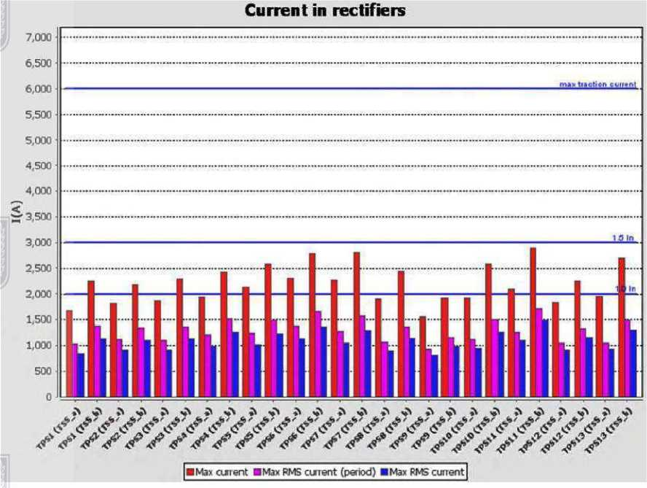

**Illustration 4.4.1.3.1 Specifications for peak and average current for every rectifier station along Metro Line M3** [

• Maximum RMS current for one minute: 1715 amps

• Maximum RMS current for two hours: 1494 amps

• The nominal power of a rectifier is 3000 kW, and the nominal current based on voltage of 1500 V is 2000 amps.

• Based on the IEC 62590 and IEC 62695 standards, the expected overcurrents are:

* Overcurrent for two hours for Rectifier VI is equal to 1.5 times the nominal current, i.e.3000 amps.
* According to the simulation of current demand by the metro, the maximum expected current for two hours is 1494 amps, which is under the 3000-amp limit.
* The overcurrent for one minute of Rectifiers Class VI is equal to three times the nominal current, i.e. 6000 amps. According to the simulation, the maximum RMS overcurrent for one minute is 1715 amps, which is lower than the upper limit of 6000 amps.
* This estimate shows that the rectifier with nominal power of 3000 kW

A malfunction situation where there is an electrical short for a short time on a single railway line (for several seconds) can stream 6000 amps DC on the catenary. Division of the current between the two conductors, simply, when the railway is insulated from the ground, is that the third rail carries the current in the direction from the substation to the train, and the tracks return the current to TTR, in equal division between the right and left track. Percentage of current in each circuit is shown in paragraph a above.

The returning current line is based on the connection of the track to the return line of the direct voltage supply outlet at the substation. Parallel to the rail line there is sometimes thickening of the cross-sectional area of the copper cables to reduce the electrical resistance of the return current path, and reduce the stray currents.

1. **Geometric characteristics**

Illustration 4.4.1.3.2 shows a schematic cross-section of an underground metro train (third-rail system) The working assumption is that the minimum depth between ground level and the train track is 16 meters (lower than the depth shown in the illustration). Third rail system: A positive (+) feeding rail and the two rails on which the metro train travels return the current to the rectifying station (-) X2.

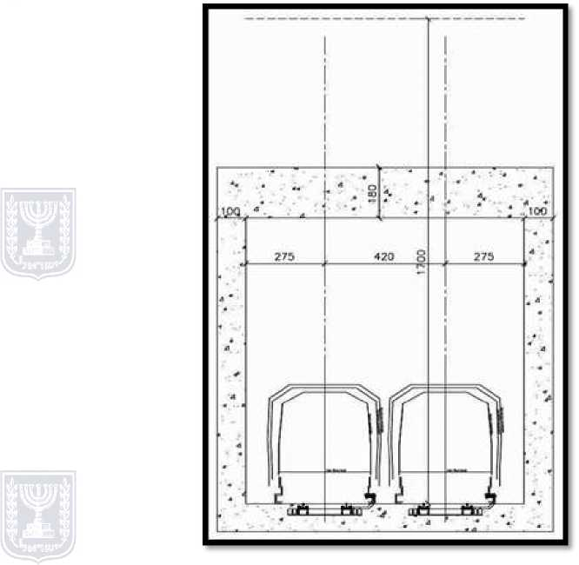

**Illustration 4.4.1.3.2 - Schematic cross-section of an underground metro train -- third-rail system**

Illustration 4.4.1.3.3 shows a schematic cross-section of an underground metro train (fourth-rail system). Fourth-rail system: There is a fourth rail parallel to the third rail that serves to return the current to the rectifying station. The rails that the metro train travels on serve only as a riding surface, and not for returning current.

**4.4.1.4 Estimate of magnetic field flux**

The calculation was performed for DC, to check the effect on pacemakers of a static magnetic field when the accepted sensitivity threshold for pacemakers according to ACGIH is 5 Gauss; the estimate for magnetic field flux whose source is in the AC of the rectifier ripple on the DC was compared to the EPM recommendations for a threshold of 4 mG (which refers to AC) on average per day. Frequency of the ripples assuming there are rectifiers with 24 diodes is 1200 Hz.

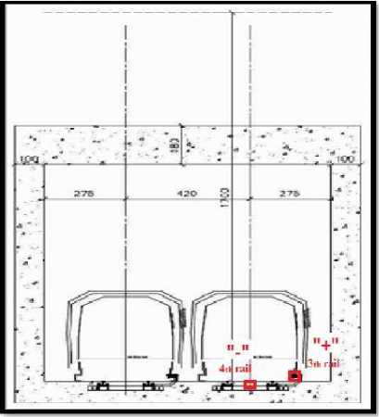

**Illustration 4.4.1.3.3 - Schematic cross-section of the underground metro train - fourth-rail system**

The calculation of the magnetic field flux from the track was performed for two trains, one in each direction, on the two tracks shown in Illustration 4.4.1.3.2. The estimate of the magnetic field flux was performed in relation to human exposure restriction requirements for this flux, as stipulated in the Non-Ionizing Radiation Law 2006. There is currently no mandatory threshold in the Radiation Law. The recommended exposure threshold at an average maximum current is 4 mG per day.

Since the calculation, which is aimed?? at based on?? the EPM recommendations, refers to the average exposure per day, this average should be calculated from within the metro timetable that we have yet to receive.

**4.4.1.5 Magnetic field flux calculated for a third-rail system**

a**. Magnetic field flux with DC of 1500 amps (common situation)**

Illustration 4.4.1.5.1 shows the magnetic field flux with DC of 1500 A for two trains traveling in opposite directions (common situation), while Illustration 4.4.1.5.2 shows the same flux against the background of the tunnel cross-section. From within the illustrations, it can be seen that the maximum static magnetic field flux -- at a height of 1 meter above the ground (17 meters above the track) is 40 mG (40 milliGauss), and from within the carriages, the maximum static field flux reaches 500 milliGauss. That is, in both cases, the maximum static magnetic field flux complies with the 5 Gauss criterion.

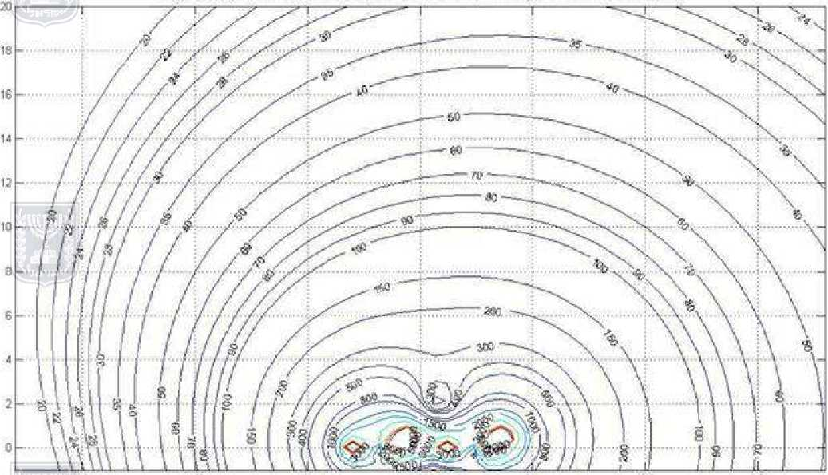

**Illustration 4.4.1.5.1 - Magnetic field flux at DC of 1500 amps (common situation)**

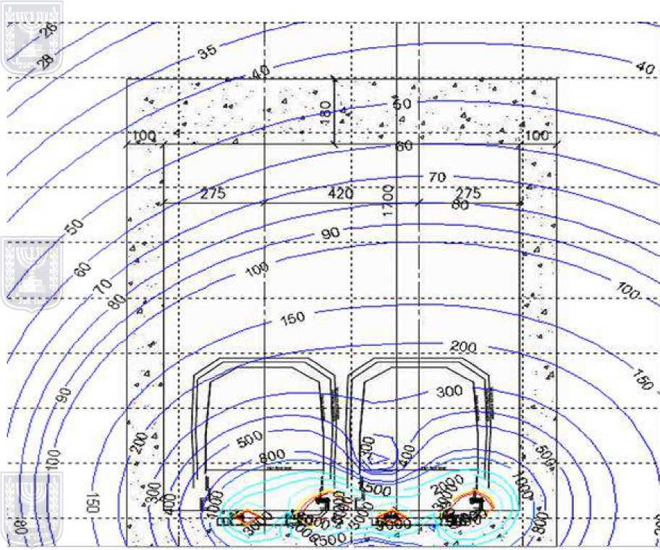

**Illustration 4.4.1.5.2 - Magnetic field flux at DC of 1500 amps against the background of the tunnel cross-section**

**b. Magnetic field flux at peak DC of 5145 amps**

Illustration 4.4.1.5.3 shows the magnetic field flux at a peak DC of 5145 amps for both trains traveling in opposite directions, while Illustration 4.4.1.5.4 shows the same flux against the background of the tunnel cross-section. From the illustrations, it can be seen that the magnetic field flux in each location around the track, and within the train, is lower than the exposure threshold for pacemakers (5000 mG), that is, it is not higher than 3000 nGauss, at DC of 5145 amps.

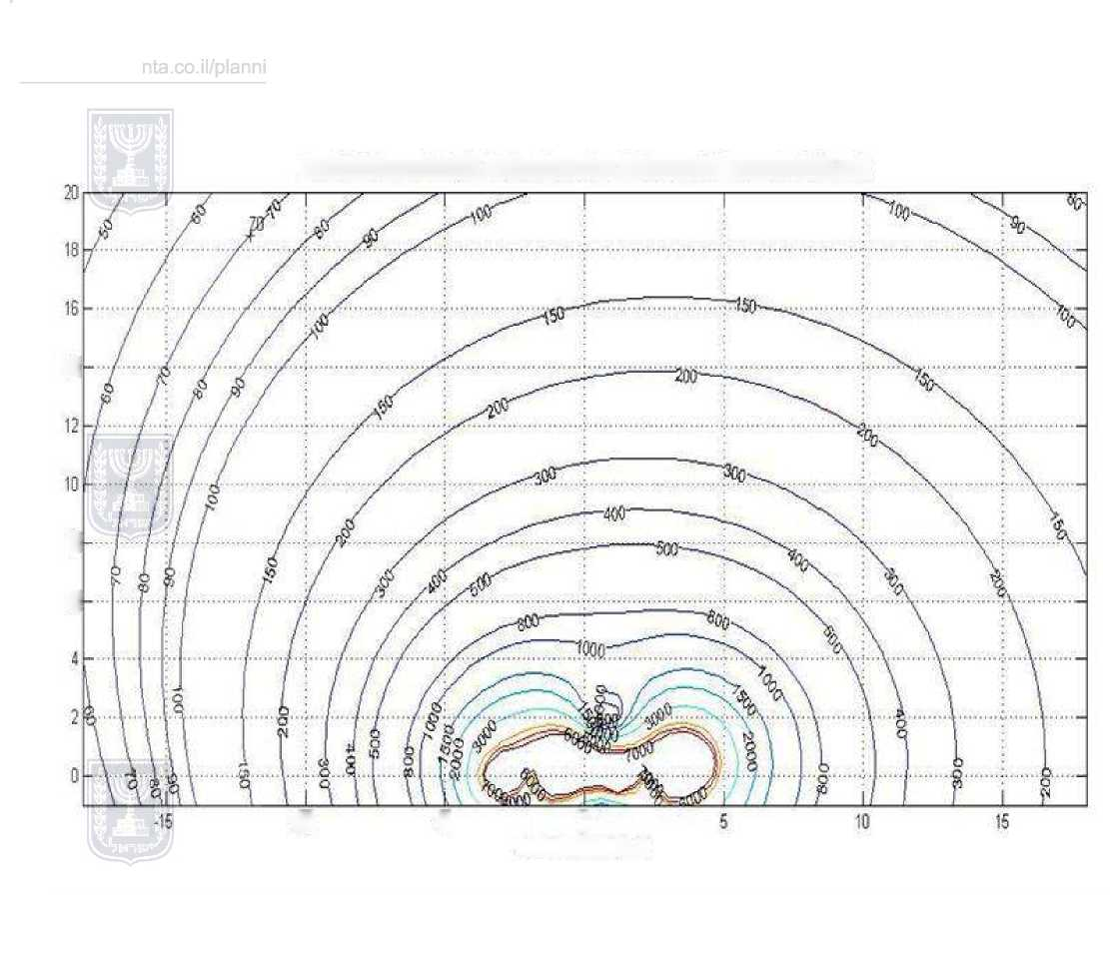

**Illustration 4.4.1.5.3 – Magnetic field flux at peak DC of 5145 amps**

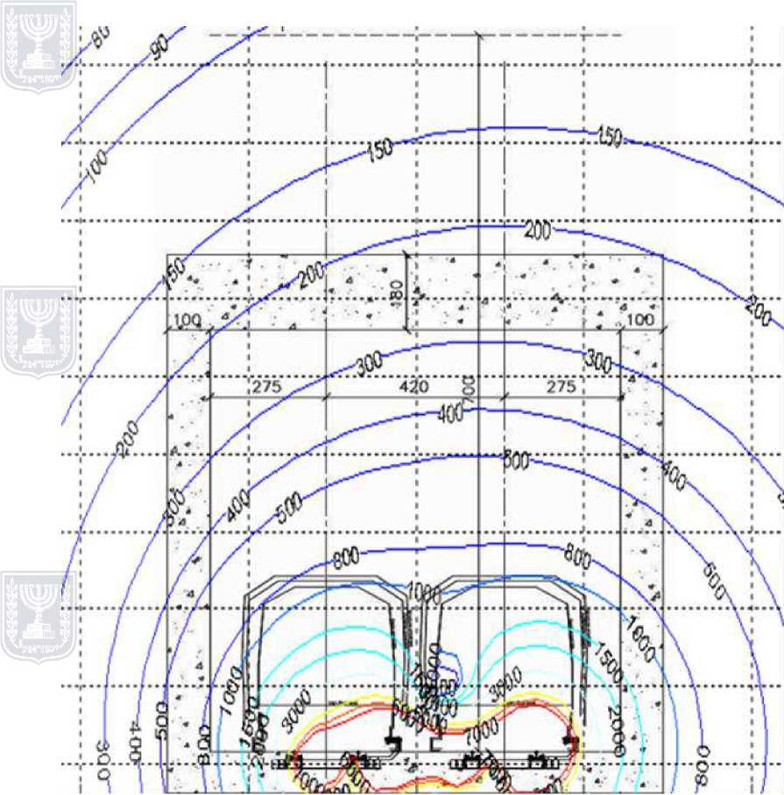

**Illustration 4.4.1.5.4 - Magnetic field flux at peak DC of 5145 amps against the background of a tunnel cross-section**

c. **Magnetic field flux calculated with AC**

Illustration 4.4.1.5.5 shows the daily average magnetic field flux, with a ripple current of 13.8 amps for two trains traveling in opposing directions, with current of 1500 amps. The illustration shows the following findings regarding the magnetic field flux from the track and the train, both above ground and within the train:

The flux at ground level (above the track): The height above the track platform at which the magnetic field flux of 4 mG is obtained is in fact the height of the roof of the tunnel, about eight meters under ground level. There is no need to map the route of the metro track to locate conflicts, as above ground level the magnetic field flux is very low, barely 0.1 mG, which is lower than the typical background atmosphere. The metro train moves with a maximum load of 1500 amps in the tunnel.

As stated, the magnetic field flux reduces to 4 mG at the daily average current already within the metro tunnel, about eight meters under ground level, and therefore, there are no restrictions above ground level.

Magnetic field flux within the train: The passengers within the train are exposed to a maximum magnetic field flux of 10 mG. However, considering the short ride, the daily average would not be higher than 4 mG (this is true also for workers spending time in the train, assuming that the time they stay there is similar to that of a working day, and does not exceed eight to ten hours a day.)

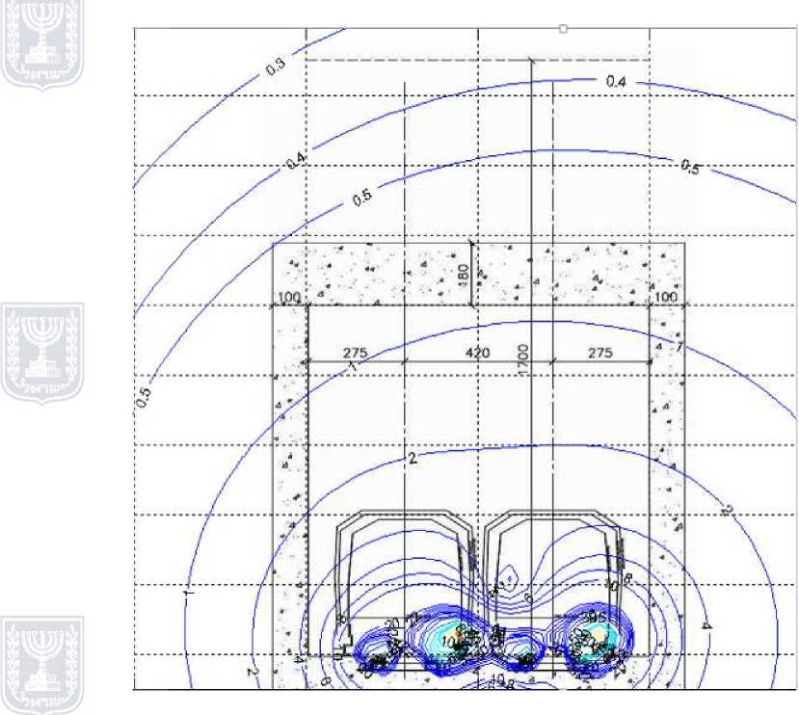

**Illustration 4.4.1.5.5 - Magnetic field flux with AC**

**4.4.1.6 Magnetic field flux calculated for a fourth-rail metro system**

a. **Magnetic field flow with DC of 1500 amps (common situation):**

Illustration 4.4.1.6.1 shows magnetic field flux with DC of 1500 amps for two trains traveling in opposite directions (common situation), while Illustration 4.4.1.6.2 shows the same flux against the background of a tunnel cross-section. From the illustrations, it can be seen that the maximum static field flux -- at a height of one meter above the ground (17 meters above the track): is 90 mG (90 milliGauss), and within the carriages, the maximum static field flux reaches 2000 milliGauss. That is, in both cases, the maximum static magnetic field flux complies with the 5 Gauss criterion.

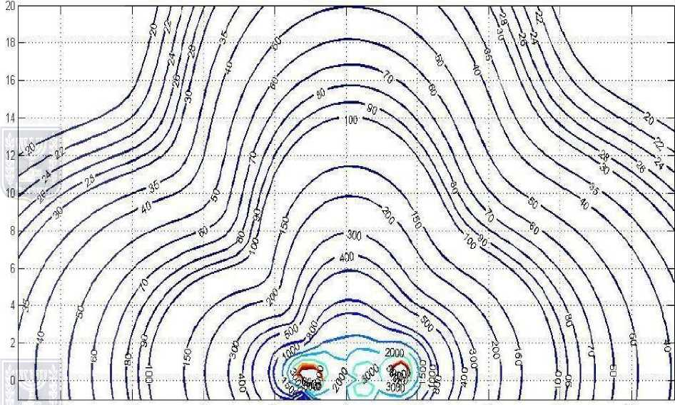

**Illustration 4.4.1.6.1 - Magnetic field flux with typical DC (fourth-rail system)**

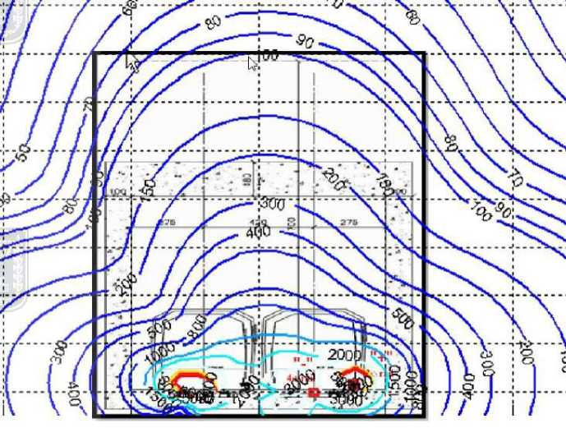

**Illustration 4.4.1.6.2 - Magnetic field flux with typical DC against the background of a metro tunnel**

**b. Magnetic field flux at peak DC of 5145 amps**

Illustration 4.4.1.6.3 shows the magnetic field flux at a peak DC of 5145 amps for two trains traveling in opposite directions, while Illustration 4.4.1.6.4 shows the same flux against the background of a cross-section of the tunnel. From the illustrations, it can be seen that the static magnetic field flux in each location around the track and within the train is 7000 milliGauss, i.e. it is higher than the exposure threshold for pacemakers (5000 mG). Outside the tunnel, the static magnetic field flux is not higher than 300 mGauss, at a DC of 5145 amps.

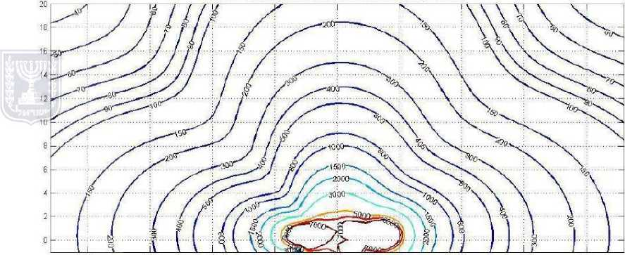

**Illustration 4.4.1.6.3 - Magnetic field flux with DC, fourth-rail system**

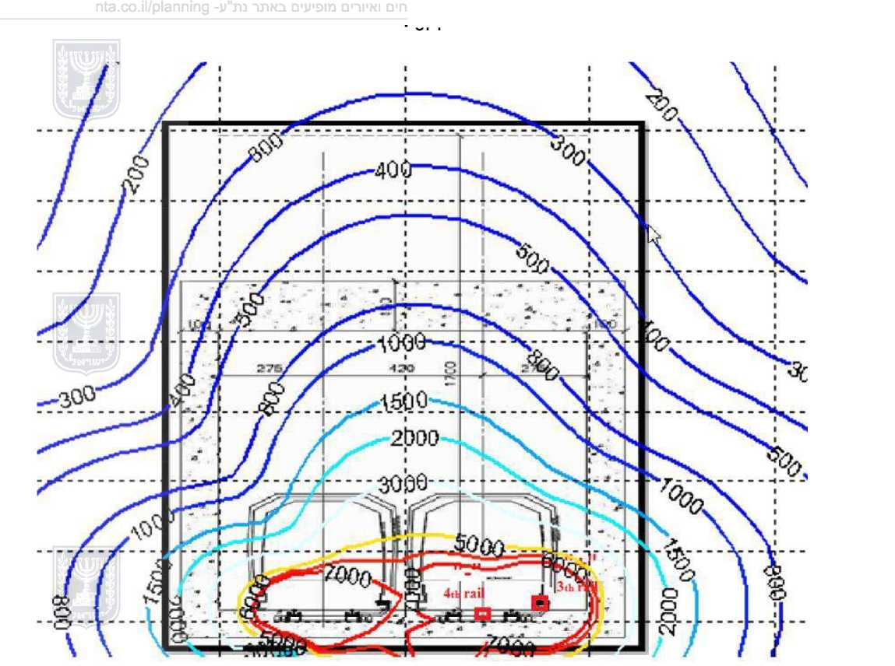

**Illustration 4.4.1.6.4 - Magnetic field flux with DC against the background of the metro tunnel**

**c. Magnetic field flux with DC ripples of 1500 amps (AC of 13.8 amps) in a fourth-rail system**

Illustration 4.4.1.6.5 shows the daily average magnetic field flux, with a ripple current of 13.8 amps in two trains traveling in opposite directions, with current of 1500 amps in a fourth-rail system, while Illustration 4.4.1.6.6 shows the same diagram on the background against a tunnel cross-section. The illustrations indicate the following findings regarding the magnetic field flux from the railway and the train, both at ground level and within the train:

The flux at ground level (above the track): the height above the track platform at which a magnetic field flux of 4 mG is obtained is about eight meters underground. There is no need to map the route of the metro track to locate conflicts as at ground level, the magnetic field flux is very low, barely 0.1 mG, which is lower than the typical background atmosphere. The metro train moves with a maximum load of 1500 amps in the tunnel.

Magnetic field flux within the train: passengers within the train are exposed to a maximum magnetic field flux of 20 mG. However, considering the short time of the ride, the daily average would not exceed 4 mG. This is true also regarding workers in the train, assuming that the time they are there is similar to that of a working day, and does not exceed eight to ten hours per day.)

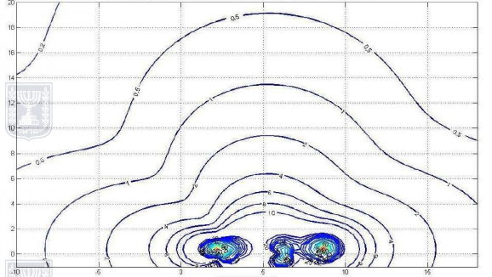

**Illustration 4.4.1.6.5 - Magnetic field flux with AC of 13.8 amps, in a fourth-rail system**

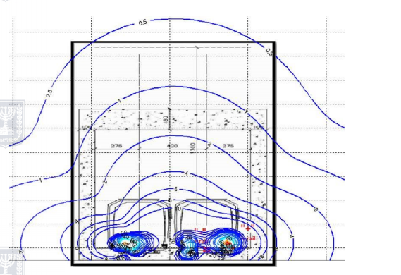

**Illustration 4.4.1.6.6 - Magnetic field flux at ripple current in a fourth-rail system, shown against the background of the metro tunnel**

**4.4.1.7 Summary and conclusions**

a. Third-rail system

• **Magnetic field flux with AC** - the safety range for residential buildings above ground is 0 meters; therefore, there are no restrictions.

• **Riders within the train** -- are exposed to a maximum magnetic field flux of 10 mG, but considering the short ride time, the daily average is no higher than 4 mG.

• **Magnetic field flux with DC** - the magnetic field flux above ground is lower than 35 mG, and it has no effect on people or equipment. Within the metro train carriages, a static magnetic flux field of 3 G is possible, which is lower than the recommended exposure threshold for pacemakers.

b. Fourth-rail system

• **Magnetic field flux with AC** - the safety range for residential buildings above ground is 0 meters; therefore, there are no restrictions.

• **Riders within the train** -- are exposed to a maximum magnetic field flux of 20 mG, however considering the short ride time, the daily average does not exceed 4 mG.

• **Magnetic field flux with DC** - magnetic field flux above the ground is lower than 90 mG and has no effect on people or equipment. Within the metro carriages, a static magnetic field flux of 7 G is possible. This is higher than the recommended exposure threshold for pacemakers.

**4.4.2 Effect of electromagnetic radiation from facilities at individual stations**

At all the stations, technical rooms are planned with electrical systems for voltage stabilization, control, etc. The effect of these facilities is local and not expected to exceed criteria required of the stations' technical areas.

An examination of the depot complex design carried out by SYSTRA (DTP Depot Design Criteria) indicated that there were not expected to be deviations from the EPM electromagnetic criteria outside the depot complex -- the effect of the sources is expected to be localized/short range, and accordingly, the complex does not create restrictions in its surroundings in this regard. In terms of safety, no special problems are expected due to the distance of radiation sources from the manned areas in the complex.

Note that at the detailed planning stage, a radiation survey will be performed to verify compliance with requirements/standards of occupational hygiene by these facilities. Where required, protective means will be determined as needed to ensure compliance with these requirements.

Reference to substations -- see section 4.4.7.

**4.4.3 Vulnerability of Electronic Systems to Magnetic Field Flux**

The most well-known impact in the past was on computer displays, televisions, and video cameras using cathode ray tube (CRT) technology. The minimum sensitivity of a CRT display to DC magnetic field flux is 600 mG (a little more than the geo-magnetic field).

Today, most of the technologies of free electron beam devices have been replaced with technology that is completely insensitive to magnetic field flux, namely with type TFT-LCD and LED screens (flat screens). This technology is not sensitive to magnetic fields, and there is in any case no data on what the maximum magnetic field is that could cause interference in flat screens. The vulnerability of magnetic media to magnetic interference in DC and at network frequency is so high (6000 - 10000 mG that there is no danger of losing the data stored in the magnetic media due to external fields.

Regarding time-varying magnetic field flux, i.e. at the network frequency of 50 Hz, equipment containing free electron beam technology is liable to be extremely sensitive to these disturbances. The highest sensitivity is attributed to the scanning electronic microscope (SEM) which is sensitive to a field as low as about 0.2 mG. SEM are found in certain sectors of high-tech industry, such as semi-conductors and bio-engineering industries. It is a very expensive instrument and is therefore not common in areas that do not have high-tech industries. In any event, the imaging performed to the alternating magnetic field flux above ground indicates values lower than 0.2 mG, i.e., there is not expected to be any effect on sensitive devices like SEM.

**a. Electromagnetic field vulnerability (except for radio receivers)**

The emission of electromagnetic noise at radio frequencies at a distance of 10 meters from the railway infrastructure and from the train is defined in standard EN-50121-2. Sensitivity of electronic systems to radio frequency interference is defined in standard EN61000-4-3.

Table 4.4.3.1. below shows the emission levels for a magnetic field and an electric field for a1500 V overhead power system.

**Table 4.4.3.1: Emission levels for magnetic and electric fields**

|  |  |  |
| --- | --- | --- |
| Third-rail voltage | Magnetic field emissions  150 kHz-30MHz  (dBµA/m) | Electrical field emissions  30-1000MHz  dBµV/m |
| 1500 V | 15-65 | 65-80 |

Systems containing semiconductors, printed circuit boards and electrical wires have limited immunity to electromagnetic radiation at radio frequency. Most civilian standards require minimum radiation immunity of 1 V/m for general electronic equipment, and 3 V/m for industrial and medical electronics. There is no specific standard for pacemakers, but in the literature there is a requirement for minimum immunity of 100 V/m. Similar immunity is required for a wheelchair with an electronic steering system. Following are several representative standards, including Israeli Standard 961 which adopted a comparable European standard.

a. Israeli Standard 961, Part 8.2, August 1998 (Modification of European standard EN 50082-2 from March 1995). Immunity of industrial electronic equipment to a continuous wave, in the 80-1000 MHz frequency range, AM modulation would be 10 V/m, except for the following frequencies in which the immunity is 3 V/m: 87-108 MHz; 174-230 MHz, 470-790 MHz.

IEC Standard 601-1-2 of 1993: Immunity of medical electronic equipment in the 26-1000 MHz range is 3 V/m.

b. European Telecommunications Standards Institute (ETSI), ETS 300 386-1 on immunity of telecommunications equipment to radio frequency radiation: three classifications of equipment: Class 1-3 have immunity of 1 V/m, 3 V/m, and 10 V/m defined respectively in the frequency range of 150 kHz - 1000 MHz.

c. US military standard of immunity to radio radiation at the level of the box MIL-STD-461E, test RS103:

|  |  |
| --- | --- |
| Frequency range | Immunity |
| 10 kHz – 2 MHz | 20 V/m |
| 2 MHz – 40 GHz | 50 V/m |

Comparing between the required immunity of electronic systems and the maximum electromagnetic emissions requirement for the metro infrastructure, a very large gap can be seen between the expected level of electromagnetic emissions, less than 60 mV/m, and the minimum immunity of electronic equipment, which in the worst case would not be less than 1 V/m, i.e. 16 times better than the standard emissions level for the infrastructure at a distance of 10 meters.

Thanks to the depth of the metro train tunnel, the electrical field propagated at the ground level is much lower than 1 V/m, so that no impact is expected from the radiofrequency RF radiation on the electronic systems for the length of the metro route and above it.

**b. Radio vulnerability to RF electromagnetic fields**

RF interference may occur on radio receivers that are much more sensitive than "regular" electronic equipment that does not operate on radio frequencies. Highly-sensitive radios enable reception of signals at an intensity that does not exceed 20-30 µV/m. This sensitivity is characterized by a narrow bandwidth around the working frequency of the receiver, such that wide-band interference characteristic of electrical transportation activity (such as generation of momentary electromagnetic fields due to electrical sparks and high voltage corona discharge) does not penetrate at significant power to a narrow-band receiver. Experience teaches that at up to 40dBµV/m, there is no interference on radio receivers. According to work carried out at York University, it can be expected that the interference range caused to AM radio receivers is between 560-1500 meters, see below in Table 6-2[4]. Due to the nature of the interference emissions from the metro train infrastructure, it is unlikely that interference would be caused to FM radio receivers. If there is any short-range interference from the tracks, it would be momentary. According to data in the above-mentioned document regarding radio and television receivers in residential and office buildings, interference in light-rail infrastructures was rare in Europe, and only from a short distance of 10 meters. In rare cases of permanent interference to radio receivers, there are technical solutions to reduce the coupling of the RF electromagnetic emissions from the train infrastructure to the sensitive receiver. These solutions involve preventing sparks between the pantograph and the catenary by improving the sliding between them and the attenuation of the emissions radiated from the electronic power systems operating inside the train itself. Regarding shortwave transmission (the HF frequency range), here there are still many Wi-Fi services, but the frequency spectrum in HF is already loaded with levels of interference significantly above 40dBµV/m, such that the addition of electromagnetic noise from the metro train is apparently not felt, especially considering the narrow-band reception of HF receivers (about 5 kHz).

Table 4.4.3.2 refers to AM receivers for feeding with AC 15 kV. In all likelihood, at 1.5 kV DC, the ranges are shorter.

**Table 4.4.3.2: Protection distance for AM receivers, 15 kV AC catenary**

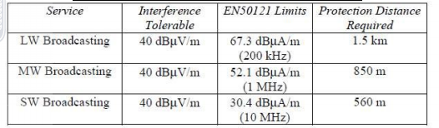

Standard EN-50121-2 specifies the level of maximum radiated interference in a range of 10 meters from the metro railway infrastructure. In the phases of procuring the metro train systems and constructing the infrastructures, it is necessary to ensure compliance with this standard to reduce the cases in which electromagnetic interference is caused to electronic systems and radio receivers.

c**. Summary of electromagnetic compatibility between electronic systems and electromagnetic fields in the vicinity of the track area.**

At this stage, there are no measurements of the RF electromagnetic radiation field outside the track area. Based on the requirements of the European standard, an electromagnetic field that complies with the standard must be ensured within a distance of 10 meters from the track. According to the expected attenuation of the radiation spreading through the layers of earth above the tunnel, there is no doubt that this requirement would be met, no interference of electronic systems would be caused by the RF electromagnetic field, and there would be no interference of radio receivers in AM or FM modulation.

Interference to life-saving medical electronic equipment in health institutions is considered extremely critical. The immunity of this equipment to electric fields is 3 V/m (according to IEC 601-1-2). At a distance greater than 10 meters, the electric field is lower than this. Special care needs be taken with medical electronic equipment with CRT displays that are liable to be sensitive to magnetic field flux of 2 mG. In such cases, a minimum range of 12 meters between the metro train infrastructure and health institutions is recommended. Since the depth of the tunnel is 17 meters, this requirement is completely fulfilled.

**d. Impacts on land uses, including "sensitive uses" along the route**

The term "sensitive uses" refers to sites such as hospitals, IDF bases, educational institutions, academic institutions, and the like. In contrast with the above-ground light rail that might impact such sensitive uses, the underground metro train does not affect above-ground systems defined as "sensitive uses" at all. These uses can be marked on the route, but there is no need to do so because according to the results of the simulation, the intensity of the electromagnetic fields does not exceed the threshold values recommended by the EPM at street level. Impact on buried infrastructures such as telephone, internet, cable television cables, and water, fuel, gas pipes, etc., which include corrosion and /or voltage induction were not assessed in this report since there is still no exact or detailed information on the location of these infrastructures in relation to the metro train line or the geometric relations (distance and whether or not the lines or pipes cross the route) of the infrastructures from the line.

All longitudinal infrastructures (which are parallel to the metro line) pass outside the metro line strip. Outdoor infrastructures are at a depth of at least 1.40 meters[5]. There is therefore a height difference of about 15 meters between the buried infrastructures and the metro track, and therefore, they are not expected to be affected by the program.

**e. Summary and conclusions**

• **Electromagnetic compatibility between electronic systems and the electromagnetic field above the metro track** -- there is not expected to be interference with sensitive electronic systems like SEM, nor with various types of radio receivers.

Interference to life-saving medical electronic equipment in health institutions is considered extremely critical. Immunity of this equipment to the electrical field is 3 V/m (according to IEC 601-1-2). At a distance greater than 10 meters, the electric field is lower than this. There would be no impact at all on life-saving electronic systems.

• Infrastructures - Impacts on concealed infrastructures like telephone, internet, and cable television wires, and water, fuel, and gas pipes, etc., which include corrosion and/or voltage induction 'were not assessed for this report since there is not yet any exact or detailed information on the location of these infrastructures in relation to the metro train route, or on the geometric relations (distance and whether or not the lines or pipes cross the route) of these infrastructures with the route. It appears that no impact is expected as there is a 15 meter height difference between the metro tunnel and the buried infrastructures located near the ground level.

• Cable television infrastructures: no interference expected.

• Bezeq telephone infrastructures: no interference expected.

**4.4.4 Possible solutions to prevent negative impacts from stray currents**

Stray currents are currents caused when the electrical power generated to feed the metro lines overflows to the ground or to any metal structure in its vicinity, instead of returning to the transformer via train tracks intended to serve as return current conductors to this source, according to the design. These currents may create accelerated corrosion in metal infrastructures near metro lines. This phenomenon is well-known in the world of projects such as the metro, because metro lines pass near buildings that contain steel construction and other systems made of metal: water pipes, containers, and more.

The planned track and the metro systems pass through a concrete tunnel that is insulated from electricity (so that the return currents pass within the tunnel space as planned. Despite this, there is a possibility of uncontrolled absorption and emission (stray currents) to nearby structural steel / metal systems.

1. American Conference of Governmental Hygienists (ACGIH) standard, Recommended Levels of Exposure for the Professional Population
2. ICNIRP – Guidelines for Limiting Exposure to Time Varying Electric, Magnetic, and Electromagnetic Fields (up to 3000 GHz).  
    ICNIRP – International Council for Non-Ionizing Radiation Protection, 25 November 2010
3. Exposure of the Population to Electromagnetic Radiation at the Power Grid Frequency, from the EPM internet site page of 24 July 2002.
4. York University UK – Potential EMI to Radio Services from Railways Final Report (AY4110) for Radio Communication Agency
5. According to information received from Mr. Avishai Neve – director of planning for the purple line in Tel Aviv.