Research Program

Plasmonic Metasurfaces with broken space-inversion symmetry: From geometric Berry  
phase to topological plasmonics

Gorodetski Yuri

1. Scientific background

Two-dimensional (2D) materials have been of great interest since the  
discovery of graphene. In recent years, the field has developed rapidly with the discovery of many types of 2D materials such as transition metal dichalcogenide (TMD) monolayers.1-5 Due to  
the unique physical properties of TMDs and their broad potential applications, research has focused on the fabrication and underlying physics of TMDs. TMDs are semiconductors of the form *MX*2 where *M* is a transition metal atom such as Mo or W and *X* is a chalcogen atom such as S, Se, or Te. When cleaved to a monolayer, these materials display a direct band-gap, strong spin-orbit  
coupling, and favorable electrical and mechanical properties. Thus, TMDs such as *M0S2* have a valley degree of freedom, enabling the development of valleytronic  
devices.6 TMDs also possess topological phases due to their symmetry, giving rise to a non-trivial  
Berry phase. Many TMDs behave as topological insulators (TIs) hosting topologically protected  
conducting-edge states.7,8 Because of the great promise of TMDs, it is essential that we understand their physical processes.

The Berry phase9 is a phase added to an eigenstate after completing a closed loop in  
the parametric space in which it is defined.10 The Berry phase is caused by non-trivial topology of the state-space and often called a ’’geometric phase”.11,12 In crystals of broken time-reversal or space-  
inversion symmetry, the level degeneracy of chiral eigenstates (quasi-spins) is lifted. This lift gives rise to  
the so-called Berry curvature which is comparable to the appearance of magnetic monopoles.13In symmetric structures such as graphene, time-reversal symmetry can be broken using a strong  
magnetic field. TMDs such as *M0S2* and *WSe2* have a hexagonal lattice structure similar to that of  
graphene; however, the different atoms within the honeycomb unit cell break inversion  
symmetry. Therefore, the Berry phase accumulated by Bloch electrons at their Dirac points, which  
are degenerate in graphene, are of opposite sign making the K and K’ valleys distinguishable.

It has been shown repeatedly that light modes propagating in a periodically modulated spacecan exhibit behavior analogous to electronic wave-function in a crystal.14’15 The parameter space  
that defines the state of polarized light is the Poincare sphere, where the north and south poles correspond to right- (RCP) and left-hand circular polarization (LCP), respectively. A cyclic  
change of the polarization state induces a measurable and helicity-dependent Pancharatnam-Berry  
(PB) phase.16,17 This phase is equal to half of the solid angle enclosed by the loop. The PB phase  
is responsible for the spin-Hall effect of light1218 and has played an important role in numerous  
applications in optics19 20 and plasmonics.21-23

1. Research objectives and expected significance

Here we consider plasmonic PB phase metasurfaces with graphene-like structures but with bro-  
ken inversion symmetry. Plasmonic metasurfaces with subwavelength space-variant anisotropic  
scatterers have been shown to produce the PB phase.22 24 Such structures have been used for  
spin-dependant directional excitation of surface plasmon (SP) waves and have been the subject of  
much research25-27 due to their potential in development of nano-photonic devices. By measuring  
the plasmonic response upon illumination with different spin states in momentum space, we show  
that the excited plasmonic modes strongly depend on the helicity of the incident light. Explicitly,  
we observe a spin-degeneracy lifting analogous to the behavior of TMDs at their K and K’ valleys.  
In our case, inversion symmetry is broken by angular difference between adjacent apertures in the  
metasurface. This angle leads to opposite PB phases in the K and K’ points in momentum space,  
resulting in a contrast between the two circular polarizations in both the near and far field. This con-  
trast is then varied by controlling the aperture angle. These results are consistent with numerical  
calculations that we performed.

Interestingly, it seems that an analogy can be drawn between our structures and 2D materi-  
als such as TMDs. Both have a graphene-like structure but with inversion symmetry broken. As  
mentioned above, this broken symmetry causes a strong spin-orbit interaction and the occurrence  
of a Berry phase. The plane separation between the constituent atoms in the unit cell can be as-  
sociated with the rotation of the apertures in our metasurface. The pseudospin accounting for the  
rotational motion of electrons within the honeycomb unit cell is just like the SP waves circulating in  
the unit cell of our structure, following the path of constructive phase building. It has been shown  
that optical topological phases can model complex quantum systems.28 Much theoretical insight  
can be gained from such analogies. Although the fabrication of 2D materials is improving rapidly, it  
currently remains a complicated procedure. Our structures, by contrast, are easy and cheap to pre-pare, as well as being very flexible having many parameters to play with. Measuring and analysing  
our system is also very straightforward with many degrees of freedom. We thus propose a simple  
way to analyze optical properties of TMDs and possibly make predictions of yet unknown features.  
If this connection could be shown theoretically, this could open many doors to further deepening of  
our understandings of TMDs.

1. Proposed research and preliminary results

Our metasurface is an array of rectangular apertures in a 100 nm thick gold film, arranged in a  
honeycomb lattice. The lattice constant is *a* = 3Asp/4, where Asp is the wavelength of the SP  
excited at the gold-air interface and is given by Asp = , whereas e*au(n)* is the dielectric

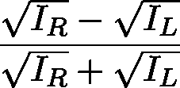function of gold at frequency *u.* We rotated each of two neighboring apertures to  
an angle of *0* = ?r/4 between them. We used a laser diode at Ao = 2?rc/w = 780 nm and, therefore,  
in our case, *a* = 574 nm. A scanning electron microscope (SEM) image of our sample is presented  
in Fig. 1 (c). The apertures were milled by using a focused ion beam (FIB) into the gold film evaporated on a glass substrate by sputtering. The laser beam was expanded then  
focused by a microscope objective *(NA* = 0.25) onto the sample at the air-gold interface. The back of the glass substrate was brought into contact with an oil-immersion objective *(NA* = 1.3)  
that collected plasmonic leakage radiation.29 A tube lens then formed an image on the camera,  
with an additional (Fourier) lens using a flipped mount to image the k-space, as needed. The  
polarization state of the incident light was controlled by a polarizer and waveplate before  
the sample. The setup is illustrated schematically in Fig. 1 (g). The measurements were preformed  
in real and reciprocal (k-space) spaces. In Figs. 1 (a, b, d, and e), the real space distributions  
for the incident RCP and LCP light are shown as measured by circular analyzer. We found in the cases of cross-polarization (Figs. 1b and d), there was a strong localization of light along the  
circumference of the metasurface, whereas the outside and inside of the structure remained dark.  
When the output polarization was the same as the input (Figs. 1a and e), there was no special behavior  
and the light appeared to be transmitted by the structure. We further measured the response of  
the structure for both spin states (without polarization filtering at the output) in the k-space and  
calculated the circular dichroism (CD) of the structure, defined as

(1)

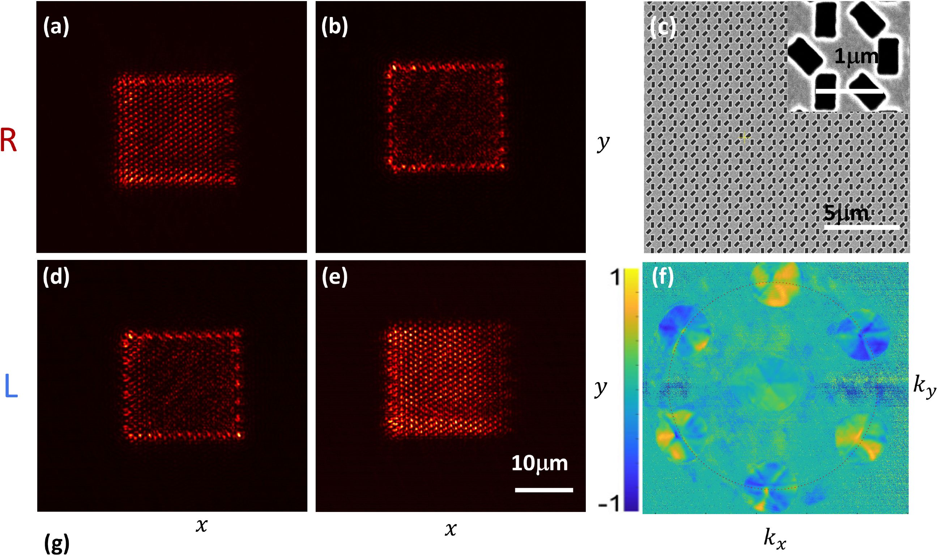

l2 lp qwp tl fl cam

- . cm h m

**Sample QWP LP**

Figure 1: (a),(b),(d), and (e) Plasmonic spin-dependant edge-state at the boundary of a graphene-  
like metasurface when the output polarization differs from the input (input polarization arranged in  
rows and output in columns), (c) A SEM image of the metasurface with a close up of the unit cell in  
the inset, (f) Spatial CD map (in k-space) of the structure. The primary plasmonic resonance circle  
is marked by the dotted red line, (g) Schematic illustration of the optical setup consisting of lenses  
(L-i, L2), a linear polarizer (LP),quater wave plate (QWP), focusing objective (FOB), oil-immersion  
objective (OOB), tube lens (TL), Fourier lens (FL) and a camera (CAM).

where *I^l* is the measured intensity for RCP and LCP illumination, respectively (Fig. 1f). K-space  
measurements are discussed later (see Section xxx) in greater detail. We note that the diffraction orders have a strong polarization dependence, whereas the central (zero) order near null CD. Specifically,  
we observe three predominantly LCP polarized orders; the other three are RCP. This spin-  
dependent k-space directionality resembles excitonic directional behavior in TMDs.

To understand the meaning of our measurements, we refer to the structure dis-  
cussed in Ref. [27], We consider a hexagonal lattice of rectangular apertures rotating along its  
primary directions. The rotation rates are defined by constants N = 3 and M = -3 (here N and M are  
the number of the grating periods needed to complete a rotation of *n* radians) (see Fig. 2, inset).  
The relative angle between the neighboring apertures is tt/3 and the lattice constant is *a* — 2ASp/3.  
As discussed in detail in ref. [27], with these parameters, only three unidirectional plasmonic beams  
are excited for each circular polarization state. This strong polarization selectivity is achieved by the rotation-induced Coriolis term added to the momentum-matching condition, which leads to the  
PB phase.

Explicitly, a structure defined by the direct lattice primitive vectors **a =** aa and **b =** *bb* produces  
a diffraction pattern according to its reciprocal primitive vectors a* = 27r4S)and a* = 27r4^r  
However, the space-variant aperture rotation *0(x,y)* (with respect to the *y* axis) leads to an additional

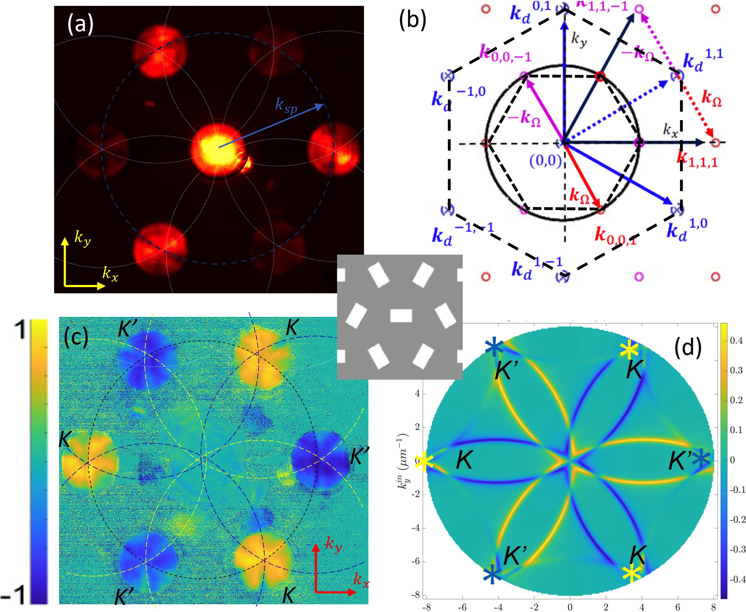

Figure 2: (a) A raw image of our measured angular intensity distribution in an ILF. The primary plas-  
monic resonance circle marked in blue and the secondary resonances in white, (b) Theoretically  
calculated k-space diagram. Blue crossed marks correspond to OOOs. Red and lavender circles  
correspond to RCP and LCP BOs, respectively. Solid blue arrows correspond to the reciprocal  
lattice vectors and solid red and lavender to the momentum of the two BOs, respectively. Dotted  
lines show the displacement of an ODO and its respective BOs. Solid dark blue lines denote the  
total optical momentum of a diffracted mode, (c) CD map of the hexagonal PB phase grating, (d)  
Simulated CD.

term in the total grating momentum of -o-ko. We define the Coriolis term kn = 2Q, where  
Q — Qaa* + is the aperture rotation rate vector, Qa — Va0(a?, *y) =* and Qb — Vb#(z, *y) —*

are rotation rates along the primary axes and *a =* ±1 is the photon spin taking the value +1 for  
RCP and -1 for LCP.

We captured a raw image of the k-space as presented in Fig. 2a. Our k-space im-  
age is an isofrequency surface (IFS), which is essentially a slice of the three-dimensional dispersion  
at the laser frequency w. The diffraction pattern is clearly visible and corresponds to the reciprocal  
lattice of the hexagonal structure. The circle of radius |fcsp| = 2tt/Asp (marked by the dashed line) is  
the plasmonic resonance representing the excitation of the SPs at the gold-air interface. The additional circular arcs are replications of the plasmonic momentum circle centered at other diffraction  
spots, due the grating periodicity.30 Some of these secondary modes are marked to guide  
the eye. Points in fc-space at which a diffraction spot coincides with the primary plasmonic  
mode represent the momentum at which the excitation of the SP occurs. Therefore, in  
real space, the SPs propagate in the directions determined by the momentum match-  
ing27 (see Figs. 3c and 3f). As shown schematically in Fig. 2b, the diffraction spots coinciding  
with the plasmonic circle are the Berry orders (BOs) originating from the geometrical phase. Theordinary diffraction orders (ODOs) resulting from the periodicity of the structure (disregarding  
the rotation of apertures) fall further away and are out of our field of view. The inner hexagonal  
dashed line marks the edge of the first Brillouin zone (FBZ) with the *K* and *K'* points coinciding  
with BOs. Measuring for both polarization states, we obtain the CD map shown in Fig. 2c. The map indicates that the secondary modes centered at the *K* and *K'*points maintain the polarization of the corresponding BO. We see this in the simulated  
CD map (Fig. 2d) where the plasmonic modes are traced throughout the  
FBZ using a scattering formalism based on the coupled waveguidemode method.31 We conclude  
that the presented hexagonal PB phase structure has a strong spin dependence manifested  
in the diffraction pattern and the secondary plasmonic modes.

Now we consider this hexagonal PB phase structure as a superposition of three sub-lattices of  
non-rotating aperture. Each sub-lattice has a period of 3a, a displacement *a* between them and is rotated 60° with respect to one another (Fig. 3a). As expected, each sub-  
lattice does not induce a PB phase. However, the combination of the three structures  
at different orientations results in the PB phase. When one of the  
sub-lattices is removed, the structure becomes a graphene-like metasurface with lattice  
constant *a* = 2A/3 and relative angle *0* = tt/3 (Fig. 3b). It should now be pretty  
obvious that the efficiency of the full hexagonal structure is degraded and the spin-degeneracy that  
was lifted, reappears. Nevertheless, the broken space-inversion symmetry of the structure still  
results in spin-dependent directionality. Both real and fc-space measurements of such a structure show the described behavior (Fig. 3c-f).

The missing sub-lattice can link the weaker polarization contrast to the PB phase discontinuity. This discontinuity can be compensated for by varying the relative angle between the two remaining  
sub-lattices. We fabricated several more structures with different relative angles and measured the  
CD maps in the fc-space (Eq. 1). From the CD, we calculated and plotted the polarization contrast between  
the orders at points *K* and *K'* and the relative angle *a* (Fig. 4a). For comparison, we used a simple model based on Huygens’ principle to simulate the momentum  
space distribution of the SP waves excited by the sub-lattices with a phase difference of 2*<t9(x,* y)  
(Fig.4 a, dashed line).

We found that in the full range of scanned angles (from 0° to 90°), the measured points  
showed a qualitative correspondence to the model prediction with a peak contrast around 33°. When  
the relative angle tends to 0° or 90°, the structure becomes spin-degenerate (as expected) and the

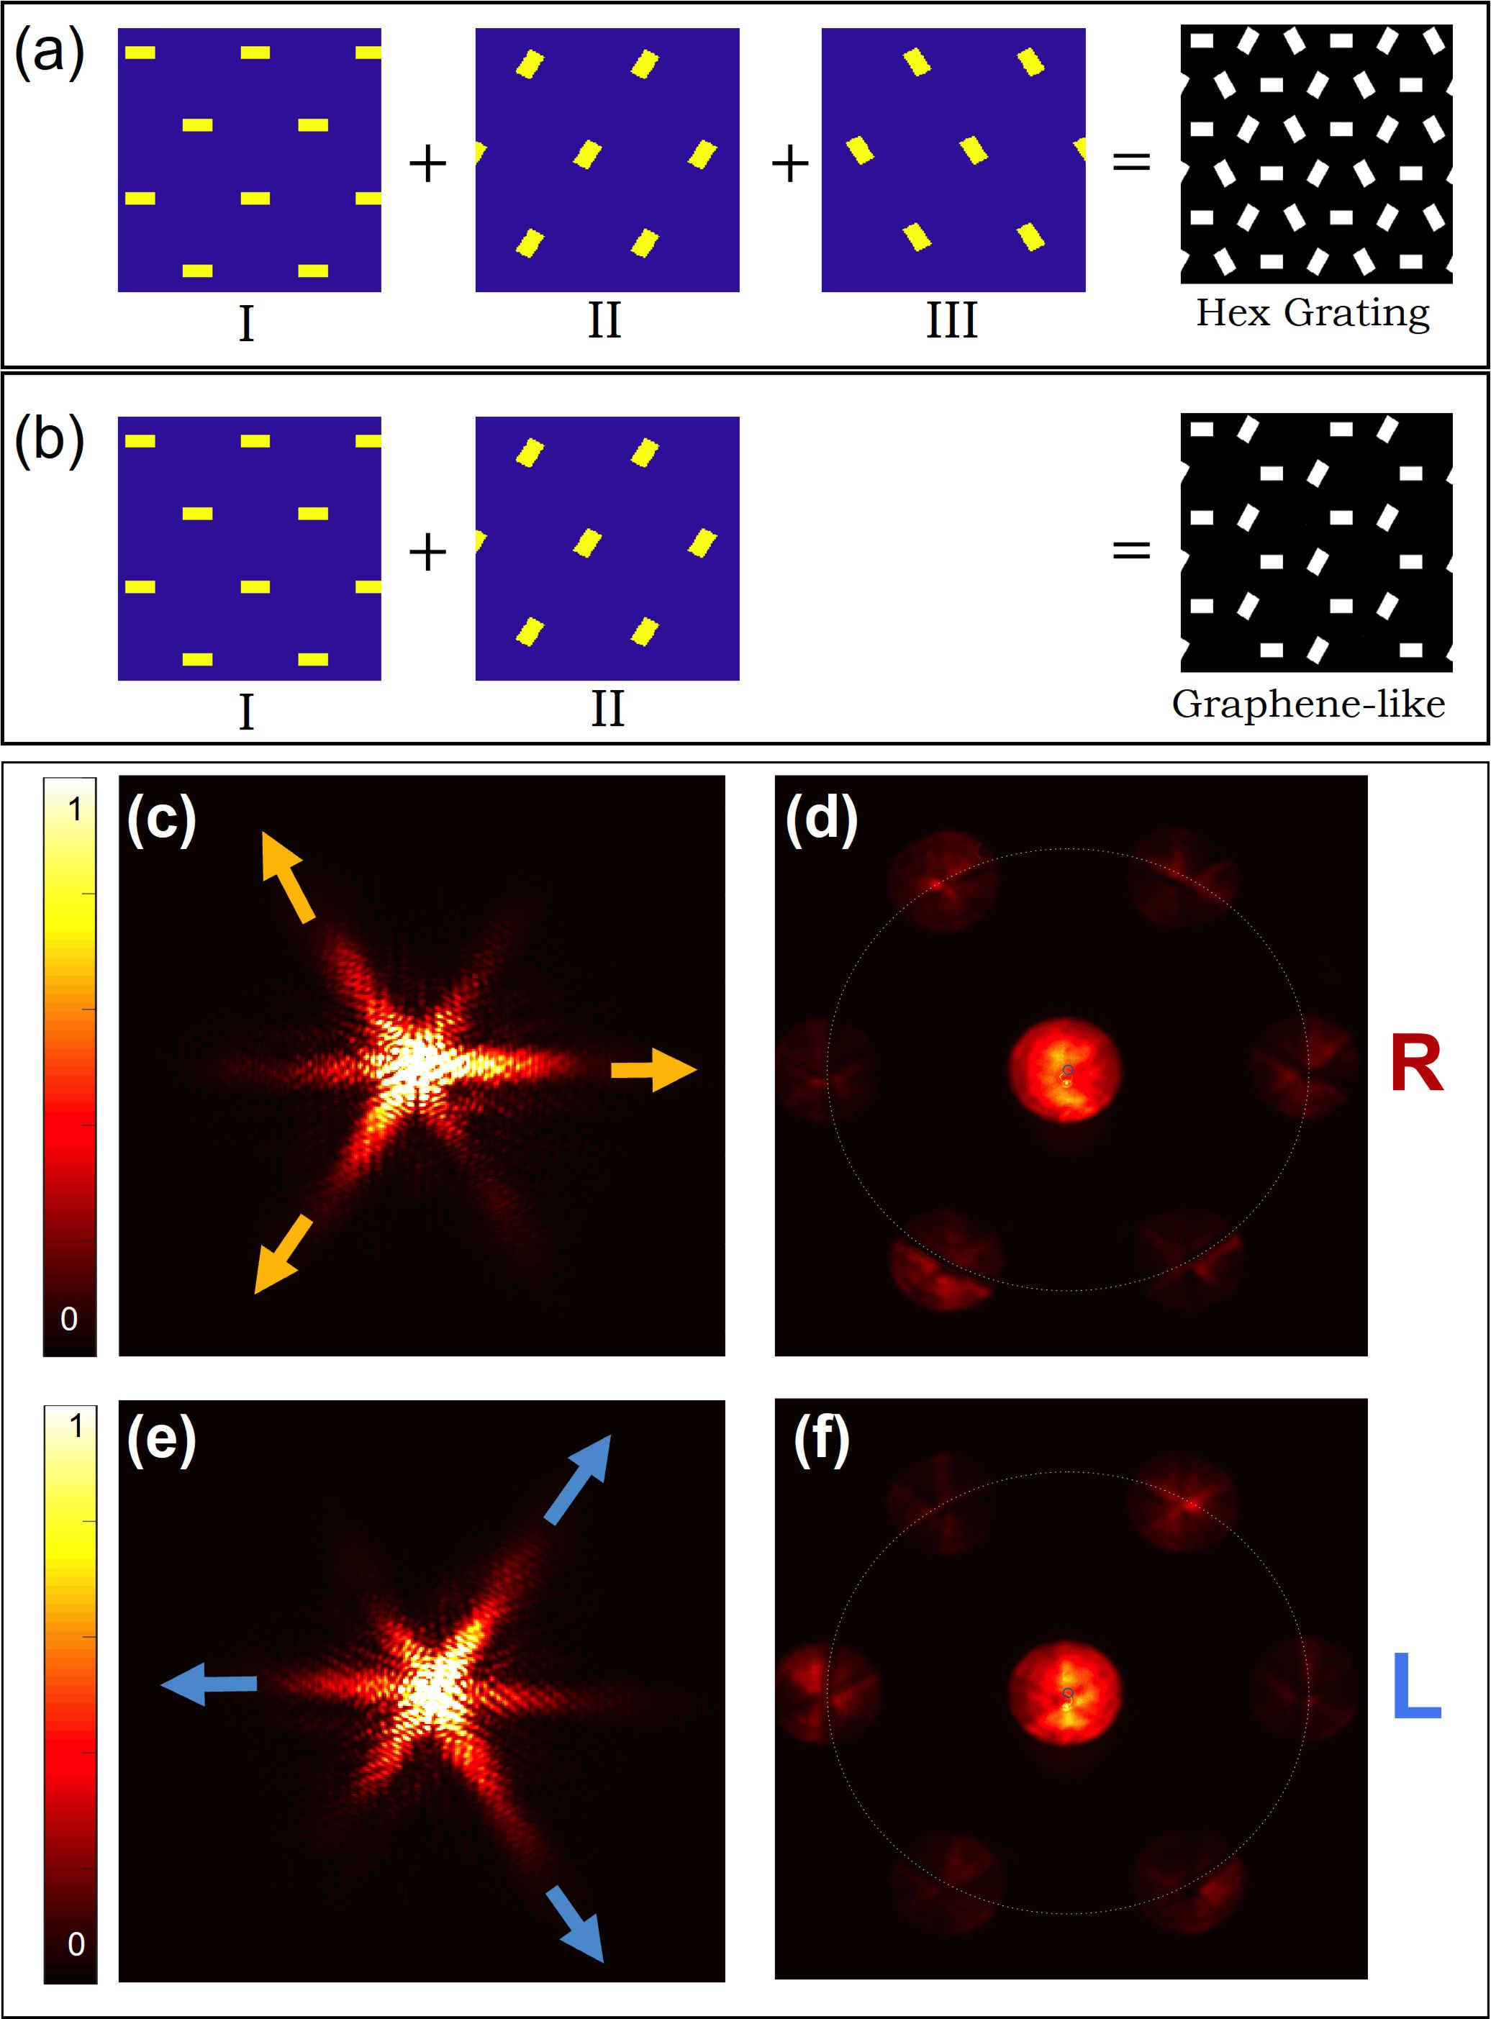

Figure 3: (a) Illustration of decomposition of the hexagonal topological grating into three topologi-  
cally trivial sub-lattices, (b) Superposition of only two sub-lattices gives our graphene-like metasur-  
face. Correspondence between k-space and real space. (c),(d) Real and fc-space images respec-  
tively for RCP light. The three brighter diffraction spots coinciding with the plasmonic circle in (d)  
correspond to the three stronger plasmonic beams propagating in real space in (c). (e) and (f) The  
same as (c) and (d) for LCP light.

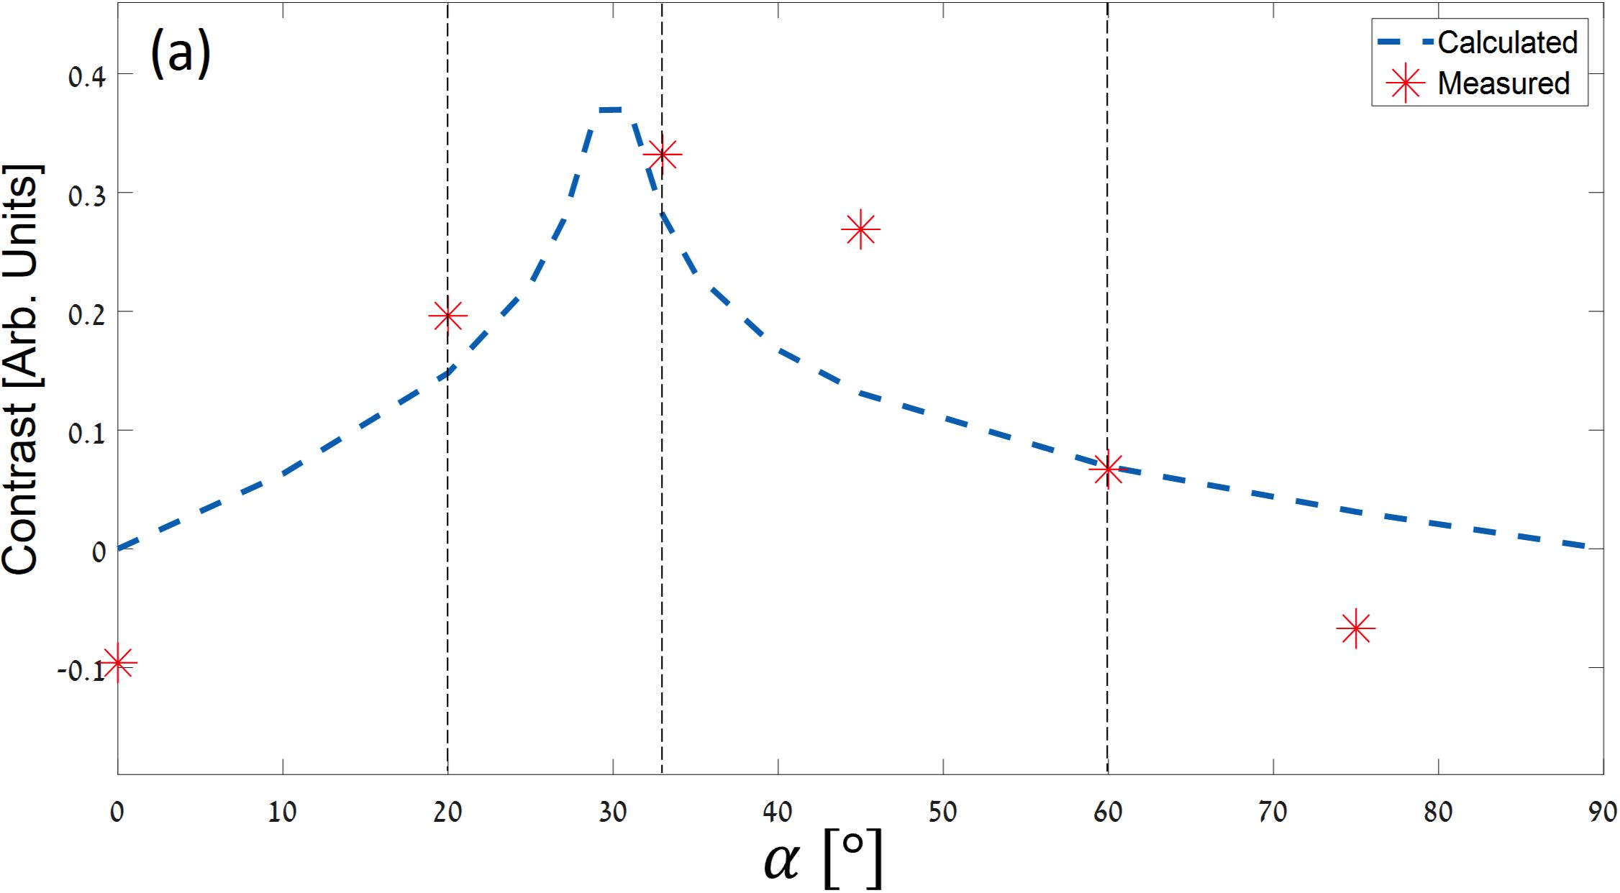

(b)

K' K

K K'

K' K

**a = 20°**

(c)

K' K

K K'

K' K

**a= 33°**

(d)

K' K

K K'

K' K

*a* - 60°

Figure 4: (a) Measured intensity contrast between diffraction orders excited with different circular  
polarizations as a function of the relative angle between the two sublattices, (b)-(d) Measured k-  
space CD maps for angles 20°, 33°, 60°.

polarization contrast diminishes. This confirms that the PB phase acquired by the SP waves  
is the main effect responsible for the spin-dependent directional excitation of our graphene-like  
metasurface. Again, the polarization selectivity in the *K* and *Kf* directions is reminiscent of the spin-  
dependent valleys in the characteristic dispersion of the TMDs. We made further important observations by investigating the CD maps of structures with different *a* (Fig. 4b-d). We found  
that the structure with *a =* 33° exhibiting the maximum contrast (Fig. 4 c) also had homogeneous diffraction spots, similar to the hexagonal structure (Fig. 2c). Away  
from the peak angle, we noted that the polarization of the orders located at *K* and *Kr* points became  
space-variant. Interestingly, this behavior is also imprinted in the corresponding plasmonic modes.  
Figure 5a shows the measured and calculated IFS CD map behind the structure with a lattice  
constant *a* = 510 nm and */theta =* ?r/3. It appears from the color-coding that the polarization  
exciting each of the plasmonic mode rings varies strongly along the azimuthal direction. The  
effect becomes more pronounced when the structure period is increased to *a = 574nm* (Fig. 1) and the angle is set to *0 =* tt/4. Our measured and calculated maps indicate the  
polarization state of the absorption in the *k-*space; therefore, one can regard our structure as a  
resonant space-variant polarizer. To examine the effect of this optical manipulation, we conveniently mapped  
the data as a closed path on a Poincare sphere, resulting in the geometric Berry phase. By following the  
calculated plasmonic modes, we indeed noticed a winding phase within each diffraction spot

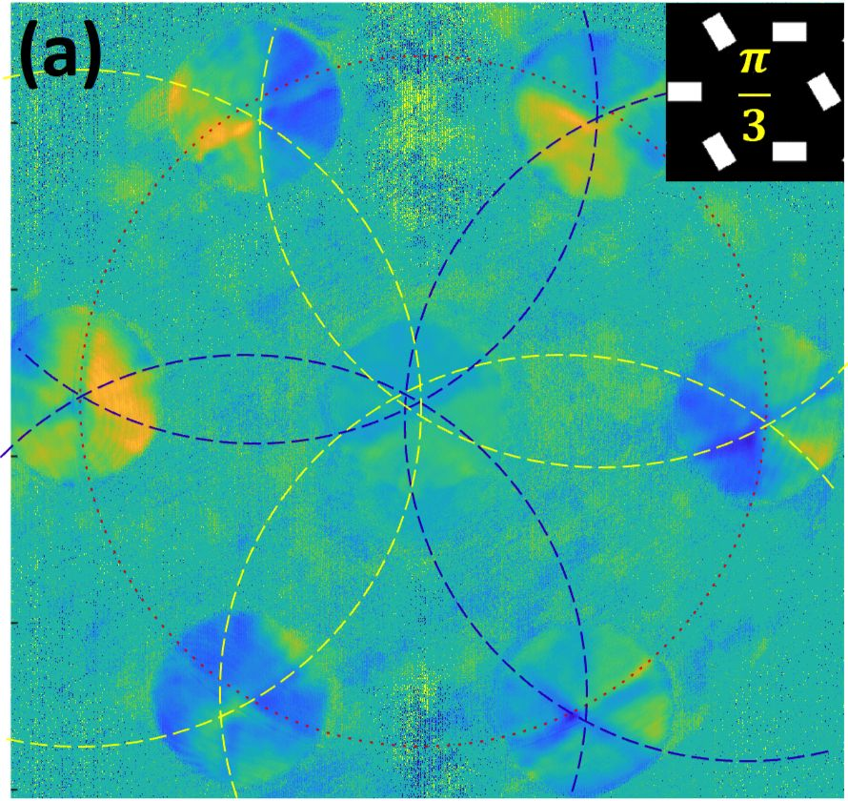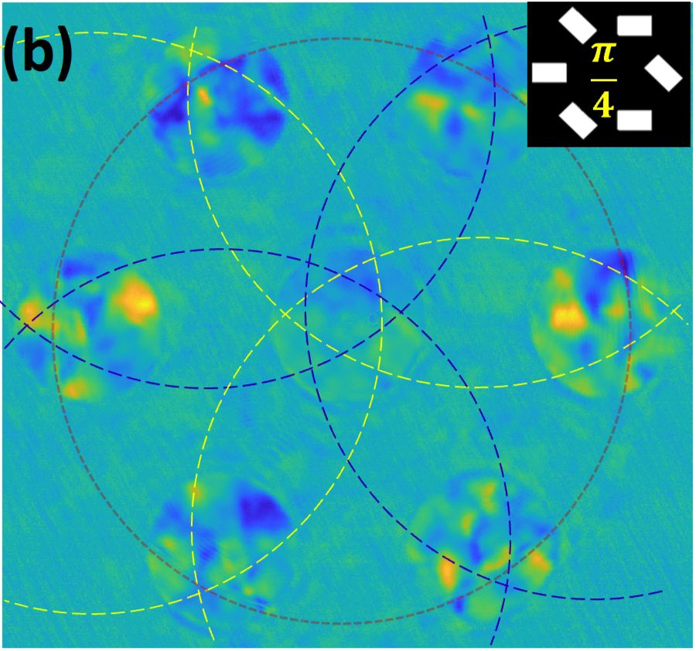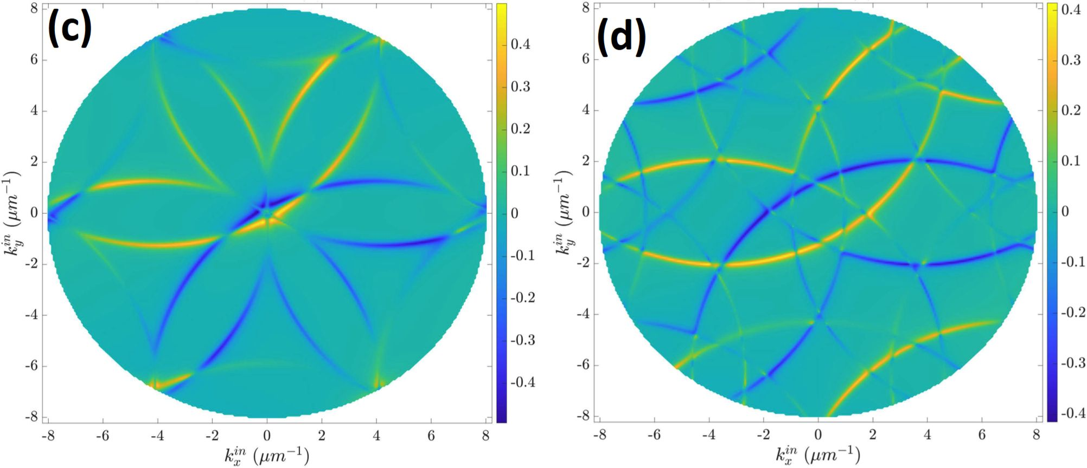

A = 510*nm*

A = 574*nm*

Figure 5: Measured CD maps in of graphene-like structure with a lattice constant *a =* 510 nm (a)  
and *a =* 574 nm (b) showing space-variant polarization, (c) and (d) Simulated CD maps for given  
periods.

which appeared to be a function of structure period and the relative angle. When we examined the  
raw *k-*space images measured with the latter structures (a = 574*nm* and *a =* ?r/4), we recognized  
a dark spot in the center of each diffraction spot, which we propose arose from the aforementioned  
phase singularity. We compared this distribution with the one measured from the full hexagonal  
structure but illuminated with a laser beam decorated by a spiral phase (Fig.6). The similarities  
between the images led us to the conclude that our graphene-like structure shown (Fig. 1)  
induces an optical vortex in each diffraction order.

* 1. Working Hypothesis

It appears that turning a hexagonal structure into a graphene-like structure by subtracting one of the  
three comprising sub-lattices makes a fundamental change in the behavior of the SPs. First, as can  
be seen in Fig. 6 each of the six apertures in a graphene-like unit-cell has only three neighbors  
in a contrast with six neighbors in the hexagonal one. This clearly reduces the plasmonic hopping  
mobility in the array leading to band-gap opening along the primary axes. Accordingly, the SP  
wave is forced to circulate between the closest neighbours in the unit-cell. When the apertures  
of the array are rotated, the unit-cell becomes chiral, which lifts the degeneracy between the two  
counter circulating plasmonic modes, giving rise to a favourable vorticity. Summing up the local  
unit-cell bound SP vortices results in our case in an overall topological Berry phase along the edge  
of the whole structure seen in Fig. 1 as an edge state. This polarization dependent plasmonic

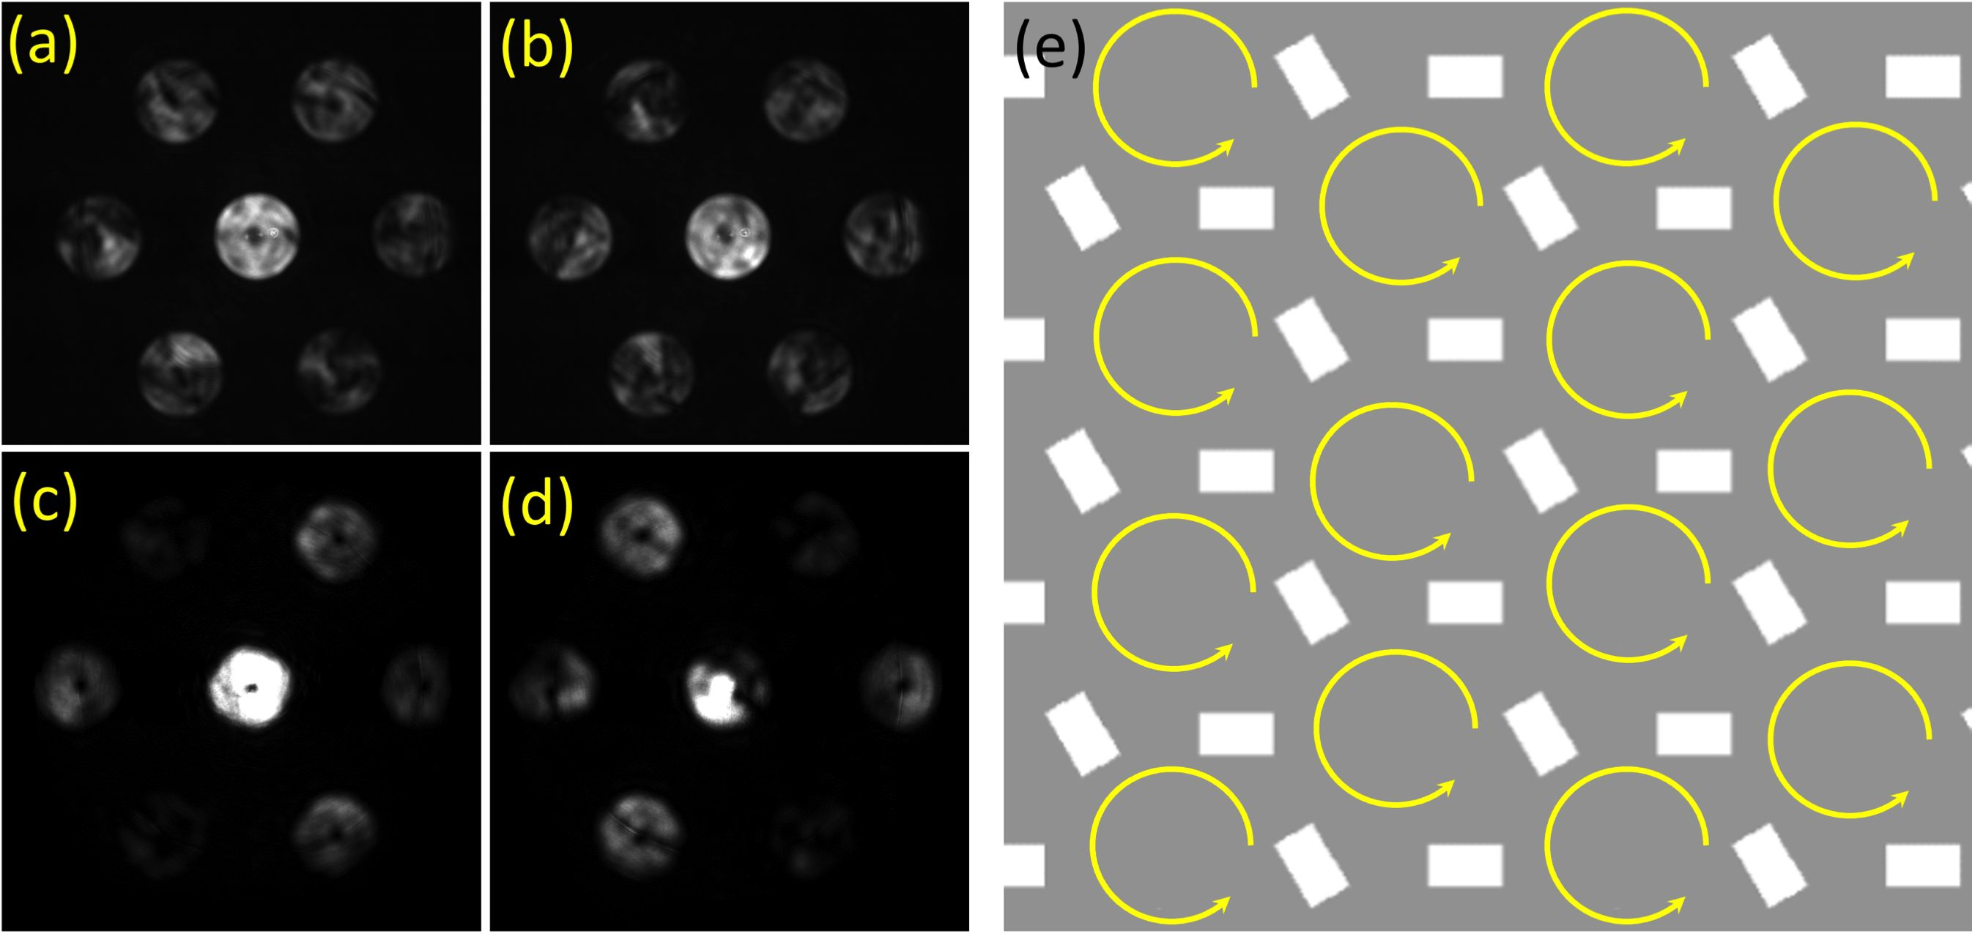

Figure 6: The comparison of the measured k-space distributions for the structure with *a* = 574 nm  
and *a* — 7r/4 with RCP and LCP illumination (a) and (b) and for the hexagonal structure decorated  
with a spiral phase with *a* = 510 nm with RCP and LCP illumination (c) and (d). The schematic  
plasmonic hopping circulation is shown in (e).

mode is induced by a space-inversion symmetry breaking in the structure in analogy with a variety  
of recently presented topological insulators.

* 1. Research design and methods

The research plan suggests theoretical modelling of the plasmonic metasurface based on the con-  
cepts of topological photonics and analogies with TMD behavior. Initially, a geometry and the  
structure parameters are chosen depending on the desired functionality. Then a numerical model is  
investigated using a commercially available software (such as Comsol Multiphysics and Lumerical)  
and also by semi-analitical methods based on the scattering formalism.31 Once the metasurface is  
optimized it is designed and fabricated on a thin (100 nm) golden layer by means of a FIB milling.  
We use sputtering type evaporation to avoid homogeneity caused by large scale crystallization.  
The analysis of the structure is then performed in a free-space beam set-up shown in Fig. 1 under  
illumination of a CW diode laser at the wavelength of 780 nm. The polarization state at the entrance  
and the exit of the system is controlled by a set of the HWP and a QWP. The fc-space images are  
obtained by an additional Fourier lens. The CD maps are acquired using the Eq. 1 by alternate  
illumination with the RCP and the LCP states.

* 1. Future Plan and Outlook

Our preliminary results show that space-inversion symmetry in graphene-like plasmonic metasurfaces leads to strong polarization that is dependent directivity on SP modes and under some conditions  
results in a spin-dependent edge state. These effects have been recently demonstrated with excitonic  
modes in TMDs. Further study of our proposed structures may shed light on thefundamental aspects of topological phases both in solid-state physics and in photonics, providing  
a vast range of possible nanophotonic applications. The main aim of the proposed research is to  
establish our experimental findings by solid theoretical modeling and exploring the variety of  
designs and concepts of topological plasmonic metasurfaces. Specifically, the future research will  
be concentrated on the following subjects:

• Direct measurement of the topological phase preliminary results show that our structure is  
capable of inducing a spiral phase due to a space-variant coupling to the plasmonic modes.  
Currently, this effect has been only shown quantitatively by comparison with the hexagonal  
structure illuminated with a spiral phase (Fig.6). Nevertheless, this phase can be measured in our system by using heterodyne interferometry. Previously, we constructed a  
leakage radiation microscopy set-up embedded in a Mach-Zehnder interferometer to obtain an instantaneous phase of a plasmonic signal (Fig. 7). This system was

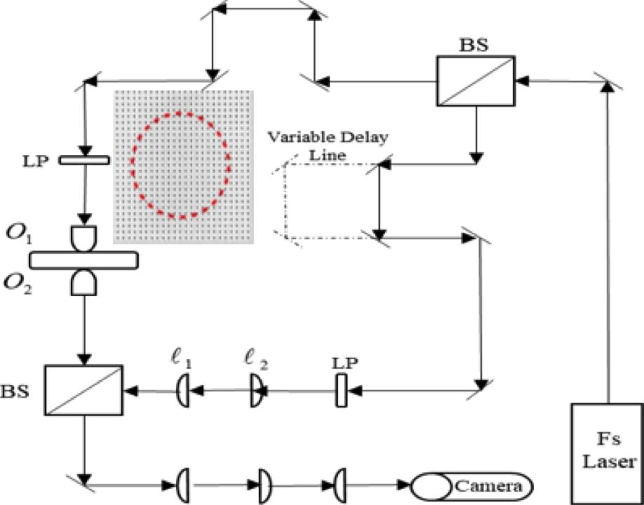

*Li Lj*

Figure 7: Hetrodyne system based on a Mach-Zehnder interferometry for time-resolved plasmonic  
pulse tracking.

earlier used to track the propagation in time of ultra-short plasmonic pulses.32 We propose  
to modify this set-up to conveniently capture the phases of different diffraction orders in the fc-space. These measurements can provide the connection between the structure  
configuration and geometry and the resulting topological phases.

* **Developing a rigorous mathematical model of topology-based plasmonic manipulation**We plan to elaborate a theoretical basis of the proposed effect starting from an accurate  
  analysis of the band-gap characteristics, studying the geometrical effects, and optimizing the  
  system. The developed model should directly link the physical grating parameters with the  
  localization strength and the lifetime of plasmonic edge modes.
* **Realizing topological metasurface based on graphene-like structure**

We propose to investigate more plasmonic structures, potentially leading to the appearance of edge states, topological phases and spin-dependent behavior. Using the space-inversion symmetry as a  
trigger for spin-orbit coupling, we propose using arrays with chiral unit-cells (Fig. 8). We believe that the chirality would influence the overall topological phase  
of the domain and provide an additional means for light manipulation.  
Specifically, we propose that each unit cell of the structure induces chiral plasmonic near-fields, resulting in an overall topological phase. We have already investigated similar structures with constant or space-variant chirality that have shown strong polarization-dependent  
behavior and may be good candidates for topology based plasmonics.33

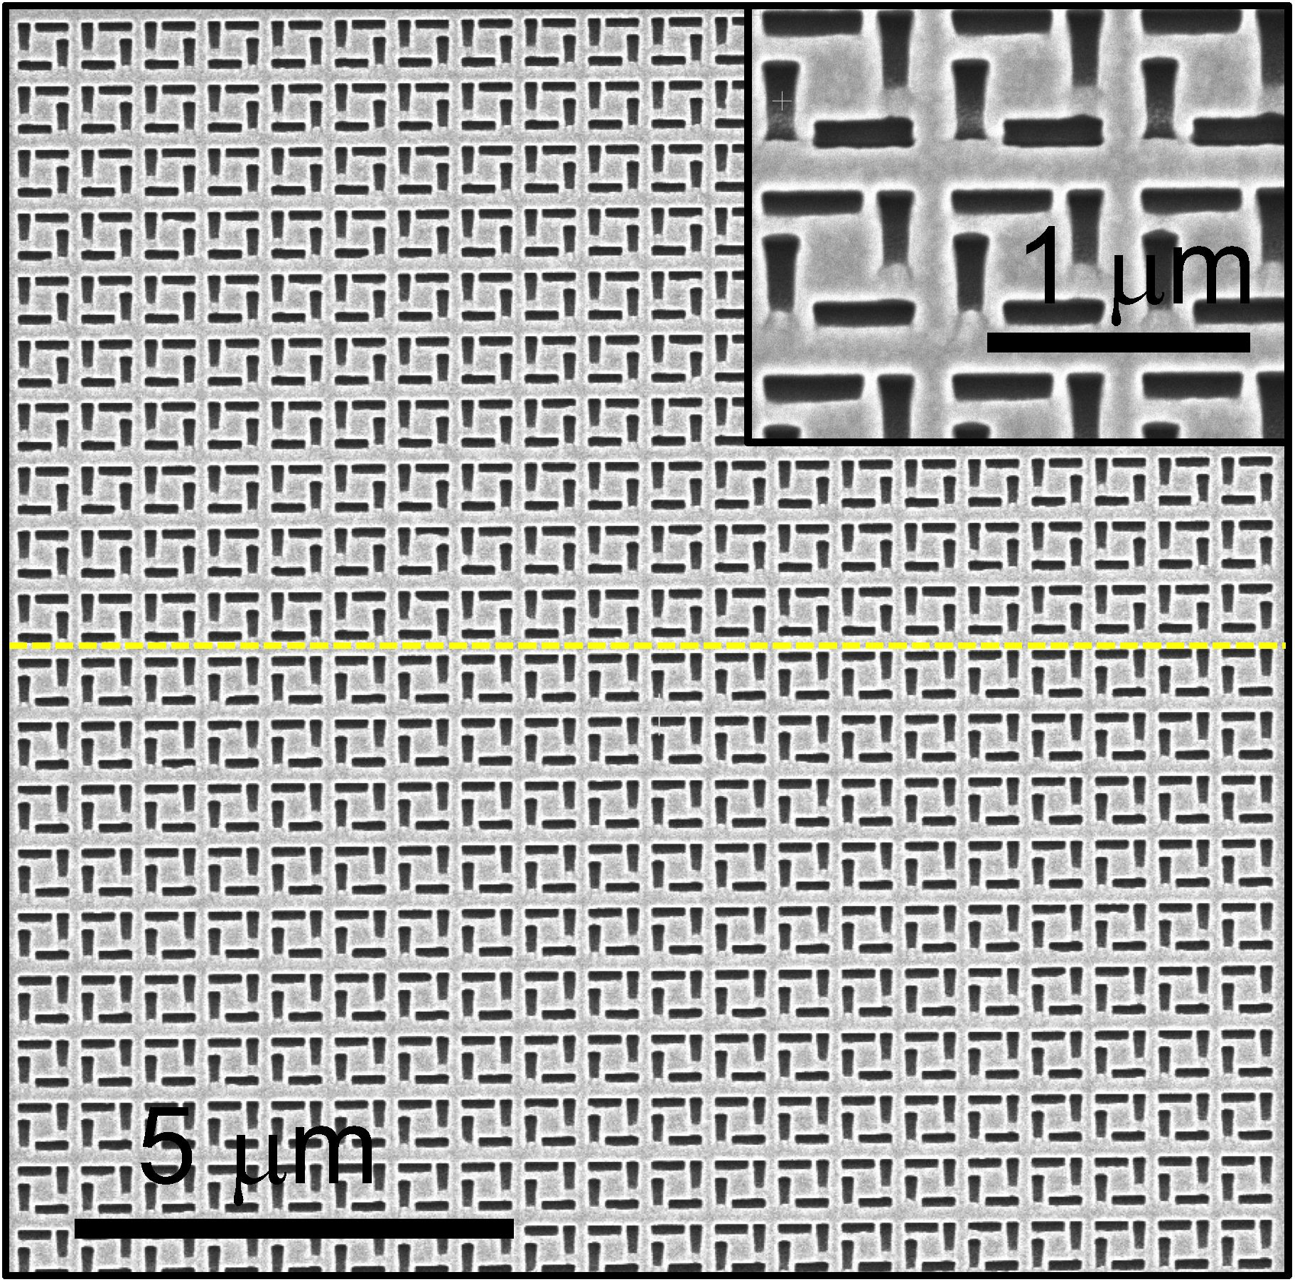

Figure 8: SEM image of the fabricated chiral metasurface. The unit cell here comprises of 4 rect-  
angles arranged in a chiral way with a broken mirror symmetry (see the inset). The handedness of  
the unit cell in the upper part is opposite to the one in the lower part (a dashed line separates the  
domains).

We intend to investigate the behavior of plasmonic waves in structural ’’domains” with opposite  
handedness, which could lead to the topological states.

**• Proposing practical applications** Some practical applications for sensing, optical communication, computing, and nanophotonic circuitry will be proposed and experimentally tested. The proposed plasmonic metasurfaces and the fundamental concepts may  
play a crucial role in understanding complex physical mechanisms that govern the optPcal spin-orbit interaction and topological photonics as well as opening new opportunities in  
nanotechnology development.

* 1. Current Research Infrastructure

Our nanooptics lab in Ariel University possess the following equipment

• High Resolution Sputter Coater equipped with QCM thickness meter - for gold evaporation

• Preheated sonication bath - for sample and glassware cleaning

• Drying oven (2501) with air circulation mechanism - for drying samples

• Pigtail CW laser (Ao = 780*nm,* 20mW power)

• C-Fiber 780 femtosecond Erbium laser (Ao = 780nm, 70*fspulseduration* lOOmVV average  
power)

• Polarizing elements - for full polarization control

• Optics free space elements - for beam shaping filtering aligning and manipulating

• Number of CMOS and CCD based cameras - for image acquisition

• Computers - for collecting data and controlling the optical elements

• Various PZT based transducers and motors - for precise alignment

• Optomechanical elements

• Olympus microscope

• Optical dry and oil immersion objectives - for imaging and illumination of samples

• Three TMC air damped and stabilized optical tables

• One computer station with COMSOL software installed on it

Resources outside of Ariel University

• Bar-llan university nanofabrication facilities - for nanofabrication of our samples

• Tel-Aviv university nanofabrication facilities - for nanofabrication of our samples

Human resources currently affiliated with the project

• Eliav Epstein - research fellow (Graduated with PhD, January 2021)

• Pasha Goz - PhD student (finishes February 2027)

• Sahil Sahoo - PhD student (finishes October 2027)

* 1. Expected Outcomes and Pitfalls

We will start with the investigation of SP wave propagation in lattices with broken space-inversion  
symmetry as discussed in Research Plan and Preliminary Results. While the preliminary results are convincing, more experimental data should be obtained to verify our concepts and conclusions. In particular we plan to perform a full numerical study of the photonic band-gap structure of our metasurfaces  
and compare the results obtained with the graphene-like unit-cell and the hexagonal structure. By  
manipulating the periodicity, orientation angle and other parameters, we plan to achieve various  
topological phases in *K* and *K'* points. This could provide a means for topologically based plasmonic  
mode manipulation. We expect to summarize our results and further investigations in 7 to 9 high-  
impact factor papers within the period of the three years.

Although some of the expected results have been partially verified in our lab the future investigation will have to deal with rather complex experimental settings and nanofabrication challenges.  
We have much experience in both of these areas, nevertheless we take into account possible pit-  
falls that could arise from either technical or theoretical issues. With this in mind, we expect that  
our research could provide a fundamental niche for further studies in topological plasmonics and  
nanophotonics in general.

Bibliography

1. N. Mounet, M. Gibertini, P. Schwaller, D. Campi, A. Merkys, A. Marrazzo, T. Sohier, I. E.  
   Castelli, A. Cepellotti, G. Pizzi, *et al.,* “Two-dimensional materials from high-throughput com-  
   putational exfoliation of experimentally known compounds,” *Nature nanotechnology,* vol. 13,  
   no. 3, pp. 246-252, 2018.
2. S. Z. Butler, S. M. Hollen, L. Cao, Y. Cui, J. A. Gupta, H. R. Gutierrez, T. F. Heinz, S. S. Hong,  
   J. Huang, A. F. Ismach, *et al.,* “Progress, challenges, and opportunities in two-dimensional  
   materials beyond graphene,” *ACS nano,* vol. 7, no. 4, pp. 2898-2926, 2013.
3. S. Manzeli, D. Ovchinnikov, D. Pasquier, O. V. Yazyev, and A. Xis, “2d transition metal  
   dichalcogenides,” *Nature Reviews Materials,* vol. 2, no. 8, pp. 1-15, 2017.
4. G. Wang, A. Chernikov, M. M. Glazov, T. F. Heinz, X. Marie, T. Amand, and B. Urbaszek,  
   “Colloquium: Excitons in atomically thin transition metal dichalcogenides,” *Reviews of Modern  
   Physics,* vol. 90, no. 2, p. 021001,2018.
5. A. Gupta, T. Sakthivel, and S. Seal, “Recent development in 2d materials beyond graphene,”  
   *Progress in Materials Science,* vol. 73, pp. 44-126, 2015.
6. J. R. Schaibley, H. Yu, G. Clark, P. Rivera, J. S. Ross, K. L. Seyler, W. Yao, and X. Xu,  
   “Valleytronics in 2d materials,” *Nature Reviews Materials,* vol. 1, no. 11, pp. 1-15, 2016.
7. F. Wu, T. Lovorn, E. Tutuc, I. Martin, and A. MacDonald, “Topological insulators in twisted tran-  
   sition metal dichalcogenide homobilayers,” *Physical review letters,* vol. 122, no. 8, p. 086402,  
   2019.
8. X. Li, S. Zhang, and Q. Wang, “Topological insulating states in 2d transition metal dichalco-  
   genides induced by defects and strain,” *Nanoscale,* vol. 9, no. 2, pp. 562-569, 2017.
9. M. V. Berry, “Quantal phase factors accompanying adiabatic changes,” *Proceedings of  
   the Royal Society of London. A. Mathematical and Physical Sciences,* vol. 392, no. 1802,  
   pp. 45-57, 1984.
10. D. Xiao, M.-C. Chang, and Q. Niu, “Berry phase effects on electronic properties,” *Reviews of  
    modern physics,* vol. 82, no. 3, p. 1959, 2010.
11. J. Segert, “Photon berry’s phase as a classical topological effect,” *Physical Review A,* vol. 36,  
    no. 1, p. 10, 1987.
12. K. Y. Bliokh, A. Niv, V. Kleiner, and E. Hasman, “Geometrodynamics of spinning light,” *Nature  
    Photonics,* vol. 2, no. 12, pp. 748-753, 2008.
13. L. Lu, J. D. Joannopoulos, and M. Soljacic, “Topological photonics,” *Nature photonics,* vol. 8,  
    no. 11, pp. 821-829, 2014.
14. J. D. Joannopoulos, P. R. Villeneuve, and S. Fan, “Photonic crystals,” *Solid State Communi-  
    cations,* vol. 102, no. 2-3, pp. 165-173, 1997.
15. E. Yablonovitch, “Inhibited spontaneous emission in solid-state physics and electronics,” *Phys-  
    ical review letters,* vol. 58, no. 20, p. 2059, 1987.
16. S. Pancharatnam, “Generalized theory of interference and its applications,” in *Proceedings of  
    the Indian Academy of Sciences-Section A,* vol. 44, pp. 398-417, Springer, 1956.
17. M. V. Berry, “The adiabatic phase and pancharatnam’s phase for polarized light,” *Journal of  
    Modern Optics,* vol. 34, no. 11, pp. 1401-1407, 1987.
18. K. Y. Bliokh and Y. P. Bliokh, “Topological spin transport of photons: the optical magnus effect  
    and berry phase,” *Physics Letters A,* vol. 333, no. 3-4, pp. 181-186, 2004.
19. C. McDonnell, J. Deng, S. Sideris, T. Ellenbogen, and G. Li, “Functional thz emitters based on  
    pancharatnam-berry phase nonlinear metasurfaces,” *Nature communications,* vol. 12, no. 1,  
    pp. 1-8, 2021.
20. S. Liu, S. Qi, Y. Li, B. Wei, P. Li, and J. Zhao, “Controllable oscillated spin hall effect of  
    bessel beam realized by liquid crystal pancharatnam-berry phase elements,” *Light: Science  
    & Applications,* vol. 11, no. 1, p. 219, 2022.
21. Z. Bomzon, G. Biener, V. Kleiner, and E. Hasman, “Space-variant pancharatnam-berry phase  
    optical elements with computer-generated subwavelength gratings,” *Optics letters,* vol. 27,  
    no. 13, pp. 1141-1143, 2002.
22. K. Y. Bliokh, Y. Gorodetski, V. Kleiner, and E. Hasman, “Coriolis effect in optics: unified geo-  
    metric phase and spin-hall effect,” *Physical review letters,* vol. 101, no. 3, p. 030404, 2008.
23. K. Y. Bliokh, “Geometrical optics of beams with vortices: Berry phase and orbital angular  
    momentum hall effect,” *Physical Review Letters,* vol. 97, no. 4, p. 043901,2006.
24. Y. Gorodetski, A. Niv, V. Kleiner, and E. Hasman, “Observation of the spin-based plasmonic  
    effect in nanoscale structures,” *Physical review letters,* vol. 101, no. 4, p. 043903, 2008.
25. L. Huang, X. Chen, B. Bai, Q. Tan, G. Jin, T. Zentgraf, and S. Zhang, “Helicity dependent  
    directional surface plasmon polariton excitation using a metasurface with interfacial phase  
    discontinuity,” *Light: Science & Applications,* vol. 2, no. 3, pp. e70-e70, 2013.
26. J. Lin, J. B. Mueller, Q. Wang, G. Yuan, N. Antoniou, X.-C. Yuan, and F. Capasso,  
    “Polarization-controlled tunable directional coupling of surface plasmon polaritons,” *Science,*vol. 340, no. 6130, pp. 331-334, 2013.
27. M. Fox and Y. Gorodetski, “Generalized approach to plasmonic phase modulation in topolog-  
    ical bi-gratings,” *Applied Physics Letters,* vol. 120, no. 3, p. 031105, 2022.
28. L. Feng, R. El-Ganainy, and L. Ge, “Non-hermitian photonics based on parity-time symmetry,”  
    *Nature Photonics,* vol. 11, no. 12, pp. 752-762, 2017.
29. A. Drezet, A. Hohenau, D. Koller, A. Stepanov, H. Ditlbacher, B. Steinberger, F. R. Aussenegg,  
    A. Leitner, and J. R. Krenn, “Leakage radiation microscopy of surface plasmon polaritons,”  
    *Materials science and engineering: B,* vol. 149, no. 3, pp. 220-229, 2008.
30. E. D. Epstein, L. Singh, S. Sternklar, and Y. Gorodetski, “The role of plasmonic excitations in  
    the optical activity of periodic structures with configurational chirality,” *Applied Physics Letters,*vol. 116, no. 13, p. 131106, 2020.
31. F. Loren, G. L. Paravicini-Bagliani, S. Saha, J. Gautier, M. Li, C. Genet, and L. Martin-Moreno,  
    “Microscopic analysis of spin-momentum locking on a geometric phase metasurface,” *Physical  
    Review B,* vol. 107, no. 16, p. 165128, 2023.
32. Y. Gorodetski, T. Chervy, S. Wang, J. A. Hutchison, A. Drezet, C. Genet, and T. W. Ebbe-  
    sen, “Tracking surface plasmon pulses using ultrafast leakage imaging,” *Optica,* vol. 3, no. 1,  
    pp. 48-53, 2016.
33. L. Singh, M. Fox, S. Sternklar, and Y. Gorodetski, “Topological diffraction from grating with  
    space variant chirality,” *ACS Photonics,* vol. 9, no. 4, pp. 1395-1399, 2022.