**The invasion of the holo-organism - The importance of the mycobiome for the invasion of arthropods**

1. **Scientific background**

Invasive species, introduced, established, and spread beyond their native range, are a major feature of the Anthropocene period due to the increased movement of people and goods (Le Roux, 2022). Insects are the main invasive species affecting native species composition dramatically (Kenis et al., 2009), causing high economic costs to the food supply and human health (Diagne et al., 2021). In the US alone, invasive insects caused an estimated damage of US$21.4 billion per year in 2017 (Diagne et al., 2021). There are multiple characteristics of invasive insects. 1) Generalist feeding habits, allowing them to utilize diverse food sources. Insects often possess adaptations enabling them to feed on a variety of plants or prey on different organisms (Snyder and Evans, 2006). This versatility increases their suitable resources in new environments. 2) Invasive species consume resources more efficiently than native species. They may have specialized physiological or behavioral adaptations, allowing them to extract maximum energy or nutrients from limited resources, giving them a competitive edge (Shik and Dussutour, 2020). 3) Invasive insects are environmentally tolerant to a wide range of environmental conditions, including temperature, humidity, and soil types. This adaptability enables insects to thrive in diverse habitats, increasing their chances of survival and spread (Renault et al., 2017). 4) Reduced natural predators: Invasive insects have reduced natural predators. They are often introduced to regions with no natural predators or where predators are ineffective or can be evaded. Without these natural control mechanisms, insects can experience reduced pressure and fewer constraints on population growth (Fortuna et al., 2022). 5) High dispersal and reproduction rates allow insects to colonize novel environments (Renault et al., 2017).

Invasive species often exhibit phenotypic plasticity to establish a proliferating population in a novel habitat. Thus, they can adapt their traits and behaviors to different environments (Le Roux, 2022). This flexibility allows invasive insects to exploit resources and adapt to changing circumstances, giving them a competitive advantage over native species. An additional factor that contributes to phenotypic plasticity and is mostly neglected is the holobiome (Renault et al., 2017), which consists of the organism and its associated microorganisms (Zilber-Rosenberg and Rosenberg, 2008). These microorganisms can affect the host genome through horizontal gene transfer (Renault et al., 2017), influencing host phenotypic plasticity. For example, microbes can provide the host with nutrients, allowing it to consume a more generalist diet. The microbes can detoxify plant defensive allelochemicals for herbivorous insects (Oliver and Martinez, 2014) or utilize the diet more efficiently to become a better competitor (Oliver and Martinez, 2014). Microorganisms can sometimes affect their host’s ability to survive in different abiotic conditions, such as low and high temperatures (Heyworth et al., 2020). Therefore, the presence and composition of microorganisms and their effect on their host’s invasive ability is a novel research direction that should be further investigated.

Insects are known to have a comprehensive world of interactions with microorganisms. Insects can harbor microorganisms on their outer skeleton, in their gut, within their cells, or within specialized organs called mycangia or bacteriocytes (Douglas, 2015). The microbes can be transmitted between generations vertically or acquired by each generation from the environment or other individuals (Bright and Bulgheresi, 2010). Microorganisms provide essential nutrients lacking in the insect’s diet, such as specific amino acids, vitamins, and sterols (Douglas, 2009). This phenomenon is common in insects with a homogenous diet, such as aphids, termites, and planthoppers (Douglas, 2015, 2009). In addition, microorganisms can assist in the digestion of indigestible plant materials such as lignin and cellulose and increase the nutrient intake efficiency of their host (Douglas, 2015, 2009). Usually, insects that use microorganisms to degrade plant cell walls will be equipped with fermentation chambers or projecting papillae in their hindguts (Douglas, 2015, 2009). Microbes can assist herbivorous insects by detoxifying plant secondary metabolites, as seen in *Lasioderma serricorne* beetles that eliminate allelochemicals using the yeast-like symbiont *Symbiotaphrina kochi* (Douglas, 2015). The microorganism can protect its host against natural enemies like the symbiont *Hamiltonella defensa,* which confers pea aphid resistance to the parasitoid *Aphidius ervi* (Douglas, 2015). In addition, microbes can affect the production of pheromones, influencing insect behaviors, including aggregation and oviposition sites (Engl and Kaltenpoth 2018). Therefore, due to the vast interactions between insects and microorganisms, we expect that microorganisms affect the invading abilities of insects through improved fitness and competition (Lu et al., 2016).

The black soldier fly (*Hermetia illucens*; BSF) is a good model for the influence of microorganisms on the invasive abilities of insect hosts. The BSF is of Nearctic origin and distributed in most warmer parts of the world due to its highly invasive capabilities (Ståhls et al., 2020). The BSF completes its life cycle within 60 days (Makkar et al., 2014). The larvae have detritivorous feeding habits and grow in rotten organic material, from household compost to animal feces and carcasses (Makkar et al., 2014). At the 6th instar stage (pre-pupa), the larvae become black and desert the organic material to pupate. The emerging adults do not feed but reproduce, and the female lays about 500-1000 eggs near organic material (Booth and Sheppard, 1984). The larvae encounter an array of beneficial and pathogenic microorganisms in the rotten organic material. Bacteria in the BSF gut are composed of a core community that changes according to the substrate composition (De Smet et al., 2018; Klammsteiner et al., 2020). The bacteria are hypothesized to assist in the hydrolytic degradation of complex substrates (Callegari et al., 2020) and increase substrate utilization efficiency (Li et al., 2022).

The mycobiome composition of the BSF gut and environment is also composed of a core community (Boccazzi et al., 2017; Vitenberg and Opatovsky, 2022) that may assist in amino-acid and vitamin B6 metabolism (Kannan et al., 2023). Because BSF is widespread throughout the Palearctic region, it has to deal with wa ide temperature gradient and survives during diapause in the cold season. The dominant fungus found in temperate Italy and Russia (Boccazzi et al. 2017, Kuznetsova et al. 2022) is *Pichia kudriavzevii*. In Mediterranean northern Israel (Vitenberg & Opatovsky 2022), *Pichia Tropicalis* is the dominant species, whereas in the semi-arid South of Israel (see **Preliminary results**), *Kluyveromyces marxianus* is dominant. The dominance differences may be due to yeast adaptation or other advantages at different temperatures. In addition, plants protect against herbivory using primary and secondary metabolites, such as polysaccharides (cellulose, pectin, and lignin) and polyphenols (tannins). For insects that consume decaying vegetative materials, such as the BSF, the degradation of polysaccharides and polyphenols can facilitate digestion. As fungi are known to degrade these metabolites, especially for wood-eating insects (Dowd, 1992.; Geib et al., 2008; Itoh et al., 2018), their presence can improve the nutrition of invasive insects, therefore facilitating invasion. Our preliminary results indicate that *C. tropicalis* increases carbohydrates in a substrate containing fiber (see **Preliminary results**). The results indicate that *C. tropicalis* may digest normally indigestible fiber. Our research concentrates on the ability of the BSF mycobiome to improve the insect’s invasive abilities. The effect of insect gut fungal composition on invasiveness is poorly understood, yet because of the intense metabolic complexity of fungi, the mycobiome is expected to influence insect physiology dramatically.

As the BSF colonizes novel and temporal habitats, it should have a strong competitive ability. These abilities provide a potential for invasiveness for the BSF. In 1959, Furman et al. (Furman et al., 1959) argued that in manure where multiple larvae of BSF larvae are abundant, *Musca domestica* (L.) flies are scarce. This observation (also observed personally) may indicate the strong competitive abilities of the BSF larvae. However, direct consumption of *M. domestica* was not observed. In our preliminary work, the survival of *M. domestica* larvae after exposure to BSF larvae was examined for direct consumption. Survival was also evaluated after BSF consumption for indirect harmful extrusions by the BSF larvae and after the addition to the feeding substrate of *Candida tropicalis*, a common yeast-like fungi from the BSF gut and environment. A significant reduction in survival was found in the *M. domestica* larvae exposed to the fungi (**Figure 1 and Preliminary results**).

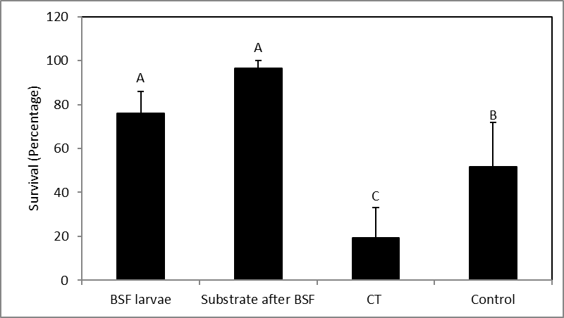

**Figure 1.** Survival of house fly larvae in a diet with BSF larvae (BSF larvae), in the substrate after BSF feeding (Substrate after BSF), in a diet with *Candida tropicalis* (CT), and a standard diet (Control).

This result led us to the main hypothesis of the proposal. We hypothesize that BSF transfers microorganisms to novel habitats through its gut system. We further hypothesize that BSF aids the colonization of specific microorganisms that help BSF compete, colonize existing habitats, and invade new ones. This process can be achieved by 1) Directly harming other competing species, 2) Changing the environment, making it less suitable for other organisms, 3) Improving the nutrient utilization of the BSF from the substrate, or 4) Helping the BSF to better cope with new abiotic conditions. Regardless of the process, for these interactions to occur deliberately, BSF must identify and be attracted to these microorganisms and aid in their colonization in a novel environment.

1. **Research objective and expected significance**

**The overall objective of the proposed study is to obtain direct evidence for the effect of mycobiome composition on insect-host invasiveness and to understand the mechanisms underlying this effect**. There are five specific objectives in this proposal. 1) Test for vertical transmission of fungi in the BSF life cycle, 2) Test for colonization of specific fungal species by the BSF, 3) Examine the ability of BSF to detect specific fungal species, 4) Evaluate the influence of microorganisms on adapting to new environments (abiotic conditions), 4) Determine the influence of microorganisms on adapting to new environments (biotic conditions), and 5) Evaluate the effect of the mycobiome on BSF community composition and colonization of habitats. *The* ***significance*** *and* ***novelty*** *of this research lie in providing knowledge about insect-gut mycobiome interactions, which has received little or no attention. Our proposal will also provide knowledge regarding the effects of microorganisms on insect invasiveness, an unresearched topic. Our research will provide basic knowledge of unstudied interactions and effects on microorganisms and their hosts. This knowledge can be applied to different systems of invading insects, such as agriculture or invading non-insect organisms. In addition, our research will provide knowledge regarding the influence of microorganisms on interactions within the multi-trophic web by using laboratory experiments to test for specific effects*. The data will be combined into a multi-species environment using machine learning methods to construct a complex experimental setting. A summary of the research design is presented in Figure 2.

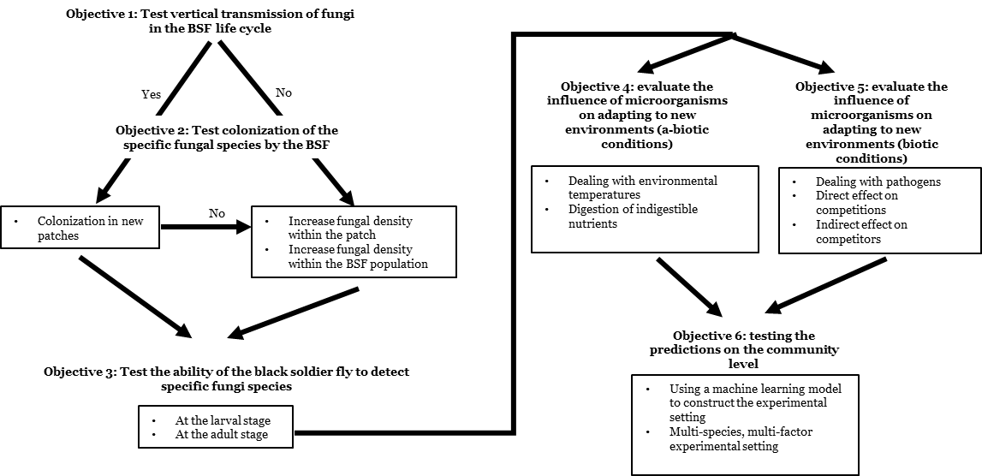

**Figure 2.** A summary of the research design. Research objectives are marked in bold, and planned tests are presented in boxes.

1. **Detailed description of the proposed research**

C.1. General working hypothesis

My general hypothesis is that the fungal microorganisms in the insect gut increase the invasiveness of their insect host by mutual interaction. The effect on the host is due to changes to the environment that are more suitable for the insects, increasing their adaptability to abiotic conditions or reducing the competitiveness of competitors. By contrast, the insect host provides a vector for microbial dispersal or helps them to colonize the habitat. To test this hypothesis, we will combine molecular and ecological tools to examine the dispersal and colonization of insects and microorganisms at the individual, population, and community scales.

C.2. Objective 1 - Vertical transmission of specific fungi throughout the BSF lifecycle

C.2.1. Specific working hypothesis

We propose that common fungal species in the BSF gut and environment (Boccazzi et al., 2017; Vitenberg and Opatovsky, 2022) will be transmitted vertically throughout the BSF life cycle and colonize new environmental patches. We will test this hypothesis by identifying and quantifying the fungal load throughout the BSF life stages on the outer cuticle and within the gut. The experiments will determine if fungi are transferred from adults to pupa and if adults transfer them through their eggs.

C.2.2. Identifying fungal community composition and quantifying fungal load through the BSF lifecycle

We will test the presence of microorganisms and determine their composition on the outer and inner parts of BSF adults, eggs, 1st instar, 5th instar, and pupa. The outer surface will be washed with buffer, and DNA will be extracted from the wash buffer using a DNA extraction kit. For the inner parts, the surface will be sterilized, and the gut, or whole contents from eggs and small larvae, will be used for DNA extraction. In all cases, the rRNA gene ITS region will be amplified using the primer set ITS1-ITS2 [(ITS1: TCCGTAGGTGAACCTGCGG; ITS2: GCTGCGTTCTTCATCGATGC (White et al., 1990)]. We will sequence the libraries on the Illumina MiSeq platform using 2x150bp paired-end reads. Raw sequence will be processed to remove adapters, primers, to denoise the reads and remove chimeric sequences using R package DADA2 (Vitenberg and Opatovsky, 2022). The dereplicated sequences will be clustered into operational taxonomic units (OTUs) with the UNITE reference database (Nilsson et al., 2019). This analysis will provide data regarding changes in the community composition. We will use qPCR with specific primers to the ITS region to test for quantitative changes in fungal abundance.

To test for fungal transfer between adults and larvae, we will examine adult BSF hatched from the pupa of larvae reared through the whole life cycle on a basic diet containing all nutrients, including casein, sugar, potato starch, canola oil, mineral mix, vitamin mix, sawdust, and water (Kannan et al., 2023). We will supplement the diet with the yeasts *C. tropicalis* and *P.* *kudriavzevii* isolated from the BSF gut and *S. cerevisiae* purchased separately. The specific yeast amounts (% of diet) required to achieve effect, will be tested beforehand. These adults will lay eggs on a sterile diet, and the egg surfaces and contents will be tested for our specific fungi. If the specific yeasts are present in the eggs, we will conduct a further experiment to test for fungal transfer within larval stages and to adults. In this case, we will place the eggs in a sterile substrate and determine the presence of the fungi at different larval stages, pupa, and adults. If the eggs lack fungi, they will be placed in substrates that include yeast. Five individuals from each yeast and life cycle will be examined and compared to individuals from a diet without supplemental yeast.

The species *C. tropicalis* and *P.* *kudriavzevii* will be taken from fungal isolates in the Opatovsk laboratory. We will rear the fungi on yeast extract peptone dextrose (YPD) medium and concentrate them by centrifugation for addition to the insect diet. Adult flies will be reared in 1X1X1 cages in a rearing room at 30oC, 70% humidity, and 12/12 L/D in the Opatovsky laboratory and allowed to lay eggs on cardboard placed over plastic cases with diet. We will rear larvae in 250 ml plastic cases containing 100 gr of insect diet per 100 larvae in a rearing chamber at 27oC, 70% humidity, and 12/12 L/D (NUVE, TK-600)

C.2.3 Expected results and pitfalls

Objective 1 will provide data on whether common fungi in the BSF gut are acquired at the larval stage and transferred to the next generation through the adults.

C.3. Objective 2 - Colonization of specific fungal species by the BSF

C.3.1. Specific working hypothesis

We hypothesize that BSF is selective for several yeast species, allowing the yeasts to reproduce and colonize existing environments or transmit to novel environments. If we detect vertical transmission, we will examine fungal colonization of novel environments by BSF adults. If no vertical transmission is detected, we will test for an increased abundance of the specific fungi due to BSF. If we detect vertical transmission but no colonization of fungi by BSF adults, we will also investigate changes in yeast abundance in the environment.

C.3.2. Dispersal of specific fungi to novel patches

To understand fungal dispersal by BSF to novel patches, adults reared on a diet with supplemented fungi will be exposed to sterile substrate for egg laying. We will measure the presence and abundance of the fungi in the substrate compared to a substrate exposed to adults reared on a sterile substrate without supplemental fungi. The adults will be hatched and reproduced in net cages in the rearing room and provided with plastic cases containing diet and cardboard for egg laying. After laying, the eggs will be hatched in a Petri dish in a rearing chamber. The larvae will be incubated in a rearing chamber with a 500 gr diet in a two-liter plastic case (500 larvae per case, 5 replicates per treatment). We will look at the presence and abundance of the yeasts using qPCR with general primers for yeast (YEASTF 5′-GAGTCGAGTTGTTTGGGAATGC-3′; YEASTR 5′-TCTCTTTCCAAAGTTCTTTTCATCTTT-3′; Hierro et al. 2006) and specific primers for the tested yeast *C. tropicalis* (Garcia-Martines et al. 2010). One gram samples will be taken from different substrate locations and depths (three samples from the center of the pile – upper part, middle, and bottom and the same sample from the edge of the pile) every five days from encountering hatched larvae (five replicates per treatment).

C.3.3. Dispersal of specific fungi within the patches

We will investigate the assistance of the BSF in fungal colonization within the patch by placing newly hatched larvae (1st instar) in substrates supplemented with yeasts placed in the middle of the pile consisting of 500 gr of diet and 500 larvae placed in 2 L plastic box in a rearing chamber (five replicates per treatment). We will conduct a preliminary experiment to determine the effect of different amounts of yeast (0.001% and 0.01% from the diet weight) on the establishment by BSF. The presence and abundance of the yeast will be tested in the substrate, as explained before (section C.3.2), and will be compared to substrates without supplemental yeast.

C.3.4. Dispersal of specific fungi within the population

We will also test the dispersal of fungi to other BSF larvae within the population. The experiments will be based on the results of the previous section (C.2.2.). If the hatched larvae contain the yeast, 10 larvae (1st instar) will be placed in a sterile substrate with 90 sterile larvae. We will take 30 larvae every five days and analyze them for yeast using specific and general primers (as described in section C.3.2.). We will conduct five replicates. If the hatched larvae do not contain the yeast, sterile larvae will be placed in substrates supplemented with yeasts (0.001% and 0.01% from the diet weight) that will be placed in the middle of the pile. The percentage of larvae that contain the yeast will be sampled as described.

C.3.5. Expected results and pitfalls

If the fungi are vertically transmitted during the BSF life cycle, we expect that BSF will help to colonize the microbe in new habitats. If the fungi are not vertically transmitted, we hypothesize that the fungi arrive at the patch individually, but the BSF larvae help the fungi to colonize and take over the patch. Therefore, we expect an increase in the abundance of fungi in the patch. In case we do not observe any effect of BSF larvae on fungal colonization, we will examine different diets: 1) Standard substrate for Dipteran (Gainesville diet contains alfalfa, wheat bran, and corn meal) (Hogsette, 1992), 2) Diet that is composed of fruits and vegetables, resembling household composts that are colonized naturally by BSF), and 3) Chicken manure, which is a habitat colonized naturally by BSF)

C.4. Objective 3 - BSF identification of specific microorganisms

C.4.1. Specific working hypothesis

We hypothesize that if microorganisms provide an advantage for the insect, the insect will be able to identify microorganisms in the environment. The identification will occur either at the adult stage, affecting the decision by adults where to lay eggs, or at the larval stage, affecting the consumption pattern of patches of food with microorganisms.

C.4.2. Identification of selected fungi by the BSF adults

We will test our hypothesis with two experiments. We will examine the direct effect of microorganism volatiles on adult attraction using an olfactometer and the impact of microorganisms on the oviposition behavior of SBF in cage experiments.

The olfactometer experiments will be conducted on an olfactometer purchased for this purpose. In each set of experiments, we will compare fly behavior in two samples: one diet sample without yeast and one with yeast. Four types of diet will be tested for the effects of the substrate itself and interactions between the microorganisms and the substrate: 1) Basic diet (Kannan et al., 2023), 2) Standard substrate for Dipteran (Gainesville diet) (Hogsette, 1992), 3) A diet resembling household compost, and 4) Chicken manure. We will investigate the impact of these diets on *C. tropicalis,* *P. kudriavzevii,* and *S. cerevisiae* growth (eight replicates per combination). If present, we will determine the minimum abundance of yeast producing the effect. In each experiment, we will use one BSF adult, mated female two days after hatching.

The cage experiment will be conducted in 1X1X1 m net cages placed in a rearing room at 30oC, 70% humidity, and 12/12 L/D. At the beginning of the experiment, we will place 40 BSF pupae in each cage. We will determine the best combination of diet and yeast in each experiment according to the olfactometer. If we observe no effect in the olfactometer experiments, we will test the four types of diets. For treatments, a 200 ml plastic container will be placed in each cage with eight replicates per cage. In separate experiments, we will test each of the four diets with the cardboard above the substrate for oviposition in each plastic container. The effect on oviposition will be measured by collecting the eggs and comparing their weights using ______.

C.4.3. Identification of microorganisms by BSF larvae

To test the hypothesis that BSF larvae can detect microbes, we will conduct two experiments: examine the direct effect of microorganism volatiles on larval attraction using an olfactometer and the effect of microorganisms on larval feeding behavior in plate experiments.

The olfactometer experiments will utilize BSF female adults fed the identical four diets and yeast combinations (see section C.4.2) with 3rd instar (five days larvae) and 5th instar (eight replicates each).

For the plate experiments, we will use 20 cm petri dishes containing a thin layer of substrates with half the plate containing a supplemental microorganism (see section C.4.2). We will record larvae using the device name (manufacturer) and analyze movement using Ethovision XT software (Noldus). The time spent per area will be calculated every 30 min from the placement of the larvae. We will conduct each experiment with 3rd instar (five-day-old) and 5th instar larvae (eight replicates per experiment).

C.4.4. Expected results and pitfalls

We expect the yeast to influence the substrate preference of either BSF adults or larvae, or both. However, if we may find no preference by the insect, we will examine our experimental conditions further.

In the cage experiments, BSF adults could be affected by volatile masking within the cage. Therefore, we will compare the egg weights between isolated treatment experiments where each sealed cage receives a specific treatment. If no effect on larval movement is detected, we will conduct a “cafeteria” experiment with different lumps of food (Shishkov et al., 2019). In addition, we will test the preference in the presence or absence of yeast in adult and larvae guts.

If it is confirmed that the insect may contribute to fungal colonization non-selectively in the environment, this could lead us to a potentially novel mechanism.

C.5. Objective 4 – Influence of selected fungi on adaptation (abiotic conditions)

C.5.1. Specific working hypothesis

We expect fungi in the environment to provide an environmental advantage to host BSF. We will explore these advantages under two conditions favoring an invasive species in rotten organic material: high and low temperatures and indigestible plant materials (polysaccharides and tannins) in the substrate.

C.5.2. Effect of temperature on adaptation

To test for the influence of the selected fungi temperature adaptation, we will rear larvae from 1st stage on a basic diet (Kannan et al., 2023) with and without supplemental *P. kudriavzevii*, *C. tropicalis*, *K. marxianus,* and *S. cerevisiae* as a reference fungi. Initially, the yeast inoculums will be extensive (1% of total diet weight). After the effects are identified, we will test minimal yeast inoculums. The experiment will be done in a rearing chamber, in 2 L plastic cages with 250 gr of diet and 250 larvae. We will examine five temperatures: optimal 30oc, minimal 25Oc, maximal 35Oc, and extreme cold 15oc and hot 40oc (Yong-Chia et al. 2018) using five replicates per temperature. The development time until the pupa stage, survival at each life stage, hatching rates, and body weight of 5th instar larvae and adults will be measured.

C.5.3. Effect of indigestible plant materials on BSF digestion

We will investigate the influence of our selected fungi on the digestion of indigestible plant materials using larvae reared on a basic diet (Kannan et al., 2023) with additional components. The effect of fungi on polysaccharide digestion will be tested by adding sawdust and 1% of the diet weight of *P. kudriavzevii*, *C. tropicalis*, *K. marxianus,* and *S. cerevisiae* as a reference to the diet (25%). We will supplement the diet with yeast in two ways. One group will be added one week before larval inoculation, whereas a second group will be supplemented during larval addition to the experimental (100 mg diet with 100 larvae per flask, five replicates). Larval weight will be measured when 50% of the larvae change color and become pre-pupa. We will measure differences in the amounts of remaining polysaccharides by digestion with H2SO4 (1.25%) and NaOH (1.25%), then burning the remains at 600°C in a laboratory furnace (Bifartherm) to exclude the weight of minerals in the samples.

To assess its detoxification, we will add tannin to the basic diet (0.01%, 0.1%, and 1%; Sigma-Aldrich). Our four yeast species will be supplemented in two ways. One group of larvae will be supplemented one week before inoculation, whereas a second group will be supplemented during larval inoculation (100 mg diet with 100 larvae per flask; five replicates). When 50% of larvae change color and become pre-pupa, the larvae weight will be measured. The remaining tannins will be measured using a specific detection kit (Abbexa Ltd.).

C.5.4. Expected results and pitfalls

We expect our experiments to reveal the influence of gut fungi on the growth rate and survival at different temperatures. If we do not observe an influence, we will conduct similar experiments with an insufficient low-protein diet (Yong-Chia et al. 2018). We predict that our experiments with indigestible plant materials will show enhanced larval growth due to fungi digestion of harmful or indigestible materials. If providing the yeast prior to larval addition is harmful due to fungal fermentation products, we will evaluate yeast supplementation amounts at different times before larval addition. We will also assess the influence of the four yeasts at different larval stages.

C.6. Objective 5 - Influence of selected fungi on adaptation (biotic conditions)

C.6.1. Specific working hypothesis

We hypothesize that environmental fungi provide an advantage to their BSF hosts. We will test this expectation using two biotic conditions that an invasive species may encounter in rotten organic material: fungal and bacterial pathogens (entomopathogens) and competitors such as other non-BSF Dipteran larvae. We will examine the effect of our specific yeasts on other Dipteran species directly by consumption of yeast or indirectly by executing BSF larvae in the substrate. We will also test other Diperans by incorporating fungi into the substrate prior to larval inoculation.

C.6.2. Influence on pathogen resistance

To test the effect of select fungi on BSF larval growth in the presence of pathogens, we will expose BSF larvae to entomopathogenic microorganisms with and without each of our four gut fungi. The experiment will utilize a 100gr simple diet and 100 larvae per plastic flask. The diets will be supplemented with one each of the four select fungi. Pathogens will be added after one week of larval rearing. The pathogens are the fungi *Beauveria* spp. and *Metarhizium* spp. and the bacterium *Bacillus thuringiensis*. We will compare larvae reared on the pathogens substrates to larvae reared without the pathogens. When 50% of larvae reach the pre-pupa stage, we will analyze each selected gut fungus, pathogens in the substrate, and pathogens in the larvae using RT-PCR with specific primers. In addition to the microbial abundance by RT-PCR, the larval weight, larval survival ratio, and the hatching ratio of the adults will be determined.

C.6.3. Influence on other Diperan species

We will investigate the influence of BSF and our selected fungi on Dipteran species that BSF may encounter in the natural environment. The experiments will utilize plastic flasks with 25 gr of Gainesville diet suited for Diptera (Hogsette, 1992). In the first experiments, three Diptera species, *Musca domestica, Drosophila melanogaster,* and BSF*,* will be reared from 1st instar to pupa in diet alone to test for survival (25 larvae per species, five replicates). When all larvae become pupa, we will measure their body sizes, time to reach pupa, and survival rates. To evaluate competition, we will grow 12 larvae of the three species together. When the pupa become larvae, we will measure larval survival, time to reach pupa, and pupal body weight. In the second experiment, the three Diptera species will be grown together from 1st instars (12 larvae per species). Due to differences in growth rates, we will measure larval survival every five days until BSF reaches the pupal stage. Also, we will investigate supplementation times for each Diptera species due to differing growth rates and body sizes. For example, we may add BSF larvae after one week of growth by the other species. These experiments will determine whether BSF larvae directly consume the larvae of the other Diptera species. In the third experiment, we will test the development of Diptera species on a Gainesville diet previously consumed by BSF larvae through their lifecycle. The experiments will elucidate whether BSF larvae extract metabolites harmful to the competitors, such as ammonia or uric acid. In the fourth experiment, we will provide a Gainesville diet supplemented with each of the four selected fungi (1% diet weight per species) to the three Diptera species and then measure pupal body weight, time to reach pupa, and survival rates. The results will indicate whether the selected fungi harm the non-BSF Diptera species. If we observe a harmful effect on the non-SBF Diptera, we will determine the minimum abundance of fungi in the environment, resulting in reduced survival.

C.6.4. Expected results and pitfalls

We expect that supplementation of gut fungi will affect the survival or body size of BSF larvae encountering entomopathogenic microorganisms. If no effect is observed, we will utilize a less nutritious, low-protein diet to weaken the larvae and their immune system.

In competitions between BSF larvae and each of the other two Diptera, we expect to observe reduced body mass or survival when two species are present compared to one species. If no effect is seen, the diet may be sufficient for both species and is not limiting. In this case, we will enhance competition by increasing the number of larvae of both species (Chase and Berlovsky 1994).

We also expect the fungal-supplemented substrate to affect the body size or survival of the Diptera species. If no effect is detected, another set of experiments will be conducted. We will feed BSF larvae with the four select fungi. After BSF pupation, the remaining substrate will be used to rear the three Diptera species. We will then test interactions between BSF and its gut fungi and the effect of this combination on competitors.

C.7. Objective 6 – Testing the predictions at the community level

C.7.1. Working hypothesis

We hypothesize that factors affecting the BSF life cycle and gut fungi provide an adaptive advantage at the community level. We will construct a multi-species experiment to understand the invasion potential of fungal-hosting BSF. To build such an experimental setting, we will use machine learning based on the results of Objectives 1 to 5.

C.7.2 Machine learning model

We will use ECHO, a generic simulator (Holland 1992) designed to explore interactions among large numbers of adaptive agents (AA). ECHO provides populations of evolving, reproducing agents that are distributed geographically with inputs of renewable resources at various sites. This AA model provides a realistic framework for ecosystem simulation, evolving ecosystem structures, and behaviors by emerging, submerging, interacting, and evolving ecological entities. ECHO is an individually based AA that is proven to apply to a spatially explicit simulation of highly simplified terrestrial food webs (Recknagel 2006).

C.7.3 Multi-species experiments

We will conduct the experiments in net cages (1X1X1 m) in a rearing room according to the abiotic conditions determined in Objective??). One Kg of Gainesville diet will be placed in plastic containers within the cages, and Diptera eggs or larvae will be placed according to the ECHO model (3 replicates per condition). We will conduct the experiment over two months to allow the development of several generations of the three Diptera species. Every 10 days, the number of larvae, pupa, and adults will be measured, and the presence and abundance of the different fungi species will be measured by RT-PCR with specific primers from 1 gr substrate samples (3 replicates per substrate).

C.7.4 Expected results and pitfalls

**D. Preliminary results**

We tested the interaction of BSF larvae and house fly larvae in plastic flasks containing 25 grams of Gainesville diet. The treatments were tested: 1) Rearing 25 BSF larvae with 25 house fly larvae to test for direct predation, 2) Rearing 50 house fly larvae on remaining substrate from BSF larvae consumption to detect active metabolites extracted by BSF), 3) Rearing 50 house fly larvae on substrate supplemented with 1gr *Candida* to examine the growth effect, 4). Rearing 50 house fly larvae without supplements as a control. We conducted five replicates per treatment. We incubated all treatments for four days in a rearing chamber at 29oC and 70% humidity. Live larvae from the treatments were then counted to calculate survival, and the average weight of three larvae was measured. We found that survival of house fly larvae was reduced in control and Candida treatments compared to treated BSF larvae and larvae fed the BSF remains (Hdf=3,21=31.6, p<0.01, **Figure 1).**

We isolated fungi from the guts of BSF larvae collected at different locations: Shear Yeshov- 33°13′35″N 35°38′48″E, Kiryat Tivon - 32°42′56″N 35°07′36″E, Timrat - 32°42′13″N 35°13′31″E, Kfar Ha’Horesh - 32°42′04″N 35°16′22″E, and Ruhama - 31°29′51″N 34°42′19″E. We found a decrease in the abundance of *Candida tropicalis* and an increase in the abundance of *Kluyveromyces marxianus* toward the South of Israel (**Figure 3**). The colonies were isolated from five larvae on YPD agar. Ten colonies per larva were identified by Sanger sequencing HyLabs, Rehovot, Israel) with primers ITS1-ITS2 (ITS1: TCCGTAGGTGAACCTGCGG; ITS2: GCTGCGTTCTTCATCGATGC) (White).

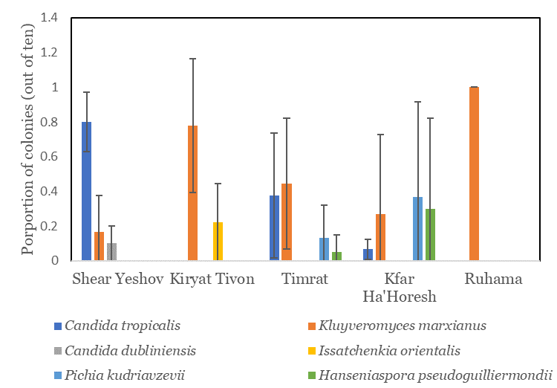

**Figure 3.** The proportion of colonies isolated from five BSF larvae from different locations.

We examined the effect of entomopathogenic fungi (*Beauveria bassiana*) onBSF larvae by rearing the larvae (1st instar) on Gainesville diet for four days. We then transferred the larvae to the treatments with the Bioveria formulation (BF) (LAM International, Butte, Montana, USA). The fungal conidia were counted using a hemocytometer, and one high concentration of 107 conidia/ml was selected for use, as reported by Lecocq et al. (2021). We used three treatments: 1) Control (no fungus), 2) Dipping larvae in BF for one minute and transferring them to the Gainesville diet (BD), and 3) Feeding larvae on the Gainesville diet treated with the BF. After 10 days of fungal treatment, we measured larval body weight, and the larvae were grown until emergence. We counted the emerging adults and measured their body weight. The *B. bassiana* feeding treatment (BF) significantly reduced BSF larval weight (0.63 ± 0.04 g), compared to the control (2.52 ± 0.08 g) and the dipping treatment (BD) (2.34 ± 0.06 g) (p = 0.0001). Furthermore, we found that the BF treatment significantly decreased the percentage of adult emergence (8 ± 5.83%), compared to the control (76 ± 14.89%) and BD (38 ± 9.69%) (p = 0.02) (**Figure 1B**). Additionally, the BF treatment significantly reduced BSF adult fly weight (28 ± 3.54 mg) compared to the control (94 ± 4.71 mg) and BD (90.3 ± 5.69 mg) (p = 0.014). We observed no significant difference in larval weight, adult emergence, or adult weight between the control and BD (Kannan et al. under review).

To investigate BSF larval preference for fungi in the substrate, we made YPD substrate using 65 gr of YPD powder per liter. We poured 10-30 ml autoclaved YPD at 50 C° per Petri dish. When solid, 100 ml of *S. cerevisiae* was spread on half of the treatment group of the Petri dish, then Petri dishes were incubated for 24 hours to form large yeast colonies (fig 1). We added one larvae to each Petri dish for 4 hours (**Figure 4**). Videos of the larval movements were taken with a camera above the Petri dishes, and the data was processed using the program Ethovision. We found no larval preference for any Petri dish location, indicating that the substrate should contain a thin layer of larval diet, and other fungi should be tested.

**E. Personnel and facilities**

Our laboratory is well-equipped for molecular biology, including thermoshakers, centrifuges, a PCR thermocycler (T100, BioRad), and online quantitative PCR (BioRad CFX384). For rearing and handling of insects and fungi, the lab has a temperature-controlled rearing room, an incubator for controlled insect rearing, a dissecting stereomicroscope (Zeiss, Stemi 508), a biological hood, and shakers and incubators for culturing yeast. A rearing room will be dedicated to adult flies to perform the necessary work for the grant. A post-doctoral fellow (100%) and a part-time technician will be recruited for this project. Illumina and nanopore sequencing will be conducted at the Research Resources Center, University of Illinois at Chicago (see Support Letter from Dr. Stefan J. Green), and Dr. _____ from the MIGAL will assist with the machine learning models (see Support Letter).