Global Impact Awards   
Honoring Those Making a Positive Impact in the Developing World   
**​Gala Event attended by the President of Israel, Reuven (Ruvi) Rivlin**  
January 16, 2019

Tel Aviv Museum of Art 18:30-21:00

18:30 – Reception

Due to security requirements, please arrive on time.

19:45 – Doors closing

Due to live broadcast, participants will not be allowed to enter after this hour

**The event will broadcast live on Walla! News**

MCs: Orly Vilnai and Guy Meroz

The awards ceremony will include musical interludes by Shy Ben Tzur and his group.



Shy is an Israeli composer/producer/poet and performer who lives in India and Israel.

In 2015, Ben Tzur recorded an album with British guitarist and composer [Jonny Greenwood](https://en.wikipedia.org/wiki/Jonny_Greenwood" \o "Jonny Greenwood) and a group of Indian musicians at the 15th-century Mehrangarh Fort in the Indian state of [Rajasthan](https://en.wikipedia.org/wiki/Rajasthan" \o "Rajasthan).[[3]](https://en.wikipedia.org/wiki/Shye_Ben_Tzur" \l "cite_note-3) The sessions and Greenwood's 2015 India tour were filmed by [Paul Thomas Anderson](https://en.wikipedia.org/wiki/Paul_Thomas_Anderson" \o "Paul Thomas Anderson) for his documentary *[Junun](https://en.wikipedia.org/wiki/Junun" \o "Junun)*.

**Professor Samuel Pohoryles – *The Late Dr. Yehuda Paz Lifetime Achievement Award***

**In recognition of a lifetime of activity and of his contribution to global development through agriculture – actions which vastly improved the lives of countless people in the developing world.**

**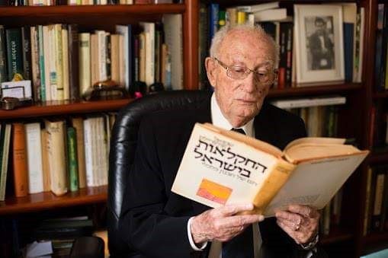**

**Global Impact Awardees:**

## IsraAid

## In recognition of the long-standing, comprehensive activities in the field of international, humanitarian aid, which stands as a symbol of Israeli humanitarian efforts world-wide.

**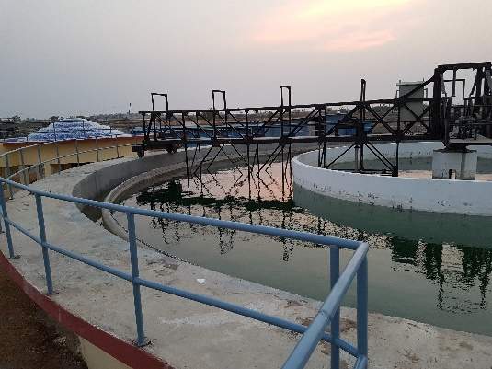Gadag Karnataka Project, Tahal**

**In recognition of the extensive infrastructure project that connected hundreds of thousands of homes in India to running water; an act that is representative of the manner in which Israeli industry is able to positively impact the developing world.**

## Soapy Care

## In recognition of technological innovation in the field of health and sanitation, a project that exemplifies the way in which Israeli technological innovation provides solutions to the challenges of the developing world.

## 

## Arie Levy – SSF: Rescuers without Borders

## In recognition of outstanding humanitarian actions, and serving as a shining example of Israel’s commitment to the developing world.

****

**GivingWay**

**In recognition of the creative and original thought within the field of international volunteer work, and for their inspiring actions.**

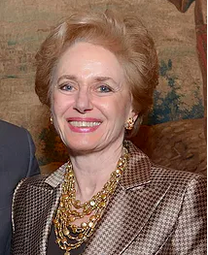

**Dr. Georgette Bennett**

In recognition of her outstanding contribution to the field of humanitarian aid and her tireless efforts to forge connections between Israel and the global Jewish community. Her work has transformed countless lives.

## ×ª××¦××ª ×ª××× × ×¢×××¨ âªâ¢ Jean-Claude Nkulikiyimfuraâ¬âJean-Claude Nkulikiyimfura

In recognition of his outstanding contribution to the field of international development, and of his unceasing efforts to forge ties between Israel and the global Jewish community. His work has transformed countless lives.