PI: Orli LAchamy, Application No.: 1407/25

A. Detailed Description of Program

The atmospheric jet stream is a fast stream of air concentrated at subtropical or middle latitudes, approximately ten kilometers above the ground. It is tightly coupled to surface weather systems through mutual interactions, and its time scales range widely, from days to years and even decades. Understanding the dynamic processes controlling jet variability is crucial for elucidating climate variability in the subtropics and midlatitudes.

The response of the jet to climate change induced by the anthropogenic increase in greenhouse gas con-  
centration is complex and only partially understood (Shaw, 2019). The most prominent response detected in climate simulations and observations is a poleward shift of the jet (Wooltings et al., 2023). The shift is explained by dynamic mechanisms independent of longitude, namely zonally symmetric mechanisms. However, the jet structure is zonally asymmetric and can be viewed as a combination of jets at large longitudinal sectors covering large oceanic basins and continents. The jet variability and response to climate change are often explained by applying zonally symmetric arguments while referring to jets at specific longitudinal sectors. ***We propose to investigate the extent to which zonally symmetric or asymmetric processes influence jet dynamics across large longitudinal sectors.***

Two main mechanisms drive the jet. **The first mechanism** is the conservation of absolute planetary and angular momentum: Planetary angular momentum is highest at the equator and decreases toward the poles. Air rises in the tropics due to strong convection and moves poleward from the tropics in the upper branch of the Hadley circulation cell. The poleward moving air advects absolute angular momentum, increasing the relative angular momentum proportional to the zonal wind (Held and Hou, 1980). This mechanism creates a strong jet at the subtropical edge of the Hadley cell in the upper troposphere, called a subtropical or thermally-driven jet (Lee and Kim, 2003). **The second mechanism** involves momentum transport by extratropical eddies, also called storms or weather systems. Due to potential vorticity conservation, extratropical eddies transfer zonal momentum into the latitude from which they propagate meridionally. As a result, the eddies create a jet at midlatitudes, called a midlatitude, polar-front, or eddy-driven jet (Lee and Kim, 2003). The conceptual distinction between the subtropical and eddy-driven jets is useful but can be misleading because the jet is generally affected by both mechanisms (Lachmy and Hamik, 2014, 2016), as well as other processes, such as vertical advection of zonal momentum and diabatic processes that modify the potential vorticity. When considering the jet at a limited longitudinal sector, these processes include zonal advection of momentum, acceleration due to the pressure gradient force, and Rossby wave propagation. ***We propose to examine the processes that affect the jet at large longitudinal sectors.***

Jets are usually classified as subtropical or eddy-driven according to their characteristics. Theoretically, angular momentum advection drives a jet at the subtropical edge of the Hadley cell in the upper troposphere. In contrast, eddy momentum flux drives a jet inside the Ferrel cell, the midlatitude atmospheric overturning circulation cell, with surface westerlies below the upper tropospheric jet. Thus, the subtropical and eddy-driven jet latitudes are often defined as the latitudes of maximum vertical zonal wind shear and maximum surface westerlies, respectively (Waugh et al., 2018). For example, during the Southern Hemisphere (SH) winter, a strong, persistent jet in the Indo-Pacific sector is concentrated in the subtropical upper troposphere **(Figure la)** with weak lower tropospheric A diagram of a weather map
westerly winds below **(Figure 1c)**, known as a subtropical jet. In contrast, during the same season, the jet in the Atlantic sector is concentrated at midlatitudes, accompanied by a strong surface westerly wind. The jet tends to fluctuate in latitude, which is characteristic of an eddy-driven jet. Similarly, the SH summer jet **(Figure lb, d)** is classified as eddy-driven (Kim and Lee, 2004). However, observations indicate the mechanisms of the jet in each sector and season are a mixture of processes (Williams et al., 2007; Li and Wettstein, 2012; Gillett et al., 2021; Spensberger et al., 2023).

**Figure 1.** Zonal wind climatology (blue shading, in ms-1), in the upper (200 hPa) (a,b) and lower (850 hPa)  
(c,d) troposphere , during Southern Hemisphere winter (June-August, JJA) (a,c) and summer  
(December-February, DJF) (b,d). The red contours in (a,b) represent the temperature at the 850 hPa pressure  
level, with a contour interval of 5 K, and the hottest contour level of 285 K. The red contours in (c,d) represent  
the eddy poleward momentum flux, where eddies are defined as deviations from the monthly mean, with a  
contour interval of 20 m2 s-2, starting from zero. The green contours in (a,b) show the outgoing longwave  
radiation (OLR), with a contour interval of 10 W m2, from 180 to 220 W m2. These contour levels represent  
the lowest values of OLR, which indicate strong convection.

The jet stream is affected by a combination of mechanisms, which play different roles at different longitudinal sectors. The sources of this zonal asymmetry vary between the two hemispheres. In the Northern  
Hemisphere (NH), continents and ocean currents play a major role in shaping the longitudinal structure of  
the jet (Nakamura et al., 2004), in addition to the effect of zonal asymmetries in tropical convection (Li and  
Wettstein, 2012; Hoskins and Yang, 2021). The SH jet flows mostly above the ocean, and its asymmetry  
is due to tropical convection driving a localized Hadley circulation (Inatsu and Hoskins, 2004;  
Hoskins et al., 2020; Patterson et al., 2020). For example, tropical convection is indicated by the outgoing longwave radiation (OLR) **(Figure la)**. While the subtropical SH winter jet is driven by tropical convection, it is also affected by eddy momentum flux and Rossby wave propagation (Williams et al., 2007; Gillett et al., 2021; Hoskins et al., 2020; Hoskins and Yang, 2023). The eddy-driven jet in the SH winter has a zonally-asymmetric structure, which is affected by the subtropical jet structure (Nakamura and Shimpo, 2004), Antarctic orography (Patterson et al., 2020), and Rossby wave propagation from the tropics (Ding et al., 2012).

Identifying the mechanisms of the jet structure and its variability is particularly challenging due to internal feedback mechanisms within the atmospheric circulation (Lorenz and Hartmann, 2001, 2003). The jet and the  
extratropical eddies are strongly coupled. Therefore, they cannot be considered two separate flow components, with the jet responsible for the eddies. While the interaction between the jet and the midlatitude eddies is responsible for jet variability on daily to monthly time scales, the variability at  
longer time scales are affected by processes such as sea surface temperature (SST) variability, large-scale  
variability of tropical convection, and coupled oceanic-atmospheric oscillations such as El-Nino Southern  
Oscillation (ENSO) (Liu et al., 2021). ***Our primary goal is to identify the mechanisms of jet variability at time scales ranging from monthly to interannual and quantify their relative roles in altering jet properties.***

Causal relationships cannot be concluded from observational data because specific processes cannot be  
examined in isolation. Thus, lagged correlations are used to detect relations between different variables. If a significant correlation is found between one variable and another following it temporally, we can hypothesize that the first variable drives the lagging variable; however, this phenomenon does not prove causality. In recent years, more sophisticated statistical analyses have been implemented in climate science, enabling more rigorous detection of causal relations between variables (Kretschmer et al., 2016; Runge et al., 2019; Barnes et al., 2019; Kretschmer et al., 2021). These methods correct for the spurious effects of autocorrelation on the lagged correlation between two variables (Runge et al., 2014) and confounding and mediating variables, assuming the variables are included in the analysis (Runge et al., 2019). We will apply causal detection methods to observational data on jet properties and their potential drivers, allowing us to estimate quantitively the role of jet processes at each longitudinal sector and season.

The simulated response of the jet to climate change is affected by the historical circulation produced in each model. Biases in the representation of longitudinal jet structure could lead to biases in the projected jet response. For example, the poleward shift of the eddy-driven jet has a large inter-model spread and is correlated with the historical jet latitude during SH winter (Curtis et al., 2020; Simpson et al., 2021), but this correlation is limited to the Pacific sector (Breul et al., 2023). Recent studies emphasize the role of tropical SST biases in driving zonally asymmetric jet biases in climate models (Oudar et al., 2020; Waugh et al., 2020; Liu et al., 2021; Liu and Grise, 2023). ***We propose combining climate model data output analyses with causal detection methods to identify and quantify biases in the representation of processes driving jet processes across large longitudinal sectors.***

A direct way to examine jet-enabling processes is to perform controlled experiments using idealized numerical global circulation models. We will use an idealized moist aqua-planet model with localized tropical heating. The localized heating drives a localized Hadley cell and subtropical jet, like that observed in the atmosphere (Figure 4). ***We aim to isolate the effect of asymmetric tropical heating, which plays a dominant role in longitudinal transitions between jets of subtropical or eddy-driven characteristics (Inatsu and Hoskins, 2004; Patterson et al., 2020; Hoskins and Yang, 2023).***

B. Research objectives & expected significance

The overall goal of the proposed study is to advance the understanding of jet dynamics across large longitudinal sectors, where the jet properties are relatively uniform. Our proposal will address four questions:

1. To what extent can the climatology, variability, and climate change response of the jet across large longitudinal sectors be explained by theoretical arguments applied to statistically-symmetric circulation?

2. What are the relative roles of jet variability drivers over large longitudinal sectors in the NS and HS during different seasons? The drivers include angular momentum advection from the tropics, extratropical eddy activity generated due to an SST front, Rossby wave propagation from the tropics, and  
stratospheric polar vortex variability.

3. What are the biases associated with jet mechanisms over large longitudinal sectors in climate models, and how are the biases related to projections of the jet response to climate change?

4. How does the jet respond to localized tropical heating, and what are the mechanisms controlling its  
longitudinally-dependent properties?

Current theoretical models primarily apply to zonally-symmetric conditions, whereas the actual jet is zonally asymmetric. It is unknown if jet dynamics over large longitudinal sectors are similar to those of a zonally-symmetric jet. Previous studies used linear regression and lagged correlation methods to correlate jet variability with climatic variables. These methods add insight into processes leading to jet variability but do not imply causal relationships. The methods are thus not sufficient to conclude the most critical dynamic mechanisms. Our proposal will use novel detection methods that correct for spurious effects, enabling a rigorous analysis of causal relationships between variables. By combining statistical analyses of observed and climate model data with controlled numerical experiments using an idealized model, we will isolate the processes leading to observed jet structure and variability. ***Our proposal will lead to a better understanding of jet responses to external forces related to interannual variability and anthropogenic climate change. This understanding will improve the interpretation of climate model projections, reducing the uncertainty in future jet dynamics.***

**C. Detailed description of the proposed work**

**C.l Working hypothesis:** We hypothesize that zonally-asymmetric driving of the jet is affected by local zonally-dependent processes. Therefore, variability and response to climate change cannot be adequately explained by zonally-symmetric theory. We further hypothesize that angular momentum transport driven by localized tropical convection is a major determinant of the longitudinal structure, variability, and response of the jet to climate change, particularly in the SH. Due to the zonally-asymmetric jet structure caused by tropical convection, the momentum budget is affected by processes relevant only to a zonally-asymmetric jet: zonal advection, zonal pressure gradients, and Rossby wave propagation. The zonally-dependent interaction between the jet and extratropical eddies reshapes the jet, leading to a zonally-dependent statistically steady state. We hypothesize that all these processes play a role in determining the jet variability and response to climate change.

**C.2 Research design and methods:** The first two parts of this study will focus on statistical analysis of observational and climate model data. The third part will include controlled experiments using an idealized global circulation model (GCM) to examine the effect of zonally-asymmetric forcing of the jet. In the following paragraphs, we describe the statistical methods that will be used, the observational and climate model data that will be analyzed, and the idealized model experiment.

***C.2.1 Causal detection method****:* Dynamic atmospheric processes can be described in a mathematically compact way by defining indices that best capture a specific phenomenon. For example, the Nino-3.4 SST index measures the state of the atmosphere and ocean with respect to the El-Nino Southern Oscillation (ENSO). Other important indices include the North Atlantic Oscillation (NAO) index, the Northern Annular mode (NAM), the Southern Annular mode (SAM) indices, and the Southern Oscillation Index (SOI). Many studies define their own indices for targeting specific phenomena. Calculating lagged correlations between indices assists in identifying processes in the climate system. However, the correlation between two climactic indices time series is affected by indirect processes beyond one index directly affecting the other. Thus, this method may not correctly indicate the actual dynamic processes. An example relevant to our proposal is the correlation between indices of the subtropical and polar-front (eddy-driven) jet position and the strength over large longitudinal sectors with the indices of NAO, the Pacific North American (PNA) pattern and Nino 3.4 (Liu et al., 2021). These correlations indicate potential dynamic connections between tropical and extratropical processes, but the exact causal relation cannot be inferred.

Recent studies have used causal detection methods to quantify the connections between climatic  
variables, described by time series of climatic indices (Kretschmer et al., 2016; Runge et al., 2019; Kretschmer  
et al., 2021). We will use the method described by Kretschmer et al. (2016) and Runge et al. (2019), beginning with calculating all the relevant time series and their correlations. As in the example in section C.3.1, if we are interested in the drivers of the Pacific SH winter jet variability, our time series will include the jet strength over this region during the SH winter months and all other time series dynamically connected with this variable, during and before the winter months. By calculating the correlations between the time series of the Pacific SH winter jet strength index and all other chosen time series, we exclude those that are not statistically significant as irrelevant. After the identification of the relevant time series, the causal detection algorithm includes two steps:

1. Identify direct effects between the time series using partial correlations. Variables found to be  
Conditionally independent variables will be considered not directly related. This leaves only the potential direct drivers of the variable of interest, called “parent processes” (Kretschmer et al., 2016).

2. Quantitatively estimate the strength of each causal relation. A standardized linear regression  
model is assumed based on the variable of interest and its parent processes identified in Step 1. The coefficients  
of this model are estimated using an algorithm called “PC algorithm,” named after Peter Spirtes and Clark  
Glymour, Spirtes, et al. (2001).

The outcome of this analysis is a graphical model of the causal effect network describing the connections  
between all the variables analyzed. Each node in this network describes a variable. The arrows connecting the nodes describe the causal relationships between variables, with the coefficients calculated in Step 2 assigned to each respective arrow. The resulting causal effect network will validate or invalidate different hypotheses regarding the causal relations between the variables (Shepherd, 2021).

*C.2.2 Observational data:* The data will include ERA5 reanalysis data (Hersbach et al., 2020) for atmospheric variables such as zonal and meridional wind speeds and temperature. Data on OLR, indicating the strength of tropical convection, will be from the National Oceanic and Atmospheric Administration (NOAA) interpolated OLR data set (Liebmann and Smith, 1996). SST data will be from the HadlSST data set (Rayner et al., 2003). The proposed observational data analysis is described in section C.3.1.

*C.2.3 Comprehensive climate model data:* We will use data from the Coupled Model Intercomparison Project Phase 6 (CMIP6). To compare the representation of physical processes in climate models with observational data, we will use data from the historical experiment. This data mimics climate conditions when wide coverage of observational data exists. To investigate how jet-driving mechanisms are affected by anthropogenic climate change, we will compare data from the pre-industrial (piControl) experiment with data from the abrupt 4xCC>2 experiment. The two experiments include at least a 50-year period when the flow is in a steady state statistically, allowing an examination of atmospheric circulation maintenance under steady climate conditions. The proposed analysis of the climate model data is described in section C.3.2.

***C.2.4 Idealized model experiment:*** We will use the Model of an idealized Moist Atmosphere (MiMA) (Jucker and Gerber, 2017), which is embedded in the ISC A modeling framework (Vallis et al., 2018). This idealized model includes a representation of water vapor and the physical processes of convection, condensation, and radiation. The model includes the water vapor radiative effect, as elaborated for an older version by Frierson et al. (2006). The model is considered intermediate complexity (Maher et al., 2019) because its default configuration is an aqua-planet with no continents, clouds, or ice and excludes chemical processes. While more idealized than comprehensive climate models, moist processes make the model more complex and realistic than dry idealized models, such as the Held-Suarez model (Held and Suarez, 1994). In the dry model, circulation tends to be fixed in a merged jet regime unless strongly forced to an empirical jet profile (Wu and Reichler, 2018; White et al., 2024). In contrast, the aqua-planet model captures the characteristics of subtropical and eddy-driven jets **(Figure 4)**. The model is also designed to include modifications to the forcing and boundary conditions easily and reproduces a realistic structure of climatological stationary waves (Garfinkel et al., 2020). We will run the model with solstice conditions to produce both subtropical and eddy-driven jets. We will also add localized tropical diabatic heating to create zonally-asymmetric circulation, capturing the observed jet characteristics (see section C.3.3 for more details).

**C.3 Work plan and preliminary results**

*C.3.1 Jet variability drivers in observations:* Jet variability at monthly and longer time scales arises from a combination of internal jet eddy interactions and other atmospheric variables external to jet eddy systems. Many studies point to the role of tropical SST variability in driving jet variability in both hemispheres (Ding et al., 2012; Li and Wettstein, 2012; Baker et al., 2019; Yang et al., 2020; Gillett et al., 2021; Liu et al., 2021). Zonally-asymmetric tropical convection, induced by zonally-asymmetric SSTs, affects the jet via two main processes: localized angular momentum advection by upper tropospheric divergent flow (Hoskins and Yang, 2023) and generation of quasi-stationary Rossby waves propagating from the tropics to the extratropics (Jin and Hoskins, 1995; Inatsu and Hoskins, 2004). While zonal asymmetries from topography and land-sea contrast dominate the NH, these factors play a secondary role in SH jet asymmetry (Patterson et al., 2020).

***Preliminary data:*** We did a preliminary observational analysis of the SH winter jet to demonstrate the importance of zonally-asymmetric tropical convection in driving zonally-asymmetric jet variability and the usefulness of causal detection. We focused on the Pacific sector, where the jet characteristics are typical of a subtropical jet **(Figure 1)**, and examined variables regressed on the jet speed. In this case, we included variables related to tropical convection (measured by OLR), eddy-driven jet strength (measured by the lower tropospheric wind), and the extratropical temperature gradient (measured by the high latitude lower tropospheric temperature). All the variables could be connected to processes affecting the Pacific subtropical jet variability.

We also did a regression of the upper and lower tropospheric winds, OLR, and the lower tropospheric temperature on the jet speed in the Pacific sector during SH winter **(Figure 2)**. A time series was obtained for the jet speed during the winter months (June, July, and August), denoted by qq4. Similarly, *u^J* and *u^J* denote a time series of the jet speed relative to qq4,leading by one and two months, respectively. The two time series denoted by U850> *OLR* and o represent the lower tropospheric zonal wind, OLR, and the lower tropospheric temperature, respectively, averaged over the respective boxes in Figure 2.

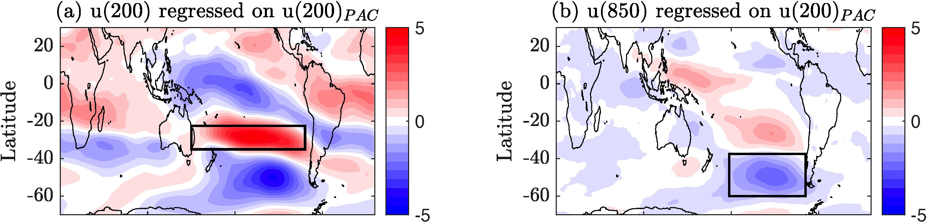

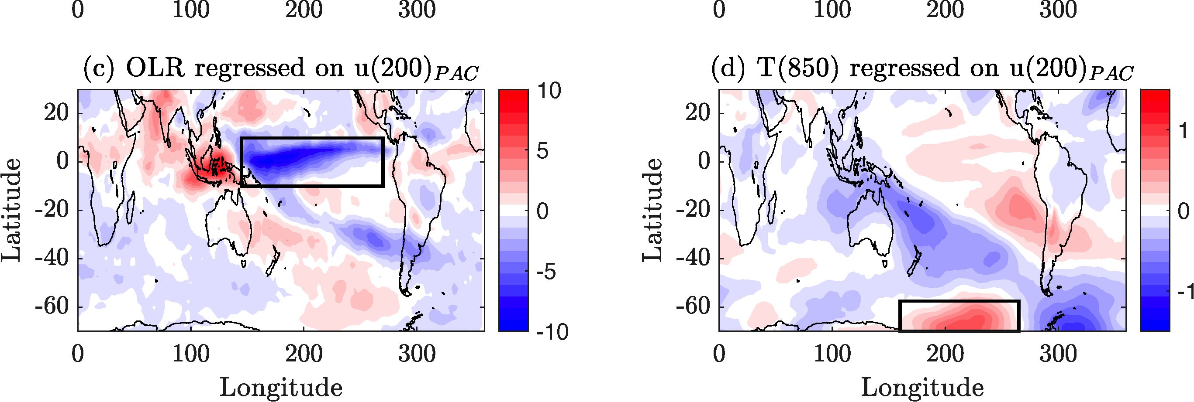

**Figure 2.** Variables regressed on the upper tropospheric zonal wind in the subtropical Pacific sector (rectangle box in (a)) during SH winter (June-August): (a) Upper tropospheric (200 hPa) zonal wind, in m s-1, (b) Lower tropospheric (850 hPa) zonal wind, in m s-1, (c) OLR, in W m-2 (negative anomalies indicate stronger convection), (d) Lower tropospheric (850 hPa) temperature in K. The rectangle boxes in each panel indicate the region of averaging to obtain the time series for the causal detection analysis (see text).

We determined the correlation coefficients between the different time series and qq4 **(Table 1)**. Correlation coefficients with a significance level of 99% or greater are shown in bold numbers. Only variables significantly correlated with wfoo4 at leading months (MM J and AM J) are potential drivers of the jet variability on monthly

**Table 1.** Correlation coefficients between the time series of different variables and the upper tropospheric zonal wind in the Pacific sector during June-August. The variables include the upper tropospheric zonal wind (GI200), the lower tropospheric zonal wind (us5o), OLR, and the lower tropospheric temperature (Ts5o), where each variable is averaged over the respective box in Figure 2. The first row is for the time series during months June-August, (simultaneous with u^oo4). The second and third rows are for time series during May-July and April-June, respectively, with a one- and two-month lead, respectively, relative to U2004. Correlations marked in bold letters are significant at the 99% level.

|  |  |  |  |  |
| --- | --- | --- | --- | --- |
|  | *U200* | ^850 | *OLR* | ^850 |
| JJA |  | **-0.67** | **-0.38** | **0.28** |
| MJJ | **0.49** | **-0.32** | **-0.36** | 0.02 |
| AMJ | **0.36** | -0.23 | -0.19 | 0 |

time scales. In this example, four relevant variables were found: ^200, ^850, J, and *OLRMJJ.* The first

two variables are due to the upper tropospheric zonal wind autocorrelation, leaving tropical convection and eddy-driven jet variability as potential external causes of subtropical Pacific jet variability. The high latitude lower tropospheric temperature anomaly is not a potential driver on monthly time scales, though it is correlated with the jet strength during JJA.

The significant correlation does not necessarily imply a causal relation. Thus, we next applied the first step in the causal detection method described in section C.2.1. We examined if the correlation of *OLRMJJ* with oo4 is an indirect effect of the synchronous correlation between *OLRMJJ* and the autocorrelation time scale when the jet speed is longer than one month. To test this theory, we calculated the partial correlation between *OLRMJJ* and wfoo4 conditioned on *u^J.* The result was a partial correlation of -0.27, which is greater than 99% significant **(Table 2)**, supporting the hypothesis that OLR is a direct driver of the jet speed anomaly on a time scale of one month. In contrast, we showed in a similar test that lower tropospheric zonal wind is not a direct driver of the jet speed anomaly on a monthly time scale **(Table 2)**. We also performed a similar test for the Pacific jet during SH summer (December-February). The results (not shown) indicate that OLR is a potential driver of the jet speed anomaly with a lead time of one and two months.

**Table 2.** As in Table 1, but showing partial correlation coefficients, conditioned on *u^qJ.*

|  |  |  |  |
| --- | --- | --- | --- |
|  | *U200* | ^850 | *OLR* |
| MJJ |  | 0.06 | **-0.27** |
| AMJ | 0.027 |  |  |

Our preliminary results indicate that tropical convection is a direct driver of jet variability in the upper troposphere. In contrast, other variables correlated with jet variability, such as lower tropospheric zonal wind and high latitude lower tropospheric temperature anomalies, are not direct drivers on monthly time scales. ***This analysis demonstrates the usefulness of the first step in the causal detection method described in section C.2.2.1. The second step will be to quantify the strength of each causal connection.***

In the proposed research, we will include additional time series in the causal detection analysis for the jet variability at each sector and season. The variables for these time series will be chosen to represent all plausible influences on the jet variability based on previous studies and our observational analysis. We will perform two analyses before applying the causal detection method.

1. Calculate the momentum budget terms and their lagged correlations for variable jet events, defined as local jet strength and latitude anomalies over specific longitudinal sectors. This approach will enable us to evaluate the relative importance of processes driving jet variability at each longitudinal sector and season. We will compare acceleration terms for zonally-dependent processes with terms affecting the zonal-mean momentum budget, enabling us to assess the importance of zonal asymmetries for jet maintenance and variability.

2. Evaluate the relative roles of Rossby wave generation and poleward angular momentum advection in influencing tropical convection of the jet strength. We will calculate the divergent component of the wind field, from which we will calculate the local Hadley circulation stream function (Schwendike et al., 2014; Nguyen et al., 2018; Raiter et al., 2024) and its meridional angular momentum advection. The effect of the Rossby wave source will be calculated using a barotropic model for Rossby wave propagation (Hoskins and Ambrizzi, 1993). We will examine the extent of jet variability over large longitudinal sectors associated with quasi-stationary Rossby waves excited by a tropical source and variations in angular momentum advection by the local Hadley circulation. Combining dynamic process analysis using observational data with causal detection methods will improve our understanding of the mechanisms controlling jet variability over large longitudinal sectors.

***C.3.2 Drivers of jet variability and response to change in climate models:*** The robust response of the zonal-mean zonal wind to climate change comprises a poleward shift of the eddy-driven jet and a strengthening of the subtropical jet. Whereas this zonal-mean response appears in a wide range of models under various climate change forcing scenarios and in observations, the longitudinally-dependent response is more complex (Barnes and Polvani, 2013; Yang et al., 2020; Waugh et al., 2020). The longitudinal dependence of the jet response is related to the longitudinal dependence of the Hadley cell response. In response to climate change, during SH winter, the meridional circulation weakens over the Indo-Pacific sector and strengthens over the East Pacific (Staten et al., 2019; Raiter et al., 2024). Consistently, the upper tropospheric subtropical jet weakens slightly and shifts poleward over the Indo-Pacific region and Australia, extending further downstream to the East Pacific (Patterson et al., 2021). The exact mechanisms driving the local jet response are unknown.

The jet response variability in models participating in the CMIP is larger than the multi-model mean response. It has been recognized in recent years that considering the inter-model variability of the response over specific longitudinal sectors may identify model biases, reducing uncertainty (Oudar et al., 2020; Waugh et al., 2020; Liu et al., 2021; Liu and Grise, 2023; Breul et al., 2023). In particular, Breul et al. (2023) found that inter-model variations in the zonal-mean jet latitude during the SH winter are geometric artifacts of strength variations in the eddy-driven Pacific jet. This finding helps explain the relationship between climatological jet latitude and jet shift due to climate change found in Simpson and Polvani (2016), an emergent constraint for the jet shift (Simpson et al., 2021). This striking example demonstrates the importance of examining the jet response over specific longitudinal domains.

***Preliminary data:*** We will examine the drivers of jet variability in CMIP6 models compared to the observed drivers we will find, as described in section C2.3.1. As a preliminary test, we considered the SH winter jet and its relationship with tropical convection in two different climate models. We investigated pre-industrial zonal wind and OLR and their responses to quadrupling CO2 for two models **(Figure 3)**: CNRM- ESM-1 and MIROC-ES2L. Comparing with previous results (Figure la, c), we found that the zonal wind in CNRM-ESM-1 is realistic, whereas, in MIROC-ES2L, the subtropical jet is too strong and extends too far zonally, with weak near-surface winds. The OLR profile is more realistic in MIROC-ES2L, whereas it is too narrow and concentrated equatorially in CNRM-ESM-1. The responses of the zonal wind and OLR to quadrupling CO2 are quite different between the two models. The differing zonal wind responses might be attributed to the different climatological extratropical circulations (Curtis et al., 2020) or differences in tropical convection, as indicated by the OLR (Liu and Grise, 2023). Other factors may be responsible, such as the stratospheric polar vortex (Williams et al., 2024), cloud radiative effects (Voigt and Shaw, 2016), or coupling with the oceanic circulation (Chemke, 2022). In our proposal, we will investigate the sources of the inter-model spread in the jet response over different longitudinal sectors. In addition, we will examine the sources of internal jet variability in the different models.

As for the observed jet variability analysis, we will use causal detection methods to identify drivers of jet variability in CMIP6 models. For example, we present pre-industrial simulations of the two models **(Figure 3)**. Repeating the procedure as described in section C.3.1, we calculate correlations between the winter subtropical jet strength in the Pacific sector during winter (JJA) and OLR in the tropical Pacific during JJA (simultaneous), MJJ (one month earlier) and AMJ (two months earlier), as well as the lagged autocorrelations of the subtropical jet strength **(Table 3)**. The correlations are higher in MIROC-ES2L than CNRM-ESM-1 for both the autocorrelation of the subtropical jet strength and its correlation with OLR (left half of **Table 3**). Conditioning for the subtropical jet strength during MJJ reduces the correlations, but the correlations between the jet strength and OLR one and two months earlier remain significant (right half of **Table 3**). The high correlations indicate an indirect connection, mediated by the subtropical jet strength during MJJ, and are partially due to a direct driving of the jet variability by tropical convection. The direct driving of the jet variability by tropical convection is high in MIROC-ES2L compared to CNRM-ESM-1 and the observed values **(Table 2)**. For a more accurate and wide view of the causal drivers of subtropical jet variability, we need to add relevant analysis variables, and the subsequent steps in the causal detection analysis will be applied, as described in section C.2.1.

Longitude

Longitude

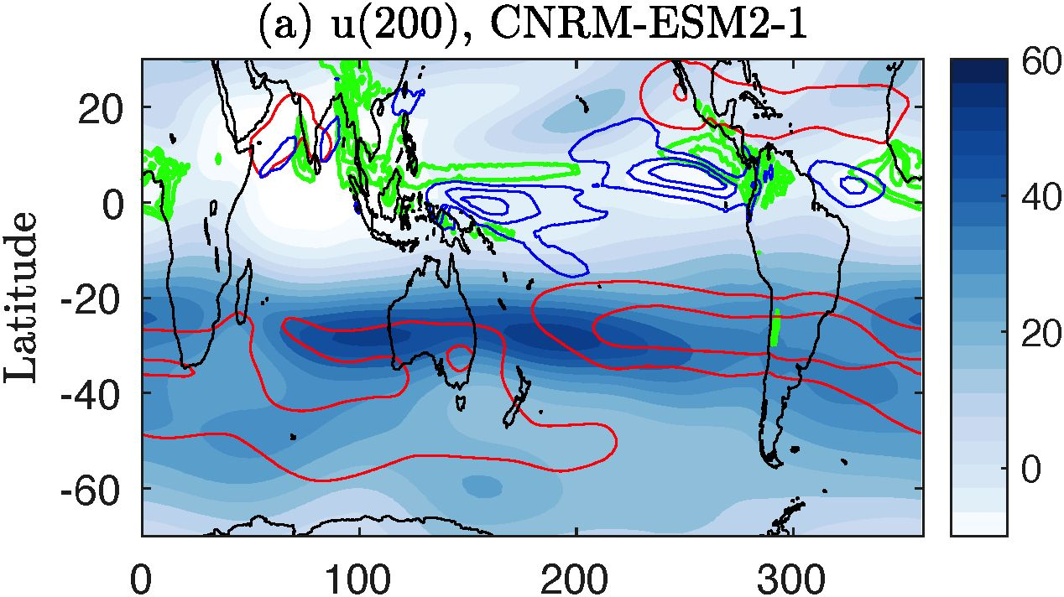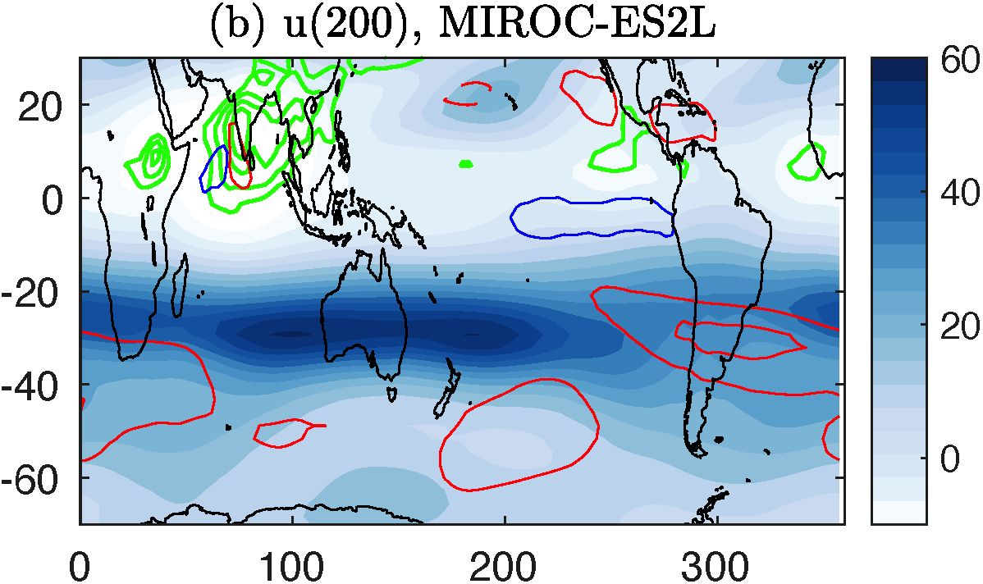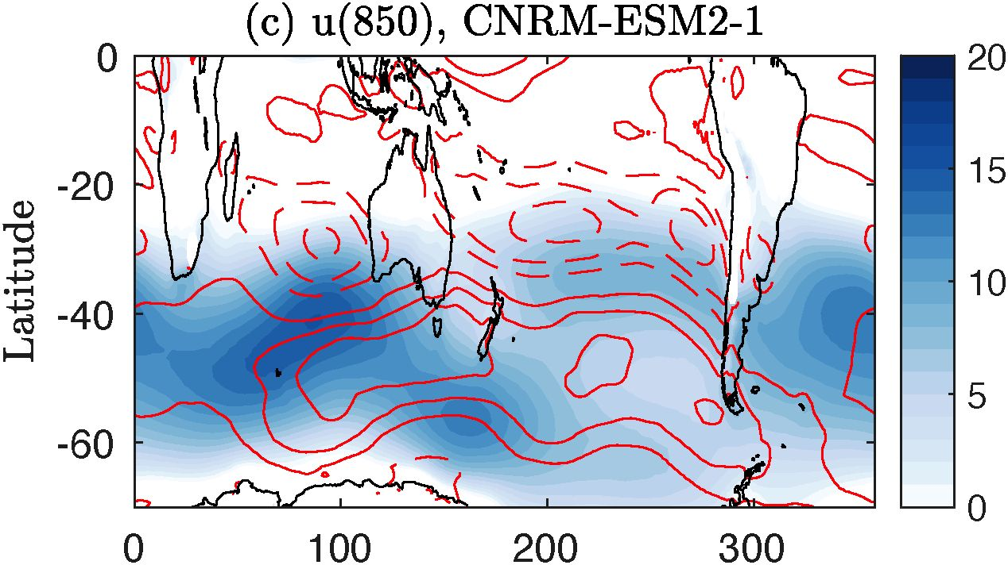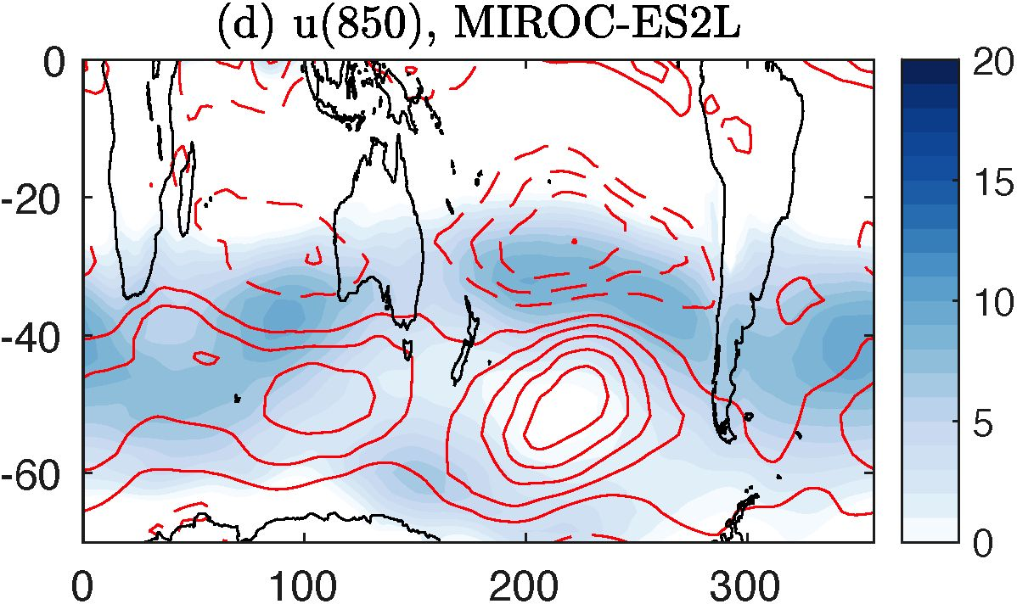

**Figure 3**. Zonal wind climatology (blue shading, in m s-1), in the upper troposphere (200 hPa) (a,b) and lower troposphere (850 hPa) (c,d), during SH winter, from the pre-industrial simulation of two CMIP6 models: CNRM-ESM-1 (a,c) and MIROC-ES2L (b,d). Red contours show the zonal wind response to quadruplingCO2, with solid (dashed) contours for positive (negative) values, and a contour interval of 5 m s-1 (1 m s-1) for the upper (lower) tropospheric wind response, where the zero contour is omitted. The green and blue contours in (a,b) show the outgoing longwave radiation (OLR), with a contour interval of 10 W m2, from 180 to 220 W m2, and its response to quadrupling CO2, with contour levels -30, -20 and -10Wm2, indicating increased tropical convection.

**Table 3.** Correlation coefficients (left half of the table) between the time series of the Pacific subtropical jet strength during JJA (t/jfoo4) and both the subtropical jet strength one (MJJ) or two (AMJ) months earlier and the outgoing longwave radiation (OLR) during JJA, MJJ and AMJ. The correlations are calculated for the internal monthly variability in two CMIP6 models: CNRM-ESM-1 and MIROC-ES2L. The right half of the table shows the relevant partial correlations with u^doS after conditioning for the subtropical jet strength during MJJ J). Correlations marked in bold letters are significant at the 99% level.

|  |  |  |  |  |  |  |
| --- | --- | --- | --- | --- | --- | --- |
|  | Correlation with qq4 | | | | Conditioned on *u^qJ* | |
|  | CNRM-ESM-1 | | MIROC-ES2L | | CNRM-ESM-1 | MIROC-ES2L |
|  | ^200 | *OLR* | ^200 | *OLR* | it2oo *OLR* | U200 *OLR* |
| JJA |  | -0.31 |  | -0.55 |  |  |
| MJJ | 0.49 | -0.48 | 0.65 | -0.67 | -0.30 | -0.47 |
| AMJ | 0.36 | -0.49 | 0.52 | -0.39 | -0.03 -0.24 | -0.11 -0.29 |

We propose to extend our analysis to all CMIP6 models for which relevant data is available. The outcome will determine the extent to which different models capture the processes driving the jet variability. This knowledge will improve the evaluation of model performance and decrease the uncertainty of projections regarding the jet response and its variability due to climate change.

***C.3.3 Jet variability in an idealized model with localized tropical heating:*** A direct way to examine causal relations in atmospheric circulation is a numerical model, where it is possible to control specific processes actively. The idealized model, MiMA (described in section C.2.2.4), will be used to examine jet dynamics in the presence of a zonally-asymmetric tropical heat source. Because the model includes moist processes, it qualitatively captures the sporadic localized nature of tropical convection (Frierson et al., 2006; Frierson, 2007), an essential factor for creating a realistic subtropical jet (Hoskins and Yang, 2023). Localized tropical heating added to a dry model produces a transient subtropical jet, which is not maintained in a steady state (Williams et al., 2007). In fact, a realistic subtropical jet is rarely produced by a dry model, except when forced using observational data (Kim and Lee, 2004; Wu and Reichler, 2018). Our preliminary results show that MiMA captures the localized structure of the subtropical jet driven by localized tropical heating, as seen in observations.

***Preliminary data:*** We performed a preliminary simulation of NH winter conditions created using a solar insolation profile and a prescribed SST profile that peaks in the SH tropics. A localized diabatic heat source was added around the latitude of maximum ascent, with a limited longitudinal extent. The localized heat source drives a localized jet, resembling the observed subtropical jet, whereas an eddy-driven jet exists at other longitudes **(Figure 4**, compared with **Figure 1)**. This preliminary result demonstrates that the idealized model is suitable for studying the response of the jet to localized tropical heating.

**Figure 4.** Zonal wind (in m s-1) in the idealized model simulation with additional localized tropical heating, averaged over the statistically steady state period, (a) Zonal mean zonal wind as a function of latitude and pressure, (b) Zonal wind at pressure level 200 hPa, as a function of longitude and latitude, (c) as in (b) but for the pressure level 850 hPa. The thick black contour in (b) marks the 2 K day-1 diabatic heating contour at pressure level 300 hPa. The region inside this contour has larger values of diabatic heating.

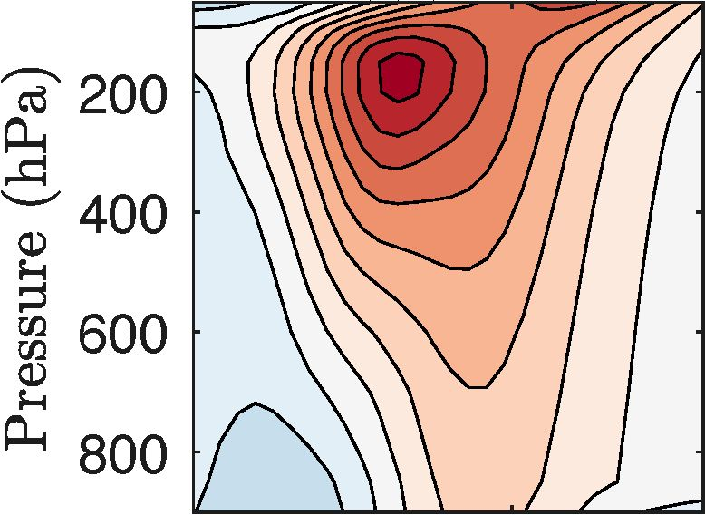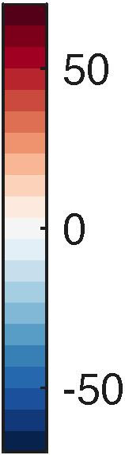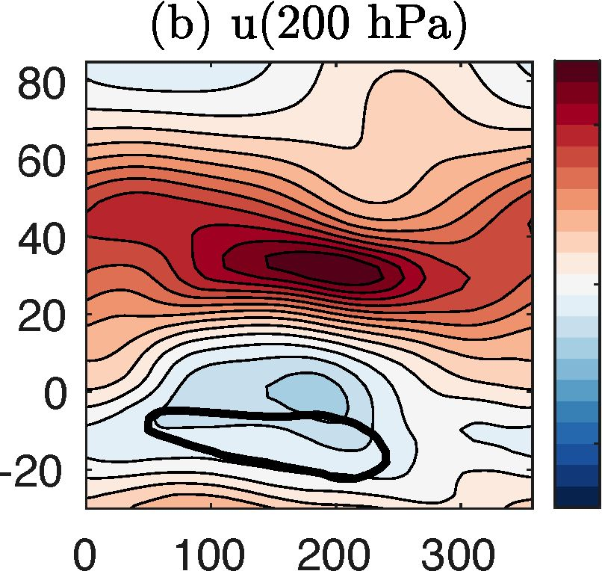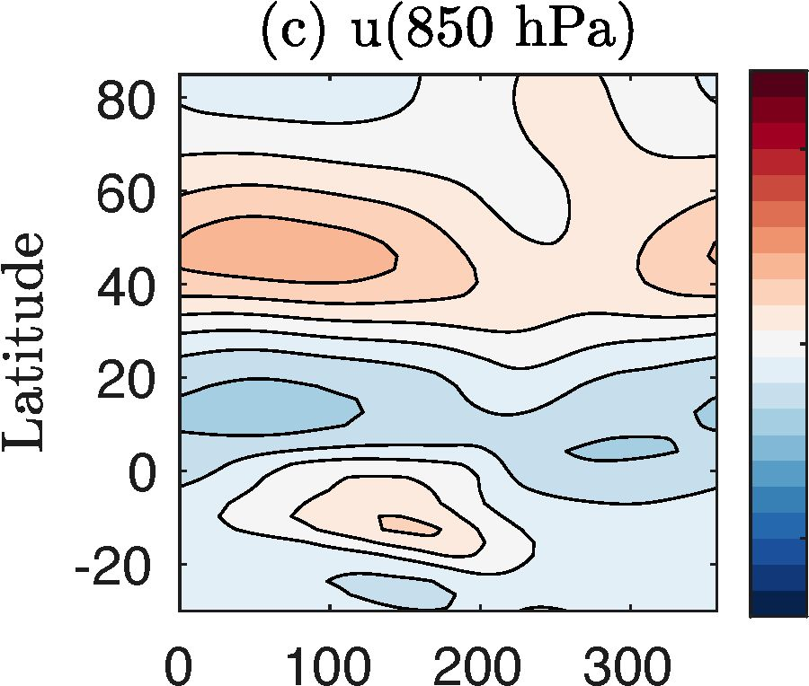

(a) Zonal mean u (m/s)

Latitude

Longitude

Longitude

Using this model, we will perform a series of simulations varying the properties of the tropical heat source across a wide range of values to examine the effect on the jet climatological profile and variability. The controlled properties of the heat source will include its longitudinal, latitudinal, and vertical extent, distance from the equator, and strength. These parameters will produce a wide range of jet profiles, with varying dominance of the subtropical- or eddy-driven jet over a wide range of longitudes. Once the desired range of circulations is achieved, we will analyze the jet-driving mechanisms in each simulation. The simulations will be steady state and ensembles of switch-on simulations where localized tropical heating is abruptly changed, allowing an analysis of transitions between steady states.

We will analyze four jet-driving mechanisms. 1. The zonal momentum budget as a function of longitude and latitude in the upper troposphere. Each of the terms in the momentum budget will be calculated for steady state and transition periods to identify processes leading to changes in the jet properties. 2. Lagged regressions of different variables with respect to events of extreme jet properties. The variables will include, for example, an analysis of the meridional stream function, eddy heat, and momentum fluxes around strong jet events. 3. Analysis of Rossby wave propagation to determine its role in shaping the zonally-asymmetric jet structure. 4. Causal detection of jet variability drivers in the model for comparison to the observational data analysis results.

We expect that idealized model simulations will provide an overview of the dynamics leading to zonally-asymmetric jet structure arising from asymmetric tropical heating. In particular, the results will reveal processes leading to zonal transition in jet characteristics between the subtropical and eddy-driven jet types. Williams et al. (2007) suggested that the zonal structure of the springtime SH jet arises from localized tropical heating that drives a localized subtropical jet. The jet is baroclinically unstable, leading to the growth of midlatitude eddies on its downstream side. This growth, in turn, drives an eddy-driven jet further downstream. They used a dry model to test this hypothesis, but the model could only reproduce a realistic jet zonal structure for a limited time. Our preliminary results demonstrate that the moist model we will use can reproduce this realistic structure in a statistically steady state. Therefore, the moist is more suitable for examining the processes leading to the zonally-asymmetric jet structure.

Overall,…..

**C.4 The researcher’s resources for conducting the research:** The PI is a faculty member in the Department of Natural Sciences at the Open University of Israel and has published many papers on various aspects of midlatitude atmospheric circulation and jet stream dynamics. The Open University of Israel owns a high-performance computing (HPC) system with sufficient cores for the idealized MiMA model at T85 resolution. The HPC is sufficient to capture the dynamics in the proposal. The University employs a full-time technical HPC support team. This system’s 320 cores and 50TB of storage are dedicated exclusively to the PI’s group. The Lachmy group has published four papers based on MiMA and observational and climate model data analysis using this HPC system (Lachmy and Kaspi, 2020; Lachmy, 2022; Peles and Lachmy, 2023; Ghosh et al., 2024). We request funding to extend the HPC system storage by 50TB (100TB total) to store more reanalysis (observational) data and climate model data output. The storage is essential because most data stored so far is zonally averaged as a function of latitude, pressure, and time. In contrast, for our proposed research, we must save longitudinally-dependent data as a function of longitude, latitude, and time for several pressure levels.

Our proposed data analysis methods are similar to methods used previously, except for the causal detection analysis. For this analysis, we will collaborate with Prof. Marlene Kretschmer from Leipzig University, who kindly shared her causal detection code (Kretschmer et al., 2016), as indicated in the attached letter.

**C.5 Expected results and pitfalls**: We expect the proposed research to advance the understanding of jet dynamics under zonally-asymmetric conditions. The observational data analysis is expected to confirm or negate our hypotheses for the processes controlling jet dynamics at specific longitudinal sectors and seasons (Nakamura et al., 2004; Williams et al., 2007; Hoskins and Yang, 2023). Previous studies examined correlations between jet variability and different climatic variables, such as eddy momentum flux and OLR. While this type of analysis indicates the consistency or inconsistency of data with different hypotheses, it is ambiguous because correlations may not indicate causal relations. We expect that causal detection analysis will reveal which correlations are due to causal relations, at what time scales, and to what extent. We acknowledge that causal detection has its limitations. The method assumes that all relevant processes are included in the analysis, which might not be accurate. Therefore, the detected relationships should be considered potentially causal (Barnes et al., 2019). Other underlying assumptions include stationarity and Gaussian distributions of the model variables, as well as linear relations between variables. The results could be sensitive to the choice of time scale for the time series. We will perform the necessary sensitivity tests to determine the optimal choice of variables and time scales to capture causal relationships most reliably. Causal detection relies on previous knowledge of potentially relevant variables affecting the one of interest. We will, therefore, include calculations of momentum budget terms and Rossby wave propagation in the observational data analysis. These calculations will result in a more knowledgeable picture of the processes controlling jet variability at large longitudinal sectors before performing the Causal detection analysis.

The climate model data analysis is expected to add insight into the sources of inter-model jet variability. We expect that by revealing the associations between jet properties and their driving processes in models, we will identify specific processes to be captured more realistically to simulate the jet dynamics correctly. Our approach will improve the assessment of models, producing more reliable projections of the jet response to climate change, for example, by identifying emergent constraints to jet-driving mechanisms (Simpson et al., 2021). In addition to inter-model variability, our analysis may detect sources of biases in jet representation across all models. While CMIP6 models are improved compared to CMIP5, there are still biases in the jet representation (Bracegirdle et al., 2020). By comparing modeled jet-driving processes to observations, we expect to shed light on the sources of these biases.

The idealized model simulations are expected to yield new information about the response of the jet to localized tropical heating, which is unstudied in a moist model. We expect this simulation to advance our understanding of processes determining jet properties and their observed longitudinal transitions. The dynamics of the jet in the real atmosphere are also affected by processes not included in the model, such as ocean variability, cloud radiative effects, and sea ice processes. However, since tropical convection plays a major role in the longitudinal jet structure, we expect the simulations to capture an essential aspect of the dynamics. The comparison between the model simulations and the observational analysis will reveal the extent to which the model captures the actual dynamics.

References

1. H. S. Baker, T. Woollings, C. E. Forest, and M. R. Allen. The linear sensitivity of the North Atlantic  
   Oscillation and eddy-driven jet to SSTs. *J. Climate,* 32:6491-6511, 2019.
2. E. A. Barnes and L. Polvani. Response of the midlatitude jets, and of their variability, to increased  
   greenhouse gases in the CMIP5 models. *J. Climate,* 26:7117-7135, 2013.
3. E. A. Barnes, S. M. Samarasinghe, I. Ebert-Uphoff, and J. C. Furtado. Tropospheric and stratospheric  
   causal pathways between the MJO and NAO. *J. Geophys. Res. -Atmos.,* 124:9356-9371, 2019.
4. T. J. Bracegirdle, C. R. Holmes, J. S. Hosking, G. J. Marshall, M. Osman, M. Patterson, and T. Rackow.  
   Improvements in circumpolar Southern Hemisphere extratropical atmospheric circulation in CMIP6 com-  
   pared to CMIP5. *Earth and Space Science,* 7:e2019EA001065, 2020.
5. P. Breul, P. Ceppi, and T. G. Shepherd. Revisiting the wintertime emergent constraint of the Southern  
   Hemispheric midlatitude jet response to global warming. *Wea. Climate Dyn.,* 4:39-47, 2023.
6. R. Chemke. The future poleward shift of Southern Hemisphere summer mid-latitude storm tracks stems  
   from ocean coupling. *Nat. Commun.,* 13:1730, 2022.
7. P. E. Curtis, P. Ceppi, and G. Zappa. Role of the mean state for the Southern Hemispheric jet stream  
   response to CO2 forcing in CMIP6 models. *Environmental Research Letters,* 15:064011, 2020.
8. Q. Ding, E. J. Steig, D. S. Battisti, and J. M. Wallace. Influence of the tropics on the Southern Annular  
   Mode. *J. Climate,* 25(18):6330-6348, 2012.
9. D. M. W. Frierson. The dynamics of idealized convection schemes and their effect on the zonally averaged  
   tropical circulation. *J. Atmos. Sci.,* 64:1959-1976, 2007.
10. D. M. W. Frierson, I. M. Held, and P. Zurita-Gotor. A gray-radiation aquaplanet moist GCM. Part I: Static  
    stability and eddy scale. *J. Atmos. Sci.,* 63:2548-2566, 2006.
11. C. I. Garfinkel, I. White, E. P. Gerber, M. fucker, and M. Erez. The building blocks of Northern Hemi-  
    sphere wintertime stationary waves. *J. Climate,* 33:5611-5633, 2020.
12. S. Ghosh, O. Lachmy, and Y. Kaspi. The role of diabatic heating in the midlatitude atmospheric circulation  
    response to climate change. *J. Climate,* 37:2987-3009, 2024.
13. Z. E. Gillett, H. H. Hendon, J. M. Arblaster, and E.-P. Lim. Tropical and extratropical influences on the  
    variability of the Southern Hemisphere wintertime subtropical jet. *J. Climate,* 34:4009-4022, 2021.
14. I. M. Held and A. Y. Hou. Nonlinear axially symmetric circulations in a nearly inviscid atmosphere. *J.  
    Atmos. Sci.,* 37:515-533, 1980.
15. I. M. Held and M. J. Suarez. A proposal for the intercomparison of the dynamical cores of atmospheric  
    general circulation models. *Bull. Amer. Meteor. Soc.,* 75(10):1825-1830, 1994.
16. H. Hersbach, B. Bell, P. Berrisford, S. Hirahara, A. Horanyi, J. Munoz-Sabater, J. Nicolas, C. Peubey,  
    R. Radu, D. Schepers, et al. The ERA5 global reanalysis. *Quart. J. Roy. Meteor. Soc.,* 146:1999-2049,  
    2020.
17. B. J. Hoskins and T. Ambrizzi. Rossby wave propagation on a realistic longitudinally varying flow. *J.  
    Atmos. Sci.,* 50(12): 1661-1671, 1993.
18. B. J. Hoskins and G-Y. Yang. The detailed dynamics of the Hadley cell. Part II: December-February. *J.  
    Climate,* 34(2): 805-823, 2021.
19. B. J. Hoskins and G-Y. Yang. A global perspective on the upper branch of the Hadley Cell. *J. Climate,*36:6749-6762, 2023.
20. B. J. Hoskins, G.-Y. Yang, and R. M. Fonseca. The detailed dynamics of the June-August Hadley cell.  
    *Quart. J. Roy. Meteor. Soc.,* 146(727):557-575, 2020.
21. M. Inatsu and B. J. Hoskins. The zonal asymmetry of the Southern Hemisphere winter storm track. *J.  
    Climate,* 17:4882^4892, 2004.
22. F. Jin and B. J. Hoskins. The direct response to tropical heating in a baroclinic atmosphere. *J. Atmos. Sci.,*52:307-319, 1995.
23. M. Jucker and E. P. Gerber. Untangling the annual cycle of the tropical tropopause layer with an idealized  
    moist model. *J. Climate,* 30:7339-7358, 2017.
24. H. K. Kim and S. Lee. The wave - zonal mean flow interaction in the southern hemisphere. *J. Atmos. Sci.,*61:1055-1067,2004.
25. M. Kretschmer, D. Coumou, J. F. Donges, and J. Runge. Using causal effect networks to analyze different  
    Arctic drivers of midlatitude winter circulation. *J. Climate,* 29:4069-4081, 2016.
26. M. Kretschmer, S. V. Adams, A. Arribas, R. Prudden, N. Robinson, E. Saggioro, and T. G. Shepherd.  
    Quantifying causal pathways of teleconnections. *Bull. Amer. Meteor. Soc.,* 102:E2247-E2263, 2021.
27. O. Lachmy. The relation between the latitudinal shifts of midlatitude diabatic heating, eddy heat flux, and  
    the eddy-driven jet in CMIP6 models. *J. Geophys. Res. -Atmos.,* 127:e2022JD036556, 2022.
28. O. Lachmy and N. Hamik. The transition to a subtropical jet regime and its maintenance. *J. Atmos. Sci.,*71:1389-1409,2014.
29. O. Lachmy and N. Hamik. Wave and jet maintenance in different flow regimes. *J. Atmos. Sci.,* 73:  
    2465-2484, 2016.
30. O. Lachmy and Y. Kaspi. The role of diabatic heating in Ferrel cell dynamics. *Geophys. Res. Lett.,* 47:  
    e2020GL090619, 2020.
31. S. Lee and H. K. Kim. The dynamical relationship between subtropical and eddy-driven jets. *J. Atmos.  
    Sci.,* 60:1490-1503, 2003.
32. C. Li and J. J. Wettstein. Thermally driven and eddy-driven jet variability in reanalysis. *J. Climate,* 25:  
    1587-1596, 2012.
33. B. Liebmann and C. A. Smith. Description of a complete (interpolated) outgoing longwave radiation  
    dataset. *Bull. Amer. Meteor. Soc.,* 77:1275-1277, 1996.
34. X. Liu and K. M. Grise. Implications of warm pool bias in CMIP6 models on the Northern Hemisphere  
    wintertime subtropical jet and precipitation. *Geophys. Res. Lett.,* 50:e2023GL104896, 2023.
35. X. Liu, K. M. Grise, D. F. Schmidt, and R. E. Davis. Regional characteristics of variability in the Northern  
    Hemisphere wintertime polar front jet and subtropical jet in observations and CMIP6 models. *J. Geophys.  
    Res. -Atmos.,* 126:e2021JD034876, 2021.
36. D. J. Lorenz and D. L. Hartmann. Eddy-zonal flow feedback in the Southern Hemisphere. *J. Atmos. Sci.,*58:3312-3327,2001.
37. D. J. Lorenz and D. L. Hartmann. Eddy-zonal flow feedback in the Northern Hemisphere winter. *J.  
    Climate,* 16:1212-1227, 2003.
38. P. Maher, E. P. Gerber, B. Medeiros, T. M. Merlis, S. Sherwood, A. Sheshadri, A. H. Sobel, G. K. Vallis,  
    A. Voigt, and P. Zurita-Gotor. Model hierarchies for understanding atmospheric circulation. *Reviews of  
    Geophysics,* 57(2):250-280, 2019.
39. H. Nakamura and A. Shimpo. Seasonal variations in the Southern Hemisphere storm tracks and jet streams  
    as revealed in a reanalysis dataset. *J. Climate,* 17:1828-1844, 2004.
40. H. Nakamura, T. Sampe, Y. Tanimoto, and A. Shimpo. Observed associations among storm tracks, jet  
    streams and midlatitude oceanic fronts. *Earth’s Climate: The Ocean-Atmosphere Interaction, Geophys.  
    Monogr,* 147:329-345, 2004.
41. H. Nguyen, H. H. Hendon, E-P. Lim, G. Boschat, E. Maloney, and B. Timbal. Variability of the extent  
    of the Hadley circulation in the Southern Hemisphere: A regional perspective. *Clim. Dyn.,* 50:129-142,  
    2018.
42. T. Oudar, J. Cattiaux, and H. Douville. Drivers of the northern extratropical eddy-driven jet change in  
    CMIP5 and CMIP6 models. *Geophys. Res. Lett.,* 47:e2019GL086695, 2020.
43. M. Patterson, T. Woollings, T. J. Bracegirdle, and N. T. Lewis. Wintertime Southern Hemisphere jet  
    streams shaped by interaction of transient eddies with Antarctic orography. *J. Climate,* 33:10505-10522,  
    2020.
44. M. Patterson, T. Woollings, and T. J. Bracegirdle. Tropical and subtropical forcing of future Southern  
    Hemisphere stationary wave changes. *J. Climate,* 34:7897-7912, 2021.
45. O. Peles and O. Lachmy. Estimating the lowest latitude of baroclinic growth. *J. Atmos. Sci.,* 80:1401-  
    1414, 2023.
46. D. Raiter, E. Galanti, R. Chemke, and Y. Kaspi. Linking future tropical precipitation changes to zonally-  
    asymmetric large-scale meridional circulation. *Geophys. Res. Lett.,* 51:e2023GL106072, 2024.
47. N. A. A. Rayner, D. E. Parker, E. B. Horton, C. K. Folland, L. V. Alexander, D. P. Rowell, E. C. Kent, and  
    A. Kaplan. Global analyses of sea surface temperature, sea ice, and night marine air temperature since the  
    late nineteenth century. *J. Geophys. Res. -Atmos.,* 108:4407, 2003.
48. J. Runge, V. Petoukhov, and J. Kurths. Quantifying the strength and delay of climatic interactions: The  
    ambiguities of cross correlation and a novel measure based on graphical models. *J. Climate,* 27:720-739,  
    2014.
49. J. Runge, S. Bathiany, E. Bollt, G. Camps-Valls, D. Coumou, E. Deyle, C. Glymour, M. Kretschmer,  
    M. D. Mahecha, J. Munoz-Mari, et al. Inferring causation from time series in Earth system sciences. *Nat.  
    Commun.,* 10:2553, 2019.
50. J. Schwendike, P. Govekar, M. J. Reeder, R. Wardle, G. J. Berry, and C. Jakob. Local partitioning of  
    the overturning circulation in the tropics and the connection to the Hadley and Walker circulations. *J.  
    Geophys. Res. -Atmos.,* 119:1322-1339, 2014.
51. T. A Shaw. Mechanisms of future predicted changes in the zonal mean mid-latitude circulation. *Current  
    Climate Change Reports,* 5(4):345-357, 2019.
52. T. G. Shepherd. Bringing physical reasoning into statistical practice in climate-change science. *Climatic  
    Change,* 169:2, 2021.
53. I. R. Simpson and L. M. Polvani. Revisiting the relationship between jet position, forced response, and  
    annular mode variability in the southern midlatitudes. *Geophys. Res. Lett.,* 43(6):2896-2903, 2016.
54. I. R. Simpson, K. A. McKinnon, F. V. Davenport, M. Tingley, F. Lehner, A. Al Fahad, and D. Chen.  
    Emergent constraints on the large-scale atmospheric circulation and regional hydroclimate: Do they still  
    work in CMIP6 and how much can they actually constrain the future? *J. Climate,* 34:6355-6377, 2021.
55. C. Spensberger, C. Li, and T. Spengler. Linking instantaneous and climatological perspectives on eddy-  
    driven and subtropical jets. *J. Climate,* 36:8525-8537, 2023.
56. P. Spirtes, C. Glymour, and R. Schemes. *Causation, prediction, and search.* Bradford, 2001.
57. P. W. Staten, K. M. Grise, S. M. Davis, K. Kamauskas, and N. Davis. Regional widening of tropical  
    overturning: Forced change, natural variability, and recent trends. *J. Geophys. Res. -Atmos.,* 124:6104-  
    6119, 2019.
58. G. K. Vallis, G. Colyer, R. Geen, E. Gerber, M. Jucker, P. Maher, A. Paterson, M. Pietschnig, J. Penn, and  
    S. I. Thomson. Isca, vl. 0: A framework for the global modelling of the atmospheres of Earth and other  
    planets at varying levels of complexity. *Geosci. Model Dev.,* 11:843-859, 2018.
59. A. Voigt and T. A. Shaw. Impact of regional atmospheric cloud radiative changes on shifts of the extrat-  
    ropical jet stream in response to global warming. *J. Climate,* 29:8399-8421, 2016.
60. D. W. Waugh, K. M. Grise, W. J. M. Seviour, S. M. Davis, N. Davis, O. Adam, S.-W. Son, I. R. Simpson,  
    P. W. Staten, A. C. Maycock, C. C. Ummenhofer, T. Bimer, and A. Ming. Revisiting the relationship  
    among metrics of tropical expansion. *J. Climate,* 31:7565-7581, 2018.
61. D. W. Waugh, A. Baneijee, J. C. Fyfe, and L. M. Polvani. Contrasting recent trends in Southern Hemi-  
    sphere westerlies across different ocean basins. *Geophys. Res. Lett.,* 47:e2020GL088890, 2020.
62. I. P. White, O. Lachmy, and N. Hamik. Influence of diabatic heating on the maintenance of the midlatitude  
    jet. *Quart. J. Roy. Meteor. Soc.,* 2024.
63. L. N. Williams, S. Lee, and S. W. Son. Dynamics of the southern hemisphere spiral jet. *J. Atmos. Sci.,* 64:  
    548-563, 2007.
64. R. S. Williams, G. J. Marshall, X. Levine, L. S. Graff, D. Handorf, N. M. Johnston, A. Y. Karpechko,  
    A. Orr, W. J. Van de Berg, R. R. Wijngaard, et al. Future antarctic climate: Storylines of midlatitude jet  
    strengthening and shift emergent from cmip6. *J. Climate,* 37:2157-2178, 2024.
65. T. Woollings, M. Drouard, C. H. O’Reilly, D. M. H. Sexton, and C. McSweeney. Trends in the atmo-  
    spheric jet streams are emerging in observations and could be linked to tropical warming. *Commun. Earth  
    Environ.,* 4:125, 2023.
66. Z. Wu and T. Reichler. Towards a more earth-like circulation in idealized models. *J. Adv. Model. Earth  
    Syst.,* 10(7): 1458-1469, 2018.
67. D. Yang, J. M. Arblaster, G. A. Meehl, M. H. England, E.-P. Lim, S. Bates, and N. Rosenbloom. Role of  
    tropical variability in driving decadal shifts in the Southern Hemisphere summertime eddy-driven jet. *J.  
    Climate,* 33:5445-5463, 2020.