**Title: Pregnancy Complications and Hematopoietic Stem Cell Biology Changes in Umbilical Cord Blood.**

**Keywords: Pregnancy complication, GDM, PET, UCB-HSC biology, OMICS**

**Scientific Abstract**

During pregnancy, medical complications can increase the risk of morbidity and mortality for mothers and their offspring. Gestational diabetes mellitus (GDM) and preeclampsia toxemia (PET) are among the leading causes of pregnancy complications. Pregnancy complications are increasingly prevalent and may affect the umbilical cord blood (UCB) hematopoietic stem cells (HSC). Despite the importance of HSC biology during pregnancy, the specific consequences of pregnancy complications are not well understood. Previous studies indicate that additional maternal and baby-related factors may impact HSCs. However, the studies only assessed the number of total mononuclear cells (MNC) in the UCB of women without pregnancy complications. HSC transplantation (HSCT) is a significant medical advance, and UCB is rich in HSCs, offering a potentially straightforward solution for patients needing transplantation. A knowledge gap exists about the cost and benefits of UCB banking and the factors influencing transplant success.

We propose to address this gap by investigating how pregnancy complications, specifically GDM and PET, affect the biological characteristics of UCB-derived HSC. We hypothesize that complications significantly impact the total number, cell phenotype, and functions of HSCs. Our preliminary results indicate differences in HSC counts and composition in samples from women diagnosed with GDM and PET compared to healthy controls. We will collect UCB samples from women diagnosed with GDM and PET and healthy controls, and the groups will be compared using *in vitro* and *in vivo* approaches. We will characterize the composition of HSC subpopulations and evaluate their functional properties, including proliferation, differentiation, and activity state. We will also perform molecular analyses to uncover potential pathways associated with changes in HSCs and examine their reconstitution capacity in a humanized animal model. The proposed project is significant for three primary reasons. First, HSC biology is critical yet poorly understood. Second, we will combine *in vitro* and *in vivo* analyses with an OMICS strategy to provide new data on HSC biology at the genomics, transcriptomics, and proteomics levels. Third, we will propose possible molecular and physiological mechanisms that drive HSC biology changes. We expect our proposal to provide essential knowledge advancing fundamental, translational, and clinical HSC research. Furthermore, the proposal may significantly impact HSC collection for UCB banking, ensuring optimal quality and cost-effectiveness. Improved selection of UCB units for appropriate transplant recipients offers practical benefits to HSC research and transplantation.

**I. Scientific Background**

**Hematopoietic stem cells (HSCs):** Stem cells are present in multicellular organisms and can self-renew or differentiate into various cell types in response to specific signals. This property gives stem cells the capacity for tissue repair, replacement, and regeneration1. Stem cells can be found in embryonic and adult organisms; however, embryonic stem cells may differentiate into more cell types than adult stem cells1. Different stem cell types exist depending on their origin and potency. HSCs are adult multipotent stem cells that can develop into all blood cells.2. Three significant sources of HSCs arebone marrow harvested by aspiration from the cavity of the ilium (hipbone), peripheral blood obtained through leukapheresis, and umbilical cord blood (UCB) collected from the placenta after childbirth.

During embryogenesis, HSCs arise from hemogenic endothelium within the developing embryo. These cells undergo a process known as endothelial-to-hematopoietic transition, transforming into hematopoietic cells, including HSCs. HSC development during embryogenesis occurs in specific anatomical locations. The first site is the yolk sac3,4, and around embryonic day 10.5 (E10.5), the Aorta Gonad Mesonephros (AGM) region becomes the primary site for the emergence of definitive HSCs3–5. Hematopoiesis occurs transiently in the placenta and umbilical cord during embryonic development3–5. These tissues contribute to the production of primitive blood cells and play a role in supporting fetal circulation3. As embryonic development progresses, hematopoiesis transitions from the AGM region to the fetal liver, which becomes the primary site of definitive hematopoiesis. HSCs initially develop in the fetal liver and then migrate to the bone marrow, which becomes the main hematopoietic organ postnatally and throughout adult life 3–5. HSCs are among the most abundant stem cells in umbilical cord blood (UCB)6, and their collection is relatively easy without risk to the donor and a small likelihood of transmitting clinically significant infections7. During hierarchical proliferation and differentiation, self-renewing HSCs differentiate into multipotent progenitor cells (MPPs) that further differentiate into lineage-common lymphoid progenitor cells (CLPs) or standard myeloid progenitor cells (CMPs). The lineage-committed progenitors finally differentiate into terminal functional lymphoid cells, megakaryocyte-erythroid progenitor cells (MEPs), and granulocyte-macrophage progenitor cells (GMPs)8, typically characterized by the expression **CD34+9,10.**

HSCs reside within specialized microenvironments called niches 3,5 that provide signals essential for their maintenance and regulation3–5. The stem cell compartment regulates HSC function during response to stresses like infection, inflammation, hematopoietic injury11, and other microenvironment changes. HSC self-renewal, differentiation, and mobilization are affected by altered production of cytokines, growth factors, and other signaling molecules and changes to the niche composition and function3,11

**UCB-HSC therapeutic use**: UCB has been a therapy since1989 12,13 14. Transplantation of UCB-derived HSCs is a promising treatment for multiple hematologic, immunologic, malignant, and inherited metabolic disorders 15. The importance of UCB as an HSC source has thus created a growing need for storage inventories of genetically diverse UCBs. Such UCB units are available when no adult peripheral blood stem cell or bone marrow donor exists. In addition, cord blood banking has developed to around 800,000 units stored in public banks and more than four million units in private banks worldwide16,17. These UCB banks permit faster access to unrelated donor cord blood stem cells, significantly reducing the median search time from three to four months for bone marrow and peripheral blood stem cells to as few as two weeks for UCB stem cells 16,18. Successful UCB transplantation depends on the total mononuclear cell (MNC) dose and the quantity and quality of infused HSC CD34+ cells19. However, UCB has limitations compared with other stem cell sources, including insufficient cell doses for some recipients, prolonged immune reconstitution, and lack of donor white blood cells (WBC) 20–22. ***Characterizing and quantifying HSCs and progenitor cells from UCB samples can provide valuable information for clinical research*** 8. For example, the characterization of HSCs and progenitor cells for hematological disorders provides insights into disease progression, identifies abnormal cell populations, and monitors treatment responses23–25. Transplantations using UCB are still experimental, and variables affecting the quality, proliferation, and differentiation of HSCs are significant research focuses12,26–29. In this respect, UCB quality may be affected by maternal and fetal characteristics. Among these features are birth weight, placental weight, sex of the newborn, maternal age, number of pregnancies, route of delivery, and previous abortion30–36. ***Despite this valuable knowledge about transplantation, information regarding the effects of common pregnancy complications on UCB HSCs is scarce and presents a critical knowledge gap***.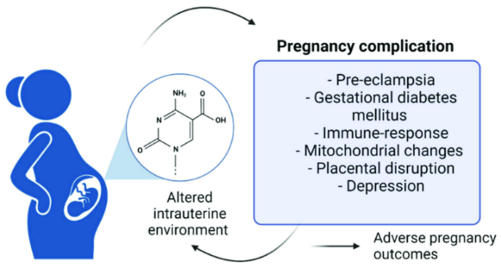

**Pregnancy complications:** Pregnancy complications are defined as health challenges linked to pregnancy 37,38. These complications may include physical and mental situations that distress the health of the mother or baby37 **(Fig. 1)**. Pregnancy complications can lead to premature birth or cesarean delivery, fluid in the lungs, bleeding problems, liver or kidney damage37,39,40, macrosomia, neonatal hypoglycemia, gestational diabetes mellitus (GDM), type 2 diabetes mellitus, and cardiovascular disease in pregnant women 37,41. There is also a risk of seizures, stroke, fetal respiratory distress during labor, and death of either the mother or the baby. 39,42,43. ***The most common pregnancy complications are GDM, PET, anemia, urinary tract infections, and heart disease37,40****.*

**Gestational Diabetes Mellitus (GDM):** GDMis one of the most common pregnancy complications, affecting 5–10% of pregnancies 45, and is defined as the onset of glucose intolerance first recognized during pregnancy. GDM significantly affects the quantity and quality of UBC stem cells regardless of the treatment regimen 45–50. However, the precise consequence is still controversial. More HSC and progenitor cells (HSPC) are found in the UCB of neonates of mothers with GDM on insulin therapy compared to neonates of healthy women51. Other studies demonstrate that UCB mesenchymal stromal cells are profoundly affected by GDM, displaying premature aging, mitochondrial dysfunction, and alteration in neonatal endothelial colony-forming cells47–49. GDM’s effect on HSCs could be related to increased oxidative stress, leading to decreased HSC proliferation and elevated rates of cellular senescence and cell death46 or molecular modification52***. The precise molecular and physiological mechanisms underlying these GDM effects are unclear and require investigation***46.

**Preeclampsia/Pre-Eclamptic Toxemia (PET):** PET is a significant and common pregnancy-specific disease that affects 2–5% of pregnancies53,54. PET leads to substantial morbidity and mortality in mothers and infants 55. PET is diagnosed during pregnancy, typically after twenty weeks of gestation, by the presentation of maternal hypertension and proteinuria. This severe condition can cause serious complications and may lead to maternal seizures (eclampsia) as well as liver and kidney failure, fluid in the lungs, internal bleeding, and death of either the mother or the baby. 55. PET may reduce mono-nucleated cell (MNC) and progenitor stem-cell numbers in UBC obtained at birth 50,56,57. ***However, it is unclear how PET affects UCB HSCs.***

Pregnancy complications such as PET and GDM are significant abnormalities in the placental environment that include abnormal cytotrophoblast differentiation, shallow trophoblast invasion, and decreased maternal blood flow to and from the placenta49,58. These changes can alter placental hemodynamics with abnormal umbilical artery blood flow, which can alter the *in-utero* environment. Erythropoietin (EPO) and insulin lead to fetal hypoxia49,58,59.EPO regulates fetal erythropoiesis 60 and is essential for cell growth and hematopoiesis, thus affecting HSC 59**.  *We hypothesize that these pregnancy complications will affect the level number and function of the placental stem cell compartment and its associated population of HSCs, including their subpopulation composition, proliferation, differentiation potential, and activation state.***

**II. Research Objectives and Expected Significance**

Stem cells are undifferentiated and produce similar cells, divide indefinitely (self-renewal), and differentiate into specialized cell lineages. UCB is an essential source of HSCs for transplantation in blood disorders, and transplant success depends on the dose of total nucleated and HSC cells infused. Therefore, collecting, banking, and listing high-quality UCB units with abundant HSCs is essential. Previous studies indicate that several maternal and fetal-related factors influence the quantity of UCB-derived HSCs30,33,34,61. Such studies were conducted during healthy, non-complicated pregnancies, and most measured the total MNC numbers without the composition of HSC subpopulation, proliferation, differentiation, and activity state. These poorly examined characters may explain variable responses to UCB transplants. Characterization and quantification of these critical parameters may improve sample banking beyond the current state-of-the-art. ***Our proposal goals are to understand the impact of two common pregnancy complications, GDM and PET, on the biological activity of UCB-derived HSC and identify possible mechanisms that account for such changes.***

**Research Objectives:** To achieve these essential goals, we propose four objectives.

**Objective 1.** Establish a sample bank of HSCs from GDM, PET, and healthy control (HC) donors.

Characterize the level and cell composition of the UCB-derived HSC population and sub-population and evaluate their functionality *in vitro*, focusing on their proliferative capacity, differentiation, and activity state. **Objective 2.** Identify molecular mechanisms associated with phenotypic and functional changes in UCB-derived HSC, specifically DNA alternation and RNA gene expression**.** **Objective 3**. Detect correlations between patient clinical and demographic factors and changes in UCB-derived HSC. **Objective 4.** Evaluate the reconstitution capacity of UCB-derived HSC *in vivo* in a humanized mice model.

**Proposal Significance**: Our proposal will contribute new basic and clinical knowledge at four levels. **1.** A basic understanding of pregnancy complications on UBC HSCs biological changes will be critical new knowledge. **2.** The proposal uses a multi-OMICS strategy to provide critical data in different HSC biology levels: genomic, transcriptomic, and proteomics. **3.** We will combine *in vitro* and *in vivo* techniques to reinforce our results and gain complementary knowledge. **4.** We will identify the physiologic and molecular mechanisms associated with UBC HSC changes due to pregnancy complications.***We expect our work to yield crucial data for advancing basic, transitional, and clinical research on HSCs****.* ***This data includes new evidence between microenvironment changes, such as metabolic and oxidative stress-related factors due to pregnancy complications, and the impairing development of HSC lineages and functional properties***. These data could potentially affect patient care in cell banking by reducing the time and cost required to evaluate, process, and store UCB-derived HSCs. Additionally, our proposal could improve the success of transplant procedures by enabling an enhanced selection of UCB units for suitable recipients**.**

**III. Detailed Description of the Proposed Research**

**1. Working hypothesis:** Pregnancy complications like **GDM** and **PET** affect the total number count, subpopulation composition, and functional properties of UCB-derived HSCs.

**2. Research design and methods**: To achieve our objectives, we will perform a multi-layer study of UCB-derived HSCs, studying their cell composition and functionality as presented in a schematic overview of our investigation strategy **(Fig. 2)**.

***Objective 1****:* We will examine the effects of GDM and PET on UCB-derived HSC quantity and quality. *In vitro* and *in vivo* experiments will be run in parallel.

1. Sample collection**:** We will collect samples according to regulations set by the Minister of Health of Israel. All participants in our study will provide informed consent. The study is approved by Soroka Medical Center’s Institutional Review Board (IRB) (SOR-0217-22). Trained obstetricians will collect UCBs from mothers providing informed consent. Optimally, collection within 5-10 minutes of placental delivery will produce a higher volume cell count62. Fifty to 100 ml of UCB will be collected from the umbilical vein into a sterile bag containing citrate phosphate dextrose anticoagulant. Samples will then be delivered to the lab for further processing within 2-8 hrs. To strengthen the reliability of our study and ensure that differences are statistically significant, we used G*Power software to calculate the minimum number of samples required63. Based on a power analysis for a two-tailed test with an alpha error rate of 0.05 and a desired power of 0.95, we need at least 110 GDM samples and 110 HC samples. However, due to the limited number of patients available for PET analysis, we plan to collect 60 PET samples and increase the HC samples to 150 to achieve statistically significant differences (as described above).

2. CBC (complete blood counts) Analysis: To determine the total MNC number and identify changes in WBCs, freshly collected 1 ml UCB samples will be transferred to the hematology lab at Soroka Medical Center and processed for CBC using a Sysmex XE-2100 Automated Hematology System (Sysmex UK Ltd, Milton Keynes, UK). The following parameters will be measured and recorded: weight, volume, TNC count, percentages of neutrophils, leukocytes, and monocytes, number of nucleated red blood cells, and hematocrit.

**Fig.2 Investigation Strategy**. We will collect UCB samples from pregnant women with GDM, PET, and HC during delivery. We will isolate MNCs and plasma fractions from the samples to analyze cell markers and functionality. Additionally, we will isolate CD34+ HSCs and conduct molecular analysis. The plasma fraction will be used to detect markers of disease severity. Finally, we will correlate the results with donor data.

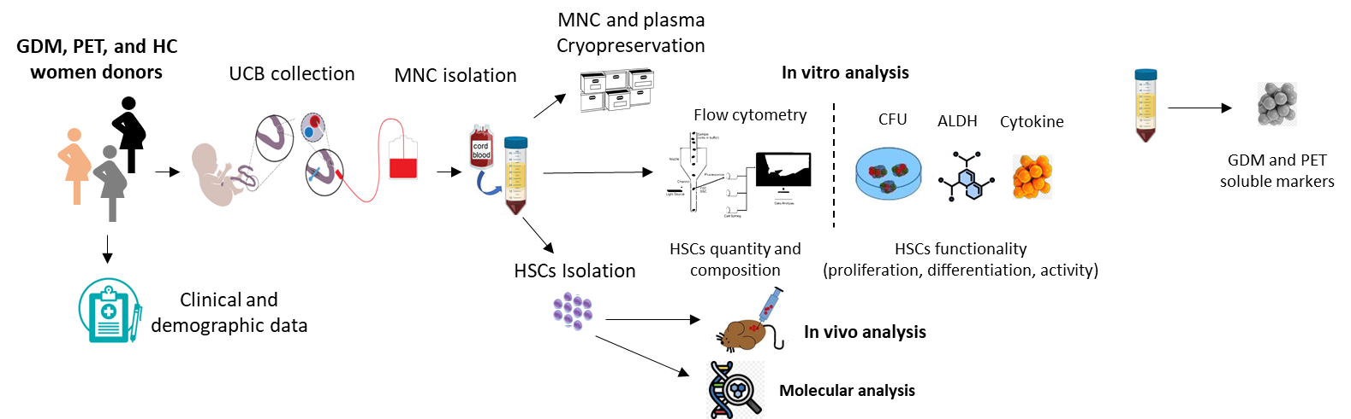

3. MNC isolation from UCB: MNC fractions will be used to study HSC phenotypes and levels by flow cytometry and their functional capacity *in vitro*. UCB samples will be diluted and separated by a standard protocol using a high-density gradient methodology64. The MNC pellet (108 cells/ml) will be suspended, aliquoted for immediate use, or cryopreserved and stored for future use. The plasma fraction will be collected, aliquoted, and used fresh or cryopreserved.

4. Multiparametric phenotyping of UCB CD34+ HSCs by flow cytometry:To identify HSC multipotent progenitor cells, myeloid, lymphoid, megakaryocyte, erythroid, and granulocyte-macrophage lineages, we will establish a flow panel to analyze cell surface phenotypic markers. We will label samples with monoclonal antibodies to detect the following HSCs lineages: MPPs, CMPs, CLPs, MEPs, and GMPs **(Fig. 3).** The antibody mixture will target CD135, CD10, CD34, CD38, CD45, CD45RA, CD90, and a LIVE/DEAD viability marker, 7AAD. Flow cytometry data will be acquired on a BD FACSCanto II analyzer and analyzed by Flowjo software (version 10.10). **Fig.3. The differentiation hierarchy of HSC** 65**.**

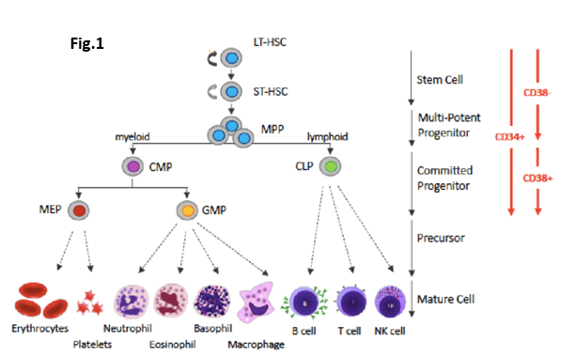

5. UCB CD34+ HSC proliferative capacity:Our first approach to studying the functional state of UCB-derived HSCs will be a colony-forming unit (CFU) assay. The assay is widely used for HSCs and HSPCs66,67. CFU assays measure individual cells’ proliferation and differentiation ability within a sample. According to the manufacturer’s protocol, 5 × 103 MNC cells will be seeded in a 35mm petri dish with semi-solid media68 and incubated at 37◦C in 5% CO2. After 14 days, we will count colonies, record different morphologies, and quantify CFU using an inverted light microscope. We will distinguish colony types by examining progenitor colonies’ characteristic color, morphology, and size.

6. UCB CD34+ HSC aldehyde dehydrogenase assay:Aldehyde dehydrogenase (ALDH) enzyme will be assessed since its expression correlates positively with HSC transplantation engraftment, and its activity levels is an advanced method for HSC qualification69. There is also little information about UCB-derived HSCs and the correlation of ALDH activity with CFU potential. Therefore, we will analyze ALDH activity using the ALDEFLUOR assay (StemCell Technologies, CA) to complement our CFU data, categorizing UCB-derived HSCs as ALDH+ and ALDH-. To perform the ALDEFLUOR assay, UCB MNC suspensions will be adjusted to 106 cells/ml, and their supernatants will be stained for ALDH, CD38, CD34, CD45, CD73, and CD90 and analyzed by flow cytometry.

7. UCB CD34+ HSCs cytokine analysis: To identify factors responsible for UCB-derived HSC functionality, we will analyze isolated plasma from the UCB specimen for critical cytokines, growth factors, and chemokines using fluorescence-encoded beads and a bead-based multiplex assay panel the LEGEND plex™ Human HSC Panel (BioLegend, USA). These soluble markers are involved in HSC differentiation and lineage-specific cell populations. Targets include IL-6, FLT3L, GM-CSF, IL-3, IL-34, IL-11, SCF, LIF, CXCL12 (SDF-1), IL-15, M-CSF, and IL-7. Cytokine levels will be analyzed by flow cytometry.

***Objective 2:*** We will Identify the molecular mechanisms associated with changes in UCB-derived HSCs using DNA mutation and RNA gene expression.

8. Isolation of UCB-derived HSCs: To detect molecular mechanisms associated with functional changes in UCB-derived HSCs, we will isolate MNCs by magnetic cell separation using the positive selection MACS CD34 Microbead Human Kit (Miltenyi Biotec, Germany) according to the manufacturer’s protocol**.**We will use fresh and thawed MNC pellets, and the purity of the CD34+ HSCs will be determined by flow cytometry. Isolated CD34+ HSCs (104 cells/ml) will be used immediately or cryopreserved for molecular analysis and *in vivo* studies.

9. Molecular analysis of Isolated UCB-derived CD34+ HSCs:To investigate the molecular regulatory mechanisms of HSC affecting cell function, self-renewal, and differentiation, we will perform DNA alterations and gene expression profiling. Our analysis will cover single nucleotide variations (SNV), insertions, deletions, stop mutations, splice mutations, and DNA fusions. We will purify DNA and RNA from CD34+ HSCs derived from the UCB of patients with GDM, PET, and HCs using the AllPrep DNA/RNA Kit (Qiagen, Germany). Nucleic acids will be quantified with a NanoDrop 2000c Spectrophotometer and sent for sequencing (Syntezza Bioscience, Israel) and RNA expression analysis (Weizmann Institute of Science, Israel). We will focus on 97 genes involved in HSC regulation70. Genomic DNA (≥1 μg) will be used to construct DNA libraries with the xGen cfDNA and FFPE DNA library prep kit (IDT, USA). Capture and hybridization will be performed using the xGen™ Custom Hybridization Capture Panels. Sequencing will utilize the Illumina HiSeq 2000 and reads will be aligned to the hg19 human genome. Somatic mutation analysis will be conducted using the SEQ platform (Genomize, Turkey) and verified via Sanger sequencing, setting a mutation frequency threshold of over 10% of total readouts. RNA gene expression will be analyzed with NanoString nCounter gene expression code sets targeting 770 genes involved in stem cell biology (nCounter® Stem Cell Characterization Panel set). Probe target RNA hybridization reactions and normalization will follow the manufacturer’s protocol. Differentially expressed genes will be defined as those having a > 2-fold significant change in expression. A gene ontology (GO) enrichment analysis and visualization tool (Gorilla tool) will be used for functional enrichment analysis with GO terms71. Significant functional enrichment terms will be defined as those with a false discovery rate corrected P value ≤.05. DNA and RNA analysis will be done on all GDM and PET samples (~200) presenting different HSC levels of functional variability and compared to HC (n= 100). Each sample will be tested in duplicate.

***Objective 3****:* We will correlate donor clinical and demographic factors with changes in UCB-derived CD34+ HSCs.

10. Collection of donor clinical and demographic data:To identify clinical and demographic information that is associated with UCB-derived CD34+ HSC levels, composition, and functionality, we will collect the following information from donors: maternal age, gestational age at delivery, gravidity, parity, newborn gender, newborn weight; records of maternal and fetal pregnancy complications; and records of neonatal complication, maternal disease history, previous treatment, and medication history. We will also collect clinical CBC and chemistry lab information such as electrolytes, kidney and liver function tests, and glucose and calcium levels. The significance of differences between GDM, PET, and HC data will be assessed using T-tests and two-way ANOVA followed by post-hoc Fisher’s Least Significant Difference (LSD) test. We will use Pearson correlation and Wilcoxon Rank-Sum tests to measure the similarity or correlation between two data sets by comparing their attributes. All statistical analyses will be done using the Statistics package Prism software v9.1 (GraphPad Software, Boston, Maryland, USA). A P value (two-sided) of less than 0.05 indicates a significant difference.

11. Characterization of GDM and PET severity: To assess the severity of GDM and PET among our donors, we will measure maternal blood plasma levels of two hormones linked to these complications. Identifying varying levels of disease severity will enhance our understanding of how GDM and PET affect the HSC population. The analysis will measure insulin levels for GDM and erythropoietin (EPO) for PET. This work will be conducted using immunochemistry at the endocrinology laboratory of Soroka Hospital. Additionally, for GDM donors, we will evaluate plasma levels of other cytokines and markers associated with diabetes, including C-peptide, active GLP-1, GLP-1, insulin, and leptin. This work will be done in our lab using a magnetic bead-based Luminex multiplex assay72.

***Objective 4****.* We will evaluate the reconstitution capacity of UCB-derived CD34+ HSCs*in vivo* using a humanized mouse model.

12. Reconstitution of UCB-derived CD34+ HSCs *in vivo*: To complement our *in vitro* work and provide biologically relevant evidence for functional UCB-derived CD34+ HSCs, we will test their reconstitution capacity*in vivo* in humanized mice. We will use four-week-old female NSG-SGM3 mice to generate humanized mice following transplantation of UCB-derived CD34+ HSCs. Isolated fresh or thawed UCB-derived CD34+ HSCs will be injected at a concentration of at least 3 × 104/250ul into mice via the tail vein. Mice will be monitored, and 50ul of blood will be drawn from the tail vein every two weeks starting from week 8 post-injection (early signs of reconstitution are typically seen at week 1073). We will define successful humanization as a 25% or higher percentage of human CD45+ cells to mice PBMCs. We will sacrifice the humanized mice 12-16 weeks post-transplantation, and the thymus, spleen, peripheral blood, femurs, and tibiae obtained will be analyzed by flow cytometry. All animal procedures, treatments, and testing will strictly adhere to ethical principles and guidelines outlined in the NIH Guide for the Care and Use of Laboratory Animals. The Animal Care Ethics Committee of the Ben-Gurion University of the Negev, Israel, will approve these procedures. They will comply with the Ministry of Health of Israel’s regulations.

12. Flow cytometry of human UCB-derived CD34+ HSCs reconstituted in NSG-SGM3 mice:Collected blood and organ samples from the humanized mice will be processed to single-cell suspensions using a 70-micron nylon cell strainer (BD Falcon, Franklin Lakes, NJ), suspended in a blocking buffer and stained with a mixture of monoclonal antibodies73: β2-microglobulin, CD3, CD4, CD8, CD14, CD19, CD22, CD33, CD33, CD34, CD38, CD41, CD42b, CD45, CD56, CD71, CD117, CD133, CD16, CD203c, and CD235. The following monoclonal antibodies will stain mouse cells: TER-119, CD45, and H-2Kd. Data will be acquired on the Canto II flow cytometer (BD Biosciences, USA) and analyzed using FlowJo software, version 10.10 (Tree Star, Inc.).

***Objective 1 aims to identify specific cell compositions and functional indicators of high-quality HSCs. Objective 2 will uncover new pathways and mechanisms influencing HSC quality and quantity. Objective 3 will use physiological and demographic correlation analyses to reveal clinical factors linked to HSC changes, which could serve as prognostic and predictive markers. Finally, Objective 4 will provide critical biological validation of our results*.**

**Project feasibility:** The study’s experimental design and participating investigators were carefully chosen to ensure feasibility. The participants include highly skilled physicians and an experienced team to carry out tasks, including clinical management, sample collection, animal work, OMIC, *in vitro* studies, and data analysis in well-equipped facilities. Patient recruitment and sample collection will be conducted at Soroka Academic Medical Center. Ethical proposals for patient sample collection are approved, and the ethical protocol for animal work has been submitted.

**IV. Potential Pitfalls, Ways to Overcome Them, and Alternative Approaches**

**Availability of patient samples**: To successfully tackle this main challenge, we have established a strong collaborative partnership with Soroka Hospital and have implemented an innovative long-term sample collection strategy to ensure the capture of all eligible cases. Prof. Kessous, the Deputy Director of Soroka Medical Center and this proposal’s head PI, has forged a robust research collaboration with the gynecologic and obstetric division. Both directors of the maternity ward have agreed to participate, ensuring we meet the minimum sample size required to detect significant differences (see attached letters).

**Cell viability and functionality:** When isolating, freezing, and thawing HSCs, there is a risk of reduced cell viability, especially for functional assays like CFUs. Thus, we will minimize the time between collection and processing to improve the cryopreservation and thawing protocols, ensuring high cell viability after thawing. Additionally, we will compare a subset of fresh and cryopreserved samples to ensure consistency. If cryopreserved cells exhibit a significant loss of function, we will prioritize analyzing fresh samples**.**

**Functional assays:** We recognize that assays may yield varying results, so we plan to use multiple tests to complement one another, including CFU, ALDH, and soluble cytokine measurements. We will also assess UCB-derived CD34+ HSC functionality *in vivo* using the humanized mouse model.

**Molecular analysis**: Our molecular strategy is limited because we use a pre-selected DNA and RNA panel instead of complete sequencing and expression analysis. However, our target DNA and RNA panel includes a substantial set of genes associated with various aspects of HSC biology. Furthermore, we will isolate and preserve DNA and RNA samples to extend our analysis if needed.

**Engraftment failure in humanized mice:** Engraftment failure may happen when HSCs are transplanted into immunodeficient mice, especially with low numbers of transplanted cells and high levels of T-cells, which is a graft versus host disease (GVHD) response. We will employ a magnetic bead separation (MACS) technique to positively select and enrich UCB-derived CD34+ HSCsto improve engraftment success. We will isolate and enrich CD34+ cells through positive selection. However, if the purity threshold is not achieved, we will employ a second separation step to deplete T-cells through negative selection (EasySep™ Human T Cell Isolation Kit, StemCell, USA), minimizing cell loss and potential GVHD response in mice.

**Preliminary results:** Ethical approval was obtained from the Institutional Helsinki Committee at Soroka University Medical Center **(approval number 0217-22-SOR).** Sample collection and all experiments needed for the study are approved. ***Our preliminary results demonstrate four critical results supporting our proposal. 1. We can collect the necessary samples. 2. We have obtained the capability and experience to conduct experiments and analyze cell phenotyping and functional tests related to HSCs. 3. We are proficient at collecting and analyzing clinical and demographic data for the study groups. 4. We have the expertise and facilities to perform the in vivo humanized mice experiment.***

**Table 1.** **A comparison of maternal & fetal characteristics in GDM and control groups**. Values presented are mean ± SEM—BP- blood pressure. P value is significant <0.05.

Thus far, we have collected 55 UCB samples from women diagnosed with GDM, PET, and HC (25, 5, and 25, respectively). The sample volumes are 50-70 ml. Additionally, we collected the following mother’s However, red blood cells (RBCs) were significantly lower in the GDM group than controls (p=0.0065), indicating a potential impact of GDM on erythropoiesis. In contrast, the EPO analysis revealed no significant differences between the GDM and HC groups.

|  |  |  |  |  |  |  |
| --- | --- | --- | --- | --- | --- | --- |
|  |  |  | |  | | |
|  |  | |  | |  |
|  |  | |  | |  |
|  |  | |  | |  |
|  |  | |  | |  |
|  |  | |  | |  |
|  |  | |  | |  |
|  |  | |  | |  |
|  |  | |  | |  |

|  |  |  |  |  |  |  |
| --- | --- | --- | --- | --- | --- | --- |
|  |  |  | |  | | |
|  |  | |  | |  |
|  |  | |  | |  |
|  |  | |  | |  |
|  |  | |  | |  |
|  |  | |  | |  |
|  |  | |  | |  |
|  |  | |  | |  |
|  |  | |  | |  |

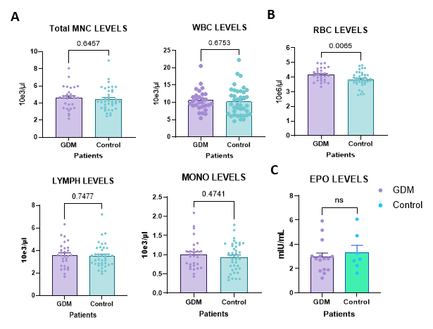

**Fig. 4. A comparison of complete blood count (CBC) and Erythropoietin analysis in umbilical cord blood (UCB) samples from Gestational diabetes mellitus (GDM) and healthy control (HC) donors.**

**Fig 6**. **Flow cytometry comparison of HSCs and HSPC populations in UCB of GDM and HC.** shows the cell percentage of various HSC and HSPC populations in UCB of GDM (n=8) and HC (n=11) samples. Total CD34+CD45+ cells (A), CD38- population (encompassing HSCs and multipotent progenitors) (B), CD38+ progenitor cells (C), CLP cells (D), CMP cells (E), GMP cells (F), and MEP cells (G). Results are represented as means ± SEM.

Next, we quantified and characterized HSCs by flow cytometry to target CD34+ HSCs and their lineages in isolated MNC from UCB samples. We developed a panel for the detection of the following subpopulation: multipotent progenitors (MPPs), common lymphoid progenitors (CLPs), common myeloid progenitors (CMPs), granulocyte-monocyte progenitors (GMPs), and megakaryocyte-erythroid progenitors (MEPs). Our flow cytometric gating strategy successfully discriminated and detected the total HSC population and subpopulations **(Fig. 5).** 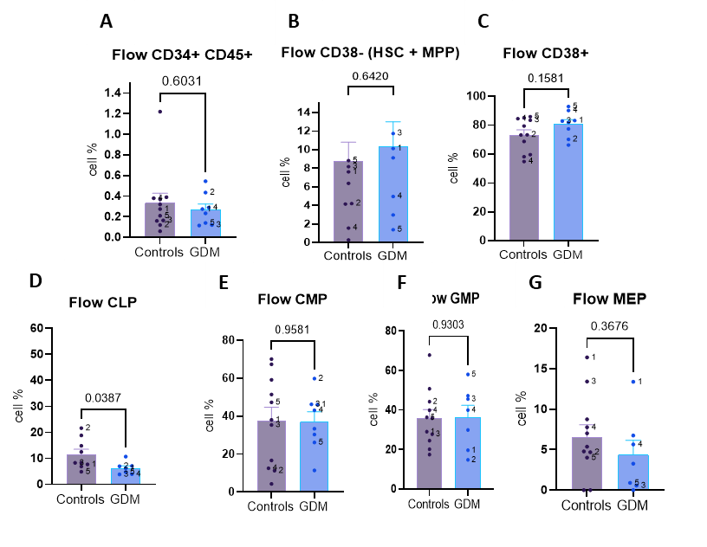Initial flow cytometry (group size n= 25) showed differences in the expression of cell surface markers between the HSC subpopulations of individuals with GDM and 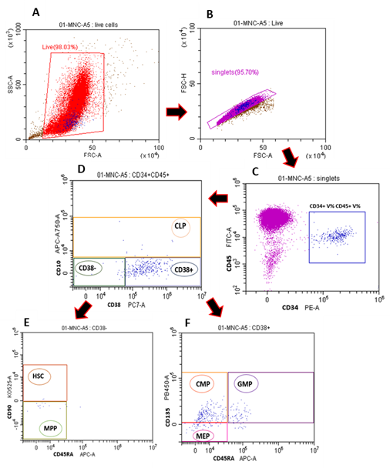the HC (**Fig. 6**). In contrast, the MNC cell count failed to show any clear difference, which could suggest a lack of effect. However, our analysis revealed a statistically significant reduction in CLP cells in the GDM group compared to the HC group (p=0.0387). Additionally, lower levels of total CD45+CD34+ and MEP cells and slightly elevated levels of CD38- and CD38+ cells were detected in the GDM group. Our results highlight the importance of our proposed project by identifying specific subpopulations of HSCs that are more affected than others and provide a proof of concept of our work.

**Fig 5**. **Flow cytometry gating strategy of HSC and HSPC detection**, Flow cytometry gating strategy for detecting CD34+ HSCs and HSPCs in MNCs from UCB. (A) Live cells are gated using forward scatter area (FSC-A) and side scatter area (SSC-A). (B) Single cells were identified based on forward scatter height (FSC-H) versus FSC-A. (C) CD34+CD45+ cells are gated to HSCs and HSPCs. (D) CD34+CD38+ cells indicate committed progenitors, while CD34+CD38- cells identify primitive stem cell populations, which are further divided into common lymphoid progenitors (CLPs) based on CD10 expression. (E) CD34+CD38- cells are analyzed for HSCs (CD90+CD45RA-) and multipotent progenitor (MPP) populations (CD90-CD45RA-). (F) CD34+CD38+ cells are subdivided into common myeloid progenitors (CMPs), granulocyte-monocyte progenitors (GMPs), and megakaryocyte-erythroid progenitors (MEPs).

In parallel with flow cytometry phenotypic characterization, we performed our first functional assay, the CFU assay, to assess the proliferation capacity of UCB-derived HSCs. The CFU results indicated we could effectively observe different colonies by light microscopy. The colonies displayed distinct color, morphology, and size, depending on the potential for proliferation and differentiation of HSCs. The results show seven colony types derived from a CFU assay **(Fig. 7).**

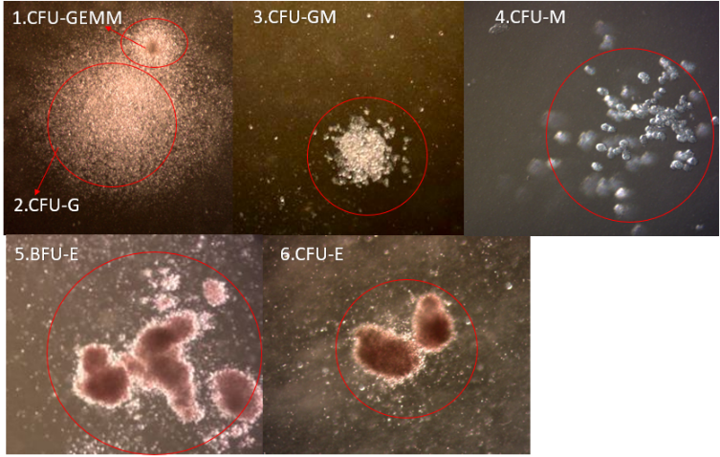1. CFU-GEMM colonies have compact central areas and contain erythroid, granulocyte, macrophage, and megakaryocyte cells. 2. CFU-Gcoloniescontain small granulocyte cells. 3. CFU-GM colonies contain both small and large cells. 4. CFU-M colonies contain large macrophage cells. 5. BFU-E early erythrocyte progenitors comprise 3-8 densely packed clusters**.** 6. One to two densely packed clusters. 7. CFU-E erythrocyte progenitor cells.

**Fig 7**. **Representative colonies from a CFU assay demonstrating the differentiation potential of hematopoietic stem and progenitor cells.** (1) CFU-GEMM, (2) CFU-G, (3) CFU-GM, (4) CFU-M (5) BFU-E (6) CFU-E. Each colony reflects different stages and types of hematopoietic progenitor differentiation.

**For *molecular and in vivo* work**, we separated CD34+ HSCs from our MNCs fraction. We successfully isolated and enriched our test samples using positive CD34+ selection by a magnetic-based separation method with fresh and frozen specimens (**Fig. 8).** The initial population of CD34+ HSCs in the non-separated samples was 0.70% as identified by CD34+ and CD45+ markers. After separation, the CD34+ cell population significantly increased to 97.68%. The total cell yield was approximately 5x104 cells/ml, demonstrating the feasibility and effectiveness of our separation technique.

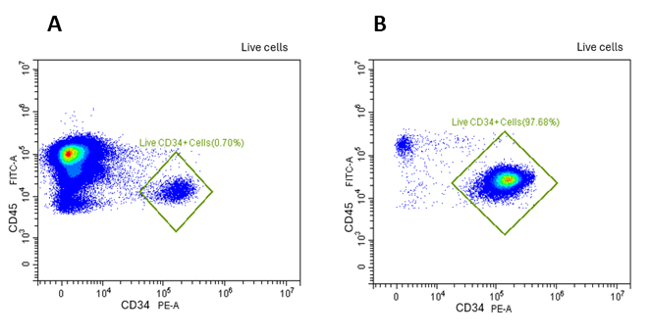

**Fig. 8. CD34+ cell population before and after separation from UCB samples.** A flow cytometry analysis of live cells before and after separation by magnetic beads separation technique

Beyond *in vitro* studies, we have **established a colony of immunodeficient mice** using the NOD.Cg-Prkdcscid Il2rgtm1Wjl Tg (CMV IL-3, CSF2, KITLG)1Eav/MloySzJ strain, also known as NSG-SGM3 mice. This triple transgenic strain may perform better in HSC transplants and supports the regeneration of the entire hematopoietic system 74,75. We have utilized this strain to create a humanized model of peripheral blood mononuclear cells (PBMC) to study GVHD before our planned humanized HSC model. We examined the clinical and cellular aspects of xeno-GVHD induced by PBMCs of HC. The PBMC humanized model results provided essential information on immune system dynamics and GVHD responses *in vivo*, which would assist us in developing and optimizing our HSC humanized model.

The main objective of this proposal is to provide new insights into how important pregnancy complications, specifically GDM and PET, affect the biological evolution of HSCs in the umbilical cord. We aim to enhance our understanding of HSC subpopulations and progenitor cell composition, differentiation, proliferation, and activity state. Additionally, we intend to identify the molecular and physiological pathways associated with these changes.

By integrating our *in vitro* and *in vivo* research with clinical demographic and physiological data, we hope to identify potential predictive and prognostic biomarkers of high-quality HSCs. This knowledge could significantly advance future basic and translational research in the field of HSCs and may also have important medical implications for HSC banking and transplantation.

All information gathered during this study will be shared among the participating investigators and made available to other researchers in the field through open-access publications and data-sharing platforms.

**Bibliography:**

1. El Barky, A. R., Ali, E. & Mohamed, T. M. *Stem Cells, Classifi Cations and Their Clinical Applications*. *Am J Pharmacol Ther* vol. 1 www.scireslit.com (2017).

2. Lee, J. Y. & Hong, S. H. Hematopoieticstem cells and their roles in tissueregeneration. *Int J Stem Cells* **13**, (2020).

3. Coskun, S. & Hirschi, K. K. Establishment and regulation of the HSC niche: Roles of osteoblastic and vascular compartments. *Birth Defects Res C Embryo Today* **90**, 229–242 (2010).

4. Julien, E., El Omar, R. & Tavian, M. Origin of the hematopoietic system in the human embryo. *FEBS Lett* **590**, 3987–4001 (2016).

5. Gao, X., Xu, C., Asada, N. & Frenette, P. S. The hematopoietic stem cell niche: from embryo to adult. *Development* **145**, (2018).

6. Laurenti, E. & Göttgens, B. From haematopoietic stem cells to complex differentiation landscapes. *Nature* **553**, 418–426 (2018).

7. Zech, N. H. *et al.* The rationale behind collecting umbilical cord blood. *J Turk Ger Gynecol Assoc* **11**, 99–101 (2010).

8. Biosciences, B. *et al.* *Application Note Multiparametric Immunophenotyping of Human Hematopoietic Stem Cells and Progenitor Cells by Flow Cytometry Multiparametric Immunophenotyping of Human Hematopoietic Stem Cells and Progenitor Cells by Flow Cytometry Multiparametric Immunophenotyping of Human Hematopoietic Stem Cells and Progenitor Cells by Flow Cytometry*. (2012).

9. Pafumi, C. *et al.* CD34+ Stem Cells from Umbilical Cord Blood. *Clin Pract* **1**, e79 (2011).

10. Anjos-Afonso, F. & Bonnet, D. Human CD34+ hematopoietic stem cell hierarchy: how far are we with its delineation at the most primitive level? *Blood* **142**, 509–518 (2023).

11. Govindarajah, V. & Reynaud, D. Tuning of the Hematopoietic Stem Cell Compartment in its Inflammatory Environment. *Curr Stem Cell Rep* **4**, 189–200 (2018).

12. Rocha, V. & Gluckman, E. Clinical Use of Umbilical Cord Blood Hematopoietic Stem Cells. *Biology of Blood and Marrow Transplantation* **12**, 34–41 (2006).

13. Roura, S., Pujal, J.-M., Gálvez-Montón, C. & Bayes-Genis, A. The role and potential of umbilical cord blood in an era of new therapies: a review. *Stem Cell Res Ther* **6**, 123 (2015).

14. Gluckman, E. *et al.* Hematopoietic Reconstitution in a Patient with Fanconi’s Anemia by Means of Umbilical-Cord Blood from an HLA-Identical Sibling. *New England Journal of Medicine* **321**, 1174–1178 (1989).

15. Gupta, A. O. & Wagner, J. E. Umbilical Cord Blood Transplants: Current Status and Evolving Therapies. *Front Pediatr* **8**, (2020).

16. Gupta, A. O. & Wagner, J. E. Umbilical Cord Blood Transplants: Current Status and Evolving Therapies. *Front Pediatr* **8**, (2020).

17. Mayani, H., Wagner, J. E. & Broxmeyer, H. E. Cord blood research, banking, and transplantation: achievements, challenges, and perspectives. *Bone Marrow Transplant* **55**, 48–61 (2020).

18. Zhu, X., Tang, B. & Sun, Z. Umbilical Cord Blood Transplantation: Still Growing and Improving. *Stem Cells Transl Med* **10**, S62–S74 (2021).

19. Sanz, M. A. Cord-Blood Transplantation in Patients with Leukemia — A Real Alternative for Adults. *New England Journal of Medicine* **351**, 2328–2330 (2004).

20. Moretta, A. *et al.* Analysis of immune reconstitution in children undergoing cord blood transplantation. *Exp Hematol* **29**, 371–379 (2001).

21. Laughlin, M. J. *et al.* Hematopoietic Engraftment and Survival in Adult Recipients of Umbilical-Cord Blood from Unrelated Donors. *New England Journal of Medicine* **344**, 1815–1822 (2001).

22. Gluckman, E. Current status of umbilical cord blood hematopoietic stem cell transplantation. *Exp Hematol* **28**, 1197–1205 (2000).

23. Ashkan Emadi, M. P. U. of M. J. Y. L. M. U. of M. S. of M. Myelodysplastic Syndrome (MDS). (2023).

24. National Academies of Sciences, Engineering, and Medicine; Health and Medicine Division; Board on Health Care Services; Committee on Identifying New or Improved Diagnostic or Evaluative Techniques. Advances in the Diagnosis and Evaluation of Disabling Physical Health Conditions. Washington (DC): National Academies Press (US); 2023 May 1. 7, Techniques for Hematological Disorders. Available from: https://www.ncbi.nlm.nih.gov/books/NBK593683/.

25. Dotson JL, Lebowicz Y. Myelodysplastic Syndrome. [Updated 2022 Jul 18]. In: StatPearls [Internet]. Treasure Island (FL): StatPearls Publishing; 2024 Jan-. Available from: https://www.ncbi.nlm.nih.gov/books/NBK534126/.

26. Goldman, J. Editor’s Note. *Bone Marrow Transplant* **25**, 1–1 (2000).

27. Rocha, V. *et al.* Transplants of Umbilical-Cord Blood or Bone Marrow from Unrelated Donors in Adults with Acute Leukemia. *New England Journal of Medicine* **351**, 2276–2285 (2004).

28. Rosenau, E. H. *et al.* Characteristics of thawed autologous umbilical cord blood. *Transfusion (Paris)* **52**, 2234–2242 (2012).

29. Mancinelli, F. *et al.* Optimizing Umbilical Cord Blood Collection: Impact of Obstetric Factors Versus Quality of Cord Blood Units. *Transplant Proc* **38**, 1174–1176 (2006).

30. Al-Deghaither, S. Y. Impact of maternal and neonatal factors on parameters of hematopoietic potential in umbilical cord blood. *Saudi Med J* **36**, 704–712 (2015).

31. Wen, S.-H., Zhao, W.-L., Lin, P.-Y. & Yang, K.-L. Associations among birth weight, placental weight, gestational period and product quality indicators of umbilical cord blood units. *Transfusion and Apheresis Science* **46**, 39–45 (2012).

32. Jan, R.-H., Wen, S.-H., Shyr, M.-H. & Chiang, B.-L. Impact of maternal and neonatal factors on CD34+ cell count, total nucleated cells, and volume of cord blood. *Pediatr Transplant* **12**, 868–73 (2008).

33. Nakagawa, R. *et al.* Analysis of maternal and neonatal factors that influence the nucleated and CD34+ cell yield for cord blood banking. *Transfusion (Paris)* **44**, 262–267 (2004).

34. Rowisha, M. A., El-Shanshory, M. R., El-Hawary, E. E., Ahmed, A. Y. & Altoraky, S. R. M. Impact of maternal and neonatal factors on umbilical cord CD34+ cells. *Stem Cell Investig* **7**, 5–5 (2020).

35. Wen, S.-H., Zhao, W.-L., Lin, P.-Y. & Yang, K.-L. Associations among birth weight, placental weight, gestational period and product quality indicators of umbilical cord blood units. *Transfusion and Apheresis Science* **46**, 39–45 (2012).

36. Pafumi, C. *et al.* Differences in Umbilical Cord Blood Units Collected during Cesarean Section, before or after the Delivery of the Placenta. *Gynecol Obstet Invest* **54**, 73–77 (2002).

37. Gebremariam, B. M., Aboye, G. T., Dessalegn, A. A. & Simegn, G. L. Rule-based expert system for the diagnosis of maternal complications during pregnancy: For low resource settings. *Digit Health* **10**, (2024).

38. Muglia, L. J., Benhalima, K., Tong, S. & Ozanne, S. Maternal factors during pregnancy influencing maternal, fetal, and childhood outcomes. *BMC Med* **20**, 418 (2022).

39. McCarthy, F. P. & Kenny, L. C. Hypertension in pregnancy. *Obstet Gynaecol Reprod Med* **19**, 136–141 (2009).

40. Johns Hopkins Medicine. Common Pregnancy Complications. (2023).

41. Shen, J. *et al.* An Innovative Artificial Intelligence–Based App for the Diagnosis of Gestational Diabetes Mellitus (GDM-AI): Development Study. *J Med Internet Res* **22**, e21573 (2020).

42. Cleveland Clinic Medical. Preeclampsia. *https://my.clevelandclinic.org/health/diseases/17952-preeclampsia* (2021).

43. Kawakita, T. *et al.* Increased Neonatal Respiratory Morbidity Associated with Gestational and Pregestational Diabetes: A Retrospective Study. *Am J Perinatol* **34**, 1160–1168 (2017).

44. Andrawus, M., Sharvit, L. & Atzmon, G. Epigenetics and Pregnancy: Conditional Snapshot or Rolling Event. *Int J Mol Sci* **23**, 12698 (2022).

45. Blue, E. K. *et al.* Gestational diabetes induces alterations in the function of neonatal endothelial colony-forming cells. *Pediatr Res* **75**, 266–272 (2014).

46. Tusimin, M. *et al.* Effects of gestational diabetes mellitus on the quality and quantity of blood hematopoietic stem cells: a case-control study. *Croat Med J* **62**, 590–597 (2021).

47. Kim, J. *et al.* Umbilical Cord Mesenchymal Stromal Cells Affected by Gestational Diabetes Mellitus Display Premature Aging and Mitochondrial Dysfunction. *Stem Cells Dev* **24**, 575–586 (2015).

48. Wajid, N. *et al.* The effect of gestational diabetes on proliferation capacity and viability of human umbilical cord-derived stromal cells. *Cell Tissue Bank* **16**, 389–397 (2015).

49. Mohd Idris, M. R., Nordin, F., Mahdy, Z. A. & Abd Wahid, S. F. Gestational Diabetes Mellitus in Pregnancy Increased Erythropoietin Level Affecting Differentiation Potency of Haematopoietic Stem Cell of Umbilical Cord Blood. *Front Med (Lausanne)* **8**, (2021).

50. Nordin, F., Idris, M. R. M., Mahdy, Z. A. & Wahid, S. F. A. Preeclampsia in pregnancy affecting the stemness and differentiation potency of haematopoietic stem cell of the umbilical cord blood. *BMC Pregnancy Childbirth* **20**, 399 (2020).

51. Hadarits, O. *et al.* Increased Proportion of Hematopoietic Stem and Progenitor Cell Population in Cord Blood of Neonates Born to Mothers with Gestational Diabetes Mellitus. *Stem Cells Dev* **25**, 13–17 (2016).

52. Andrawus, M., Sharvit, L. & Atzmon, G. Epigenetics and Pregnancy: Conditional Snapshot or Rolling Event. *Int J Mol Sci* **23**, 12698 (2022).

53. Raia-Barjat, T., Edebiri, O. & Ni Ainle, F. Preeclampsia and Venous Thromboembolism: Pathophysiology and Potential Therapy. *Front Cardiovasc Med* **9**, (2022).

54. Ives, C. W., Sinkey, R., Rajapreyar, I., Tita, A. T. N. & Oparil, S. Preeclampsia—Pathophysiology and Clinical Presentations. *J Am Coll Cardiol* **76**, 1690–1702 (2020).

55. Gumina, D. L., Black, C. P., Balasubramaniam, V., Winn, V. D. & Baker, C. D. Umbilical Cord Blood Circulating Progenitor Cells and Endothelial Colony-Forming Cells Are Decreased in Preeclampsia. *Reproductive Sciences* **24**, 1088–1096 (2017).

56. Surbek, D. V. *et al.* Effect of preeclampsia on umbilical cord blood hematopoietic progenitor-stem cells. *Am J Obstet Gynecol* **185**, 725–729 (2001).

57. Qiu, L. *et al.* Effect of preeclampsia on umbilical cord blood stem cells in relation to breast cancer susceptibility in the offspring. *Carcinogenesis* **36**, 94–98 (2015).

58. Gauster, M., Desoye, G., Tötsch, M. & Hiden, U. The Placenta and Gestational Diabetes Mellitus. *Curr Diab Rep* **12**, 16–23 (2012).

59. Santillan, D. A. *et al.* The effects of preeclampsia on signaling to hematopoietic progenitor cells. *Proceedings in Obstetrics and Gynecology* **3**, 1–11 (2013).

60. Teramo, K. A. & Widness, J. A. Increased Fetal Plasma and Amniotic Fluid Erythropoietin Concentrations: Markers of Intrauterine Hypoxia. *Neonatology* **95**, 105–116 (2009).

61. Ballen, K. *et al.* Bigger is better: maternal and neonatal predictors of hematopoietic potential of umbilical cord blood units. *Bone Marrow Transplant* **27**, 7–14 (2001).

62. Mousavi, S., Zarrabi, M., Abroun, S., Ahmadipanah, M. & Abbaspanah, B. Umbilical cord blood quality and quantity: Collection up to transplantation. *Asian J Transfus Sci* **13**, 79 (2019).

63. https://resources.nu.edu/statsresources/downloadinggpower.

64. Zhang, Q. & Sun, X. Density Gradient Ultracentrifugation Technique. in 37–58 (2018). doi:10.1007/978-981-10-5190-6_3.

65. Soverini, S., De Santis, S., Monaldi, C., Bruno, S. & Mancini, M. Targeting Leukemic Stem Cells in Chronic Myeloid Leukemia: Is It Worth the Effort? *Int J Mol Sci* **22**, 7093 (2021).

66. Kronstein-Wiedemann, R. & Tonn, T. Colony Formation: An Assay of Hematopoietic Progenitor Cells. in 29–40 (2019). doi:10.1007/978-1-4939-9574-5_3.

67. Skific, M. & Golemovic, M. Colony-forming unit assay as a potency test for hematopoietic stem/progenitor cell products. *Molecular and experimental biology in medicine* **2**, 51–56 (2019).

68. https://www.stemcell.com/culture-and-analysis-of-hematopoietic-progenitor-cells-in-cfu-assays.html.

69. Gencer, E. B., Yurdakul, P., Dalva, K. & Beksaç, M. Flow Cytometric Aldehyde Dehydrogenase Assay Enables a Fast and Accurate Human Umbilical Cord Blood Hematopoietic Stem Cell Assessment. *Turkish Journal of Hematology* **34**, 314–320 (2017).

70. Jakobsen, N. A. *et al.* Selective advantage of mutant stem cells in human clonal hematopoiesis is associated with attenuated response to inflammation and aging. *Cell Stem Cell* **31**, 1127-1144.e17 (2024).

71. Eden, E., Navon, R., Steinfeld, I., Lipson, D. & Yakhini, Z. GOrilla: a tool for discovery and visualization of enriched GO terms in ranked gene lists. *BMC Bioinformatics* **10**, 48 (2009).

72. https://cytokine.creative-proteomics.com/human-diabetes-cytokine-panel-service.htm.

73. Beyer, A. I. & Muench, M. O. Comparison of Human Hematopoietic Reconstitution in Different Strains of Immunodeficient Mice. *Stem Cells Dev* **26**, 102–112 (2017).

74. Wunderlich, M. *et al.* Improved multilineage human hematopoietic reconstitution and function in NSGS mice. *PLoS One* **13**, e0209034 (2018).

75. Beyer, A. I. & Muench, M. O. Comparison of Human Hematopoietic Reconstitution in Different Strains of Immunodeficient Mice. *Stem Cells Dev* **26**, 102–112 (2017).