**Scientific abstract** – **Uncovering the molecular mechanisms of host-parasite interactions during *Myxobolus bejeranoi* infection of tilapia**

The myxozoans are a large group of obligate parasites recently placed within the phylum Cnidaria. They have complex life cycles, infecting vertebrates (primarily fish) and invertebrates (primarily worms) in freshwater and marine environments. Myxozoan parasites cause morbidity and mortality in farmed and wild fish populations worldwide. **Despite their global impact, there are large gaps in our understanding of the molecular mechanisms that underlie myxozoan infection**. Here, we propose to use our recently identified myxozoan species, *Myxobolus bejeranoi*, as a model system to understand the molecular mechanisms involved in host-parasite interaction. *M. bejeranoi* causes mortality in hybrid tilapia ((Nile tilapia (*Oreochromis niloticus*) x blue tilapia (*O. aureus*)), the main fish farmed in Israel and one of the most important globally. We discovered that *M. bejeranoi* successfully proliferates in host gills by systemically modulating the immune response. **The key objective of our proposal is to understand the molecular cascades activated upon *M. bejeranoi* infection, resulting in broad immune suppression in host fish and successful parasite proliferation.**

Our results indicate that blue and Nile tilapia purebred parents are initially infected by *M. bejeranoi*. However, blue tilapia is susceptible to the parasite, which sporulates and causes disease, whereas Nile tilapia is resistant, as no parasite development occurs after the initial infection. **We hypothesize this difference is due to genetic, molecular, and cellular differences between the two host species.** To discover the mechanisms of successful myxozoan infection, we will apply a comparative multi-omics approach combining transcriptomics, proteomics, metabolomics, and microscopy. We will compare susceptible and resistant tilapias as well as the parasite before exposure and at multiple times post-exposure. We will analyze the gills (the site of sporulation), the head kidney (the main immune organ), and serum (a potential signaling route). Comparative transcriptomics of gills and head kidneys will provide molecular insights into myxozoan replication and sporulation and differential genetic features of host resistance mechanisms. Comparative proteomics of time series will reveal the functional states of cells and their dynamic responses to infection. Specifically, proteomics may identify serum protein signals underlying the post-infection systemic immune shutdown we detected. Comparative metabolomics will inform us of host adaptive metabolic responses that characterize the disease susceptibility phenotype. We will use multi-omics analysis tools to combine the results of our three approaches to generate a comprehensive network of host-parasite interactions. We will also reveal the molecular mechanisms active during parasite sporulation and cyst formation by targeted and untargeted MALDI imaging and analyze the spatial expression of parasite and host proteins. The analysis will be followed by metabolite and spatiotemporal gene analyses. Finally, we will compare our findings to other groups of parasites to identify common molecular mechanisms of infection and host resistance.

**Our proposal is the first comprehensive attempt in Myxozoa to combine layers of biological information to reveal the mechanisms underlying host-parasite interactions and to elucidate the myxozoan mode of action. As significant, our data may facilitate the development of new strategies for protecting cultured fish from parasite infection.**

**Detailed description of the research program**

1. **Scientific background**

Myxozoans are microscopic, eukaryotic, spore-forming, obligate parasites within the phylum Cnidaria (1-9). Compared to their free-living cnidarian relatives, myxozoans have greatly reduced body plans, and their genomes lack key signaling genes and transcription factors that are hallmarks of multicellularity. However, they retain the phylum-defining stinging nematocysts, known in myxozoans as polar capsules (4,10-12), and genes necessary for their function as obligate parasites (2,13). The complex myxozoan life cycle includes two hosts: a vertebrate, mainly fish, and an invertebrate, mostly worms (8,14) (**Fig. 1A**). Transmission between hosts is achieved by two distinct types of waterborne spores termed actinospores and myxospores (15,16). Myxozoans are common in marine and freshwater systems worldwide. Moreover, they are significant pathogens of wild and farmed fish, causing diseases such as proliferative gill disease, ceratomyxosis, and whirling disease (17). In Israel, myxozoan infections are found in farmed sea bream in the Gulf of Eilat and the Mediterranean (18-20). Infection causes disease and mortality in freshwater tilapia hatcheries and in tilapia in the Sea of Galilee ((21,22) and Israel Central Fish-Health Laboratory 2012 Report). Recently, we identified a new myxozoan species, *Myxobolus bejeranoi*, as the cause of up to 40% mortality in commercial cultures of hybrid tilapia *Oreochromis aureus* (blue tilapia) x *O. niloticus* (Nile tilapia) (22) (**Fig. 1**).

Native to Africa, tilapia is the second most important farmed fish globally and is promoted by the United Nations Food and Agriculture Organization (23). Over the last decade, tilapia has become an important cultured freshwater fish in Israel, constituting 60% of total production (24). **Therefore, understanding the myxozoan infection process in tilapia is critically important economically and nutritionally for Israel and the world.** **Myxozoans are also an extremely attractive group, evolutionarily, being ancient and one of the smallest multicellular parasites that evolved about 600 mya** (8). While Myxozoa comprises about 2400 species (25), fewer than ten myxozoan genomes or transcriptomes at different levels of assembly are available (reviewed in (26)). **Hence, there are large gaps in our understanding of the molecular aspects of the infection process.** During our current ISF grant, we successfully established an *M. bejeranoi* transcriptomic dataset from invasion, the initial step of infection, through sporulation (27) and discovered that *M. bejeranoi* proliferates in host gills by modulating the fish immune system (28).

**The main objective of our proposal is to identify and characterize the signaling cascades initiated in fish gills upon *M. bejeranoi* infection, which results in broad suppression of the host immune system and successful parasite proliferation*.*** Because these cascades are activated by host-parasite interaction, we will investigate them using multi-omics combining genomics, transcriptomics, proteomics, metabolomics, and microscopy during the course of infection in the permissive host, the resistant host, and the parasite.

* 1. **Fish-Myxozoa interaction**

Recent studies exploring fish immunoreactions to myxozoan infection demonstrate that an early innate response is followed by a late adaptive response (reviewed in (29,30)). **These events indicate** **some myxozoans may** **evade or modulate the fish immune system;** **however, the mechanisms underlying the**

**interaction are unknown**. Genomic and transcriptomic studies of infected fish show changes in gene expression, thereby informing our understanding of host immune mechanisms (29-38).

Our recent work reveals that *M. bejeranoi* can induce systemic and tissue-specific effects on the immune response of the hybrid tilapia host. In the gills, the site of parasite sporulation, the immune system is activated only with intense infections, whereas in the spleen, the immune system is partially inhibited. In the head kidney, the primary immune organ of fish, we find a complete immune shutdown (28). **However, the molecular signals generated by the parasite and how these modulate the fish immune response are unknown.** We also examined the host specificity of *M. bejeranoi* by challenging the purebred parents of the hybrid tilapia. We found that the parasite only sporulates in blue tilapia, leading to cyst development in their gills, like hybrid tilapia. A qPCR analysis of Nile tilapia revealed invasion with the parasite and expression comparable to blue tilapia at the beginning of infection. However, unlike blue tilapia, the infection level in Nile tilapia did not escalate ((39) and see **Preliminary results Fig. 3A**). The parasite was detected in Nile tilapia gills for up to a month but did not sporulate, and the host showed no sign of infection (39). Additionally, markers for immune system activation and IgM were upregulated in Nile tilapia and not blue tilapia (see **Preliminary results Fig. 3B, C** **and Fig. 4**), indicating that Nile tilapia sense the invader and control its proliferation by immune system activation. **To reveal the mechanism underlying the cross-talk between fish and Myxozoa, we will comprehensively analyze the transcriptomes and proteomes of blue tilapia, Nile tilapia, and the parasite before and during infection.** To understand the host-parasite communication signals and the molecular pathways triggered by the parasite, we will combine the obtained transcriptomics and proteomic data with metabolomic profiles.

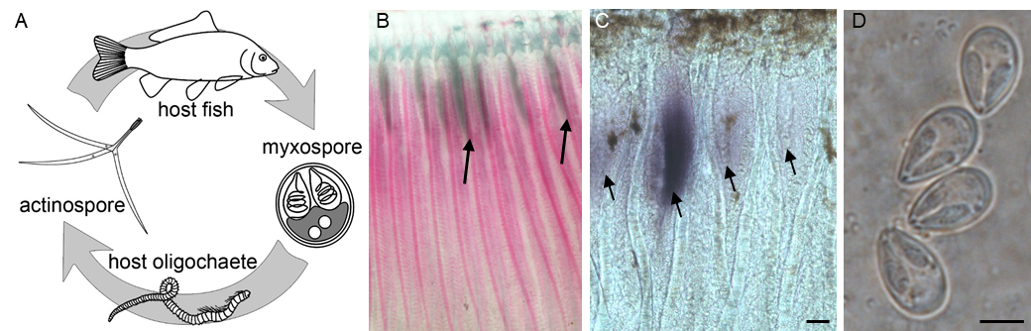

**Figure 1. Generalized life cycle of a myxozoan parasite.** (**A**) The invertebrate host ingests myxospores, which release the parasite sporoplasm. The parasite replicates and develops into actinospores. Released actinospores float until they encounter the fish host. The parasite replicates within the fish and transforms into myxospores that are released back into the water. The scheme is courtesy of S. Atkinson. (**B**) Developing *Myxobolus bejeranoi* myxospores in encapsulated plasmodia (arrows) within hybrid tilapia gills. Each plasmodium contains hundreds of spores. **(C)** Whole-mount in situ hybridization for *M. bejeranoi* SSU rRNA in parasite-infected hybrid tilapia gills showing cysts at different developmental stages (arrows). Bar, 50 m (**D**) *M. bejeranoi* myxospores, bar, 5 m.

* 1. **Metabolomics: A comprehensive platform to measure phenotype at the molecular level**

Metabolomics has emerged as an important research approach. It allows high-throughput analyses of hundreds of metabolites associated with different biological pathways, thereby offering a powerful tool for unraveling mechanisms of action (40,41). Metabolites are defined as substrates, intermediates, and products of metabolism, including small molecules, signaling molecules, transporters, cofactors, amino acids, carbohydrates, lipids, hormones, and even small proteins. As end-products of cellular processes, these molecules reflect the underlying biochemical activity of a tissue. Metabolomics is at the forefront of biomarker discovery for pathophysiological mechanisms of diseases such as obesity, diabetes, and cancer (42). Moreover, cellular metabolism affects immune cell state and fate and, thereby, immune system function in health and disease (43,44).

The cross-talk between immune and metabolic processes is conserved across the animal kingdom (44). Metabolomics is also important in aquaculture (45,46) and parasitology (47-49). However, the application of metabolomics to myxozoan research is limited to two *Enteromyxum* sp. and *Sphaerospora fugu* that are not closely related to *M. bejeranoi* (50,51). **We will incorporate comparative metabolomics to discover the molecular signals activated during parasite infection and proliferation. By combining comparative transcriptomic and proteomic analyses with matrix-assisted laser desorption/ionization imaging (MALDI imaging), we expect to obtain multiple layers of information, providing meaningful insights into host-parasite communication signals and their mechanism of action.**

1. **Research objectives and expected significance**

Our overall objective is to understand the mechanisms that underlie successful myxozoan infection of the fish host. To achieve this objective, we will analyze fish-myxozoan interactions over time in susceptible and resistant hosts using genomics, transcriptomics, proteomics, and metabolomics combined with specific spatial molecular analyses. Transcriptomics, proteomics, and metabolomics provide distinct layers of information. Notably, essential information at the proteome and metabolome levels cannot be predicted from genomics and transcriptomics. Each approach stands independently and will advance our understanding of host-parasite interaction. We will use the causative agent of tilapia mortality, *M. bejeranoi*, which is the most common and accessible freshwater myxozoan species in Israel (**Fig. 1**). Our combined results will create an extensive network of interactions and key compounds that will be analyzed for their spatiotemporal expression. Figure 2 shows a schematic illustration of the proposed work plan and the inter-relationships between our aims.

* 1. **Specific research aims**

**Aim 1:** Uncover the mechanisms underlying successful myxozoan infection in susceptible blue tilapia compared to resistant Nile tilapia using transcriptomics and proteomics.

**Aim 2:** Perform comparative metabolomics to identify metabolites that mediate myxozoan infection.

**Aim 3:** Construct a comprehensive model of the processes that unfold during myxozoan sporulation by comparative gene expression, metabolomics, and spatial proteomics analyses.

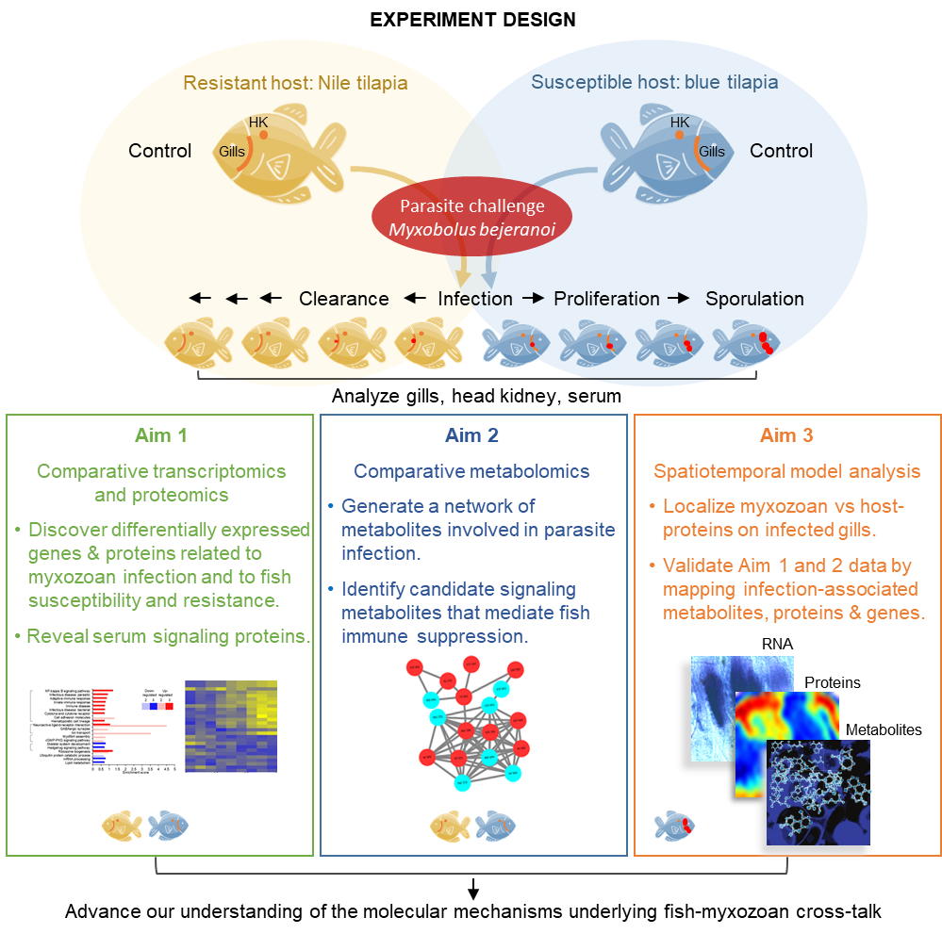

**Figure 2. Study design overview.** A schematic illustration of how the different Aims are interconnected. In Aim 1, we will generate molecular data from susceptible and resistant tilapia hosts and the parasite *M. bejeranoi* before and during infection time series to decipher host-parasite interactions. In Aim 2, we will perform comparative metabolomics to reveal signaling metabolites that play a role in silencing the host immune response. In Aim 3, we will create a comparative “3D” model map of molecular responses to gill infection by combining data from protein and metabolite imaging, protein immunolocalization, and in situ hybridization assays. Each aim stands on its own and can be performed independently; however, the results of the aims can be integrated to obtain comprehensive insight into fish-myxozoan cross-talk. HK, head kidney.

* 1. **Expected significance**

We propose to study a recently identified myxozoan parasite, which infects hybrid tilapia by suppressing the host immune response (22,27,28). **Our study will be the first comprehensive, comparative investigation of myxozoan infection processes in resistant and susceptible fish hosts by integrating transcriptomics, proteomics, and metabolomics.** Our study will highlight the early stages of infection before parasite proliferation by focusing on pathways activated or inhibited in the two tilapia species. Our temporal analysis will also identify host-parasite cross-talk and genes, proteins, metabolic pathways, and metabolites that respond specifically to parasite proliferation and sporulation. We expect to identify signaling proteins and metabolites modulated in response to parasite infection that subsequently mediate the silencing of the host immune response. **Our study will be the first to correlate infection processes with the spatial expression of these signaling molecules using MALDI-MS imaging of infected gills. Thus, we will connect signaling molecule localization and function.** Our results will advance the understanding of common functions of endoparasites and specific myxozoan infection processes. **Additionally, since myxozoans are a large and unique group in the Cnidaria phylum, we expect the data to shed light on their evolution**. Furthermore, myxozoan parasites affect wild and cultured fish worldwide and in Israel. *M. bejeranoi* has seriously threatened tilapia aquaculture, causing high mortality and economic losses. **We expect that the basic knowledge gained on host-parasite interactions will provide essential knowledge toward developing treatments for parasite infection, such as small molecules or peptides that interfere with infection signaling or parasite development.**

1. **Detailed description of the proposed research**
   1. **Working hypotheses**

Recently, we discovered that while both parent tilapia species are infected, *M. bejeranoi* proliferates and sporulates only in blue tilapia (39). Therefore, our **working hypothesis** **is that *M. bejeranoi* is a specialist parasite of blue tilapia that lacks the general molecular mechanisms necessary for its complete life cycle in closely related Nile tilapia (Hypothesis 1)**. **As a** **null hypothesis, the parasite has a general infection molecular mechanism, but fish hosts respond in a host-specific manner despite being closely related species** (see **Preliminary results Fig. 3**). To test these hypotheses, we will comparatively analyze the two fish species and the parasite to identify differentially modulated genes, proteins, and metabolites before and during infection. We expect the data toprovide specific insights into myxozoan infection and broader revelations into host-parasite cross-talk.

Our study is supported by well-annotated published genomic data from the two purebred tilapia species, enabling efficient analysis of metabolic pathways (52-54), as we demonstrated previously. Furthermore, we acquired well-annotated transcriptomic data for *M. bejeranoi*, allowing us to identify transcripts within target pathways (39). Additionally, our preliminary proteomic results from infected gills demonstrate the identification of both host and parasite proteins. Whereas transcriptomics will mirror the differential genetic background, we postulate that proteomics and metabolomics will identify functional proteins and signaling molecules, as demonstrated in other parasites (47,55-57). Such components will enable us to propose signaling pathway models for host susceptibility.

*M. bejeranoi* suppresses the immune response of hybrid tilapia (28). **We hypothesize that the signal for systemic immune suppression in the head kidney, the main immune organ, originates at the gills, the site of sporulation (Hypothesis 2).** We will test this hypothesis by comparative proteomics and metabolomics of head kidneys and gills from the two purebred tilapia parents.We anticipate major differences in the presence of these signals between resistant Nile tilapia and susceptible blue tilapia hosts. In susceptible hosts, we expect to find host-synthesized signaling molecules in gill cysts. Indeed, our preliminary comparison of infected versus non-infected gills revealed that 38% of identified metabolites were specific to infected gills (see **Preliminary results Fig. 5**). We will also visualize the spatial distribution of molecules in infected gills to correlate their location with their function. In the head kidney, we expect proteins and metabolites related to activation or suppression of the immune system. **Because the parasite infection triggers a systemic reaction, we hypothesize that serum analysis will identify proteins and metabolites that are signals for the immune shutdown that we have found** **(Hypothesis 3) (Preliminary results Fig. 6)**. We will test this hypothesis by comparative proteomics and metabolomics of serums of control fish and the two purebred tilapia parents during infection. We will search for unique signaling molecules detected only in the susceptible blue tilapia and only during infection.

We were recently awarded a VATAT institutional grant to establish a metabolomics unit (see **Research design and methods**, **Aim 2**). Thus, we have the expertise and facilities to implement the proposed research.

* 1. **Research design and methods**
* Experimental design and sample collection: The experiments will be conducted at the fishponds at Reshafim Pisciculture and the Central Fish Health Laboratory, Nir David, in collaboration with the Dor Research Station (see Letters of collaboration). We will test three host tilapia species: blue (susceptible), Nile (resistant), and hybrid (susceptible, positive control). We will use three-month-old fish grown in a parasite-free environment. Parasite infectious stages from pond water will be used, as recently detailed (27,28). Briefly, the pond will be monitored weekly between mid-July and September to determine the optimum start time for the experiment. We will expose cages of blue tilapia to the pond for 24 h, then assay gills for parasite infection using our *M. bejeranoi* - specific qPCR assay (22,28). When more than 80% of the control fish are infected, the experimental fish will be similarly exposed. Fish will then be transferred to indoor tanks with a flow-through, parasite-free water system at the Central Fish Health Laboratory. We will collect time series samples (*n*=30 at each time point) of exposed fish at 0, 3, 6, 9, 12, 15, 18, and 21 days post-exposure (dpe). Previous experiments show that cysts can be seen from 12 dpe. In parallel, unexposed fish will be sampled at three times points (0, 12, and 21 dpe). We will evaluate the infection levels by light microscopy, histology, and qPCR (28). Gills and head kidney from control and exposed fish will be snap-frozen in liquid nitrogen and stored at -80 0C until analyzed. Tissues will also be fixed for microscopic sectional analysis and in situ hybridization (see Aim 3). Serum will be collected from the caudal vein at 0, 3, 9, 15, and 21 dpe (*n*=20 for each sample) from the same fish sampled for gills and head kidneys and kept at -80 0C until analyzed.
* **Aim 1: Uncover the mechanisms underlying successful myxozoan infection in susceptible compared to resistant tilapia using transcriptomics and proteomics.** Rationale:Our preliminary results indicate that the susceptibility of hybrid tilapia to *M. bejeranoi* infection is similar to its purebred parent, blue tilapia, whereas the other parent, Nile tilapia, is resistant. Notably, our data show that after exposure to waterborne parasite stages, all three fish species have detectable parasite DNA on their gills (39) (see **Preliminary results Fig. 3 for blue and Nile tilapia**). However, whereas hybrid and blue tilapia infections progress to sporulation, parasites do not propagate in Nile tilapia (39). We also found that cytokines mediating host immune response are increased in Nile tilapia but not blue tilapia. Significantly, IgM is greatly increased in Nile tilapia but not in blue tilapia (see **Preliminary results Figs. 3, 4**). We will utilize this host-parasite system to decipher host-parasite cross-talk by comparing gene and protein expression profiles of the two purebred tilapia species before and after infection. We already have transcriptomic data for hybrid tilapia, which indicates that *M. bejeranoi* modulates the fish immune response and enabled us to generate a de novo transcriptome database for the parasite (27,28) (see **Preliminary results** section **Genomic and transcriptomic data of *M. bejeranoi***). **Thus, by comparing data obtained from the closely related susceptible and resistant species, together with the parasite, we can identify genes, proteins, and molecular pathways important for infection and host resistance (Hypothesis 1 and Null hypothesis).** Transcriptional profiling will provide molecular insights into the myxozoan replication and sporulation processes, and host immune mechanisms. Proteomic profiling, which is widely used to identify early biomarkers of diseases and pathogen infections and to discover therapeutic targets (55,58), will reveal the actual functional state of the cells and their dynamic responses to infection **(Hypothesis 2)**. **Specifically, we postulate that serum proteomics will reveal proteins that serve as signals for the immune shutdown that we have found** (28) (**Hypothesis 3**). We are experienced with these methods (11,59-64) and performed the first proteomic analysis in Myxozoa(11,62). Additionally, our preliminary proteomic data (see **Preliminary results Figs. 7, 8**) demonstrate active pathways in infected gills compared to control hybrid tilapia, and from the same infected gills, we also identify the parasite proteins. We will use our expertise to profile genes and proteins expressed by parasites and hosts during different stages of infection to reveal molecular signals of host-parasite interactions. Our results will be used to identify metabolic pathways and will be combined with the metabolomics networks resulting from Aim 2. We will compare these results to recently published *Tetracapsuloides bryosalmonae* comparative transcriptomes in natural carrier host and dead-end host (65), other myxozoans, and parasites of other groups to determine if there are common, evolutionarily conserved mechanisms of endoparasitism.
* Fish infection and sampling: We will sample infected and uninfected fish using the same experimental design described (see **Experimental design and sample collection**). We will obtain gills, head kidney, and serum samples from uninfected fish of the two species, and time series samples post-infection. Based on the identification of *M. bejeranoi* by gill qPCR and histology to determine the level of infection, **we will collect representative samples of three stages of infection**: *initial* (positive qPCR with no microscopic evidence of the parasite), *intermediate* (appearance of plasmodia), and *advanced* (parasite sporulation). We will collect the *initial* stage of infection from post-exposure Nile tilapia even though the infection does not progress in this host. We will also collect samples at other time points as from blue tilapia. Five biological replicates from each fish group and infection stage will be analyzed.
* Nucleic acids and protein extraction: We will extract RNA, DNA, and protein from gill tissue, and RNA and protein from head kidney tissue simultaneously using TRIzol Reagent (Thermo Scientific). The main advantage of this method is the **ability to analyze DNA, RNA, and protein from the same tissue.** Serum proteins will be treated similarly to proteins extracted from other tissues (see Transcriptomic profiling below).
* Transcriptomic profiling: For the transcriptomic analysis, 40 samples will be collected from each species: five control and 15 infected gill samples, representing five biological replicates of initial, intermediate, and advanced infection stages. Head kidney samples will be extracted from the identical specimens. mRNA libraries and sequencing (150 bp, paired-end) will be done in Macrogen Europe or a similar company. Total RNA will be subjected to mRNA enrichment by the poly(dT) method. Standard strand-specific barcoded TrueSeq libraries (Illumina) will be constructed for each of the 80 mRNA-enriched samples. The libraries will be pooled and sequenced on an Illumina NovaSeq 6000 at a depth of ~100 million pair-end reads per sample. Based on our experience (27), this depth will yield sufficient myxozoan sequences to detect early infection stages after filtering out fish host sequences. Additionally, as demonstrated in our previous study (28), five biological replicates at four time points offer the sensitivity necessary to identify host signaling pathways and regulatory signals. To generate transcriptomes, sequence reads from healthy and infected fish will be mapped first to the available genomes of blue and Nile tilapias (<http://ftp.ensembl.org/pub/release-104/fasta/oreochromis_aureus>; <http://ftp.ensembl.org/pub/release-104/fasta/oreochromis_niloticus/>) using STAR (66), and then raw read-count tables will be generated using the HTseq. The unmapped reads will be mapped to our novel *M. bejeranoi* genome or our available de novo transcriptome database (27) to generate raw read-count tables (see **Preliminary results** section **Genomic and transcriptomic data of *M. bejeranoi***).
* Proteomic profiling: For proteomic analysis, similar samples will be analyzed as for transcriptomics with the addition of serum samples from similar stages or time points from the two fish species. All samples will be prepared and analyzed by unbiased proteomics, using liquid chromatography-tandem mass spectrometry (LC-MS/MS) on a Q Exactive mass spectrometer at the Smoler Proteomics Center, Technion. We are highly experienced with proteomic analysis (11,59,60,62) and have developed the bioinformatic pipeline and tools to analyze the new data, as evidenced by our recent proteomics from a different myxozoan, *Ceratonova shasta* (62). MS data will be searched using MaxQuant proteomics software (67) against tilapia species and *M. bejeranoi* predicted proteins, and only proteins with minimum counts of two unique peptides found in at least three biological replicates will be considered valid (see **Preliminary results, Figs. 7, 8**).
* Comparative analyses: Fish and myxozoan RNA-seq datasets will be analyzed in parallel. We will look for infection-specific transcripts in hosts by comparing infected and uninfected fish and between parasite-challenged blue and Nile tilapia. At an early stage of infection, before sporulation, we will examine specifically if and how the fish innate immune system reacts to the parasite. We expect differences in expressed genes and pathways between gills of resistant and susceptible fish, possibly genes that trigger reactions against myxozoan proliferation. We will also examine the head kidney to determine if the immune system is activated in the resistant Nile tilapia. At later time points, we expect to find transcriptome changes in Nile tilapia related to the immune system and apoptosis, which are down-regulated upon infection in the hybrid tilapia (28). Alternatively, we will examine insulin-related pathways, which we found are highly expressed in susceptible fish (28). Insulin is suggested as an immunomodulatory hormone in fish, inducing immune suppression (68-70). We do not know how Nile tilapia constrains myxozoan proliferation; therefore, the “omics” comparison is expected to be highly informative.

In the myxozoan analyses, we will focus on samples from infected blue tilapia. We will compare plasmodial stages to identify stage-specific transcripts related to cell division initially and later to cell differentiation. While we already have myxozoan transcriptomic data from infected hybrid tilapia (27), adding blue tilapia data will broaden our dataset and support our metabolic pathway analysis (see Aim 2). Enriched GO processes and Kyoto Encyclopedia of Genes and Genomes (KEGG) pathways will be identified using Fisher’s exact test (FDR <0.05). Gene network interactions will be analyzed by STRING (<http://string-db.org/>). The transcriptome profiles of each infection stage will be compared to proteomic profiles to uncover expression dynamics, although we expect somedivergence between the two profile types. We are specifically interested in several groups of proteins, including fish proteins that are highly and differentially expressed at early infection. These may serve as early biomarkers for parasite infection and increase our understanding of the process. In the myxozoan, we are most interested in proteins that are highly and differentially expressed during early proliferation and may be tested as potential therapeutic targets. We predict that the myxozoan proteomic dataset will reveal proteins interacting with the fish immune system. Our preliminary proteomic analysis showed that myxozoan calreticulin, a critical protein involved in modulating the complement system in various parasite groups, ranked among the top 30 most highly expressed proteins, closely correlating with our transcriptomic findings (27) (see **Preliminary results Fig. 8**). We also expect myxozoan proteins specific for proliferating stages compared to the mature myxospore.

* Conserved mechanisms of endoparasitism: To identify homologous proteins and molecular pathways across different groups of parasites, including *Polypodium hydriforme*, *Trypanosoma* spp., and *Entamoeba* spp., we will search the NCBI database of parasitic organisms, which currently contains 80 genomes. Identified homologs will be analyzed phylogenetically to determine whether there are valid protein markers for endoparasitism. We will also explore potential interactions between such myxozoan markers and proteins of the host immune response pathways.

**To our knowledge, this will be the first comparative transcriptomic and proteomic study of myxozoan-fish interaction that highlights genes, signaling proteins, and molecular pathways needed for successful parasite infection and proliferation.**

**Aim 2: Comparative metabolomics to identify metabolites that mediate myxozoan infection.** Rationale: Metabolites are key communication signals produced specifically in response to pathogenic conditions. Comparative metabolic profiling of infected versus healthy tissues provides insights into disease susceptibility phenotypes (71). Our initial untargeted metabolomics study indicated that new metabolites are synthesized in parasite-infected gills, and principal component analysis demonstrated two separated clusters of metabolites in control and infected fish (see **Preliminary results Fig. 5**). These findings, together with recent demonstrations of the method revealing host-pathogen interactions in fish diseases (45,46,50,51,72-75) and parasite infection (47-49), prompted us to propose a larger scale metabolomic analysis. We are, however, aware of the complexity of the method. Although there are libraries of thousands of known metabolites, the number of identified metabolites in untargeted samples is usually much smaller. To identify metabolites involved in host-parasite interaction, we will compare gills, head kidney, and serum metabolomes of resistant Nile tilapia and susceptible blue tilapia before and during infection. Comparison between the two purebred fish will highlight metabolites whose expression is limited to either resistant or susceptible fish (Hypothesis 1) **(see Preliminary results Figs. 4, 6**). We will also look for metabolites synthesized in gills in response to infection and highly abundant in the serum and head kidney, as these are candidate messengers that travel through the serum to modulate the immune system (Hypotheses 2 and 3). Overall, these results will direct us to metabolites potentially involved in adaptive responses and immune regulation.

* Metabolomic analysis: We will use untargeted metabolomics to explore differences between metabolomes and discover biomarkers and metabolic mechanisms (76). Mass spectrometry (MS) is the primary analytical tool for metabolomics. It shows the chemical composition of a sample as well as the structure, spatial, and temporal distribution of each constituent without the need for labels or probes (77). Samples from infected and uninfected fish from susceptible and resistant hosts will be obtained using the experimental design as for Aim 1 (and indeed may be obtained simultaneously). However, this experiment is independent of the experiments in Aim 1 and can be done separately. Tissue samples from the gills, serum, and head kidney of control and infected fish hosts will be extracted with methanol, followed by an untargeted LC-MS/MS metabolomic analysis. Methanol is a widely used solvent we successfully applied in our preliminary studies. However, if the results of Aim 1 suggest, for example, the involvement of fatty acids, we will change the solvent accordingly (78). Five biological samples will be analyzed from gills, head kidney, and serum of two control host fish at three time points (experimental beginning, middle, and end). Similarly, infected host fish will be analyzed at three time points of infection (180 samples in total). Each analysis will be supplemented with an internal standard to monitor changes in accuracy and retention time. Peak alignments will be based on MS1 and MS2 by MZmine software and GNPS (gnps.ucsd.edu). Background noise and baseline level peaks will be removed to avoid false discovery. Analyses will utilize molecular network algorithms enabling the connection of structurally related molecules based on their fragmentation pattern by tandem MS (79,80). Comparative metabolomics will be performed using online tools, including MZmine and GNPS molecular networking (79,81). These tools will enable the characterization of a “disease state” profile and annotation of differential biomarkers.

**Our metabolomics approach will provide extensive data on metabolites and their networks and specifically highlight signaling metabolites involved in host-parasite interaction during *M. bejeranoi* infection.**

* Comparative analysis of results of Aims 1 and 2: By this project stage, we will have transcriptomic and proteomic datasets for both hosts and the parasite, as well as metabolomic profiles. We will then integrate the datasets. First, for each dataset (matrices), feature selection (genes, proteins, or metabolites) will be applied to attenuate the effects of feature redundancy, sparsity, low variance, and number of features for each “omic” block (82). We will use the filter method mRMR (83), recently recommended for multi-omics datasets (84). We will apply and compare two data integration methodologies: unsupervised dimensionality reduction and a supervised graph-based approach, using graph convolutional networks (85,86). Both approaches will identify unique, infection-stage-specific biomarkers, including transcripts, proteins, and metabolites.

**Our network analysis will provide comprehensive insight into host-parasite interaction in susceptible and resistant hosts supported by three levels of information (genes, proteins, and metabolites).** The results will be further tested and validated in Aim 3.

**Aim 3:** **Construct a comprehensive model of the processes that unfold during myxozoan sporulation.**

Rationale: Aim 3 will identify key molecular pathways and proteins that are activated during advanced stages of infection (Hypothesis 2). Therefore, the analysis will be limited to susceptible blue tilapia when parasite cysts are visible (**Fig. 1B**). We will perform spatial proteomics followed by spatial metabolomics and then test the findings by spatiotemporal gene and protein expression analyses. We will analyze the spatial distribution of proteins and metabolites in infected gills using MALDI imaging. This method provides an overview of the spatial distribution of proteins and metabolites (using different settings), which enables the identification of molecules of interest. The selected parent mass ions of molecules can be displayed by pseudo-color based on the intensity in each pixel, creating a distribution map (77,87,88). The advantage of this method is that it maintains tissue integrity, thereby facilitating the correlation of the MALDI results with histological findings. The method provides unique insights into the spatial distribution of molecules not possible by other techniques (89,90). To determine where proteins are produced and their distribution following infection, we will look for different patterns of proteins in and around the cyst area, compared with uninfected tissue, using untargeted MALDI imaging. **Notably, we will also be able to differentiate between fish and parasite proteins on the infected gills using the newly generated proteomic data from Aim 1 and the large datasets we have generated for the parasite** (27) **(**see **Preliminary results** section **Genomic and transcriptomic data of *M. bejeranoi*).** We will also use targeted MALDI imaging for specific proteins identified in Aim 1 (91-93). For example, we will analyze expression patterns of cytokines and HSP90 that we previously identified in infected gills in the hematopoietic organs (28). Similarly, we will examine the spatial distribution of metabolites. Thereafter, we will correlate the obtained spatial information with the proteomic results of Aim 1 and metabolic pathways identified in Aims 1 and 2 to determine whether cyst metabolites originate in the parasite or host. While the parasite probably exploits the host for metabolite production, the spatial proteomics and metabolomic analyses of cysts will identify specific metabolites synthesized or induced by the myxozoan (94). Finally, we will analyze their temporal and spatial expressions to determine associations between selected metabolites or proteins and differentially activated metabolic pathways. However, as a pitfall, if the untargeted spatial analysis produces less information than expected, we will concentrate on targeted MALDI imaging and “classical” expression analysis as described below to validate the results from Aims 1 and 2.

* MALDI imaging: We will use the recently purchased Bruker Autofelx max at the interdisciplinary center for metabolomics at the University of Haifa combined with flexImaging analysis software (see Luzzatto-Knaan Letter of Collaboration). Tissues will be sectioned and mounted on a matrix appropriate for either protein or metabolite imaging, then dried and subjected to a 20-50 m raster analysis to create distribution maps of individual molecules (90).
* Gene and protein expression analysis: The dynamic spatiotemporal expression patterns of selected genes will be analyzed using real-time qPCR and in situ hybridization (ISH). We have already performed ISH successfully during infection and its progression (**Fig. 1** and (39)). The abundance and distribution of key proteins will be validated by commercial antibodies or specifically generated antibodies for identified components using western blots and immunohistochemistry. These RNA and protein methods are used routinely in my lab on different cnidarian species (63,95).

**Overall, the outcome of these analyses will generate a multi-dimensional visualization of the infection process, highlighting key molecular players. These central contributors will serve as the foundation for potentially impactful treatments designed to enhance the health of fish farming.**

* 1. **Preliminary Results**
* **Genomic and transcriptomic data of *M. bejeranoi***. We generated a draft genome for *M. bejeranoi* with BGI (China) using long fragment read technology (96). After filtering out existing blue and Nile tilapia genomes, we obtained a genome size of 193 MB. However, the resulting genome is still too fragmented. Currently, we are sequencing the genome using the PacBio system through our collaborators at Oregon State University. Additionally, we generated de novo transcriptomic data from isolated cysts and infected gills containing 11,399 unique transcripts. These transcripts were functionally annotated using Trinotate and analyzed by BLASTX against the NCBI nr database and KEGG. The raw sequence is publicly available in the NCBI SRA database (Bioproject accession PRJNA995317), and the transcriptome is publicly available at DDBJ/EMBL/GenBank (accession GKNV00000000).
* **Comparison of cytokine gene expression in blue and Nile tilapia before and after myxozoan infection.** Our recent data demonstrates that the parasite infects both tilapia species. However, the parasites did not proliferate or develop into cysts in Nile tilapia and decreased during the month following infection (39). Our data also indicate that the cytokines IL1 and TNF were upregulated in infected Nile gills, whereas there was no change in expression between control and infected gills in blue tilapia (**Fig. 3**). The results indicate that Nile tilapia is resistant to *M. bejeranoi*, and upon parasite penetration, the host immune system recognizes the invader and is activated (see also **Fig. 4**).

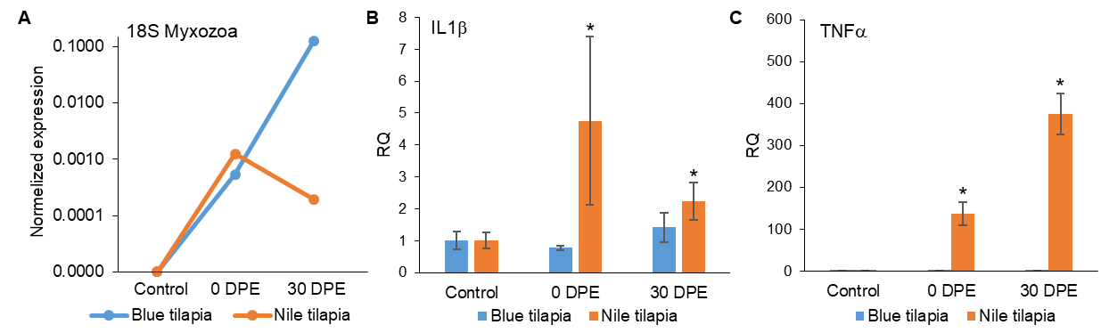

**Figure 3**. **qPCR determination of *M. bejeranoi* SSU rDNA and fish cytokines in infected blue and Nile tilapia relative to control uninfected fish**. The two species were exposed to the parasite for one week, and samples were collected at three time points: before exposure (control), 0 days post-exposure (dpe), and 30 dpe. RNA was extracted from sample gills, and cDNA was synthesized and tested by qPCR for myxozoan infection levels (A) and fish cytokines (B, C). **(A)** Infection levels of *M. bejeranoi* SSU rDNA. In control uninfected fish, the parasite was undetectable. Interestingly, the normalized expression levels were similar in blue and Nile tilapia at 0 dpe. However, at 30 dpe, the parasite increased in blue tilapia but decreased in Nile tilapia, indicating that Nile tilapia exhibits resistance to the infection. The y-axis is in logarithmic scale, indicating a near 1000-fold difference in amount. **(B)** IL1 cytokine relative quantification(RQ) shows significantly elevated expression of IL1β in Nile tilapia at 0 dpe. At 30 dpe, expression decreased but remained significantly greater than control uninfected Nile tilapia. There was no significant difference in IL1β expression between control and infected blue tilapia. **(C)** TNF RQin Nile tilapia was upregulated, increasing approximately 100-fold at 0 dpe and reaching 400-fold at 30 dpe compared to control uninfected fish. In contrast, the levels of TNFα in blue tilapia remained constant, similar to the control. The results were normalized to GAPDH in 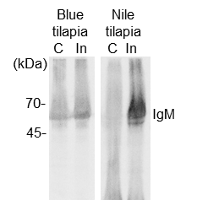tilapia. Experiments were performed with at least four biological replications, and the results are presented as the average fold change ± SE.

**Figure 4. Comparison of serum in blue and Nile tilapia before and after myxozoan infection.** Blue and Nile tilapia were exposed to the parasite for one week, and serum samples were collected before exposure (control) and 13 days post-exposure. Western blot analysis with specific antibodies against IgM of blue and Nile tilapia demonstrated that in blue tilapia, there was no change in the level of IgM. However, in Nile tilapia exposed to the parasite, there was a 25-fold increase in IgM. C- control, In- infected.

* 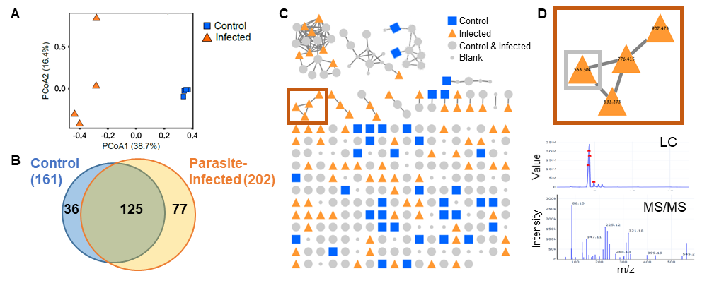**Metabolomic analysis of control and infected hybrid tilapia gills**. Samples were extracted with methanol and analyzed with LC-MS/MS. For feature detection and molecular networking, data were processed using the online GNPS interface with the classical and MolNetEnhancer workflows. Different types of metabolites were identified, including lipids, organic oxygen compounds, benzenoids, and nucleosides. We found distinct clusters of control and infected metabolites and 77 metabolites expressed uniquely in infected gills (**Fig. 5**).

**Figure 5. Characterizing disease-associated markers by LC-MS/MS-based metabolomics.** **(A)** PCA analysis of control healthy gills versus parasite-infected gills (*n*=4). **(B)** Venn diagram showing both common and specific metabolites in control and infected gills, indicating that specific metabolites are synthesized during infection. **(C)** Networking visualizes clusters of structurally related compounds (box), annotation, and differential abundance. **(D)** Characterization of selected compounds (boxed in (C) found only in infected samples. The LC and MS/MS spectra of a specific compound in D (lower panel).

* **Differential metabolomics analysis of serum in control and infected blue and Nile tilapia**. Serum samples were extracted with methanol and analyzed with LC-MS/MS. The data was analyzed using the GNPS online platform. Eight hundred ninety-one metabolites were detected in the four different samples, and the comparison of infection serums is shown (**Fig. 6)**.

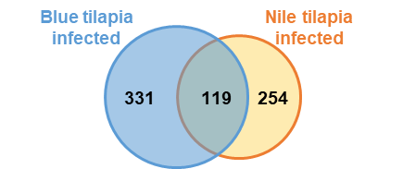**Figure 6.** **A sub-comparison between infected blue and Nile tilapia serums.** After removing shared metabolites with control fish serums (n=3), we identified 119 common metabolites in the two tilapia species. Interestingly, there were 331 and 254 unique metabolites expressed in infected blue and Nile tilapia serums, respectively. Among the unique metabolites, we expect to find potential signals for immune suppression or resistance. We will compare infected serum metabolites to those in gills and head kidneys to identify common metabolites unique to the infection stage and specific to either blue or Nile tilapia.

* 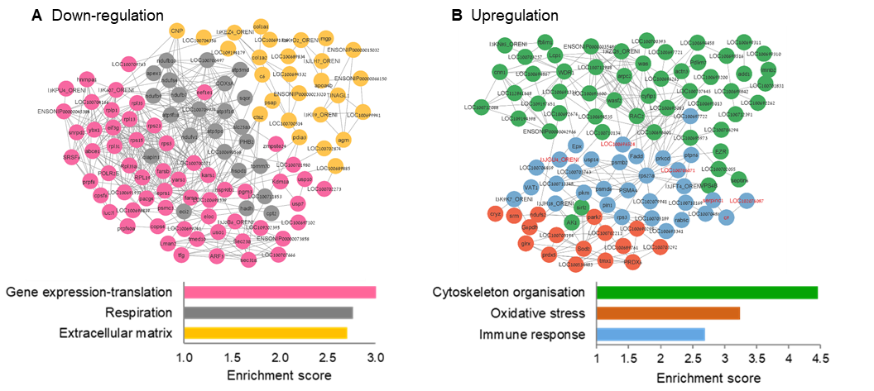**Proteomic profiling of control and infected gills of hybrid tilapia using host and parasite datasets.** Proteins from control and infected hybrid tilapia gills were extracted and analyzed for significant expression changes. In the infected gills compared to the controls, enriched down-regulated processes included ECM modification, respiration, and gene translation, while enriched upregulated processes included oxidation stress, immune response, and cytoskeleton organization (**Fig. 7**). Furthermore, **in the same infected gill samples, we analyzed *M. bejeranoi* proteins** using predicted proteins from our recent transcriptomic data. Among the top 30 highly expressed parasite protein groups (**Fig. 8**), we identified histones, known to be among the earliest genes expressed. Additionally, we detected cathepsins, enolase, and calreticulin as highly expressed proteins. These proteins also exhibited significant transcription levels in our transcriptomic analysis. Cathepsin, as suggested by us and others, may contribute to host tissue and extracellular matrix degradation. In contrast, enolase and calreticulin are known to be involved in host immune modulation in other parasite groups. **Our proteomic analysis demonstrates that host and parasite proteins can be obtained from the same tissue sample.**

**Figure 7. Network analysis for enriched processes in infected versus control uninfected gills.** We conducted a comparative proteomic profiling to identify changes in the proteome between infected and control gills. We analyzed proteomes of four replicates of control and infected gills. Selected enrichment results (FDR<0.05) of **(A)** down-regulated processes and **(B)** upregulated processes are shown. Key immune genes, including complement components, serpins, engulfment, and cell motility are highlighted in red. The protein network corresponding to the enriched process is color-coded, similar to the enriched graph.

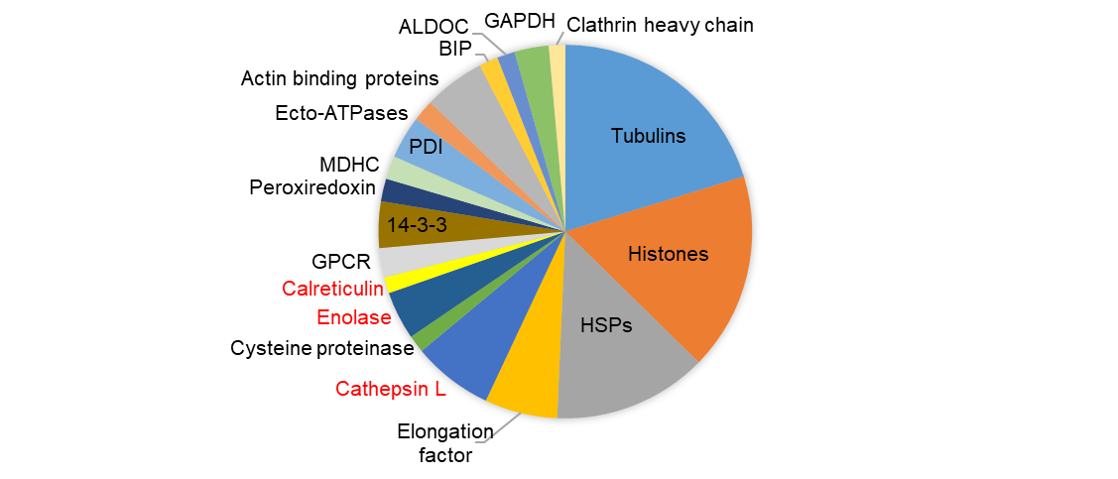**Figure 8. The 30 most expressed protein groups of *M. bejeranoi* in infected gills.** Note the abundance of housekeeping proteins such as tubulins, elongation factor, and histones, as well as heat shock proteins (HSP) and BIP that are molecular chaperons promoting protein maturation, structural maintenance, and regulation. Candidate proteins for host immune modification (red), specifically, calreticulin and enolase will be further targeted using MALDI imaging.

**Our combined transcriptomic, proteomic, and metabolomic studies will unveil enigmatic molecular events during myxozoan infection, provide a significant understanding of myxozoan adaptive evolutionary mechanisms, and offer insights for developing novel preventive measures against infection.**

* 1. **Feasibility, available resources, and expected pitfalls**

The feasibility of our proposed approach is well supported.

**1)** We have access to infectious myxozoan material and fish through our collaboration with the Central Fish Health Laboratory and the Dor Research Station (22,27,28,39) (see **Letter of Collaboration**).

**2)** We are experienced with transcriptomic and proteomic analyses, including profiling of myxozoan proteomes, and we have established a bioinformatics pipeline to combine the two datasets in collaboration with the University of Haifa Bioinformatic Unit (11,59,60,62) (see **Letter of Collaboration**).

**3)** We were recently awarded a large institutional VATAT grant to establish a metabolomics unit. This unit is already active and equipped with MALDI-TOF and LC-ESI-MS/MS for chemical and structural characterization and for imaging mass spectrometry of spatial patterns of molecules in the tissue section (see **Letter of Collaboration**).

**4)** The PI is highly experienced in the field of cnidarian biology, including ten years in leading biotech companies in the fields of healthcare and drug delivery (97-100) (see PI CV).

**5)** We are consulting with XXX, an expert in YYY (see **Letter of Collaboration**).

**6**) We have an ongoing collaboration with Prof. Bartholomew and Dr. Atkinson at Oregon State University, USA, who are experts on myxozoan molecular characterization (see **Letter of Collaboration**).

As in any scientific investigation, proposed experiments may take longer than expected, which we have addressed in relevant sections by proposing alternative approaches. Over the years and in our current ISF-funded project, we have gained considerable experience designing field experiments and collecting samples. Our current ISF research has already resulted in four publications, and another is in preparation. In addition, we propose techniques we are highly experienced with or have strong technical support. The metabolomic analysis of Aim 2 is the most challenging aspect of our proposal; however, we have gained experience with this method (see **Preliminary results**) and are supported by a leading expert in this field (see **Letter of Collaboration**). To mitigate risk, our three aims are interconnected but not interdependent. With each objective, we take a different approach to address the molecular mechanism underlying host-parasite interaction. Each Aim can be pursued independently, provide meaningful insight into our research questions, and may be published separately. However, combining the results of the three objectives will yield powerful and comprehensive novel insights into the molecular response to myxozoan infection.

My lab has the equipment and expertise required to execute the proposed project. The lab is equipped for biochemistry, cell biology, and molecular biology experiments, including RT-PCR, UPLC with a diode-array detector, autosampler and fraction collector, Zeiss fluorescence AxioImager M2 and Nikon AZ100 microscopes, NanoDrop, electrophoresis apparatus for DNA, RNA and protein separation, and other standard molecular biology equipment. We have dedicated cnidarian cultivation rooms, including cooled incubators, large, controlled aquarium tanks, and access to wild-caught material through the Marine School Diving Center. We also have access to SEM and TEM through the University of Haifa Electron Microscope Facility and the Bioinformatics Unit at Haifa University, including proteomic analysis software. In addition, we have access to wet laboratory facilities of the Central Health Fish Laboratory for fish infection experiments. Overall, these resources will allow my team to perform the proposed state-of-the-art research successfully.

**References**

1. Siddall, ME, Martin, DS, Bridge, D, Desser, SS, and Cone, DK. (1995) The demise of a phylum of Protists: phylogeny of Myxozoa and other parasitic Cnidaria. *J Parasitol* 81, 961-967

2. Chang, ES, Neuhof, M, Rubinstein, ND, Diamant, A, Philippe, H, Huchon, D, and Cartwright, P. (2015) Genomic insights into the evolutionary origin of Myxozoa within Cnidaria. *Proc Natl Acad Sci USA* 112, 14912-14917

3. Foox, J, and Siddall, ME. (2015) The road to Cnidaria: history of phylogeny of the Myxozoa. *J Parasitol* 101, 269-274

4. Holland, JW, Okamura, B, Hartikainen, H, and Secombes, CJ. (2010) A novel minicollagen gene links cnidarians and myxozoans. *Proc R Soc B* 278, 546-553

5. Jimenez-Guri, E, Philippe, H, Okamura, B, and Holland, PWH. (2007) *Buddenbrockia* is a cnidarian worm. *Science* 317, 116-118

6. Nesnidal, MP, Helmkampf, M, Bruchhaus, I, El-Matbouli, M, and Hausdorf, B. (2013) Agent of whirling disease meets orphan worm: phylogenomic analyses firmly place Myxozoa in Cnidaria. *PLoS One* 8, e54576

7. Atkinson, SD, Bartholomew, JL, and Lotan, T. (2018) Myxozoans: Ancient metazoan parasites find a home in phylum Cnidaria. *Zoology* 129, 66-68

8. Holzer, AS, Bartošova‐Sojkova, P, Born‐Torrijos, A, Lövy, A, Hartigan, A, and Fiala, I. (2018) The joint evolution of the Myxozoa and their alternate hosts: A cnidarian recipe for success and vast biodiversity. *Mol Ecol* 27, 1651–1666

9. Kodádková, A, Bartošová-Sojková, P, Holzer, AS, and Fiala, I. (2015) *Bipteria vetusta* n. sp. – an old parasite in an old host: tracing the origin of myxosporean parasitism in vertebrates. *Int J Parasitol* 45, 269-276

10. Shpirer, E, Chang, ES, Diamant, A, Rubinstein, N, Cartwright, P, and Huchon, D. (2014) Diversity and evolution of myxozoan minicollagens and nematogalectins. *BMC Evol Biol* 14, 205

11. Piriatinskiy, G, Atkinson, SD, Park, S, Morgenstern, D, Brekhman, V, Yossifon, G, Bartholomew, JL, and Lotan, T. (2017) Functional and proteomic analysis of *Ceratonova shasta* (Cnidaria: Myxozoa) polar capsules reveals adaptations to parasitism. *Sci Rep* 7, 9010

12. Lom, J, and Dykova, I. (1992) Myxosporidia (Phylum Myxozoa). *Protozoan Parasites of Fishes* 26, 159-235

13. Yang, Y, Xiong, J, Zhou, Z, Huo, F, Miao, W, Ran, C, Liu, Y, Zhang, J, Feng, J, Wang, M, Wang, M, Wang, L, and Yao, B. (2014) The genome of the Myxosporean *Thelohanellus kitauei* shows adaptations to nutrient acquisition within its fish host. *Genome Biol Evol* 6, 3182–3198

14. Eszterbauer, E, Atkinson, S, Diamant, A, Morris, D, El-Matbouli, M, and Hartikainen, H. (2015) Myxozoan life cycles: practical approaches and insights. in Myxozoan Evolution, Ecology and Development, Springer. pp 175-198

15. Wolf, K, and Markiw, ME. (1984) Biology contravenes taxonomy in the Myxozoa: new discoveries show alternation of invertebrate and vertebrate hosts. *Science* 225, 1449-1452

16. Kent, M, Margolis, L, and Corliss, J. (1994) The demise of a class of protists: taxonomic and nomenclatural revisions proposed for the protest phylum Myxozoa Grassé, 1970. *Can J of Zool* 72, 932-937

17. Okamura, B, Gruhl, A, and Bartholomew, JL. (2015) Myxozoan evolution, ecology and development, Springer, Switzerland

18. Diamant, A, Ram, S, and Paperna, I. (2006) Experimental transmission of *Enteromyxum leei* to freshwater fish. *Dis Aquat Organ* 72, 171-178

19. Katharios, P, Rigos, G, and Divanach, P. (2011) *Enteromyxum leei* (Myxozoa), a lethal intruder of tropical pet fish: first case in Humphead Wrasse, *Cheilinus undulatus* (Rüppell, 1835). *J Exot Pet Med* 20, 138-143

20. Diamant, A, Lo, J, and Dykova, I. (1994) *Myxidium leei n. sp.*, a pathogenic myxosporean of cultured sea bream *Sparus aurata*. *Dis Aquat Organ*  20, 137-141

21. Gupta, A, Haddas-Sasson, M, Gayer, K, and Huchon, D. (2022) Myxozoan infection in thinlip mullet Chelon ramada (Mugiliformes: Mugilidae) in the Sea of Galilee. *Sci Rep* 12

22. Lövy, A, Smirnov, M, Brekhman, V, Ofek, T, and Lotan, T. (2018) Morphological and molecular characterization of a novel myxosporean parasite *Myxobolus bejeranoi* n. sp.(Cnidaria: Myxosporea) from hybrid tilapia in Israel. *Parasitol Res* 117, 491–499

23. Anderson, JL, Asche, F, and Garlock, T. (2017) Globalization and commoditization: The transformation of the seafood market. *J Commod Mark*

24. Hulata, G (ed) (2014) Tilapias-biology and culture, Ma’arechet Publishing House, Israel

25. Zhang, Z-Q. (2013) Animal biodiversity: an update of classification and diversity in 2013. *Zootaxa* 3703, 5-11

26. Alama-Bermejo, G, and Holzer, AS. (2021) Advances and Discoveries in Myxozoan Genomics. *Trends Parasitol*, S1471-4922 (1421) 00013-00011

27. Maor-Landaw, K, Avidor, I, Rostowsky, N, Salti, B, Smirnov, M, Ofek-Lalzar, M, Levin, L, Brekhman, V, and Lotan, T. (2023) The molecular mechanisms employed by the parasite *Myxobolus bejeranoi* (Cnidaria: Myxozoa) from invasion through sporulation for successful proliferation in its fish host. *Int J Mol Sci* 24, 12824

28. Maor-Landaw, KS, M., Brekhman, V, Ofek-Lalzar, M, Yahav, T, and Lotan, T. (2022) Infection by the parasite *Myxobolus bejeranoi* (Cnidaria: Myxozoa) suppresses the immune system of Hybrid Tilapia. *Microorganisms* 10, 1893

29. Davey, GC, Calduch-Giner, JA, Houeix, B, Talbot, A, Sitjà-Bobadilla, A, Prunet, P, Pérez-Sánchez, J, and Cairns, MT. (2011) Molecular profiling of the gilthead sea bream (*Sparus aurata* L.) response to chronic exposure to the myxosporean parasite *Enteromyxum leei*. *Mol Immunol* 48, 2102-2112

30. Ronza, P, Robledo, D, Bermúdez, R, Losada, AP, Pardo, BG, Sitjà-Bobadilla, A, Quiroga, MI, and Martínez, P. (2016) RNA-seq analysis of early enteromyxosis in turbot (*Scophthalmus maximus*): new insights into parasite invasion and immune evasion strategies. *Int J Parasitol* 46, 507-517

31. Robledo, D, Ronza, P, Harrison, PW, Losada, AP, Bermúdez, R, Pardo, BG, José Redondo, M, Sitjà-Bobadilla, A, Quiroga, MI, and Martínez, P. (2014) RNA-seq analysis reveals significant transcriptome changes in turbot (*Scophthalmus maximus*) suffering severe enteromyxosis. *BMC Genom* 15, 1149

32. Gorgoglione, B, Wang, T, Secombes, CJ, and Holland, JW. (2013) Immune gene expression profiling of proliferative kidney disease in rainbow trout *Oncorhynchus mykiss* reveals a dominance of anti-inflammatory, antibody and T helper cell-like activities. *Vet Res* 44, 55

33. Barrett, DE, and Bartholomew, JL. (2021) A tale of two fish: Comparative transcriptomics of resistant and susceptible steelhead following exposure to Ceratonova shasta highlights differences in parasite recognition. *PLoS One* 16, e0234837

34. Sudhagar, A, Ertl, R, Kumar, G, and El-Matbouli, M. (2019) Transcriptome profiling of posterior kidney of brown trout, *Salmo trutta*, during proliferative kidney disease. *Parasit Vectors* 12, 569

35. Zhao, Y, Weng, M, Zhang, Q, Li, A, and Zhang, J. (2021) Transcriptomics analysis of the infected tissue of gibel carp (Carassius auratus gibelio) with liver myxobolosis infers the underlying defense mechanisms from the perspective of immune-metabolic interactions. *Aquaculture* 542, 736867

36. Bailey, C, Strepparava, N, Wahli, T, and Segner, H. (2019) Exploring the immune response, tolerance and resistance in proliferative kidney disease of salmonids. *Dev Comp Immunol* 90, 165-175

37. Piazzon, MC, Estensoro, I, Calduch-Giner, JA, Del Pozo, R, Picard-Sánchez, A, Pérez-Sánchez, J, and Sitjà-Bobadilla, A. (2018) Hints on T cell responses in a fish-parasite model: Enteromyxum leei induces differential expression of T cell signature molecules depending on the organ and the infection status. *Parasit Vectors* 11

38. Faber, M, Shaw, S, Yoon, S, De Paiva Alves, E, Wang, B, Qi, Z, Okamura, B, Hartikainen, H, Secombes, CJ, and Holland, JW. (2021) Comparative transcriptomics and host-specific parasite gene expression profiles inform on drivers of proliferative kidney disease. *Sci Rep* 11

39. Maor-Landaw, K, Avidor, I, Salti, B, Smirnov, M, Brekhman, V, and Lotan, T. (2023) The myxozoan parasite Myxobolus bejeranoi (Cnidaria: Myxozoa) infection dynamics and host specificity in hybrid tilapia aquaculture. *Parasitology*, 1-28

40. Liu, X, and Locasale, JW. (2017) Metabolomics: A Primer. *Trends Biochem Sci* 42, 274-284

41. Bauermeister, A, Mannochio-Russo, H, Costa-Lotufo, LV, Jarmusch, AK, and Dorrestein, PC. (2022) Mass spectrometry-based metabolomics in microbiome investigations. *Nat Rev Microbiol* 20, 143-160

42. Gonzalez-Covarrubias, V, Martínez-Martínez, E, and Del Bosque-Plata, L. (2022) The Potential of Metabolomics in Biomedical Applications. *Metabolites* 12, 194

43. Chapman, NM, and Chi, H. (2022) Metabolic adaptation of lymphocytes in immunity and disease. *Immunity* 55, 14-30

44. Lercher, A, Baazim, H, and Bergthaler, A. (2020) Systemic Immunometabolism: Challenges and Opportunities. *Immunity* 53, 496-509

45. Alfaro, AC, and Young, T. (2018) Showcasing metabolomic applications in aquaculture: a review. *Rev Aquac* 10, 135-152

46. Lulijwa, R, Alfaro, AC, and Young, T. (2022) Metabolomics in salmonid aquaculture research: Applications and future perspectives. *Rev Aquac* 14, 547-577

47. Olson, WJ, Martorelli Di Genova, B, Gallego-Lopez, G, Dawson, AR, Stevenson, D, Amador-Noguez, D, and Knoll, LJ. (2020) Dual metabolomic profiling uncovers Toxoplasma manipulation of the host metabolome and the discovery of a novel parasite metabolic capability. *PLOS Pathogens* 16, e1008432

48. Cordy, JR. (2020) Mining the human host metabolome toward an improved understanding of malaria transmission. *Front Microbiol* 11, 164

49. Kokova, D, and Mayboroda, OA. (2019) Twenty years on: Metabolomics in helminth research. *Trends Parasitol* 35, 282-288

50. Sitjà-Bobadilla, A, Gil-Solsona, R, Estensoro, I, Piazzon, MC, Martos-Sitcha, JA, Picard-Sánchez, A, Fuentes, J, Sancho, JV, Calduch-Giner, JA, Hernández, F, and Pérez-Sánchez, J. (2019) Disruption of gut integrity and permeability contributes to enteritis in a fish-parasite model: a story told from serum metabolomics. *Parasit Vectors* 12

51. Kodama, H, Otani, K, Iwasaki, T, Takenaka, S, Horitani, Y, and Togase, H. (2014) Metabolomic investigation of pathogenesis of myxosporean emaciation disease of tiger puffer fish T*akifugu rubripes*. *J Fish Dis* 37, 619-627

52. Bian, C, Li, J, Lin, X, Chen, X, Yi, Y, You, X, Zhang, Y, Lv, Y, and Shi, Q. (2019) Whole genome sequencing of the Blue Tilapia (Oreochromis aureus)provides a valuable genetic resource for biomedical research on Tilapias. *Mar Drugs* 17, 386

53. Tao, W, Xu, L, Zhao, L, Zhu, Z, Wu, X, Min, Q, Wang, D, and Zhou, Q. (2021) High‐quality chromosome‐level genomes of two tilapia species reveal their evolution of repeat sequences and sex chromosomes. *Mol Ecol Resour* 21, 543-560

54. Qin, H, Yu, Z, Zhu, Z, Lin, Y, Xia, J, and Jia, Y. (2022) The integrated analyses of metabolomics and transcriptomics in gill of GIFT tilapia in response to long term salinity challenge. *Aquac Fish* 7, 131-139

55. Swearingen, KE, and Lindner, SE. (2018) Plasmodium parasites viewed through proteomics. *Trends Parasitol* 34, 945-960

56. Reverter, M, Sasal, P, Banaigs, B, Lecchini, D, and Tapissier-Bontemps, N. (2022) Butterflyfish gill mucus metabolome reflects diet preferences and gill parasite intensities. in Applied Environmental Metabolomics, Elsevier. pp 183-198

57. Kumar, G, Shivam, S, Sudhagar, A, Saravanan, K, Sathish Kumar, T, and El-Matbouli, M. (2023) Chapter 18 - Proteomic approaches and their applications in salmonid health research. in Frontiers in Aquaculture Biotechnology(Lakra, WS, Goswami, M, and Trudeau, VL eds.), Academic Press. pp 249-257

58. Bateman, NW, and Conrads, TP. (2018) Recent advances and opportunities in proteomic analyses of tumour heterogeneity. *J Pathol* 244, 628-637

59. Levitan, S, Sher, N, Brekhman, V, Ziv, T, Lubzens, E, and Lotan, T. (2015) The making of an embryo in a basal metazoan: Proteomic analysis in the sea anemone *Nematostella vectensis*. *Proteomics* 15, 4096-4104

60. Rachamim, T, Morgenstern, D, Aharonovich, D, Brekhman, V, Lotan, T, and Sher, D. (2015) The dynamically evolving nematocyst content of an Anthozoan, a Scyphozoan, and a Hydrozoan. *Mol Biol Evol* 32, 740-753

61. Brekhman, V, Malik, A, Haas, B, Sher, N, and Lotan, T. (2015) Transcriptome profiling of the dynamic life cycle of the scypohozoan jellyfish *Aurelia aurita*. *BMC Genom* 16, 1-15

62. Brekhman, V, Ofek-Lalzar, M, Atkinson, SD, Alama-Bermejo, G, Maor-Landaw, K, Malik, A, Bartholomew, JL, and Lotan, T. (2021) Proteomic analysis of the parasitic cnidarian *Ceratonova shasta* (Cnidaria: Myxozoa) reveals diverse roles of actin in motility and spore formation. *Front Mar Sci* 8, 632700

63. Levy, S, Brekhman, V, Bakhman, A, Malik, A, Sebé-Pedrós, A, Kosloff, M, and Lotan, T. (2021) Ectopic activation of GABA B receptors inhibits neurogenesis and metamorphosis in the cnidarian *Nematostella vectensis*. *Nature Ecology & Evolution* 5, 111-121

64. Reuven, S, Rinsky, M, Brekhman, V, Malik, A, Levy, O, and Lotan, T. (2021) Cellular pathways during spawning induction in the starlet sea anemone *Nematostella vectensis*. *Sci Rep* 11

65. Shivam, S, Ertl, R, Sexl, V, El-Matbouli, M, and Kumar, G. (2023) Differentially expressed transcripts of Tetracapsuloides bryosalmonae (Cnidaria) between carrier and dead-end hosts involved in key biological processes: novel insights from a coupled approach of FACS and RNA sequencing. *Vet Res* 54

66. Dobin, A, Davis, CA, Schlesinger, F, Drenkow, J, Zaleski, C, Jha, S, Batut, P, Chaisson, M, and Gingeras, TR. (2013) STAR: ultrafast universal RNA-seq aligner. *Bioinformatics* 29, 15-21

67. Cox, J, and Mann, M. (2008) MaxQuant enables high peptide identification rates, individualized ppb-range mass accuracies and proteome-wide protein quantification. *Nat Biotechnol* 26, 1367

68. Marín-Juez, R, Jong-Raadsen, S, Yang, S, and Spaink, HP. (2014) Hyperinsulinemia induces insulin resistance and immune suppression via Ptpn6/Shp1 in zebrafish. *J Endocrinol* 222, 229-241

69. Yada, T, and Nakanishi, T. (2002) Interaction between endocrine and immune systems in fish. *Int rev cyt* 220, 35-92

70. Zhou, Y, Yu, W, Zhong, H, Li, J, Li, H, He, F, Zhou, J, Tang, Y, Yu, J, and Yu, F. (2016) Transcriptome analysis reveals that insulin is an immunomodulatory hormone in common carp. *Fish Shellfish Immunol* 59, 213-219

71. Garg, N, Luzzatto-Knaan, T, Melnik, AV, Caraballo-Rodríguez, AM, Floros, DJ, Petras, D, Gregor, R, Dorrestein, PC, and Phelan, VV. (2017) Natural products as mediators of disease. *Nat Prod Rep* 34, 194-219

72. Low, C-F, Rozaini, MZH, Musa, N, and Syarul Nataqain, B. (2017) Current knowledge of metabolomic approach in infectious fish disease studies. *J Fish Dis* 40, 1267-1277

73. Lulijwa, R, Alfaro, AC, Merien, F, Meyer, J, and Young, T. (2019) Advances in salmonid fish immunology: A review of methods and techniques for lymphoid tissue and peripheral blood leucocyte isolation and application. *Fish Shellfish Immunol* 95, 44-80

74. Lazado, CC, Breiland, MW, Furtado, F, Burgerhout, E, and Strand, D. (2022) The circulating plasma metabolome of *Neoparamoeba perurans*-infected Atlantic salmon (*Salmo salar*). *Microb Pathog* 166, 105553

75. Maha, IF, Xie, X, Zhou, S, Yu, Y, Liu, X, Zahid, A, Lei, Y, Ma, R, Yin, F, and Qian, D. (2019) Skin metabolome reveals immune responses in yellow drum *Nibea albiflora* to Cryptocaryon irritans infection. *Fish Shellfish Immunol* 94, 661-674

76. Peng, B, Li, H, and Peng, X-X. (2015) Functional metabolomics: from biomarker discovery to metabolome reprogramming. *Protein Cell* 6, 628-637

77. Luzzatto-Knaan, T, Melnik, AV, and Dorrestein, PC. (2015) Mass spectrometry tools and workflows for revealing microbial chemistry. *Analyst* 140, 4949-4966

78. Kang, J, David, L, Li, Y, Cang, J, and Chen, S. (2021) Three-in-one simultaneous extraction of proteins, metabolites and lipids for multi-omics. *Front Genet* 12

79. Wang, M, Carver, JJ, Phelan, VV, Sanchez, LM, Garg, N, Peng, Y, Nguyen, DD, Watrous, J, Kapono, CA, Luzzatto-Knaan, T, Porto, C, Bouslimani, A, Melnik, AV, Meehan, MJ, Liu, W-T, Crüsemann, M, Boudreau, PD, Esquenazi, E, Sandoval-Calderón, M, Kersten, RD, Pace, LA, Quinn, RA, Duncan, KR, Hsu, C-C, Floros, DJ, Gavilan, RG, Kleigrewe, K, Northen, T, Dutton, RJ, Parrot, D, Carlson, EE, Aigle, B, Michelsen, CF, Jelsbak, L, Sohlenkamp, C, Pevzner, P, Edlund, A, Mclean, J, Piel, J, Murphy, BT, Gerwick, L, Liaw, C-C, Yang, Y-L, Humpf, H-U, Maansson, M, Keyzers, RA, Sims, AC, Johnson, AR, Sidebottom, AM, Sedio, BE, Klitgaard, A, Larson, CB, Boya P, CA, Torres-Mendoza, D, Gonzalez, DJ, Silva, DB, Marques, LM, Demarque, DP, Pociute, E, O’Neill, EC, Briand, E, Helfrich, EJN, Granatosky, EA, Glukhov, E, Ryffel, F, Houson, H, Mohimani, H, Kharbush, JJ, Zeng, Y, Vorholt, JA, Kurita, KL, Charusanti, P, Mcphail, KL, Nielsen, KF, Vuong, L, Elfeki, M, Traxler, MF, Engene, N, Koyama, N, Vining, OB, Baric, R, Silva, RR, Mascuch, SJ, Tomasi, S, Jenkins, S, Macherla, V, Hoffman, T, Agarwal, V, Williams, PG, Dai, J, Neupane, R, Gurr, J, Rodríguez, AMC, Lamsa, A, Zhang, C, Dorrestein, K, Duggan, BM, Almaliti, J, Allard, P-M, Phapale, P, Nothias, L-F, Alexandrov, T, Litaudon, M, Wolfender, J-L, Kyle, JE, Metz, TO, Peryea, T, Nguyen, D-T, Vanleer, D, Shinn, P, Jadhav, A, Müller, R, Waters, KM, Shi, W, Liu, X, Zhang, L, Knight, R, Jensen, PR, Palsson, BØ, Pogliano, K, Linington, RG, Gutiérrez, M, Lopes, NP, Gerwick, WH, Moore, BS, Dorrestein, PC, and Bandeira, N. (2016) Sharing and community curation of mass spectrometry data with Global Natural Products Social Molecular Networking. *Nat Biotechnol* 34, 828-837

80. Luzzatto-Knaan, T, Garg, N, Wang, M, Glukhov, E, Peng, Y, Ackermann, G, Amir, A, Duggan, BM, Ryazanov, S, Gerwick, L, Knight, R, Alexandrov, T, Bandeira, N, Gerwick, WH, and Dorrestein, PC. (2017) Digitizing mass spectrometry data to explore the chemical diversity and distribution of marine cyanobacteria and algae. *eLife* 6

81. Pluskal, T, Castillo, S, Villar-Briones, A, and Orešič, M. (2010) MZmine 2: Modular framework for processing, visualizing, and analyzing mass spectrometry-based molecular profile data. *BMC Bioinform* 11, 395

82. Picard, M, Scott-Boyer, M-P, Bodein, A, Périn, O, and Droit, A. (2021) Integration strategies of multi-omics data for machine learning analysis. *Comput Struct Biotechnol J* 19, 3735-3746

83. Peng, H, Long, F, and Ding, C. (2005) Feature selection based on mutual information criteria of max-dependency, max-relevance, and min-redundancy. *IEEE Trans Pattern Anal Mach Intell* 27, 1226-1238

84. Li, Y, Mansmann, U, Du, S, and Hornung, R. (2022) Benchmark study of feature selection strategies for multi-omics data. *BMC Bioinformatics* 23, 1-18

85. Cantini, L, Zakeri, P, Hernandez, C, Naldi, A, Thieffry, D, Remy, E, and Baudot, A. (2021) Benchmarking joint multi-omics dimensionality reduction approaches for the study of cancer. *Nature Communications* 12

86. Lovino, M, Randazzo, V, Ciravegna, G, Barbiero, P, Ficarra, E, and Cirrincione, G. (2022) A survey on data integration for multi-omics sample clustering. *Neurocomputing* 488, 494-508

87. Yang, JY, Phelan, VV, Simkovsky, R, Watrous, JD, Trial, RM, Fleming, TC, Wenter, R, Moore, BS, Golden, SS, and Pogliano, K. (2012) Primer on agar-based microbial imaging mass spectrometry. *J Bacteriol* 194, 6023-6028

88. Garg, N, Zeng, Y, Edlund, A, Melnik, AV, Sanchez, LM, Mohimani, H, Gurevich, A, Miao, V, Schiffler, S, and Lim, YW. (2016) Spatial molecular architecture of the microbial community of a *Peltigera lichen*. *Msystems* 1, e00139-00116

89. Fujimura, Y, and Miura, D. (2014) MALDI Mass Spectrometry imaging for visualizing In situ metabolism of endogenous metabolites and dietary phytochemicals. *Metabolites* 4, 319-346

90. Yang, J, and Caprioli, RM. (2014) Matrix pre-coated targets for high throughput MALDI imaging of proteins. *J Mass Spectrom* 49, 417-422

91. Ye, H, Greer, T, and Li, L. (2012) Probing neuropeptide signaling at the organ and cellular domains via imaging mass spectrometry. *J Proteomics* 75, 5014-5026

92. Devaux, S, Cizkova, D, Quanico, J, Franck, J, Nataf, S, Pays, L, Hauberg-Lotte, L, Maass, P, Kobarg, JH, Kobeissy, F, Mériaux, C, Wisztorski, M, Slovinska, L, Blasko, J, Cigankova, V, Fournier, I, and Salzet, M. (2016) Proteomic Analysis of the Spatio-temporal Based Molecular Kinetics of Acute Spinal Cord Injury Identifies a Time- and Segment-specific Window for Effective Tissue Repair. *Mol Cell Proteomics* 15, 2641-2670

93. Bottek, J, Soun, C, Lill, JK, Dixit, A, Thiebes, S, Beerlage, A-L, Horstmann, M, Urbanek, A, Heuer, H, Uszkoreit, J, Eisenacher, M, Bracht, T, Sitek, B, Hoffmann, F, Vijitha, N, Von Eggeling, F, and Engel, DR. (2020) Spatial proteomics revealed a CX3CL1-dependent cross-talk between the urothelium and relocated macrophages through IL-6 during an acute bacterial infection in the urinary bladder. *Mucosal Immunol* 13, 702-714

94. Luzzatto-Knaan, T, Melnik, AV, and Dorrestein, PC. (2019) Mass spectrometry uncovers the role of surfactin as an interspecies recruitment factor. *ACS Chem Biol* 14, 459-467

95. Agron, M, Brekhman, V, Morgenstern, D, and Lotan, T. (2017) Regulation of AP-1 by MAPK signaling in metal-stressed sea anemone. *Cell Physiol Biochem* 42, 952-964

96. Wang, O, Chin, R, Cheng, X, Wu, MKY, Mao, Q, Tang, J, Sun, Y, Anderson, E, Lam, HK, Chen, D, Zhou, Y, Wang, L, Fan, F, Zou, Y, Xie, Y, Zhang, RY, Drmanac, S, Nguyen, D, Xu, C, Villarosa, C, Gablenz, S, Barua, N, Nguyen, S, Tian, W, Liu, JS, Wang, J, Liu, X, Qi, X, Chen, A, Wang, H, Dong, Y, Zhang, W, Alexeev, A, Yang, H, Wang, J, Kristiansen, K, Xu, X, Drmanac, R, and Peters, BA. (2019) Efficient and unique cobarcoding of second-generation sequencing reads from long DNA molecules enabling cost-effective and accurate sequencing, haplotyping, and de novo assembly. *Genome Res* 29, 798-808

97. Ayalon, A, Shichor, I, Tal, Y, and Lotan, T. (2011) Immediate topical drug delivery by natural submicron injectors. *Int J Pharm* 419, 147-153

98. Lotan, T. (2016) Leveraging nematocysts toward Human care. in The Cnidaria, Past, Present and Future, Springer. pp 683-690

99. Shaoul, E, Ayalon, A, Tal, Y, and Lotan, T. (2012) Transdermal delivery of scopolamine by natural submicron injectors: in-vivo study in pig. *PLoS One* 7, e31922

100. Tal, Y, Ayalon, A, Sharaev, A, Kazir, Z, Brekhman, V, and Lotan, T. (2014) Continuous drug release by sea anemone *Nematostella vectensis* stinging microcapsules. *Mar Drugs* 12, 734-745