Exelot - Exit-Valley Campaign
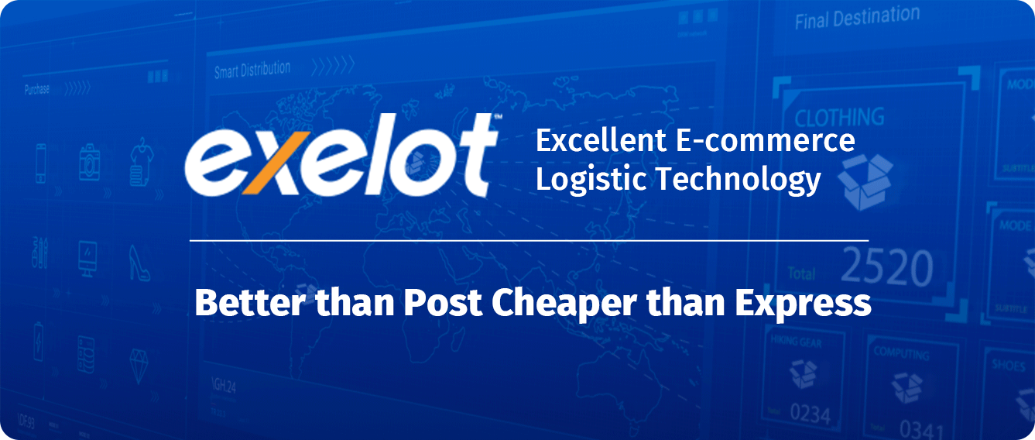

- Exelot has developed a pioneering digital platform (SaaS) for shipping and delivering e-commerce products to cross-border markets.
- The Exelot platform serves e-commerce marketplaces, online retailers and forwarders, making the logistic chain quick, reliable and affordable.
- The Exelot team is highly experienced; the company is growing 200%-300% YoY and penetrating a rapidly growing market, valued at $60 billion.

Campaign highlights

A breakthrough global shipping technology
The international shipping market often faces a “bottleneck” in the form of outdated, slow postal services or overpriced shipping services, which make purchasing less attractive for buyers, and do not offer a suitable solution for sellers. Exelot disrupts this market by offering online platforms and e-commerce stores a service which is faster and more reliable than postal services. Furthermore, it is far more affordable than express rates. The platform developed by the company offers a first-of-its-kind system, specializing in cross-border B2B2C shipping, and offering a far superior alternative, both tech-wise and financially, in the market niche between postal services and express companies (such as Fedex, UPS and DHL).

Answering the needs of a huge and fast-growing market
Throughout the world, online purchasing is rapidly taking the place of physical store sales. This global shipping market, estimated at around 60 billion dollars in 2019, is growing at an exponential rate each year. Purchasing online from foreign countries grew from 44% in 2014 to 77% by 2018. This growth is expected to continue over the next decade and render Exelot’s unique technological solution attractive for both e-commerce sites and logistics suppliers, as well as giant companies in the fields of shipping and e-commerce, who are searching for advanced logistical tech solutions.

An end-to-end logistic solution
The uniqueness of Exelot’s system lies in offering an innovative digital solution, within one platform, for everystep of the international logistics chain. The platform supports: pick-ups, smart consolidations, AI and machine learning technologies for optimization, and a smart multi-vendor based method. The platform combines shipping options via land, air and sea, and provides support for every step of the shipping process, from pick-up at warehouses, to terminals, customs clearance and especially distribution, delivery and tracking. In this way, Exelot provides e-commerce marketplaces and e-retailers with a complete solution, helping them to avoid wasting time and money on logistics, as well as increase their sales in new target countries.

Investing in an already operational, fast-growing company
Since its establishment, Exelot has shown a growing rate of x 2.5 – x 4 every year, in the scope of sales and shipments carried out by the platform. Its activity grew from 500 shipments a month in March 2017, to a monthly volume of over 50,000 shipments in the summer of 2018 and is expected to reach over 500,000 annual shipments by the end of 2019. The company provides services through its platform to AliExpress suppliers and other small-mid marketplaces, e-retailers and forwarders from China and Hong Kong directly to Israel. It currently serves 18 e-commerce sites, both directly and via a frontal boned-hub in Cyprus. Exelot currently aims at extending its activity to other countries, including: Greece and the Balkans, Romania, Italy, Sweden, Denmark, Ukraine and Belarus. In 2020, the company will also enter additional countries in Europe, the US, parts of East Asia and Africa.

IP with great potential for value increases, leading the global B2C shipping market for e-commerce
The logistics market is considered technologically conservative. Exelot’s technology has large-scale benefits in this field for users of the system, from sellers and shippers, to forwarders, customs brokers or logistics warehouses. Exelot’s technology addresses an ecosystem characterized by a great need for investments, mergers and acquisitions. It is expected to appeal to various segments of the logistics, shipping, e-commerce and software markets. This might include marketplaces such as Alibaba, JD or Wish of China, Amazon, eBay, Lazada, the Indian FlipKart, etc., as well as service platforms for e-commerce sites such as Shopify, Magento, Shopware and others, plus software giants including SAP and Salesforce. Furthermore, major maritime shipping players have recently started to develop their international e-commerce shipping, after realizing the huge market potential of e-commerce, especially with the expected rise in the shipping of larger and heavier products by sea freight.

A team of experts in the fields of shipping, logistics and e-commerce
The company is comprised of an experienced and solid team led by CEO Daniel Cohen. Daniel has vast experience in business development, marketing and sales, in high-tech and commercial companies (LocatioNet, Aerialink, Mey-Eden and others). Daniel served as the VP of Business Development and Strategy for the Israel Post. He has worked extensively with overseas markets, including Europe, Asia and the US, and on innovative technological projects overseas. Exelot’s Director of Technology (CTO), Yitzhak Varsanno, served as Chief Programmer at "MAANA" in the IDF (formerly part of Mamram) and has contributed to the success of both large companies (Partner, Applied Materials) and start-ups. Eli Koretsky, Exelot’s Business Development and Sales Manager for China, has 10 years’ experience in logistics dealing with China and has served as the Israeli market manager for the Chinese Alibaba/AliExpress group. The company’s Distribution and Customer Service Manager has extensive experience in distribution and customer services, including FedEx. Mariano Ptacsinsky, the CFO, has many years’ experience in large financial companies, securities, and financing IT and international projects, including Peninsula and Leumi Card in Israel.

The need

In recent years, online shopping has increasingly replaced physical sales in stores, and the volume of e-commerce shipments has grown accordingly. In Israel, for instance, existing fashion store chains have sustained a significant decrease in business, due to the increasing number of fashion shipments ordered online from overseas. American fashion giant GAP will soon recommence its operation in Israel, but this time not by opening stores - a model that has previously failed for the brand in the local market - but exclusively through an e-commerce website. This choice reflects just how much the future of commerce lies in online shopping and is in fact dependent on logistics and shipping services.
Nevertheless, over 90% of e-commerce shipments are still distributed worldwide via old-fashioned postal services, most of which are characterized, as anyone who has ever shopped online knows, with inefficiency, poor speed and relatively low credibility, with many shipments falling “between the cracks”, generating financial damages or lack of potential income for sellers, and of course, dissatisfaction and lack of trust among end users, which jeopardizes future sales.
In Israel, for example, in a damning report issued by the State Comptroller, around 80% of the people surveyed claimed to have experienced some kind of loss or damages due to the poor functioning of the postal service. Another report by the Universal Postal Union (UPU), from 2018, cited a greater figure of 25% of all customers, who demand better shipping times.
The frustration expressed by both sellers and buyers seems to be justified: currently, transfer times for deliveries via postal services range from 10-30 days, sometimes longer, with low satisfaction rates among both shippers and customers, of which – according to postal sector inquiries - a third has complained about the shipping time frames, delivery methods, and limited or non-existent tracking options.
E-commerce retailers suffer from this reality and would like to shorten delivery times between countries as much as possible, to an ideal standard of 4-7 days per shipment - including flights, customs handling and distribution. Various express service shippers offer a fast 3-7 day delivery service, but usually at a very high cost, which often exceeds the price of the product itself, decreasing affordability.
In addition, the logistics market suffers from outdated, old-fashioned technological systems, which are mainly suitable for the B2B market, but not developed enough to meet the needs of the B2C market. These systems rely on the use of printed shipping documents, do not allow for proper tracking of the entire logistics chain, and require manual handling, with high VAT and customs duties when transporting products across borders.

. Fix the headline of the slide below – Domestic delivery vs. international experience

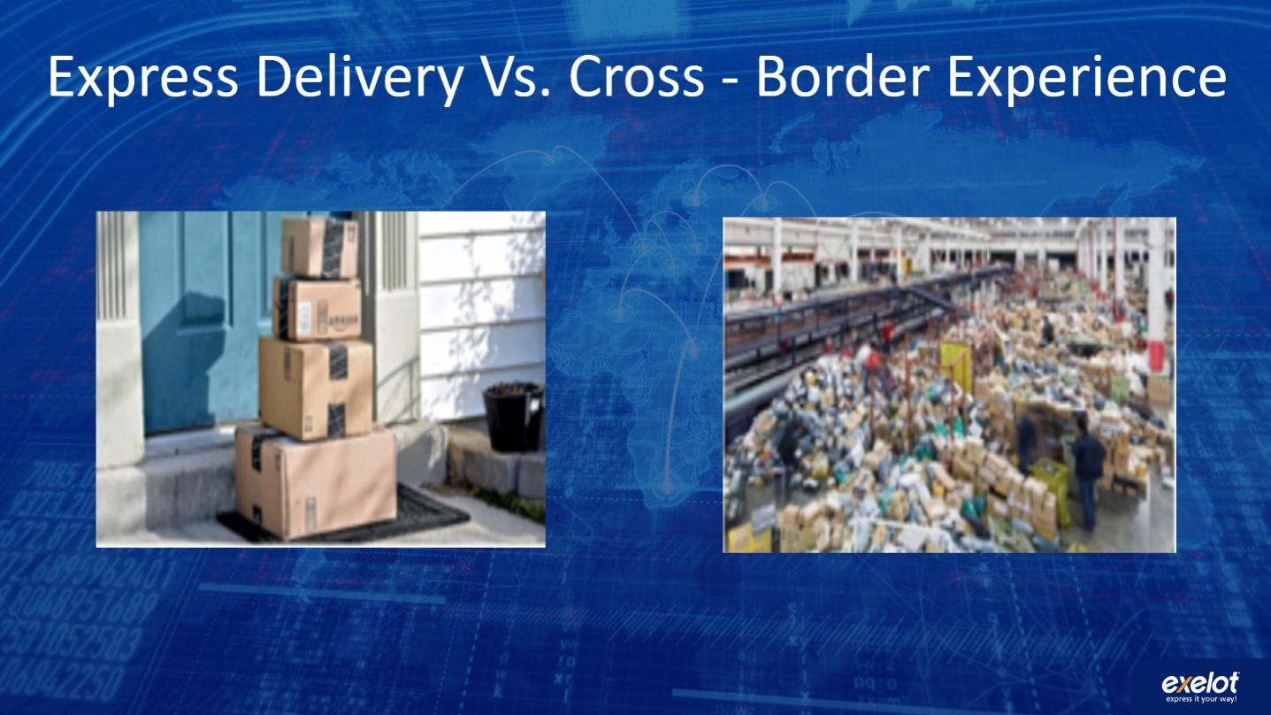
The solution
Exelot provides a system which answers a significant market need for a smart and advanced logistics platform enabling cross-border e-commerce shipments, through a model based on multiple logistics service suppliers. The development includes the combination of a comparison tool for shipping and delivery options, optimization algorithms for service providers, and measurements of suppliers’ performance, in order to improve efficiency and service times. These factors and algo-calculations lower the costs in general, as reflected in the rising volume of shipments controlled by the Exelot system.
How does it work?
Exelot’s system is based on its proprietary: it is a fully independently developed digital platform. In order to provide its service, Exelot does not rely on solutions offered by the postal sector or express shipping companies (Fedex, UPS, DHL), but instead supplies sellers with a premium private route. For this purpose, it cooperates with private suppliers throughout the entire logistics chain, including airlines, logistics warehouses, forwarders, customs brokers, and delivery companies in the last mile. Thus, Exelot takes advantage of the worldwide demand among suppliers for additional logistics and offers full flexibility in its performance and capacities; it improves the flow of data to and from sellers, and dramatically increases the speed and reliability of the entire service, as well as tracking abilities and total shipment costs.
The Exelot system also gathers information regarding the product’s various data, automatically calculates VAT additions in various destination countries, and allows for automatic billing without the need for telephone calls and manual billing. The system also supports product return-to-supplier processes, and even the returned product’s destruction, when necessary.
Exelot supplies e-commerce platforms and the rest of its clients with accessible, reliable online information, and allows for the tracking of every shipment on all levels, including all of the package information, and tax or VAT payments for billing, as well as various logistical reports.

Flow chart - A shipment’s journey on the Exelot system:
צריך לתקן את המלל בתוך הסלייד – שפה לא מתאימה – לדוגמא client buy a product... להחליף ל Order created
אחכ 2-מספיק Pick & Pack, 3 –בסדר, 4 – Air/Ocean Freight, 5 – Bonded facility 6- בסדר, 7- בסדר, 8 - Delivery,
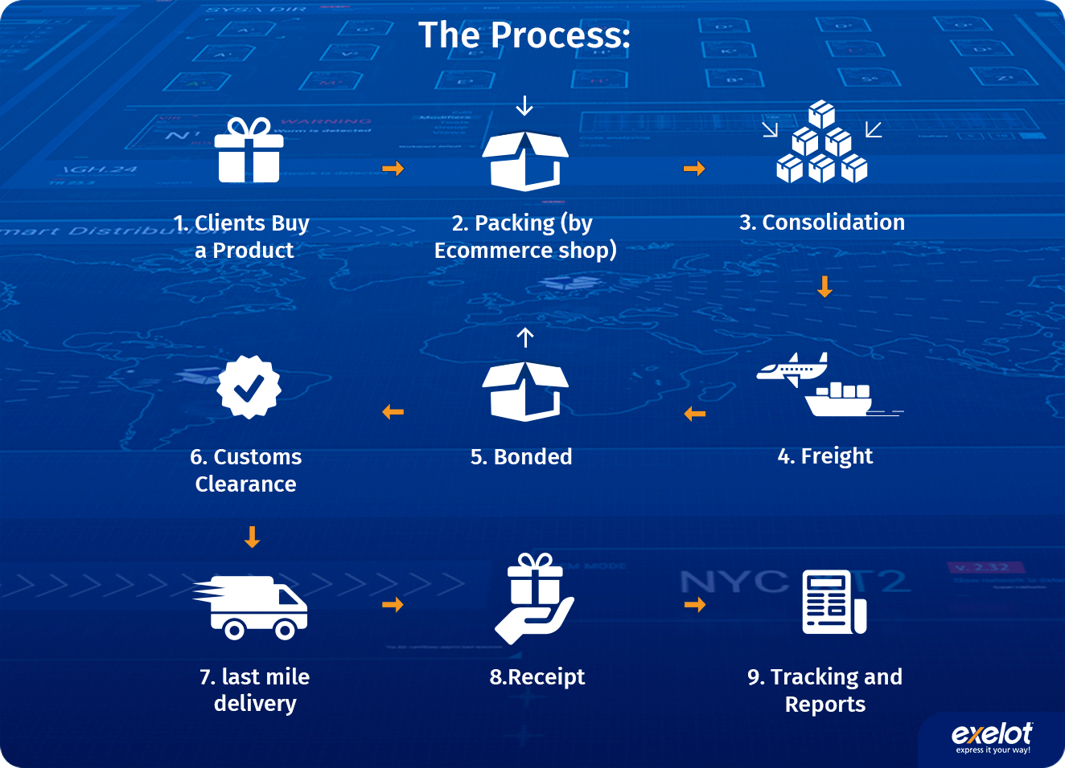
Exelot’s system creates a market niche which allows for much faster and more reliable shipment than postal services, while ensuring significantly lower costs compared to express rates. The platform represents a major improvement in the end customer’s satisfaction rate, in transit times and tracking, and accordingly helps sellers to generate more sales in additional target countries. Exelot also speeds up the process for customs brokers and forwarders, allowing them to manage billing and shipments digitally.
The world of e-commerce is gradually expanding in scale in terms of shipping and delivery, involving larger and heavier products, and Exelot already offers a complete solution for the shipping of such packages, with a combination of shipping methods over land, air and sea (soon, trains will be added) and between front bonded processing warehouses in various destination countries.
Furthermore, when autonomous vehicles and drones enter the shipping market, Exelot will be ready to offer these services to customers in locations where such means are authorized for e-commerce shipping purposes.

The technology

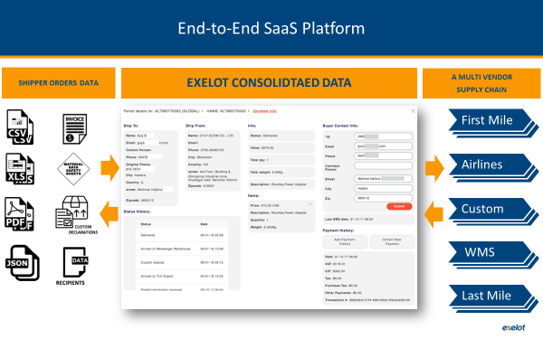
The company has developed a cloud-based SaaS platform, which is connected to e-commerce marketplaces, e-retailers, or logistical companies who serve them. The system handles packages from the moment an order is placed by the end user. With regard to the seller’s warehouse, the system manages and tracks each step of the package’s logistics chain. For sorting according to the shipping method, destination country, and suitable means of distribution (such as shipping from door to door, or to distribution centers, or automated pick-up locations), while also using the package value for customs declarations such as VAT payments, adjusting the shipment in that regard to each destination country and relevant data format. Where necessary, the system consolidates packages based on various parameters, and addresses the issue of marine, aerial or land transport. The system also supports shipping via short-term warehouses which are used as a bonded space for storing, collecting and packaging for shipment - a process known as fulfillment (such as the FBA tag, meaning “Fulfilled By Amazon”, which is well known in the e-commerce industry, or “By Alibaba” in the near future). The system controls all stages of shipping to warehouses, and manages inventory processes, while informing the various sellers of any need to restock items.
The system uses AI and machine learning modules to analyze the package’s data, and specifically to compare the performance of various partners within the shipping process, including the airline companies involved in air freight, customs agents and especially “last mile” delivery vendors. The platform compares performances, abilities, overloads and deviations from service level agreements (SLAs), and accordingly calculates how to route shipments when alternating options. It also provides relevant alerts in irregular cases and deviations off schedule, along with reports regarding each shipment and consolidated cargo.

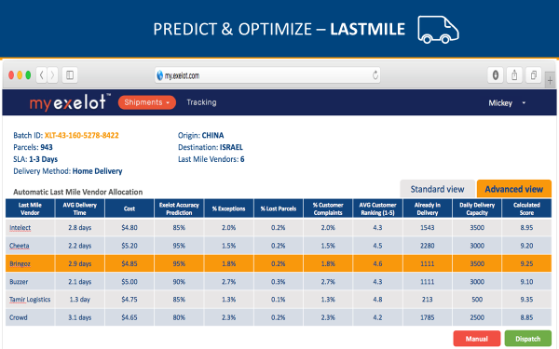
Regarding customs issues, the system calculates the requested VAT for relevant packages when it is not paid in advance at the time of purchase (this is typical when buying from China and India, unlike purchases from the US), notifies customers according to the destination country, collects VAT automatically via various means, and sends the appropriate invoices and receipts to the end client.
The system allows for the full tracking of the package’s journey, for both sellers and end customers, from the moment the shipment leaves the supplier’s warehouse, until it reaches the customer, including dozens of status types required by logistical companies who support stores. It also provides the e-commerce platform or stores with reports and online access to tracking at all required levels, from the cargo’s documentation and the original file sent, to the level of a single package or client.
In this way, both sellers and end customers enjoy full transparency in the entire logistics process, while the Exelot platform monitors the entire process online. In addition, optimization and shipment consolidation assist in lowering the transfer time to a few days, decreasing shipping costs, and creating incredible added value for suppliers. In the future, the company intends to increase its big data capabilities, to generally improve the logistics process, thereby increasing the company’s profitability, and for the purpose of supplying marketing recommendations and different data insights based on logistics data.

The market
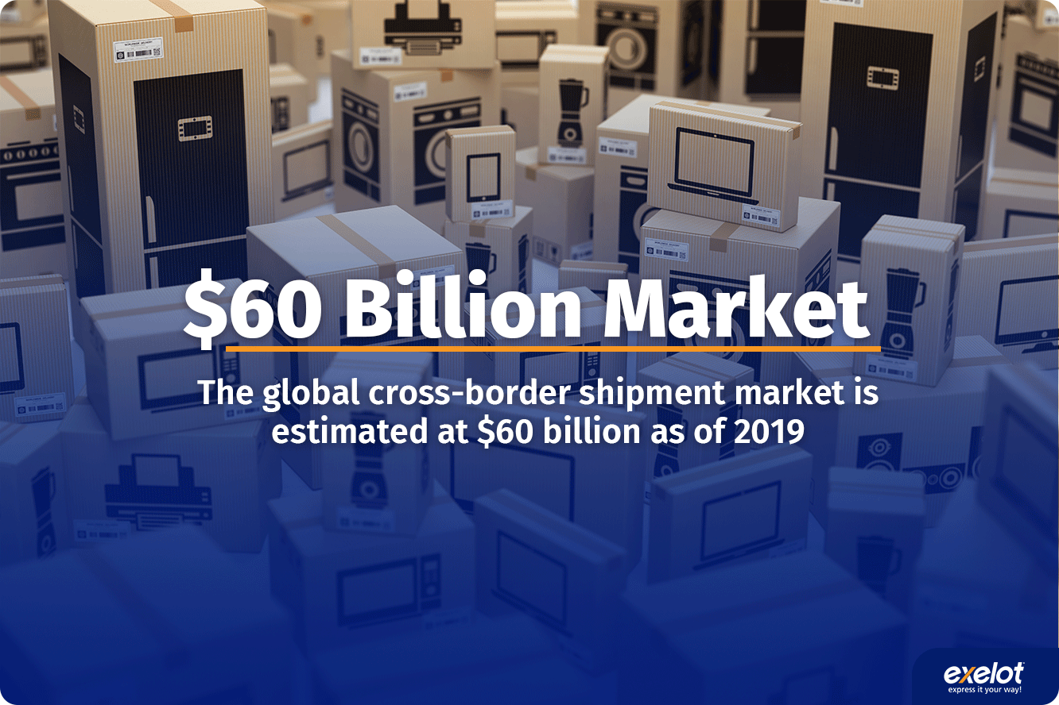
The global shipping market for e-commerce products grew from 45% of buyers in 2014, to 77% in 2018, in shipments of items between country borders. In Europe alone, 72% of 260 million online shoppers (about 186 million buyers) purchased a product from a foreign country in 2016. The Scandinavian postal service (PostNord Sverige) issued an e-Commerce in Europe report in 2017, forecasting the continued growth of the cross-border shipping trend.

Out of all online shoppers, 75% order at least one product every month, which arrives via shipping from another country. Recently, the share of online shoppers via smartphones has doubled, from 14% in 2016, to 29% in 2018.
Exelot’s share of the relevant market is comprised of items valued at over $35-40 (starting from this price, it is more beneficial for sellers to pay for improved shipping rather than use standard postal services) and is valued at 20 billion dollars, with most of the market held and handled by postal services, and the rest by express companies (Fedex, UPS, DHL) and smaller logistics integrators.

Online purchasing between countries
Research conducted at the end of 2018 in 41 countries and among 33,500 people, regarding the origin countries of e-commerce shipments, found that China (a market in which Exelot already specializes) has grown in export scales considerably, compared to other countries, who have lost market share since 2016:

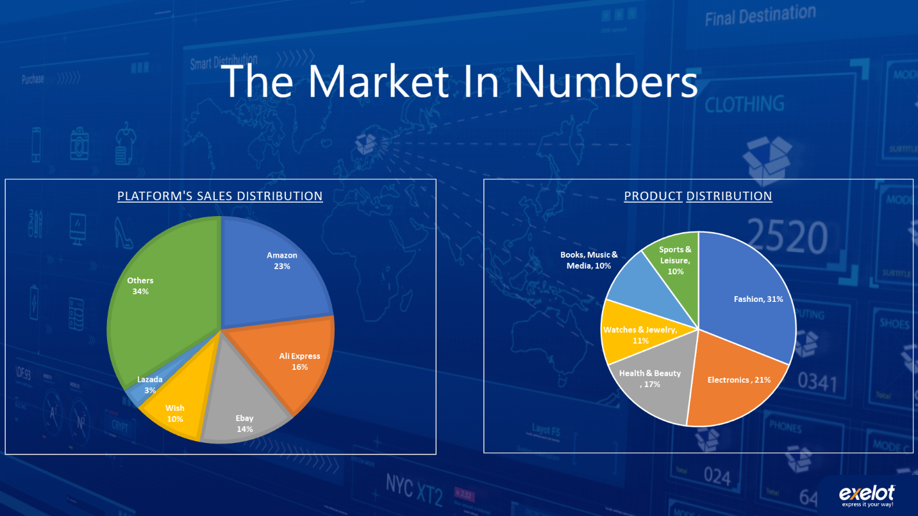
According to the study, on average, 36% of international buyers placed orders with shipments arriving from China (up from 26% in 2016), 11% from the US (down from 15% in 2016), 13% from Germany (down from 16% in 2016), 12% from the UK (down from 15%), and 3% from France (down from 5%). About 25% of buyers made orders shipped from other countries (Japan, Korea and Russia).
This means that China, where Exelot is already fully deployed, is the most popular source country for international orders made by US and European buyers, with Europe itself growing in the total proportion of orders, from 33.2% in 2016, to 38.7% in 2017.
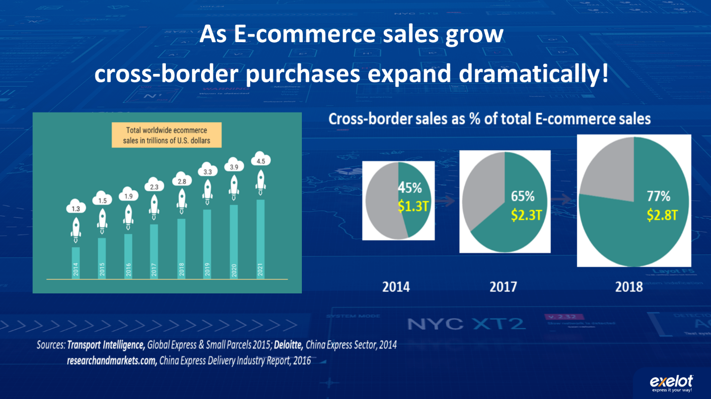
Main obstacle: shipment times and reliability of reports
Past surveys have shown that up to 50% of the barriers preventing online purchasing are due to logistical reasons such as delivery times, costs of shipping and the inability to return or insure products.
Over 41% of shipments require more than 10 days, with 26% delivered in a timeframe of 15-30 days. In fact, only 46% of products are delivered in less than 10 days, and there is a real need and thirst for a solution to this problem, among both customers and suppliers, who require reasonable pricing to be maintained. In countries such as Brazil, Mexico, Russia, Hungary, Australia and New Zealand, as well as many African and Arab countries, the percentage of shipments taking over 15 days is even higher, and shipment times can even significantly exceed 30 days.
As a result, 25% of online shoppers have complained about lengthy shipping times, and an additional 10% complained about inconvenient hours of delivery. In Europe, about 35% of shoppers were willing to pay an additional cost for faster shipments.
In many countries, the issue of customs and VAT presents another obstacle, with 16% of all buyers required to pay tax and/or VAT for the product purchased abroad. In some countries, this percentage value is much higher: India - 72% of buyers, Vietnam - 52%, Morocco - 40%, China - 50%, and Brazil - 40%.
In addition, small and medium-sized shipping operations do not maintain the required minimum number of shipments for them to be able to allow a faster delivery. Exelot answers their need through consolidations and optimizations of shipments.

Competitors

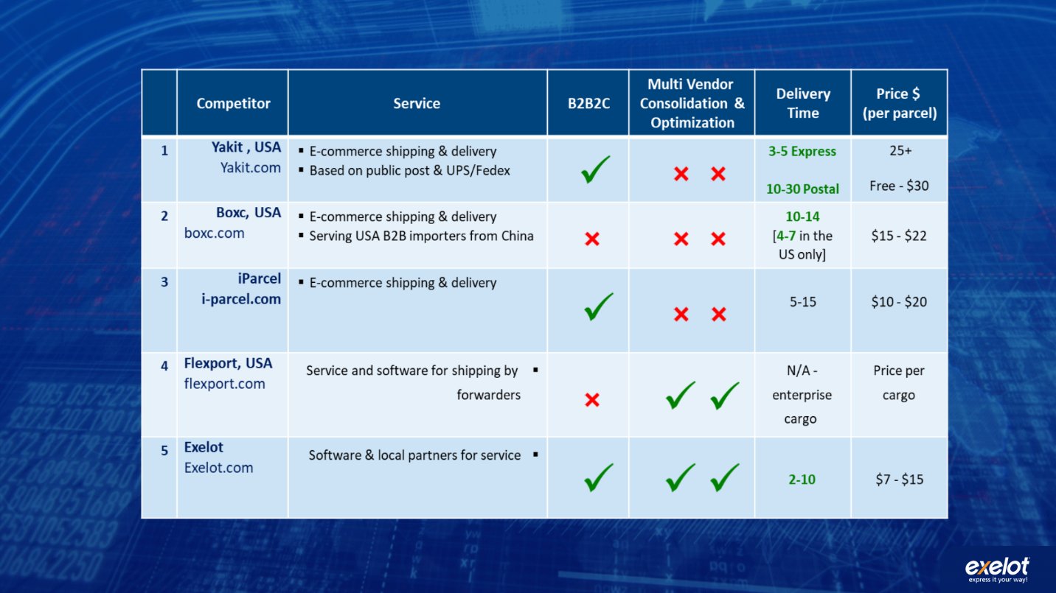

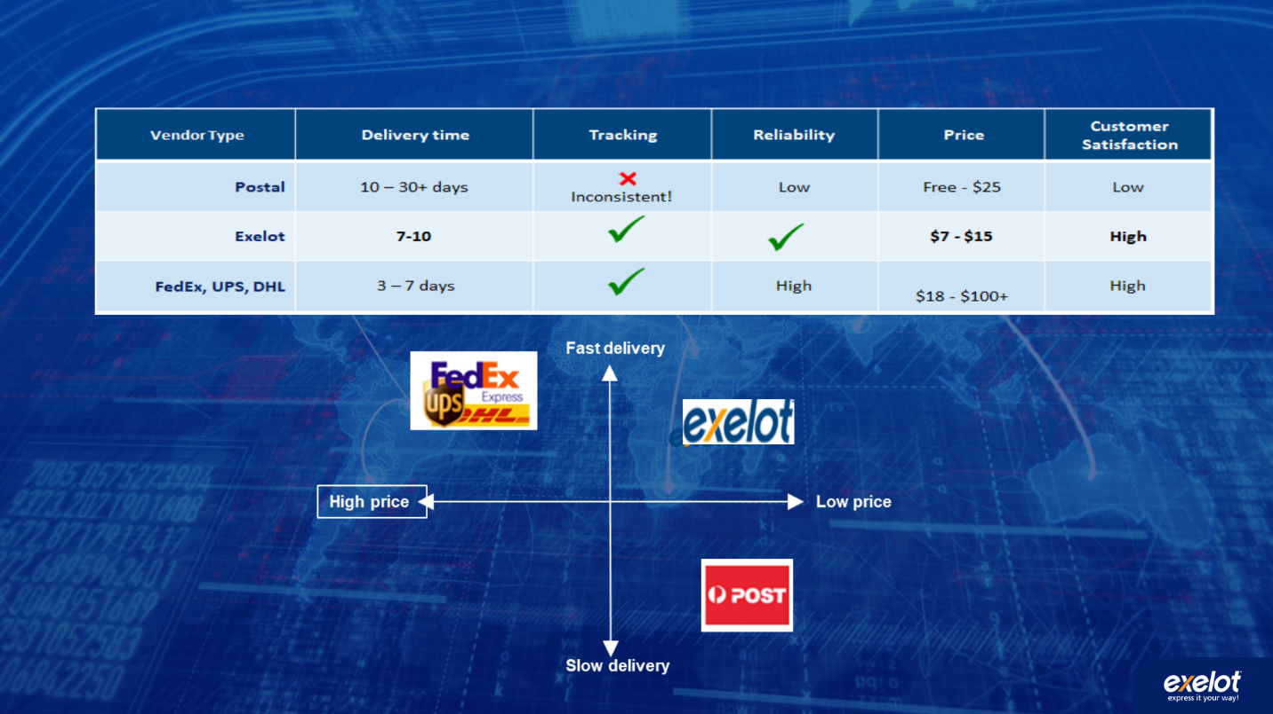

Business model

Exelot operates in a unique B2B2C model, based on several channels through which the company creates income:
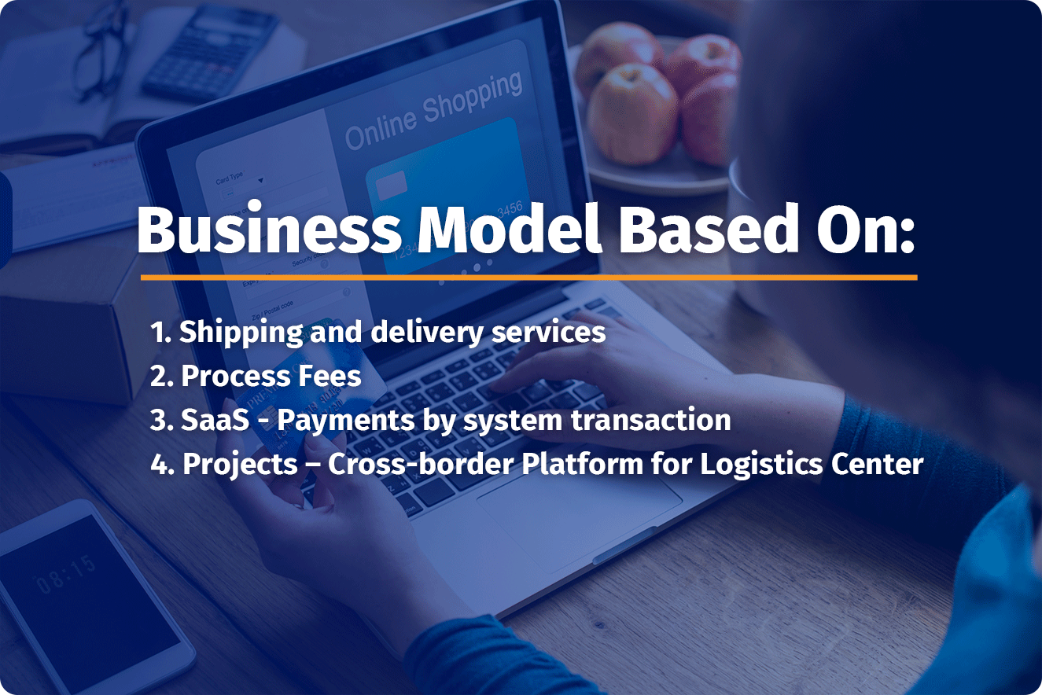
- Shipping and distribution services - payments from e-commerce stores for all shipments, paid on a monthly basis.
- Process fees - additional payment for customs and VAT costs.
- SaaS - sales of the system’s services by use of modules (for example: collection, consolidation and preparation for flight, calculation and processing of tax and VAT payments, customs brokers and release, preparation and routing for distribution, tracking and reports).
- Projects - establishing a logistical system for e-commerce in logistical centers such as those planned by the company in China, India, Singapore, Africa and the Ukraine, including an installation fee, yearly subscription fee, and services provided via the platform with payment for transactions made.

Timeline
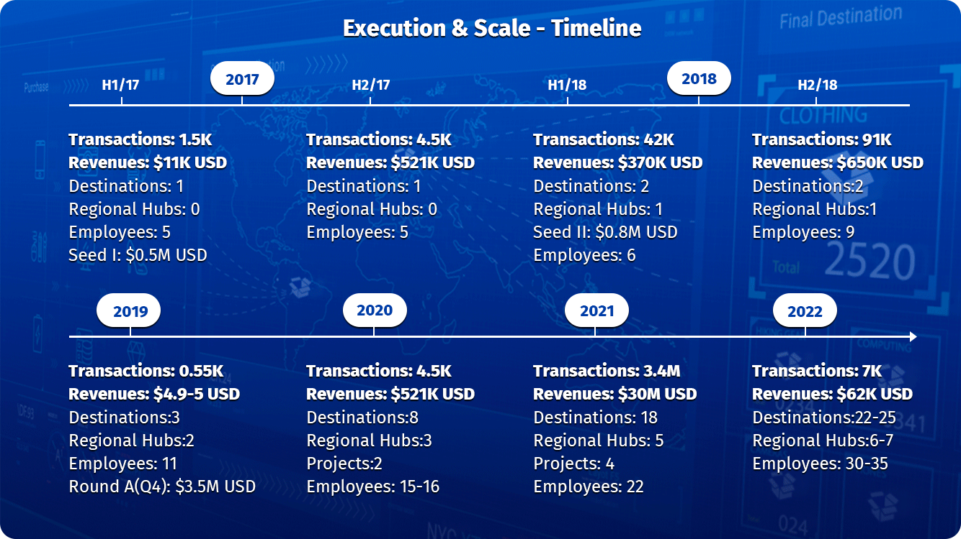

Revenue forecast

Sales cycles:
Detailed in terms of volumes of deliveries/transactions, and sum of customer invoices:
Month (2019) | Shipments made | Invoices for clients $USD
January | 19,184 | 214,414$
February | 16,752 | 185,532$
March | 25,307 | 233,798$
April | 30,105 | 293,927$
May | 44,853 | 456,345$
June | 45,927 | 473,090$
July | 49,270 | 463,700$
August | 52,200 | 492,143$
September | 53,400 | 503,300$
Q4 Expectations | 190,000 | 1,660,000$
Total | 526,998 | 4,976,249$

Total volume of deliveries in the system for previous years:

Year | Amount | Balance Sheet Revenue
2017 - March to Dec. | 47,737 | 1,583,014 NIS/445,919$
2018 | 132,872 | 3,469,573 NIS/977,344$

Delivery forecast for 2020:
Israel - 825,000; Overseas 375,000; Total for 2020: 1,200,000 shipments via Exelot's platform.

Go-to-market strategy
The company’s go-to-market strategy is based on a multi-channel and multi-layered B2B2C model, regarding products and services, divided into main origin countries and destination countries:
- Products:
  - Software and total service (end-to-end or partial, without air freight).
  - Software only with an option for full monitoring and customer service.
  - Project-based, for the embedment of the platform (turn-key with transaction fees or a JV model).
- Client segmentation:
2.1 Marketplaces/e-commerce platforms.
2.2 E-commerce websites (e-retailers/"stores").
2.3 Forwarders and customs brokers.
- Geographical distribution according to progress:
Origin countries: China and Hong Kong, East Asia and India.
Europe (with an emphasis on England, Germany) and the US.
Target countries: Growing from 3 target countries mid-2019 to 25 target countries serviced by the end of 2022.

Country blocks/clusters – 2020-2021:
1) Israel, Turkey, Greece and Cyprus
2) Scandinavia
3) The Balkans
4) Eastern Europe and several former USSR countries (Ukraine, Belarus, Latvia, Estonia)
5) East Africa
6) Mexico, Brazil and Chile.

Existing service agreements and strategic cooperation
- Exelot serves AliExpress suppliers for the Alibaba group to Israel and through the Cyprus hub at the request of AliExpress to extend the sales to additional foreign countries. The Exelot shipping option is embedded in Ali’s system for the sellers through this Cypriot hub.
- Exelot works in tight cooperation with Overseas Commerce, a public company traded in Israel and the largest and leading marine container terminal operator in the country. "Overseas Commerce" also operates an air cargo terminal in Israel, where it provides services to Exelot, and it owns a large new maritime terminal in Africa. The company is considering entering additional countries in the fields of cargo terminals and supply warehouses. "Overseas Commerce" is also a holder of an investment option in Exelot, as part of a loan converted to shares that was given to Exelot
- The company cooperates closely with the Wel Com company in China, offering logistics services to online suppliers - consolidating and routing their products to various terminals, optimized by the Exelot system.
- Exelot works with the Euro freight logistics company based in Cyprus, which operates a fulfillment and bonded center with custom broker capabilities for the EU. This cooperation is used by Exelot to expand its activities to neighboring countries, such as Greece, Bulgaria, Romania, additional Balkan countries and, in the future, Arabic countries.
- Exelot cooperates closely with the "Bansard" company, which operates in France and Hong Kong, supplying maritime and aerial shipping services in China, Hong Kong and Europe.
- Cooperation with Cal Cargo Airlines for shipping Exelot’s e-commerce freight to Israel, Cyprus and Greece, plus a few more European countries by the end of 2019.
- Cooperation with I-Pack Express in the US, to receive Exelot’s shipments, carry out custom clearance processes, and take care of labeling and distribution across the US. Both companies intend to broaden this cooperation in 2020, to include the shipment of cargo to the US by sea in containers from China and Hong Kong.
- Exelot has signed an LOI (letter of intent) with the Rwandan government to form a JV, in which the company will be given 51% of the e-commerce platform activity for importers and exporters in Rwanda, with a joined expansion of activities to 5 additional East African countries (Kenya, Tanzania, Uganda, Burundi) incorporating maritime, aerial and land services. This cooperation entails further cooperation with the following entities: DP World, the franchise holder and operator of Rwanda's main logistics center in the capital city Kigli, with a space of 100,000 square meters (DP owns and operates around 82 container terminals worldwide); The Kenya Ports company; RwandAir; and the leading mobile payments company in Rwanda.

Exit strategy
Exelot has the potential to be sold or merge, in the future, with companies from various sectors, who are related to the field of international e-commerce shipping. Another option would be to issue stock to the public via an Initial Public Offering (IPO).
Numerous players are already showing interest in investing in the company, either for the opportunity of purchasing its unique technology in the growing cross-border market, or for leveraging its clientele database and existing orders. Another interest is being shown in its forwarding and distribution system, set in various target countries.
The company might also be attractive to companies from the software for organizations sector, such as Salesforce, Service Now, SAP and others.
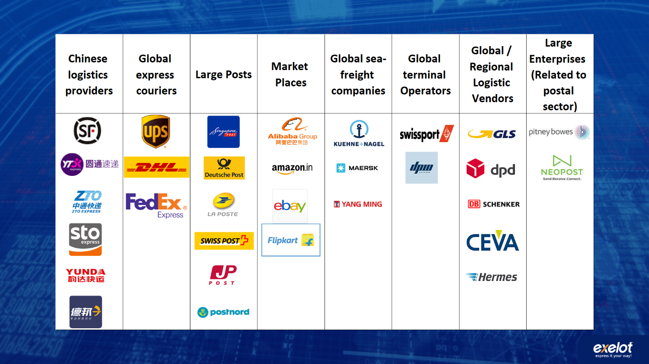
Related examples:
- Israeli company “Flying Cargo” was sold in two stages to international shipping giant DHL, for an estimated 190 million dollars.
- https://www.themarker.com/markerweek/.premium-MAGAZINE-1.6872304
https://www.ynet.co.il/articles/0,7340,L-3460510,00.html

- In the US, I-Parcel was sold to UPS for approximately 70 million dollars.
- https://www.port2port.co.il/article/%D7%A9%D7%A8%D7%A9%D7%A8%D7%AA-%D7%90%D7%A1%D7%A4%D7%A7%D7%94/%D7%A9%D7%99%D7%9C%D7%95%D7%97-%D7%91%D7%99%D7%A0%D7%9C%D7%90%D7%95%D7%9E%D7%99/UPS-%D7%A8%D7%95%D7%9B%D7%A9%D7%AA-%D7%90%D7%AA-i-parcel-%D7%A9%D7%9E%D7%90%D7%A4%D7%A9%D7%A8%D7%AA-%D7%9E%D7%A1%D7%97%D7%A8-%D7%90%D7%9C%D7%A7%D7%98%D7%A8%D7%95%D7%A0%D7%99-%D7%91%D7%9E%D7%98%D7%91%D7%A2-%D7%95%D7%91%D7%A9%D7%A4%D7%94-%D7%9E%D7%A7%D7%95%D7%9E%D7%99%D7%99%D7%9D/

- Border Guru, a digital platform for logistics, and Seko, a forwarding company, were acquired and merged by the giant logistics vendor Hermes, in Germany.
- https://www.crunchbase.com/organization/borderguru
- https://postandparcel.info/98032/news/hermes-germany-reveals-new-acquisition-and-international-aims-of-the-group/

- Softbank has invested a huge sum of 1 billion dollars in the company Flexport.
- https://www.flexport.com/blog/flexport-secures-usd1-billion-in-funding-led-by-softbank-vision-fund
Bordefree – חברה ישראלית במקור הפועלת בתחום הרחבת יכולות הסחר המקוון של מוכרים מקומיים למדינות רבות ברחבי העולם (ללא פתרון לוגיסטי משלה), הונפקה תחילה ונמכרה לאחר מכן ל Pittney-Bowsספק ציוד, מכשור ותוכנות מהמובילים בעולם לתחום הדואר ושרשרת האספקה, תמורת 395 מליון דולר.
https://en.globes.co.il/en/article-pitney-bowes-to-acquire-borderfree-for-395m-1001033968

Use of funds
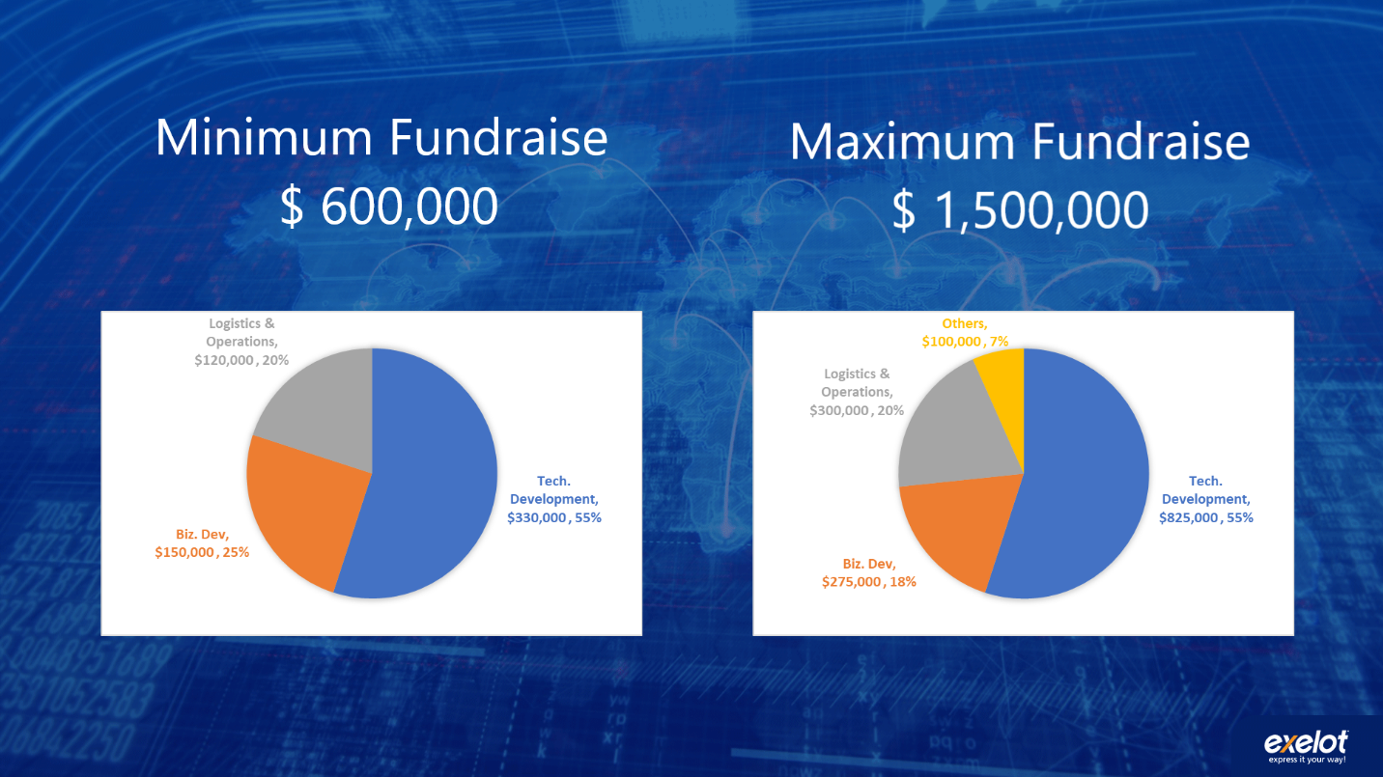
- Based on a 24-month plan.
- Funds will be used for technological development and the opening of new markets. As far as possible, funds will also be used to strengthen operations.
- In a minimal recruitment scenario, an additional "A round" will be planned.

Minimal funding - $600,000
Technological development:
- Goals: Developing version 3 of the platform, including additional modules
- Recruiting a full-time Head Programmer (who will serve as #2 to the company’s CTO)
Marketing and business development:
- Goals: Adding 12 target countries within 24 months. Including traveling abroad
Logistics supervision and operations:
- Goals: Expanding logistics supervision and customer service

Maximum recruitment: $1,500,000
Technological development:
- Recruiting a full-time Head Programmer (who will serve as #2 to the company’s CTO)
- Two additional programmers (one back-end and one front-end or two full-stack developers)
- Outsourcing when necessary
- Salary increase for the CTO
Marketing and business development:
- Additional sales manager for China/East Asia
- Additional European business development - opening up to new target countries and logistics partners
Logistics supervision and operations:
- Goals: appointing two overseas logistics supervisors, international customer service

The team

שם | תפקיד | תיאור | תמונה
דניאל כהן  Daniel Cohen | מנכ"ל  CEO | Entrepreneur and VP of Business, Development and Strategy at the Israel Post company. VP of Business Development and Marketing at High-Tech (LocatioNet, Aerialink) and Industrial companies.  Over 20 years’ management and international business experience (LLB, MBA).  Has led European projects with large worldwide teams estimated at tens of millions of Euros, and maintains close relations and projects in Asia.  Experienced with start-ups and large enterprises. | 
יצחק ורסנו  Izack Varsanno | מנהל פיתוח טכנלוגי / CTO  Founder and CTO | Over 25 years’ experience with programming and managing programmers in the military and private sectors and the start-ups arena. 7 years’ service as Chief Programmer/Chief Architect for the IDF logistics unit at MAANA (retired as Major of IDF) with extensive experience in managing and programming. Pioneer in cloud-based systems, years of experience with both start-up companies (Precise, Always-On) and large enterprises such as Partner in Israel (IT Infrastructures manager) and Applied Materials. | 
אלי קורצקי  Eli Koretsky | מנהל פיתוח עסקי ומכירות, סין  VP Business Development and Sales, China | B.A. in Economics and East Asian Studies from HUJI, China. Previously, Eli served as the Israeli market manager for the Chinese Alibaba/AliExpress group.  7 years’ experience with e-commerce operations, marketing, logistics and user experience.  An expert in cross-cultural business development and fluent in Chinese, Russian, English and Hebrew. Extensive experience with on-line retailers and logistic vendors for the online industry. | 
יעקב גזית  Yaacov Gazit | סמנכ"ל פיתוח עסקי  VP Business Development | A married father of four, with a BA in Economics and Business Administration alongside an MBA specializing in finance. Yaakov has extensive experience in financial consulting for companies, corporations and individuals, as a freelancer. Served for almost 5 years in senior positions in the Israel Post company, with experience in business development and foreign trade management of an annual NIS 400 million budget, with dozens of employees.  Seven years’ experience as a privatization coordinator in the Governmental Companies Authority of the Ministry of Finance. Yaakov previously handled the privatization of IAI, the Bank for Industrial Development, and the Company for Automation, among others. He also served as a Jewish Agency representative in Pittsburgh, USA, as chair of the Hebrew University Student Union, and as a member of the board of directors of cooperative associations in the Jerusalem area.  נשוי ואב ל-4, בוגר תואר ראשון בכלכלה ומנהע"ס לצד MBA עם התמחות במימון. בעל ניסיון רב, בייעוץ פיננסי לחברות, אגודות שיתופיות ופרטיים כעצמאי. שימש קרוב ל-5 שנים בתפקידים בכירים בדואר ישראל, עם ניסיון בפיתוח עסקי וניהול סחר חוץ בהיקף שנתי של כ-400 מיליון ש"ח ועשרות עובדים. 7 שנות ניסיון כרכז הפרטה ברשות החברות הממשלתיות במשרד האוצר. טיפל בעבר בהפרטת תע"ש, הבנק לפיתוח התעשיה, החברה לאוטומציה ועוד. שימש דירקטור בחברות מובילות במשק: רפא"ל, תע"ש , קרן קיסריה והחברות הבנות ועוד, וכמנהל תחום נכסים מניבים בחברת נדל"ן מדווחת. בעבר שימש שליח הסוכנות היהודית ב Pittsburgh, USA, יו"ר אגודת הסטודנטים באונ' העברית, וחבר וועד מנהל באגודות שיתופיות באזור ירושלים. | 
מריאנו פטסינסקי  Mariano Ptascinsky | מנהל כספים  CFO | Mariano has more than 20 years’ experience in the field of financing, credit and credit insurance. Until recently, he served as director of the Consumer Credit Department, managing over NIS 8 billion at Leumi Card (Max). Prior to that, he was VP of Credit and Risk Management at the largest car importer in the country, and a credit manager in the defense industry responsible for financing deals worth tens of millions of dollars. He has also served as an entrepreneur and CEO of a financial start-up, sold to Meitav Dash, and as entrepreneur and VP of a financing company - led from the concept stage to the stock exchange In Tel Aviv. Mariano holds a BA in Economics from Tel Aviv University and an MBA from the Technion; he is a graduate of Risk Management (FRM) and a certified mediator. | 
עינת מזמר  Einat Mezamer | מנהלת שרשרת לוגיסטית ושירות לקוחות | Over 12 years’ experience in the world of logistics and international shipping in the business and private sectors, including Fedex and other private companies.  Extensive knowledge of the supply chains with leading companies in the world.  Management experience in a variety of areas: from service and operations to sales. | 

Cross-Border E-commerce Shopper Survey 2018, IPC Global Postal Industry Report and IPC Carrier Intelligence Reports, January 2019 (33,000 respondents, 41 Countries). Researchandmarkets.com, China Express Delivery Industry Report, 2016 This is incomplete/unclear. Cross-Border Magazine, August 2018 WIK Consult, Dynamic Development of Cross-border E-commerce through Efficient Parcel Delivery, 2018 (16,400 respondents, 30 countries). What do these references refer to?

