

**An experiment testing the effectiveness of the Bio T Plus preparation in controlling false codling moth in citrus (Ness Ziona, September−October 2017)**

Dr Shaul Ben Yehuda, Ministry of Agriculture and Rural Development’s Extension Service,

Ricardo Bar’am, Kibbutz Hatzor

In collaboration with Eran Shilo—BioYome Company

**Aim:**

To test the effectiveness of the Bio T Plus prepartion in controlling false codling moth (*Thaumatotibia (Cryptophlebia) leucotreta*) in citrus.

**Methods and materials:**

**The crop:** The experiment was conducted in a citrus orchard of the Newhall navel variety, planted in Ness Ziona in 1997.

**Irrigation:** drip

**Soil:** medium

**Phenological stage**: green fruit undergoing colour break

**Weather conditions:**

3/10/2017: temperature: 26.9°C, relative humidity: 64%

11/10/2017: temperature: 21.1°C, relative humidity: 70%

19/10/2017: temperature: 24.0°C, relative humidity: 34%

**Additional pest control treatments in the orchard:** No previous treatments to control false codling moth.

**Experimental procedure:** The experiment was conducted in randomised blocks, with four repeats for each treatment, and three to five trees in each repeat. A buffer row was maintained to prevent droplet transfer between treatment groups.

**Application method and spraying volume:** Spray gun until runoff, volume: 300 L/dunam (10002)

**Baseline infestation:** The experiment startedafteradult moths were captured in monitoring traps, and infestation was identified in a small number of fruits.

**Bio T Plus application dates:**

* 3/10/2017, morning
* 11/10/2017, morning
* 19/10/2017

**Cryptex standard treatment application dates:**

* 2/10/2017
* 15/10/2017

**Sample size:** All suspect fruit

**Evaluation dates:** 30/10/2017 No further evaluations were conducted because of the ripening of fruit and the beginning of harvest.

**Evaluation method:** Larvae presence in fruit was determined after peeling the skin and cutting the fruit into thin slices. In each experimental repeat, all the suspect fruits on the trees were inspected by 5 people for a fixed time of about 10 minutes (about 50 minutes for a four-tree repeat).

**Analysis:** The JMP (version 5.1) software was used for statistical analysis**.** Results were analysed by ANOVA with a post hoc Tukey-Kramer test to determine statistically significant differences between treatments.

**Preparations:**

* Bio T Plus, SC containing Bacillus thuringiensis subsp. Kurstaki at 16,000 international units (ITU)/mg per litre.
* Cryptex, a granulovirus preparation for the control of false codling moth, at 2x1013/L + Colfix, a powder containing 40% polyvinyl resin

**Treatments:**

|  |  |  |
| --- | --- | --- |
| **No.** | **Preparation** | **cm3/dunam or %** |
| 1 | Bio T Plus | 750 |
| 2 | Bio T Plus | 1500 |
| 3 | Standard treatment* (Cryptex + Colfix) | 20 + 0.06% |
| 4 | Control | - |

* The standard treatment was sprayed only twice.

**Results:**

The results are presented in Table 1 and Figure 1.

All Bio T Plus treatments were significantly different from the control at the time of evaluation.

No signs of phytotoxicity were observed with any of the treatments. No stains were observed on the foliage.

**Table 1** Fruit infestation by false codling moth live larvae in the different experimental groups

|  |  |  |  |
| --- | --- | --- | --- |
| **No.** | **Treatment** | **cm3/dunam or %** | **Number of false codling moth live larvae present in fruit/experimental repeat**  **(average)** |
| 1 | Bio T Plus | 750 | 0.5 b |
| 2 | Bio T Plus | 1500 | 0.0 b |
| 3 | Standard treatment (Cryptex + Colfix) | 20 + 0.06% | 1.0 ab |
| 4 | control |  | 2.5 a |

* Values labelled by different letters are significantly different from each other (P<0.05)

** The JMP (version 5.1) software was used for statistical analysis**.** Results were analysed by ANOVA with a post hoc Tukey-Kramer test to determine statistically significant differences between treatments.

**Figure 1** Fruit infestation by false codling moth live larvae in the different experimental groups

(Ness Ziona, 2017)

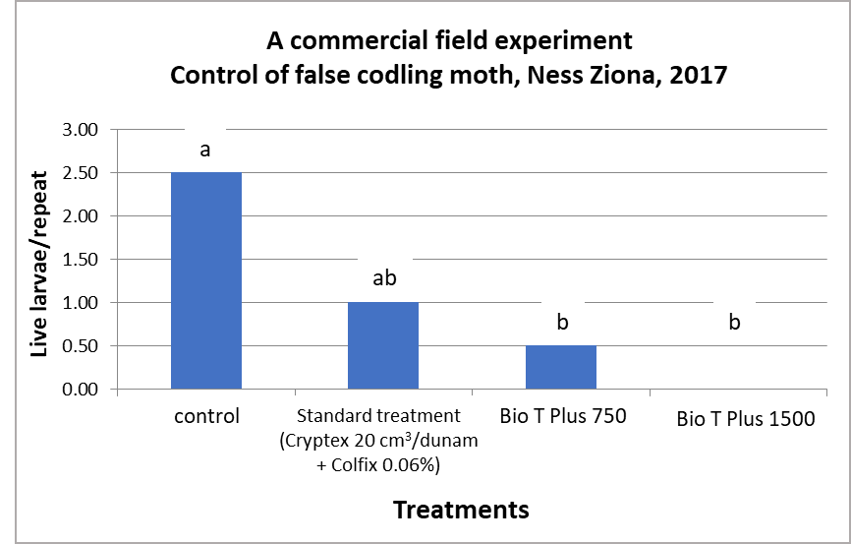

* Values labelled by different letters are significantly different from each other (P<0.05)

**Discussion and conclusions:**

The Bio T Plus preparation, tested at 750 cm3/dunam and at a double concentration, effectively eliminated false codling moth larvae in citrus. Larvae infestations in treated fruit were significantly lower than in the control.

We assume that the incomplete application of the standard treatment (which was mistakenly sprayed only twice and at a relatively large interval) negatively affected its activity compared to the other treatments.

No phytotoxicity was observed in the crop treated with Bio T Plus (including the double concentration). No effects on foliage or fruit were observed during growth.

The high effectiveness of the Bio T Plus in controlling false codling moth in citrus, which was demonstrated in the current experiment and previous experiments, suggests it can be included in the combined control management of the moth in citrus and other crops.

**Acknowledgements:**

We thank Udi, the orchard foreman, for allocating the plot and assisting in the experimentation. The experiment was conducted as part of the targeted research and development scheme of the Extension Service (2017−2018) to promote monitoring and control of false codling moths in orchards.