Programmable Smart Fast Gas Chromatograph and Open Probe Controller

##### Eli Flaxer*1,2 and Tal Alon1

1AFEKA - Tel-Aviv Academic College of Engineering, 69107 Tel-Aviv, Israel.

*Correspondence author: E-mail: flaxer@afeka.ac.il.

**Abstract**

Today, labs that carry out chemical analyses for regulatory, food safety, health, forensics, or even security purposes are looking for ways to accelerate the analytical process. Slow procedures are costly because the necessary instruments are expensive, and require maintenance and more highly trained staff to operate them. One of the more ubiquitous instruments in such labs is a gas chromatograph (GC), which analyzes a solution and converts each of its component compounds into gaseous form to be further analyzed and identified, usually by a mass spectrometer (MS). This separation process in a GC can be rather time-consuming, partly due to the slow heating and cooling of the GC column through which the compounds move, which happens inside a box-shaped oven.

This paper describes a controller developed for a unique Open Probe Fast GC instrument that enables, among other things, rapid and controlled heating and cooling of a gas-carrying capillary transfer line. Fast heating is achieved by precisely controlling the electrical current flowing through the small inner-diameter steel tube through which the GC column passes. The fast cooling occurs by exposing the low-mass heated tube to room temperature, along with the assistance of a simple fan that carries the heated air away. This technology also supports control of other system parts, including a unique quick sampling device called an Open Probe that allows for an even faster analysis cycle. Our design is based entirely on DSP and digital control, and using PWM control enables a compact and efficient system.

**Keywords**: Fast GC, Open Probe, Real-time Controller.

1. **Introduction**

Gas chromatography coupled with mass spectrometry (GC-MS) is the primary system used for the detection and identification of volatile and semi-volatile compounds. The sampling stage in which a sample is prepared and introduced into the GC, and the chromatography stage in which compounds are heated to become vaporized and separated, while traveling in their gas phase through a thin glass tube (called a column) are extremely time-consuming. The analytical cycle that starts with a new analysis and ends with the instrument being ready to begin another analysis ranges from 10 to 60 minutes. Instrument developers have been working on shortening the analysis time of GC for several decades [1-3], and the research remains ongoing [4-10].

The Amirav group at Tel-Aviv University developed a new instrument called Open Probe Fast GC, which accelerates the combined sampling and chromatography time to less than one minute [11-13]. This instrument uniquely provides a low-cost, real-time analysis in combination with GC separation and mass spectrometric analysis.

The Open Probe is based on an ambient pressure vaporization oven with helium purge-flow protection and an MS ion source. Sample introduction into the Open Probe is done by transferring sample material onto a sample holder, and then inserting the holder into the Open Probe oven and pressing a button. The Open Probe is mounted onto the low thermal mass (LTM) fast GC, based entirely on a thin-walled and low internal-diameter steel tube, coupled with an MS. The tube is resistively heated for rapid heating and cooling, a temperature control technique utilized by instrument developers since the late 1980’s [14-20]. A diagram of the Open Probe Fast GC can be seen in Figure 1.

The controller described in this paper governs the operation of the entire system, including the pneumatics (using a pump and several solenoid valves) for the operation of the open probe, but mainly operates the precisely controlled, super-fast heating and cooling of the fast GC’s steel tube. This is performed in several modes: current-controlled or temperature-controlled, while calculating the temperature from the electrical resistance measurements of the steel tube.

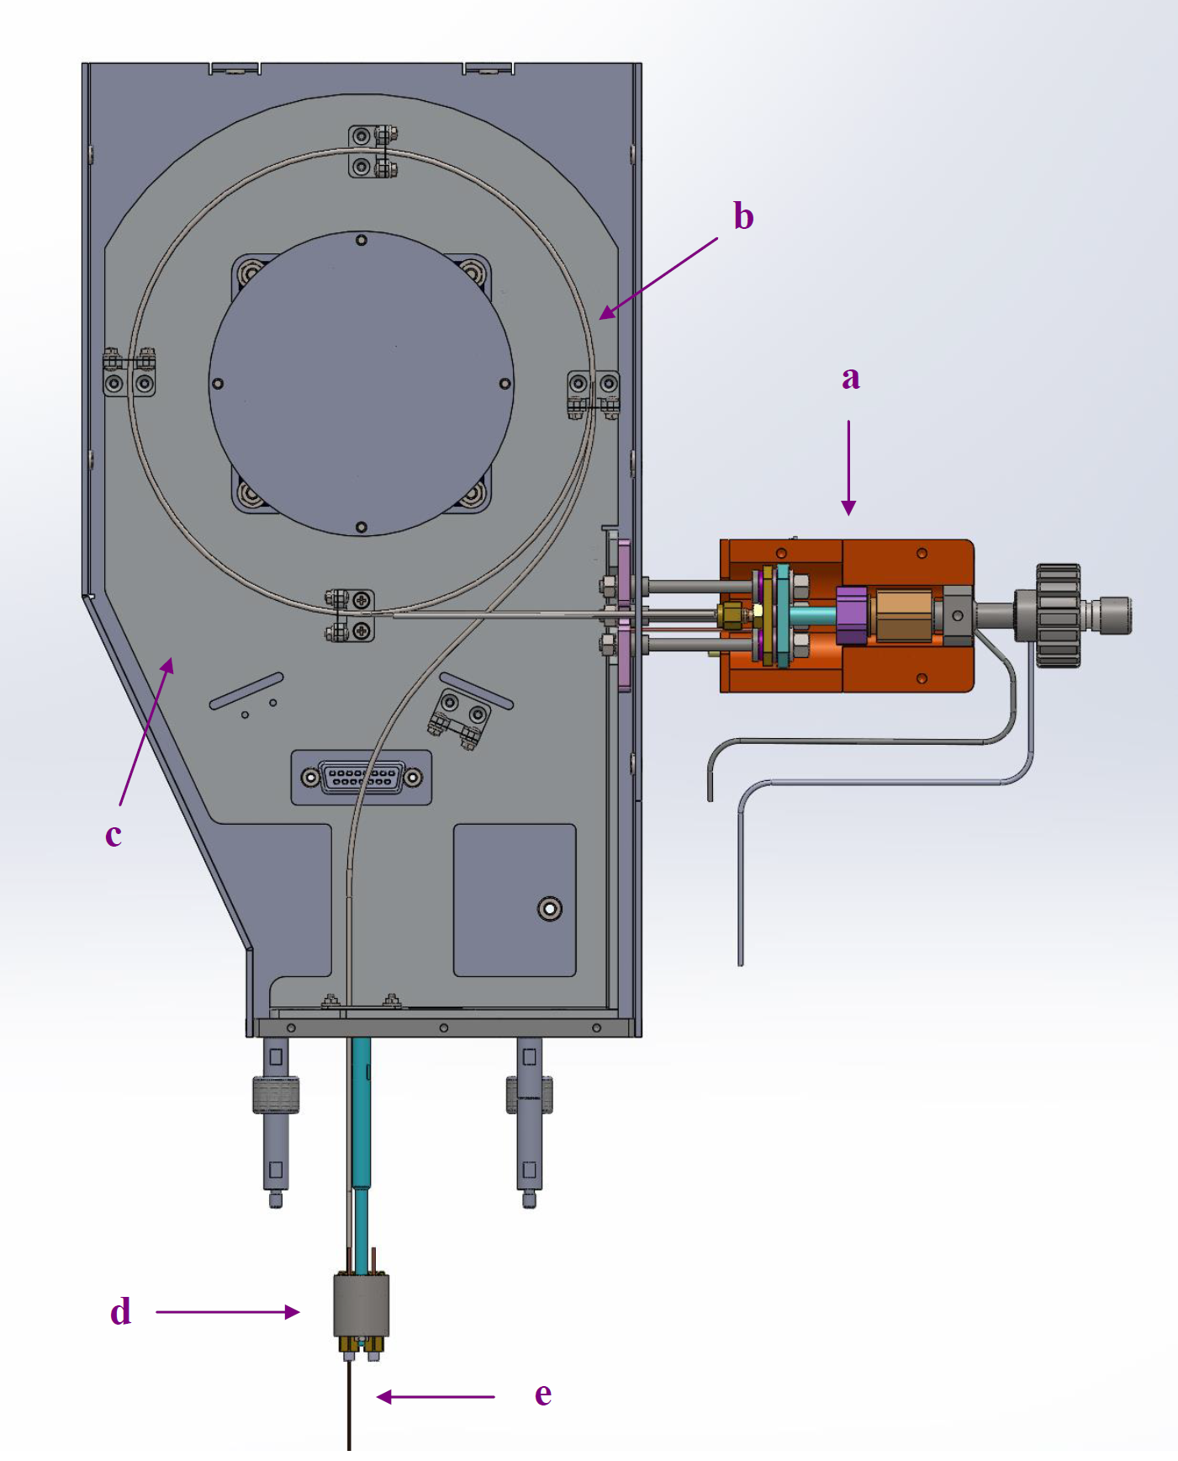

Figure 1 - Diagram of the Open Probe Fast GC-MS with its covers removed. a) the Open Probe, b) the fast GC heated steel tube, c) the fast GC holder, d) the Open Probe Fast GC interface with the GC oven, and e) the Open Probe Fast GC capillary column interfaced with the MS transfer line via the GC oven.

1. **Design Considerations**

Since analog technology is outdated, inaccurate, and limited, we decided to utilize digital technology. In this work, we used an embedded micro-controller containing a pulse width modulation (PWM) unit, an isolated gate driver, and a high power IGBT semiconductor switch.

The PWM technique was chosen to regulate the current and temperature of the system since several hundred watts are involved, and the system still needs to be efficient and compact. In the first step, it was essential to decide which current and voltage ranges were needed. Since several types of steel tubes can be used, the system worked with one of two power sources: 24 volts or 48 volts. Two 24-volt power supplies were used, connected in series or in parallel, according to the required tube. The needed current range was about 10 amps, so a power supply of 500 watts was sufficient. Although PWM regulationwas used to control the current, it was preferred to drive the steel tube with direct current to allow accurate voltage and current measurements. Such accurate measurements are needed to calculate the resistance of the steel tube (R=V/I) and derive its temperature from it.

Measuring the temperature exclusively by the thermocouple is local and not accurate enough; therefore, the temperature of the heated tube (and of the column inside) was calculated using the tube’s resistance, known to be temperature-dependent. In PWM regulation, the instantaneous voltage on the tube swings between two voltage levels at a high frequency, causing elevated levels of noise that make accurate measurements difficult, and therefore unsuitable for resistance calculations. To convert the pulsed current to direct current, a carefully and precisely designed LC filter was used. The converter structure is similar to a back-type converter, where the DC value is determined by the PWM duty cycle. While direct current with a low ripple is required, fast responses are also critical in creating a fast temperature profile. The switching frequency of the PWM controller is 100 kHz, where a time response of about one millisecond is needed. Therefore, the LC filter was designed with a bandwidth frequency of about 1 kHz.

**2.1 Electronic Circuit**

The block diagram of the electronic circuit is described in Figure 2. The circuit comprises five blocks: Controller, Regulator, Sensors, RB-AMP, and USB-COM. The block diagram displays the electronic architecture of the controller. The J7 connector connects to the thermocouple and measures the temperature directly. J6 and J8 are connected to the heated tube in the form of a 4-wire I-V measurement. In this concept, two wires are used to supply the current to the tube, while the second pair of wires is used to measure the actual voltage that is applied to the tube.

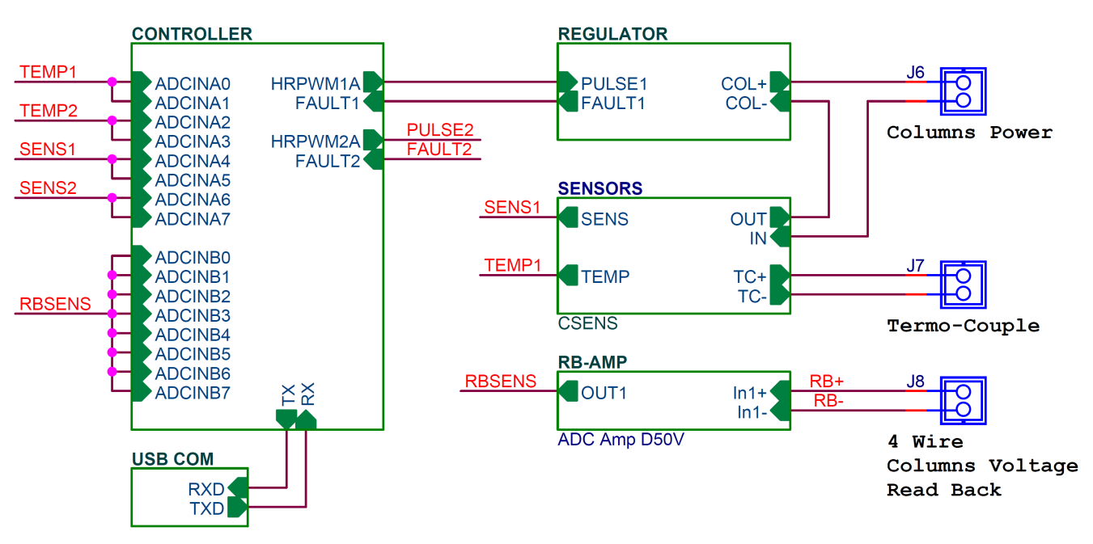

Figure 2 – Block diagram of the electronic circuit.

Figure 3 describes the core of the controller. The central device of this block is the TMS320F28335 digital signal controller (DSC) from Texas Instruments. This controller includes 512 kB Flash memory for programming and 68 kB static RAM for data - enough to hold a large amount of data and complex software. In addition, it contains high-resolution pulse width modulation (HRPWM) units, 16 channels of fast analog to digital converter, and a wide range of communications peripheral units.

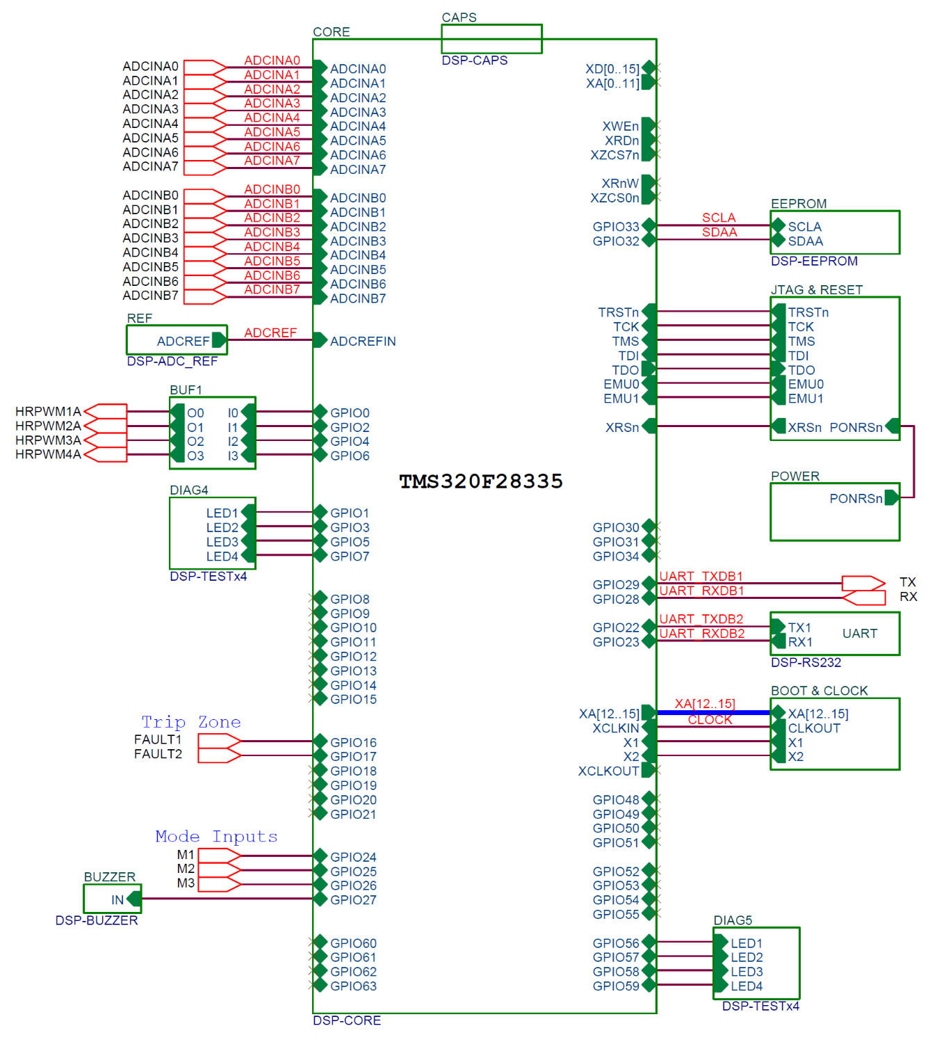

Figure 3 – The architecture of the digital signal controller and its peripherals.

The regulator block, depicted in Figure 4, is the most significant component in our design. To implement the temperature controller, an HRPWM channel of the DSC is used to regulate the heating current of the steel tube. The circuit includes an optocoupler to isolate the DSC from power devices, a smart gate driver TD350E, IGBT for switching, and the LC filter mentioned above. TD350E is a superior gate driver for IGBT, which contains all of the controls and protections required to perform the switching of the IGBT while maintaining very high reliability. Unlike most drivers, a negative gate drive is avoided because the TD350E includes an interior innovative active Miller clamp. This device comprises an adjustable double turn-off level. This feature provides additional protection against surges in overcurrent situations. We used an IRGIB7B60KD – an IGBT with an ultrafast soft recovery diode that can hold 600 volts and 8 amperes. L2 and C17 implement the abovementioned LC filter. The 100 µH coil can hold a current of 17A, while a capacitor of 1000 µF can hold a voltage of 80 V. Before assembling the system, the filter’s response was investigated using SPICE simulation. The simulation showed that an additional filter was needed on the power supply. This filter, consisting of L1 and C18 components, prevents the power supply from collapsing by drawing a high current from it.

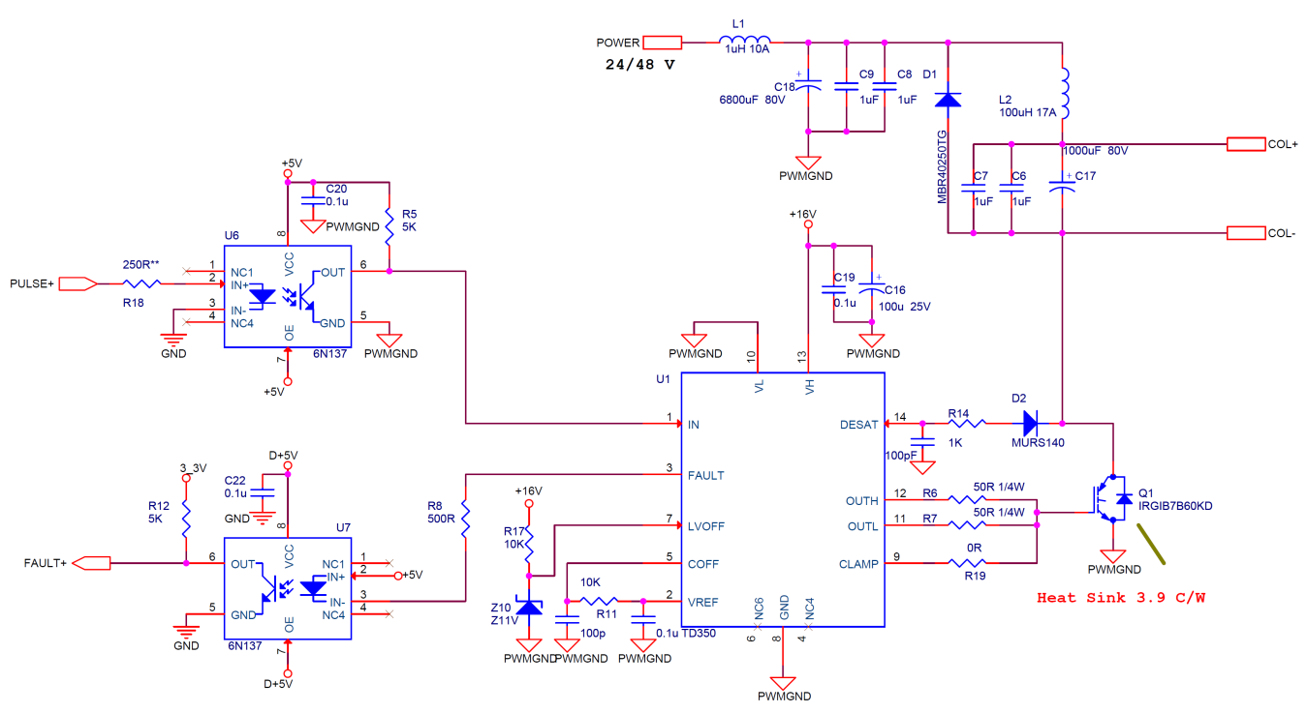

Figure 4 – The regulator electronic circuit. L2 and C17 implement the LC filter.

The sensors block shown in Figure 5 depicts the current sensor connected in series to the heated tube. The internal analog to digital converter of the micro-controller allows voltages in the range of 0-3 volts; therefore, all sensed signals must be scaled to this range. The LMP8601 devices are fixed-gain, precision current sense amplifiers (current-shunt monitors). The common-mode input voltage is in the range of –22 V to +60 V when operating from a single 5V supply. The LMP8601 is ideal for unidirectional and bidirectional current sensing applications. These devices have a precise gain of 20 and can, in most targeted applications, drive an ADC to full-scale value. The shunt resistor is 10 mΩ, which produces 0.1 volts for 10 amps, while the output of the amplifier, following a gain of 20, produces 3 V / 15 A. The AD8497 is a precision instrumentation amplifier with thermocouple cold junction compensators on an integrated circuit. It produces a 5 mV/°C output directly from a thermocouple signal by combining an ice point reference with a pre-calibrated amplifier. Figure 6 depicts a floating differential amplifier, which converts the heated tube’s read-back voltages, at the 4-wire connection to the voltage level of the ADC. Since the maximum working voltage is 48 volts, it is necessary to attenuate the voltage by a gain of 1/20. The USB block consists of an FTDI MM232R bridge that converts the USB protocol to an RS-232 protocol and connects to the processor UART.

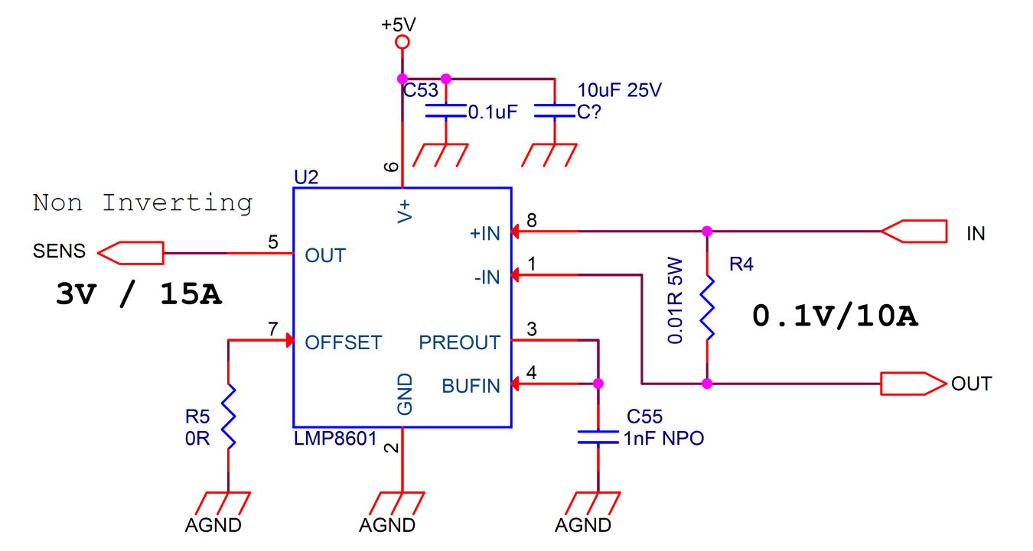

Figure 5 – The current sensor connected in series to the heated tube.

The power pins of the analog devices must bypass 0.1 uF and 10 uF capacitors. To reduce mutual interference between the digital and analog sections, each section must have its own ground, with all grounds joined at one point. Together with the LC filter, all devices are combined into a tailor-made printed circuit board (PCB), as shown in Figure 7.

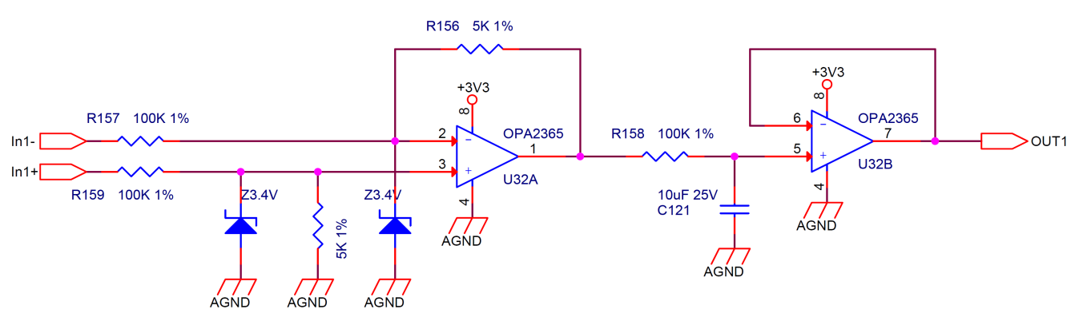

Figure 6 – The floating differential amplifier, which converts the heated tube’s read-back voltages at the 4-wire connection to the voltage level of the ADC.

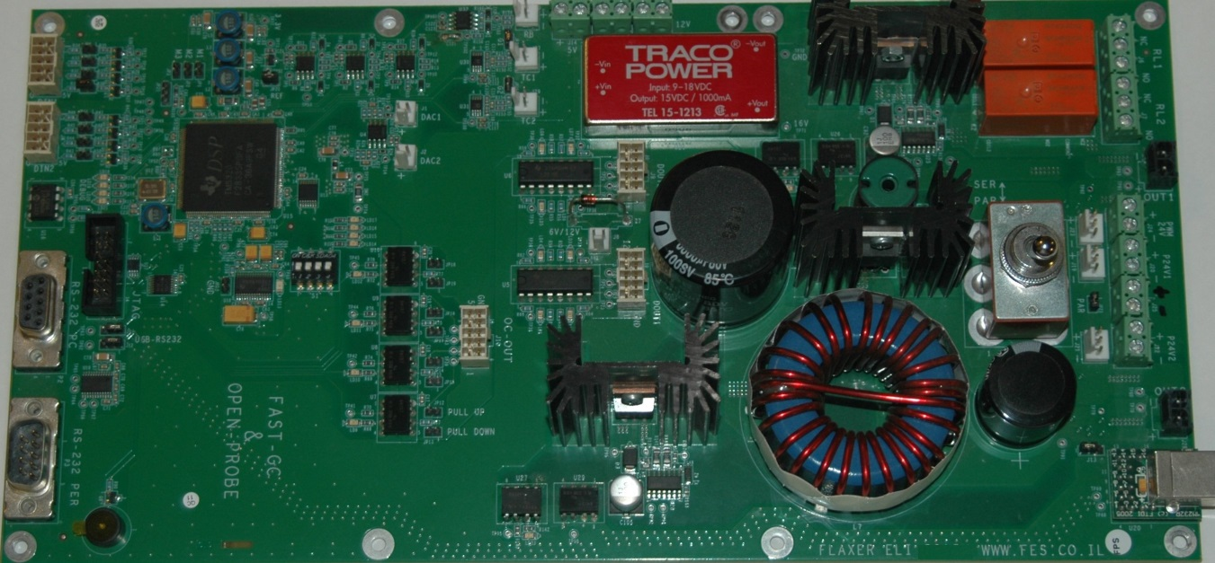

Figure 7 - The tailor-made printed circuit board of the controller.

**2.2 Embedded Software and User Interface**

We used the Code Composer Studio 8.0 (CCS) environment and ANSI C language to write the embedded program. A hardware timer (TIMER0) is used to implement the real-time mechanism of the software. The timer generates a high priority interrupt every 100 ms. This clock is the trigger for the sampling and feedback control processes. The high-speed oversampling allows us to digitally filter the measured signals.

We used proportional integral differential (PID) control to regulate the heated tube’s current. The control is fully implemented by the embedded software, and therefore flexible in its control options. The present controller has several modes of operation: a) constant voltage; b) constant current; c) constant thermocouple temperature; d) constant read-back voltage; and e) constant resistance (V/I). The constant voltage mode works in an open loop, while the other four modes use a PID control to regulate the relevant variable. Each mode has its own PID coefficients, which are programmed by the communication software. In addition to PID control, we integrated the ability to load a time control profile for each of the abovementioned parameters into the embedded software. The loaded profile consists of eight linear segments containing pairs of control and time values. When working with a profile, the controller sets, in real-time, the target values of the control to the profile values.

To control the various parts of the system, PC software that connects with the hardware was also developed, where the main screen can be seen in Figure 8. Note the heat control table that specifies the current flowing through the fast GC’s steel tube at every second of the analysis.

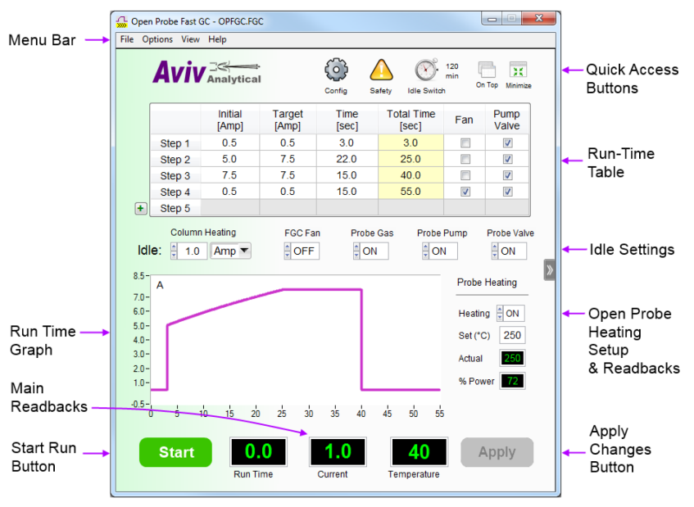

Figure 8. The main screen of the Open Probe Fast GC control software. The software enables full control of every part of the system with an easy-to-use and user-friendly interface.

The graphical user interface (GUI), seen in Figure 8, and its communication program were written under the National Instrument Lab Windows CVI environment, which has full compatibility with ANSI C. The program lets the user set a method of operation and add specific safety values monitored by the software. The program can also trigger a response, and display selected relevant information about the system’s parameters. An analysis can be initiated by pressing the “start” button on the main panel or by pressing a physical button near the Open Probe’s entrance. More sophisticated users can access a special mode that enables the calibration of all parameters, including the resistance to temperature coefficients, PID coefficients, and more.

1. **Results**

The various system functions were tested to verify the performance and responsiveness of the electronics, and then to evaluate the system’s performance as an analytical instrument. The control is based on PWM with a switching frequency of 100 kHz, where the current values are determined by the duty cycle. So, for zero current, the duty cycle will be zero, and for any other current, the duty cycle will be the ratio of this current to the maximum current. Figure 9 represents the controller response to the current step of 0-2 A in current mode regulation. A Tektronix MDO 3054 oscilloscope was used to measure the signal at four points in the circuit. Channel 1 shows the 5 V PWM pulses at the inputs of the optocoupler U6; channel 2 shows the 15 V PWM pulses at the outputs of the gate driver U1 (inputs of the IGBT); channel 3 shows the FAULT signal of optocoupler U7; and channel 4 shows the filtered current through the heated tube. We can clearly see that the current is completely filtered from the 100 kHz frequency and responds to the pulse within about two milliseconds, as we would expect from this specifically-designed filter. As observed, the FAULT signal does not wake up, which shows that the system is working properly.

Figure 10 shows a current profile graph representing the tube’s current for 40 seconds, during which we can determine, from the software, the desired current profile at each moment. In this profile, we set the heated tube’s current to 0.5 A for 4 seconds, then for the next 5 seconds, it rises linearly from 0.5 A to 2 A, then stabilizes at 2 A for 3 seconds, then rises linearly from 2 A to 5 A over 8 seconds, stabilizes at 8 A for 10 seconds, then rises linearly to 7 A over 4 seconds, and stabilizes there for 6 seconds.

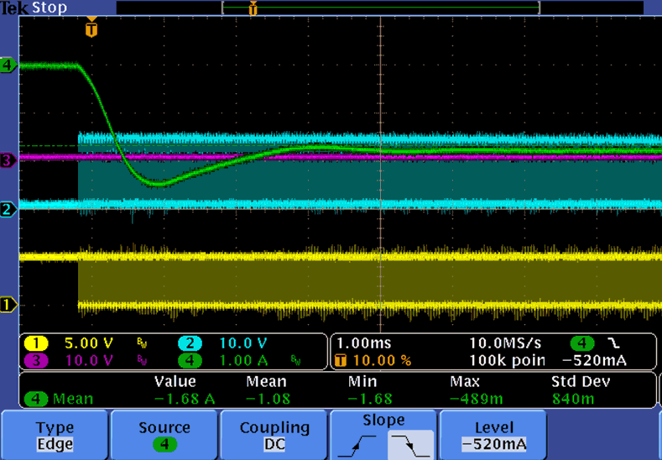

Figure 9 - Controller response to the current step of 0 A to 2 A in current mode regulation. Channel 1 show the 5 V PWM pulses at the inputs of the optocoupler U6, channel 2 shows the 15 V PWM pulses at the outputs of the gate driver U1, channel 3 shows the FAULT signal of optocoupler U7, and channel 4 shows the filtered current through the heated tube.

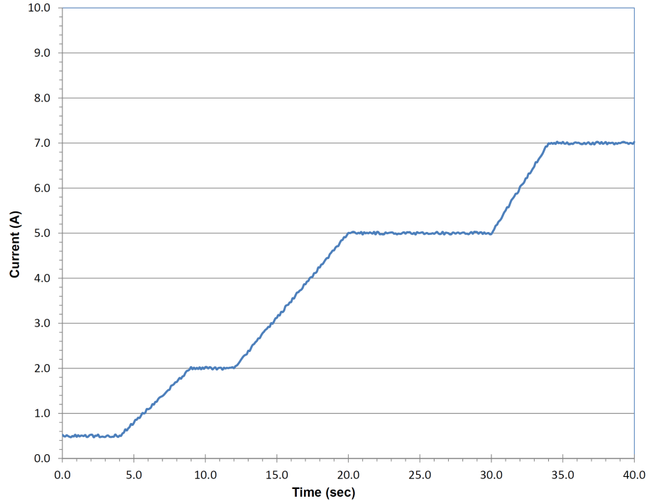

Figure 10 – A current profile graph that represents the tube’s current over 40 seconds.

Amirav’s group rigorously tested the analytical capabilities of the system [21]. The Open Probe Fast GC was mounted on a standard Agilent 7890 GC with an Agilent 5977A MS. The system yielded a 30 s separation and 50 s full analysis cycle-time for tetrahydrocannabinol and cannabinol compounds in Cannabis flower, while providing quality mass spectra that can be used for library identification, as seen in Figure 11. Also attained were a 20 s separation and 40 s full analysis cycle-time for the analysis of heroin, a 30 s process for cockroach-repellent liquid residue on a tomato, and a 40 s process for trace TNT on a human hand [11]. It also gave less than one-minute analysis time of trace trinitrotoluene transferred from a finger onto a glass surface, vitamin E in canola oil, sterols in olive oil, polybrominated flame retardants in plastics, alprazolam in Xanax, and free fatty acids and cholesterol in human blood [12].

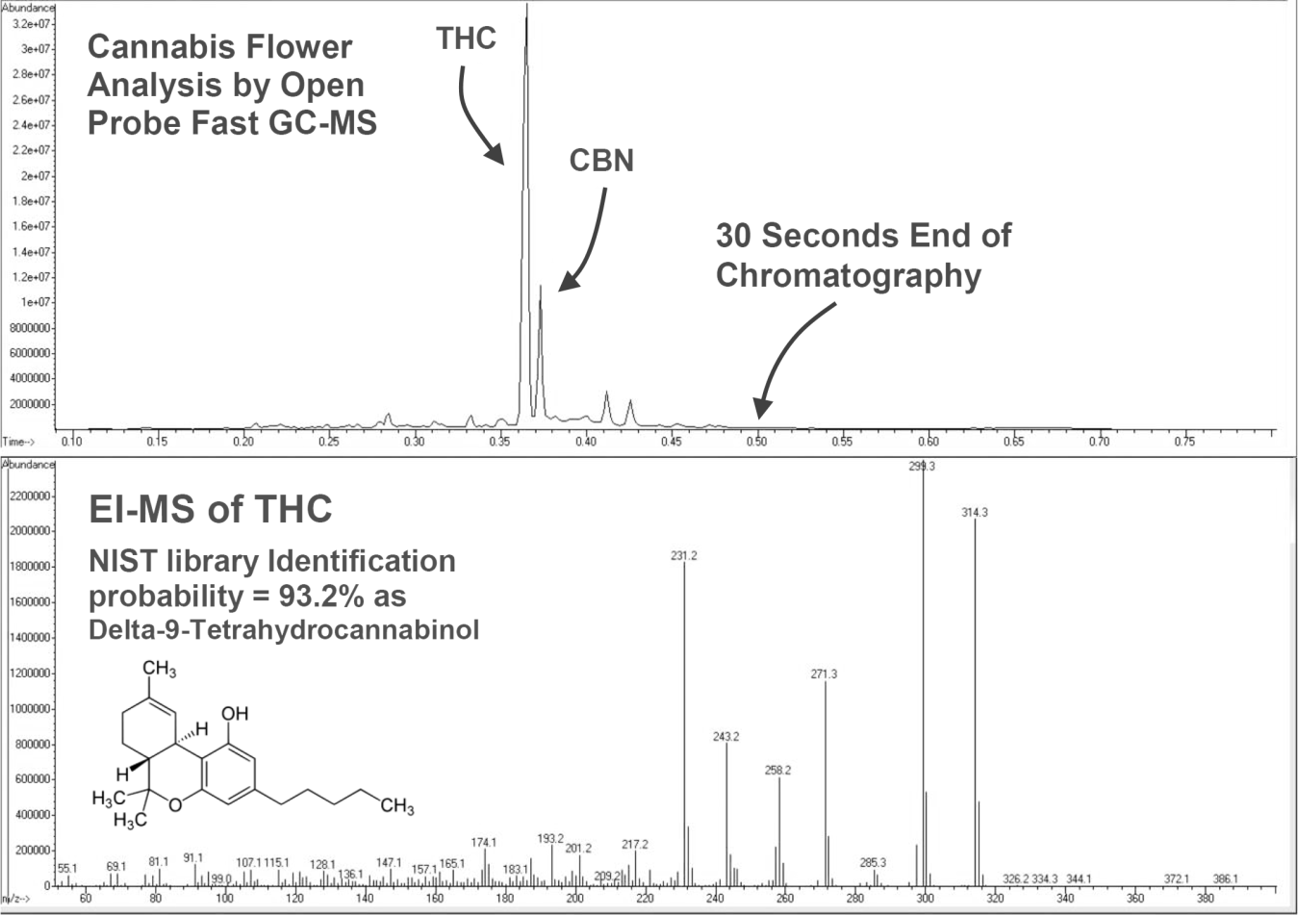

Figure 11 – Open Probe Fast GC-MS analysis of Cannabis, performed in under 30 seconds while providing NIST-library compatible mass spectra for standard quality identification.

1. **Conclusions**

In conclusion, the design principles of a programmable controller for fast GC and atmospheric pressure real-time open probe have been demonstrated, using a digital signal processor to control the smart and fast resistive heating. The instrument provides real-time analysis with a chromatographic separation and mass spectral library identification for the first time, all with unparalleled analysis cycle times.

1. **Acknowledgments**

The authors are grateful to Professor Aviv Amirav for his excellent advice on performing this work.

**6. References**

[1] S. J. MacDonald, D. Wheeler, “Fast temperature programming by resistive heating with conventional GCs,” Am. Lab. 30 (1998) 27.

[2] G. Frishman, A. Amirav, “Fast GC-PFPD system for field analysis of chemical warfare agents, Field,” Anal. Chem. Technol. 4 (2000) 170–194.

[3] G. Frishman, N. Tzanani, A. Amirav, "Electrolyzer operated gas cylinder free GC-FID,” Field. Anal. Chem. Technol. 5 (2001) 107–115.

[4] D. Malan, S. J. vanderWalt, and E. R. Rohwer, “A high-repetition-rate, fast temperature-programmed gas chromatograph and its online coupling to a supercritical̀ fluid chromatograph (SFC×GC),” Rev. Sci. Instrum. 91 (2020).

[5] E. Matisova, M. Domotorova, “Fast gas chromatography and its use in trace analysis,” J. Chromatogr. A 1000 (2003) 199–221.

[6] D.-W. You, Y.-S. Seon, Y. Jang, J. Bang, J.-S. Oh, K.-W. Jung, “A portable gas chromatograph for real-time monitoring of aromatic volatile organic compounds in air samples,” J. Chromatogr. A 1625 (2020) 461267.

[7] M. D. Chopra, P. J. Müller, J. Leppert, M. Wüst, P. Boeker, “Residual solvent analysis with hyper-fast gas chromatography-mass spectrometry and a liquid carbon dioxide cryofocusing in less than 90 s,” J. Chromatogr. A 1648 (2021) 462179.

[8] M. S. Klee and L. M. Blumberg, “Theoretical and Practical Aspects of Fast Gas Chromatography and Method Translation,” J. Chroma. Sci. 40 (2002).

[9] M. Fischer, S. Wohlfahrt, J. Varga, G. Matuschek, M. R. Saraji-Bozorgzad, T. Denner, A. Walte, and R. Zimmermann, “Optically Heated Ultra-Fast-Cycling Gas Chromatography Module for Separationof Direct Sampling and Online Monitoring Applications,” Anal. Chem. 87 (2015) 8634−8639.

[10] Y. Zhanga, D. Wua, X. Yana, K. Dinga, Y. Guan, “Integrated gas chromatography for ultra fast analysis of volatile organic compounds in air,” Talanta 154 (2016) 548–554.

[11] A. Amirav, U. Keshet, T. Alon, A. B. Fialkov, “Open Probe fast GC–MS—Real time analysis with separation,” Int. J. Mass Spec. 371 (2014) 47-53.

[12] U. Keshet, T. Alon, A. B. Fialkov and A. Amirav, “Open Probe fast GC–MS - combining ambient sampling ultra-fast separation and in-vacuum ionization for real-time analysis,” J. Mass Spec. 52 (2017) 417-426.

[13] A. B. Fialkov, S. J. Lehotay, A. Amirav, “Less than one minute low-pressure gas chromatography - mass spectrometry,” J. Chromatogr. A 1612 (2020) 460691.

[14] B. J. Hopkins, V. Pretorius, “Rapid evaporation of condensed gas chromatographic fractions,” J. Chromatogr. A 158 (1978) 465–469.

[15] B. A. Ewels, R. D. Sacks, “Electrically-heated cold trap inlet system for high-speed gas chromatography,” Anal. Chem. 57 (1985) 2774–2779.

[16] M. E. Hail, R. A. Yost, “Compact gas chromatograph probe for gas chromatography/mass spectrometry utilizing short resistively-heated aluminum-clad capillary columns,” Anal. Chem. 61 (1989) 2410–2416.

[17] E. U. Ehrmann, H. P. Dharmasena, K. Carney, E. B. Overton, “Novel column heater for fast capillary gas chromatography,” J. Chromatogr. Sci. 34 (1996) 533–539.

[18] K. M. Sloan, R. V. Mustacich, B. A. Eckenrode, “Development and evaluation of a low thermal mass gas chromatograph for rapid forensic GC-MS,” Field Anal. Chem. Tech. 5 (2001) 288–301.

[19] G. Sacks, T. Brenna, “Comparison of microwave and conventionally heated columns for gas chromatography of fatty acid methyl esters,” Am. Lab. 35 (2003) 22.

[20] C. Bicchi, C. Brunelli, C. Cordero, P. Rubiolo, M. Galli, A. Sironi, “Direct resistively heated column gas chromatography (ultrafast module-GC) for high-speed analysis of essential oils of differing complexities,” J. Chromatogr. A 1024 (2004) 195–207.

[21] Open Probe Fast GC-MS - Real Time Analysis with Separation, The Advanced GC-MS Blog Journal, (2014), <http://blog.avivanalytical.com/2014/12/open-probe-fast-gc-ms-real-time.html>,