Figure legends

Figure 1. Study Design.

Figure 2. Preterm birth rate. Spontaneous preterm birth rate prior to 37, 34, 32, and 28 weeks of gestation for women in the progesterone treatment group (red) and the non-treatment group (blue).

Figure 3. Gestational age at diagnosis.

Figure 4. Kaplan–Meier plot. Survival analysis showing the probability of patients continuing pregnancy without spontaneous delivery, by days from the cervical length measurement to delivery, for the progesterone treatment group (red line), and the non-treatment group (blue line). Progesterone reduces the risk of spontaneous delivery prior to 37 weeks with an adjusted hazard ratio (aHR) of 0.60 [0.40–0.89] (p = 0.011); and prior to 34 weeks with an aHR of 0.33 [0.15–0.73] (p = 0.006). Adjustments were performed for maternal age, cervical length, gestational age at diagnosis, threatened labor, and preterm birth history.

Figure 1. Study Design

Excluded: 115
Missing data (n = 8)
Previous progestogen treatment (n = 55*)
Cervical cerclage (n = 20*)
Medically indicated preterm-birth (n = 38)
Delivery the day of cervical length measurement (n = 1)
3,871 women with cervical length measurements between 24 + 0–33 + 6 weeks during the study period
643 women with cervical length of ≤ 25 mm
3,228 women with cervical length > 25 mm
528 women included in the study population
186 received micronized progesterone
342 did not receive micronized progesterone

* Seven women received a combination of cervical cerclage and vaginal micronized progesterone treatment.

Figure 2. Gestational age at diagnosis

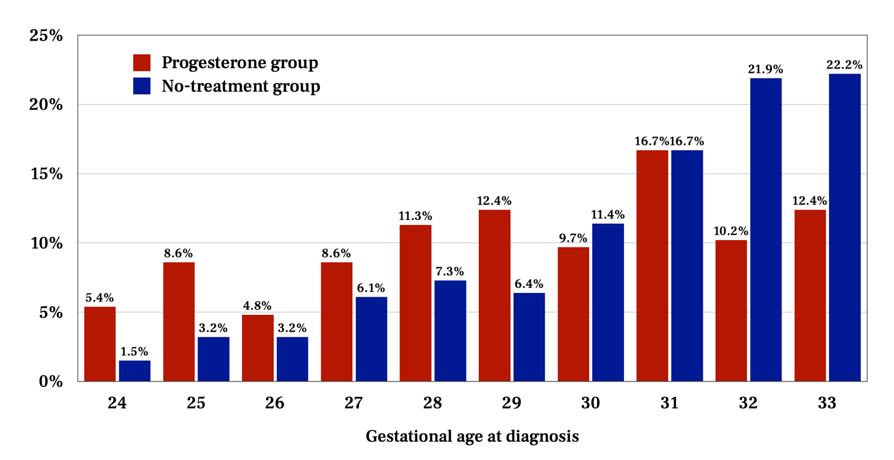

Figure 3. Preterm birth rate

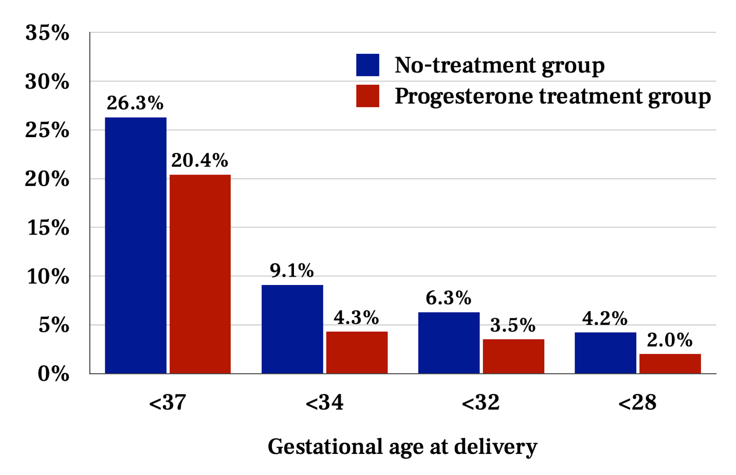

Figure 4. Kaplan–Meier plot

