**Figures**

Procedural

Justice

H4 (Mediation)

H6 (Moderated mediation)

H2

Waiting Duration

Information

Aggression

H3

H5

H1

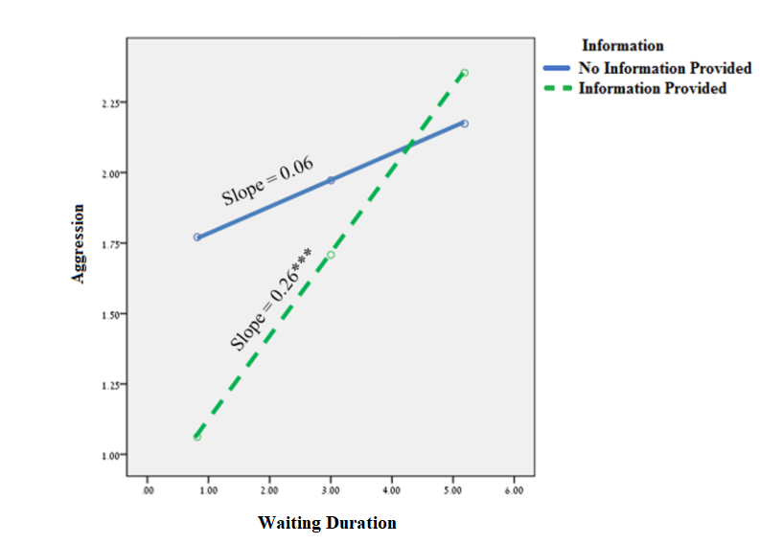

Waiting Duration

Information

Procedural justice

Aggression

β = -0.24***

β = -0.14*

β Direct effect = 0.06

β Indirect effect (mediation) = 0.04* [0.01, 0.08].

β Wait time × Information = 0.02*

β Indirect effect (moderated mediation) = 0.03* [0.01, 0.07]. \**p* < 0.05, *** *p* < 0.001