The Rich Get Richer and the Poor Get Poorer:
Investors in Biotechnology Firms Behavior Post-IPOs

Tiran Rothman
WIZO Academic College, School of Management,
Haganim 21, Haifa, 31090
Israel
tiran@wizodzn.ac.il

Smadar Siev
Ono Academic College, Faculty of Business Administration, Haifa Campus.
Port Gate Building, Port 32, Haifa, 3303201
Israel
smadar.siev@gmail.com

Corresponding Author:
Smadar Siev
smadar.siev@gmail.com

This research did not receive any specific grant from funding agencies in the public, commercial, or not-for-profit sectors.

The Rich Get Richer and the Poor Get Poorer:
Investors inpost Biotology Firms Behavior Post-’ IPOs
Tiran Rothman and Smadar Siev

Abstract
This paper analyzes stock price behavior patterns after initial public offering (IPO) events in the biotechnology sector and explores the role of social media in determining these patterns. Our main results indicate positive and significant cumulative average abnormal returns (CAAR) of 3.70% in the first 20 days following an PO, ntil the end of quiet period,)and a decline of tens of percent overithe followingsthree3years. However, when dividing the sample into two subsamples according to firm size, using a separation market value of u$00 millionas he overall picture changes dramatically. F: -s with a market value lower than $500 millionM yelded a positive yet not significant CAAR 20 days post- IP and a significantn igative sigR from day 50. anrms with a market value higher than $500 millionM$ periencedpresesitficant positive CAAR from day 20 after the IPO and throughoutdurinfollowingconse. These findings can be attributedWe rehe limited attention of investors’ limintion tofor thew IPOs increasesarises the end of quiet period and, in the case of small-sized firms, then shes duringin theo small spears. An exmination ofObserving social mshare returns, demonstrateswe se a robust coion between the two, which may indicate that investors’ attention to these firms is also reflected in social media.

Keywords: IPO; pharmaceutical companies; financial markets; social media; behavioral finance

JEL Classification: D8 (Information, Knowledge, and Uncertainty); G11 (Portfolio Choice; Investment Decisions); G14 (Information and Market Efficiency; Event Studies); G17 (Financial Forecasting and Simulation).

1. Introduction
The biotechnology sector is fuelled by entrepreneurship, technology, science and finance. thile technology and science are relatively accessible for artrepreneurs, finding is more challenging to find. The “‘nw world”’ ompanies theking to develop one or morefedugs havrted to emerge a decade ago when technology became less expansive. Most of these companies do not have tangible assets and their operational risk is relatively high, making it difficult to find and securefinHence, issue hault, we witnes number of biotech companies are that seekto aise public capital throughout IPOs.

1.1 Focus of the Study
This paper focuses on the “new world” of biotech firms that are traded in U.S. market. The first part of the paper examines how the new Jumpstart Our Business Startups Actr(JOBS ActC,has influenced investors’ activity during the three years post- PO as reflected in the cumulative average abnormal return (CAAR).

The orientation of the second part of the paper is behaviouristic, identifying correlations between investments patterns and investors’ activity on social media. The decision-making process of participants in financial markets is not always rational and is often influenced by motives other than risk and return, such as the perceived quality of a firm. One of the channels for shaping investors’ perceptions is posts published about a firm through social media channels, from online message boards to Facebook and Twitter. We chose to focus on Twitter, as it enjoys increasing popularity and because tweets are characterized by non-scrutinized, unstructured, informal and very short texts.

In a world where there is almost an endless amount of available information, firms’ competition for investors' attention has become fiercer than ever. We were therefore interested in exploring how the discourse level of Twitter comments, without any potentially controversial evaluation of their content, and the short-term and long-term main capital market variables in td long-term fPO mutualyuence each other.the mutual influence between the

  - IPO Relevant Legislation
The public offering process is divided into four main regulatory periods. The first, pre-IPO stage refers to the pre-filing period that begins when the company chooses an underwriter and ends when a company files a registration statement with the U.S. Security and Exchange Commission (SEC). This is deemedDthe first “quiet period” during which the companyais subject to restrictions on public disclosure relatedino the offering. During this pre-filing period, nofers cannot be made, prospective purchasers cannot be contacted and the identity of underwriters cannot be publicly disclosed. Te second regulatory period begins when the registration statement is declared effective atfole end of the pre-filing waiting(2) The pre- ends ws second period, the company may, for the most part, generally mffers. However, the company is prohibited from engaging in; sales of isthe securitiend from entering into bindingbindin ents to sell the offered security. During the third, or post-IPO period, also designated the second quiet period and which lasts for 25 days, shares in the company can be freely sold if they are accompanied are prohibites. After this second quiet period ends,The period endor broker-dealers are no longer required to deliver a prospectus and they can underkerearch coverage on the company and its shares.publish share covern tourt (4) -up period, when mreholders are prted from selling their shares. Lock-up periods usually last between 90 to 180 days after the IPO. Once the lock-up period ends, most trading restrictions are removed.
Another relevant legislation to our study is the JOBS Act that was enacted in the United States in April 2012. The Act has altered the new world environment, establishing, inter alia, a new process of disclosures for public offerings by a new class of companies referred to as emerging growth companies (EGCs). According to SEC regulations, an EGC is defined as a company which first sold its equity in a registered offering after December 8, 2011, and which has total gross annual revenues of less than $1 billion during its most recently completed fiscal year. The Act was designed to boost job creation by giving smaller companies access to the capital needed to expand their businesses. Companies that qualify can file draft IPO registration statements confidentially with the SEC. They are also able to file two years of audited financial statements instead of three, to delay compliance with the Sarbanes-Oxley Act requirement for auditor opinions on internal controls, and to delay implementation of new or revised accounting standards. Even more significant is the newly permissible use of “test-the-waters” communications with qualified institutional buyers and institutional accredited investors. Thus, EGCs are allowed to reach qualified institutional buyers before the lock-up period ends.
Below is a general description of IPO regulation periods:
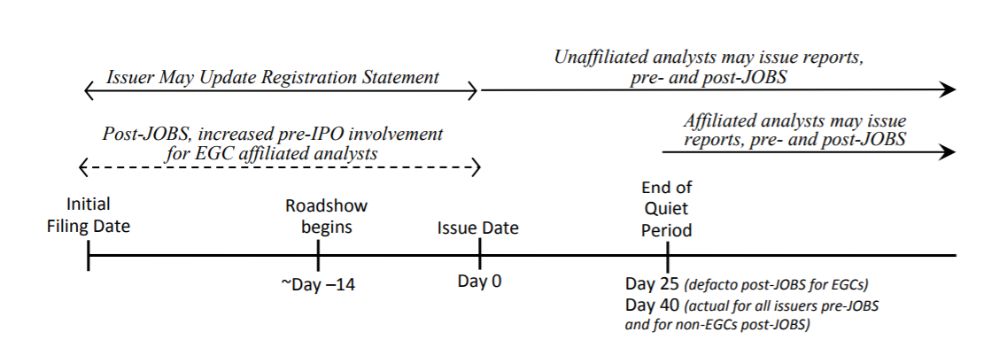

1.3 IPO and Stock Performance
While numerous issues involving IPOs have been widely studied, those most relevant to our study address share performance up to three years following the IPOs. Jain and Kini (1994) showed low performance of IPOs for up to three years after the offering, and Loughran and Ritter (1995) reported that IPO stocks yielded an average of 5% over a one-year post-IPO period, compared to 12% for a comparably-sized non-IPO benchmark. In a seminal paper, Ritter and Welch (2002) investigated the long-term performance of IPOs and found that the three-year average market-adjusted return on IPOs was a negative 23.4%. In contrast, a study conducted by Goergen et al. (2009) on IPOs in France and Germany issued during the period 1996–2000 found no significant abnormal returns. In one of Ritter’s latest studies, Chang et al. (2017) found that applying a simple buy-and-hold strategy for three years after the purchase of one share of every company issuing an IPO between 1980 and 2015 would yield an 18.7% decline in value, with shares of technological firms exhibiting even greater declines. esearchers have also been puzzled about declines in returns close to the expiration of IPO lock-up periods,Thnd somea fudies have concluded that the market reacts negatively to tock-up periods expirations. The research of Ofek (2000), conducted in the United States from 1996 through 1998, Ofend an abnormal negative return during this period as well as a. I to a 3drop in the stock price, and a 40% increase in volume 180 days after theposO. Examining IPOs in the United States from 1988 through 1997, Fiedley et al. (2001,) aav and Gompers (2003), and Field and Hanka (2001) all observed negative abnormal returns of approximately. 2 near the time of the lock-up period’s expiration.aro

1.4 Media and Stock Performance
According to Merton (1987), the most common way to boost investors' awareness is to promote the visibility of the firm through the media. Shiller (2000) wrote:
The role of the news media in the stock market is not, as commonly believed, simply as a convenient tool for investors who are reacting directly to the economically significant news itself. The media actively shape public attention and categories of thought, and they create the environment within which the stock market events we see are played out.

Shiller (2000) found that extra media coverage draws investors’ attention to these stocks. This leads to a positive feedback effect, in which big returns are followed by more big returns because of increased media coverage. In contrast, Fang and Peress (2009), who analyzed the effect of the media coverage magnitude on stock returns in the U.S stock market,.found that a portfolio of stocks not covered by the media outperformed a portfolio of stocks with high media coverage by 3% per year following portfolio formation. In their view, the “"o media premium”"may stemsfrom limitations on trading or totcompensation for little or lack of information.

Bhattacharya at, et al. (2009) explored the role of the media in the internet IPO bubble between 1996 and 2000. They found that media coverage was much more intense for internet IPOs: there were more total new items, more good news and more bad news for internet IPOs than for a matching sample of non-internet IPOs. They found that the media intensified their coverage of good news for internet IPOs in the bubble period and intensified their coverage of bad news for internet IPOs in the post-bubble period. The effect on daily abnormal returns, which was lower for internet IPOs, especially during the bubble period, indicates that the market largely discounted the media hype., tTh

Siev (2014) also documented a gap in stock returns between firms publishing a low number of press releases (PRs) and those publishing a high number of press releases, with the former enjoying higher returns. This gap (PR Premium) was found for both the year in which the PR was published and the year following, with a magnitude of 7–8% and 5–6%, respectively. The analysis also indicated that the average daily trading volume of firms with a high PR volume was three times higher than that ofwfirms with a lLw PR volume. The difference in trading volume supports the hypothesisnthat perceived company image can influencebfinancial trading activity. Applying the same logic, firms that enjoyha high level of public attention due to a much higher volume of annual PRs get moticed more, which leads to overpricing, which can ultimately yield lower returns.

In addition to the information generated by the firms and the press, discussed in the previous section, firm-related information is also disseminated by the investment community using online social media.
One of the earliest studies conducted about internet stock messages boards was that of Wysocki (1998), which examined what characterizes firms whose stocks receive the highest volume of posted messages. He found that the most attention-grabbing firms were characterized by: extreme returns, either high or low; high market value; high price/earnings (P/E) ratio; high book-to-market ratio; high volatility; high trading volume; and high analyst coverage. Wysocki (1998) also found that an increase in overnight message postings led to a positive abnormal return and an increase in trading volume on the next day. Studies on the online sScial networks effect, such as that of Antweiler and Frank (2004), found adairect correlation etween iaternet message board activity on one hand, andsstock volatility and trading volume on the other. The authors determinedfthat,when many messages wereaposted on a given day, there wai a negative return on the next day. Das and Chen (2007) found a negative correlation between changes in the numberaof messages and changes in the contemporaneous stock prices. According to Chen et al. (2014), the views expressed in both articles and commentaries posted on a popular social media outlet predicted future stock returns foria period of three months after their publication.

Other studies examined blog posts to predict stock market behavior. Gilbert and Karahalios (2010) used over 20 million posts from the LiveJournal website to create an index of the national mood in the United States,Uwhich they call the Anxiety Index. They found that when this index rose sharply, the S&P 500 Index ended the same day marginally lower than was expected.

In their initial work, Zhang et al. (2011) analyzed a sample of Twitter posts for six months on a daily basis to measure collective fear and hope ExaminingTwhether these collective emotions aorrelated with major stock indices in the U.S. market, the authors.found that “emotional tweet percentage significantly negatively correlated with Dow Jones, NASDAQ and S&P 500, but displayed significant positive correlation to VIX.” Forbergskog and Blom (2014) demonstrate that the positive and negative sentiment extracted from tweets couldcpredict both positive and negative S&P 500 returns the following day.bFurthermore, Sul, et. al. (2014) showeddeove that sent polarities extracted from tweets are positiveorrelated with intraday returns of the S&P 500, and Twitter users with more followers had greaterahave strongn the returns. Liew and Wang (2016) documented a contemporaneous relationship between IPOs’’ tweet sentment and returns in the first trading day. In addition, they found that prior days Ient in the days preceding the IPO could predict thecan predict IPO’s eturns from opening price to closing price.

2. Stock Behavior Post-IPO
2.1. Research Goals and Hypotheses
As described above, the period after an IPO is priced and first opens for trading is its second quiet period, during which the company’siaffiliated analysts or underwriters are not allowed to publish any research about the company. duinsequently, the stock rades as an “uncovered”’ stock. it does so as an "ncovereriod is quiet important, as outside coverage can then be launched, which could have a significantis important as coverage of The duration of the quiet period has changed over the years, and recently the SEC recently has sho to 10 days. Howe the vast majority of investment banks still observe the 25-th day rule, so that outside covegecommences, i.e. coverage starts 25 days afteri thricing. Our goal was to intigate CAAR behavior from the IPO date to the end of the quiet period and thereaftersubsequentlyafterwards.

Thus, it can be expected to see an upward trend in CAAR during the quiet period and a downward trend after the quiet period ends. An increase in CAAR is expected due to the natural hype immediately following the IPO. The later downward trend can be explained, in part, to the publishing of numerous reports about the company or its sector and future forecasts by affiliated analysts. Dividing the sample into two subsamples according to firm size, we expect to observe better performance among large-sized firms because l:rge-sized irms are likely to have more experience, morehavailable resources and a igger products ortfolio. The presence of these factors is likely to enhance a sarge firm’s' otential for future success as well as to attract greater attention fromgrnvestors’ We formulated tFo following hypotheses to reflect these expectations:

H1: Quiet Period: Stock’s return until the end of the quiet period:
The natural hype from the new IPO will yield positive CAAR from the IPO date until the end of the quiet period.

H2: Quiet Period: Stocks return post-quiet period:
As new information arrives to the market due to the end of the quiet period, and as the initial hype diminishes,dimiial e stwillexperience is reflected in

H3: stok returns and market capitalization:.
Large-sized firms are likely to perform better than small-sized firms, due to their higher potential for future success and their greater share of investor attention.

2.2 Data and Method
Our initial database consisted of all biotech companies that issued IPOs in the period from January 2013 to November 2017. Data was extracted from the EvaluatePharma database and consisted of 283 companies. We focused on companies traded in the United States, thus excluding firms traded on non-U.S. stock exchanges. We also excluded firms that became private or were merged into or acquired by others from the time of the IPO until three years following thedIPO. Our final database consistedsof 182 firms. Table 1 displays the number of IPOs per year in our final database.

Table 1: IPOs per year
Year | No. of IPOs
2013 | 30
2014 | 70
2015 | 49
2016 | 29
2017 | 4
Total | 182

Note: This table presents the number of IPOs per year in the final database.

A prominent feature of the firms in our sample is their relatively low market capitalization, as can be seen in Table 2. The average market value is $454.2 million and the median market value is $287.1 million.

Table 2: Market Value as of December of the IPO Year ($million)
Average | 454.2
Median |  | 287.1
Min. | 1
Max. | 2,346.7
Std. Dev. | 494.4
Observations | 182

Note: This table presents descriptive statistics of the firms’ market capitalizations.

The event study approach was employed to examine market reaction to IPO events. The actual date of the IPO was marked as t=0 and the daily stock prices extracted from the NASDAQ website and Yahoo Finance were applied for the period t= 0,..,755 (three years post-IPO), to calculate daily logarithmic returns. Two return benchmarks were utilized: the IXJ Healthcare Index, and the S&P 500 Market Index. The Cumulated Average Abnormal Return (CAAR) was calculated by subtracting the benchmark returns from the stock return. As no stock prices exist prior to the IPO, conditional return using the market model was not calculated. Due to the low average market value of $454.2 million (Table 2), we sought to explore the difference in CAARs in relation to firm size. Consequently, we divided our database into two subsamples of small and large firms and calculated the CAAR for each of them. The average rounded market value of $500 million was chosen as a threshold to differentiate between small-sized and large-sized firms.

In addition, normalized trading volumes were computed as a proxy for market attention. For each firm in our sample, the natural logarithm of the daily trading volume throughout the period t=0,.., 755 was recorded, and each observation was normalized by subtracting the mean and dividing by the standard deviation calculated over the period. Then, the average across all firms for each day relative to the IPO date was calculated.

2.3 Results
The CAAR results for selected time periods during the three years post-IPO are presented in Table 3. Panel A presents the results for the entire sample. Panel B presents the results for firms with a market capitalization ≤ 500M$ (70% of the sample), or small-sized firms. Panel C presents the results for the firms with a market capitalization higher than $500 millionM(30% of the sample), or large-sized(firms) Results are shown for the two benchmarks of -arket and sector indices. As the CAAR results relative to the two benchmarks are similar, reference will be made wnly to the tector index benchmark Figure 1, Panels A– panels A to C descry CAAR and normalized trading volumes for the entire sample of, small-sized and lrge-sized firs. respectively.

As shown in Panel A of Ttble 3, the CAAR that washcalculated for the first 20 trading days post- IO is positive, significant, and equals 3.7% (t = 2.18). These results support our H1 hypothesis. After 20 trading days, performance began to decrease, aiminishing significantly around the 50th trading day, with. AAR = 0.26% (t = 0.09). P,e hundred- 10ding days post-IPO, CAAR = - 7.11% (t= -1.68); 200 trading days post- IPO, AAR =is -207% ( t= -3.42) ; 250trading days post-IPO CAAR =is -21(t = -3.18); after ars (550 trading days) post-IPO, CAAR =is -503% ( t= -4.92); and after years (75 trading days) post-IPO, CAAR =is -70.66% = -5.54). Panel A in Figure 1 shows, proves thecline was consistent from day 20 onwards. These reults are consistent within line wititerature and support our H2.
With respect to small companies (Table 3, Panel B), CAAR for the first 20 trading days post-IPO was positive yet not significant, with CAAR = 1.44% (t = 0.92). Fifty trading days post-IPO, CAAR was negative and significant, at -5.12%, (t = -1.64); 100 trading days post- IPO, CAAR was
-15.63%, (t = -3.35); one year post-IPO, CAAR was negative, at -33.72% (t = -4.45). Panel B in Figure 1 shows that the decline started on day 25 and continued consistently from that point onward. The results for large firms (Table 3, Panel C) reveal a completely different picture. After 20 trading days, CAAR was positive and significant, with CAAR = 9.1%, (t = 2.19); after 50 trading days, CAAR = 13.0%, (t = 2.26); after 100 trading days CAAR = 13.1% (t = 1.73). One year after the IPO, CAAR = 9.1% tt = 0.83). The refined picture of daily CAAR is presented in onanl C of Figure 1. CAAR reaches its peakpic 15.76% on day 165 post-IPO at begins to decline from that point until it disappears startetely 596 days post- IPO. nother prominent finding is that large firms’' CAARwas much more volatile than small firms’' CAAR

Specifically, investors’ activity post-IPO differs according to the firm’s size. Small-sized firms exhibited negative CAAR in the first year post-IPO and large firms exhibited positive CAAR in the first year post-IPO. These findings support our H3 hypothesis.

Table3: Post-IPO CAARs, +1 to +755 days
Panel A: The Entire Sample
Days Relative to Event | Deviation from Market Index |  | Deviation from Sector Index
Days Relative to Event | CAAR, % | t-stat. | CAAR, % | t-stat.
1 to 10 | 0.58% | 0.47 | 0.50% | 0.38
1 to 20 | 3.88% | 2.35 | 3.70% | 2.18
1 to 50 | 0.60% | 0.19 | 0.26% | 0.09
1 to 100 | -6.83% | -1.54 | -7.11% | -1.68
1 to 150 | -12.17% | -1.96 | -12.84% | -2.42
1 to 200 | -19.75% | -2.76 | -20.57% | -3.42
1 to 250 | -19.80% | -2.58 | -21.00% | -3.18
1 to 550 | -54.05% | -4.92 | -50.33% | -4.92
1 to 755 | -77.45% | -5.77 | -70.66% | -5.54
Observations | 182 |  | 182

Panel B: Small-Sized Firms (market cap < $500 million)
Days Relative to Event | Deviation from Market Index |  | Deviation from Sector Index
Days Relative to Event | CAAR | t-stat. | CAAR | t-stat.
1 to 10 | 0.12% | 0.10 | 0.09% | 0.07
1 to 20 | 1.57% | 1.04 | 1.44% | 0.92
1 to 50 | -4.89% | -1.22 | -5.12% | -1.26
1 to 100 | -15.61% | -2.93 | -15.63% | -2.92
1 to 150 | -23.41% | -2.93 | -23.79% | -2.99
1 to 200 | -33.56% | -3.67 | -34.12% | -3.74
1 to 250 | -32.60% | -3.35 | -33.72% | -3.49
1 to 550 | -77.32% | -5.56 | -73.48% | -5.30
1 to 755 | -101.50% | -5.97 | -92.61% | -5.47
Observations | 128 |  | 128

Panel C: Large-Sized firms (market cap > $500 million)
Days Relative to Event | Deviation from Market Index |  | Deviation from Sector Index
Days Relative to Event | CAAR | t-stat. | CAAR | t-stat.
1 to 10 | 1.69% | 0.52 | 1.45% | 0.44
1 to 20 | 9.35% | 2.30 | 9.06% | 2.19
1 to 50 | 13.63% | 2.38 | 13.01% | 2.26
1 to 100 | 13.97% | 1.85 | 13.08% | 1.73
1 to 150 | 14.48% | 1.60 | 13.12% | 1.44
1 to 200 | 13.00% | 1.27 | 11.55% | 1.14
1 to 250 | 10.51% | 0.95 | 9.14% | 0.83
1 to 550 | 1.51% | 0.10 | 4.92% | 0.31
1 to 755 | -19.54% | -1.03 | -12.10% | -0.64
No. of firms | 54 |  | 54

Note: This table displays Cumulative Average Abnormal Return for the entire sample and the two subsamples of firms with market valuations below $500 million (Panel B) and above $500 million (Panel C) as of December of the IPO year.

Figure 1: Post-IPO CAARs, +1 to +755 days
Panel A: The Entire Sample
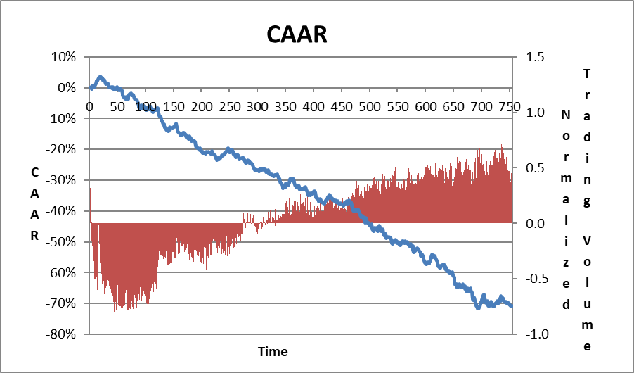
Panel B: Small Firms (market value < $500 million)

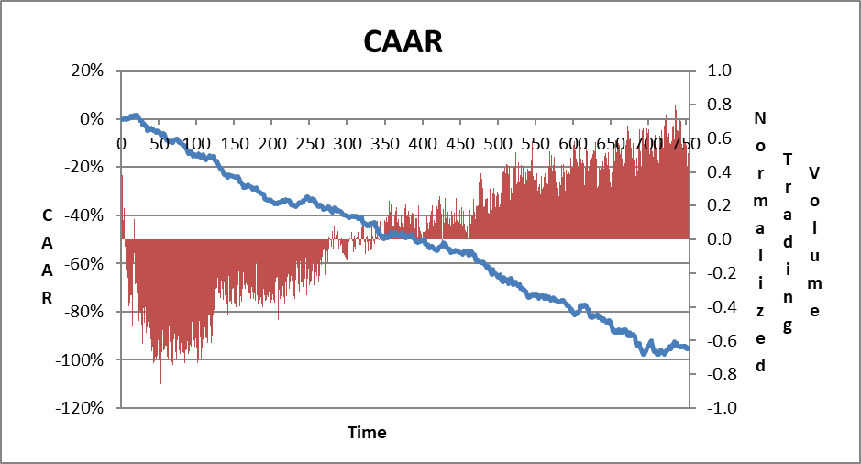

Panel C: Large Firms (market value > $500 million)

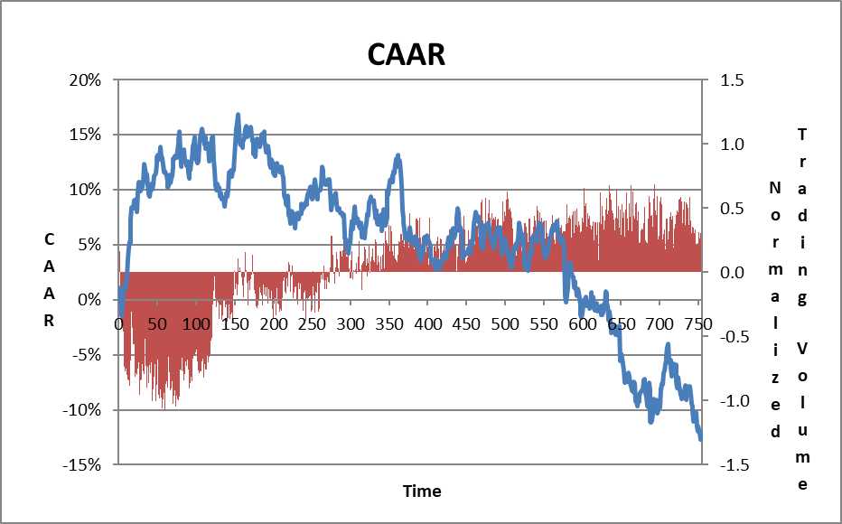

Note: These figures present daily CAAR after the IPO from day 0 to day 755. Panel A presents CAAR for the entire sample.. ; pl B presents CAAR for small firms and Ppanl C presents CAAR for large firms . AAR was calculated relative to verssector index.

In terms of trading volumes, the IPO day was characterized by the highest trading volume during the entire three-year post-IPO period. On the ,econd trading day, trading volumes decreased substantially and from that point an, trading volumes showed an increasing growthetrend over time .or both small and large firms.(sSe Ffgure 1, P nels A to. Acomparison ofCompding volumes between small-sized largearge-sized small reveal that in the first 20 trading days post-IPO,, therading volume of small-sized size fias twice thatn of lage-sized size fi Durin the three years following the IPO, there wasis no aantage for small or large firms with respect to trading volume(large)he time, the trading volume of small firms exceededs that he trge firms and vice versa.

Investors’ activity on the Twitter social media platform before and after the IPO will now be examined. We explore the correlation between Twitter volume and stock returns. In addition, based on the results above, we look at the relation between the firm size and the Tweet volume, analyzing, inter alia, whetherdfirms use social media as a tool to promote a successful IPO.?

3. Social Media and IPOs
When considering the volume of tweets as a reflection of the level of attention a firm has attracted, it should be noted that the volume of tweets has been weighted relative to the tweet volume of other firms. As a result, even a low tweet volume can stand out in an environment where comparable firms have a lower volume or no tweets at all, thereby creatingecreimpact, perhaps even similar to that of to irm with very high tweets voume in an environment of high tweets voumes. Therefore, the mereThatber of tweets itself is often meaningless; the numberit bomes more meaningful only when compared with others in the comparable sectorsegmr that reason, we cnumber of tweets above and below the median for each year relative to the IPO have been characterized as High Twitter Volume (HTV) and Lo Twitter Volume (HTV respectively.
3.1 Research Goals and Hypotheses
Our goal was to analyze the correlations and possible causality between the annual volume of tweets about a firm and that firm’s main capital market variables. The expectation was that a positive relationship would be found, so that large-sized firms with high trading volumes and high returns would increase investor interest, which would be Weflected in a higher volume of tweets, and, conversely, thatahigher volumes of tweets would draw investors’ attention, which would be reflected in higher market activity..In addition, it was expected to find causality between the annual volume of tweets about a firm and that firm’s returns, so that. high volume of tweets in a given period wouldwiave positive impactefn returns in the ensuingfobsequen

We formulated the following hypotheses to reflect these expectations:

H4: Correlation: There will be a positive correlation between Twitter volume and capital market variables: risk, returns, trading volume and market capitalization.

H5: Causality: a: There will be a positive causality between the annual volume of tweets
about a firm and its and returns.
causality between the volume of tweets a firm
receives in periods of less than one year, or one week,/two weeks and
one month) in the period prior to the IPO and returns in parallel periods post-
IPO.

3.2 Data and Method
For each firm in our sample, we downloaded its related tweets using Python programing, starting from the calendar year preceding the IPO day and up to three calendar years post-IPO. We extracted all tweets containing: full company name, price, and the firm’s ticker symbol, as well as the company's Ttitter user name if there was one, e.g. "@chimerix" for Chimerix. Next, we hxcluded all the unrelated tweeis in which the company name appeared in a non-company context, such as “Adam Kadmon” for Kadmon. Our Ttitter database consistedsof daily tweeis for each company and contained over 1.5 million tweeis. Table 4 displays descriptive statistics regarding the annual tolume of tweets.
Table 4: Volume of Tweets: Descriptive Statistics
 | IPO Year-1 | IPO Year | IPO+1 Year | IPO+2 Year
Average | 359 | 2,237 | 3,083 | 3,558
Median | 246 | 1,524 | 2,377 | 2,326
Std. Dev. | 377 | 2,690 | 2,978 | 3,976
Min. | 0 | 0 | 197 | 15
Max. | 2,035 | 26,126 | 20,022 | 27,579
No. of Tweets | 65,349 | 407,067 | 548,815 | 542,232
No. of firms | 182 | 182 | 178 | 147

Note: This table presents Twitter volume descriptive statistics for one year before the IPO up to two years post-IPO.

Two main findings emerged, as presented in Table 4. First, the average annual number of tweets increased over the years, from 359 during the year preceding the IPO, through 2,237 tweets during the IPO year and up to 3,558 tweets two years after the IPO. The second notable observation is the huge variance in the annual volume of tweets among the firms. For example, in Adverum Biotechnologies’ IPO year, it had zero tweets, while Juno Therapeutics had over 26,000 related tweets in its IPO year. The growing number of annual tweets reflects both the growth in Twitter's popularity and the increased interest in firms over time.

To explore the correlations between the volume of tweets and capital market variables, we employed both univariate and multivariate analysis. In the univariate analysis, we calculated several capital market variables for each firm in our database and compared the average of these variables between the LTV and HTV groups. The compared variables were: Return (t), the rate of return on a firm's stock at period t; Trading volume (t), a firm's daily average trading volume at period t; and Std. Dev. (t), the standard deviation of daily returns calculated over the period and used as a proxy for total risk. Beta is a proxy for systematic risk coefficients. Estimations, were made from the market model regression on the S&P 500 Index returns using the first 50 trading days after the IPO and therefore is displayed for the year of the IPO only. Market value (t) was calculated as the number of shares for December of that year multiplied by the stock price of that day.

The multivariate analysis employs two sets of ordinary least squares (OLS) linear regressions to analyze the contemporaneous relation between annual volume of tweets and the annual returns and abnormal returns. The regression equations were:

$$\begin{aligned}\text{Re}\text{turn}({\text{IPO}}_{\text{year}}+t)=β_{0}+β_{1}∗\text{Beta}+β_{2}∗\text{HTV}({\text{IPO}}_{\text{year}}+t)+ \\ β_{3}∗Y\text{2013}+\text{.}\text{.}\text{.}+β_{6}Y\text{2016}+β_{7}∗\text{NMV}({\text{IPO}}_{\text{Year}}+t)\end{aligned}$$
(2)
$$\begin{aligned}\text{Abnormal}\text{_Re}\text{turn}({\text{IPO}}_{\text{year}}+t)=β_{0}+β_{1}∗\text{Beta}+β_{2}∗\text{HTV}({\text{IPO}}_{\text{year}}+t)+ \\ β_{3}∗Y\text{2013}+\text{.}\text{.}\text{.}+β_{6}Y\text{2016}+β_{7}∗\text{NMV}({\text{IPO}}_{\text{Year}}+t)\end{aligned}$$
$$∀0<t<2$$

Explained variables were returns and abnormal returns. The abnormal return was calculated relative to two benchmarks: The S&P 500 Index and the IXJ index. Explanatory variables were: Beta; HTV as a dummy variable that receives 1 for companies with a high volume of tweets and 0 otherwise. The dummy variables for the IPO years 2013–2017 are Y2013 to Y2016, which are aimed at capturing potential influence during a given year. Normalized Market Value (NMV) was calculated by subtracting a firm’s average market value from the firm’s value and dividing by standard deviations of the firm’s size for that year.

Additional multivariate analyses employing causality tests will be detailed later.

3.3 Results

3.3.1 Univariate Analysis
Table 5 presents capital market variables’ descriptive statistics for the years of the IPO, IPO+1 and IPO+2 in Panels A, B and C, respectively. Panel D presents absolute tweet volume for small-sized and large-sized firms. Results suggest that firms that were characterized by HTV wereaalso characterized by higher risk (total and systematic), higher returns, higher trading volumes and higher market values compared to LTV firms. For example,:differences in returns reached: 7% (pPvalue = 0.08) in the IPO year, 51% ((-value = 0.001) in the following year and 29% (p-value = 0.04) in the IPO+2 year.;Trading vVlumes for the HTV firms were 2.7 - 8 times higher than for the LTV firms and mMaket value was 1.7 – times higher for the HTV firms. These results, upports ur H4 hypothesis.

Table 5: Capital Market Variables: Descriptive Statistics for HTV and LTV Firms
Panel A: IPO Year
 | LTV | HTV | Diff | P-Value of Diff.
Beta (50 Days) | 0.68 | 1.00 | 0.31 | 0.03
Return's Volatility | 0.05 | 0.12 | 0.07 | 0.14
Return | 0.05 | 0.12 | 0.07 | 0.08
Trading Volume | 94,321 | 267,332 | 173,011 | 0.00
Market Value ($M) | 322.74 | 585.66 | 262.91 | 0.00
Observations | 91 | 91

Panel B: IPO Year+1
 | LTV | HTV | Diff. | P-Value of Diff.
Return's Volatility | 0.044 | 0.057 | 0.013 | 0.001
Return | -0.15 | 0.36 | 0.51 | 0.001
Trading Volume | 162,046 | 441,602 | 279,556 | 0.000
Market Value ($M) | 418.17 | 844.56 | 426.38 | 0.001
Observations | 89 | 89

Panel C: IPO Year+2
 | LTV | HTV | Diff. | P-Value of Diff.
Return's Volatility | 0.04 | 0.06 | 0.01 | 0.000
Return | 0.00 | 0.29 | 0.29 | 0.043
Trading Volume | 244,890 | 660,862 | 415,973 | 0.000
Market Value ($M) | 493.44 | 841.79 | 348.35 | 0.017
Observations. | 75 | 72

Panel D: Absolute Tweet Vvlume per Ffrm Ssze
Absolute Tweet Volume | Small | Large | P-value of Diff.
IPO Year -1 | 310 | 474 | 0.01
IPO Year | 2,068 | 2,636 | 0.07
IPO Year+1 | 3,063 | 3,135 | 0.43
IPO Year+2 | 3,404 | 4,001 | 0.20

Note: Panels A to C present descriptive statistics of market variables for the sample firms divided into LTV and HTV firms. Panel D presents absolute annual tweet volume from one year before the IPO through two years after the IPO.

3.3.2 Multivariate Analysis
In light of the positive contemporaneous correlation found between annual tweet volume and company returns, we conducted the regression analysis as set forth in equations 1 and 2. The rRgressionsresults are displayed in Table 6. Panels A, B and C display the results for the IPO,
IPO+1 and IPO+2 years respectively.

The extended and the limited models are presented for each year. In cases that the tweet annual volume was not part of the limited model, we analyzed its contribution as an addition to the limited model and as a stand-alone variable. We presented only the autoregressive (AR) regression results relative to the sector index due to similarities between the two selected benchmarks.

Table 6: The Correlation Between (Abnormal) Returns and Tweet Volume: Regression Results
Panel A: IPO Year

 | Return |  |  |  | AR to Sector
 | Model 1 | Model 2 | Model 3 | Model 4 | Model 5 | Model 6 | Model 7 | Model 8
Intercept | 1.63 (0.00) | 1.71 (0.00) | 1.76 (0.00) | 0.07 (0.48) | 1.38 (0.01) | 1.48 (0.00) | 1.51 (0.00) | -0.05 (0.59)
Year 2013 | -1.12 (0.04) | -1.13 (0.04) | -1.29 (0.02) |  | -1.12 (0.04) | -1.13 (0.03) | -1.29 (0.02)
Year 2014 | -1.20 (0.02) | -1.21 (0.02) | -1.4 (0.01) |  | -1.11 (0.03) | -1.13 (0.03) | -1.31 (0.01)
Year 2015 | -1.94 (0.00) | -1.94 (0.00) | -2.12 (0.00) |  | -1.66 (0.00) | -1.66 (0.00) | -1.83 (0.00)
Year 2016 | -1.59 (0.00) | -1.56 (0.00) | -1.8 (0.00) |  | -1.46 (0.01) | -1.43 (0.01) | -1.67 (0.00)
Beta | -0.13 (0.03) | -0.12 (0.05) | -0.14 (0.03) |  | -0.14 (0.02) | -0.13 (0.04) | -0.15 (0.02)
NMV | 0.22 (0.00) | 0.24 (0.00) |  |  | 0.22 (0.00) | 0.24 (0.00)
HTV | 0.18 (0.20) |  | 0.30 (0.03) | 0.21 (0.15) | 0.21 (0.12) |  | 0.33 (0.02) | 0.25 (0.07)
Adjusted R- Squared | 0.20 | 0.20 | 0.16 | 0.01 | 0.16 | 0.15 | 0.11 | 0.01
Observations | 182 | 182 | 182 | 182 | 182 | 182 | 182 | 182

Panel B: IPO Year+1

 | Return |  |  | AR to Sector
 | Model 1 | Model 2 | Model 3 | Model 4 | Model 5 | Model 6
Intercept | 0.06 (0.69) | -0.08 (0.34) | -0.15 (0.10) | -0.04 (0.80) | -0.13 (0.13) | -0.19 (0.03)
Year 2013 | 0.08 (0.69) |  |  | 0.05 (0.83)
Year 2014 | -0.44 (0.02) |  |  | -0.30 (0.10)
Year 2015 | 0.02 (0.92) |  |  | 0.02 (0.91)
Beta | 0.00 (0.94) |  |  | 0.01 (0.82)
NMV | 0.27 (0.00) | 0.27 (0.00) |  | 0.26 (0.00) | 0.26 (0.00)
HTV | 0.39 (0.00) | 0.38 (0.00) | 0.51 (0.00) | 0.38 (0.00) | 0.37 (0.00) | 0.50 (0.00)
Adjusted R- Squared | 0.18 | 0.17 | 0.08 | 0.18 | 0.16 | 0.08
Observations | 178 | 178 | 178 | 178 | 178 | 178

Panel C: IPO Year+2
 | Return |  | AR to Sector
 | Model 1 | Model 2 | Model 3 | Model 4
Intercept | 0.08 (0.62) | 0.00 (0.98) | -0.02 (0.89) | -0.09 (0.44)  09 (0.44)
Year 2013 | -0.74 (0.00) |  | -0.6 (0.02)
Year 2014 | -0.05 (0.8) |  | -0.05 (0.79)
Beta | 0.00 (0.97) |  | 0.00 (0.98)
NMV | 0.02 (0.77) |  | 0.02 (0.79)
HTV | 0.49 (0.01) | 0.29 (0.08) | 0.48 (0.01) | 0.32 (0.05)
Adj. R-Squared | 9.4% | 2.08% | 4.3% | 2.04%
Observations | 147 | 147 | 147 | 147

Note: This table displays the results of OLS regressions in which the dependent variables were Return and Abnormal Return. P-values are in parentheses. Because our data ends in 12/1/18, firms for which the IPO took place after Dec. 1,. 217 were excluded were the therefore for IPOysis.,firms fr which the Irms for which the IPO took place after Dec.12.1, .2016 were exclud

For the IPO year (Table 6, Panel A), tweet volume was not part of the limited models (Models 2 and 6). The tweet volume receives explanatory power in the absence of the normalized market value (NMV) variable: 0.3 in Model 3 (P = 0.03) and in 0.33 in Model 7 (P = 0.02). As a stand-alone variable (Model 8), the tweet volume coefficient was 0.25 (P = 0.07) and explains 1% of the AR variance. The significant coefficients of the years and the intercept capture the change in a firm’s (abnormal) return during the first year after the IPO for each year. The Beta coefficient was negative. The NMV coefficient was found to be significant and ranged between 22% and 24%,

Regressions conducted for the IPO+1 year ) Table 6, Panel B(, showed that HTV firms yielded higher abnormal)returns of t7% – % hian did LTV firms (Models 1,2 ,4 and 5). Another interesting result wasis at the volume of tweets as a stand- alne variable explaineds 8 of the variance of the normalized returns and abnormal returns (Mmodls 3 and 6). The NMV coefficient wais ositive and significant across (al the models), ndicating that (abnormal) returns grewowsong with firms’ value.

Regarding the IPO+2 year, (Table 6, Panel C), the volume of tweets was the only significant coefficient. It explained about 2% of the variance of (abnormal) returns (Models 2 and 4). Companies characterized by a high volume of tweets demonstrate 29%–32% higher (abnormal) returns relative to firms with a low volume of tweets.
We turn now to examine the causality between tweet volume and returns. We conducted three sets of regressions. First, we examined whether tweet volume in a certain year affected stock returns in the following year. Specifically, we conducted the following regressions:

(3)

(4)

No causality was found.

In light of these results, we analyzed smaller time periods and were interested mainly in the time period around the time of the IPO. Therefore, we explored the combinations of the periods of: one week, two weeks, and one month botore and after the IPO. Thus, we analyzed, iether hgh or / w tweets vlume onea wek, / t weeks or/ oe a mth before the IPO affected the post-IPO returns onea wek, two/twoks or one/a mth after the IPO.poste, too, no we sality was found.

Third, we employed Granger's (1969) causality approach. We analyzed whether returns could be explained by lagged values of returns and whether adding lagged value of HTV improves this explanation. In contrast, we also examine the reverse direction, askingLwhether tweetsvolume can be explained by its lagged values and whether a lagged value of returns adds explanatory power.
The regression equations were:

(5)
$\text{Re}\text{turn}(\text{IPO}+2)=β_{0}+β_{1}\text{*Re}\text{turn}(\text{IPO}+1)+β_{2}\text{*Re}\text{turn}(\text{IPO})+β_{3}∗\text{HTV}(\text{IPO}+1)+β_{4}∗\text{NMV}({\text{IPO}}_{\text{Year}}+2)$ (6)

$$\text{HTV}(\text{IPO}+2)=β_{0}+β_{1}∗\text{HTV}(\text{IPO}+1)+β_{2}∗\text{HTV}(\text{IPO})+β_{3}\text{*Re}\text{turn}(\text{IPO}+1)$$

Regression results are displayed in Table 7.

Though very small, IPO+1 year’s return has some explanatory power for next year’s return (Adjusted R² = 2%). However, hHih tweets olume at the IPO+1 year dido ot explain the next period’s return (Panel A). Regarding the reverseopirection (Panel B), high tweets olume during IPO +1 year wasis good predictor for high tweets olume during IPO+2 year (R²=17%). The return at IPO+1 year didoeot explain the realization of high or low tweets vlume in the consecutive year. Both regressions present a contemporaneous relationship between tweets vlume and returns during the IPO+2 year.

Table 7: Granger's Causality tests

Panel A: Dependent Variable Return (IPO Year +2)

 | Model 1 | Model 2 | Model 3 | Model 4
Intercept | 0.16 (0.05) | 0.167 (0.05) | 0.14 (0.25) | 0.15 (0.23)
Return IPO Year+1 | -0.17 (0.05) | -0.18 (0.04) | -0.18 (0.05) | -0.24 (0.02)
Return IPO_Year |  | -0.05 (0.6) | -0.05 (0.58) | -0.09 (0.33)
HTV IPO Year+1 |  |  | 0.05 (0.79) | 0.06 (0.73)
NMV Dec. IPO Year+2 |  |  |  | 0.13 (0.15)
Adjusted R- Squared | 2.00% | 1.51% | 0.87% | 1.61%
Observations | 147 | 147 | 147 | 147

Panel B: Dependent Variable HTV(IPO Year +2)
 | Model 1 | Model 2 | Model 3
Intercept | 0.26 (0.00) | 0.25 (0.00) | 0.25 (0.00)
HTV IPO Year +1 | 0.42 (0.00) | 0.41 (0.00) | 0.4 (0.00)
HTV IPO Year |  | 0.04 (0.66) | 0.04 (0.64)
Return IPO Year+1 |  |  | 0.02 (0.68)
Adjusted R- Squared | 17.0% | 16.6% | 16.1%
Observations | 147 | 147 | 147

Note: This table displays Granger's causality tests. P-values are in parentheses.

To conclude, we did not find any causality between tweet volume, high or low, and returns in either direction.

4. Discussion and Conclusions
During the last few decades, psychological aspects of decision-making have been successfully integrated into economic modeling, adding to the descriptive power of the traditional normative approach based on rational expectations. Numerous study results indicating individuals’ cognitive limitations have been documented as part of this trend.
Contributing to this line of work, we focus on the post-IPO period of biotechnology firms representing the “new world” of firms. Most of these are small-sized firms developing one or only a few drugs. Therefore, investors’ attention has enormous influence on companies’ share prices. The phenomenon of a collapse in shares’ CAAR has been well known for years (see Loughran and Ritter, 1995 and Ritter and Welch, 2002). However, however only a small portion of the studies have focused on the biotechnology sector, despite this sector being ranked as a leading one based on itsarevenues. Furthermore, the change in regulations signified by the passage of the JOBS Act in 2012 has dramatically altered investors’ approach to these kind of small-sized sirms, resulting in these firms receiving more attention from capital markets.p

ThisOstudy documents the investment patterns in the innovative biotechnology industry. The overall picture of stocksperformance after IPO’ indicatesdthat firms receive short-term hype immediately after the IPO with positive and significant CAARs that peak close ro the end of the quiet period 20 days after the IPO. This increaseupn CAAR is followed by a consistent and long decline in the subsequentcohree years. IPO’stocks underperform the market with negative CAARs of 20% during the first year, ne% during the second year and ne% during the third year. These results reflectma weakness or nefficiency inofhe market, providing y. another example oftondividuals’ cognitive limitations. These findings also indicate that the thanges engendered by the 2012 (JOS ActCT)ves at actually changed long-term returns, a result found th similar studies (see Loughran and Ritter, 1995 and Ritter and Welch, 2002) conducted before the enactment of the Act.2012

Unexpected results emerged when analyzing investors’ activity according to firm size. In our sample, small-sized firms demonstrated negative CAAR, while large-sized firms enjoyed positive CAAR in the post-IPO years. We suggest that this dramatic difference in results experienced by small-sized firms and large-sized firms can be attributed to the ability of the irms' o meet investors'xpectations of a desirable growth rate of revenues and profits. Large companies, whichwhre likely to rely on a broad product line, find it easier to meet or exceed market expectations in that regard, as evidenced by their psitive yet volatile CAAR, n the years following the IPO (Figure 1, Ppael C.). It appears that the volatility reflects lose monitoring by the market, thsponses toof t results of trials, and adherence to drug development timelines. Small-sized sizms' exy on one or a few drugs. Any delayDeladevelopment or experimental failure, mae it difficult for these small firms to meet investors' expectations regarding desirable growth rates of revenue and profits. Failing to meet these expectations can lead to negative CAARs. This make-or-break situation for small-sized sizes may affectlead optimal timing for IPO.

Our study shows that examining IPOs in terms of the firms’ maturity is critical to the success of the issue. Consequently, a value ofa$500 millionMmay be viewed as a threshold for biotech firms seeking to go forward with anfoPO. We can observepohat small-sized sirms are overpriced at the IPO stage, while large-sized sirms are underpriced. aTis finding is of great importance to firms aiming to raiseatoney via the capital markets.

Failure to meet market expectation, as explained above, results in limited investor attention, as can be seen in the findings regarding small-sized firm. These findings are consistent with those of Barber and Odean (2007), who measured indirect investor attention using three observable measures that are likely to be associated with attention-grabbing events: media, unusual trading volume, and extreme returns. We did find that small-sized firms are characterized by a lower tweet volume one year before and one year after the IPO (Table 5, Panel D) as well as returns which led to negative CAARs (Table 3, Panel B). We did not ascertain any volume difference.
This study contributes to theWbehavioral aspects of IPO behavioraby documenting the relationshipsbetween the annual Twitter discourse levelyand stock returns. The univariate analysis indicates that firms characterized by a high volume of tweets are larger, with higher thding volumes, is are ity and stock returns are higntemporaneous correlation between tweets volumeand returns was also recorded in the multivariate analysis, indicating that the difference in returns between HTV and LTV firms is about 30% everyper yearin favor he HTrms outperforming the LTV firms, in each of th three years after the IPO. These findings are consistent with our hypotheseis view that lagd high yield companies will attractgrab more inves' attention, areflected in the Twitter discourse volume, in Twitter and ies attracting more investor attention are larger and enjoy higher yields.vice versa.

We emphasize once again that the correlation was found only with regard to the volume of tweets, regardless of their content and/or the resulting sentiment. We suggest that the high volume of discourse in itself contributes to investor awareness of the company. The ongoing exposure on Twitter leads to the branding effect of the firm, which increases investor confidence in its reliability and prosperity. The resulting perceived quality of the firm leads to a higher volume of purchases of its shares at a high price. These purchases prove to be justified due to the continued difference in returns in favor of the HTV firms. Finding a gap of 30% in returns should be of great interest to the firms themselves, as they can become active on the Twitter platform and tweet for themselves. As noted above, the percentage of tweets examined originating in the companies themselves was very low, representing on average less than 1% of the entire sample ofwtweets.

Despite our expectation of finding a causality link between tweet volume and returns, no such link was uncoveredwe dite various regressions we conducted. This absence of the expected(lack ng may stem from the relatively long periods of time we examined of one a wee two weeks, onea mont and onea year It may be thehe effect of tweets is myopic or short-sighted in its na and affects for tperiods of hours or days, as was shown by Zhangrgskog and Blom (2013); and Sut al. (2014) and. Zhan et al. (2011). These relavely long periodsames examined in this study constitute a limitation. F in this search is needed in that re causation during short-term time periods, suchin short tor two-days in the years post-IPO as well as to explore the effect of exploringlume efect forsized size and lsized size firms ately.

To conclude, our findings have implications about investors’ limited attention regarding small-sized firms, which become “off-the-radar” stocks. We assume an IPO ignites a period of investor attention which rises until the end of the second quiet period after the IPO. Investor attention for small-sized firms diminishes during the post-IPO years, as investors begin again their search for their next lottery-like opportunity. Observing social media attention and share returns, we see a robust correlation between the two, which may indicate that investor attention is also reflected in social media.

References

Antweiler, W., & Frank, M. Z. (2004). Is all that talk just noise? The information content of internet stock message boards. The Journal of finance, 59(3), 1259-1294

Barber, B. M., & Odean, T. (2007). All that glitters: The effect of attention and news on the buying behavior of individual and institutional investors. The Review of Financial Studies, 21(2), 785-818.‏

Bhattacharya, U., Galpin, N., Ray, R., & Yu, X. (2009). The role of the media in the internet IPO bubble. Journal of Financial and Quantitative Analysis, 44(3), 657-682.‏

Bradley, D. J., Jordan, B. D., Yi, H. C., & Roten, I. C. (2001). Venture capital and IPO lockup expiration: An empirical analysis. Journal of Financial Research, 24(4), 465-493.

Brav, A., & Gompers, P. A. (2003). The role of lockups in initial public offerings. The Review of Financial Studies, 16(1), 1-29.‏

Chang, C., Chiang, Y. M., Qian, Y., & Ritter, J. R. (2017). Pre-market trading and IPO pricing. The Review of Financial Studies, 30(3), 835-865.

Chen, H., De, P., Hu, Y. J., & Hwang, B. H. (2014). Wisdom of crowds: The value of stock opinions transmitted through social media. The Review of Financial Studies, 27(5), 1367-1403.‏

Das, S. R., & Chen, M. Y. (2007). Yahoo! for Amazon: Sentiment extraction from small talk on the web. Management science, 53(9), 1375-1388.‏

Fang, L., & Peress, J. (2009). Media coverage and the cross‐section of stock returns. The Journal of Finance, 64(5), 2023-2052.‏

Field, L. C., & Hanka, G. (2001). The expiration of IPO share lockups. The Journal of Finance, 56(2), 471-500.‏

Forbergskog, J. O., & Blom, C. R. (2014). Twitter and stock returns (Master's thesis).

Gilbert, E., & Karahalios, K. (2010, May). Widespread Worry and the Stock Market. In ICWSM (pp. 59-65).

Goergen, M., Khurshed, A., & Renneboog, L. (2009). Why are the French so different from the Germans? Underpricing of IPOs on the Euro New Markets. International Review of Law and Economics, 29(3), 260-271.

Granger, C. W. (1969). Investigating causal relations by econometric models and cross-spectral methods. Econometrica: Journal of the Econometric Society, 424-438.‏

Jain, B. A., & Kini, O. (1994). The post‐issue operating performance of IPO firms. The journal of finance, 49(5), 1699-1726.‏

Liew, J. K. S., & Wang, G. Z. (2016). Twitter sentiment and IPO performance: a cross-sectional examination. Journal of Portfolio Management, 42(4), 129.‏

Loughran, T., & Ritter, J. R. (1995). The new issues puzzle. The Journal of finance, 50(1), 23-51.‏

Merton, R. C. (1987). A simple model of capital market equilibrium with incomplete information. The journal of finance, 42(3), 483-510.‏

Ofek, E. (2000). The IPO lock-up period: Implications for market efficiency and downward sloping demand curves.

Ritter, J. R., & Welch, I. (2002). A review of IPO activity, pricing, and allocations. The journal of Finance, 57(4), 1795-1828.‏

SEC ECG regulations link (2017) https://www.sec.gov/smallbusiness/goingpublic/EGC

Shiller, R. J. (2000). Measuring bubble expectations and investor confidence. The Journal of Psychology and Financial Markets, 1(1), 49-60.‏

Siev, S. (2014). The PR Premium. Journal of Behavioral Finance, 15(1), 43-55.‏

Sul, H. K., Dennis, A. R., & Yuan, L. I. (2014, January). Trading on Twitter: The financial information content of emotion in social media. In System Sciences (HICSS), 2014 47th Hawaii International Conference on (pp. 806-815). IEEE.

Wysocki, P. (1998). Cheap talk on the web: The determinants of postings on stock message boards

Zhang, X., Fuehres, H., & Gloor, P. A. (2011). Predicting stock market indicators through twitter “I hope it is not as bad as I fear”. Procedia-Social and Behavioral Sciences, 26, 55-62.

. The authors' names appear in alphabetical order.
EvaluatePharma database is one of the top global pharma databases: http://www.evaluate.com/
A detailed list of the companies can be provided upon request.
Market capitalization for December of the IPO year calculated by multiplying the number of shares appearing in the firms’ profit and loss statement by the stock price on that day. The result was confirmed with the value appearing on the stockraw.com website.
One of our goals was to explore whether firms thatwconduct an active tweeiing policy had an advantage over these who do notnwith respect to returns. Surprisingly, the firms’ activity on Twitter was zero or very low. For example, in the IPO year, only 15 out of 182 companies used Twitter and were responsible for ess than 0.6% of the total number of tweets, This low participation rate within the total number offrweets renderedmahis analysis pointless.
Market capitalization is calculated for December on the basis of the year of the firm’s IPO.t

