# Course Book

## Performance Marketing: Search and Social

**DLMOMPMSS01_E**

**8** Introduction

### Learning Objectives

###### Introduction **9**



In the area of performance marketing, online marketing instruments are used to obtain measurable responses from users, e.g., downloads, app installs, or transactions. The most common areas of online marketing are presented during this course with a focus on their potential applications.

Additional aspects of the online marketing mix and thus of performance marketing, are also discussed and include search engine optimization, search engine advertising, social media, and mobile marketing.

Alongside the specific features of performance marketing, such as its measurability, modularity, optimizability, and crosslinking, the various performance marketing instruments are also presented. Furthermore, after working through this course book, you will be able to strategically integrate performance marketing instruments into the marketing mix with a particular focus on increasing conversion, as well as monitoring, measuring, and controlling.

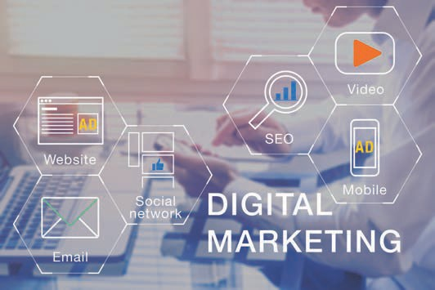

# Unit 1

## Fundamentals of Performance Marketing

##### STUDY GOALS

On completion of this unit, you will be able to ...

... understand the fundamentals of performance marketing as well as its individual performance aspects.

... classify and differentiate performance marketing as part of the marketing mix.

... characterize the various features of performance marketing.

... understand how key instruments of performance marketing function and apply them.

DL-D-DLMOMPMSS01_D-L01

### Fundamentals of Performance Marketing

#### Introduction

Corporate communication has undergone radical changes in recent decades. In this context, we speak of the *push* and *pull* communication directions. *Push* means that media are actively conveyed to the recipients, whether they want it or not. For example, traditional advertising, such as TV commercials and ads in newspapers, falls into this category. In contrast, online communication channels belong more to the *pull* category. In these cases, people actively search the internet for information, products, or services and then voluntarily click on the search hits and ads that appear. Others follow brands or companies on Instagram and Twitter, or they sign up for newsletters. Nevertheless, *push* communication also exists in online marketing. This can be in the form of banners that are placed and embedded among digital texts, such as those found the SPIEGEL media brand website. Overall, the trend is now moving away from *push* and increasingly toward *pull* (Beilharz, 2021). The combination of both communication directions certainly makes sense and as a result, companies and brands are increasingly utilizing the numerous possibilities offered by the world wide web.

As a global communications medium, the internet offers nearly unlimited space for managing goods, services, or brands in communications (IHK für Rheinhessen, n.d.). A major advantage in online marketing is the measurability ofcampaigns. For example, it is possible to track how often an internet ad is clicked and how many people buy a product or service after coming across a particular website via an ad in a search engine such as Google.

GAFAM

The GAFAM acronym refers to the world's largest IT companies: Google (Alphabet Inc.), Amazon, Facebook (Meta Inc.), Apple and Microsoft, all of which have a significant impact on the economy and society.

Above all, interactivity gives users the opportunity to freely choose the scope, as well as the type, time, and duration of interactive exchanges with websites, web stores, apps, social media, or other online marketing instruments (Walsh et al., 2020, p. 539). The **GAFAM** corporations, i.e., Google, Amazon, Facebook (which now calls itself Meta), Apple, and Microsoft dominate much of the western world's online content. This is because these companies also own YouTube, Google Maps, Instagram, WhatsApp, iTunes, Windows, Office, Teams, and LinkedIn (Beilharz, 2021). This means that anyone seeking to properly implement online marketing cannot avoid engaging with these companies, as well as their methods and offers.

Although traditional marketing measures such as advertising space in public places, direct marketing, PR, TV, newspaper, and radio advertising are still effective, online marketing measures are becoming increasingly relevant in the digital environment. It is to be noted here that digital marketing, internet marketing, and online marketing are terms that can be used synonymously.

The traditional advertising measures mentioned above are dwindling in their significance, which has resulted in a shift in marketing budgets toward digital media. In the course of digital transformation processes, online marketing has become a key success factor in reaching people where they now spend an increased amount time — namely on the internet.

Fundamentals of Performance Marketing

Naturally, companies should therefore orient their communication activities toward reaching their customers exactly where they are. The figure below summarizes the online marketing instruments and arranges them into two areas: the activities that are visible to users and those that take place in the background, i.e., are not visible to users .

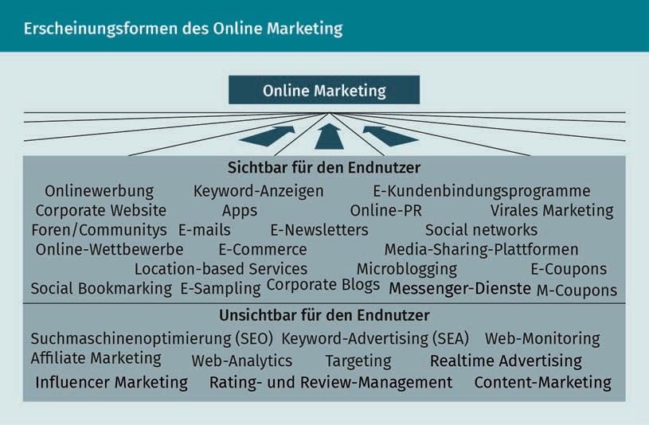

It is essential for companies to direct as many visitors as possible to their website or to encourage them to use the company's app. This is referred to as traffic. Felix Beilharz divides *traffic* into the following categories: e*arned traffic*, i.e., merited or provided traffic that companies or brands do not pay for directly. This is also referred to as *organic traffic,* since it is generated automatically, e.g., users reach a company's website via search engines such as Google or Bing, via Facebook or Instagram, via LinkedIn, or via links in online editions of newspapers or online portals. In contrast, *paid traffic* is generated through advertising on the internet. In addition, there is also *owned traffic,* e.g., traffic related to the possession of newsletter recipients’ email addresses. All three types of traffic are important, but it is to be emphasized here that companies should pay particular attention to owned traffic (Beilharz, 2021).

Various instruments can be applied to succeed in this endeavor, all of which are designed to achieve measurable reactions or even transactions with the respective users. Online marketing is constantly evolving and gives particular rise to another important term that comes into play: *performance marketing*.

It is therefore important to ask the following questions: