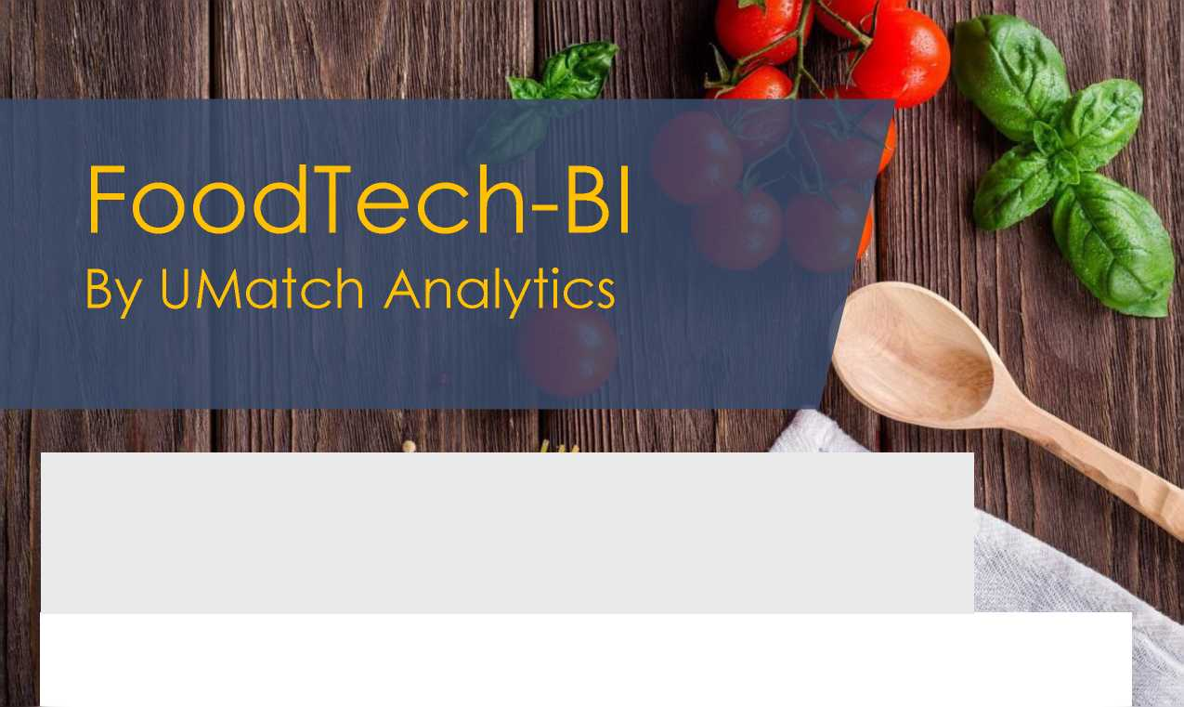

FoodTech is becoming one of the most promising sectors within the Israeli startup ecosystem. The only platform you need for your next business step in the Israeli FoodTech Ecosystem.

Our Platform brings all the relevant players to the table - Start the game!

**Our Israeli Ecosystem Numbers**

313 205 252 10

Companies &

Corporations

Academies &  
Research Centers

Startups

Investors

Our Platform Services

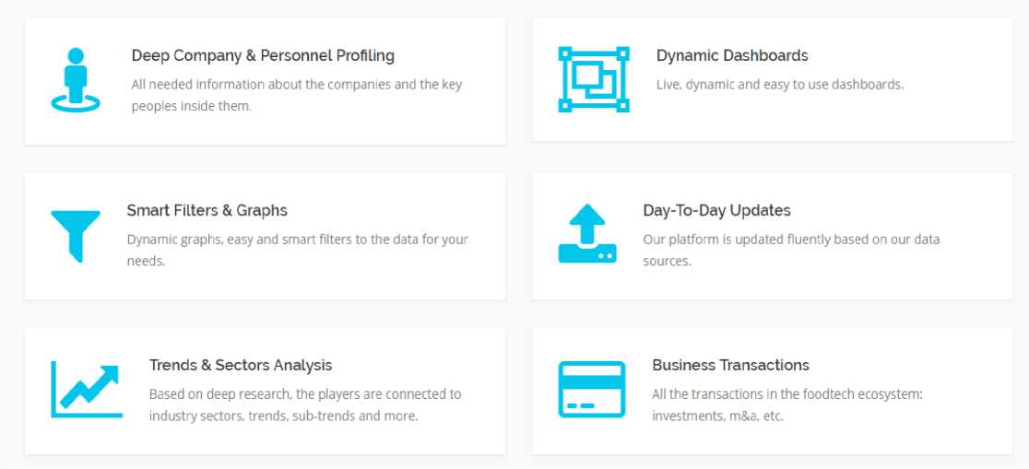

About Us

We are a next-gen business intelligence platform that provides real,  
actionable and accurate information about businesses and business-people.

SMART BI PLATFORM

Based on the abilities of our BI platform that contains machine learning and AI algorithm methods. Actionable reports that contain industry trends & sectors analysis, intent analysis, industry fit, network matching, competitive landscapes, etc.

CYBER METHODOLOGIES

Unique cyber intelligence methodologies and technological tools for the business and marketing world in order to create very accurate business connections for companies.

DEEP UNDERSTANDING

We create a business synergy network that understands and learns the market eco system profiles, business motivations and uptodate needss and produces daytoday business insights, recommendationsand matching results.



FoodTech Trends Report

|  |  |  |  |
| --- | --- | --- | --- |
| L FoodTech Trends Report | |  |  |
|  | ■ ■ | □□ |  |
|  |  | ■*י |  |
| AgroTech | Alternative protein (Novel Ingredients) | Digital & E-Commerce | Food Safety & Traceability |
| An innovative technology designed to render agricultural production more efficient and profitable- Israeli agtech excellence, e.g. in plant genomics and plant based protein, is a strong foundation for foodtech innovation | Alternative proteins, such as plant-based meat substitutes and edible insects, provide a substantial amount of protein but require less natural inputs to produce then the most common protein sources, meat and fish.  Composed of different sequences of amino acids, proteins are found in almost all whole foods. Protein is responsible for building lean | Businesses or commercial transactions carried out by means of electronic networks, pnmarily the internet For foodtech. ecommerce typically involves food online marketplaces or delivery platforms. E-commerce brands can target the right consumers, individualize their journey, and provide a seamless shopping experience. The world's food retailers are shifting to e-commerce | Technologies that track and monitor food production or in other ways reduce the risk of food-bome illnesses. With an increasing demand for food, rigorous testing (Disease  Control and Prevention) at every step of the food supply chain is becoming even more important to circumvent contamination at any | point dunng the process. Online quality and |
|  |  |  |  |
|  |  | - ’ |  |
| Food-Enhancing Technology | Human Health & Nutrition | Plastics & Packaging | Tech for Restaurants |
| Includes Pood Personalization. Robots 81 Drones  Big data 81 Analytics. VR. Al 61 Machine Learning. Pood Processing. Food Aesthetics, Supply Chain  Tech, 3D Printing, etc | Software and gadgets that empower users to make better and healthier decisions regarding the food they eat With the rise of health awareness among the public more consumers taking note of their wellness and to trace the food they eat in order to improve their health and to prevent certain chronic diseases. | Pood packaging is packaging for food. A package provides protection, tampering resistance, and special physical, chemical, or biological needs. It may bear a nutrition facts label and other information about food being offered for sale. Packaging that will keep moisture and oxygen away from foods for a longer time to require less use of preservatives. | Companies providing technology solutions to restaurants and businesses (mostly SaaS platforms) to enable restaurants work seamlessly. Solutions such as HR management, inventory management order management marketing, and loyalty program management |



FoodTech Startups Analysis

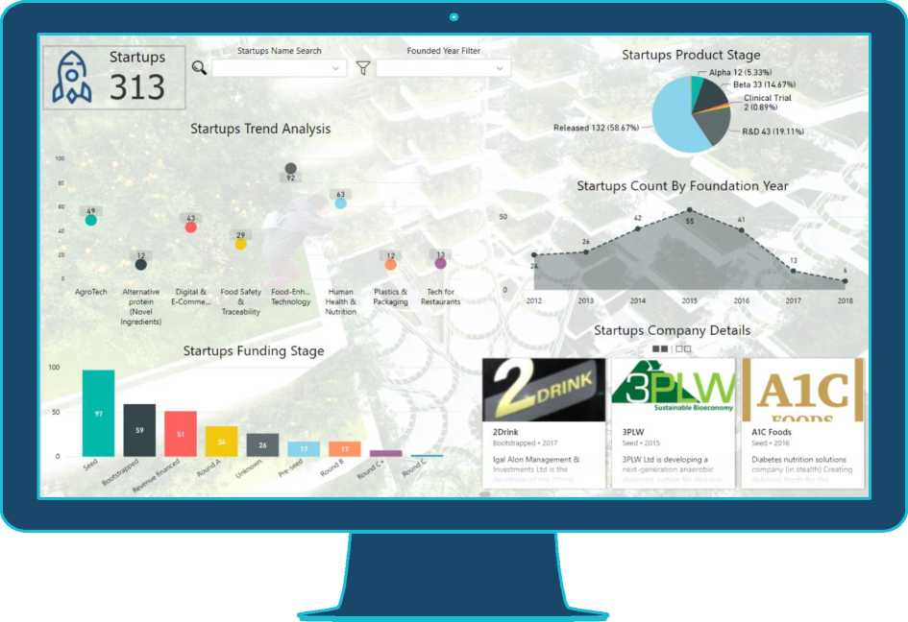

FoodTech Transactions - M&A and IPO

Company Name Serach

sajon

**S3.200M**

**saitxi**

I PROTALI >X

2018

**Total Amount**

**S157.5M**

**Total Amount**

S7100M

**Frutarom**

**Food-Enhancing**

**Technology**

**International Flavors &**

$ח FoodTech Transactions - M&A & IPO

**B.OD״**

TOP 10 - M&A & IPO Total Amount by Company Name

**Eatwith;׳,TsM**

״»״ «,» “»

Transactions Details

Number of Deals (M&A and IPO)

**Round •IPO M&A**

**SimpleOrder**

Tech Tor Restaurants Upserve

**Takeaway com**

FoodTech Startups Transactions by Trends & Year

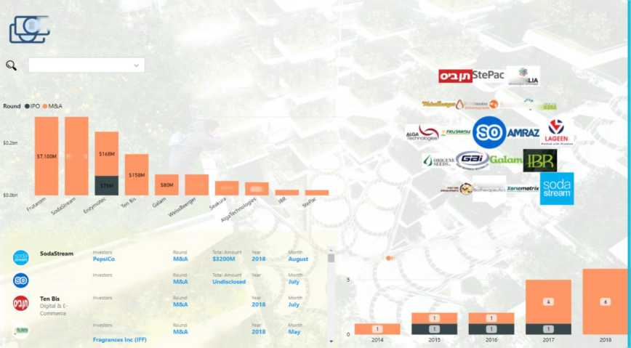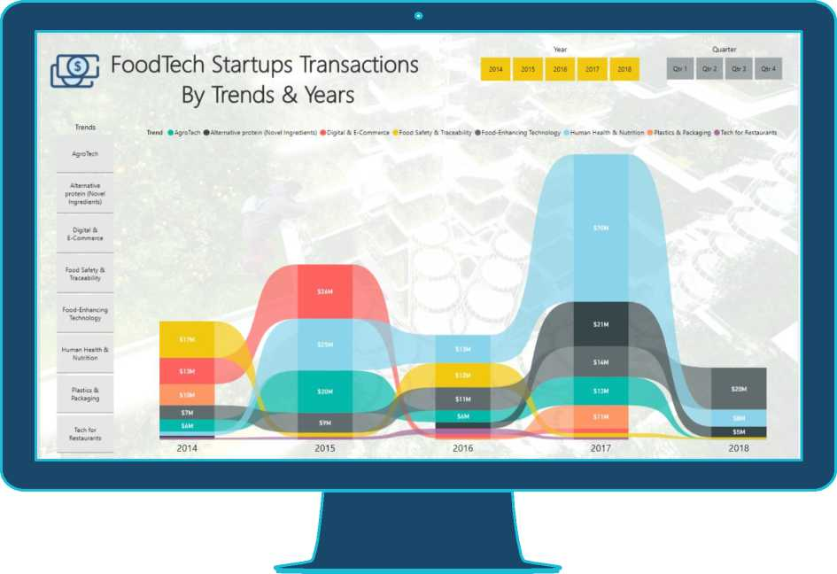

**FoodTech Personal Data**

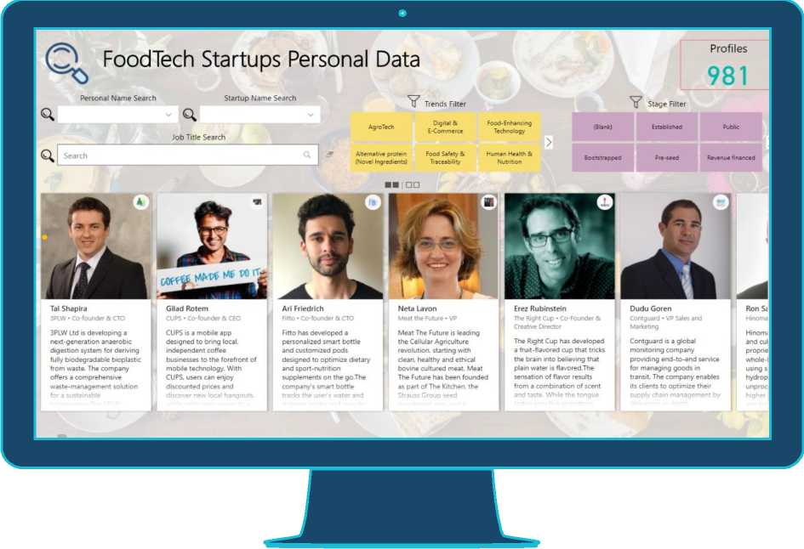

**FoodTech Market Penetration**

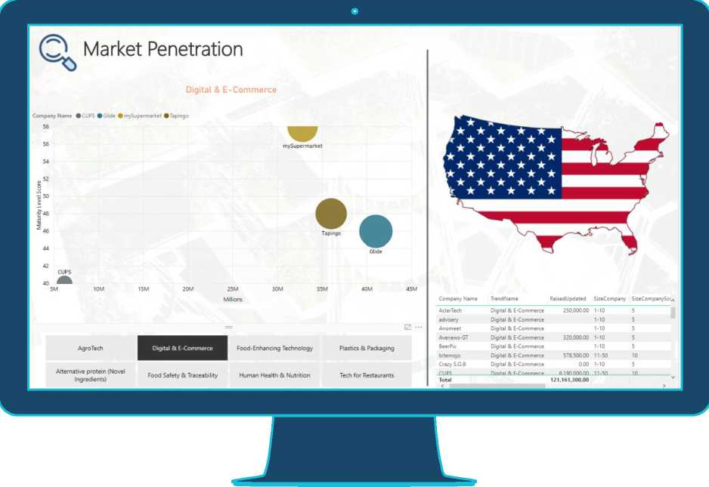

**FoodTech Researchers to Industry Matching**

