**Abstract**

We report herein an underwater biological chorus coming from the margin of the New Jersey Atlantic continental shelf and that we tentatively attribute to a species of fish. The chorus occurred every night for over a month during the Shallow Water 2006 experiment and covers the frequency band 4.8−150 Hz, with maximum intensity in the band 1450−2000 Hz. Remarkable intensity peaks occurred at 500, 725, 960, 1215, 1465, 1700, and 1920 Hz, rising to as much as 20 dB above the background noise without the chorus. The chorus begins at sunset and reaches its maximum intensity within an hour, following which it weakens slightly and then gradually climbs again to a peak before sunrise, at which point it quickly weakens and disappears. Its frequency-domain characteristics and the nocturnal timing are reminiscent of sound produced by underwater animals. The intensity of the chorus weakens along the across­shelf path going shoreward, which indicates that the chorus originates from the margin of the continental shelf rather than from the coastal zone, as is generally considered. The chorus contains a single type of acoustic signal that takes the form of double-pulse bursts that last about 8.7 ms, with each pulse containing several acoustic cycles. The time interval between successive bursts varies from 1.5 to 1.9 s. Signals containing a number of bursts vary in length from tens to hundreds of seconds. Although it is impossible to determine the fish species responsible for the chorus, its characteristics, including its low frequency and intensity, its single type of short-duration sound signal, and its multiple peaks in the frequency domain, are all consistent with the general characteristics of fish sounds.

**INTRODUCTION**

The background sound field of ocean noise is continuous and ubiquitous, and diverse sources of noise exist in the ocean, including man-made and natural sources. Underwater biological sounds are important sources of instantaneous noise, especially in biological gathering areas, such as coral reefs, where biological sounds form an important part of the local soundscape. Numerous marine animals can produce sound, including marine mammals, invertebrates, and fish (Coquereau et al., 2016; Gervaise et al., 2019). Bio-noise varies widely in the time, frequency, and spatial domains (Etter, 2018). A “chorus” is defined as three or more animals making calls that overlap or are produced in rapid succession (Greenfield and Shaw, 1983; McCauley and Cato, 2016; Cato, 1978; Rice et al., 2017; D’Spain and Batchelor, 2006). For example, fish usually vocalize at night, forming a chorus. When numerous fish vocalize together, individual voices superimpose on each other, significantly increasing the acoustic intensity over a relatively wide frequency band for a few hours (Erbe et al., 2015). Fish choruses are the dominant component of ocean noise.

Reports of marine animals creating sounds have appeared in the scientific literature since at least the 19th century, and vigorous research on underwater biological noise began in World War II (D’Spain and Batchelor, 2006; Kasumyan, 2008). The first seminar on marine bioacoustics in 1963 further promoted research into biological noise (Kasumyan, 2008). However, current reports on biological sounds, except for marine mammals (Erbe et al., 2017), invertebrates, and fish, mainly involve shallow waters such as coral reefs and coastal waters or shallow continental shelves (Freeman et al., 2014; Sánchez-Gendriz and Padovese, 2017b; McCauley and Cato, 2016; Archer et al., 2018). After an anatomical survey in the 1950s, the importance of sound communication in the ecology of deep-sea fish became substantially clearer. Based on this research, it is further assumed that sound production is common in bottom fish on the continental slope (Marshall, 1954; Marshall, 1967; Wall et al., 2014). Since then, reports have appeared of sound produced by deep-sea fish in various non-coastal waters. Fish at the continental margin and in the deep sea can also produce sound, but such choruses, which significantly impact the ocean soundscape, are rarely discussed in the literature. McCauley and Cato (2016) believe that this is likely due to the lack of sampling or the inability to determine the source of the sound, not because of the lack of choruses (Mann and Jarvis, 2004; McCauley and Cato, 2016).

In the Atlantic Ocean, deep-sea fish sounds have been recorded in various zones. Mann and Jarvis (2004) localized a biological sound to a depth of 548–696 m in the Tongue of the Ocean off Andros Island, Bahamas, where the bottom is at a depth of 1620 m. Given that the sound was pulsed and of relatively low frequency, they tentatively attributed it to deep-sea fish. Rountree et al. (2012) used a deep-water autonomous underwater listening system to make a 24-hour recording on the seafloor at 682 m depth in Welkers Canyon located south of Georges Bank. They recorded numerous biological sounds: in addition to several sounds produced by certain cetaceans and dolphins, they recorded at least 12 unique unidentified sounds that are believed to be produced by fish or cetaceans. Carrico et al. (2019) recorded biological sounds using Ecological Acoustic Recorders bottom-moored 5 to 10 m from the Condor seamount at an approximate depth of 190 m and on the seafloor at a depth of 36 m in Princess Alice Bank. Although the Azores host a wealth of fish species, only 20 species from 14 families have been reported, and at least 79 species from 24 families are potential sound producers.

In the Canadian waters of the Northeast Pacific, sound from deep-sea fish was recorded by the North East Pacific Time-Series Undersea Networked Experiment (NEPTUNE), which is part of the Ocean Networks Canada Observatory. The system is located on the seafloor about 1 km off the west coast of Vancouver Island at a depth of almost 1000 m. The system also has three NEPTUNE-Canada cameras (Širović, 2012; Doya et al., 2014; Wall et al., 2014). In addition to baleen whales and odontocetes, numerous broadband pulsed signals are recorded, which may be produced by fish. In addition to the sound known to be produced by Sablefish (Anoplopoma fimbria), many unknown sounds are recorded. Wall et al. (2014) present 32 possible sources for these sounds, not all of which are attributed to fish. Doya et al. (2014) argue that the biological sound in this area does not follow day-night or tidal-based rhythms.

From the Pacific Ocean off California have come several reports of non-coastal biological noise. These seas also host a fish chorus in addition to the sound produced by individual fish. McDonald et al. (2006) undertook long-term continuous observations in the waters west of San Nicolas Island, California, at a depth of 1090 meters. The experiment was done at the same location as in the 1960s, which allowed a comparison of the deep-sea ambient noise. The 1960s experiment recorded a diel pattern of 10–20 dB variation in the frequency band 80–300 Hz, but McDonald et al. (2006) did not observe a diel pattern. At 315 Hz, the sound pressure spectrum from 2003–2004 is greater than that from 1964–1965, even when the noise is stronger at night. The strong noise background may have masked the diel pattern or altered the fish sounds related to reproductive and predatory behavior, thereby deteriorating the undersea environment, reducing the richness of the fish, and leading to the disappearance of the diel pattern.

Although no diel pattern has been detected in fish choruses, occasional “fish bumps” or brief impulsive sounds of unknown origin have been detected. In addition, cetacean sounds at 15–20 Hz have been detected. At a depth of 175 m, 35 km southeast of San Clemente Island, a biological chorus was detected by D’Spain and Batchelor (2006), who deployed a large-vertical-aperture, 131-hydrophone, two-dimensional billboard array. The chorus energy spectrum has two broad spectral peaks centered around 1.5 and 5 kHz. The biological chorus appeared at sunset and disappeared at sunrise. No individual biological sound was detected. D’Spain and Batchelor attribute this not to a local voice but to the 43-Fathom Spot 2 km away, a popular Southern California fishing spot whose depth can exceed 75 m. Therefore, the origin of the sound remains unknown; it could be marine mammals, fish, invertebrates, or a combination thereof. Širović et al. (2009) made passive-acoustic recordings of sounds at 14 locations in the Gulf of Southern California to study the sound of rockfish. The sea depth ranges from 44 to 160 m, including the 43-Fathom Spot where the duration is longest. The fish sounds at the 43-Fathom Spot are in the low frequencies (less than 900 Hz) and consist mostly of individual sounds (i.e., no choruses), which means that the chorus reported by D’Spain and Batchelor (2006) may have come from the 43-Fathom Spot. Reshef et al. (2018) conducted 12 years of passive observations at 18 locations in the Gulf of Southern California and detected two important choruses in the frequency bands 100–200 and 400–800 Hz. The signals were lower in intensity at the offshore sites than at the inshore sites, which suggests that the chorus propagates from the inshore sites to the offshore sites or that the offshore sites contained fewer fish. Pagniello et al. (2019) used a Wave Glider surface vehicle to detect five types of fish choruses along the California coast and state that the second type of chorus is the same as the 400–800 Hz chorus reported by Reshef et al. (2018).

In the deep-sea waters off Australia, several fish choruses have been detected. Cato (1978) detected biological choruses at different locations in the tropical waters near Australia at depths of 35, 640, and 1000 m. Note that the experimental site is within 6 km of shallow water with coral reefs. The source of this biological chorus may thus be fish or sea urchins in the shallow sea. Instantaneous choruses were also detected and were composed of intense clicking sounds, apparently from sperm whales. Kelly et al. (1985) reported a 400–600 Hz nighttime biological chorus from three deep-water sites 250, 700, and 900 km from the Australian coast at depths of 1500–5500 m. The sound is thought to be produced by Croakers, which are fish of the family Sciaenid and whose habitat is shallow coastal waters. However, because fish usually produce a low sound intensity and because the propagation distance is limited, it is improbable that the individual sound would be detected at a site 250 km offshore. Erbe et al. (2015) explored the marine soundscape of Perth Canyon at a depth of 430–490 m, 70 km offshore from the coast of Perth.

Biological sound is an important component of the soundscape. Whales dominate seasonally at low (15–100 Hz) and mid frequencies (200–400 Hz), and fish or invertebrate choruses dominate at high frequencies. In the Perth Canyon, nighttime choruses likely due to fish are detected all year round in the range 1000–2500 Hz. The unknown hump at 600 Hz could be another type of fish or an invertebrate chorus. McCauley and Cato (2016) argue that the most likely source of the 2 kHz chorus in Perth Canyon is fish of the family Myctophidae foraging in the water column. They have also reported sporadic choruses from other locations on the Australian shelf slope.

Fish sounds are abundant in coastal zones, shallow water, and deep water. That said, fish choruses are rarely reported on the margin of the continental shelf and in deep waters. However, if a chorus appears, it becomes the dominant component of ocean noise over a relatively wide frequency band. This paper reports a new fish chorus appearing on the margin of the New Jersey Atlantic continental shelf and describes the characteristics of the chorus. The chorus does not originate in the coastal zone and differs from the documented biological sounds of the American Atlantic coast.

**METHODS**

The Shallow Water 2006 experiment was done on the New Jersey Atlantic shelf （approximately 100 miles east of the New Jersey coast）and lasted from mid-July to mid-September, 2006 (Newhall et al., 2007). The experiment deployed a total of 62 acoustic and oceanographic moorings in a “T” geometry along the shelf path following 80 m isobaths and across the shelf path starting at a depth of 600 meters and going shoreward to a depth of 60 meters. Among the moorings, five Single Hydrophone Receiving Units (SHRUs) were positioned across the shelf path in the sequence SHRU2, SHRU1, SHRU3, SHRU4, and SHRU5 at depths of 107, 85, 83, 67, and 65 m, respectively (see Fig. 1). The SHRU hydrophones were all deployed 7 m above the seafloor.

The SHRU sampling frequency was 9765.625 Hz, the flat passband was 4424 Hz, the −3 dB frequency was 4785 Hz, the passband ripple was 0.005 dB, and the sensitivity was 170 dB (i.e., 1 μPa/V). The SHRUs were active over differed periods of time: SHRU2 started recording at 14:18 on July 26 and ended at 08:25 on August 31, 2006; SHRU1 started recording at 11:07 on July 26 and ended at 05:22 on August 31, 2006; SHRU3 started recording at 20:41 on July 28 and ended at 14:32 on September 2, 2006; SHRU4 started recording at 14:42 on July 29 and ended at 09:14 on September 3, 2006; and SHRU5 started recording at 19:04 on July 29 and ended at 13:25 on September 4, 2006. This study uses Universal Time Coordinated (UTC). Local time is obtained by subtracting 4 hours from UTC (Newhall et al., 2007).

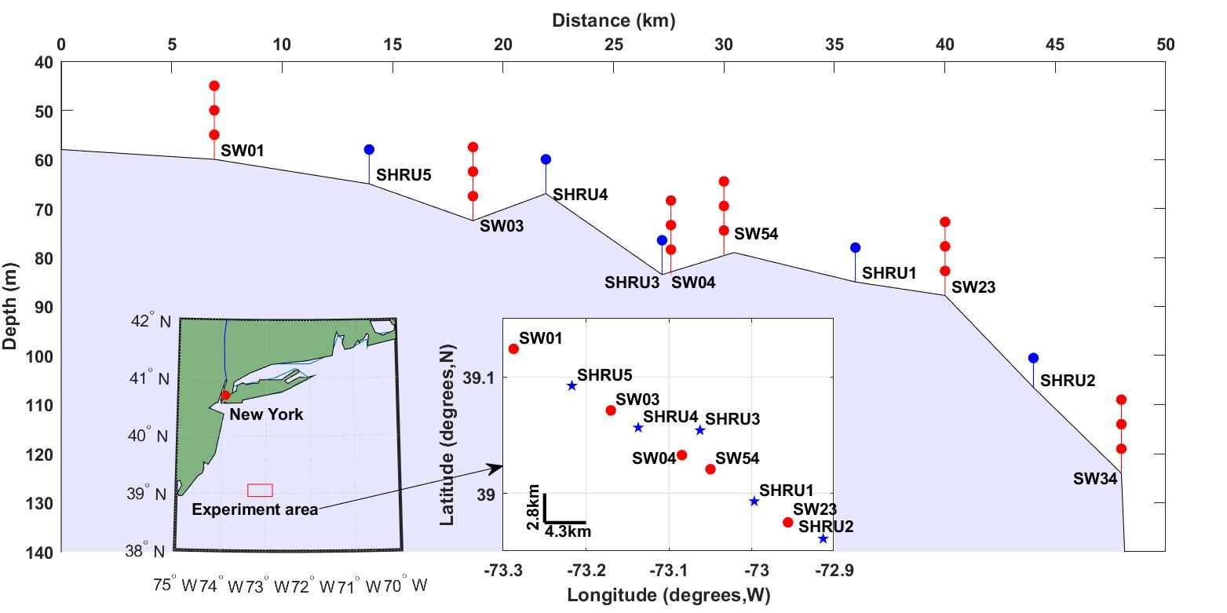

Fig. 1. Experiment area and SHRU depth.

All data were processed by using MATLAB (The MathWorks, Inc.). To understand the characteristics in the frequency domain, the noise data were Fourier transformed to produce the power spectral density (PSD). The computational process did not select the data, which contain various signals and unknown interferences. To calculate the PSD, each segment had 8192 points for the Fourier transform with gate window. The PSD had a 50% overlap, and the frequency resolution was 1.192 Hz. In addition, the PSD was averaged over different time intervals, allowing it to distinguish variations in noise from different sources over time (McCauley and Cato, 2016). Based on the PSD, the spectral probability density (SPD) was calculated in the form of normalized histograms of decibel levels in each frequency bin. The SPD can be used to evaluate the tonal contribution of different components of marine noise, and the percentiles can reveal the underlying distribution of noise intensity (Merchant et al., 2013; Archer et al., 2018).

**RESULTS**

All soundscapes recorded at the experimental site by the SHRUs vary periodically with a period of one day. The noise intensity in this area increases at sunset and diminishes at sunrise. Nighttime witnesses a host of indistinguishable noise signals, forming a sort of biological chorus with clear and stable frequency, temporal, and spatial distributions.

The noise PSD is calculated and averaged over an hour to obtain the spectrogram of the noise field. Figure 2 shows the time-frequency distribution of the noise recorded by SHRU2 from July 26 to July 31 and from August 26 to August 31, 2006: the sound field clearly varies in a diel pattern. The acoustic signals detected in this experiment are also available from Fig. 2. For example, signals at 300 and 400 Hz are detected for several minutes every half hour and become continuous in Fig. 2 after averaging over an hour.

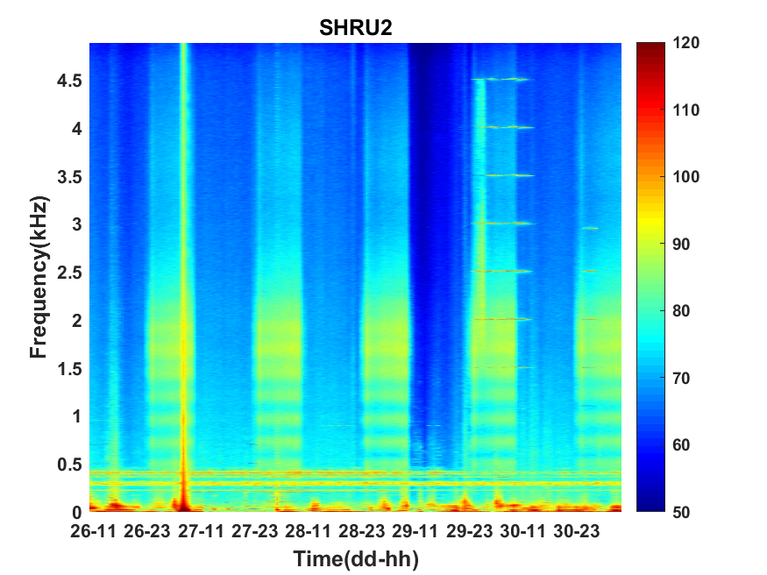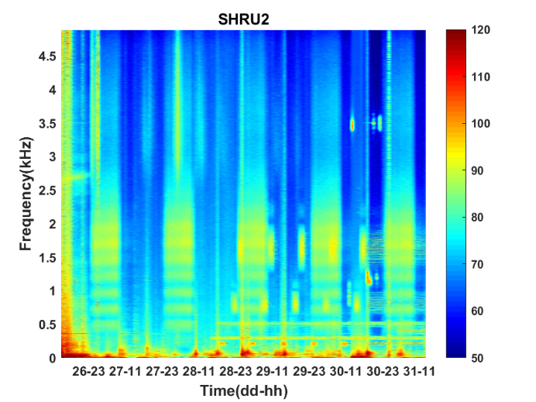

Fig. 2. Spectrograms of noise recorded by SHRU2 from July 26 to July 31 (left) and from August 26 to August 31 (right).

To calculate the PSD, we select the 1280 s of sound data from both the daytime and the nighttime on August 28. The method is the same as described above, but without the averaging. Figure 3 shows the time-frequency distributions of daytime and nighttime noise. Figure 4 shows the average daytime and nighttime PSD from Fig. 3. At night, the soundscape intensity increases significantly above about 150 Hz and peaks around 1700 Hz. During the day, this difference reduces to around 20 dB. In addition, the chorus peaks at 500, 725, 960, 1215, 1465, 1700, and 1920 Hz. The difference between adjacent peaks is 220 to 255 Hz, which is not uniformly distributed.

Figure 5 shows the SPD calculated from the one-hour-averaged PSD. The frequency interval is 1.192 Hz, and the histogram bin width is 1 dB. Above 150 Hz, the SPD distribution of each frequency has two peaks. As for the spectral distribution shown in Fig. 4, these two peaks correspond to the distribution of different daytime and nighttime soundscapes. The nighttime chorus is more concentrated and dense, whereas the daytime chorus is more scattered. No double peaks appear below 150 Hz. In addition, the black curve fluctuates rapidly in some frequency bands, which corresponds to signals detected during the experiment at, e.g., 300 and 400 Hz.

Sound above 4.8 kHz was not detected due to limited sampling frequency. However, as can be seen from Fig. 4, the intensity of nighttime sound remains greater than that of the daytime sound at frequencies above 4.8 kHz, which indicates that the chorus likely emits energy at high frequencies. However, given that the chorus intensity weakens with increasing frequency above 2 kHz and that the intensity difference between the nighttime and daytime chorus decreases upon approaching 4.8 kHz, the chorus above 4.8 kHz should be less intense and thus can be neglected.

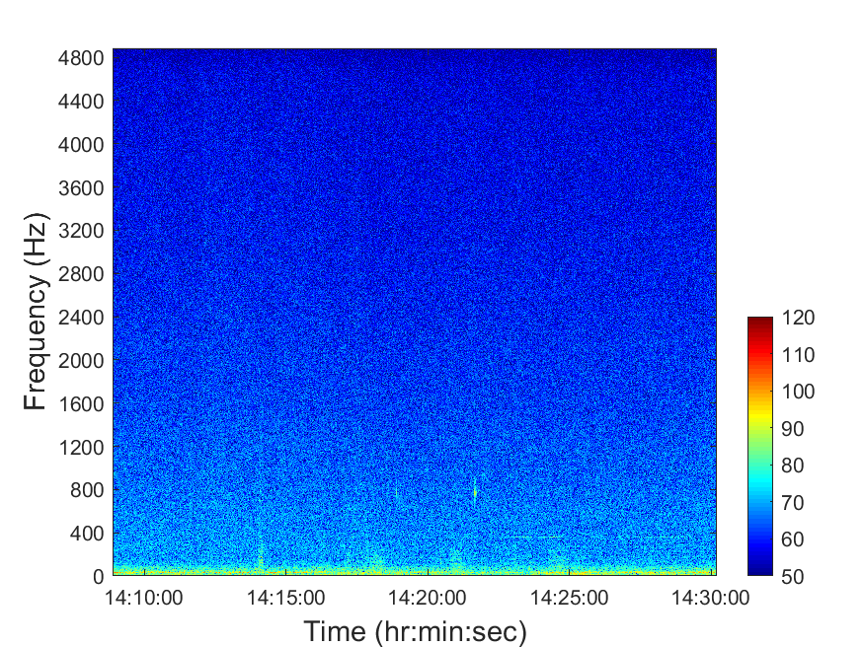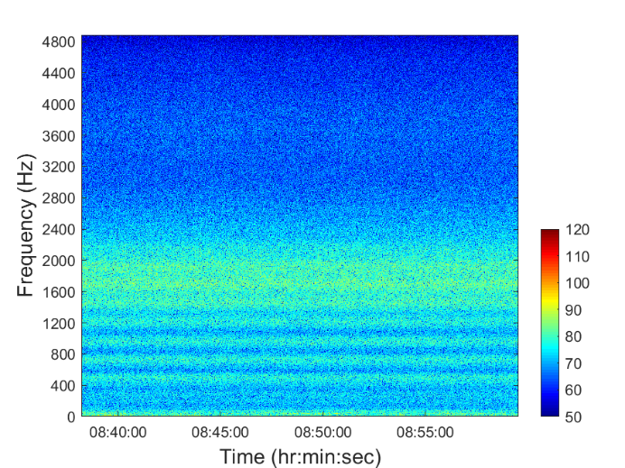

Fig. 3. Spectrogram of 1280 s noise on August 28, 2006 in the daytime (left) and nighttime (right).

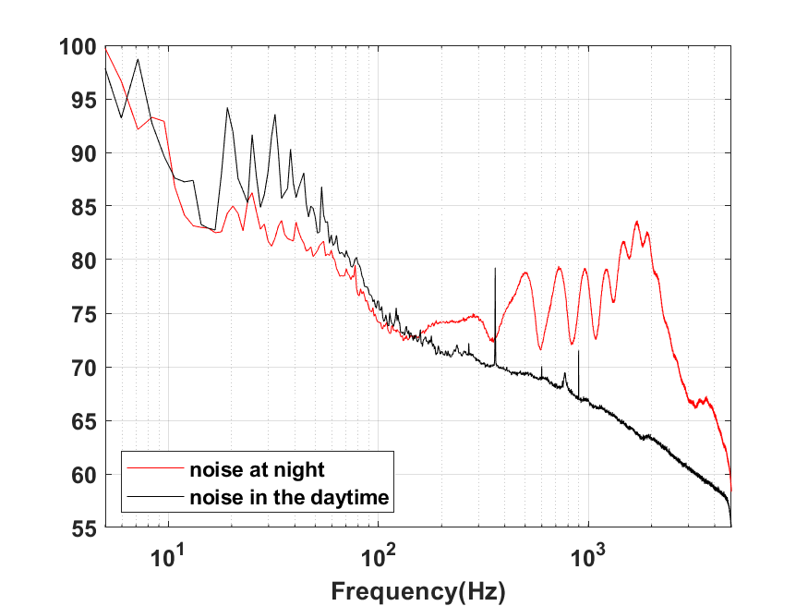

Fig. 4. PSD of nighttime and daytime noise.

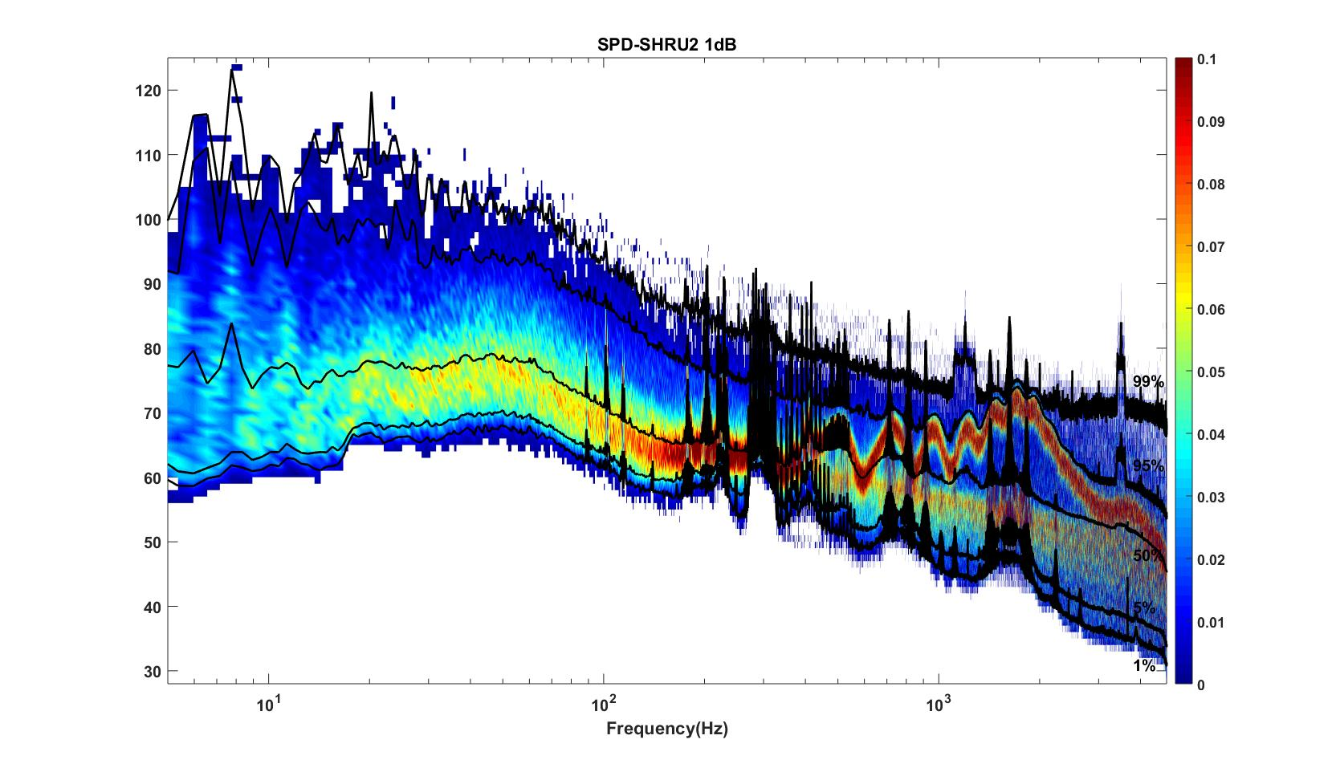

Fig. 5. SPD from one-hour averaged PSD with frequency interval 1.192 Hz and histogram bin width of 1 dB.

As shown in Fig. 4, the chorus is most intense from 1450 to 2000 Hz, so we calculate the variation of sound intensity from 1450 to 2000 Hz. Figure 6 shows the results for the five SHRUs. The horizontal axis represents time (UTC) from July 27 to September 2, 2006. Figure 6 shows clearly that the sound intensity varies periodically with a one-day period; the chorus appears and disappears at essentially the same time every day. It increases in intensity around 00:00 and disappears around 10:00, which is consistent with the sunset and sunrise at the experiment site. Note that the nighttime becomes longer over the course of the experiment, which means that the sun sets earlier and/or rises later. If the chorus is related to daylight, its appearance and disappearance should follow the sunrise and sunset. Because the chorus intensity is greatest at SHRU2, we determine the daily appearance and disappearance time from the noise recorded by SHRU2 and compare the results with the time of sunrise and sunset (see Fig. 7, left). In addition, we calculate the nighttime noise intensity for July 27 and August 27 when the chorus appears and disappears (see Fig. 7, right). Sunset is 20:14 on July 27 (00:14, July 28, UTC), and sunrise is 05:53 on July 28 (09:53, July 28, UTC). Sunset is 19:36 on August 27 (23:36, August 27, UTC) and sunrise is 06:22 on August 28 (10:22, August 28, UTC). The sunset and sunrise times are taken from the “Time and Date” website for Atlanta, which is close to the experimental site.

Considering that the background noise level varies, the chorus start and end times are difficult to determine. As a reference, we choose as start time a time around sunset when the chorus is at maximal intensity, and as end time we choose when the intensity begins to decline at sunrise. These moments correspond to the strongest sound intensity (cf. Fig. 7, right). Therefore, in Fig. 7, left, the chorus starts after sunset and ends before sunrise. As shown in Fig. 7, left, the start and end times of the chorus change every day, which is consistent with the evolution of sunrise and sunset. From this, we infer that the chorus begins at sunset and disappears at sunrise. Figure 7, right, shows that the chorus intensity quickly becomes maximal shortly after sunset but then decreases to a minimum in about an hour. Next, it gradually strengthens to a new maximum before sunrise and then quickly disappears.

In addition to temporal variations, Fig. 6 also reveals the spatial distribution of chorus intensity, which is strongest at SHRU2 and weakest at SHRU5. We consider the chorus on August 7, which has less interference, to calculate the nighttime intensity and average it. The result is 80.1 dB at SHRU2, 76.6 dB at SHRU1, 71.0 dB at SHRU3, 68.7 dB at SHRU4, and 63.4 dB at SHRU5. Combining these results with Fig. 1 shows that the chorus intensity weakens going shoreward along an across­shelf path. In other words, the chorus intensity decreases upon approaching the coast, which means that the source of the chorus is not evenly distributed throughout the experimental area but is mainly near the margin of the continental shelf or even in the deep sea, not the coastal zone or the continental shelf.

H:\shru\Computation by Zhang\pictures\NI_Diurnal_Varition_SHRU.tif

Fig. 6. Intensity measured by SHRUs as a function of time during the experiment.

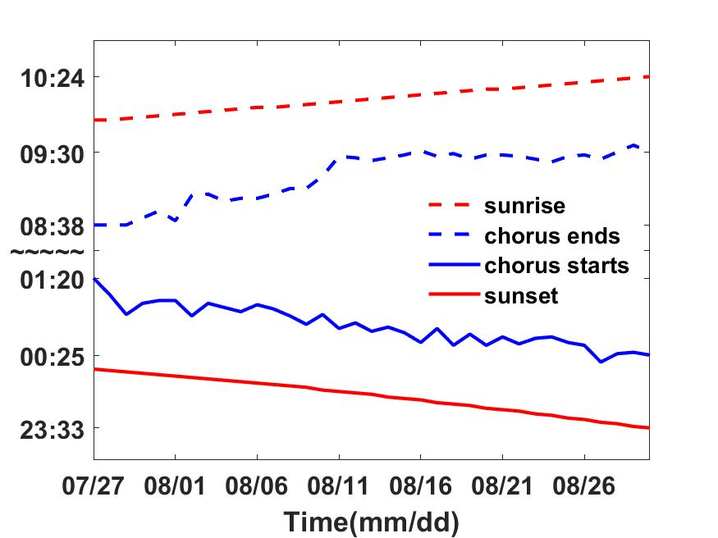H:\shru\Computation by Zhang\pictures\Compare_July28_Aug28_SHRU2.tif

Fig. 7. (left) Start and end time of chorus and time of sunrise and sunset as functions of time. (right) Nighttime noise intensity as a function of time of day on July 27 and August 27, 2006, recorded by SHRU2.

At SHRU2, the chorus is relatively strong, and the individual chorus signals are recognizable in the time domain. Figure 8 shows that, at about 3:50 am on August 7, a 20 s unstable signal occurred consisting of 12 strong bursts at intervals of 1.5–1.9 s. The first strong burst is shown on a larger scale in the middle panel. Each burst lasts about 8.7 ms and contains a first weaker pulse and a second stronger pulse, with each pulse containing several cycles. In addition to the signals detected by SHRU2, individual signals are also detected at SHRU1, although these are weaker than those at SHRU2. No individual signals are detected at SHRU4 and SHRU5. Although Fig. 8 shows only 20 s of data containing 12 bursts, these signals can last for tens to hundreds of seconds, with varying burst durations. Thus, this experiment detects only one type of signal; no other types of biological signals or other sounds are detected, which may be because they are beneath the noise level.

Figure 9 compares the PSD of the bursts detected by SHRU2 and of the overall signal without distinguishing individual bursts with that of the daytime noise from Fig. 4. To calculate the PSD of the bursts, the 12 bursts in Fig. 8 are considered separately and then averaged. The length of each burst is 92 samples (about 9.4 ms). If the noise from an individual signal cannot be distinguished (such as the noise between 0.38 and 0.39 s), it is cut from the spectrum. The comparison shows that the overall nighttime signal (i.e., without distinguishing individual bursts) is stronger than the daytime signal. In the frequency domain, the energy distribution of the bursts is like that of the nighttime signal but with greater intensity, which means that the chorus is continuous at night. In the time domain, the signals cover each other and so cannot be distinguished.

Given that the individual bursts are very short and separated by 1.5 to 1.9 s and that the chorus is continuous in the time domain, it must be due to a large number of sources, so the signals may frequently overlap each other in the time domain. SHRU1 is about 4.1 km from SHRU2, which detects a strong individual signal. However, no corresponding individual signal is detected at SHRU1. Thus, the sound intensity is too weak to propagate the 4.1 km between the detectors. However, the chorus is distributed over a wide spatial range, so the acoustic sources should also similarly distributed. The chorus must therefore be due to a collection of animals and not just a single animal.

H:\shru\Computation by Zhang\the comparision of signal in time domain\The nosie signal in time domain.tif

Fig. 8. Noise detected by SHRU2 in the time domain.

H:\shru\Computation by Zhang\the comparision of signal in time domain\Compare the frequency domain.tif

Fig. 9. PSD of noise detected by SHRU2.

**DISCUSSION**

The results show that the noise occurs primarily at night, appearing at sunset and disappearing at sunrise, following a diel pattern. Furthermore, the frequency band of the sound is consistent with that of biological sounds, so the most likely source of the noise is marine animals. Biological sounds are often associated with behavior such as predation, courtship, reproduction, warning, attack, communication, and navigation. Some sounds are made by marine animals themselves, whereas others are generated by impacts between marine animals or by water flow or interactions at the water surface.

In the ocean, many species of marine animals can vocalize, including marine mammals, invertebrates, and fish (Coquereau et al., 2016; Gervais et al., 2019). Among the species that can vocalize, invertebrates and fish are the main contributors to choruses. In addition, marine mammals sometimes vocalize together in the shallow or deep sea, such as the communication of cetaceans (McCauley and Cato, 2016).

Marine mammals can produce sounds for communication and navigation. In addition, movements, such as foraging and impacting the water surface, can also produce sounds (Tyack and Clark, 2000; Au, 1993; Dunlop et al., 2008). Erbe et al. (2017) reviewed the sounds produced by marine mammals in Australia and Antarctica, including whales, dolphins, sea cows, and carnivores. All sounds can be grouped into three classes, continuous-wave sound, frequency-modulated sound, and broadband sound pulses. Mellinger and Clark (2003) pointed out that mammalian vocalizations in the North Atlantic Ocean are basically the same as that in other regions, although some differences exist; namely, the specific frequency, duration, and repetition interval may differ. The frequency of mammalian sounds is very wide, ranging from a few Hz to more than 100 kHz (Havera et al., 2018). The duration and type of sounds produced by marine mammals differ significantly from the chorus reported herein, so the chorus is not likely to be produced by marine mammals.

Many species of invertebrates, such as shrimp, can also produce sounds, and the frequency of vocalization is relatively high. Coquereau et al. (2016) recorder 20 species of invertebrates along the coast of the Northeast Atlantic Ocean and found eight that produce sounds, including sea urchins, shrimp, and spider crabs. The peak frequency emitted by these invertebrates exceeds 3 kHz, and some can reach above 50 kHz. Buscaino et al. (2011) characterized the acoustic behavior of the European spiny lobster *Palinurus elephas* in a water tank. The measured signal duration, number of pulses per signal, pulse rate, bandwidth, peak intensity, and peak frequency all differ significantly from the chorus reported herein. For example, the peak frequency reported by Buscaino et al. is 19.52 kHz.

Snapping shrimp are a widespread family of Caridean shrimp comprising over 600 species (Lillis and Mooney, 2016) and are an important source of biological marine noise. They live typically at depths less than a few tens of meters and have an approximate geographic range of ±40° latitude (Bohnenstiehl et al., 2016; Au and Banks, 1998). They produce sound over a wide range of frequency bands, mainly in the high frequencies (from tens of hertz to kilohertzs). The duration of an individual signal is relatively short, less than 1 ms (Au and Banks, 1998; Freeman et al., 2014; Bohnenstiehl et al., 2016; Lillis and Mooney, 2016). According to the analysis of sounds recorded in the waters off New Zealand (Radford et al., 2010), sea urchins produce sound in the frequency band from 800 to 2500 Hz, with a peak between 1000 and 1200 Hz, although Soars et al. (2016) detected a higher-frequency band(2.3 to 9.2 kHz). The frequency band of sound produced by sea urchins in tropical waters is higher than that produced by temperate-water sea urchins, and the sound duration and frequency band also depend on the sea urchin size. However, the sound produced by sea urchins gradually changes frequency. In the time domain, each burst consists of only a single pulse, whereas the chorus reported herein is made of double pulses (Radford et al. 2008). Given that the frequency and temporal characteristics of invertebrate sound differ significantly from those of the chorus reported herein, it is unlikely that the chorus is produced by invertebrates.

We now consider fish as the origin of the chorus. Over 25 000 fish species are known (D’Spain and Batchelor, 2006), of which over 800 species from 109 families worldwide are known to be soniferous (Fish and Mowbray, 1970; Kaatz, 2002; Rountree et al., 2006; Kasumyan, 2008; Slabbekoorn et al., 2010; Parsons et al., 2016b; Carrico et al., 2019), and this number is growing as research continues to discover soniferous fish. Fish vocalization is often associated with courtship, reproduction, warning, etc. (Kasumyan, 2008; Popper and Hawkins, 2019; Rogers et al., 2020) and is very weak compared with other organisms (Kasumyan, 2008). Most of the energy is in the low frequencies, below 1 to 2 kHz (Kasumyan, 2008).

The chorus reported herein is quite simple: it contains a series of bursts, with each burst containing two pulses. As shown in Fig. 8, the energy is also concentrated in the low frequencies. More importantly, it contains spectral peaks that are relatively evenly distributed within the frequency domain of some fish. The frequency defined by the inverse of the time between spectral peaks is called the “pulse repetition frequency,” where the pulses are triggered by muscle contractions (Oppenheim and Schafer, 2004; McCauley, 2012; Parsons et al., 2013; Parsons et al., 2016a; Parsons et al., 2016b; Sánchez-Gendriz and Padovese, 2017a). In the chorus reported herein, the time between pulses is about 4.3 ms, so the inverse is 233 Hz, which is consistent with the interval of the spectral peaks. In addition, fish choruses commonly occur at night, when large numbers of fish gather and vocalize together, thereby greatly increasing the broadband sound for a few hours (Cato, 1978; McCauley, 2012; Parsons et al., 2013; Erbe et al., 2015). Fish sound is generally characterized by its low frequency and short duration (Fish and Mowbray, 1970; Amorim, 2006; Kasumyan, 2008, Wall et al., 2014). Thus, the characteristics of fish sounds are like those of the chorus reported herein, so the chorus is likely produced by fish.

To further specify which type of fish may produce this chorus, we searched the literature to identify fish that produce sound similar to that of the chorus. Table 1 lists the fish species considered.

Table 1. Fish species considered as source of chorus.

|  |  |  |
| --- | --- | --- |
| Species | Family | References |
| Weakfish | sciaenid family |  |
| Tigerfish | Therapon jarbua |  |
| Midshipman | Porichthys notatus |  |
| Long-horned sculpin | Myoxocephalus octodecimspinosus |  |
| Sea robin | Prionotus carolinus |  |
| Damselfish | Pomacentridae | Mann et al., 2008 |
| Croakers | Sciaenidae | Mann et al., 2008; Mann, 2016 |
| Drums | Sciaenidae | Mann et al., 2008; Mann, 2016 |
| Haddock | Gadidae or cod | Mann et al., 2008 |
| Haddock | Melanogrammus aeglefinus | Casaretto et al., 2015 |
| Batrachoididae | toadfish or frogfish |  |
| Toadfish | Opsanus tau | Bass and Baker, 1991; Fine, 2001; Mann, 2016; Rice et al., 2017 |
| Groupers | Epinephelidae | Mann, 2016 |
| Black drum | Pogonias cromis |  |
| Red drum | Sciaenops ocellatus |  |
| Silver perch | Bairdiella chrysoura | Rice et al., 2017 |
| Atlantic croaker | Micropogonias undulatus |  |
| Striped cusk-eel | Ophidion marginatum | Mann, 2009 |
| Nassau Grouper |  | Rowell et al., 2018 |
| Codfish | gadids | Rountree et al., 2006 |

None of the fish listed in Table 1 produce sound similar to the chorus reported herein. We also searched the website Fishbase (Froese and Pauly, 2019), which contains 90 types of fish sounds, none of which match our chorus. We also searched freshwater fish, but without finding any match. The University of Massachusetts, Amherst website on Fish Ecology (Rountree, 2019) also describes a variety of fish sounds, but none match the chorus reported herein. Thus, despite consulting numerous sources, we are not able to identify the fish species that produces the chorus detected in this work. This chorus may thus be produced by a previously unknown soniferous fish species, which needs us to investigate further.

The spatial distribution of the chorus intensity shows that the chorus is strongest at SHRU2 and weakest at SHRU5. In other words, the chorus intensity weakens as you approach the coastal zone. At SHRU5, the chorus is already very weak, so areas closer to the coast than SHRU5 would likely experience no chorus. Because fish emit only a weak sound intensity, the sound does not propagate over long distances, so the fish must be distributed throughout the experimental area. The spatial distribution of the chorus indicates that the fish become less abundant closer to the coast. In the experimental area, the chorus is most intense at SHRU2, which means that the fish are most abundant in this area. Beyond SHRU2, toward the deep sea, the chorus distribution fades and thus cannot be known. However, the results do indicate that the source of the chorus is not the coastal zone, but the margin of the continental shelf and maybe the continental slope or deep sea.

The biological noise reported for the Atlantic coast of the United States differs from the chorus reported herein, which also indicates that fish are not numerous in the shallow sea. In the mid-Atlantic Ocean off the southern New Jersey coast, biological sounds are mainly produced by three types of fish: Atlantic croaker (Micropogonias undulates), weakfish (Cynoscion regalis), and striped cusk-eel (Ophidion marginatum) (Mann and Grothues, 2009). Cusk-eels produce a peak in intensity when calling at dusk and a smaller peak when calling at dawn. The cusk-ell chorus lasts all night and varies in intensity. In the western Gulf of Maine, a remotely operated vehicle was used to investigate the vocalization of fish (Rountree and Juanes, 2010). Sixteen species of fish and one species of squid were observed. Ten fish species produce sound, including Atlantic cod (Zemeckis et al., 2019). The Estuarine soundscapes are dominated by the sounds produced by invertebrates at 2–23 kHz, such as shrimp in Pamlico Sound, North Carolina, in the southeastern USA (Lillis et al., 2014), which produce spectral peaks in the frequency bands 200–300 and 450–600 Hz. Lillis et al. (2014), however, attribute the sounds to oyster toadfish (Opsanus tau).

Other soniferous fish include weakfish (Cynoscion regalis), pigfish (Orthopristis chrysoptera), silver perch (Bairdiella chrysoura), and Atlantic croaker (Micropogonias undulates). Off the coasts of Georgia and eastern Florida, the fish chorus is dominated by Black drum (Pogonias cromis) and toadfish (Opsanus sp.). In addition, red drum (Sciaenops ocellatus), silver perch (Bairdiella chrysoura), and an unidentified soniferous species also produce sounds (Rice et al., 2017). In addition, choruses exist in tropical nearshore habitats in Florida, producing both high and low frequencies. Butler et al. (2016) attribute the low-frequency sound to toadfish and the high-frequency sound to shrimp. However, none of the biological sounds reported for the Atlantic coast of the United States are the same as the fish chorus reported herein, so the source should be different.

A one-day recording was made at 682 m depth in Welkers Canyon on the continental slope, which is northeast of our experiment site. Numerous biological sounds were detected, including various cetaceans and at least 12 unknown sounds produced by cetaceans or fish. However, no chorus was recorded, and the biological sounds differ from the fish chorus reported herein (Rountree et al., 2012).

Thus, although the Shallow Water 2006 experiment elucidates the characteristics of the chorus, the source remains undetermined, although evidence suggests that it is produced by fish. The intensity of the chorus can rise 20 dB above the background sound of the local ocean. The chorus lasts all night and strongly affects the local sound field. Further research is required to identify the species that produces the chorus, which would improve our understanding of the local ecosystem and biological sound fields.

**CONCLUSIONS**

This work reports a biological chorus emanating from the margin of New Jersey Atlantic continental shelf and tentatively attributes it to an unidentified species of fish. The chorus occurred every night for over a month (July to August, 2006) and was recorded by five SHRUs. The frequency band of the chorus is 150 Hz to 4.8 kHz, with the maximum intensity occurring between 1450 and 2000 Hz. In addition, clear peaks in intensity occur at 500, 725, 960, 1215, 1465, 1700, and 1920 Hz. In the maximum band at SHRU2, the chorus intensity rises to 20 dB above the background noise level. The chorus begins at sunset and ceases at sunrise; it reaches its strongest peak in intensity within one hour of sunset, following which it weakens slightly before again gradually increasing to peak before sunrise, at which point it quickly weakens and disappears.

Of the five SHRUs, the chorus intensity is strongest at SHRU2 and weakest at SHRU5, which indicates that the intensity weakens along a shoreward across­shelf path. In other words, the chorus intensity decreases as you approach the coast. The intensity is quite weak at SHRU5, so it is likely undetectable closer to the coast than SHRU5. Because fish produce low-intensity sound, the sound signal does not propagate over long distances, which means that the fish should be distributed throughout the experimental area. The spatial distribution of the chorus intensity implies that the fish must be less abundant as you approach the coast. In the experimental area, SHRU2 records the highest chorus intensity, so the greatest abundance of fish must be in this area. However, the chorus intensity may be stronger still farther out to sea, in deeper waters and farther from the coast.

The chorus consists of only one type of signal, with relatively stable characteristics. The signal is made up of bursts about 8.7 ms long and containing two pulses, each of which contains several cycles. The time interval between successive bursts varies from 1.5 to 1.9 s. The duration of each signal is tens to hundreds of seconds, which means that the number of bursts in each signal varies widely. SHRU1 is about 4.1 km from SHRU2, where a strong individual signal is clearly detected. However, no corresponding individual signal is detected at SHRU1, which indicates that the sound intensity produced by the fish is weak and does not propagate over a long distance. However, the spatial extent of the chorus is quite large, so the spatial extent of the source of the chorus must also be relatively large. Assuming fish are the source of the chorus, the large spatial extent of the source implies that a large number of fish contribute to the chorus. In the experimental site, the spatial distribution of fish is consistent with the spatial distribution of the chorus.

Many individual animals, mainly invertebrates and fish, gather to produce choruses, although marine mammals also sometimes vocalize together. Numerous speciesy produceaties The sounds produced by marine mammals can be grouped into three classes that cover frequencies ranging from a few Hz to over 100 kHz. The frequency band of sea urchins is the same as that of the chorus reported herein, but sea urchins produce no spectral peaks within this frequency band, and their bursts contain only single pulses in the time domain. The acoustic energy of the chorus reported herein is concentrated in the low frequencies. The chorus is characterized by one type of signal of short duration and with multiple spectral peaks, which is characteristic of fish sounds. Thus, the most likely source of the chorus is fish.

Despite comparing the chorus with the sounds produced by numerous species of fish, no match was found. However, not all fish sounds were compared, so the chorus may yet be generated from a known fish sound. However, the biological sounds documented for the Atlantic coast of the United States all differ from the fish chorus, which implies that the habitat of this fish is not within the coastal zone. The fish choruses previously reported are mainly in shallow sea areas, such as coastal zones. The fish chorus reported herein has its origin on the margin of the continental shelf, or perhaps on the continental slope or in the deep sea. At present, only the sound characteristics of the fish chorus are known. Further investigation is required to determine the sound source, which should help to better understand the ecosystem on the margin of the continental shelf.