What are the Unique Characteristics of Integrating Mobile Applications in Learning?

Yuval Shafriri
Tel Aviv University
Israel
yuval.shafriri@gmail.com

Dalit Levy
Zefat Academic College
Israel
dalitl@zefat.ac.il

Abstract: This paper presents five emergent categories of uniqueness with regard to learning with mobile applications (apps), and suggests an overarching profile to characterize such apps. The proposed profile is the result of an analytic process conducted in order to answer the question in the title. The categories are organized into three levels. The micro level focuses on interactions and includes (i) interaction with the device and (ii) interaction with the environment. The intermediate level focuses on activities and includes (iii) location-based learning and (iv) supporting any learning environment. The macro system level includes (v) applications as part of a complex system. Common to these emergent categories is the experience of learning in blended spaces. This primary pedagogical principle leads to additional principles such as embodied cognition, the device as a discovery machine, and open playful design. The paper discusses the interrelationships between these principles, and concludes with drawing a profile of uniqueness, enabling utilization of such principles for deep understanding of the environment and for promoting new literacy of 'mobile system thinking'.

Introduction
"Men say they know many things;

But lo! they have taken wings, —

The arts and sciences,

And a thousand appliances;

The wind that blows

Is all that any body knows."

(Thoreau, 1854, p. 33)

The poem appears in the famous book "Walden or, living in the wood", in which he contrasted the life in thewoods unmediated inquiry experience with what was regarded then, in the mid-nineteenth century, as a "civilized life" (Thoreau, 1854, p. 6). In his writings, Thoreau tried to identify and study those skills that are "necessary of life" (ibid., p. 12), or to find those human skills and necessities that one cannot live without, beyond the "thousand appliances" blown by the wind. In somewhat an opposite direction, this paper characterized modern 'appliances', or the abundance of mobile applications that support inquiry and learning of the surrounding. Today, digital components are heavily embedded within the natural environment on which Thoreau wrote. Together with the shifting socio-cultural environments, mobile apps have been gaining a novel role throughout the process of coming to know (Pegrum, 2016). Thoreau did not imagine an appliance accessible for every child, which could measure wind blow, weather, or heart beats. However, his questions remain relevant: What can one know using mobile apps, and what can one not come to know with this kind of 'appliances'? Aiming to contribute to this long-standing discussion, our study sought to identify unique affordances of mobile applications for learning and to draw a subsequent profile of uniqueness.

The educational use of mobile computing devices and mobile applications is thought to have significant learning potential and increased opportunities for learners and teachers alike. Smartphones are already massively embedded in daily life, but integrating mobile technologies within learning environments is a complex and challenging mission that requires innovative pedagogical thinking and strategic changes (Traxler & Koole, 2014). In addition, while many educational initiatives take advantage of unique affordances of mobile technologies in creating new learning opportunities, others tend to implement 'traditional' e-learning methods with the aid of mobile devices.

Although a lot of research has been conducted recently on mobile learning and on integrating mobile apps in educational settings the task of identifying the unique features and affordances of mobile technologies has not been straightforward. Three types of affordances are often mixed: (1) affordances attributed to non-mobile desktop applications, such as complex design systems like AutoCAD; (2) universal applications operating both on non-mobile and mobile computing devices, thus available anywhere and anytime; and (3) affordances attributed exclusively to mobile apps. While many studies focus on learning with mobile applications as part of using a broader technology-enhanced learning toolbox, our research sought to focus solely on those learning processes and learning outcomes that are made possible only when using mobile apps, and to identify those unique and exclusive affordances. We therefore define a unique mobile application as an application with a potential added value when integrated in a learning environment, a value not feasible when using non-mobile desktop systems. Such benefits are also unattainable in traditional outdoor learning environments, when no digital technologies are involved.
The range of unique mobile learning affordances stems from specific context-sensing capabilities as well as from the ability to embed universal affordances in a tiny mobile device. The ADL (Advanced Distributed Learning) initiative suggests eight general affordances for mobile learning: augmenting, capturing (audio, imagery, video), communicating, contextualizing, eReading, media playing, notifications/remainders, and supporting memory and performance. Although the very basic capabilities of most current mobile devices are indeed enablers of those affordances, not all are exclusive to mobile learning. Thus, our study posed two further questions: first, what makes mobile apps unique for educational purposes? And, second, what are the idiosyncratic affordances of mobile technologies that support their informed integration in learning environments?
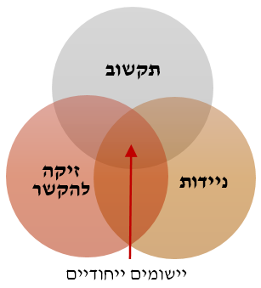
In attempting to answer those questions, we analyzed 230 mobile applications for learning, and selected for further qualitative analysis a quarter of them (~60 apps). Based on ADL (2015) and the literature dealing with the premises of mobile learning (Kearney, Schuck, Burden, & Aubusson, 2012; Traxler & Kukulska-Hulme, 2015; Pegrum, 2016 and others), the selection criterion was formulated as follows - unique educational mobile apps are those included in the intersection of three key areas: Mobility (physical and mental), Ubiquitous learning, and Contextual awareness. Using the first letter in the name of each key area, this paper suggests the abbreviation MUC to label these distinctive learning apps (Fig. 1).
Mobility
Ubiquity
Context
Awareness
Unique Mobile Apps

Figure 1: MUCs - Unique mobile apps selected for the study

While both the "M" (Mobility) and the "U" (Ubiquitous) imply independent learning anytime and anywhere, the "C" (Context awareness) suggests some dependency on the instructional designer's and/or the learner's situated decisions and actions. The distinctiveness of the selected MUCs derives therefore from being able to act anytime in any space, while being sensitive to the context of the actual environment and to the user learning activity in it. This combination is what makes mobile apps unique for learning purposes; our aim has been to characterize this uniqueness.
From the thorough examination of the selected unique apps using a grounded theory approach (Guba & Lincoln, 1989), five categories of uniqueness have emerged and a more general profile of uniqueness has been outlined. After briefly describing the methodology we used in the next section, this paper details the emergent categories and their interrelations, and discusses the resulting profile of uniqueness.

Research Framework

In order to promote the wise integration of mobile apps in learning, the research goal has been to identify the distinctive learning potential of MUCs. Thus, the main research question, as it appears in the title of this paper, has been - What are the unique characteristics of integrating mobile applications in learning?
The main question has been followed by two sub-questions:
- What learning principles are inherent in those unique characteristics of MUCs?
- What links exist between these principles?
In order to answer these questions, a three-phase research framework has been applied. First, we assembled an initial inventory of 230 applications, based on recommendations for educational apps apparent in the Web, web and free to use for any teacher or user. During that initial analytic phase, a tendency had been recognized towards universal design of apps that can be used both in mobile and non-mobile computing devices. The instructional design approach of such universal apps usually seeks to adapt existing E-Learning features into a mobile format. Examples of universal apps can be found in some gaming apps, quizzes, or general social media involvement. However, due to their lack of uniqueness with regard to mobile learning, such applications were excluded from the analysis in later phases. During the first phase, the initial inventory was sorted according to the uniqueness criterion as described in the Introduction section above (see also Fig. 1). Generic learning management apps were also excluded, as well as apps that have not been freely accessible for the typical learner. The result of the first phase has been a group of sixty selected MUCs, all designed for a specific content or context.
In the second phase, a thorough examination of about half of the sixty unique apps was performed. The analytic framework combined three approaches: the FRAME model (Koole, 2009) for analyzing mobile learning projects; an approach for surveying educational websites in general (Nahmias, Mioduser, Oren, & Lahav, 1999); and the TPACK framework, integrating technology, pedagogy and content knowledge (Rosenberg & Koehler, 2015). While the first FRAME model regards mobile learning as a process and puts less emphasis on the content, the latter two approaches deal with E-learning for specific content but leave out the situated and contextual mobile affordances. The combination of these three methods therefore enabled both the analysis of context affordances, and the analysis of content affordances enabled by the selected MUCs. Based on this combination, we developed a four-dimensional framework for characterizing mobile apps for learning: a) the technological dimension; b) the social-organizational dimension; c) the dimension of mobile interaction with the content; and d) the learning dimension (see Fig. 2, Phase II-a). We further applied that combined framework to investigate twenty-five MUCs using a thorough inductive analysis (Thomas, 2006), to construct an emergent categorical system containing five themes of uniqueness, as is illustrated in Fig. 2 (Phase II-b).
The last analytic phase used the emergent five themes to characterize all sixty classified MUCs. During this phase, we identified the unique learning potential of each theme (Fig. 2, Phase III).
Phase I: Selecting 60 MUC apps
From 230 recommended mobile apps (in Phases 1,2)
Constructing the uniqueness profile:
Common related principles of the themes
Phase II-b: Emergence of 5 themes of uniqueness, in 3 levels;
Classification of the 60 MUCs according to those themes
Phase III. Identifying the unique learning potential of each theme, as expressed by the MUCs classified in it
Phase II-a: Constructing a 4-dimensional categorical system
Technology; Social; Interaction; Learning
By analyzing 25 MUCs
2 themes in the Micro level - Interactions: on screen; with the surrounding
2 themes in the Intermediate level - location based activities; support learning in any environment
1 theme in the Macro level: The mobile app as part of a complex system
Figure 2: Three-phase analytic process
As part of the overall analytic process outlined in Fig. 2, and following the emergence of the five themes of uniqueness in Phase II-b, we also identified in Phase III the learning potential according to each theme within the sixty selected MUCs. These benefits were formed and summarized throughout a gradual process, as shown in Fig. 3.
Device
Affordances
Interactions
Learning Affordances
Educational
Values

Figure 3: The process of recognizing the learning potential of a mobile app (and theme)

For example, in the Little Digits app the learner multi-touches the mobile device touch screen with an appropriate number of fingers (see also Fig. 5 below). The affordances include multi-touch representation of numbers, vocal feedback, and recording data, and the learning potential derives from realizing the number concept by receiving real time sensory feedback from the mobile app. The key theme of uniqueness apparent in this mobile app has been recognized as interaction with the mobile device (one of the two themes in the micro level). Another example is Traces, a mobile app producing place-based multimedia messages. The key theme of uniqueness in this example is of course location-based learning (one of the two themes in the intermediate level). In this case, the learning potential derives from the combination of message and location to create new meaning. Additionally, there is apparent potential for creating personal and social relations with the content, the location, and/or other users, relations that might enhance personal involvement and therefore help in promoting understanding.
As a result of the overall analytic process, we combined the five themes to outline a general profile of uniqueness that embraces the common unique educational affordances and values identified in the analyzed MUCs according to the five themes. The resulting profile is detailed further in the last section of this paper.

Results: Five Emergent Themes of Uniqueness for Learning with MUC applications

The distinction between a unique and universal mobile app had served as a starting point in this study. Following the analysis described in the previous section, and using the emergent profile of uniqueness, we can now redefine what can be regarded as a unique mobile application for learning: it is an application that combines virtual sources on screen with physical, human, and additional digital sources from the surrounding. Such a combination is not a regular part of learning in a desktop setting, nor is it possible in fieldwork without digital support. In other words, unique mobile apps are capable of creating the experience of learning in blended spaces (Benyon, 2012). This important concept will be further discussed in the last section of this paper; here, the emergent categorical system is outlined (Fig. 4), and its five themes of uniqueness are detailed.
As is apparent in the model shown in Fig. 4, the resulting themes of uniqueness are organized into three levels: the micro-level of the Interactions between the user and the app (tThemes 11, I2); the intermediate level of the Activity (Themes A3, A4); and the macro-level of the System context (Theme S5). Tab. 1 summarizes the number of MUCs featured in each theme. Note that a specific app can be included in more than one category; consequently, the overall number of apps is greater than the 60 selected for the analysis. In what follows, we present each theme in detail and bring examples for its unique learning potential.

Uniqueness Category | # of Apps | Examples
I1. Interaction with the device | 16 | Little Digits, Hopscotch, Motion Math
I2. Interaction with the environment | 20 | Star Tracker, Elements 4D, Science Journal, color Vacuum
A3. Location based learning | 12 | TaleBlazer, ARIS, Treasure-HIT, FreshAiR, Traces
A4. Support any learning environment | 19 | Birdsnap, BlippAR, Tonara, Google Translate
S5. The app as part of a complex system | 20 | Geocaching®, Coach's Eye, Google Street View, Sense-it
Table 1: Number of MUCs in each category

Theme I1: Interacting with the Content in the Device Using Gestures (Micro Level – Interaction)

Considering the interaction between the user and the mobile application, two categories of uniqueness have emerged, named 11 and 12 (see Tab. 1 above for examples). The distinctiveness of mobile apps for learning included in the first category of interaction lies in the way by which the user touches or handles content and objects within the application. The learning potential of mobile apps in this category is attached to embodied cognition learning strategies (Abrahamson & Lindgren, 2014) and to the use of open gestures mode (Bairral & Arzarello, 2015) for interaction and for construction of content. Example images of Theme 11 mobile apps are shown below.

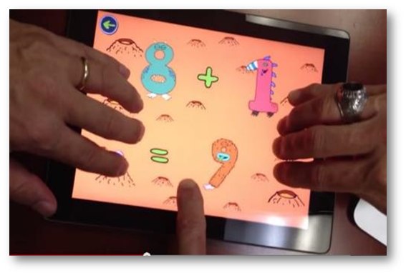 | 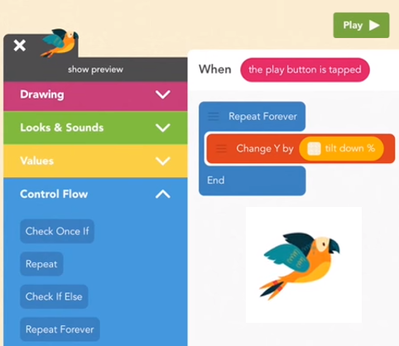  Tilt Down %
Figure 5-a: Little Digits - Two users touch the screen with 9 fingers and receive vocal feedback from the mobile app. | Figure 5-b: Hopscotch - Tablet programming for kids. Parrot will change its flight slope according the Y tilt variable. The unique feature is the ability to experience the result of the tilt-embodied interaction.

Applications categorized in Theme I1 often enable a unique state of interacting with virtual content using movements and gestures of the real human body (Segal, 2011). Such interactions uniquely combine in-app virtual sources with outside sources originating in the player/learner body, to create an integrative medium supporting embodied cognition. Benyon (2012) coined the term 'blended space' to describe such integration of sources in mobile learning. In MUCs of the first theme, unique blended spaces involve human gestures and digital sources, but there are other options for creating blended spaces with the aid of MUCs. In fact, we were able to recognize different ways of creating blended spaces in all the emergent themes in this study. As a result, we regard 'blended space' as an overarching principle of uniqueness supported by all the investigated mobile applications for learning. As has been noted above, a detailed account of this powerful idea appears in the last section of this paper.

Theme I2: Interacting with the Environment, Mediated by the Device (Micro Level – Interaction)
This category derives from apps that apply sensing features of the mobile device, to enable environmental data processing or mobile Augmented Reality (mAR). These interactions create a second type of 'blended space' experience (Benyon, 2012), merging in-app virtual sources with outside sources originating in the learning environment, rather than in the learner body.
Two main types of interaction can be found in MUCs of the second theme:
- Sensing, measuring, and analyzing real world data (see an example in Fig. 6-a).
- Augmented Reality applications (AR) which are either object-based or location-based (Fig. 6-b).

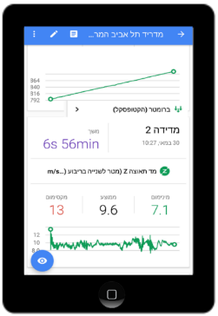 | 
Figure 6-a: Google Science Journal - various sensors can create "world as lab" experiments.  The image presents changes in g (Z axis acceleration) due to in-flight air turbulences. | Figure 6-b: Star Chart - Sky browsing Mobile AR app. The user can see "here and now" the otherwise invisible effect of Venus & Jupiter conjunction  (The sky map was captured on Aug 26, 2016).
The unique learning affordance of apps in this category is the notion of the device as a context sensor (FitzGerald et al., 2013). Learners can use the device as a 'discovery machine' in experiential learning processes, where mobile sensors are used by the app for revealing hidden/invisible features of the environment; to get meaningful data from environmental objects they did not pay attention to before; and to see the world in new ways. This learning affordance might drive curiosity and motivation for new discoveries or constructions (Arnone, Small, Chauncey, & McKenna, 2011). It also promotes open and playful learning design and discovery approaches (Kamarainen, Metcalf, Grotzer, & Dede, 2015).

Theme A3: Location-based Learning Activities (Intermediate Level – Activity Context)
Analyzing the activity level, two additional categories of uniqueness have emerged, named A3 and A4. The first category of activity context includes apps that use location, directions and movement sensors, sometimes with other features appearing in category 12 above. Besides the ability to navigate and explore the environment, the uniqueness here is the ability to construct programmed movement activities. Such apps control the movement of the actor and lead her or him to a certain point of interest (POI) with content/context relevant to the learning process. This makes the learning scenario more situated and contextual then traditional E-learning. Another uniqueness of this category is the ability to generate contextual POIs, therefore to create 'blended spaces' (Benyon, 2012) by designers, teachers, and students alike, applying the idea of "the world as a construction kit" (Silver, 2014). The pedagogical integration of these apps could be best achieved with a place-based learning approach (Zimmerman & Land, 2014).
One example of an MUC app in this theme is TaleBlazer, which supports the manipulation and programing of many entities, including moving the POI itself dynamically. Users and learners can design and create (usually on a PC) sophisticated 'blended space' artifacts based on their evolving understanding of the environmental context. They can then play with these artifacts on the mobile app. Fig. 7 brings an example of the desktop version editor, including the various programmable virtual agents (shown in the upper image of Fig. 7) and the positioning of one of these agents on a real map (lower image of Fig. 7).
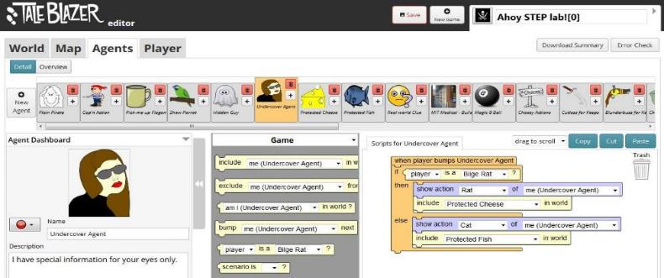
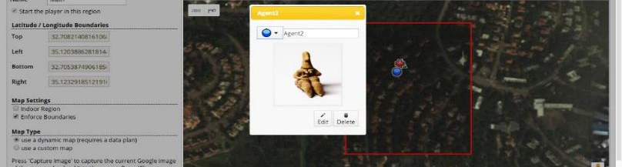
Figure 7: Tale Blazer – complex location-based programmed activities.

Theme A4: Support any Learning Environment (Intermediate Level – Activity Context)
Apps in this category have the goal of supporting learning and knowledge performances in any environment, including non-mobile devices such as desktop computers, large screens, books, etc. Such MUCs can be integrated into any learning scenario: formal or informal; personal or collaborative; structured or open; indoor or outdoor. The unique mobile apps included in Theme A4 are of three types:
- Applications with automated or semi-automated recognition features, such as object recognition (see Fig. 8-a) or movement recognition.
- Applications containing performance training which support collaborative reflection on the performance (see an example in Fig. 8-b).
- Applications containing mobile AR object recognition tools, aimed at supporting user performance (see Fig. 8-c).
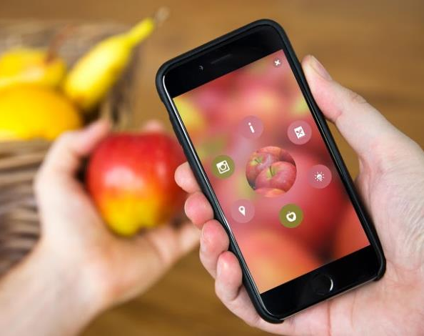  Figure 8-c: BlippAR - Object recognition AR tool. Helps in identifying objects for language learning as well as other learning scenarios. | 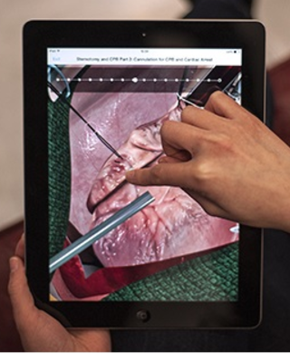  Figure 8-b: Touch Surgery -  Surgery training and treatment support. | 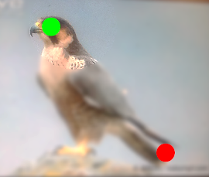Figure 8-a: Bird snap – A bird recognition app, based on semi-automated mechanism. User must point the tail and the head. Both the user and the device are "context sensors" cooperating in the recognition task.
Such MUCs tend to use a wide range of 'smart' features such as speech, audio, visual, and object recognition. We can see these apps as mobile cognitive tools used for enhancing human knowledge performance, while acting within the authentic environment such as lab, factory, field, nature, indoor or outdoor sport, etc. (Herrington, Reeves, & Oliver, 2014). In other words, these mobile applications enable what Clark & Chalmers (1998) call 'extended mind' (see also Oldfield & Herrington, 2012).

Theme S5: Mobile Application as Part of a Complex System (Macro Level – System Aspect)
The system level includes one additional category of uniqueness, named S5. Apps in this category operate on multiple contexts within complex technological and pedagogical systems. Some apps might function as a node in an integrated network of human and artificial actors. Other apps are connected to non-mobile devices such as PCs or screens, or to other users. The unique learning potential emerges from the ability to interact with many actors and sensors all at once and in real time, a richness which is typical for complex systems. The learning affordances of such MUCs support collaborative thinking processes and are powered by crowd sourcing. The Geocaching system shown in Fig. 9 is a very well-known example. The mobile app in this case functions as an end-unit of the complex online Geocaching platform, and is used for searching and navigating to geocaches.
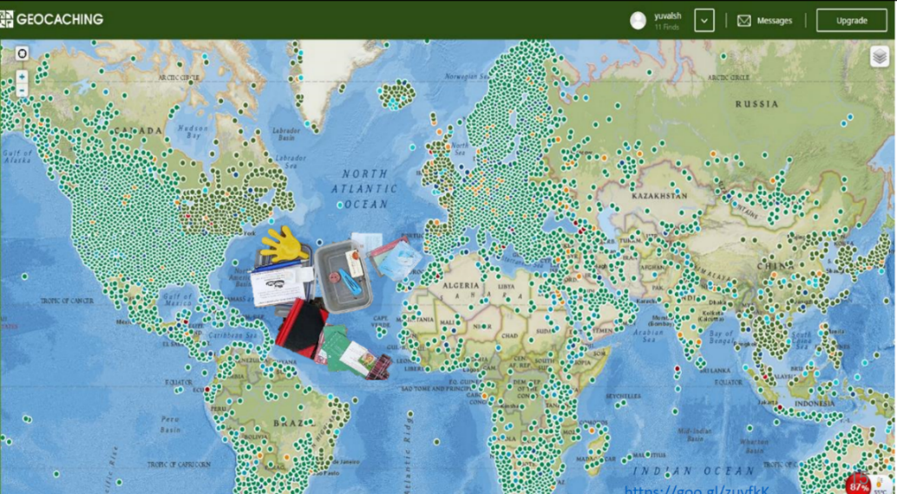
Figure 9: Geocaching World Map

Each green dot in the map represents a specific location in the world, where users hide or find a physical geocache box, usually containing a logbook and some replaceable object (as shown in the middle of Fig. 9). Geocaching is a complex location-based social media system that can be used in simple as well as in advanced learning scenarios (Jeffrey & Lucy, 2013). Unlike apps such as Pokémon Go!, in which all the agents are virtual, the geocache serves as a physical anchor embedded within the virtual medium. Therefore, like MUCs in the previous themes, geocaching activities combine realistic with digital/virtual sources to create pedagogically rich blended spaces. Furthermore, users are not only investigating the environment but are actually changing it. Geocache hiders and seekers alike need therefore to be sensitive to environmental norms and to societal ethics.
The system aspect is the highest level of looking at MUCs, and at the same time, it contains the other levels. It is thus not surprising to recognize features enabling the realization of blended spaces when using unique mobile applications included in this macro-level theme. In addition to the powerful principle labeled blended space, from this inclusive systemic category emerges also the principle of mobile thinking (Donohue & Crosby, 2013) as a new literacy for the knowledge society. The next section elaborates on these top-level principles and rephrases them as enablers of learning potential unique to MUCs.

Discussion

The five themes of uniqueness detailed above share some commonalities. Identifying and extracting these common features enabled the construction of a uniqueness profile characterizing mobile application for learning, thus answering the questions raised in our study regarding the learning principles inherent in MUCs and the links between these principles. Before turning to the resulting profile, we map the unique affordances and learning potential within each theme, and emphasize their unique learning principles.

Extracting the Common Learning Principles of Unique Mobile Applications

Table 2 summarizes the main characteristics found in each of the five themes of uniqueness, extracts the unique learning potential of mobile apps in each theme, and emphasizes the educational values attached in the form of learning principles.

Theme | Unique affordances | Unique learning potential | Learning Principles
I1. Interaction with the device | Embodied interaction | - Embodied cognition as a learning strategy  - Learners can use direct & open gestures and thus engage in learning by design  - Learners can design their own gesture interactions | Embodied Cognition  Blended Space Experience (body gestures + virtual objects)  Playful Personal Design
I1. Interaction with the device | Direct manipulation & control
I1. Interaction with the device | Open interaction mode
I1. Interaction with the device | Minimal & open-ended playful design
I1. Interaction with the device | 'Here and now' interaction design
I2. Interaction with the environment | Context sensing, documenting, and processing environmental data | - Cognitive tools for smart learning with and from the environment  - Reviling invisible parts of daily life  - Support discovery learning  - Contextual learning – learners engage in authentic, situational and playful activities  - Employ the idea of 'the world as a lab' or use the environment as a library or as an artifact  - Empowering environment affinity with AR | 'Inquiry/Discovery Machine' for learning in/with the surrounding  Blended Space Experience (environment + virtual objects)  Embodied Cognition  Playful Personal Design
I2. Interaction with the environment | Sharing artifacts during the experiential inquiry process
I2. Interaction with the environment | Embodied recognition tools and processes
I2. Interaction with the environment | Augmented Reality (AR)
A3.  Location based learning | Movement and activity programming | - Discovery learning approach  - Message + place= meaning  - Applying learning by design (of blended space artifacts)  - Cognitive and spatial dissonance as a learning strategy  - The world as a construction kit | Blended Space Experience by creating artifacts and activities and tracking them 'here and now'  Embodied Cognition (of the environment)  Playful Design  Mobile complex thinking
A3.  Location based learning | Mobile Augmented Reality (mAR)
A3.  Location based learning | Embodiment in the environment
A3.  Location based learning | Location based games, hyper-contextual activities
A3.  Location based learning | Creating blended spaces artifacts by learners
A3.  Location based learning | Mobile collaboration of blended spaces artifacts
A4.  Support any learning environment | Object recognition smart tools | - Cognitive tools for supporting recognition tasks  - Knowledge support in AR blended spaces  - Just-in-time (JIT) learning – here and now  - Learners can become context sensors (with an appropriate design approach) | 'Inquiry Machine' in support of smart learning  Mobile complex thinking  Blended Space Experience  (note: cognitive load and dissonance should be compromised)
A4.  Support any learning environment | Outsourcing of cognitive skills
A4.  Support any learning environment | Training and on-the-job support
S5. The app as part of a complex system | The app as end unit/actor in the system | - Creativity and problem solving in blended spaces  - Device + Learners as context sensors  - Mobile collaboration using crowd sourcing  - Serendipity learning | Mobile Thinking in Complex Systems as the Main Literacy  - Inquiry Machine  - Playful Personal Natural Learning  Hyper-Contextual Blended Space Experience
S5. The app as part of a complex system | Smart learning using the apps /actors as context-sensors
S5. The app as part of a complex system | Blended spaces of multi systems: Multi devices, screens, spaces & Contexts (Hyper-context)

Table 2: Mapping unique affordances, learning potential, and common learning principles

As can be seen in the rightmost column of Tab. 2, the five themes of uniqueness have some educational values in common, labeled above as learning principles, since they can be used beyond the particular mobile technology to guide instructional design in general. Overall, five principles have been recognized:
- Blended Space Experience (pink colored), identified as significant in all the themes.
- Embodied Cognition (purple colored), identified as significant in three of the five themes.
- Inquiry Machine (green colored), also found significant in three themes.
- Playful Personal Design (blue colored) in four themes.
- Mobile Thinking (gray colored), found as significant in the intermediate and system level themes.
These learning principles are interrelated in such a way that each one enables the others. Together, they can create a unique learning experience, what is regarded here as the uniqueness profile of MUCs. It should be noted that only the most unique principles have been emphasized and colored. There may be additional universal principles, like authentic learning or PBL in general, that are not exclusive to unique mobile apps such as those analyzed in our study, and therefore have not been regarded as part of the uniqueness profile that is discussed below.

Uniqueness Profile of MUCs

The list of common learning principles enables the construction of a uniqueness profile of MUC apps. First and foremost, the pink-colored learning principle entitled Blended Space Experience has been dominant in each and every theme of uniqueness. Following the inductive analysis summarized in Tab. 2, and using the conceptual framework suggested by Benyon (2012, 2014), we rephrase the title of this unique learning principle into Blended Space – Here and Now. In addition to its manifestation in all the themes, this powerful idea also enables and supports the other four learning principles. The study therefore suggests seeing Blended Space – Here and Now both as a new medium and as a powerful idea in mobile learning. Blended spaces interweave unique mobile apps with users and their learning experiences. In other words, every interaction in a unique mobile app simultaneously merges the personal, physical, and societal environments/contexts with the app's digital content and virtual space. In addition, this merging happens within a situated 'here and now' activity, which might lead to a meaningful learning experience. This unique mobile experience forms the ground for both the challenges and for the pedagogical potential inherent in mobile learning. The challenges include the cognitive and spatial dissonance and the disruption from the merging. An important implication of the first learning principle is probably the creativity potential for constructing such spaces by the learners themselves.
The study recognized four additional pedagogical principles that stem from the fundamental, powerful idea of 'blended space' and that were found significant for most of the uniqueness themes. The second principle of Embodied Cognition, colored purple in Tab. 2, was found dominant in the first three themes of uniqueness. This learning principle promotes the use of mobile sensors for gestures, movement tracking, and spatial embodiment as a learning strategy (O’Neill & Benyon, 2015). It is regarded as significant for immersing in activities designed for constructing abstract concepts such as mathematical proportion (in apps like Motion Math) or the periodic table (in apps like element4D). The principle of embodied cognition is expressed through direct manipulation of objects within the app as well as through taking advantage of the environment as an 'object to learn with'. Technologies such as mAR, mVR, IOT and wearable computing also employ this principle to enhance the learning experience. Together with blended space, the possibility of embodiment enhanced by unique mobile apps can be thought of as an innovative medium blurring the borders between sensory data and mental constructions.
The third principle of Inquiry Machine has been apparent in three themes (colored green in Tab. 2). The mobile device as an inquiry or 'discovery machine' and as a context sensor (FitzGerald, 2013; Udell & Woodhill, 2014) entitles using innovative 'smart' cognitive tools for exploration and investigation, especially in cases when learners use mobile apps for making the invisible evident with the aid of novel object recognition technologies. The unique educational goal of mobile inquiry itself develops the learner as a context sensor (Kamarainen et al., 2016). The learning potential of using the mobile device as an inquiry machine is empowered by combining it with the principle of blended space, when physical interaction is involved in operating the inquiry machine. Applying the third learning principle enables the design of highly authentic learning environments (Burden & Kearney, 2016) while supporting community sharing and environmental change.
The fourth design principle is related to Open, Personal, and Playful Learning and is colored blue in Tab. 2 above. The unique mobile apps examined in this study tend to use an open design approach, allowing for spontaneous learning and serendipity in the discovery process, while bringing the role of the actor (e.g. learner) closer to the role of the scientist in the field. Our assumption is that such approach is crucial for meaningful learning with MUC apps. The unique mobile affordances support learners' discoveries and control, and assist in developing personal curiosity by engaging learners in context sensing. Together with the principle of 'inquiry machine', learners can develop a sense of competence that encourages their curiosity (Arnone et.al, 2011). It should be noted here that in a more structured approach, the sensors might remain at the device level and could create dependency on it, while in the open approach the learners ARE the sensors and therefore depend mainly upon themselves. In addition, the fourth principle implies that the mobile app should be part of the learner daily life, as well as being in a continuous interaction with both the environment and the actor's body and behavior.
The fifth and last principle has been entitled Mobile System Thinking, to denote the emergence of a new metacognitive literacy that requires learners' awareness of multiple contexts, as well as their understanding of their place as actors in complex situations (the fifth principle is colored gray in Tab. 2 above). Blended spaces, by definition, are complex systems, due to the merging of physical and virtual domains. Thus, the highest cognitive skill identified in this study was 'system thinking', and its uniqueness lies in also being 'mobile thinking' (Donohue & Crosby, 2013, Quinn, 2011). The idea of 'mobile thinking' refers to the player's awareness of the device capabilities in the context of ever-changing environment data, as well as to the conscious search of systemic factors and phenomena in the environment. Here, too, the player functions as a context sensor, applying device sensing and recognition affordances (Wilensky & Resnick, 1999). The situation becomes even more complex using additional crowd-sourcing inquiry applications, and considering spatial actions and data created by multiple actors. Such complexity might carry greater learning potential than the individual actions of the learner per se; this is the rationale for citizen inquiry apps and systems (Herodotou, Villasclaras-Fernández, & Sharples, 2014; Sharples et al., 2017). The need for developing Mobile System Thinking literacy is also related to the issue of dissonance and distraction of mobile apps, a built-in challenge of any mobile learning and blended space experience.
Taken together, the above principles draw a uniqueness profile of MUCs that supports deep understanding of the environment in which the mobile app operates. As is drawn in Fig. 10, the overall profile stems from the fundamental principle shown below, while each additional principle has some relationship with this major unique learning principle as well as with the others. In other words, the study suggests that these principles should be treated not just as a list, but as a structure in which the components are placed layer upon layer so that each layer serves as a base for the next, and all are made possible by applying the founding principle Blended Space – Here and Now. Thus, the mobile device serves as a context sensor of a Discovery Machine in diverse environments, enabling Embodied Cognition interactions as a learning strategy using smart learning through sensory affordances. Mobile learning activities also enable building Blended Space artifacts in context, documenting sensations, and sharing data and messages between near and distant actors in an Open and Playful approach. All of the above-mentioned principles lead ultimately to Mobile System Thinking, which is needed in multi-device learning situations and within Blended Space experiences.
One implication of the uniqueness profile is the importance of environmental context (physical, human, and virtual) in the design process. Learning designers, teachers and students alike should understand not just the affordances of the mobile technology, but also the environmental ones. Along with the structure and the flow of the unique mobile learning principles, Fig. 10 presents the main question that needs to be considered in applying each of these principles.
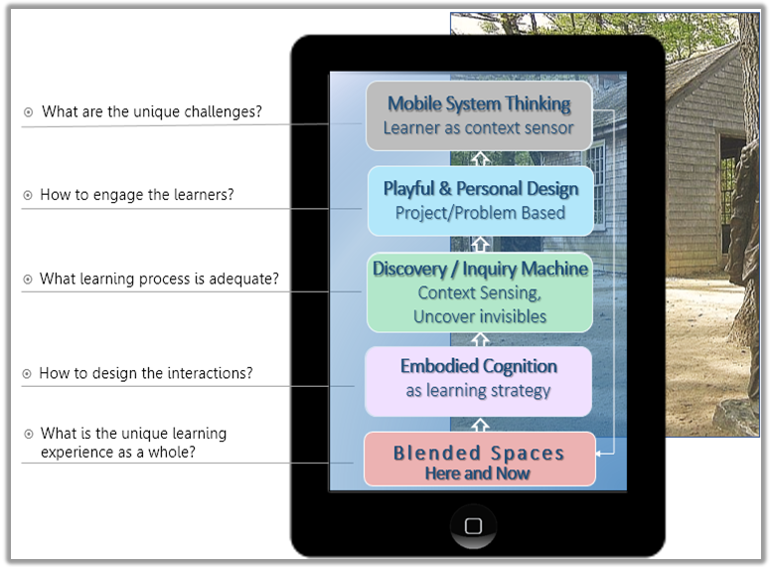
Figure 10: The Uniqueness Profile of the learning experience with mobile apps

Summary and Implications
Based on the thorough analysis of sixty unique mobile applications, labeled here MUCs, this paper presented five emergent categories of uniqueness with regard to learning with mobile applications, and suggested an overarching profile to characterize such apps. The proposed uniqueness profile, together with the detailed account of its learning principles, can serve as an answer to the question in the title of this paper: what are the unique characteristics of integrating mobile applications in learning?
As has been discussed in previous sections and drawn schematically in Fig. 10, the uniqueness profile stems from the fundamental principle Blended Space – Here and Now, and the additional four learning principles are interconnected. One implication of this profile has been previously stated – namely, the importance of environmental context (physical, human, and virtual) in the design process, and the necessity to understand not just the affordances of the mobile technology, but also the environmental ones. Therefore, experience designers (UX), instructional designers, teachers, and students alike should be able to move through physical, mental and pedagogical (blended) spaces.
Another implication is related to learning environments and applications other than those included in our study. The uniqueness profile indeed stems from analyzing mobile apps defined as unique for learning (MUCs), but it might be applied to more general mobile learning activities using universal mobile apps like Twitter, Instagram, or even the smart mobile camera. Other innovative technologies like mobile-AR/VR headsets, mobile apps supplying an interface to wearable devices, IOT related apps, etc., can be integrated into any learning environment as cognitive tools to support knowledge integration. Furthermore, mobile devices can participate in the learning discourse through conversational applications like Apple's Siri, Google Assistant, Amazon's Echo and chatbots, and thereby become an equal player in the discourse. The challenges regarding the status of technology in human-environmental relations arise here once more. The interdependence between the environment and the mobile application has been apparent throughout the phases of this study; from the first phase of considering 230 mobile applications to the last phase of constructing the uniqueness profile, the environment has been recognized to affect (and to be influenced) by almost every mobile app we analyzed. Cognitive and spatial dissonance often occurs when using any mobile app (Deegan, 2013; Farman, 2013; Beland & Murphy, 2016). In fact, the universal apps transport the stationary situation into a mobile condition; this interdependence between the external environment and any mobile virtual application is a central insight from this research.
The notion of Blended Space implies the emergence of a new environment in which digital components are embedded. What is known as 'learning with the environment' is obviously possible without mobile devices, and in fact has been carried out since the dawn of humanity, as has been exemplified in the case of Henry David. Thoreau's Walden at the beginning of this paper. Although our study did not deal with the differences between digital and non-digital learning with the environment, this kind of research might constitute a fruitful continuation. Through blended space applications, the environment becomes a computed object to learn with, and the activity becomes mobile learning with the environment instead of E-learning about the environment. The uniqueness profile suggested in this paper offers a framework for analyzing the environment properties in relation to the characteristics of the application and of the player, but those characteristics play a central role even when using a different design model. In terms of design considerations, the environment and the context are inherent dimensions that need to be added to the TPACK framework (Rosenberg & Koehler, 2015), and this is another central insight of our study.
Finally, a major challenge is to apply MUCs affordances not only as 'context sensor' extensions of the human body and mind, but also as a way for the learners themselves to become 'context sensors', curious and aware of their surroundings. This is particularly important with the emerging trend of smart 'things' with novel abilities related to cognitive and affective domains (Ally & Prieto-Blázquez, 2014). Another challenge is to extend the question 'how to wisely integrate mobile apps in learning?' into 'how to integrate any learning into daily life?'. The importance of this question grows at times when mobile apps already serve as the digital interface to the world, while the world itself is constantly becoming digital, connected, and smarter. This fascinating combination invokes new objects to think with, and probably new ways of being, experiencing and learning.

References
Abrahamson, D., & Lindgren, R. (2014). Embodiment and Embodied Design. The Cambridge Handbook of the Learning Sciences, 2, 358-376.
ADL. (2015, 2015-11-05). Mobile Technology: Affordances. Retrieved Jan 9, 2017 from https://www.adlnet.gov/adl-research/mobile-augmented-reality-performance-support/mobile-learning/mobile-technology/ .
Ally, M., & Prieto-Blázquez, J. (2014). What is the Future of Mobile Learning in Education? International Journal of Educational Technology in Higher Education, 11(1), 142-151.
Arnone, M.P., Small, R.V., Chauncey, S.A., & McKenna, H.P. (2011). Curiosity, interest and engagement in technology-pervasive learning environments: a new research agenda. Educational Technology Research and Development, 59(2), 181-198.
Bairral, M., & Arzarello, F. (2015). The Use of Hands and Manipulation Touchscreen in High School Geometry Classes. Paper presented at the CERME 9 - Ninth Congress of the European Society for Research in Mathematics Education.
Benyon, D. (2012). Presence in Blended Spaces. Interacting with Computers, 24 (4), 219-226.
Benyon, D. (2014). Spaces of Interaction, Places for Experience. Synthesis Lectures on Human-Centered Information, 7(2), 1-129.
Burden, K., & Kearney, M. (2016). Conceptualising Authentic Mobile Learning. In D. Churchill, J. Lu, T. K. F. Chiu & B. Fox (Eds.), Mobile Learning Design (pp. 27-42). Singapore: Springer.
Clark, A., & Chalmers, D. (1998). The Extended Mind. Analysis, 58(1), 7-19.
Donohue, P. J., & Crosby, M. E. (2013). Developing a Culturally-Rich Interactive Model for mLearning. In J. Keengwe (Ed.), Pedagogical Applications and Social Effects of Mobile Technology Integration (pp. 206-224). Hershey, PA: IGI Global. doi:10.4018/978-1-4666-2985-1.ch012
Herodotou, C., Villasclaras-Fernández, E., & Sharples, M. (2014). The Design and Evaluation of a Sensor-Based Mobile Application for Citizen Inquiry Science Investigations. Proceedings of the European Conference on Technology Enhanced Learning (pp. 434-439). Springer, Cham.
Herrington, J., Reeves, T., & Oliver, R. (2014). Authentic Learning Environments. In J. M. Spector, M. D. Merrill, J. Elen & M. J. Bishop (Eds.), Handbook of Research on Educational Communications and Technology (pp. 401-412), NY: Springer.
Hirsh-Pasek, K., Zosh, J. M., Golinkoff, R. M., Gray, J. H., Robb, M. B., & Kaufman, J. (2015). Putting Education in “Educational” Apps Lessons from the Science of Learning. Psychological Science in the Public Interest, 16 (1), 3-34.
FitzGerald, E., Ferguson, R., Adams, A., Gaved, M., Mor, Y., & Thomas, R. (2013). Augmented reality and mobile learning: the state of the art. International Journal of Mobile and Blended Learning, 5(4), 43-58.
Guba, E.G. and Lincoln, Y.S. (1989). Fourth Generation Evaluation. London, UK: Sage Publications.
Kamarainen, M. A., Metcalf, S., Grotzer, T., Browne, A., Mazzuca, D., Tutwiler, M. S., & Dede, C. (2013). EcoMOBILE: Integrating augmented reality and probeware with environmental education field trips. Computers & Education, 68 (0), 545-556. doi: http://dx.doi.org/10.1016/j.compedu.2013.02.018
Kamarainen, A., Metcalf, S., Grotzer, T., & Dede, C. (2015). EcoMOBILE: Designing for Contextualized STEM Learning Using Mobile Technologies and Augmented Reality. In H. Crompton & J. Traxler (Eds.), Mobile Learning and STEM: Case Studies in Practice (pp. 98-124), New York: Routledge‏.
Kearney, M., Schuck, S., Burden, K., & Aubusson, P. (2012). Viewing Mobile Learning from a Pedagogical Perspective. Research in Learning Technology, 20(1).
Koole, M. L. (2009). A Model for Framing Mobile Learning. Mobile learning: Transforming the delivery of education and training, 1(2), 25-47.
Nachmias, R., Mioduser, D., Oren, A., & Lahav, O. (1999). Taxonomy of Educational Websites - a Tool for Supporting Research, Development and Implementation of Web-based Learning. International Journal of Educational Telecommunications, 5(3), 193-210.
Notari, M. P., Hielscher, M., & King, M. (2016). Educational Apps Ontology. In D. Churchill, J. Lu, T.K.F. Chiu, & B. Fox (Eds.), Mobile Learning Design: Theories and Applications (pp. 83-96). Springer.
Oldfield, J., & Herrington, J. (2012, November). Mobilising Authentic Learning: Understanding the Educational Affordances of the iPad. In ASCILITE-Australian Society for Computers in Learning in Tertiary Education Annual Conference. Australasian Society for Computers in Learning in Tertiary Education.
O’Neill, S., & Benyon, D. (2015). Extending the Semiotics of Embodied Interaction to Blended Spaces. Human Technology, 11(1), 30-56. doi:10.17011/ht/urn.201505061739
Rosenberg, J. M., & Koehler, M. J. (2015). Context and technological pedagogical content knowledge (TPACK): A systematic review. Journal of Research on Technology in Education, 47(3), 186-210.
Quinn, C. N. (2011). Designing mLearning: Tapping into the Mobile Revolution for Organizational Performance. John Wiley & Sons.
Segal, A. (2011). Do Gestural Interfaces Promote Thinking? Embodied Interaction: Congruent Gestures and Direct Touch Promote Performance in Math. Unpublished Doctoral Dissertation, Columbia University.
Shafriri, Y. (2017). Unique Characteristics of Mobile applications integration in Learning. Unpublished M.A Thesis (Hebrew), Tel Aviv University.
Sharples, M., Aristeidou, M., Villasclaras-Fernández, E., Herodotou, C., & Scanlon, E. (2017). The Sense-it App: A Smartphone Toolkit for Citizen Inquiry Learning. International Journal of Mobile and Blended Learning, 9(2), 16-38.
Silver, J. J. S. (2014). Lens x Block: World as Construction Kit. Unpublished doctoral dissertation, Massachusetts Institute of Technology. http://hdl.handle.net/1721.1/9559
Thomas, D. R. (2006). A General Inductive Approach for Analysing Qualitative Evaluation Data, American Journal of Evaluation, 27(2), 237-246.
Thoreau, H. D. (1854). Walden or, Life in the Woods. Available online at http://www.eldritchpress.org/walden5.pdf
Traxler, J., & Kukulska-Hulme, A. (2016). Contextual Challenges for the Next Generation. In J. Traxler, and A. Kukulska-Hulme (Eds.), Mobile Learning: The Next Generation (pp. 208-226). London: Routledge.
Wilensky, U., & Resnick, M. (1999). Thinking in Levels: A Dynamic Systems Approach to Making Sense of the World. Journal of Science Education and Technology, 8 (1), 3-19.

[?] As an example of this novel role, see the map of Thoreau's cabin, as has been captured by one of the mobile apps included in our study.
[?] See http://www.adlnet.gov/adl-research/mobile-augmented-reality-performance-support/mobile-learning/mobile-technology/
[?] http://www.cowlyowl.com/apps/little-digits
[?] http://traces.io/#about
[?] Due to space limitations, the comprehensive categorical system is not included (see Shafriri, 2017 for Hebrew version).
[?] See for example the video tutorial at https://youtu.be/g6d_Z32R6Vo
[?] https://play.google.com/store/apps/details?id=com.step.taleblazer
[?] In August 2017, 3 million caches have been mapped around the world.
[?] See the online map in https://www.geocaching.com/map/ (login required)
[?] https://itunes.apple.com/us/app/motion-math-fractions/id410521340?mt=8
[?] https://itunes.apple.com/us/app/elements-4d-by-daqri/id782713582?mt=8
This is reflected in students' testimonies about activity with the FreshAIR app we examined (Kamarainen et al., 2013).

