**Thesis Submitted in Partial Fulfillment of the**

**Requirements for the M.Sc. Degree**

**Estimation of the instantaneous angular speed and diagnostic of bearings**

Gabriel Davidyan

July 2020



Ben-Gurion University of the Negev

Faculty of Engineering Sciences

Department of Energy Engineering

**BEN-GURION UNIVERSITY OF THE NEGEV**

**FACULTY OF ENGINEERING SCIENCES**

**DEPARTMENT OF MECHANICAL ENGINEERING**

**Estimation of the instantaneous angular speed and diagnostic of bearings**

THESIS SUBMITTED IN PARTIAL FULFILLMENT

OF THE REQUIREMENTS FOR THE M.Sc DEGREE

**By: Gabriel Davidyan**

**Supervised by: Prof. Jacob Bortman**

**Dr. Renata Klein**

March 2020

Author:………………………………….. Date:………………….

Supervisor:………………………………… Date:…………………..

Chairman of Graduate Studies Committee:………………….. Date:……………

**Abstract**

Rolling-element bearings are one of the most important components of rotating machinery and strongly impact the safety of such machines. Factors such as design, installation technology, conditions of use, and sudden load cause rolling-element bearings to suffer from different degradation modes such as corrosion, overheating, and contamination. These degradation modes are serious problems and often result in fires and other phenomena that pose a clear risk to the health and safety of the operator.

Minimizing the occurrence of such failures requires that the remaining useful life of rolling-element bearings be determined, which means not only detecting faults but also estimating their size and the time before they reach a critical size. One of the most common methods to diagnose rotating machinery is based on vibrations. Vibration analysis is an effective method for detecting various faults and malfunctions. The various methods of vibration signal processing require knowing the rotational speed of the machine in question, since, with rotating parts, events occur at specific angular positions rather than at specific times. For this reason, an accurate estimate of the instantaneous angular speed (IAS) is important for reliable diagnostics. Inaccurate angular speed due to dynamic phenomena such as unbalance, misalignment, or eccentricity can mask the effects of incipient localized faults. In practice, however, direct measurement of the rotational speed is often impossible, expensive, or inaccurate.

This work focuses on estimating the IAS directly from the vibration signal to diagnose bearings, gears, and other mechanisms. This study compares several methods of estimating IAS directly from the vibration signal and subsequently proposes and experimentally verifies a complete vibration-analysis scheme for bearings. In addition, a new algorithm is proposed to automatically determine the IAS from the vibrations when the angular speed varies in time. In the first stage, the rotation speed is approximated based on the time-frequency representation of the vibrations, and the IAS is determined in the second stage. A complete analysis scheme for the diagnosed IAS is then proposed and verified by comparison with experimental data and simulations.

**Acknowledgments**

I cannot offer enough gratitude for my supervisor Prof. Jacob Bortman for his guidance and support throughout my research. Without his active support, this research could not be achieved. His knowledge, experience, and belief in research independence were a significant factor for the success of this research.

I am particularly grateful to Dr. Renata Klein for her advice at each stage of the research. Her nonstop attention and fruitful ideas. Her contribution is irreplaceable.

Furthermore, I would also like to thank Eng. Aharon Klipper for his broad help in the execution of experiments and technical support.

My thanks are also given to my friends who have been working with me at the HUMS lab in the Department of Mechanical Engineering.

**Publications**

Gabriel Davidyan, Renata Klein, Jacob Bortman (2019). “Estimation of the instantaneous angular speed and diagnostic of passenger-coach air-conditioner fan bearings.” Annual Conference of the Machinery Failure Prevention Technology (MFPT) Society, Philadelphia, United States, May 2019.

**Contents**

1 INTRODUCTION 1

1.1 Research Objectives 3

2. LITERATURE REVIEW 3

2.1 Estimation of Stationary and Time Varying Rotational Speed 3

2.2 Bearing Diagnostics 7

3. THEORETICAL BACKGROUND 7

3.1 Bearing-Feature Characterization 8

3.2 Power Spectral Density 10

3.3 Angular Resampling 10

3.4 Synchronous Average 11

3.5 Vold–Kalman Filter 11

3.6 Zero Crossing 12

3.7 Envelope 12

4. SIGNAL GENERATION 13

The simulation of each vibration signal was done as follows (Figure 8): First, the global simulation parameters and the rotational speed are fixed, and the signal and noise are generated based on these parameters. Next, the transmission function is calculated to simulate signals from real machines in which excitations created by the rotating parts are transferred to the sensor by the transfer functions corresponding to the machinery’s structure, which amplify each frequency range differently. The signals created in the second step are then convoluted with the transmission function. The simulation reproduces the dynamic behavior of shaft, gear, and bearing components. 14

4.1. Bearings 14

4.2. Gears 15

4.2. Shaft 15

5. ALGORITHM FOR ESTIMATING ROTAIONAL SPEED 16

5.1. Process for Preliminary IAS Curve Selection 17

5.3. IAS Extraction 23

5.3.1 Simulated Time-Varying Angular Speed 24

5.3.2 Experimental stationary Angular Speed 26

5.4. IAS Evaluation 29

5.4.1 Order Comparison 29

5.4.2 Order VS Synchronous Average Comparison 32

5.5 Conclusions 35

6. EXPERIMNTAL SETUP 36

6.1 Experimental Result 38

7.1 Energy-Level Analysis 40

8. SUMMARY 45

9. BIBLIOGRAPHY 47

**List of Figures**

Figure 1: The three steps of the CBM technique. 1

Figure 2: The research methodology. 2

Figure 3: Bearing-tone parameters. 8

Figure 4: Amplitude and frequency modulation of a sinusoidal signal. 9

Figure 5: Illustration of the categories of peaks extracted in the order domain: BT, FM and AM. AM are the two closest (lowest order) sideband (SB) pairs to the BT. The rest are FM-related SB. All SBs are spaced by shaft frequency 10

Figure 6: Envelope detection process: (a) unfiltered time-domain signal, (b) band-passed signal, (c) envelope of band-passed signal, (d) envelope spectrum. 12

Figure 7: Vibration signals generated in the system transmitted to a sensor via a transmission path consisting of a number of transmission functions. The images of the gear, bearing, and shaft are from Ref. [31]. 13

Figure 8: Schematic illustration of simulation to create vibration signal. The images are from Ref. [32]. 14

Figure 9: Algorithm for estimating rotational speed directly from a vibration signal. The relevant IAS curve is first isolated from the TFR, then the relevant phasors are extracted, and finally the phasors are combined to determine the IAS. Additionally, the accuracy of the estimated IAS is evaluated. 17

Figure 10: Proposed process for preliminary selection of IAS curve. The process extracts multiple time-frequency curves from the TFR of a vibration signal. 19

Figure 11: Process for preliminary selection of IAS curves: (a) spectrogram, (b) third-harmonic T-F curves within the specified IAS range with peak in the top 10% in magnitude, (c) continuous third-harmonic T-F curve. 20

Figure 12: Normalized continuous first and third harmonics of rotational speed T-F curves. 20

Figure 13: Isolating of one value in the extracted curve which selected in the preliminary curve selection process, see 5.1) around which filtering is done using a cascade of band-pass filters and a VKF. The figure shows the filtration process around the first harmonic (≈24.6 Hz) of the rotational speed. 22

Figure 14: Isolation of a single value in the curve selected by preliminary curve selection (see section 5.1) and same curve filtered by using a cascade of band-pass filters and a VKF. The figure shows the filtration around the twelfth harmonic (≈295.4 Hz) of the rotational speed. Lower and upper sidebands appear both in the recorded and filtered signals. 23

Figure 15: Combined overlapping signals obtained from filtering process. Six of 38 overlapping segments are marked in red. Each of the 38 signals represents a stationary IAS of a different frequency. 23

Figure 16: Estimated IAS (blue) compared with simulated RPS with slow rate of change according to $(100 Hz)et/T+(5 Hz)sin⁡(t)$ (red). 24

Figure 17: Estimated IAS (blue) compared with simulated RPS with rapid rate of change according to (25 Hz) + $(5 Hz)sin⁡(πt)$ (red). 25

Figure 18: MSD index, showing the mean error between the simulated rotational speed and the estimated IAS. The result shows that, as the acceleration increases, the error increases. In addition, inclusion of higher harmonics leads to smaller error. 26

Figure 19: RPS measured from a balanced fan shaft (blue) and IAS estimated from first RPS harmonic (≈24.6 Hz) by a VKF (red) and a Butterworth filter (green). 27

Figure 20: RPS measured from an unbalanced fan shaft (blue) and IAS estimated from first RPS harmonic (≈24.6 Hz) filtered by a VKF (red) and a Butterworth filter (green). The IAS estimated by using the Butterworth filter appears smoother than that estimated by using the VKF 27

Figure 21: RPS measured from an unbalanced fan shaft (blue) and IAS estimated from the twelfth RPS harmonic (≈295.4 Hz) by using a VKF (red) and by using a Butterworth filter (green). The IASs estimated by the different methods differ significantly between 35 and 36 s. 28

Figure 22: RPS measured from an unbalanced fan shaft (blue) and IAS estimated from the first RPS harmonic (≈24.6 Hz) filtered by a VKF (red) and by a Butterworth filter (green). The estimated IAS is smooth and uniform and follows the general trend of the measured rotational speed, with no evidence of edge effects. 29

Figure 23: IAS evaluation process. The data are first resampled by using the estimated IAS, following which the order spectrum, synchronous average, and order spectrum of the synchronous average are calculated. Finally, to evaluate the IAS, the order spectrum and the order spectrum of the synchronous average are compared. 29

Figure 24: Illustration of the order comparison process. The figure shows the order spectrum produced by using the estimated and recorded angular speed fixed around harmonic 56 of the RPS. In this case, the relatively smeared peak of order spectrum produced by the measured rotational speed (blue) has the lowest PEC and EL Indexes. Here, the order spectrum produced by the IAS estimated using the Butterworth filter (red) has the highest PEC and EL indexes. 31

Figure 25: Illustration of the process to compare the order of the VS synchronous average. The figure shows the reference order spectrum (blue) VS SA order spectrums fixed around harmonic 30 of the RPS. In this case, of the three SA orders shown, the synchronous average calculated by using the measured rotational speed (black) will differ most from the reference order (blue) and therefore have the largest EL. 33

Figure 26: Average energy leakage of harmonics 1, 3, and 12 for (a) unbalanced shaft and (b) balanced shaft. The figure shows the calculated total EL of the SA spectrum compared with the order spectrum according to the $ELSA$ index. Each data set plotted consists of five points, where each point is the average EL of twelve harmonics. 34

Figure 27: Average energy leakage for 125 experiments, each column represents the average EL of 25 experiments. 35

Figure 28: Experimental apparatus; the red rectangles show the position of the speed sensors. 37

Figure 29: Disassembled TVH 6205 bearing showing seeded fault in outer race: (1) bearing balls, (2) inner race, (3) outer race, (4) polymeric cage. 37

Figure 30: Processing scheme for evaluating defects. The IAS is first estimated, and then angular resampling is done and the PSD is calculated. Finally, the envelope PSD is calculated. 38

Figure 31: Order spectra (heathy bearing shown in black, 1.5-mm-defect bearing in red, 2.5-mm-defect bearing in blue, and 3.5-mm-defect bearing in green). 39

Figure 32: Envelope order spectrum (heathy bearing shown in black, 1.5-mm-defect bearing in red, 2.5-mm-defect bearing in blue, and 3.5-mm-defect bearing in green). 39

Figure 33: Expanded view of an envelope order spectrum for a 3.5-mm-defect bearing in which the upper and lower sidebands caused by modulation are easily identified. 40

Figure 34: Mean summed energy of sidebands and of BPFO fault in the envelope order spectrum. 42

Figure 35: Mean summed energy of sidebands and of BPFO fault in the order spectrum. 42

Figure 36: Box-plot diagram of order spectrum. Each point represents the total energy for orders associated with a fault in a particular experiment. 43

Figure 37: Box-plot diagram of envelope order spectrum. Each point represents the total energy for orders associated with a fault in a particular experiment. 44

**List of Tables**

Table 1: Simulation specifications. 15

Table 2: Cascade band-pass filter parameters. 21

Table 3: VKF filter parameters. 21

Table 4: Indexes resulting from spectrum shown in Figure 25. 30

Table 5: Values of spectrum-evaluation indexes. 31

Table 6: Experiment specifications. 37

Table 7: Values for evaluating mean summed energy. 41

**Nomenclature**

|  |  |  |
| --- | --- | --- |
| **Nomenclature** |  |  |
| $$f(t)$$ | *Signal in the time domain* | *[-]* |
| $$\hat{F}\left(t\right)$$ | *Signal in the frequency domain* | *[-]* |
| *t* | *Time vector* | *[s]* |
| $$f\left(n\right)$$ | *Tracked order component* | *[Hz]* |
| $$ϵ\left(n\right)$$ | *Nonhomogeneous term* | *[-]* |
| *y(n)* | *Data equation* | *[-]* |
| $$μ(n)$$ | *Nonhomogeneous term* | *[-]* |
| *r* | *Weighted factor* | *[-]* |
| $$∆f$$ | *Relative bandwidth* | *[Hz]* |
| $$u\left(t\right)$$ | *Hilbert transform of function* | *[-]* |
| *EL* | *Energy leakage* | *[dB]* |
| *PEC* | *Peak energy concentration* | *[dB]* |
| *RPS* | *Rotational speed* | *[Hz]* |
| $$ω$$*Attenuation*  *Ripple*  *Filter order*  *Filter cascade*  *Band pass* | *Angular velocity*  *Frequency reject coefficient*  *Variation of filter-*[*insertion loss*](https://en.wikipedia.org/wiki/Insertion_loss) *in the passband*  *Maximum number of delay elements*  *Succession of filters where each filter filters the preceding signal*  *Range of frequencies transmitted by a filter* | *[rad/s]*  *[dB]*  *[dB]*  *[-]*  *[-]*  *[Hz]* |
|  |  |  |

# 1 INTRODUCTION

Condition-based maintenance (CBM) is a maintenance technique whereby maintenance actions are based on the actual condition of a system. The goal of CBM is to avoid unnecessary maintenance tasks by executing them only when evidence exists that a component is behaving abnormally. When implemented correctly, CBM can significantly reduce maintenance costs and workload, increase availability, and improve safety.

CBM consists of three steps [1] (Figure 1):

1. Data acquisition, whereby data relevant to system health is obtained;

2. Data processing, in which the data from step 1 are analyzed;

3. Making maintenance decisions, whereby efficient maintenance policies are recommended.

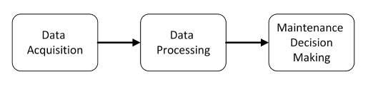

Figure 1: The three steps of the CBM technique.

The condition of components is monitored by processing data collected by sensors attached to the components. The data are summarized by condition indicators that reflect the component health, which is considered in the decision-making process. The analysis can be applied to various types of data, including vibration, acoustic, and oil debris. Vibration analysis is the prevalent method for monitoring rotating components. Vibration data are analyzed by using various signal-processing techniques to extract features that are then used to diagnose the current condition of the rotating mechanism. Faults are detected during the diagnosis stage. Fault isolation allows a specific failing component to be identified, following which the extent and nature of the fault are estimated. During the prognosis stage, the time-to-failure is estimated based on the fault identified in the diagnosis stage. Vibration analysis is commonly used for diagnoses and is effective for detecting various faults and malfunctions; it is already used to monitor jet engines, wind turbines, and other machines [2] [3].

Because rotating parts cause events to occur at specific angular positions rather than at specific times, the various methods of processing vibration signals require knowledge of the rotational speed of rotating machines. Thus, an accurate estimate of the instantaneous angular speed (IAS) is important for reliable diagnostics. Dynamic phenomena such as unbalance, misalignment, or eccentricity can lead to inaccurate estimates of the angular speed and can mask the effects of incipient localized faults. In practice, however, direct measurement of rotational speed is often impossible, expensive, or inaccurate.

The present research investigates the vibration signature of healthy and damaged ball bearings. The bearing signature includes local faults of various magnitudes as well as system unbalance. In this research, the rotational speed of the system is estimated based on the measured vibration signature of a bearing instead of by direct measurement. By using the measured vibration signal and the estimated rotational speed, bearing faults can be identified.

This study analyzes the vibration signals from bearings with a spalled outer race. As shown in Figure 2, the research methodology is based on the combination of experiments and the analysis of simulated vibrational signals. The comparison of simulations and measurements improves our understanding of the limitations of the proposed method and helps in developing an automated, generic algorithm to estimate the IAS directly from the vibrational signal. Comparing the experimental signals with the simulated signals provides the requisite information to understand how a vibration signature is modified by the presence of a fault.

Validation

Simulation/ Experiments

comparison

Figure 2: The research methodology.

Chapter 2 reviews the relevant literature for this study, and Chapter 3 presents the theoretical background. Chapter 4 describes the research objectives, and Chapter 5 presents the simulation. Chapter 6 discusses an algorithm for directly estimating the IAS from the vibration signal, and Chapter 7 presents the experimental setup used to test the algorithm. Chapter 8 analyzes the results, and Chapter 9 discusses how defects can be detected and diagnosed based on the vibration signal. Finally, Chapter 10 summarizes the work and discusses its implications.

# Research Objectives

The primary objective of this study is to diagnose and detect faulty bearings based on the vibration signatures of healthy and damaged bearings. The various methods of vibration-signal processing require knowledge of the rotational speed. Operational limitations of the system under study prevent the installation of a speed sensor, which means that the rotational speed cannot be directly measured. For this reason, this study aims to estimate the IAS based on the vibration signal.

This study compares several methods for directly estimating the IAS from a vibration signal. In addition, an approach is proposed to automatically extract the IAS from a vibration signal when the rotational speed is stationary or varies in time. This research verifies the following hypotheses:

* A spall in the outer race causes the bearing dynamics to differ from that of a healthy bearing.
* Instantaneous angular speed can be estimated based on vibrations (i.e., without using a tachometer) for both stationary and time-varying angular speed.

# 2. LITERATURE REVIEW

This chapter reviews the literature on two themes, each of which will be presented separately: determination of the IAS under stationary and time-varying rotational speed and the detection and characterization of bearing defects.

## 2.1 Estimation of Stationary and Time-Varying Rotational Speed

For bearings operating under stationary rotational speed, faults can be diagnosed in the frequency domain because each type of fault has a specific characteristic frequency that is proportional to the rotational speed of the shaft. If the rotational speed cannot be measured, the IAS can be estimated directly from the vibration signal in many different ways, each with its advantages and disadvantages. One of the earliest methods to estimate IAS is based on the Fourier transform, and this approach remains the simplest to implement. Some commercial IAS-estimation software packages offer Fourier-based IAS evaluation; Ref. [4] analyzes these methods in detail and compares the associated errors both qualitatively and graphically. Although Fourier-based methods are good for monitoring IAS in steady-state conditions, they are unsuited for non-steady-state data, in which variations in the rotational speed widen the frequency spectrum.

Signals are complex, with different families of harmonics coexisting alongside the various harmonic orders and interacting with the structural resonances of the machine. This multicomponent nature means that the signal must be decomposed, which may be done by using the Empirical Mode Decomposition (EMD) algorithm, which is a popular technique to decompose multicomponent signals. With this technique, the decomposed signal is represented as a sum of a finite set of intrinsic mode functions, each of which is assumed to be a single component. Although empirical mode decomposition has proven its usefulness for decomposing multicomponent signals, it is not characterized as a filter. In addition, despite being a well-known method, the full theoretical framework of empirical mode decomposition has yet to be clarified. Finally, the main disadvantage of the method is that, in the presence of noise, the technique provides poor estimates of the IAS [5].

Reference [6] introduced a new approach for robust IAS estimation called the “multi-order probabilistic approach” (MOPA). The main idea of this method is that it considers the most probable periodic mechanical events of the mechanism being studied to infer the most probable IAS at each time step. The first step is to obtain a list of all periodic phenomena of the system, such as shaft rotational speed and meshing frequencies and their harmonics, with frequencies related to the frequency of the shaft of interest. The MOPA then uses all the *a priori* kinematics knowledge to fusion all the component harmonics, which, after smoothing, finally gives the IAS. The MOPA was applied to a challenging signal recorded from the gearbox of a wind turbine and performed exceptionally in terms of relative error with respect to the IAS estimated by processing the tachometer signal [6]. Overall, the method accurately estimates the rotational speed even when the speed fluctuates significantly. However, despite the good results, the MOPA suffers from a number of disadvantages: First, it is a relatively new method, which increases the uncertainty regarding its limitations. In addition, the method has only been tested with steady-state signals produced by machines running at a relatively stationary rotational speed. Moreover, prior knowledge of the machine being studied is required to apply this method.

Adaptive filters such as the Vold-Kalman filter (VKF) can also be used to estimate the IAS. The VKF was first adapted to order tracking by Vold and Leuridan in 1993, but its underlying theory is not as straightforward. The VKF technique allows the extraction of close and crossing orders in systems with multiple shafts and features a finer frequency and order resolution than conventional techniques. The filtering capabilities are independent of the rate of change of the rotational speed [7] [8] [9]. However, despite the many benefits, the VKF technique has some notable disadvantages. Reference [10] objectively compared the features of the VKF technique and found that other methods, such as Gabor order tracking, are clearly more efficient than the VKF technique in terms of rejecting out-of-band energies. Additionally, the VKF technique requires longer computation time than the other methods examined, making it unsuitable for real-time processing. Reference [11] proposed an adaptive VKF approach to overcome this drawback, which makes the VKF a more practical and powerful tool, suitable for real-time monitoring. Many researchers [12] [13] [14] [15] have discussed the issue of setting the filter passband, which is a fundamental characteristic of the VKF. However, the theoretical framework for selecting the VKF bandwidth is incomplete and requires further investigation.

Rotating machinery often operates at varying rotational speeds, in which case stationary-speed methods are not applicable. Therefore, methods to diagnose machine faults for varying rotational speed are of critical importance for industrial applications. Various methods have been proposed to diagnose bearing faults under conditions of non-stationary rotational speed, including methods based on signal resampling [16] [17], machine learning [18] [19], and time-frequency analysis [20] [21]. However, some of the existing methods used to determine the IAS for non-stationary rotational speed are incomplete. Many factors limit the accuracy of angular resampling of signals. Machine learning methods can be used to automatically diagnose bearing faults without knowing the rotational speed and without signal resampling [22]. However, numerous data are required to train the method-related parameters. Time-frequency analysis techniques, such as the short-time Fourier transform, can reveal the instantaneous rotational frequency of the shaft as a curve in the time-frequency representation (TFR) [22]. Additionally, the TFR can be used to estimate the time-varying rotational speed or instantaneous rotational frequency of the shaft. However, the diagnosis of an automatic bearing fault requires that the instantaneous rotational frequency of the shaft be extracted from the TFR [22].

The algorithm to extract multiple time-frequency curves was recently developed to extract the time-frequency curves from the TFR of a signal [23]. This algorithm serves to extract multiple time-frequency curves from the TFR of the bearing-vibration signal. Bearing faults can be automatically diagnosed if the instantaneous characteristic frequency of the fault and the instantaneous rotational frequency of the shaft are recognized from the extracted time-frequency curves. This is done by calculating the average frequency ratio of two curves and comparing this average to the characteristic coefficient of each fault. The characteristic coefficient of the fault is the ratio of the characteristic frequency of the fault to the rotational frequency of the fault, which remains constant even for non-stationary rotational speed. However, if the bearing is healthy, the average ratio of two randomly extracted curves matches the characteristic frequency of the fault regardless of whether the extracted curve is the instantaneous characteristic frequency of the fault or the instantaneous rotational frequency of the shaft. This leads to a false result whereby a healthy bearing is diagnosed as faulty. Therefore, the average ratio of two curves is insufficient to identify the instantaneous characteristic frequency of the fault and the instantaneous rotational frequency of the shaft [23].

Reference [24] recently proposed a two-step method to estimate the IAS: In the first step, the IAS is roughly estimated based on a time-frequency distribution, such as a spectrogram. In the second step, a narrow-band-pass filter tuned to the desired frequency is applied based on the first IAS estimate, and a refined estimate is obtained by frequency demodulation. The first IAS estimate obtained from the spectrogram is used for angular resampling of the vibration signal, allowing the vibrational component of interest to be filtered in the angular domain by using a constant-bandwidth band-pass filter and resampling it back to the original time domain. The final IAS estimate is then obtained by frequency demodulation of the previously filtered signal. This method is attractive because it is simple to implement and provides accurate estimates of the rotational speed even when the IAS fluctuates strongly. However, the method has three major drawbacks: First, it is as yet unsuited for practical applications: the authors report that automated, unsupervised reconstruction of rotational speed from the vibration signal remains impossible with the proposed method [24]. Second, the method requires *a priori* knowledge of the machinery and visual examination of the spectrogram (i.e., it is not automated). Finally, the method has been tested only with experimental signals but has not been simulated with more general signals, making it difficult to determine whether the method works well in other cases. We thus conclude that further research and new methods are needed to estimate the IAS when the rotational speed is non-stationary.

## 2.2 Bearing Diagnostics

Methods for bearing diagnostics and prognostics can be divided into two main categories: physics-based methods and data-based methods [25]. Currently, most of the physics-based methods stem from frequency and time-domain analysis of the acceleration signal [26]. A widely accepted and well-known approach is to identify/ detect a fault in a bearing by examining the frequency domain.

Each bearing element affects the spectrum in a different way. A fault in a given bearing element is signaled by an increase in the vibration energy of the specific element. For example, in this study, a fault in the outer race produces a ball-pass frequency outer race (BPFO) frequency [27].

Examining the frequency domain is not the only method to detect defects. Various methods are available that use time-domain analysis or the combination of the frequency- and time-domain analysis to detect bearing defects and estimate their size. For example, for bearings, spike-energy analysis has been used to identify defects and estimate their severity [28]. The characteristic vibration signals of bearings with inner race defects, outer race defects, or roller defects allow these defects to be identified. To detect defects in bearings, Ref. [28] presents an acoustic-emission method that reportedly is more sensitive to variations in defects. A statistical comparison of the acoustic-emission results with vibration analysis using features such as root mean square and kurtosis reveals that the vibration signal is not correlated with fault size. However, although statistical parameters such as peak-to-peak value, root mean square, crest factor, and kurtosis may reveal the presence of defects, they give no information about defect location. With statistical methods, data gathered from pristine bearings are simply compared with those gathered from defective bearings. Compared with these conventional methods, experiments indicate that the proposed method of vibration monitoring is highly reliable, improves fault detection, and is very sensitive to fault severity, making it an extremely useful technique. In addition, the magnitude and frequency of the vibrations allow defects to be located precisely and their severity to be estimated.

## 3. THEORETICAL BACKGROUND

This chapter summarizes the theoretical background needed to understand the methods and techniques used in this research.

### 3.1 Bearing-Feature Characterization

In the spectral signature of a vibration signal, different peaks can be explained in theory as being excited by the shaft or by bearings interacting with the shaft. These peaks must be classified to differentiate between “healthy” and “faulty” bearings. Moreover, they provide information on the fault type and severity. With faulty bearings, the highest-energy peak in the frequency (order) domain belongs to the bearing tone (BT) and its harmonics. These frequencies are influenced by the geometric parameters (Figure 3) of the bearing and the rotational speed of the shaft, as indicated by the following equations:

$BPFO=\frac{f_{r}}{2}n\left[1-\left(\frac{d}{D_{p}}\right)\cos\left(α\right)\right]$, (1)

$BPFI=\frac{f_{r}}{2}n\left[1+\left(\frac{d}{D_{p}}\right)\cos\left(α\right)\right]$, (2)

$FTF=\frac{f_{r}}{2}n\left[1-\left(\frac{d}{D_{p}}\right)\cos\left(α\right)\right]$, (3)

$BSF=\frac{f_{r}}{2}n\left[1-\left(\frac{d}{D_{p}}\right)\cos\left(α\right)\right]$, (4)

where $f_{r}$ is the rotational speed of the shaft in revolutions per second (Hz), $n$ is the number of balls, $d$ is the ball diameter, $D_{p}$ is the bearing pitch diameter, and $α$ is the contact angle.



Figure 3: Bearing-tone parameters.

The BT frequencies correspond to the rotational speed of the shaft with which the bearing interacts. Other peaks in the spectra indicate one of two phenomena: amplitude modulation (AM) or frequency (phase) modulation (FM) of the bearing tones.

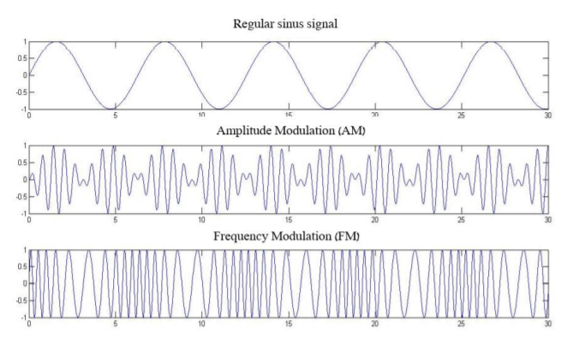

Figure 4: Amplitude and frequency modulation of a sinusoidal signal.

These phenomena are expressed in the frequency (order) domain as a pair of sidebands (upper and lower SBs). The spacing between the carrier frequency (BT) and the SB frequency is the basic frequency of the modulating signal (in the case of bearings, this is the shaft frequency, which is the first order in the order domain). Generally, the first SB around each bearing tone is associated with an AM component. The AM components are associated with imperfections such as unbalance, bearing eccentricity, and shaft misalignment [29]. Fourier analysis provides the following mathematic expressions for a periodic signal, an AM signal, and a FM signal [30]:

$y\left(t\right)=\sum_{m=1}^{M}{A_{m}\left(2πmft+φ_{m}+φ_{0}\right).}$ (5)

${AM}_{m(t)}=\sum_{n=1}^{N}{A_{mn}(2πnft}+α_{mn})$. (6)

${FM}_{m(t)}=\sum_{k=1}^{K}{B_{mk}(2πkft}+β_{mk})$. (7)

where $f$ is the carrier frequency.

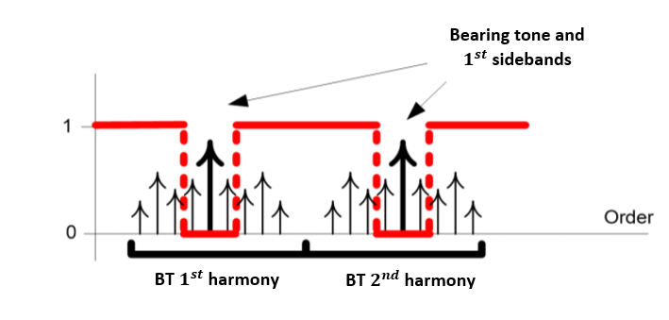

Figure 5: Illustration of the categories of peaks extracted in the order domain: BT, FM, and AM. AM are the two closest (lowest order) sideband (SB) pairs to the BT. The rest are FM-related SB. All SBs are spaced by shaft frequency

### 3.2 Power Spectral Density

Measured signals contain random noise, which can be reduced by averaging several signals. Such averaging can be done by considering partial blocks (windows) of the signal, with each block containing a certain number of cycles. The power spectral density (PSD) provides the energy distribution of a signal in the frequency domain and is calculated by averaging the Fourier transform within several windows on the time-domain signal. The statistical error in the PSD is $1/\sqrt{M}$, where *M* is the number of windows. The PSD of the signal $\hat{F}\left(t\right)$ is

$PSD\left(f\right)=\frac{1}{M∙dt}\sum_{m=1}^{M}{{|{\hat{F}}_{m}(t)|}^{2}}$. (8)

where *M* is the number of windows, $f$ is the frequency of the measured signal, and *t* is time.

### 3.3 Angular Resampling

The angular resampling algorithm was designed to overcome instability in the rotational speed. Angular-velocity tracking is one of the most important and sensitive stages in the vibration analysis of synchronous machines. The raw vibration signal is resampled by using the rotational-speed signal. With angular resampling, the signal is resampled in constant angular increments rather than in constant time increments as done originally. The sampled time-domain signal is remapped to a “cycle” domain, and a Fourier transform of cycle-domain data produces an “order-domain” signal, analogous to the Fourier transform of the time-domain signal to the frequency domain. In the order-domain, each impulse per cycle generates a peak in the first order.

### 3.4 Synchronous Average

The synchronous average (SA) is a signal-processing technique for the vibration analysis of mechanical systems. The SA removes all signal components asynchronous with a particular nominal frequency. In practice, the SA is done by averaging together a series of signal segments, each corresponding to one period *T* of a synchronizing signal:

$y(t)=\frac{1}{N}\sum_{n=0}^{N-1}{y(t+nT)}$. *n =*1, 2, 3 …. (9)

where $N$ is the number of cycles in the signal and 𝑦 is a vector in $R^{N}$ representing a single cycle.

Given sufficient averaging, non-synchronous peaks are averaged out of the spectrum, whereas spectral peaks that are harmonics of the rotational speed remain.

### 3.5 Vold–Kalman Filter

The VKF extracts vibration components from a time-varying vibrational signal. The VKF method has three main advantages: First, it works directly in the time domain. Second, it allows accurate tracking of harmonic orders. Third, its tracking performance is independent of rotational speed. The advantage of VKF compared with other order-tracking techniques is that it allows the amplitude and phase of the time-domain signal corresponding to a specific component to be extracted from the raw data. VKF relies on two basic equations, the first of which is the “data equation”

$y\left(n\right)=f\left(n\right)+μ(n)$, (10)

where $f\left(n\right)$ is the tracked order component, $μ(n)$ contains the other components, and *n =*1, 2, 3, …. The second basic equation is the “structural equation”

$f\left(n\right)-2cos\left(ω∆T\right)f\left(n-1\right)+f\left(n-2\right)=ϵ(n)$, (11)

where $f\left(n\right)$ is the tracked-order component, $ω$ is the angular frequency, and $ϵ\left(n\right)$ is a nonhomogeneous term representing the other components. A more detailed explanation of the function of the data and structural equations can be found in Ref. [12].

Given these two fundamental equations, a VKF can extract and track the targeted components and acquire their corresponding temporal waveform without involving angular resampling. However, the filter performance depends strongly on the filter bandwidth $∆f$ and on the weighting factor *r*:

$r= \frac{1}{π∆f}\frac{\sqrt{\sqrt{2}-1}}{\sqrt{1-{\left[\cos\left(ω∆t\right)\right]}^{2}}}$. (12)

The weighting factor is inversely proportional to the frequency bandwidth $∆f$. The coefficients of the denominator of the VKF transfer function are functions of the weighting factor, and their values affect the filter selectivity. A large (small) weighting factor leads to high (low) values of these coefficients, making the filter more (less) selective. The VKF transfer function is

${\left|H(e^{jω∆t})\right|}^{2}=\frac{1}{2r^{2}+1-4r^{2}\cos\left(ω∆t\right)+2r^{2}cos⁡(2ω∆t) }$, (13)

### 3.6 Zero Crossing

The simplest way to estimate the instantaneous frequency of a signal is to count the number of times the signal crosses zero within a small segment of the signal. The instantaneous frequency can be estimated from the number of zero crossings [30] within a small window of length $\left(2N+1\right)$. This is done by using

$x\left[n\right]=\frac{π}{2(2N-1)}\sum_{m=-n}^{m=n}{|x\left(m\right)-x\left(m-1\right)|}$. (14)

where *x* is the recorded signal, *N* is the signal length, and *n*=1, 2, 3…

### 3.7 Envelope

To prevent the non-detection of the characteristic defect frequencies of bearings in the direct spectrum of a vibration signal, envelope detection was used to detect bearing faults. Three main steps are required to define the envelope: The vibration signal is first filtered by a band-pass filter, which removes the high-frequency random noise and the “large” low-frequency components, leaving only the burst of high-[frequency vibrations](https://www.sciencedirect.com/topics/engineering/frequency-vibration), as shown in [Figures 6](https://www.sciencedirect.com/science/article/pii/S2288430017300192" \l "f0015)(a) and 6(b). Next, an envelope is traced around the bursts in the band-passed signal ([Figure 6](https://www.sciencedirect.com/science/article/pii/S2288430017300192#f0015)c) by using a [Hilbert transform](https://www.sciencedirect.com/topics/engineering/hilbert-transform). In the last step, the envelope signal is converted into the frequency domain for analysis (Fig[ure](https://www.sciencedirect.com/science/article/pii/S2288430017300192#f0015) 6d).

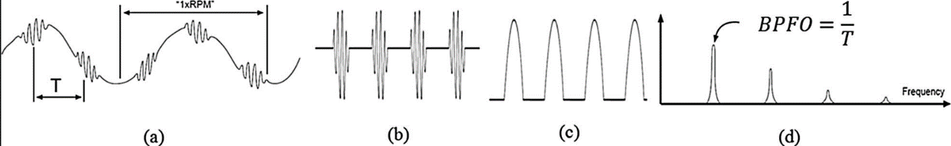

Figure 6: Envelope detection process: (a) unfiltered time-domain signal, (b) band-passed signal, (c) envelope of band-passed signal, (d) envelope spectrum.

The [Hilbert transform](https://www.sciencedirect.com/topics/engineering/hilbert-transform) is defined as a convolution of the time-domain signal $u\left(t\right)$ with the function *h*(*t*) = 1/*πt*. This time-domain transform maps a real-valued time-domain signal $u\left(t\right)$ to another time-domain signal $h\left(u\right)\left(t\right)$ as indicated by

$h\left(u\right)\left(t\right)=\int_{-∞}^{∞}{u\left(t\right)h\left(t-τ\right)dτ}$. (15)

The Hilbert transform produces a frequency-independent 90° phase shift that does not modify the non-stationary characteristics of the modulating signal. Demodulation is done by forming a complex-valued time-domain signal $\tilde{u}\left(t\right)$ called the analytic signal, which is a complex time series. This envelope is obtained by summing the magnitude of the analytic signal with the original time-domain signal $u\left(t\right).$

# 4. SIGNAL GENERATION

The goal of the simulation described in this chapter is to simulate a signal measured by a sensor. Signals recorded by a sensor constitute the system’s response to excitation by the rotating parts in the system. This response depends on the transmission path between the various parts and the sensor. Figure 7 schematically shows signals that are passed through a transmission path to the sensor. This may be described mathematically as

 (16)

where is the signal measured by the sensor, is the simulated gear signal, is the simulated bearing signal, is the simulated shaft signal, $h$, $h_{1}$, $h_{2}$, $h_{3}$ are the shock response of the transfer functions $H$, $H_{1}$, $H_{2}$, $H_{3}$, respectively, and the operator * is convolution.

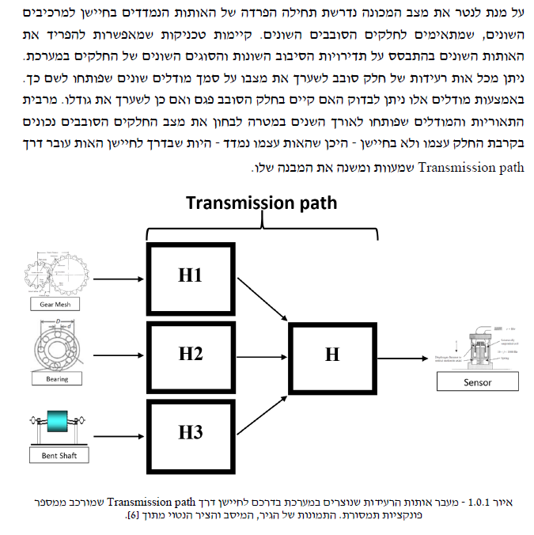

Figure 7: Vibration signals generated in the system transmitted to a sensor via a transmission path consisting of a number of transmission functions. The images of the gear, bearing, and shaft are from Ref. [31].

To test Eq. (16), a large database of simulations was constructed, where each simulation was constructed from a transmission function, signals of gears and bearings, and various signals connected to the rotational speed and white noise.

### The simulation of each vibration signal was done as follows (Figure 8): First, the global simulation parameters and the rotational speed are fixed, and the signal and noise are generated based on these parameters. Next, the transmission function is calculated to simulate signals from real machines in which excitations created by the rotating parts are transferred to the sensor by the transfer functions corresponding to the machinery’s structure and that amplify each frequency range differently. The signals created in the second step are then convoluted with the transmission function. The simulation reproduces the dynamic behavior of shaft, gear, and bearing components.

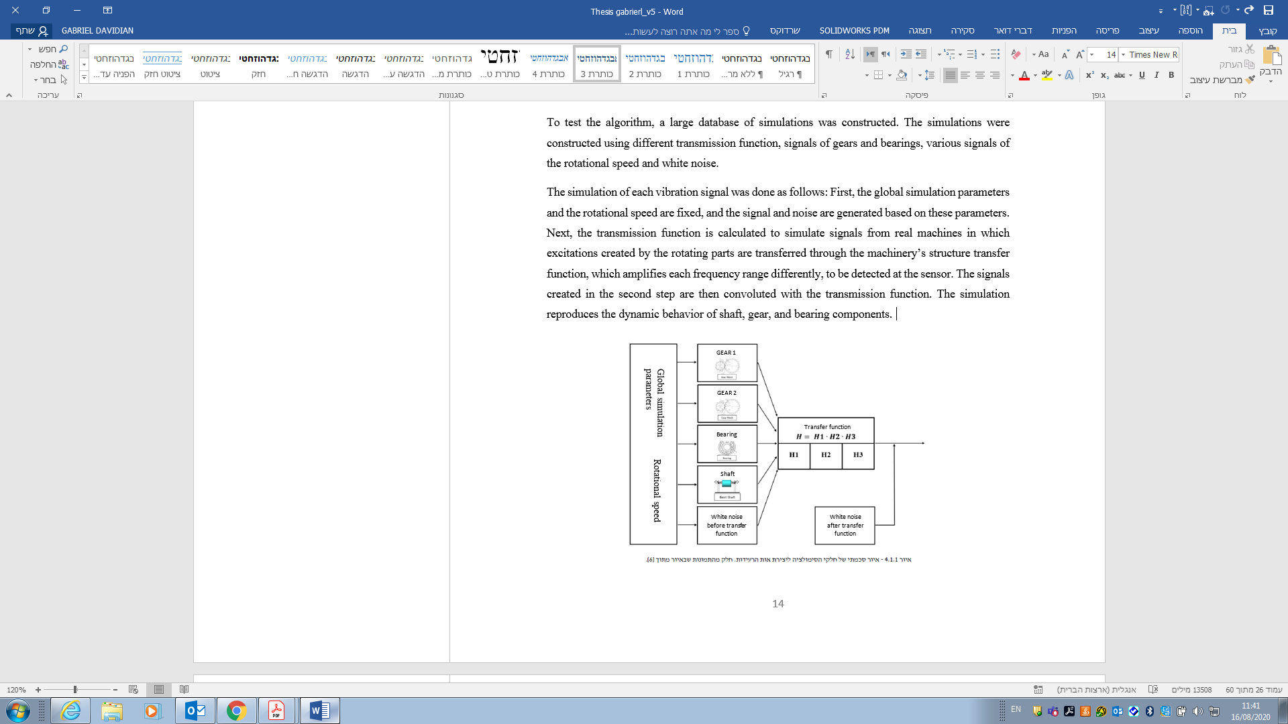

Figure 8: Schematic illustration of simulation to create vibration signal. The images are from Ref. [32].

The simulated vibration signal simulates a single (virtual) motor shaft. In addition, virtual bearing- and gear-like components with gear meshes were included in the simulation by modulating the frequency of the rotation speed.

### 4.1. Bearings

The bearing simulation was done as follows: a series of delta functions was first produced at a rate corresponding to the defect (the BPFO in this case), and then the series was convolved with the bearing transmission function. The mathematical description of the bearing signal is

$B_{signal}(t)=A\left[{Delta}_{s}\left(t\right)\sum_{n=1}^{H}{sin⁡(2π∙RPS∙t)}\right]$, (10)

where $B_{signal}$ is the simulated bearing signal, ${Delta}_{s}$ is the delta functions series, $A$ is the simulated bearing signal amplitude, $H$ is the number of harmonics and $RPS$ is the rotational speed.

### 4.2. Gears

The simulation allows for two gear wheels, for each of which the following parameters must be determined: amplitude, number of teeth, number of harmonics, and modulations. The simulation is produced by constructing periodic signals according to the modulations, which are modulated on the various harmonics using frequency modulation. The signal can be mathematically described as follows:

$G_{signal}\left(t\right)=A\sum_{n=1}^{H}{sin⁡\left[2π∙\int{(RPS}+{FM}_{s})dt\right]}$, (11)

here $G_{signal}$ is the simulated gear signal, $N$ is the number of gear teeth, $A$ is the amplitude of the simulated gear signal, $H$ is the number of harmonics, $RPS$ is the rotational speed, and ${FM}_{s}$ is the modulated signal (periodic signal).

### 4.2. Shaft

The shaft is simulated by creating harmonics corresponding to the rotational frequency of the shaft. Mathematically, this is described as follows:

$S_{signal}=A\sum_{n=1}^{H}{a_{n}sin⁡(2π∙\int{RPS}dt+θ_{n})}$, (11)

where $S_{signal}$ is the simulated shaft signal, $A$ is the amplitude of the simulated shaft signal, $H$ is the number of harmonics, $RPS$ is the rotational speed, $a_{n}$ is the amplitude of harmonic *n*, and $θ_{n}$ is the phase of harmonic *n*.

The amplitudes of all synchronous elements ( $A_{k,i}$ for 𝑘 = 1, 2 corresponding to $RPS)$ and gear meshes were constant, and 2 dB of white noise was added. The shaft $RPS$ was dictated by different functions (see Table 1). In total, twenty-two signals were simulated from constant-amplitude bearing faults with different $RPS$ profiles or shaft harmonics (see Table 1 for the specifications of the bearing tones, $RPS$ ranges, and shaft harmonics).

Table 1: Simulation specifications.

|  |  |  |  |  |  |  |
| --- | --- | --- | --- | --- | --- | --- |
| Record | | Bearing tone | $RPS$ profile | Acceleration | RPS range | Shaft harmonics |
| 1 |  | BPFO – 3.5 | Stationary speed, 25 Hz | 1 | [23 26] | [1 12] |
| 2 |  | BPFO – 3.5 | Stationary speed, 25 Hz | 1 | [23 26] | [ 1 3] |
| 3 |  | BPFO – 3.5 | Stationary speed, 25 Hz | 1 | [23 26] | [1 3 12] |
| 4 |  | BPFO – 3.5 | Stationary speed + $5sin⁡(πt)$ | 11 | [15 35] | [1 12] |
| 5 |  | BPFO – 3.5 | Stationary speed + $5sin⁡(πt)$ | 11 | [15 35] | [1 3] |
|  |  |  |  |  |  |  |
| 6 |  | BPFO – 3.5 | Stationary speed + $5sin⁡(2πt)$ | 11 | [15 35] | [1 3] |
| 7 |  | BPFO – 3.5 | Stationary speed + $5sin⁡(2πt)$ | 11 | [15 35] | [1 12] |
| 8 |  | BPFO – 3.5 | Stationary speed + $5sin⁡(2πt)$ | 11 | [15 35] | [3 12] |
| 9 |  | BPFO – 3.5 | Stationary speed + $5sin⁡(2πt)$ | 11 | [15 35] | [1 3 12] |
| 10 |  | BPFO – 3.5 | $${100e}^{t/T}$$ | 10 | [95 285] | [1 3] |
| 11 |  | BPFO – 3.5 | $${100e}^{t/T}$$ | 10 | [95 285] | [12 24] |
| 12 |  | BPFO – 3.5 | $${100e}^{t/T}$$ | 10 | [95 285] | [1 12] |
| 13 |  | BPFO – 3.5 | $${100e}^{t/T}+5sin⁡(t)$$ | 12 | [95 285] | [1 3] |
| 14 |  | BPFO – 3.5 | $${100e}^{t/T}+5sin⁡(t)$$ | 12 | [95 285] | [1 3 12] |
| 15 |  | BPFO – 3.5 | $${100e}^{t/T}+5sin⁡(πt)$$ | 12 | [95 285] | [1 12] |
| 16 |  | BPFO – 3.5 | $${100e}^{t/T}+5sin⁡(πt)$$ | 12 | [95 285] | [3 12] |
| 17 |  | BPFO – 3.5 | $${100e}^{t/T}+5sin⁡(2πt)$$ | 12 | [95 285] | [1 3] |
| 18 |  | BPFO – 3.5 | $${100e}^{t/T}+5sin⁡(2πt)$$ | 12 | [95 285] | [1 12] |
| 19 |  | BPFO – 3.5 | $${100e}^{t/T}+5sin⁡(5πt)$$ | 19 | [95 285] | [1 3] |
| 20 |  | BPFO – 3.5 | $${100e}^{t/T}+5sin⁡(5πt)$$ | 19 | [95 285] | [1 12] |
| 21 |  | BPFO – 3.5 | $${100e}^{t/T}+5sin⁡(5πt)$$ | 19 | [95 285] | [1 3 12] |
| 22 |  | BPFO – 3.5 | $${100e}^{t/T}+5sin⁡(5πt)$$ | 19 | [95 285] | [1 50] |

# 5. ALGORITHM FOR ESTIMATING ROTATIONAL SPEED

The frequency characteristics of a signal can be revealed in the time-frequency domain. Time-frequency techniques, such as the short-time Fourier transform or the wavelet transform, can be used to obtain the TFR of a signal. The IAS frequencies appear as time-frequency (T-F) curves in the TFR. However, to further analyze or use the frequencies, IAS T-F curves must be extracted from the TFR, which may result in numerous curves. Most of the extracted curves do not necessarily correspond to integer multiples of the instantaneous rotational frequency of the shaft.

The originality of this work lies in the proposed algorithm, which classifies the extracted curves based on their continuity. More specifically, a curve whose duration differs from that of the recorded vibration signal is rejected because it is unlikely to correspond to the rotational speed. However, curve continuity alone is not enough, so further analysis is done by matching curves. The algorithm searches the TFR over all integer multiples of the instantaneous rotational speed of the shaft until continuous matching curves are found. These considerations lead to the following criteria:

* The proposed algorithm requires that the instantaneous rotational speed of the shaft has at least two harmonics.
* The probability that the IAS curve will be extracted increases with increasing number of harmonics of the instantaneous rotational speed of the shaft.

The proposed algorithm uses all the information available about the kinematics of the machine. A number of inputs are required for the proposed method: the range of the instantaneous rotational speed of the shaft, the IAS acceleration, the recorded vibration signal, and the harmonics of the IAS of the shaft. The simplicity and availability of the required inputs give the proposed approach a significant advantage over conventional approaches.

The method proposed herein to estimate angular speed was developed by combining several existing methods. Figure 9 describes three tasks: first, a preliminary selection process in which the relevant IAS curve is isolated from the existing curves estimated from the TFR. Next, based on the estimated curve, the relevant phasors are extracted from the vibration signal. Each of the extracted phasors represents a stationary IAS curve. The extracted phasors (i.e., multiple stationary IAS curves) are then combined to determine the IAS. Finally, the estimated IAS accuracy is evaluated.

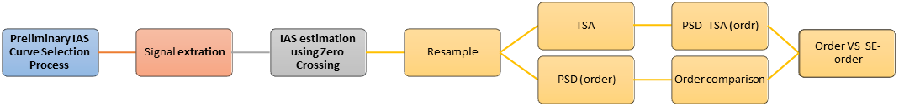

Preliminary IAS Curve Selection

Signal Extraction

IAS Extraction

IAS Evaluation

Multiple stationary IAS curves combined to comprise a vector

A low resolution IAS curve selected in the preliminary curve selection process

Estimated IAS obtained through overlapping of multiple stationary IAS curves and Zero Crossing

Figure 9: Algorithm for estimating rotational speed directly from a vibration signal. The relevant IAS curve is first isolated from the TFR, then the relevant phasors are extracted, and finally, the phasors are combined to determine the IAS. Additionally, the accuracy of the estimated IAS is evaluated.

## 5.1. Process for Preliminary Selection of IAS Curves

The proposed process for preliminary selection of IAS curves allows us to extract multiple time-frequency curves from the TFR of a vibration signal. Figure 10 describes four tasks: First, the spectrogram and its frequency resolution are calculated based on the IAS acceleration. This produces peaks that fall within the specified range for each spectrum in the TFR. Next, for each spectrum in the TFR, local maxima in the top 10% in magnitude are extracted. The percentile criterion filters out noise that is not related to the instantaneous rotational speed.

Let the TFR of the signal $x(t)$ be $X(τ,f)$, where $τ$ is the time and $f$ is the frequency. The local maxima within the specified range can then be extracted from $X(τ,f)$ as follows:

$C(τ,f)=\left\{ξ(τ_{n},f)=\begin{aligned}\left\{\begin{aligned}\frac{d|X(τ_{n},f)|}{df}=0 \\ \frac{d^{2}|X(τ_{n},f)|}{d^{2}f}<0\end{aligned}\right. , &\{f∈R:H∙RPS1≤f≤H∙RPS2\}∩ξ(τ_{n},f)>p \\ 0 , &else\end{aligned}\right.$ (12)

where $p$ is the percentile, ***RPS1*** and ***RPS2*** are the lower and upper boundaries of the specified rotation-frequency range, respectively, $H$ is the harmonic of the rotational speed, $ξ(τ_{n},f)$ is a local maximum and $n=1,2,…,N$ is the time resolution of the TFR.

The remaining local maxima (top 10% in magnitude) form a large number of time-frequency curves and do not necessarily represent the integer multiples of the instantaneous rotational frequency of the shaft. Therefore, further filtering is done based on the continuity of the remaining time-frequency curves. The remaining curves are normalized to the 1st harmonic of the rotational speed as follows:

$C(τ,f)=\left\{\begin{aligned}\frac{1}{H}C(τ_{n},f), & \{n∈z:n=1,2,…,N\}∩C(τ_{n},f)≠0 \\ ∅ , & else ,\end{aligned}\right.$ (13)

where $H$ is the harmonic of the rotational speed and $τ$ is the time of the signal.

Finally, to associate the extracted curve with the instantaneous rotational speed of the shaft, the curves obtained from a certain harmonic are compared with those obtained from other harmonics until a match is found in all harmonics. This comparison process can only be done if a single curve remains in any given harmonic (i.e., if in one of the rotational speed harmonics only one continues top 90 percentile in magnitude within the lower and upper boundaries of the specified rotation-speed range curve left). This curve is then used as a reference curve against which other curves are compared. If none of the rotational speed harmonics consists of only a single curve, then another rotational speed must be chosen, which is a disadvantage of the proposed algorithm.

The curves are compared by using an index to calculate the relative squared difference (SD) between the different curves at each time point:

*SD* = $\sum_{z=1}^{H}{\sum_{j=1}^{M}{\sum_{i=1}^{N}{\frac{{(ψ\left(i,f\right)-{ζ\left(i,f\right)}_{j,z})}^{2}}{{ψ\left(i\right)}^{2}}}}}$. (14)

In Eq. (14), $ψ$ is a curve from a certain harmonic with only a single curve, $ζ$ is a curve from another harmonic, $H$ is the rotational speed of the former harmonic, $M$ is the number of curves in a certain harmonic, and $N$ is the time point.

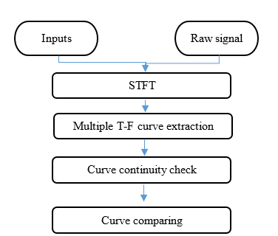

Figure 10: Proposed process for preliminary selection of IAS curve. The process extracts multiple time-frequency curves from the TFR of a vibration signal.

The effectiveness of the method is validated by simulated signals with time-varying speed (see Table 1 for the specifications of the rotational speed) and data collected from an experimental system operating at constant speed. To illustrate the proposed process, the following example is provided. Figure 11a shows the spectrogram of the simulated signal. The rotational speed in this case is dictated by

$RPS={100e}^{t/T} Hz$, (15)

where *t* is the signal duration, and *T* is the signal period (20 s in this case), so the rotational speed ranges from 100 to 280 Hz.

The spectrogram shows all curves in the range for the third harmonic of the rotational speed, namely, 300 to 1000 Hz. Figure 11b shows the multiple T-F curves extracted, which reveal that many curves are not continuous. These non-continuous curves are deleted so that only continuous curves remain (Figure 11c). This process is repeated for all harmonics of rotational speed. The remaining curves are normalized to the rotational speed of the first rotational-speed harmonic. Finally, the remaining curves from all rotational-speed harmonics are compared between themselves to find a matching curve. Figure 12 gives an example of two continuous matching curves, the first and third rotational -speed harmonics in this case.

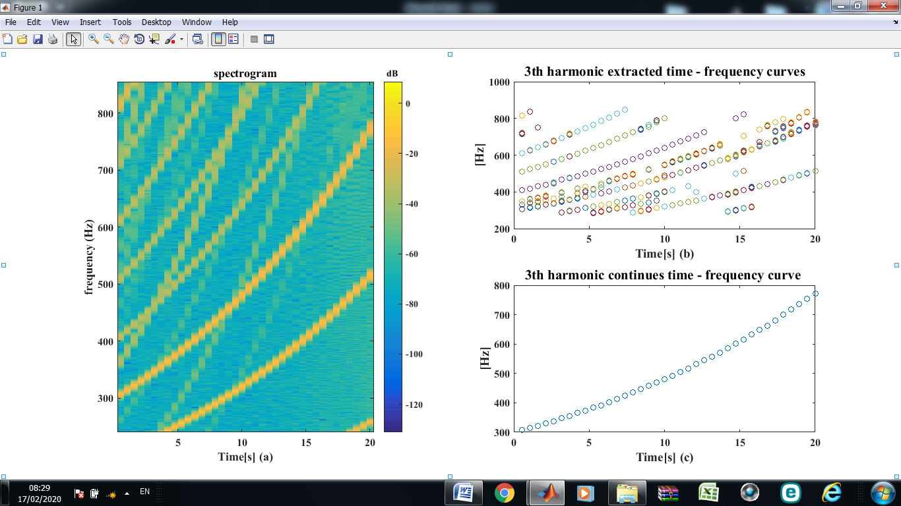

Figure 11: Process for preliminary selection of IAS curves: (a) spectrogram, (b) third-harmonic T-F curves within the specified IAS range with peak in the top 10% in magnitude, (c) continuous third-harmonic T-F curve.

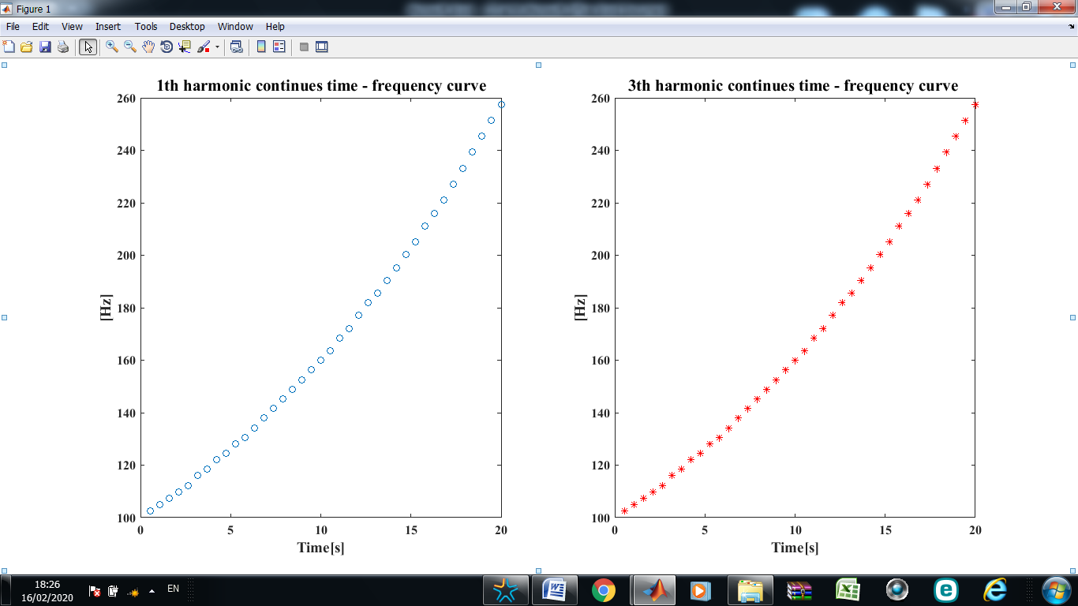

Figure 12: Normalized continuous first and third harmonics of rotational speed T-F curves.

5.2. Signal Extraction

To estimate the IAS, the specific phasor must be isolated from the many vibrational components in the vibration signal. Each value in the estimated IAS curve (selected in the preliminary curve selection process) serves as a value around which filtering is done to estimate the specific phasor. For the signal extraction, two filter schemes where considered: A cascade of band-pass filters and a VKF.

Three rotational-speed harmonics (1, 3, and 12) were filtered from the recorded vibration signal obtained from the balanced and unbalanced experimental fan system. Table 2 lists the filter parameters, bandpass, attenuation, and ripple. For stationary rotational speed, the VKF bandwidth was set at 10% of the nominal rotation frequency for all tracked harmonics (the literature indicates [7] that good results are observed when the filter bandwidth is 10% of the nominal rotation frequency), as shown in Table 2. However, when the rotational speed varied in time (so that the harmonics could shift from their nominal values), the VKF bandwidth had to be wider. Thus the bandwidth was calculated as four times the rotational speed acceleration so that the bandwidth increased with increasing acceleration, as shown in Table 3.

Table 2: Cascade band-pass filter parameters.

|  |  |  |  |  |  |  |
| --- | --- | --- | --- | --- | --- | --- |
| Attenuation  (dB) | Ripple (dB) | Filter order | Filter cascades | Bandpass  (Hz) | Harmonic | Nominal RPS  (Hz) |
| 10 | 3 | Auto | 20 | [20 30] | 1 | 24.6 |
| [70 80] | 3 |
| [290 300] | 12 |

Table 3: VKF filter parameters.

|  |  |  |
| --- | --- | --- |
| Harmonic | Time-varying frequency bandpass  (Hz) | Stationary rotational speed bandpass  (Hz) |
| 1 | $$4×acceleration$$ | 10% of the nominal rotation frequency |
| 3 |  |
| 12 |  |

The filtering process is validated by data collected experimentally and from simulated vibration signals. Figure 13 shows the spectrum of the first harmonic of the rotational speed (≈24.6 Hz) using the proposed method. The spectrum shown in Figures 13 and 14 was generated by a bearing with a 3.5 mm spall on an unbalanced fan shaft. The figures show the spectrum (black), the spectrum of Butterworth filtered signal (light blue), and the spectrum of the VKF signal (red).

Figure 13 shows that both the Butterworth filter and the VKF provide high performance for isolating the first harmonic of the rotational speed (≈24.6 Hz). However, the VKF is slightly smoother than that produced by the Butterworth filter. This can be explained by the set of filter specifications (ripples, attenuation, etc.) and other filter properties. However, the general shape of each filter response curve is almost identical for the Butterworth filter and the VKF. Both the Butterworth filter and the VKF significantly attenuate the spectrum outside each filter’s passband. Clearly, both filtering methods can isolate the harmonics; however, within the passband, the VKF isolates better and attenuates less relative to the Butterworth filter.



Figure 13: Isolating of one value in the extracted curve selected in the preliminary curve selection process (see section 5.1) around which filtering is done using a cascade of band-pass filters and a VKF. The figure shows the filtration process around the first harmonic (≈24.6 Hz) of the rotational speed.

As a result of shaft imbalance, two sidebands (Figure 14) appear near the twelfth harmonic (≈295.4 Hz); both filtering methods fail to completely overcome this issue (sidebands appeared in the filtered signal, Figure 14). The appearance of the sidebands in the filtered signal leads to an inaccurate estimate of the rotational speed (see section 5.3, Figure 22). The region shown in Figure 13 is an example of a region where the use of the proposed method is not recommended.



Figure 14: Isolation of a single value in the curve selected by preliminary curve selection (see section 5.1) and the same curve filtered by using a cascade of band-pass filters and a VKF. The figure shows the filtration around the twelfth harmonic (≈295.4 Hz) of the rotational speed. Lower and upper sidebands appear both in the recorded and filtered signals.

## 

## 5.3. IAS Extraction

In the IAS-extraction phase, the signals obtained after the filtering process are combined to comprise a vector with overlapping segments (Figure 15). The overlap is designed to suppress edge effects, which result from the discontinuities at the points where segments connect. Then, zero crossing is applied to the resulting vector to obtain the instantaneous rotational speed of the shaft.

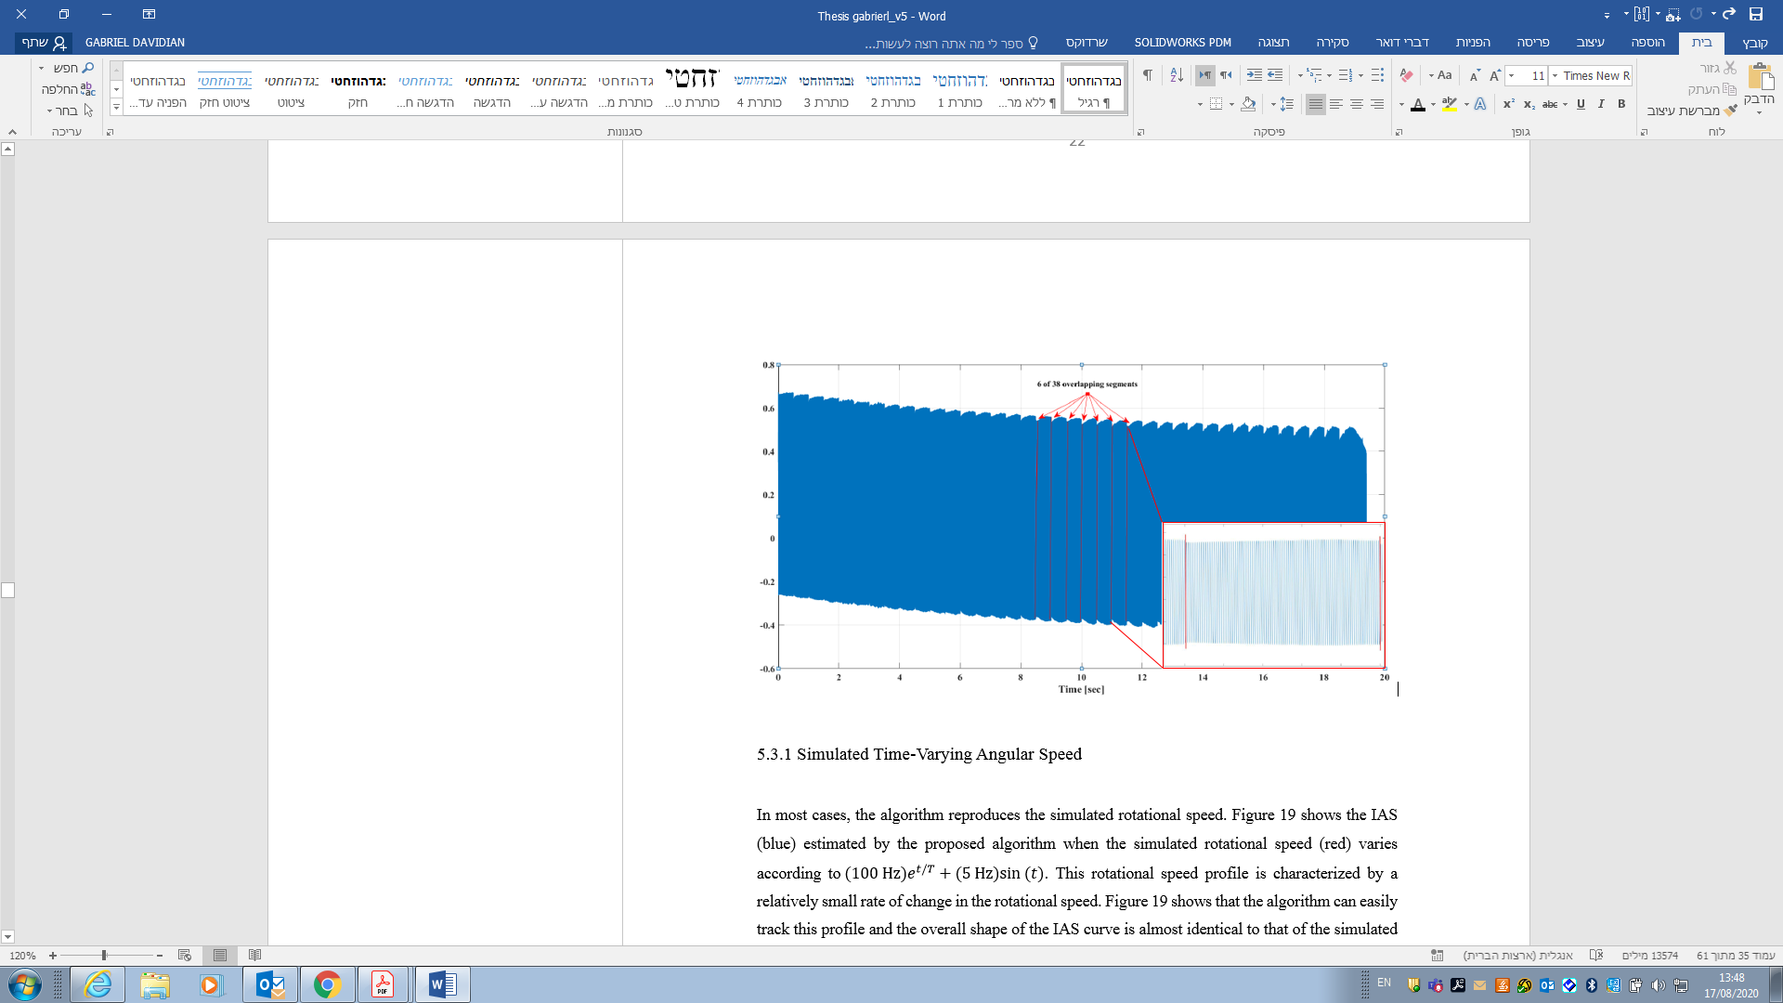

Figure 15: Combined overlapping signals obtained from filtering process. Six of 38 overlapping segments are marked in red. Each of the 38 signals represents a stationary IAS of a different frequency.

The effectiveness of the IAS extraction is validated by using simulated signals with time-varying speed (see Table 1 for the specifications of the rotational speed) and data collected from an experimental system operating at constant speed.

### 5.3.1 Simulated Time-Varying Angular Speed

In most cases, the algorithm reproduces the simulated rotational speed. Figure 16 shows the IAS (blue) estimated by the proposed algorithm when the simulated rotational speed (red) varies according to ${ (100 Hz)e}^{t/T}+(5 Hz)sin⁡(t)$. This rotational speed profile is characterized by a relatively small rate of change in the rotational speed. Figure 16 shows that the algorithm can easily track this profile, and the overall shape of the IAS curve is almost identical to that of the simulated rotational speed. This means that the process functions well for extracting and selecting the T-F curves and estimating the IAS. The results in Figure 16 show that the IAS curve is smooth, with no evidence of edge effects. This explains the need for overlap between VKF segments and leads to the conclusion that the default 50% overlap is proper.

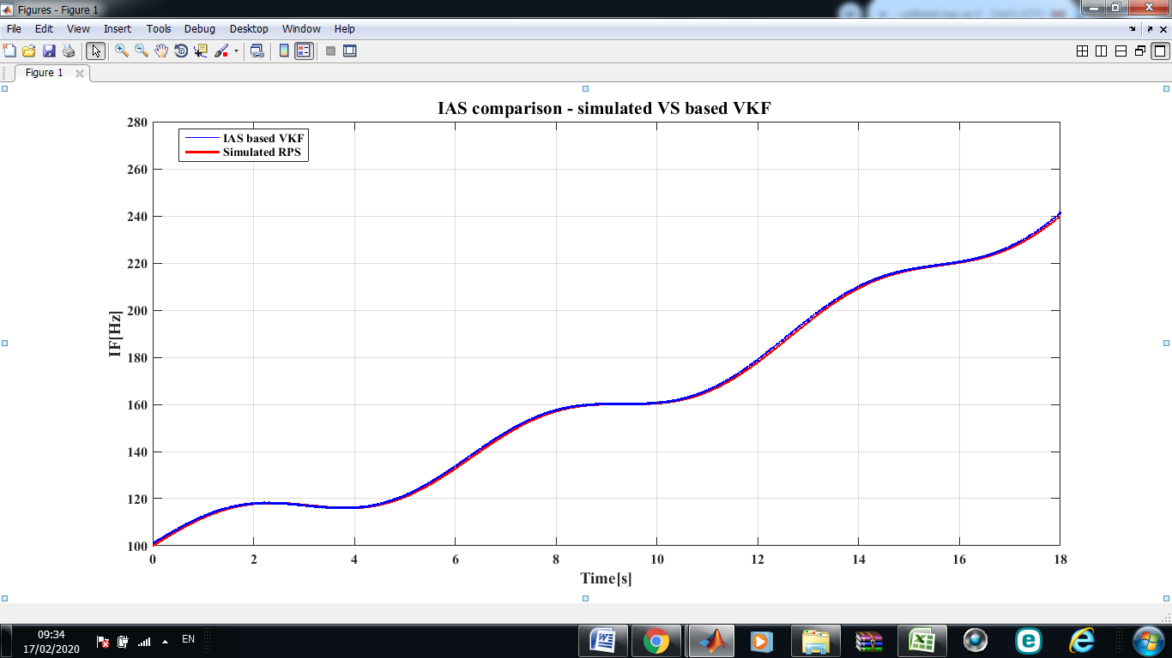

Figure 16: Estimated IAS (blue) compared with simulated RPS with slow rate of change according to ${ (100 Hz)e}^{t/T}+(5 Hz)sin⁡(t)$ (red).

Figure 17 presents the results of the algorithm for estimating the IAS when the simulated rotational speed is the sum of a constant and a sine function: (25 Hz) + $(5 Hz)sin⁡(πt)$. In each segment, the rotational speed can accelerate by as much as ± $10 {Hz}/s$. A closer look reveals some differences between the estimated IAS and the simulated rotational speed. However, despite the rapid changes, the algorithm generated an IAS with the same shape as the simulated rotational speed. In this case, too, the curve is smooth without edge effects at the connecting points between VKF segments. Similar results occur for the other simulated rotational speeds.

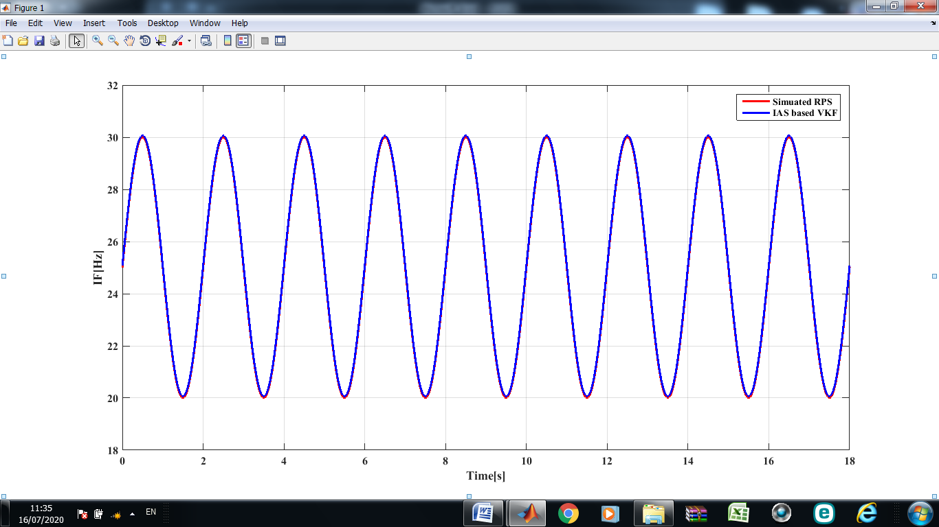

Figure 17: Estimated IAS (blue) compared with simulated RPS with rapid rate of change according to (25 Hz) + $(5 Hz)sin⁡(πt)$ (red).

The results presented to this point represent the IAS estimated by using the continuous T-F curve obtained from the first simulated harmonic of the rotational speed since it was chosen by default. However, one may decide to use another RPS harmonic. Moreover, when the IAS is estimated by using other rotational speed harmonics (the third and twelfth, in this case), the results remain just as good. However, we cannot rely solely on visual results, so an index is proposed to calculate the mean error between the simulated rotational speed and the estimated IAS. The index calculates the relative Mean Squared Difference (MSD) between the RPS and the estimated IAS at each time point:

*MSD* = $100\%×\sqrt{\frac{1}{N}\sum_{i=1}^{N}{\frac{{({RPS}_{i}-{IAS}_{i})}^{2}}{{{RPS}_{i}}^{2}}}}$, (16)

where *N* is the total number of time points and *i* iterates over all time points.

Figure 18 shows the results obtained by using *MSD* index for each simulated rotational speed and IAS estimated by each RPS harmonic. For example, the rightmost bar represents the result of the MSD index when using the twelfth RPS harmonic to estimate the IAS. The following conclusions can be drawn from these results:

* as the acceleration increases, the error increases;
* higher harmonics lead to smaller error.

These results mean that working with higher harmonics of the RPS should be preferred to obtain better resolution.

Figure 18: MSD index, showing the mean error between the simulated rotational speed and the estimated IAS. The result shows that, as the acceleration increases, the error increases. In addition, the inclusion of higher harmonics reduces the error.

### 5.3.2 Experimental stationary Angular Speed

So far, the proposed algorithm has been tested on simulated signals. However, to verify the results and establish a reliable algorithm, the results must be compared with experimental results. Toward this end, a measured signal was used for this purpose.

Figures 19 and 20 show 5 s of rotational speed data (blue) measured from a balanced and unbalanced fan shaft, respectively. The figures also show the IAS estimated from the first harmonic filtered by a VKF (red) and a Butterworth filter (green). The estimated IAS estimated by using the Butterworth filter appears smoother than that estimated by the VKF. However, the general shape of the IAS is essentially identical in both cases.

The measured rotational speed for the balanced shaft differs significantly from that for the unbalanced shaft (noisier and fluctuates more relative to a balanced shaft). These differences also appear in the estimated IAS, which is noisier and fluctuates more than the IAS estimated from the balanced system. The IAS evaluated by both methods has short edge effects (1 s at the beginning and end of the signal). Therefore, these values are cut from the overall estimated IAS time signal (40.2 s). For most operational limitations of the system, such a reduction has no effect. Therefore, these methods are considered practical for estimating IAS. Conversely, the envelope (Hilbert transform) provides a poor estimate of the IAS in the presence of noise. The IAS estimated by the envelope has long edge effects, ≈5 s of the IAS time history. The emergence of these edge effects significantly reduces the IAS time history. The long-edge effects lead us to abandon this method herein.

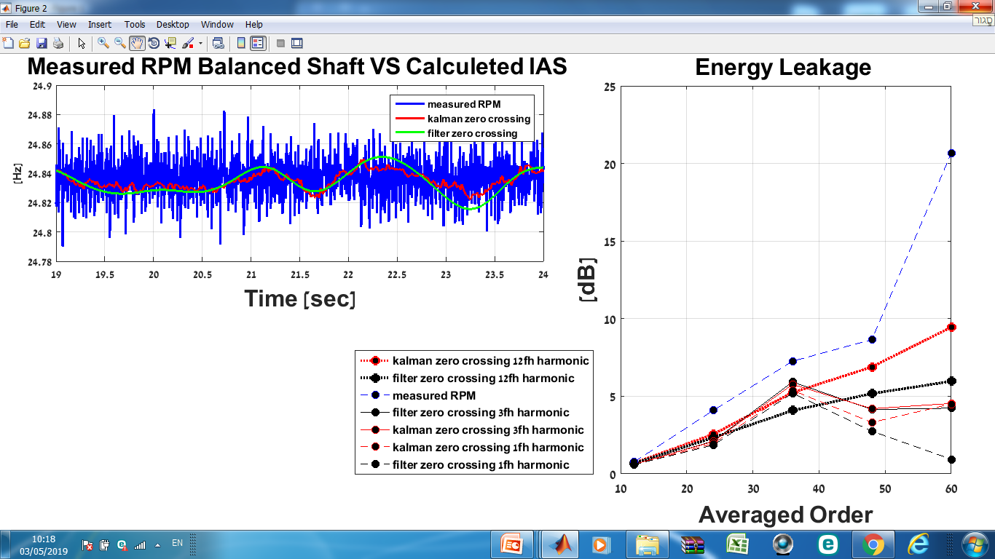

Figure 19: RPS measured from a balanced fan shaft (blue) and IAS estimated from first RPS harmonic (≈24.6 Hz) by a VKF (red) and a Butterworth filter (green).

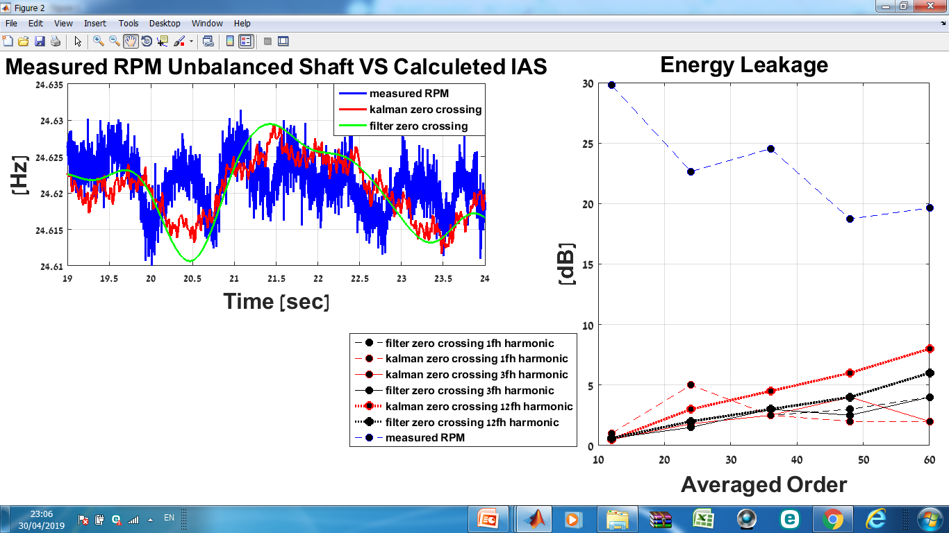

Figure 20: RPS measured from an unbalanced fan shaft (blue) and IAS estimated from first RPS harmonic (≈24.6 Hz) filtered by a VKF (red) and a Butterworth filter (green). The IAS estimated by using the Butterworth filter appears smoother than that estimated by using the VKF

Figure 21 shows 5 s of the RPS (blue), which was measured for the unbalanced fan shaft. In the case shown, the IAS was estimated by using a signal filtered from the twelfth harmonic (≈295.4 Hz) of the RPS. As shown in Figure 21, the IASs estimated by the different methods differ significantly between 35 and 36 s. This difference is due to the incapacity of the VKF and the Butterworth filter to attenuate the sidebands present near the twelfth harmonic.

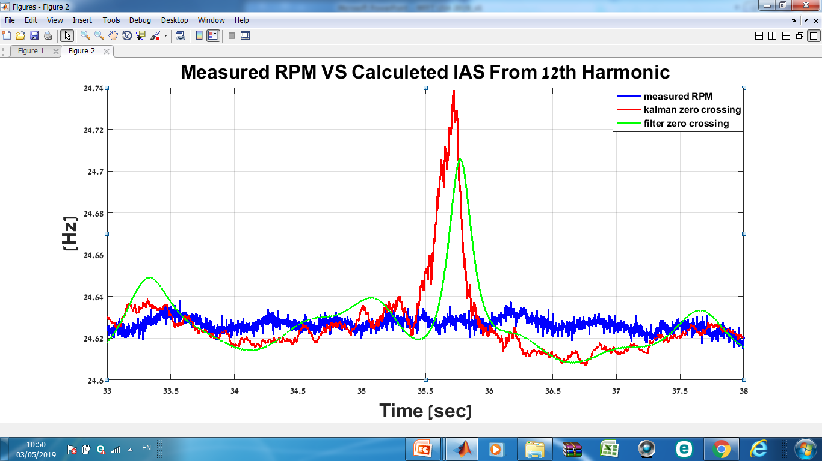

Figure 21: RPS measured from an unbalanced fan shaft (blue) and IAS estimated from the twelfth RPS harmonic (≈295.4 Hz) by using a VKF (red) and by using a Butterworth filter (green). The IASs estimated by the different methods differ significantly between 35 and 36 s.

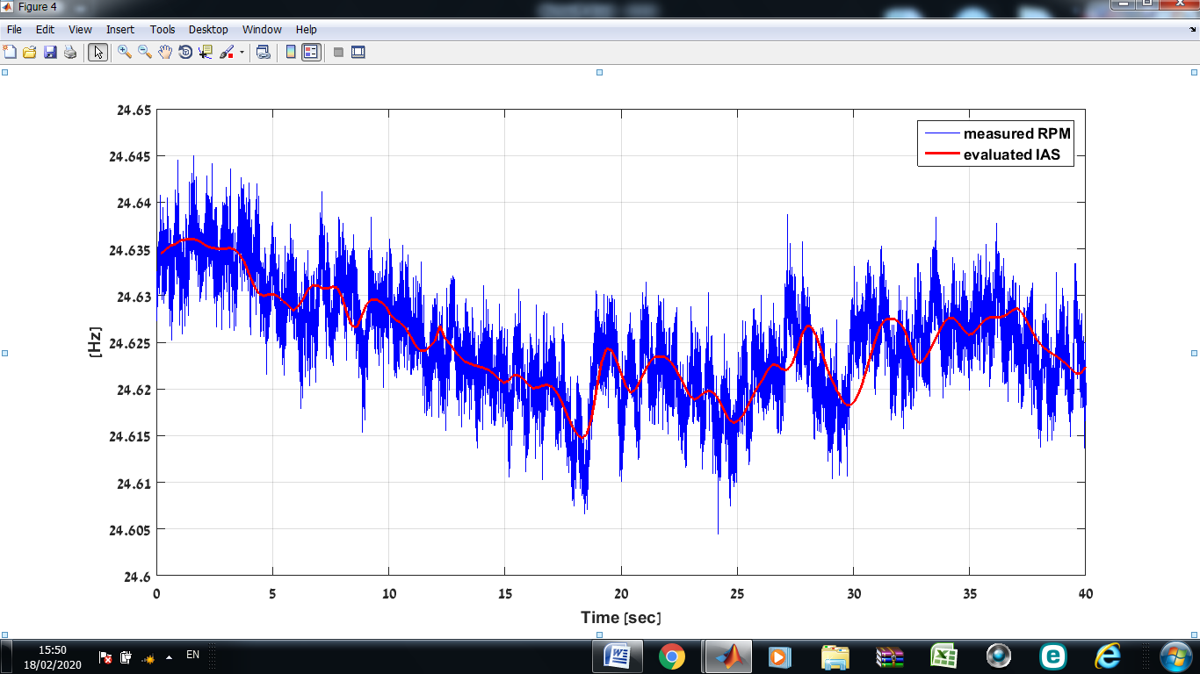Figure 22 shows 40 s of rotational-speed data (blue) measured from an unbalanced fan shaft. The figure also compares the IAS (red) estimated by the algorithm applied to the first harmonic of the measured rotational speed filtered by a VKF (red) and by a Butterworth filter (green). The measured RPS is noisy and fluctuates significantly. Conversely, the estimated IAS is smooth and uniform. As shown in Figure 22, the estimated IAS follows the general trend of the measured rotational speed, with no evidence of edge effects. This result is important for most practical systems. Therefore, these methods can be considered practical for estimating the IAS based on either constant or time-varying rotational speed.

Figure 22: RPS measured from an unbalanced fan shaft (blue) and IAS estimated from the first RPS harmonic (≈24.6 Hz) filtered by a VKF (red) and by a Butterworth filter (green). The estimated IAS is smooth and uniform and follows the general trend of the measured rotational speed, with no evidence of edge effects.

## 5.4. IAS Evaluation

In the evaluation phase, each estimated IAS is used to analyze the vibrations. Figure 23 shows the evaluation process in which the data are resampled, and the order spectrum, synchronous average, and order spectrum of the synchronous average are calculated. To evaluate the IAS, the order spectrum of the vibrations and the order spectrum of the synchronous average are compared.

Figure 23: IAS evaluation process. The data are first resampled by using the estimated IAS, following which the order spectrum, synchronous average, and order spectrum of the synchronous average are calculated. Finally, to evaluate the IAS, the order spectrum and the order spectrum of the synchronous average are compared.

### 5.4.1 Order Comparison

To evaluate the nature of the estimated IAS, two indexes were developed based on an index proposed by Koren *et al.*: the energy leakage (EL) index and the peak energy concentration (PEC) index. To evaluate the estimated IAS the order spectrum was calculated using estimated and recorded angular speed.

For each order spectrum, the EL was measured as the ratio in dB between the order spectrum at integer multiples of the rotation speed to the background noise caused by other elements and the transfer function. This gives the ratio between (i) the area under the order spectrum at integer multiples of the rotation speed to (ii) the area under the background noise. Specifically,

$EL=\frac{\sum_{i}{S_{O,i}}}{\sum_{j}{S_{O,j}}}, ∀ i∈Z_{O}, j≠i$, (17)

where $S_{O,i }$ is the order spectrum of the resampled signal integer multiples of the RPS in bin *i*, and $S_{O,j}$ is the order spectrum of the background noise in bin *j*.

A large EL index is characteristic of a spectrum with little energy leakage (i.e., the optimal spectrum is the spectrum with the narrowest, highest peaks). A high, narrow peak means that more energy is concentrated in the peak, which means that less energy is leaked. Smeared peaks may mask the effects of faults in the bearings or in other rotating components.

The peak energy concentration (PEC) is the ratio of the order spectrum for integer multiples of the RPS to the root mean square (RMS) of the signal. This gives the ratio between (i) the area under the order spectrum at integer multiples of the rotation speed to (ii) the area under the background noise:

$PEC=\frac{\sum_{i}{S_{O,i}}}{RMS}$, (18)

where $S_{o,i }$ is the order spectrum at integer multiples of the RPS in bin *i*.

The PEC measures the fraction of the total energy that is concentrated in the peaks. A large PEC means that more energy is concentrated in the integer multiples of the spectrum rather than in the background noise.

Figure 24 illustrates the process for spectrum evaluation. The figure shows the order spectrum produced by using the estimated and recorded angular speed with a tachometer focused on harmonic 56 of the rotational speed. The amplitude depends on the order of the spectrum that is calculated. In this case, the order spectrum produced by the measured rotational speed (blue) has the lowest PEC and EL Indexes. In contrast, the order spectrum produced by the Butterworth filter (red) has the highest PEC and EL indexes, as can be seen in Table 4.

Table 4: Indexes resulting from spectrum shown in Figure 25.

|  |  |  |
| --- | --- | --- |
| Result | Method | Index |
| 0.0176 | Sensor | **PEC** |
| 0.0184 | VKF |
| 0.0189 | Butterworth |
| 1.1631 | Sensor | **EL** |
| 1.7016 | VKF |
| 1.7201 | Butterworth |

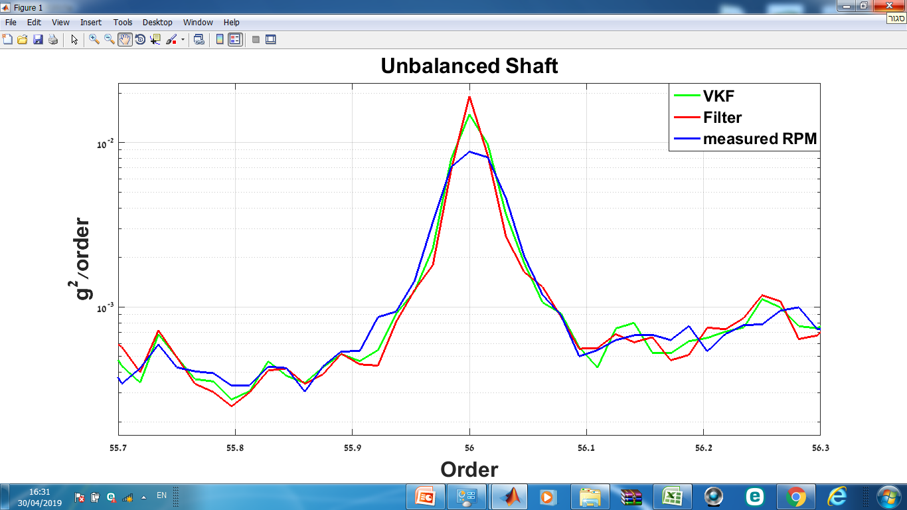

Figure 24: Illustration of the order comparison process. The figure shows the order spectrum produced by using the estimated and recorded angular speed fixed around harmonic 56 of the RPS. In this case, the relatively smeared peak of order spectrum produced by the measured rotational speed (blue) has the lowest PEC and EL Indexes. Here, the order spectrum produced by the IAS estimated using the Butterworth filter (red) has the highest PEC and EL indexes.

Table 5 gives the calculated spectrum evaluation indexes (PEC and EL), which represent the averaged indexes for the first-harmonic order spectrum. A total of 125 experiments were performed: 25 experiments for each of the five bearings. For example, the PEC and EL indexes presented in the table under the heading “healthy” represent the average of indexes obtained from 25 experiments conducted with a healthy bearing installed.

These results show that the best results are obtained for the order spectrum calculated by using the IAS evaluated with the VKF. Conversely, the worst order spectrum indexes are calculated based on the IAS measured using a speed sensor. For the third harmonic, the difference between the methods is not significant but remains consistent. In general, the indexes calculated and the order spectrum produced using the IAS evaluated from the first harmonic are higher than those calculated using the third harmonic, and the results are similar and consistent for both balanced and unbalanced systems.

These results lead to the conclusion that the order spectrum produced using the IAS evaluated from the first IAS harmonic using the VKF has the highest and narrowest peaks. Such high, narrow peaks lead to better diagnosis and identification of faulty bearings since the peaks are not smeared and do not mask other peaks of interest.

Table 5: Values of spectrum-evaluation indexes.

|  |  |  |  |  |  |  |
| --- | --- | --- | --- | --- | --- | --- |
| 3.5 mm | 2.5 mm | 2 mm | 1.5 mm | Healthy | Method | Index |
| 2.885 | 2.337 | 2.723 | 2.745 | 0.017 | **Sensor** | **PEC** |
| 2.920 | 2.362 | 2.739 | 2.772 | 0.018 | **VKF** |
| 2.895 | 2.341 | 2.727 | 2.749 | 0.017 | **Butterworth** |
| 2.813 | 2.702 | 2.962 | 2.910 | 1.163 | **Sensor** | **EL** |
| 2.995 | 2.916 | 2.994 | 2.997 | 1.700 | **VKF** |
| 2.901 | 2.811 | 2.978 | 2.959 | 1.648 | **Butterworth** |

### 

### 5.4.2 Order VS Synchronous Average Comparison

The synchronous average is extremely sensitive to noise and accuracy of the rotational speed. Inaccuracies in the rotational speed result in energy leaking from the high orders of the synchronous average spectrum. The evaluation process of the estimated IAS consists of calculating the total energy loss from the synchronous average spectrum compared to the order spectrum:

${EL}_{SA}=10\sum_{i}{\log_{10}{\frac{S_{O,i}}{S_{SA,i}}}}$, (19)

where $S_{O,i }$ is the level of the order spectrum, and $S_{SA,i}$ is the level of the SA order spectrum of integer multiples of the resampled signal of the RPS in bin *i*. The comparison is only made at the integer multiples of the angular speed and is calculated in dB.

Figure 25 illustrates the differences between the spectrums, where different IAS estimates can produce different levels of EL. In the case shown in Figure 25, the order spectrum is determined by the rotational speed measured by a speed sensor (blue), and the EL index ${EL}_{SA}$ is calculated relative to this order. In this case, the synchronous average calculated by using the measured rotational speed will have the largest EL [i.e., the distance to the reference order (blue) is the largest among the three SA orders shown] of the three SAs shown in the figure. This large EL is due to the inaccurate rotational speed caused by phase errors during signal resampling, which leads to significant energy leakage in the higher orders.



Figure 25: Illustration of the process to compare the order of the VS synchronous average. The figure shows the reference order spectrum (blue) VS SA order spectrums fixed around harmonic 30 of the RPS. In this case, of the three SA orders shown, the synchronous average calculated by using the measured rotational speed (black) will differ most from the reference order (blue) and therefore have the largest EL.

Figures 26a and 26b show the calculated total EL of the SA spectrum compared with the order spectrum according to the ${EL}_{SA}$ index [Eq. (19)] for the unbalanced shaft and the balanced shaft, respectively. In this case, the reference order spectrum is that calculated by using the VKF-estimated IAS. The EL is calculated for the first 60 harmonics of the rotational speed. Each data set plotted consists of five points, where each point is an average EL of twelve harmonics. The figure shows the average EL for the IAS estimated from each of the three selected rotational-speed harmonics (first, third, and twelfth). This type of graph was produced for each experiment, and the results in Figure 26 show one example from each bearing.

The results show (Figure 26) that, for the balanced shaft, the smallest EL was calculated for the SA order spectrum calculated by using the Butterworth-estimated IAS. This result means that, in this case, the reference order spectrum fits the Butterworth SA order. For both the balanced and unbalanced shafts, the worse results are obtained from the twelfth harmonic, as expected. In addition, for all cases, the EL increases with increasing harmonic order, which is the result of the inaccuracies in the estimated IAS that accumulate as phase errors during signal resampling, leading to significant EL in the high orders of the SA spectrum. Nevertheless, the largest EL occurs for the measured rotational speed—up to 21 dB at the highest SA order (Figure 26b).

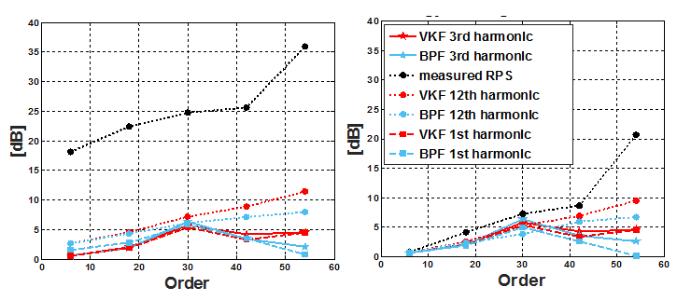Similar results appear in Figure 26a (unbalanced shaft); however, the most significant difference appears in the EL for the measured rotational speed. In this case, the maximum EL is 36 dB, which is 58% more EL than that calculated for the balanced shaft. The IAS produced directly from the vibration signal produced significantly better results than those produced by the measured rotational speed.

(a) (b)

Figure 26: Average energy leakage of harmonics 1, 3, and 12 for (a) unbalanced shaft and (b) balanced shaft. The figure shows the calculated total EL of the SA spectrum compared with the order spectrum according to the ${EL}_{SA}$ index. Each data set plotted consists of five points, where each point is the average EL of twelve harmonics.

Figure 27 shows the average EL for all experiments. Each column represents the average EL of 25 experiments. For example, the rightmost column refers to the average EL calculated for the IAS evaluated by tracking the first harmonic of the rotational speed using the Butterworth filter in the experiments conducted with a healthy bearing. In most cases, the average EL is lower when the IAS is evaluated by using the VKF. The largest average EL was calculated for the experiments involving a healthy bearing installed on the fan shaft, which is because the “peaks” of the rotational-speed harmonics are four times smaller than those created when a faulty bearing was installed in the experimental system. In this case, both Butterworth and VKF tracking methods perform poorly. However, even in this situation, both methods are superior to the results calculated for the measured RPS.

Figure 27: Average energy leakage for 125 experiments, each column represents the average EL of 25 experiments.

## 5.5 Conclusions

This chapter presents the algorithm and validates it by using simulated time-varying rotational speed and recorded stationary rotational speed. The estimated IAS was compared with the simulated IAS and from the experiments, and an index quantifying the error is proposed. The index is calculated for several test cases, its significance is explained, and the results are discussed. It presents the IASs estimated by the proposed algorithm and explains the relationship between poor phasor isolating (i.e., the difficulties of tracking harmonics with low signal-to-noise ratios) and poor IAS estimates. In addition, it presents the calculated indexes for order evaluation and explains their significance and importance. Finally, it discusses how EL is related to “low-quality” IAS. These results lead to the following conclusions:

* The first IAS harmonic provides the best results at high orders.
* For the measured data, both methods for extracting rotational speed signals from the vibrations (i.e., a cascade of Butterworth filters and the VKF) provide good results.
* The VKF and Butterworth filters produce very similar results. However, the VKF is preferred because of its efficiency.
* The Estimating rotational speed based on zero crossings is more accurate than phase estimation via envelope.
* The proposed algorithm can track, extract, and estimate the IAS even when the rotational speed changes rapidly.
* The root mean squared error is relatively low in all simulated scenarios, which reflects the quality of the algorithm.
* The error grows as the acceleration of the signal increases and as the rate of change of the rotational speed increases. However, a higher harmonic produces smaller errors.
* High rotational harmonics should be used by default to estimate the IAS.

# 6. EXPERIMENTAL SETUP

Experiments were conducted by using an experimental system consisting of a dedicated table to which was mounted a passenger-car condenser fan. The system consists of an electric motor that rotates a fan with 12 fan blades and a 25 mm shaft. The rotor of the electric motor and fan blades are mounted to the motor shaft, which is supported by two bearings. Figure 28 shows the assembled system with the sensor locations.

Experimental data were acquired by measuring physical phenomena with a sensor and transforming the sensor output into a digital signal. In the experiments, rotational speed was measured by using a Honeywell 3030AN variable-reluctance speed sensor, and vibrations were monitored by using a three-axis piezo-electric Dytran 3053B2 S/N 1787 accelerometer.

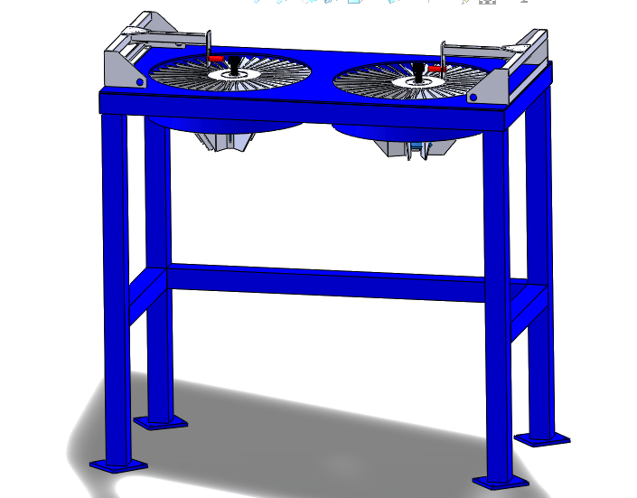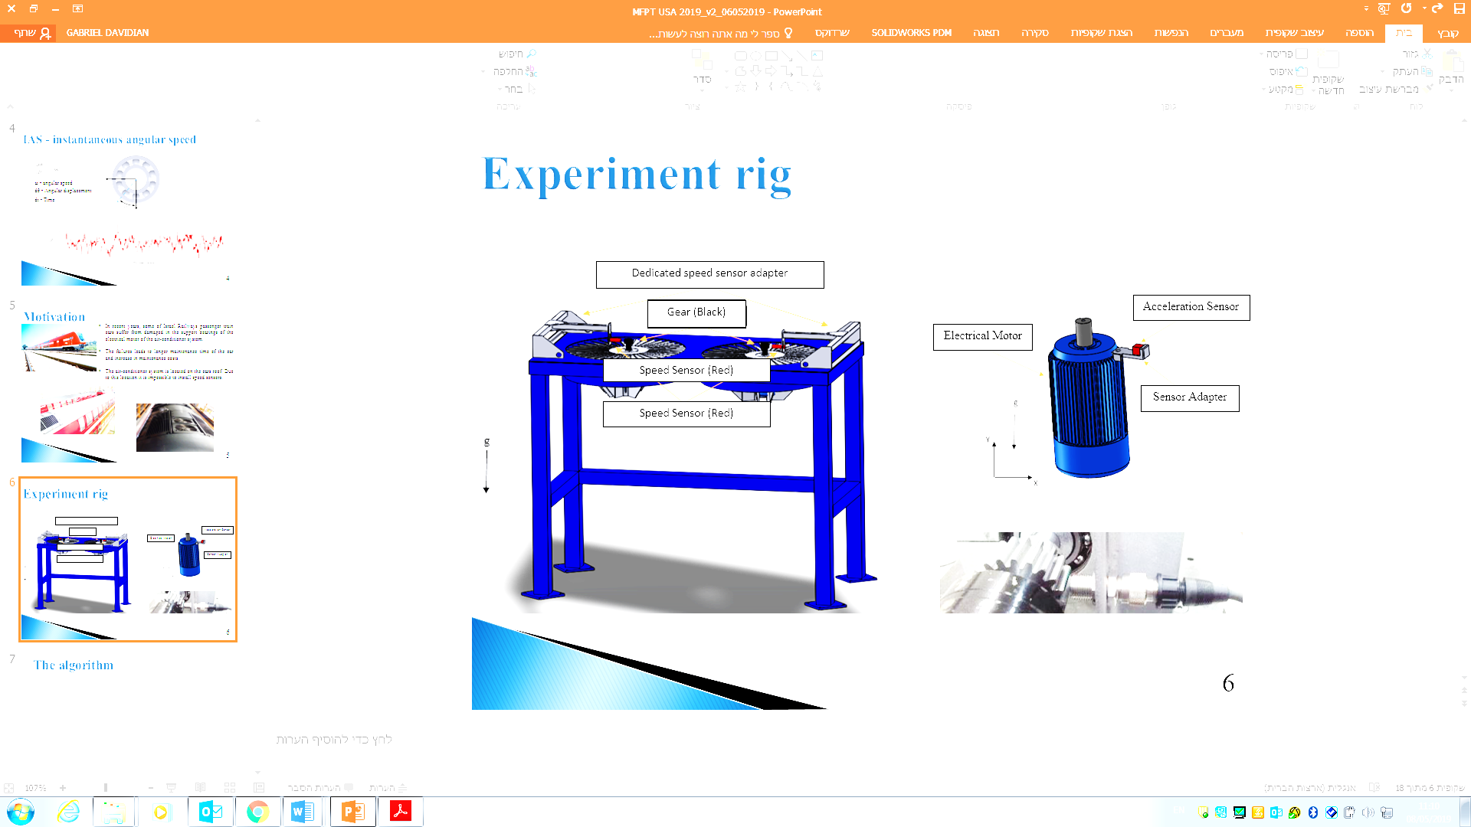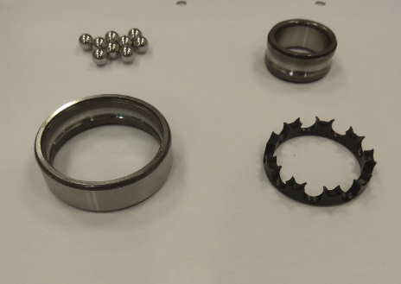

Figure 28: Experimental apparatus; the red rectangles show the position of the speed sensors.

A set of experiments was conducted on healthy and seeded outer race bearings (TVH 6205 bearings). The cage structure and material (polymer) of this bearing makes it possible to easily disassemble (reassemble) the bearing. This feature is important because it facilities seeding the artificial defects in the bearing. Figure 29 shows a disassembled TVH 6205 bearing. The faults were created by removing material from the bearing outer race (Figure 29) using electric discharge machining. The spall width was measured in the tangential direction (i.e., the direction of bearing rotation). Table 6 lists the spall widths that were tested in these experiments.

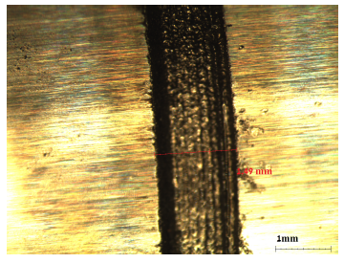

1

2

3

4

Figure 29: Disassembled TVH 6205 bearing showing seeded fault in outer race: (1) bearing balls, (2) inner race, (3) outer race, (4) polymeric cage.

The rotational speed of the fan shaft was about 1475 rpm, 24.6 Hz. Under these working conditions, the frequencies of interest [BPFO, ball pass frequency inner race (BPFI), FTF, BSF] were calculated and appear in Table 6. Five bearings were tested by running 25 experiments with each bearing (each lasting 60 s), making a total of 125 experiments. The sampling rate of the accelerations and of the rotational speed was set at 15 kHz.

Table 6: Experiment specifications.

|  |  |  |  |  |  |  |  |
| --- | --- | --- | --- | --- | --- | --- | --- |
| Bearing mark  spall size [mm] | | Bearing tone | | Experiments | Nominal RPS (Hz) | Sampling frequency (kHz) | Experiment duration  (sec) |
| **Hz** | **Order** |
| E-00 | 0 | 133.42  87.98  114.84  9.78 | 5.418  3.577  0.4  4.707 | 25 | 24.6 | 15 | 60 |
| E-01 | 1.5 | 25 | 24.6 | 15 | 60 |
| E-02 | 2.5 | 25 | 24.6 | 15 | 60 |
| E-03 | 3 | 25 | 24.6 | 15 | 60 |
| E-04 | 3.5 | 25 | 24.6 | 15 | 60 |

## 6.1 Experimental Result

Effective diagnostics of bearings rely on extracting features from vibrations signals. These features contain information that can be used to identify the defect at early stages. This chapter thus investigates how bearing defects can be identified.

The processing scheme depicted in Figure 30 contains several steps. In the first step, the IAS is estimated by using the proposed method. Next, angular resampling is done and the PSD in the order domain is calculated. The envelope is then produced and the envelope PSD is calculated. The PSD and envelope PSD are calculated by using 34 frames and a 50% overlap Hanning window. Finally, the features are extracted.

Figure 30: Processing scheme for evaluating defects. The IAS is first estimated, and then angular resampling is done and the PSD is calculated. Finally, the envelope PSD is calculated.

Figure 31 shows the order spectrum obtained from a faultless bearing and from a faulty bearing. The signals are color-coded as noted in the figure caption. The electric motor is subjected to an axial load of a 5.9 kg rotor mounted on its shaft, so it is not surprising that the highest-energy signature is in the axial direction. The analysis therefore focuses on measurements in this direction.

The order spectrum displays no bearing tones in the baseband measurement because other vibration sources produce dominant order components. Furthermore, distinguishing between faultless- and faulty-bearing order spectra is difficult, making it difficult to compare the spectra of the different orders with the spectrum of the nominal order.

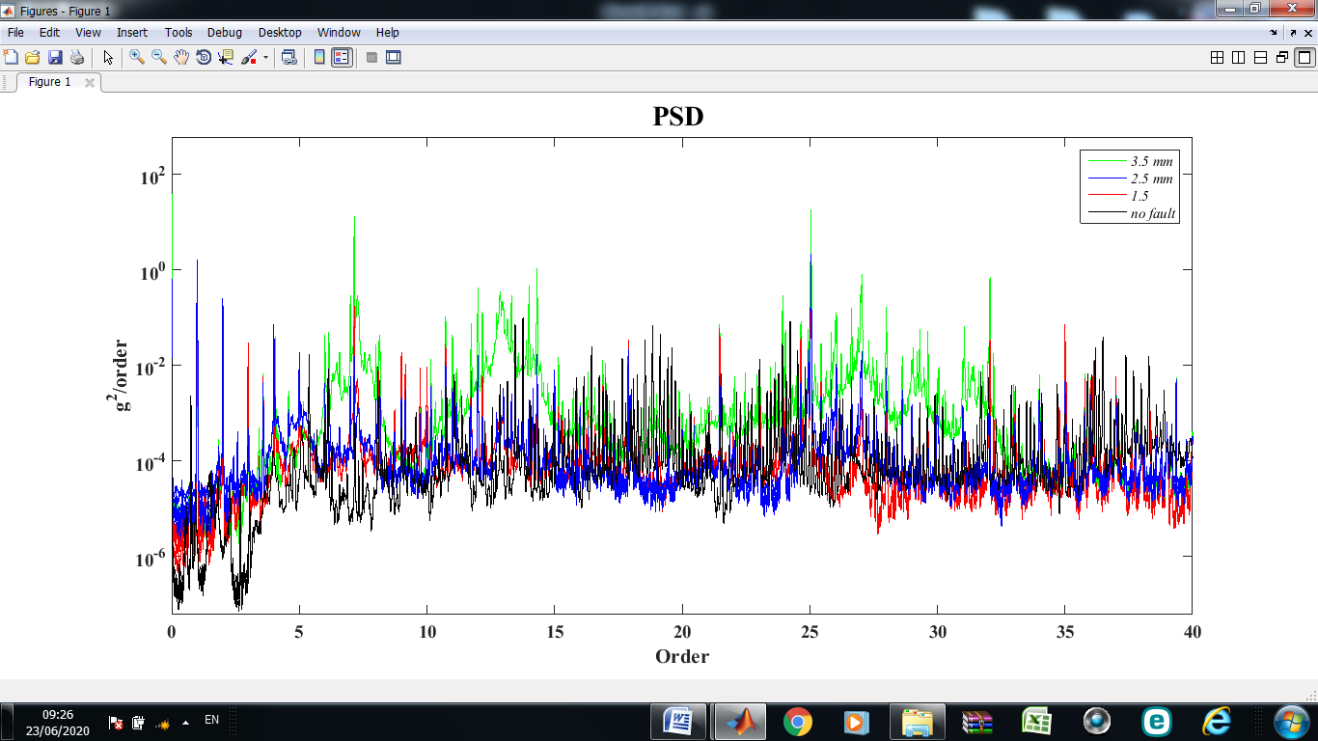

Figure 31: Order spectra (heathy bearing shown in black, 1.5-mm-defect bearing in red, 2.5-mm-defect bearing in blue, and 3.5-mm-defect bearing in green).

The order spectrum teaches us little about the case under consideration. Consequently, we analyze the envelope: the envelope order spectrum is presented in Figure 32. The BPFO orders (BPFO is 3.578 times the rotational speed of the bearing) and their harmonics appear clearly in Figure 32, which clearly indicates that the outer race contains a fault. The envelope spectrum shows clearly that the energy level is lowest when no defect is present. Furthermore, note that the defect is more readily detected as it grows, which is expressed by a higher-amplitude BPFO. These features make the envelope spectrum an effective tool for signal analysis in this case.

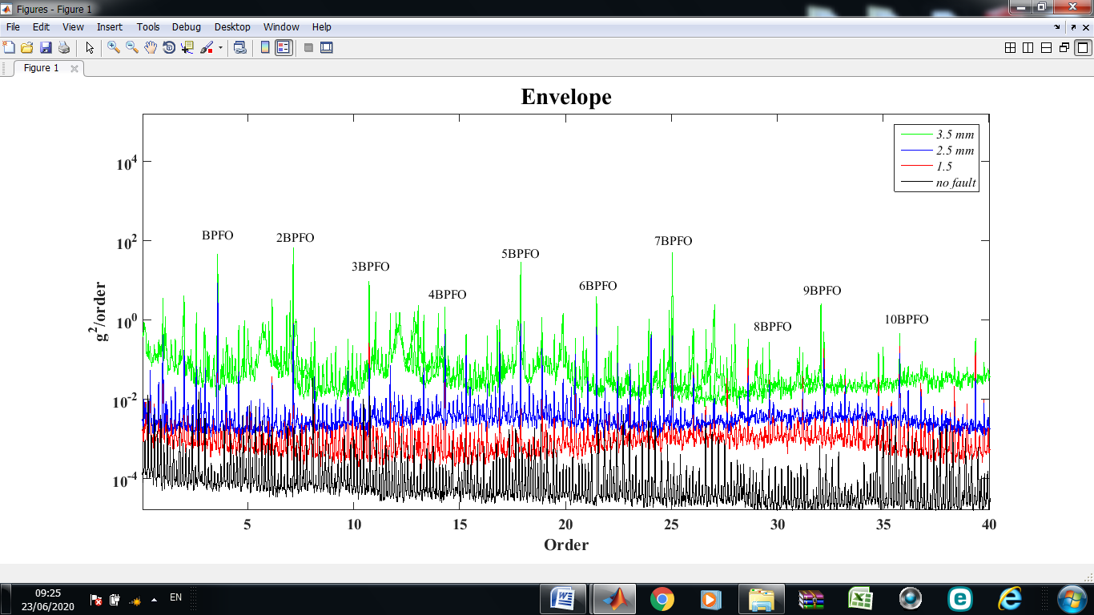

Figure 32: Envelope order spectrum (heathy bearing shown in black, 1.5-mm-defect bearing in red, 2.5-mm-defect bearing in blue, and 3.5-mm-defect bearing in green).

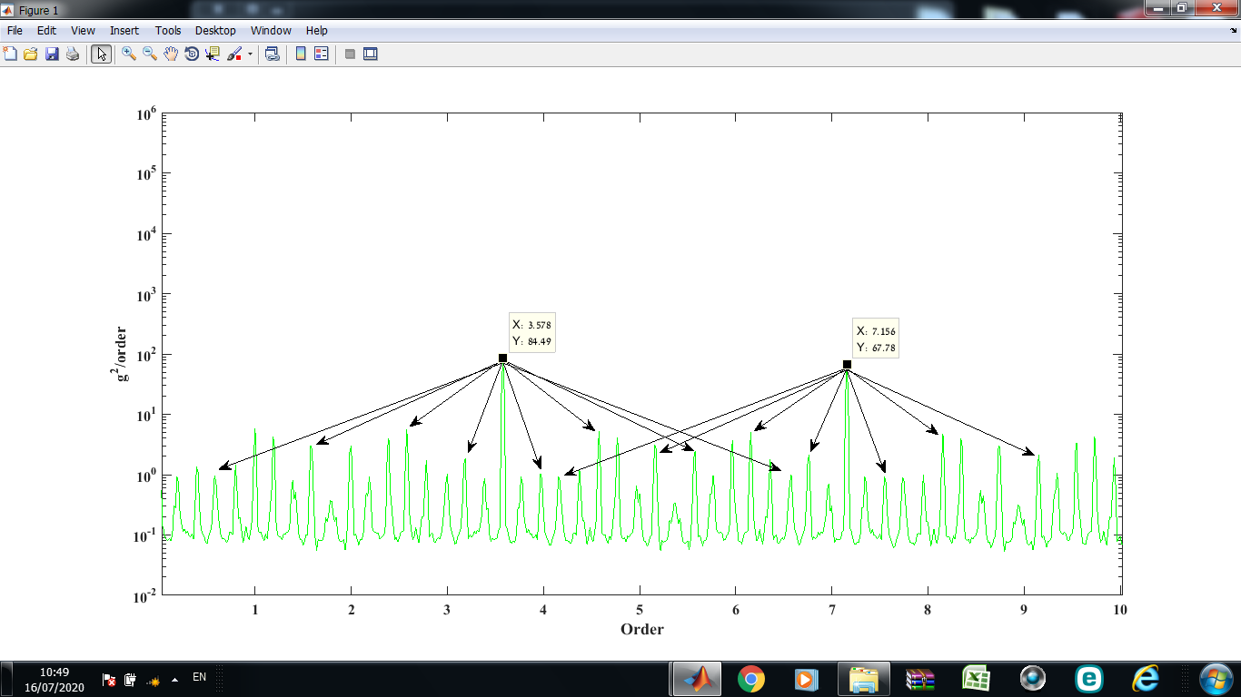Figure 33 shows an expanded view of an envelope order spectrum for a 3.5-mm-defect bearing, in which upper and lower sidebands caused by modulation are easily identified. The results (Figure 33) show that the BPFO value does not equate precisely with the theoretical value. This discrepancy stems from slippage and from the fact that the theoretical BPFO is based on the geometry of the bearing, whereas, in practice, the geometry and dimensions of the bearing may be inaccurate.

Figure 33: Expanded view of an envelope order spectrum for a 3.5-mm-defect bearing in which the upper and lower sidebands caused by modulation are easily identified.

For the case under study, the envelope analysis proves to be a powerful technique that helps to separate the effects of specific faults from background vibrations. Analyzing the envelope of the order spectrum facilitates the diagnosis and makes it easier to distinguish between signals due to defects because the periodicity of the impacts is easily recognized.

## 7.1 Energy-Level Analysis

The first part of this chapter distinguishes between the signal from a healthy bearing and that from a damaged bearing. The results indicate that the energy levels of the different bearing signals differ significantly. Because the experiments were done under identical conditions, we assume that this trend is related to the spall size.

To determine whether the increase in energy is due to the spall size, the energy of orders related to the fault are summed over the order spectrum and over the envelope order spectrum:

$E=\sum_{n=1}^{H}{\left[E_{H}+\sum_{i=0}^{N}{(E_{H-i}+E_{H+i})}\right]}$, (20)

where $E$ is the sum of the energies, $H$ is the harmonic number of the fault, and $N$ is the number of fault sidebands.

For each experiment, 50 BPFO harmonics were considered. However, a larger number of sidebands appeared in the envelope order spectrum compared with the order spectrum, as indicated by Table 7. In the envelope order spectrum, 15 sidebands and 10 cage sidebands are appeared around the BPFO and its harmonics, whereas, in the order spectrum, only 10 sidebands and 5 cage sidebands appear. Table 7 gives the mean summed energy, where each row represents the mean energy of 25 experiments; for example, the mean energy from 25 experiments with the healthy bearing is 10.79 $G_{rms}$ in the envelope order spectrum and 1.15 in the order spectrum.

Table 7: Values for evaluating mean summed energy.

|  |  |  |  |  |  |  |  |  |  |  |
| --- | --- | --- | --- | --- | --- | --- | --- | --- | --- | --- |
| Bearing mark  spall size [mm] | | Bearing tone | Experiments | Summed fault harmonic | Summed fault sideband | | | | Mean summed energy  [$G_{rms}$] | |
| **Cage sideband** | | **Sideband** | | Envelope | Order |
| Envelope | Order | Envelope | Order |
| E-00 | 0 | 3.578 | 25 | 50 | 10 | 5 | 15 | 5 | 10.79 | 1.15 |
| E-01 | 1.5 | 3.5782 | 25 | 50 | 10 | 5 | 15 | 5 | 75.85 | 3.21 |
| E-02 | 2.5 | 3.5782 | 25 | 50 | 10 | 5 | 15 | 5 | 138.98 | 5.69 |
| E-03 | 3 | 3.5782 | 25 | 50 | 10 | 5 | 15 | 5 | 187.46 | 6.78 |
| E-04 | 3.5 | 3.5783 | 25 | 50 | 10 | 5 | 15 | 5 | 242.66 | 9.17 |

Figures 34 and 35 show the mean energy of sidebands and of the BPFO fault for all spall sizes in the envelope order spectrum and in the order spectrum, respectively. For all cases, the upper and lower sideband energy is greater than the energy of the cage sidebands. Furthermore, the energy increases with increasing spall size. Comparing the two figures reveals significant differences in the amplitudes of the BPFO and its sidebands. The amplitudes in the envelope order spectrum are significantly greater than those of the order spectrum. In addition, the relatively large energy differences among the various spall sizes in Figure 36 makes it easy to distinguish between different spall sizes, which contrasts with the result shown in Figure 35. This is important because it allows us to follow and rank the severity of the faults.

Figure 34: Mean summed energy of sidebands and of BPFO fault in the envelope order spectrum.

Figure 35: Mean summed energy of sidebands and of BPFO fault in the order spectrum.

Figures 36 and 37 show a box diagram of the total energy calculated for all 125 experiments. Each point represents the total energy for orders associated with a fault in a particular experiment. As can be seen in Figure 37, healthy and faulty bearings are easily distinguished based on their significant energy differences. For example, it is easy to distinguish between a healthy bearing with an average energy of 1.15 $G_{rms}$ and a variance of 0.28 $G_{rms}$ and a 1.5-mm-spalled bearing with an average energy 3.21 $G_{rms}$ and a variance of 0.85 $G_{rms}$. However, the situation becomes complicated as the spall size increases. Looking at the results for 2.5-, 3.0-, or 3.5-mm-spalled bearings (Figure 37) shows that the energy levels for each experiment are scattered and thus may be misleading. For example, in some of the experiments with the 2.5-mm-spalled bearing, the higher bounds of the energy are 6.5–7.0 $G_{rms}$, which is greater than the lower bounds of the energy (≈6 $G_{rms}$) for experiments with the 3.0-mm-spalled bearing. This may lead to a misdiagnosis of fault severity. Thus, a fault threshold cannot be accurately assigned from the results shown in Figure 37.

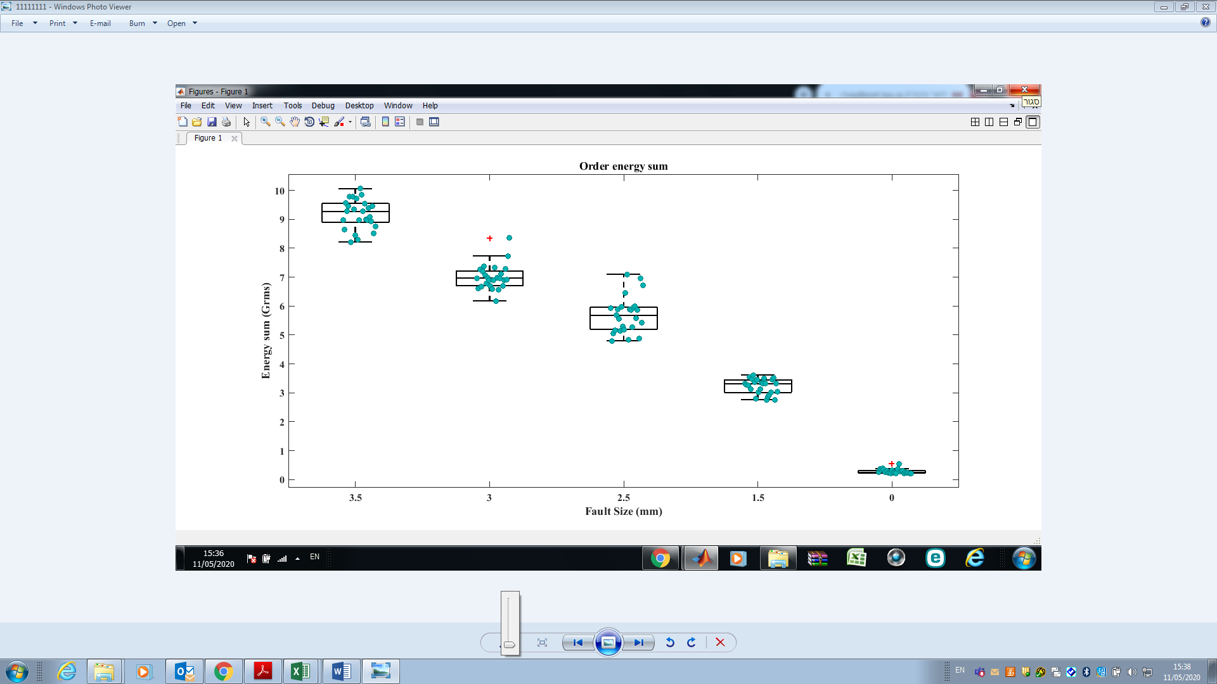

Figure 36: Box-plot diagram of order spectrum. Each point represents the total energy for orders associated with a fault in a particular experiment.

A fault threshold is thus required that will clearly separate, for all fault situations, the maximum energy of a non-faulty element (bearing, shaft, etc.) from the minimum energy of a faulty element.

Figure 37 shows that the use of the envelope order spectrum provides such a threshold, where the lower energy of an element with a smaller fault does not overlap with the upper energy of an element with a larger fault. Thus, the envelope order spectrum provides a reliable energy threshold. For the case under study, the threshold is determined to be 11 $G_{rms}$, which is the maximum energy level for non-faulty elements. For the experimental data acquired as part of this study this method provides 100% fault identification for all fault situations. In this way, the characteristic energy level can be used to diagnose bearing faults automatically and to locate faulty components.

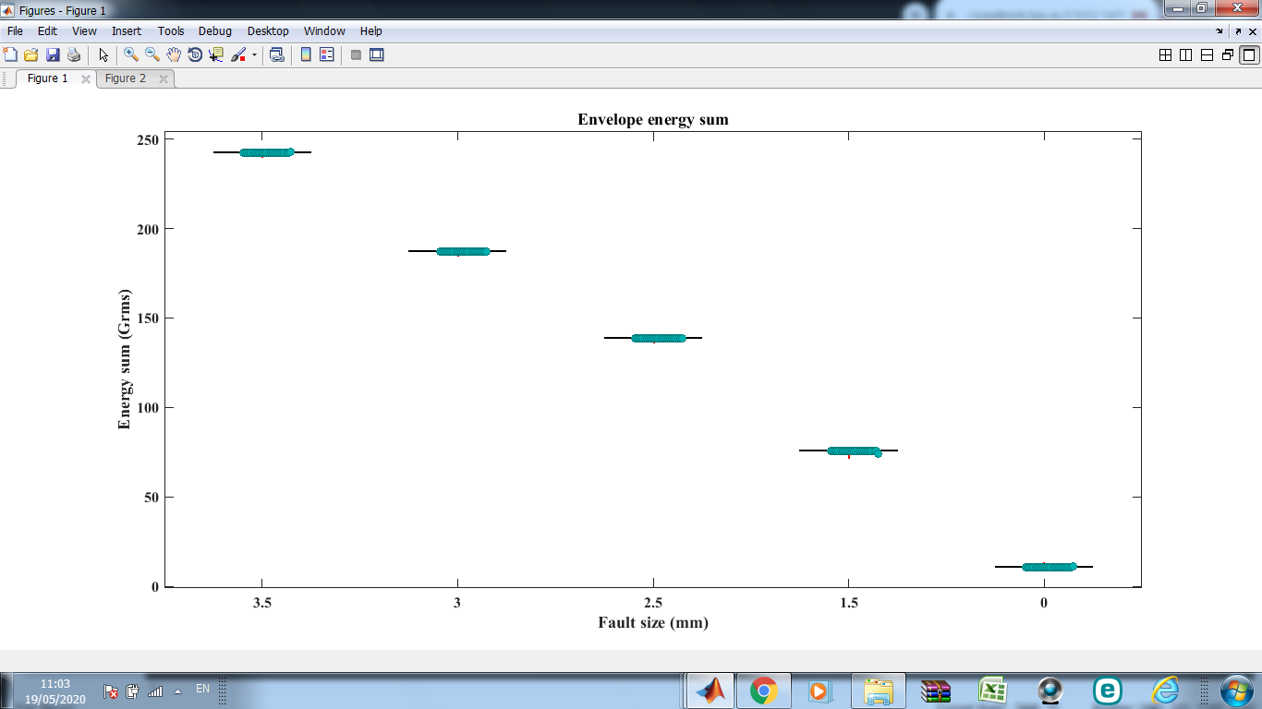

Figure 37: Box-plot diagram of envelope order spectrum. Each point represents the total energy for orders associated with a fault in a particular experiment.

7.2 Conclusions

* The analysis of the bearing failures justifies the signal-processing scheme.
* For the experimental data acquired in this study, the envelope order spectrum should be used to search for bearing tones.
* The use of the IAS estimated by the proposed method allows a healthy bearing to be distinguished from a damaged bearing even when the defect is relatively small (1.5 mm).
* The analysis of experiments with seeded faults validates the concept of extracting the RPS from the vibration signal and demonstrates that bearing faults can be detected and their severity ranked. Based on these results, an algorithm to diagnose bearings and that does not require a rotation speed sensor was developed and verified.

# 8. SUMMARY

This research offers a method for identifying defected bearings in machinery with rotating parts in which direct measurement of the rotational speed is impossible, expensive, or inaccurate. The study compares several methods to estimate the IAS directly from a vibration signal and shows that the rotational speed can be directly determined from the vibration signal. The relative advantages and disadvantages of each estimation method are discussed, and the experimental apparatus and units of measurement are also presented. A method to accurately determine the RPS is proposed and implemented, as is an algorithm to automatically extract the IAS from the vibration signal (even when the rotational speed varies in time). To diagnose rotating machine parts, a complete scheme for analyzing the IAS is proposed and then verified by comparing its results with experimental data and with the results of simulations.

Numerous experiments were carried out to verify the capabilities of the proposed algorithm. The experiments involved dismantling suitably sized bearings so as to insert defects of various sizes, following which the vibration signatures of the reassembled bearings were analyzed. The results show that defective bearings can be differentiated from healthy bearings and that even the spall size of defective bearings can be identified. Furthermore, the Hilbert method is determined to be unsuitable for the bearings studied herein because it is subject to edge effects. Additionally, the results indicate that the VKF and Butterworth methods provide accurate estimates of the IAS, even when applied to a relatively unbalanced shaft. Although the VKF and Butterworth methods are both superior to the measured rotational speed in terms of EL, the VKF is preferred because it is more efficient. The results indicate that the VKF method is a practical alternative for estimating the IAS in real systems.

The proposed algorithm to estimate the IAS under conditions of time-varying angular speed is described and verified by comparing its results with those of simulations and experiments. Overall, the algorithm provides accurate estimates of the IAS even under conditions of relatively large acceleration. The proposed algorithm performs well in terms of relative error with respect to the IAS estimated by processing a tachometer signal. One notable advantage of the proposed algorithm is that it requires almost no prior knowledge of kinematics, unlike other methods that are currently available.

The proposed algorithms can be used to support maintenance decisions and recommend effective maintenance policies. The algorithm clarifies several decision-making issues such as frequency of maintenance, safety definitions, and the decision-making method to select the most affordable maintenance operations (i.e., understanding which maintenance option is most economical in a given situation). The algorithm should lead to a much better understanding of which type of maintenance should be done and how to schedule maintenance to ensure maximum efficiency. By revealing the true condition of rolling-element bearings, implementing this type of algorithm in the maintenance scheme will lead to the design of cost-effective action plans.

# 9. BIBLIOGRAPHY

|  |  |
| --- | --- |
| [1] | D. L. D. B. A. K. Jardine, "A review on machinery diagnostics and prognostics implementing condition-based maintenance," *Mechanical systems and signal processing,* p. 1483–1510, 2006. |
| [2] | D. G. N. A. L. a. R. S. W. Lewicki, "Evaluation of MEMS-Based Wireless Accelerometer Sensors in Detecting Gear Tooth Faults in Helicopter Transmissions.," 2015. |
| [3] | P. J. D. G. L. a. D. D. L. Dempsey, "Investigation of current methods to identify helicopter gear health," in *Aerospace Conference*, 2007. |
| [4] | J. R. Blough, " Development and analysis of time variant discrete Fourier transform order tracking," *Mechanical and Systems and Signal Processing ,* pp. 1185- 1199, 2003. |
| [5] | J. a. v. d. B. Han, " MEmpirical mode decomposition and robust seismic attribute analysis," in *CSPG CSEG CWLS Convention*, Alberta, CA, 2011. |
| [6] | H. A. J. A. Q. Leclère, "A multi-order probabilistic approach for Instantaneous Angular Speed tracking," *Mechanical Systems and Signal Processing,* pp. 375-386, 2016. |
| [7] | J. Tuma, "Setting the pass bandwidth in the Vold-Kalman order tracking filter," in *Twelfth International Congress on Sound and Vibration*, Lisbon, 2005. |
| [8] | M. C. a. L. Y. F. Pan, " Further exploration of Vold-Kalman-filtering order tracking with shaft –speed information," *Mechanical Systems and Signal processing,* pp. 1410-1428, 2006. |
| [9] | C. A. H. R. Feldbauer, " Realisation of a Vold-Kalman Tracking Filter – A Least Square Problem," in *COST G-6 Conference on Digital Audio Effects*, Verona Italy, 2000. |
| [10] | M. C. L. S. W. a. C. C. C. Pan, " Improvement on Gabor order tracking and objective comparison with Vold-Kalman filtering order tracking," *Mechanical Systems and Signal processing,* pp. 653-667, 2006. |
| [11] | M. C. a. W. C. X. Pan, " Adaptive Vold-Kalman filtering order tracking.," *Mechanical Systems and Signal processing.,* 2007. |
| [12] | H. M. M. a. B. J. Vold, " Theoretical foundations for high performance order tracking with the Vold-Kalman filter," in *Proc. SAE Noise & Vibration Conference*, Traverse City, 1997. |
| [13] | H. H. H. M. M. C.-R. D. Vold, " Multi axle order tracking with the Vold-Kalman tracking filter," *Sound and Vibration magazine,* pp. 30-34, 1997. |
| [14] | G. S. a. K.-H. H. Herlufsen Henerik, "Characteristics of the Vold/Kalman order tracking filter," in *17th International Modal Analysis Conference*, Kissimmee, 1999. |
| [15] | S. H. H. K.-H. H. a. V. H. Gade, "Characteristics of the Vold-Kalman order tracking filter," 1999. |
| [16] | M. L. J. L. W. C. T. Wang, "Rolling element bearing fault diagnosis via fault characteristic order (FCO) analysis," *Mech. Syst. Signal Process,* p. 139–153, 2014. |
| [17] | C. S. X. J. W. H. Z. Z. J. Shi, "An Auto Instantaneous Frequency Order Extraction Method for Bearing Fault Diagnosis under Time-Varying Speed Operation," pp. 2-6, 2017. |
| [18] | D. A. C.N. Networks, "Bearing Fault Diagnosis under Variable Speed Using Convolutional Neural Networks and the Stochastic Diagonal Levenberg-Marquardt Algorithm," 2017. |
| [19] | J. K. S.A. Khan, " Automated bearing fault diagnosis using 2D analysis of vibration acceleration signals under variable speed conditions," *Shock Vib,* 2016. |
| [20] | M. L. Y. G. J. Shi, "Bearing fault diagnosis under variable rotational speed via the joint application of windowed fractal dimension transform and generalized demodulation: a method free from prefiltering and resampling," *Mech. Syst. Signal Process,* pp. 15-33, 2016. |
| [21] | R. Z. R. R. W. B. M. Cocconcelli, "STFT based approach for ball bearing fault detection in a varying speed motor," *Cond. Monit. Mach. Non-Stationary Oper,* pp. 41-50, 2012. |
| [22] | N. B. M. L. H. Huang, "Bearing fault diagnosis under unknown time-varying rotational speed conditions via multiple time-frequency curve extraction," *Sound Vib,* pp. 414-423, 2018. |
| [23] | N. B. M. L. H. Huang, "Algorithm for multiple time-frequency curve extraction from time-frequency representation of vibration signals for bearing fault diagnosis under time-varying speed conditions," in *Proceedings of the ASME Design Engineering Technical conference 8*, 2017. |
| [24] | T. B. ,. J. A. Jacek Urbanek, "A two-step procedure for estimation of instantaneous rotational speed with large fluctuations," 2013. |
| [25] | A. Z. S. T. A. C. C. M. J. a. Heng, " Rotating machinery prognostics: State of the art, challenges and opportunities," 2009. |
| [26] | P. P. M. j. Gupta, "Fault detection analysis in rolling element bearing: A review.," *Materials Today: Proceedings 4 (2),* p. 2085–2094, 2017. |
| [27] | N. C. A. Tandon, "A review of vibration and acoustic measurement methods for the detection of defects in rolling element bearings," *Tribology international,* p. 469–480, 1999. |
| [28] | A. M. M. D. Al-Ghamd, " A comparative experimental study on the use of acoustic emission and vibration analysis for bearing defect identification and estimation of defect size," *Mechanical systems and signal processing,* p. 1537–157, 2006. |
| [29] | B. P. J. A. S. M. R.B Randall, "New cepstral methods of signal preprocessing," ISMA, Leuven, Belgium, 2012. |
| [30] | B. P. J. A. S. M. R.B Randall, "Cepstrum-based operational modal analysis revisited A discussion on pole-zero models and the regeneration of frequency response functions," *Mechanical Systems and Signal Processing (MSSP),* 2016. |
| [31] | R. Randall, "vibration based condition monotoring," 2011. |
| [32] | R. B. Randall, "Vibration-based condition monitoring: industrial, aerospace and automotive applications," John Wiley & Sons, 2011. |
| [33] | H. M. M. a. B. J. Vold, " Theoretical foundations for high performance order tracking with the Vold-Kalman filter," in *Proc. SAE Noise & Vibration Conference*, Traverse City, 1997. |

**תקציר**

מסב גלגול הוא אחד הרכיבים החשובים והנפוצים ביותר במכונות ומשפיעים מאוד על בטיחות המכונה. גורמים כמו תכנון, טכנולוגיית התקנה, תנאי שימוש ועומס פתאומי גורמים למסבים למצבי דגרדציה שונים כמו קורוזיה, התחממות יתר וזיהום. מצבי דגרדציה אלו מהווים בעיות חמורות וגורמים לרוב לשריפות ותופעות אחרות המהוות סיכון ברור לבריאותו ובטיחותו של מפעיל המכונה.

צמצום התרחשותם של כשלים מחייב להעריך את אורך החיים השימושי (Remaining Useful Life) של המסב. הערכת אורך החיים השימושי של המסב היא מרכיב מפתח לפרוגנוסטיקה במכונות סובבות. על מנת להעריך את אורך החיים שנותר למסב, נדרש לדעת אם קיימת תקלה, מהי חומרת התקלה והערכת פרק הזמן שנותר עד שהתקלה תתפתח והמכונה תגיע למצב קריטי.

אחת השיטות הנפוצות ביותר לאבחון מכונות מסתובבות מבוססת על רעידות. ניתוח רעידות הוא שיטה יעילה לגילוי תקלות שונות. השיטות השונות של עיבוד אות רעידות דורשות את ידיעת מהירות הסיבוב של המכונה, היות וכאשר עוסקים במכונה סובבת אירועים מתרחשים במיקומים זוויתיים ספציפיים ולא בזמנים ספציפיים. מסיבה זו, הערכה מדויקת של המהירות הזוויתית המידית (instantaneous rotational speed) חשובה לדיאגנוסטיקה אמינה. מהירות זוויתית לא מדויקת כתוצאה מתופעות דינמיות כגון חוסר איזון או אקסצנטריות עלולות להסוות את ההשפעות של תקלות מקומיות מתחילות. אולם בפועל, מדידה ישירה של המהירות הזוויתית המידית היא לעיתים בלתי אפשרית, יקרה או לא מדויקת.

עבודה זו מתמקדת באמידת המהירות הזוויתית המידית ישירות מאות הרעידות לאבחון מסבים, תמסורות ומכניזמים שונים. מחקר זה משווה בין מספר שיטות להערכת המהירות הזוויתית המידית ישירות מאות הרעידות ומציע גישה לניתוח אות הרעידות על בסיס תובנות פיזיקליות מתוצאות סימולציה וניסויים . בנוסף מוצע אלגוריתם חדש שיאמוד אוטומטית את המהירות הזוויתית המידית ישירות מאות הרעידות כאשר המהירות הזוויתית משתנה בזמן. בשלב הראשון נאמדת המהירות הזוויתית המידית על סמך הייצוג של אות הרעידות במישור תדירות - זמן, ובשלב השני נקבעת מהירות הסיבוב. לאחר מכן מוצעת גישה לניתוח מלא של המהירות הזוויתית המידית על בסיס תובנות מתוצאות סימולציות וניסויים.

אוניברסיטת בן גוריון בנגב

הפקולטה למדעי ההנדסה

המחלקה להנדסת אנרגיה

**הערכת המהירות הזוויתית המידית על סמך רעידות ודיאגנוסטיקה של מסבים**

חיבור זה מהווה חלק מהדרישות לקבלת תואר מגיסטר בהנדסה

**מאת: גבריאל דוידיאן**

תמוז תש"פ יולי 2020