I read accurately and fluently.

Reading

I'm halfway there. I need to practice my reading so that it will be more accurate and fluent.

I'm an active participant in class. I’m prepared to make effort and behave sportingly.

I’m at the beginning of the road. To move up a level, I need to continue practicing the sounds.

Physical Education r

I’m halfway there. In order to move up a level, I have to behave sportingly.

I'm at the beginning of the road. To move up a level, I need to be more active in class.

Writing r

I’m careful about the accepted rules of writing.

I'm halfway there. To move up a level, I need to be careful with the rules of writing.

I show creativity and carry out my work seriously and with effort.

I'm at the beginning of the road. To move up a level, I need to keep to the rules of writing.

I show creativity. In order to move up a level, I need to put more effort into my work.

I know the numbers up to 100, and mathematical concepts.

>□

I'm an active participant in lessons and show interest and control over the study materials.

Sciences

I'm halfway there. To move up a level, I need to continue practicing the subjects we studied in class.

I'm at the beginning of the road. To move up a level, I have to continue practicing.

I show interest in the study materials. In order to move up a level, I need to be more active in lessons.

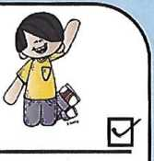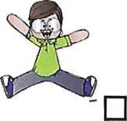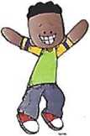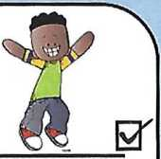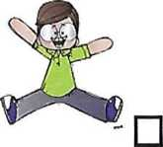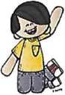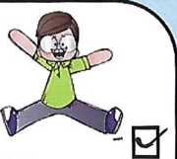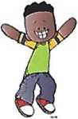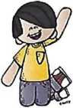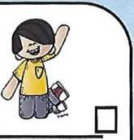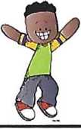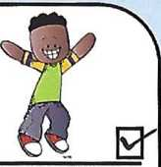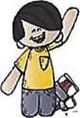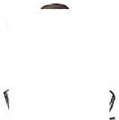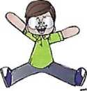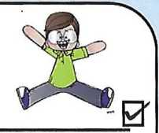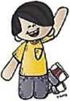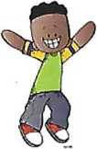

Art

I'm at the beginning of the road. In order to move up a level, I need to put more effort into my work.

Mathematics

I'm at the beginning of the road. In order to move up a level I need to show more interest in the lessons.