**Grafting of zwitterionic polymer brushes from polyacrylonitrile ultrafiltration membranes and their impact on membrane performance**

Eric Ziemann*,1, Tali Coves1, Orly Levin1, Roy Bernstein*,1

1Department of Desalination and Water Treatment, Zuckerberg Institute for Water Research, The Jacob Blaustein Institutes for Desert Research of the Ben-Gurion University of the Negev, Campus Sde Boker, 8499000, Israel.

* corresponding authors

* e-mail: (EZ) ziemann@post.bgu.ac.il; (RB) royber@bgu.ac.il

**Abstract.** The protocol presented utilizes a two-step activation process to achieve surface-initiated atom transfer radical polymerization (SI-ATRP) and chemically grafted poly(sulfobetaine methacrylate) polyzwitterion brushes with controlled density and thickness to polyacrylonitrile (PAN) ultrafiltration membrane surfaces. The activation is based on the known amidoxime synthesis on PAN membrane surfaces, with subsequent mixed oxadiazole formation to incorporate a suitable ATRP initiator. To confirm successful SI-ATRP and differences in the polyzwitterion brush density and thickness, the grafting was qualitatively verified by x-ray photoelectron spectroscopy, attenuated total reflection Fourier transform infrared spectroscopy, and atomic force microscopy (AFM). Specifically, we qualitatively show the differences in the brush interface layers by using lateral force microscopy (LFM) with both sharp and colloidal AFM probes. All brush interface layers showed reduced friction when using colloidal probe LFM and unique stick-slip behavior and nano-wear ripple mode when using sharp probe LFM. We studied how membrane filtration is then affected by surface-attached polymer brushes under dynamic membrane filtration conditions. We show that the molecular weight cutoff and the membrane permeability vary with brush density and thickness and demonstrate that both high and low-density brushes offer superior antifouling against sodium alginate and significantly improved flux recovery ratios than that of a pristine PAN membrane under similar hydrodynamic conditions. Finally, we analyze how Hofmeister series anions affect membrane filtration with 0.01, 0.1, and 0.5 mol/L KCl, KBr, KSCN, K2SO4, and K2HPO4 solutions. The results reveal a positive flux effect for KCl, KBr, and KSCN solutions and a negative flux effect for K2SO4 and K2HPO4 solutions, suggesting that the polyzwitterion brushes are grafted exclusively to the surface and crowd the pore mouth in media with strongly hydrated counterions. Overall, this work provides a method for preparing well-controlled polymer brushes on porous membranes to produce membranes with excellent antifouling properties.

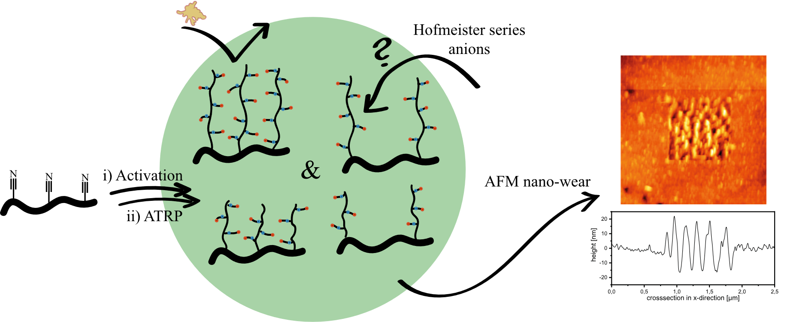

# Introduction

Membrane separation processes have become important in many industries, particularly in the field of water treatment.[1,2] Although very efficient, one significant challenge for membrane filtration is the high fouling propensity of most commercial membranes (organic fouling, biofouling, or inorganic fouling).[3] Membrane fouling reduces the membrane flux, either temporarily (reversible fouling) or permanently (irreversible fouling), impacts process efficiency, and increases energy costs.[4,5] Membrane fouling can be hindered, decreased, or prevented by using antifouling strategies that reduce the probability of a foulant attaching to the membrane surface or, if attached, facilitate its easy removal.[4]

One vastly studied approach to combat fouling is surface modification with low-fouling polymers. For example, increasing surface hydrophilicity results in a hydration layer that can thermodynamically protect interfaces against the adsorption of foulants.[6–9] Surface modification can be applied through coating techniques and grafting of polymers to form films,[10] gels,[11,12] or networks.[13] The incorporation of hydrophilic and/or antimicrobial nanomaterials to the membrane surface can further enhance membrane antifouling properties. Another promising surface modification technique is the attachment of polymer brushes,[6,14] which produces superior antifouling resistance in material science applications in general, and in membrane science in particular.

Polymer brushes refer to a system in which chains of polymer molecules are tethered to a surface, typically through a single anchor point, at a sufficiently high graft density such that the chains become crowded and stretch away from the surface to avoid overlapping.[14–16] Such polymer brushes have been attracting a growing interest in many fields because they allow for the development of tailored surface properties and can add a stimulus-response activity, thus yielding “smart materials.”[17,18]

The superior antifouling properties of polymer brushes are typically assigned to a synergy between mechanical (steric) repulsion of foulants (for high-density brushes) and a decrease in surface-free energy. In particular, superhydrophilic zwitterion brushes have gained significant interest as surface-modification agents because they provide strong hydration that resists non-specific protein adsorption.[6,14,19–23] However, despite the extensive research done on grafting controlled polymer brushes onto different materials, the grafting of polymer brushes onto polymeric membranes and particularly, onto porous membranes has received much less attention.[14,17]

One reason for this may be due to the absence of reactive chemical groups on the common porous membranes. Well-defined brushes with uniform properties are typically polymerized by using controlled “living” radical polymerization, of which atom transfer radical polymerization (ATRP) is the most popular method.[18,24,25] To facilitate the ATRP reaction, the commonly used commercial ATRP initiators should undergo nucleophilic substitution with an active group, such as free hydroxyl or amine groups. However, most common ultrafiltration (UF) membranes [such as polysulfones, polyvinylidene difluoride (PVDF), or polyacrylonitrile (PAN)] do not feature these reactive groups. Although the requisite functional groups may be introduced by surface functionalization, the surface adaption of these membranes is neither straightforward nor easily controlled. Moreover, the most common method for attaching ATRP initiators to the surface of porous membranes [so-called surface initiation ATRP (SI-ATRP)] is the adsorption of an ATRP initiator by using a polymeric macroinitiator or self-assembled monolayers. For example, Bruening’s group developed an all-aqueous route for growing polymer brushes which are presumably compatible with common microfiltration (MF) membranes.[26] Early on, Ulbricht and Yang demonstrated surface-initiated polymerization of acrylic acid via adsorption of benzophenone (notably, not a macroinitiator system) onto inert membrane surfaces. While not strictly a controlled radical polymerization, this yielded brush-like motifs and could be modified further to include a controlled radical polymerization system.[27] Davenport *et al*. modified dopamine (DOPA) with the αBiBB ATRP initiator to achieve surface and in-pore functionalization of PVDF UF membranes with a poly(DOPA-αBiB) layer from which poly(sulfobetaine methacrylate) (polySBMA) brushes could be grown.[28] Although successful, physically adsorbed systems can be prone to low surface density or post-modification detachment.[29,30]

By activating the membrane polymer before fabrication[33] or by using membrane polymers containing hydroxyl groups (e.g., cellulose),[34] porous polymeric membranes have been modified (via SI-ATRP) with covalently grafted defined polymer brushes by attaching the ATRP initiator to a previously activated surface.[27,31,32] For example, Xu *et al*. activated a nylon solvent-stable membrane in formaldehyde and then attached the ATRP initiator.[35] Zhao *et al*. demonstrated free radical grafting of an anchoring polymer onto polypropylene MF membranes followed by post-graft modification with an ATRP initiator in tetrahydrofuran to facilitate grafting of polySBMA brushes.[36] A similar approach was applied by Husson and Luzinov, who grafted poly(glycidyl methacrylate) films onto solvent-stable plasma-activated PVDF membranes and obtained the ATRP initiator by gas-phase reaction with bromoacetic acid *in vacuo* at 90 °C.[37] Recently, Carter *et al*. showed that impregnating UF membrane pores with glycerol or other pore-protection agents could significantly limit in-pore grafting and thus mitigate the reduction in flux due to the presence of brushes inside the membrane pores. Likewise, Porter *et al*. suggested that restricting the grafting to the active side of the membrane could also limit in-pore grafting because the dense active layer is less likely to sterically allow access for reactants.[38,39]

The goal of the present research was to develop a systemic approach to synthesize ultralow-fouling molecular-brush-functionalized polymeric porous membranes. To begin, we developed a method to covalently attach an ATRP initiator system to the surface of PAN UF membranes. The brush density on the membrane surface is controlled by controlling the ATRP initiator density. Next, the SI-ATRP grafting approach is used to tether defined linear polymer brushes to the membrane surface. Membranes grafted with several different brush layers were then characterized by using several analytical techniques. The results indicate that, compared with pristine PAN membranes, the brush-decorated membranes provide superior antifouling against alginate. Finally, we observe and discuss how electrolyte solutions, and specifically their various anions, affect membrane flux.

# Experiment

## Materials

Polyacrylonitrile (*M*w ≈ 150 kg/mol, *T*g = 125 °C, *n*D,20 = 1.519) was purchased from Scientific Polymer Products, Inc (Ontario, NY, USA) and dried as it was received *in vacuo* with subsequent storage in a desiccator over activated silica. *N*-(3-sulfopropyl)-*N*-(methacryloxyethyl)-*N*, *N*-dimethylammonium betaine (SBMA) was purchased from Merck KGaA (Darmstadt, Germany) and, after washing with diethyl ether, dried *in vacuo* before use. The salts KCl, KBr, KSCN, K2SO4, and K2HPO4 and acetyl chloride were also purchased from Merck KGaA (Darmstadt, Germany) and used as received. The membrane support Novatexx 2471 was kindly provided by Freudenberg Filtration Technologies SE & Co. KG (Weinheim, Germany). Hydroxylamine hydrochloride, polyethylene glycols (PEGs) (*M*n = 10, 35, 100, 200, 400 kDa), low-viscosity sodium alginate, CuBr, and 2,2’-bipyridine (bpy) were purchased from Sigma-Aldrich (Rehovot, Israel). CuBr was washed with glacial acetic acid, abs. ethanol, and diethyl ether and then dried *in vacuo* before use; the other compounds were used as received. 2-Bromobutyryl bromide and cetylammonium chloride were purchased from Tokyo Chemical Industry (Tokyo, Japan), CuBr2 from Acros Organics (Geel, Belgium), triethylamine from Fischer Scientific (Kiryat Shmona, Israel), and sodium acetate and *N*-methyl-2-pyrrolidone from Carlo Erba Reagents (Barcelona, Spain), and all were used as received. Acetonitrile (LC-gradient grade), abs. methanol, abs. ethanol, isopropanol, glycerol, chloroform, glacial acetic acid, dimethyl sulfoxide (extra dry), diethyl ether, and dichloromethane were all purchased from BioLab (Jerusalem, Israel) in AR grade and used without further purification. For water-free reactions, solvents were passed through a column of activated basic alumina.

## Instrumentation

Attenuated total reflection-Fourier transform infrared (ATR-FTIR) spectra were acquired by using a Bruker Vertex 70 with a Pike Technologies MIRacle single reflection (45°) ATR clamp using a Ge crystal. Scans were done at a mirror velocity of 5 kHz and a resolution of 4 cm−1, and the results were averaged over twenty single scans per sample spot and five distinct spot locations per membrane coupon. X-ray photoelectron spectroscopy (XPS) was used to characterize the samples after drying the samples at least overnight in high vacuum on a Thermo Fischer Scientific ESCALAB 250 with a microfocused Rowland circle Al-Kα source with a 500 µm spot size. Sample spectra were corrected for the charging effect with the C1*s* peak at 284.6 eV as an internal reference. The water contact angle (CAw) of the membranes was measured using the captive-bubble method (3 µL air) with a Dataphysics OCA 15 Plus video-based contact-angle-measuring device. The ζ-potential surface charge of the membrane samples (2 × 1 cm) was determined from the measured streaming potential by using an Anton Parr SurPass electro-kinetic analyzer and companion software. The samples were analyzed by using the adjustable-gap cell (10 µm, maximum pressure 400 mbar) with measurements collected in a 1 mM KCl electrolyte solution at pH 9 to 3 adjusted by 0.1 mol/L aqueous HCl or NaOH. Measurements were made in triplicates. Molecular weight cutoff for membranes was determined by using 90% rejection extrapolated from the rejection data of 10, 35, 100, 200, and 400 kDa PEG. The PEG rejection was determined by using gel permeation chromatography quantitation of feed and permeate concentrations of single-solute PEG filtration. Gel permeation chromatography measurements were conducted using a Waters Acquity Advanced Polymer Chromatography system with MeOH/H2O 1:4 v/v mobile phase, an Acquity UPLC Protein BEH SEC column (200 Å, 1.7 µm, 4.6 × 150 mm), and a differential refractive index detector with subsequent quantification via Waters Empower 3 software. Atomic force microscopy (AFM) topography images of membrane samples were obtained under water by using an Asylum Research Oxford Instruments MFP-3D-Bio in AC mode (1 Hz over 5 × 5 µm² or 2.5 × 2.5 µm²) using an Olympus AC240BSA-R3 cantilever with 512 scan lines per image. Surface roughness (Sq) was determined by using Gwyddion software, version 2.53, to calculate moment-based statistical quantities. All lateral force measurements were done using the AFM in contact mode while applying 12.5× integral gain. We also used a sharp Olympus AC240BSA-R3 silicon cantilever with tetrahedral point-terminated (9±2 nm) silicone probe and a normal spring constant *k* = 1.1 N/m (59.9 kHz). Lateral friction measurements were conducted by scanning back and forth perpendicular (90°) to the cantilever axis at 1 Hz over an area of 1 × 1 µm². During the scan, the applied normal load was increased from 25 to 125 nN to obtain a profile for different loads; deflection drift was noted manually before and after each scan at 0 nN load. Normal load calibration of the cantilever was administered on a hard silicone substrate, which yielded a conversion factor of 87 nN/V. Likewise, colloidal probe lateral force microscopy was done by using a Novascan silicon cantilever with a 5 µm SiO2 colloidal probe and a spring constant of 0.066 N/m. Here, friction measurements were made by back and forth scanning perpendicular (90°) to the cantilever axis at 1 Hz over a 5 × 5 µm2 area at 256 scan lines. During the scan the applied normal load set point was increased from 1 to 8 V in order to yield a profile for different loads; a drift of deflection was noted manually before and after each scan at 0 V load. Additionally, three distinct single scans at a set point of 8 V were taken per sample. Normal-load calibration of the cantilever was conducted on a hard silicone substrate, which yielded a conversion factor of 4.5 nN/V.

## Fabrication of polyacrylonitrile membranes **1**

Dry PAN powder (33.0 g, 14.4 wt.%) was dissolved in LiCl/N-methyl-2-pyrolidone (118 mL ≡ 121 g) and dry DMSO (68 mL≡75 g) at 30 °C to obtain a UF membrane dope solution. The dope solution was cast (knife, 24 mm/s) onto a non-woven Novatexx 2471 support fixed on a clean glass slate at a wet film thickness of 250 μm. After an induction period of 180 s, the glass-supported film was immersed in a coagulation bath of deionized water maintained at 5 °C to obtain the phase inversion membrane. The cast membranes were then annealed for 15 minutes in deionized water maintained at 90 °C to obtain anisotropic PAN UF membranes **1**. Membranes were cut into 46-mm-diameter coupons by using a punch hole and stored in glycerol/ethanol 1:1 v/v until further use (at least 8 h).

## Synthesis of polyacrylonitrile-amidoxime membranes **2**

The PAN-amidoxime membranes **2** were synthesized according to published procedures.[40–42] Hydroxylamine hydrochloride (2.0 g, mmol/coupon) was dissolved in *i*PrOH/H2O (40 mL/coupon, 1:1 v/v), then the aqueous sodium acetate solution (1 mol/L) was slowly added to the mixture until reaching a pH of 8. The reaction mixture was heated to 65 °C internal temperature, and PAN membrane coupons **1** (46 mm diameter) were added for the specified reaction time of 1.5 h unless otherwise noted (Figure S1). After the specified reaction time, PAN-amidoxime membranes **2** were retrieved and washed with 0.1 N aqueous HCl, methanol, and deionized water, then stored in ultrapure water until further use.

## Synthesis of polyacrylonitrile-oxadiazole membranes **3**

The PAN-oxadiazole membranes **3** were synthesized according to adapted published procedures.[41,43–45] Amidoxime membranes **2** were equilibrated for 2 h in saturated potassium chloride solution, and then dipped in a beaker containing ultrapure water before being dried with filter paper and sitting in ambient air for 10 minutes. Meanwhile, 2-bromoisobutyryl bromide (100% = 1 mmol/coupon, 50% = 0.5 mmol/coupon, 0% = 0 mmol/coupon), acetyl chloride (100% = 0 mmol/coupon, 50% = 0.5 mmol/coupon, 0% = 1 mmol/coupon), and cetylammonium chloride (80 mg, 0.25 mmol) were dissolved in dry dichloromethane/chloroform (30 mL/coupon, 1:1 v/v). The reaction mixture was cooled to −10 °C (acetone and ice), and then dry triethylamine (2.1 eq. total acyl halide) was slowly added through a cannula. The ambiently dried membrane coupons **2** (46 mm) were added to the reaction mixture, which was then stirred at −10 °C for half an hour and then heated to reflux for one hour. After stirring for an additional hour without heating, the PAN-oxadiazole coupons **3** were retrieved, washed with methanol and deionized water, and stored in EtOH/MeCN (1:1 v/v), shielded from light until further use.

## Surface-initiated atom transfer radical polymerization

For the ATRP reactions, a solution of MeOH/H2O/MeCN 4:1:2 v/v/v was degassed via three freeze-pump-thaw cycles and the transfer-flask headspace was sparged with nitrogen for 20 minutes. A Schlenk tube with stir bar was evacuated and backfilled with nitrogen three times and then charged with sulfobetaine methacrylate (0.75 mmol/coupon). In a separate tube, the procedure was carried out with CuBr (1 µeq resp. total SBMA), CuBr2 (0.2 µeq), and bpy (2.5 µeq). The monomer was dissolved in the deoxygenated-solvent mixture (25 mL/coupon), as was the catalyst in a separate flask (1.5 mL/coupon). The reaction flask was placed in an oil bath maintained at 35 °C, and membrane coupons were introduced through a nitrogen counterflow. Once the reaction temperature was reached, the catalyst complex mixture was injected through a cannula, and the reaction proceeded for the specified time (5 or 10 h).

After the specified reaction time, the coupons were retrieved and immediately washed with acetonitrile and ethanol. Finally, PAN-brush-pSBMA coupons **4** were washed in ultrapure water on an orbital shaker for at least 24 h during which the water was replaced three times. Coupons were stored under ambient conditions in ultrapure water until further use.

# Results and Discussion



**Scheme 1**: Surface activation of PAN **1** via an amidoxime **2**. Further reaction with functional acyl halides yields a mixed oxadiazole with ATRP initiator functionality.

PAN-*brush*-poly(sulfobetaine methacrylate) **4** membranes were obtained via direct SI-ATRP from surface-functionalized PAN membranes (Scheme 2) via a two-step surface functionalization route from pristine PAN UF membranes **1** with subsequent polymerization. Initially, modification of PAN **1** with hydroxylamine yields an amidoxime surface **2**. Following the activation, the ATRP initiator functionality was attached to obtain a mixed oxadiazole **3**(Scheme 1). This approach provides direct control of the initiator surface density by varying its molar ratio in competition with an acyl halide lacking ATRP initiator functionality. Finally, the polySBMA brushes were polymerized by using SI-ATRP.



**Scheme 2**: SI-ATRP from the mixed PAN oxadiazole **3** yields PAN-*brush*-pSBMA membranes **4**.

## Polyacrylonitrile modification and surface-initiated atom transfer radical polymerization

The first modification step is based on the previous work of Hicke *et al.* and uses hydroxylamine to convert the nitrile of **1** to the amidoxime motif **2**.[40] The reaction was done at 65 °C in an aqueous medium at pH 9. However, PAN degrades in the presence of an aqueous base above a threshold temperature and forms conjugated cyclic sequences.[46] These side reactions reduce the concentration of nitrile groups needed for surface functionalization and also cause the material to become brittle, which is accompanied by changes in surface morphology.[47] Both of these side effects are undesirable for membranes. Therefore, we explored the use of sodium acetate as a mild base (five orders of magnitude less basic than, e.g., carbonate), which induces substantially fewer cyclic sequences. The ATR-FTIR analyses in Figure S1(a) show the formation of amidoxime **2** with almost zero formation of defect sequences, as indicated by the absence of the tell-tale CH2 wagging band around 1400 cm‑1.

The previous work of Hicke *et al.* also showed that PAN-amidoxime **2** membranes express a higher degree of swelling at the interface layer and are thus less permeable compared with the pristine PAN **1** membranes. To find a good conversion-permeability-repeatability compromise for the membranes, we undertook a kinetic study of the amidoxime **2** modification. As shown in Figure S1(b), the conversion of nitrile groups increases exponentially over time, which allows a pseudo-first-order kinetic to be derived. Here, assuming the viable nitrile groups of PAN **1** are the rate-limiting compound and that hydroxylamine is in excess, provides the pseudo-first-order rate constant *k*′ = 2.2 × 10‑4 s‑1. Working in the pseudo-first-order regime allows the different coupon sizes or geometries to be compared based on the reaction timescale without adjusting all reactant concentrations to the new geometry. Furthermore, Figure S1(b) shows that the reproducibility for 0.5 and 1.0 h reaction times is somewhat lower than for longer reaction times. Here, a trade-off of permeability in favor of better repeatability was taken in the membrane modification to achieve PAN-amidoxime **2** membranes with an average permeability of 390±35 L m−2 h−1 bar−1 (which is 37% lower than that of the pristine PAN **1**) after a reaction time of 1.5 h.

The second step of the modification process is based on the reaction of acyl halides with amidoximes to form O-esters and N-amides that can be amenable to cyclization via base and raised temperature in aprotic polar solvents to form oxadiazoles.[48] Here, we used cetylammonium chloride as catalyst in tandem with an excess of triethylamine as a non-nucleophilic base to facilitate the O-esterification and induce cyclization. The conversion of the amidoxime **2** was followed by characterization with ATR-FTIR (Figure 1) and XPS (Table 1).

**Table 1**: Elemental Composition (in atomic percent) obtained by XPS for the initiator-modified membranes **3** (0%, 50%, and 100%), pristine PAN (reference **1**), and PAN-activated amidoxime membrane (**2**).

|  |  |  |  |  |  |  |  |  |  |  |
| --- | --- | --- | --- | --- | --- | --- | --- | --- | --- | --- |
|  | PAN Reference | | Amidoxime | | 0% Initiator | | 50% Initiator | | 100% Initiator | |
| BEpeak [eV] | at.% | BEpeak [eV] | at.% | BEpeak [eV] | at.% | BEpeak [eV] | at.% | BEpeak [eV] | at.% |
| C1*s* | 285.7 | 77.8 | 284.8 | 57.1 | 285.7 | 68.8 | 285.5 | 70.6 | 285.7 | 70.1 |
| N1*s* | 398.9 | 22.2 | 399.3 | 25.4 | 399.1 | 19.6 | 398.8 | 21.3 | 399.0 | 20.0 |
| O1*s* | - | - | 532.5 | 17.6 | 531.9 | 11.7 | 532.0 | 7.6 | 532.0 | 7.7 |
| Br3*d* | - | - | - | - | - | - | 70.1 | 0.6 | 70.0 | 2.2 |

The XPS results in Table 1 show a binding energy of 70 eV for Br3*d*, which indicates that an ATRP-active C-Br bond forms for membrane **3**. In addition, the membrane surface has greater higher bromine content for the 100% ATRP initiator concentration compared with the 50% ATRP initiator concentration. Note that, in this work, molar ratios of 0%, 50%, and 100% viable ATRP initiator were used in the reaction mixture; however, given the differences in partitioning the surface initiator and the reactivity of the initiator *versus* the competitor, the real surface density may differ from the composition of the binary mixture.[49] For example, as seen in Table 1, a one-to-one reaction ratio (50% initiator) yields roughly a third of the bromine content with respect to that obtained for the 100% initiator; this is also shown in the peak areas of the ATR-FTIR spectra (although ATR-FTIR can only be used as a semi-quantitative indication). Moreover, the increase in the XPS C1*s* signal and the decrease in the O1*s* signal is consistent with the O-esterification and cyclization since the final oxadiazole **3** has a higher carbon ratio than the amidoxime **2**.

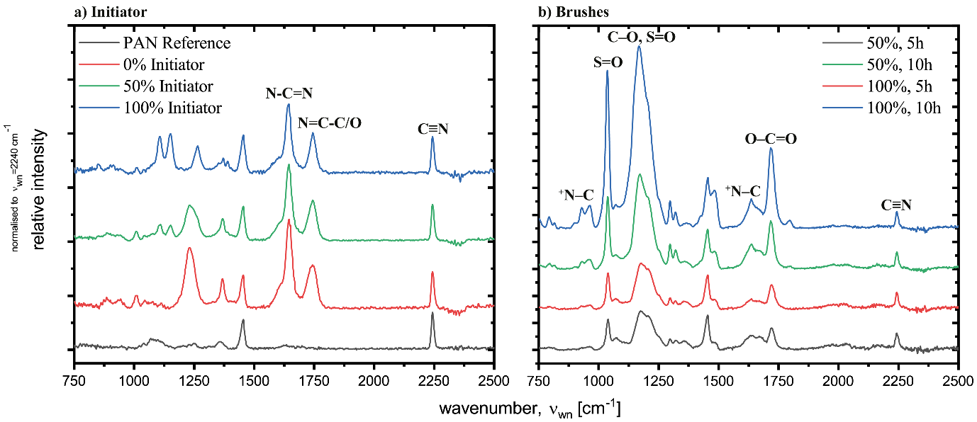

**Figure 1**: (a) ATR-FTIR spectra of 0%, 50%, and 100% initiator membranes **3** and a pristine PAN **1** membrane. For demonstration and verification, the analyses were conducted on membranes with three times longer activation time (3 h) because the normal reaction time only shows minor peaks in ATR-FTIR analysis. (b) ATR-FTIR spectra of 50%-5h, 50%-10h, 100%-5h, and 100%-10h polySBMA grafted membranes **4** (based on 1 h activation).

After the successful introduction of ATRP initiator functionality at two different densities on the surfaces of PAN UF membranes, SI-ATRP could be carried out. For ATRP with the zwitterionic monomer SBMA, which is readily soluble only in water or a similar highly polar protic solvent, we chose a catalyst system as reaction medium consisting of MeOH/H2O/MeCN 4:1:2 v/v/v with CuBr/CuBr2/bpy 1:0.2:2.5 µeq. (respective monomer).[50,51] The polymerization was carried out for 5 and 10 h to yield two different chain lengths. The successful grafting of poly(SBMA) brushes to the PAN membrane surface was verified by ATR-FTIR based on the carbonyl (1725 cm‑1), sulfone (1040, 1250 cm‑1), and ammonium (930, 960, 1635 cm‑1) bands [Figure 1(b)]. In addition, although no significant difference in peak area appears between the two Si-ATRP initiator densities for the shorter reaction time (Figure 1, 5h, 50% and 100%), it is clearly observed for the longer reaction time (Figure 1, 10h). Moreover, the XPS analysis (Table 2) reveals a new S2*p* signal at 167 eV binding energy, which is associated with the organic sulfonate groups of SBMA. The growth of the S2*p* signal with reaction time reflects an increase in polySBMA-brush thickness. Likewise, the XPS N1*s* signal near 402 eV, associated with the quaternary alkylammonium motif of polySBMA, increases with both initiator density and reaction time (Table 2). Based on the XPS and ATR-FTIR analyses, we conclude that polySBMA brushes were successfully grafted at two different densities and chain lengths via SI-ATRP.

**Table 2**: Elemental composition (at.%) obtained by high-resolution XPS for polySBMA brush-covered membranes with 50% and 100% initiator density at ATRP times of 5 and 10 h.

|  |  |  |  |  |  |  |  |  |
| --- | --- | --- | --- | --- | --- | --- | --- | --- |
|  | 50%, 5 h | | 50%, 10 h | | 100%, 5 h | | 100%, 10 h | |
| BEpeak [eV] | at.% | BEpeak [eV] | at.% | BEpeak [eV] | at.% | BEpeak [eV] | at.% |
| C1*s* | 285.5 | 69.0 | 285.5 | 66.9 | 285.4 | 68.8 | 285.5 | 67.6 |
| N1*s* | 398.8 | 15.2 | 399.1 | 11.0 | 398.8 | 12.6 | 399.3 | 9.3 |
|  | 399.3 | 13.7 | 399.1 | 8.2 | 399.3 | 10.3 | 399.3 | 6.1 |
|  | 402.0 | 1.5 | 401.9 | 2.7 | 402.1 | 2.3 | 402.0 | 3.2 |
| O1*s* | 530.8 | 10.0 | 531.0 | 18.3 | 530.8 | 15.7 | 531.0 | 18.9 |
| S2*p* | 167.0 | 0.8 | 167.0 | 3.8 | 166.8 | 3.0 | 167.3 | 4.3 |

## Membrane Characterization

The captive bubble method was used to measure a water contact angle CAw = 28±2° for the zwitterion brush-covered membranes with high initiator density, which is more hydrophilic than the base membrane with CAw = 41±1° (Figure 2). The hydrophilicity for the lower initiator density [CAw = 42±2° (5h), 37±1° (10h)] was closer to that of the base membrane (Figure S2). The negative control was a membrane with an oxadiazole surface motif and was more hydrophobic (CAw = 49±2°) than the pristine PAN—as expected from a comparatively hydrophobic oxadiazole motif. Note that CAw for water could not be measured via sessile drop mode since the water drop immediately soaked into the brush-covered membranes. Likewise, the streaming potential measurements of brush-covered membranes showed a more positive surface compared with the base PAN membrane and a slightly negative potential compared with the amidoxime-**2**-modified first-stage membranes (Figures 2 and S3). The polySBMA-covered membranes revealed an isoelectric point around pH 5 to 6, with the surface charge switching from positive to negative. Although a zwitterion modification is formally neutral, this trend is often observed for zwitterion-covered materials,[52] as further discussed by Guo *et al*.[53]

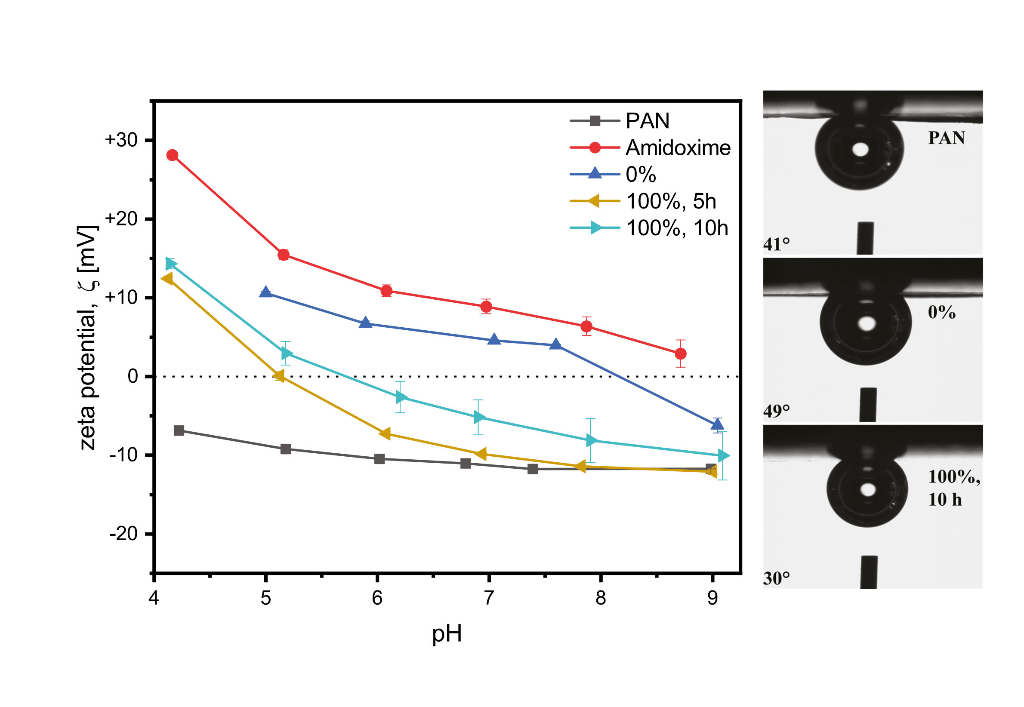

**Figure 2**: (left) -potential analysis for pristine (PAN), amidoxime, and 50% and 100% modified membranes in the pH range 4 to 9. (right) Representative images of the contact-angle measurements in captive-bubble mode of pristine, 0%, and 100% 10 h membranes.

The surface morphology of the brush-covered membranes was explored by AFM in water (Figures 3, S4, and S5). While the reference membrane showed a plateau and valley structure with rough nodules covering the surface (Sq = 10.3±1.1 nm, Figure 3, left), the brush-modified membranes featured a much smoother surface (Sq = 1.9±0.2 nm, Figure 3, middle and right) with no discernible plateau or valley motifs.

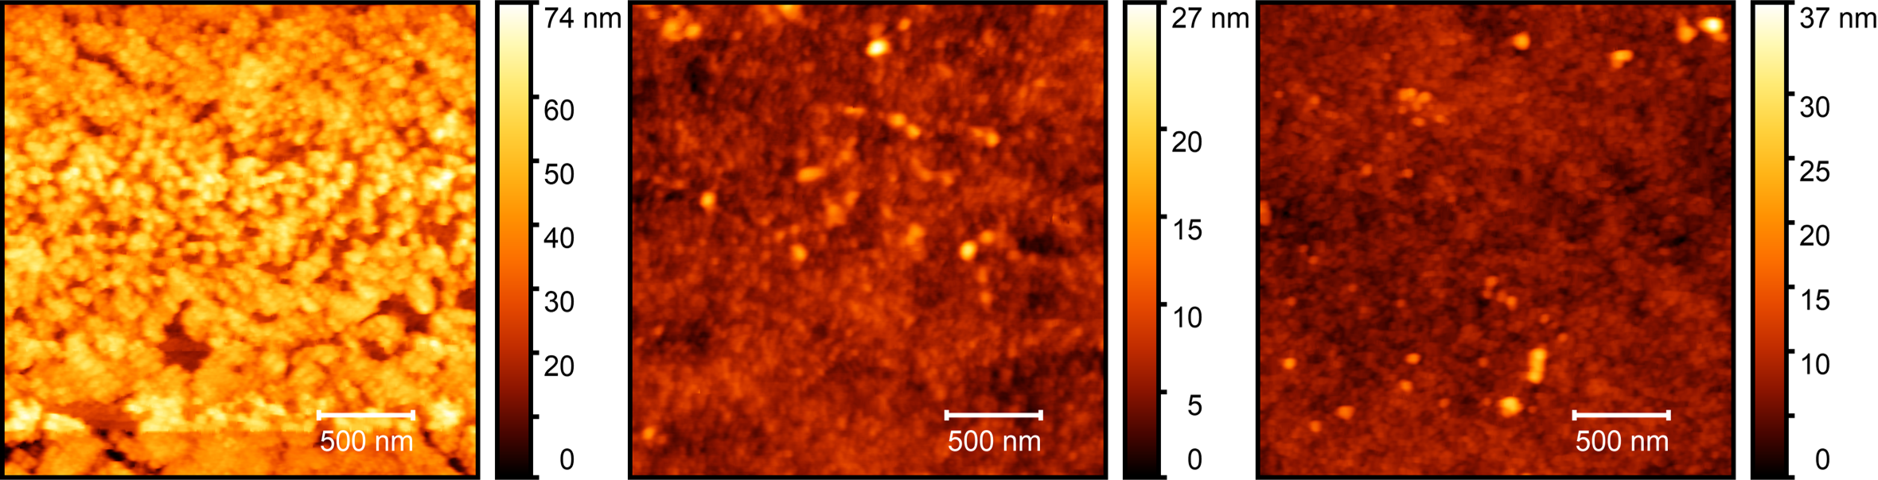

**Sq=1.9 nm**

**Sq=1.9 nm**

**Sq=10.3 nm**

**Figure 3**: Results of AFM topography measurements in deionized water over area of 2.5 × 2.5 µm². The reference membrane (left) has rough nodules and Sq ≈ 10 nm, while polySBMA membranes 100% 10 h (middle) and 100% 5 h (right) have a smoother, continuous surface.

## Lateral Force Microscopy

Direct measurements of the length or density of polymer brushes grafted onto a porous polymer surface are very challenging.[14] Therefore, we used lateral force atomic force microscopy (LFM) to qualitatively distinguish, based on nanotribological properties, between the brush layers grafted under the four conditions. The LFM measurements were conducted in two ways: (i) with a 5 µm colloidal tip that does not penetrate the brush layer and is subject to macroscopic friction, and (ii) with a nominally 9 nm sharp tip that penetrates the brush layer, facilitating entanglement with adjacent brushes to experience microscopic friction, as schematically shown in Figures 4A and 5A.[54,55]

**(B)**

**(A)**

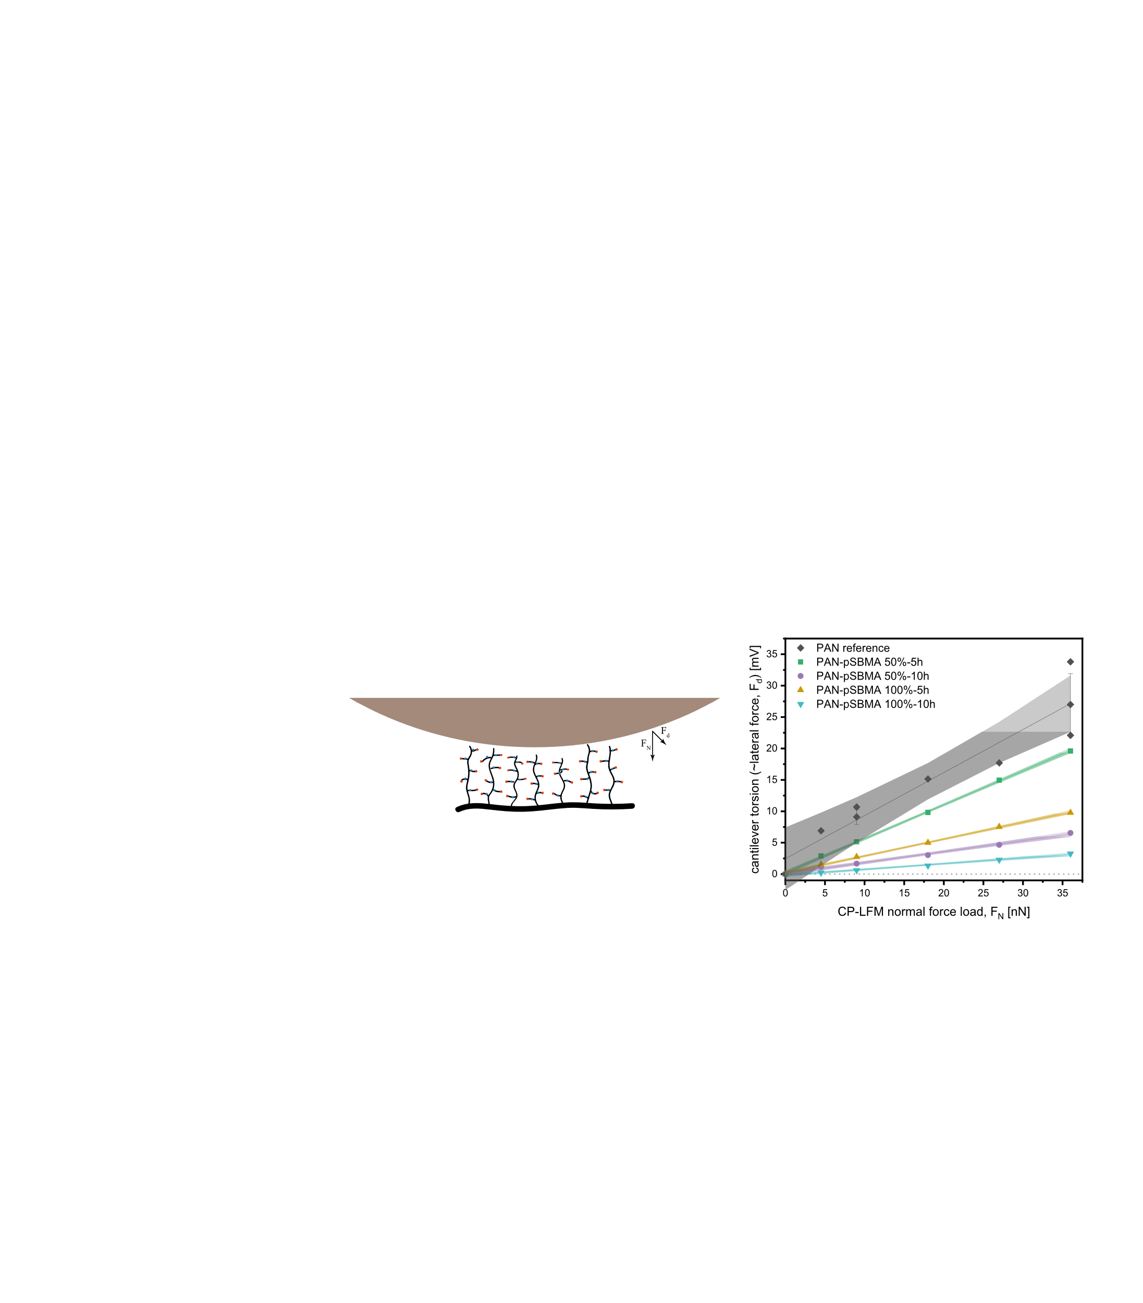

**Figure 4:** (A) Schematic interaction and forces on the colloidal tip cantilever during LFM measurement. (B) Colloidal-probe LFM friction measurements, with lateral force given as cantilever torsion in mV. The data points of cantilever torsion (including data from three distinct membrane locations) *versus* normal force load were fit to a line using OriginPro 2018 SR1b’s QuickFit function; 95% confidence bands for the linear fits are displayed as a gray shadow.

In colloidal-probe LFM, the colloidal tip is expected to compress the surface layer and not penetrate it. Furthermore, hydrated polymer brushes, such as polyzwitterions, are expected to lead to superior lubrication by decreasing friction due to the fluidity (viscoelastic behavior) of the hydrated layers encapsulating the polymer chains.[56] Here, as shown in Figure 4, the reference PAN membrane experiences the highest friction (the lateral force equivalent is given as cantilever torsion in mV) at all normal force loads. The measured friction depends to some extent (approx. 20 to 35 mV at 125 nN) on the location on the membrane surface; however, the friction is consistently much higher than that of the brush-covered membranes. The observed differences in friction on the reference membrane might be due to the discussed surface motifs because the plateau and valley structure yield two distinct surface types (that could not be imaged with a colloidal probe, ergo the observed friction regimes could not be attributed to a surface topology regime). Of note, all brush-covered membranes experience significantly less friction (i.e., lower cantilever torsion) than the reference membrane, and the friction profiles deviate much less than those of the base membrane. Here, friction tends to decrease more as a function of brush thickness between PAN-pSBMA 50% 5 h and PAN-pSBMA 50% 10 h than as a function of brush density between PAN-pSBMA 50% and PAN-pSBMA 100% candidates. Clearly, the densest and thickest brushes on the PAN-pSBMA 100% 10 h membrane have the lowest friction, with almost zero resistance at low normal force loads.

For the sharp tip LFM (ST-LFM), we expect that, with a greater normal force *F*N, the tip penetrates more into the brushes and, due to the perturbance, experiences a stronger interaction. The lateral movement of the cantilever means that the entangled brushes should offer resistance to the cantilever movement, which should produce a lateral deflection force *F*d (torsion of the cantilever).[55]

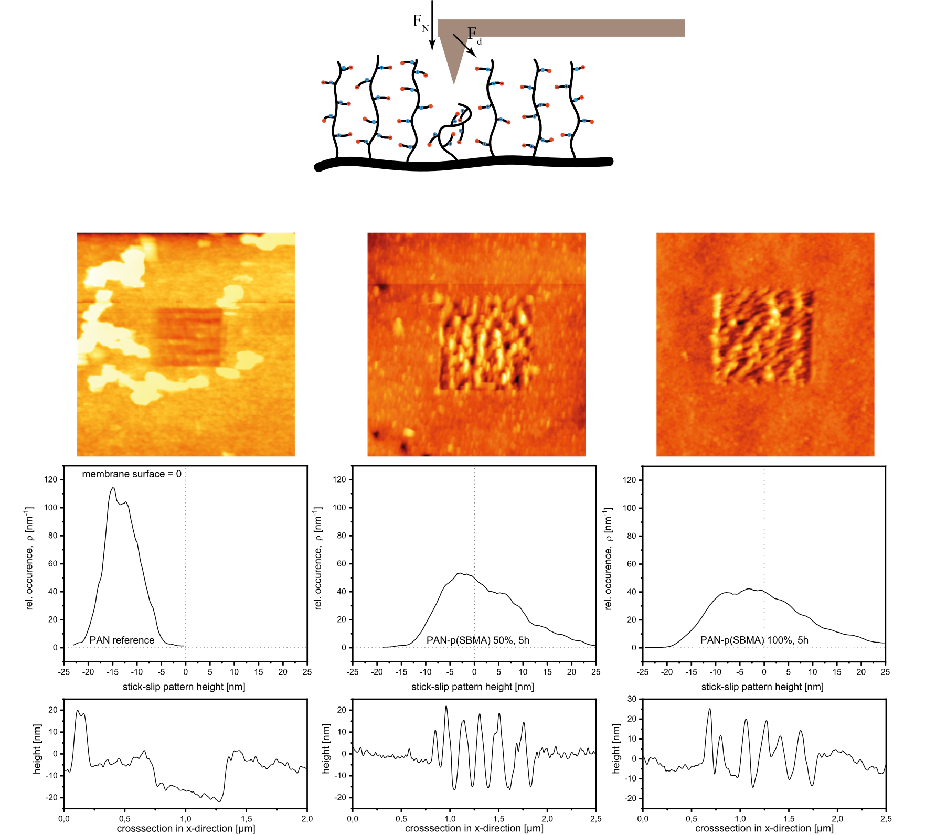

**(B)**

**(A)**

**Figure 5:** (A) Schematic interaction and forces on the sharp tip cantilever during ST-LFM measurement. (B) Topography analysis of membrane surfaces after the surface was scanned at 125 nN normal load. The stick-slip patterns leading to the morphologies presented are discussed in the supporting information. Two-dimensional and representative one-dimensional cross-section analyses of the patterns created on the membrane surface reveal the characteristic morphology caused by the sharp tip disturbance of the brush surface. From left to right are shown the PAN reference, PAN- pSBMA 50% 5h, and PAN-pSBMA 100% 5 h.

The behavior of the sharp tip during ST-LFM measurements is discussed further in the supporting information (i.e., its stick-slip behavior as presented in Figures S9 through S12). The important point here involves ripple formation as a mode of nano-wear; this appears on the brush-covered membranes, as shown in Figure 5 for the 5 h membranes (for 10 h membranes, see Figure S6). Distinct ripples form, similar to the ripples observed by Vyas *et al*. for polystyrene brushes.[57] Conversely, the pristine PAN membrane displays a carved-out morphology at a high normal force load of 125 nN (Figures 5, S7, and S8). These observations suggest that the brush-covered membrane surface is soft and susceptible to perturbation on a nanoscopic scale with the stick-slip behavior of the sharp tip producing the ripples,[57,58] while the harder and more brittle surface of the reference membrane results in a breakage-mode of material failure. The topology of rippled surfaces is consistent with the findings of other LFM measurements and with other analyses since the PAN-pSBMA 50% 10 h and PAN-pSBMA 100% 5 h membranes show a similar height distribution, whereas the height distribution of PAN-pSBMA 50% 5 h spans a smaller range and PAN-pSBMA 100% 10 h spans a larger range.

## Aspects of brush-covered membrane performance

The pure water flux of poly(sulfobetaine methacrylate) brush-covered membranes **4**, shown in Table 3, is less than that of the activated membrane **2** (initially 390±35 L m−2 h−1 bar−1). A decline in pure water flux is expected for brush-covered membranes because the additional brush layer exerts more resistance against the flux through the interface.[27,39] Because the pure water flux of the modified membranes **4** is reduced, the benefits of the modified membrane performance should be gained from their resistance to fouling and/or improvement in the trade-off between flux and selectivity. Therefore, the MWCO of the membranes was measured, and its evolution during the synthesis is presented in Table 3. While the base PAN membrane **1** has a high MWCO of around 300 kDa, the activated PAN-amidoxime **2** is around 230 kDa. Here, the reduction in MWCO also leads to the decline of the measured permeability (Figure S1). Although PAN-pSBMA 50% 5 h has an MWCO slightly under that of PAN-amidoxime **2**, the MWCO of the PAN-pSBMA 50% 10 h and 100% 5 h are around 100 and 150 kDa, respectively.

The antifouling properties of polyzwitterion-modified surfaces are well described.[28,52,59,60] Here, we demonstrate the antifouling effect of brush-covered PAN UF membranes by using 10 ppm sodium alginate in an electrolyte solution (8.5 mmol/L KCl, 1 mmol/L NaCl, 1.5 mmol/L CaCl2). A reference membrane of unmodified PAN with a permeability (155±20 L m−2 h−1 bar−1) and MWCO (≈90 kDa) similar to that of the modified membranes was prepared for this experiment to compare the fouling propensity of modified PAN with that of unmodified PAN under similar hydrodynamic conditions.

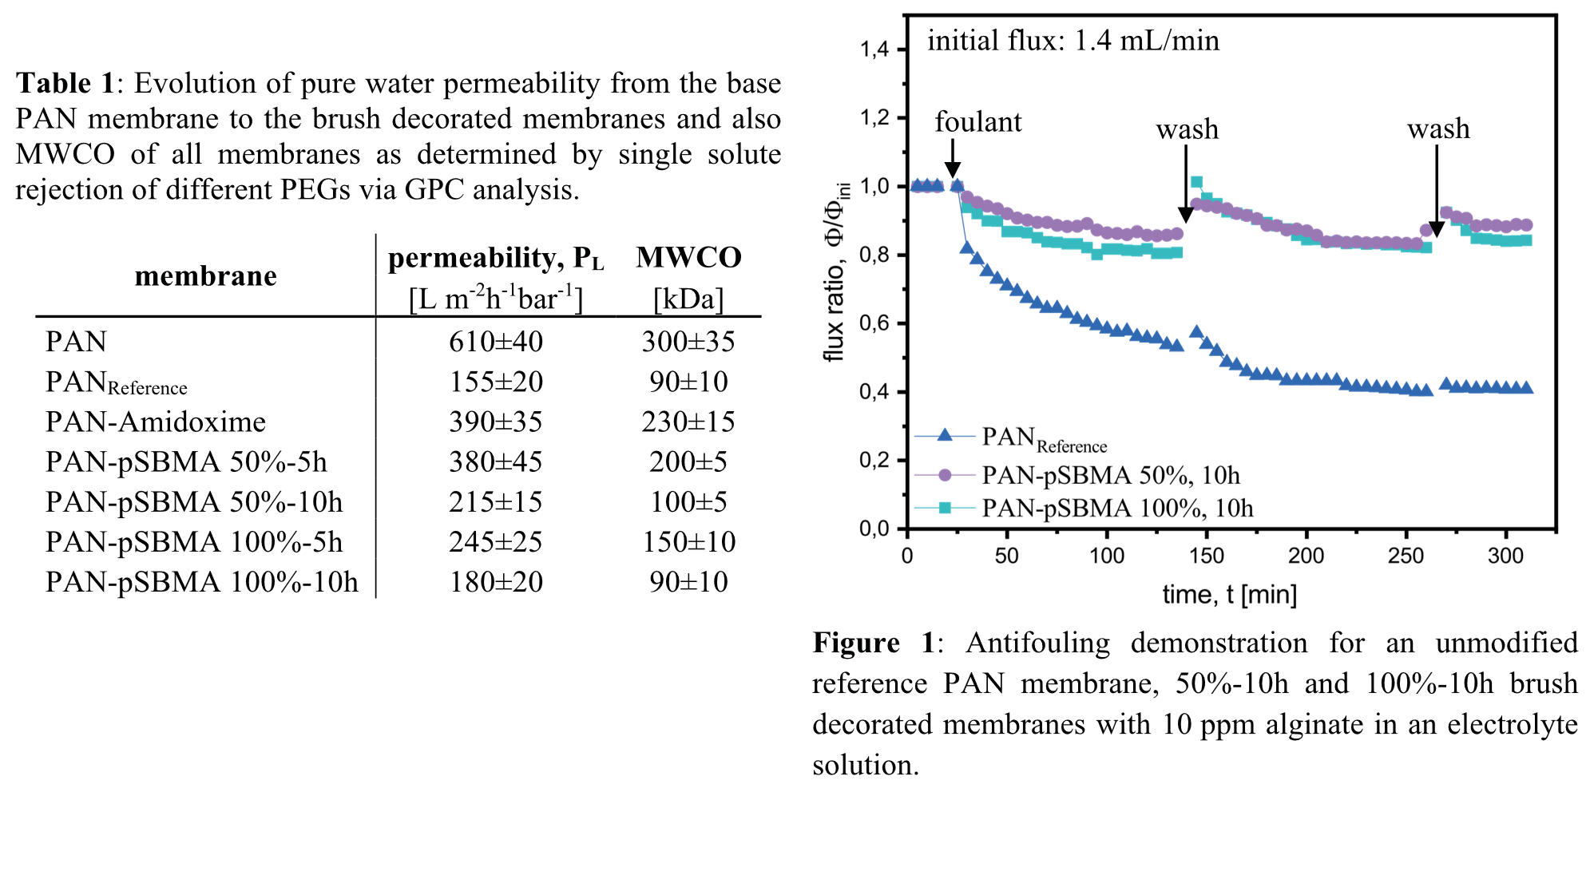

Figure 6, which presents the change in flux during filtration, shows that the pristine PAN membrane experiences a significant decline in flux (55% of the initial flux) after only 2 h and also bears a very poor fouling recovery ratio. Conversely, membranes covered with both high and low-surface density brushes have excellent antifouling properties, with less than 20% flux reduction after 2 h of filtration and a high water fouling reduction ratio with over 90% flux recovery after the washing step.

Zwitterion polymer brushes change their conformation in response to electrolyte concentration and ion composition, and this change can be more pronounced for brush-decorated surfaces than for dissolved macromolecules with diameters larger than the brush correlation length. The stimulus response of zwitterion polymers to salt can also be employed for self-cleaning of fouled surfaces.[61,62] In this research, the change in flux of 100% 10 h polySBMA grafted membranes in 0.01, 0.1, and 0.5 mol/L single-salt solutions of K2HPO4, K2SO4, KCl, KBr, or KSCN was examined (the pristine reference PAN **1** and activated membranes **2** were also tested as references and did not respond to any salt). Since anions usually affect polyzwitterions stronger than cations,[63] the cation was held constant.

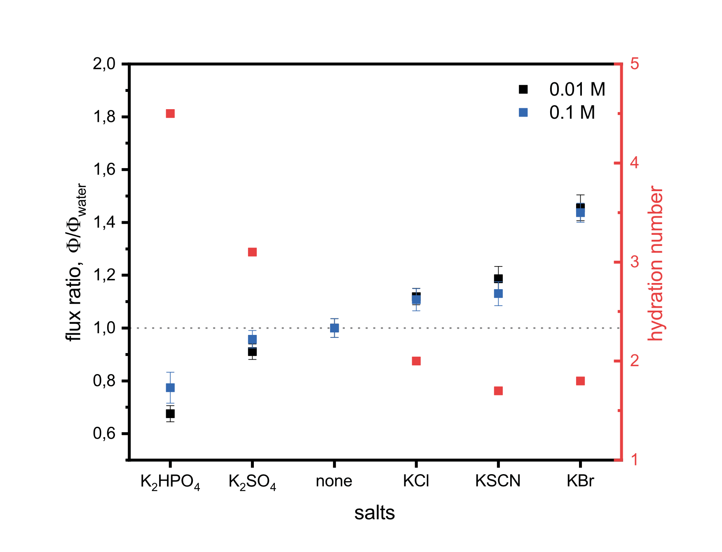

**Figure 7**: Flux ratios for salt solutions at 0.01 and 0.1 mol/L *versus* pure water. The hydration numbers of the anions were taken from Marcus[64] and are superimposed on the right-hand side. First-shell phosphate hydration was extrapolated linearly from Marcus and Eiberweiser *et al.*[65]

Polyzwitterions typically exhibit the anti-polyelectrolyte effect (i.e., they swell with increasing salt concentrations and retain a constant volume above a critical salt concentration[66]). This effect is due to strong Coulomb interactions of quaternary alkylammonium and alkyl sulfonate residues in either inter or intra-chain interactions.[59,63] When surrounded only by water molecules, these interactions can lead to a collapsed polymer structure with hydrophobic chain residues exposed to the surroundings.[63] Upon adding a salt that can shield part of the inter and intra-chain alkylammonium-sulfonate interactions, the polyzwitterion chains can stretch and assume a brush conformation that is more hydrophilic.[63,67] The flux ratio in Figure 7 indicates whether the salt-solution flux is higher (Φ/Φwater>1) or lower (Φ/Φwater<1) than the pure water flux. The results in Figure 7 show Φ/Φwater>1 for chloride, thiocyanate, and bromide anions, whereas Φ/Φwater<1 for sulfate and hydrogen phosphate anions, with the strongest effect observed in bromide and phosphate solutions.

The swelling results in Figure 7 generally corroborate previous reports. For example, Delgado and Schlenoff investigated the swelling of free polyzwitterion chains in solution and showed increased swelling of polyzwitterions following the anion series -SCN < Br- < Cl- < SO42−.[66] Likewise, Sakamaki *et al*. observed stronger swelling of dense polysulfobetaine brushes on silicone slabs in −SCN over Cl−,[68] whereas Xiao *et al*. observed the swelling trend Cl− < Br- < SO42− for dense brushes on silicon wafers.[63] More importantly, considering the trend in polyzwitterion swelling with respect to the reported data, one would expect that, were the brushes grafted inside the membrane pores, the permeate flux would decline with increasing brush swelling according to SO42− > -SCN > Br- > Cl−.However, this is inconsistent with the relative-flux results in Figure 7. As an explanation, we propose that the anion effect reported in Figure 7 is due to the particular structural configuration of the brush on the surface of a permeable porous boundary, which is a defining feature of UF membranes. For weakly hydrated anions that limit the polyzwitterion self-interaction on the surface, the membrane pores are free of collapsed chains, which allows an increase in flux. In this case, more stretched or swollen brushes leads to higher water flux (Figure 8, middle) compared with the water flux in pure water (Figure 8, left). However, some brushes are also grafted in the vicinity of the membrane-pore mouth. In this case, highly hydrated anions that strongly compete with the inter and intra-chain alkylammonium-sulfonate interactions of polyzwitterion chains could lead to lateral swelling of brushes to accommodate the water clusters, thus crowding the pore voids and reducing the flux (Figure 8, right). Here, it stands to reason that stronger hydrated anions such as phosphate lead to a more significant lateral displacement and more effectively reduce the flux compared with sulfate.

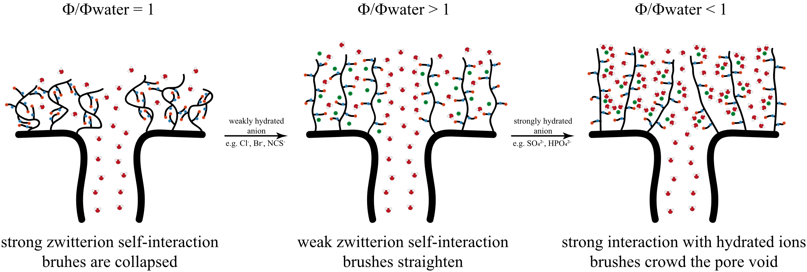

**Figure 8**: Schematic representation of brush configuration around pore mouth that could lead to observed trends in flux ratios.

Moreover, the flux-change trends described herein are consistent with the Hofmeister series,[69,70] except for the thiocyanate solution, which has a lower flux than a bromide solution. Furthermore, when comparing the salt concentrations in Figure 7 with 0.5 mol/L in Figure S14, the flux ratios clearly approach a common value with increasing salt concentration. This might suggest a saturation of the polyzwitterion brush above a critical salt concentration, as observed by Delgado and Schlenoff for free polyzwitterions in solution.

# Conclusion

We propose herein a protocol to utilize SI-ATRP from PAN UF membrane surfaces to obtain poly(sulfobetaine methacrylate) brushes of two different densities and two different lengths. The successful grafting is confirmed by CAw, ζ-potential, ATR-FTIR, AFM, and XPS analysis. Qualitative control over density and length is evinced by XPS, ATR-FTIR, and LFM. The effects of the modification on membrane permeability and MWCO are also elucidated. Furthermore, the known antifouling properties of polyzwitterion modifications are demonstrated for these membranes on sodium alginate filtration, revealing excellent fouling resistance and flux recovery. Finally, the effects of Hofmeister series salts on membrane performance are determined in terms of flux ratio *vs*. pure-water flux for 0.01, 0.1, and 0.5 mol/L KCl, KBr, KSCN, K2SO4, and K2HPO4 solutions. A positive flux effect for KCl, KBr, and KSCN solutions and a negative flux effect for K2SO4 and K2HPO4 solutions suggest that the polyzwitterion brushes express this unique swelling behavior only when they are grafted mostly to the surface and crowd around pore mouths. We believe this unique behavior warrants further research since the counterion effect for polyzwitterions on permeable boundaries is not extensively discussed in the literature.

# Acknowledgments

The authors gratefully acknowledge the BMBF-MOST German-Israeli Water Technology Cooperation program number WT1605/02WIL1455/AnMBRA for financial support. The research was also partially funded by the Israeli Water Authority, grant number 4501809609. E.Z. would like to thank the Kreitman School of Advanced Graduate Studies for a supporting scholarship and Dr. Armin Greiner of Freudenberg Filtration Technologies SE & Co KG for providing non-woven membrane support. Furthermore, the authors declare no conflicts of interest.

References

[1] H. Strathmann, *AIChE J.* **2001**, *47*, 1077–1087.

[2] M. Ulbricht, *Polymer* **2006**, *47*, 2217–2262.

[3] R. Zhang, Y. Liu, M. He, Y. Su, X. Zhao, M. Elimelech, Z. Jiang, *Chem. Soc. Rev.* **2016**, *45*, 5888–5924.

[4] W. Guo, H.-H. Ngo, J. Li, *Bioresour. Technol.* **2012**, *122*, 27–34.

[5] K. V. Peinemann, S. P. Nunes, *Membranes for Water Treatment: Volume 4*, Wiley-VCH, Weinheim, **2010**.

[6] M. Kobayashi, Y. Terayama, H. Yamaguchi, M. Terada, D. Murakami, K. Ishihara, A. Takahara, *Langmuir* **2012**, *28*, 7212–7222.

[7] R. G. Chapman, E. Ostuni, S. Takayama, R. E. Holmlin, L. Yan, G. M. Whitesides, *J. Am. Chem. Soc.* **2000**, *122*, 8303–8304.

[8] P. Harder, M. Grunze, R. Dahint, G. M. Whitesides, P. E. Laibinis, *J. Phys. Chem. B* **1998**, *102*, 426–436.

[9] E. Ostuni, R. G. Chapman, R. E. Holmlin, S. Takayama, G. M. Whitesides, *Langmuir* **2001**, *17*, 5605–5620.

[10] S. Zhang, J. Cao, N. Ma, M. You, X. Wang, J. Meng, *Appl. Surf. Sci.* **2018**, *428*, 41–53.

[11] W. Zhang, W. Cheng, E. Ziemann, A. Be’er, X. Lu, M. Elimelech, R. Bernstein, *J. Membr. Sci.* **2018**, *565*, 293–302.

[12] I. Eshet, V. Freger, R. Kasher, M. Herzberg, J. Lei, M. Ulbricht, *Biomacromolecules* **2011**, *12*, 2681–2685.

[13] W. Zhao, J. Huang, B. Fang, S. Nie, N. Yi, B. Su, H. Li, C. Zhao, *J. Membr. Sci.* **2011**, *369*, 258–266.

[14] J. J. Keating, J. Imbrogno, G. Belfort, *ACS Appl. Mater. Interfaces* **2016**, *8*, 28383–28399.

[15] P. G. de Gennes, *Adv. Colloid Interface Sci.* **1987**, *27*, 189–209.

[16] A. Halperin, M. Tirrell, T. P. Lodge, in *Macromol. Synth. Order Adv. Prop.*, Springer-Verlag, Berlin/Heidelberg, **1992**, pp. 31–71.

[17] W. L. Chen, R. Cordero, H. Tran, C. K. Ober, *Macromolecules* **2017**, *50*, 4089–4113.

[18] K. Matyjaszewski, *Adv. Mater.* **2018**, *30*, 1–22.

[19] D. Murakami, M. Kobayashi, T. Moriwaki, Y. Ikemoto, H. Jinnai, A. Takahara, *Langmuir* **2013**, *29*, 1148–1151.

[20] A. Halperin, *Langmuir* **1999**, *15*, 2525–2533.

[21] S. Y. Lee, Y. Lee, P. Le Thi, D. H. Oh, K. D. Park, *Biomater. Res.* **2018**, *22*, 3–9.

[22] S. Paschke, K. Lienkamp, *ACS Appl. Polym. Mater.* **2020**, *2*, 129–151.

[23] Y.-S. Guo, Y.-F. Mi, Y.-L. Ji, Q.-F. An, C.-J. Gao, *ACS Appl. Polym. Mater.* **2019**, *1*, 1022–1033.

[24] K. Matyjaszewski, J. Xia, *Chem. Rev.* **2001**, *101*, 2921–2990.

[25] T. G. Ribelli, F. Lorandi, M. Fantin, K. Matyjaszewski, *Macromol. Rapid Commun.* **2019**, *40*, 1800616.

[26] N. Anuraj, S. Bhattacharjee, J. H. Geiger, G. L. Baker, M. L. Bruening, *J. Membr. Sci.* **2012**, *389*, 117–125.

[27] M. Ulbricht, H. Yang, *Chem. Mater.* **2005**, *17*, 2622–2631.

[28] D. M. Davenport, J. Lee, M. Elimelech, *Sep. Purif. Technol.* **2017**, *189*, 389–398.

[29] O. Azzaroni, I. Szleifer, *Polymer and Biopolymer Brushes: For Materials Science and Biotechnology*, John Wiley & Sons, **2018**.

[30] G. Fleer, M. A. C. Stuart, J. M. H. M. Scheutjens, T. Cosgrove, B. Vincent, *Polymers at Interfaces*, Springer Science & Business Media, **1993**.

[31] A. Friebe, M. Ulbricht, *Langmuir* **2007**, *23*, 10316–10322.

[32] J. J. Keating, M. Sorci, I. Kocsis, A. Setaro, M. Barboiu, P. Underhill, G. Belfort, *J. Membr. Sci.* **2018**, *546*, 151–157.

[33] L.-P. Zhu, H.-B. Dong, X.-Z. Wei, Z. Yi, B.-K. Zhu, Y.-Y. Xu, *J. Membr. Sci.* **2008**, *320*, 407–415.

[34] N. Singh, J. Wang, M. Ulbricht, S. R. Wickramasinghe, S. M. Husson, *J. Membr. Sci.* **2008**, *309*, 64–72.

[35] F. J. Xu, J. P. Zhao, E. T. Kang, K. G. Neoh, J. Li, *Langmuir* **2007**, *23*, 8585–8592.

[36] Y.-H. Zhao, K.-H. Wee, R. Bai, *J. Membr. Sci.* **2010**, *362*, 326–333.

[37] N. Singh, S. M. Husson, B. Zdyrko, I. Luzinov, *J. Membr. Sci.* **2005**, *262*, 81–90.

[38] C. J. Porter, J. R. Werber, C. L. Ritt, Y.-F. Guan, M. Zhong, M. Elimelech, *J. Membr. Sci.* **2020**, *596*, 117719.

[39] B. M. Carter, A. Sengupta, X. Qian, M. Ulbricht, S. R. Wickramasinghe, *J. Membr. Sci.* **2018**, *554*, 109–116.

[40] H.-G. Hicke, P. Böhme, M. Becker, H. Schulze, M. Ulbricht, *J. Appl. Polym. Sci.* **1996**, *60*, 1147–1161.

[41] F. Eloy, R. Lenaers, *Chem. Rev.* **1962**, *62*, 155–183.

[42] M. A. Walters, A. B. Hoem, M. Shibasaki, N. Yamagiwa, in *Encycl. Reag. Org. Synth.*, American Cancer Society, **2006**.

[43] H. Otaka, J. Ikeda, D. Tanaka, M. Tobe, *Tetrahedron Lett.* **2014**, *55*, 979–981.

[44] A. R. Gangloff, J. Litvak, E. J. Shelton, D. Sperandio, V. R. Wang, K. D. Rice, *Tetrahedron Lett.* **2001**, *42*, 1441–1443.

[45] K. D. Rice, J. M. Nuss, *Bioorg. Med. Chem. Lett.* **2001**, *11*, 753–755.

[46] H. N. Friedlander, L. H. Peebles, J. Brandrup, J. R. Kirby, *Macromolecules* **1968**, *1*, 79–86.

[47] F. Huang, Y. Xu, S. Liao, D. Yang, Y.-L. Hsieh, Q. Wei, *Materials* **2013**, *6*, 969–980.

[48] *Handbook of Heterocyclic Chemistry*, Elsevier, **2010**.

[49] S. B. Lee, R. R. Koepsel, S. W. Morley, K. Matyjaszewski, Y. Sun, A. J. Russell, *Biomacromolecules* **2004**, *5*, 877–882.

[50] N. V. Tsarevsky, T. Pintauer, K. Matyjaszewski, *Macromolecules* **2004**, *37*, 9768–9778.

[51] N. V. Tsarevsky, W. A. Braunecker, K. Matyjaszewski, *J. Organomet. Chem.* **2007**, *692*, 3212–3222.

[52] R. Bernstein, V. Freger, J.-H. Lee, Y.-G. Kim, J. Lee, M. Herzberg, *Biofouling* **2014**, *30*, 367–376.

[53] S. Guo, D. Jańczewski, X. Zhu, R. Quintana, T. He, K. G. Neoh, *J. Colloid Interface Sci.* **2015**, *452*, 43–53.

[54] A. Halperin, E. B. Zhulina, *Langmuir* **2010**, *26*, 8933–8940.

[55] P. Mocny, H.-A. Klok, *Mol. Syst. Des. Eng.* **2016**, *1*, 141–154.

[56] U. Raviv, S. Giasson, N. Kampf, J.-F. Gohy, R. Jérôme, J. Klein, *Nature* **2003**, *425*, 163–165.

[57] M. K. Vyas, B. Nandan, K. Schneider, M. Stamm, *Eur. Polym. J.* **2009**, *45*, 1367–1376.

[58] F. Dinelli, G. J. Leggett, P. H. Shipway, *Nanotechnology* **2005**, *16*, 675–682.

[59] G. S. Georgiev, E. B. Kamenska, E. D. Vassileva, I. P. Kamenova, V. T. Georgieva, S. B. Iliev, I. A. Ivanov, *Biomacromolecules* **2006**, *7*, 1329–1334.

[60] E. van Andel, S. C. Lange, S. P. Pujari, E. J. Tijhaar, M. M. J. Smulders, H. F. J. Savelkoul, H. Zuilhof, *Langmuir* **2019**, *35*, 1181–1191.

[61] K.-T. Huang, S.-B. Yeh, C.-J. Huang, *ACS Appl. Mater. Interfaces* **2015**, *7*, 21021–21029.

[62] Y.-L. Zhu, Z.-Y. Lu, Z.-W. Li, Z.-Y. Sun, X. Liu, *Langmuir* **2019**, *35*, 6669–6675.

[63] S. Xiao, Y. Zhang, M. Shen, F. Chen, P. Fan, M. Zhong, B. Ren, J. Yang, J. Zheng, *Langmuir* **2018**, *34*, 97–105.

[64] Y. Marcus, *J CHEM SOC FARADAY TRANS* **1991**, *87*, 5.

[65] A. Eiberweiser, A. Nazet, G. Hefter, R. Buchner, *J. Phys. Chem. B* **2015**, *119*, 5270–5281.

[66] J. D. Delgado, J. B. Schlenoff, *Macromolecules* **2017**, *50*, 4454–4464.

[67] S. Xiao, B. Ren, L. Huang, M. Shen, Y. Zhang, M. Zhong, J. Yang, J. Zheng, *Curr. Opin. Chem. Eng.* **2018**, *19*, 86–93.

[68] T. Sakamaki, Y. Inutsuka, K. Igata, K. Higaki, N. L. Yamada, Y. Higaki, A. Takahara, *Langmuir* **2019**, *35*, 1583–1589.

[69] V. Mazzini, V. S. J. Craig, *Chem. Sci.* **2019**, *10*, 3430–3433.

[70] V. Mazzini, V. S. J. Craig, *Chem. Sci.* **2017**, *8*, 7052–7065.