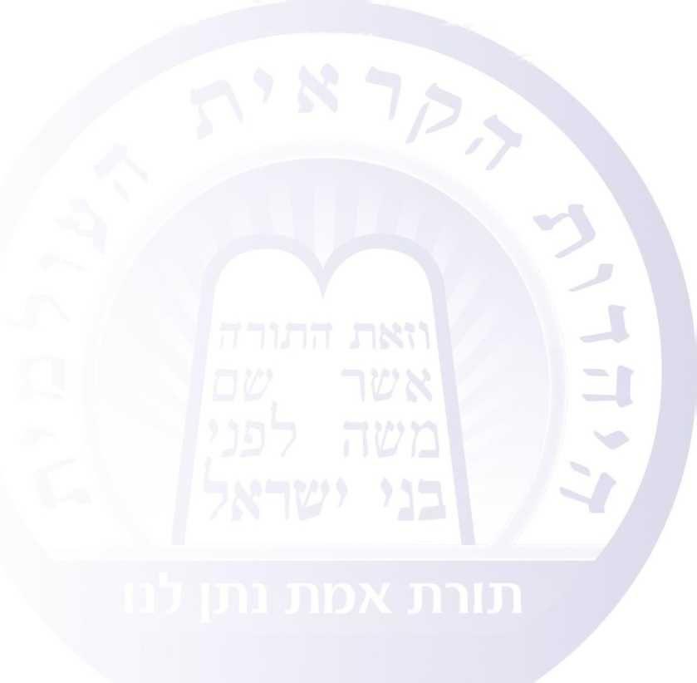

What is Karaite Judaism?

Karaite Judaism is based on the belief that the Creator gave our prophet Moses (peace be upon him) at Mount Sinai just one single Torah — the written Torah, about which the Bible tells us, “The Torah of the Lord is perfect, reviving the soul.”[1] Karaite Judaism believes in the sanctity of the 24 books of the Bible (the Torah, Prophets, and Writings), but rejects granting binding validity to any later, human text like the Mishnah or the Talmudim[2] (and the rest of later rabbinic literature), those books called “the Oral Law.”

**Karaite Judaism and the Oral Law**

As noted, the Karaite approach rejects granting sanctity or binding validity to the Oral Law. We nonetheless view the Mishnah and Talmud as words of wisdom and as a part of the cultural and historical inheritance of the Jewish people, written over the course of the centuries. Some of these words of wisdom are **correct**, but others are mistaken; like anything else that is a human creation, it may not contradict the words of God. It may neither add to them nor detract from them, in accordance with the commandment explicitly written in the Torah: “You shall not add anything to what I command you or take anything away from it.”[3]

In the Bible as a whole, there are many indications of the existence of just one Torah — the written Torah — which was given at Sinai.

1. For example, in Deuteronomy we read, “When Moses had put down in writing the words of this Teaching to the very end.”[4] That is, all the words of the Torah were put down in writing. An additional indication of this kind can be found in Malachi, where we read, “Be mindful of the Teaching of My servant Moses, whom I charged at Horeb with laws and rules for all Israel.”[5] The Holy One commands the prophet Malachi, the last of the prophets, to be mindful of the Torah of Moses. He does not mention any other Torah. In Joshua too we read, “Be most resolute to observe faithfully all that is written in the Book of the Teaching of Moses, without ever deviating from it to the right or to the left.”[6] The psalms likewise tell us that “the teaching of the Lord is perfect.”[7] “Perfect” means that it is complete. The Torah is complete and needs nothing additional.
2. The contents of the Oral Law itself bear witness that it is not divine. Nowhere in the Oral Law do we find instructions or commandments given directly by God. It is entirely formulated as a human text: “R. Eliezer said this and R. Judah said that.” This proves that we are not dealing here with the words of the living God, but with words that come from flesh and blood. Moreover, the disagreements found on almost every topic of discussion in the Mishnah and Talmud demonstrate that these are not the words of the living God, since it is impossible that God would contradict His own words by teaching both a thing and its opposite. In addition, how can one possibly claim that the Oral Law is an interpretation of the Torah when it discusses subjects that the Torah itself does not discuss? Even the Rabbanites[8] themselves admit that most of their laws (like those about release from vows, the Sabbath, the festival offerings, and misappropriation of Temple property) are not connected to the Torah, have no basis in the Torah, or are extremely farfetched. We read in the Mishnah, “The laws of release from vows float in the air, having nothing on which to depend. The laws of the sabbath, festival offerings, and misappropriation of Temple property — these are like mountains suspended by a hair, for they consist of a miniscule amount of Bible and many laws.”[9] Similarly, there are countless disputes that remain unresolved.

**Who Is Responsible for Interpreting the Torah?**

In Karaite Judaism, we believe that today, now that prophecy has ceased, along with any human leadership originating in a divine source, every Jew is obligated to study Torah and to interpret its plain sense in accordance with the standards that will be set forth in what follows. When you come right down to it, all Jews are individually responsible for what they do and get the reward (or punishment) that their actions deserve. The rabbinic authority on which a person might rely is not rewarded or punished.

1. Prov 19:8.
2. Babylonian and Palestinian (“Jerusalem”).
3. Deut 4:2.
4. Deut 31:24.
5. Mal 3:22.
6. Josh 23:6.
7. Ps 19:8.
8. An inclusive term for those who believe in the Oral Law (principally Orthodox Jews).
9. M. Hag. 1:11.