**Embedding Educational Computer Games into Lessons**

Keywords: mathematics learning, computer games, lesson plan, methodology

# Literature Review

Integration of computer games into lessons has previously been described in the literature. Use of these games has potential advantages for students’ learning outcomes and motivation. For example, research has found that computer games can be more beneficial than pencil-and-paper exercises in terms of improving students’ motivation for learning mathematics (Ke, 2008). Additionally, use of computer games can increase students’ sense of self-efficacy and improve their attitudes toward learning, and these impacts persist after the actual time of playing the game (Riconscente, 2013). Other educational computer games, such as a game in the domain of fractions along a number line (Riconscente, 2013); an arithmetic-based computer game that contains reflective features (Pareto et al., 2011); and practice using a proportional reasoning game, have all been found to contribute to students’ knowledge in the games’ subject, and even to explicit knowledge they gain consequently (Vrugte et al., 2015).

Some studies have investigated broader learning considerations. For example, research comparing use of computer games in three different conditions: cooperatively within a game, competitively within a game, or in a non-game condition found the two conditions using a game were more beneficial for learning than the non-game condition (Ke & Grabowski, 2007). Other research found that learning preliminary algebraic thinking using a computer game along with a short class discussion improved users’ learning (Van den Heuvel-Panhuizen, Kolovou & Robitzsch, 2013). In light of these findings, it seems that further examination of the use of educational computer games in a broad context is needed.

The concept of orchestration describes teachers using an artifact in the lesson, during a specific task. Drijvers et al. (2013) define the various orchestrations teachers can perform when working with computer(s) while conducting a lesson in a computer lab. Eight orchestrations describe teachers’ work with the whole class and five describe their work with one student or with a pair of students.

In terms of lesson goals, teachers’ actions during the lesson cannot be separated from their students’ learning process. Therefore, description of teachers’ orchestrations performed during the lesson should be represented alongside their students’ level of thinking.

In the Israeli educational system, students’ thinking is differentiated into four levels. Two of these describe lower levels of thinking (Knowing and Recognizing; Algorithmic thinking) and two describe higher levels of thinking (Procedural thinking/ Open search and Reasoning). Although there is no specific definition for a High Level of Thinking (HLoT), there are characteristics to describe it (Resnick, 1987):

* HLoT is non-algorithmic.
* HLoT is characterized by complexity and uncertainty about the way to reach the solution.
* HLoT requires the learner to make judgments, and undertake interpretation and self-regulation.

# The current study – Research aims and questions

The aim of the research: to suggest a methodological tool that traces teaching behaviors during a lesson that integrates mathematical computer games.

Research question: How can mathematics teachers in primary schools, who have no previous experience using mathematics computer games, integrate these games into lessons?

# Methodology

The research participants were 18 primary school mathematics teachers who participated in a professional development course during 2018. As part of the course requirements, the teachers were asked to plan a lesson that embeds use of computer games and to implement the lesson in their classes. During the professional development course meetings, the teachers shared their experiences. All teachers’ reports were documented by camera and transcribed, to supplement the written report each teacher submitted, which included a lesson plan and a reflective description.

Analysis of the lessons was done using *lesson fluency pictures*. This tool was developed to give an elaborate description of teachers’ actions during all parts of the lesson. It allows for consideration of various aspects of the lesson, such as orchestrations, sequence, participants, level of thinking, and the artifacts in use. Instrumental orchestration describes the specific teaching actions the teacher performs during the lesson. Sequence provides a chronological description of the activities in a lesson. The participant circle differentiates between various interactions during the lesson, such as teacher-student interaction, teacher-student interaction, or students working without teachers’ help or guidance. A complementary description portrays the level of thinking that characterizes the activity, the specific artifact in use, and gives a particularly detailed description of the actions that embed the computer game(s) into the lesson.

# Preliminary Results and Discussion

*Figures 1a, 1b, and 1c* display the *lesson fluency pictures* of three teachers. All three lessons took place in a computer lab. The teaching action sequence, reflected along the horizontal axis, shows the order of actions from the beginning of the lesson at the left-hand side of the picture through the end of the lesson on the right-hand side. The placement of the oval shapes along the vertical axis represents the level of thinking that characterizes the activity. The type of outline around the oval shapes gives information about the participants in the activity. The double outline signifies the actions of a teacher working with a whole class; the single outline signifies teacher interactions with one or two students; and the dotted outline represents student/s working by themselves, without teacher guidance.

The arrows indicate the connections between use of the computer game and the nearby lesson sections, among them, the higher-order thinking tasks.

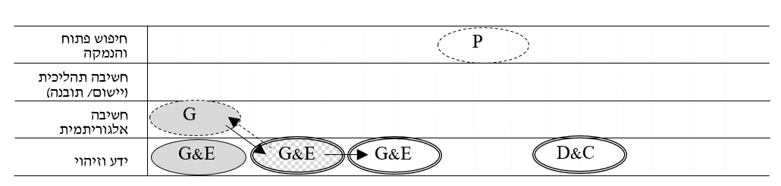

Figure 1a: Bracha's lesson

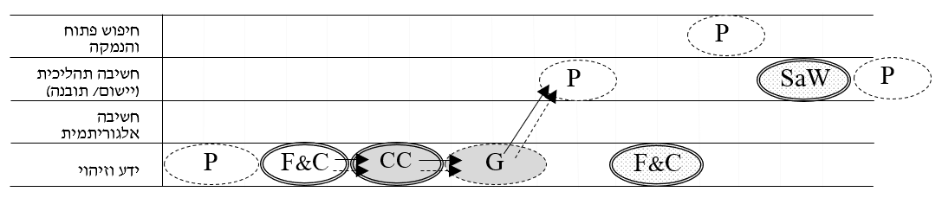

Figure 1b: Noa's lesson

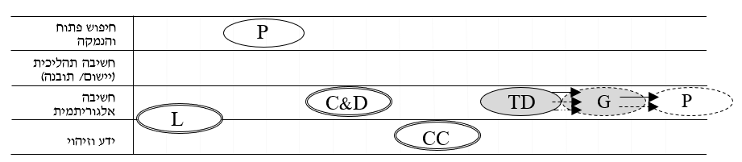

Figure 1c: Sigal’s lesson

Comparison of the lessons shows that the time during which the teachers used the computer games in the lessons (indicated by the shaded ovals) differed. The orchestration the teacher implemented while using the games also varies between: Guiding and Explaining the game content (G&E); Technical Demonstration (TD) of using the game; Gaming (G), which refers to students playing the game by themselves; and Concept Clarifying (CC), which refers to clarification of mathematical concepts by using the game.

This research makes several contributions. Its methodological contribution is the succinct description of lessons, which enables comparison between them. Its conceptual contribution is an expansion on Drijvers et al. (2013) conceptualization, in that the features of the game (feedback), students’ age (primary school), and the learning environment (a class with an overhead projector), allow for new orchestrations. The research also makes a practical contribution by enabling the instructional community to follow different layers of a lesson when planning and implementing it.

References