Identification of 4Q11 (4QpaleoGenExl) Fragments

4Q11, also known as 4QpaleoGenExl, is a fragmentary manuscript that preserves text from the last verse of Genesis and portions of Ex 1:1 to 36:36. This study identifies small fragments of it. Some of these fragments were transcribed in the official edition of the scroll published in 1992 by Patrick Skehan, Eugene Ulrich, and Judith Sanderson,[1] who, however, did not associate them with a specific text of Genesis or Exodus. Fortunately, we are now privileged to have access to new images that were not accessible to the editors. Available from the Leon Levi Dead Sea Scrolls Digital Library of Israel Antiquities Authority, these images allow us to improve our readings and offer new identifications. Other fragments discussed in this study have not yet been published. Some were cataloged but not transcribed by the editors, while others were not assigned to 4Q11 at all.

1. Material Evidence and the Official Edition of 4Q11

According to Skehan, Ulrich, and Sanderson, 4Q11 consists of sixty-four fragments. It was written in paleo-Hebrew script, and has been dated paleographically to the last century BCE.[2] Due to the large size of the writing block, the large bottom margins, the skilled script, and the limited number of scribal interventions, Emanuel Tov classified 4Q11 as a *De Luxe* edition.[3]

The number of fragments that belong to 4Q11 but were not included in the official edition is, in fact, even greater. IAA plate 395, which is associated with 4Q11, comprises twenty-eight fragments.[4] Of these, only six fragments are assigned to 4Q11 in the official edition.[5] However, the other twenty-two belong to 4Q11 as well because they share material features. The leather surface of these fragments and the deterioration of the ink in cases where traces of letters have been preserved correspond to the materiality of the 4Q11 fragments. Some of the fragments are also paleographically compatible with 4Q11. Although most of the plate 395 fragments are barely legible, sporadically preserved letters do appear in some. These letters correspond to the script of 4Q11, indicating that the fragments derive from the same manuscript. Consequently, we posit that 4Q11 comprises eighty-six fragments.

This study proposes new identifications for fragments in three categories: (1) those transcribed, but not identified in the official edition (2.1);[6] (2) those included, but not transcribed or identified in the official edition (2.2); (3) unpublished fragments from IAA plate 395 (2.3). Unfortunately, of the unpublished fragments, only three are identifiable. We number these fragments 65–67, based on their association with the text of Exodus.

2. New Identifications

2.1Fragments transcribed, but not identified in the official edition

2.1.1 *Frag. 44 (IAA 398.23; PAM 42.011, 42.803)[7]*

Fragment 44 preserves traces of a seam on its left side, indicating that it belongs to the last column on the sheet. As only isolated etters are preserved on each line, the identification is based on the successful combination of all legible letters in the five attested lines of the fragment.[8]

Based on the new identification, fragment 44 should be joined with fragment 7ii, on which Ex 11:4–12:12 is preserved.[9] The join yields the following transcription of 4Q11 7ii+44 lines 19–23:[10]

2.1.2 *Frag. 46 (IAA 398.13; PAM 42.011, 42.803)[11]*

Skehan, Ulrich, and Sanderson did not read the letter *aleph* at the end of both line 2 and 3 and therefore did not identify this fragment.[12] Yet, though these letters are broken, their identity is probable. The only possible identification of such a combination is Ex 19:22–23. The traces of the letter precede *lamed* in line 3 (as can easily be seen in the IR image), match the letter *bet*, and reinforce the new identification:

Fragment 21 attests to Ex 19:24–20:2. According to the new identification of fragment 46, we may conclude that fragments 21 and 46 were close to each other in the original scroll, prior to its deterioration.

2.1.3 *Frag. 47* *(IAA 398.3; PAM 42.011, 42.802)[13]*

Fragment 47 is poorly preserved. It attests to the remains of four lines of text, only two of which are legible. The reading of the hitherto indecipherable letters *tsade* and *samech* in lines 2 and 3, respectively, enables the identification of the text preserved in fragment 47 as Ex 23:9–11.[14] The new identification yields the following transcription:

The textual identification of fragment 47 is supported by material considerations. According to the proposed identification, fragment 47 should be directly joined to fragment 23, which preserves the text of Ex 23:5–16.[15] Indeed, when the fragments are aligned according to the preserved text, their physical protrusions fit well together (fig. 1). Consequently, the new identification of fragment 47 as Ex 23: 9–11 is certain.

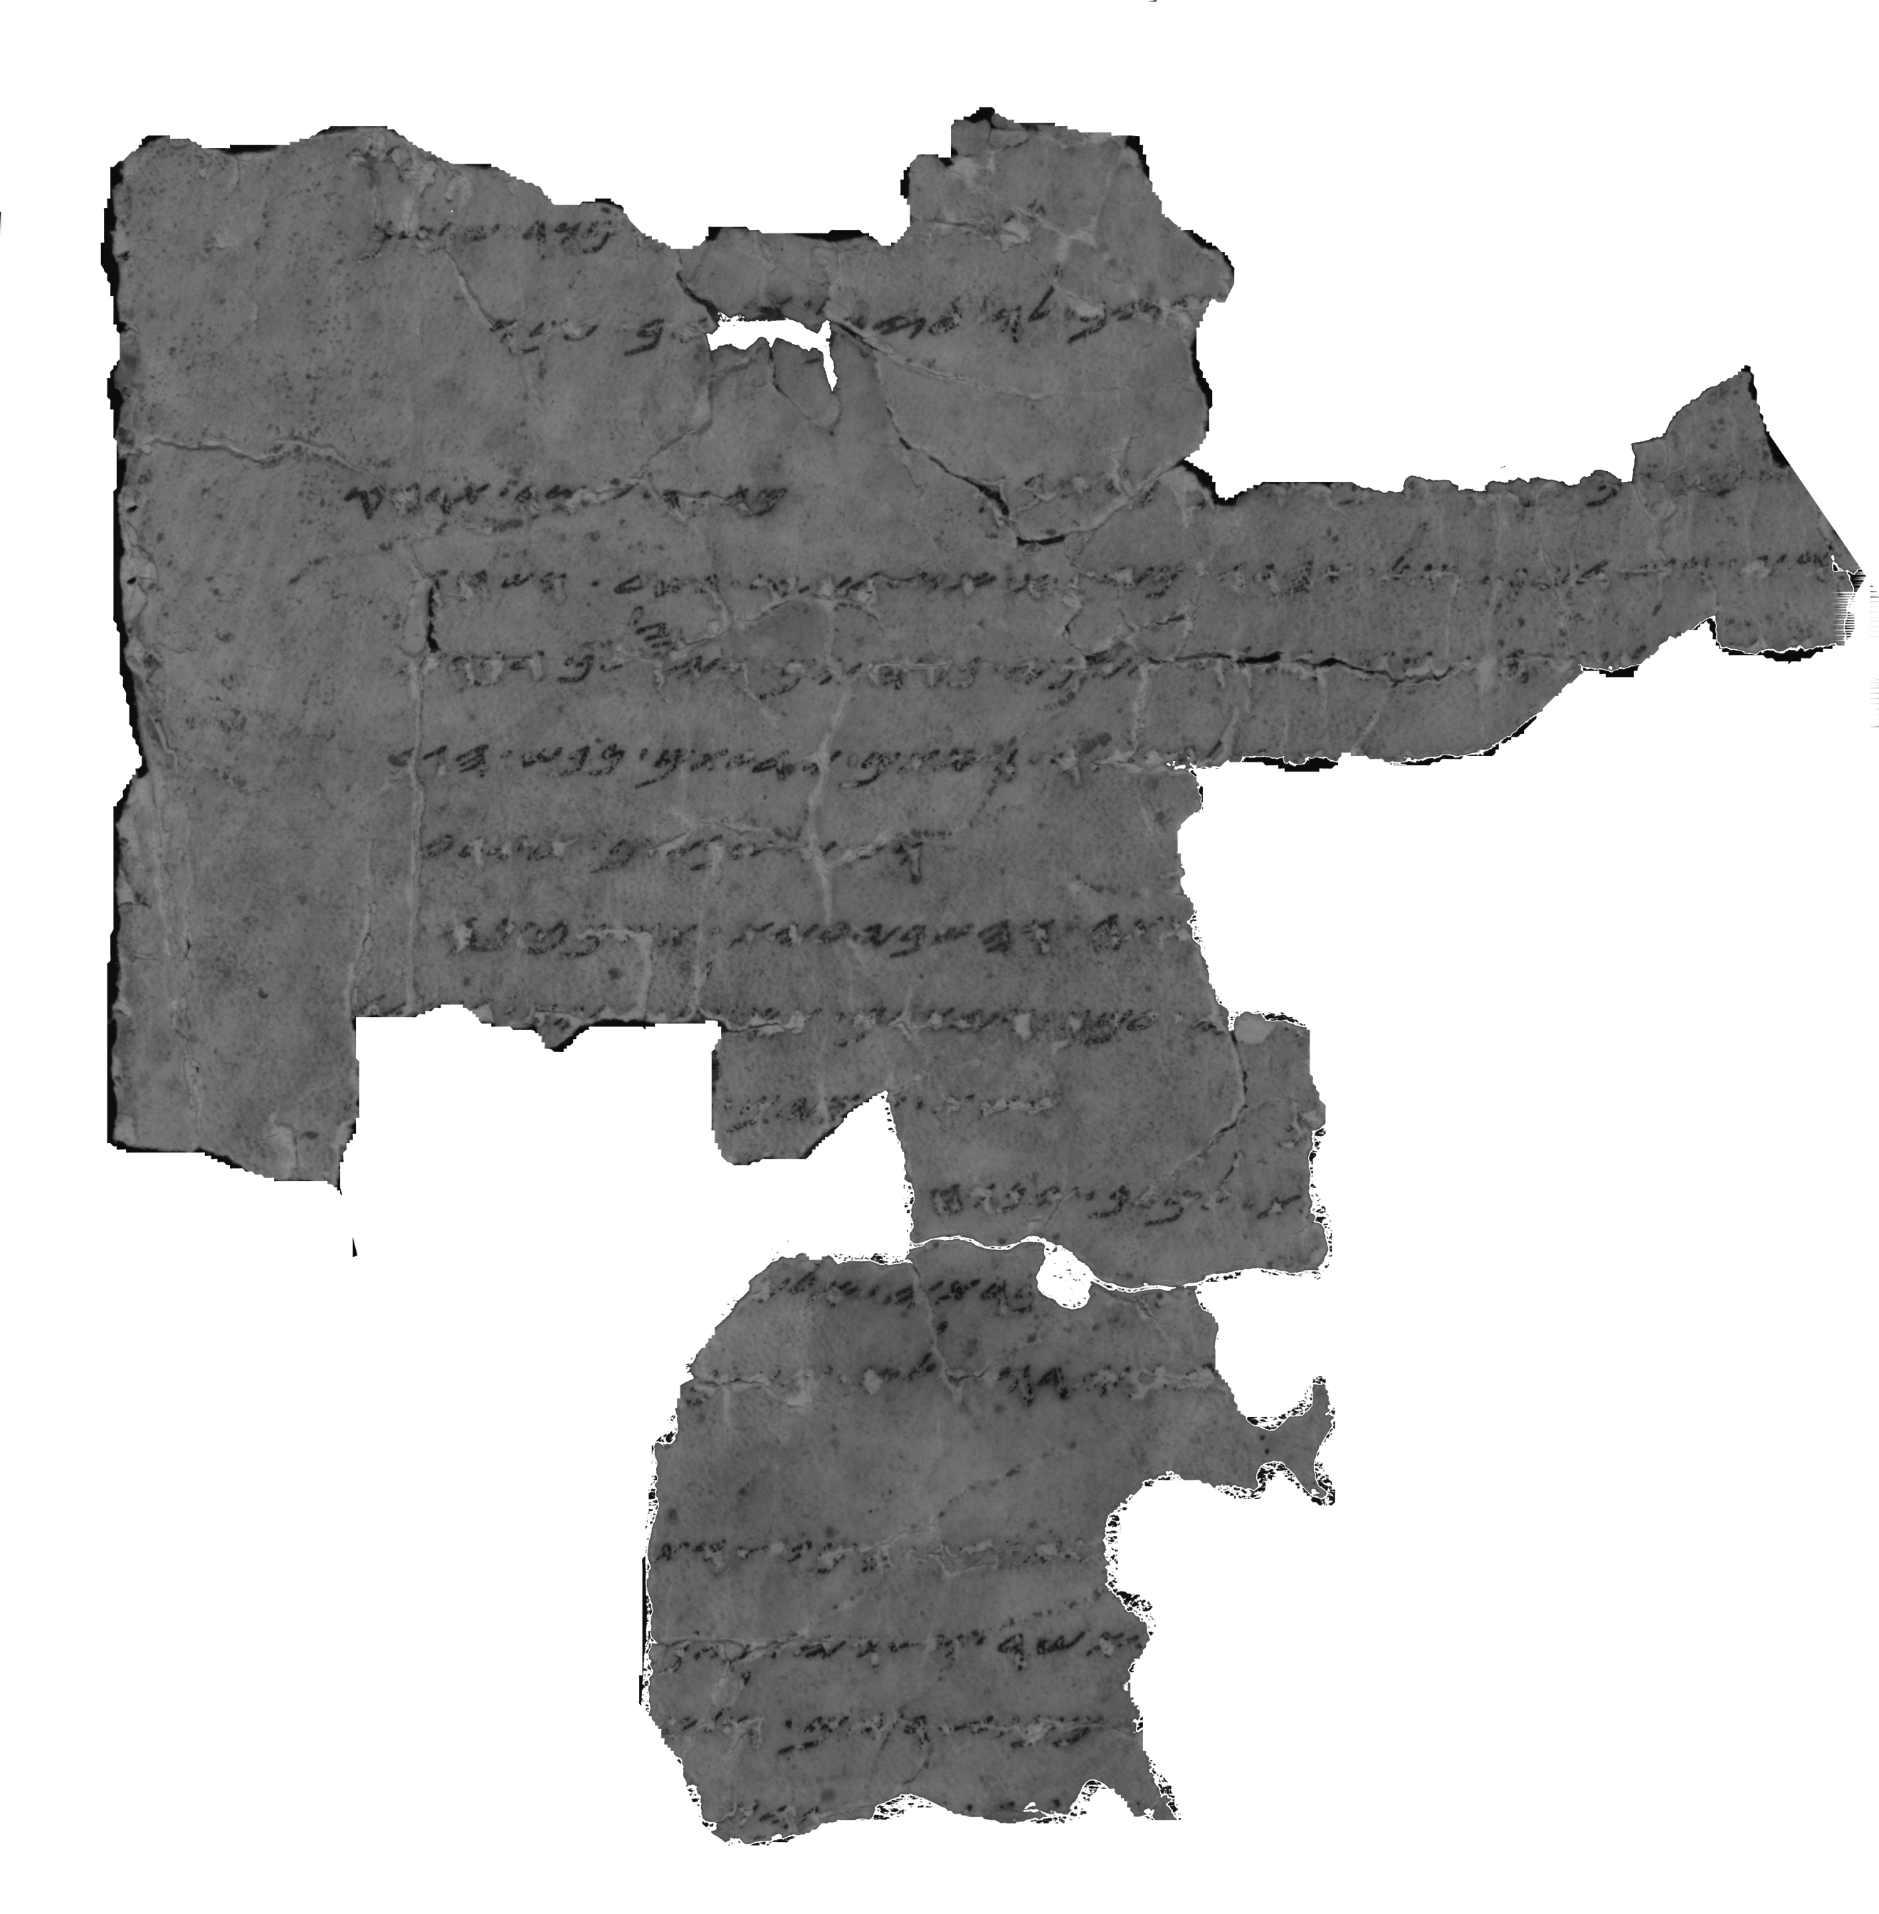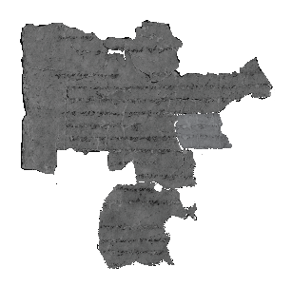

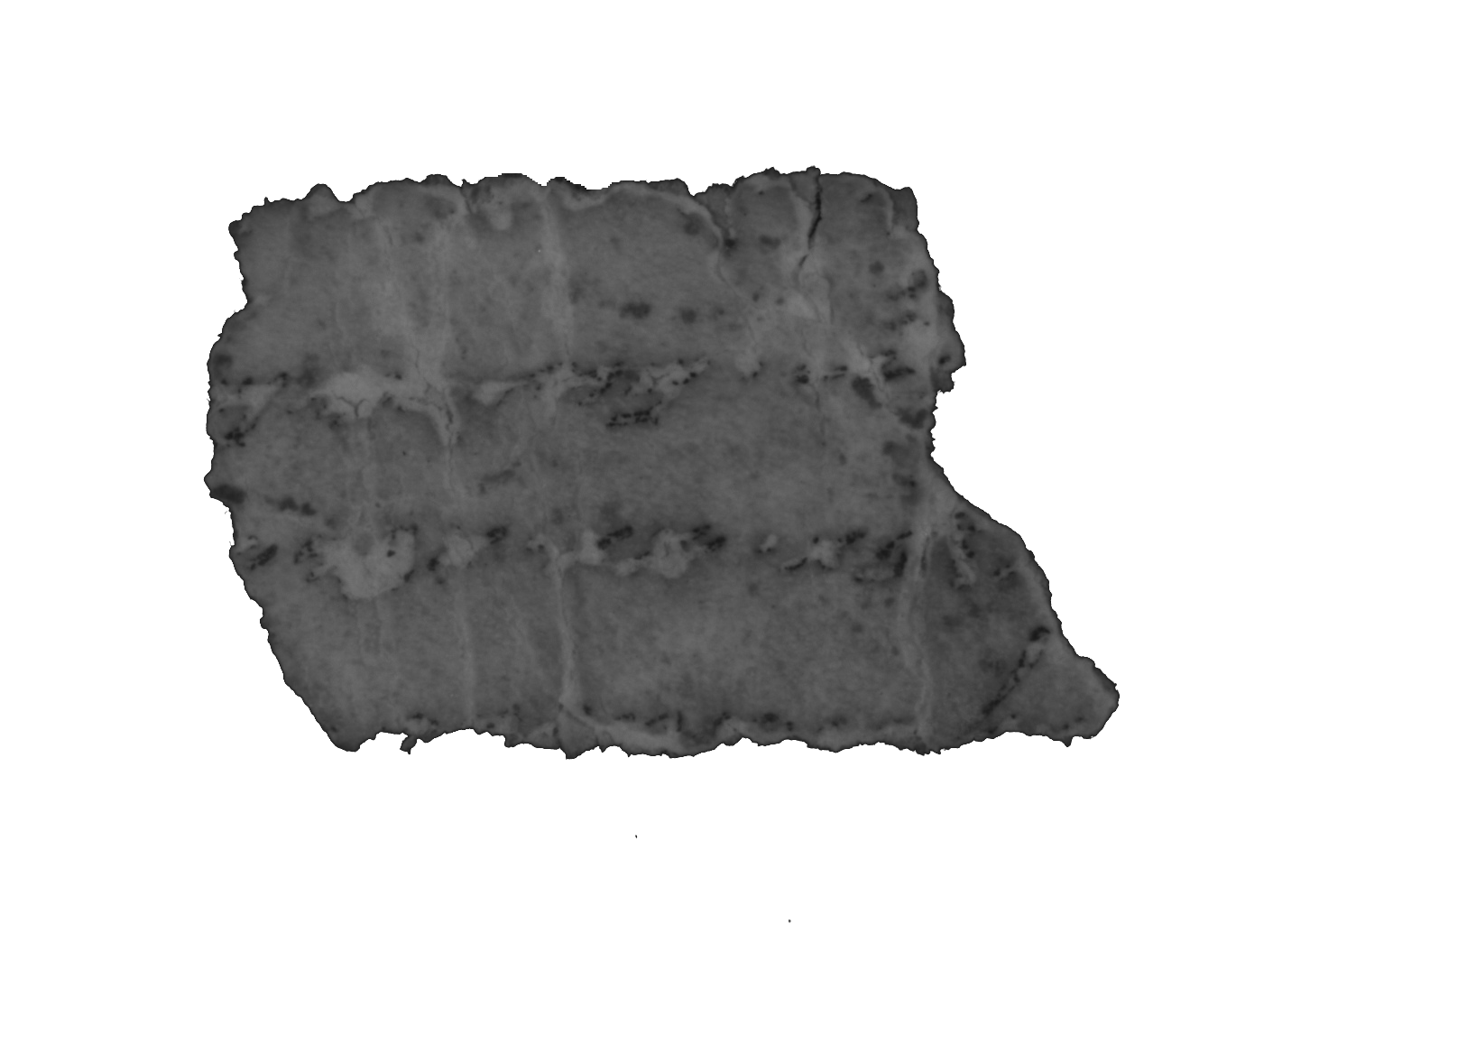

Figure 1: 4Q11 23; 4Q11 47; 4Q11 23+47

Given this new join, one may propose readings for the indecipherable letters of lines 1 and 4 of fragment 47. This could result in the transcription of 4Q11 47+23 lines 8–11 as:

2.1.4 *Frag. 48 (IAA 398.14; PAM 41.387, 42.803)[16]*

Fragment 48 preserves wide intercolumnar margins, whose width is 2 cm.[17] Only three partial words have survived in this fragment. Despite the paucity of evidence, however, the fragmentary text can be identified. The particular string of letters and words fits those of Ex 15:2–4, yielding the following partial reconstruction:[18]

The ink traces in line 1 seem to spell out the word יה. Such a reading is also in line with the expected distance between lines 1 and 2, as determined by the textual reconstruction of lines 2 and 3 (fig. 2).

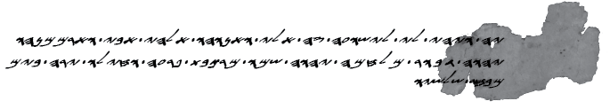

Figure 2: Textual reconstruction of 4Q11-Ex 15:2–4 (4Q11 48)[19]

The traces of the last legible letter in line 2 may form the right leg of *gimel*. If this is the case, then the new identification of fragment 48 reveals a possible agreement between 4Q11 and SP-Ex 15:3, against MT:[20]

|  |  |  |  |
| --- | --- | --- | --- |
| 4Q11 | SP | MT | NRSV |
| יהוה ג֯[בור | יהוה גיבור במלחמה  יהוה שמו | ‏יְהוָה אִישׁ מִלְחָמָה  ‎  יְהוָה שְׁמוֹ | The Lord is a warrior; the Lord is his name |

2.2 Fragment included but not transcribed or identified in the official edition

2.3 Unpublished fragments from IAA plate 395

2.3.1 *Frag. 65 (IAA 395.13; PAM 42.803)[21]*

Only two partial words survive in fragment 65, and the distance between them is approximately one line. The fragment in MT-Ex and SP-Ex can be identified in three possible ways, namely, as: (1) Ex 9:23–24 (מצרים; היה כמוהו); (2) Ex 10:14 (מצרים; ארבה כמוהו); (3) Ex 15:10–11 (אדירים; מי כמוכה).[22]

Traces of the two uncertain letters in line 2 indicate that their identification as Ex 10:14 is preferable:

1. The second letter is evident from traces of a left vertical stroke and remains of a letter’s head. These traces do not resemble a *yod*, which is what one might expect were the text identified as Ex 15:10–11. Instead, they seem to represent the letter *he*, in accordance with the proposed identification of the text as Ex 9:23–24 or Ex 10:14.
2. The traces of the first letter in line 2 look more like *bet* than like *yod*. They are thus well suited for the reconstruction of the text as אר]ב֯ה֯ (Ex 10:14), rather than ה]י֯ה֯ (Ex 9:24).

The identification of fragment 65 as Ex 10:14 results in the following transcription:[23]

The new identification may be reinforced by the materiality of fragment 65 and closed preserved fragments. According to the new identification, fragment 65 belongs to the column of fragments 7i+8, which preserve the text of Ex 9:33–10:5.[24] Based on the textual reconstruction of the fragmentary lines preserved in fragment 7i, the width of this column is approximately 50–55 characters. This estimate is in line with the column width of fragment 65, as calculated from the reconstruction of the missing text between the lines.

2.3.2 *Frag. 66 (IAA 395.25; PAM 41.388, 42.803)[25]*

Fragment 66 contains three lines. Lines 1 and 3 are poorly preserved and barely legible. Nonetheless, the identification of the fragment is possible due to the reading of line 2. Traces of the oblique stroke of the *aleph* are best seen in the PAM image. Moreover, the ink of the letters *resh* and *vav* has peeled away. These letters, however, can be recognized by their outlines, which are clearly visible in the IR image. Based on these readings, fragment 66 can only be identified as Ex 25:21–22, yielding the following transcription of lines 2–3:

According to this identification, fragment 66 should be joined with fragment 29, which preserves Ex 25:19–21 (fig. 3).[26]

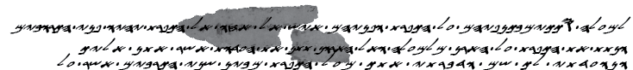

Figure 3: Join of 4Q11 66 with 4Q11 29

2.3.3 *Frag. 67 (IAA 395.9; PAM 42.803)[27]*

Identification: Ex 28:28 (possible)

Fragment 67 is tiny and amounts to three fragmentary lines. Of these, only line 2 is legible. The ink marks in line 1 are probably remnants of the base of a letter, possibly *bet*, *kaf*, *mem*, *nun*, or *pe*. Given the secure reading of line 2, it can be identified in two possible ways, namely, as: (1) Ex 28:28; (2) Ex 39:21. Both may fit the additional traces on the fragment.

4Q11 does not preserve any text from Ex 36:36 onwards, though two additional fragments preserve the text of Ex 28.[28] The identification of fragment 67 as Ex 28:28 thus seems plausible. This potential new identification yields the following transcription:

3. Conclusions

In this study, we have proposed new identifications for eight hitherto unidentified fragments of 4Q11: frags. 44; 46–48; 52; 65; 66; 67. These new identifications first and foremost shed light on the textuality of the scroll before its deterioration and grant us a better understanding of its content.

The proposed identifications also provide insight on the textual and material analysis of 4Q11. Textually speaking, fragment 48 reveals a possible agreement between 4Q11 and SP in Ex 15:3. Given the fragmentary state of the scroll and the inconclusive situation regarding its textual classification, this agreement may prove valuable to the analysis of the scroll’s text and its relation to other copies of Exodus from Qumran.[29]

The new identifications also contribute to the matter of the materiality of 4Q11. In some cases, they reveal direct or distant joins of the fragments discussed and other preserved fragments. The new joins provide useful information on the processes that cause repeated damage to the scroll when it was rolled up. These, as well as material signs on particular fragments, such as seam remains (fragment 44) and bottom margins (fragment 52), may contribute to the material reconstruction of 4Q11.

1. Patrick Skehan, Eugene Ulrich, Judith Sanderson, “11. 4QpaleoGenesis-Exodusl,” in *Qumran Cave 4 IV: Paleo-Hebrew and Greek Biblical Manuscripts* (DJD 9; Oxford: Clarendon Press, 1992).
2. Mark David McLean, *The Use and Development of Paleo-Hebrew in the Hellenistic and Roman Periods* (Harvard University, 1982), 66. Despite the time elapsed, McLean’s study is the most highly developed and comprehensive typological assessment of paleo-Hebrew script attested in the Dead Sea scrolls. Cf. Michael Langlois, “Dead Sea Scrolls Paleography and the Samaritan Pentateuch,” in *The Samaritan Pentateuch and the Dead Sea Scrolls*, ed. Michael Langlois (Leuven: Peeters 2019), 272. Langlois dates 4Q11 to the third century BCE, “though earlier and later dates are possible.”
3. Emanuel Tov, *Scribal Practices and Approaches Reflected in the texts Found in the Judean Desert* (STDJ 54; Leiden: Brill, 2004), 119.
4. Image in <https://www.deadseascrolls.org.il/explore-the-archive/image/B-371331>. For the association of plate 395 with 4Q11, see Stephen A. Reed, *The Dead Sea Scrolls Catalogue: Documents, Photographs, and Museum Inventory Numbers* (Atlanta: Scholars Press, 1994), 44; Tov, *Revised Lists of the Text from the Judean Desert* (Leiden: Brill, 2010), 22.
5. Fragments 51 (IAA 395.17); 52 (IAA 395.26); 53 (IAA 395.11); 56 (IAA 395.15); 59 (IAA 395.12); 62 (IAA 395.22).
6. The identification of fragments 44, 47, and 48 was firstly proposed by Drew Longacre, *A Contextualized Approach to the Dead Sea Scrolls Containing Exodus* (PhD Thesis: University of Birmingham, 2015), 108.
7. Image in <https://www.deadseascrolls.org.il/explore-the-archive/image/B-475414>.
8. Cf. Skehan, Ulrich, and Sanderson, “4QpaleoGenesis-Exodusl,” 49. The editors read the first legible letter in line 2 as *ayin*. In addition, they do not offer readings for the letters *het*, *resh*, and *vav* in lines 3, 4, and 5, respectively.
9. Image in <https://www.deadseascrolls.org.il/explore-the-archive/image/B-499664>; For the transcription, see Skehan, Ulrich, and Sanderson, “4QpaleoGenesis-Exodusl,” 31–32.
10. Note that 4Q11 reads מן [העזים] in Ex 12:5 (fragments. 7ii+44, 19–20), while MT and SP reads ומן העזים. LXX is in agreement with MT/SP (καὶ τῶν ἐρίφων).
11. Image in <https://www.deadseascrolls.org.il/explore-the-archive/image/B-475374>.
12. Skehan, Ulrich, and Sanderson, “4QpaleoGenesis-Exodusl,” 49.
13. This fragment is not available on the website of the Leon Levy Dead Sea Scrolls Digital Library. For the PAM image, see <https://www.deadseascrolls.org.il/explore-the-archive/image/B-284767>.
14. Cf. Skehan, Ulrich, and Sanderson, “11. 4QpaleoGenesis-Exodusl,” 49. The editors incorrectly read the second word in line 2 as two words: מ◦ וֹיֹכֹ[. In addition, they read the first word in line 3 as ◦בת. Therefore, they are not able to offer a tentative identification of this fragment.
15. Skehan, Ulrich, and Sanderson, “11. 4QpaleoGenesis-Exodusl,” 42.
16. Image in <https://www.deadseascrolls.org.il/explore-the-archive/image/B-475378>.
17. Skehan, Ulrich, and Sanderson, “11. 4QpaleoGenesis-Exodusl,” 50, suggest that ink from the letters of the preceding column survived on the right edge of the fragment, but traces of it are not evident in PAM and IAA images.
18. Cf. Skehan, Ulrich, and Sanderson, “11. 4QpaleoGenesis-Exodusl,” 50. The editors do not propose an identification for fragment 48 as they read line 3 incorrectly: בב[ ] כֹל֯י[.
19. Font design: Einat Tamir.
20. Cf. LXX-Ex 15:3: κύριος συντρίβων πολέμους, that possibly reflects the Hebrew ה' גובר במלחמה.
21. Image in <https://www.deadseascrolls.org.il/explore-the-archive/image/B-362147>.
22. The word מצרים occurs twice in Ex 11:5–6, alongside the word כמהו. However, the distance between the words is too short or too long to encompass a complete line. The line length is estimated by the text of fragment 7ii, which contains Ex 11:4–12:12 (see n. 10).
23. Note the spelling of the word כמוהו with *vav*, as opposed to כמהו in MT-Ex and SP-Ex.
24. Image in <https://www.deadseascrolls.org.il/explore-the-archive/image/B-499664>; For the transcription, see Skehan, Ulrich, and Sanderson, “4QpaleoGenesis-Exodusl,” 30–31.
25. Image in <https://www.deadseascrolls.org.il/explore-the-archive/image/B-362171>.
26. Image in <https://www.deadseascrolls.org.il/explore-the-archive/image/B-475422>. For the transcription, see Skehan, Ulrich, and Sanderson, “11. 4QpaleoGenesis-Exodusl,” 43.
27. Image in <https://www.deadseascrolls.org.il/explore-the-archive/image/B-362139>.
28. Fragments 36, 37. See images in <https://www.deadseascrolls.org.il/explore-the-archive/image/B-475382>; <https://www.deadseascrolls.org.il/explore-the-archive/image/B-475350>, respectively. For the transcription, see Skehan, Ulrich, and Sanderson, “11. 4QpaleoGenesis-Exodusl,” 46–47.
29. For a discussion of the textual classification of 4Q11, see e.g. Tov, “The Biblical Texts from the Judaean Desert: An Overview and Analysis of Published Texts,” in *The Bible as Book: The Hebrew Bible and the Judaean Desert Discoveries*, ed. Edward D. Herbert, Emanuel Tov (London: British Library, 2002), 154; Armin Lange, “2.2.1 Ancient, Late Ancient, and Early Medieval Manuscript Evidence”, in *Textual History of the Bible*, General Editor Armin Lange. Consulted online on 11 March 2021 <http://dx.doi.org.rproxy.tau.ac.il/10.1163/2452-4107_thb_COM_0002020100>.