[1]

Design and Evaluation of a Passive Knee Exoskeleton for Vertical Jumping

Coral Ben-David, Barak Ostraich, and Raziel Riemer, Member, IEEE

*Abstract*— Exoskeletons have been shown to augment human mobility and facilitate daily tasks such as walking, running, and hopping. The goal of an exoskeleton is to reduce the effort (i.e., metabolic rate) expended by its user in doing aerobic tasks. However, exoskeletons that assist fast, explosive movements, specifically vertical jumping, have yet to be thoroughly investigated. Furthermore, a fundamental lack of understanding still prevails regarding human-exoskeleton interactions. In the present work, we design and test a passive knee exoskeleton to increase vertical jumping height. The exoskeleton consists of springs acting parallel to the quadriceps femoris muscle. To increase the jump height, the springs store energy in the negative-work phase, during knee flexion, and inject the energy in the following positive-work phase, during knee extension. The exoskeleton was tested on ten healthy subjects during two experimental sessions in which the subjects jumped as high as possible. In the first session, the subjects jumped without the benefit of instructions on how to use the exoskeleton. In the second session, the subjects were trained to better utilize the exoskeleton and explored different jumping techniques to improve their use of the exoskeleton. The training in the second experiment led to a 6.2% $±$ 0.9% (mean $±$ SE) increase in jump height compared with jumping without the exoskeleton.

*Index Terms*— Adaptation, Augmentation, Exoskeleton, Vertical Jumping.

# INTRODUCTION

T

He field of wearable exoskeletons has developed tremendously over the past decades. Exoskeletons are primarily designed for rehabilitation or augmentation of normal physical human performance. Enhancing the physical performance of humans in different activities could improve user efficiency and is highly desirable for workers in a physically demanding environment, such as industrial workers, police officers, soldiers, and firefighters.

The goal of the multiple wearable exoskeletons designed and studied in previous research is to augment walking or running by reducing the metabolic cost. Over the past decade, several studies have shown that metabolic power is reduced in walking [1]–[5] and running [6]–[8], and one study even demonstrates an exoskeleton that assists both walking and running [9].

Sawicki *et al*. [10] reviewed peer-reviewed publications that report exoskeletons that improve user walking or running efficiency and categorized these as either “tethered” or “autonomous.” Furthermore, they classified autonomous systems as active or passive. Active exoskeletons contain actuators that add energy to the motion [9], [11], whereas passive exoskeletons use passive elements such as springs and dampers [7], [8], [12]. Nuckols *et al*. [13] describe the notion of energy transfer from one phase of motion to the next, either within or across joints. This notion can be used to design passive exoskeletons that extract energy during the negative phase and inject the energy in a later positive phase. Passive exoskeletons are typically cheaper and lighter than active exoskeletons, whereas active exoskeletons are more adaptable given their ability to exploit any torque-time profile.

The use an exoskeleton to augment walking, running, and leaping was proposed back in 1890 by Yagn [14], who presented a theoretical design consisting of long bow springs operating parallel to the legs. Later, Grabowski and Herr [15] designed a full-leg exoskeleton that reduces the metabolic cost during hopping by up to 30% from 2.0 to 2.6 Hz. Farris and Sawicki [16] also designed an exoskeleton that reduces the metabolic cost during hopping. Their design includes a passive spring-loaded ankle exoskeleton that reduces the metabolic cost of hopping by 12% at 2.5 Hz.

However, hopping is an aerobic activity and differs from fast, explosive movement, such as vertical jumping. To the best of our knowledge, only have heretofore attempted to build and test an exoskeleton for fast-explosive motion. Their passive-elastic ankle exoskeleton uses a one-way clutch mechanism to enhance vertical jumping. In the pilot tests, the subjects nearly reached their maximum vertical jump height with the exoskeleton, but could not surpass it.

Vertical jumping starts with a negative-work phase during hip and knee flexion and ankle dorsiflexion. In this phase, the jumper lowers their body into a squat position. The next phase is a positive-work phase that includes hip and knee extension and ankle planter-flexion. This phase extends from the start of upward movement until the toes leave the ground [18]. In addition, hip and knee joint torques have been reported to exceed ankle torques during a vertical jump [18]–[20].

In this work, we build and test experimentally a passive knee exoskeleton with springs acting parallel to the muscle. The springs store energy during the negative-work phase and return the energy in the following positive-work phase. We focus on the knee joint because of the large torques involved and because the design is simpler than for the hip joint.

The goals of the study are thus to test whether a passive exoskeleton can improve vertical jumping height, to better understanding the functioning of exoskeletons for fast, explosive motions, and to discern human-exoskeleton interactions.

# Methods

## Subjects

Ten healthy males (age 24.9 ± 2.7 years; mass 73.0 ± 3.7 kg; height 1.74 ± 0.03 m) participated in the study. Note that only a single exoskeleton was available, so only subjects that fit the exoskeleton were selected. Two additional subjects dropped out during the experiments, one of which was afraid of using the exoskeleton and thus did not bend his knees during the jump. For the other subject, the exoskeleton proved too narrow at the knee, causing pain during the jump. All subjects provided written informed consent before participation in the study. The study was approved by Ben-Gurion University’s Human Research Institutional Review Board.

## Exoskeleton Design

For this study, we designed and constructed the passive knee exoskeleton shown in Fig. 1. The exoskeleton consists of aluminum 6061 frames, attached to the leg with the help of wide Velcro® straps. Rubber springs (typically used for spearguns) to contribute to torque are located near the knee and are aligned parallel to the quadriceps femoris muscle. The mass of the exoskeleton is about 1.5 kg per leg. Specifications of the exoskeleton components are given in Appendix A.

## Protocol

Two experimental sessions were performed. In the first session, the subjects jumped as high as possible without the benefit of instructions on how to best use the exoskeleton. In the second session, the subjects were first trained how to use the exoskeleton. The two sessions were performed as in previous studies for walking [1], [21], which showed that the subjects adapted to the exoskeleton and that their performance improved from one session to the other.

Fig. 1. The proposed knee exoskeleton.

In the first session, the subjects jumped vertically without the exoskeleton (NoExo), with the exoskeleton but with no spring connected (Exo0) (in this case, the exoskeleton is a deadweight), with the exoskeleton and four springs that each provide 70 N m at a 90° knee bend (Exo1), with the exoskeleton and six springs that each provide 105 N m at a 90° knee bend (Exo2), and again without the exoskeleton (NoExo2). These tests were done in random order, and tests NoExo and NoExo2 served as control tests. giventestfree jumped with the springless exoskeleton foritThe thenjumped verticallytimesand the.

The torques given for the exoskeleton are based on tensile tests of the rubber springs that relate spring force to strain ratio. The tests were done with the help of a universal testing machine (Hounsfield, H10KT). The 70 and 105 N m torques are equivalent to a spring stiffness of 38 and 57 N m/rad, respectively, which represents a compromise between keeping the device compact and lightweight using relatively affordable components and providing larger torques. Furthermore, based on previous studies [18]–[20] with professional athletes, these values provide about 20% and 33% peak knee torque during the jump, respectively. .

Due to COVID-19 restrictions, the second session was undertaken about three months after the first session. Since the results from the first session reveal a positive correlation between spring stiffness and jump height, the second session included only two tests: one without the exoskeleton (NoExoS2) and one with the exoskeleton with springs that provide, after training, 105 N m at a 90° knee bend (Exo2S2).

To improve the adaption to the exoskeleton in this session, we had the subjects explore different jumping techniques. The experimental protocol was adapted from Gast [22], who found that walking on rough terrain while exploring various walking speeds reduces the time for converges of the cost of transport to minimum during walking at preferred speed. In addition, in a study of human walking with exoskeletons, Selinger [23] found that subjects discovered their optimal step frequency in exploratory sessions in which they walked at high and low step frequencies. Thus, after jumping without the exoskeleton, the subjects in the present work were trained in the use of the exoskeleton. The training consisted of executing four squat jumps from different starting postures (e.g., maximum bend at the knee, flat feet, and straight back). We then chose the jump with the maximum vertical height and tweaked the technique to optimize the results. The subjects were instructed to keep their feet a pelvic-width apart, to the extent possible. Each subject executed up to ten training jumps so as to adapt to the new jumping technique with the exoskeleton.

In both sessions, the subjects followed a given warm-up routine. Then, for each jump, they were instructed to jump as high as possible with their hands crossed on their chest (see Fig. 2). To prevent fatigue, the subjects rested for 2 minutes between jumps. Figure 2 shows the phases of the jump.

## Data Collection

The motion of the subjects was recorded using fourteen cameras operating at 179 Hz (Qualisys, Gothenburg, Sweden) and that tracked reflective markers fixed to the subjects and to the exoskeleton. Ground reaction forces were recorded at 2040 Hz by using an instrumented treadmill (Bertec, Columbus, OH, USA). During one jump, the force-plate initialization malfunctioned, so this jump was omitted. The activity of the right-leg rectus femoris and gastrocnemius muscles was measured by using surface electromyography (EMG) sensors (Trigno Wireless System, Delsys, Boston, MA, USA) at 2000 Hz. We chose to examine these muscles because of their contribution to vertical jumping [24]–[27]. The skin around the attachment of the EMG sensors was shaved and scrubbed clean with 70% alcohol. The EMG sensors were attached to the body by using adhesive tape provided by the manufacture. However, due to sweating and shock during landings, the EMG sensor on the rectus femoris muscle moved for three subjects during the final tests. Additionally, during the final tests, the EMG sensor on the gastrocnemius muscle also moved for two subjects. Thus, the data from these jumps were not used.

Fig. 2. The jumping experiments. a) The subject wearing the exoskeleton and preparing for vertical jumping under the experimental protocol. The subject is standing on an instrumented treadmill while markers and EMG sensors are attached to him. b) The different phases of the vertical jump: Standing, the starting position for the Upward Movement (UPM), Take-Off (TO), and reaching Max Height. During knee flexion the springs are stretched, and from UPM to TO, the stored energy in the springs is added to the biological energy. The COM height parameters are also presented according to the phase of the jump. The muscles in red represents the knee extensor muscles and ankle plantar flexors. We measured EMG from Rectus Femoris and Gastrocnemius.

## Data Analysis

The data from all three systems were recorded and synchronized using Qualisys Track Manager software (Qualisys, Gothenburg, Sweden) and then exported into Visual 3D (C-Motion Inc., Rockville, MD, USA), which uses bottom-up inverse dynamics [28] with six degrees of freedom to calculate joint angles, angular velocities, body center of mass (COM), torques, and powers.

The angles for the ankle, knee, and hip joints are defined as follows: The ankle angle is measured from the foot to the shank; when standing, it is about 90 $°$ and increases during plantar flexion. The knee angle is measured from the shank to the thigh; when standing, it is about 180 $°$ and decreases during flexion. Finally, the hip angle is measured from the thigh to the pelvis; when standing, it is about 180 $°$ and decreases during flexion.

The motion of the subjects and the ground reaction forces were filtered by using two fourth-order Butterworth low-pass filters with 10 and 35 Hz cutoff frequencies, respectively. EMG recordings were digitized by using a bandpass filter (20–450 Hz) and processed in Matlab (Math Works Inc., Cambridge, MA, USA) to obtain a linear envelope. The EMG data were rectified and filtered by using a second-order low-pass Butterworth filter with 3 Hz cutoff frequency. This signal processing is based on that used in Refs. [29]–[31].

Matlab was used to calculate the height, kinetic, and kinematic parameters. The maximum (minimum) height ( $ΔH_{min})$ is defined as the difference between the standing COM and the maximum (minimum) height of the COM ( see Fig. 2). Specifically,

, ()

, ()

where is the height of the COM while standing, $H_{max}$ is the maximum height of the COM during the flight phase of the jump, and $H_{min}$ is the minimum height of the COM during the pre-jump squat.

Next, we calculate the net mechanical work performed by the ankle, knee, and hip joints from the start of upward movement (UPM) to take-off (TO):

 ($SEQ Equation \backslash * ARABIC$ $3$)

where $P_{j}$ is the power at joint *j*, $M_{j}$ is the torque at joint *j*, and ${\dot{ω}}_{j}$ is the angular velocity at joint *j*. The UPM point is defined as, and the TO point is defined as the point where the ground reaction force first goes to zero. The total knee power and work have exoskeleton and biological contributions. The exoskeleton power is calculated by using a model that predicts the torque provided by the exoskeleton (based on experiment and theory) multiplied by the measured angular velocity (for details, see Appendix B):

. ($SEQ Equation \backslash * ARABIC$ $4$)

The biological-knee power obtained by subtracting the exoskeleton power from the total knee power is given by

 ($SEQ Equation \backslash * ARABIC$ $5$)

Finally, the maximum EMG of the rectus femoris and gastrocnemius muscles is determined for each jump, and the maximum muscle activity for each jump is normalized by the average maximum muscle activity of the control conditions (i.e., NoExo for the first session and NoExoS2 for the second session).

## Statistics

Given that the subjects had different physical traits and jumping techniques, we used a linear mixed model, with the subject as a random effect, for all jumping tests (i.e., NoExo, Exo0, Exo1, Exo2, NoExo2, NoExoS2, and Exo2S2) to examine how the exoskeleton affects jumping height. The linear mixed model used the parameters (i) work performed by the joints and the exoskeleton, (ii) muscle activity, (iii) joint angles, and (iv) $H_{min}$. In addition, Q-Q plots ensure that the models produce normally distributed residuals. Jumps were compared pairwise by using Tukey’s honestly significant difference test with a significance level of 0.05. Statistical analysis was done by using R-studio, Ver 1.1.463 (R Ver 3.5.1; RStudio, Inc. Boston, MA, USA).

# Results

We examine to determine how the experimental conditions affect jumping height (Fig. 3). Examination of for jumps Exo0, Exo1, and Exo2 shows that the jump height increases as the spring stiffens (P < 0.05). However, there was no significance difference between jumps NoExo and NoExo2. Analysis of jumps Exo2S2 shows that training with the exoskeleton significantly increases (P < 0.0001). The average $ΔH_{max}$ for jump Exo2S2 is 45.9±7.3 cm (mean $±$ SD), which is 2.7 $±0.4$ cm higher than the average for jumps NoExoS2, and 8.2 $±0.4$ cm (mean $±$ SE) higher than the average for jumps Exo0 (i.e., an increase in height of 6.2% and 21.6%, respectively). Furthermore, we checked whether the subjects’ vertical jumping ability changed between the two experimental sessions and found no significant difference without the exoskeleton (NoExo, NoExo2, and NoExoS2, P > 0.05). The results show that eight out of the ten subjects jumped higher with the exoskeleton (Exo2S2) than without the exoskeleton (NoExoS2), as detailed in Appendix C.

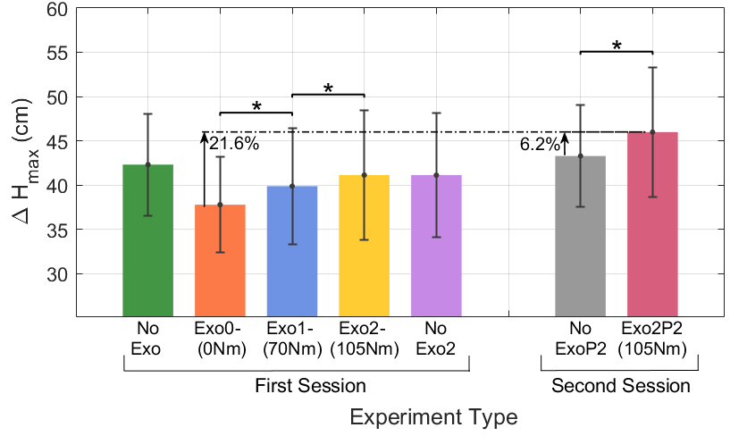

Fig. 3. Maximum jump height relative to standing for each of the seven jumping conditions. Results are averaged over all subjects. Error bars give SD and $\text{*}\text{P}≤0.05.$

To better understand these results we use the data from the inverse dynamics analysis for four jumps: Exo0, Exo2, NoExoS2, and Exo2S2. First, we calculated the joint work done by the ankle, knee, and hip, as given by Eq. (3), for both legs together. We also calculate the net biological-knee work and net exoskeleton work )Fig. 4(. The total joint and exoskeleton work for jumps Exo2S2 is 694.75 $±$ 90.9 J and exceeds the work done in all other conditions (P < 0.0001). For example, it exceeds the work done in NoExoS2 and Exo by 155.7 $±$ 9 and 142.5 $±$ 9 J (mean $±$ SE), respectively. Also, the total knee work (i.e., exo+bio) for jumps Exo2S2 is greater than the work done in all other jumps (P < 0.0001). Additionally, all the jumps with the exoskeleton increase the work done by the hip relative to the work done in the NoExoS2 jumps (P < 0.01). Furthermore, the hip does the most work for jumps Exo2S2 (P < 0.0001). 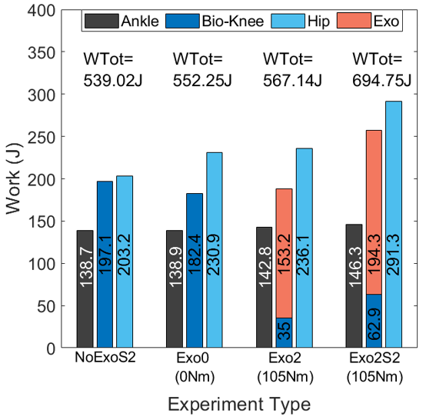

Fig. 4. Work done by exoskeleton and biological knee, ankle, and hip joints from upward movement (UPM) to take-off (TO) for jumps NoExoS2, Exo0, Exo2, and Exo2S2, both legs. The results are the average of all subjects.

Next, we compared jumps NoExoS2 and Exo2S2 based on the profiles of the angle, torque, and power at the ankle, knee (bio+exo), and hip. We examine these parameters from upward movement (UPM) to take-off (TO) and normalize this phase of the motion to 100% so that the results from the two jumps will have the same scale (see Fig. 5). Appendix D gives all the data (not normalized) for the jump of nine subjects from standing to TO. Given the symmetry, we only show data from the right leg. The comparison shows that the joint angles, torque, and power undergo similar trajectories. The peak of the average total knee torque without exoskeleton (NoExoS2) for the right leg is 1.39 $±0.48$ N/kg, which is about 101 $±35.0$ N m. Furthermore, Table I gives quantitative information on the average joint angle at the UPM point and $ΔH_{min}$ for jumps NoExoS2, Exo0, Exo2, and Exo2S2. At the UPM point, the angles at the knee and hip for jumps Exo2S2 are smaller than for jumps NoExoS2, indicating greater joint flexion (P < 0.0001). The lowest COM height (i.e., largest $ΔH_{min})$ was for jumps Exo2S2 (P < 0.0001). Also, $ΔH_{min}$ for jumps NoExoS2 is greater than for jumps Exo0 and Exo2, which means that the COM height of the former is lower that of the latter two (P < 0.03).

TABLE I

Average Joint Angles and Minimum COM at UPM.

|  |  |  |  |  |
| --- | --- | --- | --- | --- |
|  | NoExoS2 | Exo0 | Exo2 | Exo2S2 |
| **Squat Angle (deg)**  Ankle  Knee  Hip | 78.0 $± 5.8$ 71.1 $± 15.4$ 48.9 $± 18.0$ | 79.0 $± 8.2$ 74.5 $± 15.9$ 47.5 $± 23.1$ | 78.8 $± 58.2$ 77.4 $± 16.5$ 44.9 $± 21.0$ | 80.2 $± 8.1$ 59.2 $± 9.2$ 35.2 $± 10.0$ |
|  |  |  |  |  |
| $ΔH_{min}$**(cm)** | 37.9 $± 8.2$ | 35.2 $±8.0$ | 35.2 $±7.4$ | 44.6 $±4.4$ |

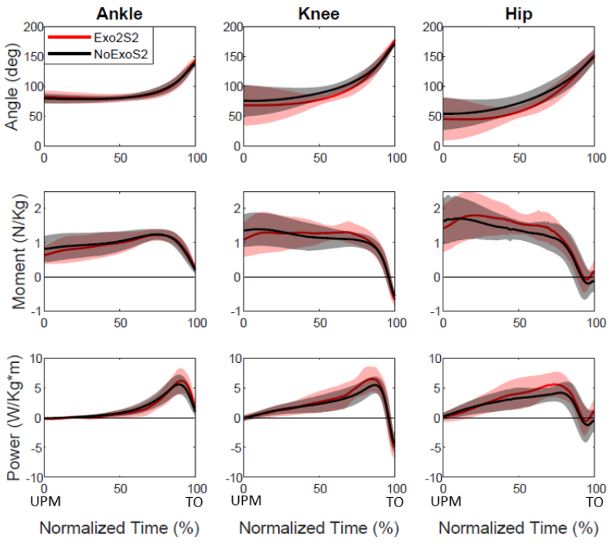Fig. 5. Angle, torque, and power at ankle, hip, and knee (bio+exo) during jumps NoExoS2 and Exo2S2, from upward movement (UPM) to take-off (TO), for right leg. The solid line gives the average over the five final jumps of all subjects for all jump conditions, and the shaded area is the SD.

Finally, Fig. 6 compares the peak of the normalized EMG signals for jumps Exo0, Exo2, NoExoS2, and Exo2S2.

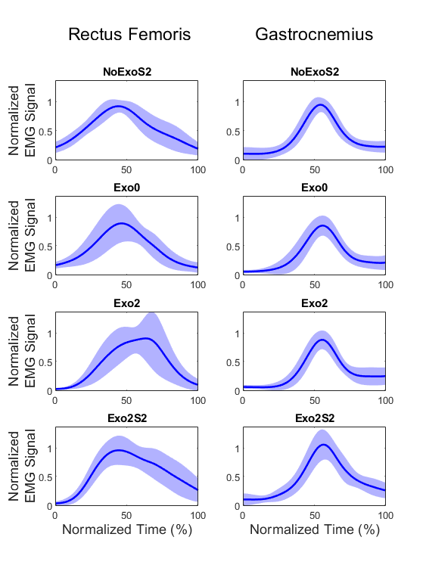Fig.6. Normalized EMG signals of rectus femoris and gastrocnemius muscles during jumps NoExoS2, Exo0, Exo2, and Exo2S2. The solid line is the average over the final five jumps of all subjects and for all jump conditions, and the shaded area is the SD.

The peak of the rectus femoris EMG signal does not statistically differ for all these jumps (P > 0.4), and the peak of the gastrocnemius EMG signal is similarly constant for all jumps except Exo2S2. The EMG signal for jump Exo2S2 is the largest of all the jumps (P < 0.01) and is 12.7%% greater than for jump NoExoS2. Note that the EMG signal is examined from standing (0.25 s before UPM) to and is normalized to 100% so that the results from the four jumps are on the same scale.

# Discussion

The results show that, after training to jump with the exoskeleton, the subjects increased their jump height by 6.2% compared to jumping without the exoskeleton. This improvement in vertical jumping height demonstrates that the exoskeleton augments the fast, explosive jumping movement.

A major factor in improving the jump height is the dipper squat position. Although studies show that the squatting position does not affect jump height [32], [33], they were done without an exoskeleton. In this study, the subjects increased knee flexion to achieve the dipper squat position, which results in more energy being stored in the springs. In addition, the hip angle is smaller (i.e., greater hip flexion) at the start of the upward movement, which also corresponds to a lower COM. The changes in the hip joint might be explained by the need for the subjects to avoid falling backward. The changes in $ΔH_{min}$ and in the joint angles are also reflected in the net work done by the joints. The total knee work and hip work increases when using the exoskeleton, where part of this additional energy is required just to raise the COM back to.

Comparing the total joint work and for (i) jumping with a springed exoskeleton with maximum spring constant (Exo2) with (ii) jumping with a springless exoskeleton (Exo0) gives us a better understanding of the human-exoskeleton interaction. We analyze the energy balance, where each jump has two energy components: one to move the COM from the lowest point (UPM) to standing, and another to move the COM from standing to maximum height. If we assume no energy loss, then the difference in joint work between jumps Exo2S2 and jumps Exo0 may be formulated as

($SEQ Equation \backslash * ARABIC$ $6$)





where $ΔH_{max,2}^{p}$ is the predicted increase in height when using the exoskeleton, $ΔW$ is the difference in total joint work between the two jumping conditions, and *m* = 73 kg is the average mass of the subject plus exoskeleton (3 kg). Recall that $ΔH_{min}$ is the difference between the COM height when standing and the minimum COM height (when squatting), and $ΔH_{max}$ is the difference between the COM when standing and the maximum COM height (in flight). Note also that the subscripts 2 and 0 refer to Exo2S2 and Exo0, respectively. In this analysis, the jump height $ΔH_{max,2}^{p}$ is predicted by using the other work parameters and the other heights obtained from the experiments. Based on the experimental results for jumps Exo0, the expected increase in height for jumps Exo2S2 is 46.1 cm, whereas the actual increase in height gained is 45.9 $±7.3$ cm (mean $±$ SD). This confirms the quality of the fit to the measurements.

Next, we analyze the energy balance to compare the predicted height with the actual height for jumping with and without the exoskeleton (i.e., jumps NoExoS2 and Exo2S2). In this case, the mass differs for the two jumps because Exo2S2 includes the exoskeleton mass. The calculation gives

(7)





where $m_{h}$ is the average mass of the human subjects, is the exoskeleton mass, is for Exo2S2, and and $ΔH_{max, no}$ are for NoExoS2.

Accordingly, based on the experimental results for jumps NoExoS2, the expected jump height for jumps Exo2S2 is 53.7 cm, whereas the actual height in the experiments is 45.9 $±7.3$ cm (mean $±$ SD). This result indicates that not all difference in joint work translates into jump height, comparing to the result predicted and actual height based on Exo0 and Exo2S2 conditions that was negligible. The difference between the two predicted jumps heights (Exo2S2 based on Exo0 vs. Exo2S2 based NoExoS2) might be explained by the limitations of the exoskeleton, such as the fit of the exoskeleton to the user (recall that we used a single exoskeleton for all subjects). A misfit might result in losing work to compress the shank and thigh. A custom exoskeleton for each subject (see, e.g., Collins *et al*. [1]) could potentially lead to more efficient use of the exoskeleton work and, therefore, to higher jumps. Furthermore, it is possible that the exoskeleton reduces the degrees of freedom in the joint, thereby reducing the efficiency of the jump mechanics.

The exoskeleton design uses spring torques of 70 and 105 N m to provide an additional torque equivalent to about 20% and 33%, respectively, of the peak knee torque (approximately 300 N m). These ratios are based on studies [18]–[20] that used professional athletes weighing about 80 kg. However, the subjects in the present study were not professional athletes, their weight averaged about 73 kg, and their peak torque was approximately 200 N m (both knees together). Thus, in the second series of experiments, the spring stiffness is approximately 50% of the biological-knee capability. In this study, the second experiment (Exo2S2) shows that the total work provided by the biological knee is 26% of the total knee work, which is an improvement over the first experiment where the biological knee contributes only 17% of the total knee work.

In addition, we compare our findings with simulated human jumping with a passive exoskeleton [34], which is based on a model with peak total biological-knee torque of 320 N m. The results of the simulation predict that of springs that provide approximately 50% of the maximum knee torque of the biological knee would lead to a contribution of about 35% biological work to the total knee work, which is only 9% greater than our results.

An analysis of the maximum normalized EMG signal indicates that no statistical difference exists between the rectus femoris muscle activation with and without the exoskeleton. For all the jumping conditions, the EMG signals from the gastrocnemius muscle are the same (except for one jumping condition for which the change is small). This means that the subjects attained their maximum capability in terms of force production, which is consistent with the findings of Ref. [34] that the muscles produce maximum force regardless of the spring stiffness. The difference between the two experiments and the fact that the EMG peaks in all jumping conditions suggest that users might be able to improve their performance if they train for jumping with the exoskeleton, which might lead to a force-speed curve for the muscle [35], [36].

When analyzing the difference between jumping with and without the exoskeleton, the techniques used in each case must be examined. During a vertical jump with the exoskeleton, the subjects must find the optimum squat position to starch the springs. The consequence is that they remain in the squat position for a long time relative to the time in the squat for the vertical jump without the exoskeleton. As a result, jumps without the exoskeleton were more like countermovement jumps, whereas jumps with the exoskeleton were more like squat jumps (see also Appendix C).

According to multiple studies, countermovement jumps are almost always higher than squat jumps [18], [37]–[39]. Komi *et al*. [38] suggested that the height increase is due to the storage and use of elastic energy. They claim that the tendinous tissues store elastic energy during downward movement and expend the energy in the upward movement. However, several studies recently claimed that storage and use of elastic energy are not the main difference between countermovement and squat jumps [37], [40]–[42] since significantly more energy is lost as heat during a countermovement jump than during a squat jump. Bobbert *et al*. [37] argue that the primary contribution of a countermovement is that it allows the muscles to build up a high active state and significant force before they start contracting, thereby allowing the muscles to produce more work.

Therefore, future studies should examine jumping with the exoskeleton using the countermovement strategy to better understand human-exoskeleton interactions and potentially increase the jump height.

# Conclusion

This study presents a passive exoskeleton that increases vertical jumping height. The exoskeleton contains springs positioned parallel to the quadriceps femoris muscle that provides approximately 50% torque assistance for the biological knee.

The study discusses two experimental sessions. In the first session, the subjects were equipped with the exoskeleton and jumped without the benefit of instructions on how to use it. In the second session, the subjects were trained how to use the exoskeleton by exploring different jumping techniques to increase the jump height.

The results of the second series of experiments reveal an increase in jump height of 6.2 $±$ 0.9% (mean $±$ SE) when using the exoskeleton compared with the jump height without the exoskeleton, and an increase in jump height of 21.6% compared with jumping with a springless exoskeleton.

The lack of improvement in jump height during the first session indicates that further investigation is necessary to increase the jump height.

An analysis of energy balance and additional potential jumping strategies suggest that the jump height can be further improved. Thus, future studies should focus on exploring additional jumping techniques, including countermovement.

## Appendix

Appendix A:

Contributions to Passive Exoskeleton Mass for One Leg

|  |  |
| --- | --- |
| Segment | Mass |
| **Aluminum frame** | **1272 g** |
| Net spring  Spring with attachments | 14.8 g  24.4 g |
| **3 Springs for highest stiffens** | **73.2 g** |
| **Velcro stripes with attachments** | **160 g** |
| **Total mass** | **1505.2 g** |

This table gives the total mass for an exoskeleton with the stiffest spring, for one leg.

Appendix B: Calculation of the exoskeleton work

The design of the knee exoskeleton called for a lightweight spring with a suitable spring constant, which took the form of a rubber tubing generally used for spearguns. However, because rubber materials exhibit viscous behavior, the force-length curve depends on the stretching velocity. Our initial intent was to use an s-type sensor to measure the forces. However, due to the dimensions of the exoskeleton, the s-type sensor could only be used with a single spring attached to the exoskeleton. Thus, we develop a model to determine the spring force based on experimental data.

Several models are available to describe viscoelastic materials, all of which combine springs and dampers (Fig. B1).

We experimented to find the most suitable model for our spring. In the experiments, two subjects jumped 20 times (six squat jumps, six countermovement jumps, and eight continuous jumps). The force was measured at 125 Hz by using an S-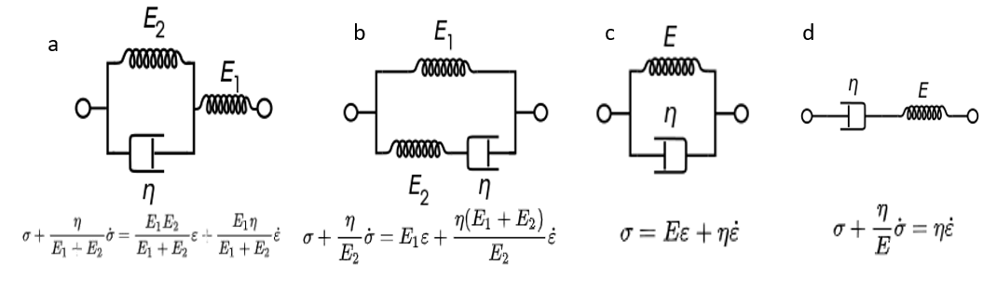type instrument (model 363, Vishay, Malvern, PA, USA) with an A-to-D board (PhidgetBridge 4 Model 1046_0B, PHIDGETS Inc., Calgary, Canada). Next, we developed a Mathcad program to optimize the model parameters for each of the four models (i.e., we minimized the least-squares error between the model and the experimental data). The Kelvin–Voigt model provided the best fit with a minimum of parameters. Thus, our model is

Fig. B1. Four viscoelastic models: (a) Kelvin representation, (b) standard linear solid model Maxwell representation, (c) Kelvin–Voigt model, (d) Maxwell model, where E is the Young’s modulus and η is the damping coefficient.

 (1)

where $σ$ is stress, $E$ is the Young’s module, η is the damping coefficient, $ϵ$ is the strain, and $\dot{ϵ}$ is the strain rate.

To convert stress into force, we used

 (2)

where *A* is the true cross-sectional area of the rubber spring and $F_{0}$ is the initial force due to the initial tension of the spring.

Combining Eqs. (1) and (2) gives

, (3)

where $V_{0}$ is the initial volume of the spring, *L* is the spring length, which depends on the angle, and are computed from the knee angle and angular velocity.

The strain, where *R* is the radius of the exoskeleton pulley (Fig. B1), $L_{0}$ is the initial spring length, and $θ$ is the change in the knee angle. Thus,

. (4)

Next, we insert the radius (55 mm), the initial length of the spring (50 mm), and the initial radius of the spring (9 mm) to obtain



In our trial experiments, we measured.

To find, we applied a least-squares fit using Matlab and obtained with a correlation factor $R^{2}=0.91$. Another measure of the accuracy is the difference in the work calculated for each jump. The mean error in the work for each simulated torque relative to experiment is 4.6% with standard deviation of 13%.

Upon examining the data, we noticed an interaction between the effect of strain and the effect of strain rate. Thus, by using a curve fit, we add to the Kelvin model a component Cϵ, obtaining

(5)



which gives with a correlation factor *R*2 = 0.93, a mean work error of 2.4%, and a standard deviation of 13.3%. Figure B2 shows the model results vs the experimental results for a sample of nine jumps.

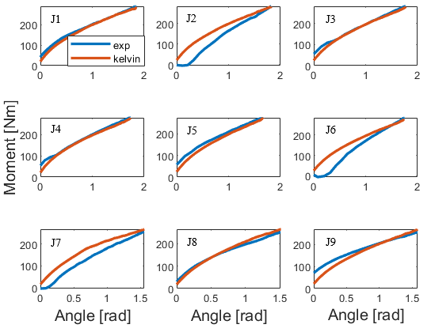

Fig. B2. Nine jump examples showing the fit of the force prediction (red curves) vs the experimental result (blue curves).

To calculate the total work, we use

. (4)



Appendix C: $ΔH_{max}$ for each subject for jumps NoExoS2 and Exo2S2.

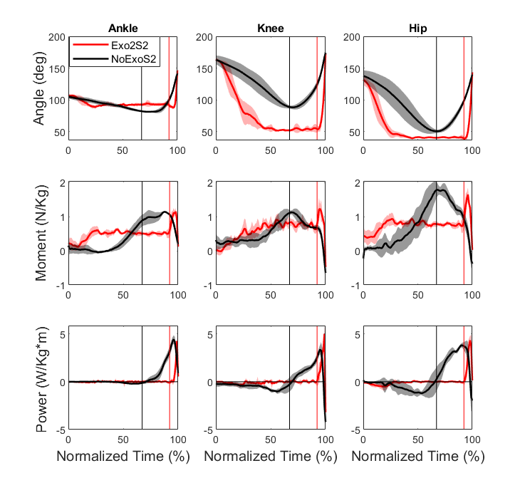

Appendix D: Angle, torque, and power of ankle, total knee (exo+bio), and hip from standing to take-off (TO), of one subject (Average $±$ SD of five jumps), right leg. The vertical lines represent the start of upward movement (UPM) for each jumping condition. For jumps Exo2S2, the subject reaches a squat position and searches for the right position for several torques until the start of upward movement. Thus, his jumping strategy with the exoskeleton is more like a squat jump as opposed to a countermovement without the exoskeleton. Note that the normalized time is calculated differently than in Fig. 5.

Acknowledgments

The authors would like to thank Professor Yisrael Parmet for his advice regarding the proper statistical methods, Benyamin Shargorodski for assistant in conducting the experiments, and Shimon Richter and Aviel Maman for their contribution to the development of the force-measurement system and the model to predict the spring forces.

References

[1] S. H. Collins, M. Bruce Wiggin, and G. S. Sawicki, “Reducing the energy cost of human walking using an unpowered exoskeleton,” *Nature*, vol. 522, no. 7555, pp. 212–215, 2015.

[2] P. Malcolm, W. Derave, S. Galle, and D. De Clercq, “A Simple Exoskeleton That Assists Plantarflexion Can Reduce the Metabolic Cost of Human Walking,” *PLoS One*, vol. 8, no. 2, pp. 1–7, 2013.

[3] L. M. Mooney and H. M. Herr, “Biomechanical walking mechanisms underlying the metabolic reduction caused by an autonomous exoskeleton,” *J. Neuroeng. Rehabil.*, vol. 13, no. 1, pp. 1–12, 2016.

[4] H. J. Lee *et al.*, “A Wearable Hip Assist Robot Can Improve Gait Function and Cardiopulmonary Metabolic Efficiency in Elderly Adults,” *IEEE Trans. Neural Syst. Rehabil. Eng.*, vol. 25, no. 9, pp. 1549–1557, 2017.

[5] B. Lim, J. Jang, J. Lee, B. Choi, Y. Lee, and Y. Shim, “Delayed Output Feedback Control for Gait Assistance and Resistance Using a Robotic Exoskeleton,” *IEEE Robot. Autom. Lett.*, vol. 4, no. 4, pp. 3521–3528, 2019.

[6] G. Lee *et al.*, “Reducing the metabolic cost of running with a tethered soft exosuit,” *Sci. Robot.*, vol. 2, no. 6, pp. 1–3, 2017.

[7] R. Nasiri, A. Ahmadi, and M. N. Ahmadabadi, “Reducing the energy cost of human running using an unpowered exoskeleton,” *IEEE Trans. Neural Syst. Rehabil. Eng.*, vol. 26, no. 10, pp. 2026–2032, 2018.

[8] C. S. Simpson *et al.*, “Connecting the legs with a spring improves human running economy,” *J. Exp. Biol.*, vol. 222, no. 17, 2019.

[9] J. Kim *et al.*, “Reducing the metabolic rate of walking and running with a versatile, portable exosuit,” *Science (80-. ).*, vol. 365, no. 6454, pp. 668–672, 2019.

[10] G. S. Sawicki, O. N. Beck, I. Kang, and A. J. Young, “The exoskeleton expansion: improving walking and running economy.” J*ournal of NeuroEngineering and Rehabilitation*, *17*(1), 1-9, 2020.

[11] S. Lee *et al.*, “Autonomous multi-joint soft exsosuit with online optimization reduces energy cost of loaded walking,” *J. Neuroeng. Rehabil.*, p. Under review, 2018.

[12] C. J. Walsh, K. Edo, and H. Herr, “a Quasi-Passive Leg Exoskeleton for Load-Carrying Augmentation,” *Int. J. Humanoid Robot.*, vol. 04, no. 03, pp. 487–506, 2007.

[13] R. W. Nuckols, K. Z. Takahashi, D. J. Farris, S. Mizrachi, R. Riemer, and G. S. Sawicki, “Mechanics of walking and running up and downhill: A joint-level perspective to guide design of lower-limb exoskeletons,” *PLoS One*, vol. 15, no. 8, p. e0231996, Aug. 2020.

[14] N. Yagn, “Apparatus for facilitating walking, running, and jumping,”. U.S. Patents 420 179 and 438 830, 1890.

[15] A. M. Grabowski and H. M. Herr, “Leg exoskeleton reduces the metabolic cost of human hopping,” *J. Appl. Physiol.*, vol. 107, no. 3, pp. 670–678, 2009.

[16] D. J. Farris and G. S. Sawicki, “Linking the mechanics and energetics of hopping with elastic ankle exoskeletons,” *J. Appl. Physiol.*, vol. 113, no. 12, pp. 1862–1872, 2012.

[17] S. Kim, Y. Son, S. Choi, S. Ham, and C. Park, “Design of a simple, lightweight, passive-elastic ankle exoskeleton supporting ankle joint stiffness,” *Rev. Sci. Instrum.*, vol. 86, no. 9, 2015.

[18] S. Fukashiro and P. V. Komi, “Joint moment and mechanical power flow of the lower limb during vertical jump,” *Int. J. Sports Med.*, vol. 8, no. SUPPL. 1, pp. 15–21, 1987.

[19] A. Vanezis and A. Lees, “A biomechanical analysis of good and poor performers of the vertical jump,” *Ergonomics*, vol. 48, no. 11–14, pp. 1594–1603, 2005.

[20] M. F. Bobbert and G. J. van Ingen Schenau, “Coordination in vertical jumping,” *J. Biomech.*, vol. 21, no. 3, pp. 249–262, 1988.

[21] S. Galle, P. Malcolm, W. Derave, and D. De Clercq, “Adaptation to walking with an exoskeleton that assists ankle extension,” *Gait Posture*, vol. 38, no. 3, pp. 495–499, 2013.

[22] K. Gast, R. Kram, and R. Riemer, “Preferred walking speed on rough terrain: Is it all about energetics?,” *J. Exp. Biol.*, vol. 222, no. 9, 2019.

[23] J. C. Selinger, S. M. O’Connor, J. D. Wong, and J. M. Donelan, “Humans Can Continuously Optimize Energetic Cost during Walking,” *Curr. Biol.*, vol. 25, no. 18, pp. 2452–2456, 2015.

[24] P. C. Goodwin, K. Koorts, R. Mack, S. Mai, M. C. Morrissey, and D. M. Hooper, “Reliability of leg muscle electromyography in vertical jumping,” *Eur. J. Appl. Physiol. Occup. Physiol.*, vol. 79, no. 4, pp. 374–378, 1999.

[25] R. Pereira, M. Machado, M. Miragaya, L. N. Pereira, and F. Sampaio-jorge, “Muscle Activation Sequence Compromises Vertical Jump Performance,” *Serbian J. Sport. Sci.*, vol. 2, no. 1–4, pp. 85–90, 2008.

[26] K. Sotiropoulos *et al.*, “Effects of warm-up on vertical jump performance and muscle electrical activity using half-squats at low and moderate intensity,” *J. Sport. Sci. Med.*, vol. 9, no. 2, pp. 326–331, 2010.

[27] F.-J. Tsai, Y. Liu, S.-H. Chen, and Y.-C. Huang, “Biomechanical Characteristics and EMG Activities of Weighted Countermovement Jump,” in *ISBS-Conference Proceedings Archive*, 2004.

[28] D. A. Winter, *Biomechanics and Motor Control of Human Movement: Fourth Edition*. 2009.

[29] T. Lenzi *et al.*, “Intention-Based EMG Control for Powered Exoskeletons,” vol. 59, no. 8, pp. 2180–2190, 2012.

[30] W. Rose, “Raw signal amplification,”. Mathematics and Signal Processing for Biomechanics ,2014.

[31] T. K. K. Koo and A. F. T. Mak, “Feasibility of using EMG driven neuromusculoskeletal model for prediction of dynamic movement of the elbow,” vol. 15, pp. 12–26, 2005.

[32] W. S. Selbie and G. E. Caldwell, “A simulation study of vertical jumping from different starting postures,” *J. Biomech.*, vol. 29, no. 9, pp. 1137–1146, 1996.

[33] Z. J. Domire and J. H. Challis, “The influence of squat depth on maximal vertical jump performance,” *J. Sports Sci.*, vol. 25, no. 2, pp. 193–200, 2007.

[34] B. Ostraich and R. Riemer “Simulation of a Passive Knee Exoskeleton for Vertical Jumping,”. *ASB 44Annual Meeting.* Georgia Institute of Technology, 2020.

[35] P. Jiménez-Reyes, P. Samozino, M. Brughelli, and J. B. Morin, “Effectiveness of an individualized training based on force-velocity profiling during jumping,” *Front. Physiol.*, vol. 7, no. JAN, pp. 1–13, 2017.

[36] C. U. A. Nalysis, O. F. The, and C. O. J. Ump, “Power-Time,Force-Time, and Velocity-Time Curve Analysis of the Countermovement Jump: Impact of Training,” *J. Strength Cond. Res.*, vol. 23, no. 1, pp. 177–186, 2009.

[37] M. F. Bobbert, K. G. M. Gerritsen, M. C. A. Litjens, and A. J. Van Soest, “Why is countermovement jump height greater than squat jump height?,” *Medicine and Science in Sports and Exercise*, vol. 28, no. 11. pp. 1402–1412, 1996.

[38] Komi P. V and Bosco C, “Utilization of stored elastic energy in leg extensor muscles by men and women,” *Medicine and Science in Sports*, vol. 10, no. 4. pp. 261–5, 1978.

[39] B. Van Hooren and J. Zolotarjova, “The Difference between Countermovement and Squat Jump Performances: A Review of Underlying Mechanisms with Practical Applications,” *J. Strength Cond. Res.*, vol. 31, no. 7, pp. 2011–2020, 2017.

[40] B. Kopper, Z. Csende, L. Trzaskoma, and J. Tihanyi, “Stretch-shortening cycle characteristics during vertical jumps carried out with small and large range of motion,” *J. Electromyogr. Kinesiol.*, vol. 24, no. 2, pp. 233–239, 2014.

[41] G. J. van Ingen Schenau, “An alternative view of the concept of utilisation of elastic energy in human movement,” *Hum. Mov. Sci.*, vol. 3, no. 4, pp. 301–336, 1984.

[42] F. C. Anderson and M. G. Pandy, “Storage and utilization of elastic strain energy during jumping,” *J. Biomech.*, vol. 26, no. 12, pp. 1413–1427, 1993.

1. This paper was submitted for review at XXX. This work was supported in part by Helmsley Charitable Trust through the Agricultural, Biological and Cognitive Robotics Initiative of Ben-Gurion University of the Negev and the Israel Science Foundation under Grant 899/18.

   Coral Ben David is with the Faculty of Industrial Engineering, Ben-Gurion University of the Negev, Israel (e-mail: coralben@post.bgu.ac.il).

   Barak Ostraich is with the Faculty of Industrial Engineering, Ben-Gurion University of the Negev, Israel (e-mail: ostr@post.bgu.ac.il)

   Dr. Raziel Riemer is with the Faculty of Industrial Engineering, Ben-Gurion University of the Negev, Israel (correspondence email: rriemer@bgu.ac.il)