Dear Group Leader,

First of all, thank you for your cooperation!

General Instructions:

- Film the conversation of the two teen participants with the survivor.

- Film the survivor’s meeting with the teen participants, in which he or she tells his or her story.

- The raw footage can be up to 30 minutes in length.

- Ask the survivor to bring his or her photographs from the period of the Holocaust, and films in which he or she appeared in the past, including films from earlier trips to Poland.

- Instruct the survivor to limit him or herself to short and focused answers.

**How To Shoot? Instructions for Filming**

* The interview should be conducted in a quiet place.
* The basic “frame” needs to include the teen participants and the survivor sitting together in a semicircle facing the camera.
* It is important to change the camera angle from time to time and to focus both on the survivor while he or she is speaking and on the teen participants while they ask questions or listen to the speech.
* The film should show the entire group with the survivor.
* The film should show several teen participants listening to his or her speech and asking questions.
* The film should sometimes show the survivor alone, his or her expressions, etc.
* The film should sometimes show the teen participants alone, their expressions, etc.
* A group picture of everyone together with the survivor. 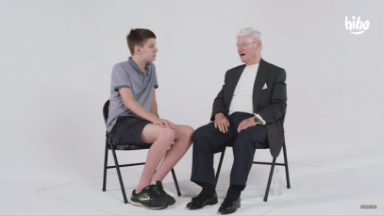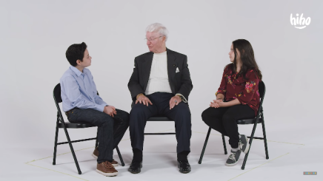

**Sample Questions for the Interview: We Remember the Past and are Committed to the Future!**

1. Tell us where you were during the Holocaust?

2. Were you with your family?

3. Do you remember a particular moment and why?

4. How did you survive?

5. How many years have you been accompanying the trip to Poland?

6. Why did you decide to join the trip?

7. Was there a particularly emotional moment on the trip to Poland?

6. What is the message for participants on the trip?

**Examples of Filming Ambience:**

* Filming the meeting and the goodbyes, if there is a hug or touching.
* Walking with the survivor in the hallway.
* Looking together at a picture.
* Drinking or preparing tea together.

**Filming an Interview with Two Teen Participants after their Meeting with the Survivor**:

Please film the teen participants describing:

* How did they feel in the conversation?
* What are they taking away from the conversation?
* Why did they decide to join the trip to Poland?
* Why is it important to them?

**Important!! If you have the opportunity to do so, please use professional equipment, including at least a camera, microphone, and tripod.**

**Important!! Please clearly record the names of those whom you filmed and send it to us in a Microsoft Word file.**

Please send the raw footage through one of the following websites:

[https://wetransfer.com](https://wetransfer.com/) or [https://www.myairbridge.com/en](https://www.myairbridge.com/en/)

The final deadline is March 28, 2019.

Thank you for your cooperation,

The staff of Amit Productions