**Integrating ICT in Science Classes: Is it Effective?**

**ABSTRACT**

**Aim/Purpose:** This study analyzes the effectiveness of integrating information and communication technology (ICT) into learning in fifth-grade science classes in Israel. Specifically, it examines the effect on students’ motivation, sense of self-efficacy, achievement, and collaboration,.

**Background:** Many countries integrate ICT in classes as a means to improve learning, advance digital literacy, and increase student achievement. However, research on the academic effectiveness of these programs is still emerging.

**Methodology:** The research method was quasi-experimental. Measurements were collected before and after the implementation of an ICT program, and pre- and post-level differences between the treatment and control group were assessed using the difference-in-differences (DID) method.

**Contribution:** The contribution of this study lies in the development of an effectiveness analysis that may contribute to improved performance among disadvantaged minority students and to the development of their collaboration skills.

**Findings:** The results of the effectiveness analysis show a larger incremental trend in achievement and a higher level of collaboration among students in the treatment group compared to their counterparts in the control group. Changes in student motivation and self-efficacy were not statistically significant.

**Recommendations for Practitioners:** Future studies in other countries that have minority populations suffering from educational resource constraints could benefit from the findings of this study.

**Recommendations for Researchers:** The two groups in this study were taught by different teachers; for future research, a design deploying the same teachers is recommended, so that only the teaching method is variable.

**Impact on Society:** The societal impact of this study lies in its development of an effectiveness analysis, which will allow effective incorporation of ICT in schools improving performance among disadvantaged minority students and enhancing their collaboration skills.

**Future Research**: Future research should examine and control for computer literacy.

**Keywords:** ICT, science education, effectiveness, difference-in-differences (DID), public elementary schools, low-SES schools

**Introduction**

The information age highlights the importance of information and knowledge in all aspects of life (Resnick, 2002). Accordingly, education has begun to adopt innovative methods of teaching and learning in a computerized environment, with the aim of equipping students with the 21st-century competencies they require (Pedró, 2006; Zohar, 2011). Following this trend, many countries in the world use information and communications technology (ICT) in the classroom, both as a tool to improve student achievement and to promote digital literacy as an end in itself (Livingstone, 2012).

Many Western countries are seeing a growing trend of integrating ICT in classes, which is seen a powerful tool for innovation in education. Proper use of ICT can improve the quality of learning and connect it to real-life situations experienced by learners (Fu, 2013). Integrating ICT in teaching and learning has several advantages. First, the use of ICT offers additional opportunities for developing critical thinking skills. Second, it can improve the quality of learning and teaching and support teaching by providing access to learning content (Fu, 2013).

Previous research has found the integration of ICT in science classes to be effective (Kubiatko, 2010; Kubiatko & Vlckova 2010; Ziden et al., 2011), indicating that ICT use improves science learning from an early age (Kubiatko, 2010). Additionally, integrating ICT in science classes at the primary school level was shown to improve students’ attitudes toward learning science and contributed to improved student achievement (Spiezia, 2010; Ziden et al., 2010; Ziden et al., 2011).

There are several parameters by which the effectiveness of integrating ICT in education can be measured. Fu (2013) highlights four such parameters: (1) student motivation, (2) student collaboration, (3) student self-efficacy, and (4) academic achievement. We examined these four parameters using data from students enrolled in Arabic-speaking public schools in Israel. In Israel, public schools in which the curriculum is taught in Arabic are marked by lower levels of achievement as compared to Hebrew-speaking schools (Abu-Asaba, 2007).

**Literature Review**

**Integrating ICT in class**

ICT integration includes the use of computers, the internet, and other media such as radio and television. In many Western countries, ICT is widely used in education (Fu, 2013; Livingstone, 2012; Sánchez & Alemán 2011), and its integration in education continues to expand (Fu, 2013). The increasing use of ICT in teaching reflects a change in the perception of learning, which is no longer seen as a passive reception of knowledge from the teacher, but as an ongoing, lifelong activity in which learners seek knowledge over time from new sources (Fu, 2013).

Integrating ICT into learning processes has several benefits (Fu, 2013; Sánchez & Alemán, 2011; Chai et al., 2010). However, the mere use of ICT in teaching does not guarantee all these advantages: it is likely more beneficial when integrated with relevant pedagogy. Furthermore, the integration of ICT in class may also have a negative impact on learning (Martinovic & Zhang, 2012). Another scenario concerns the personal aspects of teaching and learning: if the use of ICT replaces the teacher-student relationship, the student might perceive a lack of feedback from the teacher, which may not only make it more difficult to understand the material but also damage the student’s self-confidence (Fu, 2013).

***Integrating ICT in science class***

Previous research has found integrating ICT in science classes to be effective (Kubiatko, 2010; Kubiatko & Vlckova 2010; Ziden et al., 2011; Zucker et al., 2008). Specifically, the use of ICT has increased high school students’ interest in science. Similar findings were reported for elementary schools. In a study comparing an experimental group that studied science using ICT with a control group that studied science using traditional means only, ICT use not only improved students’ attitudes towards the material taught and science in general, but also improved their achievement (Ziden et al., 2011; Zucker et al., 2008).

**Measuring the effectiveness of integrating ICT in class**

The literature points out that ICT integration is effective in terms of (1) student motivation, (2) student collaboration, (3) student self-efficacy, and (4) academic achievement (Fu 2013). Using ICT in education in general, and at a young age in particular, contributes to increasing student motivation (Livingstone, 2012). Additionally, integrating online learning with face-to-face learning widens students’ opportunities for collaboration, and increases their willingness to connect with other students (Anastasiades et al., 2010). Finally, the use of ICT contributes to improving academic achievement, especially in science (Ziden et al., 2010).

**The Israeli context**

In Israel two local initiatives integrate ICT in science classes: the “Laptop for Every Student Project” and the “Classroom Computer Student and Teacher Project.” As part of these initiatives, science teaching is conducted through animation videos. For example, videos are used to teach “Earth and the Universe” in elementary school, and “Materials and Their Properties” in middle school (Klein, 2011).

While research on the effectiveness of ICT integration in science classes in Israel is scarce, studies on integrating ICT in classes in general (without focusing on science) are more numerous (Brandes & Strauss, 2013). In a study examining high school teachers’ and students’ attitudes toward a program teaching biology using computers in Israel, both teachers and students identified with the program’s goals for integrating ICT into life science teaching (Shemesh et al., 2008).

Although many initiatives at both the national and local level have been implemented to promote ICT integration in the classroom, the incorporation of new technologies into the education system has not kept pace with technological developments. Furthermore, the current gap between the possibilities afforded by ICT and its actual uses is significant, and the state of the infrastructure and students’ levels of access to computers and the internet are still very limited (Vorgan, 2010).

Despite these challenges, research based on classroom observations suggests that integrating laptops in classrooms may contribute to the adoption of innovative pedagogies, since the practice may advance skills regarded as crucial to the 21st century such as collaborative learning (Manny-Ican et al., 2013). In a more recent study, Getz and Goldberg (2016) found that since Vorgan’s (2010) study, the situation in Israel has improved with regard to the integration of instructional ICT, partly because of the implementation of the 21st-Century Education Adjustment Program and the activities of the “Thought Center,” which was founded to support teachers in using computers in Israel (Getz & Goldberg, 2016). However, despite this improvement, Nir et al. (2016) report that the changes have put a lot of pressure on teachers and administrators to fulfill technological requirements. Specifically, due to the large effort invested in dealing with technology, teachers are reported to lack time for significant in-person teaching.

The objective of this study is to assess the effectiveness (in terms of motivation, self-efficacy, achievement, and collaboration) of the ICT program implemented as part of fifth-grade science classes in Arabic-speaking public schools in Israel.

The following research questions are addressed:

1. Is the change in motivation level greater among students in the ICT program than in their counterparts on the traditional program?
2. Is the change in the level of self-efficacy greater among students in the ICT program than in their peers on the traditional program?
3. Is the change in achievement greater among students in the ICT program than in their peers on the traditional program?
4. Are there differences in the level of collaboration between the students in the ICT program and their peers in the traditional program?

Based on the literature review, our hypotheses are the following:

1. Studying in the ICT program will improve motivation, self-efficacy, student achievement and collaboration among students in the experimental group.
2. The improvement will be significantly greater among students in the experimental group than among those in the control group.

**Methods**

**Study variables**

Table 1: Study variables

|  |  |  |  |
| --- | --- | --- | --- |
| Variable type | Variable | Variable values | Measurement scale |
| Background | Gender | 1 = Male  2 = Female | Nominal \ dichotomous |
| Independent Variable | Learning program | 0 = Traditional  1 = ICT | Nominal \ dichotomous |
| Dependent variables | Motivation | 1-5 | Quasi-interval |
| Self-efficacy | 1-5 | Quasi-interval |
| Achievement | 0-100 | Quasi-interval |
| Collaboration | Low-to-high collaboration in aspects: interest, trust, support, willingness, security. | Qualitative |

**Research design**

The present study uses a mixed-method paradigm: the quantitative portion is intended to test the research hypotheses, while the qualitative portion aims to validate the quantitative findings as well as examine variables that are hard to quantify, such as the degree of student collaboration in class.

In the quantitative portion, the research design is quasi-experimental: pre- and post-measurements were carried out in an experimental group (students studying on the ICT program) and a control group (students studying on a traditional, non-ICT program); however, the experimental conditions could not be assigned randomly. A quasi-experimental setup was chosen because it allowed us to measure the effect of the intervention on an experimental group as compared to a control group. It was not possible to implement a true experimental setup, as we had no control over which schools chose to implement the ICT program; thus, the assignment of students to groups could not be randomized. In this situation, using the difference-in-differences (DID) method is appropriate (see below, Angrist & Pischke, 2008). Both student groups were assessed at two points in time: in the experimental group, the first measurement was conducted prior to the implementation of the ICT program, and the second one at the end of the academic year. The control group was assessed at the same interval.

The qualitative portion comprised six structured classroom observations: three observations of science classes on the ICT program and three corresponding observations at the non-computerized school.

**Intervention**

Students in both schools studied the state science curriculum, covering similar topics, but the material was delivered using different teaching methods (ICT versus traditional). The sole difference between the classes was the method of teaching employed by the teachers; in the experimental group, teachers used technological literacy to develop digital skills among students, while the control group was taught in the traditional approach.

The computerized school joined the ICT program five years prior to this research. A computer-based curriculum for teaching science in the fifth grade was developed, including approximately 35 lessons delivered during the school year. Each week, one such lesson took place in a special computer room with digital tools. A second weekly science lesson was held in a regular classroom using laptop computers.

While fifth-graders in the traditional non-computerized school learned the same material, most of the lessons were delivered using textbooks and conducting regular lab activities prepared by the teacher. Group learning lessons were also conducted without the incorporation of digital tools. Occasionally, the teacher used computers and other technical tools as teaching aids; however, the equipment was much more limited than that used in the experimental group's school.

In the experimental group, the science studies incorporated are a variety of innovative technologies, including:

Digital books: On the computer screen, the student views a digital book that links to computerized activities on each topic. Through these activities, students can apply what they learned, check their answers, and repeat the practice several times.

The program included the use of digital tools that the teacher refers students to - and the student performs skills at an innovative level that sorts information, organizes information.

E-learning environments: Teachers and students enter an e-learning environment associated with the Ministry of Education, using a uniform password. The teacher uploads assignments to students with a deadline. Teachers sometimes return the students’ work for corrections that the student should address.

Collaborative files: The teacher prepared files on various topics using Google Docs, slideshows, and Google forms.

Google searches: Fostering students’ independence through online research.

Among the experimental group, some of the lessons took place in a room equipped with desktops with a high internet connection that allows file sharing and some of the lessons took place in a classroom equipped with a cart of laptops and tablets.

In the control group, the same science topics were studied but without the use of innovative digital tools. Computers were occasionally used at a basic level with desktop computers in the computer lab. For example, the class watched a relevant video and engaged in activities prepared by the teacher in the lab room. Most of their learning was based on the use of textbooks and experiments in a laboratory room using physical equipment. In the traditional learning, the teacher would explain the topic and give assignments, sometimes from the textbook and sometimes printed as worksheets that include questions and exercises to apply the material being taught or a task with instructions.

Attached is an example from the detailed lesson plan delivered among the experimental group.

**Procedure**

In order to test the effectiveness of the ICT program among fifth-grade students attending elementary school in Arab education in Israel, two groups studied the state-backed science curriculum of Israel’s Ministry of Education, while one used ICT and the other did not. The study lasted one year. Data collection was conducted at two points, before and after the intervention. In September, the first month of the school year, the first measurement for data collection was made, with the same research tools (detailed below) applied to both groups. Then, in early October, the intervention in the experimental group began, and lasted until the end of the school year. The lessons that were part of the intervention program were delivered by the science teachers twice a week throughout the school year. The program included supervision of the teaching of sciences and the mass ICT instructors from the Ministry of Education to the schools. The intervention program included a content specification combining digital skills and literacy. At the same time, the control group studied the same sequence of study material, using the traditional method as described above. In early June, towards the end of the school year, the second measurement was performed among the two groups, using the same research tools as in the first measurement.

The study design was chosen due to its compatibility with the long-term nature of the research set-up. It examined the effect of the independent variable, namely, the ICT teaching method. Using this before-and-after method, we are able to monitor and neutralize the background variables of the students even though they are similar in their background characteristics.

**Participants**

The students examined in the two groups have similar socioeconomic background characteristics and come from the same geographical area. They are all students from the weakened Arab population in Israel. They were in fifth grade in primary schools in the Arab sector in Israel, in a locale where most students have a low socioeconomic status.

Likewise, the teachers in the two groups at the schools have similar characteristics, with regards age range as well as seniority, education, and experience as science teachers. They underwent professional development and science teacher-training at the same center for professional development for science teachers.

The sample consisted of 57 fifth-graders from a school that operates a non-ICT program, and 88 fifth-graders from a school that joined the ICT program, giving a total of 145 students. Both schools are located in the same geographic area and classified as Arabic-speaking public schools. The school from which we recruited the control group is the only elementary school in the area that at the time of the study had not entered the ICT program; it was selected because it closely resembles the ICT-integrated school with respect to other characteristics (such as geographical area, socioeconomic status, heterogeneous level of achievement). The classes constituting the sample were heterogeneous and included students with special educational needs and learning disabilities. The control group comprised 28 girls and 29 boys, which was representative of the student population in this school.

This population was selected because so far there are only few studies of ICT programs in Arabic-speaking public schools in Israel (Nachmias et al., 2010). In addition, education in Arabic-speaking public schools suffers from many difficulties, including severe resource limitations (Abu-Asaba, 2007), so studies that may contribute to the evaluation of cost-effectiveness are of particular importance.

The schools were selected in a convenience sample. This sampling method is not probabilistic and therefore reduces the external validity of the study. However, the statistical method used in the present study (DID) makes it possible to isolate the effect of the program.

**Tools**

In order to examine the research hypotheses on (1) motivation, (2) self-efficacy, and (3) achievement, data sets were collected using two questionnaires and one achievement test, respectively. The questionnaires and test were administered at the beginning and end of the academic year by the science teachers.

*Student motivation questionnaire*

The Personal Achievement Goal Orientation (PAGO) scale by Midgley et al. (1998) was used to measure student motivation. The questionnaire comprises 24 items rated on a 5-point Likert scale ranging from “strongly disagree” to “strongly agree.” The questionnaire helps assess the motivations or goals that students adopt when dealing with their assignments. The internal consistency of the questionnaire as determined in previous studies ranged from 0.71 to 0.80 (Midgley et al., 1998); in the present study, it was 0.66. The score was calculated by averaging over all questions answered by the respondent. The questionnaire was translated into Arabic by teachers with professional translation experience and reviewed by two other teachers to verify the accuracy of the language. In addition, confirmatory factor analysis (CFA) with adjustment was carried out, yielding a comparative fit index (CFI) of 0.968.

***Self-efficacy questionnaire***

To test the students’ sense of self-efficacy, we used the scale developed by Chen and Gully (1997). The questionnaire comprises 14 items rated on a 5-point Likert scale ranging from “Not at all describing me” to “Describing me to a great extent.” Various studies have confirmed its high content and predictive validity (Chen et al., 2001), finding an alpha coefficient of over .90 (Chen & Gully, 1997). Reliability in the present study was 0.84, again averaging over all questions to which the respondent replied. The questionnaire was translated into Arabic by teachers versed in translation and tested by two teachers to verify the accuracy of the language. In addition, CFA with adjustment was again performed, yielding a CFI of 0.906.

***Science achievement test***

A structured achievement test was developed for the purposes of this study by a science-based steering team. It included knowledge and comprehension questions on science subjects taught in school, and was validated by a content table featuring all test items, including a weight and level for each item. The test was translated and administered to the students in Arabic. When checking for reliability in terms of internal traceability, we obtained a .86 correlation between the two halves of the test. To calculate the final reliability value, a correction according to the Spearman-Brown formula was performed, yielding a .92 correlation.

***Structured* *observation to assess student collaboration***

We used structured observation to examine the research hypothesis on (4) student collaboration during the students’ preparation of a final product in group work. The observations were conducted with a checklist compiled by Wadawi (2013) and found to be cross-validated with other research methods, such as interviews with students and teachers (Wdmani, 2012). Collaboration was evaluated using three observations each at the computerized and non-computerized school, respectively. In each instance, notes on the checklist were taken by the researcher and two additional observers from the science team to ensure the reliability of the data. Observations were carried out three times over the course of the study, and at the end of each observation the researcher and the two other observers cross-commented on each criterion included in the structured observation.

***Quantitative data analysis***

The statistical analysis was performed using the DID method, in which the effect of a particular policy (in this case, the integration of ICT in science teaching) is calculated by estimating the relationships between the dependent and independent variables and comparing the average change in the experimental group with the average change in the control group at two corresponding time points (before and after the intervention). This calculation is performed using multiple linear regression analyzes, where the dependent variable is the measured variable (e.g., the level of achievement), and the explanatory variables are the intervention (i.e., ICT-integrated vs. traditional learning), the time (before and after learning), and the interaction between intervention and time. The significance of the interaction indicates whether the DID between groups is statistically significant (Card & Krueger 1994).

***Qualitative data analysis***

This study used the phenomenographic approach (Marton, 1986) to analyze data and classify concepts based on an ongoing comparison and search for similarity, variation, and complementarity between the two. The approach is based on the collection of descriptions, sentences, statements, ideas, thoughts, and experiences during fieldwork. Analysis starts with the identification of common features and patterns in the data collected, on the basis of which preliminary conceptual categories are formed. After “refining” the categories and determining their hierarchy, criteria for including a data point in each category are developed. In the present study, descriptions of the three observations by all observers were mined for similarities. Shared and similar descriptions of each category were summarized in Table 8.

**Results**

This section presents the analysis of the three regression models for the variables (1) motivation, (2) self-efficacy, and (3) achievement, and the observation analysis for the (4) collaboration variable.

**Hypothesis Testing**

**(1) Motivation.** To examine the effect of the learning method (ICT-integrated learning vs. traditional learning) on the dependent variables, the mean and standard deviations of the students’ levels of motivation were calculated, as presented in Table 2 and Fig. 1.

Table 2

*Means and Standard Deviations of Student Motivation in the Experimental and Control Group*

|  |  |  |  |
| --- | --- | --- | --- |
| *Measurement* | |  | *Group* |
| *After* | *Before* |  |  |
| 2.26 | 2.28 | Mean | Experimental group (N = 88) |
| 0.52 | 0.48 | SD |
| 2.24 | 2.23 | Mean | Control group (N = 57) |
| 0.43 | 0.34 | SD |

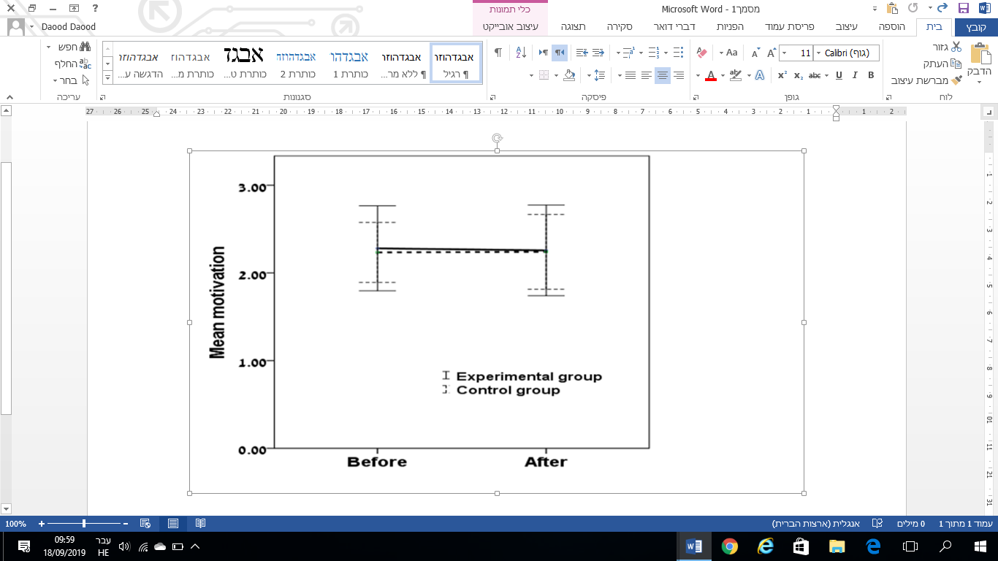

*Figure 1*. Means and Standard Deviations of Student Motivation in the Experimental and Control Group.

Table 2 and Fig. 1 show that the average motivation ratings in the experimental group before and after the intervention were 2.28 and 2.26, respectively; we see a minimal decrease in motivation between the first and second measurement. For the control group, the means were 2.23 and 2.24, respectively, indicating a minimal increase in motivation between the first and second measurement.

To test the first hypothesis, expecting a greater increase in motivation among fifth-graders at Arabic-speaking public schools with ICT integration in science classes compared to that among their peers studying in the traditional manner, the following DID equation was formulated (**Eq. 1**):

$$M(i)=a+β_{1}C+β_{2}T+β_{3}I+e$$

where *M* is motivation of student *i*; $a$ is the cutter; *β* is the regression coefficient; *C* is the group (treatment/control); *T* is the measurement (motivation before/after); *I* is the interaction (*C × T*); and *e* is the error term. The results of the analysis are presented in Table 3.

Table 3

*Testing Differences in Motivation*

|  |  |  |  |  |  |  |  |  |
| --- | --- | --- | --- | --- | --- | --- | --- | --- |
| *α significant* | | *SE* | *Β* | *b* | | *Variable* | | |
| 0.000 | | 0.061 | - | 2.302 | | Fixed | | |
| 0.767 | | 0.086 | - 0.028 | -0.025 | | Time | | |
| 0.657 | | 0.078 | -0.037 | -0.033 | | Treatment (ICT) | | |
| 0.819 | | 0.110 | 0.026 | 0.024 | | Time * ICT | | |
|  | | R=0.029, R2=0.001 | | | |  | |  |

Table 3 shows no significant interaction effect, meaning that no significant differences were found between the motivation level of students studying on the ICT program and that of their peers studying on the non-ICT program. Thus the results lead us to reject the first hypothesis: learning with ICT integration does not have a statistically significant effect on student motivation.

**(2) Self-efficacy.** To test the effect of the learning method (ICT-integrated learning vs. traditional learning) on self-efficacy, the means and standard deviations of the students’ levels of self-efficacy were calculated as presented in Table 4 and Fig. 2.

Table 4

*Means and Standard Deviations of Students’ Self-Efficacy in the Experimental and Control Group*

|  |  |  |  |
| --- | --- | --- | --- |
| *Measurement* | |  | *Group* |
| *After* | *Before* |  |  |
| 1.69 | 1.7 | Mean | Experimental group (N = 88) |
| 0.7 | 0.7 | SD |
| 1.71 | 1.67 | Mean | Control group (N = 57) |
| 0.43 | 0.48 | SD |

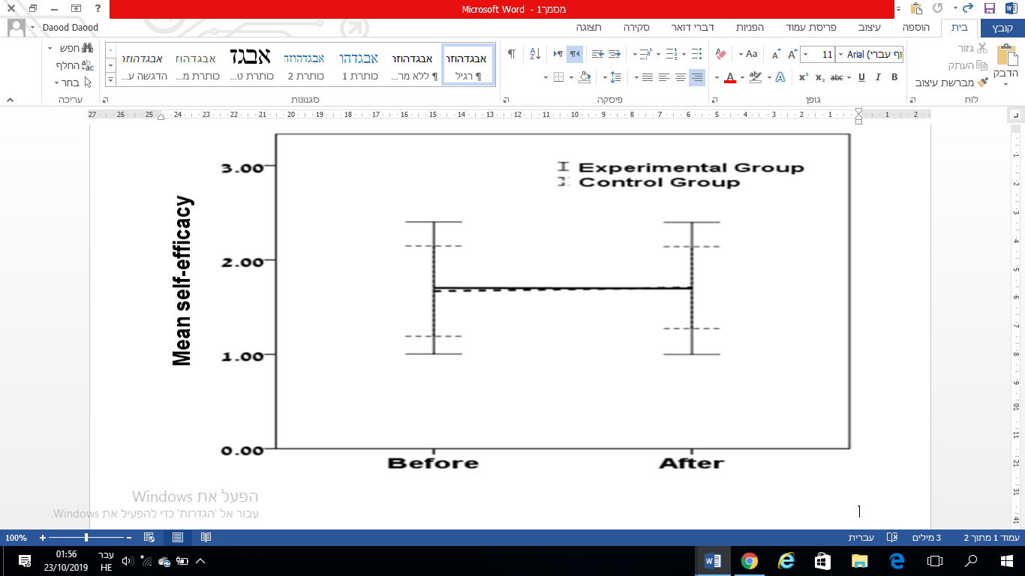

*Figure 2*. Means and Standard Deviations of Students’ Self-efficacy in the Experimental and Control Group.

Table 4 and Fig. 2 show that the mean self-efficacy scores in the experimental group before and after the intervention were 1.70 and 1.69, respectively, showing a slight decrease in self-efficacy between the first and second measurements. For the control group, the means were 1.67 and 1.71, respectively, showing a slight increase in self-efficacy over this period.

To test the second hypothesis, expecting a greater increase in self-efficacy among students on the ICT program compared to their peers attending the traditional program, the following DID equation was formulated (**Eq. 2**):

$$SE(i)=a+β_{1}C+β_{2}T+β_{3}I+e$$

where *SE* is the self-efficacy of student *i*; $a$ is the cutter; *β* is the regression coefficient; *C* is the group (treatment/control); *T* is the measurement (motivation before/after); *I* is the interaction (*C × T*); and *e* is the error term. The results of the analysis are presented in Table 5.

Table 5

*Testing Differences in Self-Efficacy*

|  |  |  |  |  |  |  |  |  |
| --- | --- | --- | --- | --- | --- | --- | --- | --- |
| *a significant* | | | *SE* | *Β* | *b* | | *Variable* | |
| 0.000 | | | 0.082 | - | 1.776 | | Fixed | |
| 0.248 | | | 0.115 | - 0.109 | -0.124 | | Time | |
| 0.058 | | | 0.105 | - 0.159 | -0.184 | | Program (ICT) | |
| 0.296 | | | 0.148 | 0.117 | 0.143 | | Time * ICT | |
|  | R = 0.119, R2 = 0.014 | | | |  | |  | |

Table 5 shows that no significant effect was found for the interaction, meaning that no differences were found between the change in self-efficacy of students studying on the ICT program and that of their peers studying on the non-ICT program. That is, learning with ICT integration does not have a statistically significant effect on student self-efficacy. Thus, the findings do not support the second hypothesis.

**(3) Achievement.** To test the effect of the learning method (ICT-integrated learning vs. traditional learning) on achievement, the means and standard deviations of the students’ achievement were calculated as presented in Table 6 and Fig. 3.

Table 6

*Means and Standard Deviations of Student Achievement in the Experimental and Control Group*

|  |  |  |  |
| --- | --- | --- | --- |
| *Measurement* | |  | *Group* |
| *After* | *Before* |  |  |
| 70.97 | 61.16 | Mean | Experimental group (N = 88) |
| 15.4 | 16.64 | SD |
| 71.42 | 69.74 | Mean | Control group (N = 57) |
| 15.47 | 15.69 | SD |

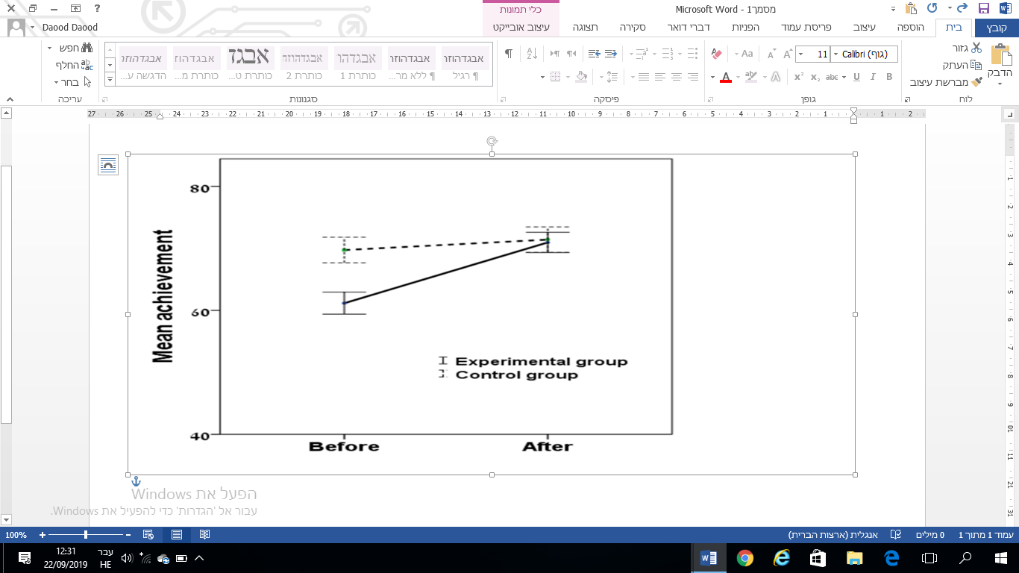

*Figure 3*. Means and Standard Deviations of Student Grades in the Experimental and Control group.

Table 6 and Fig. 3 show that the average student achievement in the experimental group increased from 61.16 before the intervention to 70.97 after the intervention. For the control group, the respective scores were 69.74 and 71.42, also showing a small increase between measurements.

To test the third hypothesis, which proposes a greater increase in achievement among students on the ICT program compared to their peers attending the traditional program, the following DID equation was formulated (**Eq. 3**):

$$G(i)=a+β_{1}C+β_{2}T+β_{3}I+e$$

where *G* is the grade of student *i*; $a$ is the cutter; *β* is the regression coefficient; *C* is the group (treatment/control); *T* is the measurement (motivation before/after); *I* is the interaction (*C × T*); and *e* is the error term. The results of the analysis are presented in Table 7.

Table 7

*Testing Differences in Achievement*

|  |  |  |  |  |  |  |  |  |
| --- | --- | --- | --- | --- | --- | --- | --- | --- |
| *a significant* | | *SE* | | *Β* | *b* | | *Variable* | |
| 0.000 | | 2.100 | | - | 71.421 | | Fixed | |
| 0.571 | | 2.970 | | 0.051 | 1.684 | | Time | |
| 0.002 | | 2.696 | | -0.256 | -8.578 | | Program (ICT) | |
| 0.034 | | 3.812 | | 0.228 | 8.123 | | Time * ICT | |
|  | | R=0.272, R2=0.074 | | |  | |  | |

Table 7 shows a statistically significant interaction effect, indicating a significant difference in the change in achievement between programs: the increase in achievement between measurements was higher for students on the ICT program than for those on the traditional program. These findings confirm the third hypothesis, which states that the improvement in achievement will be significantly greater for students on the ICT program than for students at the non-participating school.

**(4) Collaboration.** To test the fourth hypothesis, which proposes a difference between the level of collaboration among students attending the ICT program compared to that found among their peers attending the traditional program, we used a structured observation (Wadawi 2013). Table 8 shows the criteria included in the collaboration checklist and short characterizations of all observations conducted by the researcher and the two other observers in the experimental and control groups.

Table 8

*Testing Differences in Collaboration among Student in the Experimental and Control Group*

|  |  |  |
| --- | --- | --- |
| *Description of the degree of collaboration in the control group* | *Description of the degree of collaboration in the experimental group* | *Criteria in the checklist* |
| moderate collaboration | high collaboration | **General organization of the class** |
| moderate collaboration | high collaboration | **The degree of interest in learning from colleagues** |
| moderate collaboration | high collaboration | **Trust among students** |
| moderate collaboration | high collaboration | **Encouragement and support among team members** |
| moderate collaboration | high collaboration | **Students' willingness to study in a group** |
| moderate collaboration | high collaboration | **Communication capabilities between team members** |
| low collaboration | high collaboration | **Students' self-confidence** |
| moderate collaboration | high collaboration | **General Assessment of Learning Outcomes** |

Table 8 shows that the level of collaboration among students enrolled in the ICT-integrated program was high with respect to the following aspects: the level of interest in learning from peers, student trust, encouragement and support among group members, students’ willingness to study in a group, quality of communication between group members, and students’ self-confidence in group learning. An analysis of the observations revealed that a high degree of cooperation was consistently seen across all three observations.

In contrast, observations on the traditional learning program were mixed, suggesting that collaboration between students in the control group was partial and inconsistent. Regarding interest in learning from peers, some observations revealed a high level of interest, whereas others noted interest in learning from peers only in some of the task phases. Concerning student trust, during most observations a trusting atmosphere among students was perceived, but in one observation trust among the students was seen in only some of the groups. In terms of encouragement and support among group members, some of the observations did not see mutual encouragement by the students, while others saw encouragement of only the high-achieving students. Regarding students’ willingness to study in a group, the observations were split between instances in which most of the students expressed a willingness to study in groups, and others in which only some of the students expressed enthusiasm. Regarding communication between group members, two observations reported good communication between most students during the group tasks, whereas one observation noted good communication in only some of the groups. With regard to students’ self-confidence during group work, only some of the students demonstrated self-confidence, especially the high-achieving ones who received encouragement.

These findings confirm the fourth hypothesis: the level of collaboration among fifth-graders at the Arabic-speaking school with ICT-integrated science classes is higher than that found among their peers studying on the traditional program.

**Discussion**

The purpose of this study was to examine the effectiveness of integrating ICT in science classes in Israel. The effectiveness measures were selected to align with the original goals of the ICT program (Brandes & Strauss 2013).

The results of the study show that, contrary to expectations, there were no significant differences between the groups regarding improvement in motivation. These findings are inconsistent with those of Livingstone (2012), who proposes that the use of ICT in education in general, and at an early age in particular, contributes to increasing student motivation, and also with those of Kubiatko (2010), who showed that the use of ICT in science instruction increased students’ interest in the material being studied.

There are two possible explanations for this discrepancy. The first explanation is based on the distinction between the ICT program’s design and its implementation. According to Vorgan (2010), the gap between the possibilities afforded by ICT and its actual use can lead to some of the program goals not being realized (Brandes & Strauss, 2013). The actual implementation of the ICT program may not bring out the program’s full potential, and thus not increase motivation. According to this explanation, training teachers to deliver a more successful implementation of the program may improve student motivation.

A second possible explanation concerns the premises of the ICT program itself. Due to the technological requirements, the implementation of such a program creates great pressure on teachers and administrators. Specifically, due to the effort invested in managing the technology, teachers do not have time for significant in-person teaching (Nir et al., 2016). According to this explanation, the teachers might have been so occupied with implementing the technology that they had less time left for in-person interactions with the students. Personal contact in teaching is an important factor affecting students’ interest and involvement in class. As a result of the reduction in contact, student motivation could have decreased; on the other hand, this decrease could have been balanced with the increase in motivation that other studies (Livingstone, 2012; Kubiatko, 2010) associate with the use of ICT, so that in effect no group difference in the change in student motivation was observed.

Regarding student collaboration, the findings agree with previous research that showed ICT-integrated learning combined with face-to-face learning expands students’ opportunities for communication and collaboration, supports their ability to express themselves, and increases their willingness to connect with other students (Anastasiades et al., 2010). The findings of the present study confirm that the ICT program improved students’ collaborative learning in terms of their interest in learning from peers, student trust, encouragement and support among group members, students’ willingness to study in groups, communication skills among group members, and students’ self-confidence in group learning.

Collaborative learning contributes to improved academic achievement, and ICT supports learning through discussion (Kubiatko & Vlckova 2010). Our observations indicate that ICT use did indeed contribute to learning through discussion, which thus may be one of the factors that significantly improved students’ achievement.

Concerning self-efficacy, the research findings do not align with previous research. While the literature finds a positive relationship between the use of ICT and self-efficacy (Celik & Yesilyurt, 2013), our study found no significant differences in self-efficacy. One explanation might again be the gap between the potential of ICT and its actual use (Vorgan, 2010), precluding the realization of some of the program’s goals (Brandes & Strauss 2013), including the enhancement of students’ sense of self-efficacy. The second explanation might be inherent in the ICT program. According to Fu (2013), when ICT replaces the teacher-student relationship, the student may receive insufficient teacher feedback; this deficit may make it difficult for the student to understand the material and also impede the development of self-confidence. According to this explanation, when students do not receive the teacher feedback they need in the learning process, even though they may assimilate the material and improve their achievement, they may still not feel confident and therefore not improve their sense of self-efficacy.

On the other hand, our findings are consistent with previous research showing that ICT programs improve student achievement (Kubiatko, 2010; Ziden et al., 2011; Zucker et al., 2008) and that ICT integration is effective at improving achievement in science and scientific literacy (Spiezia, 2010). Also, computer-aided technology emphasizes divergent and multidimensional thinking and the visual illustration of complex phenomena, features necessary in science teaching (Klein, 2011).

In line with these explanations, it is not surprising that the present study, like previous research, finds that the ICT program improves students’ achievement in the sciences. In addition, apart from enhancing students’ ability to understand abstract subjects, improving scientific literacy, and supporting students’ high-order thinking ability, we found that ICT may also improve students’ achievement via increased collaboration.

**Limitations and further research**

This study has several limitations. First, the assignment of students into control and treatment groups was not randomized; thus selection bias might blur our findings. Second, the school sample was not random, which might affect the effectiveness of ICT integration observed. Both factors limit the generalizability of these results. Third, the study examined student achievement in general, without looking at specific aspects of knowledge and comprehension; future research should test the effect of the ICT program on more specific aspects of students’ skills. Fourth, since the study compared the ICT program only to a traditional program, it could not evaluate its effectiveness compared to other types of non-traditional programs. Fifth, while computer literacy was not measured, it may also have affected the research findings; future research should examine and control for computer literacy. In addition, the two groups were taught by different teachers; for future research a design deploying the same teachers is recommended, so that only the teaching method is variable. Future studies in other countries that have minority populations suffering from educational resource constraints could benefit from the findings of this study.

**References**

Abu-Asaba, H. (2007). *Arab education in Israel: Dilemmas of a national minority*. Jerusalem: The Floorsheimer Institute for Policy Studies. (In Hebrew)

Anastasiades, P. S., Filippousis, G., Karvunis, L., Siakas, S., Tomazinakis, A., Giza, P., & Mastoraki, H. (2010). Interactive videoconferencing for collaborative learning at a distance in the school of 21st century: A case study in elementary schools in Greece. *Computers & Education, 54(2),* 321–339.

Angrist, J. D., & Pischke, J. S. (2008). *Mostly harmless econometrics: An empiricist's companion*. Princeton, NJ: Princeton University Press.‏

Brandes, A., & Strauss, A. (2013). *Education for a society of culture and opinion—changes in the 21st century and their implications: Recommendations for adapting the education system in Israel to the 21st century*. Jerusalem: Israeli National Academy of Sciences. (In Hebrew)

Card, D., & Krueger, A. B. (1994). Minimum wages and employment: A case study of the fast food industry in New Jersey and Pennsylvania. *The American Economic Review, 84(4),* 772–793.

Chai, C. S., Koh, J. H. L., & Tsai, C. C. (2010). Facilitating preservice-teachers' development of Technological, Pedagogical, and Content Knowledge (TPACK). *Educational Technology & Society, 13*(4), 63–73.‏

Chen, G., & Gully, S. M. (1997, August). *Specific self-efficacy, general self-efficacy, and self-esteem: Are they distinguishable constructs*? Paper presented at the57th annual meeting of the Academy of Management, Boston.

Chen, G., Gully, S. M., & Eden, D. (2001). Validation of a new general self-efficacy scale. *Organizational Research Methods, 4*(1)*,* 62–83.

Fu, J. S. (2013). ICT in education: A critical literature review and its implications. *International* *Journal of Education and Development Using Information and Communication Technology, 9*(1)*,* 112–125.‏

Getz, D., & Goldberg, I. (2016). *Best practices and lessons learned in ICT sector innovatio*n:‏ *A case study of Israel*. Washington, DC: World Bank Group. Retrieved from http://documents.worldbank.org/curated/en/657111468185331183/Best-practices-and-lessons-learned-in-ICT-sector-innovation-a-case-study-of-Israel .

Klein, S. (2011). *Content and skills combinations in teaching and learning of the natural sciences according to the curriculum in Israel*. Jerusalem: Israeli National Academy of Sciences. (In Hebrew)

Kubiatko, M. (2010). Czech university students’ attitudes towards ICT used in science education. *Journal of Technology and Information Education, 2*(3)*,* 20–25.‏

Kubiatko, M., & Vlckova, K. (2010). The relationship between ICT use and science knowledge for Czech students: A secondary analysis of PISA 2006. *International Journal of Science and Mathematics Education, 8*(3)*,* 523–543.‏

Livingstone, S. (2012). Critical reflections on the benefits of ICT in education. *Oxford Review of Education, 38*(1)*,* 9–24.‏

Manny-Ican, A., Berger-Tikochinsky, T., & Beshan, C. (2013). Does using instructional means encourage innovative pedagogical interaction in the classroom? In A. Eshet-alkali, S. Caspi, N. Eden, J. Kalman Gary, & V.I. Yair (Eds.), *Chase conference book for learning technology studies 2013: The person studying in the technological era* (pp. 122–129). Ra'anana, Israel: The Open University. (In Hebrew)

Martinovic, D., & Zhang, Z. (2012). Situating ICT in the teacher education program: Overcoming challenges, fulfilling expectations. *Teaching and Teacher Education, 28*(3)*,* 461–469.‏

Marton, F. (1986). Phenomenography: A research approach to investigating different understandings of reality. *Journal of Thought, 21*(3)*,* 28–49.

Midgley, C., Kaplan, A., Middleton, M., Maehr, M. L., Urdan, T., Anderman, L. H., ... & Roeser, R. (1998). The development and validation of scales assessing students' achievement goal orientations. *Contemporary Educational Psychology, 23*(2)*,* 113–131.‏

Ministry of Education. (2011). *Adapting the 21st-century education system*. Jerusalem: Ministry of Education. (In Hebrew)

Nachmias, R., Mioduser, D., & Forkosh‐Baruch, A. (2010). ICT use in education: Different uptake and practice in Hebrew‐speaking and Arabic‐speaking schools in Israel. *Journal of Computer-Assisted Learning, 26*(6)*,* 492–506.‏

Nir, A., Ben-David, A., Bogler, R., & Zohar, A. (2016). School autonomy and 21st-century skills in the Israeli educational system: Discrepancies between the declarative and operational levels. *International Journal of Educational Management, 30*(7)*,* 1231–1246.‏

Pedró, F. (2006). *The new millennium learners: Challenging our views on ICT and learning*. Retrieved from https://publications.iadb.org/publications/english/document/The-New-Millennium-Learners-Challenging-our-Views-on-ICT-and-Learning.pdf ‏

Resnick, M. (2002). Rethinking learning in the digital age. In G. Kirkman (Ed.), *The global information technology report: Readiness for the networked world* (pp. 32–37). Oxford: Oxford University Press.

Sánchez, J. J. C., & Alemán, E. C. (2011). Teachers’ opinion survey on the use of ICT tools to support attendance-based teaching. *Computers & Education, 56*(3)*,* 911–915.‏

Shemesh, M., Schwartz, I., Sand, T., Freund, T., Schiffer, R., Veissenshter, I., Talmon, G., & Dreyfus, A. (2008). Matriculated matriculation exams adapted to the online learning environment in life sciences. In A. Eshet-alkali, S. Caspi, N. Eden, J. Kalman Gary, & V.I. Yair (Eds.), *Chase conference book for learning technology studies 2013: The person studying in the technological era* (pp. 207–211). Ra'anana, Israel: The Open University.

Spiezia, V. (2010). Does computer use increase educational achievements? Student-level evidence from PISA. *OECD Journal: Economic Studies, 2010*(1), 1–22.‏

Vorgan, I. (2010). *School computing: A snapshot*. Jerusalem: Knesset Research and Information Center. (In Hebrew)

Wadawi, J. K. (2013). An assessment of cooperative learning effectiveness in tourism and hospitality teaching: A case study of selected student groups at Strathmore University in Kenya. *Ecoforum Journal, 2*(1)*,* 2–18.

Wdmani, R. (2012). *Patterns of change and development in teachers’ perceptions of the meaning of teaching and learning in technology-based environments*. Pages, 54, 167–192. (In Hebrew)

Ziden, A. A., Ismail, I., Spian, R., & Kumutha, K. (2011). The effects of ICT use in teaching and learning on students’ achievement in science subject in a primary school in Malaysia. *Malaysia Journal of Distance Education, 13*(2)*,* 19–32.

Zohar, A. (2011). Towards communication with a pedagogical horizon. *Echo of Education, 86*(2), 95–98. (In Hebrew)

Zucker, A. A., Tinker, R., Staudt, C., Mansfield, A., & Metcalf, S. (2008). Learning science in grades 3–8 using probeware and computers: Findings from the TEEMSS II project. *Journal of Science Education and Technology*, 17(1), 42–48.

**Appendixes**

An example of two lessons from each unit from the ICT program

(including appendixes and screen shots)

|  |  |  |  |  |  |  |  |  |
| --- | --- | --- | --- | --- | --- | --- | --- | --- |
| Example of lessons from unit No4 | | Example of lessons from unit No3 | | Example of lessons from unit No2 | | Example of lessons from unit No1 | |  |
| 8 | 7 | 6 | 5 | 4 | 3 | 2 | 1 | Number of online rate |
| Digestive System  (Shared task) | Digestive System | Respiratory system  (Shared task) | Respiratory system | States of Matter  (Shared task) | States of Matter | Animals  (Shared task) | Animals | the subject of the lesson |
| Ebag from CET Website  (Digital Content Unit and Digital Schoolbook)  (See screenshot No 8) | Ebag from CET Website  (Digital Content Unit and Digital Schoolbook)  (See screenshot No 7) | Ebag from CET Website  (Digital Content Unit and Digital Schoolbook)  See screenshot No 6) | Ebag from CET Website  (Digital Content Unit and Digital Schoolbook)  (See screenshot No 5) | Ebag from CET Website  (Digital Content Unit and Digital School Books)  (See screenshot No 4) | Ebag from CET Website  (Digital Content Unit and Digital Schoolbook)  (See screenshot No 3) | Ebag from CET Website  (Digital Content Unit and Digital Schoolbook)  (See screenshot No 2) | Ebag from CET Website  (Digital Content Unit and Digital Schoolbook)  (See screenshot No 1) | Learning materials  CET |
| 8  Combining a Digital tool with a shareable file in order to arrange digestive system components  (See Appendix E ) |  | 6  Cooperative task  Shared Word file with computerized writing  (See Appendix D) |  | 4  Working on a cooperative task using shareable Panel  Examples of materials from different States  (See Appendix C) |  | 2  Cooperative task  Google Docs Table for sorting animal  (See Appendix B) |  | Cooperative task  In the online lesson No. |
|  | |  | |  | | Appendix A | | Appendix to the detailed lesson plan |

(Appendix- A)

An example of a planned lesson combined with ICT from the first unit (lesson number 1 and 2)

|  |  |
| --- | --- |
| Lesson planning | Component |
| The fifth grade | Class / target audience |
| minutes two lessons 90 | Time frame (minutes) |
| The lesson takes place in the plenum having the teacher with a projector stand and an interactive whiteboard.  Students have computers in the computer lab. | Learning-technological environment model used in the lesson |
| From the educational curriculum | Field of knowledge\ the topic of the lesson |
| The lesson includes a learning sequence about the animal world unit.  There will be lessons about the living environments of animals, lessons about the life characteristics of animals, and lessons about all subsistence needs of animals.  In additional to these lessons in terms of learning continuity there will be online lessons that are connected the topic of animal matches alongside with vertebrates and invertebrates topic. | Learning Continuity |
| Describe animal adaptations to the environment in which they live.  Describe common characteristics of insects and mollusks that belong to invertebrates.  Describe common traits and characteristics for fish, amphibians, reptiles, birds and mammals – vertebrates.  Concepts:  Living environment, environmental matches, body structure, and behavior.  Invertebrates: Insect Department, Mollusk Group.  Invertebrates: Fish Department, Amphibian Department, Reptile Department, Poultry Department, Mammal Department. | Content goals |
| Using a variety of communication tools.  Media Literacy and Information (Finding Information / Assessing Information / Visualizing and Illustrating / Using Multiple Information Types: Text / Image / Voice / Copyright).  Communication Skills: (Email / Collaborative Editing).  Thinking and Solving Problems (Identifying a Problem / Defining the Need for Information to Solve the Problem / Displaying a Solution Space).  Interpersonal skills and collaborative work (collaborative editing, building common knowledge on file, on site, in a discussion group).  Independent learning and conduct while maintaining ethical and network-protected conduct (ICT tasks: Independent learning / Learning while receiving feedback / Learning while acquiring knowledge). | 21st Century Skills |
| Introducing the theme of the lesson, which is matching the suitable environment for the animal - 5 minutes.  Intermediate summary -5 minutes.  Explanations -10 minutes. Frontal  View animal examples -10 minutes.  Lesson 1 will be a personal workshop for each student on the Ebag.CET website, around a task in the digital content unit "matching the suitable environment for the animal", entering the Ebag website according to each student's personal password. Students will also use the digitalized schoolbook. -15 minutes.  (see screenshot No.1)  Further to Lesson 1, lesson 2 will include the topic of animal sorting which belongs to this unit.  Lesson 2 will include two tasks about invertebrate and vertebrate.  1. a task on the Ebag.CET website -15 minutes  (see screenshots 2+3)  2. Collaborative assignment for student in groups, and at the end of the class students present their group product, students will also use Google for searching wanted information that will help them with the final product - 30 minutes.  (see appendix No.5) | The structure and the course of the lesson and organization of students |
| Animal life characteristics\ the mutual traits and characteristics of each department of animals.  Thinking and Solving Problems (Identifying a Problem / Defining the Need for Information to Solve the Problem / Displaying a Solution Space).  Media Literacy & Information (Finding Information / Assessing Information / Visualizing and Illustrating / Using Multiple Information Types: Text / Image / Voice). | Required prior knowledge |
| Online tasks that the teacher prepares,  1. The teacher sends an assignment to students on the Ebag.CET website: Students should submit to the teacher individually at the end of the lesson to receive a feedback.  2. The teacher activates the student groups with a collaborative assignment, and they have to submit it in a group, students will receive a group feedback on their final product, the product evaluation will reflect the attainment of lesson objectives in content and 21st century skills. | The product of the lesson |
| Incorporating multiple representations into the same information that addresses cognitive style variance  Providing different and ranked tasks  Directing to continue learning and permitting tasks at the Ebag.CET website. | Addressing the variance regarding to the students |
| Reference to Learning Outcomes and Learning Processes: Remarks for Teaching and Return to Teacher, Reflective Summary of the Learner, Peer Assessment in the Plenum, Evaluation Using the Product. | Assessment method (learning and product) |

Screenshot No' 1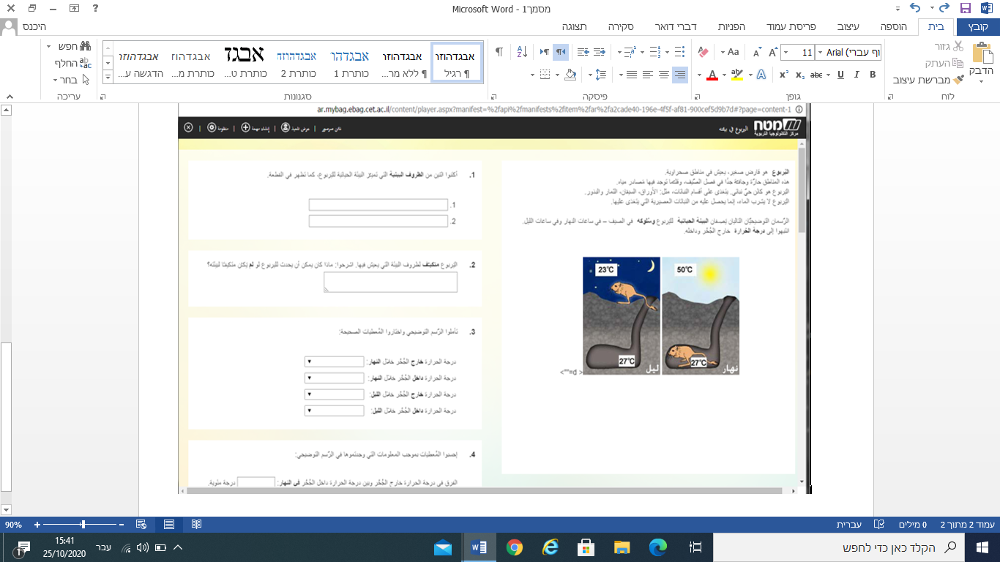

Screenshot No' 2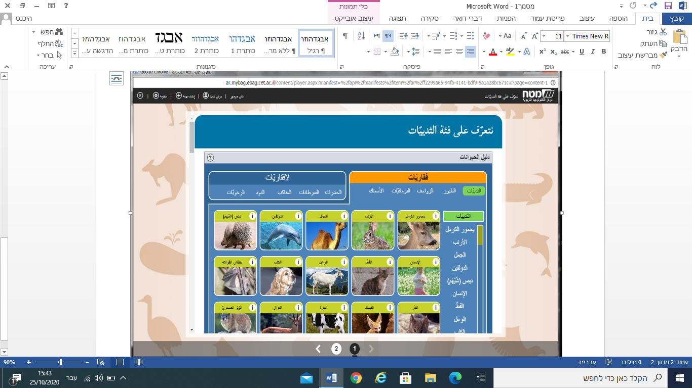

Screenshot No' 3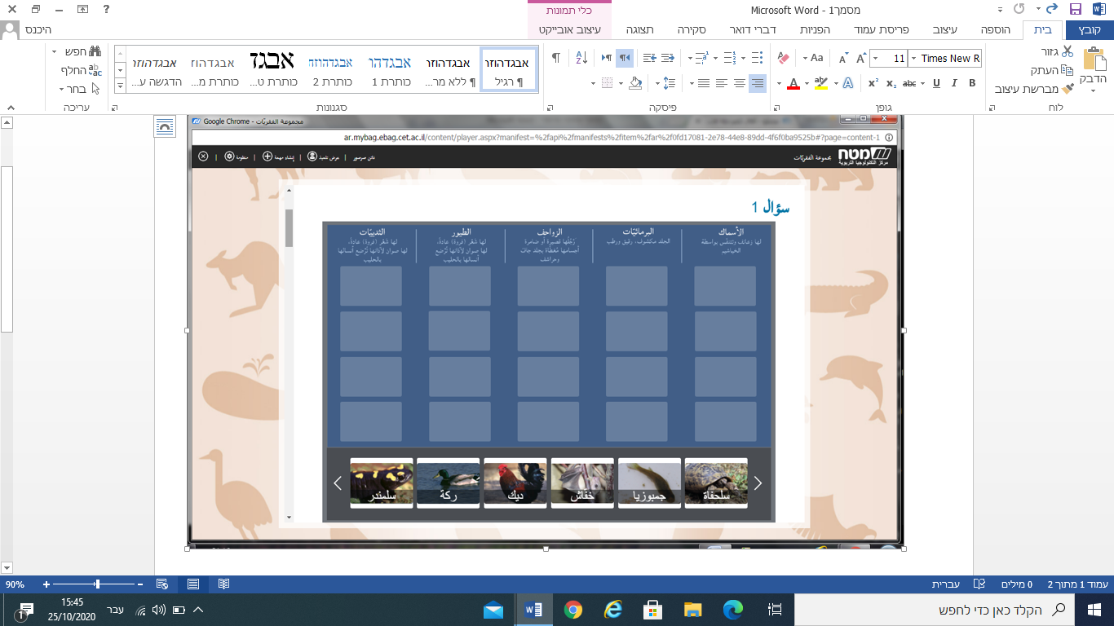

(Appendix- B)

Animals (vertebrates, not vertebrates)

#Each group chooses one of the following categories and classifies the animals that belongs to it.

#1-

A- Classify the following animals according to the appropriate category: Eagle, ant, snake, frog, comb, cat, bulb, salamander, crocodile, mullet, dog, lioness, turtle, dory, cockroach, gymnast, toad.

A- Add to your category the names of animals.

|  |  |  |  |  |  |
| --- | --- | --- | --- | --- | --- |
| The birds | Reptiles | Fish | Amphibians | Mammals | Insects |
|  |  |  |  |  |  |
|  |  |  |  |  |  |
|  |  |  |  |  |  |
|  |  |  |  |  |  |

Screenshot No' 4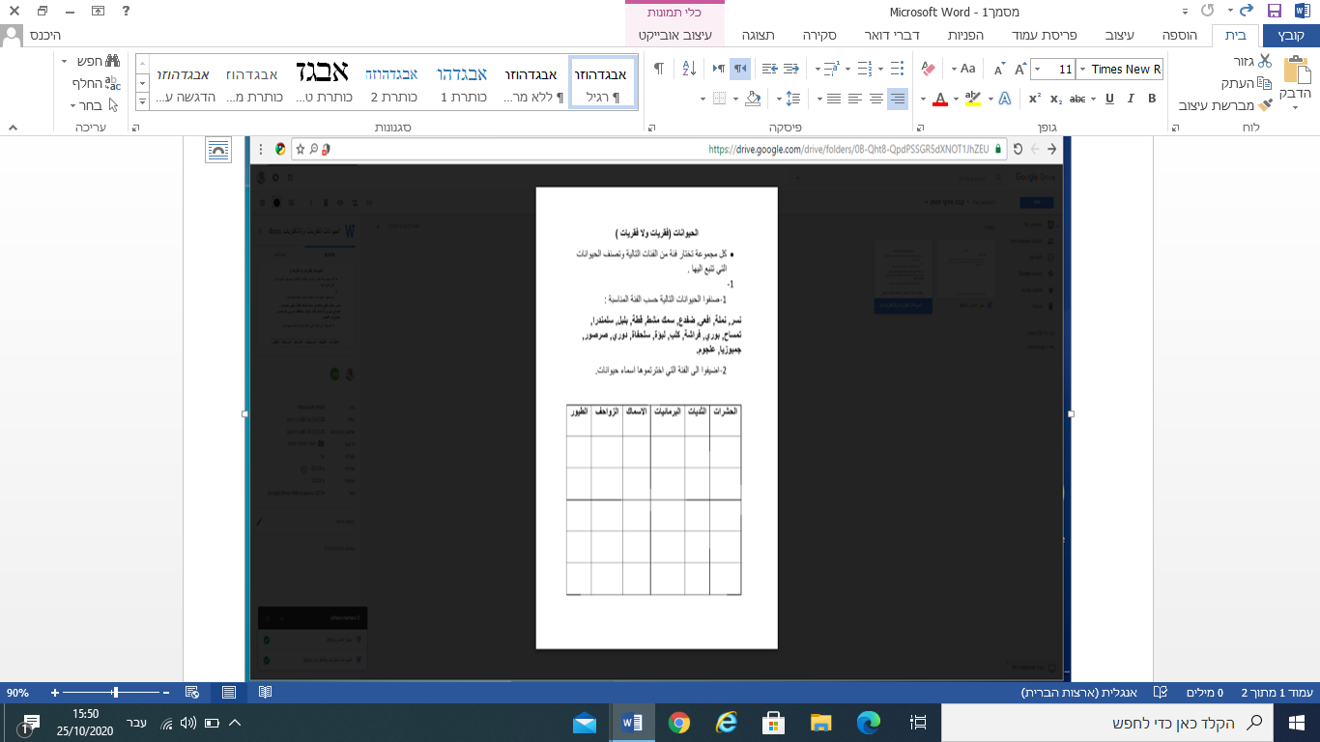

<https://drive.google.com/file/d/0B-Qht8-QpdPScklmZC1MWlFRM00/view?usp=sharing>

<https://goo.gl/DoBqwF>

(Appendix- C)

States of matter

Event Instructions:

# Each group gives examples of solid, liquid and gaseous substances in the common board in the lino computerized instrument.

Screenshot No' 5

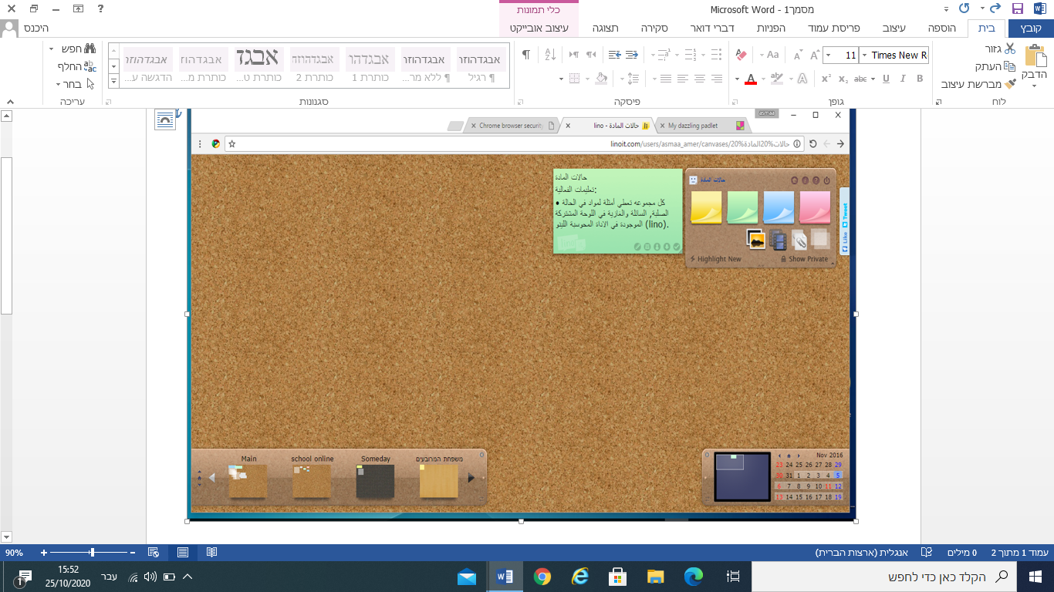

<https://goo.gl/k1rZBs>

(Appendix- D)

respiratory system

Event Instructions:

1-In front of you is a picture of the respiratory system, write the following members in the appropriate place

2-Choose a member and search in the Google search engine and write about its structure and function

*respiratory system image from Google Images, extend an arrow and an empty square

|  |  |  |
| --- | --- | --- |
| Occupation | Building | member name |
|  |  |  |

Screenshot No' 6

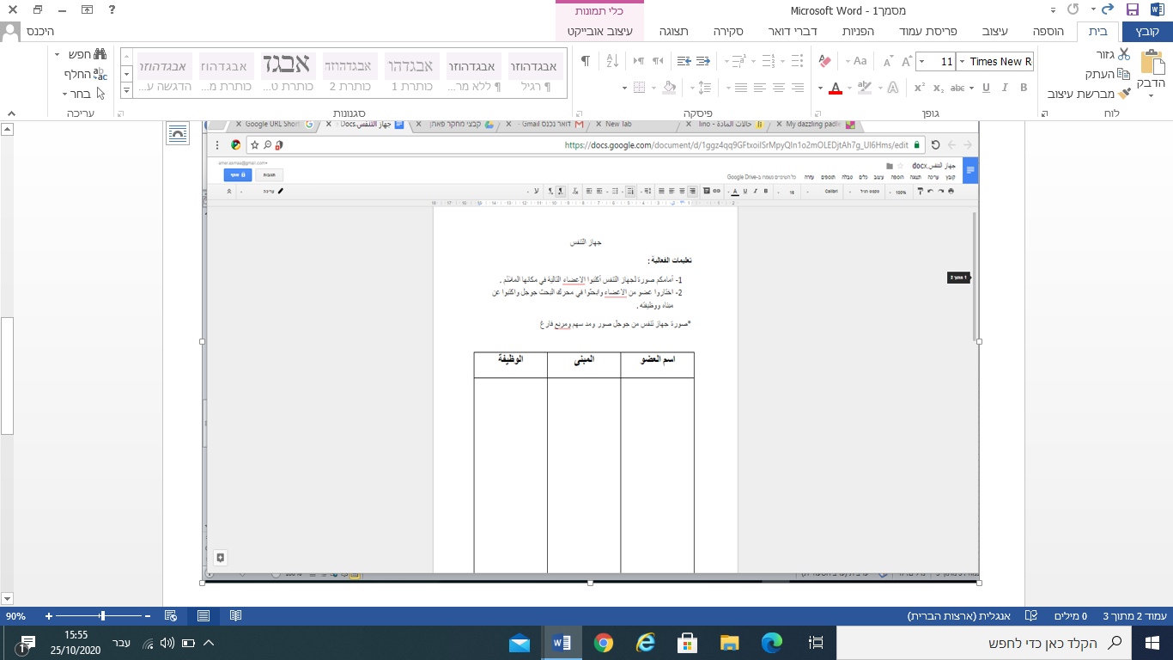

<https://goo.gl/II0JHC>

Screenshot No' 7

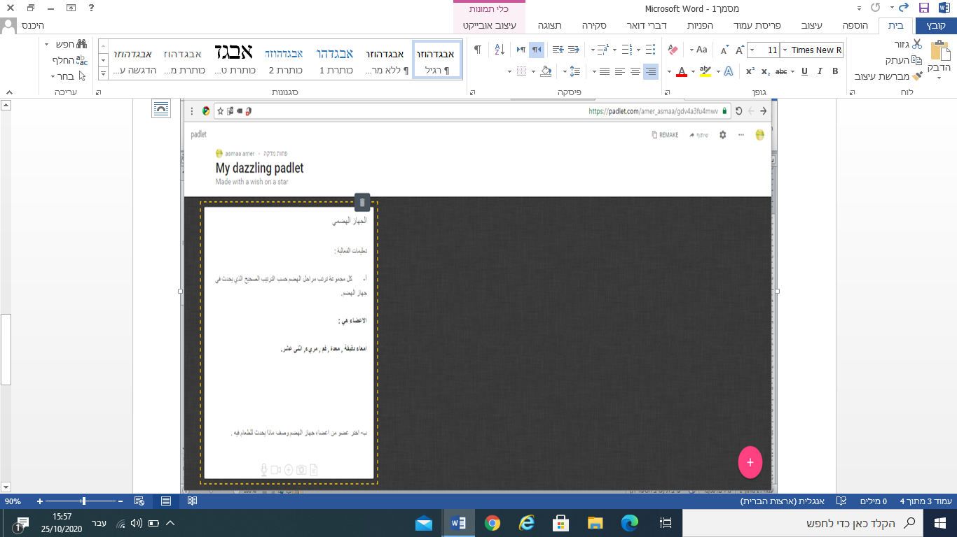

(Appendix- E)

Digestive system

Event Instructions:

A - Each group arranges the stages of digestion according to the correct order that occurs in the digestive system.

The members are:

Small intestine, stomach, mouth, esophagus, twelve.

B- Choose a member of the digestive system and describe what happens to the food in it.