Figure 1: The wormhole (00:59:12)

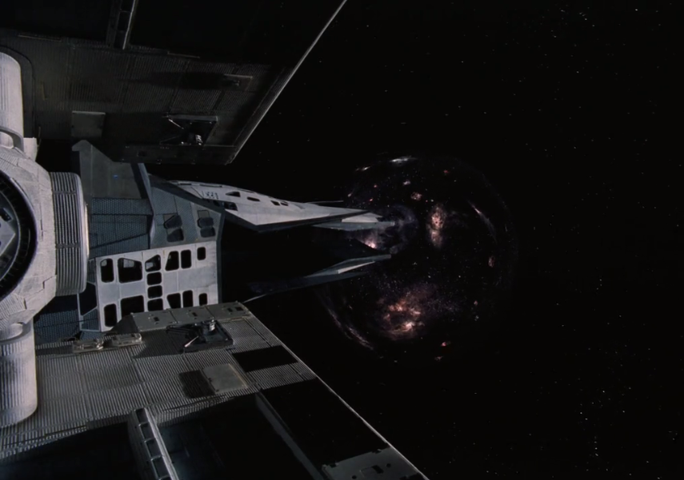

Figure 2: Humanity in the grips of catastrophe (02:19:33)

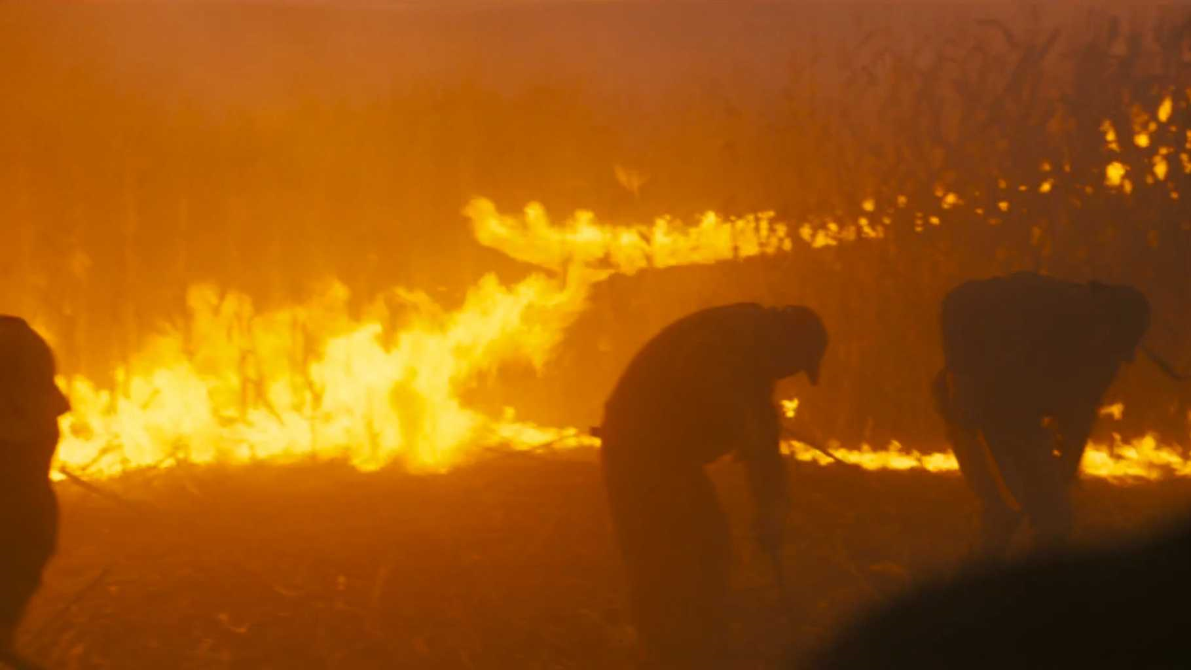

Figure 3: Dr. Mann in his cryo-chamber (01:36:24)

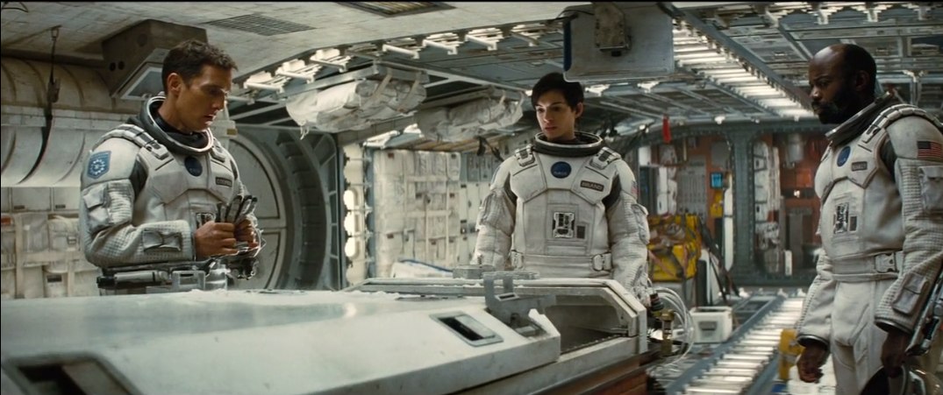

Figure 4: Cooper inside the tesseract (02:27:14)

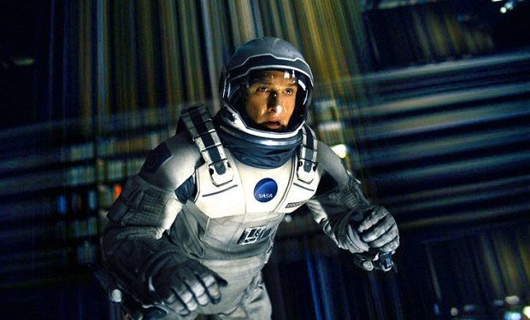

Figure 5: Cooper and young Murph, father and daughter **(00:06:18)**

